Professional Career Development
SHAHBAZ ZAFAR
1814615
BMSK4005
MS. MARY MARCH

Table of Contents
Introduction 3
Summary of my experiences during study and in the workplace 4
Self-evaluation review 6
Learning style 10
Personal development 11
Review of understanding and expectation of the world of employment 14
Career ambitions and aspirations 14
Personal Development 15
Conclusion 16
Reference 17

Introduction

When it comes to stepping up to develop the career then it is also crucial to look back to previous experiences in order to reflect on the past experiences to learn from it and fix any issues that have happened before which can impact later if kept unchecked without any strategies. That is how professional development takes place. It is a process that people go through to develop certain skills and knowledge that would be useful in their future career. But it does take a while to understand the skill gaps and then act on it in order to improve. People learn from both personal and professional life experiences and reflecting on every background can be very important to understand own skills and competencies. And that is what the purpose of this report is where I will be reflecting on my personal and professional life while also explaining some of the relevant theories to help me reflect on my experiences and the skills that I have so that I could come up with a development plan that would help me to gain the skills and knowledge that do not have.

Summary of my experiences during study and in the workplace
Though I am now living at UK, I am actually from Islamabad, Pakistan. My early studies were done within Islamabad, Pakistan and I completed my graduation from Comsats Institute of Information Technology. After my graduation, I was looking for a job and fortunately found a work as a Network Assistant within Comsats. From there I gained enough work experiences for three years and this is where I decided to apply for CIMA at Glyndwr University where I got accepted as well. I decided that I want to build my career by studying further, so when I got accepted at the university, I moved to the UK so that I could pursue my goals and objectives. The issue that I had to deal with is that after I completed the CIMA, I was unable to find a suitable job for myself and I was left unemployed for quite some time. Since I was not being able to do anything with that situation, I decided to become entrepreneur instead and start my own business. However, deep inside I grew an interest towards becoming an IT professional as it is something that I always wanted to become since I was a kid and in this moment this interest kept sparking. So after continuing my business for four years, I realized that I want to pursue this interest to become an IT professional; therefore, I started doing CERTHE Skills for the Workplace in order to get back to studies so that I could develop new skills, which I think was the right decision, as I got the opportunity to improve on the skills that I lack from my previous studies and this is where I would be able to develop my skills through continuous efforts. During both of my earlier studies as well as my work experience and the four-year business run, I was able to develop a lot of skills and knowledge that I believe I can be able to make use of if I get to become an IT professional. However; I still believe that I also need to learn a lot, especially the knowledge required to work in the IT profession in specific. At the moment, my plan is to enter for the Bachelor of Information Technology so that I could fully commit to my childhood interest and be able to achieve this goal.

Positive experience
Negative experience
Started CERTHE Skills for the Workplace
Started my own business
Couldn’t find a job for a while
Completed CIMA
Moved to UK
Applied for CIMA and got accepted
Got a job at Comsats
Graduated from Comsat Institute of Information Technology
Birth

Self-evaluation review

When it comes to self-evaluation, the aim is to identify own strengths and weaknesses in order to learn about the skills that have been formed over the past experiences and the gaps that still remain within the learning (Brown et al., 2013). This is because it helps in order to focus on those gaps and come up with plans to improve on those gaps to improve own skills and knowledge.
There are usually different ways that individuals can go with to evaluate their own strengths and weaknesses that occurred within previous experiences. Usually the most common that is used for reflecting on past experiences is the Gibb’s reflective cycle that consists various steps to reflect on past learnings and actions that need to be taken.
The Gibb’s reflective cycle uses various steps to go in-depth with a particular situation or event where the learners started to learn and get a new experience. Based on the understanding of the situation or event, the learner is then expected to understand how he or she felt during that moment and what they think of those moments at this time so they could gain overall understanding on the situation in order to reflect upon the actions that could’ve been taken and the strategies that can be taken to plan ahead the improvements on the learning gaps during the situation.
Below is a detailed explanation of my own past learning experiences using the Gibb’s reflective cycle where I have explained my own learning process as well as the issues that I had faced during the learning experience which helped me to develop a plan to improve on my skills.
Description
From my childhood, I wanted to become an IT professional because technologies always intrigued me and I felt this subject very interesting to learn. So I eventually studied to focus on this subject only and managed to graduate from Comsats Institute of Information Technology. Before my graduation, I got to understand and learn about the basic IT skills and knowledge that allowed me to learn how to operate a computer. However; certain software such as power point for developing presentations felt harder to learn. I got the basics, but I still am not good at these. But I managed to get expected grades and graduated. The learning significantly occurred when I actually got to work at Comsats as a Network Assistant. This is where I learned some advanced aspects of technology and skills that are connected to networking. Everything was easy when I was at my homeland. But I decided to apply for CIMA, so when I got the opportunity, I had to move to UK. Though I did complete my CIMA, it was a very challenging experience for me as I had faced difficulties in managing time for study while organizing my personal stuffs so I could get settled in this new place. The thing is; jobs weren’t available and I couldn’t find a job for a long time. During that time, my interest to become an IT professional grew and I decided to start my own business instead so I could pursue my career. Through becoming an entrepreneur, I was able to gain some new skills such as management, communications, operations management, leadership skills etc. and by four years I had enough knowledge from the business that I can make use of to develop my career. But my ultimate goal to become an IT professional hasn’t happened yet and aside from my past working experience at Comsats, I realized I need to study further and gain knowledge of advanced technologies through study therefore, I started CERTHE Skills for the Workplace to get back to my early learnings before graduation as well as my learnings from working at network operations. The main reason I started with this area is to finally pursue my career goal to become an IT professional through learning.
Feelings
My feeling towards my goal to become an IT professional had always felt interesting of course. But the actual feelings that I had to deal with to trying to get to my goal have been rather a mix of several feelings. I was excited when I got to study for my graduation at the Comsat Institute of Information Technology as this is where I started to progress towards my goals. I would try to regularly participate in classes and worked harder to learn all I can; therefore, excitement and keen interest in learning was something that I was dealing with. I felt happier when I got to work at Comsat as a Network Assistant as it allowed me to actively work in a setting that is relevant to my goal. Besides, this was a good opportunity for me to gain some practical skills from working there which was something that always made me happy. I worked there for three years and during that time I was always interested to learn. But I needed to continue to develop my career, so I started to lean towards learning CIMA and I applied for it in the UK and was really happy when I got accepted at Glyndwr University. This allowed me to pursue my goal and get settled in the UK so I was excited as well as nervous at the same time because of new place and new people as well as unknown results of what I could be doing. But I was under a lot of stress when I couldn’t find a job after I completed CIMA and felt depressed. I decided to make changes myself and got really excited to start my own business, and after successfully being able to do it, I felt confident and in control of my situation. After some time, when I started studying again, I felt really confident this time about my goal to become an IT professional.
Evaluation
Based on my evaluation; I can say that most of my learning happened during my work at Comsats. Also, during my business, I also gained some skills that are not directly linked to IT sector, but can be crucial in terms of employability skills as I developed some career related skills from doing the business. However, the issue here is that I lost my focus when I couldn’t find a job after completing CIMA. I developed stress and I was unable to control my stress due to the tension of not being able to pursue my career for becoming an IT professional for an IT organization. Time management was also another aspect that I lack, as I had difficulties in managing time for study and other stuff when I first came to the UK. There are some software that I still do not have much ideas on to operate with available functionalities such as Power Point from Microsoft. And I believe my lack of knowledge in some of the software could be a huge problem if I want to become an IT professional. I do have knowledge on networking and some experiences, as I have worked for Comsats. However, I still have a lot to learn if I want to develop my career as an IT professional in the IT sector. But I tend to enjoy studying, which is the reason for me to keep myself focused towards study and I have also been able to complete my previous studies because of this.
Analysis
The overall analysis that I can conduct from this evaluation of my past experience is that my educational background as well as my job experience allowed me to gain some skills and knowledge that could help me to be able to become an IT professional for an IT organization. Furthermore; since I have also started the CERTHE Skills for the Workplace, I should be able to gain further skills that would help me to reach my career goal. But some of the negative experiences did contributed to the development of my stress. I am eager to learn and can gain good amount of skills and knowledge through learning from doing or academic courses. For instance, I have good knowledge of networking because of my past job experience. However, I still lack some IT skills such as having the idea of operating some of the software. I do have some extra skills that I had been able to develop through the business that I had started and that is the reason I am hoping that I would be able to learn more and control my stress in order to become efficient in IT sector so that I would be able to build my career as an IT professional in specific.
Conclusion
A lot of things that I had issues with during my past experiences could’ve been done differently to get better outcomes. First of all; I worked for Comsats as a Network Assistant for quite some time, but the thing is, I could’ve started getting trainings on other IT skills and there are tons of external organizations that offer training on graphic designing, certain software operations such as Microsoft Word or Power Point, or programming language etc. I love learning new things, especially things that are connected with my goal to become IT professional. But I showed little efforts during my early work years. I did complete CIMA and I also have knowledge as an entrepreneur which I believe would be crucial in pursuing my career objective. But if I could’ve planned my approaches to develop my skills before, then I would’ve probably gotten a job after completing CIMA and I wouldn’t have developed stress and anxiety and these things surely can affect my performance at workplace especially during work pressure in workplace.

Action plan
Based on the overall evaluation of my past experiences; I have some plans to improve myself. First of all; my target is to increase my IT skills through trainings offered by various IT organizations for a fee. I also plan to seek knowledge on how to control my stress because I am a very focused person towards my career goals and things like stress and personal emotions can affect my goal achievement. So, I would seek advices and techniques to control my stress especially under pressure. I also have plans to get admission to Bachelor of Information Technology after I complete my current course and with this, I believe I would be able to learn further knowledge that would contribute to the IT sector.

Learning style
There are three ways that individuals can learn from sources. These are known as visual, auditory and kinaesthetic learning (Jordan et al., 2008). Each type of these learning styles can help individuals to learn. But in terms of approaches, these are different from each other learning styles.
According to the concept of visual learning; it is the most basic form of learning that involves learning from observations and from information that is presented using methods like images, video, signs, gestures, written data, behaviours and many other which can be seen by others and thus allowing individuals to learn from this (Reece et al., 2000). In my case, I mostly had to learn my way through this learning style as this is something that occurred in lectures during my educational period and I also learned from observations when I worked. Even with this course, I am learning new things through text books and class lectures where information is presented to help us learn.
Auditory learning indicates the learning process that happens through listening. If people are good at learning from what is being spoken to them and if individuals can take notes from what they hear, then it means they are good at listening to others and they learn well from listening rather than observing something. During study, we pay attention to our lecturers and carefully listen to the lectures which involves this learning style. But in my case, I couldn’t simply understand examples just from listening as I always looked for practical explanations which is not something that I would get from this learning style.
Kinaesthetic learning involves learning through active experimentations especially if it involves directly interacting with the object related to learning with touching and being used in order to learn its practical use (Zhou et al., 2014). Our workshop exercises during study sometimes involved kinaesthetic learning style, such as interacting with a computer to learn its functions. So, this was another common learning approach that I had experienced during my previous study and work experiences as there were a lot of actions that required to be learned through practical experimentations, hence this style applied.
But overall; I tend to learn better from visual representation of information and detailed explanations that can be presented using media. I also sometimes rely on kinaesthetic learning when it comes to practical learning, but I do not do well if it is important to only learn from hearing and listening.

Personal development
The personal development involves actions that are planned to ensure that skills gaps are mitigated and individuals could be able to develop new skills which would enhance their efficiency and help them to be eligible to seek a better career (Yena, 2014). The personal development cannot be carried out until the strengths and weaknesses are revealed which are essentially the things that can make or break the career objective (Gravells et al., 2010). There are several ways to do this. However; I have chosen to go with SWOT analysis so that I could learn my own capabilities before I plan to develop my skills.
Strength | Weakness
Always looking to learn and develop skills  Have knowledge of networking  Have ideas on how to become an entrepreneur  Can focus on tasks at hand | Can easily become stressed  Less IT skills and practical knowledge  Not organized in terms of time management
Opportunity | Threat
Join trainings offered by IT organizations available widely to improve IT skills  Join courses offered to improve stress management skill as well as time management | Being easily stressed means it will break my ability to focus during heavy work shifts  Lack of some key IT skills would surely affect my employability

The next thing that I need to be doing is to set up my plans to improve on my weaknesses that I had identified earlier. I plan to do this using the SMART objective tool. My SMART objective is the following –
Specific | Measurable | Achievable | Relevant | Time-bound
Stress management | I would be able to keep my focus at work | Should be easier to learn as there are plenty of techniques available on the internet and courses. | Will be able to work during heavy work shifts which will improve the work performance | By six months, then continuous
IT skills | Will be able to understand and use a wide variety of information technologies that are available | Can be learned from internet as well as books, articles. Will register to IT skill training programs offered by IT organizations. Bachelor of Information Technology would also help me to improve this skill | It will increase my employability skill to become an IT professional | By a year
Time management | Would be able to organize tasks at hand | Time management learning course | Will be able to benefit from this in both personal and professional areas especially when working under heavy shifts | By three months
There are some skills that I have which I have shown using the Johari Window in order to provide information on how these things can also contribute to my personal development. These are the following –
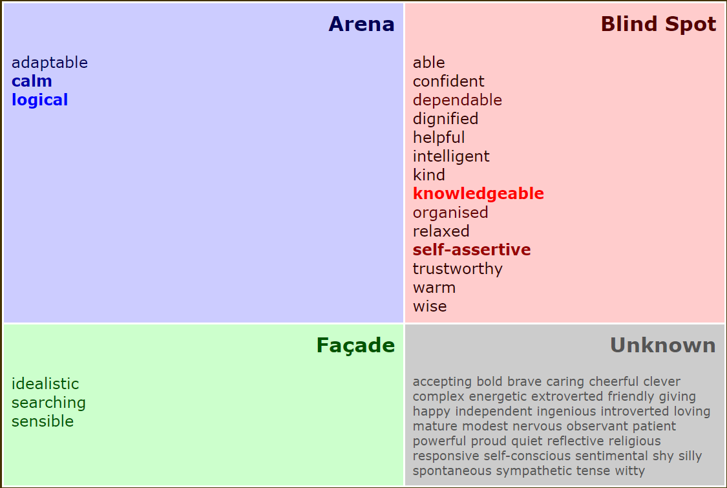

Review of understanding and expectation of the world of employment

The IT sector is quite vast as there are plenty of technologies that are being used to provide service to the society (Cottrell, 2010). For this reason, IT sector requires skilled employees who are specialized in IT skills. Although basic knowledge can be sufficient in seeking jobs in this sector; it can impact on the long-term career planning, as advanced IT skills are necessary to have in order to reach higher positions in IT sector. There are several degrees that can also contribute to the employment seekers within this sector. But most employers in IT organizations look for candidates who can show practical explanation of their skills related to information technology as this can be complicated based on the service that the organization is based on. For instance; and IT consultancy firm would require its workforce to have tons of ideas on technologies in order to be efficient when providing IT consultancy to the clients, but customer care services on the other hand can work well with some specific IT skills only related with the organization. Having ideas on various IT skills can contribute a lot to the IT sector. But skills like communication, teamwork, time management, ability to work under pressure situations as well as being able to solve issues at hand are some of the skills that employers also expect from candidates within the IT sector as these are essentially the extra factors to workplace that not only builds an individual to become a successful IT professional but also be an efficient employee for the organization.

Career ambitions and aspirations
As I have mentioned before; I have the goal to become an IT professional since I was a child and I have always wanted to learn about various technologies. This is why my career ambition is to be able to work as an IT professional for a renowned organization in the IT sector. My aspiration is to be able to train my skills to improve my knowledge on IT sector so that I could have better skills as an IT professional. That is why I am also planning to get admitted to Bachelor of Information Technology and currently doing CERTHE Skills for the Workplace.

Personal Development
In order to achieve my carer objective, I have conducted my own plan to reach the skills that needs improvements. The plan to develop the required skills for reaching my goal is below -
What are my goals | What will I be doing to achieve the goals | By when | What could be the barriers? | How can I manage the obstacles | What support do I have to reach the goals | Review of how am I doing
Learn how to control stress | Seeking courses to learn stress management | Six months, and then continuous practice | Study times and personal stuff | Managing my schedule for study and training | Information on the internet, guidance from the trainer in the training courses. | I have been slowly improving the way I control my stress but still need time to be better at this.
IT skill development | Studying for Bachelor of Information Technology, getting training from IT organizations | A year | Study times and personal stuff, stress | Managing my schedule as well as applying stress management learning to keep the focus | Participating in classes and training sessions | I have not admitted to Bachelor of Information Technology yet but will do so after completing my current study. I am looking for IT organizations that provide trainings for IT skills
Time management | Studying time management course to learn | Three months. | Finding time for study and personal stuff as well as other skill development trainings | Managing the schedule properly | Course lectures and information available on the internet. | Have found a course for time management offered by an organization. Will register after completing my current study. But until then I am learning from reading online blogs.

Conclusion

The report concludes with my plan develop the skills that I lack so that I can improve on these to become eligible to reach my career goal which is to become an IT professional for a renowned organization. I have previously gained enough skills through my previous study and work experience. But I still have ways to go if I seek my career in the IT profession; therefore, my understanding on the concept of career development and my plans should be useful in establishing my career goal and objective.

Reference
Brown, G., Bull, J. and Pendlebury, M. (2013). Assessing Student Learning in Higher Education. Hoboken: Taylor and Francis.
Jordan, A., Carlile, O. and Stack, A. (2008). Approaches to learning. Maidenhead: Open University Press.
Reece, I. and Walker, S. (2000). Teaching Training and Learning: A Practical Guide. Sunderland: Business Educational Publisher.
Zhou, M. and Brown, D. (2014). Educational Learning Theories. San Francisco: Dalton State College.
Yena, D. (2014). Career Directions: New Paths to Your Ideal Career. 6th ed. MCGRAW-HILL EDUCATION - EUROPE.
Gravells, A. and Simpson, S. (2010). Planning and Enabling Learning in the Lifelong Learning Sector. Exeter: Learning Matters Ltd.
Cottrell, S. (2010). Skills for success. Basingstoke: Palgrave Macmillan.

