
BA(Hons) Leadership and Management Skills for the Workplace

Workplace Culture and its impact on Organisational Efficiency

BMSW 5105
Lecturer: Md Kalam
Student name: Nicoletta Camba
Student Id: 1915298
World count: 5375
Date: 06/09/2021

Table of Contents
Introduction 3
Ferrari's Company 3
External Factors' Impact on the Organization 4
Organisational structure 6
Ferrari's organisational structure 7
Organisational culture 8
Ferrari's organisational culture 10
Artefacts from Ferrari's corporate culture 10
Hofstede Model 11
Ethical Dilemma 14
Ethical Dilemma and barriers within Ferrari. 15
Conclusion 16
References 17
Individual Reflective Essay 20

Introduction

Over time, the term culture has taken on a variety of meanings: from the Latin "colere," which means "to cultivate" the land, to "cultus," which means "cultured," which refers to a person's knowledge.
The term culture refers to an individual's realisation: it is defined as a set of skills that allows them to engage actively and successfully in the life of their community. Companies are linked to this concept of culture, and we can see how it plays a crucial part. Cannot talk about a corporation without mentioning the concept of organisational culture, which is described as an organisation's definitive collection of ideas, beliefs, knowledge, attitudes, and behaviours. The impact of organisational culture on situational factors within the context of an organisation is a specific research issue in management science that has never waned in popularity.
The word "organisational culture" refers to policies that give people direction and guidance. It is a sophisticated system that includes common beliefs, values, and assumptions that govern employee behaviour. The psychological and social environment of the organisation is distinctive and distinct because of these underlying concepts, attitudes, and values.
This report intends to analyse the workplace culture and the functional capability inside the Ferrari company; it will describe the culture and context of the organisation using management tools, will deepen the impact of the external and internal environmental factors between the department and the people inside the organisation. This paper explores what strategy for success the Ferrari company has used to establish a winning organisational culture and describe Ferrari's organisation. Then, we will enter more specifically into the corporate culture and how a winning ethical culture is created, which factors affect the organisation's culture and which factors affect the success and the role of leaders inside the company.

Ferrari's Company
Ferrari S.p.A. is an Italian automobile manufacturer based in Maranello that makes automobiles one-of-a-kind in performance, technological advancements, and design. It is active in the high-end sports car and racing car markets and the world of motorsport. The history of this company follows in the footsteps of its founder Enzo Ferrari. It begins to be written in 1929 when Scuderia Ferrari was founded in Modena with a capital of 200,000 lire.
In 1947 the 125 S was made, and it was only one of the many creations that brought awards to this company. The 1950s saw the Ferrari team celebrate more victories than anyone else in the history of Formula 1. Moreover, during these years, the partnership with Carrozzeria Scaglietti began to produce and assemble Ferrari chassis.
In 1960 Ferrari became a joint-stock company to open its range of experience from the world, racing to the industrial one, and so in 1973, the production of cars began. The industrial world and the world of racing remain two open and parallel scenarios for the company, in which it obtains various successes and awards. The company always stands out from the competition thanks to its constant innovation and technology that embraces the future.

External Factors' Impact on the Organization
External influences have an impact on every organisation, but the magnitude of this impact varies. The performance and culture of an organisation are influenced by macro-environmental elements that can help the organisation determine its strengths, weaknesses, opportunities, and threats to analyse themselves and their competitors in the market.

Strengths of Ferrari.
The mechanisation of activities has improved Ferrari's products' consistency and has enabled the company to better respond to market demands.
Ferrari devotes much attention to the training and development of employees, which results in a competitive team that is driven to succeed.
Go to Market techniques for products has been very successful.
Ferrari has a good base of raw material suppliers, which allows it to overcome any threat in the supply chain.
Ferrari always manages to complete the projects it invests in, which does not make it lose money in investments.
Ferrari blends complementary activities very well and integrates many technological activities to streamline operations resulting in a reliable supply chain.
Product innovation is a successful track record of developing new products.
Ferrari has achieved high customer satisfaction and good brand equity among potential future customers thanks to its specialised customer management department.

Ferrari's Weaknesses.

Ferrari needs an improvement in product marketing; even if the product is a sales success, the positioning and the unique selling proposition are not well defined. In this sector, the attacks of competitors are powerful.
The company structure is very consistent with the company strategies, which limits the expansion of products.
Ferrari has a lower profitability index and contribution rate than the industry average.
The workforce is very worn out compared to other companies in the industry; this leads to more expenses in the training and development of its employees than its competitors.
Ferrari has to review the financial planning; the current assets and liquid assets ratios show inefficiency in financial planning.
In technological innovation, Ferrari should invest much more given the size of its expansion and the various locations it wants to take the market to.

Ferrari's Opportunities.

The new tax policy can be an excellent opportunity to increase Ferrari's profitability. The competitive advantages will disappear as the market develops, and Ferrari will increase its competitiveness against its rivals. The government's green initiative will also allow state government contractors to buy Ferrari products. Consumer responses are opening new markets for Ferrari, which sees an 'excellent opportunity' to diversify into new categories of similar products. Reduced shipping costs can reduce the cost of products, allowing Ferrari to increase profitability and gain new market share.

Threats Ferrari.

The shortage of qualified personnel in critical world markets does not allow Ferrari to have a constant growth of profits in those countries where it would like to expand. The demand for high products is seasonal, and any unforeseen incident would long-term impact the company. The supply chain based on physical infrastructure risks being threatened by the new way customers shop through internet channels. Counterfeiting is another issue that Ferrari is facing; low-quality imitations are becoming a risk in emerging and low-income regions. Rising raw material costs may jeopardise Ferrari's profitability. Different nations' liability rules differ, and Ferrari could be susceptible to various liability lawsuits if regulations in those markets alter.

Organisational structure
Organisation structures occur in various shapes and sizes, and the company's strategy influences its design. The goal of an organizational structure is to aid the organization in attaining its goals and objectives and assist employees in successfully fulfilling their tasks. An organizational structure helps management coordinate and regulate activities by assigning job functions and obligations to individuals.
According to Daft (2008), we can define organisation structure as:
(1) a list of tasks that have been formally assigned to persons and departments.
(2) formal reporting ties, such as lines of authority, decision-making authority, the number of hierarchical levels, and managers' scope of control
(3) the establishment of tasks that allow for effective cross-departmental coordination.
On the other hand, the organisational structure is like a team's tactical arrangement. Everything is constructed on foundations; various forms can be used, depending on the type of business and the principal goal.
These are the three primary configurations of organisational structure: functional, divisional and matrix structure.
The real benefit of functional structures is the ability to achieve high local efficiency factors, resulting in high role specialisation and, as a result, improved operational efficiency in each function.
The most significant disadvantage, on the other hand, is the creation of "stagnant compartments." Each compartment functions like a separate company, posing the risk of a lack of coordination with the others and making achieving common goals difficult.
However, the corporation is "segmented" internally under a divisional structure, such as a line of products/services or a market with a divisional structure. On the other hand, some "non-specific" functions, such as administration and information systems, maybe maintained centrally. The real benefit of these structures is that they create internal competition between equivalent units, which boosts performance, especially in businesses with important diversification features. Furthermore, the efficacy of a functional organisation would be jeopardised in such a situation.
The fundamental downside of these arrangements, on the other hand, is the difficulty in taking advantage of economies of scale and even rare synergies. The risk is comparable to functional structures, such as establishing different firms within the same organisation.
Finally, the so-called matrix structure combines the previous structures and attempts to address their flaws. In practice, the matrix structure is established on both practical and business-specific dimensions, such as by-product/service line or market. Multiple "project managers” are responsible for a given project in a conventional matrix organisation.
The advantage of these structures is that they combine specialisation and coordination, they do, however, have higher management overheads.

Ferrari's organisational structure
After the tough start to the 2020 Formula One season, Scuderia Ferrari has decided to say goodbye to a horizontal organisation of work in the technical area and return to a well-defined hierarchical scale. The last few years have shown that the technical area is where most failures have been detected, and consequently, the need to improve different areas has been recognised. Reviewing the Ferrari organisation should make the process of innovation and development of car performance faster and more efficient.
With the new structure, new clear objectives and changes in approach, the Ferrari factory will be reorganised, giving more responsibility to the single areas.
Ferrari revisiting its structure, defining a more hierarchical structure, and then entrusting the heads of each area with all the powers necessary to achieve the objectives set has also created a new area called Performance Development. In contrast, the other areas of competence remain unchanged.

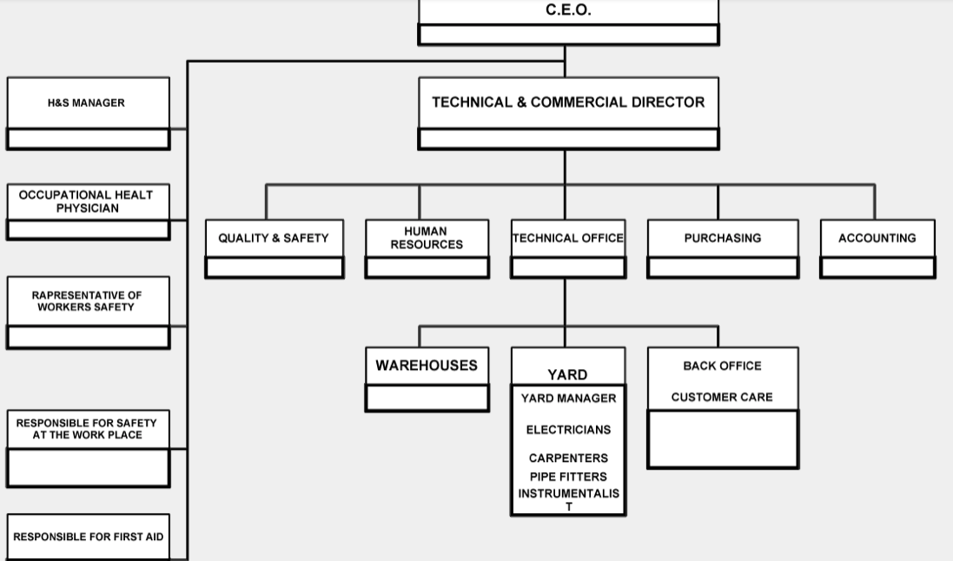
Source: http://www.gruppoferrari.net/organigramma/

Ferrari Structure
Ferrari's functional structure is based on the hierarchical principle and the progressive subdivision and focusing of corporate objectives into sub-objectives, which are assigned in cascade to the levels below the executive body. This organisational form follows the principle of grouping according to homogeneous activities/functions by bringing together employees with homogeneous skills. It can be said that all operations of the exact nature are part of the same function and are under the control of the same manager.
The pyramid represents this structure, with the highest authority at the top and functional departments and operational units below that. All competencies and human capabilities concerning specific activities are consolidated and provide the organisation with in-depth and specialised knowledge.
It is possible to trace the articulation of the structure into three basic levels: the general management or strategic summit, functional departments, operational units.

Organisational culture
All companies, whether they are aware of it or not, have an organisational culture. Learning about and analysing the elements that make up this culture; understanding how these influence the business is crucial for modern companies, which face new challenges and changes every day. Let us find out together what organisational culture means, how a company can form its own organisational culture, and how the company climate is influenced.
There are several theories of organisational culture. According to Edgar Schein (1992), organisational culture is a system of values, beliefs, principles, ideas, ways of thinking, opinions, and implicit knowledge, assumed and shared (by an organisation) that determine how the group perceives and evaluates and deals with the environment.
According to Schein, an organisational culture develops within a group of people. From the observation of a group, the three main elements that constitute it can be deduced and analysed:
Artefacts: are the most superficial elements, which can be observed by making a first, shallow analysis of a group or company, such as the architecture of the physical environment, the furniture, the technologies it employs, the way its employees behave.
Explicit values. They are the social principles that guide the group's behaviour, defining what is right and wrong. In a company, they are the ideals, goals, values, inspirations, and ideologies inferred from observing the mission. These values are communicated externally and internally, the way products and services are presented.
Basic assumptions. They represent what is an established truth for the group. They are instinctive elements, which lie below the ordinary level of consciousness and have great power: they can influence each group's perceptions, thoughts, and feelings.
The organisational culture of a company is created spontaneously, without the group members being aware of it. It starts to form even before its birth, with the person's values, ideas, and objectives who founded it. However, when the company is populated with people who spend much time together, the actual organisational culture takes shape and consolidates. Among the elements that contribute to its formation are the leadership style, the historical, social and political conditions at the time of the company's birth and development, and the culture of the country in which it operates.
Edgar Schein uses three theories to explain the formation of organisational culture:
Sociodynamic theory: it is used to explain the internal relations of a group of people, both the relationships that develop between the members of the group and the relationships that develop between them and the leaders of the group.
Leadership theory: helps to understand how leaders initiate, develop, and enforce their assumptions within organisations.
Learning theory. It is helpful to understand why some solutions adopted by a company become established while others disappear.
We can think of organisational culture as the company's personality. There are four basic types of organisational structures:
Hierarchical: This culture is well-defined and consistent. It is a very traditional culture that emphasises control and authority to keep the company functioning efficiently. This culture provides a sense of security and stability.
Market: This culture is like Hierarchical Culture in that it emphasises security and stability, but it is more focused on results. Working in this atmosphere is highly competitive, and there is a strong emphasis on production.
Clan: The organisation's employees are at the centre of this sort of organisational culture. Working here is an enjoyable experience. Employees are encouraged to express themselves more openly, and loyalty is promoted. Teamwork is also given a great deal of weight.
Adhocracy is a form of culture that encourages people to think beyond the box. Employees are allowed some leeway to try new things and think outside the box. Creativity is praised and encouraged. The environment is fluid, and positions are not always precise. It differs significantly from the rest of the corporate cultures.

Ferrari's organisational culture
Ferrari's corporate culture is more closely linked to a work environment structured with a vertical hierarchy and a high structure. It means that the management retains decision-making authority and has direct control over the behaviour of employees. All dependents are rewarded with monetary and non-monetary rewards for their innovative and creative work habits.
However, because of the predisposition of organisations toward a rigid work discipline, empowerment and autonomy are limited..
The demands for autonomy and empowerment among dependents have grown, management has shifted from a centralised to a decentralised structure. As a result of this transition, a specific authority will be transferred from the apex to the base. The organisation will achieve a new balance between rigid and fluid structures.

Artefacts from Ferrari's corporate culture
The outermost stratum of organisational culture is made up of artefacts. The open-door policy, office disposition, and the official code of dressing for dependents are all part of Ferrari's corporate culture. The cultural artefact Ferrari is visible from the outside, yet it is not easy to comprehend.
Ferrari’s company culture and values
The Ferrari fundamental values are a collection of common goals, principles, and standards. Responsibility, diversity, quality, cooperation, enthusiasm, honesty, and leadership are essential values. The Ferrari leadership recognises the need of communicating essential value information to everyone, ensuring that they are understood and put into practice.
Assumptions made within the Ferrari corporate culture
Assumptions are deeply rooted notions and philosophies that form the foundation of Ferrari's corporate culture. Despite playing a vital part in the development of fundamental values and visible behaviours, employees are frequently unaware of these underlying assumptions.

Hofstede Model
Different frameworks based on national culture can be discovered in the literature, Hofstede’s proposal being one of the most significant. Hofstede (1983) has argued for a long time that organisational actions are inextricably linked to culture. Hofstede established the cultural dimensions theory: power distance, collectivism / individualism, uncertainty avoidance, masculinity / femininity, temporal perspective and indulgence.
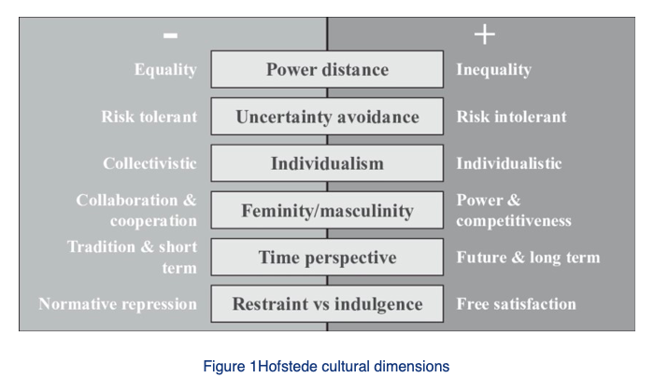
Power distance
According to Schwartz (1999), the concept of distance from power examines how society interacts with the power of its institutions. It expresses how people with less power in institutions and organisations in a country expect and accept an unequal distribution of power. High levels of separation from power are linked to a high level of respect for authority. Countries with a low distance from power do not accept a formal hierarchical system in which each person remains in his or her position, and the power is not justified. Decentralised organisations are preferred in these countries, but centralised forms of power are preferred in countries with greater distance.

Individualism versus collectivism
According to Kanter (1982), individualism refers to a society in which individual rights are free and independent, and individuals are more concerned with themselves. In contrast to collective civilisations, where the group's goals and well-being are prioritised over the individual's, individualist cultures place a greater emphasis on achieving personal goals.

Masculinity versus Femininity
This dimension assesses how much weight a society places on conventionally masculine values like aggressiveness, ambition, power, and consumerism and stereotypical feminine values like the importance placed on human relationships. Cultures with a high ranking on the masculinity scale tend to have more pronounced gender disparities and be more competitive and ambitious. On the other hand, those with low scores show fewer gender differences and place a higher priority on relationships. However, it should be recognised that aggressiveness, ambition, power, and consumerism are not always conducive to positive transformation. Human interactions, quality of life, and service to others are all essential parts of femininity, and they are all critical for implementing and beginning new procedures. According to Kaasa and Vadi (2010), businesses whit hight level of femininity focus on people in a calm, conflict-free, and, most importantly, trust-based working environment.

Rejection of uncertainty
According to (Hofstede, 1991), a society's tolerance for unpredictability, ambiguity, and risk can be classified as a cultural component. As a result, this dimension assesses a company's ability to deal with unfamiliar situations, unexpected events, and changing stress. Countries with a high score on this index are less tolerant of change and use strict norms, regulations, and laws to reduce dread of the unknown. People and businesses with a high level of uncertainty rejection, according to Allred and Swan (2004), will always prevent the implementation of innovation processes.
House et al. sustain (2002) accepting uncertainty and risk is vital for generating new ideas and advancing innovation processes. The countries with lower rejection scores will be more receptive to change.
Long-term orientation versus short term orientation.
Culture's long term (also known as "Confucianism") have a more practical perspective that emphasises saving and current-day education as a strategy for preparing for the future. For Hofstede et al. (2010), long-term oriented societies encourage attitudes towards future benefits, this behaviour postpone social fulfilment, including immediate emotional gratification, for a better future .Cultures with a short-term orientation, on the other hand, appreciate old methods, spend much time developing relationships, have a circular view of time, maintain traditions and conventions, and are wary of societal change That is to say, the past and present are linked, and what cannot be done today can be done tomorrow.

Indulgence versus control
This dimension measures how people in each society can control and satisfy their desires, immediate needs and impulses. People and businesses in more tolerant countries are more permissive when gratifying their aspirations for enjoyment and amusement. Members of more restrictive cultures, on the other hand, believe that such matters should be handled by rigid standards (Hofstede et al., 2010). Human pleasure and happiness in life are linked to indulgence (Hofstede, 2011). On the other hand, control implies a set of stringent societal rules and conventions that regulate and discourage the fulfilment of urges.

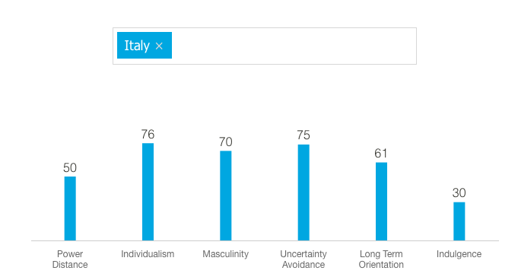
Source : https://www.hofstede-insights.com/product/compare-countries/

With a score of 76, Italy has an individualist and egotistical culture. This dimension differs from central Italy, where less individualistic behaviour is observed, and family ties and belonging groups are critical social characteristics.
Italy is a small country with a strong emphasis on success. Because any Italian can achieve success in the workplace, there could be much competition among co-workers to get forward.
Italy has a high avoidance of uncertainty score of 75, indicating that Italians are dissatisfied in uncertain situations. The Uncertainty Avoidance strategy (in which the planning process can be flexible in response to changing circumstances) can be particularly stressful to Italian people. The pragmatic aspect of Italian culture is demonstrated by Italy's top score of 61 in this category. People of pragmatic civilisation believe that circumstances, context, and time strongly influence truth. They demonstrate the capacity to save and invest money, perseverance, and parsimony in achieving their goals by quickly adapting traditional practices to changing circumstances. The moderation characterises Italian culture, which has a low score of 30. Cynicism and pessimism are typical in civilisations with limited valuations in this domain. Furthermore, unlike indulgent civilisations, moderate societies value free time and have greater control over fulfilling their desires.

Ethical Dilemma
Companies maintain a high focus on all aspects of their business while paying attention to maximising processes. Over time, the need to adopt a corporate Code of Ethics has developed, capable of identifying the main features that identify each company, whether large or small and introduce the concept of social responsibility of those involved.
Therefore, within it, through the definition of shared values, it is intended to underline the unlawful and irresponsible behaviour that harms the company and address the strategic choices to be adopted.
However, it is essential to emphasise the common sharing of values, of the rules contained in the code, so that it does not remain just a manifesto but is absorbed and internalised by each company participant.
Each company chooses how to organise its own Code of Ethics, but there are generally standard structural features. The initiative of adoption is the work of the initiative of adoption is taken by the top management, which has to work convincingly to show the indispensability of the values and rules elaborate. The code usually opens with a preamble in which the company's general mission and vision are identified. The mission aims what the company intends to pursue; the vision specifies the cultural traits that should guide the individuals who work in the company's name.
The very concept of organisation requires the presence of specific ethical standards.
These regulate the actions of all the system members aimed at a given goal in virtue of the satisfaction of economic and social objectives.
These codes are a valuable tool for disseminating decision-making and operational models within the company, highlighting the attention of company management to ethics and social responsibility, and facilitating the emergence of a positive image of the company in the eyes of its stakeholders.

Ethical Dilemma and barriers within Ferrari.
Due to the Covid-19 pandemic, all companies have closed; Ferrari was no exception.
The closure of the factories worldwide do not have spare even the headquarters in Italy, where, with great regret, the CEO had to announce its closure until the crisis caused by the pandemic had been abated.
After initial attempts to resolve the situation in other ways and thus keep production running, Ferrari had to give in and suspend production, finding itself at the crossroads of an ethical dilemma concerning its employees and the best attitude to adopt following this forced closure.
The CEO decided to pay every employee who could not use smart working (only the business sector remained active) without using the redundancy fund. The delegated administrator was in regular contact with the people he was responsible for, sharing his actions with them, offering support and attention, and listening to what they had to say. Another ethical challenge that the company has faced is restart operations safely while keeping the workforce healthy. The concept has been developed into a full-fledged strategic plan. The company decided to provide safer working conditions, better operational and quality control, and emotional support through a programme that encompassed all employees at all levels, reinforcing the sense of belonging to the company. Ferrari is an example of how the company puts employees first, underlining the concept of family and cohesive group. That is the most important aspect has led the company to be so successful in the world.
Ferrari's Ethics has a very high value; its entire corporate philosophy is based on it.
The vision on which it is based and the mission it pursues could not exist without a solid and marked code of ethics like the one found in the Italian company.
Ferrari is a mix of tradition and innovation, new ideas that embrace and marry old ones.
Ferrari's vision is to bring the excellence of its brand to the world, and its mission is to build exclusive cars using unique objects. Once again, Ferrari’s ethic proves to be true to its line: the materials used in the construction of the cars, every detail that characterises them, remains faithful to an ethic that leaves no room for compromise, even in the face of difficult times like the pandemic.
The increase in the cost of raw materials, the technological innovation, cultural and financial differences with other countries, the availability of highly qualified personnel to be employed in countries where it wants to export production, the risk of imitations of the brand and finally the choice of an online channel for customers rather than the use of infrastructure are all barriers that Ferrari has been able to highlight throughout the pandemic and that it will have to overcome if it wants to keep up its brand of excellence.

Conclusion
In an increasingly dynamic, rapidly evolving and changing world, some companies struggle to move forward because they are unable to accept change and adapt. Often, the cause of this difficulty is a lack of awareness, not knowing their own organisational culture and its elements in-depth, remaining anchored to outdated basic assumptions.
A well-defined organisational culture, in which explicit values are clear and fundamental assumptions are elements capable of changing and evolving according to needs, is essential for a company. In times of change, this organisational culture becomes the basis to be anchored to face and overcome them.
Before the emergence of Covid, companies' reputations, trust and esteem revolved around their behaviour in the marketplace, but since the pandemic, ethical behaviour has become the number one driver of product quality.
Many businesses have been able to maintain a high level of reputation because most of them have invested in and prioritised assistance and support for the country's needs, particularly for the health and safety of their employees. Ferrari, during the pandemic, has been able to demonstrate both a tremendous ethical value towards its employees and a great recognition to its country Italy by manufacturing and distributing respirators for all Italian hospitals.

References

Daft, R. (2015) Management. 12th Ed., South-Western College Pub.
Oliver ,G.(2011) Organisational culture for information manager . Witney: Chandos Publishing.
Needle D. (2004) Business in Context:An introduction to business and its Environment.
KotterJP, Heskett JL. (1992) Corporate culture and performance. New York: Free Press.
Schein E. (1992) Organizational culture and leadership: A Dynamic View. San Francisco, CA:Jossey-Bass.
Kirkman, B. L., Lowe, K. B. & Gibson, C. B. (2006). A quarter century of culture’s consequences: A review of empirical research incorporating Hofstede’s cultural values framework. Journal of International Business Studies, 37(3), 285-320.
Hofstede, G. (1983). The cultural relativity of organizational practices and theories. Journal of international business studies, 14(2), 75-89
Schwartz, S. (1999). A theory of cultural values & some implications for work. Applied Psychology, 48(1), 23- 47.
Kanter. R. 1982. The Change Masters. New York, NY: Simon & Schuster.
Rhyne, L.C., Teagarden, M.B. & Van den Panhuyzen, W. (2002). Technology-based competitive strategies: the relationship of cultural dimensions to new product innovation. The Journal of High Technology Management Research, 13(2), 249-277.
Kaasa, A. & Vadi, M. (2010). How does culture contribute to innovation? Evidence from European countries. Economics of Innovation and New Technology, 19(7), 583-604.
Hofstede, G. (1991). Organizations and cultures: Software of the mind. McGrawHill, New York.
Allred, B., & Swan, K. (2004). Global versus multidomestic: culture’s consequences on innovation. Management International Review, 44(1), 81-105.
House, R., Javidan, M., Hanges, P. & Dorfman, P. (2002). Understanding cultures and implicit leadership theories across the globe: an introduction to project GLOBE. Journal of World Business, 37(1), 3-10
Hofstede, G., Hofstede, G. & Minkov, M. (2010). Cultures and Organizations: Software of the Mind: Intercultural Cooperation and its Importance for Survival. McGraw-Hill, New York, NY.
Hofstede, G. (2011). Dimensionalizing cultures: The Hofstede model in context. Online readings in psychology & culture, 2(1), 1-26.
https://www.hofstede-insights.com/product/compare-countries/ [Accessed 19 August2021]
: http://www.gruppoferrari.net/organigramma/[Accessed 3 September 2021]
: https://www.hofstede-insights.com/product/compare-countries/[Accessed 27 August 2021]
Emanuele Invernizzi Stefania Romenti Michela Fumagalli, (2012),"Identity, communication and change management in Ferrari", Corporate Communications: An International Journal, Vol. 17 Iss 4 pp. 483 - 497 Permanent link to this document:
http://dx.doi.org/10.1108/13563281211274194 [Accessed 15 August 2021]
https://thestrategystory.com/2021/08/29/ferrari-marketing-strategy/ [Accessed 02 September 2021]

https://corporate.ferrari.com/sites/ferrari15ipo/files/sustainability_report_2018_ferrari_nv_stampa_web.pdf [Accessed 28 August 2021]
https://corporate.ferrari.com/sites/ferrari15ipo/files/ar_2020_ferrari_web.pdf [Accessed 30 August 2021]
Witcher,B.& Chau,v.,2010. Strategic Management: Principles and Practice .New York: Cengage Learning EMEA.
Hofstede ,G. 1983. The cultural relativity of organizational practices and theories. Journal of International Business Studies, 14(2), pp.75-89

Individual Reflective Essay

The module Workplace culture and its impact on Organisational Efficiency thoroughly explained how to mean the culture inside an organisation. Behind every company, there are not only studies focused on market research, but psychological, sociological and anthropological approaches, enabling companies to create a constructive and proactive organisational helpful climate for project development. Every company has its own organisational culture that guides employees to adopt certain behaviours in specific contexts. The module explored the importance of human relations within companies and highlighted how the right cultural approach could make a difference to any organisation, small, medium, or large. The study of the module is an opportunity to reflect and better understand certain aspects of organisations, abolish old hesitations, and give space to new concepts gained from theory.
The module study led to reflections that have sometimes not been considered before; it is essential to know the organisational culture, the mission, and values if a person want make part in a company.
Everyone’s cultural background determines values and ways of thinking and the experiences accumulated in life, both private and professional.
The analysis carried out on the Ferrari company highlighted its strengths and the threats it faces, considering the problematic Covid moment that has halted the entire world economy.
Ferrari has had to deal with misunderstandings in the organisational structure, ethical dilemmas, and the management of the pandemic.
Making mistakes is a company's most significant opportunity; rewarding risk and failure drives the company into new market slices and allows leaders to look beyond.
It is not a lack of talent that slows down a company's growth but a lack of corporate culture. A solid corporate culture can make people's development a corporate mission, an objective that goes hand in hand with other business objectives.
Today's companies need to talk about values, culture, growth mindset and not just turnover. The willingness to learn, the ability to fail and to rise from failure helps to take courage to do things never thought of before, which generate new opportunities and innovation.
Sharing corporate values, spending time with colleagues, rewarding the achievement of goals and results, listening to employees' needs, creating connections are all tools that companies have to strengthen the organisational culture and allow it to be shared at every level of the company.
From the final analysis and study of the module, it can be deduced that a solid organisational culture enhances the corporate value and people's perception of a specific organisation.

