

Module: Introducing the Modern Workplace
LCBB4003

ASSESSMENT 1 TASK 2
Individual Reflective Report
Module Lecturer: Dr. Hoang Dang Nguyen.
Student: Oleksandra Chebotareva (id 2247384)

I will start my reflective report based on the Gibbs Reflective Model (Amanda Wain, 2017), this model seems been closer to my perception of construct this report.
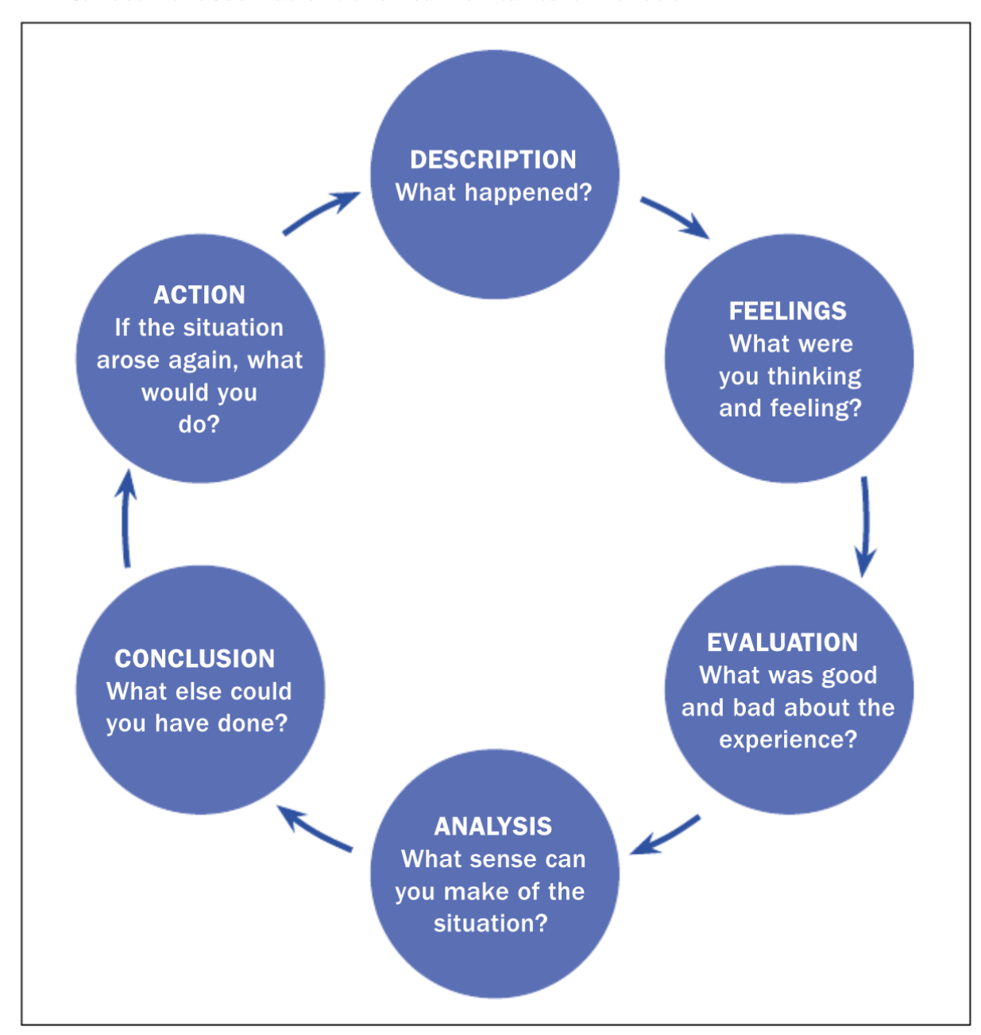
Gibbs Reflective Cycle (1988)
(Amanda Wain, 2017)
Description
I has been part of a group of 5 students with whom I spread my contributions in making assignment, for an important task for our university class. My experience with this group was the first one and, as a general fact, first one since university started.
As a first part of the task was to choose an organization for our assignment and all students from group to be able to have at least summary knowledge about chosen organization. We debate about it and in the end, we choose to design our assignment about chain grocery Tesco, one of the biggest worldwide and everyone had a positive reaction to this subject. Me being assigned to present everything about how leadership plays its role inside the organization.

Feelings
Being our first assignment together as a group we tried to be very professional from the beginning even if all of us it was at the first time working in this system obviously each of us nervous as I seen many of my colleges’ but excited and in the same time happy to give the best and to prove their strength into a group definitely as a first experience everyone was looking to understand exactly each role they have. Personally, my first feeling was that I was integrate myself very good into this group, from the first moment everyone has been considered and I think this was the main feeling for each other that we are a group that we can collaborate very decent based on our interaction as individuals.
Evaluation
I mention from before as this assignment has been a first for everyone who’s involved so I think first we should be proud of as that we did this as a group without having opportunity to work together before, but we collaborate very good, we tried to give indications to each other when we thought is necessary in order to make sure that our work it will look best as we can at the end.
For everyone from the group, I think, first was emotion as it was something new in our life, student life with live presentation and as a prove of this fact, in that day all group was got involve with hours before everything to start and we tried to discuss with each other last details, to make our presentation to each other and make last checks and last corrections before our live one. It was a first for everyone, as I mentioned, but for me pressure of this assignment was even bigger as I’m not very use to it to have speeches in public.
Analysis
I’ve been very confident in my work but like all others with feeling that I could do better which I think it’s a very positive reaction for my next assignments, to have the will to make everything better to improve even when you see that you did well. An important role as I mention earlier is to maintain contact with each other, so I think we could’ve had better results if we would’ve had opportunity for some meetings outside class and to debate more. My result in the end was that I need to develop myself more outside the task and to be more creative in my answers as a negative part and to have more confidence in work as a positive part.
Conclusion
A big help in my creation process for future, I think, is to use more authors who develop same ideas about one concept, as more you read from different authors more chances to understand more deeply about the subject and different authors could present a concept in different manners and one of it could be probably easier to acknowledge than other. As talking in public is a must I think I need for future more practice, more people around me to encourage me step by step who can be very helpful for me in building my trust in public speaking. Reading with loud voice practice also I considered as been very helpful in the past so could be a good option too because I know that I can be capable of very good answers but not feeling confident in front of public can be a turn off.
Also, as for this task in particular another thing that I felt putting pressure on me it was to do other actions at the same time to speak and to make my presentation to corelate them without practice before I found it very difficult especially that my speech was very closer to limit time. So, my speech needs to be improved as a first conclusion and, my opinion, is that only in class, I can practice it and improve my method, distributive attention second on my list so far, to try to make my speech content more clearly and objective regarding the allocated time for each speech.
My reflective conclusion about my first task is that I was able to create something based on my own research, a very hard work who end it with more positive conclusions than negative or much better to say that positive things was there, and negative things are very easy to eradicate by next assignment.

Action plan
My action plan to have an improvement attitude towards what I mention in my conclusion is to get myself involved in all next tasks to try to organize with my colleague’s meetings outside the courses and to debate it face to face in regard to observe and gather experience and to exchange more tips from each other experiences in order to improve ourselves.

References:
- https://www.researchgate.net/publication/320342913_Learning_through_reflection

Article. Learning through reflection, October 2017, British Journal of Midwifery 25(10):662-666
DOI:10.12968/bjom.2017.25.10.662. Authors: Amanda Wain. University of Nottingham.

