Exploring the difference in anxiety before and after a CBT short-course

Introduction
With a prevalence of 14% among people aged 14 to 65 over the course of a year, anxiety disorders are the most prevalent type of mental illness in Europe. Their onset typically occurs in early adulthood or childhood. Those who are impacted frequently experience additional mental or physical ailments (sequential comorbidity). Generalised anxiety disorder (GAD), phobias, panic disorders, separation anxiety and selective mutism, two conditions often confined to childhood, all fall under the term anxiety disorders. Since anxiety can also be a major symptom of other mental or physical illnesses, a thorough differential diagnostic diagnosis is crucial. The initial choices for therapeutic approaches are psychotherapy and medication therapy. The most effective psychotherapy by far has been cognitive behavioural therapy (Ströhle et al., 2018).
One of the most prevalent anxiety disorders is panic disorder, with lifetime prevalence rates in the general population estimated to range between 2.1-4.7%. Since panic disorder is frequently accompanied by a chronic progression that causes financial stress and a loss of quality of life, it is crucial to avoid and treat it properly (Kim, 2019).
Panic disorder is characterised by recurrent, unexpected panic attacks with symptoms such as tachycardia, dizziness, chest pain, and fear of recurring attacks or behavioural changes. The prevalence of panic disorder in pre-adolescent children (ages under twelve) is less than 0.5%. An estimated 1 to 3% of adolescents experience panic disorder, which usually begins between the ages of 15 and 19. Among girls (1.7%) and boys (0.5%), panic disorder typically co-occurs with other anxiety disorders, particularly agoraphobia (Baker et al., 2022).
Cognitive behavioural therapy (CBT) is an intervention that maintains mental disorders and psychological distress by targeting cognitive factors. Developed by Beck (1970) and Ellis (1962), this approach hypothesizes that maladaptive cognition perpetuates emotional distress and behavioural problems. In Beck's model, maladaptive cognition includes general beliefs or schemas about the world, oneself, and the future that evoke specific automatic thoughts. In this model, therapeutic strategies are used to change these maladaptive cognitions in order to reduce emotional distress and change problematic behaviour (Hoffmann et al., 2012).
The efficacy and effectiveness of CBT for anxiety disorders are well established in both randomized placebo-controlled trials and naturalistic settings. A Cochrane review of psychotherapy for several anxiety disorders further supports the positive effects of CBT. (Otte, 2011). In 27 randomized, placebo-controlled trials involving 1,496 patients, controlled effect sizes ranging from 0.35 (small effect) for panic disorder to 1.37 (large effect) for obsessive-compulsive disorder showed that CBT was superior to all shown to be more effective than placebo for anxiety disorders. A quantitative literature review of studies conducted in randomized, placebo-controlled trials and naturopathic settings has demonstrated the efficacy and effectiveness of CBT as an acute intervention for adult anxiety disorders, despite some limitations of the original studies. Nonetheless, the findings also imply that there is still a lot of potential for the study and analytic methodologies to be improved. Hence, it is now difficult to assess the actual size of the effect. However, the meta-analyses show that CBT is by far the psychotherapy approach for treating anxiety disorders that has the most consistent empirical backing. As a result, CBT can be suggested as the gold standard for individuals with anxiety disorders who are receiving psychotherapeutic treatment (Otte, 2011).
It is hypothesised that levels of self-reported anxiety will be significantly lower following the completion of a six-week CBT short course.

Method
Participants
The number of participants that took part in the study (plus any information about how many were males/females if applicable). Range of ages of participants and the mean and SD of age. Demographic information of participants for your report: Twenty-four participants in total; 11 males and 13 females Range of ages 19-63. M = 27.93, SD = 11.24 Seven of the 24 participants had been clinically diagnosed with an anxiety disorder while the other 17 had not.

Design
The design = within-subjects; all participants completed the Anxiety Symptoms Questionnaire (ASQ) before and after taking part in a six-week CBT short-course. The independent variable was the completion of the ASQ (before and after the CBT course) and the dependent variable was the intensity of anxiety symptoms reported. The test used to analyse data will be the Wilcoxon Signed Ranks Test.

Materials
The Anxiety Symptoms Questionnaire (ASQ; Baker et al., 2019) was used to collect data on participants self-reported intensity of anxiety symptoms. The full questionnaire aims to assess both intensity and frequency of symptoms however, for the purpose of this study, only intensity data was used within the analysis.
There were 17 questions on the Anxiety Symptoms Questionnaire (ASQ). At the start of the questionnaire, there were clear instructions. The scale for scoring each question was 0-10. Fatigue or Lack of Energy is an example of a question from ASQ. The overall intensity scores might vary from a minimum of 0 to a maximum of 170. The higher score represent. extreme distress.

Procedure

A volunteer sample of members of the public were notified of the research study via a study advertisement poster placed within a self-help group for individuals experiencing symptoms of anxiety. Interested participants were prompted to contact the lead researcher to receive further information about the requirements of the study. Full study information was sent via email to each interested participant. Participants were informed that they would be required to take part in a six-week short-course of CBT aimed at helping them manage their anxiety symptoms, and that they would be asked to complete a short anxiety questionnaire before and after taking part in the CBT course. On the first day of their CBT sessions, each participant completed the ASQ to assess the intensity of their anxiety symptoms prior to taking part in the course. Following the completion of the final session after the six-week period, participants were again asked to complete the ASQ. Participants were thanked for their participation and provided with the opportunity to ask questions. A debrief form was provided outlining the aims of the study.

Results
A Wilcoxon Signed Ranks Test was conducted to determine whether the intensity of anxiety symptoms reported by participants reduced following the completion of a six-week short course of CBT. The value of W was calculated as the smaller of W+ and W-, and therefore W was equal to 81.5. The critical value of W as indicated by the critical values table for 24 participants was 91, and so it has been observed that there is/is not a significant difference in participants anxiety symptom intensity. The median scores indicate that intensity of symptoms was lower following the completion of the CBT short-course (median before = 52.5 and median after = 49).

References

Baker, H.J., Hollywood, A. & Waite, P. (2022). Adolescents’ lived experience of panic disorder: an interpretative phenomenological analysis. BMC Psychol 10, 143. https://doi.org/10.1186/s40359-022-00849-x

Hofmann, S.G., Asnaani, A., Vonk, I.J., Sawyer, A.T., Fang, A. (2012). The Efficacy of Cognitive Behavioral Therapy: A Review of Meta-analyses. Cognit Ther Res. 2012 Oct 1;36(5):427-440. doi: 10.1007/s10608-012-9476-1. Epub 2012 Jul 31. PMID: 23459093; PMCID: PMC3584580.

Kim, Y.K. (2019). Panic Disorder: Current Research and Management Approaches. Psychiatry Investig. 2019 Jan;16(1):1-3. doi: 10.30773/pi.2019.01.08. Epub 2019 Jan 25. PMID: 30696237; PMCID: PMC6354045.

Otte, C. (2019). Cognitive behavioral therapy in anxiety disorders: current state of the evidence. Dialogues Clin Neurosci. 2011;13(4):413-21. doi: 10.31887/DCNS.2011.13.4/cotte. PMID: 22275847; PMCID: PMC3263389.

Ströhle, A., Gensichen, J., Domschke, K. (2018). The Diagnosis and Treatment of Anxiety Disorders. Dtsch Arztebl Int. 2018 Sep 14;155(37):611-620. doi: 10.3238/arztebl.2018.0611. PMID: 30282583; PMCID: PMC6206399.

Appendices

- Consent form
- Debrief form
- Anxiety Symptoms Questionnaire
- Wilcoxon Signed Ranks Test


Centre for Psychology and Counselling

Study Debrief Sheet
(words underlined and in italics should be changed to fit your specific study)
Exploring differences in anxiety levels pre- and post-CBT short-course.

Thank you for taking part in the study.

The aim of this study was to assess the effectiveness of a six-week short course of CBT in assisting in the reduction of anxiety symptoms. We specifically aimed to find out whether self-reported anxiety symptoms, as recorded by participants at the beginning of their first CBT session, reduced when the same questionnaire was completed for a second time following the completion of the six weeks of CBT. We expect to find that taking part in the course of CBT significantly reduces symptoms of anxiety in participants.

If you wish to withdraw your data from the study, you must tell the researcher now. After this point, all of your data will be anonymised and we will not be able to trace it back to you.

If taking part in this study has raised any questions, please speak to the researcher on put your name and student email address here or contact the academic supervisor insert supervisor contact here, name and email.

Thank you once again for taking time to participate in this study.

Put your name here

Put your programme of study here
(BSc Applied Psychology, or BSc Psychology, or BSc Psychology and Counselling)

University of Wales Trinity Saint David
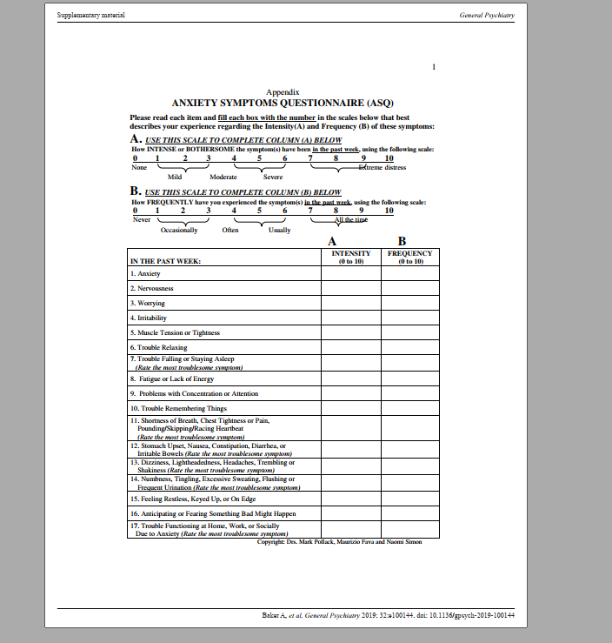

Report 1 Data: Wilcoxon Signed Ranks Test

P | Anxiety BEFORE CBT | Anxiety AFTER CBT | Difference | Order | Rank | Sign
1 | 100 | 80 | 20 | -1 | 3 | -3
2 | 56 | 46 | 10 | -1 | 3 | -3
3 | 111 | 110 | 1 | 1 | 3 | 3
4 | 80 | 84 | -4 | 1 | 3 | 3
5 | 54 | 50 | 4 | 1 | 3 | 3
6 | 40 | 41 | -1 | -2 | 7 | -7
7 | 21 | 23 | -2 | -2 | 7 | -7
8 | 35 | 29 | 6 | 2 | 7 | 7
9 | 34 | 30 | 4 | 3 | 9 | 9
10 | 45 | 25 | 20 | -4 | 12.5 | -12.5
11 | 81 | 74 | 7 | -4 | 12.5 | -12.5
12 | 64 | 60 | 4 | 4 | 12.5 | 12.5
13 | 27 | 31 | -4 | 4 | 12.5 | 12.5
14 | 58 | 60 | -2 | 4 | 12.5 | 12.5
15 | 51 | 50 | 1 | 4 | 12.5 | 12.5
16 | 101 | 81 | 20 | -5 | 16 | -16
17 | 49 | 48 | 1 | 6 | 17.5 | 17.5
18 | 84 | 80 | 4 | 6 | 17.5 | 17.5
19 | 29 | 39 | -10 | 7 | 19 | 19
20 | 40 | 45 | -5 | -10 | 20.5 | -20.5
21 | 68 | 65 | 3 | 10 | 20.5 | 20.5
22 | 27 | 28 | -1 | 20 | 23 | 23
23 | 12 | 10 | 2 | 20 | 23 | 23
24 | 56 | 50 | 6 | 20 | 23 | 23

W+ =218.5
W- =81.5

So W = -81.5
Critical value W =91

