
Applied Leadership and Management in the Workplace
Module Assignment Submission
Student Name: | Helen Grandin
Student Number: | 1708671
Module Code: | BMSK5007
Module Title: | Changemakers – Creativity and Value Creation – Part 2 – Reflection

Statement of Confirmation of Authenticity
By the act of making this submission, the student declares that this is the work of the student named above. The work has not, in whole or in part, been knowingly presented elsewhere for assessment, or where assessment has been built on a previous assessment, this has been identified. Where materials have been used from other sources it has been properly acknowledged. If this statement is untrue, the student acknowledges that an assessment offence has been committed.
Attention is drawn to the plagiarism and unfair practice policies of the University.

Table of Contents
Reflection 3
Description 5
Feelings 5
Action Plan 6
References 7

Reflection

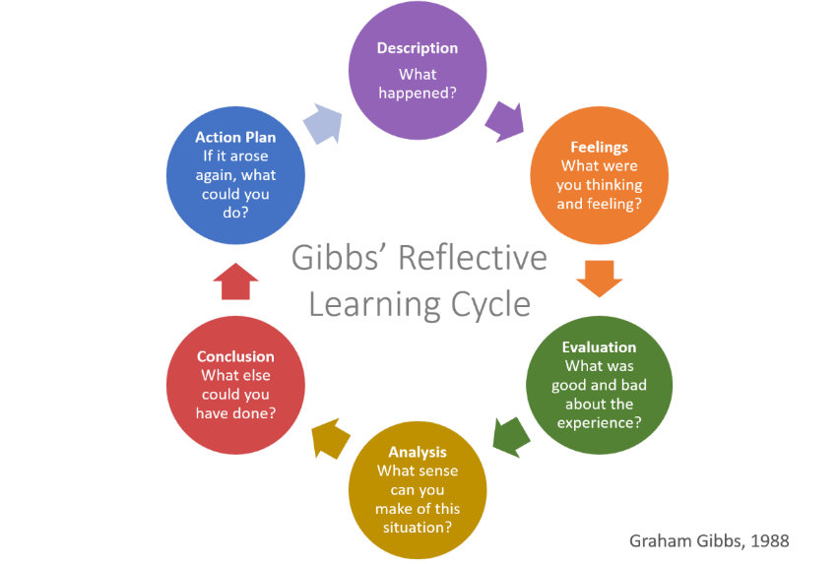

Using this approach to process an experience is a smart idea. This could be an isolated incident or something you encounter regularly, like team meetings that require cooperation. Although Gibbs first recommended using it for recurring events, the stages and concepts also hold true for one-time encounters. If you use a standalone experience, your action plan can be broader and consider how you might use the findings in the future.
A list of useful questions to ask for each level of the model. They can guide what kinds of items make sense to include at that stage, but you do not have to answer all of them.
Description - What took place? Where and when did it take place? Who was in attendance? What actions did the others, and you take? What was the situation's outcome? What brought you there? What did you wish to happen?
Feelings - What emotions did you experience at the time? How did you feel both before and after the incident? What emotions do you suppose others were experiencing in this situation? How do you believe the current situation is perceived by others? What were your thoughts at the time? How do you feel about the current situation?
Evaluation - What aspects of the encounter went well and poorly? What was successful? What didn't go as planned? What positive or bad contributions to the situation did you and others make?
Analysis - Why did everything go smoothly? Why was it not successful? How do I interpret the situation? What expertise - my own or others can assist me in understanding the situation?
Conclusion - What did this experience teach me? How could things have turned out better for all parties involved? What abilities must I acquire to manage a circumstance like this effectively? What more was there for me to do?
Action Plan - What would I do differently if I had to do it all over again? How am I going to acquire the necessary skills? How can I ensure that the next time, I can behave differently?

Description

Doing this GAMS assignment was interesting, however, the software used to build the slides were not programmed with the read-aloud option which for me is a useful tool for retaining information and understanding the topic more clearly.
Working through the Creativity and Innovation module. I had to study the learning materials in each of the four parts that made up this module. After finishing these units, I was given an assignment that needed me to come up with an innovative way to improve customer experience that would create value. I also had to develop a poster and a two-minute elevator pitch that had to be recorded. I also had to construct a mind map to show the thoughts and concepts of how I came up with my idea.
My first step was to research whether any other cleaning companies offered additional services and whether they had the desired outcome of creating value and customer satisfaction. This was not as easy as I thought it would be, there were very few companies offering the services I had in mind and the ones that did either were reluctant to give me any information or were no longer operating. I then created a questionnaire for my current customers asking them what they thought and if would it interest them if we proceeded with the additional services. Discussions with the employees went well with all agreeing to take on some additional services.

Feelings

I had never created an e-portfolio or blog so was anxious as to how I was going to do this module plus having COVID-19 the more I thought about it the more I confused myself and I will admit I did procrastinate with it which made completing it very hard. I found it difficult to think of an idea and when I did, I realised that I was not on the right track and had to re-start from scratch flicking back through the slides to jog my memory with what I had to be doing which disheartened me even more and put it off longer. With time running out, I scrambled to get something down. I could have done better if I had given myself more time and did not procrastinate.
Creating the promotional video was nerve-racking as I do not have much confidence in talking to or for an audience even if they are not in the same room. I knew exactly what I had to say but had to keep retaking as I kept making mistakes which was frustrating. I added my notes to each slide to help me remember where I was which helped complete the video. I enjoyed designing the poster and slide backgrounds.
On discovering that some companies were no longer operating I felt anxious but not deterred.
The results of the questionnaire gave me hope that it could work, and I was willing to take the risk.

I could have achieved a lot more with this assignment if I had implemented a study plan and stayed focused. Also, I should have asked questions and done more research on how to create an e-portfolio and blog as this would have enabled me to create a more presentable piece of work in the correct format. I also need to work on my presenting and skills and find ways to help which works for me. Even though I added my notes to the slides I got distracted when I had to click to change slides, so I need to increase my confidence in navigating the PowerPoint software as I do not use it regularly.
Overall, it was a good experience that pushed me out of my comfort zone. I have learned I need to apply myself more and not allow myself to become distracted, keep focused and ask questions when I am not sure about certain things instead of trying to make sense of it myself and getting confused.

Action Plan

If I were to do this assignment again I would.
- Ask more questions when I do not understand something.
- Do more in-depth research to get a better idea of what needs to be done.
- Put information into my assignment after each class while it is still fresh in my mind, even if it is not correctly set out.
- Dedicate at least two days per week for university work/study days.
- Do not allow myself to get distracted during study days.
- Create a to-do list for each day and complete it.

References

Gibbs’ reflective cycle. The University of Edinburgh. (1970, November 11). https://www.ed.ac.uk/reflection/reflectors-toolkit/reflecting-on-experience/gibbs-reflective-cycle

