

BMDM7006
Evidence Portfolio

Student name: | Jiajun Hong | Student ID number: | 1806581
Programme: | DBA
Module: | Resilience, Talent and Technology
Module code: | BMDM7006 | Contribution to Overall Module Assessment (%): | 50%
Lecturer: | Julie Hayward | Internal Verifier: | Gareth Hughes

Content
About Netflix………………………………………………………………………….1
Entry 1 PESTEL Analysis of Netflix and How External Factors Affecting Its Talent Attraction………………….…………………………………………2
Appendix 1 References……………………………………………………………….5
Appendix 2 PESTEL Table of Netflix…………………………………………….....10
Entry 2 Labor Market Trends in the US and Japan Facing Netflix…………....13
Entry 3 How Technology Impact HRP in Netflix 19
Entry 4 An Executive Summary Style Overview on HRM Policy of Netflix Japan 21
Entry 5 Presentation 27
Entry 6 Analysis of Atkinson’s Flexible Firm Model in the Open Talent Economy and Its Implication for Netflix 30
Entry 7 Organizational Resilience Model Concerning Human Resources Factors 36

About Netflix
Netflix，the silicon tech giant and undisputed market leader in providing streaming media services featuring its original content, operating at more than 190 countries, with more than 151 million paying subscribers worldwide by the Q2 2019 (Watson, 2019), is chosen as the organization to be discussed in this portfolio.

Task 1
PESTLE Analysis of Netflix and How External Factors Affecting Its Talent Attraction

PESTEL framework (CIPD, 2019; Sammut-Bonnici and Galea, 2015) will be used to analyze Political, Economic, Sociological, Technological, Legal and Environmental factors facing Netflix, as listed in the PESTEL analysis table in appendix 2. The following paragraphs will only deal with part of those factors due to the word limitation.
Political factors
The US new tax law lowers the tax rate from 35 percent to 21 percent and provides more legal tax breaks, which increases company profits and drives investment and growth (Megan Cerullo, 2019). According to Marks (2019), although Netflix made the biggest ever profit in 2018, it paid no US taxes using tax credit policy. That means more cash bullet for the company’s talent desire to strengthen its reputation of paying the top in the market (Crawshaw, Budhwar and Davis, 2017).
Remuneration, will strengthen the company’s employee value proposition (Armstrong & Taylor, 2014) and acts as a huge attraction to the targeted talent and help Netflix expand its talent pool to always hire “A” players (McCord, 2014).
Economic factors
(1) The strong dollar narrows company’s profit margin than expected since most of its cost in overseas market are dollar-denominated (Reuters,2018).
(2) The rapidly rising competitors, like Walt Disney who is taking its content away from Netflix and build its own streaming website and Amazon prime video that has expanded to more than 200 countries.
Less profit means less remuneration. Diverse players in the market means a top talent war, the loss of the unique working experience, and challenge to the company’s leading role. These weaken its employer brand (Walker, 2007).
Sociological factors
(1) A “cord-cutting” trend. A variety of viewing options provided by online video have made those expensive satellite or cable TV less attractive. Younger viewers (aged between18-34) are 27% less likely to watch traditional TV (Bradshaw & Bond, 2017).
(2) Half of the workforce will be Millennials soon. They are socially conscious and put more attention to company’s CSR practices and work-life balance (Cone Communications, 2016).
(3) It ranked the second place of the top employers in the world according to a survey with 3800 tech workers (Hired Report, 2019)
Netflix takes employees as “fully formed adults”. That meets the younger generation’s needs. Its bright future and social status also continuously strengthen its employer brand.
Technological factors
(1) Cisco predicts that by 2022 the internet users will account for 60 percent of the world population and Video will account for 82% of all IP traffic, with more than 28.5 billion networked devices and connections and more than doubled mobile speeds (Cisco, 2018).
(2) On the threshold of the fourth industrial revolution, the company meets both challenges and benefits in the digital trend. For example, recruitment will be greatly influenced by AI and bigdata.
As technology advances, and with advancing internet infrastructures, the streaming industry will keep growing and attract more resources pouring into it, including its power to attract more talent into this industry. Netflix will no doubt be benefited from this prospect.
On the other hand, new technology within this open talent economy (Deloitte, 2013) provides Netflix with a worldwide talent pool and a real two-way selection between the company and the potential employees.
Environmental factors
Netflix brings huge pressure to the environment because of its huge data transfer backed by huge amount of necessary infrastructure (Cwienk,2019), therefore, it ranked D for green energy use (Greenpeace report, 2017). It kept taking actions to reduce its negative environment impact operate with sustainable strategy that it ranked 11 in the EPA’s Green Power Top 30 Tech and Telecom (EPA, 2018). Considering the fact that more and more Millennials put corporate social responsibility to a historical high level (Cone Communications, 2016), that will help attract the talent as an employer of choice as a brand with Corporate social responsibility (CSR).

Appendix 1 References
Armstrong, M., & Taylor, S. (2014). Armstrong’s Handbook of Human Resource Management Practice. Kogan Page: London
Bienkov, A. (2019). Trump will be blamed for a global recession if he continues his trade war with China, says Boris Johnson. Available at:
https://www.businessinsider.com/boris-johnson-donald-trump-trade-war-china-global-recession-g7-2019-8?r=US&IR=T (Accessed: 15th October 2019)
Burchard, H. (2019). Europe braces for Trump trade war. Available at:
https://www.politico.eu/article/europe-braces-for-trump-trade-war/ (Accessed: 16th October 2019)
Bartash, J. (2018). Repatriated profits total $465 billion after Trump tax cuts - leaving $2.5 trillion overseas. Available at: https://www.marketwatch.com/
story/repatriated-profits-total-nearly-500-billion-after-trump-tax-cuts-2018- 09-19 (Accessed: 16th October 2019)
Bui, Q and Russell K, (2019). How Much Will the Trade War Cost You by the End of the Year? Available at: https://www.nytimes.com/interactive/2019/
business/economy/trade-war-costs.html (Accessed: 16th October 2019)
Bradshaw, T., and Bond, S. (2017) Netflix looks to become world's entertainer as it hits milestone. Financial Times. Available at: https://www.ft.com/
content/06b55bb8-6d0c-11e7-bfeb-33fe0c5b7eaa (Accessed: 16th October 2019)
Cerullo, M. (2019). 60 of America's biggest companies paid no federal income tax in 2018. Available at:
https://www.cbsnews.com/news/2018-taxes-some-of-americas-biggest
-companies-paid-little-to-no-federal-income-tax-last-year/ (Accessed: 16th October 2019)
Cisco (2018. Cisco Predicts More IP Traffic in the Next Five Years Than in the History of the Internet. Available at: https://newsroom.cisco.com/press-
release-content?type=webcontent&articleId=1955935 (Accessed: 16th October 2019)
Cone Communications (2016). 2016 Cone Communications Millennial Employee Engagement Study. Available at:
http://static1.squarespace.com/static/56b4a7472b8dde3df5b7013f/t/5819 e8b303596e3016ca0d9c/1478092981243/2016+Cone+Communications+Millennial+Employee+Engagement+Study_Press+Release+and+Fact+Sheet.pdf (Accessed: 16th October 2019)
Crawshaw, J., Budhwar，P. and Davis, A.(2017). Human Resource Management. Sage: London
Cwienk, J. (2019). Is Netflix bad for the environment? How streaming video contributes to climate change. Available at:
https://www.dw.com/en/is-netflix-bad-for-the-environment-how-streaming-video-contributes-to-climate-change/a-49556716 (Accessed: 16th October 2019)
Dreyfuss, E. (2019). Saudi Arabia Won't Be the Last Country to Censor Netflix. Available at: https://www.wired.com/story/saudi-arabia-netflix-censorship/ (Accessed: 16th October 2019)
EPA, 2018. Green PowerTop 30 Tech and Telecom (as of July 23, 2018). Available at:
https://www.epa.gov/greenpower/green-power-partnership-top-30-tech-telecom-pdfs(Accessed: 16th October 2019)
Editorial Team (2019). Netflix might not support 8K in 2020. Available at:
http://www.8ktv.com.au/editorial/netflix-might-not-support-8k-in-2020/ (Accessed: 16th October 2019)
GUPTA, R. (2019) Three Ways the Interest Rate Cut Could Benefit Netflix. Available at: https://articles2.marketrealist.com/2019/09/three-ways-the
-interest-rate-cut-could-benefit-netflix/ (Accessed: 16th October 2019)
Greenpeace report, 2017. Clicking clean: who is winning the race to build a green internet? Available at: http://www.clickclean.org/usa/en/ (Accessed: 10th October 2019)
Hired Report, 2019. 2019 Global Brand Health Report. Available at:
https://hired.com/page/brand-health-report (Accessed: 16th October 2019)
International Monetary Fund, 2019. World Economic Outlook (April 2019). Available at: https://www.imf.org/external/datamapper/LUR@WEO/
OEMDC/ADVEC/WEOWORLD/USA (Accessed: 16th October 2019)
Maddaus, G. (2019). Fox Scores Big Win in Netflix Poaching Suit. Available at:
https://variety.com/2019/biz/news/fox-win-netflix-poaching-suit-12032342 15/ (Accessed: 16th October 2019)
McCord, P. (2014). How Netflix Reinvented HR. Harvard Business Review., JANUARY–FEBRUARY 2014 ISSUE. Available at:
https://hbr.org/2014/01/how-netflix-reinvented-hr (Accessed: 15th October 2019).
Prete. R. and Goth. B, (2019). Netflix, Others Push States to Decide on Taxing Their Services. Available at:
https://news.bloombergtax.com/daily-tax-report-state/netflix-others-push- states-to-decide-on-taxing-their-services (Accessed: 16th October 2019)
Reuters (2018). Factbox: Strong U.S. dollar hurts U.S. firms across multiple industries. Available at: https://www.reuters.com/article/us-usa-companies-
currency-factbox/factbox-strong-u-s-dollar-hurts-u-s-firms-across-multiple-industries-idUSKBN1KE2BH (Accessed: 16th October 2019)
Sozzi, B. (2019). How Trump's trade wars could hammer Netflix. Available at:
https://finance.yahoo.com/news/how-trumps-trade-war-could-hammer-net flix-160034721.html (Accessed: 15th October 2019).
Spangler, T. (2016) Netflix User Sues Over Rate Hike, Claiming Breach of Contract. Variety. Available at: http://variety.com/2016/digital/news/netflix
-user-lawsuit-class-action-rate-hike-1201807561/ (Accessed: 10th October 2019)
Stenovec, T. (2016). Netflix may have to censor some of its content for other countries. Available at:
https://www.businessinsider.com/netflix-may-have-to
-censor-its-content-2016-1?r=US&IR=T (Accessed: 16th October 2019)
Taxamo (2019). Digital tax trends: International plans to tax the digital economy. Available at:
https://blog.taxamo.com/insights/international-digital-tax-trends (Accessed: 16th October 2019)
The Guardian (2019). The tech giants won’t like it, but a digital tax must become a reality. Available at:
https://www.theguardian.com/business/2019/feb/03/tech-giants- facebook
-oecd-digital-tax-must-become-reality (Accessed: 16th October 2019)
Watson, A. (2019) Number of Netflix paying streaming subscribers worldwide from 3rd quarter 2011 to 2nd quarter 2019 (in millions). Available at:
https://www.statista.com/statistics/250934/quarterly-number-of-netflix-streaming-subscribers-worldwide/ (Accessed: 16th October 2019)
WEF report, 2018). The Global Competitiveness Report 2018. Available at:
http://www3.weforum.org/docs/GCR2018/05FullReport/TheGlobalCompet itivenessReport2018.pdf (Accessed: 16th October 2019)

Appendix 2: PESTEL Table of Netflix
 | External factors to consider | Factors affected within the company
Political | Government policy  Political stability | It cannot conduct business in Syria, Crimea and North Korea because of US government restriction that prohibited all American companies to conduct business in these places.  It is not able to enter mainland China, one of the biggest economies. Chinese government prohibits video services from foreign companies. But now Netflix has a chance to break into mainland China as the innovation measures launched in August, 2019 by Beijing city which allows foreign companies to setup online audio-visual programs on the premise of satisfying content supervision and data security.  There are also specific censorship problems in different countries.
Political | Government policy  Political stability | The confrontation with foreign countries will continue as Trump believes that will get him votes.
Political | Tax | A dangerous new trend that the governments around the world is targeting Netflix for tax as the company enjoys a rapid expansion worldwide.  The new tax law lowers the tax rate from 35 percent to 21 percent and provides more legal tax breaks, which increases company profits and drives investment and growth.
Political | Global trade agreements or restrictions | Boris Johnson said to President Trump that the trade war would be blamed for the global economic slowdown.  The Trade war with China and Trump’s confrontation with other countries increased the uncertainty of the risk asset market. Raising debt will be more expensive for Netflix, especially when it is addicted to and indulged in burning money to support its aggressive expansion globally.  The tit-for-tat waves of tariffs between the US and China has dragged down the world economy and will cost average American households at about $460 this year, a threat for the subscriber loss.  And there is a dangerous trend that the governments around the world is targeting Netflix for more tax. All these uncertainties overshadow the ability for profit and future growth which will threaten its power to lead in the industry and thus weaken its ability to attract the top-level talent.
Economic | Exchange rates | Though the company enjoys a rapid expansion and large growth in overseas market, strong dollar narrows company’s profit margin than expected since most of its cost are dollar-denominated
Economic | Economic growth/decline  &Interest rates  &unemployment rate  & Consumer spending habits | As the world’s most competitive economy, American has unparalleled ability to attract the top talent worldwide.  Strong dollar enhances the confidence of overseas investors. As optimistic expectation, $4 trillion will be repatriated and generate more investment and jobs in the U.S.  The US unemployment rate is 3.5%, almost a history low point.  The interest rate cut by the European central bank and the federal Reserve means cheaper loans for both the company and the customer.  The good economic situation and full employment stimulates spending on the entertaining giant, which will boost its growth.
Economic | Competitors | Other streaming sites are emerging. They’re taking content away from Netflix, for example, the Walt Disney Company will launch their own streaming service. It announced it would not be renewing its contract with Netflix that started in 2016. The deal elapsing will see some massive Disney titles leave Netflix as well as titles from the Marvel and Star Wars lineup, this force Netflix to create more original movies and television shows to stay relevant. Other competitors, such as Amazon Prime, which has expanded its service to more than 200 countries, are all challenging Netflix’s leading role in the market.
Social | Consumer trends/tastes | The competition between traditional TV and online video has entered a new phase. A variety of viewing options provided by online video have made those expensive satellite or cable TV less attractive and the market has witnessed a “cord-cutting” trend.
Social | Consumer buying habits  Population demographics Lifestyle factors | Nielsen research shows that younger viewers tend to entertain using smartphones and internet-connected devices. Those aged between 18 to 34 are 27% less likely to watch traditional TV than those aged 35 and older.  Half of the workforce will be Millennials soon. They are socially conscious and put more attention to company’s corporate social responsibility practices and take that as an important factor when finding a job.
Social | Good social image | It ranked the second place of the top employers in the world according to a survey with 3800 tech workers.
Technology | Innovation | As an emerging technology, 8K resolution is four times better than 4K and provides a sharper watching experience. Netflix thinks it is HDR, not 8K, is the future. And 8K might not be supported in 2020.  Cisco predicts that by 2022 the internet users will account for 60 percent of the world population and Video will account for 82% of all IP traffic, with more than 28.5 billion networked devices and connections and more than doubled mobile speeds.  The world is on the threshold of the fourth industrial revolution. AI, robotics, bigdata are contributing to the great changes. The company meets both challenges and benefits in the digital trend.
Legal | Employment law  Common law | It has to face a variety of lawsuits that challenge the company’s reputation and profit. Such as a consumer lawsuit rising from a rate hike which lead to widespread criticism, poaching suit with Fox, shareholder lawsuit.
Legal | Employment law  Common law | Operating worldwide increases the difficulty to abide by different laws in different markets
Environmental | Environmental restrictions Corporate social responsibility | The access to the streaming service bring huge pressure to the environment and climate change because of the data transfer and the huge amount of necessary infrastructure.  Netflix ranked D for green energy use in 2017 while other FAANG group members get A.  Netflix ranked in the EPA’s Green Power Top 30 Tech and Telecom and was at 11.

Task 2
Labor Market Trends in the US and Japan Facing Netflix

In this task, a comparison and contrast of labor market trends in the US and Japan will be conducted, including the analysis of impacts those trends have on the chosen organization. Related statistics are retrieved from the latest websites of the US Bureau of Labor Statistics, the World Bank, and Trading Economics.
Similarities of the two markets
1. The US and Japan labor markets are both tight labor markets
Both countries hit a historical low unemployment rate, with the US at 3.5% and Japan at 2.2%. Job openings is much higher than hires in the US which shows a critical skill shortage in its labor market, while Japan has the same situation with unemployed persons going down to a lowest point.
Impact: Facing the tight labor market, organizations have to put more resources in attracting and retaining employees (Taylor, 2010). Netflix has developed an appealing employer brand (Armstrong & Taylor, 2014) and HR practices focusing on “A” players and unique corporate culture of “working with adults” (McCord, 2014).
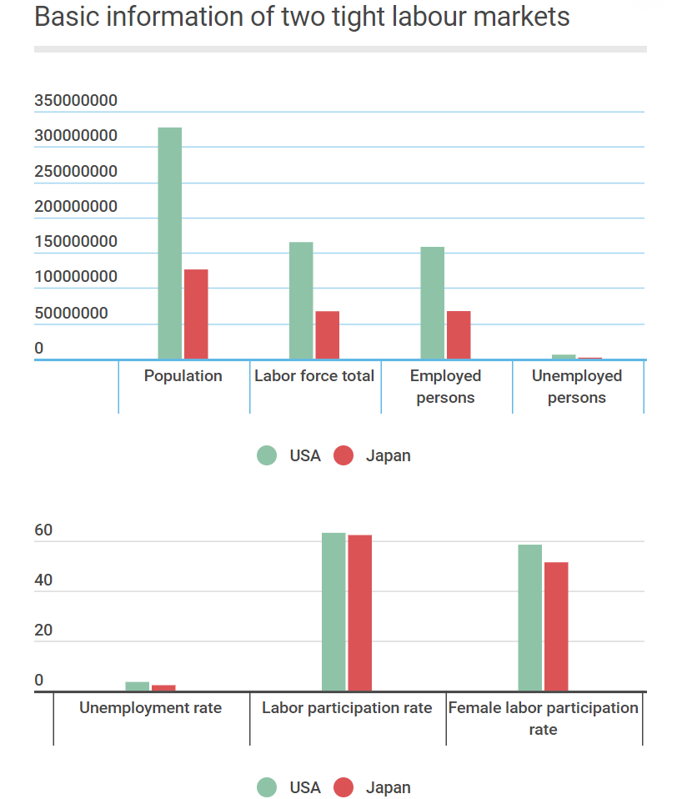
2. Aging population and more balanced and diverse workforces
Due to the fast aging speed of the population, both countries are expected to have a drop in the working population. One result is the high labor participation rate and more diverse workforces. In the US, the unemployment gap between gender and race has been shrunk to a record low. In Japan, female participation rate keeps increasing and policies are carried out to attract more oversea workers (Sieg, 2018).
Impact: Netflix embraces a diverse workforce, with 24% of its employees are Asian and 7% are Hispanic by race, 48% are women and 52% are man by gender (Watson, 2019).
3. A trend of flexible employment. Deloitte report on the future of work (Bersin, 2017) mentions that 41% of US workforce will take part in crowd or gig economy. Japan also witnesses an increasing number of part time employment, from about 6,000,000 in 2010 to 7,532,000 in 2018, with a 25% increase.
Impact: The open talent economy (Deloitte, 2013) environment helps Netflix to employ flexibly. It is estimated that Netflix employed about 600 temporaries in 2017 (Watson, 2019). The company will continue be benefited from this trend to attract more talents all over the world with different forms of employment thus to achieve the flexibility and adaptability.
Differences between the two markets
The US market enjoys a much more robust and sustainable workforce than Japan. Though the two countries both face the aging issue, but Japan has a much worse situation which reflects in three aspects.
First, the total population of Japan continues with the downward trend since 2010. Together with its lowest birth rate (1.43) and the fact that more than 27% of its population are those above 65 years old, the workforce of Japan possibly will drop 20% in 2040 (Nikkei Asian Review, 2019). The population of the US has been increasing all these years and is anticipated to increase at 0.5% every year in the 2018-2028 projection by BLS.
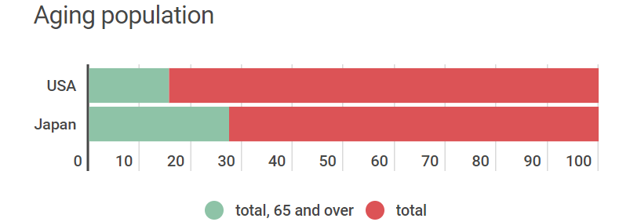
Second, the US has the strongest ability in attracting immigrations and talents. According to 2018 Elcano Global Presence Report, it tops the ranking with a point three times higher than the second China (OLIVIÉ and GRACIA, 2018). The US has the largest AI talent pool, with about 50% of the top talent, followed by China at 11%, and Japan ranks at six at 3.6% (Hiramoto, 2019), which shows a less competitive AI workforce in Japan.
Third, wages in the US shows an upward trend. It increased 5.34% year-on-year in August of 2019 while Japan recorded a 0.2% fall. Compared with the leading pay level in the US which appeals to the international market (Taylor, 2010), payroll in Japan is less competitive to attract and retain talent.
Impact: Netflix has to face a more unfriendly labor market in Japan than in the US.

Note: this work skips some other important trends which are influenced by technology, culture, and new generation due to the word limitation.

References
Armstrong, M., & Taylor, S. (2014). Armstrong’s Handbook of Human Resource Management Practice. Kogan Page: London
Bersin, J. (2017). Future of Work: The People Imperative. Available at:
https://www2.deloitte.com/content/dam/Deloitte/il/Documents/human-capi tal/HR_and_Business_Perspectives_on_The%20Future_of_Work.pdf (Accessed: 24th October 2019).
Bureau of Labor Statistics (2019). Employment Projections. Available at: https://www.bls.gov/emp/tables/civilian-labor-force-summary.htm#
(Accessed: 24th October 2019).
Bureau of Labor Statistics (2019). Employment Situation. Available at:
https://www.bls.gov/news.release/empsit.toc.htm (Accessed: 24th October 2019).
Deloitte (2013). The open talent economy: People and work in a borderless workplace. Available at: https://www2.deloitte.com/content/dam/Deloitte
/global/Documents/HumanCapital/dttl-hc-english-opentalenteconomy.pdf
(Accessed: 24th October 2019).
Hiramoto, N. (2019). Asia's AI talent pool broadens, except in Japan. Available at: https://asia.nikkei.com/Business/Technology/Asia-s-AI
-talent-pool-broadens-except-in-Japan (Accessed: 25th October 2019).
McCord, P. (2014). How Netflix Reinvented HR. Harvard Business Review. Available at: https://hbr.org/2014/01/how-netflix-reinvented-hr (Accessed: 15th October 2019).
Nikkei Asian Review (2019). Japan’s workforce expected to drop 20% by 2040 unless economy grows. Available at:
https://asia.nikkei.com/Economy/Japan-s-workforce-expected-to-drop-20-by-2040-unless-economy-grows(Accessed: 25th October 2019).
OLIVIÉ I. and GRACIA M., (2018). 2018 Elcano Global Presence Report. Available at: http://www.realinstitutoelcano.org/wps/wcm/connect/
897b80cc-47fa-4130-9c3d-24e16c7f0a66/Global_Presence_2018.pdf?MOD=AJPERES&CACHEID=897b80cc-47fa-4130-9c3d-24e16c7f0a66 (Accessed:25th October 2019).
Sieg，L., (2018). How to address Japan's shrinking labour force. Available at: https://www.weforum.org/agenda/2018/11/japan-aims-to-open-door-wider-to-blue-collar-workers/(Accessed: 25th October 2019).
Taylor, S. (2010). Resourcing and Talent Management. 5th Edition. CIPD: London
The World Bank (2019). Data for Japan and United States. Available at: https://data.worldbank.org/?locations=JP-US. (Accessed: 25th October 2019).
Trading Economics (2019). Japan - Economic Indicators. Available at: https://tradingeconomics.com/japan/indicators. (Accessed: 25th October 2019).
Watson, A., (2019). Netflix: employee count 2018. Available at:
https://www.statista.com/statistics/587671/netflix-employees/(Accessed: 25th October 2019).

Task 3
How Technology impact HRP in Netflix

The Link of the Recording:
https://uowtsd-my.sharepoint.com/:u:/g/personal/1806581_student_uwtsd_ac_uk/EcldE56uAq1KnznzZQFwWp4BriPMCvTwhfNdZvFAAZr8vQ?e=e8m03c

Reference
Armstrong, M., & Taylor, S. (2014). Armstrong’s Handbook of Human Resource Management Practice. Kogan Page: London
Bersin, J. (2017). Future of Work: The People Imperative. Available at:
https://www2.deloitte.com/content/dam/Deloitte/il/Documents/human-capi tal/HR_and_Business_Perspectives_on_The%20Future_of_Work.pdf (Accessed: 24th October 2019).
CIPD (2010a). Workforce Planning: Right people, right time, right skills. London: CIPD
Deloitte (2013). The open talent economy: People and work in a borderless workplace. Available at: https://www2.deloitte.com/content/dam/Deloitte
/global/Documents/HumanCapital/dttl-hc-english-opentalenteconomy.pdf
(Accessed: 24th October 2019).
Keating, G. (2012). Netflixed: The Epic Battle for America’s Eyeballs. Portfolio: NY
McCord, P. (2014). How Netflix Reinvented HR. Harvard Business Review. Available at: https://hbr.org/2014/01/how-netflix-reinvented-hr (Accessed: 15th October 2019).
Netflix (2019). Netflix Culture. Available at: https://jobs.netflix.com/culture (Accessed: 27th October 2019).
Taylor, S. (2010). Resourcing and Talent Management. 5th Edition. CIPD: London

Task 4
An Executive Summary Style Overview on HRM Policy of Netflix Japan

People from different cultures view the world, life and work differently and thus behave differently, therefore, the effective management of different cultures is a challenge for organizations engaged in cross-cultural activities (Hofstede, 1980; Trompenaars, 1993). Concerning with the fact western MNCs’ Japanese subsidiaries suffered a high degree of conflicts (Pudelko and Tenzer, 2011) and Netflix at a disadvantage in Japan (Blaster, 2018), this report provides an analysis on why and how Netflix should tailor its HRM policy in its Japanese subsidiary.
Different Japanese economy
Sloman (2015) suggests three broad categories of economy (command or centrally planned economy, free market economy and mixed economy). Although Japan and the US are both free markets, they differ as according to Hall and Soskice (2001), Japan is categorized into CMEs (co-ordinate market economies) while the US, LMEs (liberal market economies). Tricker (2009) gives five corporate governance model, American rules-based model, the UK/commonwealth principles-based model, the continental European two-tier model, Japanese stakeholder-oriented network model, and the Asian family-based model. Hofstede and Hofstede (2005) develop four distinctive ways to solving organizational problems in different countries using power distance and uncertainty avoidance as dimensions. Japanese tend to view organizations as “pyramids of people” while Americans take organizations as “village market”.
Current labor market trends
Though both countries have something in common as to the current labor market trends, such as tight market properties, aging population and increasing impacts of technology, Japan is at the disadvantage with the worse aging situation (Nikkei Asian Review, 2019), less ability in attracting immigrations and talents worldwide (Hiramoto, 2019), especially when Netflix is facing the harsh competition with its counterparts and ranks only the third in the Japanese streaming market (Blaster, 2018).
Cultural differences in national level and HRM level
Hofstede (2001) develops the 6D Model to help distinguish national culture among countries which includes six dimensions. They are power distance index, individualism versus collectivism, masculinity versus femininity, uncertainty avoidance index, long term orientation versus short term orientation and indulgence versus restraints. Figure 1 shows the cultural differences between the US and Japan.
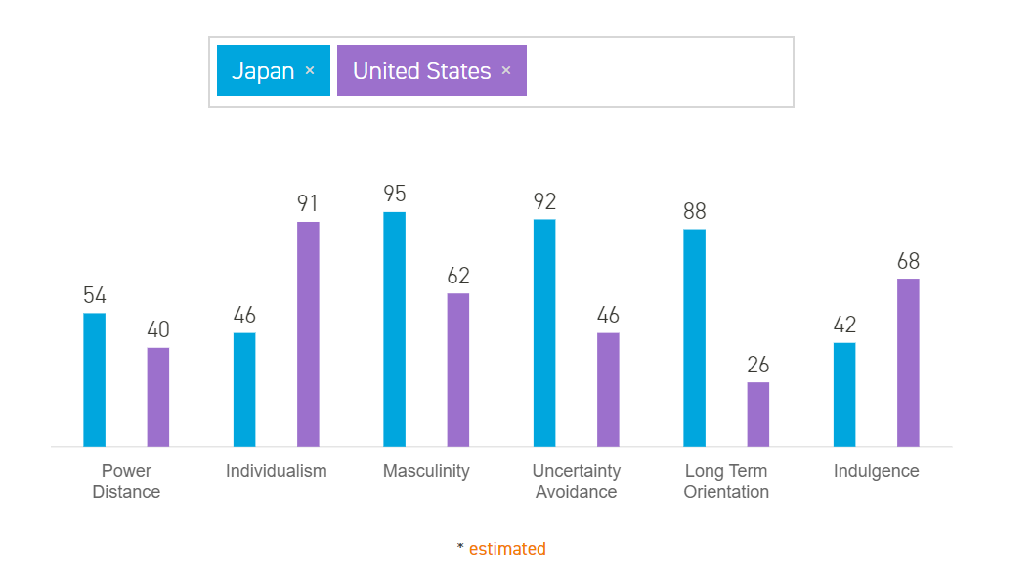
Figure 1: Country comparison between Japan and the United States.
Source: Adopted from Hofstede Insights 2019
Organization’s value is deeply affected by culture (Hofstede, 2001). National culture has an impact on HRM practices (Schuler and Rogovsky, 1998). Japanese typical HRM practices which is rooted deeply in Japanese culture are changing slowly due to global economic factors (Powell, 2017). Consensus decision-making (Bebenroth and Kanai, 2011), high employee loyalty and the lack of gender equality (Pudelko and Harzing, 2011) are still deeply ingrained HRM practices. Life employment and seniority-based wage and promotion system are still supported by the culture although they are declining and replaced more by a performance-based system. Younger generation are gaining influence and their individualistic and individualized character will gradually change the tradition (Powell, 2017).
Suggestions for HRM policies of Netflix Japan
Considering the cross-cultural management theories and the market facts, this overview provides the following specific suggestions:
1. Adopt a synergistic HRM principle (Adler, 1980) while inheriting and carrying forward the core of the Netflix culture through cultivating a real and deep cross-cultural understanding to overcome cultural barriers and avoid misunderstandings and conflicts (Berry，2002).
2. Given that Japan has high index in power distance, masculinity, uncertainty avoidance and long term orientation and its collectivism character, Netflix Japan should better localized by developing a more adapted employer brand with specific and widely accepted employee value proposition to attract and retain those key talents when at a disadvantageous situation. The HRM policy should focus on organization resilience through how to empower employees, encourage voices and innovations, promote diversity and inclusion in workplace, and prompt the effective and efficient culture integration of the work team.
3. Be more creative in operating with an expanded talent pool (Christidis et al., 2017).

References
Adler, N.J. (1980). "Cultural Synergy : The Management of Cross-Cultural Organizations" Published in W.Warner Burke and Leonard D.Goodstein (eds.), "Trends and Issues in OD : Current Theory and Practice". San Diego, California : University Associates, 1980: pp. 163-184
Bebenroth, R., and Kanai, T. (2011). Challenges of Human Resource Management in Japan. Oxford: Routledge.
Berry, J.W. (2002). Cross-cultural psychology: research and applications, 2nd ed., Cambridge: Cambridge University Press.
Blaster，M. (20180. What is Japan’s most used on-demand video streaming service? Available at: https://japantoday.com/category/entertainment/what
-is-japan%E2%80%99s-most-used-on-demand-video-streaming-service (Accessed: 28th October 2019).
Christidis, A., Kelly, S., Millier, A., and Farley, P. (2017). Delivering The Workforce For The Future. Available at:
https://www.oliverwyman.com/content/dam/oliver-wyman/v2/publications/2017/oct/Delivering%20The%20Workforce%20For%20The%20Future.pdf (Accessed: 29th October 2019).
Felfe, J. and Yan, W. (2009) "The Impact of Workgroup Commitment on Organizational Citizenship Behaviour, Absenteeism and Turnover Intention: The Case of Germany and China." Asia Pacific Business Review 15.3: 433-450. Web.
Hall, P. and Soskice, D. (2001) Varieties of Capitalism: The Institutional Foundations of Comparative Advantage, Oxford: Oxford University Press.
Hiramoto, N. (2019). Asia's AI talent pool broadens, except in Japan. Available at: https://asia.nikkei.com/Business/Technology/Asia-s-AI
-talent-pool-broadens-except-in-Japan (Accessed: 25th October 2019).
Hofstede, G. (2001). Culture’s Consequences: International Differences in Work-Related Values. Sage: London.
Hofstede, G. and Hofstede, G. J. (2005). Cultures and Organizations: Software of the Mind. New York: McGraw-Hill.
Hofstede-insights (2019). Country Comparison between Japan and the United States. Available at: https://www.hofstede-insights.com/country-
comparison/japan,the-usa/ (Accessed: 28th October 2019).
Netflix (2019). https://media.netflix.com/en/about-netflix
Nikkei Asian Review (2019). Japan’s workforce expected to drop 20% by 2040 unless economy grows. Available at:
https://asia.nikkei.com/Economy/Japan-s-workforce-expected-to-drop-20-by-2040-unless-economy-grows(Accessed: 25th October 2019).
Pudelko, M. and Tenzer, H. (2011). "Conflict in Foreign Subsidiaries of Japanese and Western Multinational Corporations: The Impact of Cultural Distance and Differences in Home-host Country Combinations." Zeitschrift Für Betriebswirtschaft 81.3: 49-71.
Pudelko, M. and Harzing, A. (2011). ‘Japanese Human Resource Management: Inspirations from Abroad and Current Trends of Change.’ In Bebenroth and Kanai, Challenges of Human Resource Management in Japan, London and New York: Routledge, pp. 28–60.
Schuler, R.S. and Rogovsky, N. (1998). Understanding Compensation Practice Variations Across Firms: The Impact of National Culture. Journal of International Business Studies, Volume 29, Issue 1, pp 159–177.
Tricker, B. (2009). Corporate Governance: Principles, Policies, and Practices. Oxford: Oxford University Press.
Task 5 Presentation

Reference
Atkinson, J. (1984) Manpower Strategies for Flexible Organisations. Personnel Management, 16, 28-31.
Businessballs. (2019). Flexible-Firm Model. Available at: https://www.
businessballs.com/organisational-culture/flexible-firm-model/ (Accessed: 7th August 2019).
Chaudhary. (2017) Technology and Digitization. A highly wired, agile and mobile workforce. The emergence of the millennial generation. These three are all rapidly changing the rules of the employment game. Available at: https://www.hcli.org/articles/tectonic-shift-house-demand-talent-transforming-consulting-world (Accessed: 5th August 2019).
Deloitte. (2013) The Open Talent Economy: People and Work in a
Borderless Workplace. Available at: http://www.deloitteblog.co.za/the-o pen-talent-economy-people-and-work-in-a-borderless-workplace/ (Accessed: 3rd August 2019).
Deloitte. (2016) 2016 Global human capital trends. Available at: https://www2.deloitte.com/us/en/insights/focus/human-capital-trends/2016.html(Accessed: 3rd August 2019).
Deloitte. (2017) 2017 Global human capital trends. https://www2.deloitte.com/us/en/insights/focus/human-capital-trends/2017.html (Accessed: 3rd August 2019).
Deloitte. (2018) 2018 Global human capital trends. Available at: https://www2.deloitte.com/us/en/insights/focus/human-capital-trends/2018.html (Accessed: 3rd August 2019).
Deloitte. (2019) 2019 Global human capital trends. Available at: https://www2.deloitte.com/us/en/insights/focus/human-capital-trends.html (Accessed: 3rd August 2019).

Juneja, (2015) Employer Branding and Talent Attraction in Open Talent

Economy. Available at: https://www.managementstudyguide.com/employer-branding-and-talent-attraction-in-open-talent-economy.htm (Accessed: 4th August 2019).
Lepak, D. P., & Snell, S. A. (2002). Examining the human resource
architecture: The relationships among human capital, employment,
and human resource configurations. Journal of management, 28(4),
517-543.
Lombardi. (2017) Harnessing the power of the open talent economy.
Available at: https://www.marginalia.online/harnessing-the-power-of-the-open-talent-economy/ (Accessed: 6th August 2019).
Nayak, D. (2019) Managing Human Resources within ‘The Open Talent Economy’. Available at: https://blog.mettl.com/talent-hub/managing-human-resources-within-the-open-talent-economy(Accessed: 5th August
2019).
Ritson, N. (2013) Strategic Management. Available at: https://my.uopeople. edu/pluginfile.php/57436/mod_book/chapter/121631/BUS5116.Ritson.Str at.Mgmt.pdf（Accessed：9 Sep. 2019）

Task 6
Analysis of Atkinson’s Flexible Firm Model in the Open Talent Economy
and Its Implication for Netflix

Flexibility has been underscored in employment system by organizations facing the rapid social and economic changes in the past twenty years (Kalleberg, 2001), with the underlying assumption that greater flexibility means the capacity for sustained competitive advantage (Taylor, 2010). Researchers have proposed different flexible labor use strategies that enable organizations to gain the flexibility they need (Atkinson, 1984; Smith, 1997; Cappelli and Neumark, 2001). Among them, Atkinson’s “flexible firm model” is highly influential both in academic and practical fields.
Atkinson’s model
The Atkinson model (Figure 1) suggests organizations breaking the traditional hierarchical structure and adopt different employment policies for different groups of employees. The core-peripheral model looks for functional, numerical and financial flexibility, consists of three layers of employees, the core, the two peripheral groups and the outsourcing layer (Atkinson, 1984).
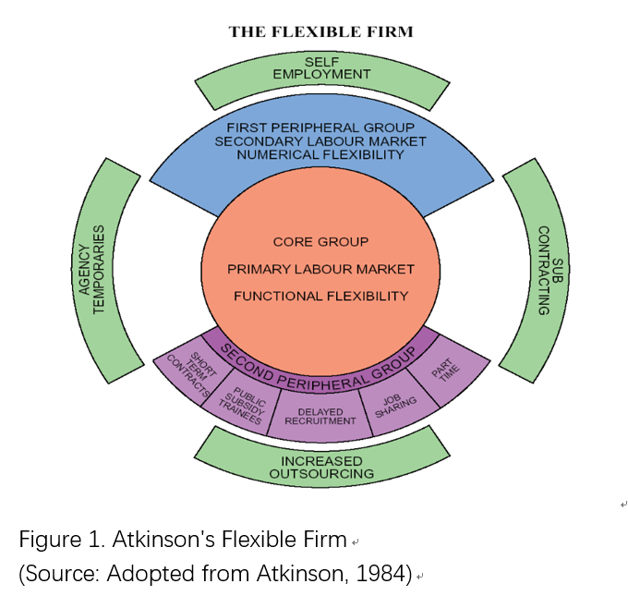
As a useful tool of description and prediction (Taylor, 2010), the model also attains flexibility in two dimensions of employment and work. On the one hand, flexible working caters to the preferences and needs of employees (DTI 2005). On the other hand, flexible working practice are more and more accepted by organizations. Take UK as an example, about 94% of organizations are adopting flexible working to some extent (ILM, 2013).
The open talent economy
Deloitte (2013) proposes the “open talent economy” which enables a business mode of collaboration, transparence, technology enabling and rapid cycling. Open talent economy is opposite to the closed economy and it allows people, capital, goods and services to flow unrestrictedly (The Economist, 2013). It is part of this rapidly changing era together with the global forces of more connected market, mobile technology, personal mobility, social media, analytics (Deloitte, 2013), the millennials and new behaviors (Morgan，2014). Featured a real two-way choice between the employer and employee and on-demand recruitment, open talent economy poses both benefits and challenges for organizations.
Reflection on the flexible firm model
It has been criticized for some reasons. The core employees are more likely to be better trained, developed, and benefited from participation in various group tasks and activities. However, peripheral employees seem to get less benefit from their work, which makes it an unfair treatment (Bryson1999), and they tend to have less commitment to the organization (Ackroyd and Procter,1998). Kallenberg (2001) argues the core-peripheral division is too simplistic, for example, some part-time workers are considered as relatively permanent.
Nowadays, the alternative workforce has become the mainstream giving the skill shortage and the low birth rate afflicting many countries (Deloitte, 2019). The number of freelancers in EU doubled between 2000 and 2014 (Morgan Stanley, 2018). Monahan and Schwartz (2018) projects that by 2020, American’s self-employed workers will be tripled to 42 million. It is not enough for organizations to change their view of talents from “business expense” to “asset” (Deloitte, 2013), but to include a strategic talent investment with a strategic management of the alternative employment forms (Deloitte, 2019).
The model which views employees as static item of the expense is obsolete in this VUCA environment with rushing trends. Millennials and the new behaviors are part of the changing power and 64% of the millennial full-time workers want to make extra money through some kind of part-time jobs (Deloitte, 2018).The skills, size and shape of the workforce for the future is also changing (Christidis et al., 2017).
Implication for Netflix
Talent investment for organizations in the diverse workforce ecosystem should focus on the clear identification of “talent vision”, “critical workforce”, “priority talent programs” and “required infrastructure” (Deloitte, 2013). Netflix should explore and develop an innovative strategy managing the extended talent ecosystem with all the critical resources it needs. By developing an appealing and distinctive employer brand, providing multiple EVPs that cater for traditional and alternative working groups, and shaping a sustainable corporate culture of diversity, inclusion, equality and trust, Netflix can strengthen its talent pipeline and gain more competitive advantages through the artistic management of the four talent pools of internal workforce, partnerships, freelance and outsourced (Christidis et al., 2017).

References
Ackroyd, S; Procter, S. (1998). British manufacturing organization and workplace relations: some attributes of the new flexible firm. British Journal of Industrial Relations, Vol. 36, No. 2, p. 163-183.
Atkinson, J. (1984). ‘Manpower strategies for flexible organizations. Personnel Management, 16: 28–31.
Cappelli, P. and Neumark, D. (2001). ‘External job churning and internal job flexibility’. Unpublished paper, Wharton School of the University of Pennsylvania.
Christidis, A., Kelly, S., Miller, A. and Farley, P. (2017). Delivering the workforce for the future. Available at:
https://www.oliverwyman.com/content/dam/oliver-wyman/v2/publications/ 2017/oct/Delivering%20The%20Workforce%20For%20The%20Future.pdf (Accessed: 2nd November 2019).
Deloitte. (2013) The Open Talent Economy: People and Work in a Borderless Workplace. Available at:
http://www.deloitteblog.co.za/the-open-talent-economy-people-and-work- in-a-borderless-workplace/ (Accessed: 2nd November 2019).
Deloitte (2018). 2018 Deloitte millennial survey: Millennials disappointed in business, unprepared for Industry 4.0. Available at:
https://www2.deloitte.com/content/dam/Deloitte/global/Documents/About-Deloitte/gx-2018-millennial-survey-report.pdf (Accessed: 2nd November 2019).
Deloitte (2019). 2019 Global human capital trends. Available at: https://www2.deloitte.com/us/en/insights/focus/human-capital-trends.html (Accessed: 2nd November 2019).
DTI (2005). Managing Change: Practical Ways to Reduce Long Hours and Reform Working Practices. London: Department of Trade and Industry, DTI/Pub 7965/1.5k/ 09/05/NP; URN 05/1421.
Economist Online Business Terms Glossary (2019). Available at: http://www.economist.com/economics-a-to-z/o#node-21529641(Accessed: 2nd November 2019).
ILM (2013). Flexible working: Goodbye nine to five. Available at:
https://www.institutelm.com/resourceLibrary/FlexibleWorking.html (Accessed: 2nd November 2019).
Jacob Morgan (2014). The Five Trends Shaping the Future of Work. Available at:
https://thefutureorganization.com/five-trends-shaping-future-work/ (Accessed: 2nd November 2019).
Monahan, K., Schwartz, J. and Schleeter, T. (2018). Decoding millennials in the gig economy: Six trends to watch in alternative work. Available at:
https://www2.deloitte.com/content/dam/insights/us/articles/4569_Decoding-millennials/DI_Decoding-millennials.pdf (Accessed: 2nd November 2019).
Morgan Stanley (2018). The gig economy goes global. Available at:
https://www.morganstanley.com/ideas/freelance-economy (Accessed: 2nd November 2019).
Smith, V. (1997). New forms of work organization. Annual Review of Sociology, 23: 315–39.

Task 7
Organizational Resilience Model Concerning Human Resources Factors

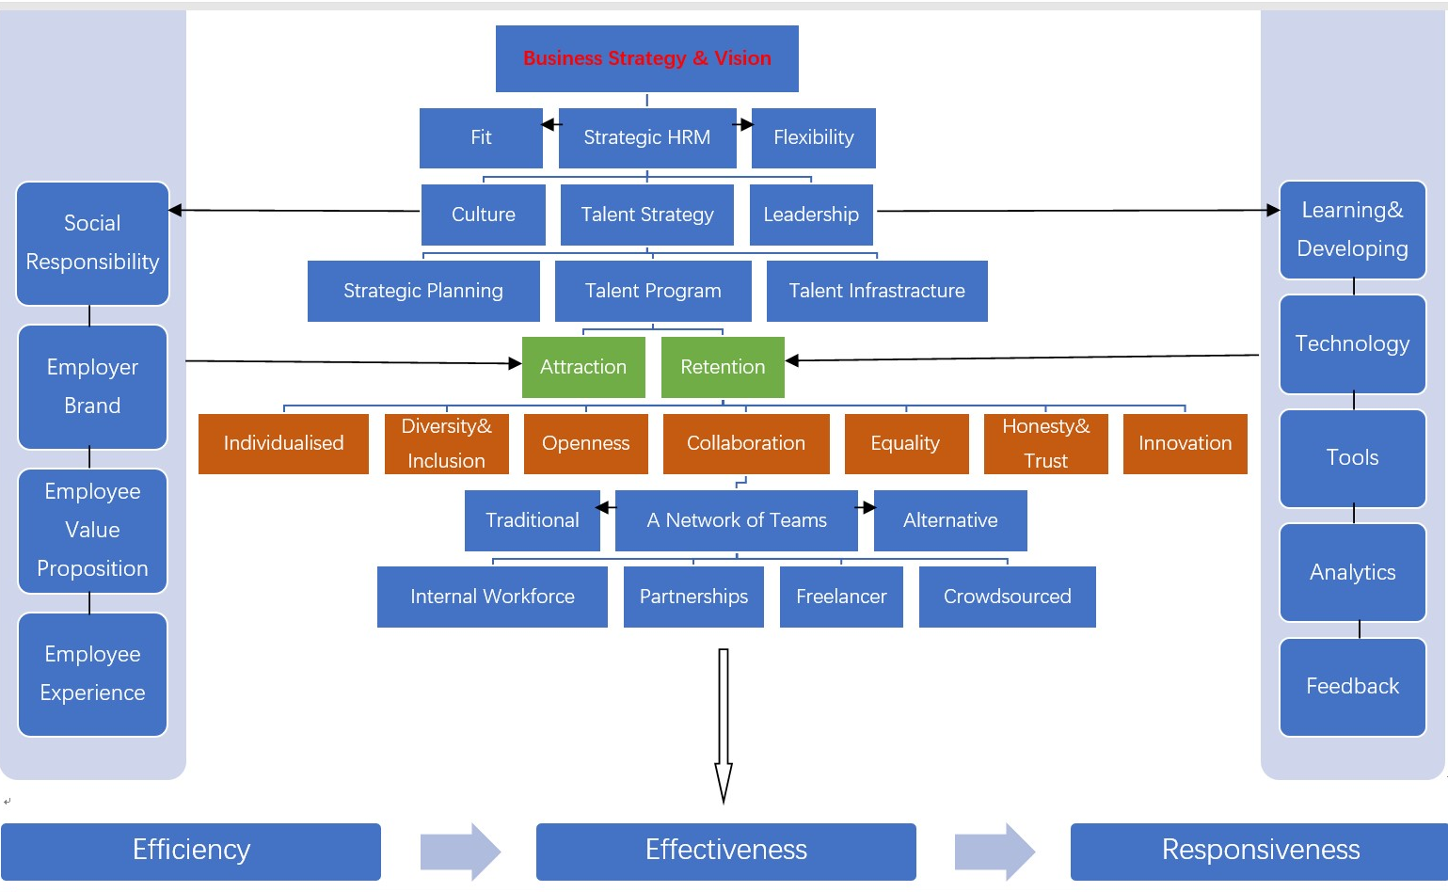

References
Atkinson, J. (1984). ‘Manpower strategies for flexible organizations. Personnel Management, 16: 28–31.
Berry, J.W. (2002). Cross-cultural psychology: research and applications, 2nd ed., Cambridge: Cambridge University Press.
Christidis, A., Kelly, S., Millier, A., and Farley, P. (2017). Delivering The Workforce For The Future. Available at:
https://www.oliverwyman.com/content/dam/oliver-wyman/v2/publications/2017/oct/Delivering%20The%20Workforce%20For%20The%20Future.pdf (Accessed: 29th October 2019).
Deloitte. (2013) The Open Talent Economy: People and Work in a Borderless Workplace. Available at:
http://www.deloitteblog.co.za/the-open-talent-economy-people-and-work- in-a-borderless-workplace/ (Accessed: 2nd November 2019).
Deloitte. (2016) 2016 Global human capital trends. Available at: https://www2.deloitte.com/us/en/insights/focus/human-capital-trends/2016.html
(Accessed: 3rd November 2019).
Deloitte. (2017) 2017 Global human capital trends. https://www2.deloitte.com/us/en/insights/focus/human-capital-trends/2017.html
(Accessed: 3rd November 2019).
Deloitte (2018). 2018 Deloitte millennial survey: Millennials disappointed in business, unprepared for Industry 4.0. Available at:
https://www2.deloitte.com/content/dam/Deloitte/global/Documents/About-Deloitte/gx-2018-millennial-survey-report.pdf (Accessed: 2nd November 2019).
Deloitte (2019). 2019 Global human capital trends. Available at: https://www2.deloitte.com/us/en/insights/focus/human-capital-trends.html (Accessed: 2nd November 2019).
Felfe, J. and Yan, W. (2009) "The Impact of Workgroup Commitment on Organizational Citizenship Behaviour, Absenteeism and Turnover Intention: The Case of Germany and China." Asia Pacific Business Review 15.3: 433-450. Web.
Hofstede, G. and Hofstede, G. J. (2005). Cultures and Organizations: Software of the Mind. New York: McGraw-Hill.
Jacob Morgan (2014). The Five Trends Shaping the Future of Work. Available at:https://thefutureorganization.com/five-trends-shaping-future-work/ (Accessed: 2nd November 2019).

Juneja, (2015) Employer Branding and Talent Attraction in Open Talent
Economy. Available at: https://www.managementstudyguide.com/employer-branding-and-talent-attraction-in-open-talent-economy.htm (Accessed: 3rd November 2019).
Lepak, D. P., & Snell, S. A. (2002). Examining the human resource
architecture: The relationships among human capital, employment,
and human resource configurations. Journal of management, 28(4),
517-543.
Schuler, R.S. and Rogovsky, N. (1998). Understanding Compensation Practice Variations Across Firms: The Impact of National Culture. Journal of International Business Studies, Volume 29, Issue 1, pp 159–177.
Tricker, B. (2009). Corporate Governance: Principles, Policies, and Practices. Oxford: Oxford University Press.

