

Christopher Scrine

BEng (Hons) Engineering Portfolio

Lvl 4 - Engineering Design

Assignment – Drill Press Main Slide Unit

Contents

Introduction Page 3
Critical Appraisal Page 4 - 5
Research Page 6 - 7
Design Specification Page 8
Manufacturing Method Page 9-10
Design Ideas Page 11
CAD Final Design Page 12
Technical Drawings Page 13
References Page 14

Introduction
I have been contacted by a machine tooling manufacturer to aid the development of a new drill press which they plan to put into production and put on the market, the manufacturer plan to produce around 1000 units per week so the design I provide must be manufacturable to that scale.
I will assess the assembly model which has been provided and design a drill press main slide for the customer and look at the process and materials which they could use to manufacture the part. I will assess different options of design and manufacture and provide my final design after evaluating drivers such as cost, ease of manufacture, start-up costs and other contributing factors.

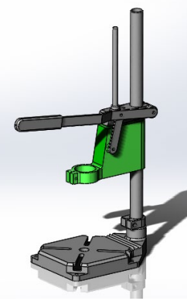

Assembly model provided by manufacturer

Critical Appraisal
To start to process I will firstly need to review the model which has been provided and assess what the customer requirements are for the part I am to design for them.
Given that the customer has stated that they intend to produce 1000 units per week I will have to ensure that the design I provide is suitable to be manufactured to that quantity and from a material and process which is readily available. 1000 units pw is a relatively high production rate so a process which could be automated would be advantageous as a labour-intensive manufacturing method would likely require increased labour and therefore increased costs. These increased costs to the manufacturer would then have be put onto the final price of the product to the customer.

After doing some quick research online at similar products the cost of a drill stand varies from around £25 for an entry level product and as much as £160 for a high-quality product. The Customer has not stated a cost requirement for the component, but I will try to provide the best solution for cost V quality. Also from researching similar products online I can see that all seem to have a similar design to the one provided, a sturdy cast iron base which will keep the stand stable due to its weight, a shaft for the DPMSU to slide up and down on a DPMSU with link arm and handle to operate the drill up and down. From looking at examples which are currently on the market I can also see that the weight of the drill stands range from 2.5kg to 5kg so the component will need to be quite lightweight.

Functionally, the component I design will have to be able to slide up and down the drill stand shaft to allow the dill attached to drill through material. Aswell as the main shaft, the DPMSU will need to be able to secure an additional guide shaft which will travel up and down when in use to keep the DPMSU square and secure. It will also be required to have attachment points for the link bars so that the DPMSU moves when the end user is operating the handle. A third requirement will be that the component will need to have a method of clamping the users drill in place when in use, the drill will need to be kept secure, so it does not move whilst user is drilling through material. The component should also be made from a material and designed in such a way that it can withstand force and not break, when user is drilling through materials forces will be applied to the component, mainly downward, so the component will need to be able to withstand these without deteriorating.

Aesthetically there are not too many considerations to make, the customer has not specified any criteria for the component’s aesthetics but after doing some research online and looking at alternative drill presses on the market they all seem to have a similar design, and none are particularly focused on the aesthetics of the product but mainly on the functionality. Even though the aesthetics on this component will not be highly contributing factor to the design I will try to make the component as aesthetically pleasing as possible i.e. rounding edges etc.

Serviceability requirements of the component will be taken into consideration. I will design the component so that it can be removed from the tool if necessary. Looking at the design and what its function is going to be I don’t believe there will be any maintenance required on the DPMSU itself but the component could become damaged with use, so I would like the component to be able to be removed in this case and replaced with a new. To do this I will use fasteners as a fixing method for the link arms to the DPMSU so that they could be removed if required. This would also be a selling point for the manufacturer as customers could then just replace a component instead of having the replace the whole unit if a failure was to occur.

Ethically I will ensure that the component will be manufactured from a recyclable material so that when the component/tool reaches its end of life that it can be recycled and not sent to landfill. With the current global climate crises that we are entering there is a strong emphasis on recycling and reduction of items going to landfill so this will be an important factor in my design.
Also, ethically I will make sure that the component I design is safe and fit for purpose. I will ensure that the component is manufactured and is a safe when both in and out of use. The part should be strong enough to withstand the forces it will be under whilst performing the drilling but also have no possible hazards whilst no in use i.e. no sharp edges.

I don’t believe there are any codes of practices I need to consider when designing the DPMSU but I should take in to consideration Health and Safety at work act 1974 and PUWER regulations to ensure that when the final product is in service it adheres to these.

Research
To gain a better understanding of the current options on the market and understand what is needed from my component I will assess a lower end, mid-range and high-end version of the drill stands and see what they offer for the price.
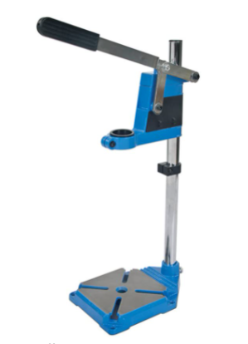
[1] Silverline 633764 Drill Stand 500 mm £24.77
Features:
- 43mm or 38mm collar hand drills
- Depth adjustment scale and stop, max drill depth of 60mm
- Solid Cast Iron base
- Weight 3kg
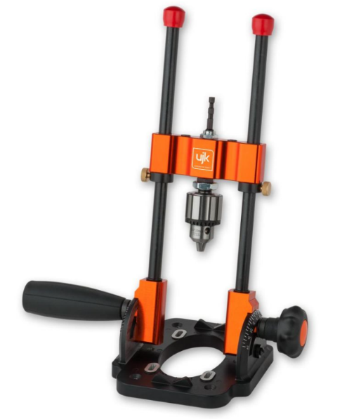
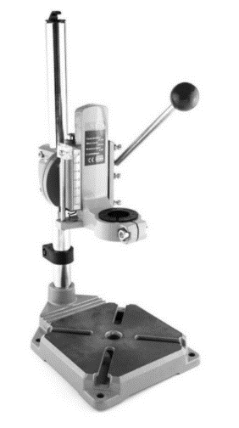
[3] UJK DRILL GUIDE WITH 10MM CHUCK £154.98
Features:
- 110° Capable of drilling any angle between +/- 55°
- Takes bits or holesaws up to 60mm diameter
- Two pins allow self centering drilling (85mm capacity)
- Suitable for most power drills, mains or cordless
- 1/4" hex drive shaft, with 3-jaw 10mm geared chuck
- Cast aluminium base, machined slide assembly with steel guide rods
- Rubberised, high-friction, non-slip base pad and auxiliary handle
- Maximum Travel 210mm

[2] Rotacraft RC7000 Drill Stand and Rotation Holder £75.09
Features:
- Fits 43mm Collar drills
- Max drill depth of 60mm
- Drill holder can rotate 90° to drill vertical or horizontal
- Solid Cast Iron base
- Weight 3.7kg

After looking at 3 examples which are currently on the market and what they offer for the price I believe the client will be looking to enter the lower end of the market after looking at their design and how it compares to current products.
The product I design will have the more basic features of the ones on offer on market:
- Drill Vertically only
- Clamp Drill of standard size 43mm
- Lightweight

Design Specification

Proposed Project: Drill Stand Main Unit Design Engineer: Christopher Scrine
Performance Requirement | Design Requirement | Design Specification
Must be able to move up and down | Connect to handle | Clip on fixing to link arm
Must be easy to transport/carry | Must be lightweight | <1kg
Must slide up and down main shaft | Must fit onto shaft | Hole with diameter Ø>25mm (+0.3mm tolerance)
Must hold drill secure | Clamp drill using fixing | Cut out to secure M5 nut 1 side and hole for m5 bolt on other
Must be affordable | Must be low cost | <£7 to manufacture
Must be able to removed/replace if necessary | Removable from main shaft & Link arms | M6 Thread for grub screw
Must be sustainable | Made from recyclable material | Recyclable material
Must be able to withstand forces of drilling | Manufactured from a strong material | Cast Alloy
Must hold guide shaft in place | fixing to secure guide shaft | M6 Thread for grub screw
Must hold guide shaft in place | hole for shaft to fit into | Hole with Ø>10mm (+0.3mm tolerance)

Manufacturing Method
Now that I have chosen my final design, I will need to look at possible methods of manufacturing and whilst doing so ensure that they are suitable and affordable before selecting a chose method.
Looking at my design I believe Die Casting will be a suitable option as this can be automated and a range of alloy materials can be used in this process and depending on what material is selected will depend on the component’s strength, finish, costs etc.
Die casting is carried out by firstly having dies manufactured which when filled when the molten metal will be used to form the final component. This is an expensive part of the process as depending on the design complexity the manufacturing of the die’s can be expensive. This is a high upfront cost but then these dies can be used thousands of times if maintained correctly. Once the Die’s are ready for casting, they are closed together and clamped in position, molten metal is then pushed into the die’s by either high or low pressure and is then held in the dies to solidify and cool. Once the metal has cooled and has taken its final shape of the casting the dies can be unclamped, and the finished product ejected using ejector pins.
Die casting can either be carried out via high pressure or low pressure, again depending on which material is used will depend on which process would be suitable. Low pressure casting is usually done with materials with a lower melting point, this can provide higher dimensional accuracy but is slower than high pressure casting. High pressure casting is done at a higher speed therefore a lower cycle time and provide a smoother finished surface on the product. Also, with high pressure casting thinner cross-sections and wall thicknesses can be achieved.
However, high pressure casting has the disadvantage that it has higher operating and initial investment costs which must be taken into consideration.

A second possible method of manufacturing could be to 3D print components, or sometimes known as additive manufacturing. This method of manufacturing involves 3D CAD models being created and then sent to the 3D printer which will then construct the mode, usually made from a thermoplastic, by laying many successive layers of thin material.
The advantages of 3D printing are that it can be used to create complex components which would otherwise be very difficult to manufacture using traditional methods or may even have had to be made in 2 parts and connected. Also, “3D printing is also emerging as an energy-efficient technology that can provide environmental efficiencies in terms of both the manufacturing process itself, utilising up to 90% of standard materials, and throughout the products operating life, through lighter and stronger design.”[5] A third advantage of 3D printing is that the product you manufacture can be altered fairly easily by someone who has received the relevant training, this then eliminates the cost of re-designing and purchasing new tooling should a component be altered.
However, although the start up costs would likely be lower for 3D printing than those compared to casting, the cost to scale up to large production volumes would likely be higher. Also, there are currently a limited amount of materials which could be selected if this process was chosen and therefore the component may not be as light and strong as desired.

After looking at a couple of possible manufacturing methods, I would suggest that my customer would produce the component I have designed using the die casting manufacturing method and use an aluminium alloy material. I think that although the start up costs would be higher, the quality of the final product would be worth the investment due to its lightweight, strength and finish. Also, hopefully the customers product is successful at market, and they could easily increase production rates beyond the 1000 units pw with little cost. Die casting will also be a more sustainable method to manufacture the part as there is very little waste.
When designing my product, I will have to take into consideration that I will be using die casting as my manufacturing method. I will incorporate features of my design to suite this method, one of these will be to fillet all angles of my design so it can improve the casting performance. This will make it much easier to eject the part from the dies once it has been cast. This will also improve the surface finish of the product as there will not be and dragging on the casting surface and will also put less stress on the die, which we want to last for many 1000’s of cycles. I will also try to maintain the wall thickness throughout the part as much as possible.
The threads for the fixings of the link arms and the grub screw for the guide shaft I would suggest to the client that they are done separately to casting. This process could also easily be automated and will give a much cleaner finished thread than if attempted as part of the casting. This will then make the assembly process easier with less defects.

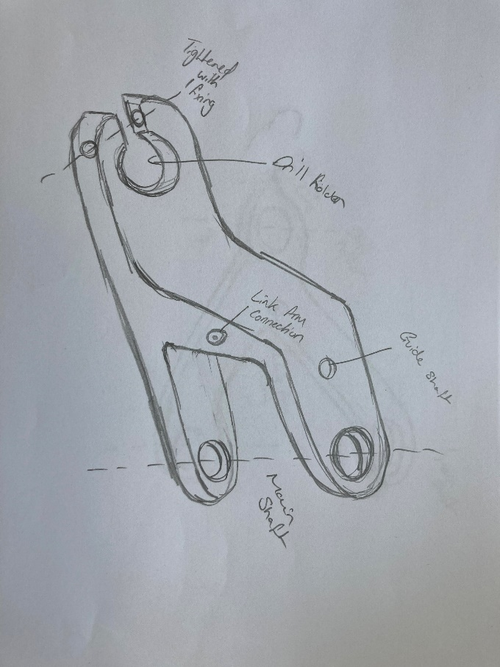
Design Ideas
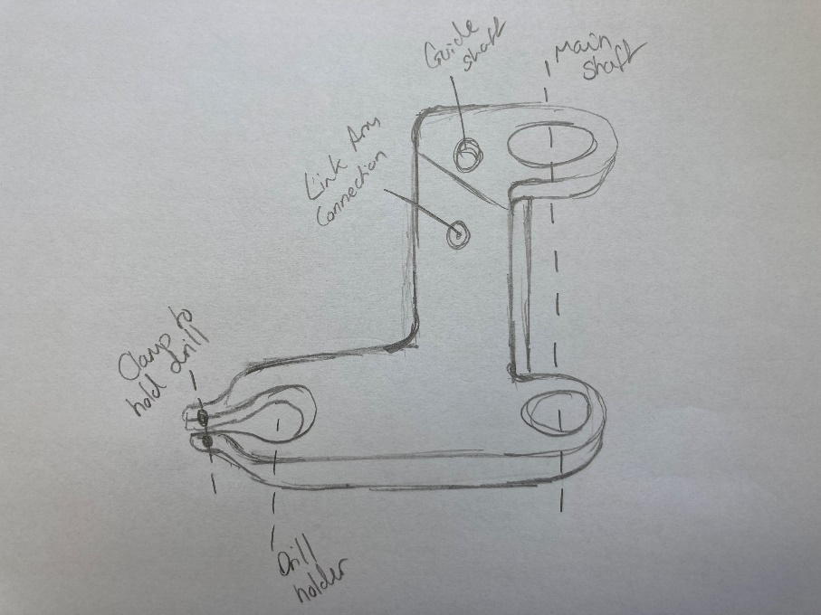
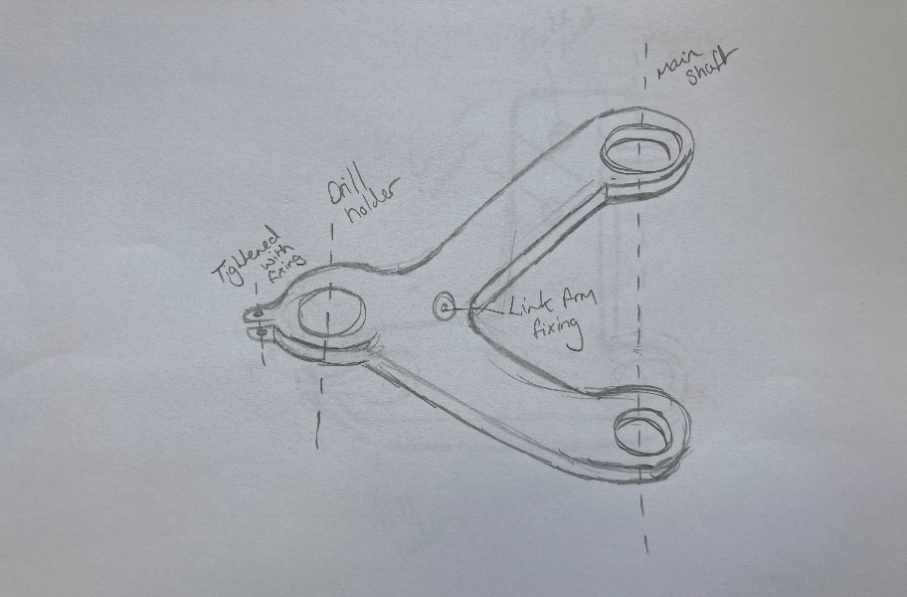
Design 3
Again, less material than original concept design so cheaper to produce
Similar options on market so not so appealing to customers
Easiest to produce as simple design
Fulfils specification requirements
Design 2
Aesthetically most appealing
Least material used so would be cheapest to produce
Would be weakest due to design so more likely to fail under stress of drilling
Fulfils specifications requirements

Design 1
Smooth/streamlined looking component
Will use less material than clients original design, therefore cheaper
Lightweight due to less material used
Original design – no current unit similar on market
Will be relatively easy component to die cast
Chosen option due to its aesthetics, weight and cost to produce

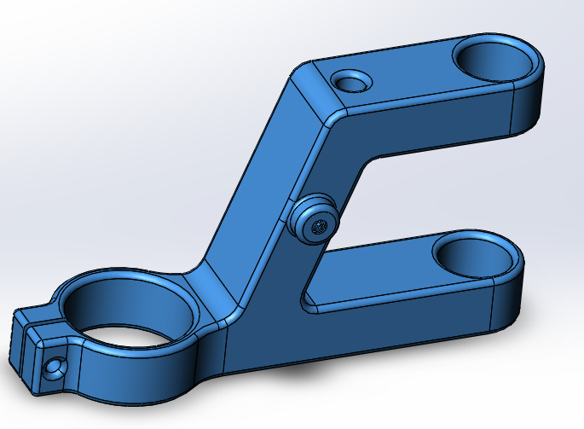
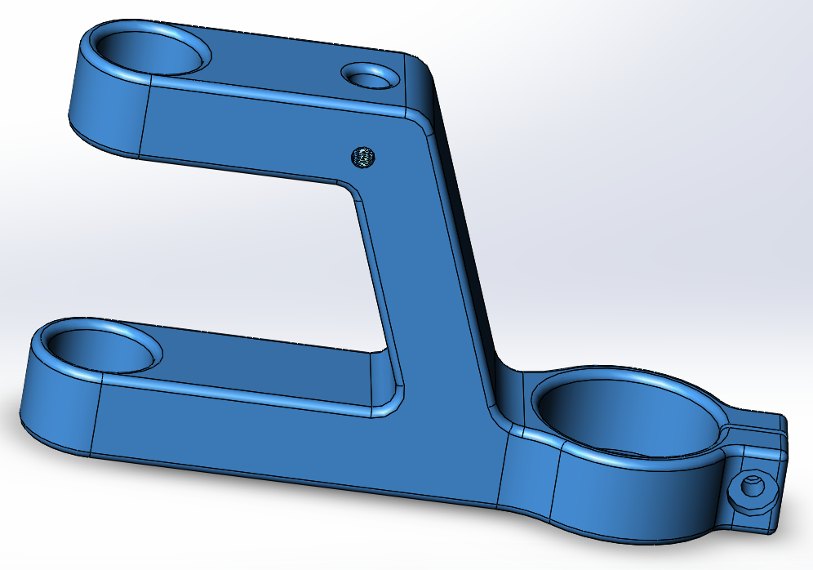
CAD Drawing of Final Design

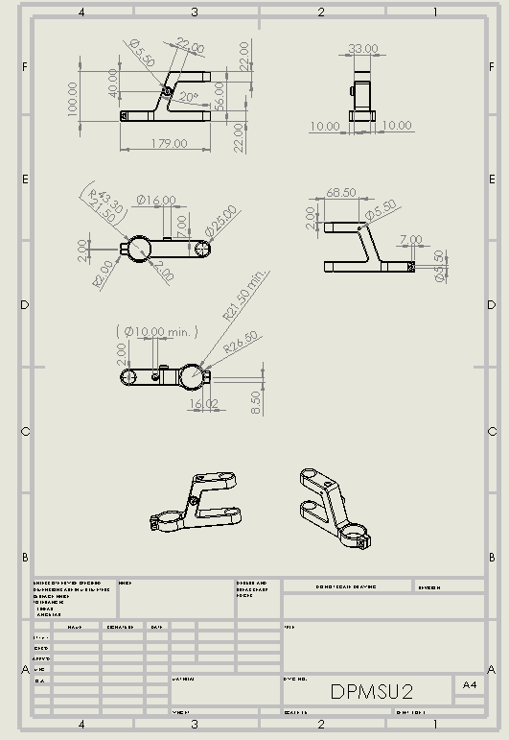
Technical Drawing

References

[1] Silverline Drill Stand - Silverline 633764 Drill Stand 500 mm : Amazon.co.uk: DIY & Tools

[2] Rotacraft RC7000 Drill Stand - Rotacraft RC7000 Drill Stand and Rotation Holder | allendalecrafts.co.uk

[3] UJK Drill Guide With Chuck - UJK Drill Guide with 10mm Chuck | Axminster Tools

[4] Die Casting - What is Die Casting? Development, Processes and Materials in Die Casting (spotlightmetal.com)

[5] 3D Printing - The Free Beginner's Guide - 3D Printing Industry

