

LCHS7002
Health Care System Organisation and Leadership

MSc Public Health and Social Care in Practice
LEVEL 7

Case Study Analysis Report

Title: Leadership, Governance, and Systems Failure in Medication Safety: A Case Study of Morphine Overdose in Neonatal Care

Case Study 1

Assignment type: Individual Report

Student Number: 2523936
Student Name: Sonali Solanki

Word Count: 4893

Table of Contents
1. Introduction 3
Background of the Case 3
Driving Teams in the Right Direction -towards Safety Goals 3
System Structures: Centralisation vs Decentralisation 4
Leadership Theories in the healthcare setting 4
Leadership in Crisis and Change Management 4
2. Main Body and Analysis 4
a. Finding out the Problem and Context of the System (Systems Thinking + Rich Picture) 4
b. Centralisation vs Decentralisation 9
c. Leadership Theories and Application 14
d. Lessons Learned and Improvement 17
3. Recommendations 22
4. Conclusion 24
References 25

1. Introduction

Background of the Case
The issue of medication safety is crucial in the context of neonatal care since even slight changes in dosages may lead to serious consequences. The case in point is about a morphine sulphate overdose incident in a 4-week-old, where the dose concentration of the higher form was filled mistakenly, resulting in a dosing mistake of 20 times. The same patient safety issue can be observed in the case of the Rajasthan hospital, where the entire system of weaknesses and insufficient control led to unfavorable clinical results (NHS, 2023).
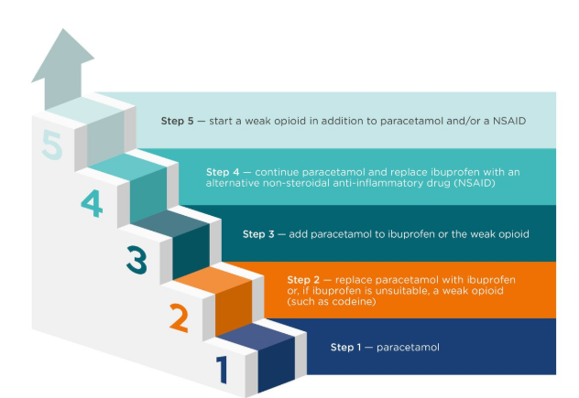
Figure 1: The Process to manage mild-to-moderate pain
(Source: National Institute for Health and Care Excellence, 2022)
This report aims to critically evaluate the leadership practices, governance structures, and system failures through the paradigm of the morphine overdose incident. It also seeks to understand the role of leadership in clinical decisions, safety culture, and error avoidance, and find gaps in organisational set-ups that result in these events.

Driving Teams in the Right Direction -towards Safety Goals
In high-risk settings, leaders take a key role in getting teams oriented towards patient safety through advocacy of effective communication, following established regulations, and making joint decisions (Jyothi, 2018). The possibility of changing attitudes and behaviours is crucial in the prevention of medication errors and safer practices that are not consistent.

System Structures: Centralisation vs Decentralisation
Healthcare systems assume different structures that are relevant to decision-making and accountability. Centralisation focuses on standardisation, control, and similar protocols, which can help decrease variability in medication administration (Ramsay et al., 2025). Decentralisation, in turn, provides freedom and quick decision-making on local levels that can be more responsive to change, but can also raise the chance of inconsistency. The failure to coordinate between prescribing, dispensing, and administration in this case is one of the weaknesses in the balance of these structures.

Leadership Theories in the healthcare setting
Transformational leadership is useful in a crisis as it aims to motivate and encourage employees to accept change and enhance safety behaviors, it can be deprived of the procedural control of high-risk jobs. Transactional leadership, a leadership that focuses on rules, monitoring, and performance, is associated with compliance with safety standards but does not encourage innovation. Situational leadership is flexible as it modifies leadership styles depending on the situation and the ability of the team, and it is especially applicable in a tricky healthcare environment.

Leadership in Crisis and Change Management
Leadership is needed in the management of immediate risks, transparency, and corrective measures in cases of medication errors and other emergencies in crisis conditions. The leadership approach can help sustain clinical governance through reinforcement of accountability, system improvement, and the elimination of errors.

2. Main Body and Analysis

a. Finding out the Problem and Context of the System (Systems Thinking + Rich Picture)
Central Problem Defined Systemically
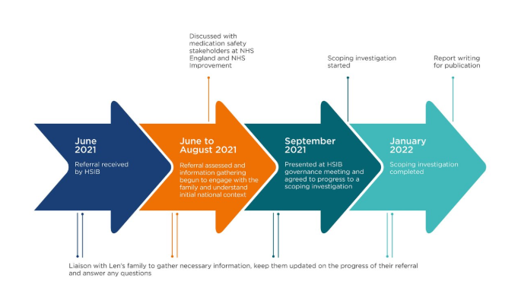
Figure 2: Summary of Timelines of Len’s Care
(Source: National Institute for Health and Care Excellence, 2022)
The morphine overdose case of the 4-week-old baby must not be perceived simply as some dispensing error, but rather as a flawed system in medication safety and control. The infants actually took a 20x dose of the drug since a 10mg/5ml solution was released (rather than the intended 100 micrograms/ml preparation, a red drug, accessed by specialists in hospitals only) (National Institute for Health and Care Excellence, 2022). This is a system-wide concern of a malfunctioning medication identification system, communication lapse, and a poor safety culture, and not a single human mistake. The fact that similar incidents have been repeated since 2018, with one fatality, is another indication of a long-standing system-wide problem (Khalil and Lakhani, 2022).
Local Case Context
On the organisational level, the incident exhibits various failures within the medication management process, such as prescribing and dispensing medications, and administration. Although there are strict formulary limitations, the morphine solution of high strength was distributed to parents, which shows that pharmacy verification control and governance controls have failed (Coacci and Schwaner, 2025). Lacking effective double-checking systems and ineffective communication among the healthcare providers enabled the error to get beyond some of the most important safety barriers.
International, National, and Global data context
On the international front, the World Health Organization approximates that at least 1 of every 10 patients in the world succumbs to medication errors, with an estimated billions of dollars in unnecessary healthcare expenses each year (World Health Organization, 2023). This points to the fact that such events are not isolated but contribute to a bigger issue of patient safety issues worldwide.
National statistics on patient safety in the United Kingdom NHS show that a large share of reported safety incidents are associated with medication, and both neonatal and paediatric groups are at risk of being affected by the dosing complexities (Mitchell, 2022). Consistent cases of morphine indicate a lack of learning and sharing of safety alerts in the country.
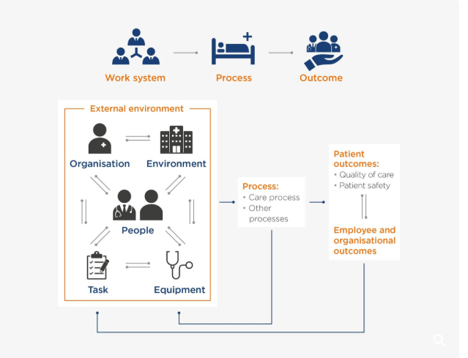
Figure 3: A Representation of the SEIPS Framework
(Source: National Institute for Health and Care Excellence, 2022)
There are also similar issues in India, where a study showed that a significant proportion of hospital adverse events, at least some of which are due to medication errors, are made worse by the high number of patients and lack of staff. Poor nurse-to-patient ratios and incompetence in terms of following safety measures contribute to the risks. The overcrowding, time pressure, and inefficiencies in the workflow are some of the factors that contribute to unsafe practices organisationally.
Identification Systemic Weaknesses
The incident discloses some systemic interrelated weaknesses:
- Gaps in Communication: There was poor transmission of information between the prescribers, pharmacists, and caregivers, with misinterpretation of dosage and formulation (WHO, 2026).
- Absence of Accountability: The responsibility between teams decreased the prospects of fault in any of the key checkpoints.
- Leadership Failures: The lack of attention to patient safety culture and proactive risk management permitted unsafe practices to be maintained.
- The interactions between these weaknesses result in a weak system that is likely to collapse.
Governance Levels Involved
The collapse cuts across various governance tiers:
- Local (Hospital Level): Weak supervision and inadequate training, inappropriate enforcement of prescribing and dispensing in action plans.
- Regional (Formulary Level): Weaknesses in controlling the restriction of red drugs and uncertainty in their implementation (Dhingra-Kumar et al., 2021).
- National (Policy Level): Weakness in making safety alert translations into practice and recurrence of familiar risks.
- This multi-layered failure implies the incompetence of aligning the governance structures and clinical practice.
Underlying Contributing Factors
The incident was caused by several root causes:
- Staff Training Problems: Low awareness of high-risk drugs and calculations of dose.
- Medication Labelling Risks: Packages were of similar shape, and the distinctions between the different concentrations were not apparent, enhancing the chances of confusion.
- System Complexity: Multiple transfers and continuous use without any technology-dependent system checks made the system susceptible to errors.
Systems Thinking Analysis
The systems thinking approach can show the way various elements interrelate:
- Interconnections: Stanza actions are based on processes that are influenced by leadership and organisational culture, and ultimately patient outcomes. As an illustration, poor protocols followed as a result of poor leadership may result in poor dispensing practices (WHO, 2022).
- Feedback Loops: Weak attack: Lack of a proper incident reporting system impedes organisational learning. Under-reporting of errors or failure to analyse effectively results in repetitive occurrences of similar errors, such as the repeated case of morphine overdoses.
- Dependencies: The clear protocols, effective communication, and competence of staff are required to conduct safe medication administration. Failure of any of the parts leads to the failure of the system (WHO, 2022).
Therefore, this failure is due to a series of systemic weaknesses as opposed to a failure point.
Rich Picture Explanation
The complexity of the healthcare system and interactions culminating in the error are visualized in the rich picture of this case. It includes:
- Stakeholders include: Infant (patient), parents, doctors (prescribers), pharmacists (dispensers), nurses (administrators), and hospital management (Seki et al., 2021).
- Processes: Prescribing of the appropriate medicine, dispensing of the drug, and administration of the drug to the client.
- Decision Points: Prescription, pharmacy checks, and bedside administration checks.
- Communication Misunderstandings: The misunderstanding of drug concentration, incompleteness of instructions, and ineffective team-to-team coordination (Seki et al., 2021).
- Weaknesses: Lack of double-checking protocols, laxity in formulary regulations, and insufficiency of the oversight.
- Sections: Feedback Loops: Incident reporting and learning schemes, which seem to be ineffective due to the recurrence of cases of the same nature.

b. Centralisation vs Decentralisation
Overview of Centralised Systems
Centralisation in healthcare is a concept whereby the decision-making power is vested in higher organisational levels and is usually vested in specialist clinicians, hospital management, and regulatory bodies. In these systems, the clinical decision, prescribing of drugs, and administrative procedures are unified and regulated at the highest level. This model is especially widespread in the clinical fields that can be regarded as high risk and where the level of competence and regulation are essential (Pessot and Lolli, 2025).
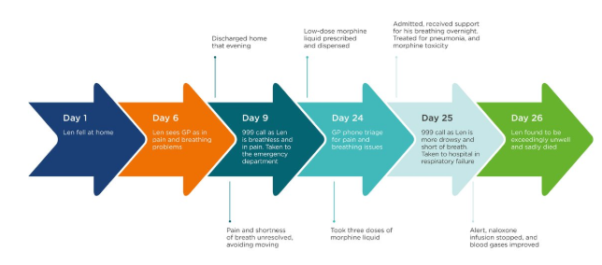
Figure 4: Summary of Timelines of Len’s Care
(Source: National Institute for Health and Care Excellence, 2022)
The fact that morphine sulphate (100 micrograms/ml) has been classified as a “RED DRUG - hospital only- in the present case is a clear indication of a centralised system. In this policy, prescription and dispensing are confined to a secondary care setting and should be started by specialists (De Pretis et al., 2025). This is to make sure that only the trained professionals get access to the potent medications and can do so under controlled conditions in hospitals, hence reducing the chances of abuse.
Advantages of Centralisation in the Case
There are several valuable advantages of centralisation, especially in handling high-risk drugs:
The Improvement of the High-Risk Drugs Control: The limitation of access to the specialist setting is a guarantee that the specialists act with morphine only, and there is no inappropriate use of this kind of medication (Shbaily et al., 2025).
Standardisation of Clinical Practice: uniform protocols and guidelines minimise the variability in prescribing and dispensing practices.
Better Clinical Government: With central control, safety standards through the system can be monitored, audited, and enforced.
Disadvantages of Centralisation in the Case
Rigidity: When structures are rigid, then healthcare providers in the area cannot flex or challenge decisions even when anomalies are noted.
Communication Breakdown: A shift in our communication occurs as the hospital-based prescribing system and the community-level dispensing system lead to a gap in communication with a potential to misinterpret (Shbaily et al., 2025).
Top-Down Communication Failure: The information moves in a downward manner: the flow is likely to bring about delays, partial comprehension, and less feedback from the front-line employees.
Poor Accountability: Accountability can be lost by putting power in one concentration, with all individuals believing that others have done the important things (Shbaily et al., 2025).
These weak points, in this instance, were one of the factors that led to the wrong concentration of morphine, even though there were explicit restrictions according to the red drug policy.
Application to the Case
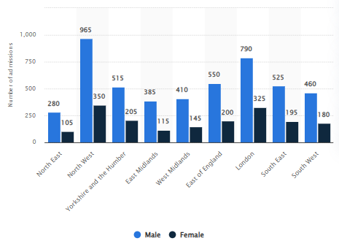
Figure 5: Drug Related Hospital Admission in England
(Source: Statista, 2020)
In this statistic, the number of admissions to an NHS (National Health Service) hospital with primary diagnosis drug-related mental health and behavioral disorders in England is shown in 2019/20, by gender and region. The number of patient admissions in 965 men and 350 women in the North West of England was taken to hospital due to drug-related mental health and behavioral problems (Statista, 2020).
The overdose of morphine incident shows how centralisation may not work where there is no efficiency in communication and accountability. In spite of the fact that strict control of the policy had to be observed in the hospital environments, the system did not comply with it during the shift to community-based care.
Key issues include:
- Effective or Ineffective Decision-Making: Decisions may take time to be clarified and verified by centralised approval methods, particularly in the case of urgent care.
- Steele (2002) indicated that the lack of Local Verification Autonomy, Community pharmacists and healthcare providers might not have been empowered or trained to challenge the prescription or verify the drug concentration independently.
- Failure of Communication Pathways: There was a failure of communication of critical information about dosage and formulation between levels of the system.
- The centralised structure, therefore, though meant to be safe, increased vulnerability to the systems.
Data and System Context Supporting Data
Empirical evidence also indicates the issues of centralised healthcare systems:
Staff-to-Patient Ratio: Statista data requires many healthcare systems to work under staffing strain; the staff-patient ratios are often higher than recommended. Increased workloads limit the ability to perform comprehensive verification and require reliance on standardised procedures (Statista, 2024).
Surgical Workload and System Pressure: BBC reports have pointed to growing workloads and strain on the system, a situation that may lead to a lack of compliance with safety protocols.
Policy Compliance Rates: According to policy analysis carried out by IBISWorld, compliance with healthcare policies varies depending on the industry, especially in complex industries in which various stakeholders are at work.
Critical Analysis: Was Centralisation the Juncture of the Error?
Most importantly, centralisation did not cause the overdose per se, but just added to the existing weakness in the system. The inflexible system hindered local intervention and minimized the chances of errors being detected. Errors occur in cases when a number of system layers fail at once, which is the case in the Swiss Cheese Model of errors, according to Reason (Reason, 2000). The inability of communication, training, and verification in the case compromised centralised control mechanisms (policy restrictions).
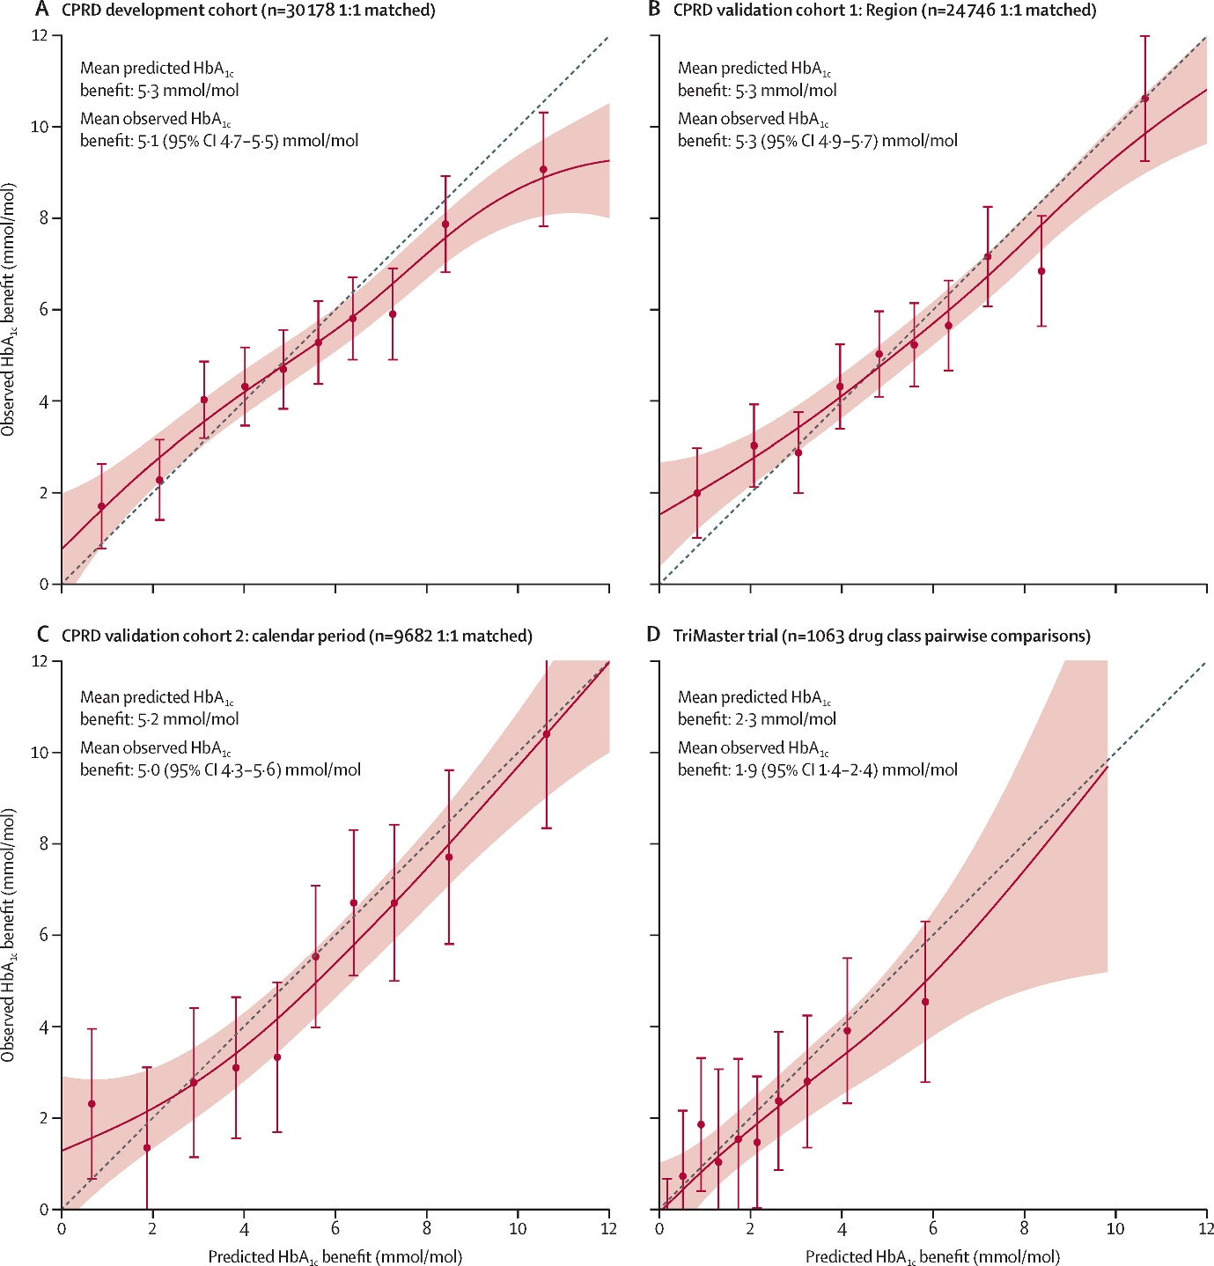
Figure 6: A Five-Drug Class Model Using Routinely Available in Clinical Features of North East and Yorkshire
(Source: Dennis et al., 2025)
The figure makes comparisons between the predicted and observed HbA1c benefits at four cohorts. Observed results are indicated with points with error bars, whereas uncertainty is indicated with shaded areas. A perfect prediction is represented by the line on a diagonal. In general, there is a good correlation between predictions and observed values in cohorts A–C, whereas the trial values have a lot of variance and lower accuracy (panel D) (Dennis et al., 2025).
Moreover, Wears and Sutcliffe (2020) believe that excessive centralisation may provide a sense of security to users, as they resort to protocols instead of critical thinking. In addition, Dixon-Woods et al. (2014) point out that top-down governance can lack success in normalizing the frontline practice unless there is robust leadership and involvement.
Decentralisation: Would it make a difference to safety?
Although the lack of risks cannot be attributed to decentralisation, there would have been a small amount of local authority, especially in verification. To elaborate, had there been a better authority and training of community pharmacists to challenge the strange prescriptions, the morphine concentration discrepancy could have been realized.
Aspect | Centralisation | Decentralisation
Decision-making | Decision-making is centralized with specialists/hospitals in charge | Decentralized with local providers
Control | Strict protocols, high standardisation | Beautiful decisions that are flexible and depend on the situation
Advantages | Effective management of high-risk medications | Quick response, enhanced access
Disadvantages | Lack of communication, inflexibility | Incongruence, and increased risk of errors
Impact on safety | Minimizes variability and latency to action | Minimizes uniformity and responsiveness, but can lower uniform safety
Table 1: Comparison Between Centralisation vs Decentralisation in Healthcare Systems
(Source: Self-Created)

c. Leadership Theories and Application
Transformational Leadership
Transformational leadership is aimed at establishing an effective vision, culture of safety, and introducing incentives to staff to prioritize patient outcomes (Boamah et al., 2018; Specchia et al., 2021). In the medical field, it is strongly associated with enhanced safety culture, workforce engagement, and negative events.
Transformational leadership, however, was not present to a very great extent in this case. The recurrence of morphine overdose incidents shows that there was an inability to incorporate a proactive patient safety culture. Previous incidents would have been used by a transformational leader to create change and encourage learning and involvement of staff in enhancing medication safety processes.
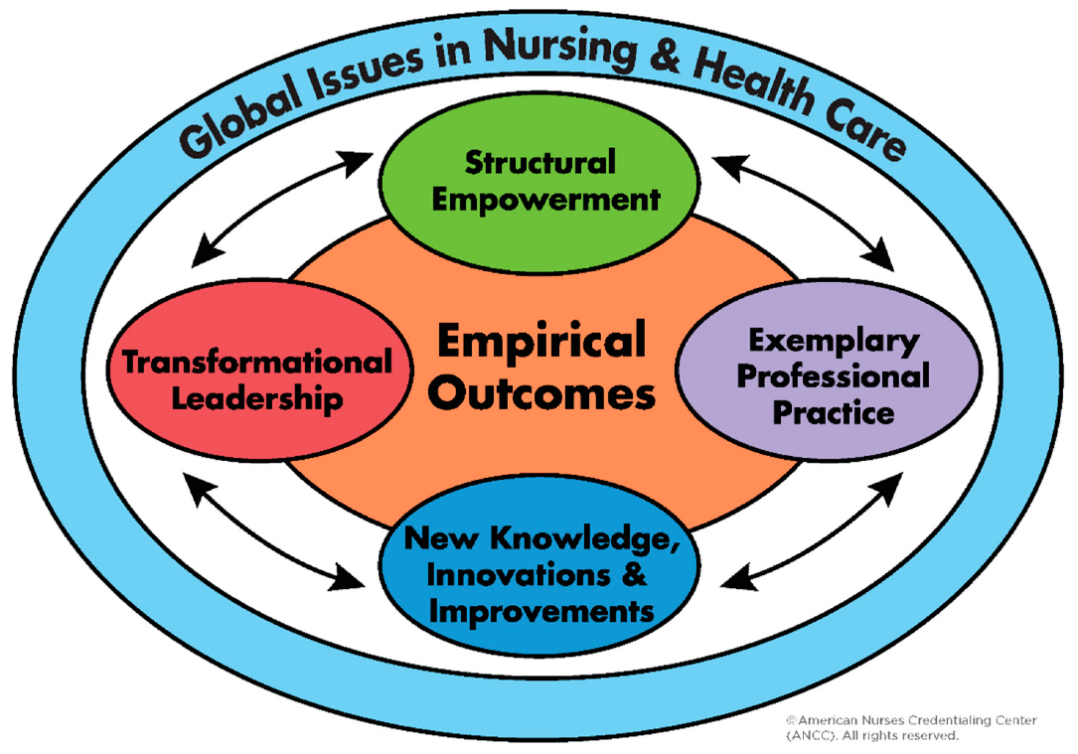
Figure 7: Measuring Transformational Leadership
(Source: Moon et al., 2019)
There is evidence of positive links between strong safety cultures and positive clinical outcomes and error reduction (Specchia et al., 2021). Poor psychological safety and low empowerment are indicated by the fact that staff members were unable to identify or regulate the dispensing error. This is in line with the observations presented by Wei et al. (2020), who point out that transformational leadership contributes to open communication and reporting of errors. The lack of such leadership in this situation enabled unsafe practices to take place, and this proves a very crucial deficiency in leadership.
Transactional Leadership
The idea of transactional leadership is built on adherence to rules, orderliness, and adherence to agreed procedures (Long et al., 2020).
There was effective transactional leadership in this case, but it was ineffective. There is also a rule-based structure that can be seen in the very fact that there exist strict protocols that are aimed at preventing misuse: the famous RED DRUG - hospital-only classification. Unfortunately, these protocols were not properly implemented and thus caused a lapse in compliance. This wrong morphine concentration was filled, although there was an established direction illustrating the fact that there were failures in monitoring, supervising, and accountability.
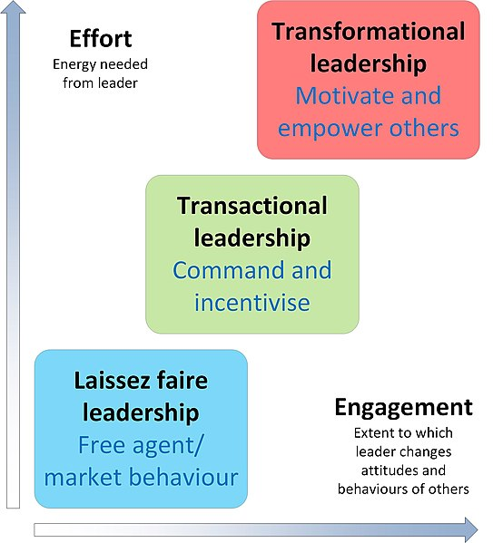
Figure 8: Application of Transactional leadership in healthcare
(Source: Rn, 2025)
One of the major drawbacks of transactional leadership is that it leads to a culture of a check box, whereby employees are concerned with filling in the sales form instead of analyzing it. Abuzied et al. (2023) note that when using various versions of rigid protocols without involving them in the lives of users, the tendency to think critically may decrease, and the possibility of making a mistake. In addition, research proves that adherence does not ensure safety without effective leadership and constant control (Long et al., 2020).
Situational Leadership
Situational leadership is more focused on its changeability, as leaders need to change the strategy depending on the circumstances and complexity of the situation (Thompson and Glasø, 2022). During crises in health care, like medication errors, leaders should take rapid action, organize teams, and take corrective measures.
Leadership during the crisis has manifested itself as reactive and not proactive. Although the use of naloxone to save the life of the infant took place, the leadership intervention was resorted to when the mistake had already been made. Situational leadership would be effective in that risks should be anticipated and preventative measures taken. Thompson and Glaso (2022) state that adaptive leadership is essential to dealing with complex healthcare settings and preventing adverse events.
Critical Analysis: Proactive and Reactive Leadership
In general, leadership in the present scenario was mostly reactive. Reported cases of incidents and the identification of five similar ones since 2018, with one being fatal, indicate a lack of organisational learning and positive risk management. Employee engagement and communication were also poor, leading to eroding leadership effectiveness. Lack of documentation in the state of clarity of communication between all prescribing, dispensing, and administration phases indicates a lack of coordination and control. Efficient communication and collaboration have been shown to be key to medication error prevention (Wei et al., 2020).
Areas for Improvement:
- Emotional Intelligence: Leaders are expected to create trust and transparency, allowing the staff to share their concerns and inquire about the decisions without fear of punishment (Majeed and Jamshed, 2021).
- Distributed Leadership: Accountability in safety checks could be enhanced by providing frontline staff with the power to make judgments and decrease the system of hierarchical staffing (Specchia et al., 2021).
- Strengthened Supervision and Responsibility: The roles, routine audit, and surveillance have to be supported in the better enforcement of safety measures.
- Proactive Safety Management: It is possible to avoid errors from being repeated by means of implementing continuous training, analysis, and redesign of the system.

d. Lessons Learned and Improvement
Connection of Leadership and Governance
Governance and Leadership indispensably play a crucial role in providing patient safety. Governance gives policies, protocols, and a system of accountability, whereas leadership acts by implementing, monitoring, and improving them all the time. In this instance, despite the fact that they had structures of governance like the policy of RED DRUG - hospital only, the leadership did not implement or change such checks. Such disconnectedness led to lax checks of the system and frequent mishaps.
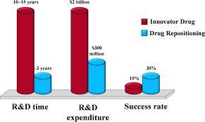
Figure 9: The Drug Repositioning Model
(Source: He and Zhao, 2025)
The concept of centrally managing high-risk medicines under the management of a specialized body was at the centre of focus in the system. But centralisation was a contributing factor to top-down failures and a lack of local accountability without strong leadership and effective communication, and the error was able to go through several stages.
Problem 1: Medication Miscommunication
Problem:
Failure in communication between the prescribing, dispensing, and administration processes resulted in the wrong morphine level being dispatched.
Data:
The percentage of medication errors that cause harm to a patient is high all over the world, and communication breakdowns have already become a critical factor (Assiri et al., 2018; WHO, 2017). Research indicates that as many as 70 percent of the negative healthcare incidents are related to communication problems (Schmutz and Manser, 2019).
Solution:
• Introduction of e-prescribing (e-prescribing) systems.
• Standardised protocols of communication (e.g., SBAR)
• Good labelling and documentation.
Critical Evaluation:
The lack of digital systems and design communication is indicative of both a gap in governance (investment in systems) and leadership (lack of prioritisation of safety tools).
Problem 2: Weak Checks and Verification Failures in the Systems.
Problem:
Absence of solid double-checking systems allowed the mistake to go through several steps undetected.
Data:
It has been shown that medication errors could be decreased by barcode medication administration (BCMA) systems up to 41% (Mulac et al., 2021). Moreover, high-risk medication errors are primarily caused by failure in performing a verification process (Keers et al., 2019).
Solution:
- Bar code medication administration systems.
- High-risk drugs require compulsory independent double-checks.
- Do abnormalities alert that are automated.
Critical Evaluation:
Lack of these systems depicts the school's poor enforcement of governance and lack of leadership concern with the risk-mitigating measures. Some centralised methods may presuppose that safety is ensured with the help of control, yet, without checking the operative controls, the errors will remain.
Problem 3: Low level of Staff training and competency
Problem:
Employees did not have enough education to recognize medications that may be risky, and detect dose and concentration discrepancies.
Data:
It is indicated that a low level of training is the strongest risk factor that may raise rates of medication errors, especially in the case of paediatric and neonatal care (Manias et al., 2020). The effectiveness of safety practices is also compromised by high workload and staffing shortages.
Solution:
- Training and competency testing of staff regularly.
- Simulation learning: Learning in high-risk areas.
- On-going professional development programmes.
Critical Evaluation:
Governance (no structured programmes) and failure of leadership (no focus on staff development and safety culture) are reflected in the training gaps.
Connections between Leadership, Structure of a System, and Feedback Loops
- The interaction of leadership structures, centralised forms of the system structure, and feedback mechanisms is evident in this case:
- Leadership: 2 Inadequate efforts to support a proactive safety culture and hold people accountable.
- System Structure (Centralisation): Lack of local control contributed to communication failures.
- Feedback Loops: The system of incident reporting and learning failed, which was caused by ineffective learning systems that allowed anyone to make the same mistake.
Braithwaite et al. (2018) suggest that healthcare systems need to operate as adaptive systems with continuous involvement of feedback to enhance safety.
Lessons Learned for Healthcare Organisations
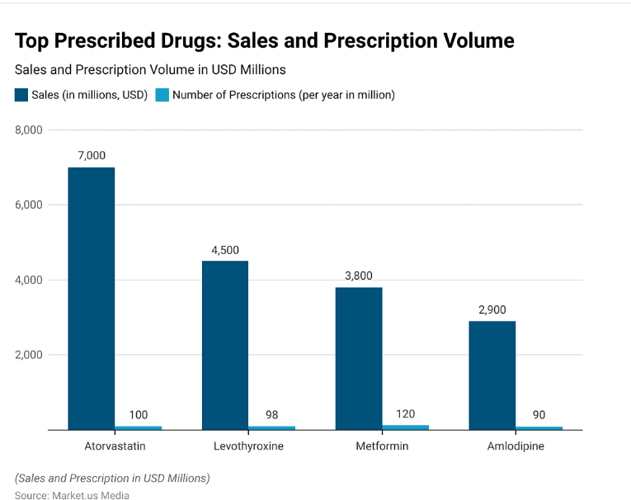
Figure 10: Facts and Statistics Drug Prescription
(Source: Samruddhi Yardi, 2025)
The world pharmacy market size is predicted to amount to approximately USD 1,750 billion in the year 2032, as compared to USD 1,108 billion in 2022, and is projected to grow at a rate of 4.8 in the forecast period between 2022 and 2032. The market size of prescription drugs in the world was estimated to be US$ 1050.26 Mn in 2021 and is estimated to record a CAGR of 9.0% by 2031.
The most prescribed line of drugs is analgesics (pain relievers), with a percentage of about 24 of the total prescriptions. It is top-selling in sales with Humira (adalimumab) earning of 19.8 billion in 2021.
We need systems thinking to take potential fixes to the problem of patient safety.
Individuals are not the common cause of errors, but a combination of interactions between people, processes, and systems. Root causes should be identified and dealt with holistically.
Leadership needs to facilitate Accountability
Efficient leadership is essential in fostering policies to be implemented, monitored, and continually refined. The leaders will need to shift toward proactive, rather than reactive, bases of their work, relying on data to predict risks.
Significance of Culture of Safety
An excellent safety culture promotes free dialogue, reporting of errors, and never-ending education. To prevent arguments, staff should be empowered to oppose decisions and report.
Ongoing Minute and feedback
To monitor the development of tendencies and avoid mistakes made, it is necessary to conduct regular safety audits, a real-time reporting system, and analyse the data.
Data part in Continuous Improvement.
Data-driven governance empowers organisations to monitor the performance, detect risks, and make specific interventions. Systems cannot be improved without the proper use of data.
Technology as Safety Enabler
Barcode medication administration, digital prescribing systems, and automated alerts can work wonders in terms of human error reduction and enhancing accuracy.

3. Recommendations
1. Leadership: Transformational and Distributed Leadership
To create a powerful patient safety culture in which medication error prevention will turn into a common concern, the establishment of a new leadership model, transformational, should be employed by the healthcare organisations. This would allow local action to be taken in instances where discrepancies occur, e.g., detection of the wrong level of morphine before dispensing. There is some suggestion that empowering staff enhances the safety outcomes and shortens the prevention of harm (O’Donovan et al., 2019).
2. Governance: Responsibility and Live Reporting.
The governance regimes need to have good accountability channels at all levels- prescribing, dispensing, and administration. The policy of RED DRUG in this instance was unsuccessful because of a lack of clear responsibility and enforcement. Organisations should introduce:
• Each step of medication management was well defined.
• Incident reporting systems in real-time to immediately identify and warn of risks.
• Essential double-check procedures of high-risk drugs.
Studies emphasize that good governance and reporting will lead to a significant decrease in negative events and increase compliance (Macrae, 2019). Policies cannot bring any changes without accountability.
3. Systems: Patient Safety and Digital Integration Systems
The accident shows why combined digital systems to reduce human error are necessary. Suggested improvements to the system level are:
- E-prescribing automation and checking of dose prescriptions.
- Barcode medication administration (BCMA) to ensure the right drug and dosage.
- Digital systems of patient identification to provide proper matching of prescribed medication and drugs.
The technologies establish several safety layers and minimize the use of manual checks. There is proof that digital interventions are effective in reducing medication errors in hospitals (Rodziewicz et al., 2022).
4. Improvement of efficiency: Technical and Allocative Efficiency
To facilitate safe medication practices, improvement towards efficiency is required:
- Technical efficiency: It should be standardised and have automated procedures or have compulsory checks to minimise variability and error.
- Allocative efficiency: This is to allocate resources in a manner that there is sufficient staffing and training, and access to safety technologies.
The problem of excessive work and staffing decreases the efficiency of safety checks. Research shows that an improvement in resource allocation enhances patient safety outcomes and the number of errors (Griffiths et al., 2018).
5. never-ending Learning and Improvement
The fact that similar occurrences keep happening means that there is a lack of organisational learning. Health organisations are recommended to implement:
• Periodic safety inspections on dangerous drugs.
• Training programmes and ongoing competency tests.
• Good incident reporting culture, promotion of transparency and learning.
• Feedback mechanisms to make lessons disseminated and applied in the respective departments.
They are necessary to minimize repeated mistakes and ensure safety in the long term, which requires continuous learning systems (Carayon et al., 2020).

4. Conclusion
This report has proven that the morphine overdose that occurred was not a single mistake but a structural failure that comprised poor leadership, a poor system of governance, and a poor communication process. The analysis has pointed out that the tools of other items that would have been pivotal in creating a patient safety culture are strong leadership and systems thinking as a means of comprehending interconnections and thus avoiding repeated errors. The governance systems should be such that they are accountable, continuously monitored, and provide appropriate implementation of safety policies. Finally, to enhance patient safety, integrated strategies with leadership, strong systems, and learning founded on data are needed.

References
Abuzied, Y. et al. (2023) ‘Impact of leadership styles on patient safety’, Healthcare. https://www.diabeticstudies.org/index.php/RDS/article/view/1493/1321
Alghamdi, A.A. et al. (2019) ‘Medication errors and patient safety’, Saudi Pharmaceutical Journal. https://www.mdpi.com/2227-9032/14/2/179
Assiri, G.A. et al. (2018) ‘What is the epidemiology of medication errors?’, Saudi Pharmaceutical Journal. https://bmjopen.bmj.com/content/bmjopen/8/5/e019101.full.pdf
Boamah, S.A. et al. (2018/updated use 2019 citations in later studies) ‘Effect of transformational leadership on patient outcomes’, Nursing Outlook. https://multidisciplinaryjournal.com/pdf/Transformational-Leadership-of-Operating-Room-Nurse-Supervisors-Patient-Safety-and-Recovery-Basis-for-Patient-Safety-Program.pdf
Braithwaite, J. et al. (2018) ‘Health systems improvement and patient safety’, BMJ. https://academic.oup.com/intqhc/article-pdf/30/10/823/27566316/mzy242.pdf
Coacci, J. and Schwaner, R. (2025). A Case of Prolonged Bradycardia and Hypotension After Ingestion of Incorrect Guanfacine Formulation. Cureus. doi: https://doi.org/10.7759/cureus.77432 .
De Pretis, F., Van Gils, M., Varheenmaa, M., Tiihonen, M. and Forsberg, M.M. (2025). Innovative approaches to collecting, aggregating, and analyzing adverse drug events in smart hospitals. International Journal of Risk & Safety in Medicine, 36(4), pp.289-301. https://journals.sagepub.com/doi/abs/10.1177/09246479251365094
Dennis, J.M., Young, K.G., Cardoso, P., Güdemann, L.M., McGovern, A.P., Farmer, A., Holman, R.R., Sattar, N., McKinley, T.J., Pearson, E.R., Jones, A.G., Shields, B.M. and Hattersley, A.T. (2025). A five-drug class model using routinely available clinical features to optimise prescribing in type 2 diabetes: a prediction model development and validation study. The Lancet. [online] doi: https://doi.org/10.1016/s0140-6736(24)02617-5 .
Dhingra-Kumar, N., Brusaferro, S. and Arnoldo, L. (2021). Patient Safety in the World. [online] PubMed. Available at: https://www.ncbi.nlm.nih.gov/books/NBK585617/.
Dixon-Woods, M. et al. (2014). Culture and behaviour in healthcare. The Health Foundation.
He, S. and Zhao, X. (2025). Drug repositioning model based on knowledge graph embedding. Scientific Reports, [online] 15(1). doi: https://doi.org/10.1038/s41598-025-95372-5
Institute for Healthcare Improvement (IHI) (2020). Patient Safety Reports.
Jyothi, S., Mir, S., Salvage, D. and Vize, C. (2018). Non-invasive Classification of Orbital Tissue Pathology Based on Texture Analysis Parameters from Magnetic Resonance Images. European Ophthalmic Review, 12(2), p.105. doi: https://doi.org/10.17925/eor.2018.12.2.105
Keers, R.N. et al. (2019) ‘Causes of medication administration errors’, Drug Safety.
Khalil, H. and Lakhani, A. (2022). Using systems thinking methodologies to address health care complexities and evidence implementation. JBI evidence implementation, 20(1), pp.3-9. https://journals.lww.com/ijebh/fulltext/2022/03000/Using_systems_thinking_methodologies_to_address.2.aspx
Leape, L. (1994). Error in Medicine. JAMA. https://foac-illea.org/uploads/reports_studies/Leape-Error%20in%20Medicine.pdf
Long, C.S. et al. (2020) ‘Transactional leadership and healthcare performance’, Journal of Healthcare Leadership. https://www.researchgate.net/profile/Masduki-Asbari/publication/339800591_EFFECT_OF_TRANSFORMATIONAL_AND_TRANSACTIONAL_LEADERSHIP_STYLE_ON_PUBLIC_HEALTH_CENTRE_PERFORMANCE/links/5f0fbdbd45851512999e50e6/EFFECT-OF-TRANSFORMATIONAL-AND-TRANSACTIONAL-LEADERSHIP-STYLE-ON-PUBLIC-HEALTH-CENTRE-PERFORMANCE.pdf
Majeed, M.T. and Jamshed, S. (2021) ‘Emotional intelligence and leadership effectiveness’, BMC Health Services Research. http://ijarbm.com/index.php/IJARBM/article/download/30/31
Manias, E. et al. (2020) ‘Interventions to reduce medication errors’, International Journal of Nursing Studies. https://journals.sagepub.com/doi/pdf/10.1177/2042098620968309
Mitchell, H. (2022). Unintentional overdose of morphine sulfate oral solution. [online] HSSIB. Available at: https://www.hssib.org.uk/patient-safety-investigations/unintentional-overdose-of-morphine-sulfate-oral-solution/.
Moon, S.E., Van Dam, P.J. and Kitsos, A. (2019). Measuring Transformational Leadership in Establishing Nursing Care Excellence. Healthcare, [online] 7(4), p.132. doi: https://doi.org/10.3390/healthcare7040132
Mulac, A. et al. (2021) ‘Effectiveness of barcode medication administration’, BMC Health Services Research.
National Institute for Health and Care Excellence (2022). Investigation report: Unintentional overdose of morphine sulfate oral solution. [online] HSSIB. Available at: https://www.hssib.org.uk/patient-safety-investigations/unintentional-overdose-of-morphine-sulfate-oral-solution/investigation-report/.
NHS (2023). Serious Incident Case Study: Infant Morphine Overdose Investigation Summary & Learning. [online] Available at: https://northyorkshireccg.nhs.uk/wp-content/uploads/2023/07/July-2023-NHS-NEY-INFANT-MORPHINE-OVERDOSE-CASE-STUDY.pdf?UNLID=193374120245125844.
NHS England (2022). Patient Safety Incident Data.
NHS North East and Yorkshire reports (2023). Serious Incident Case Study: Infant Morphine Overdose Investigation Summary & Learning. [online] Available at: https://northyorkshireccg.nhs.uk/wp-content/uploads/2023/07/July-2023-NHS-NEY-INFANT-MORPHINE-OVERDOSE-CASE-STUDY.pdf? [Accessed 17 Apr. 2026].
Pessot, E. and Lolli, J. (2025, October). Centralised or Decentralised? Decision Factors for Healthcare Supply Chain Configurations. In Working Conference on Virtual Enterprises (pp. 332-343). Cham: Springer Nature Switzerland. https://link.springer.com/chapter/10.1007/978-3-032-05673-3_20
Ramsay, A.I., Ramsay, A., Tomini, S.M., Tomini, S., Gandhi, S., Fulop, N.J., Fulop, N. and Morris, S. (2025). Centralisation of specialised healthcare services: a scoping review of definitions, types, and impact on outcomes. Health and Social Care Delivery Research, (43), pp.1-70. https://journalslibrary.nihr.ac.uk/hsdr/published-articles/REMD6648
Reason, J. (2000). Human error: models and management. BMJ. https://pmc.ncbi.nlm.nih.gov/articles/PMC1070929/pdf/wjm17200393.pdf
Rn, O.R. for N. (Open (2025). 1.3 Leadership Styles. wtcs.pressbooks.pub. [online] Available at: https://wtcs.pressbooks.pub/healthalts/chapter/1-3-leadership-styles/.
Samruddhi Yardi (2025). Prescription Drug Statistics and Facts (2025). [online] Market.us Media. Available at: https://media.market.us/prescription-drug-statistics/.
Schmutz, J. and Manser, T. (2019) ‘Communication and patient safety’, BMJ Quality & Safety.
Seki, Y., Sutrisna, M. and Olanipekun, A.O. (2021). Integrating a rich picture diagram and causal loop diagram to model stakeholder engagement in building refurbishment projects. Engineering, Construction and Architectural Management, 28(7), pp.1929-1951. https://www.emerald.com/ecam/article-abstract/28/7/1929/74800/Integrating-a-rich-picture-diagram-and-causal-loop?redirectedFrom=fulltext
Shbaily, E.M., Dighriri, I.M., Alotaibi, N.S., Alqahtani, R.M., Mushawwal, A.M., Mohammed, A.G., Barwaished, G.S., Almalki, M.M., Alshammari, M., Alharbi, S.B. and Almalki, S.M. (2025). Effectiveness of pharmacy automation systems versus traditional systems in hospital settings: a systematic review. Cureus, 17(1). https://assets.cureus.com/uploads/review_article/pdf/332211/20250224-632486-eiv13h.pdf
Specchia, M.L. et al. (2021) ‘Leadership and patient safety culture: systematic review’, Annali dell'Istituto Superiore di Sanità.
Statista (2026). [online] Smu.edu.sg. Available at: https://search.library.smu.edu.sg/discovery/fulldisplay?context=L&docid=alma99171112002601&vid=65SMU_INST%3ASMU_NUI [Accessed 17 Apr. 2026].
Statista. (2020). Drug related hospital admissions England 2020 by region| Statista. [online] Available at: https://www.statista.com/statistics/377750/drug-related-nhs-hospital-admissions-by-gender-and-region-in-england/?srsltid=AfmBOoove222CEKavcI0QICkmsIFzbr11NGGAyme3EA79haC8Zp2h2iA [Accessed 17 Apr. 2026].
Statista. (2024). Patients’ views on amount of nursing staff in NHS England 2024| Statista. [online] Available at: https://www.statista.com/statistics/1021946/patient-s-views-on-hospital-staffing-levels-england/?srsltid=AfmBOori_Gu3zhA2_36ZxldjQPKdo41OALByB_AePjooZ1JOm7gdeA1e [Accessed 17 Apr. 2026].
Thompson, G. and Glasø, L. (2022) ‘Situational leadership theory effectiveness’, Frontiers in Psychology. https://www.researchgate.net/profile/Hasan-Ahmad-22/publication/399825405_Fundamentals_of_Leadership_A_Report_on_Power_Influence_and_Best_Practices_for_Effective_Leadership/links/696a26355cc49c35ce7ea1bb/Fundamentals-of-Leadership-A-Report-on-Power-Influence-and-Best-Practices-for-Effective-Leadership.pdf
Vincent, C. (2010). Patient Safety. Wiley-Blackwell. https://repository.urindo.ac.id/files/original/2b0dd24cac3dca3e592b65a683f9c374e94d35aa.pdf
Wears, R. and Sutcliffe, K. 2020. Still Not Safe: Patient Safety and the Middle-Managing of American Medicine. books.google.com/books?hl=en&lr=&id=Siy7DwAAQBAJ&oi=fnd&pg=PP1&dq=Wears,+R.+and+Sutcliffe,+K.+2020.+Still+Not+Safe:+Patient+Safety+and+the+Middle-Managing+of+American+Medicine.+&ots=d57-tbjgXW&sig=1t2s-ELolsDzC8YedxjE1rYCOIE
Wei, H. et al. (2020) ‘Nurse leadership and patient safety outcomes’, Journal of Nursing Management. https://www.sciencedirect.com/science/article/abs/pii/S1541461220300926
WHO (2017). Medication Without Harm Global Challenge. https://www.who.int/initiatives/medication-without-harm
WHO (2022). Medication without harm. [online] World Health Organization. Available at: https://www.who.int/initiatives/medication-without-harm.
WHO (2026). Uppsala Monitoring Centre. [online] Facebook.com. Available at: https://www.facebook.com/UppsalaMonitoringCentre/posts/the-world-health-organization-who-has-found-that-at-least-1-in-20-patients-exper/1349078113615553/ [Accessed 17 Apr. 2026].
World Health Organization (2023). Patient safety. [online] World Health Organization. Available at: https://www.who.int/news-room/fact-sheets/detail/patient-safety.

