Noemi Bregolin (2030799)
Leadership vs management
Leadership and Management Theory and Practice (LCBB6003)

Introduction

“A Manager can be a leader, but a leader cannot be a manager”.
The statement “A manager can be a leader, but a leader cannot be a manager” is not considered true due to several factors. As a starting point, an evaluation of the differences between leadership and management helps to identify the concepts on which it is possible to apply changes and consequently deny the thesis.

Considering the definitions of leadership and management provided there is a strong argument that leadership aims to foster change and fluidity within organisations, while management seeks to establish security and order. The primary responsibility of managers is to promote consistency, which should result in an organisation that runs smoothly. On the other hand, leaders were committed to pursuing ongoing adaptive change in the opposite direction. A person can excel in management, leadership, or both, but mastery of a few key competencies is necessary for each role (Liphadzi, Aigbavboa and Thwala, 2017).

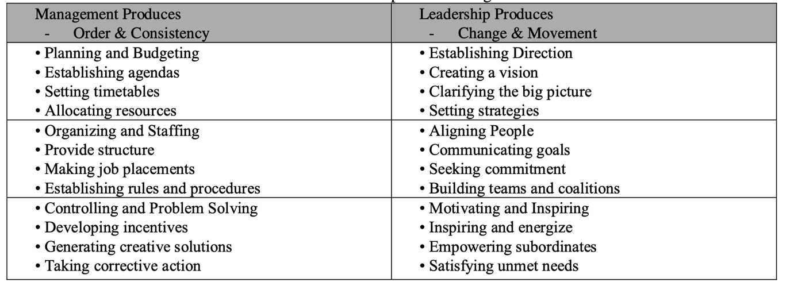(Liphadzi, Aigbavboa and Thwala, 2017)

A manager tends to focus on the practical part of controlling resources and optimising processes within the company, while the leader focuses more on the motivational factor, concentrating more on teamwork and achieving a common goal. researchers have taken a more extreme view, stating that management and leadership perform activities that are almost opposite in nature (Liphadzi, Aigbavboa and Thwala, 2017)
However, the differences’ limitations are counterproductive and applying behavioural and situational theory is sufficient to demonstrate it.
In the situational approach, leaders adjust their leadership styles to match their followers’ development levels directly. The behavioural approach defines task and relationship dimensions. A leader can adopt task-related behaviour, even if it is usually Apple's management style by Tim Cook has double faces. His leadership is described as democratic focusing on cooperation. However Tim is described by followers as sharp personality, questioning employees a lot in order to maintain control (Investopedia Team, 2023).
The Path-goal theory emphasizes the importance of leaders adapting their leadership style to the needs and abilities of their followers. By providing support, and guidance, and removing obstacles, leaders can create a motivating and empowering work environment that enables followers to achieve their goals. This approach recognizes that each follower is unique and may require different types of support to excel in their roles. The application of the theory is structured by defining leader behaviour, directive, supporting, participative or achievement-oriented leadership, follower, and task characteristics (Northouse, 2019).
Bezos's sentence ‘Good leaders are right a lot” (Hardy, 2022) describes his autocratic style. His leadership is focused on customers first. Therefore, employees must be attentive and responsive to customers' needs to meet their expectations and provide excellent service. In this context, Amazon's leadership can be described as a directive, where employees follow the processes to maintain customer satisfaction. (Hardy, 2022) The way Jeff Besos applies his leadership is reflected in highly task-related behaviour. As more than one employee within the company reports, the motivational part is almost absent, and the central part of the company is the control of employees (Kantor and Streitfeld, 2015), a purely managerial function.

McDonald's can be considered a company whose culture aims to create a positive and inclusive work environment for employees. They prioritize team-building activities that promote camaraderie and foster a sense of belonging among employees (Pontefract, 2022). Following the Path goal theory, this type of leadership can be described as participatory (Northouse, 2019).

From these examples, it is evident how the path-goal theory demonstrates how leadership and behaviour change depending on the desired reaction of followers.
However, the idea is used on a large scale following the company's general line. The path-goal theory incorporates to many aspects to be applied at a company leadership level. It is challenging to fully use the path-goal approach to enhance the leadership process in a particular organizational setting due to its broad scope and inclusion of numerous interconnected sets of assumptions (Northouse, 2019).
However, Jeff Bezos is an example of how leaders can shift their behaviour towards a task-related approach an evident confirmation of how leaders are aware of managerial tasks and how to direct them even at higher levels.

A leader can be a manager; however, situational issues set limits. In large companies like Coca-Cola, the structure prevents leaders from carrying out specific managerial its functions that take place only at a situational level. As Neville Isdell explains, combining a good balance sheet with leadership motivational functions can determine the growth of the company. He’s a good example since he has outstanding knowledge of Coca-Cola's inside processes (Russellreynolds, 2022).

Great leaders are managers because they understand the specific ways that work needs to get done to be efficient and effective, the limit is practicing managerial functions is set up by how bis is the company and the type of organization.

PERSONAL AND EMPLOYABILITY SKILLS FOR MANAGERS AND LEADERS
The managerial and leader positions require skills at a personal level and employability to predict the impact on organizational effectiveness.
‘Skills are the ability to perform something effectively, determined jointly by learning and heredity.’ (Yukl and Gardner, 2020, pp.192–215)
The skills are divided into personal traits such as self-confidence and employability skills.

PERSONAL SKILLS

The following kinds of skills are defined as personal and can be applied to both leaders and managers.

Energy Level and Stress Tolerance

Energy level and stress tolerance are crucial for managerial effectiveness, as they help to handle demanding tasks, and stressful interpersonal situations and maintain their reputation.

Moderate Self-Confidence

Self-confidence is crucial for leadership effectiveness as it leads to initiative, problem-solving, and change introduction. However, excessive self-confidence can lead to dysfunctional behaviours, such as arrogance and autocracy.

Internal Locus

People with a strong internal locus of control take responsibility for their actions and organizational performance, are more flexible, adaptive, and innovative.

Emotional Stability and Maturity

Emotional maturity is a state of well-adjusted, controlled, and self-awareness of one's strengths and weaknesses, focusing on self-improvement rather than denying them.

Core Self-Evaluation

Directly connected with the skills described previously, the core self-evaluation is a consequent assessment of the significance, effectiveness, and personal capability.

Power Motivation

Managers need power to influence subordinates, peers, and superiors. Low power needs lack assertiveness and desire for group activities. A strong need for power is desirable, but its effectiveness depends on expression. Socialized power leaders are more effective than personalized power leaders, who use power for others' benefit and avoid coercion and autocracy. They are emotionally mature, less egoistic, and less defensive.

Personal Integrity

Integrity is crucial for interpersonal trust, demonstrating honesty, loyalty, fairness, justice, and altruism. It determinants expert and referent power, retaining followers' loyalty and gaining cooperation. Key indicators include honesty, truthfulness, and consistent behavior with values.

Achievement Orientation

Moderately high motivation achievement orientation is more effective as keeps tracks of goals, action plans, and obstacles, without neglecting team.

Need for Affiliation

People with a strong need for affiliation receive great satisfaction from being liked and accepted by others, and they enjoy working with people who are friendly and cooperative. (Yukl and Gardner, 2020, pp.192–215)

EMPLOYABILITY SKILLS
Employability skills are subdivided into technical, human, and conceptual skills. (Yukl and Gardner, 2020, pp.192–215). Considering the leadership of General Motors and the managerial part of Amazon, always based on the conception and personal experience of leadership and management in the business, it can be deduced that the orientation of these skills is different.
Leadership is aimed at motivating employees. (Armstrong, 2016, pp.182–298) The exemplary case of General Motors focuses on driving change encouraging and monitoring the development of employees within the company. The skills focus on coaching, teamwork, creating open communication in the team through constructive debates and recognizing areas of failure as lessons for employees (Hurley, 2023). General Motors' leadership skills promote gratitude, empathy, influence, courage, respect, and trust in employees. Leadership skills, therefore, have an interpersonal orientation, as they interfere with employees' attitudes and emotions and favour cooperation. (Yukl and Gardner, 2020, pp.192–215)
The organization benefits from this by creating a happy and idea-rich environment for employees to feel valued. The well-being of employees within the company has led General Motors to be classified as the most inclusive organization and made it highly adaptable to unexpected changes. (Hurley, 2023).

Amazon is a poor example of leadership, as it needs to provide employee motivation within the company. The managerial part is focused on technical skills, i.e. an understanding of the methods and procedures aimed at completing tasks and on the efficiency in using the tools offered by the company. (Yukl and Gardner, 2020, pp.192–215).
Therefore, Amazon's management focuses on skills such as innovation, speed, precision, and determination.
The central part of managerial skills is delegating tasks through structured roles. Intense supervision through data guarantees great control over employees and their jobs. (Kantor and Streitfeld, 2015) In addition, power and persuasion lead to fierce competition in the workplace and consequently to an effective performance of employees as they are eager to grow in the workplace. The interviews are based purely on the workers' skills, not on their personal and professional growth (Armstrong, 2016, pp.182–298). Workers maintain strong working and decision-making independence, and self-education at work guarantees good practice and job enrichment, keeping employees who are enviable by other companies (Armstrong, 2016, pp.182–298). As Kantor and Streitfeld argue, Amazon employees are like athletes with endurance and speed. (Kantor and Streitfeld, 2015) The performance of employees also aligns with the goals of the organization, which enjoys solid profits and breaks down competition.

Within the two cases analyzed above, including conceptual skills is vital because they allow you to see the bigger picture and improve problem resolutions (Yukl and Gardner, 2020, pp.192–215). As a manager, these skills are vital and act as a bridge under challenging situations, such as employee conflicts. For example, emotional intelligence is an essential employability skill, which, in my experience, has the power to motivate the employee, to imply adequate communication and attitude for the resolution of tasks and even to lead growth on a personal level.

Conclusion

persistence. A leader is flexible, innovative, inspiring, courageous and independent and at the same time a manager is consulting, analytical, deliberate, authoritative and stabilizing. However, literature varies on the core skills of leadership and management. Some researchers have taken a more extreme view, stating that management and leadership perform activities that are almost opposite in natur

Organizational Effectiveness
The choice of objectives and strategies to pursue
• The motivation of members to achieve the objectives
• The mutual trust and cooperation of members
• The organization and coordination of work activities
• The allocation of resources to activities and objectives
• The development of member skills and confidence
• The learning and sharing of new knowledge by members
• The enlistment of support and cooperation from outsiders
• The design of formal structure, programs, and systems
• The shared beliefs and values of members

