ASSIGNMENT

Module: Changemakers: Building your Personal Brand for Sustainable Employment

Module Code: BMHP5015

Assignment: Component 2
Written Report

Student Name: Bouchra El Imrani Taidi

Student Number: 2321157



Introduction

The health and social care sector in England play a vital role in supporting individuals with a wide range of needs, particularly those affected by mental health conditions. As a Level 5 student studying health and social care, my learning so far has strengthened my understanding of personal development, employability, and the importance of building a professional identity.
Sustainable employability in the UK health and social care sector requires individuals to develop a strong combination of technical skills, personal values, professional behaviours and a clear professional identity. There has been an increasing demand for frontline healthcare professionals, especially support worker roles in health and mental services. These roles play a vital part in ensuring high-quality, holistic and compassionate care.
This report helps to examine the skills and competencies required for the position of support worker in mental health services in Discharge to assess (D2A) units as advertised on NHS Jobs/trac jobs website. In this report, I will focus on critically analysing the advertised job description and person specification, evaluating my current skills and presents a comprehensive action plan and five-year developmental timeline. Additionally, it will also explore how building a personal brand, developing a professional identity and strengthening professional networks can support long-term career progression and sustainable employment within the sector. In doing so, the report aims to demonstrate reflective ability, critical thinking, and strategic planning in line with expectations for modern health and social care roles.

Job Description and Person Specification

I will use online search platforms such as trac /NHS jobs to search for recent NHS vacancies for a mental health support worker (MHSW) within a discharge to assess service. It outlines a range of responsibilities including supporting patients who are medically optimised for discharge but require continued observation, emotional support and assessment in their own homes or temporary accommodation (NHS Jobs, 2025). The job description states that MHSWs must promote patient independence, provide practical support with daily activities, assisting patient while managing medication prompts, monitoring changes in mental state and ensuring safety of the patient. This role also includes escalating concerns to relevant clinical staff when required. The role requires supporting individuals with conditions such as dementia, Alzheimer’s disease, Schizophrenia, anxiety disorders and cognitive impairments, while applying person-centred approaches.

The person specification emphasises on strong communication and interpersonal skills, the ability to form therapeutic relationships and understanding of safeguarding. The basic knowledge of mental health conditions is highly important for this role along with capacity to work within a multidisciplinary discharge planning team. Emotional resilience and the ability to remain calm under pressure are essential. The role requires awareness of the mental capacity act (2005), risk assessment principles and confidentiality standards. Desirable criteria include previous experience in mental health, and knowledge of crisis de-escalation techniques.

Analysis of Employability Skills Required

The mental health support worker role within D2A requires a range of technical, interpersonal, ethical and organisational skills. Communication is one of the most important competencies required for this due to the need of engaging in sensitive conversations with patients experiencing distress, confusion or mental health crises. Silverman, Kurtz and Draper (2013) argue that effective communication is a central determinant of patient trust which will lead to their adherence in overall care and safety. MHSWs must adapt their approach to individuals with cognitive impairment, language barriers or trauma histories.
Interpersonal skills such as empathy, rapport building, active listening and patience are essential in supporting individuals during crisis or transition. Research shows that therapeutic relationships strongly influence recovery outcomes and service engagement (Barker, 2017). In D2A contexts, transitions can be frightening or destabilising, making supportive communication even more critical.
Teamwork is another essential employability skill. D2A services integrate hospital teams, social workers, occupational therapists, community mental health professionals and family networks. According to Pollard (2015), multidisciplinary collaboration improves co-ordination, reduces delays and ensures overall continuity of care. MHSWs must communicate observations, share relevant information and participate in discharge planning.

The role also requires strong organisational skills and the ability to prioritise tasks effectively. D2A teams operate under time pressure to support safe discharges and reduce hospital bed occupancy. Cameron and Boddy (2016) in their RCT highlighted that poor time management in health settings can negatively affect care quality and overall staff wellbeing.
Technical skills include basic mental health knowledge, observational skills, understanding risk indicators and following care plans. Familiarity with safeguarding procedures and legal frameworks such as the Mental Capacity Act (2005) is essential for safe practice (Department of Health, 2015). MHSWs must recognise early warning signs of relapse, deterioration or safeguarding concerns, and escalate appropriately to clinical staff.

Ethical and professional competencies are crucial. Banks (2020) in his case study summarised that values-based ethics highlight safe social care practice, requiring workers to uphold dignity, confidentiality and non-judgemental approaches. Emotional intelligence (EI) including self-awareness and resilience is also essential, particularly when working with distressed individuals. Goleman (2018) identifies emotional intelligence as a core employability skill influencing decision making and interpersonal effectiveness.

To support my analysis of the skills and expectations required for this role, I have included the NHS infographic titled “What is a Healthcare Support Worker” (NHS Careers, 2024). This image is relevant as it summarises the core responsibilities, values, and progression pathways associated with healthcare support roles across the NHS, including mental health settings.

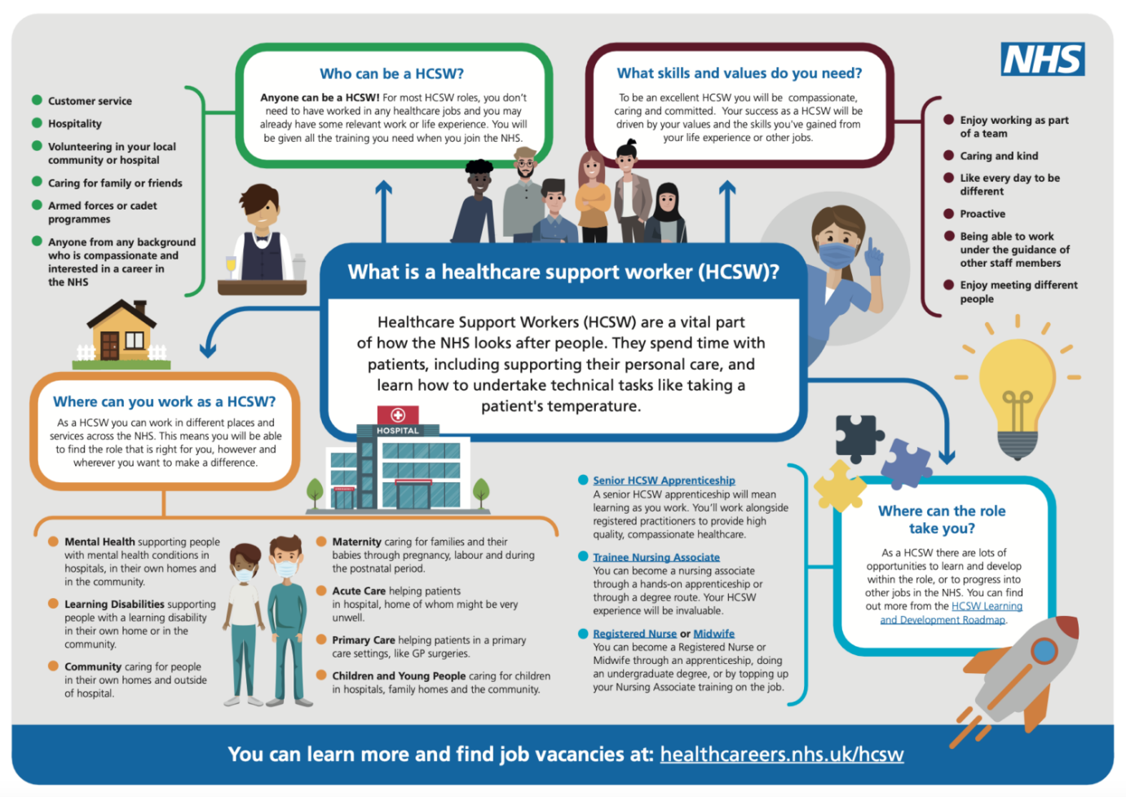
Image: Infographic of Healthcare support worker (Airedale NHS Foundation Trust, 2025)

The infographic strengthens the report by offering an accessible overview of the role, I am developing through my academic and practical experiences. It also helps to shape the timeline and goals as it also talks about learning and development roadmap which I have discussed further below in the report.

Overall, the Mental Health Support Worker role in D2A services requires a holistic blend of interpersonal, professional, technical and reflective skills.

I have also attached screenshots of job search in the appendix. (Oxford Health NHS Foundation Trust, 2025)

Evaluation of skills

While comparing my skills against the job requirements, it highlights certain strengths as well as areas for development. Through my health and social care level 5, I have gained academic knowledge of mental health conditions, safeguarding principles and person-centred care.
I believe one of my key strengths is my communication ability. I have experience of engaging with individuals in voluntary settings, care home settings which has allowed me to develop active listening, empathy and adaptability. Feedback from supervisors in my voluntary work indicates that I am approachable, patient and capable of supporting individuals with diverse needs. These qualities align well with the interpersonal demands of the D2A mental health role.
I also possess strong digital skills, enabling me to manage electronic notes and communicate effectively within teams. My ability to remain calm in stressful situations, reliable and organised helps me manage tasks efficiently skills essential when working in pressured environments like hospital discharge services.
However, I recognise that I currently lack direct clinical experience working with individuals with severe mental health conditions in discharge settings. I have limited exposure to risk assessment practices, evaluations or supporting individuals during complex transitions. I also need to develop greater emotional resilience, as mental health roles can expose staff to challenging behaviours, trauma histories and emotionally intense situations.
Incorporation of reflective tools such as a SWOT analysis will help me to identify the gaps (Wijngaarden et al., 2012). I will regularly seek help from my supervisors and tutors to gain more hands-on experience through structured placements. Additionally, developing confidence and competence in mental health support requires consistent exposure, training and reflective practice. Although, I possess strong foundational values, I need further training to meet the full person specifications and expectations of the role.

Existing experience and qualifications
My current health and social care degree has equipped me with essential knowledge of safeguarding, human development, ethics, inequalities, social care legislation and mental health frameworks. I have completed introductory training in areas such as safeguarding adults, equality and diversity and basic first aid. These demonstrate my commitment to safe practice and values-based care.
My past voluntary work and in care home settings has helped me to provide relevant experience regarding supporting individuals with emotional needs, encouraging participation in activities, and offering practical help. These experiences helped me develop communication skills, patience and cultural awareness. Although not clinical, these experiences introduced me to professional boundaries, confidentiality expectations and the emotional demands of support roles. This provides a solid foundation for transitioning into mental health services.

Building my personal brand
Personal branding involves presenting a consistent and professional identity that reflects one’s values, strengths and aspirations (Peters, 1997). To build a brand aligned with mental health support roles, I will focus on caring and empathetic approach. I will develop a professional LinkedIn profile showcasing my qualifications, training, reflective insights and commitment to mental health advocacy. Shepherd (2005) argues that a strong personal brand differentiates candidates in competitive markets and signals credibility to employers.
I will also reach out to relevant people to build connections via LinkedIn for making stronger networks and getting more information regarding jobs and requirements.
Additionally, I will also create a digital portfolio containing certificates, CPD logs, reflections and voluntary experience summaries.

Promoting professional Identity
Professional identity refers to the values and behaviours that define one’s role within the sector. Adams et al. (2006) suggest that identity develops through training, reflection and socialisation. For mental health support work, professional identity must reflect empathy, resilience, ethical awareness and trauma-informed practice. To strengthen my identity, I will engage in reflective practice, seek supervision and align my behaviour with NHS values. I will also familiarise myself with legislation relevant to D2A services, such as the care act (2014) and mental health act (1983, amended 2007), reinforcing my understanding of safe practice.

Building a professional network
Networking enhances employability by connecting individuals to opportunities, mentorship and resources (Kadushin & Harkness, 2014). To build my network, I will engage with mental health professionals through volunteering placements, LinkedIn groups, NHS mentoring programmes and career fairs. These networks will support my transition into D2A mental health services by offering insights into best practice, training events and job opportunities.

Action plan and timeline

My action plan focuses on developing the skills, experience and qualifications needed to secure a role as a mental health support within the next year. In the short term, over the next upcoming months, my immediate aim is to complete my Level 5 studies and begin gaining voluntary experience with mental health charities within NHS. I can also look for roles for healthcare assistant/ rehab assistant within mental health services to further expand my clinical hands- on practise within the relevant field. This will allow me to develop confidence in supporting individuals experiencing emotional distress and help me apply my academic knowledge in real situations. During this period, I will also complete online CPD courses related to anxiety, safeguarding and communication etc, which will strengthen my knowledge base and demonstrate my commitment to professional development. By the end of the year, I also aim to have created a professional LinkedIn profile and begun networking with mental health practitioners.
Over next year, I intend to secure part-time paid work in a support worker role within community/ residential settings or NHS. This will allow me to gain practical hands-on experience, understand organisational policies and participate in multidisciplinary (MDT) working. I am aware that job hunting can be lengthy process, therefore I will start writing my supporting information by year 4. I will also get relevant help and support from my tutors by gaining advice regarding the supporting information. During this period, I will also complete PMVA (Prevention and management of violence and aggression) or other relevant training to ensure I can safely support individuals in crisis or distress. Furthermore, I will participate in supervision sessions and reflective practice discussions to enhance my self-awareness and resilience. By the end of year 3, I expect to be confident in contributing to risk assessments, documenting observations accurately and working collaboratively with other professionals.
In the longer term, by years 4 and 5, I aim to apply for senior roles in NHS mental health support and further develop my expertise through additional CPD opportunities and specialist training. The CPD courses can include understanding dementia, building leadership roles, and advanced safeguarding. During this time, I plan to evaluate whether I would like to progress into higher-level roles/ take managerial responsibilities, pursue further study such as a postgraduate diploma in mental health. By maintaining an active professional network, engaging in reflective practice and continuing to develop my personal brand, I aim to position myself as a strong and competitive candidate for future roles.

My long-term plan is to gain clinical experience and then take on leadership and managerial responsibilities. I will start looking for management, co-ordinator roles to advance toward this goal.

Conclusion
This report has explored the key skills, professional behaviours, and values needed for a mental health support worker role within a discharge to assess (D2A) service. By closely analysing the job description, I identified vital employability skills such as effective communication, teamwork, ethical awareness, emotional intelligence, and the ability to manage crises. Reflecting on my own abilities, I recognized strengths in communication and compassion, while also acknowledging the need to gain more clinical experience and build resilience. The report further highlighted the importance of developing a personal brand, professional identity, and networking to maintain long-term employability. Through a detailed five-year action plan, I am dedicated to enhancing the skills required to succeed and grow in mental health and discharge support roles. Ultimately, my goal is to qualify as a social worker or gain a co-Ordinator/managerial role within the D2A setting, where I can contribute to safe, ethical, and person-focused patient transitions from hospital to home.

References
Adams, K., Hean, S., Sturgis, P. and Macleod Clark, J. (2006) ‘Investigating factors influencing professional identity’, Learning in Health and Social Care, 5(2), pp. 55–68.
Banks, S. (2020) Ethics and Values in Social Work. 5th edn. London: Red Globe Press.
Barker, P. (2017) Psychiatric and Mental Health Nursing: The Craft of Caring. London: Hodder Arnold.
Cameron, S. and Boddy, J. (2016) ‘Time management in healthcare’, Nursing Times, 112(4), pp. 22–25.
Care Act (2014) London: The Stationery Office.
Department of Health (2015) Mental Capacity Act Code of Practice. London: DoH.
Goleman, D. (2018) Emotional Intelligence. London: Bloomsbury.
Kadushin, A. and Harkness, D. (2014) Supervision in Social Work. New York: Columbia University Press.
Mental Health Act (1983, amended 2007) London: The Stationery Office.
NHS Constitution (2021) The NHS Constitution for England. London: Department of Health.
NHS Jobs (2025) Mental Health Support Worker – D2A Vacancy. Available at: www.jobs.nhs.uk (Accessed: [insert date]).
NICE (2020) Transition between inpatient hospital settings and community or care home settings. London: NICE.
Peters, T. (1997) ‘The brand called you’, Fast Company, 10, pp. 83–90.
Pollard, K. (2015) ‘Collaborative working in health and social care’, British Journal of Healthcare Management, 21(4), pp. 136–142.
Shepherd, I. (2005) ‘Self-marketing and personal branding’, Journal of Marketing Management, 21(5–6), pp. 589–606.
Silverman, J., Kurtz, S. and Draper, J. (2013) Skills for Communicating with Patients. London: Radcliffe.
van Wijngaarden, J.D., Scholten, G.R. and van Wijk, K.P., 2012. Strategic analysis for health care organizations: the suitability of the SWOT‐analysis. The International journal of health planning and management, 27(1), pp.34-49.
Skills for Care (2021) Code of Conduct for Healthcare Support Workers. Leeds: Skills for Care.
Skills for Health (2022) Mental Health Support Worker Competency Framework. London: Skills for Health.
Airedale NHS Foundation Trust, 2025. Health Care Support Worker. [online] Available at: https://www.airedale-trust.nhs.uk/jobs/careers/health-care-support-worker/

Appendix:

Screenshot of job search

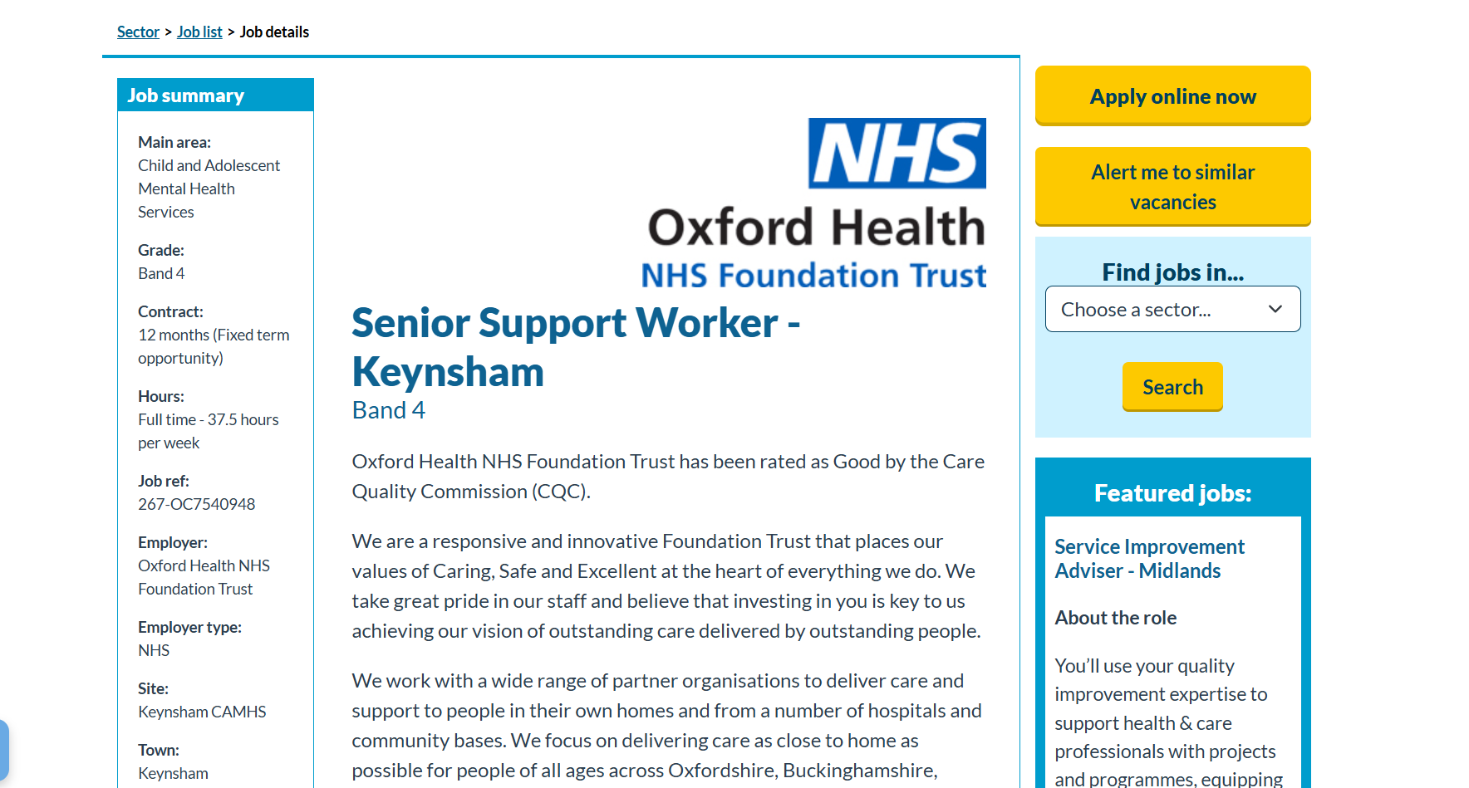
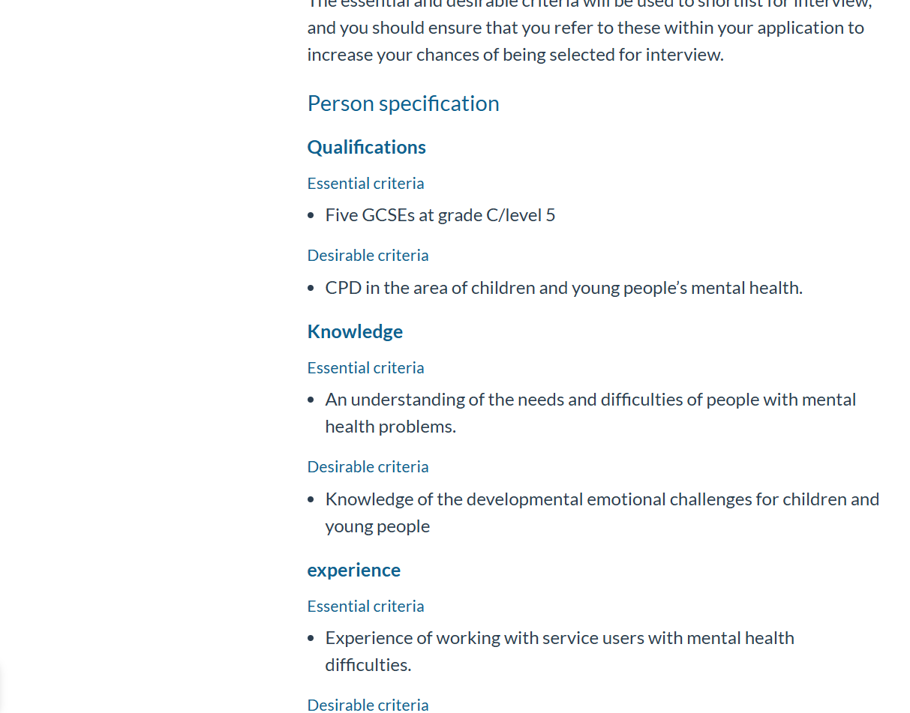

Reference: Oxford Health NHS Foundation Trust, 2025. Senior Support Worker - Keynsham. [online] Available at: https://www.healthjobsuk.com/job/UK/Oxfordshire/Keynsham/Oxford_Health_NHS_Foundation_Trust/Child_Adolescent_Mental_Health_Services/Child_Adolescent_Mental_Health_Services-v7540948?_ts=746

