Virtualisation

Student: Ana-Elena Tocariu
Student ID: 2121853
Course: Cloud Computing Architecture
Module: Cloud Computing Administration
Module code: ACCA6025
Lecturer: Renuga Jayakumar

1.Azure TCO

In this project scenario, I've replicated the existing on-premises setup to project the migration to Azure. This simulation includes a deliberate choice of hardware and network specifications tailored to the educational institute’s operational requirements.

For the server workload, I've allocated a robust configuration of 20 cores and 40 GB of memory to each server. This is a reflection of the significant processing power required to handle the demanding environment of an online educational platform. It's crucial that these platforms operate without hitches, as they support real-time interactions, video streaming, and access to a plethora of educational resources. The ten virtual machines that I've included in the plan offer scalability. This ensures that as the institute's user base grows, the infrastructure can expand to meet the increasing demands without a drop in performance. The use of VMware for virtualization in this scenario is intentional, as it replicates the institute's current environment, which is a testament to VMware's proven reliability and efficiency in their operations.

Moving to the database aspect, the selected 8 cores and 100 GB of memory for the SQL Server setup are reflective of a high-transaction environment. This mirrors the need for rapid query responses and the handling of concurrent transactions, which are typical in a bustling educational setup. The databases will house student records, course materials, and various administrative data, all of which are critical and require quick access and utmost reliability. With 1 TB of active database storage and an additional 3 TB for backup, I'm addressing both the immediate and disaster recovery needs, ensuring that data is not only available but also protected against any potential data loss scenarios.

The choice of Blob storage for files is guided by the nature of the data typically managed by an educational institution, which ranges from documents and spreadsheets to multimedia content. By allocating 1 TB of primary storage and an additional 3 TB split between backup and archival storage, I'm preparing for the lifecycle of the data from active use to long-term retention, which may be a requirement for institutional accreditation or regulatory compliance.

In terms of networking, I've selected a bandwidth provision of 500 GB, which is a careful balance between ensuring sufficient capacity for data transfer and managing operational costs. This bandwidth will support the distribution of educational content to a broad user base and facilitate synchronous educational activities without lag or disruption. The choice of the Azure UK South region is a strategic one, taking into consideration factors like latency, which affects user experience, and data residency, which could be governed by local data protection laws.

Altogether, these choices create a framework that is not only robust and capable of supporting the institute's present activities but is also scalable and adaptable enough to accommodate future growth. This forward-thinking approach is vital for the institute's transition into a more technologically agile and cost-efficient cloud-based operation.

Assumptions: Considering GLI has own or hosted data center, as per standard microservices architecture, below are the layers of infrastructure
- Webserver layer – This takes care of hosting the static content, load balancing and rendering highly available UI. This will be internet/public facing with all the security features like WAF, IDS, IPS, SSL, encryption etc.
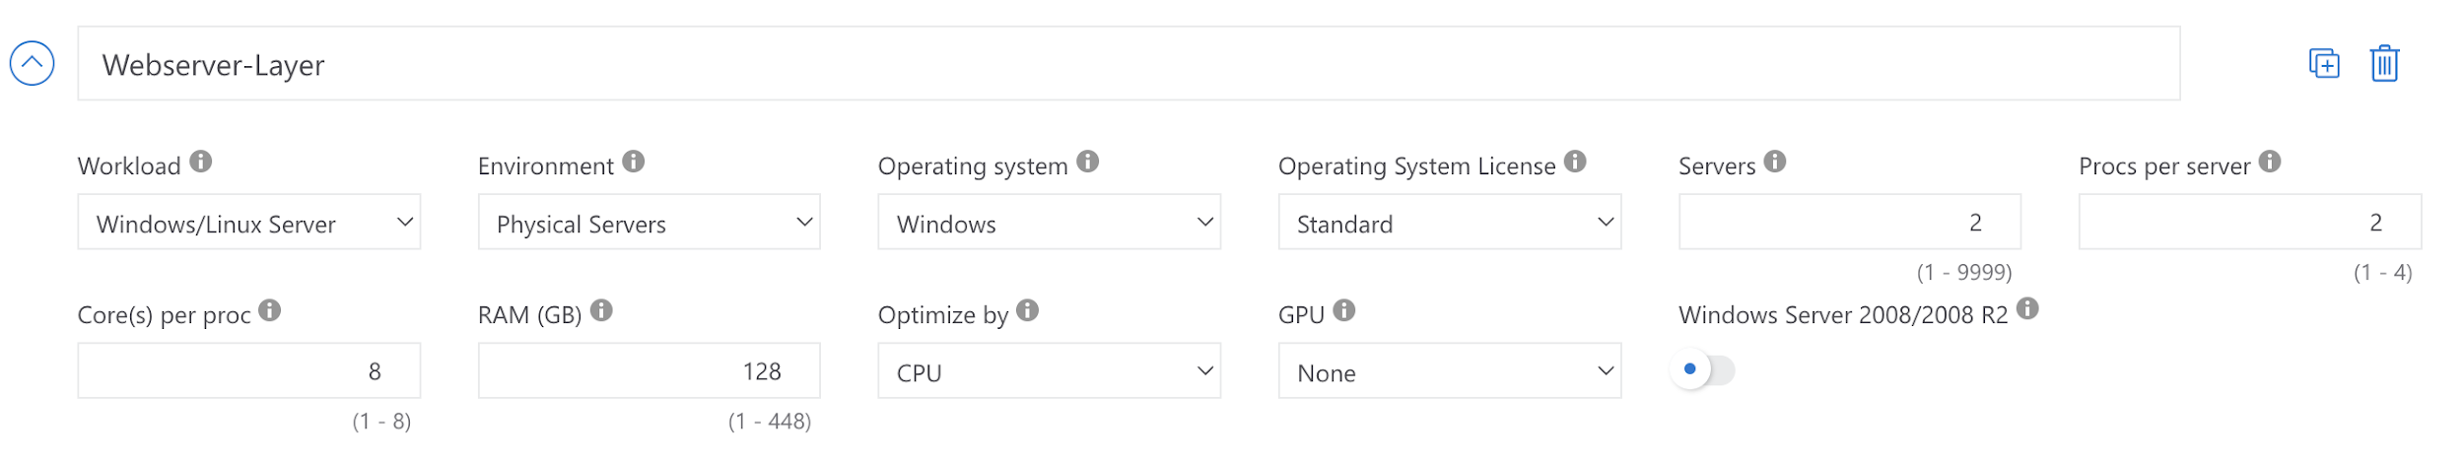
- Application Layer – This hosts the servers for application apis/micro services in container or Kubernetes or kubleflow architecture. These are stateless so that they can be scaled Up/Down as per the number of user hits or volume of data being accessed
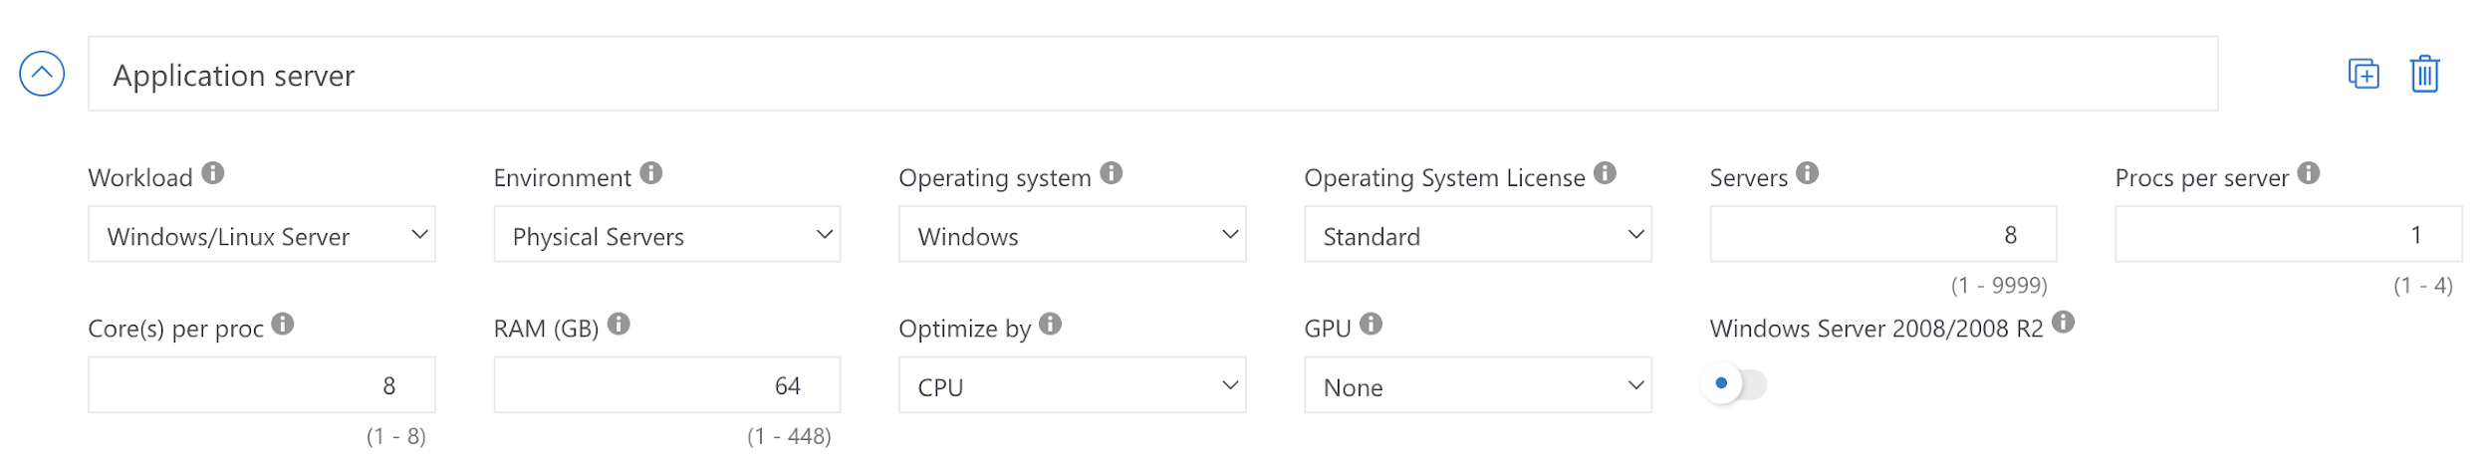
- Database Layer – This hosts the DBs for application and api related metadata. This layer has SQL DB for user data storage and management and NoSQL for metadata storage. This layer also has cache which takes care of data caching thus improving application response and reducing the latency. All these DBs and cache are configured with HA to ensure zero downtime and easy patching. There are read-replicas which server the user read and simple data query events thus lowering the load on DB and connections queue.
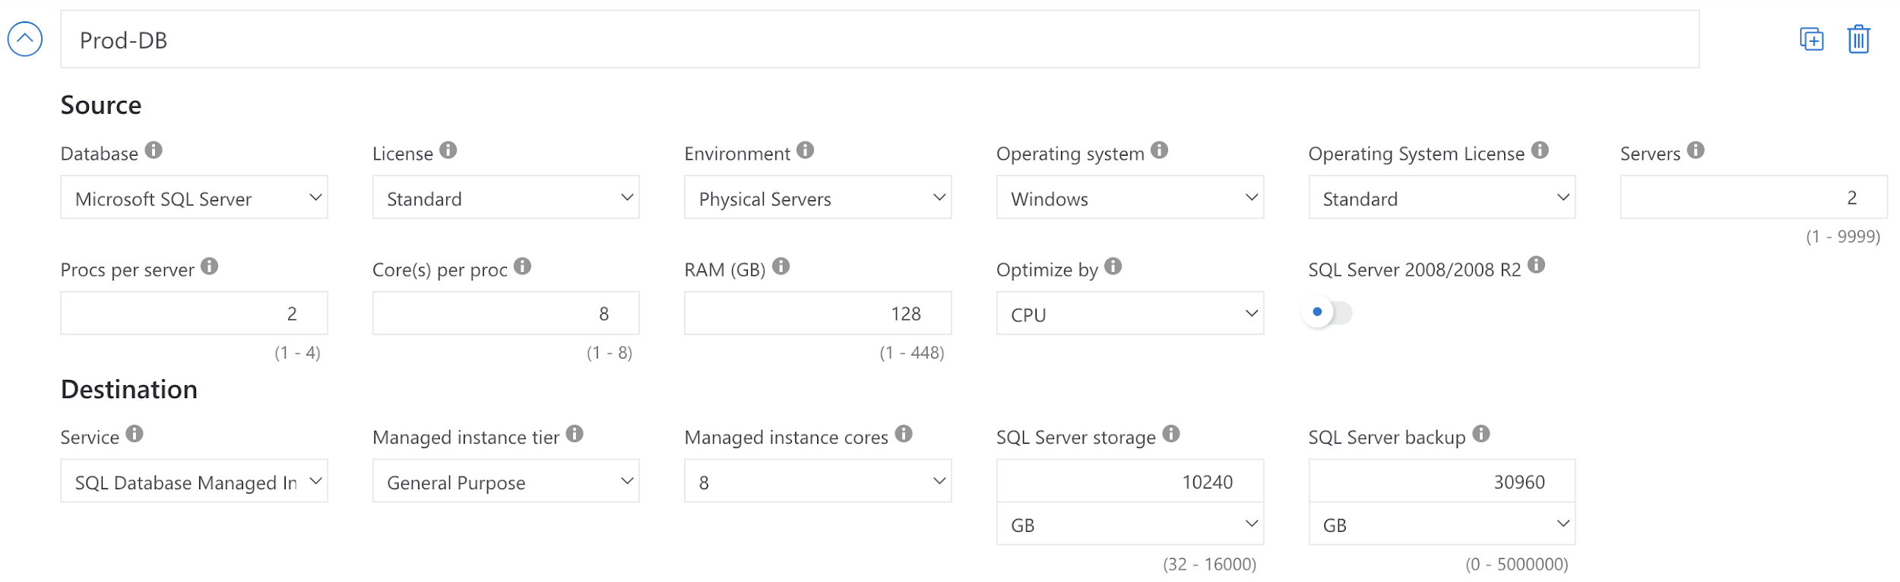
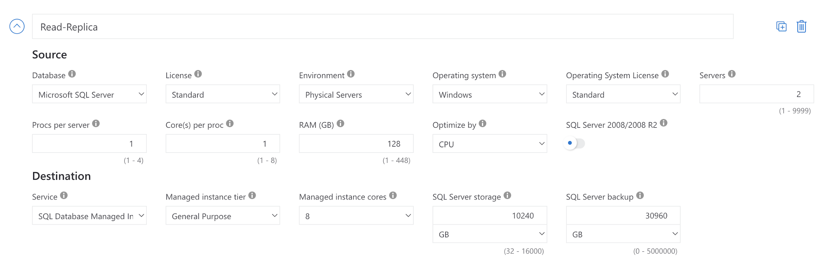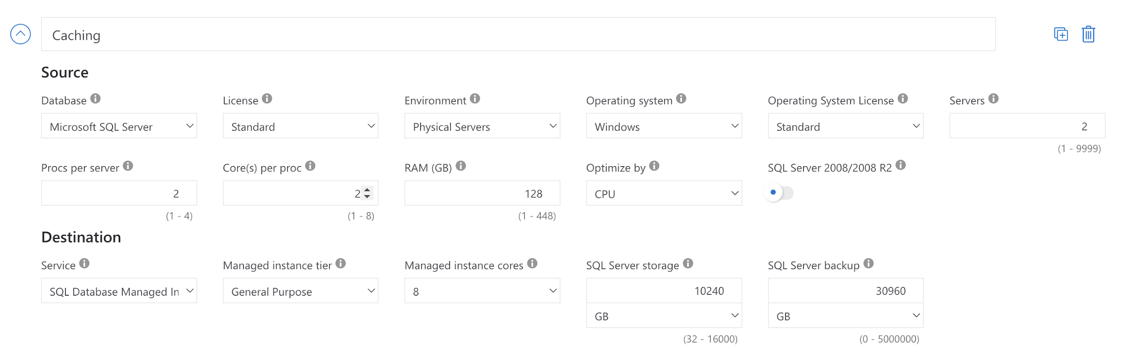

- Security and Automation – This layer hosts either physical servers or VMs for implementing security features like SIEM, VAPT, log analytics, encryption tools and devops tools like CI/CD(Jenkins/teamcity/circleci, IAC (ansible/chef/terraform)
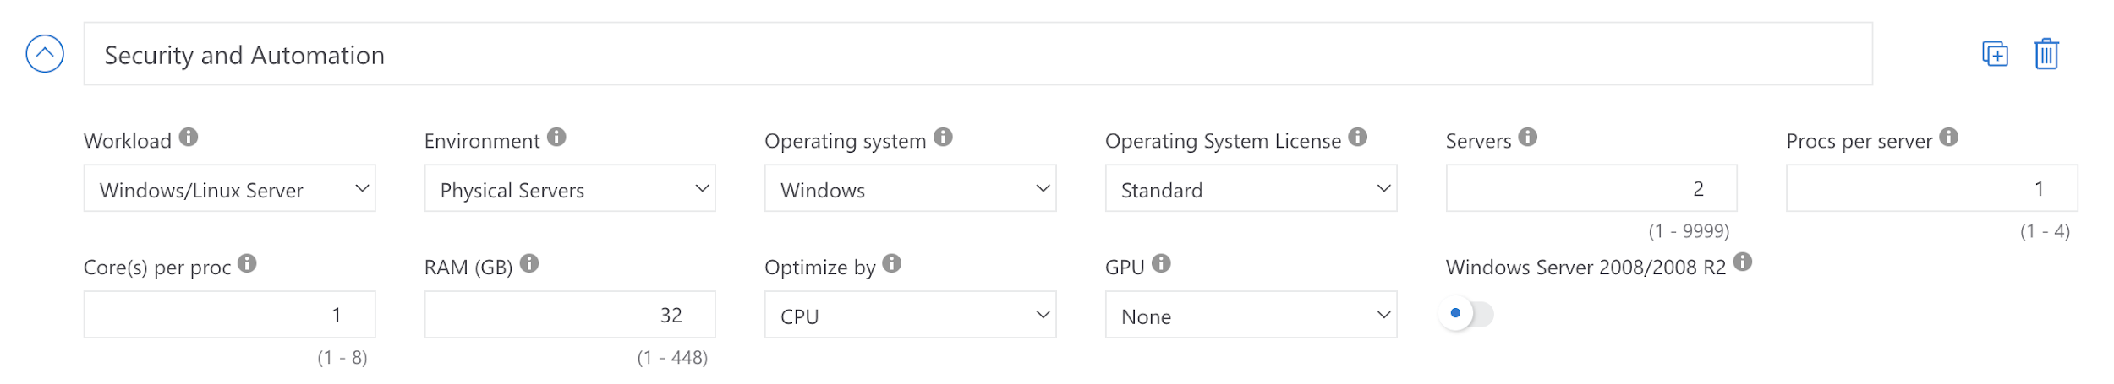
We have considered storage as 30TB for application, 10TB for DR/BCP and 20TB for Storing archived data.
Considering all these in a datacenter we have TCO attached which compares as below for 3 years: This covers section a) from task
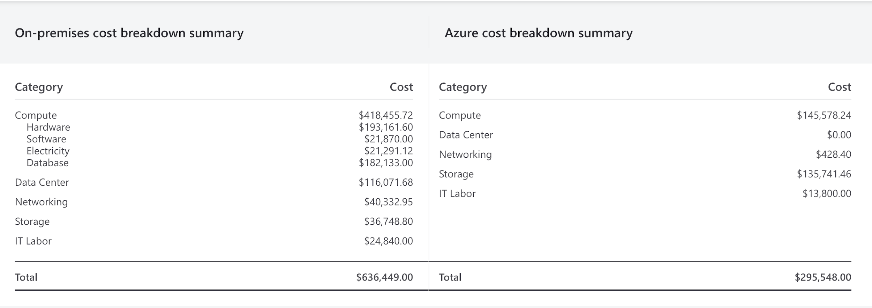
Please note that Storage cost is more on Azure because its distributed, edge-ready and with 3000 IOPs, where as in datacenter its DAS/NAS which is not HA, no edge-readiness and no IOPs.
Major benefits of Azure Storage vs datacenter SAN/NAS/DAS: (Section b) of task)
- Highly scalable :from 100GB through 1000PB with very less lead time vs procurement, install, configure, mange etc. in datacenter storage
- Highly Available: Azure Storage is highly available as it is managed service. There is support team available 24/7 for any issues to resolve. This feature replicates, encrypts and secures the data as per out need in minutes
- Durability: Once you decide on IOPs, type of storage like SSD/Io/GPP etc. you don’t have to worry about its maintenance and durability over the time
- Security: As Microsoft Azure is compliant with various certificatins like ISO 22K, GDPR, SOC2, HIPPA etc. the security of the data stored in Azure Storage is completely ben managed internally. As an end user you don’t have to worry about any security breaches or incidents unless you have followed industry best practices mentioned by Azure.
- Global Reachability: With Edge concept and replication feature your data is easily, reliably and securely accessed by end users across the world with least latency. This makes the user experience a better one
- Cost-Effective: With various options in Azure Storage like Blob, Table, Queue, File and on tiers like Hot/Cool/Archive Azure storage is most cost-effective as per your needs.
Security Features of Azure Storage:
- Enable Azure Defender for all your storage accounts.
- Turn on soft delete for blob data.
- Use Microsoft Entra ID to authorize access to storage.
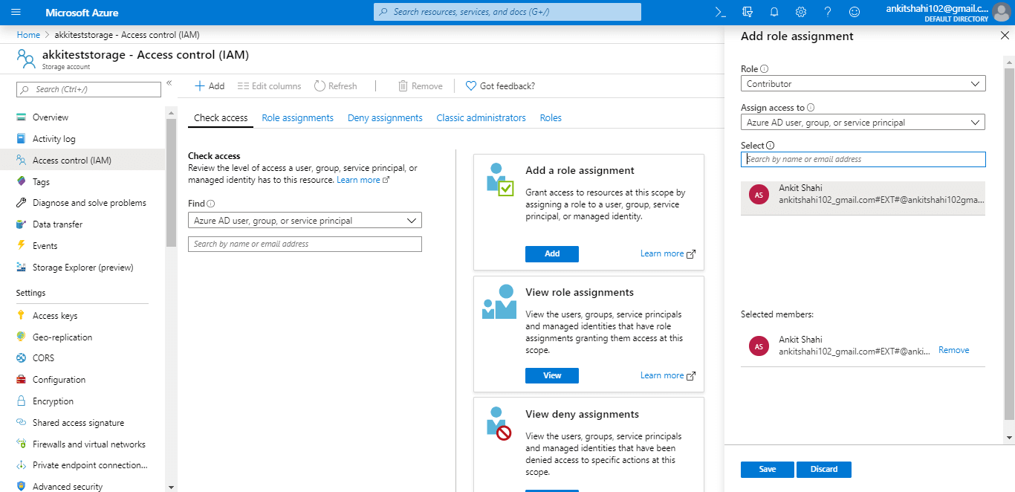
- Consider the principle of least privilege when you assign permissions to a Microsoft Entra security principal through Azure RBAC.
- Use managed identities to access blob and queue data.
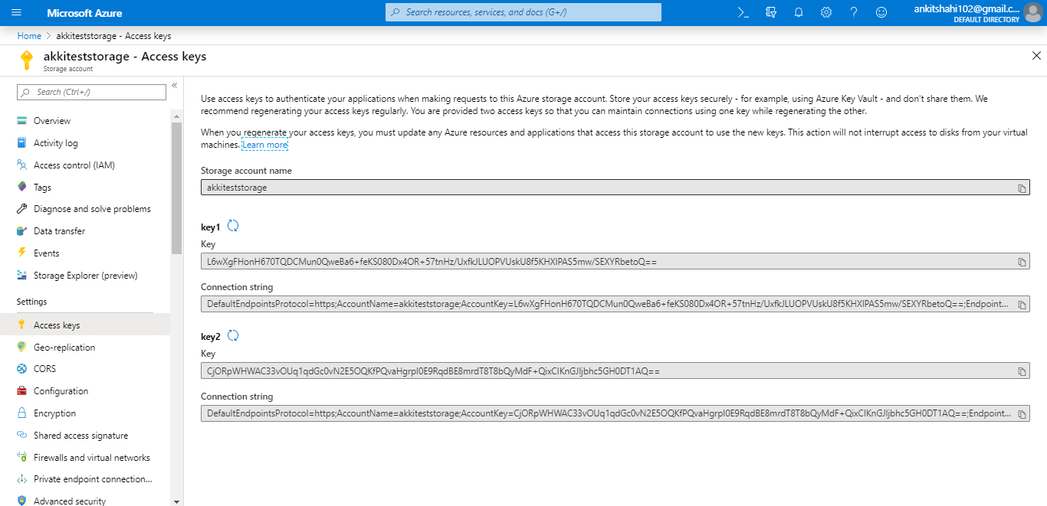
- Use blob versioning or immutable blobs to store business-critical data.
- Restrict default internet access for storage accounts.
- Enable firewall rules.
- Limit network access to specific networks.
- Allow trusted Microsoft services to access the storage account.
- Enable the Secure transfer required option on all your storage accounts.
- Limit shared access signature (SAS) tokens to HTTPS connections only.
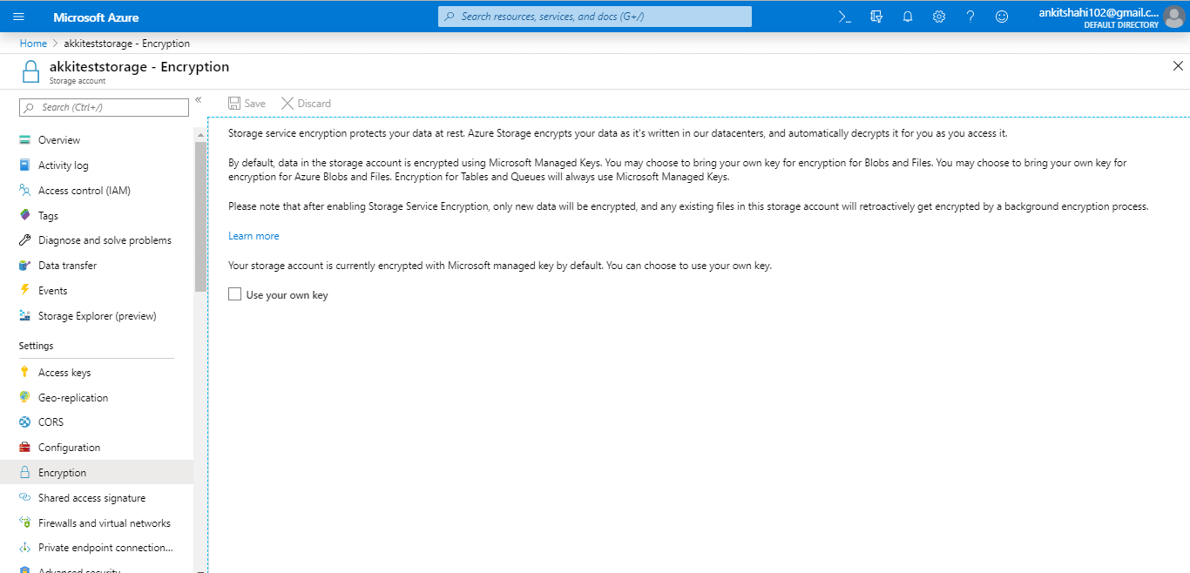
- Avoid and prevent using Shared Key authorization to access storage accounts.
- Regenerate your account keys periodically.
- Create a revocation plan and have it in place for any SAS that you issue to clients.
- Use CORS
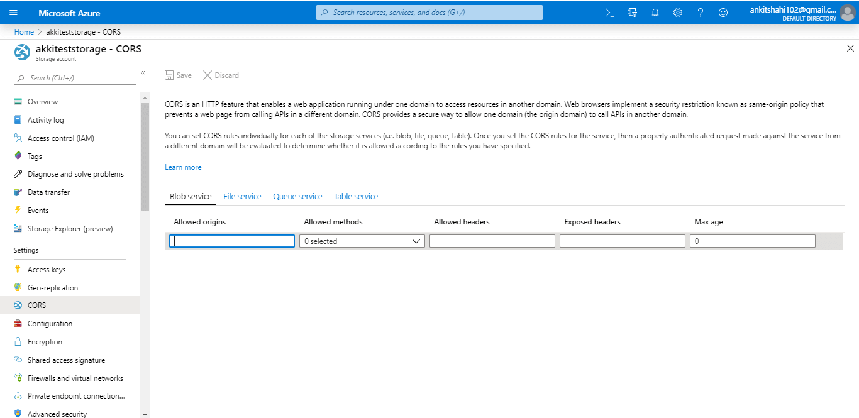
- Use near-term expiration times on an impromptu SAS, service SAS, or account SAS.
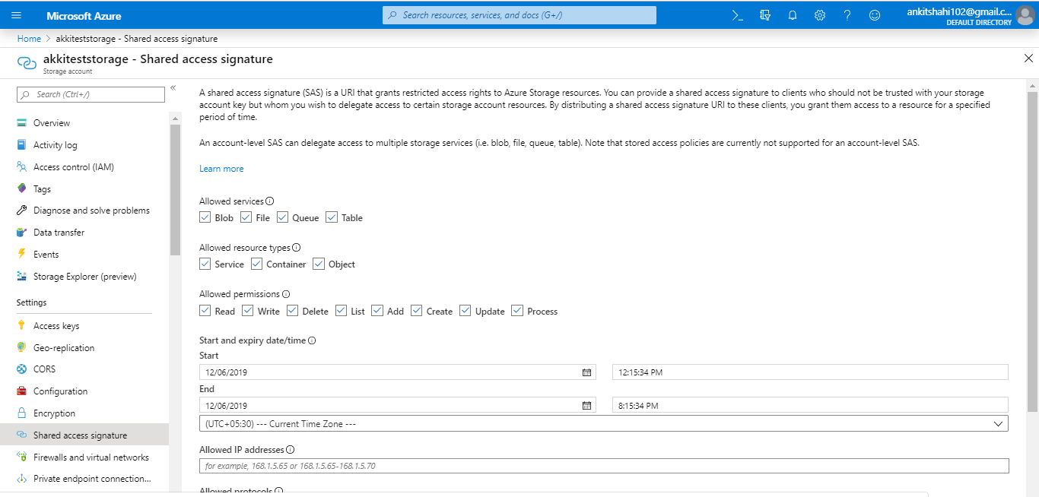
For the database choice, let’s look at the below comparison in Azure:
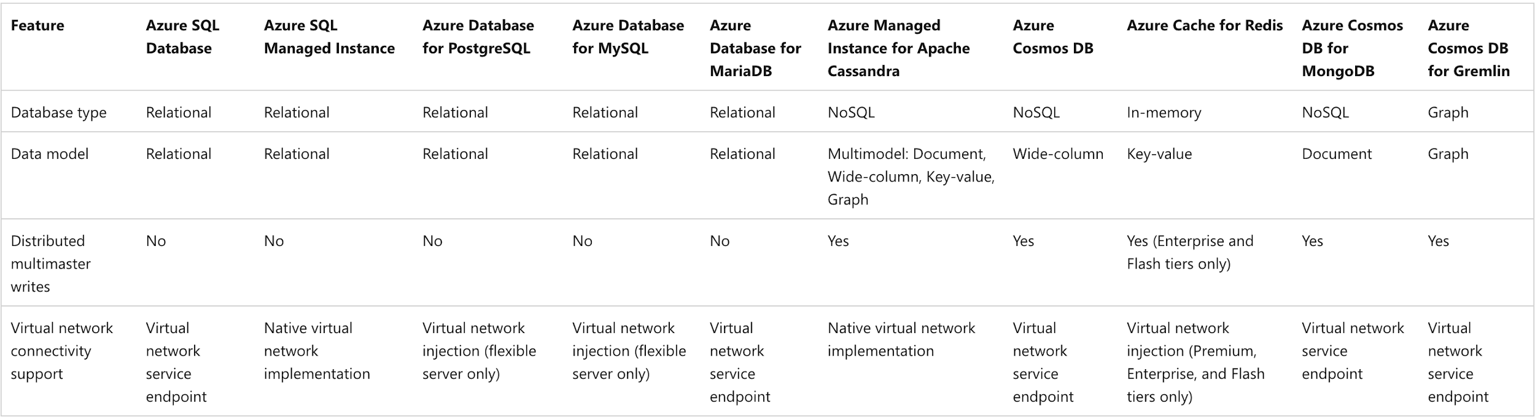
And for the user data/profile storage let’s look at the comparison:
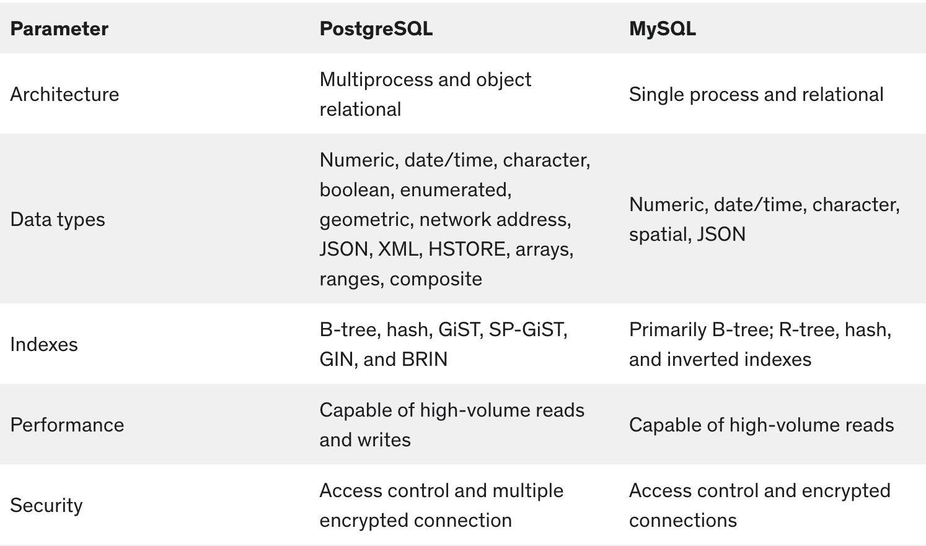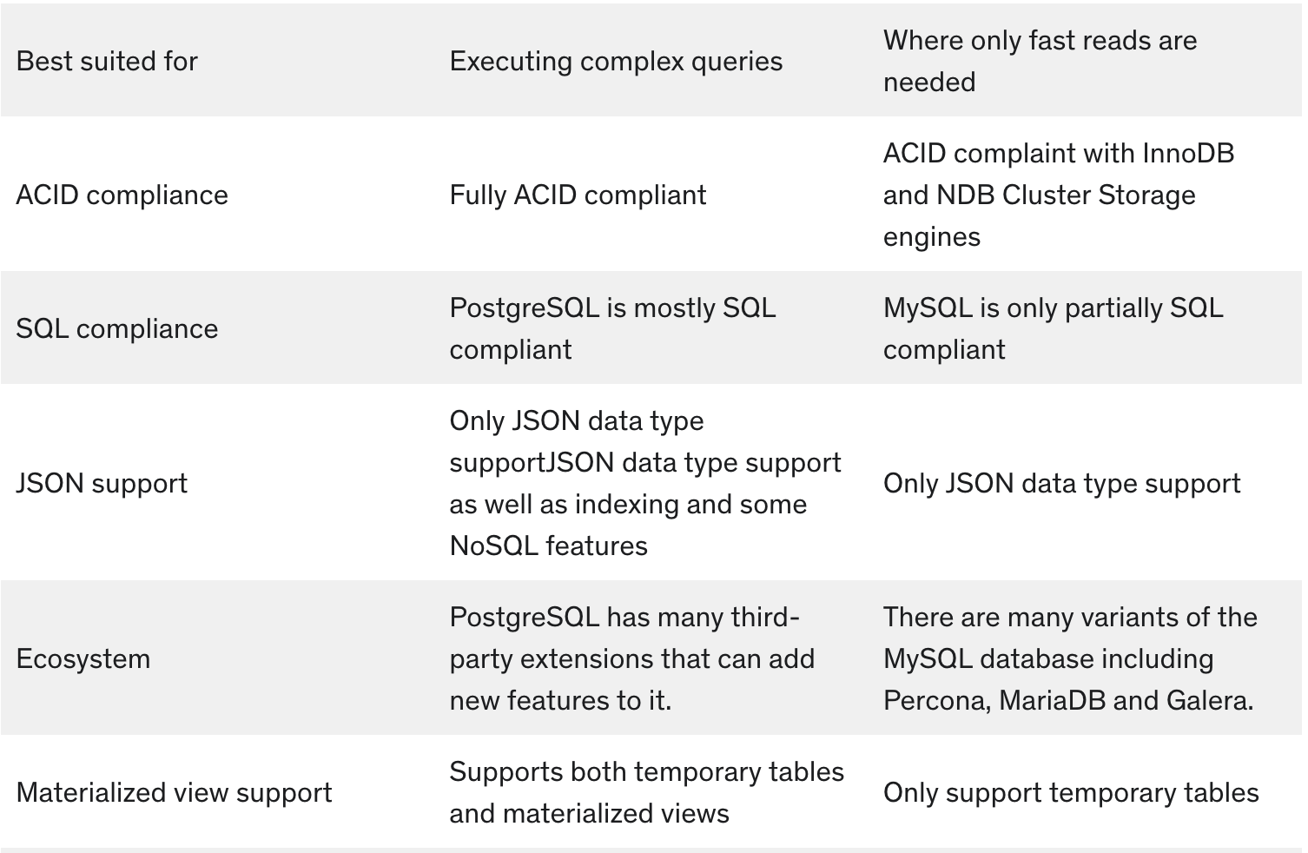

Here is the process of creating azure postgres db creation: (section c) from task)
- Select Create a resource (+) in the upper-left corner of the portal.
- Select Databases > Azure Database for PostgreSQL.
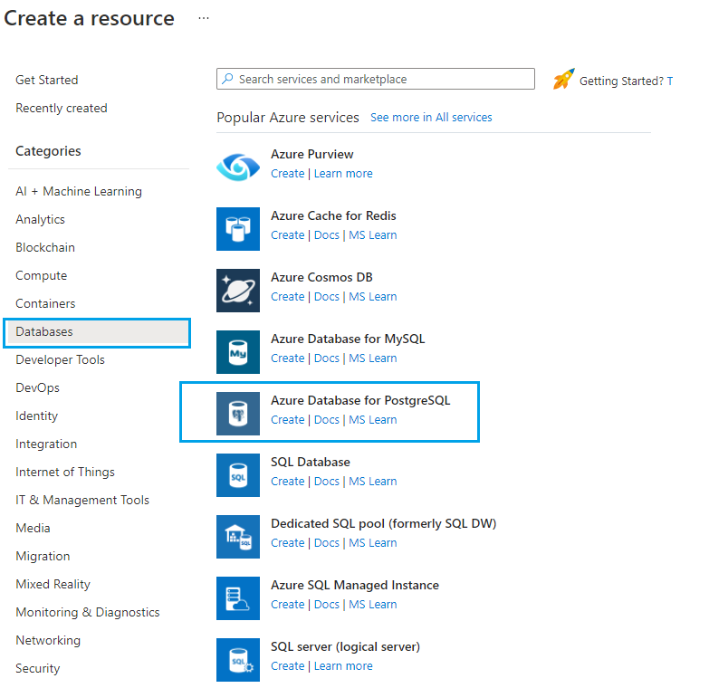
- Fill out the Basics form with the following information:
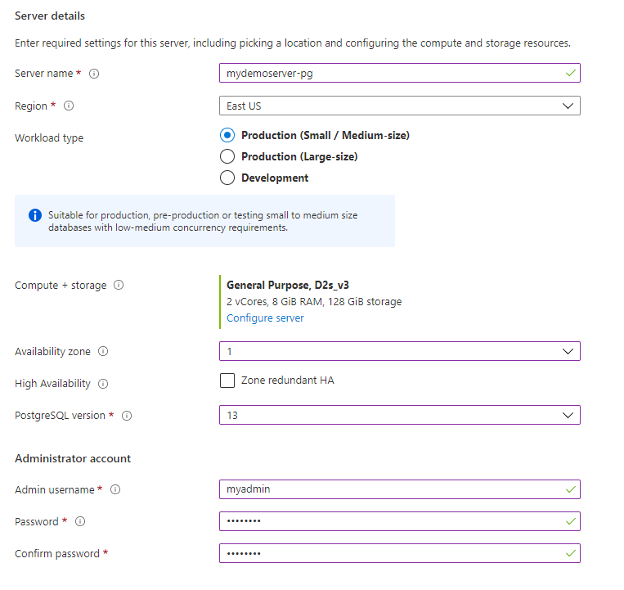
• Setting | Suggested Value | Description
Subscription | Your subscription name | The Azure subscription that you want to use for your server. If you have multiple subscriptions, choose the subscription in which you'd like to be billed for the resource.
Resource group | Your resource group name | A new resource group name or an existing one from your subscription.
Workload type | Default SKU selection | You can choose from Development (Burstable SKU), Production small/medium (General Purpose SKU), or Production large (Memory Optimized SKU). You can further customize the SKU and storage by clicking Configure server link.
Availability zone | Your preferred AZ | You can choose in which availability zone you want your server to be deployed. This is useful to co-locate with your application. If you choose No preference, a default AZ is selected for you.
High availability | Enable it for same zone or zone-redundant deployment | By selecting this option, a standby server with the same configuration as your primary will be automatically provisioned in the same avaibality zone or a different availability zone in the same region, depending on the option selected for High availability mode. Note: You can enable or disable high availability post server creation as well.
Server name | Your server name | A unique name that identifies your Azure Database for PostgreSQL flexible server instance. The domain name postgres.database.azure.com is appended to the server name you provide. The server name can contain only lowercase letters, numbers, and the hyphen (-) character. It must contain between 3 and 63 characters.
Admin username | Your admin user name | Your own login account to use when you connect to the server. The admin username must contain between 1 and 63 characters, must only cotain numbers and letters, can’t start with pg_ and can't be azure_superuser, azure_pg_admin, admin, administrator, root, guest, or public.
Password | Your password | Specify a password for the server admin account. The password must contain between 8 and 128 characters. It must also contain characters from three of the following four categories: English uppercase letters, English lowercase letters, numbers (0 through 9), and non-alphanumeric characters (!, $, #, %, and so on). Your password can't contain all or part of the login name. Part of a login name is defined as three or more consecutive alphanumeric characters.
Location | The region closest to your users | The location that's closest to your users.
Version | The latest major version | The latest PostgreSQL major version, unless you have specific requirements otherwise.
Compute + storage | General Purpose, 4 vCores, 512 GB, 7 days | The compute, storage, and backup configurations for your new server. Select Configure server. General Purpose, 4 vCores, 512 GB, and 7 days are the default values for Compute tier, vCore, Storage, and Backup retention period (in days). You can leave those sliders as they are or you can adjust them.  To configure your server with geo-redundant backups to protect from region-level failures, you can enable the Recover from regional outage or disaster checkbox. Note that the geo-redundant backup can be configured only at the time of server creation. To save this pricing tier selection, select Save. The next screenshot captures these selections.
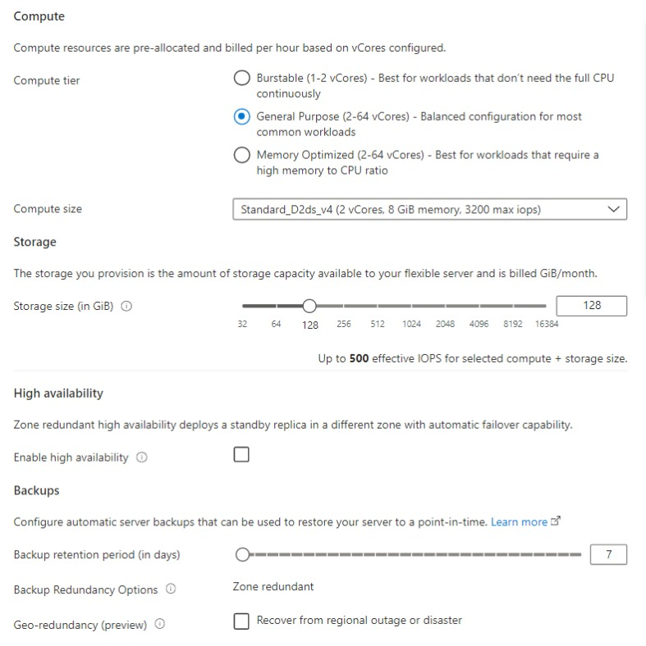
• Configure Networking options
• On the Networking tab, you can choose how your server is reachable. Azure Database for PostgreSQL flexible server provides two ways to connect to your server:
- Public access (allowed IP addresses)
- Private access (VNet Integration)
When you use public access, access to your server is limited to allowed IP addresses that you add to a firewall rule. This method prevents external applications and tools from connecting to the server and any databases on the server, unless you create a rule to open the firewall for a specific IP address or range. When you use private access (VNet Integration), access to your server is limited to your virtual network.
In this quickstart, you learn how to enable public access to connect to the server. On the Networking tab, for Connectivity method select Public access (alllowed IP addresses). To configure Firewall rules, select Add current client IP address.
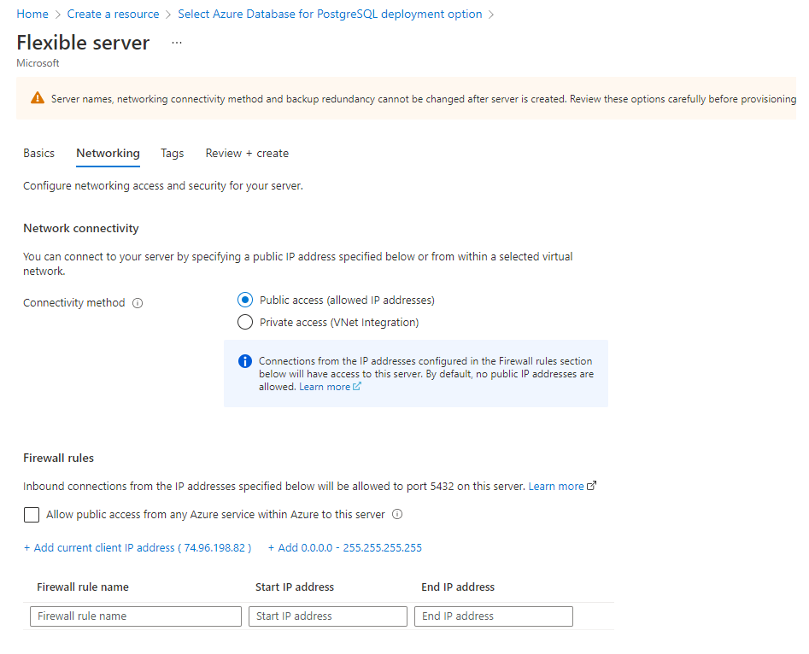• Select Review + create to review your selections. Select Create to provision the server. This operation may take a few minutes.
• You will automatically be taken to a screen in which you can monitor the progress of your deployment. Once the deployment is done, you can select Pin to dashboard, which creates a tile for this server on your Azure portal dashboard as a shortcut to the server's Overview page. Selecting Go to resource opens the server's Overview page.
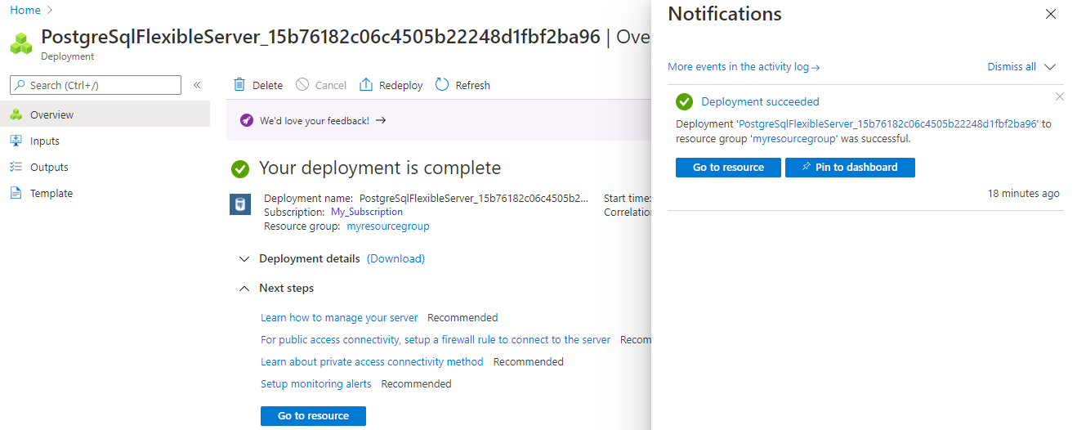
By default, a postgres database is created under your server. The postgres database is a default database that's meant for use by users, utilities, and third-party applications. (The other default database is azure_maintenance. Its function is to separate the managed service processes from user actions. You can't access this database.)
Get the connection information
When you create your Azure Database for PostgreSQL flexible server instance, a default database named postgres is created. To connect to your database server, you need your full server name and admin login credentials. You might have noted those values earlier in the Quickstart article. If you didn't, you can easily find the server name and login information on the server Overview page in the portal.
Open your server's Overview page. Make a note of the Server name and the Server admin login name. Hover your cursor over each field, and the copy symbol appears to the right of the text. Select the copy symbol as needed to copy the values.
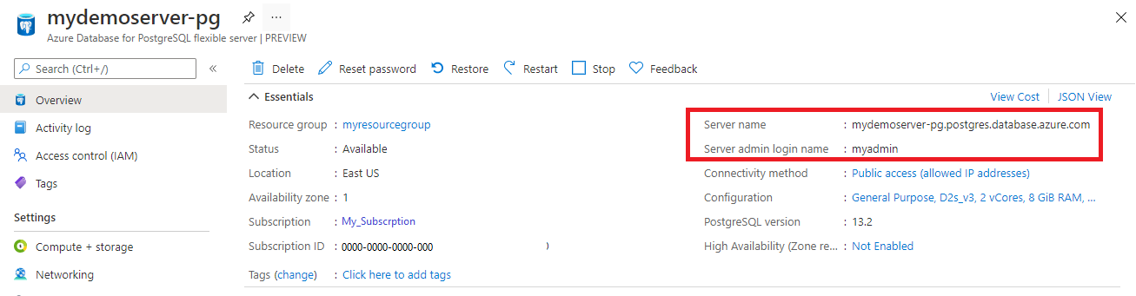
Connect to the Azure Database for PostgreSQL flexible server database using psql
There are a number of applications you can use to connect to your Azure Database for PostgreSQL flexible server instance. If your client computer has PostgreSQL installed, you can use a local instance of psql to connect to an Azure Database for PostgreSQL flexible server instance. Let's now use the psql command-line utility to connect to the Azure Database for PostgreSQL flexible server instance.
- Run the following psql command to connect to an Azure Database for PostgreSQL flexible server instance.
psql --host=<servername> --port=<port> --username=<user> --dbname=<dbname>
For example, the following command connects to the default database called postgres on your Azure Database for PostgreSQL flexible server instance mydemoserver.postgres.database.azure.com using access credentials. Enter the <server_admin_password> you chose when prompted for password.
psql --host=mydemoserver-pg.postgres.database.azure.com --port=5432 --username=myadmin --dbname=postgres
After you connect, the psql utility displays a postgres prompt where you type sql commands. In the initial connection output, a warning may appear because the psql you're using might be a different version than the Azure Database for PostgreSQL flexible server version.
Example psql output:
psql (12.3 (Ubuntu 12.3-1.pgdg18.04+1), server 13.2)
WARNING: psql major version 12, server major version 13.
Some psql features might not work.
SSL connection (protocol: TLSv1.3, cipher: TLS_AES_256_GCM_SHA384, bits: 256, compression: off)
Type "help" for help.

postgres=>
Configuring Azure Fileshare Backup: (section d) from task)
A Recovery Services vault is a management entity that stores recovery points that are created over time, and it provides an interface to perform backup-related operations. These operations include taking on-demand backups, performing restores, and creating backup policies.
To create a Recovery Services vault:
- Sign in to the Azure portal.
- Search for Backup center, and then go to the Backup center dashboard.
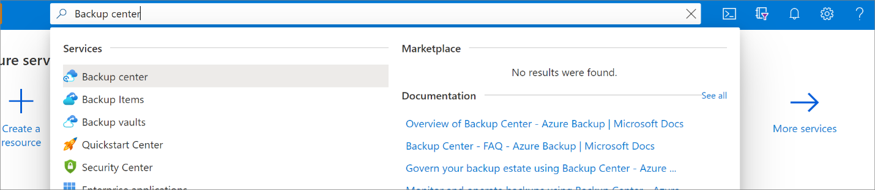
- On the Overview pane, select Vault.
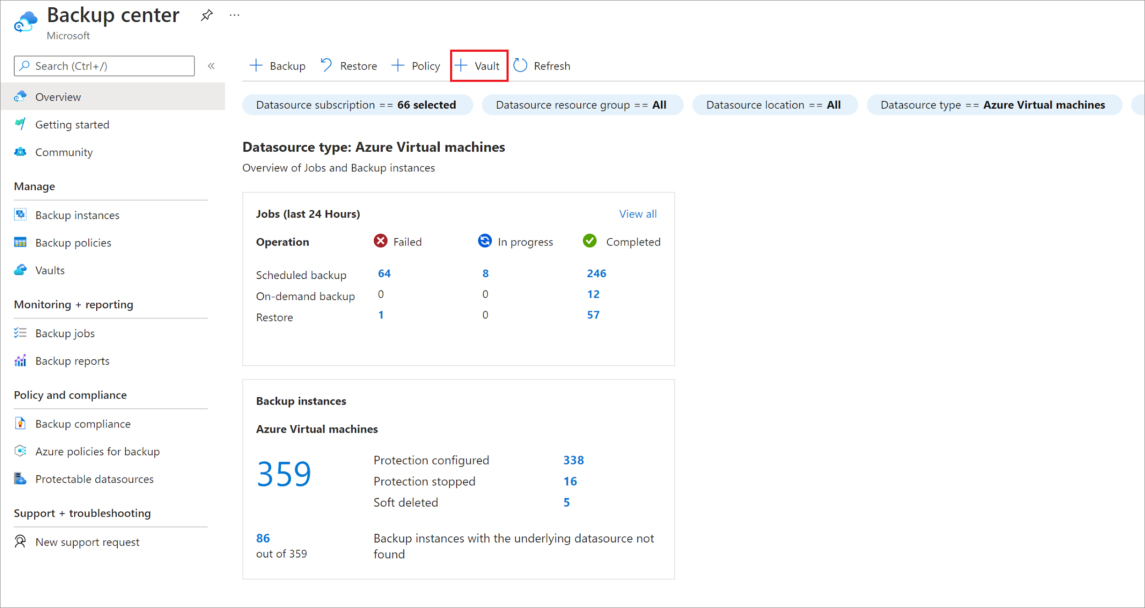
- Select Recovery Services vault > Continue.
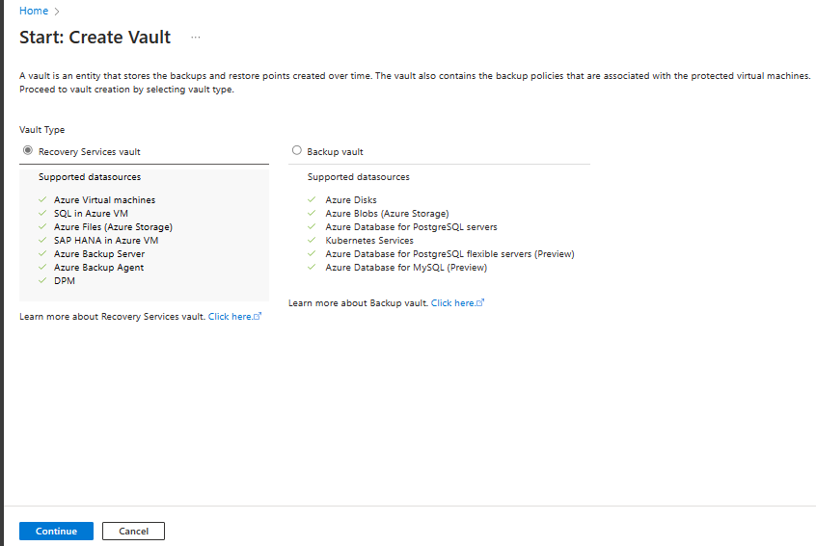
- On the Recovery Services vault pane, enter the following values:
  - Subscription: Select the subscription to use. If you're a member of only one subscription, you'll see that name. If you're not sure which subscription to use, use the default subscription. There are multiple choices only if your work or school account is associated with more than one Azure subscription.
  - Resource group: Use an existing resource group or create a new one. To view a list of available resource groups in your subscription, select Use existing, and then select a resource in the dropdown list. To create a new resource group, select Create new, and then enter the name.
  - Vault name: Enter a friendly name to identify the vault. The name must be unique to the Azure subscription. Specify a name that has at least 2 but not more than 50 characters. The name must start with a letter and consist only of letters, numbers, and hyphens.
  - Region: Select the geographic region for the vault. For you to create a vault to help protect any data source, the vault must be in the same region as the data source.

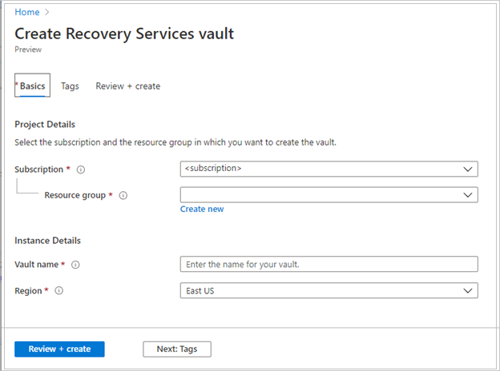
- After providing the values, select Review + create.
- To finish creating the Recovery Services vault, select Create.
It can take a while to create the Recovery Services vault. Monitor the status notifications in the Notifications area at the upper right. After the vault is created, it appears in the list of Recovery Services vaults. If the vault doesn't appear, select Refresh.
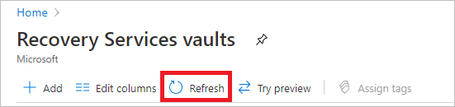
Note
Azure Backup now supports immutable vaults that help you ensure that recovery points once created can't be deleted before their expiry as per the backup policy. You can make the immutability irreversible for maximum protection to your backup data from various threats, including ransomware attacks and malicious actors.
Configure the backup
You can configure snapshot backup and vaulted backup (preview) for Azure File share from Backup center or File share blade.
Choose an entry point
To configure backup for multiple file shares from the Backup center, follow these steps:
- In the Azure portal, go to Backup center and select +Backup.
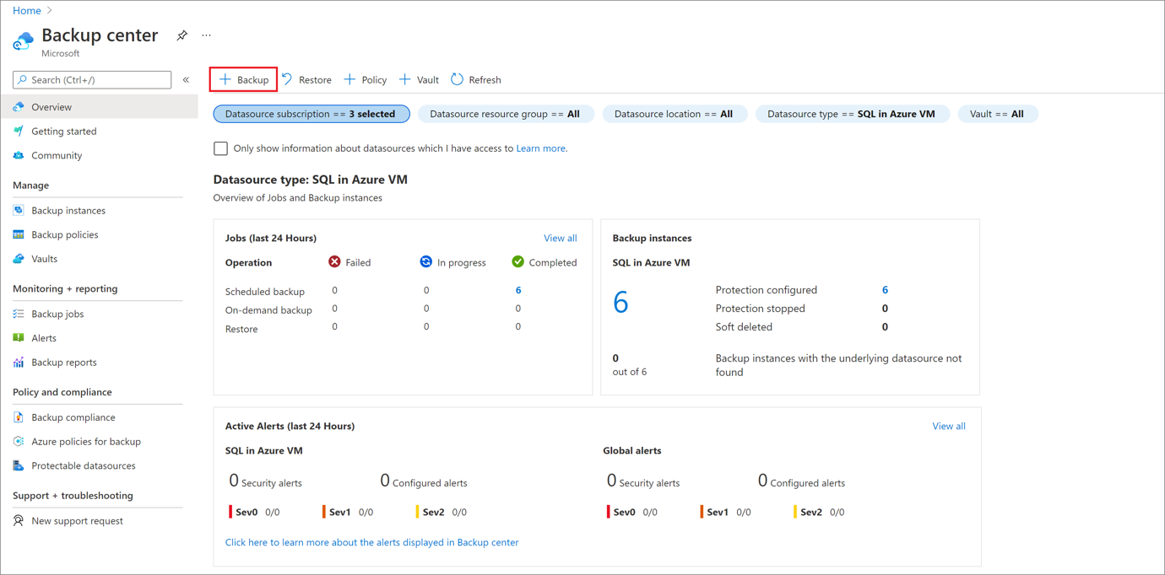
- On the Start: Configure Backup blade, select Azure Files (Azure Storage) as the datasource type, select the vault that you want to protect the file shares with, and then select Continue.
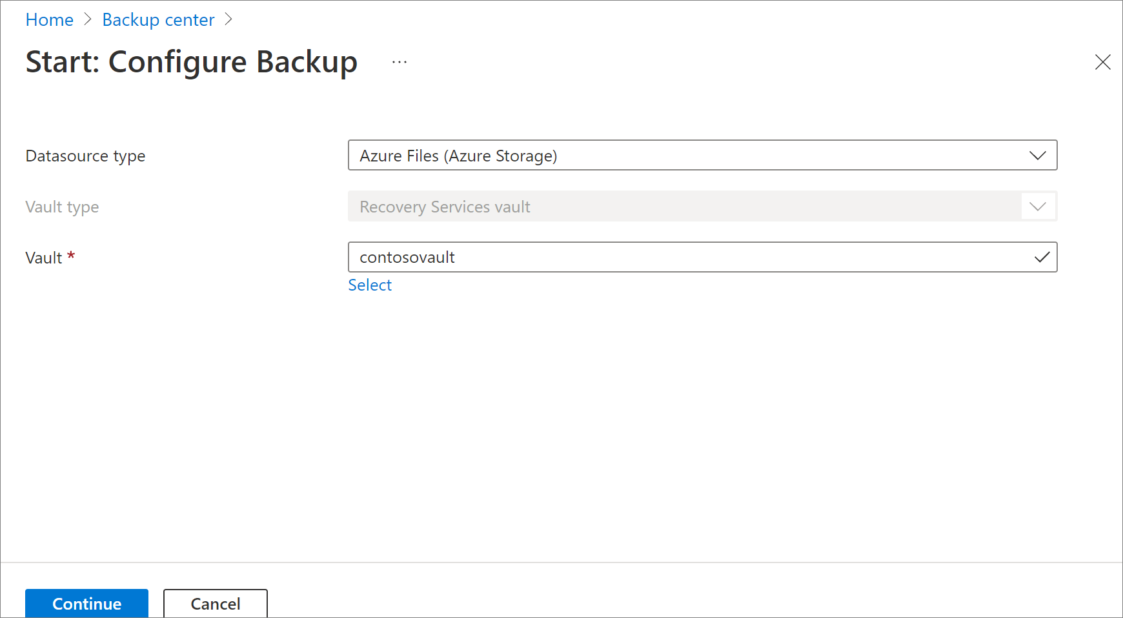
- Click Select to select the storage account that contains the file shares to be backed-up.
The Select storage account blade opens on the right, which lists a set of discovered supported storage accounts. They're either associated with this vault or present in the same region as the vault, but not yet associated to any Recovery Services vault.
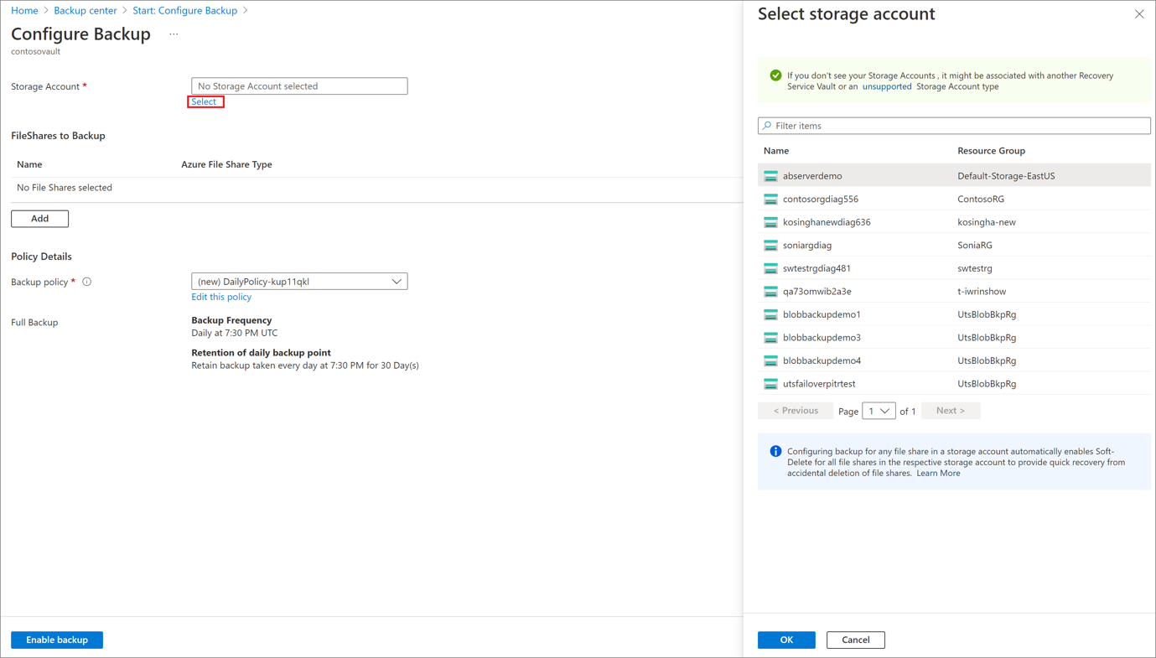
- On the Select storage account blade, from the list of discovered storage accounts, select an account, and select OK.
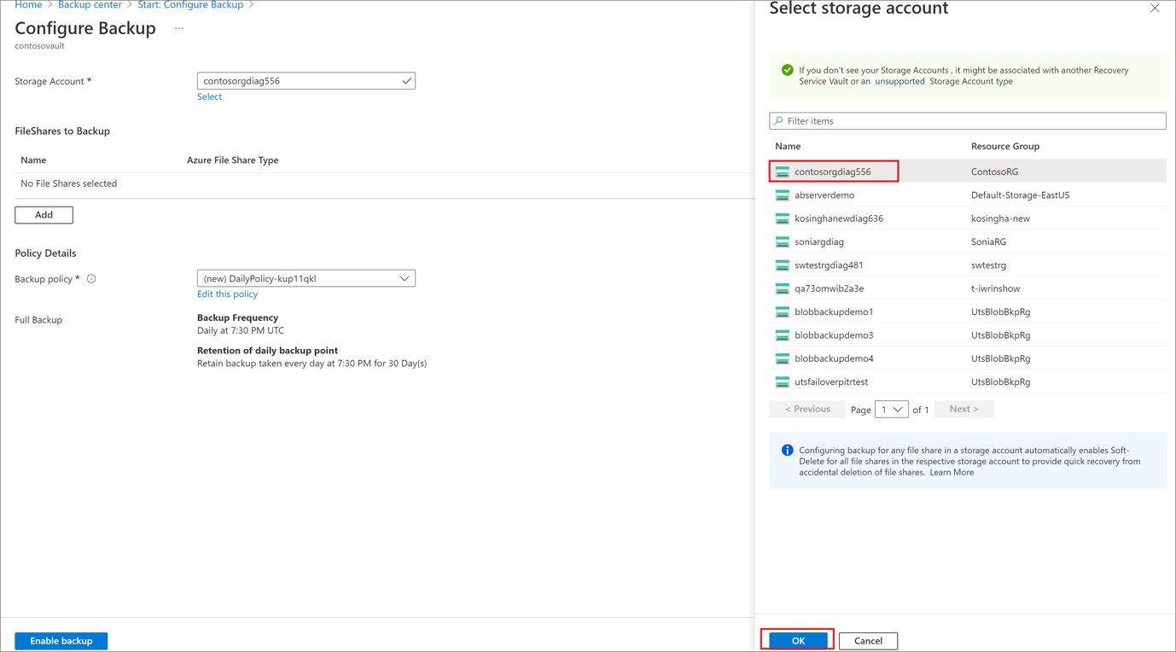
Note
If a storage account is present in a different region than the vault, it won't be present in the list of discovered storage accounts.
- On the Configure Backup blade, under the FileShares to Backup section, select the file shares type you want to back up, and then select Add.
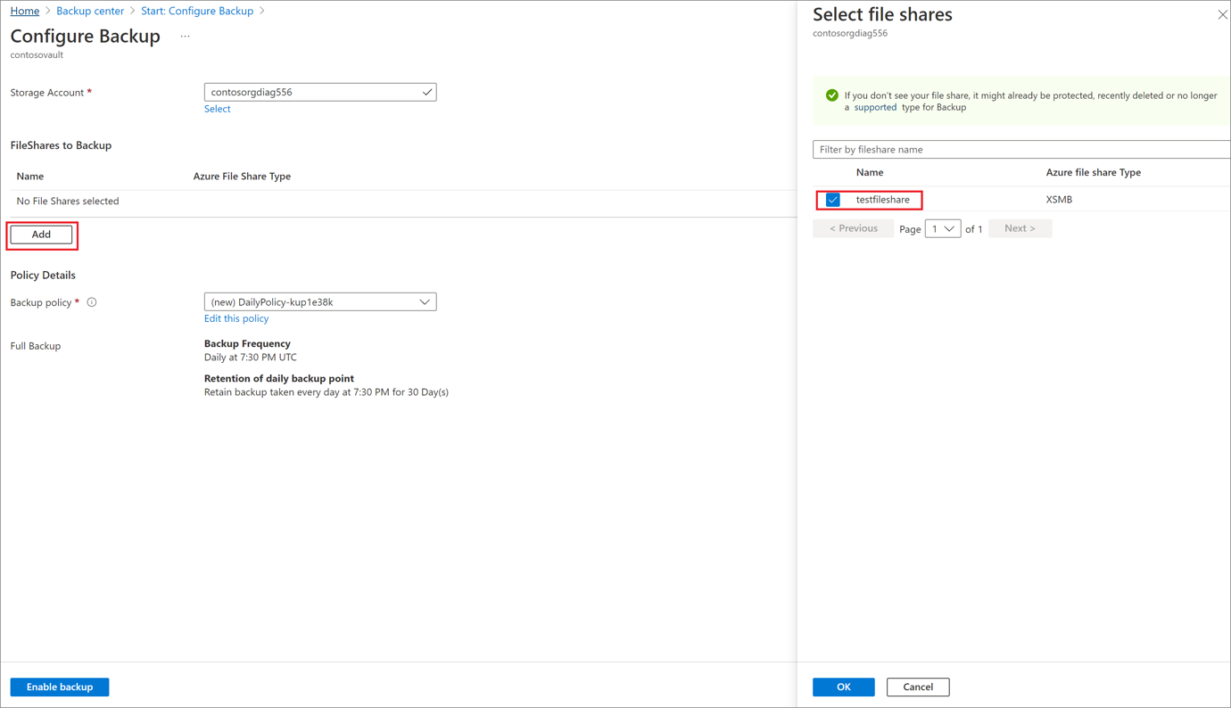
- The Select file shares context blade opens on the right. Azure searches the storage account for file shares that can be backed up. If you recently added your file shares and don't see them in the list, allow some time for the file shares to appear.
- On the Select file shares blade, from the file shares list, select one or more file shares you want to back up, and then select OK.
- On the Configure Backup blade, under Policy Details, choose an existing backup policy from the list for your file share protection or create a new policy.
To create a new backup policy, you can configure the following attributes in the backup policy:
  - On the Configure Backup blade, select Create new under Policy Details.
  - On the Create policy blade, provide the policy name.
  - On Backup tier, select one of the following tiers:
    - Snapshot: Enables only snapshot-based backups that are stored locally and can only provide protection in case of accidental deletions.
    - Vault-Standard (Preview): Provides comprehensive data protection.
  - Configure the backup schedule as per the requirement. You can configure up to six backups a day. The snapshots are taken as per the schedule defined in the policy. In case of vaulted backup, the data from the last snapshot of the day is transferred to the vault.
  - Configure the Snapshot retention and Vault retention (preview) duration to determine the expiry date of the recovery points.
Note
The vault tier (preview) provides longer retention than the snapshot tier.
  - Select OK to create the backup policy.
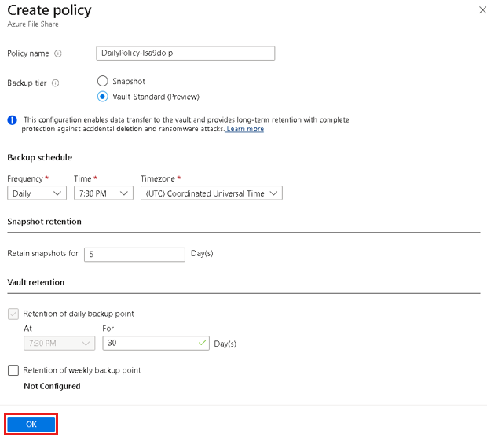
- On the Configure Backup blade, select Enable Backup to start protecting the file share.
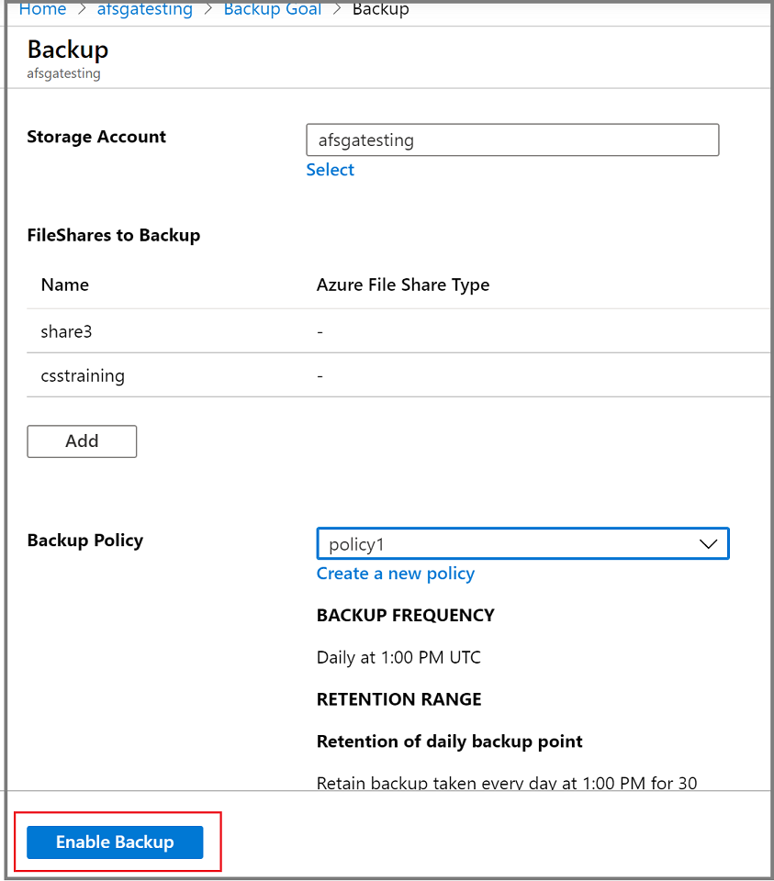
Run an on-demand backup job
Occasionally, you might want to generate a backup snapshot, or recovery point, outside of the times scheduled in the backup policy. A common reason to generate an on-demand backup is right after you've configured the backup policy. Based on the schedule in the backup policy, it might be hours or days until a snapshot is taken. To protect your data until the backup policy engages, initiate an on-demand backup. Creating an on-demand backup is often required before you make planned changes to your file shares.
Choose an entry point
To run an on-demand backup, follow these steps:
- Go to Backup center and select Backup Instances from the menu.
Filter for Azure Files (Azure Storage) as the datasource type.
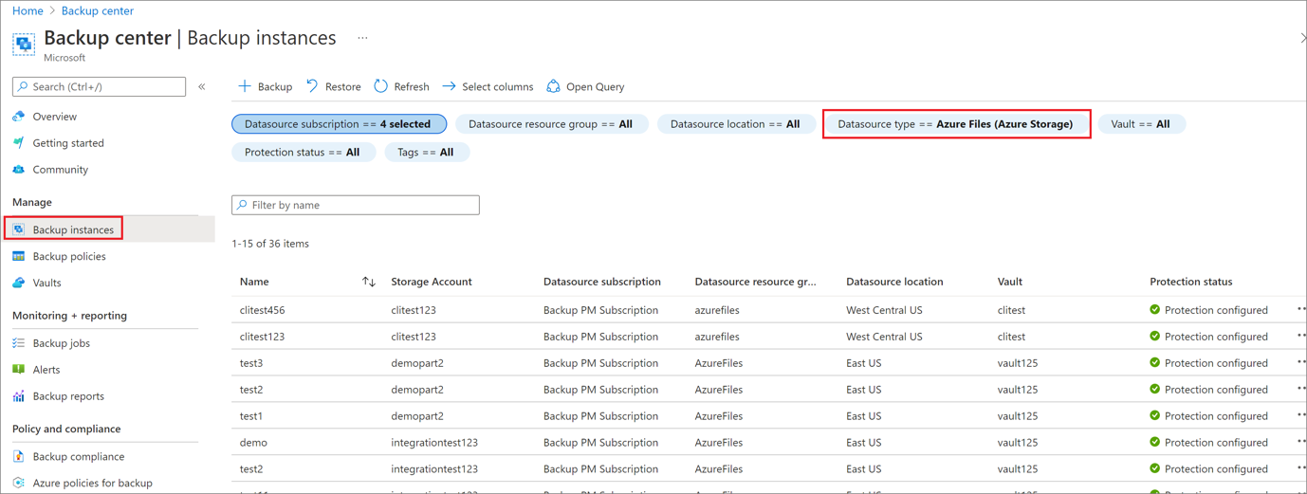
- Select the item for which you want to run an on-demand backup job.
- In the Backup Item menu, select Backup now. Because this backup job is on demand, there's no retention policy associated with the recovery point.
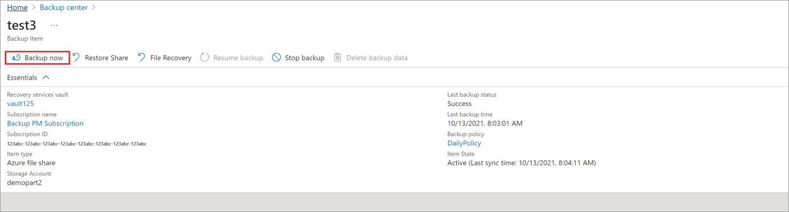
- The Backup Now blade opens. Specify the last day you want to retain the recovery point. You can have a maximum retention of 10 years for an on-demand backup.
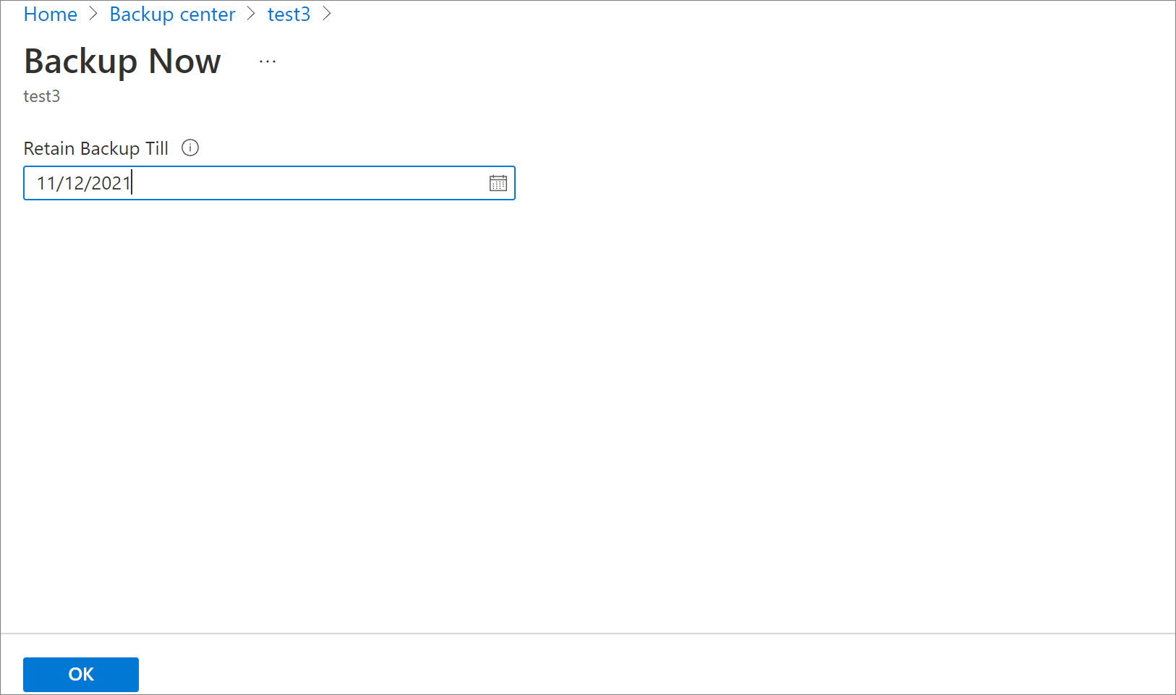
- Select OK to confirm the on-demand backup job that runs.
- Monitor the portal notifications to keep a track of backup job run completion.
To monitor the job progress in the Backup center dashboard, select Backup center -> Backup Jobs -> In progress.
Best practices
- Don't delete snapshots created by Azure Backup. Deleting snapshots can result in loss of recovery points and/or restore failures.
- Don't remove the lock taken on the storage account by Azure Backup. Deletion of the lock can make your storage account prone to accidental deletion.
How to Back up Azure Database for PostgreSQL Flexible Server:
Configure backup
To configure backup on the Azure Database for PostgreSQL Flexible Server databases using Azure Backup, follow these steps:
- Create a Backup vault.
- Go to Backup vault > +Backup.
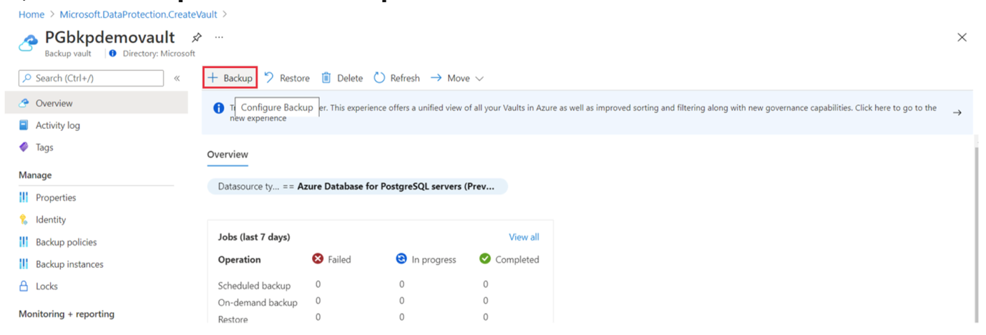
Alternatively, go to Backup center and select +Backup.
- Select the data source type as Azure Database for PostgreSQL flexible servers (Preview). 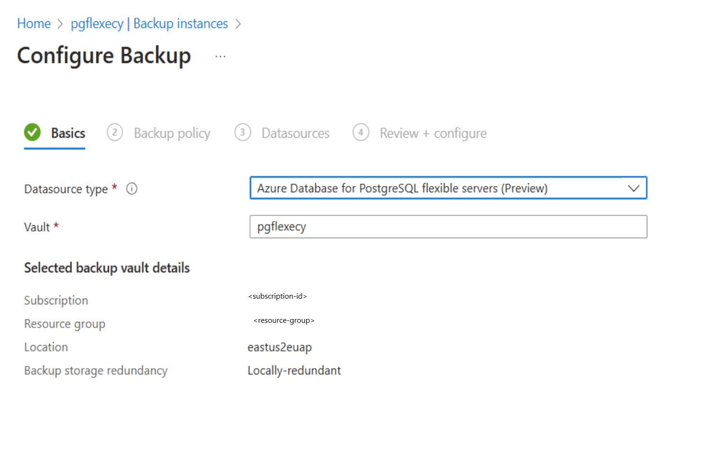
- Select or create a Backup Policy to define the backup schedule and the retention duration. 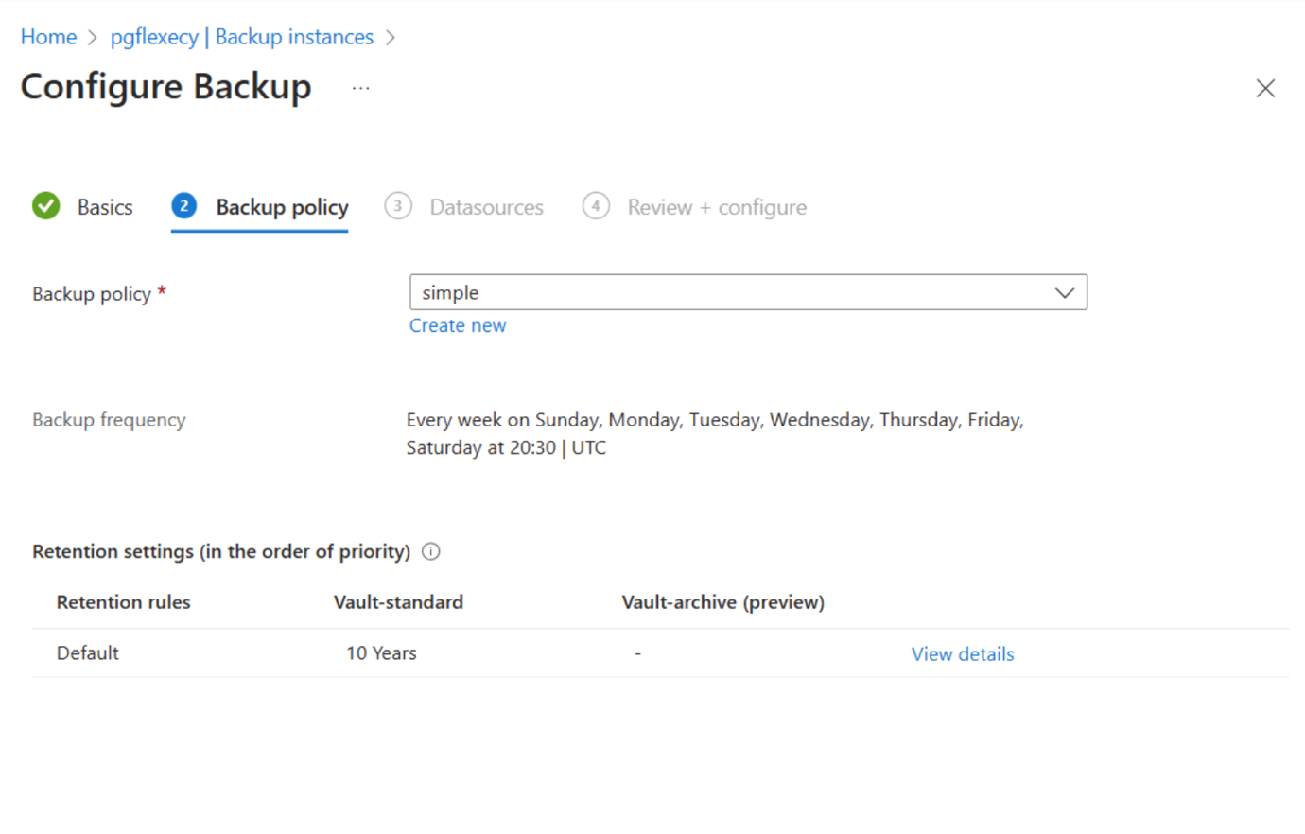
- Select Next then select Add to select the Azure Database for PostgreSQL Flexible Server that you want to back up. 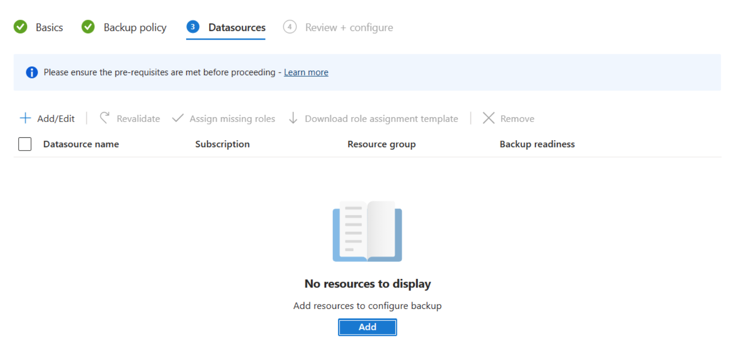
- Choose one of the Azure Database for PostgreSQL Flexible Servers across subscriptions if they're in the same region as that of the vault. Expand the arrow to see the list of databases within a server. 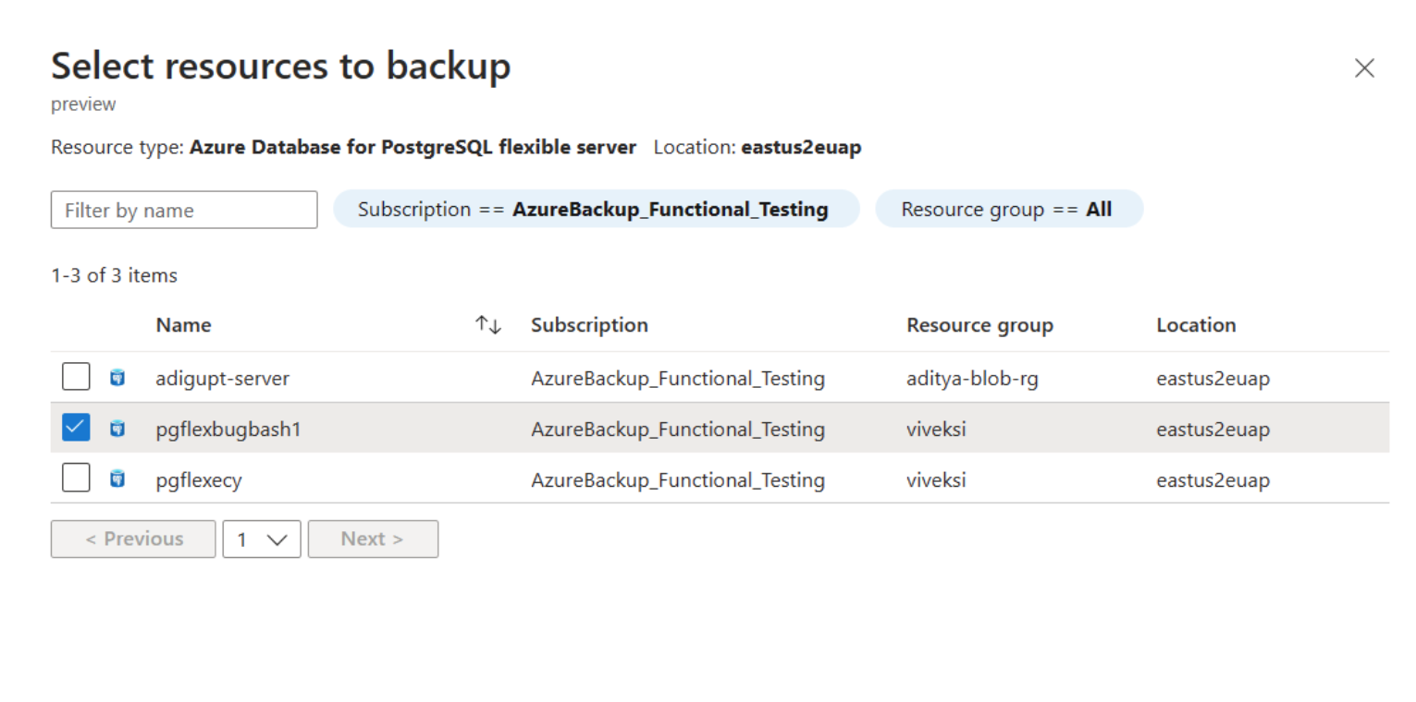
- After the selection, the validation starts. The backup readiness check ensures the vault has sufficient permissions for backup operations. Resolve any access issues by granting appropriate permissions to the vault MSI and re-triggering the validation.
- Submit the configure backup operation and track the progress under Backup instances.
Create a backup policy
To create a backup policy, follow these steps:
- In the Backup vault you created, go to Backup policies and select Add. Alternatively, go to Backup center > Backup policies > Add.
- Enter a name for the new policy.
- Select the data source type as Azure Database for PostgreSQL flexible servers (Preview). 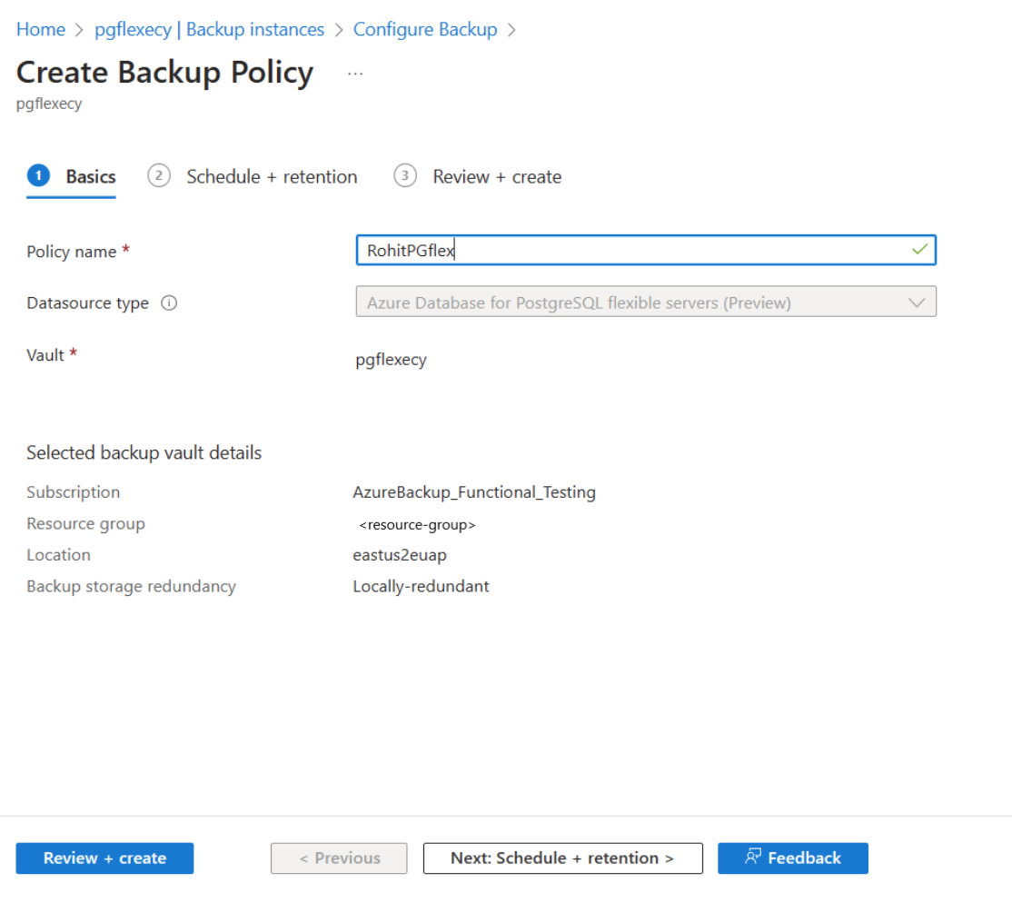
- Specify the Backup schedule.
Currently, only Weekly backup option is available. However, you can schedule the backups on multiple days of the week. 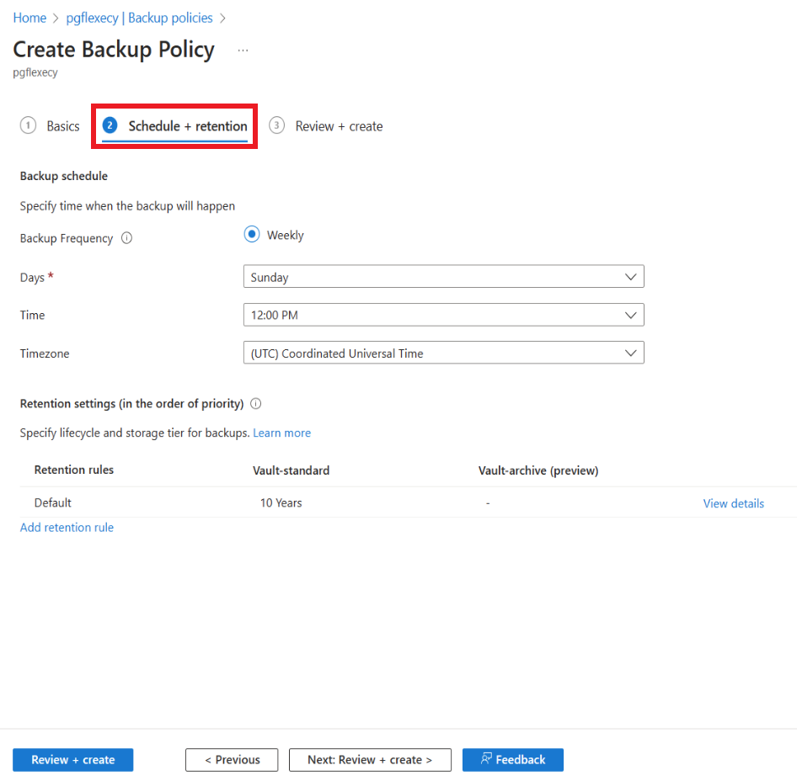
- Specify Retention settings.
You can add one or more retention rules. Each retention rule assumes inputs for specific backups, and data store and retention duration for those backups.
Note
Retention duration ranges from seven days to 10 years in the Backup data store.
Note
The retention rules are evaluated in a pre-determined order of priority. The priority is the highest for the yearly rule, followed by the monthly, and then the weekly rule. Default retention settings are applied when no other rules qualify. For example, the same recovery point may be the first successful backup taken every week as well as the first successful backup taken every month. However, as the monthly rule priority is higher than that of the weekly rule, the retention corresponding to the first successful backup taken every month applies.
Run an on-demand backup
To trigger a backup not in the schedule specified in the policy, go to Backup instances > Backup Now. Choose from the list of retention rules that were defined in the associated Backup policy.
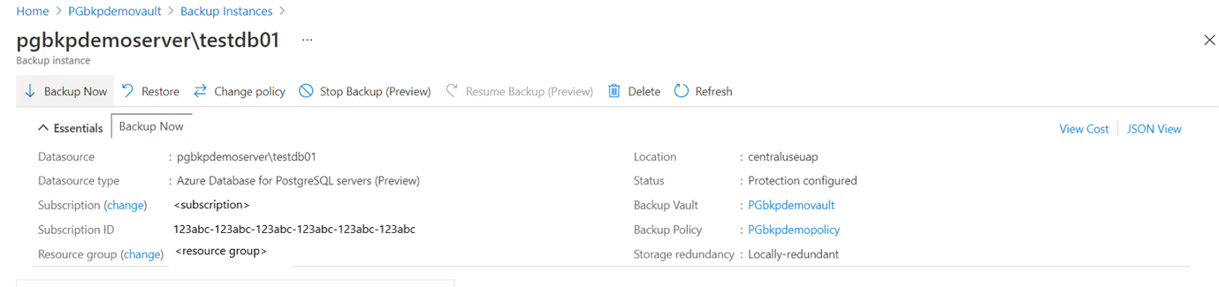
Track a backup job
Azure Backup service creates a job for scheduled backups or if you trigger on-demand backup operation for tracking.
To view the backup job status:
- Go to the Backup instance screen.
It shows the jobs dashboard with operation and status for the past seven days.
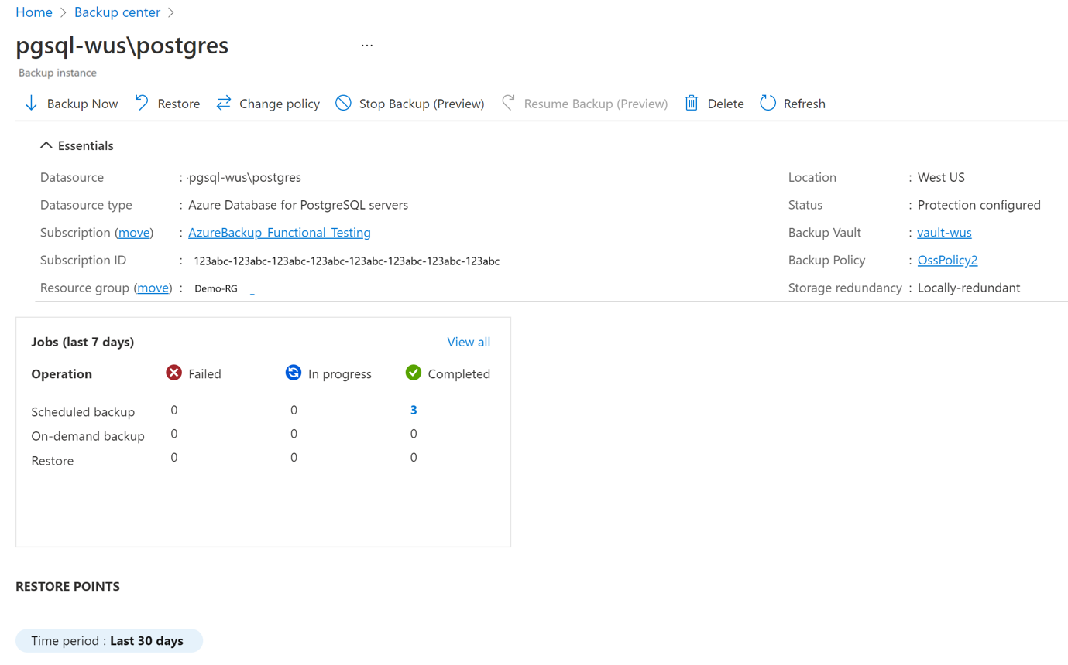
- To view the status of the backup job, select View all to see ongoing and past jobs of this backup instance.
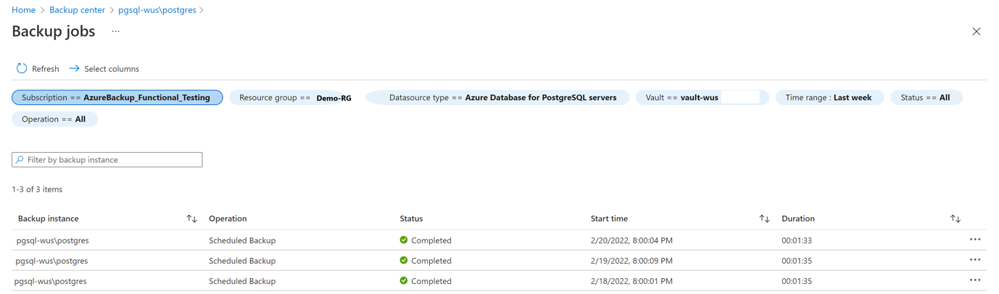
Disaster recovery of Postgresql. (Section e) of task)
By choosing flexible server DR/BCP comes along with the product. Some of the features are listed below:
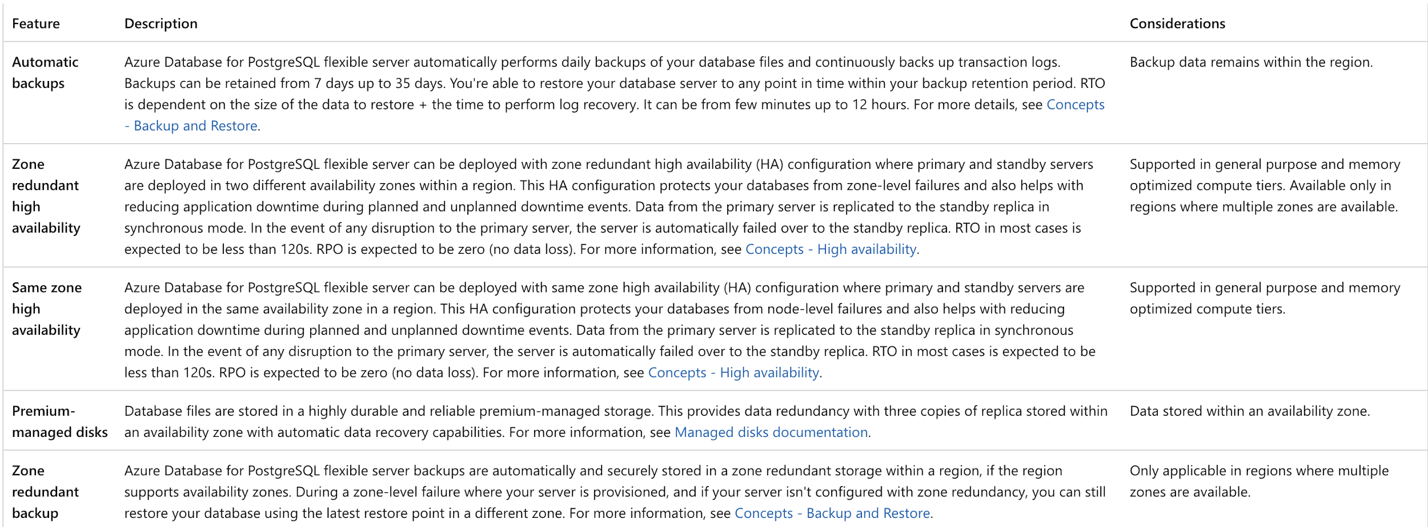
RTO and RPO details are listed below:
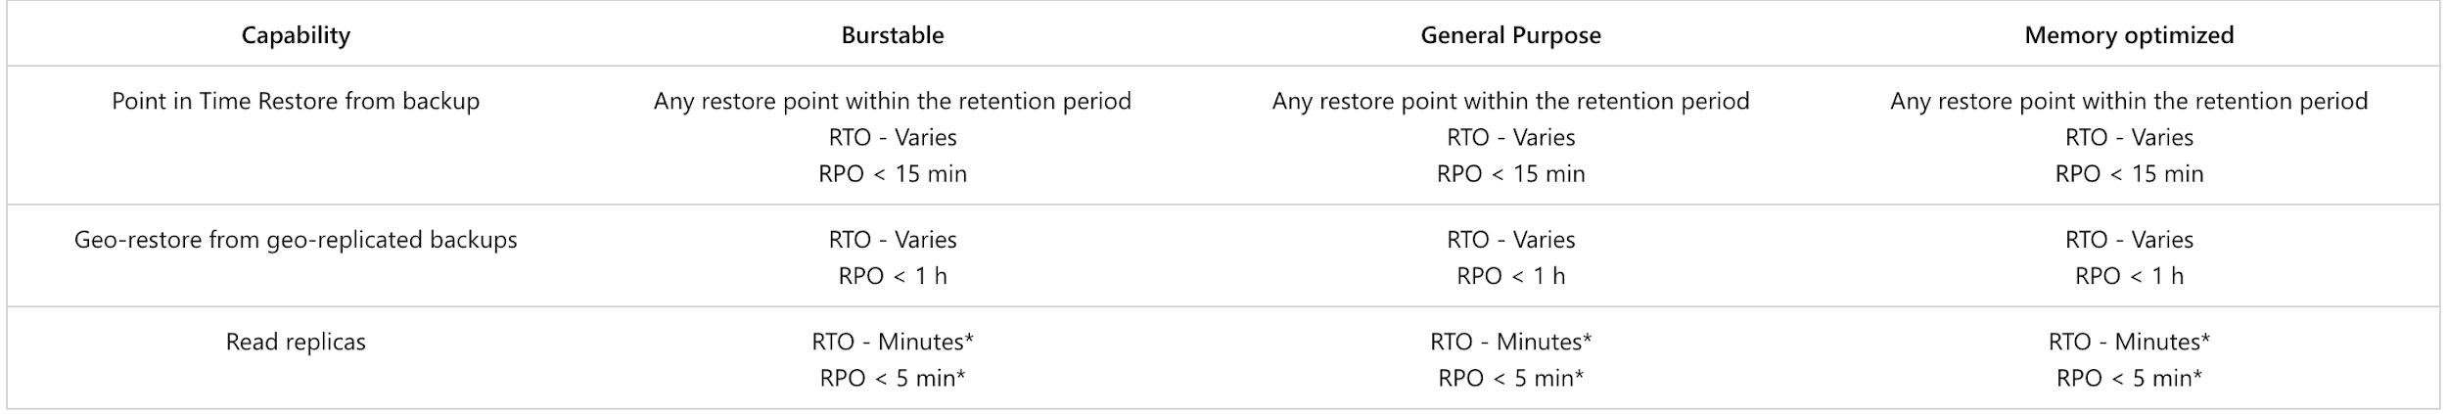
Azure Storage Redundancy for DR/BCP:
Azure Storage always stores multiple copies of your data so that it's protected from planned and unplanned events, including transient hardware failures, network or power outages, and massive natural disasters. Redundancy ensures that your storage account meets its availability and durability targets even in the face of failures.
When deciding which redundancy option is best for your scenario, consider the tradeoffs between lower costs and higher availability. The factors that help determine which redundancy option you should choose include:
- How your data is replicated within the primary region.
- Whether your data is replicated to a second region that is geographically distant to the primary region, to protect against regional disasters (geo-replication).
- Whether your application requires read access to the replicated data in the secondary region if the primary region becomes unavailable for any reason (geo-replication with read access).
The services that comprise Azure Storage are managed through a common Azure resource called a storage account. The storage account represents a shared pool of storage that can be used to deploy storage resources such as blob containers (Blob Storage), file shares (Azure Files), tables (Table Storage), or queues (Queue Storage).
The redundancy setting for a storage account is shared for all storage services exposed by that account. All storage resources deployed in the same storage account have the same redundancy setting. You may want to isolate different types of resources in separate storage accounts if they have different redundancy requirements.
Redundancy in the primary region
Data in an Azure Storage account is always replicated three times in the primary region. Azure Storage offers two options for how your data is replicated in the primary region:
- Locally redundant storage (LRS) copies your data synchronously three times within a single physical location in the primary region. LRS is the least expensive replication option, but isn't recommended for applications requiring high availability or durability.
- Zone-redundant storage (ZRS) copies your data synchronously across three Azure availability zones in the primary region. For applications requiring high availability, Microsoft recommends using ZRS in the primary region, and also replicating to a secondary region.
Locally redundant storage
Locally redundant storage (LRS) replicates your storage account three times within a single data center in the primary region. LRS provides at least 99.999999999% (11 nines) durability of objects over a given year.
LRS is the lowest-cost redundancy option and offers the least durability compared to other options. LRS protects your data against server rack and drive failures. However, if a disaster such as fire or flooding occurs within the data center, all replicas of a storage account using LRS may be lost or unrecoverable. To mitigate this risk, Microsoft recommends using zone-redundant storage (ZRS), geo-redundant storage (GRS), or geo-zone-redundant storage (GZRS).
A write request to a storage account that is using LRS happens synchronously. The write operation returns successfully only after the data is written to all three replicas.
The following diagram shows how your data is replicated within a single data center with LRS:
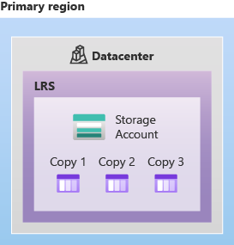
LRS is a good choice for the following scenarios:
- If your application stores data that can be easily reconstructed if data loss occurs, you may opt for LRS.
- If your application is restricted to replicating data only within a country or region due to data governance requirements, you may opt for LRS. In some cases, the paired regions across which the data is geo-replicated may be in another country or region.
- If your scenario is using Azure unmanaged disks, you may opt for LRS. While it's possible to create a storage account for Azure unmanaged disks that uses GRS, it isn't recommended due to potential issues with consistency over asynchronous geo-replication.
Zone-redundant storage
Zone-redundant storage (ZRS) replicates your storage account synchronously across three Azure availability zones in the primary region. Each availability zone is a separate physical location with independent power, cooling, and networking. ZRS offers durability for storage resources of at least 99.9999999999% (12 9's) over a given year.
With ZRS, your data is still accessible for both read and write operations even if a zone becomes unavailable. If a zone becomes unavailable, Azure undertakes networking updates, such as DNS repointing. These updates may affect your application if you access data before the updates have completed. When designing applications for ZRS, follow practices for transient fault handling, including implementing retry policies with exponential back-off.
A write request to a storage account that is using ZRS happens synchronously. The write operation returns successfully only after the data is written to all replicas across the three availability zones. If an availability zone is temporarily unavailable, the operation returns successfully after the data is written to all available zones.
Microsoft recommends using ZRS in the primary region for scenarios that require high availability. ZRS is also recommended for restricting replication of data to a particular country or region to meet data governance requirements.
Microsoft recommends using ZRS for Azure Files workloads. If a zone becomes unavailable, no remounting of Azure file shares from the connected clients is required.
The following diagram shows how your data is replicated across availability zones in the primary region with ZRS:
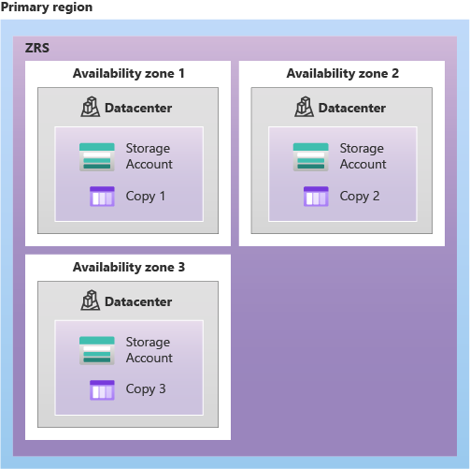
ZRS provides excellent performance, low latency, and resiliency for your data if it becomes temporarily unavailable. However, ZRS by itself may not protect your data against a regional disaster where multiple zones are permanently affected. For protection against regional disasters, Microsoft recommends using geo-zone-redundant storage (GZRS), which uses ZRS in the primary region and also geo-replicates your data to a secondary region.
The archive tier for Blob Storage isn't currently supported for ZRS, GZRS, or RA-GZRS accounts. Unmanaged disks don't support ZRS or GZRS.
Standard storage accounts
ZRS is supported for all Azure Storage services through standard general-purpose v2 storage accounts, including:
- Azure Blob storage (hot and cool block blobs and append blobs, non-disk page blobs)
- Azure Files (all standard tiers: transaction optimized, hot, and cool)
- Azure Table storage
- Azure Queue storage
For a list of regions that support zone-redundant storage (ZRS) for standard accounts, see Azure regions that support zone-redundant storage (ZRS) for standard storage accounts.
Premium block blob accounts
ZRS is supported for premium block blobs accounts. For more information about premium block blobs, see Premium block blob storage accounts.
For a list of regions that support zone-redundant storage (ZRS) for premium block blobs accounts, see Azure regions that support zone-redundant storage (ZRS) for premium block blob accounts.
Premium file share accounts
ZRS is supported for premium file shares (Azure Files) through the FileStorage storage account kind.
For a list of regions that support zone-redundant storage (ZRS) for premium file share accounts, see Azure Files zone-redundant storage for premium file shares.
Managed disks
ZRS is supported for managed disks with the following limitations.
For a list of regions that support zone-redundant storage (ZRS) for managed disks, see regional availability.
Redundancy in a secondary region
For applications requiring high durability, you can choose to additionally copy the data in your storage account to a secondary region that is hundreds of miles away from the primary region. If your storage account is copied to a secondary region, then your data is durable even in the case of a complete regional outage or a disaster in which the primary region isn't recoverable.
When you create a storage account, you select the primary region for the account. The paired secondary region is determined based on the primary region, and can't be changed.
Azure Storage offers two options for copying your data to a secondary region:
- Geo-redundant storage (GRS) copies your data synchronously three times within a single physical location in the primary region using LRS. It then copies your data asynchronously to a single physical location in the secondary region. Within the secondary region, your data is copied synchronously three times using LRS.
- Geo-zone-redundant storage (GZRS) copies your data synchronously across three Azure availability zones in the primary region using ZRS. It then copies your data asynchronously to a single physical location in the secondary region. Within the secondary region, your data is copied synchronously three times using LRS.
Note: The primary difference between GRS and GZRS is how data is replicated in the primary region. Within the secondary region, data is always replicated synchronously three times using LRS. LRS in the secondary region protects your data against hardware failures.
With GRS or GZRS, the data in the secondary region isn't available for read or write access unless there's a failover to the primary region. For read access to the secondary region, configure your storage account to use read-access geo-redundant storage (RA-GRS) or read-access geo-zone-redundant storage (RA-GZRS).
If the primary region becomes unavailable, you can choose to fail over to the secondary region. After the failover has completed, the secondary region becomes the primary region, and you can again read and write data.
Important: Because data is replicated to the secondary region asynchronously, a failure that affects the primary region may result in data loss if the primary region cannot be recovered. The interval between the most recent writes to the primary region and the last write to the secondary region is known as the recovery point objective (RPO). The RPO indicates the point in time to which data can be recovered. The Azure Storage platform typically has an RPO of less than 15 minutes, although there's currently no SLA on how long it takes to replicate data to the secondary region.
Geo-redundant storage
Geo-redundant storage (GRS) copies your data synchronously three times within a single physical location in the primary region using LRS. It then copies your data asynchronously to a single physical location in a secondary region that is hundreds of miles away from the primary region. GRS offers durability for storage resources of at least 99.99999999999999% (16 9's) over a given year.
A write operation is first committed to the primary location and replicated using LRS. The update is then replicated asynchronously to the secondary region. When data is written to the secondary location, it's also replicated within that location using LRS.
The following diagram shows how your data is replicated with GRS or RA-GRS:
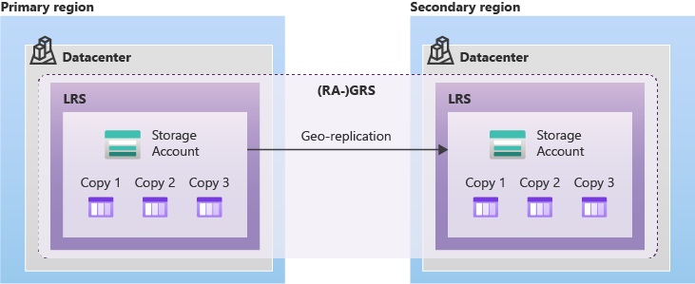
Geo-zone-redundant storage
Geo-zone-redundant storage (GZRS) combines the high availability provided by redundancy across availability zones with protection from regional outages provided by geo-replication. Data in a GZRS storage account is copied across three Azure availability zones in the primary region and is also replicated to a secondary geographic region for protection from regional disasters. Microsoft recommends using GZRS for applications requiring maximum consistency, durability, and availability, excellent performance, and resilience for disaster recovery.
With a GZRS storage account, you can continue to read and write data if an availability zone becomes unavailable or is unrecoverable. Additionally, your data is also durable in the case of a complete regional outage or a disaster in which the primary region isn't recoverable. GZRS is designed to provide at least 99.99999999999999% (16 9's) durability of objects over a given year.
The following diagram shows how your data is replicated with GZRS or RA-GZRS:
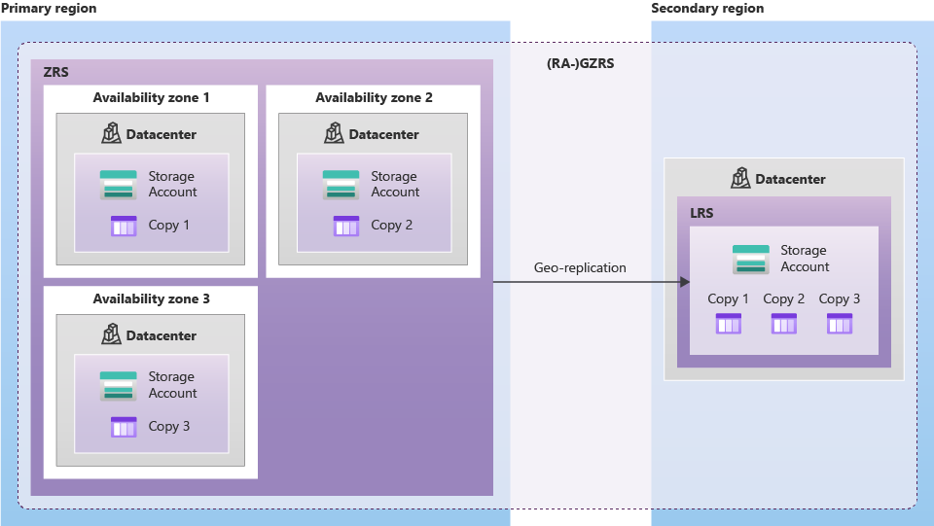
Only standard general-purpose v2 storage accounts support GZRS. GZRS is supported by all of the Azure Storage services, including:
- Azure Blob storage (hot and cool block blobs, non-disk page blobs)
- Azure Files (all standard tiers: transaction optimized, hot, and cool)
- Azure Table storage
- Azure Queue storage
For a list of regions that support geo-zone-redundant storage (GZRS), see Azure regions that support geo-zone-redundant storage (GZRS).
Read access to data in the secondary region
Geo-redundant storage (with GRS or GZRS) replicates your data to another physical location in the secondary region to protect against regional outages. With an account configured for GRS or GZRS, data in the secondary region is not directly accessible to users or applications, unless a failover occurs. The failover process updates the DNS entry provided by Azure Storage so that the secondary endpoint becomes the new primary endpoint for your storage account. During the failover process, your data is inaccessible. After the failover is complete, you can read and write data to the new primary region.
If your applications require high availability, then you can configure your storage account for read access to the secondary region. When you enable read access to the secondary region, then your data is always available to be read from the secondary, including in a situation where the primary region becomes unavailable. Read-access geo-redundant storage (RA-GRS) or read-access geo-zone-redundant storage (RA-GZRS) configurations permit read access to the secondary region.
Note: Azure Files does not support read-access geo-redundant storage (RA-GRS) or read-access geo-zone-redundant storage (RA-GZRS).
Design your applications for read access to the secondary
If your storage account is configured for read access to the secondary region, then you can design your applications to seamlessly shift to reading data from the secondary region if the primary region becomes unavailable for any reason.
The secondary region is available for read access after you enable RA-GRS or RA-GZRS, so that you can test your application in advance to make sure that it will properly read from the secondary in the event of an outage.
When read access to the secondary is enabled, your application can be read from the secondary endpoint as well as from the primary endpoint. The secondary endpoint appends the suffix -secondary to the account name. For example, if your primary endpoint for Blob storage is myaccount.blob.core.windows.net, then the secondary endpoint is myaccount-secondary.blob.core.windows.net. The account access keys for your storage account are the same for both the primary and secondary endpoints.

Supported Storage Services comparison:
Contents
No table of contents entries found.

And account types:


