What are the staff and pupils’ perceptions of Assessment for Learning?

How does the quality of questioning and discussion help improve pupils’ learning?

This assignment intends to discuss, evaluate and analyse the findings from the research study based on questioning and discussion within the classroom. The study proposes to find out if being asked questions and engaging in discussion can increase children’s knowledge and understanding. The purpose of the study is to understand how to be a skilled researcher and how to develop research skills; linking to Athrofa’s four research dispositions (Orchard and Winch, 2015). It can be categorised as ‘close to practice research’, as the children participating were already known due previous professional teaching experience (PTE2). The aims provide room to explore staff and learners’ understanding of questioning and discussion, critically evaluate and analyse the different research tools, and to improve professional practice and educational outcomes through the use of AfL (Assessment for Learning) (Austin, 2016). There is extensive background research on this study, with a high level of support from Hattie’s Effect Size (2018), which will be discussed in further detail in the literature review. Questioning within the classroom can be seen as the main focus in promoting learners’ development and thinking (Welsh Government, 2010), which provides the rationale for conducting the study. After studying the background research, the hypothesis anticipates that through the use of questioning and discussion, it will encourage deeper thought process and further engage learners within the classroom. To conduct the study, a mixed method approach will be used when conducting the research study to provide appropriate results. This includes the Mosaic Approach and Triangulation which enables the researcher to piece tiles of information together and to cross reference for a broad range of perspectives. The three research tools used to explore the study were chosen after critical evaluation (NSW Government, 2019): lesson observations, focus group interviews and staff and pupil questionnaires.

AfL can be seen as the driving force within the classroom where teachers can use a range of strategies to help progress and develop children’s learning (DES, 1988). It can be defined as
‘the process of seeking and interpreting evidence for use by learners and their teachers to decide where learners are in their learning, where they need to go and how best to get there.’ (Assessment Reform Group, 2002)

Wiliam (2011), Hattie (2008) and Wiliam and Thomson (2007) provide parallel research for this as they suggest AfL allows learners to have an input in their own learning and assessment, by providing a vision of how they can be successful. Donaldson (2020) additionally supports this as he states AfL is central to the New Curriculum in Wales as it provides children with a new approach to their learning.
When discussing AfL, Black and Wiliam (1998) provide key documents to refer to about the topic (Inside the Black Box, 1998). They strongly instigate the use of AfL in supporting children’s learning, however, they state that teachers must use the results to regulate teaching and learning in order to see significant development. If they do not make that change, there will not be an improvement; highlighting the importance of how AfL needs to not only be applied correctly but evaluated and implemented in a way the children can understand. The TGAT (1988) encourage teachers’ involvement with AfL and stress the importance that formative assessment can have within the classroom.
This assignment will acknowledge the different viewpoints and opinions of AfL, specifically focusing on questioning and discussion within the classroom.

Questioning can be seen as one of the four key elements of AfL (Black and Wiliam 1998), playing an essential role in developing learners’ understanding. There is a vast amount of research which supports questioning and discussion within the classroom, where the Welsh Government (2010) place questioning as the most important factor in formative assessment. Black et Al (2003) believe that questioning encourages effective development as students can engage with the learning and ask questions themselves to clarify uncertainty. Questioning can occur in different ways, whether it is between learners, or between the learner and the teacher. Engaging in discussion ‘provides opportunity for the teacher to respond to and re-orient the pupil’s thinking’ (Black and Wiliam, 1998, p.11). It further highlights that engaging in talk with each other, (Think, Pair, Share), allows children to improve their knowledge as they can understand the learning in their own ways. Conversely, some researchers state that discussion has limitations in the classroom. It can be suggested that it isn’t always useful as it doesn’t engage children with the learning and can cause them to become side-tracked from the task given (Beck and Kosnick, 2006). Hence, the study involves the two chosen strategies as there is highly controversial research that surrounds it. It would appear that questioning and discussion complement each other by allowing children to discuss their answers to the questions with peers and the teacher. O’Leary (2017) merges questioning and classroom discussion (QCD) within his educational research journal, where he concluded that they were well implemented together and encouraged each other within the study he carried out. Similarly, Hattie (2008) reinforces the effectiveness of questioning within learning environments as he concluded that questioning has an effect size of ‘0.48’. He expands on this by stating that anything with an effect size above 0.4 will have an enormous impact on children’s learning. The study allows the researcher to find corresponding or contradictory evidence to this. Black and Wiliam (1998), Cohen, Manion and Morrison (2004) and Rowe (1972) further condemn Hattie’s research as they highlight the fact that teachers do not give pupil’s enough thinking time to respond to questions. Research suggests that allowing a thinking time of 3 seconds or more, decreases the number of ‘I don’t know’ responses, and encourages more volunteers to answer responses (Stahl, 1994). Despite this, Tobin (1987) states that thinking time will not provide advantages to response rates, as the variables in the classroom need to be apparent for children to be able to answer the questions. On the other hand, Black and Wiliam (1998) state that children fear failure and do not want to get the question wrong in front of their peers. The incorrect responses could be seen as beneficial in the classroom, as it allows the teacher to see where the learning needs to go next (O’Leary, 2017). Questions that are asked effectively in the classroom, allow the learners to understand what is required of them (Pollard, 2014); once one child asks a question, the rest will flow. After all, ‘it is better to have a classroom full of answered questions than unanswered answers’ (Morgan and Saxton, 1991). Do you agree?

The research study took place in a large school in an affluent area, consisting of 520 pupils. A Key Stage 2, Year 6 class was chosen due to the increased level of understanding and attention (Burke, Abramovitch, Zlotkin, 2005). The study can be interpreted as action research, whereby knowledge is gathered about a social situation with the aim of improving it (Elliot, 1991). The tools used were observations, questionnaires and interviews. Each method was triangulated to see differing views, a reflection of reality and the extent of the validity (Campbell and Fiske, 1959). When undertaking each research method, there are several ethical issues that need to be considered within the classroom (BERA, 2018). Particularly informed consent, confidentiality, voluntary consent, assent and the right to withdraw. The discussion of minimising risks can also be seen within the ethics form (appendix 1) followed by a consent form for the study (appendix 2). Austin (2016) states that assent is a less formal way of agreeing to participate, therefore it was necessary to gain assent of participants; especially in the interview. Smiley faces were used within the interview to gain assent; if children did not want to answer a question, they turned it around (appendix 3).

The first method that was used within the study was observation, where the structure of the observation can be viewed (appendix 4). This took place within the natural environment for the children (Morrison, 1993) and provided ‘live’ data within the real-life context of the classroom (Cohen, Manion and Morrison, 2013, p.396). A semi-structured observation was selected due to the nature of it allowing numerical data to be collected (Cohen, Manion and Morrison, 2013) but also to write about events that naturally unfold in the setting (Punch, 2014). To measure and record relevant practice that was demonstrated within the observation, interval recording was used to highlight the number of times questioning and discussion appeared in the introduction, main body and plenary of the session (Thomas, 2017). The observation carried out was non-interventionist, (Adler and Adler, 1994) as there was no involvement on behalf of the researcher. Austin (2016) suggests that observations place less pressure on children. However, due to children being involved in the observation, letters and consent forms were sent out (appendix 5) to inform parents of the research that was being carried out. Hence, Arthur (2012) could argue that the observation may include an element of ‘reactive observation’ or overt observation, as children were aware of the nature of the observation (p.166). Conversely, Cohen, Manion and Morrison (2013) state that observations often include bias where the researcher already knows what they are looking for so may neglect other behaviours that could provide relevance to their findings. DeMunck and Sobo (1998) share similar interests as they suggest observation can lead to interpretation as a bias, where information may be interpreted to benefit the research. Thomas (2017) highlights that another limitation of observations could be the Hawthorne effect, particularly due to the fact the research study was overt. He suggests that children will act in a different manner when they know they are being observed. The bias was acknowledged before observing but put to the side to create a neutral study (Ratner, 2002).

The second method used to further the findings were questionnaires (appendix 6a&b), which can be described as a ‘versatile tool’ to enable researchers to gather different types of data (Thomas, 2017 p.217). The questionnaires were given to small sample of eighteen children within the class via iPads, whereby the results were collected via Microsoft Forms. They set out to collect outcomes and feedback (Arthur, 2012) and were kept short and simple to ensure a high number of responses (Thomas, 2017 and Denscombe, 2010 cited in Austin 2016). Due to the age of the children, the language within the questionnaire had to suit the participants so they understood what was being asked (Cohen, Manion and Morrison, 2013). This reduces the number of blank answers (Bell, 2010 cited in Austin, 2016). To prevent this, the questionnaires were piloted by a member of University of Wales Trinity St David. The questionnaire used different methods of questions to gain different responses, providing elements of pragmatism through qualitative and quantitative data (Austin, 2016). Open-ended questions were used to enhance knowledge of the topic. However, it needs to be acknowledged that open-ended questions could provide irrelevant information and the children may be confused as to how they should respond (Cohen, Manion and Morrison 2013). Gillham (2007) also implies that these types of questions are more difficult to analyse. To limit the effect of this, the questions were designed for the researcher to have an idea of the probable answers. Closed questions were also used for smoother analysis of data and to speed up the process (Cohen, Manion and Morrison 2013, Wilson and McLean 1994). These included dichotomous questions, multiple choice and Likert Scale questions (Thomas, 2017). Questionnaires can be seen as an efficient tool as they have a good response rate, provide clear responses, time efficiency and they allow people to feel more comfortable expressing their opinions as they are anonymous (Cohen, Manion and Morrison 2013, Thomas 2017, Gillham 2007). However, limitations could be present within this method, especially with prestige bias; where children might desire to look good, so they give the answer they think is correct (Thomas, 2017). Misunderstandings can also not be explained so responses may not be accurate (Gillham, 2007). To reduce the effect this had on the study, it was explained that the questionnaire is for University use only and will not be seen by their teacher.

The final method used within the study was a focus group interview, (appendix 7) which provided in depth, collective responses about the topic (Arthur, 2012). Again, a semi-structured approach was selected due to the flexibility of being able to ask new questions if an intriguing response is given, but also to stipulate a structure for the topic (Queirós, Faria, Almeidia 2017). Thomas (2017) suggests that it ‘provides the best of both worlds’ (p.206). To record the responses given by the participants, audio-recording was used which was then transcripted directly. In order to gain honest responses from the children, they need to trust the researcher. Austin (2016) suggests that if the children selected for the interview are previous pupils, ‘they will be more relaxed and open with you’ (p.76). This was beneficial for the study due to teaching the children previously. Five children from a range of ability groups were chosen at random via Dojo to participate in the focus group interview. Open-ended questions were used within the interview as it encourages further depth and allows the interviewer to delve deeper with the respondents (Cohen, Manion and Morrison, 2013). Having a structure to the interview also allows room for coding; to look for common themes within the responses and to triangulate whether they correspond with previous research methods (Thomas, 2017). Punch (2014) further agrees and suggests that interviews are one of the most efficient ways of accessing participants opinions. However, Halcomb et al. (2007) suggest that focus group interviews could cause conflict where children express differences of opinion. Austin (2016) provides further support for this as she highlights that focus groups can be dominated by one person; where other children do not feel they can speak out and have to agree with the lead speaker. To avoid this from happening, questions were asked in the same order, so each participant had a fair say in what they believe. Arthur (2012) states there is a clear strength of focus group interviews, as they provide researchers with information on why and how a topic is significant.

When analysing the findings against the research question, it became clear that there were similarities in responses from the three research tools that could be coded into areas (Austin, 2016). The two reoccurring themes that dominated the research were: the fear of failure and positivity of peer discussion. However, it is acknowledged that due to the sample size being small, findings cannot be accurately generalised and therefore lack credibility (Cohen, Manion and Morrison, 2013).

The fear of failure when answering questions provided detailed qualitative and quantitative data within the study. During the observation process, lollipop sticks were used, where a lower skilled child was asked to answer the question relating to their science experiment (appendix 8). The child was unable to answer the question and was uncomfortable, which could be seen from the first hand-experience of observation (Cohen, Manion and Morrison, 2013). The child then spoke to the teacher and stated that they don’t like answering questions when asked as they never know the answer.

The qualitative data provided the study with an in-depth understanding of a pupil’s feelings about answering questions and therefore can be coded into this theme. However, it could be argued that the study had limitations as the same child formed an attachment to the researcher from previous teaching experience and wanted to engage in conversation. This could be argued to have neglected and overlooked other relevant behaviour (Cohen, Manion and Morrison, 2013).

When undertaking the questionnaires and asking how respondents feel when they get chosen to answer a question, a lot of responses coincided (appendix 9).

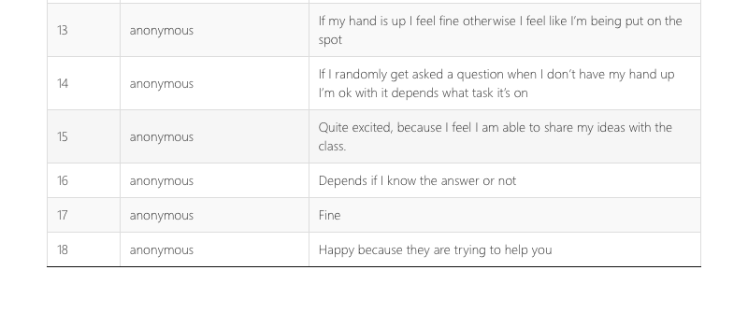
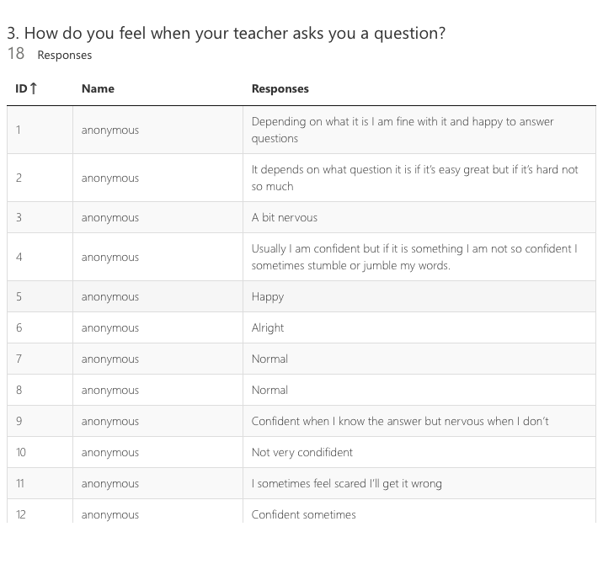

The table provides both qualitative and quantitative data as it allows the data to numerically generated (Punch, 2014), but detailed responses are provided; where 5/9 of the children are scared to get the answer wrong, they are nervous about answering the question or feel they are being put on the spot.

This suggests children’s fears about questions are prominent and this may be the reason why children don’t engage with questioning in the classroom, as previously highlighted by Black and William (1988). Triangulation was also used in this field, where the participants’ opinions were shown, the researcher was able to gather a view, before collecting a view of reality. The results provided could be of high level of significance due to the fact that participants were able to freely express their opinions, with no encouragement or involvement of the researcher (Thomas, 2017).
Due to the questionnaires only being handed out to a small sample of 18 children as 9 children were on a school trip, it needs to be acknowledged therefore, that the results generated are not representative of the whole class.

During the interview process, similar results were found which could suggest the interviewer bias affect had limited influence during the method (Cohen, Manion and Morrison, 2013). When children were asked how they felt about being chosen to answer a question (appendix 10), ¾ of the respondents said they don’t like to answer questions if their answer is wrong, which could suggest the pressure of being right in front of their peers is prominent amongst some children.

The results found could be deemed as significant due to respondents delving in deeper about their feelings, creating rapport and empathy on behalf of the interviewer (Cohen, Manion and Morrison, 2013). However, due to the importance of assent within the interviews (see appendix 7), one participant very rarely turned their smiley face around to answer the question, which affected the sample size of the focus group. It also needs to be considered that respondents may be putting on a front and providing information they think the researcher wants to gather, not what they actually think (Walford, 2001).

The use of peer discussion within the classroom was praised continuously by the children. When observing the class, it was found that they use a lot of ‘think, pair, share’, where all children engaged in this appropriately and were discussing relevant ideas, opposing Beck and Kosnick (2006). Quantitative data from the sample of children showed that they all engaged with peer discussions regularly and used it throughout their tasks to confer and check answers during their experiment (appendix 8)

It needs to be considered that information could have been missed during the observation as children were working in groups of 3-4; it was found difficult to gather information from all of the groups in the short timeframe. The nature of the school day is also different everyday which was perceived within the observation as children were on a school trip. Therefore, time was a limitation during this study.

The questionnaire provided evidence that 17 out of 18 children liked working in pairs (appendix 11a). When asking the teacher about the effectiveness of questioning and discussion, both qualitative and quantitative data was provided (appendix 11b). The teacher rated peer discussion five stars, and then provided further detail as to why they thought it was so important. The positive response correlates with previously discussed evidence from the Welsh Government (2010), Black et Al (2003) and Hattie (2008). It also provided qualitative data as it was a Likert-scale question; where the teacher strongly agreed (100%) with the statement that questioning is the most important drive within the classroom (appendix 11b).

As there were only ten iPads available for the research study, participants had to complete the questionnaire at different times, which leaves room for discussion of the questionnaires. This could limit the validity of the interview as children might be influenced by what their peers say (Thomas, 2017).

When guiding the interview, similar questions were asked to the questionnaire but provided unique, personal, qualitative data. Each child provided informative responses as to why they liked working in pairs and discussing questions. Their high-level responses were intriguing (Cohen, Manion and Morrison, 2013). When respondents were asked if they think talking to friends helps them learn (appendix 12), quantitative data could be gathered; where 4/4 participants stated they learn new skills and different views of a topic. It was also important to check with them that answers were understood correctly throughout the process to increase accuracy of results (appendix 12) (Thomas, 2017).

Within the interview, respondents answered the questions in the same order. This may have had a negative effect on the results, as louder children happened to be in the order of responding first. Other respondents may have used the same answer as the dominative child, correlating with Austin (2016).

The data collected from the research study combines the use of all the research tools, to create a generalisation that questioning and discussion both have a positive effect on children’s learning. The responses and evidence found could be deemed as valid and credible due to the fact that necessary and relevant answers were provided, which directly answered all the questions that had been asked. The findings demonstrated that children like to learn new skills from their peers and can combine both of their answers together to demonstrate an understanding. This information can be transferred to my own professional teaching practice, where I can use ‘think, pair, share’ regularly in the classroom, switching partners to allow children to gain new ideas. I can then create new ways of implementing peer discussion into the classroom using pupil voice to enhance children’s knowledge and understanding.

It was also found that a lot of children were reluctant to answer questions due to the fear of failure. In further teaching practices, I could use whiteboards, where each child writes their own answer and places the board in the air and iPads for children to anonymously submit answers to questions. Furthermore, some children didn’t think they were given enough time to answer questions, therefore, I could implement new strategies such as board timers, phone a friend, etc.

It could be argued that, due to the sample being so small, no definite generalisations can be made and cannot be deemed as credible. The research study may provide an idea of responses, but it cannot be representative. The results positively reflect the hypothesis and demonstrate constructive effects, but the effect these results may pose is limited due to the research study taking place over one school day.
If the research was to be conducted again, I would ensure that all research tools are piloted to minimise error. Throughout the whole study and assignment, I have demonstrated my understanding of the Four Research Dispositions (Orchard and Winch, 2015) and have shown professional standards when conducting research. I have continuously shown the ability to be sceptical, by always looking at different angles of the research. I have followed all ethical guidelines to conduct this research, and I feel I am now fully aware and competent in demonstrating these. To conclude, the research study illustrates my knowledge of being a skilled researcher and my commitment to taking part in the inquiring profession.

