A
DISSERTATION ON:

THE INFLUENCE OF BRAND ON CONSUMER BEHAVIOUR-
A COMPARATIVE STUDY OF STUDENT PREFERENCESBETWEEN BMW AND TESLA

By
[Student Name]
Table of Contents
Chapter 1: Introduction 6
1.1. Background of the Study 6
1.2. Research Significance 6
1.3. Research Rationale 7
1.4. Research Aim and Objectives 8
1.5. Research questions 8
1.6. Structure of the Study 9
Chapter 2: Literature Review 11
2.1. Introduction 11
2.2. Analysing the brand value between automotive car manufacturers like TESLA and BMW Research Aims and Objectives 11
2.2.1. Metric of Brand Value in the Automotive Industry 11
2.2.2. Customer preference and perception of TESLA and BMW 13
2.2.3. Role of Technology and Innovations in Brand Enhancement 15
2.2.4. Marketing and Communication Strategies along with the impact of Corporate Social Responsibility 17
2.3. Examining the preferences of the customer in relevance to providing more premium electric cars 18
2.3.1. The Influence of Brand Value on Customers for Purchasing Premium Electric Cars 18
2.3.2. The Role of Performance and Design in Providing Premium Cars 20
2.3.3. The Role of Safety Options in Premium Cars Influencing Customers’ Buying Habits 21
2.3.4. Customer Loyalty in Providing Premium Cars 22
2.4. Summary 23
Chapter 3: Methodology 24
3.1. Research Philosophy 24
3.2. Research Approach 24
3.3. Research Design 25
3.4. Population and Sampling 26
3.5. Data Collection 27
3.6. Data Analysis 28
3.7. Ethical Consideration 28
3.8. Summary 29
Chapter 4: Findings and Discussion 30
4.1. Introduction 30
4.2. Findings 30
4.3 Thematic Analysis 47
4.3.1. Analysing Brand Perception among Students 47
4.3.2. Factors influencing preferences of students towards BMW and TESLA 48
4.3.3. Comparing brand loyalty and Purchasing intention 49
4.3.4. Identification of Potential Market Strategies 49
4.3.5. Understanding the Emotional and Psychological factors 50
4.3.6. Contributing existing knowledge on customer behaviour and brand influence 51
4.4 Summary 51
Chapter 5: Conclusion 52
5.1. Conclusion 52
5.2. Linking with Objectives 52
5.2.1. Analysing the brand perception among students 52
5.2.2. Factors influencing preferences of students towards BMW and TESLA 53
5.2.3. Comparing brand loyalty and purchasing intention 53
5.2.4. Identification of Potential Market Strategies 54
5.2.5. Understanding the emotional and psychological factors 54
5.2.6. Contributing existing knowledge on customer behaviour and brand influence 54
5.3. Future perspective 55
5.3.1. Analysing the brand perception among students 55
5.3.2. Factors influencing preferences of students towards BMW and TESLA 55
5.3.3. Comparing brand loyalty and purchasing intention 55
5.3.4. Identification of Potential Market Strategies 55
5.3.5. Understanding the emotional and psychological factors 56
5.3.6. Contributing existing knowledge on customer behaviour and brand influence 56
5.4. Recommendations 56
References 57

List of Figures
Figure 1.1: The structure of the study is represented as a process diagram 9
Figure 2.1: Metric of Brand Value in Automotive Industry like BMW and TESLA 11
Figure 2.2: Customer Preference and Perception of BMW and TESLA 13
Figure 2.3: Role of Technology and Innovations in Brand Enhancement 15
Figure 2.4: Impact of Marketing, Communication and CSR strategies on BMW and TESLA 17
Figure 4.8: Perception about the eco-friendly brand 25
Figure 4.9: Opinion on the role of BMW and Tesla in social status increment 26
Figure 4.10: Responses regarding pre-purchase information gathering 27
Figure 4.11: Opinion about the best affordable brand 28
Figure 4.12: Responses about the role of online reviews in decision-making 29
Figure 4.13: Opinions about better facility providers among BMW and Tesla 30
Figure 4.14: Perception regarding best car seller among Tesla and BMW 31
Figure 4.15: Opinion about attractive marketing strategy 32
Figure 4.16: Responses regarding luxurious brand 33
Figure 4.17: Brand preferences for passenger safety 34

Chapter 1:Introduction

1.1.Background of the Study
The automobile industry has faced significant changes over the years which are related to innovations and technology. These innovations and technologies attract customers as they meet the expectations of the Customer preferences. Automobile brands play an important role in purchasing decisions and customer behaviour. The study aims to determine the influence of Brands on customer behaviour through two prominent automotivecompanies- TESLA and BMW. Bayerische, Motoren, Werke,commonly known as BMW is a German Multinational Automobile manufacturing company (Haider, 2020). It has a rich history in manufacturing luxurious cars and is one of the leading luxurious car manufacturers globally. The company has created a reputation with a perfect blend of luxuriousness and performance which meets the customer demands and preferences.
According to Niedermeyer (2019), TESLA is an American multinational company which produces electric vehicles maintaining a concern about clean energy and sustainable resources. The name of the company "TESLA" pays homage to the renowned scientist and inventor of electricity "Nikola Tesla". TESLA focuses on advancement in technology and innovations to improve the safety and driving experience. The study further deals with analysing the brand value that affects customer behaviour and preferences. Examining the customer preference for electric cars and incorporating innovations that match the customer and market insights are being studied vividly. Primary Quantitative Data has been used for the analysis and statistics identification of data for the completion of the project. The entire study has been based on a quantitative analysis method which helps in understanding the behaviour, experience as well as customer attitude. This determines the brand's influence on customers which is being studied vividly and helps in the completion of the project. Ethical considerations and sampling are being considered for the fruitful completion of the project work.

1.2. Research Significance
The study signifies customer preference which represents the long-term value for BMW and TESLA (Liu, 2021). This research provides valuable insights into customer preferences of choosing between established and luxurious brands like BMW or choosing the innovative electric vehicle brand TESLA. The research shed light on how TESLA and BMW have perceived their customer insights with specific demographics. This helps in studying the perception and preferences of customers towards luxurious and Electric Automobile brands. The research findings and analysis of the study can help in the implementation of effective marketing strategies which help in the growth of business and be the leading ones in the automobile industry. TESLA and BMW can resonate their marketing strategies with potentially increasing brand awareness and loyalty among customers. This helps in determining the current brand value and brand image of BMW and TESLA among its target audience.
This study offers and deals with the ways that a traditional car manufacturing company like BMW should adopt to compete with new innovative automobile companies like TESLA. The automobile industry has its changing landscape and preferences from time to time, which should meet the market needs and customer demands. The consumer attitude and decisions of policymakers and stakeholders are being studied in this research. This helps in creating a sustainable environment which is in prominence for the reduction of carbon emissions and attracts environment-friendly customers. Research study touches on the societal implications on a broader scale which determines the impact of branding on customers. The research study helps in providing valuable insights which influence the behaviour of the customer through brand image and perception.

1.3. Research Rationale
Research rationale deals with the growing importance of Students as their customers. It helps in understanding the student's attitude towards the brand who are the future customers and having potential impact on the Automobile industry. The transition of students from student life to work life where they become more financially independent, then the student's preferences significantly influence the Automobile market (Nansubuga and Kowalkowski, 2021). Brand perception plays a major role in shaping the behaviour of customers, especially in luxurious and electric vehicle manufacturing automobile companies. BMW has its long-established luxurious automobile manufacturing image. TESLA has maintained its brand image by maintaining innovative developments and a sustainable environment. This helps in interaction and student perception which are the driving forces that led the future customer choices in the Automobile industry.
The research rationale deals with the psychology of customer and brand loyalty which reveals the emotional connections of students with TESLA and BMW. By researching and understanding the brand loyalty and lack thereof, the research uncovers deeper insights which help in maintaining the brand image and customer loyalty. Market analysis is being studied in the research rationale that helps in determining the strengths and weaknesses of TESLA and BMW. This concerns the student preferences for each brand which enhances the unique selling propositions in differentiating BMW from TESLA in competitive markets. This research contributes to the detailed study of the behaviour of consumers influenced by branding and marketing. This helps the luxurious and electric automobile industry for exploring the brand influence on customer preferences. The impacts of the trajectory of BMW and TESLA along with the preferences of the students are being studied. Moreover, the study helps in maintaining the dynamic relationship between customers and brands like TESLA and BMW.

1.4. Research Aim and Objectives
Aim
The study aims to examine the customer behaviour and experience among students that is being influenced by automobile brands, particularly focusing on BMW and TESLA.
The objectives of the research are as follows:
- Analysing the brand perception among students: According to Dai (2020), this study helps in understanding the brand image of TESLA and BMW in context to students' perceptions like brand, quality and reputation.
- Factors influencing preferences of students towards BMW and TESLA: This helps in understanding the key drivers such as brand attribute, customer loyalty, price and sustainability for being more persistent to students.
- Comparing brand loyalty and purchasing intention: This helps in determining the student’s loyalty towards BMW and TESLA and understanding the intentions to buy these brands in future (Juet al, 2021)
- Identification of potential market strategies: According toLi (2019), this objective helps in determining and enhancing the marketing strategies that will resonate better with students' demographics.
- Understanding the emotional and psychological factors: This objective delves into the emotional and psychological aspects that shape the preference for students towards BMW and TESLA (Le and Ho, 2021)
- Contributing existing knowledge on customer behaviour and brand influence: According toHigueras-Castillo et al (2019), this objective focuses on valuable insights that influence automotive brands like TESLA and BMW with context to students' preferences for luxury and electric branded vehicles.

1.5. Research questions
- What is the perception of students for TESLA and BMW brands regarding customer loyalty, brand image and overall reputation?
- What are the exact key factors that influence the student’s preference between TESLA and BMW?
- How do considerations such as brand loyalty, design, technology, price and sustainability play a role in the process of decision-making?
- What is the extent to BMW and TESLA exhibit their brand loyalty towards students' preferences?
- Are there any notable preferences when it comes to female and male customers towards BMW and TESLA?
- How do gender-related factors affect brand perception and intentions of purchase?

1.6. Structure of the Study
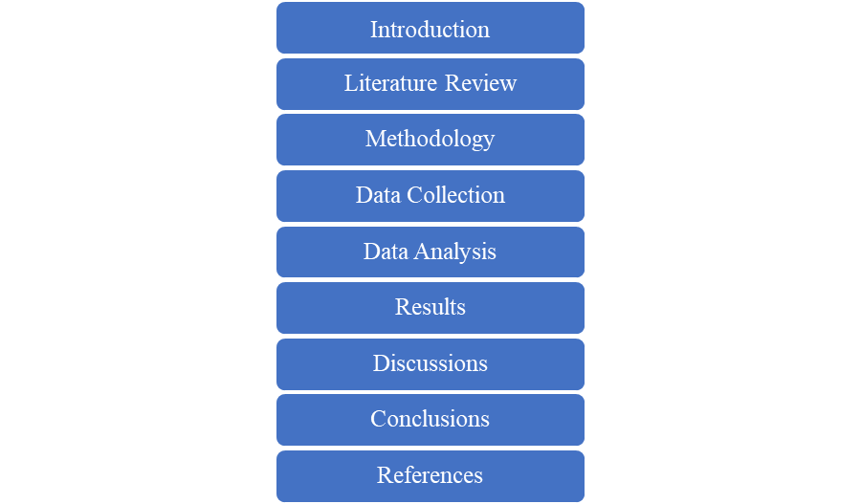

Figure 1.1: The structure of the study is represented as a process diagram
(Source: Self-Developed)

The study structure starts with an introduction where the companies are introduced properly and a short-summarized context is discussed about the influence of brand marketing on student behaviour. The introduction consists of the background and context where a detailed background of the study is being discussed along with the marketing strategies implemented for the branding. Research significance is followed by background and context, where the importance of the research is being studied and how the study is significant to BMW and TESLA are being studied. Research Rationale deals with the importance of Students as future customers and deals with the future aspects of branding that would attract today's students as customers. Research Aim and Objectives is the next step with a specific aim and objectives of the project work. Research Questions are being followed up where the questions are being discussed that arise during the completion of the project work. At the end portion, the structure of the study is dealt with.
After the introduction portion comes the Literature review. This section consists of an overview of the influence of branding strategies to attract customers along with a theoretical framework. Previous studies on consumer behaviour and brand image perception are being studied in this portion. Factors influencing branding and the theoretical approaches are being dealt with in this study. After the literature review comes methodology, which helps in determining the methods used for the completion of a project. This section consists of the Research design, sampling techniques, collection methods of data, questionnaire techniques, data analysis methods and ethical considerations. After the portion of methodology results followed by discussion comes, where the data analytics results are discussed and discussed how the result helps in brand influence of BMW and TESLA. Conclusion and references are the last part of the dissertation where the project concludes the whole study and its impact on BMW and TESLA along with references.

Chapter 2:Literature Review

2.1.Introduction
In the ever-evolving automotive world, brand value and perception play a crucial role in customer behaviour. Among all the prominent automotive players BMW and TESLA had the spotlight for the cutting edge in innovation and manufacturing electric vehicles. This research deals with the brand value analysis of the automotive industry like BMW and TESLA. The study helps in understanding the factors that help in the contribution of brand values and customer preferences. This study focuses on and aims to shed light on the dynamics of BMW and TESLA as an automotive industry that can drive the competitive advantage in the competitive advantageous markets. This chapter has dealt with analysing these factors.

2.2.Analysing the brand value between automotive car manufacturers like TESLA and BMW Research Aims and Objectives

2.2.1. Metric of Brand Value in the Automotive Industry
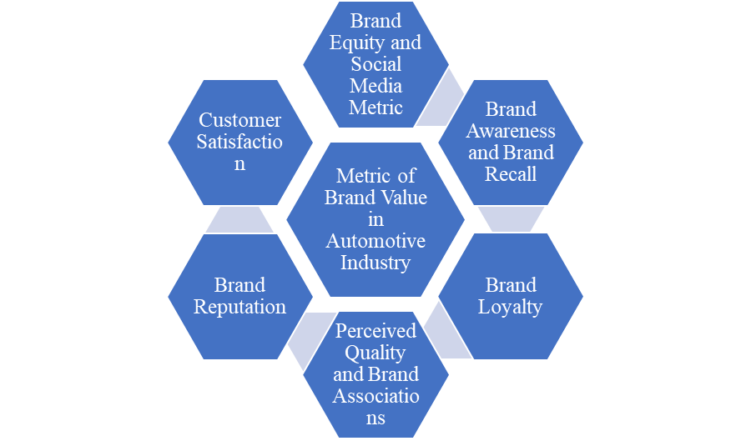

Figure 2.1: Metric of Brand Value in Automotive Industry like BMW and TESLA
(Source: Self-Developed)
With the growth of the highly competitive automobile industry, brand value plays a major role in influencing purchase decisions, student preferences and the overall success rate of TESLA and BMW in the competitive market. According to Ebelinget al. (2021), the strategies of brand values and customer perception helps in establishing a strong market presence in the field of automobiles. Brand awareness is a basic backbone of brand value that reflects the extent to which brands like TESLA and BMW are preferred and recalled by customers. Evaluation of advocacy along with brand loyalty is the two most important indicators of brand value that strengthen the relationship between the brand and the customers (Guerreiroet al., 2021). The study helps in examining the loyalty programs and customer retention rates towards BMW and TESLA. This helps to gain valuable insights which are used to assess brand loyalty in the automotive industry. Brand awareness measures the extent to which brands like BMW and TESLA are being preferred and recalled by student customers. It is considered the fundamental metric that familiarises the relationship between customer and brand engagement. High brand awareness suggests that the brand is well known and has a strong presence in the competitive automobile sector.
Brand recalling is the second metric that puts value on brand awareness and brand loyalty. This helps in assessing the degree of commitment to remain attached to a particular automobile brand such as BMW and TESLA. Aalundet al. (2021) stated that brand recall acts as an indication to retain the customer and increase in brand-customer engagement reflecting the brand's ability to retain the target audience over time. Perception in quality and brand association describes customer trust and satisfaction along with the overall impact of brand value and customer loyalty towards BMW and TESLA. Quality perception is the degree of a product of a brand in terms of performance, reliability and overall impressions. Perceived quality leads to an increase in brand value which has a direct effect on customer satisfaction and brand loyalty. Brand associations can be positive or negative according to the customer's choices that refer to attributes, emotions and values that attract the student customers towards TESLA or BMW. Brand reputation reflects the overall standing of TESLA and BMW in the competitive automotive industry in the eyes of customers, stakeholders and industry experts. A positive brand reputation leads to the growth of the brand value and customer loyalty leading to "Potential Brand Advocacy" and a positive "Mouth-of-Word".

Brand equity and social media metrics play an important role in the evaluation of brand value which later on has a direct effect on customer-brand engagement along with student customer interaction. Equity in TESLA and BMW brands is an overall view of the financial and non-financial aspects of an automotive company.

2.2.2. Customer preference and perception of TESLA and BMW
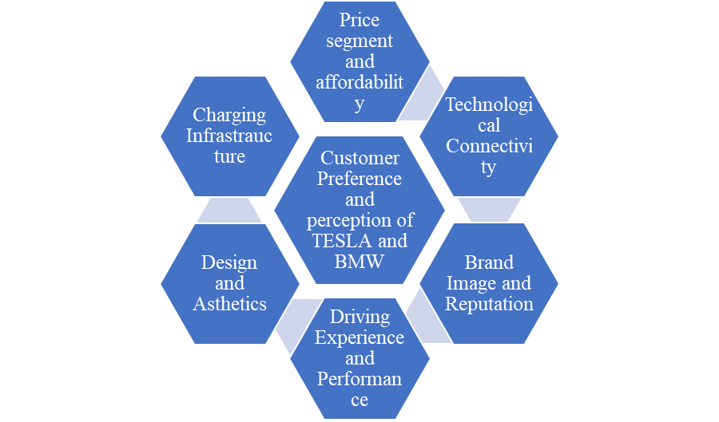

Figure 2.2: Customer Preference and Perception of BMW and TESLA
(Source: Self-Developed)
Perception of BMW and TESLA along with customer preference plays an important role in influencing the market position and brand value in the automotive industry. BMW and TESLA both have distinct identities and have different segments of the target audience which results in varying customer preferences. Some of the aspects are discussed below:
TESLA is renowned for its electric vehicles which provide a sustainable environment with cutting-edge innovative technologies. Environment-friendly customers who want innovative technologies are more aligned towards TESLA as it focuses on clean energy and automated driving facilities (Liu,2021). On the other hand, BMW has also ventured into electric vehicles, which have a good reputation in the luxurious automobile market. BMW is known to attract customers who prefer performance-oriented driving along with luxuriousness. It is appealing to those customers who want "Value Driving Dynamics" along with internally fitted combustion engines. According to Bhardwaj et al. (2020), the brand image of TESLA is often associated with technological innovations, futurism and a mission to convert the world into a sustainable environment. This perception of TESLA attracts environment-friendly and technologically innovation-savvy customers. BMW is generally known for its performance, luxuriousness and as a symbol of heritage. Kukkamallaet al. (2020) stated that BMW attracts customers who seek a blend of luxuriousness and comfort along with the status of a "Heritage Driving". TESLA is known for its infotainment systems along with over-the-air updates with the maintenance of a sustainable environment. These technologically savvy features give innovative and sustainable driving to its customers. BMW incorporates cutting-edge technology in driving performance along with luxuriousness. It attracts customers who prefer personalized driving performance along with a sense of comfort.
BMW holds a strong reputation for driving experience and performance. The company is generally known for its responsive handling, powerful engines, precise steering and along with a sense of luxury and performance. The electric vehicles of TESLA offer instant torque and smooth acceleration. It delivers different kinds of driving experiences based on instant power delivery and driving efficiency with the maintenance of a sustainable environment. The design and aesthetics of an automobile attract customers, especially students to a large extent. TESLA appears as a minimalistic and sleek contemporary appearance that attracts the student customer, who can help in future customer engagement of the company (Naeem and Sami,2020). On the other hand, BMW has great taste in design including aggressive and traditional styling in certain models. The company, TESLA offers a wide and super network of fast charging for TESLA owners for travelling long distances. This charging infrastructure appeals to the customers who prioritize and convenience the accessibility of the charging. On the other hand, BMW like other automobile manufacturers are being perceived differently by customers depending on the availability and coverage of the region. TESLA and BMW offer different price segments for different automobiles; TESLA has its price segment positioned at price sensitivity and affordability which influences the preferences of customers to invest in modern innovative technologies of TESLA. The price segment of BMW Company helps in luxurious offerings and various price points for different segments of target customers.

2.2.3. Role of Technology and Innovations in Brand Enhancement
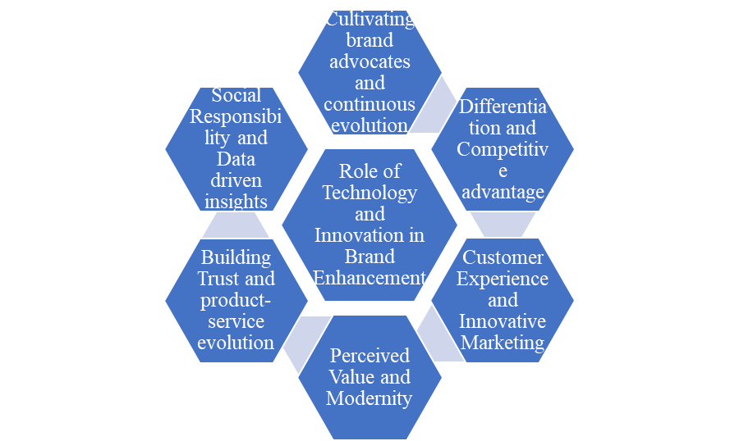

Figure 2.3: Role of Technology and Innovations in Brand Enhancement
(Source: Self-Developed)
Today's emerging competitive world of automobiles effectively leverages cutting-edge technologies and innovative solutions to secure a position in globally competitive markets. The leverage in technology and innovation helps in differentiating customer experience which establishes competitive advantages. Some of the ways are discussed below how technologies and innovations help in the contribution of brand enhancement:
Embracement in innovations and technologies helps automotive companies like BMW and TESLA to stand out in the global automotive competitive markets. Brands like BMW and TESLA that pioneer and implement new technologies can establish themselves as a leader in the automotive industry. These strategies help in establishing the loyalty and attention of the customers, especially the students. Enhancing customer experiences for technological-driven purposes in products and services and their interactions helps in improving customer experience. TESLA and BMW incorporate modern technologies like AI for maintaining streamlined processes and helping streamline interactions (Masoomzadehet al, 2020). This helps in fostering greater customer loyalty and satisfaction towards the company. Brands like BMW and TESLA that incorporate new modern technologies are being perceived as modern technology and relevant to customer preferences. This perception contributes to a positive brand image and helps in attracting technologically-savvy customers associated with quality and value innovation (Miglani, 2019). Technologies enable brands to engage captive audiences from virtual to reality experiences. Technology provides new avenues for a creative target audience and brand engagement. Products and service evolutions revolve around and evolve products through continuous advancements. Continuous technological improvements help in keeping the brand fresh and exciting while the competitive market meets changing customer needs.
Delivering the promises made to the customers and addressing the pain points of the customers helps in building trust and credibility among the customers. Implementation of modern cyber security helps in robust data security and privacy of customer data. This helps in increasing customer loyalty towards automotive brands like BMW and TESLA. Data-driven insights help to gather more vastness and enable automotive brands like BMW and TESLA to reach out more to target customers, especially students. The data provides valuable insights which help in product development, marketing strategies and customer engagement which help to build more effective brands like TESLA and BMW. Brands like TESLA create sustainable solutions which attract more environmentally friendly customers. Such innovative approaches help in the enhancement of brand reputation and loyal customer base. Fostering brand communities and engagements can help in the cultivation of brand advocates. These strategies help to share customer experiences and help in taking regular feedback which helps in active brand promotion in the automotive industry like TESLA and BMW. Active branding helps in increasing the customer loyalty base towards BMW and TESLA. A continuous evolution in innovation and technology allows automotive brands like TESLA and BMW in enhancing their value over time, which helps in attracting more customers.

2.2.4. Marketing and Communication Strategies along with the impact of Corporate Social Responsibility
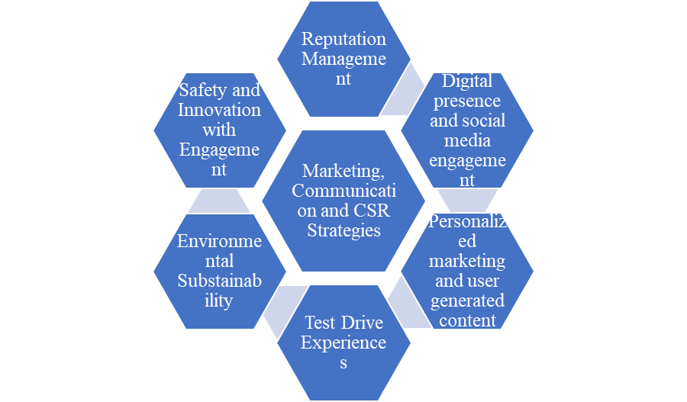

Figure 2.4: Impact of Marketing, Communication and CSR strategies on BMW and TESLA
(Source: Self-Developed)
Marketing and Communication Strategies are very crucial in the competitive market of today's world. The communication and branding strategies help in brand awareness and engage customers in driving sales. Corporate Social Responsibilities (CSR) involves the integration of social and environmental concerns which helps in the process of decision-making. CSR initiatives have a significant impact on brand perception and customer loyalty. The marketing and communication strategies for CSR initiatives are discussed below:
Juska (20210 stated that content marketing and digital presence create informative brand content to educate the target audience, especially students about their upcoming innovations, vehicles and industry trends. Social media platforms provide direct engagement with customers. This helps in solving the inquiries of the target audience, which helps in building a value of trust and maintaining customer loyalty. Offering test drives to target audiences helps in interaction with first-hand vehicles. It helps in engaging potential buyers to buy their vehicles. Brands like TESLA and BMW use their data-driven potential to perform personalized marketing. Customized advertisements, target customer engagement helps in personalized offers that help in target audience and brand interaction. Encouraging target customers to share their views and feedback in the automotive industry like BMW and TESLA helps in building trust and authenticity.
Corporate Social Responsibility (CSR) plays an important role in the automotive industry like BMW and TESLA. Brands like TESLA develop electric vehicles to reduce emissions keeping in mind the concern for the environment and the increase in pollution rate (Munten, 2021). Initiatives of CSR mark a footprint to reduce emissions and recycling. This helps to attract environment-friendly customers. BMW and TESLA have a greater area of concern with the safety of the customers. Innovative technologies like automated driving and assistance driving technologies are being incorporated in TESLA and BMW to increase the safety level. This ensures that the automotive brand respects human emotions and works on safety and commitment. Engaging relationships with stakeholders and employees of automotive companies like BMW and TESLA ensures a positive corporate image and a long-term relationship. This increases the trust and customer loyalty of the target audience. Corporate Social Responsibility (CSR) helps in opportunities for positive media coverage. This helps in branding the automotive industry to reach a mass amount of target audience. Helping brands help in managing of reputations and responding effectively to potential crises.

2.3. Examining the preferences of the customer in relevance to providing more premium electric cars

2.3.1. The Influence of Brand Value on Customers for Purchasing Premium Electric Cars
The effect of company reputation on consumers when buying luxury electric vehicles is a complex trend with a major effect on consumer behaviour and making choices. The value of a company is crucial in defining the tastes and options of discriminating purchasers wanting both comfort and environmental responsibility in the fast-expanding world of electric cars (de Ruyter, 2020). The image is based on qualities such as dependability, creativity and dedication to quality. Customers are more inclined to turn to companies they consider to be more reliable, believing that the money they spend on an electric EV will be rewarded with an automotive that meets the requirements for quality. Electric vehicles are also popular for their advanced technology features and the image of maintaining an eco-friendly atmosphere. Premium companies are often at the centre of creativity, including cutting-edge battery engineering, self-driving skills and engaging multimedia systems built into their cars. These advances not just improve the convenience of driving, but also appeal to the company’s perception of luxury and advanced thinking. Nethraet al. (2022) have stated that the pollution-free environment gets priority in the community so, EV company focus on that to maintain the preferences of customers. Individuals can connect their ideals with the choices they make by choosing luxury EV manufacturers. These companies are often linked with an international movement regarding cleaner mobility, and having one of their cars represents an indication of alignment with a larger, mindful environmental message.
The creation of EV cars is another attractive point for customers, the unique designs, and advanced technology makes the EV car more luxurious. Design is a crucial factor for premium cars these customers primarily seek luxury that aligns with their lifestyle. Innovative elements, fine texture and high quality are fundamental elements for premium cars that ensure customer satisfaction in this category. The importance of referral advertising is an intriguing component of the study. Owners who are passionate about automobiles frequently express their knowledge and opinions on websites and social networking platforms, providing a virtual place for debate about these cars (Vdovic et al. 2019). Positive feedback and suggestions from other EV fans help build a brand reputation and can substantially affect potential purchasers' buying choices. Unfavourable encounters, on the other hand, might dissuade potential purchasers, emphasising the significance of ongoing reliability and client fulfilment for luxury EV businesses. In addition, many luxury automobile manufacturers' dedication to ecology coincides with the beliefs of mindful customers. Fatin and Sudira, (2023) said that these companies frequently utilise green technology and methods of assembly, emphasising their commitment to lowering the ecological impact connected with vehicle manufacture. Such programmes are popular among shoppers who see buying things as a means to help preserve the planet. The philosophical consistency between corporate philosophy and customer ideas produces an intense emotional bond that goes beyond the practical features of automobile ownership. As the sector of electric cars expands, reputation will most certainly stay to be a crucial factor in defining customer choices, giving companies an opportunity to distinguish from one another in a competitive field (Lopes, 2021). Premium EV car companies are positioned to play an important part in influencing the development of sustainable transportation as purchasers progressively choose cars that represent their beliefs.

2.3.2. The Role of Performance and Design in Providing Premium Cars
The interaction between design and efficiency is critical in establishing the character of luxury vehicles, resulting in a fascinating combination of both practicality and style that resonates strongly with discriminating purchasers (Carlsson and Mathiasson, 2020). Premium automotive offers are built around efficiency, which is defined by authority, accuracy and vehicle characteristics. Excellent performance motors, innovative management structures, and innovative powertrain innovation combine to create a thrilling and masterful journey. Performance becomes a reflection of the brand's dedication to offering the best driving dynamics, whether it's the smooth, accurate steering around corners or the existing scream of the diesel engine. The significance of styling in defining the personality of luxury vehicles is also crucial. Design goes beyond simple appearance, embodying the core of a brand ideology and captivating spectators' interest. The external style strikes a precise blend of beauty and creativity, featuring elegant paths, athletic turns, and unique details providing an eye-catching visual impression. Every shape and wrinkle has an objective, improving both the airflow and the aesthetic appeal of the automobile. In contrast, decorating raises luxury and ease to a visual genre. Raman et al. (2021) discussed that premium automotive seats are meticulously construed ted using the best substances, superb manufacturing and local arrangement to surround passengers in an atmosphere o wealth and elegance. The genuine charm of luxury automobiles is revealed via the confluence of design and efficiency. Performing elements are effortlessly incorporated into the whole architecture, resulting in a beautiful combination of design and functionality.
The car's streamlined shape is not just for show; it also improves economy and safety at elevated speeds. The layout of buttons and displays in the cockpit is intended to be instinctive, allowing the driver to concentrate on driving without losing the optical and physical refinement that distinguishes the inside. Furthermore, both performance and aesthetic components strengthen the identity of the company by serving as a painting for communicating the brand's beliefs and objectives to the entire globe. Whether it is a dedication to the latest innovation, an appreciation of legacy, or a representation of comfort, these characteristics are frequently highlighted through the interaction between efficiency and graphic beauty. This unique personality enables luxury automobile makers to fully engage with their intended consumer base, generating trust in the company and an overwhelming feeling of connection among consumers. According to Canals et al. (2022), luxury car manufacturers focus on creativity and continuous innovation to differentiate themselves from market rivalries. This factor emphasizes the psychographic intention of the buyers as they strive to get the best possible cars with high levels of innovation. In summary, the brand reputation of the car manufacturers largely depends on their innovation levels based on technical aspects and design which positively influences buying decisions of the consumers.

2.3.3. The Role of Safety Options in Premium Cars Influencing Customers’ Buying Habits
The function of security features in luxury vehicles has a significant impact on consumers' purchasing patterns, as discriminating purchasers progressively prioritise their own and their colleagues' security. Martínezet al. (2021) stated that security has evolved from a secondary factor to a basic need, and luxury automakers have reacted by including sophisticated safety technology that exceeds current standards. These precautions not only increase purchasers' trust, but they also correspond with their ideals of privacy and quiet of mind. Luxury vehicles are frequently outfitted with an extensive range of innovative safety features that include both proactive and inactive precautions. Active safety systems, such as intelligent speed control, lane-departing alert, and automated brake assistance are intended to help drivers escape possible risks and thus avoid crashes. These characteristics reflect a brand's dedication to remaining at the cutting edge of safeguarding technological advancement, connecting with shoppers looking for a better degree of security in their everyday travel. Active precautions, on the other hand, are activated when an accident cannot be avoided. Sun et al. (2019) discussed that Premium vehicles succeed in this area additionally, with strong design elements, several safety features, and strengthened cracks all working together to reduce the impact of an accident.
High-quality metals are frequently used to form an insurance circle for passengers, demonstrating luxury manufacturers' commitment to minimising injuries in difficult circumstances. The impact of security functions on client purchasing behaviours stretches past the characteristics themselves (Sayler, 2019). This displays a brand's dedication to prioritising its consumers' happiness, producing a strong feeling of confidence and allegiance. Premium automobile purchasers not only anticipate enhanced security technologies, but they also see them as an expression of the company's principles and commitment to greatness. Premium vehicles develop an image of being security experts by pushing deeper than market requirements, a feature that appeals deeply to risk-conscious buyers. In addition, security amenities influence the whole driving procedure (Deichmannet al. 2019). Premium vehicles frequently have equipment such as adjustable lighting that improves vision at night, blind-spot tracking devices to help in switching lanes, and places-to-park help innovations that make controlling in restricted areas simpler. These amenities not only relieve travelling tension but additionally add to the perception of refinement and elegance that high-end automobile purchasers want.
The incorporation of security and comfort elements offers smooth driving expertise that is consistent with the company's mission of providing greatness in all aspects. Gilibert and Ribas, (2019) have said thatthe simplicity of finding ratings, and accident test data increases the importance of security alternatives in this era. When reaching a purchasing choice, potential customers perform extensive research, frequently depending on external reviews. Premium vehicles that earn excellent safety scores and awards from reputable organisations become attractive options. A solid security record improves the image of a company by convincing consumers that their money is protected not just by its dedication but also by independent evaluations from industry professionals. Finally, the function of safety features in luxury vehicles impacts customers' purchasing behaviours by satisfying their desire for security, trust, and comfort. Yaqoobet al. (2019) stated thatthe use of modern safety technology demonstrates a company's commitment to development and consumer satisfaction. Safety elements connect powerfully with purchasers who prioritise both elegance and protection, from active security features that avoid injuries to preventative measures that reduce the effect of crashes. Premium cars build lasting relationships with security-conscious customers by surpassing the competition and continuously providing on their pledge of security, impacting their buying patterns and developing a loyal following.

2.3.4. Customer Loyalty in Providing Premium Cars
Client devotion is critical in the luxury vehicle industry because it reflects the conclusion of a company's attempts to develop a strong and lasting relationship with its audience. Luxury automakers understand that fostering loyalty requires more than just delivering an item (Khan et al. 2022). The trip starts at the first transaction, where each step from the purchasing procedure through shipment is carefully organised to provide an unforgettable and enjoyable trip. The best brands go above and above by providing great afterwards support, personalised repair, and generating an environment of uniqueness via VIP programmes and celebrations. The devotion of clients is strengthened further by continual excellence and creativity. As per the views of Kukkamallaet al. (2020), premium automakers are always pushing the limits of design and construction to ensure that every new version maintains the company’s primary principles while delivering novel amenities that entice purchasers. This dedication to development promotes trust in current consumers that their preferred brand is constantly at the cutting edge of elegance and innovation. Customer devotion is also influenced by referral advertising. Owners who are pleased with their purchases become ambassadors for the company, spreading positive feedback with neighbours, relatives and online forums. These reviews are extremely valuable since potential consumers place a high value on the views of individuals who have personally worked with the product. As these suggestions encourage new relationships and end up adding to the company’s success, the framework of impact grows.
According to Novacescu (2019), the psychological significance of having a high-end vehicle increases consumers' loyalty. The possession of a luxury automobile is frequently associated with individuality, indicating achievement, prestige and culture. An expensive car’s feeling of success and satisfaction expands personal engagement beyond simple journeys, forming a psychological connection that exceeds the automobile’s practical elements. Finally, client commitment in the setting of luxury automobile sales is an ever-changing combination of outstanding events, creativity, psychological connection, and after-sale support. Premium automakers recognise that creating a network of devoted consumers’ necessities an extensive strategy that spans the full ownership experience, from the time it’s bought to the conclusion of the lifetime experience. Hoeft, (2021) has discussed that premium vehicle companies build a devoted following that exceeds interactions and develops into a true, lasting passion for their company by continually surpassing demands, executing commitments and developing interpersonal relationships.

2.4. Summary
This study intends to define a clear brand perception of TESLA and BMW among customers. The paper shows that the purchase decisions of customers are largely dependent on the brand value of premium car manufacturers. It has been reflected that TESLA portrays itself as an environmentally responsible car brand that offers technology-enabled electric cars. On the other hand, BMW is popular for its unique design and engine performance that differentiates it from its competitors. In addition, customer loyalty is another crucial factor that drives customers in purchasing luxury cars. This indicates the prevalence of organic or word-of-mouth marketing in the premium car segment that is widely focused by the businesses.

Chapter 3:Methodology

3.1. Research Philosophy
According to Johnson et al. (2020), while doing a research work, proper methodological selection can be admitted to be the most significant work, since this section deals with the research design, the process of collection of data, method of data analysis are decided upon and thereby making the research proceed further (Sallis et al. 2021). This research work has considered the interpretivism research philosophy to get the optimum result. Interpretivism research philosophy is a sociological research method by means of which an event or action is analysed that is based on the values, norms, and beliefs of the society culture where it occurs (Rashid et al. 2021). The interpretivism research philosophy in this research work has reflected the researcher’s significant assumptions thereby providing the research strategy base. In order to make the research work accurate interpretivism research philosophy has been followed in this research. Since according to Casula et al. (2021), the interpretivism research philosophy has the capability to supply and also support varied statements, a comparative accurate analysis between BMW and Tesla can be made with taking help of this research philosophy. Interpretivism research philosophy is assumption-based that reality is multiple, subjective, and socially made to construct (Means et al. 2023). The research philosophy plays a significant role in order to analyse data that may be difficult or tough and rather impossible to measure following a quantitative way (Singh, 2019). Taking the help of the interpretivism philosophy the research work has become capable enough in order to analyse various factors affecting consumer behaviour and preferences between BMW and Tesla. The interpretivism philosophy utilises the qualitative method of research which focuses mainly on quantitative data to gain better understanding of social interactions (Nickerson, 2022). Using qualitative research methods, the interpretivism philosophy has given this research work findings a higher level of validation.

3.2. Research Approach
This research paper has been written using an abductive approach. The abductive approach in the case of any research work gives space for intuition and creativity in order to better understand the observed phenomenon (Sætre. and Van, 2021). This research approach is adopted at the beginning of the research work as it is a very good rational explanation and gives space to the deductive approach to dictate the precise research structure. Abductive research approach has its flaws like it can often lead to negative conclusions and thereby lead towards serious mistakes and consequences (Mertala et al. 2022). In this research work, the abductive approach plays a significant role as being exploratory the approach starts with the data or the observations and then creates a hypothesis to apply in this research work (Garbuio and Lin, 2021). The abductive approach has given this research a new dimension by means of generating significant hypotheses and solving certain complex issues that do not have any clear answers as of now. Since the abductive approach also involves insights from varied disciplines; it has provided the research work a diversified perspective and helped in the development of explanations (Wiltshire and Ronkainen, 2021). By means of creative thinking and innovative ideas, the approach has led this research to consider alternative explanations on the subject topic that are not immediately obvious. Therefore, the entire research work is being carried out following the abductive approach to obtain the desired results.

3.3. Research Design
Research design in any piece of research work is a framework comprising of various methods of research and techniques that are chosen by a researcher as per the need of the research in order to complete the research and achieve success (Rashid et al. 2019). Research design allows the researcher to further sharpen the research methodologies that are most suitable for the particular research subject matter and then set up the studies accordingly to achieve success in the research work (Bougie and Sekaran, 2019). Research design are of four main types includes, Descriptive, Experimental research, Correlational, and Quasi-Experimental (Bloomfield and Fisher, 2019). In the instance of this research topic focused on the comparative study between BMW and Tesla, a systematic approach to research is followed. In this context, it is pertinent to mention that systematic approach of research is also an example of Experimental research referred to in the last sentence.
The purpose of systematic analysis is to supply a diligent summation from all the available data sourced by means of primary research conducted in the form of questionnaires (Smale-Jacobse et al. 2019). The systematic research analysis utilises all the data that are gathered from an existing research work and hence it is often termed as secondary research which means research on research (Logan, 2020). In this particular research work, systematic research analysis has the capability to assist in the instance of operating the relevant solutions. The solutions have been addressed regarding the problems that are connected or associated with the comparative case study of BMW and Tesla. Systematic research design is the best choice in instance of establishing comparative study in between the two automobile market giants BMW and Tesla include, as according to Ouyang et al. 2022 systematic analysis allows collection and analysis of data in a more profound and systematic manner.
Since, any comparative research study requires a comprehensive understanding, in this case the systematic research analysis helps in the gathering of data starting from the financial to market aspects of both companies. The analysis also helps to identify the strengths, weaknesses and also the performance benchmark of both BMW and Tesla. This analysis thereby helps to analyse the risks, opportunities, and also the innovative ideas of both the companies. Systematic research analysis also provides a much better organised approach in the data collection technique to evaluate and also interpret the data. Systematic research analysis ensures that the conclusions driven are latest and provide a path towards future researches and business decision making.

3.4.Population and Sampling
Sampling instances of any research works accounts to the choice of a part of the population in the interest of the research study (Braun et al. 2021). This part of the population study helps in the characterisation of the entire population as well. Four distinctive sampling type procedures are relevant, which includes, random sampling, judgment sampling, systematic sampling, and block sampling (Wu and Thompson, 2020). Sampling study can sometimes be erroneous due to bias or random sample collection. A purposive strategy of sampling has been followed in lieu of the research need to understand the issues in a better way. Some of the significance of sampling in this particular research work doing the comparative study between BMW and Tesla that can be considered are depicted herein. The considerations include collection of the representative data and that also without examining single individuals concerned and thereby saving both time and expenses.
A well-structured sampling has the capability to throw light upon the insights that are applied to the majority of the population of both BMW and Tesla comprises of the consumers. Sampling in this research work has ensured both statistical importance and data diversity. Therefore, the data collected are mathematically or statistically valid and on the other hand, diversification has showed the path towards a better comprehensive knowledge of the research topic. Sampling allowed the collection and analysis of data on real-time basis and measures have been taken to reduce bias and thereby uplifting the quality and reliability of the research work.
Sampling has helped this research work to be budget friendly and it is important as likewise maximum researches, this research was done on a limited budget. In this context, it is also mentioned that while conducting the comparative study between BMW and Tesla, the sampling strategy was designed carefully. Thereby, ensuring all the representatives of the studied population is interested to study the same. Since, the quality of the research conclusion primarily depends upon the method of sampling adopted, necessary care has been taken to serve the purpose.

3.5. Data Collection
Amongst the significant aspects of any research is the choice of data collection technique to be followed to get the desirable results (Pandey and Pandey, 2021). Data are usually collected from various reliable sources and are developed to justify the answers to the problem areas of the research work. Data collection techniques are of two types the primary data collection method and the secondary data collection methods (Li et al. 2019). Primary data collection in any research means that the research work was carried out by the researcher or has authorised the data collection process on behalf of the researcher. A significant benefit of primary data collection is that it goes straight to the source and does not depend on pre-existent data samplings. Sources of collection may include surveys, and statistical operations amongst others. On the other hand, Secondary data collection in any piece of research focuses on the data that are pre-existent. Sources of Secondary data collection may include reliable websites, journals, and research papers to name a few.
It can also be noted, there are three distinctive research methods that include, mono, mixed and multi methods (Younas and Durante, 2023). Usually mono method is adopted when research is targeted based on either of quantitative or qualitative approaches only. Whereas, in the case of mixed methods both qualitative and quantitative approaches are studied in the same research so as to achieve a different result. On the other hand, multi-method also termed as multiple method involves in case more than one research project is executed and in this case, combined quantitative and qualitative methods or both of them are put in use. Relevant to the current research work, the most important data collection method will be a mixed method. On the other hand, implementation of a primary quantitative collection of data will be most significant for the research purpose so as to get an in-depth analysis and understanding of the objectives that are already set in the previous chapter of this research.
The implementation of the quantitative data collection method has proved to be cost effective in the research and the method has also been selected due to its benefits in instance of effective comparison in between the research findings. In order to support the research, primary qualitative data is also done and data are collected from authentic sources like scholarly articles, websites amongst others. These legitimate sources have been chosen to support the research questionnaires that are also relevant with the statistical data inclusive in this research work. By opting for the quantitative method of data collection researcher will be able to gather a much better level of understanding the comparison between BMW and Tesla which is both accurate and conclusive. Primary quantitative data collection in this research has helped to source accurate, reliable, recent and customised data that reflects the present scenario of both the companies.
Alongside, it has helped in testing of hypothesis and taking a view of the inside strategies and data collected over time gave a longitudinal analysis of both the company performances. The analysis helped to get a better understanding about the response and evolution of both the companies in response to the latest industry drifting. In this research survey was carried out by means of a set of 20 questionnaires set prepared in relevance to the research topic which are answered by a total of 70 respondents. This survey helped to gather in-depth knowledge about the brand influence on customer behaviour in taking in account both BMW and Tesla. The executed survey and its subsequent responses provides a broader sense, and not to mention that the entire research work can come to a meaningful conclusion.

3.6. Data Analysis
According to Sheng et al. (2021), the methods of analysis of data should be included in the methodology part of research, thereby offering a clear pathway of representing how primary data will be analysed. There remains adversity while analysing the qualitative and quantitative data. Since, quantitative data analysis deals in the interpretation of numerical and statistical data, figures, graphs and charts alongside critical analysis of the same will be executed. On the other hand, qualitative data analysis considers experiments and interviews or surveys involved in the identification of the common patterns recorded amongst the respondents. Furthermore, the feedbacks are analysed in a critical manner to align with the research aims and objectives.
In this research work the survey was carried out amongst 70 respondents comprising of male, female and other genders of age group range 18 to 33 years considering the income slab from 16,000 to 27,000 INR. The data collected from the survey are evaluated in an Excel spreadsheet in a way that enabled the research work to develop a detailed and analytical insight into the survey responses.

3.7. Ethical Consideration
This particular part of the research work can be considered to be very much significant, progressing further with this research all the ethical standards that are followed while doing this research are mentioned herein this segment. In some instances of research work, it was not ethical in order to source data from an entire population. Therefore, in the scenario, studying consumer behavioural patterns, consent was taken from every consumer wherever possible and at times it was not feasible to carry out the same. While caring out the research work on comparative study of BMW and Tesla, followed the ethical principles and thereby necessary care is taken to defend the respondent’s social privacy, endurance of the harmony, minimising the harmfulness, and complying with the legal and other concerned regulatory bodies, data integrity policy have been strictly adhered too. Furthermore, adequate measures are also taken care off to make the research work bias free and not to derail from the main research objectives.

3.8. Summary
The research work take the way of primary quantitative and qualitative data analysis methods, following a mixed approach and interpretivism research philosophy along with abductive approach are the choice of the research. The research work will not remain limited just to the results but it in turn will provide requisite information upon the variables that are examined and significantly highlight the research outcome. The research revolved around the comparative analysis of the two automobile market giants, BMW and Tesla. The readers will be able to get a transparent picturesque of the research outcome of both the companies at the end of the research work and relevant research questionnaires have been chosen to conduct the survey process. The research work has strictly adhered to all the legal and ethical considerations.

Chapter 4:Findings and Discussion

4.1. Introduction
This chapter will focus on analysing the outcome or findings of the study by discussing some essential themes. The findings of quantitative data have been analysed here in the other parts of the study. This chapter will help the study by giving a detailed perception regarding the influence of Brands on Consumer Behaviour. This chapter will also discuss the way Tesla and BMW can influence the brand perception of consumers in the market. Furthermore, in this chapter, the comparison between brand loyalty and the buying intentions of consumers will be discussed to enhance the study.

4.2. Findings
The researchers of this study have conducted a “survey” regarding the brand influence in the context of BMW and Tesla. This survey was conducted in a particular place and started on 1st September and ended on 8th September. 70 participants have joined this survey and provided their opinions depending on 20 survey questions. The information has been gathered from the respondents at different times within these mentioned days. Before starting the survey, consent was taken from every respondent. The researchers basically focused on the age group of 18 to 33 because, at this age, people have an interest in several new products or brands. These age groups can provide available information by reading their preferred products. As most of the respondents were college students, therefore, in this age fascination with cars is very common.
The researchers have selected both genders to conduct this survey. Recently, it has been observed that women have more interest in four-wheelers and two-wheelers compared to men. Therefore females also can provide information regarding the car brands. The selected groups’ annual income varied from £16000 to £27000. As the researchers have selected the college students for conducting this survey, therefore, the income level of the participants was not too high. Most of the respondents belonged to the income group of £16000 to £19000. Among these 70 respondents, more of the respondents have an interest in BMW compared to Tesla. Among these respondents, the majority believe one thing the influence of brand has a significant role in shaping the purchasing behaviour of the consumer.

Figure 4.1: Study of Brand preference, comparative study between BMW and Tesla
(Source: Excel-Generated)
Both BMW and Tesla are well-known automakers with distinctive appeals. Tesla, known for its electric vehicles, champion’s supportability and state-of-the-art innovation. The industry has been transformed by its self-driving capabilities and Autopilot. BMW, then again, brags a rich history of execution and extravagance. It is favoured due to its premium interiors and sporty driving dynamics. Whether eco-conscious innovation or a combination of performance and prestige is more important.It is observed from the analysis that 22 people prefer BMW and 11 people prefer Tesla whereas 24 people prefer both companies. On the other hand, it is observed that 12 people do not prefer any of the companies. This survey helped the researchers figure out the brand preferences of people in the automobile industry.

Figure 4.2: Study of link between consumer behaviour and brand reputation
(Source: Excel-Generated)
Yes, consumer behaviour and brand reputation are directly linked. Shopper conduct, including buying choices and unwaveringness, is vigorously impacted by a brand's standing. Trust, willingness to buy, and repeat business are all increased when a brand is perceived positively. On the other hand, a bad reputation for a brand can make people avoid it, which can hurt sales and market share. For influencing consumer behaviour and maintaining a strong brand reputation, which in turn drives business success, it is essential to have effective branding, consistent product quality, and effective communication. It is observed from the survey that 33 people agreed with the statement that brand reputation and consumer behaviour are linked directly. 9 people gave negative answers whereas 8 people were confused about the fact and 20 people replied with “maybe”.

Figure 4.3: Study of brand name influence in customer behaviour
(Source: Excel-Generated)
Indeed, brand names essentially impact client conduct. They convey confidence, quality, and familiarity, which can influence decisions regarding purchases. A solid brand can inspire positive feelings, reliability, and a feeling of personality, empowering rehash business. Furthermore, brand insight can influence cost awareness, with customers frequently ready to pay something else for items related to deeply grounded brands. These psychological triggers are tapped into by effective branding strategies, influencing consumer choices and fostering brand loyalty. It is observed from the survey that 31 people agreed with the statement and 3 people disagreed with it whereas 19 people remained neutral about the fact. Besides, 16 people strongly agreed with it and 1 person strongly disagreed.
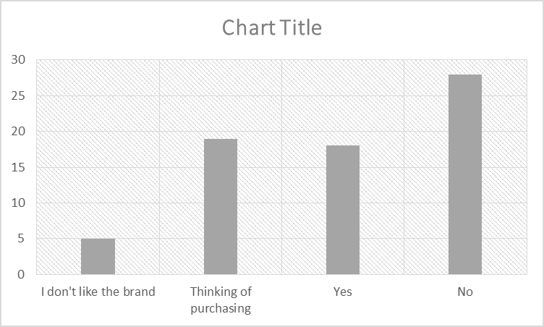

Figure 4.4: Study demonstrating the purchase behaviour in respect of BMW cars
(Source: Excel-Generated)
The poll results on BMW vehicle purchases show that respondents’ perspectives differed. 28 of 70 people who took part had never bought a BMW, demonstrating that the brand is not now favoured by a sizable portion of the sample. 19 respondents to the survey indicated they were considering buying a BMW in the future, which indicates potential prospects for the company to grow. Additionally, 18 individuals have already purchased a BMW, demonstrating a level of loyalty to the company and customer satisfaction among current clients. In contrast, 5 respondents say they do not like the brand, presumably speaking for a vociferous but small minority. According to the survey, there is the possibility for both client expansion and retention depending on the efficacy and customer appeal of the BMW brand.
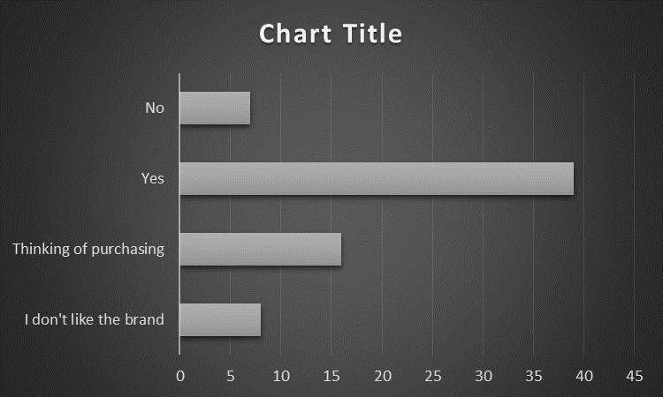

Figure 4.5: Study demonstrating the purchase behaviour in respect of Tesla cars
(Source: Excel-Generated)
According to survey information on Tesla car purchases, respondents have a remarkably upbeat attitude. 39 out of the 70 participants—a sizable majority—have already bought a Tesla, demonstrating the company’s broad popularity and market dominance. Furthermore, 16 participants indicated a potential interest in later Tesla purchases, suggesting that the company’s client base may continue to expand. A fewer number of 8 respondents, who probably reflect a minority with misgivings or worries about Tesla, disagree with the brand. Only 7 people claimed they had not bought a Tesla, which highlights how well the company is doing at luring customers. This survey’s findings show that people have conflicting feelings about BMW, stressing the necessity for the firm to both keep its devoted clientele and try to enhance its reputation among those who are dubious or unsatisfied with the brand.

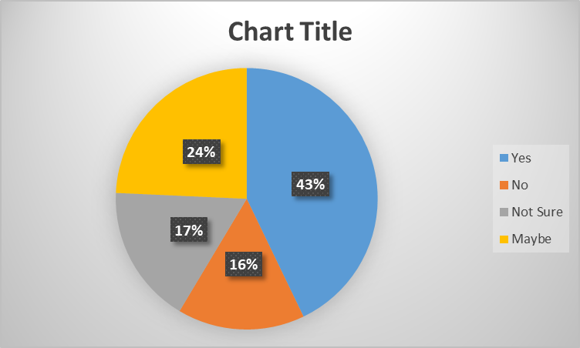

Figure 4.6: Study to understand the competitive behaviour between BMW and Tesla
(Source: Excel-Generated)
According to survey results, a sizable percentage of participants consider BMW to be a tough competitor in the EV (Electric Vehicle) industry. Out of the 70 respondents, 30 think that BMW is a formidable rival to Tesla. 11 respondents, on the other hand, disagreed with the idea that BMW was a formidable rival to Tesla, indicating that they might think BMW lagged behind in the market for electric cars. The fact that 12 individuals are unclear further highlights the topic's ambiguity or lack of knowledge. It is interesting to note that 17 respondents gave the response "Maybe", indicating some ambivalence or conflicting perspectives about BMW's ability to compare with Tesla. With regard to BMW's status as a rival to Tesla, the study reveals a spectrum of viewpoints, with a considerable portion recognising BMW's existence and promise in the market for electric vehicles.

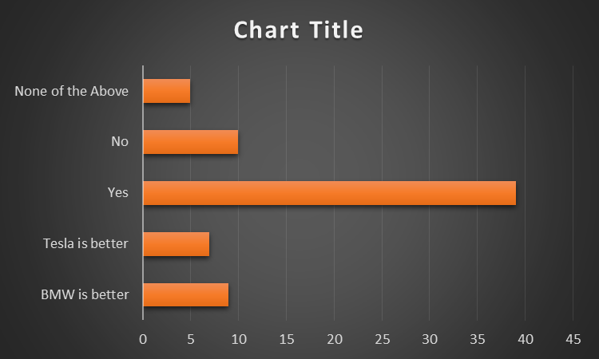

Figure 4.7: Comparative studyregarding consumerservices of BMW and Tesla
(Source: Excel-Generated)
The poll on the level of customer service provided by Tesla and BMW revealed a wide range of responses. 39 out of the 70 individuals, or a sizable share, think both brands offer good customer service. This illustrates a favourable opinion of both Tesla and BMW’s customer care initiatives. Notably, 10 participants expressed a negative opinion, showing that neither brand provides excellent customer service. This shows that both businesses’ customer service offerings may use some improvement. It is interesting to note that 9 respondents think BMW provides better customer service, whereas 7 respondents prefer Tesla in this respect. According to the survey, people have different opinions on the level of customer care provided by Tesla and BMW, with a few participants favouring one company over another and a sizable portion evaluating both brands favourably.

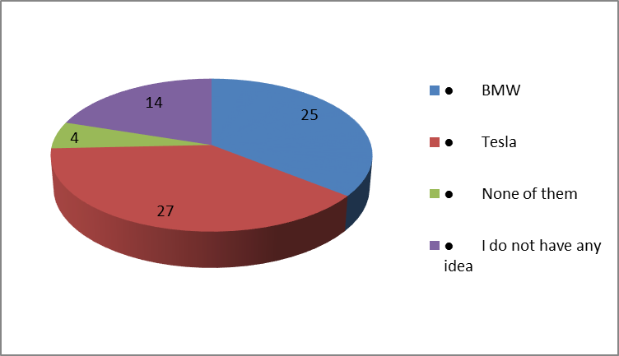

Figure 4.8: Perception about the eco-friendly brand
(Source: Excel-Generated)
The above graph focuses on explaining the responses regarding eco-friendly brands. Among 70 responses, 27 people agreed that Tesla provides a more eco-friendly brand. Whereas, 25 people answered BMW provides a more eco-friendly car compared to Tesla. Besides saving people loads of money on fuel, going battery or electric also assists both companies to reduce their carbon footprint. Therefore, electric vehicles will be a great choice for protecting the environment of the world. On the other hand, of the rest of the participants, 14 people replied that they had no idea regarding the matter. Lastly, 4 people answered both Tesla And BMW no one provided eco-friendly cars. Finally, from this chart, it is observed that Tesla gained more popularity in providing eco-friendly cars compared to BMW.
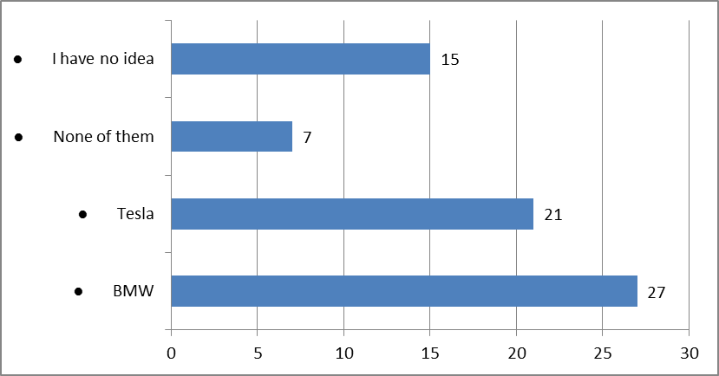

Figure 4.9: Opinion on the role of BMW and Tesla in social status increment
(Source: Excel-Generated)
Luxurious or branded cars are often connected with success and status. These cars are considered a symbol of power and wealth and these cars helped to create a perception to people about the car owner. BMW and Tesla both are known as branded cars, still, people have individual preferences about these two brands. Out of 70 people, 27 people think that BMW is a car that has the power to increase social status. On the other hand, 21 respondents agreed that Tesla played an important role in enhancing social status. 15 people replied that they had no idea about this fact and 7 people answered that both brands have no role in social status increment.
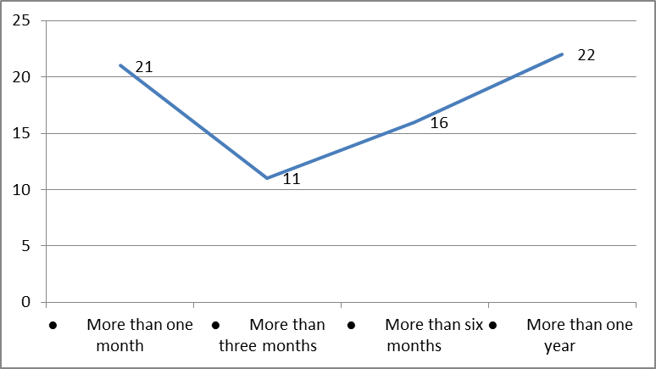

Figure 4.10: Responses regarding pre-purchase information gathering
(Source: Excel-Generated)
Purchasing a branded car is considered the most decisive choice thata buyer makes. Therefore collecting pre-purchase information is very necessary when a buyer wants to purchase a car. Among 70 responses 21 people answered that they will gather pre-purchase information for more than one month before purchasing the car. Whereas, 11 people replied that, it would take more than three months to gather information about the car. Besides these, 16 people answered that it would take six months or more to store information and finally 22 people replied that it would take more than one year to collect information for their preferred brand.

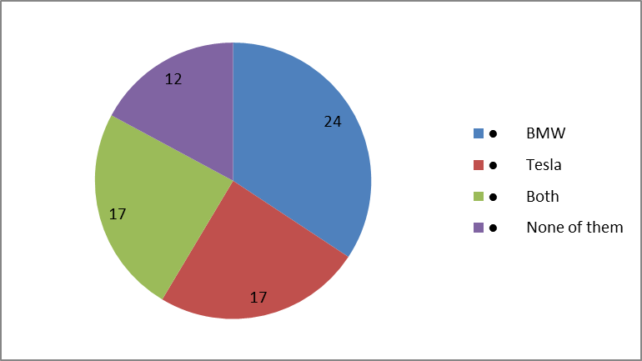

Figure 4.11: Opinion about the best affordable brand
(Source: Excel-Generated)
Affordability plays an important role in deciding whether the customer can afford a specific product within its budget constraints. Figure 4.14 portrays the graph depending on the responses regarding the affordable brand. Among BMW and Tesla, which are affordable bard, this question is very tough to answer. Still, 24 people agreed that BMW is much more affordable compared to Tesla. Among the rest of the respondents, 17 people answered that Tesla is more affordable. Apart from that, another 17 people answered that both brands are affordable. Lastly, 12 people responded that none of them are easily affordable, both are expensive.

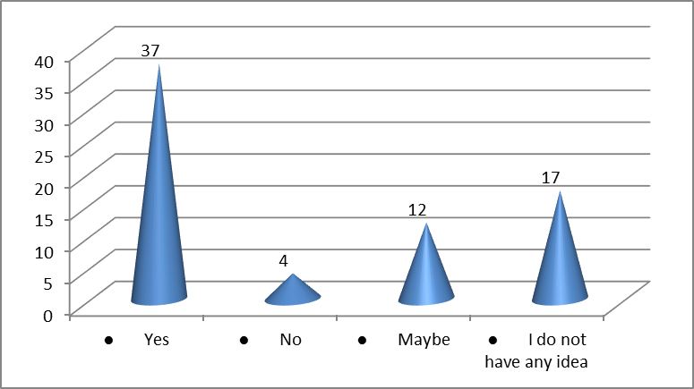

Figure 4.12: Responses about the role of online reviews in decision-making
(Source: Excel-Generated)
The exposure of customers to online reviews can influence their online shopping behaviour. Consumers search for reviews during product evaluation for purchasing. Real-life customer ratings or reviews online have a huge impact on the decision to purchase compared to celebrity or influencer reviews. Out of 70 respondents, 37 people strongly agreed that online reviews have a great positive role in decision-making for product purchasing. Whereas, only 4 people think that, there is no role of online rating consumers’ purchasing decisions. On the other hand, 12 people think that maybe online reviews have an importance in decision making. Finally, 17 people answered that they had no idea about it.
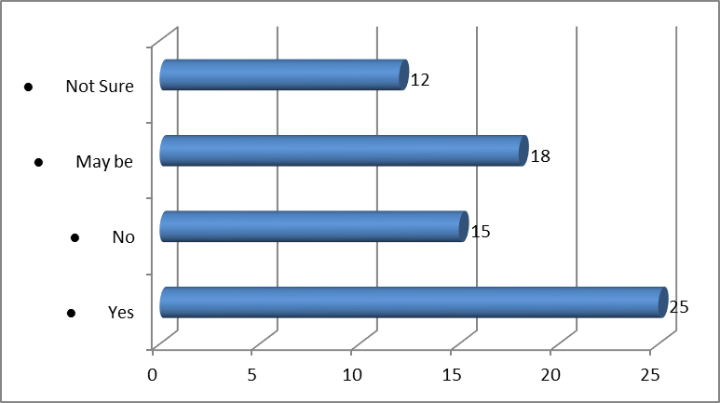

Figure 4.13: Opinions about better facility providers among BMW and Tesla
(Source: Excel-Generated)
Providing facilities is important to attract a huge level of customers and also build the brand identity. Therefore Tesla and BMW both brand try to provide better facilities to their customers and these facilities help them to increase their customer base. Among 70 people, 25 people agreed that BMW is a better facility provider compared to Tesla. Whereas 15 people deny the fact, they think Tesla provide better facility. Among the rest of the people, 18 people replied that maybe BMW provide a better facility and finally 12 people were not sure about the matter. In conclusion, depending on the response it is clear that BMW brands are better in “initial quality” compared to Tesla brands.

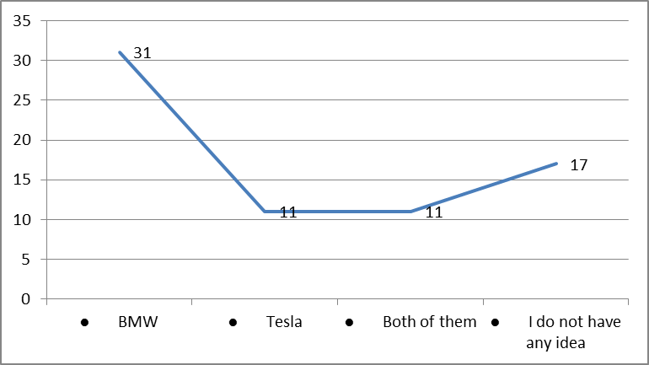

Figure 4.14: Perception regarding best car seller among Tesla and BMW
(Source: Excel-Generated)
Tesla and BMW brands both are famous for car-selling. Every year the selling number of cars by these brands is different. Based on this question, out of 70 responses, 31 respondents replied that BMW sells more cars compared to Tesla. Whereas, 11 people agreed that Tesla sells more cars. As per the report of 2022, it is found that Tesla sells more cars compared to Mercedes and BMW. On the other hand, another 11 people replied that both brands sell approximately the same number of cars throughout the year. Lastly, 17 people answered that they had no information or idea regarding the fact.
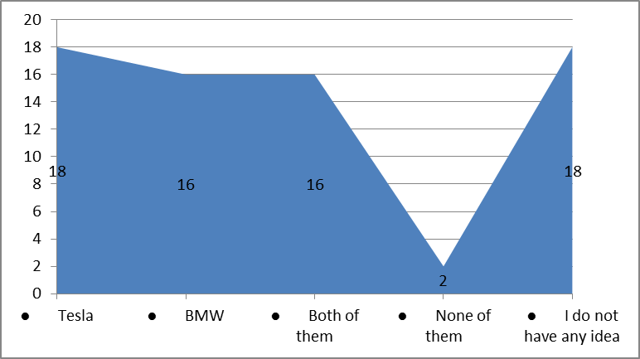

Figure 4.15: Opinion about attractive marketing strategy
(Source: Excel-Generated)
Customer attraction is one of the vital tools for enhancing the business to a great extent. Attractive marketing gets the brand into the minds and hearts of its target customers, aligning the brand with the proper values. Apart from that, attractive marketing can help both brands strengthen their brand image and survive in a competitive market. 18 respondents of the 70 respondents believed that Tesla’s marketing strategy is better than BMW's. On the other hand, 16 people replied that the strategy of BMW is much better. Besides these, 16 people answered that both brands follow an attractive marketing strategy. Among the rest of the 2 people replied that no one follows any attractive strategy and 18 people responded that they have basically no idea about the matter.
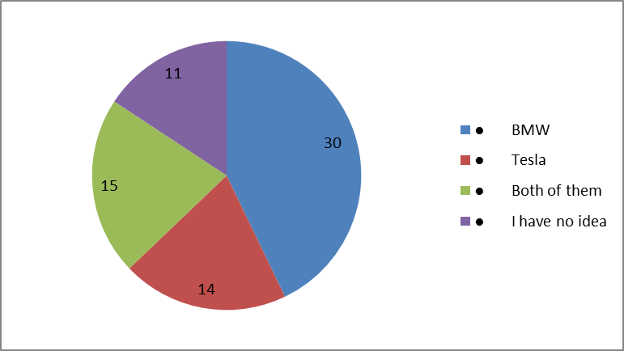

Figure 4.16: Responses regarding luxurious brand
(Source: Excel-Generated)
Sometimes “pricing” itself can be considered a marketing strategy. Many luxurious brands grasp their high product prices to make a prestigious image. This tactic appeals to the consumer, who is more prepared to pay a “premium” for the “bragging rights” that come with insufficiency. In the question about luxurious brands, 30 people prefer BMW as a luxurious brand. Whereas, 14 people believe that Tesla is more luxurious compared to BMW. However, 15 people replied that both brands are very luxurious compared to other brands. Finally, 11 people answered that they had no idea about these luxurious brands. So, after explaining this graph, it is observed that the popularity of the BMW brand as a luxurious car is much more compared to the Tesla brand.
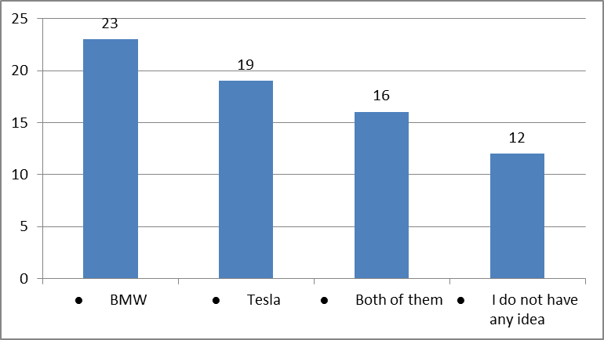

Figure 4.17: Brand preferences for passenger safety
(Source: Excel-Generated)
Passenger safety has been an important factor in the automobile sector recently. Every car company always thinks about the safety of the passengers. Discussion regarding passenger safety with the respondents resulted that, out of 70 participants 23 people agreed that BMW has more sincerity about the passengers' safety compared to Tesla. On the other hand, 19 people agreed that Tesla is more cautious about passengers' safety. Besides these, 16 people replied that both brands are very serious about their passengers' safety. Rest of the 12 people answered that they were totally incognigant about the fact. Finally, it is discovered from these responses that BMW is very much aware of its passenger safety.

4.3 Thematic Analysis

4.3.1. Analysing Brand Perception among Students
Brand perception is a concept which is related to the consumers about a company and its product (Yu and Yuan, 2019). Brand perception in consumers’ minds is established from the experiences they gather after buying a product and after using it. In the same way, the brand perception of students about BMW and Tesla can be an effective example of brand perception in the business market. As per the analysis of the literature review, students nowadays can be attracted to different types of vehicles and their companies. They also can have their preferences between the companies according to their choices. In addition to this, the students also have brand perceptions or preferences between companies like BMW and Tesla. Loyalty can be an effective factor for a company to develop their business process and attract large customers towards the company (Moriuchi, 2019). According to the literature review, students can be attracted to the strategies of the companies like the loyalty process and the consumer experiences of the companies.
Additionally, the use of technological-driven purposes can also help to attract customers, especially students in the business market (Shah and Murthi, 2021). However, it is proved in the survey process that every student has their own perception of the business of the company and they can attracted by various features of different companies. Companies like BMW and Tesla try to attract students towards their business processes and their products by applying interesting data-driven purposes in the company. Another strategy that can be very helpful to the company to attract students is to share their innovation process about a product. In addition, this can be an attractive factor for the students as they can find the process interesting. Moreover, these strategies of BMW and Tesla can have an impact on the brand perception of consumers, especially students.

4.3.2. Factors influencing preferences of students towards BMW and TESLA
Companies have some major factors with the help of which they can attract large audiences in their business process (Elali, 2021). These factors also can influence the consumers and can have an impact on the decision-making process of the consumers. As per the literature review, companies like BMW and Tesla implement some major strategies in the market to influence the brand preference of the students about the companies. Moreover, with the help of those strategies, companies try to improve the marketing structure and their influence in the business market. Price structure is an essential factor for a company to develop its business management process in the market (Saltan and Smolander, 2021). According to the literature review, one of the major strategies of Tesla is its “price sensitivity and affordability” to attract large audiences, especially students. Their “price segment position” is an effective factor with the help which they can influence the preferences of the students.
On the other hand, BMW tries to attract students with its luxuriousness along with the comfort for the people. This factor also can be helpful for BMW Company to influence the preference of students in its business process. However, Tesla also tries to influence students by implementing “clean energy and automated driving facilities” in the business market. Tesla tries to attract students by improving these factors and by making them more attractive than other companies. In addition to this, another influencing factor of BMW for students is the availability of their products in various regions. Availability plays an essential role in developing the impact of the company among its consumers and it can increase the sales of the company (Barbieriet al. 2021). These factors can have an impact on companies like BMW and Tesla to influence the preferences of students.

4.3.3. Comparing brand loyalty and Purchasing intention
Brand loyalty is an essential factor for a company as it can help the company create a positive image among the consumers in the market (Kaur et al. 2020). Brand loyalty can help the company attract a large audience by having a reliable influence on the consumers. In the same way, BMW and Tesla also try to implement brand loyalty on their customers, especially students. Brand loyalty can help companies influence the decision-making process of students about their brand perception. According to the literature review, students are mostly attracted by the loyalty programs of companies as they need to build communication with their preferred company. “Product quality and brand association” are the two most essential factors for BMW and Tesla in the market. On the other hand, the purchasing intention of consumers also depends on the loyalty programs of companies (Zhenget al. 2022). As per the literature review, these factors also can have the ability to influence the purchasing patterns of consumers.
In addition, companies need to build better trust and loyalty about companies in the minds of students to influence their purchasing intention. It can be an effective factor to increase the marketing revenue of companies than other companies. However, it also can create a better competitive environment between the purchasing intention and brand loyalty. Companies can try to improve the loyalty factors of their company to influence the buying intention of consumers from the company. According to the analysis of the literature review, purchasing intention can also help students or consumers research companies and then make their decisions in their buying process. Moreover, as per the discussion of the literature review, the brand loyalty factor can be helpful for the company to have a positive impact on the behaviour of the consumers in their buying process.

4.3.4. Identification of Potential Market Strategies
Potential market strategies are a process that a company can apply in the future to improve the business structure (Zhenget al. 2022). Potential market strategies can be helpful for companies to build positive ideas about the business process of companies in the future. In the same way, BMW and Tesla also have some major potential market strategies that they can use to enhance their marketing process. One of the most important potential marketing strategies for BMW and Tesla is that they can use the high value of their products in the future to influence a large audience in their business process. Potential market strategies can help companies at the time when they try to expand their business in the market. In addition to this, another potential strategy for BMW and Tesla is to make their customers influenced by external reviews while purchasing their products. It can also help companies build trust and loyalty to their business process with the help of these external reviews.
However, companies also need to provide a better buying experience for the consumers to have positive external reviews from other customers. External reviews for a company can make them more reliable and trustworthy for their consumers than other companies (Turnhoutet al. 2020). According to the literature review, potential marketing strategies also enhance the significance of the company on the ongoing reliability to attract customers. These factors mainly help to attract students towards the company as they can influence by the reliability of the company while investing their money in their products. Moreover, it also can help the company to generate a better amount of revenue in the market and can launch new products with the help of this revenue process. However, these potential marketing strategies can influence consumers and help companies like Tesla and BMW maintain their marketing strategies.

4.3.5. Understanding the Emotional and Psychological factors
“Emotional and Psychological” factors in a business are the most essential factors with the help of which companies can attract their customers (Papoutsiet al. 2019). Companies can implement these two factors in their business process to get a better amount of consumers than other companies. According to the literature review, emotion and values can help companies like Tesla and BMW attract students towards their business process. These two factors can be effective for companies as these can influence the decision-making process of students in the market. In addition to this, “socialisation” is another major factor in the emotional and psychological process of the company (Ek and Andersson, 2023). This factor can help companies build communication among the consumers and management of companies while purchasing products from them. According to the analysis of the literature review, Tesla and BMW also try to implement these factors of emotional and psychological processes as this can provide better buying experiences for the consumers.
Emotional and psychological factors also help companies to increase the understanding process of consumers about the safety factors in their purchasing experiences. These processes can also help consumers understand the factors of companies related to trust factors. Additionally, this can help companies to create bonds with emotion among the management of the company and students which can have a positive impact on the marketing process of the company. Tesla and BMW can create a bond with their consumers or students with emotion to provide a better purchasing experience. However, emotional and psychological factors are also connected to the learning process of consumers about companies in the market (Othman et al. 2020). Furthermore, another importance of this factor is to influence the brand perception of students about BMW and Tesla.

4.3.6. Contributing existing knowledge on customer behaviour and brand influence
Consumer behaviour is highly influenced by the brand, which is an effective factor in the business process of companies. It has its influence on the perception of students as well as attracts them towards their business management. In addition to this, brand perception can also be influenced by major strategies like loyalty factors and the trustworthiness of companies. These factors can have the ability to effect the business management of companies Tesla and BMW. In addition, these also can develop the perception of students about the brand and can attract them towards a particular company. However, emotional factors can also have an important role on the brand perception of students.

4.4 Summary
Consumer behaviour is highly influenced by the brand, which is an effective factor in theprocess of companies. It has its influence on the perception of students as well as attracts them towards their business management. In addition to this, brand perception can also be influenced by major strategies like loyalty factors and the trustworthiness of companies. These factors can have the ability to effect the business management of companies Tesla and BMW. In addition, these also can develop the perception of students about the brand and can attract them towards a particular company. However, emotional factors can also have an important role on the brand perception of students.

Chapter 5: Conclusion

5.1. Conclusion
In conclusion, this comparative study examined the influence of brands on customer behaviour specifically focusing on the preferences of students between BMW and TESLA. In the study various factors were considered to understand with brand perception impacts the decision market. It was evident that both BMW and TESLA had strong brand reputations that attracted students. BMW was renowned for its luxury or performance while TESLA was recognised for its innovative electric vehicles. These brand associations significantly influenced the preferences of the students in this study. The study found that students’ socioeconomic backgrounds played a role in their brand preferences. Those from higher-income families tended to favour BMW due to its status symbol or perceived prestige. On the other hand, students who valued sustainability or environmental consciousness were more inclined towards TESLA electric vehicles.
The study identified the impact of marketing or advertising on brand perception. BMW's long-standing reputation and extensive marketing campaigns were found to have a positive influence on students shaping their perceptions or preferences. TESLA was a relatively newer brand that relied more on technologically advanced features word of mouth or online presence to attract students. The study emphasised the evolving nature of brand preferences. It was noted that TESLA's brand image gradually became more appealing to students as the awareness or acceptance of electric vehicles continued to increase. This indicated the potential for a shift in preferences in the future. These dynamics help companies tailor their strategies to attract or retain customers in the highly competitive automobile industry.

5.2. Linking with Objectives

5.2.1. Analysing the brand perception among students
Perception towards any brand is certainly influenced by factors which include, the reputation of the brand in the market, the quality of the product the brand is delivering to the consumers, innovative ventures adopted by the brand, sustainability, and consumer experiences play significant roles. As per the study, Brand perception refers to the student perceiving a brand based on their experiences knowledge beliefs or opinions about it. Understanding brand perception helps businesses identify areas for improvement or develop strategies to enhance their reputation or appeal to their target audience. Develop targeted marketing strategies to reach students effectively leveraging channels like social media influences or student interest groups. Considering the brand identity and image perception aspect, BMW heralds a way long deep-rooted market brand image. BMW's brand image is linked with not just luxury, but precise automobile engineering and overall performance are the driving factors in making the brand both an icon of sophistication and a status symbol for students. On the other hand, Tesla is best known for its futuristic and innovative cutting-edge technologies that are eco-friendly. Thereby, making the brand a choice for eco-friendly consumers.

5.2.2. Factors influencing preferences of students towards BMW and TESLA
Analysing the whole study it acknowledges that the reputation and image of a brand significantly influence students' preferences BMW or TESLA are distinct brand identities that appeal to different demographic groups. BMW is known for its luxury performance or sport while TESLA is associated with innovation sustainability or advanced technology Students' personal preferences or values may align more closely with one brand over the other. BMW and TESLA offer advanced features or cutting-edge technology in their vehicles. Furthermore, keeping in view the student aspect some points may also be considered, Pricing plays a vital role towards any purchases and in this aspect, Tesla can be a better choice over BMW. Tesla offers better pricing for its products as innovative products like Electric Automobile offer significant cost reduction in operations and a better future resale value. In terms of innovations, technology and eco-friendliness both the brands are appealing. Despite both brands holding a strong position in the market some class of students may tend to be influenced as to how BMW and Tesla are justified by their society and peers in a generalised view.

5.2.3. Comparing brand loyalty and purchasing intention
According to the survey, Brand loyalty or purchase are interconnected concepts in customer behaviour that are often studied in marketing research. They are related with distinct characteristics or impact each other in different ways. Brand loyalty refers to a consumer tendency to continuously choose a particular category. It represents a strong attainment or reference towards a specific brand. Brand loyalty is built over time through positive experiences with the brand's satisfaction with the products and services.

5.2.4. Identification of Potential Market Strategies
According to the survey, the strategy focuses on increasing sales of existing products in current markets. This is achieved by implementing tactics such as price discounts increasing advertising or improving distribution channels. In this strategy, the focus is on creating or introducing new products and improving existing ones. This involves investing in research or development innovation and product enhancement to meet evolving customer needs or preferences. Some of the significant market strategies that BMW can adopt considering the present market scenario may include, investment in Electric Vehicle and robust global expansion of the charging infrastructure. The company needs to collaborate with other automakers and thereby can be more cost-efficient and increase its budget in R&D initiatives leveraging the technical betterment. On the other hand, Tesla should continue its product innovations, global manufacturing, and must make its own “Full-Self Driving” (FSD) technology more advanced and thereby increasing the brand image and consumer loyalty.

5.2.5. Understanding the emotional and psychological factors
As per the study, this approach involves considering both the subjective experiences and the objective data to gain a holistic understanding of the emotional or psychological factors at play. Emotional factors it is crucial to consider individuals' feelings moods or attitudes. This involves exploring with certain events and circumstances affect individuals emotionally identifying any patterns and triggers that elegit specific emotional responses or understanding how these emotions impact their overall well-being.

5.2.6. Contributing existing knowledge on customer behaviour and brand influence
Analysing the whole study of customer behaviour is crucial for businesses as it helps them anticipate or meet consumer needs effectively. In this analysis of customer behaviour data businesses identify patterns trends or preferences that allow them to tailor their marketing strategies or offerings. This leads to increased customer satisfaction loyalty or ultimately business growth.

5.3.Future perspective

5.3.1.Analysing the brand perception among students
Brand perception among students or predicting future outcomes provides valuable insights for businesses to understand their target audience or make informed marketing decisions. This will include understanding their awareness associations or overall sentiment toward the brand. The conducting surveys interviews and social media monitoring can help gauge the brand perception among students.

5.3.2. Factors influencing preferences of students towards BMW and TESLA
The preference of students towards BMW and TESLA will be several factors that can influence their choices. These factors range from personal preferences brand perception financial considerations technological advancements or environmental consciousness. The future explores these factors or discusses the potential future outcomes. Students’ preferences towards BMW and TESLA will be influenced by their individual tastes styles or aspirations.

5.3.3. Comparing brand loyalty and purchasing intention
Brand loyalty or purchasing internationally will essential factors that greatly influence a company's future outcomes. The relationship between these concepts will be crucial for businesses to effectively manage their customer or the brand. Their customers will be loyal to a brand they will likely repurchase its products and services or recommend them to others. This will lead to increased customer retention improved brand image or positive word-of-mouth advertising.

5.3.4. Identification of Potential Market Strategies
These will include understanding the target market analysing competition conducting market research or forecasting future trends. This will be evaluating elements' market strategies to achieve their goals. This identifies potential market strategies and will thoroughly understand the target market. This involves analysing demographics such as age groups gender location income levels or consumer behaviour patterns.

5.3.5. Understanding the emotional and psychological factors
Understanding the emotional or psychological factors will be crucial when examining future outcomes. Emotions or the way to greatly influence decisions behaviours or overall well-being. They will be considering these factors to better assess the potential consequences or make a more informed prediction about the future. For example, high levels of anxiety to lead more risk-averse decisions and excitement to lead greater risk-taking.

5.3.6. Contributing existing knowledge on customer behaviour and brand influence
Customer behaviour or brand influence plays a significant role in shaping the success of a business. Their customer behaviour companies will anticipate or respond to their needs preferences or buying habits effectively. This knowledge empowers businesses to make informed decisions regarding their products or overall customer experience.

5.4. Recommendations
In accordance to the present research, it is evident that invariable better understanding of consumer behaviour and better brand image plays significant factor in the consumer product purchases. Some recommendations for both the automobile market giants, BMW and Tesla, may includeup gradation of the potential infrastructure in accordance to the market demand, investments to be made in sectors like global supply chain management (SCM), R&D, and innovative technologies amongst others. Both the brands must be eco-friendly in its products and target to source for more eco-friendly innovations and cost-cutting initiatives; all these in turn will attract more consumers in this ever growing automobile sector.

References
Aalund, R., Diao, W., Kong, L. and Pecht, M., (2021). Understanding the non-collision related battery safety risks in electric vehicles a case study in electric vehicle recalls and the LG Chem battery. IEEE Access, 9, pp.89527-89532.
Barbieri, P., Pellerin, S., Seufert, V., Smith, L., Ramankutty, N. and Nesme, T., (2021). Global option space for organic agriculture is delimited by nitrogen availability. Nature Food, 2(5), pp.363-372.
Bhardwaj, S., Pandey, R., Sharma, S., Sejal, S., Iyer, G., Sharma, S., Ranjith, P.V. and Kulkarni, S., (2020). Problems faced by automobile industries: A case study on Tesla. International Journal of Tourism and Hospitality in Asia Pacific (IJTHAP), 3(2), pp.78-88.
Bloomfield, J. and Fisher, M.J., (2019). Quantitative research design. Journal of the Australasian Rehabilitation Nurses Association, 22(2), pp.27-30.
Bougie, R. and Sekaran, U., (2019). Research methods for business: A skill building approach. John Wiley & Sons.
Braun, V., Clarke, V., Boulton, E., Davey, L. and McEvoy, C., (2021). The online survey as a qualitative research tool. International journal of social research methodology, 24(6), pp.641-654.
Canals Casals, L., Etxandi-Santolaya, M., Bibiloni-Mulet, P.A., Corchero, C. and Trilla, L., (2022). Electric Vehicle Battery Health Expected at End of Life in the Upcoming Years Based on UK Data. Batteries, 8(10), p.164.
Carlsson, E. and Mathiasson, R., (2020). Perceived Quality of Car: Understanding the Customers’ First Impression.
Casula, M., Rangarajan, N. and Shields, P., (2021). The potential of working hypotheses for deductive exploratory research. Quality & Quantity, 55(5), pp.1703-1725.
Deichmann, J., Klein, B., Scherf, G. and Stützle, R., (2019). The race for cybersecurity: Protecting the connected car in the era of new regulation. McKinsey Company, New York, NY, USA, Tech. Rep.
deRuyter, A., (2020). The auto industry struggling in a changing world.
Edeling, A., Srinivasan, S. and Hanssens, D.M., (2021). The marketing–finance interface: A new integrative review of metrics, methods, and findings and an agenda for future research. International Journal of Research in Marketing, 38(4), pp.857-876.
Ek, L. and Andersson, J., (2023). Unveiling Gender Differences-Students’ Socialization Behaviour and Social Networks: A Qualitative Study at Three Elite Business Schools in Sweden.
Elali, W., (2021). The importance of strategic agility to business survival during corona crisis and beyond. International Journal of Business Ethics and Governance, pp.1-8.
Fatin, N.N. and Sudira, P., (2023), March. The integrated PjBL with STEM approach in the EV-green electric car project. In AIP Conference Proceedings (Vol. 2671, No. 1). AIP Publishing.
Garbuio, M. and Lin, N., (2021). Innovative idea generation in problem finding: Abductive reasoning, cognitive impediments, and the promise of artificial intelligence. Journal of Product Innovation Management, 38(6), pp.701-725.
Gilibert, M. and Ribas, I., (2019). Synergies between app-based car-related shared mobility services for the development of more profitable business models. Journal of Industrial Engineering and Management, 12(3), pp.405-420.
Guerreiro, M.T., Guerreiro, E.M.A., Barchi, T.M., Biluca, J., Alves, T.A., de Souza Tadano, Y., Trojan, F. and Siqueira, H.V., (2021). Anomaly detection in the automotive industry using clustering methods—A case study. Applied Sciences, 11(21), p.9868.
Hoeft, F., (2021). The case of sales in the automotive industry during the COVID‐19 pandemic. Strategic Change, 30(2), pp.117-125.
Johnson, J.L., Adkins, D. and Chauvin, S., (2020). A review of the quality indicators of rigor in qualitative research. American journal of pharmaceutical education, 84(1).
Juska, J.M., (2021). Integrated marketing communication: advertising and promotion in a digital world. Routledge.
Kaur, H., Paruthi, M., Islam, J. and Hollebeek, L.D., (2020). The role of brand community identification and reward on consumer brand engagement and brand loyalty in virtual brand communities. Telematics and Informatics, 46, p.101321.
Khan, R.U., Salamzadeh, Y., Iqbal, Q. and Yang, S., (2022). The impact of customer relationship management and company reputation on customer loyalty: The mediating role of customer satisfaction. Journal of Relationship Marketing, 21(1), pp.1-26.
Kukkamalla, P.K., Bikfalvi, A. and Arbussa, A., (2020). The new BMW: business model innovation transforms an automotive leader. Journal of Business Strategy, 42(4), pp.268-277.
Kukkamalla, P.K., Bikfalvi, A. and Arbussa, A., (2020). The new BMW: business model innovation transforms an automotive leader. Journal of Business Strategy, 42(4), pp.268-277.
Li, T., Higgins, J.P. and Deeks, J.J., (2019). Collecting data. Cochrane handbook for systematic reviews of interventions, pp.109-141.
Liu, S., (2021), March. Competition and valuation: a case study of Tesla Motors. In IOP Conference Series: Earth and Environmental Science (Vol. 692, No. 2, p. 022103). IOP Publishing.
Logan, T., (2020). A practical, iterative framework for secondary data analysis in educational research. The Australian Educational Researcher, 47(1), pp.129-148.
Martínez-Cruz, A., Ramírez-Gutiérrez, K.A., Feregrino-Uribe, C. and Morales-Reyes, A., (2021). Security on in-vehicle communication protocols: Issues, challenges, and future research directions. Computer Communications, 180, pp.1-20.
Masoomzadeh, A., Zakaria, W.N.W., Masrom, M. and Khademi, T., (2020). Intellectual capital as a key asset in the Iranian automotive industry. Journal of Environmental Treatment Techniques, 8(1), pp.429-439
Means, W.T. and Mowatt, R.A., (2023). Philosophy of science and leisure research: an exploratory analysis of research paradigms. Leisure/Loisir, pp.1-25.
Mertala, P., Moens, E. and Teräs, M., (2022). Highly cited educational technology journal articles: a descriptive and critical analysis. Learning, Media and Technology, pp.1-14.
Miglani, S., (2019). The growth of the Indian automobile industry: Analysis of the roles of government policy and other enabling factors. Innovation, economic development, and intellectual property in India and China: Comparing six economic sectors, pp.439-463.
Moriuchi, E., (2019). Okay, Google!: An empirical study on voice assistants on consumer engagement and loyalty. Psychology & Marketing, 36(5), pp.489-501.
Munten, P., Vanhamme, J., Maon, F., Swaen, V. and Lindgreen, A., (2021). Addressing tensions in coopetition for sustainable innovation: Insights from the automotive industry. Journal of Business Research, 136, pp.10-20.
Naeem, M. and Sami, A., (2020). Product brand loyalty and purchase decision: a comparative study of automobile industry of Pakistan. International Journal of Entrepreneurial Research, 3(3), pp.76-87.
Nethra, K., Bairwa, B., Kiran GS, S. and Gowda KB, T., (2022), August. Modeling and simulation of wireless electric vehicle charging using solar and wind energy. In AIP Conference Proceedings (Vol. 2461, No. 1). AIP Publishing.
Nickerson, C., (2022). Interpretivism paradigm & research philosophy. Simply Sociology, 5.
Novacescu, I., (2019). Customer insights in automotive. Knowledge Horizons. Economics, 11(4), pp.20-30.
Othman, N.H., Othman, N. and Juhdi, N.H., (2020). Entrepreneurship education and business opportunity exploitation: Positive emotion as mediator [Pendidikankewirausahaandaneksploitasipeluangbisnis: Emosipositifsebagai mediator]. CakrawalaPendidikan.
Ouyang, F., Zheng, L. and Jiao, P., (2022). Artificial intelligence in online higher education: A systematic review of empirical research from 2011 to 2020. Education and Information Technologies, 27(6), pp.7893-7925.
Pandey, P. and Pandey, M.M., (2021). Research methodology tools and techniques. Bridge Center.
Papoutsi, C., Drigas, A. and Skianis, C., (2019). Emotional intelligence as an important asset for HR in organizations: Attitudes and working variables. International Journal of Advanced Corporate Learning, 12(2), p.21.
Raman, S.R., Cheng, K.W., Xue, X.D., Fong, Y.C. and Cheung, S., (2021). Hybrid Energy Storage System with Vehicle Body Integrated Super-Capacitor and Li-Ion Battery: Model, Design and Implementation, for Distributed Energy Storage. Energies, 14(20), p.6553.
Rashid, M.H. and Sipahi, E., (2021). The importance of quantitative research in language testing and assessment: in the context of social works. Linguistics and Culture Review, 5(S1), pp.317-330.
Rashid, Y., Rashid, A., Warraich, M.A., Sabir, S.S. and Waseem, A., (2019). Case study method: A step-by-step guide for business researchers. International journal of qualitative methods, 18, p.1609406919862424.
Sætre, A.S. and Van de Ven, A., (2021). Generating theory by abduction. Academy of Management Review, 46(4), pp.684-701.
Sallis, J.E., Gripsrud, G., Olsson, U.H. and Silkoset, R., (2021). Research methods and data analysis for business decisions. Springer International Publishing.
Saltan, A. and Smolander, K., (2021). Bridging the state-of-the-art and the state-of-the-practice of SaaS pricing: A multivocal literature review. Information and Software Technology, 133, p.106510.
Sayler, K.M., (2019). Artificial intelligence and national security. Congressional Research Service, 45178.
Shah, D. and Murthi, B.P.S., (2021). Marketing in a data-driven digital world: Implications for the role and scope of marketing. Journal of Business Research, 125, pp.772-779.
Sheng, J., Amankwah‐Amoah, J., Khan, Z. and Wang, X., (2021). COVID‐19 pandemic in the new era of big data analytics: Methodological innovations and future research directions. British Journal of Management, 32(4), pp.1164-1183.
Singh, D., (2019). Understanding philosophical underpinnings of research with respect to various paradigms: Perspective of a research scholar. In ANVESH-2019 Doctoral Research Conference in Management (pp. 1-26).
Smale-Jacobse, A.E., Meijer, A., Helms-Lorenz, M. and Maulana, R., (2019). Differentiated instruction in secondary education: A systematic review of research evidence. Frontiers in psychology, 10, p.2366.
Sun, X., Shi, Z., Lei, G., Guo, Y. and Zhu, J., (2019). Analysis and design optimization of a permanent magnet synchronous motor for a campus patrol electric vehicle. IEEE Transactions on Vehicular Technology, 68(11), pp.10535-10544.
Turnhout, E., Metze, T., Wyborn, C., Klenk, N. and Louder, E., (2020). The politics of co-production: participation, power, and transformation. Current Opinion in Environmental Sustainability, 42, pp.15-21.
Varadarajan, R., 2020. Customer information resources advantage, marketing strategy and business performance: A market resources based view. Industrial Marketing Management, 89, pp.89-97.
Vdovic, H., Babic, J. and Podobnik, V., (2019). Automotive software in connected and autonomous electric vehicles: A review. IEEE Access, 7, pp.166365-166379.
Welsh, J.A., Van Der Pol, E., Arkesteijn, G.J., Bremer, M., Brisson, A., Coumans, F., Dignat‐George, F., Duggan, E., Ghiran, I., Giebel, B. and Görgens, A., (2020). MIFlowCyt‐EV: A framework for standardized reporting of extracellular vesicle flow cytometry experiments. Journal of extracellular vesicles, 9(1), p.1713526.
Wiltshire, G. and Ronkainen, N., (2021). A realist approach to thematic analysis: making sense of qualitative data through experiential, inferential and dispositional themes. Journal of Critical Realism, 20(2), pp.159-180.
Wu, C. and Thompson, M.E., (2020). Sampling theory and practice. Cham: Springer International Publishing.
Yanti, B., Mulyadi, E., Wahiduddin, R.G.H.N.Y. and Natalia Sri Martani, N., (2020). Community knowledge, attitudes, and behaviour towards social distancing policy as a means of preventing transmission of COVID-19 in Indonesia. J AdmKesehatIndones, 8(1).
Yaqoob, I., Khan, L.U., Kazmi, S.A., Imran, M., Guizani, N. and Hong, C.S., (2019). Autonomous driving cars in smart cities: Recent advances, requirements, and challenges. IEEE Network, 34(1), pp.174-181.
Younas, A. and Durante, A., (2023). Decision tree for identifying pertinent integration procedures and joint displays in mixed methods research. Journal of Advanced Nursing, 79(7), pp.2754-2769.
Yu, X. and Yuan, C., (2019). How consumers’ brand experience in social media can improve brand perception and customer equity. Asia Pacific Journal of Marketing and Logistics, 31(5), pp.1233-1251.
Zheng, R., Li, Z. and Na, S., (2022). How customer engagement in the live-streaming affects purchase intention and customer acquisition, E-tailer's perspective. Journal of Retailing and Consumer Services, 68, p.103015.

