Aerodynamic BMW group project report

Engineering management
By Kairan Bennett
2305389
ACHA5012
19th October 2025
WISA
Mark Sandford

University Wales trinity saint David

Contents page
Contents
Aerodynamic BMW group project report I
Contents page II
Introduction III
roles V
Belbin Self-Perception Inventory VI
Tasks and milestones VII
Coast and equipment VIII
Milestones IX
Project gateways X
Action plan XII

Introduction
My group project focuses on redesigning old parts and designing new parts for the car.
  - The car
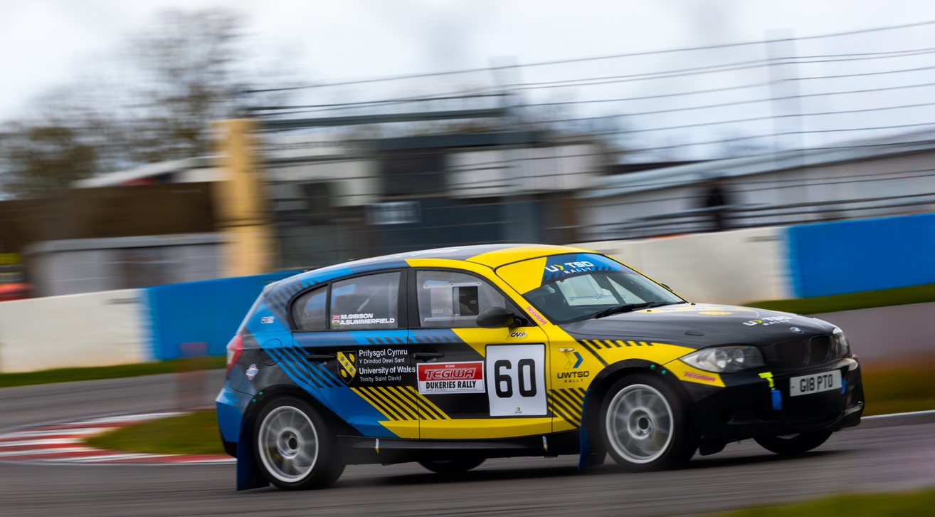
The car in question is a BMW 130i. We race the car in the circuit rally championship.
Picture 1

1.1My team’s aim was to identify key areas of the car where aerodynamic improvements would be most affective and identify areas in the rule book that we could exploit.
Doing both gives use the best results.

  - Project Planning & Teamwork
• Assign specific roles such as aerodynamics lead, CFD analyst, CAD modeller,
and report coordinator.
• Create a structured timeline with checkpoints for research, simulation, design
iteration, and reporting.
• Maintain consistent communication through weekly meetings and shared
documentation platforms.
• Record all decisions and iterations to support your final report and justify design
choices.

  - Aerodynamic Research & Analysis
1.2• Study the current aerodynamic profile of the BMW rally car — including drag
coefficient, downforce, and airflow patterns.
• Understand rally-specific aerodynamic needs: stability at high speeds, dust
management, and cooling efficiency.
• Benchmark against successful rally cars to identify effective aerodynamic
features (e.g., splitters, diffusers, roof scoops).
• Use CFD tools (e.g., ANSYS Fluent, SolidWorks Flow Simulation) to analyse
airflow and pressure distribution.
Design & Redesign Process
• Identify aerodynamic inefficiencies in the current design — areas of high drag,
poor cooling, or unstable airflow.
• Propose design enhancements: revised front splitters, rear wings, underbody
panels, and venting systems.
• Ensure compatibility with rally conditions — consider debris, mud, and variable
terrain when designing components.
• Model proposed changes in CAD and simulate their effects using CFD to validate
improvements.

  - Testing & Validation
1.3• Plan simulations and wind tunnel testing (if available) to validate aerodynamic
performance.
• Evaluate key metrics: drag reduction, downforce generation, cooling airflow, and
overall stability
• Compare results with baseline data to quantify improvements and justify design
Decisions.
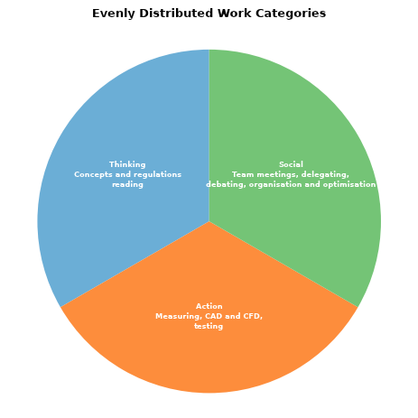

Roles
1.4
roles | Names | Personality traits | Description
Team leader/project manager | Kairan | 1.Organisational Skills, 2. Delegation  3.Team Motivation | 1.Ability to plan, prioritise, and structure tasks effectively. 2. Trusting others with tasks and giving them ownership.  3. Inspiring commitment and enthusiasm
Idea research/ concepts | Rhodri | 1. Analytical Thinking  2. Creativity | 1. Breaking complex problems into manageable parts  2. Thinking outside the box for better solutions.
Design leader | Jeremi | 1. Attention to Detail  2. 2. Teamwork | 1.Ensuring accuracy and quality control.  2. Working with designers, test engineers, and aerodynamicists
Simulation leader | Yash | 1. Precision  2. Teamwork | 1. Careful management of parameters and simulation settings.  2. Working with designers, test engineers, and aerodynamicists
Risk management leader and quality controller | Kairan | 1. Decision-Making  2. Communication Skills | 1. Making timely and informed choices even under uncertainty.  2. Clear, concise, and confident in both written and verbal communication.

Table 1

Belbin Self-Perception Inventory
My score on the Belbin Self-Perception Inventory was an overall score of 70
Scoring high in coordinator, implementer, complete finisher
But scoring low on resource investigator
Roles that would suit me would be (with respects to motorsport);
1. Project Lead / Sub-team Leader
(E.g., Aero Team Lead, CAD Lead, Suspension Lead)
Coordinator = I am delegate cleanly
Implementer = I am turning plans into results
Completer Finisher = I am ensuring quality and detail accuracy
I am the type who keeps the team on track and delivers a final product that works.

Roles I wouldn’t be as suited because I scored low on resource investigator and team worker.
1. Sponsorship & Partner Outreach
(Cold-calling companies, networking, chasing sponsors)
Why:
Low RI = networking, pitching and “making contacts” isn’t natural for me
It requires improvisation, charm, and high extroversion – not your zone

Tasks and milestones
1 | 14-Oct | 14/10/2025 | start | 0.5
2 | 14-Oct | 15/10/2025 | Identification of potential aerodynamic improvement | 1
3 | 15/10/2025 | 15/10/2025 | action plan | 1
4 | 22/10/2025 | 25/10/2025 | base CAD | 5
5 | 04/11/2025 | 25/10/2025 | base CFD | 8
6 | 20/10/2025 | 28/11/2025 | concepts | 8
7 | 19/10/2025 | 26/11/2025 | research | 8
8 | 24/11/2025 | 28/11/2025 | final design | 5
9 | 28/11/2025 | 30/11/2025 | final CAD module | 5
10 | 03/12/2025 | 05/12/2025 | CFD | 5
11 | 05/12/2025 | 05/12/2025 | risk assessment | 0.5
12 | 08/12/2025 | 09/12/2025 | real life feasibility | 3
13 | 14/12/2025 | 15/12/2025 | finish | 1

1 | 24/10/2025 | finished CAD
2 | 09/11/2025 | full CFD data
3 | 19/11/2025 | final designs
4 | 29/11/2025 | final CFD
5 | 10/12/2025 | present
6 | 12/12/2025 | Action plan for second stage

Coast and equipment
This is a list of all the equipment plus software will need though out our group project.
Also included is materials if we were going to build a large prototype and a small prototype.
  - CAD
. solid works
  - Simulation CFD
. Asus fluent
  - Prototype
. plywood (£20)
. saws (wood saw £15) (amozon.com)
. sander (£16)
. adhesive (£3)
. tape (£3)
. wind tunnel (at the university)
  - Overall project
. word
. PowerPoint
. excel
.ansys

Milestones
This is a list of the overall milestone of our group project. These are the small goals wee worked to make sure we kept on track and remained focused and didn’t get overwhelmed by thinking of the overall project. By breaking it down like this It we were also able to track to overall progress of our project.
. start
. finish a complete and usable CAD module
. finish our first CFD simulation on the unmodified car
. identify the areas we wish to improve and how we are going to get the results we want
. finish the CAD of the concept ideas that are going to be implemented onto the car
. finish a full CAD module of the modified car
. finish the CFD on the final module
. present
. (finish any alterations and the following CFD)
. have a finished prototype
. complete wind tunnel testing
. have complete aeronautical package

Project gateways
I oversaw the CFD area of the project. At this point the CAD module had been completed and after my simulations had been completed we moved onto diagnosing areas of improvement and designing a compatible aero package for the car mainly, we looked at air separation and how to keep consistent air flow over our car and the additional aeronautical package.

Aero package design

CFD sim

CAD Module

Some problems that could arise at the CAD – CFD gateway is;
- One of my gateways was CFD without a complete CFD program we wouldn’t be able to prove our overall research and also, we wouldn’t be able to move forward with our concepts and design projects therefor holding all progress on the whole project.
  - one issues I ran into with running a full CFD program was the CAD module we have for the BMW was very poor quality and made running CFD on it completely pointless. I addressed this by running the MIRA reference car multiple time with different variables and comparing my results against proven studies too prove my results are highly accurate. And in the background trying to repair the BMW CAD module.
  - With this solution we would still have proof that our team can operate CFD software and hopefully with the repair job allow me to run CFD at a later date, but we could also take reliable data from studies on the BMW to have proof of concept. This will allow the deign team to not get held up and when it comes time to apply the wing concepts we would have a complete CAD module.

- Another gateway I am involved in is as project leader keep all areas on the project on time and if they are behind schedule admittedly identifying them and helping to find a solution so the entire project doesn’t get held up.
  - one of these areas was looking at concepts for a rear wing design this team was being held up by a delay on the CFD and a lack of research in both the rally regulations and an over all lack of knowledge on wing profiles.
  - So the things I implemented was first to gather past CFD studies done on the BMW and use these as a base idea on areas to target with our design. Then I looked at the regulation to find what our parameters are and what we are legally allowed to do. And then I looked at wing profiles and some studies on them to get a better understanding on the performance we would see from a selection of different profiles.
  - This allowed the concept team to move forward with the deigns without a CFD program of the car but still have a good understanding on what areas and performance we are going to be looking at in regrades to the rally car.

Action plan
One of the areas I am involved in is the second part of our CFD simulations.
This part of the CFD will involve using our first simulation data and using our new wing concepts too generate data for the car when those wing designs have been placed on the car. This will hopefully give us a good understanding of how the car will be affected by the new wings and areas we could improve on with our designs.
  - The plan
Things to be done just before CFD;
- Top 2 or 3 designs
- Make a CAD module of those designs and attach them to the car

I am place the BMW in the same wind tunnel conditions as I did for the mira car and the first round of simulations. This will show me how we have manipulated the air flow over the car compared to the original profile.
I am going to use the plotting function and the visitation to see how the air flow is acting at key parts on the module.
I will run the same conditions for each new wing profile.
Then I will formulate the data found and with my team make improvements to the designs such as vortex generators, endplates, attack angel and position.
Once we are confident that we have chosen our final design and made our improvements I will run the simulation again on our updated designs with the same conditions (mesh and wind tunnel geometry).
Then I will run simulations this difference mesh and wind tunnel conditions from trusted studies online these will also be from simulations that have been done on the BMW 130i
This will not only give use our data to compare to but also others research.
Then I will compile our findings so we can use it for the prestation or future reference.

References
- Belbin Team Roles: Implementer, Coordinator, Completer Finisher. Belbin Associates. The Nine Belbin Team Roles (about.belbin.com). Available at: Belbin website.
- Newcastle City Council (n.d.) Project Stages and Gateways. Available at: https://community.newcastle.gov.uk/projects/content/project-stages-and-gateways.
- Atlassian (2023) How to write an effective project plan in 6 simple steps, 20 July. Available at: https://www.atlassian.com/blog/project-management/write-an-effective-project-plan
- Robinson, A. (2025) 25 Top Teamwork Skills for Workplace Success. Available at: https://teambuilding.com/blog/teamwork-skills
- Greenberg, A. (2023) 8 Easy Milestone Examples for Better Project Management. Available at: https://www.teamgantt.com/blog/the-how-and-why-of-using-milestones-in-your-project-plan

