Control Technology
  - ACMA6001
  - Dr. Gary Jones

Factory Control 1
Analyse and characterise feedback systems in both the time and frequency domains and design PLC systems to satisfy a control specification.
Critically evaluate fluid power (pneumatics and hydraulics) as a medium for the actuation and control of mechanical systems. Analyse and calculate the operational parameters.

Introduction

Task 1 – Provide a brief literature review of several PLCs currently used in industry and provide a table of Pros and Cons of each in your opinion.
Fixed PLC
These PLC’s are used for basic functions that require a small consist of power supply and the CPU and I/O system which are housed in one system. These are used for standalone tasks
Advantages –
(Staff, 2022)
These systems are reliable
Easy to trouble shoot
Disadvantages –
(ecstuff4u, 2022)
Lots of work is required to connect using wires
It has a fixed circuit operation
Module PLC
These PLC’s are used to communicate with messages being sent to the PLC and accepting the demands from the processer.
Advantages –
(eHow, 2022)
These PLC’s are cheaper than fixed PLC’s
They are easy to repair
Disadvantages –
(Quora, 2022)
These can take longer to fault find
More spaces need to be available as large amounts of stock re required
Distributed PLC
These systems are used to control or automate a process or machine within industry
Advantages
(Sachin, 2019)
Enables applications such as scheduling and information exchange
Can increase plant efficiency
Disadvantages
Requires a skilled operator as data is show through a systematic format
Is a failure occurs it can increase the mean time between failure.
(Distributed Control System, 2022)

Task 2 – Utilising the components within FactoryIO, design a factory process capable of sorting a range of package sizes and weights (minimum 4 different types).
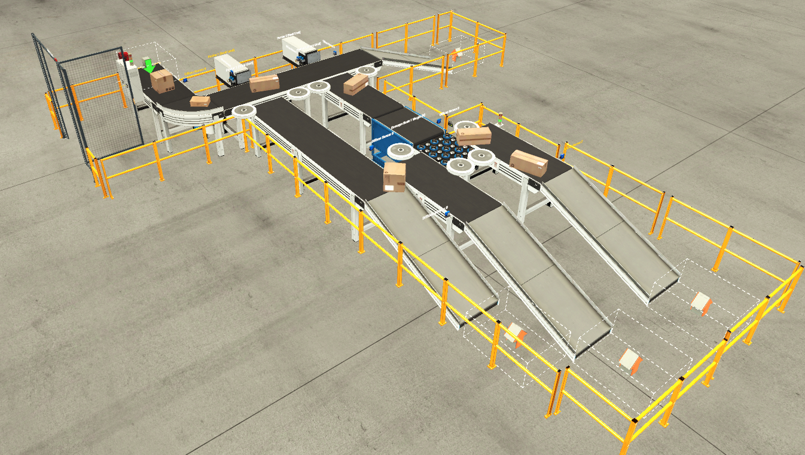
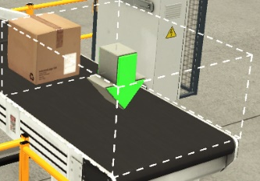
This is an overview image of the factory I have created. This process allows the boxes to come from the emit, travel around the conveyer system and sort the boxes by size and weight. This splits the boxes into pallet boxes, small boxes, medium boxes and large boxes. Once they go through the process they will fall down the slides for the boxes to be removed. Throughout the system it will count the amount of each box, weight the small and medium boxes and show the weight and active warnings when appropriate.

This is the emitter which will create boxes for the process, this directly places the boxes onto the conveyer system.

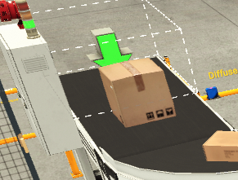
This is the large box which comes from the emitter, this will travel through the process and will be pushed onto the first conveyer and will go down the first slide to be taken away

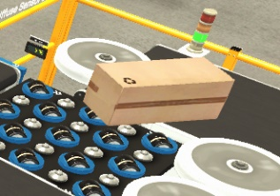
This is a medium box from the emitter which will be pushed down the second conveyer and will be weighted, using the pop up sorter it will be placed onto the right and conveyer and will slide down to be taken away

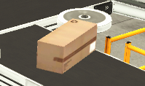
This is the small box, much like the medium boxes it is pushed onto the second conveyer and is weighted it is then placed onto the left hand conveyer to be taken away
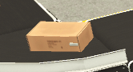
This is the pallet box, this flows though the main conveyer and is counted like all other boxes it flows down a slide at the end of the conveyer to be taken away
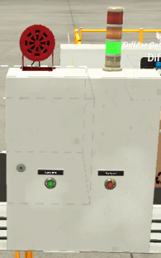

This is the switch box which will house the program to work factory system, this has a sounder on top which will sound when the system starts, the light swich will be green when in use, red when offline and yellow when preparing for use.

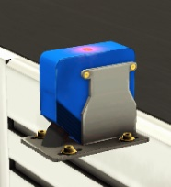
This is a sensor which is used to sense when a box travel passes it. This will work with the counter to count each size of box.

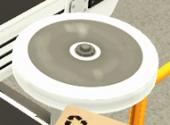
This is a directional device which will aim the direction a boxes goes in to ensure they go down the correct conveyer or do not fall off the side.
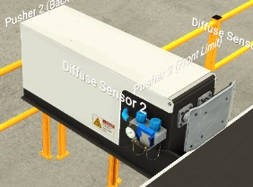
This is a pusher, it is used to push items in the direction of the pushers arm, this was used to push the boxes onto the secondary conveyers

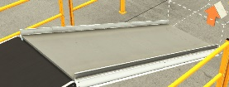
This is a slide, this was used at the end of each conveyer system for the boxes to slide down into the box removal area.
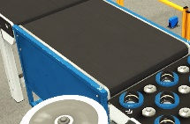
This is a weighting platform, it is used to weight the boxes once the boxes touch the attached senor
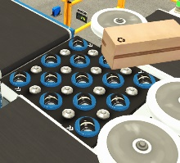
This is the pop up sorter, this is used to sort the boxes based on there weight medium boxes would sort right and small boxes would sort left

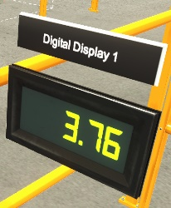
This is a digital display, this will display the weight of the boxes

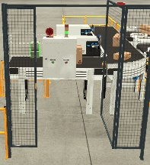

This is a safety door, in a real factory this would be locked and only accessible by those competent to use the switch board

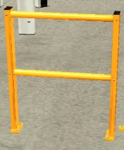
This is a barrier, this stops people getting in contact with the conveyer process to prevent injury or harm and interference with the process.

Task 3 – Write a ladder logic program to control your factory process
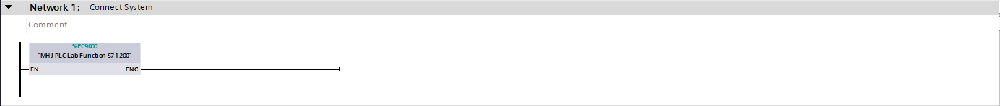
This line within the programming links the system to factory IO allows us to run the simulation on the program.
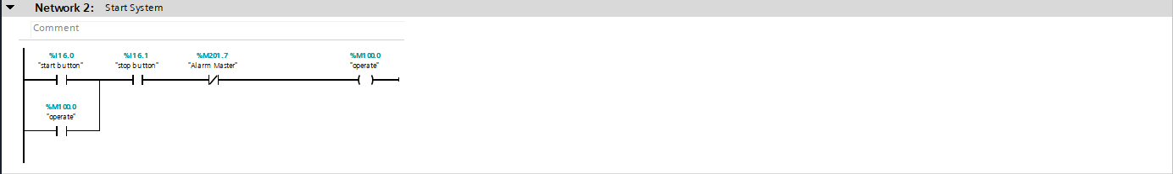
This program allows the system to start through the use of the start stop buttons
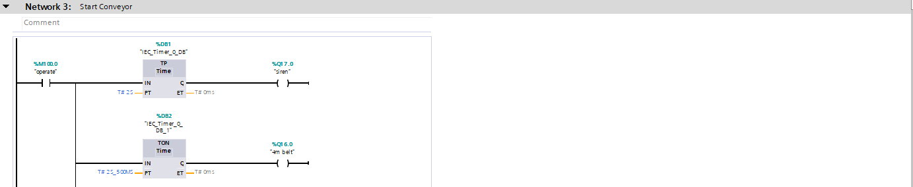
This line actives the siren once the system starts and starts the first conveyer system
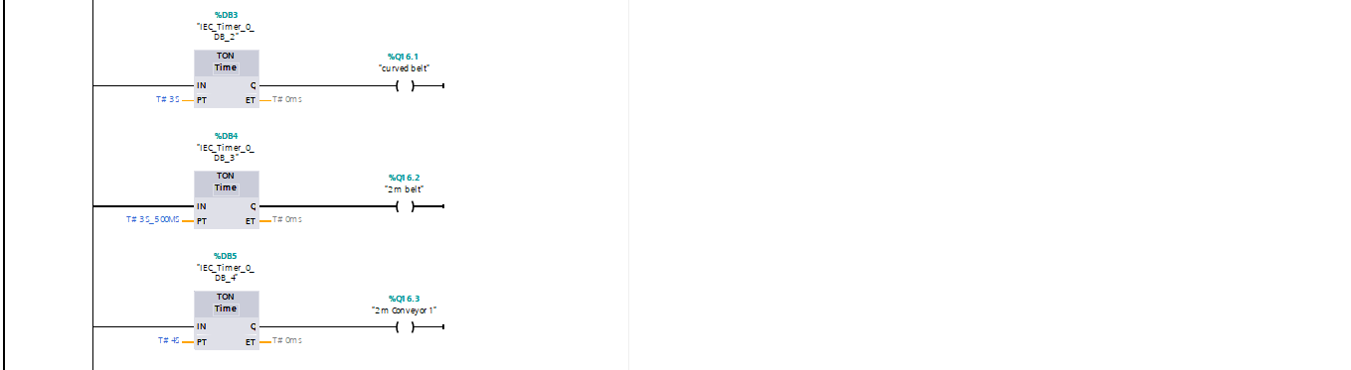
This line start 3 move conveyers attached to the system
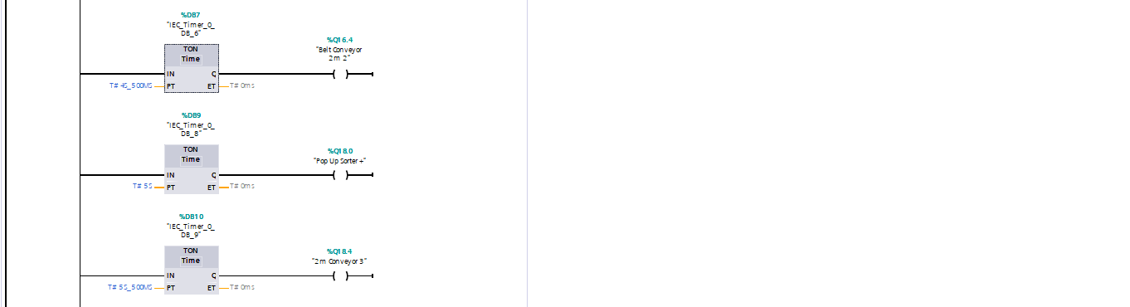
This will start another 2 conveyer belt and the pop up sorter
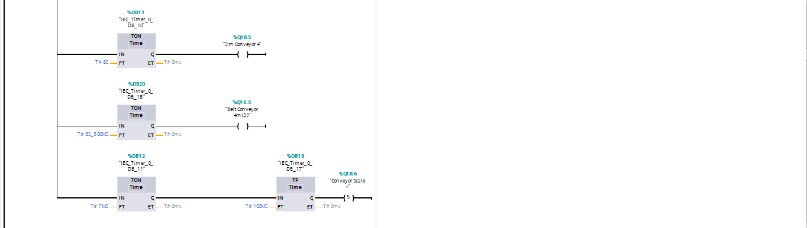
This line within the program will start 2 more conveyers and the conveyer scale
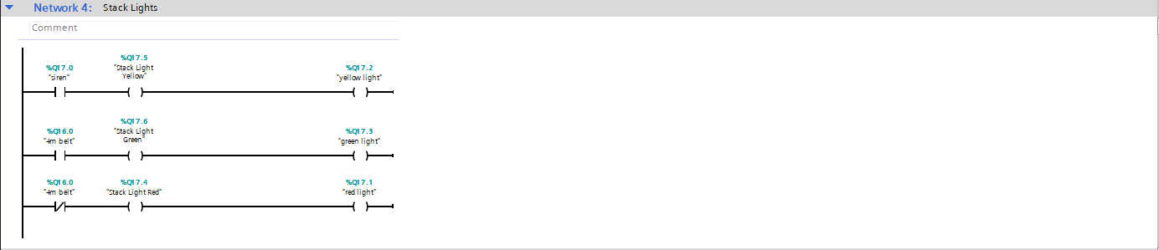
This piece of programming will operate and 2 stack lights within the factor
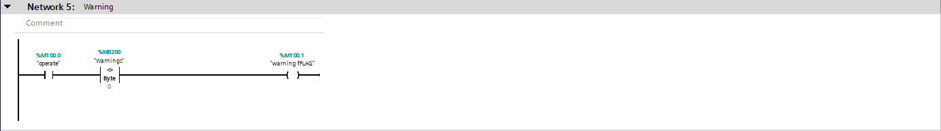
This aspect allows the warnings to work once required within the system
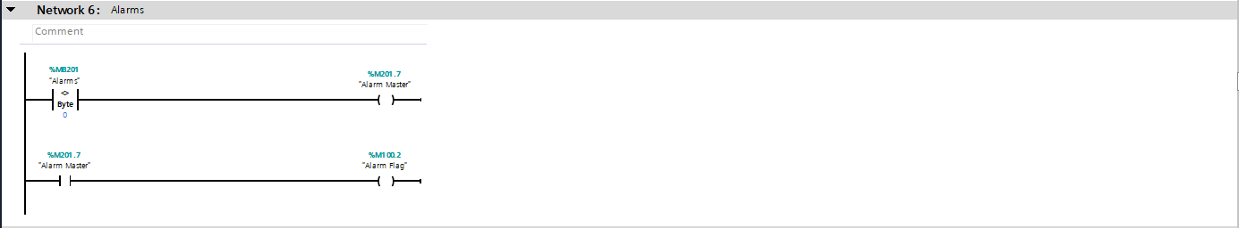
This aspect allows the alarm to work once required within the system
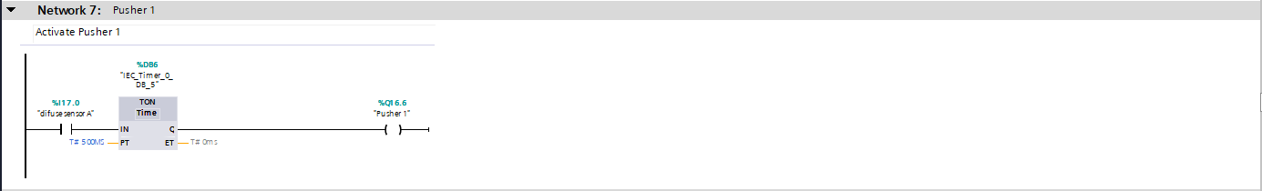
Once the first sensor senses a box pass it, the pusher will operate pushing the box onto a conveyer system
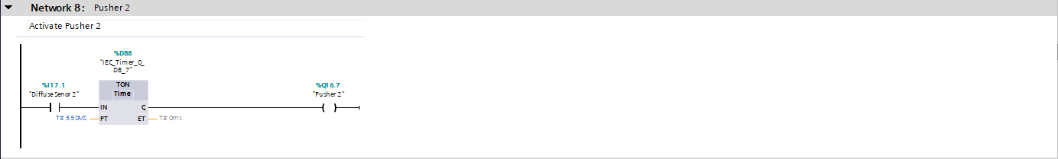
Once the second sensor senses a box pass it, the pusher will operate pushing the box onto a conveyer system
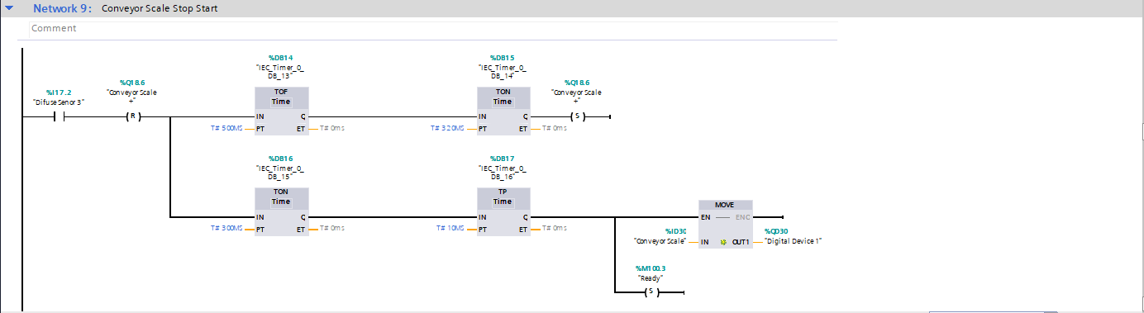
This line operates the conveyer scale, once a box hits the senor the scales conveyer will stop weight the box, record the weight and continue the process.
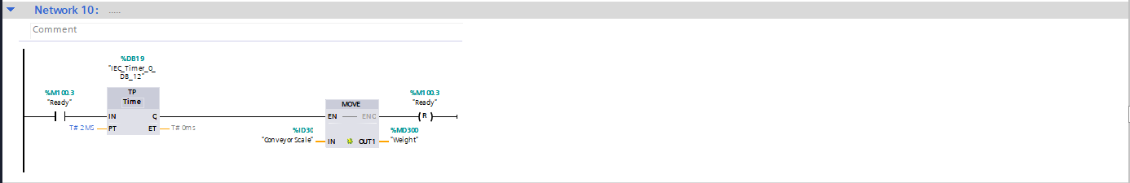
This line operates the conveyer scale, once a box hits the senor the scales conveyer will stop weight the box, record the weight and continue the process.
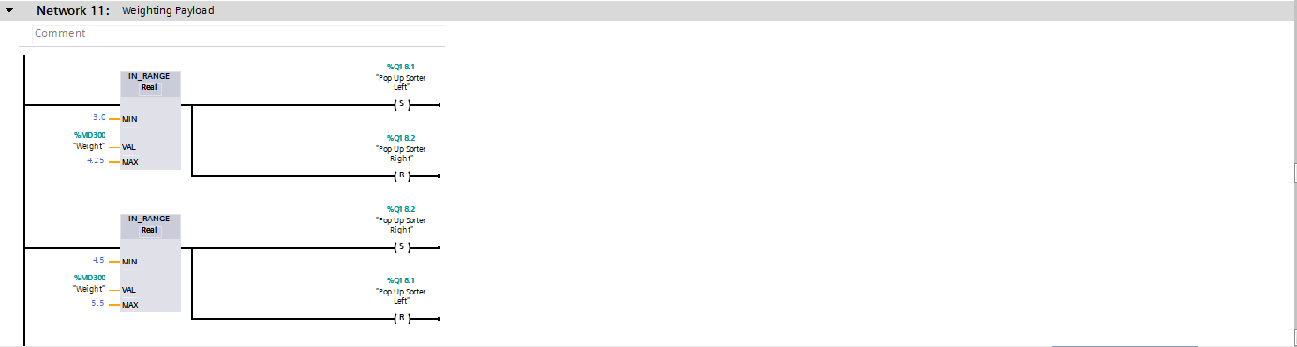
This line will determine where the box goes based on its weight, if the box is between 3.0 – 4.25 it will sort left as a small box. If the box is 4.5 – 5.5 it will sort right as a medium box.
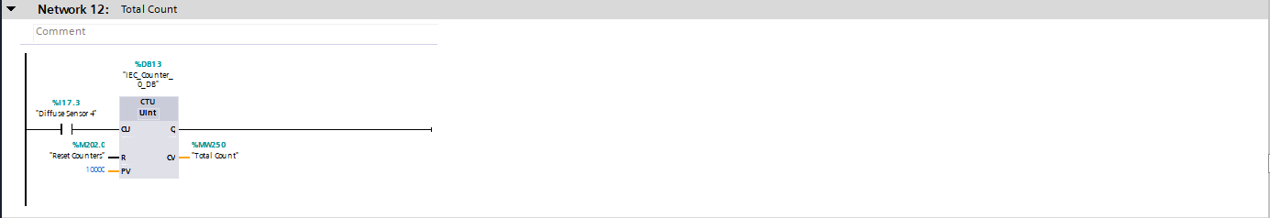
This line is used to determine the total count of boxes, it is placed just after the emitter and before any pushers to give a fair reading of the amount of boxes that have started the process.

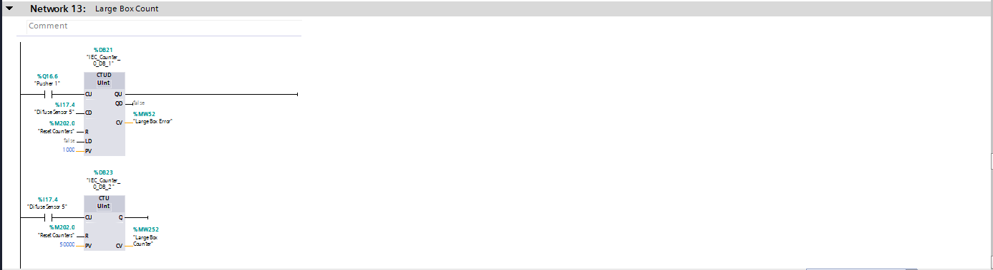
This is used to count up the amount of times pusher 1 is operated and count down the amount of times senor 5 has been active, this will result in a large box error if 0 is not maintained, I then used count up to display on the main screen.
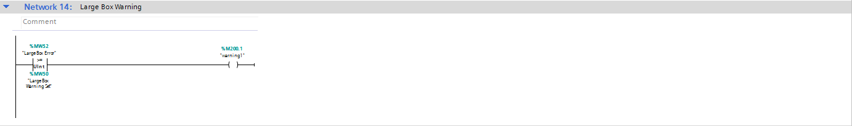
Bases on the input at the route screen warnings will occur when at inputted amount it met, this will then trigger the warning.
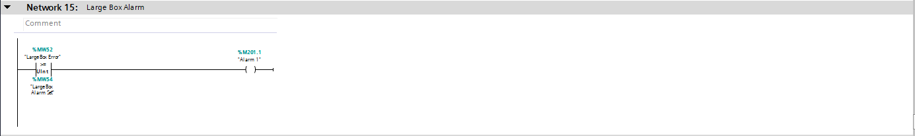
c
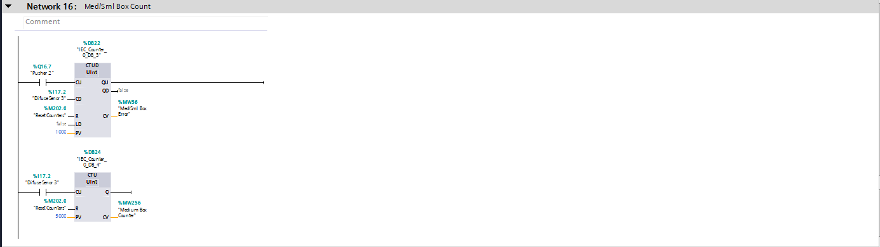
This is used to count up the amount of times pusher 2 is operated and count down the amount of times senor 3 has been active, this will result in a med/sml box error error if 0 is not maintained, I then used count up to display on the main screen.
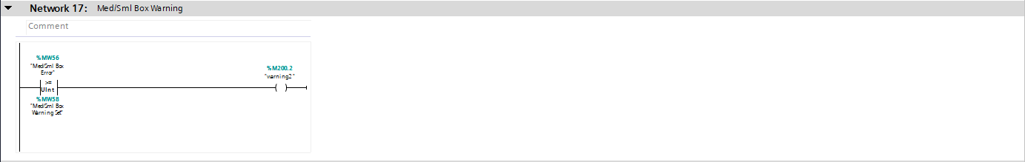
Bases on the input at the route screen warnings will occur when at inputted amount it met, this will then trigger the warning.
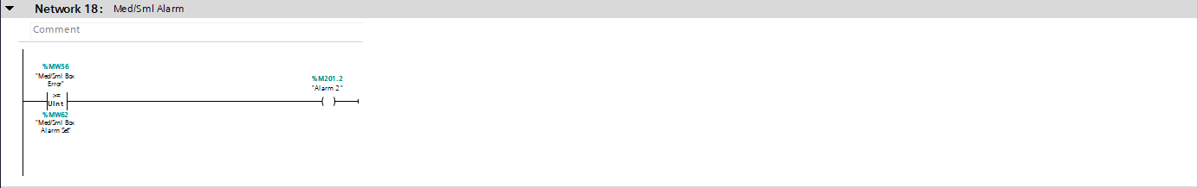
Bases on the input at the route screen alarm will occur when at inputted amount it met, this will then trigger the alarm.
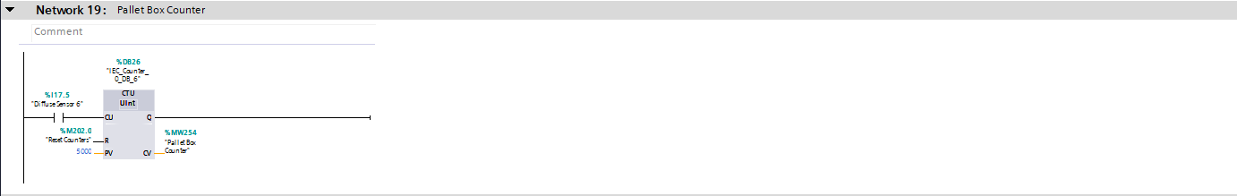
This program is used to count the amount of pallet boxes that are used in the process, senor 6 is used to count this
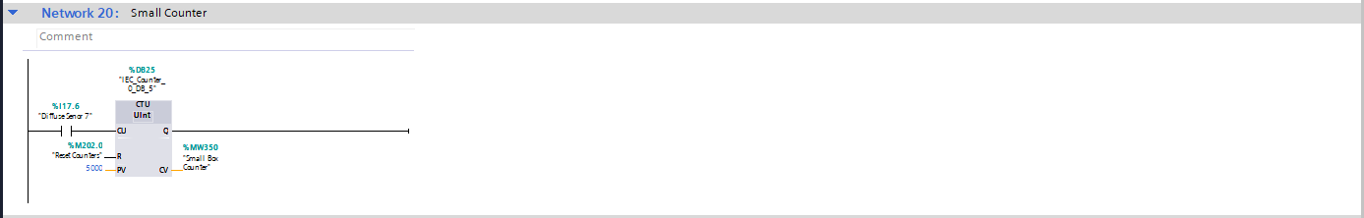
This program is used to count the amount of small boxes that are used in the process, senor 7 is used to count this
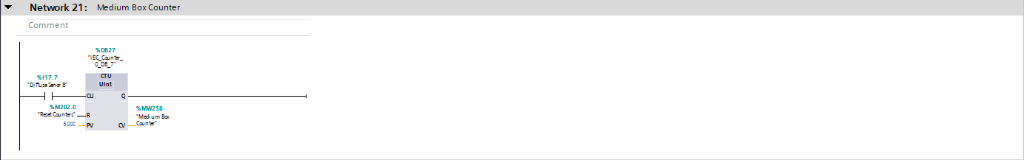
This program is used to count the amount of medium boxes that are used in the process, senor 8 is used to count this

Task 4 – Incorporate a HMI device into your factory and program.
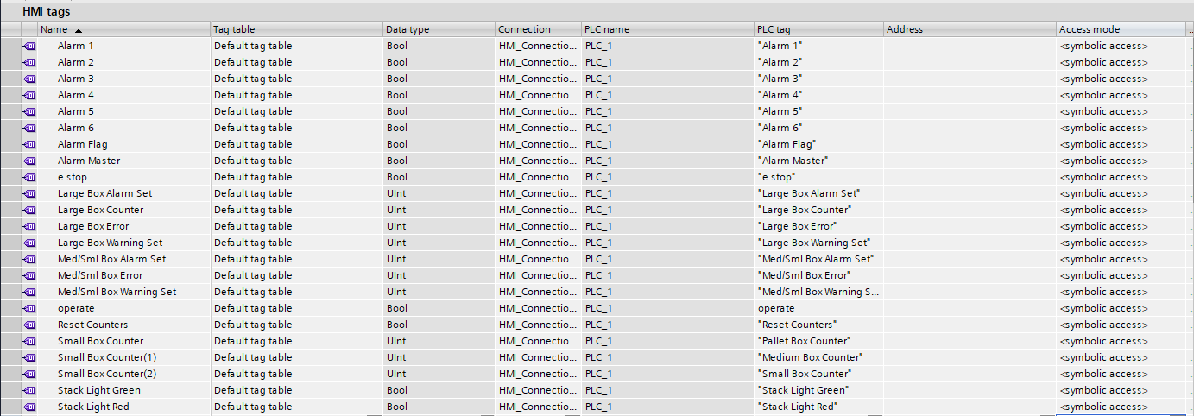
In order for the screens to work the PLC tags must be converted to HMI tags these are linked to the buttons within the root screen, warning and engineers screen. This will link the control to the function for example Alarm 1 will be linked to warning screen and will light when the input for alarm has been set. You can see what PLC tag it corresponds to by looking in the PLC tag column.

Task 5 – Design and incorporate several screens with navigation controls on to your HMI including Error/Warning and Engineering complete with their operation from the above brief.

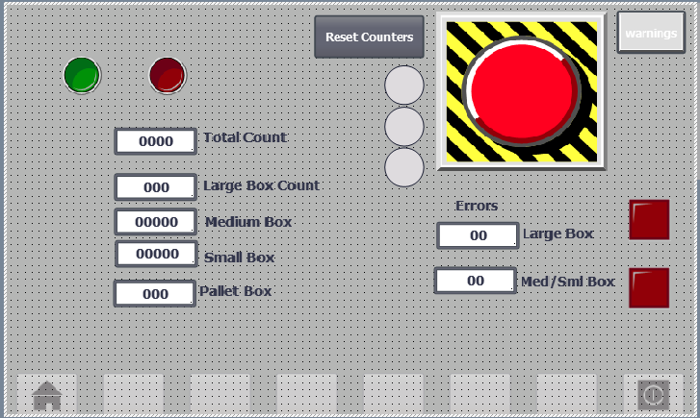
This is my root screen, this will count the amount of each box and the total amount of boxes, when the green button is pressed it will start the process. When the red button is it will stop the process. The errors will count as per the program. When the inputted limit has been met the lights to the right of the counters will light up and the process will stop. The reset counters button will reset all the values within the count section. The 3 grey lights to the left of the stop button will light up as per the stack lights, green for active, red for stopped and amber for preparing. The emergency stop button when pressed will stop the whole system. There is a button in the top right which will direct you to the warnings page.
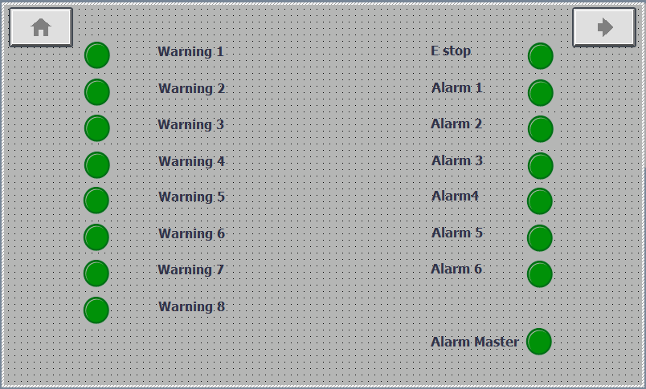
This is the warning screen, this will show warning and alarms from 1 to 9 and will activate when the alarm and warning level is inputted and met these will turn red indicating that an error or warning has occurred. The alarm master will show red when the process is stopped, when the process is active with no warning or alarms active it will be green. The button in the top right will direct you to the engineer’s page. The button in the top left will lead you back to the home page.

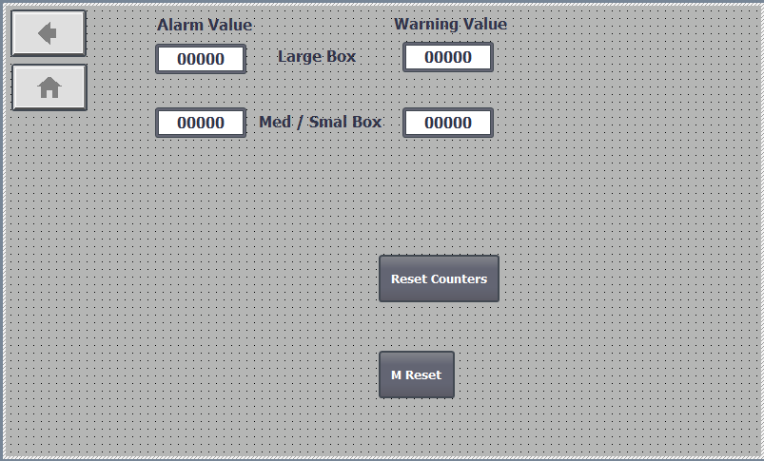
This is the engineer page. The alarm value and warning value for large & med/sml boxes can be inputted by the user, this allows us to set the amount of warnings and alarms allowed before the system automatically stops. The warnings will have to be set higher than the alarm value. The reset counter button is much like the button on the root screen it will rest all the counter values on the root screen. The “M Reset” button is the master reset button and when pressed it will clear all alarms and warnings and allow the system to function.

Process Flow Diagram
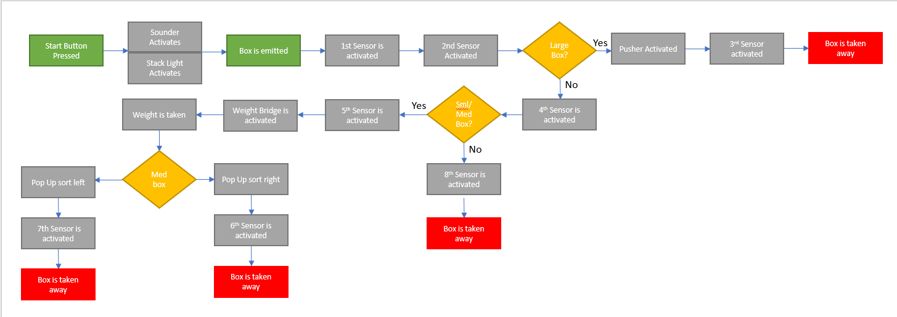
This process flow diagram show the process of the factory, if the sensors are not met as the should be warnings and alarm will occur which will stop the process.

Conclusion
I have created an automated system when will sort boxes based on size and weight using pushers, sensors, weighting Bridges, pop up sorts and emitters. The system also has alarms and warning which will occur when a box is missing the warning amount / level can be inputted by the user. This allows more control over the system. My factory is working correct and in conjunction with the screens allocated for the system.

Works Cited
Distributed Control System. (2022, July 22). Retrieved from eeeguide: https://www.eeeguide.com/distributed-control-system/
ecstuff4u. (2022, July 22). Advantages and disadvantages of PLC. Retrieved from ecstuff4u: https://www.ecstuff4u.com/2019/04/advantages-disadvantages-PLC.html
eHow. (2022, July 22). What are the advantages of a modular PLC over a fixed PLC? Retrieved from eHow: https://www.ehow.co.uk/info_12258880_advantages-modular-plc-over-fixed-plc.html
Quora. (2022, july 22). What are some disadvantages of a modular PLC? California, California, United States.
Sachin. (2019, October 8). Distributed Control Systems. Retrieved from Schneider: https://www.schneiderelectricrepair.com/distributed-control-systems/#:~:text=The%20DCS%20enables%20applications%20such,Efficiency
Staff, E. (2022, July 22). Introduction to PLC – Advantages of PLC. Retrieved from Inst Tool: https://instrumentationtools.com/introduction-to-plc-advantages-of-plc/

