Statistics Practical and Dissertation Analysis Plan – BMDS7004
Anna Harries - 0151943
Part 1 Data files 1 and 2 for SPSS analysis.
From using Data file 1 a descriptive statics table (Chart.1) has been produced, this describes the basic features of the data included in a study. This data is the basis for quantitative analysis of data. This also provides a simple summary about the sample and the measures.
The standard deviation shown here is the average amount of variability in the data set. A high standard deviation means that the values are far from the mean, while a low standard deviation indicates that values are close to mean. All apart from one of these has a standard deviation of less than 5. The data shows that over half of the population are overweight or obese, this is significant as often linked to other diseases. Over a quarter are smokers and again these impacts on other diseases and general health status of a population.
The data files are part of a report by Public Health Wales, the report presents analysis of a dataset containing six years of Welsh Health Survey results from 2003/04 to 2009 (PHW, 2012)
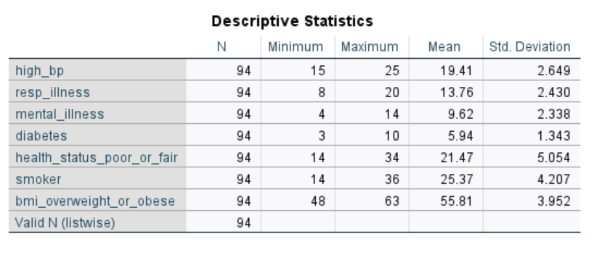Chart 1
The data files have been extracted from the Welsh Health Survey at geographies below local authority level and allows more detailed analysis of the health of people in Wales.
There are substantial variations in the proportion of people with key illnesses among Upper Super Output Areas (USOAs) in Wales.

A sample chart produced from data file 2, is shown below (Chart 2). USOA data is displayed by area, for each indicator. The Upper Super Output Areas (Areas where the average population is of 32,000 people) are compared against each other and the rate for All Wales is key circle in green which has a value of 14 (Age standardised percentage). It is clear to see from the forest plot chart that there are variations across USOA and fast difference between upper and lower confidence limit.
This chart is considering respiratory illness, and if the data lines are to left of the all wales line this is likely to indicate age-standardised percentage is lower than All wales and if to the right then higher than All Wales.
The codes are not identifiable on the chart but the full document describes the locations of the codes.
Respiratory Illness
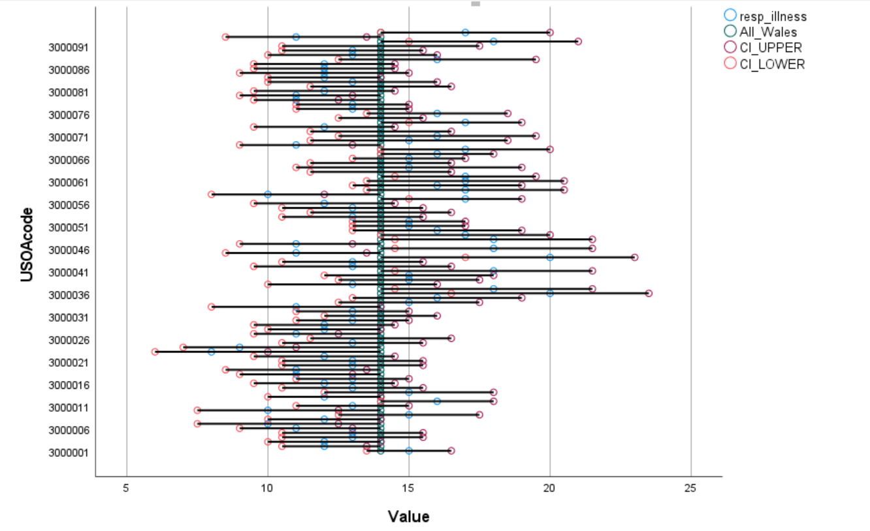
Chart 2

Dissertation Project
Context and scope.
Over the last two years a digital patient feedback system has been implemented within the health care organisation (National Health Service Trust). This organisation covers a non-surgical Cancer Service and Blood Service, therefore providing care and provision for patients and donors. A significant cost has been committed to, not just by this organisation but across Wales as it has been procured as a once for wales system. This product is an off the shelf system which is web-based and now live across all Health boards and Trusts in Wales.
It is vital to establish at various stages of implementation if the process is successful and meeting the service needs and business case scope.
While the system itself was an off the shelf purchase there was a significant process pre-implementation that involved hierarchy construction and the survey construction within the system. There were also data extraction workbooks to ensure we could gain the data in the format that was required for our organisation. Along with any system consideration for data protection and information governance.
The increased need for implementation was risk related as during the pandemic, paper feedback forms could no longer be used and there wasn’t anything in the organisation to replace the simple process of paper feedback forms. Paper forms were identified as items at increased risk from cross infection of the virus. With no alternative in place the organisation had lost the ability to hear the patients voice or receive any form of documented feedback at a time when it was required the most.
Patient feedback is a driver for quality improvement in hospitals and is considered one of the pillars of quality in healthcare along with patient safety and clinical outcomes (Berger et al, 2020). The patient feedback system implemented also ensures inclusion of all service users contributing to the Quintuple Aim (Nundy et al., 2022) and the ultimate goal to hear and act on the patient voice. This five-part aim of health, experience, cost, staff well-being and equality is what should guide us with fitness for the future plans which The Health and Social Care (Quality and Engagement) Wales Act (2020) drives along with the Citizen Voice Body and ensuring their views are heard. Therefore, policy intervention has already taken place allowing focus and structure support for intervention. It is the organisations responsibility to ensure this is met, digital tools are the method of choice moving forward and it is vital that there is a mechanism to evaluate the outcomes of that digital tool.
In the last decade, the value of patient feedback on health services has become widely accepted (Ong et al, 2020) The Health and care standards (DOH, 2015) clearly set this through Standard 6.3 Listening and Learning from Feedback
“People who receive care, and their families, must be empowered to describe their experiences to those who provided their care so there is a clear understanding of what is working well and what is not, and they must receive an open and honest response. Health services should be shaped by and meet the needs of the people served and demonstrate that they act on and learn from feedback” (Pg, 32)
There are criteria attached to this standard which can not be met as an organisation if the initial data collection of feedback is not achieved. This provided a risk and an urgency to implement a system, in addition to this the new legislation that was approaching in the Quality Act (DOH, 2020) and Duty of Candour again stresses the “always on reporting” and open culture responsibilities of The Trust.

Aim and research objectives
The digital system now holds a vast amount of rich data from almost 2 years of collection, admittedly it was a slow start with minimal allocation of resources but part of the aim of this project is to evaluate the system function in meeting the ability to gain patient feedback for service users. Part of this data can be collated from the system itself. The system can calculate the numbers of responses received for each area of the service and this can be compared to the numbers of responses pre pandemic on paper.
There were many aims at the onset of implementation of the digital system, time saving from input of data from paper responses, real time reporting so action and learning can be quicker to prevent replication while feedback processing, increased accessibility and equality for those completing surveys, completion when suitable to the service user and offering many options in how to complete (not all digital), preventing survey fatigue as measures in place to prevent frequent survey requests from differing touch points within the organisation, data analysis and reporting at the touch of a button and bench marking across Wales. It is important to distinguish what is the aim of the implementation and the aim of this project or research.
Ong et al (2020) stated that the introduction of digital collection for patient experience data can be seen and described as disruptive in many ways, to the “clinician-patient relations, to performance management and to wider governance systems in healthcare”. The aim of this project is to determine if this is the case following the introduction of a digital system to collect patient and donor feedback.
NHS Wales aims to transform health and care for patients and the public by developing new digital health services and applications.
A significant part of the Healthier Wales strategy (DOH, 2018) is to encourage patients to take a more active role in their own health and care.
The Digital Services for Patients and the Public (DSPP) programme will help people in Wales to access better healthcare and support health providers to deliver care more efficiently.
“The goal is for patients and the public to:
- personalise their health journey
- monitor health conditions more easily
- share and receive important health information
- take an active part in their own health and wellbeing
- plan for and take control of their health and care journey
- stay healthy for longer.”
Therefore, it is important to know how this system has impacted on patients and patient outcomes and is it equitable and accessible.
Access to previous data will aid this understanding and further investigation is required to determine the availability and accuracy of this historic data. It is clear that for a period of time no data was being collated in practice other than through complaints process.
Now that legislation and guidance has set and described the wider aims and objective, the research questions can now be set for this project of evaluating the implementation of a digital feedback system:
1. What is the evidence around impact on the ability to provide information on patient experience?
2. Impact on cost effectiveness to gain data required?
3. What is the user experience from the staff / patients or donors?
There is a risk that the research will go out of scope as so much information can be gained from the system. Therefore, keeping the research questions around ability to collect data, cost and user experience cover three significant areas of concern when implementing this system. Cost is important as the value for money is a large consideration when using public money and recovering from the pandemic.
It is expected that further research may be required to capture other significant analysis within the system. There has already been interest raised with regards to Anti-racist plan and what the data currently shows and how it can be improved to cover the responsibilities for the plan.
Having considered the aims and objectives and set three research questions, a research hypothesis is also needing to be set at this stage. A Hypothesis is a statement of expectation or prediction that will be tested by the research.
Hypothesis:
If a digital system for patient feedback is implemented the data received increases, patients and staff have a positive user experience and the cost is justifiable.
By creating a hypothesis, the researcher can evaluate and assess each element of meeting the hypothesis.

Select and justify any data collection that is relevant and itemise the analysis methods you will need to meet your research objectives

The system itself has a fast amount of data, therefore, it is important to remain focused on only collecting the relevant data to meet the aims and objective of this research project and not to collect data to meet the aims and objectives of the system implementation plan. There will be a requirement to not only have a data analysis plan but also to follow it strictly and not be drawn to other rich significant data relating to the overall project significance.
Blaise (2020) provided a detailed guide in how to create a data analysis plan. Whilst much of the data required is being collated via the digital system that is being implemented a plan is still required to remain on track for the objectives and research questions.
The data analysis plan is a type of roadmap to how data collected will be analysed and organised. It includes the following:
Clearly states the research objectives and hypothesis. The objectives, research questions and hypothesis are stated above. However, submission of this data analysis plan may shape the final dissertation project depending on the assessment and comments.
Clear identification of what is the desired outcome, the desired outcome is that the digital system increases feedback from service users and positively effects patient and staff user experience at a justifiable cost.
There is a need to Identify the dataset to be used, the majority of data set is included within the patient satisfaction survey that is accessible via the system implemented. However previous data from feedback needs to source and this is believed to be located on an excel speed sheet stored in a patient experience shared file.
Inclusion and exclusion criteria. This is where the detail differs from the implementation criteria. This research project requires the number of responses gained in comparison to the numbers returned during and pre-pandemic.
Included are the overall number and satisfaction score from the organisation (comment data and other question/answers are not required) learning and action for improving and equality data collection again is not required. Patients’ identifiable data is excluded unless they wish to provide contact details manually, however that section is not being considered for this research. The information that is required is at a high level without detail, the data required is overall satisfaction based on number of responses gained this can then be compared to during and pre pandemic data.
This clearly describes quantitative method, however when considering user experience from staff, patients and donors mixed method will be required as discussions will be held with individuals who maybe haven’t completed surveys and staff that are using the reporting module. These discussions would be qualitative method mixed with quantitative with a bespoke survey to ask usability type questions. Some of the data would be fact finding, this would be in relation to cost of system, resource allocation cost and paper processing cost.
Clearly state the research variables
The Intervening variables are organisation and patient linked. These are identified as staff engagement in gaining patient feedback, clinical area acuity and time available for staff, accessibility of digital device and digital skills of patient and staff (training/ support). There is also the identification that the information held digitally has been submitted by the population happy to engage digitally, it is important to consider all the population.
States statistical test hypotheses and the software for statistical analysis
Quality improvements will be evidence by regular survey monitoring and patient satisfaction, this can also be triangulated to incidents and complaints.
Creating shell tables
Shell tables can be created through the system with survey responses for whole organisation and for any bespoke survey, however it is recognised that there may be gaps and Blaise (2020) clearly states a good analysis plan should describe how missing data will be analysed. It should also be noted that if data is missing this can be written into the survey if it is data that is collected direct for the patient providing feedback.
In order to meet the research objectives a mixed methods approach to data collection will be used from the outset. The system itself hold rich quantitative data and the analytics within the system allows ease of access to the reports. However, a qualitative approach is required for the implementation impact of the system on the patients and donors using the system and on staff extracting the data for learning and sharing.
George (2021) categorises the reasons for uses mixed methods as Generalizability, Contextualization and Credibility. Based on the definition descriptors, this project would require mixed methods to allow context to findings and add richer detail to conclusions. By adding qualitative data to quantitative data helps substantiate the analysis or “put meat on the bones” as George (2021) describes the analogy.
The complexity arises with mixed methods as consideration is required on how to determine statistical and operational significance for the quantitative data and how to determine saturation and transferability for qualitative data. This essentially doubles the process of data collection.
“Statistical significance relates to the hypothesis test that can be employed, and its results, using a sample of the population. Practical or operational significance refers to differences or effects that are operationally meaningful and useful, whether or not the statistics tell us there is a difference or an effect.”
With all the detail covered, it is necessary to consider for each research question how will the data be collected.
1. What is the evidence around impact on the ability to provide information on patient experience?
Quantitative - How many feedback survey responses are available in the system from September 1st 2022 to 31st March 2023 for the whole organisation?
This is gained at the touch of a button in the digital system. This is also replicable easily with using the same logic for the report. The screen shot below Chart 3 was gain within minutes showing in 6 months (September to end of March 9,503 responses are available with an overall satisfaction score of 98%. There is a fast amount of detail within the report from free text comments to equality questions, however, for this project that detail is not required.

Chart 3
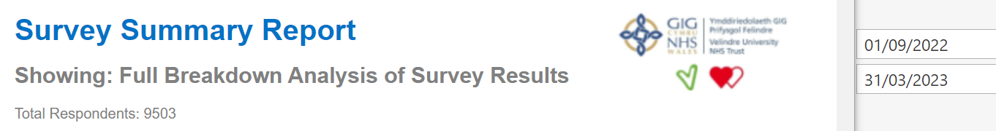
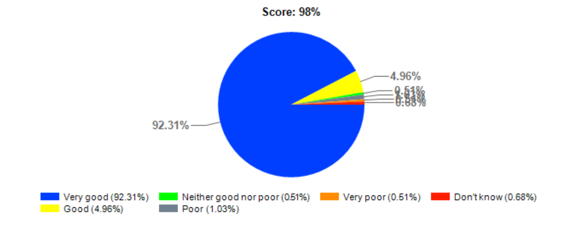
How many feedback responses are available in any format September 1st 2020 to March 31st 2021 (this was during the Pandemic and pre implementation of the digital system)
How many survey responses are available again in any format from September 1st 2019 to March 31st 2020 (this was pre pandemic but going into the start of lockdown)
2. Impact on cost effectiveness to gain data required
Prior to the digital system implementation, the cost to the organisation was paper processing of forms, manual data entry so labour costs and potential significant cost through not having the ability to hear the patient voice for learning opportunities and potential litigation through putting things right. With the new legislation in force the cost would be breaking legislation and reputational damage to the organisation.
The cost of the digital system significant and would require investigation to establish figures. This would be presented within the research to determine cost benefit between the processes.
3. What is the user experience from the divisions / patients or donors
User experience is established via mixed methods, within Welsh Blood Service, at the end of their short survey there is an additional question of how they rated the digital survey?
A bespoke survey is be created to capture specific usability data for patient/donor users and for staff. The participant information sheet will also be used to inform all participants, depending on the response rate this remains in quantitative methods, however interview style discussions will also be used to determine what prevents use for patients, donors and staff. This element would again be qualitative. It is vital to remain with the same questions within the qualitative method to ensure transferability. This is the ability to replicate the method of data collection, similarly awareness of data saturation point as it is likely that enough data will have been collected to draw necessary conclusions with out the need to interview to many users.
Ethical and information governance consideration.
With regards to access to data within the digital system itself, there are not additional considerations for information governance as this has already been assessed and a DPIA in place, all information within the system is anonymous and not patient identifiable unless they choose to identify them selves in a separate section not required for this data extract. However, as the analysis method is proposed as mixed methods and will require interview sessions with patients, donors and staff an ethical review form has been completed in draft for consideration (Appendix 1). Gelling (2016) states “The need to obtain research ethical approval is common to all research involving human participants. This approval must be obtained before research participants can be approached and before data collection can begin. The process of ethical review is one way that research participants can be confident that possible risks have been considered, minimised and deemed acceptable.” Pg1
Through consideration of this application for ethical approval and review of the University Research data management policy all aspects are included in the approval as the definition for research data included as data “defined as that which is collected, observed, or created for purposes of analysing to produce original research results. Such research data are the recorded information, regardless of the form or the media in which they may exist, necessary to support or validate a research project’s observations, findings, or outputs.” (Pg.4) Therefore extracting data from the system and placing the information in a separate record would be included in the ethical approval.
It is also noted that “in practice, the nature of research data can vary widely depending on discipline. It can be textual, numerical, qualitative, quantitative, final, preliminary, physical, digital or print. Research data comes in very many formats, including, word processed documents, PDFs, spread sheets, scanned lab books, online surveys, digital recordings, databases or computer software.”
The participant Information sheet template letter will be utilised to inform participants when interviewing them on their experience of using the digital patient feedback system.
The current Data protection impact assessment (DPIA) will be included in the documentation and if this digital system is used for a bespoke survey to establish some of the aims this notification regarding data use is part of the survey.

Appendix 1
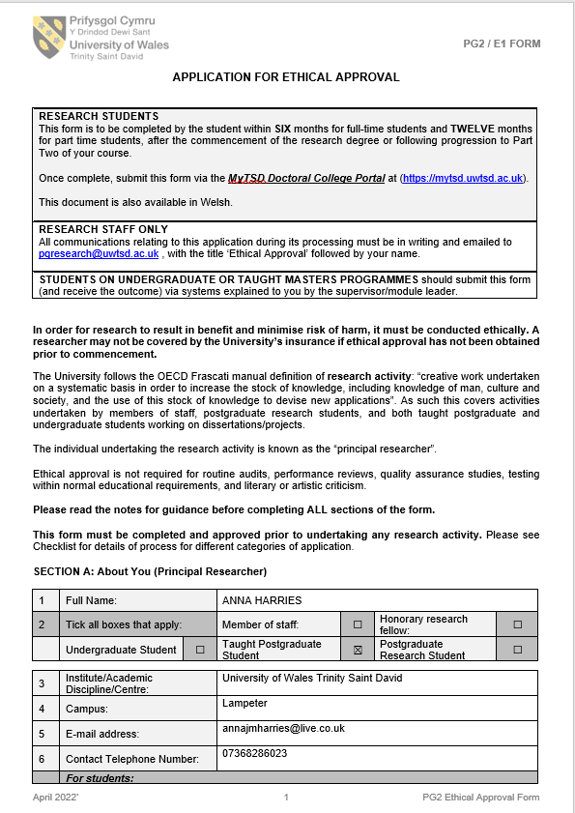

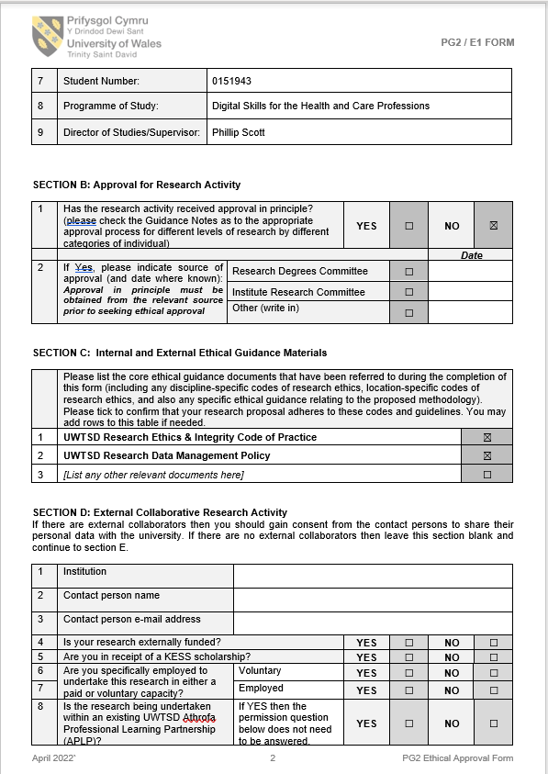
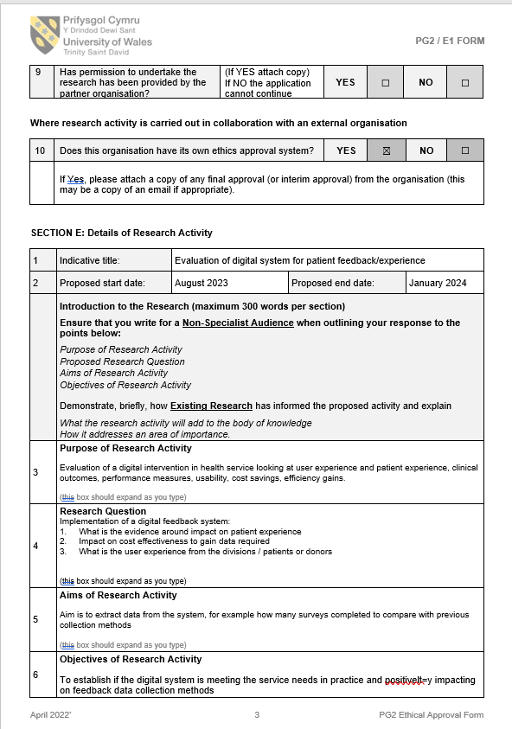

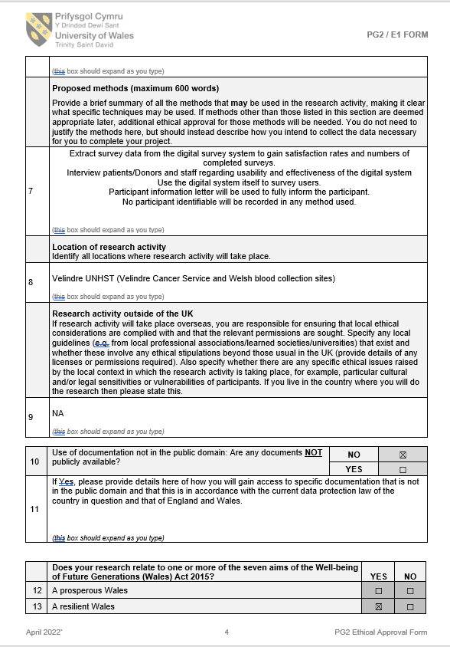
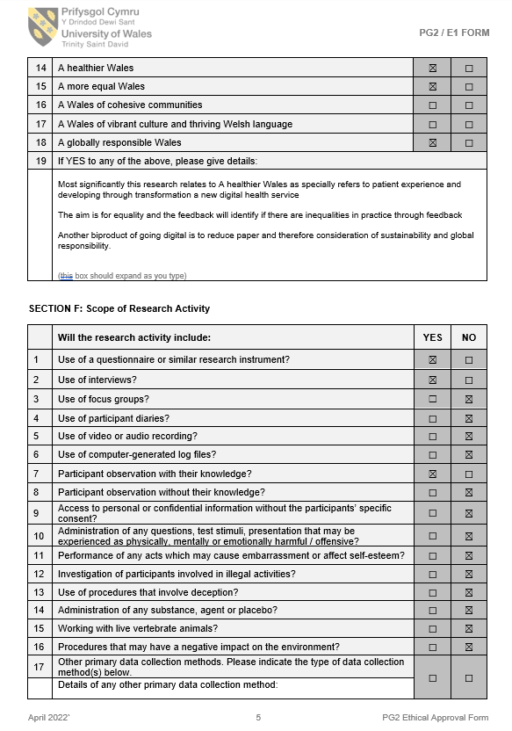

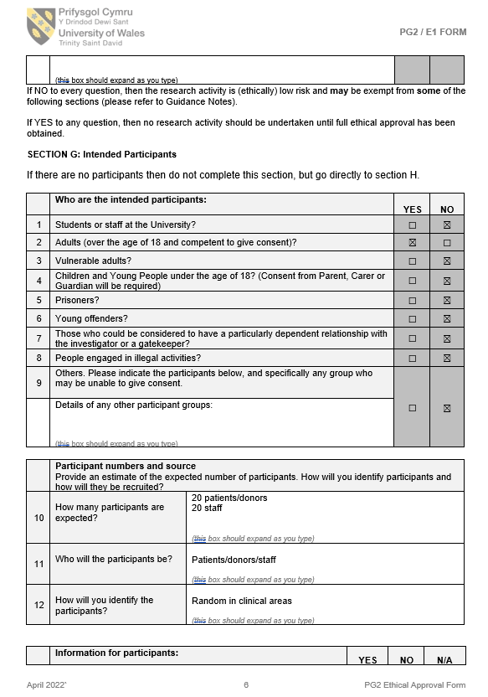

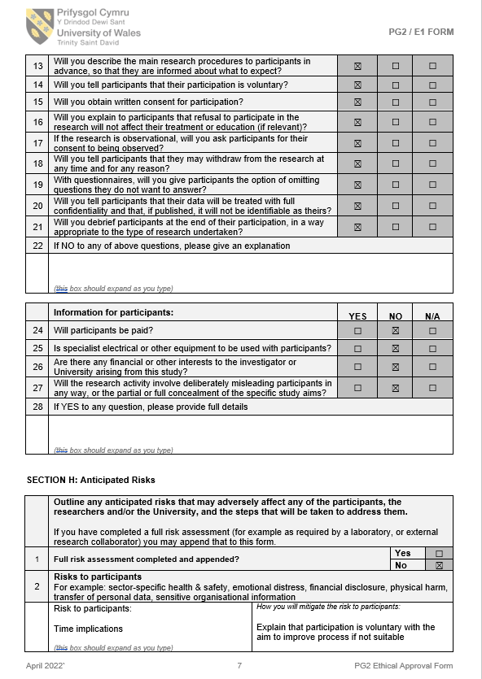
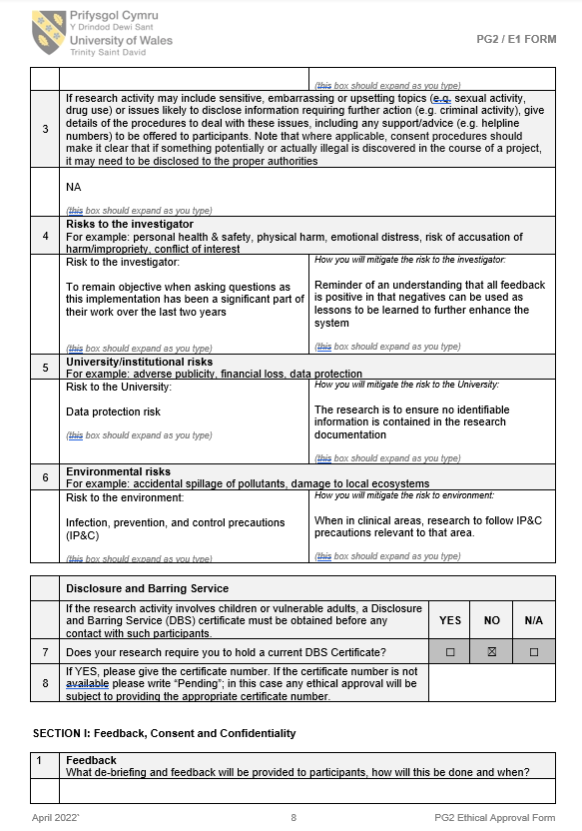
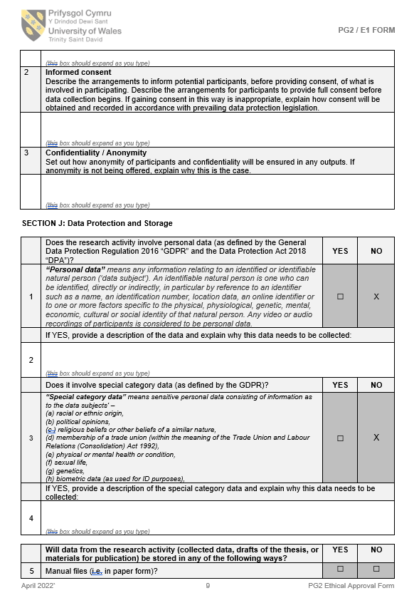

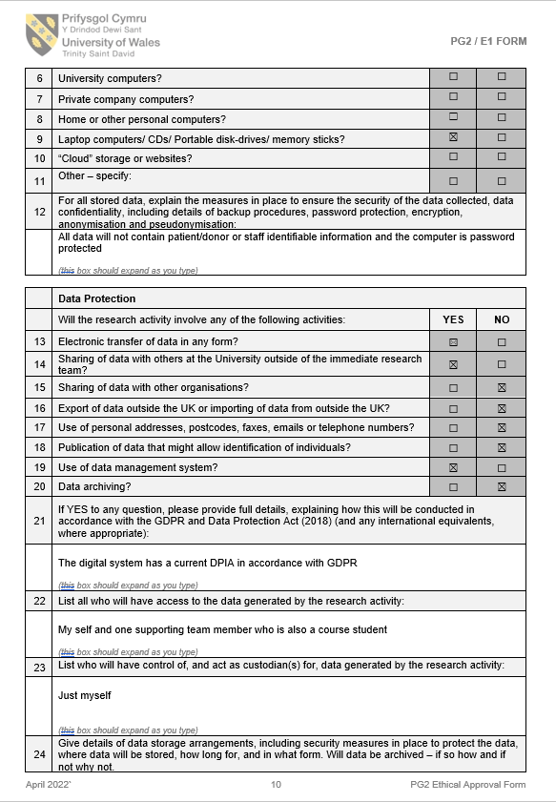
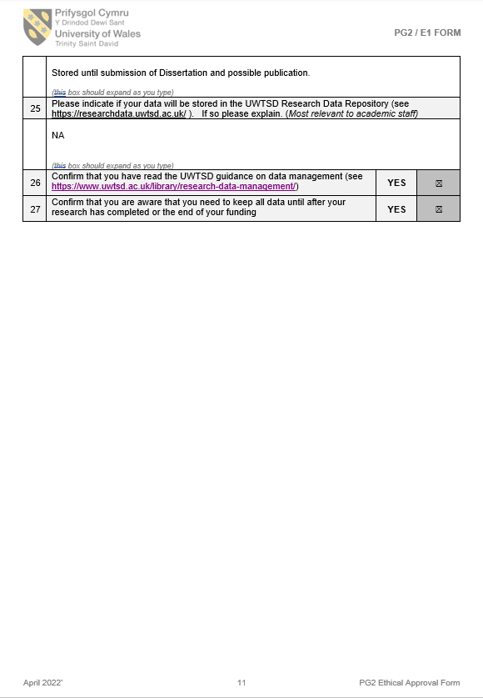
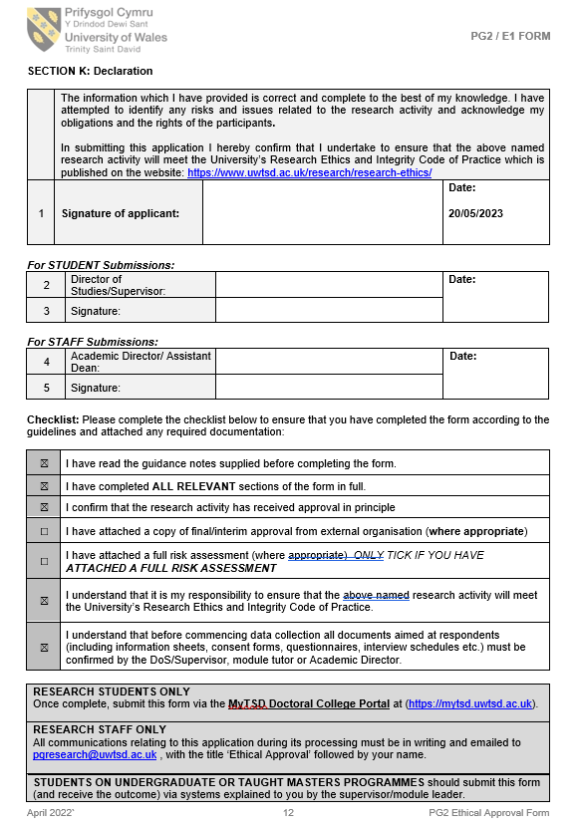

References
Berger, S., Saut, A.M and Berssaneti, F.T (2020) Using patient feedback to drive quality
Blaise, B (2020) How to create a Data Analysis Plan: A detailed Guide. https://learn.crenc.org/how-to-create-a-data-analysis-plan/#:~:text=How%20to%20Create%20a%20Data%20Analysis%20Plan%3A%20A,the%20appropriate%20statistical%20method%20to%20test%20hypotheses%20
Department of Health, 2020. The Health and Social Care (Quality and Engagement) (Wales) Act
Department of Health, 2015. Health and care standards. https://www.gov.wales/sites/default/files/publications/2019-05/health-and-care-standards-april-2015.pdf
Gelling L. Applying for ethical approval for research: the main issues. Nurs Stand. 2016 Jan 13;30(20):40-4. doi: 10.7748/ns.30.20.40.s46. PMID: 26758167.
George, T. 2021. Mixed Methods Research/Definition, Guide and Examples. https://www.scribbr.com/methodology/mixed-methods-research/
Nundy, S., Cooper, L.A and Mate, K.S., 2022. The Quintuple Aim for Health care improvement: A new imperative to advance Health Equity. https://pubmed.ncbi.nlm.nih.gov/35061006/
Ong, B.N., Hodgson, D., Small, Implementing a digital patient feedback system: an analysis using normalisation process theory. BMC Health Serv Res 20, 387 (2020). https://doi.org/10.1186/s12913-020-05234-1
PHW (2012) Sub-local authority analysis of the Welsh Health Survey https://phw.nhs.wales/services-and-teams/observatory/data-and-analysis/publication-documents/sub-local-authority-analysis-of-the-welsh-health-survey/whs-usoa-analysis-report-v1-eng-pdf/
UWTSD, 2022. The University Research data management policy

