DS 1 Template

My Screenshots/Photos
- Please add 4–6 screenshots or photos of your digital life.
- You can use your phone or laptop.
- For each screenshot, write one or two sentences explaining what it shows.

Screenshot/Photo 1
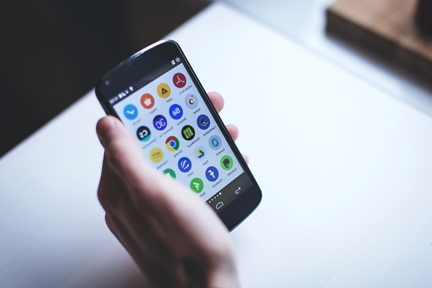
This screenshot shows a mobile phone. I m using phone every day to keep contact with my family and friends, use apps. Also, I m using phone for searching information on the internet. I also use the mobile phone in free time for listen music, or watch a movie. It helps me as well to check maps and manage with my daily activitis. (Ruggeri, 2023)

Screenshot/Photo 2

This photo shows a laptop. I use my laptop to study, write assignments. It also helps me to complete my college work and improve my computer skills. For example, I use Microsoft Word to write my assignments. I m using as well the laptop for watching the movie in my free time. (Electro Gadget Plus, 2024)

Screenshot/Photo 3

This picture shows a car. It helps me to travel to work, the shops and other places. It saves a lot of time and make travelling more easy. I m use the car as well for relax myslef, when I drive and listen the music with my friends. I can go With the car to visit a place or my family. (‘The Importance of Cars in Our Daily Lives’, 2024)

Screenshot/Photo 4

This photo shows a train. It helps me to travelling to college and some places when I don’t need a car. I use the train to travel to a different place, to visit a city. I can use as well my phone to check the train time, or buy the ticket online and recive a message about delayed. (Avanti West Coast, 2024)

Screenshot/Photo 5
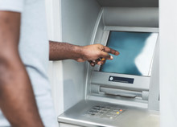
This picture shows a cash machine. I used to withdraw the money from my bank account. It is helpful when I need cash for thinks like transport or bills. Some ATM have possibility to check the balance on the account. (LINK, 2025)

Screenshot/Photo 6

This photo shows an e-mail. I use e-mail to send messages and receive important information. Helps me to communicate with my college, work and other people. I also use e-mail to recieve update about my course and important information. (Guildford.org.uk, 2025)

My Short Reflection
- Write 5–8 simple sentences about your digital life.
- You can use the sentence starters below if helpful.
I use digital tools every day to communicate with people at work, with college. I often use my mobile phone to keep contact with friends and family. I feel more confident when I use my laptop to search for information on the internet. I want to improve my computer skills and learn how to use different programs. Digital skills are important for me because they help me with everyday lifetime to communicate and with my college work. Sometimes I feel stressed to write assessments in English. I hope this module will help to improve my skills and feel more confident.

Sentence starters
- I use digital tools to …
- I feel confident when I …
- I want to improve …
- I often use these tools: …
- I sometimes feel nervous about …
- I hope this module will help me …
- Digital skills are important for me because …
You can write more if you want.

Submission Checklist
Before you submit, please check:
​​​ ☒ I added 4–6 screenshots
☒ I wrote short sentences for each screenshot
☒ I wrote my short reflection
☒ My work is my own
☒ My file opens correctly
​​☒ My file opens correctly

Referencing:
Ruggeri, A. (2023) How cellphones have changed our brains. BBC Future, 4 April. Available at: https://www.bbc.com/future/article/20230403-how-cellphones-have-changed-our-brains (Accessed: 25 October 2026)

Electro Gadget Plus (2024) The importance of laptops in the modern world. Vocal Media. Available at: https://vocal.media/writers/the-importance-of-laptops-in-the-modern-world (Accessed: 25 October 2026)

The Importance of Cars in Our Daily Lives (2024) Knowledge - Shenzhen Chunwang. 30 August. Available at: https://www.absorbwell.com/info/the-importance-of-cars-in-our-daily-lives-99785957.html (Accessed: 25 October 2026)

Avanti West Coast (2024) The advantages of travelling by train. 14 May. Available at: https://www.avantiwestcoast.co.uk/where-we-go/blog/the-advantages-of-travelling-by-train (Accessed: 25 October 2026)
LINK (2025) Majority of UK adults still value cash despite digital payments. 23 July. Available at: https://www.link.co.uk/news/majority-of-uk-adults-still-value-cash-despite-digital-payments (Accessed: 25 October 2026)

Safe and Connected: How Email Shapes Your Digital Life (2025) Guildford.org.uk. Available at: https://www.guildford.org.uk/safe-and-connected-how-email-shapes-your-digital-life/ (Accessed: 25 October 2026)

