Introduction to Web Development

HTML & CSS Web Development

Module Tutor: Kemi Ademoye

By Scott Howells
Student Number: 1701604
Table of Contents

- Introduction
- Requirements
  - Introduction to the Website
  - Site Map
  - Layout and Design Elements
- Implementation
  - Screenshots of completed Website
  - Validation
- Evaluation
  - Evaluation on the Accessibility of the Website
  - Evaluation on the Design, Usability and Content
  - Recommendations for future improvements
- References
- Bibliography

- Introduction

The purpose of this report is to outline and demonstrate an understanding of the concepts, principles and practice required in the implementation of websites. This report will contain detailed descriptions and information on an implemented website and all of the methods used to create it.

- Requirements

  - Introduction to the Website
The website created is an informative website suitable for all ages that contains information on the football club Swansea City. The purpose of the website was to give information to all those who would like to know more about the football club that is Swansea City. The website contains descriptive text and also clear images so that the audience viewing have a professional outlook on the matter. The target audience are within the teenager to pensioner group, as the text used can be seen as informal and acute.
  - Site Map
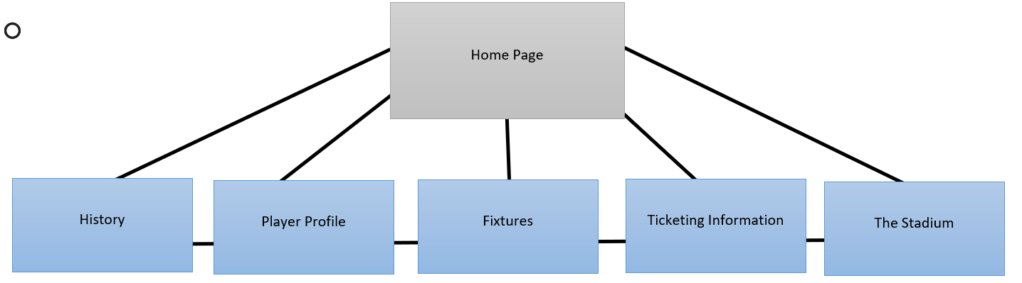
(figure 1)
This is the structure of the Website. The Home Page is the starting point to the website. There are two navbars that allow the user to navigate through the website. Each page has the navbar attached to the top of the page and at the bottom. Each page links to each other through this navbar.

  - Layout and Design Elements
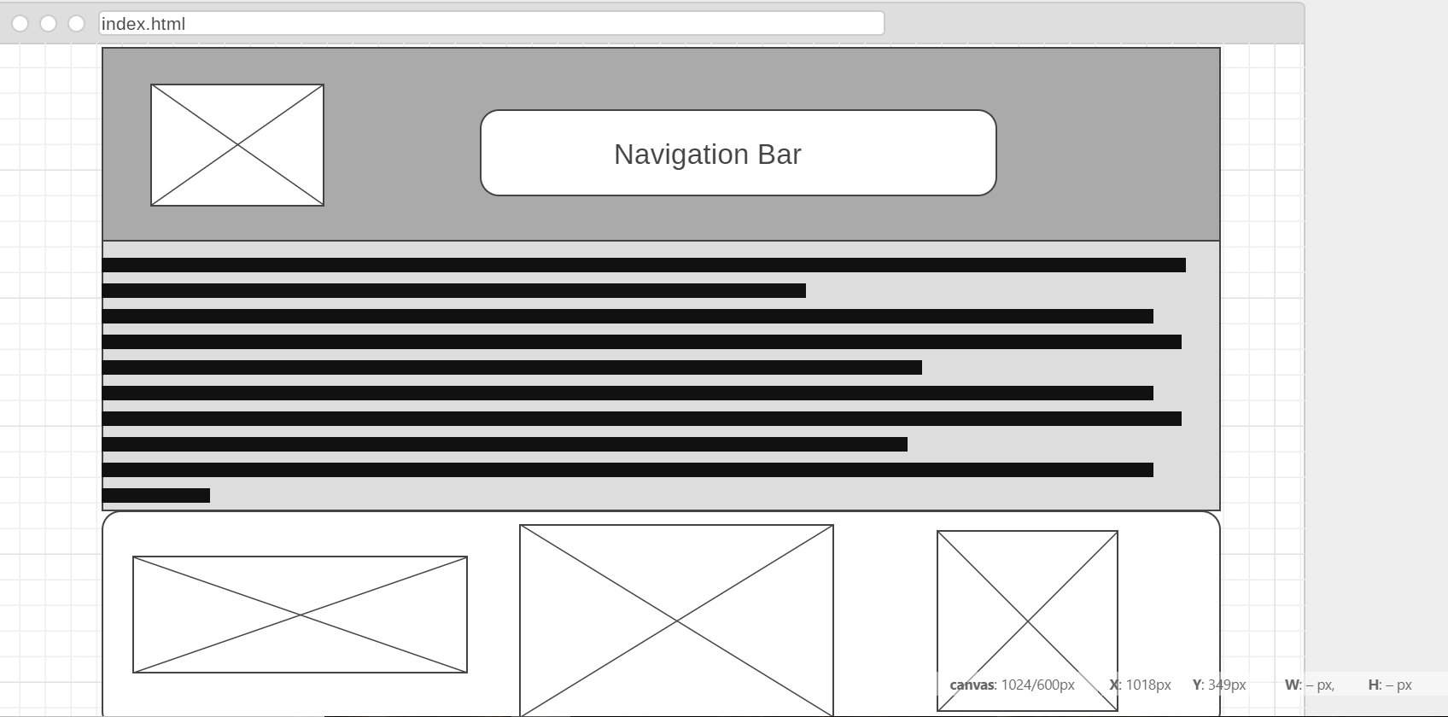
(figure 2)
Figure 2 is of the wireframe diagram that was created on [1]. This is the grid layout of the Home page located on the website.
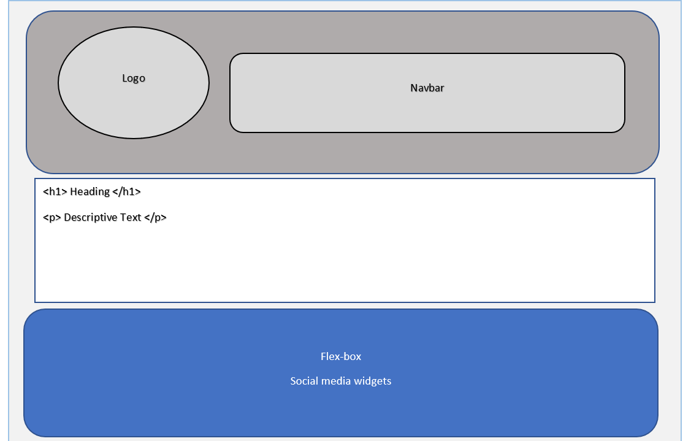
(figure 3)
Figure 3 is the content section of the Home page found on the website. The design elements of the Home page consist of the colors black, white and blue. Black and white are the house styles of the website as Swansea City’s colors are also black and white. The color blue is found at the bottom of the web page as it highlights the flex-box and the navigation used. The shape and form of the webpage is also found throughout the website. This is because most websites follow the same design layout. Viewers often rather using similar design layouts to previous websites they have visited [2].
The logo is located next to the navigation bar at the top of the webpage. The main body of text is the descriptive writing on the background of Swansea City. Also, the social media widgets that offer live posts are found here. Whilst the footer contains the simple navigation bar, and this is done so the user would not have to scroll back up the webpage.
- Implementation

  - Screenshots of completed Website
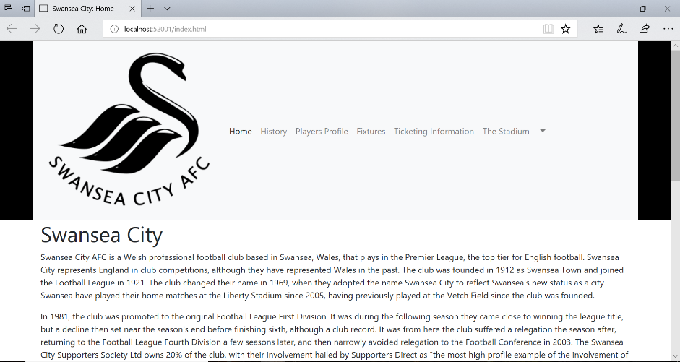
(figure 4)
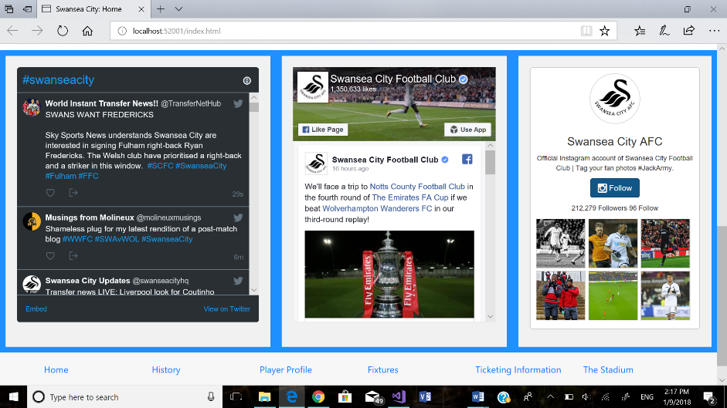
(figure 5)
Figure 4 and 5 are taken from the Home page.
Figure 5 consists of the Twitter, Facebook and Instagram live social media posts.
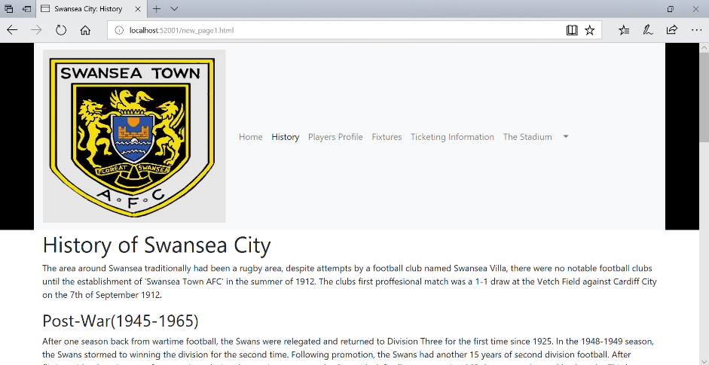
(figure 6)
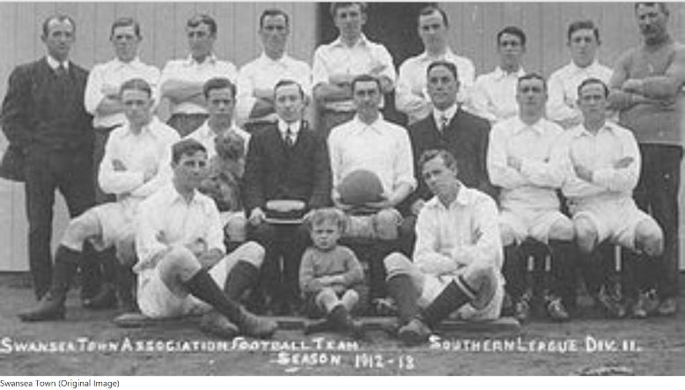
(figure 7)
Figures 6 and 7 are taken from the History page.

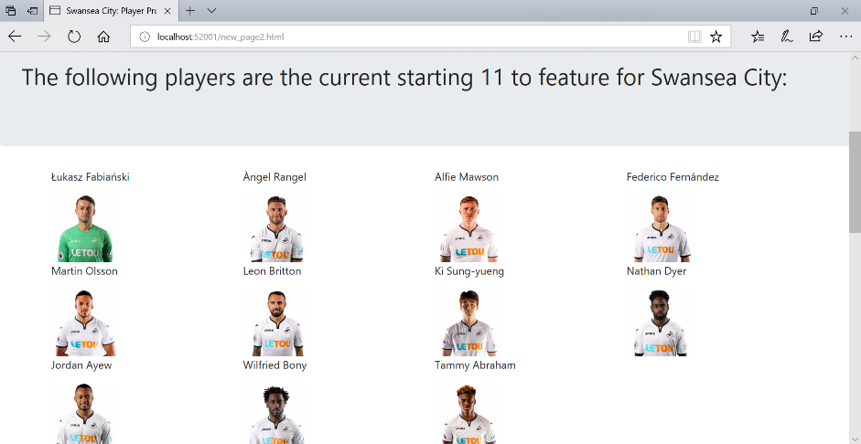
(figure 8)
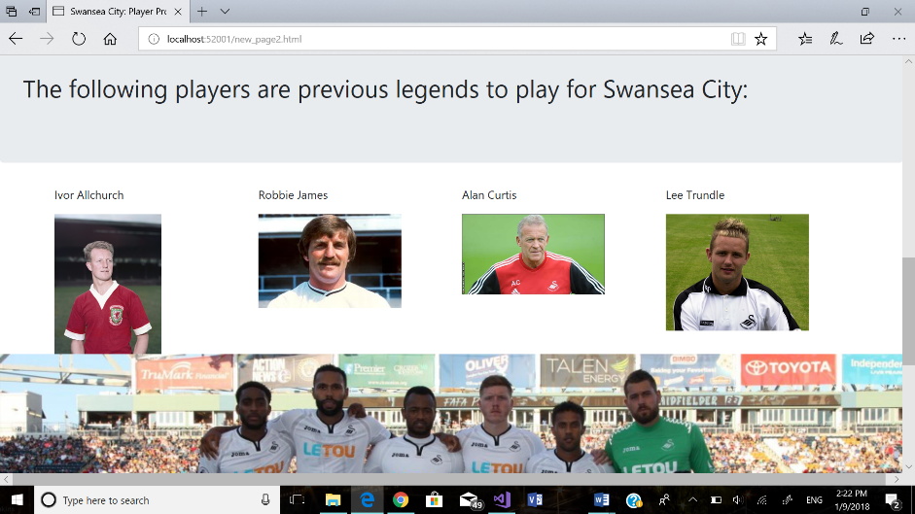
(figure 9)
Figures 8 and 9 are taken from the Player Profile page.

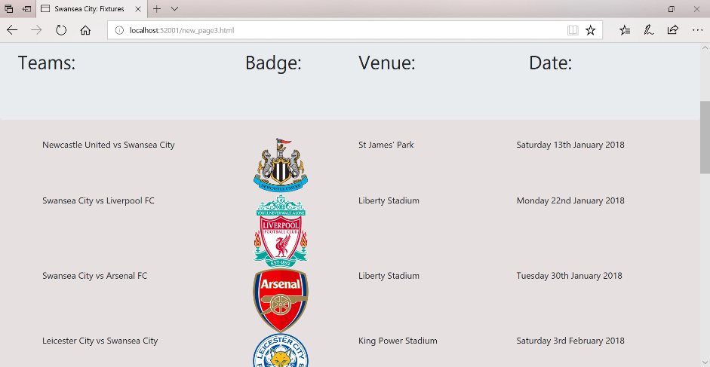
(figure 10)
Figure 10 is located in the Fixtures page.

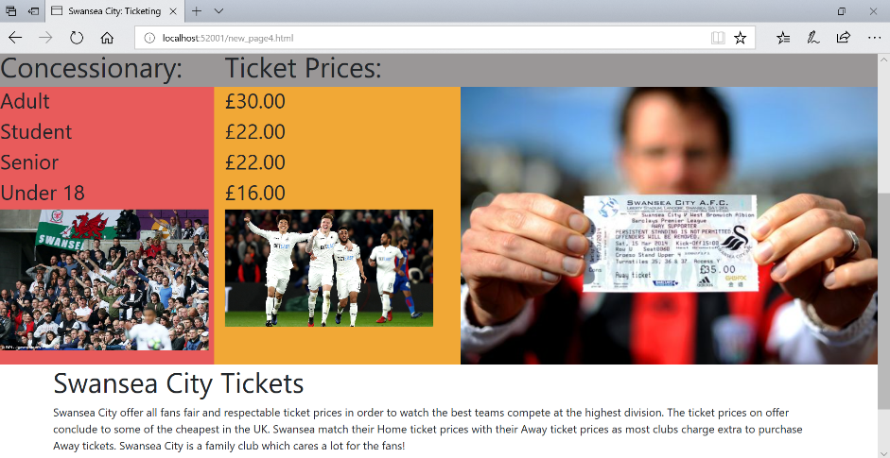
(figure 11)
Figure 11 has been taken from the Ticketing Information page.

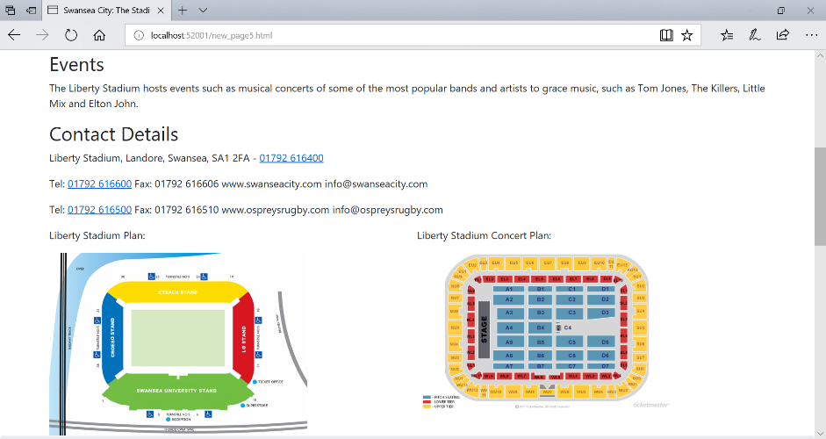
(figure 12)
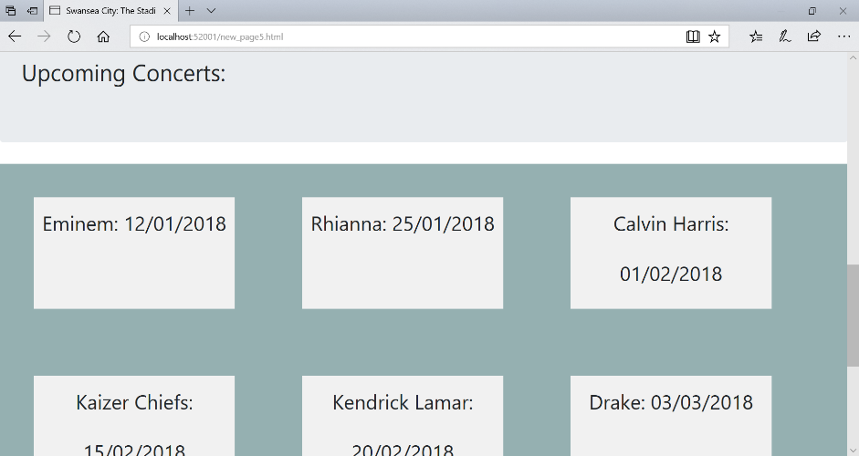
(figure 13)
Figures 12 and 13 are from The Stadium page.

  - Validation
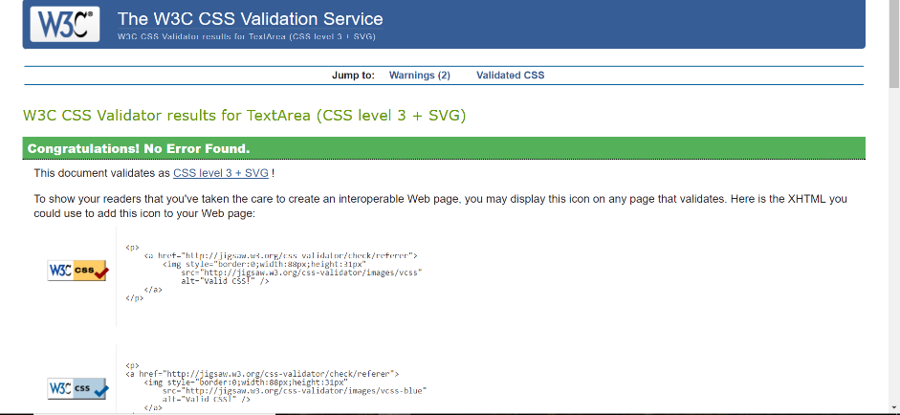
(figure 14)
Figure 14 is a screenshot of the CSS Validator result [3]. There were no errors within the StyleSheet linked.

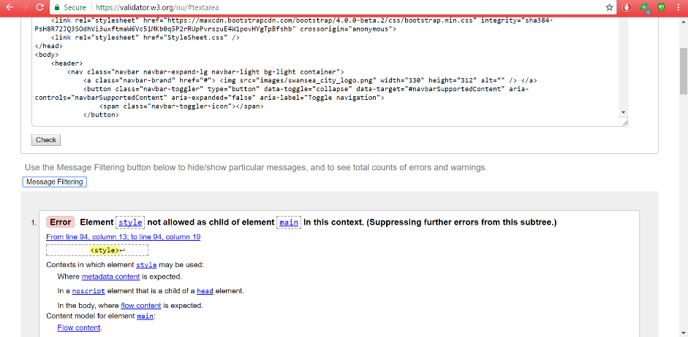
(figure 15)
Figure 15 is a screenshot of the HTML Validator [4]. There was one error that came out with the Home page. The <style> tag should not be used within the main context. It should not be the child of the main section, it should however be located where the metadata is expected.

- Evaluation

  - Evaluation on the Accessibility of the Website
The accessibility of the website was made in order for all age groups across all devices to use with no functionality issues.
Headings were used wherever necessary, and these headings outlined what the following text would be. A new heading was used for a new piece of informative text, so that the reader understands where the last piece of text stopped and where the new one begins.
The information structure was constructed so that it would be easy to read throughout the HTML code and thus would make more sense so that when the reader reads the text, he/she knows where that is. The relationships within the HTML code consist of parent design elements which influence the child elements through inheritance. What this means is if the styles of a child HTML element are not specified, the element inherits the styles of its parent, the HTML tag, commonly refereed to as the container, wrapped around it.
The website is also functioned for scalable resize. It was important to have a functioning website for users across multiple devices. Testing has been conducted and the website can successfully load neatly on tablet and mobile devices as well as different size screens.
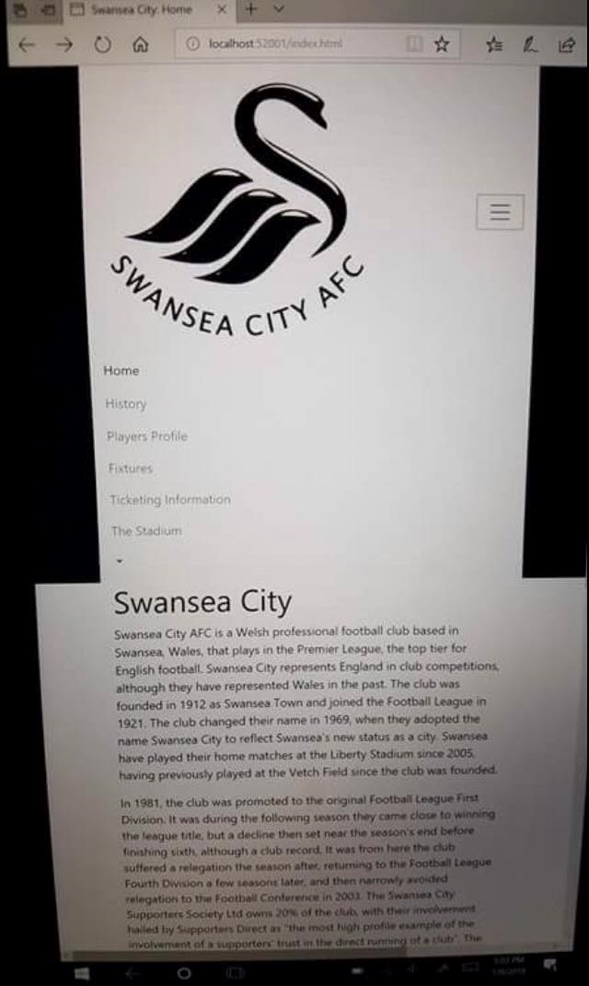
Figure 16 is the website when in tablet mode, the size of the screen changes. The navigation bar changes for a drop-down box. When this box has been touched then the navigation will then appear below.
This little feature makes the website more accessible to the users that use different devices.

(figure 16)
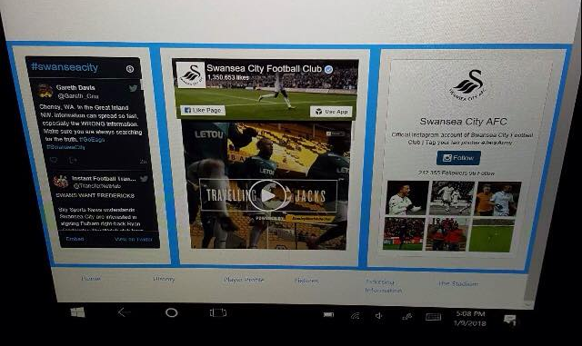
(figure 17)
Figure 17 is the flexbox which has changed in order to fully comply with the different screen size.
The main colours of the website were chosen as the house style due to the fact Swansea City use the colours white and black. It was important that these colours were incorporated throughout the website because that is Swansea City’s identity. The foreground colours were also plain to give it the professional look. There was no point in using bright red and yellow colours on a webpage that has the professional look of being white and black.
The navigation bar was a simple input that the majority of users would recognize. The navigation bar was implemented so that the users could easily use the website. The inclusion of the navigation bar at the footer of the page was introduced so that it would be easier for the user to click on instead of scrolling back up the page to click on the next navigation link.
Tools that helped the creation of the website consist of:
- Visual Studio
- http://contrastchecker.com/
- Microsoft Edge
- WCAS 2.0 [5]
- Twitter widget [6]
- Facebook widget [7]
- Instagram widget [8]
The widget tools helped create the social media live posts. By implementing the code on offer into the website, it allows for a more advanced and professional outlook on the website. The widget tool codes were implemented into the website using flexboxes and numerous other designs which took extensive amount of change and research in order to achieve a fully functioning layout. The links to the widget tools will be found within the reference table below.
  - Evaluation on the Design, Usability and Content
The website created was intended to display information and include high quality images. The final version of the website created includes all of the key factors that was intended when first thought of. The design could come across as very plain, however, there was no need in including bright and colourful pages when the house style that was intended was white and black. The colour scheme in use is of Swansea City and their identity (which is white and black).
The functionality of the website was created so that most ages could use very simply. The need for the older generation in order to know where and what to click in order to find the relative information was key as it is that generation which is known to struggle with technology [9]. It was also intended for the younger generations to know where and what to click with ease, this was accomplished with the social media live posts on the Home page.
The content was fully descriptive and very informative. It offers all those who wish to learn more about Swansea City a comprehensive understanding with a large sum on each respective page.
  - Recommendations for future improvements
In order to garner greater success from web development, the need to improve is a must. The inclusions of social media live posts were a success, however, videos, sound clips, and even google maps all allow for an improved website. The colours although justified could be improved with lighter yet colourful shades.

- References

References

[1] | [Online]. Available: https://wireframe.cc/pro/edit/135254. [Accessed 2 January 2018].
[2] | D. Ellis, "ALL WEBSITES LOOK THE SAME," [Online]. Available: http://www.novolume.co.uk/blog/all-websites-look-the-same/. [Accessed 2 January 2018].
[3] | "W3C CSS Validator," [Online]. Available: https://jigsaw.w3.org/css-validator/validator.
[4] | "Validate by direct input," [Online]. Available: https://validator.w3.org/nu/#textarea.
[5] | "Web Content Accessibility Guidelines (WCAG) 2.0," 11 December 2008. [Online]. Available: https://www.w3.org/TR/WCAG20/.
[6] | "Twitter for Websites," [Online]. Available: https://dev.twitter.com/web/overview. [Accessed 1 December 2017].
[7] | "Page Plugin," [Online]. Available: https://developers.facebook.com/docs/plugins/page-plugin/. [Accessed 1 December 2017].
[8] | "Add Instagram Photo Gallery to Website," [Online]. Available: https://instawidget.net/. [Accessed 1 December 2017].
[9] | J. Wakefield, "The generation that tech forgot," 25 May 2015. [Online]. Available: http://www.bbc.co.uk/news/technology-32511489. [Accessed 2 January 2018].

- Bibliography

The following links are for the images used within the website:
https://thebeautifulhistory.wordpress.com/clubs/swansea-city/ - Swansea Town image
http://falso9sports.com/11/08/2017/previa-premier-league-20172018-swansea-city/ - Swansea Squad in America
https://www.swanseacity.com/ - Swansea City player images
http://www.zimbio.com/pictures/kRQnnpIC86M/Weekly+Bucket/CfckZJrNatA/Ivor+Allchurch – Ivor Allchurch image
http://tdifh.blogspot.co.uk/2011/02/18-february-1998-death-of-robbie-james.html - Robbie James image
https://showmastersonline.com/forums/index.php?/topic/81501-latest-sports-guest-announcement-welsh-football-legends/ - Alan Curtis image
https://www.balls.ie/football/lee-trundle-tribute-141462 - Lee Trundle image
http://www.mirror.co.uk/sport/football/news/swansea-bigger-club-porto-6-5017892 - Swansea ticket fan
http://www.walesonline.co.uk/sport/football/football-news/swansea-city-chiefs-preparing-buy-8492054 - Liberty Stadium image 1
https://en.wikipedia.org/wiki/Main_Page - all football logos used
http://www.dailymail.co.uk/sport/football/article-4492540/Swansea-fury-fans-free-tickets-sale-online.html - Swansea City fans image
http://www.chroniclelive.co.uk/sport/gallery/pictures-newcastle-united-v-swansea-9117544 - Swansea City line-up vs Newcastle
http://www.skysports.com/football/c-palace-vs-swansea/356526 - Swansea celebration
http://www.liberty-stadium.com/ - Liberty Stadium images

marking criteria and Student FEEDBACK

This section details the assessment criteria. The extent to which these are demonstrated by you determines your mark. The marks available for each criterion are shown. Lecturers will use the space provided to comment on the achievement of the task(s), including those areas in which you have performed well and areas that would benefit from development/improvement.

Common Assessment Criteria Applied (Assignment 1) | Marks available | Marks  awarded
1. Research-informed Literature
Extent of research and/or own reading, selection of credible sources, application of appropriate referencing conventions.
Demonstrates an average level of research. (Grade mark: 50.00%) | 5 | 2.5
2. Knowledge and Understanding of Subject
Extent of knowledge and understanding of concepts and underlying principles associated with the discipline.
Demonstrates a good understanding of the standards used to design and implement a website. The main area for improvement is your use of the grid system to layout and structure your content. Note that the <style> element for CSS goes into the <head> section - see your report. Also, please note that if you are creating a multi-page website, it is better to have a single, external style sheet page that you add all your CSS to and then link this single style sheet to all your pages. That way, you define your styles once, which makes it easier to ensure that your pages are consistent and if you need to make changes, you only need to do it one place. (Grade mark: 55.00%) | 20 | 11
3. Analysis
Analysis, evaluation and synthesis; logic, argument and judgement; analytical reflection; organisation of ideas and evidence
Although you have provided a fair accessibility evaluation of the website and how this has been achieved in your website, you have made no reference to the WCAG guidelines. The accessibility evaluation is more of a general discussion and it is clear that you have not really researched the WCAG guidelines. (Grade mark: 50.00%) | 20 | 10
4. Practical Application and Deployment
Deployment of methods, materials, tools and techniques; application of concepts; formulation of innovative and creative solutions to solve problems.
A good attempt featuring a simple website with well-thought-out content. Well done. Generally, the layout and content of the website could be improved and the layout made consistent across all pages. Aim to learn how to use the grid system properly. (Grade mark: 58.00%) | 50 | 29
5. Skills for Professional Practice
Attributes in professional practice: individual and collaborative working; deployment of appropriate media; presentation and organisation.
The report is of a good standard. See your report for suggested improvements. (Grade mark: 60.00%) | 5 | 3

Assignment Mark (Assessment marks are subject to ratification at the Exam Board. These comments and marks are to give feedback on module work and are for guidance only until they are confirmed. ) | Late Submission Penalties (tick if appropriate) |  | 55.5%
 | Up to one week late |  | 55.5%
 | 1st/2nd/3rd attempt? |  | 55.5%

