

Course Title: MBA - International Business
Term 2

Student Name: CHARU GAUTAM
Student ID: 2432997

Module Name: STRATEGIC MANAGEMENT
Module Code: LCMB7003

Lecturer’s Name: Amare Desta

Deloitte

Executive Summary
Deloitte has sustained competitive advantage since an organization that has 150 plus countries of operation with 180 years brand heritage and 5 service offering with $2 billion of investment on AI and clouds is sufficient to sustain competitive advantage. The regulatory complexity, technological disruptions, and rising demand for ESG are the key macro-environment determinants of the strategic environment of the PESTEL analysis. The VRIO analysis confirms that Deloitte brand, technology support system and fortune 500 clientele are long term, imminible competitive strengths. Its CSR activities, i.e. WorldClass and WorldClimate are closely coordinated with the talent retention and development of ESG advisor. Both Balanced Scorecard and Ansoff Matrix provide the priorities in relation to revenue growth, quality audit and market growth. These are three strategic alternatives that are; enterprise-wide implementation of AI across the service lines, codification of ESG advisory as a global practice, and the creation of a scalable mid-market digital advisory offering.

Table of Contents
Section 1 - Strategic Management Analysis of Deloitte: Achieving Sustainable Competitive Advantage in Professional Services 4
Introduction 4
1. Organisational Context and Overview 4
1.1 Historical Background, Mission, Vision, and Business Model 4
1.2 Industry, Key Competitors, and Market Position 5
2. External and Internal Environment Analysis 5
2.1 PESTEL Analysis 5
2.2 Critical Success Factors and Strategic Challenges 7
2.3 Internal Environment and VRIO Framework Analysis 8
3. CSR and Sustainability Objectives 9
3.1 CSR Strategy and Business Alignment 9
4. Comprehensive and Holistic View of Deloitte: Balanced Scorecard 10
4.1 Balanced Scorecard Framework 10
5. Strategic Choices and Implementation 12
5.1 Business-Level Strategic Options 12
5.2 Corporate-Level Strategic Options 13
5.3 Change Management Assessment 14
6. Strategic Evaluation and Recommendations 14
6.1 SWOT Analysis 14
6.2 Ansoff's Matrix 15
6.3 Strategic Recommendations 16
Conclusion 17
Section 2: Reflective Account Using Gibbs' Reflective Cycle (1988) 18
References 21
Appendix 24

Section 1 - Strategic Management Analysis of Deloitte: Achieving Sustainable Competitive Advantage in Professional Services

Introduction
The professional services industry is a very knowledge intensive and competitive industry within the world economy. As the degree of sophistication of the advisory, audit and technological services that organisations require, firms in the sector should always ensure management approaches that are strategic to them are perfected, so that they remain relevant and competitive. This report applies critical theoretical perspectives of PESTEL, VRIO, Balanced Scorecard as well as the SWOT analysis to analyze strategic management approach by Deloitte, the external and internal environment, strategic positioning, CSR commitments as well as strategic choices and ultimately indicates evidence-based strategic advice that can be adopted to ensure that Deloitte remains the market leader (Mohamed and Basar, 2023).

1. Organisational Context and Overview

1.1 Historical Background, Mission, Vision, and Business Model
The origins of Deloitte Touche Tohmatsu Limited can be traced back to the year 1845 when a small London based accounting firm was owned by William Welch Deloitte. With nearly a hundred and half years, Deloitte has evolved to become the biggest professional-service organization in the globe compared to its position as a local accounting company. The other significant achievements include the merger with Touche Ross International, 1989 and Haskins and Sells 1990, which made it significantly assume its ground and increased its scale of services as a multidisciplinary firm. Today, Deloitte is involved in more than 150 countries and employs approximately 457,000 professionals around the globe, with the total of the 64.9 billion accumulated revenues FY2023, which is an impressive 14.9 percent growth factor annually (Dutt et al., 2024).
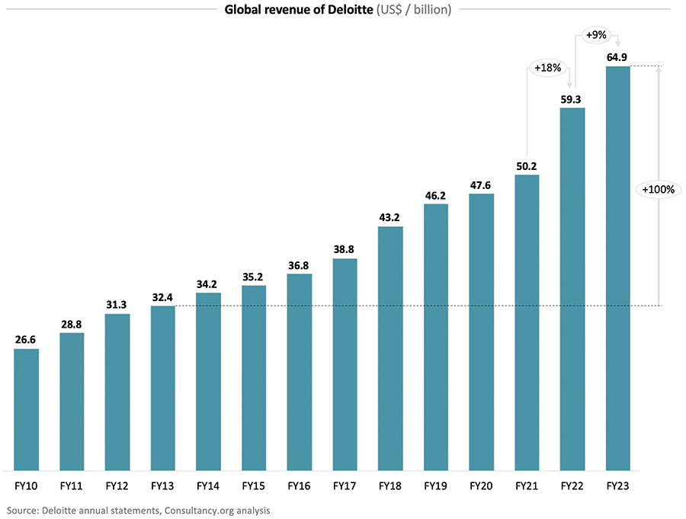 Figure: Deloitte Global revenue
Source: (Consultancy.eu, 2023)
Mission of Deloitte is to make a difference, which expresses value and measures on value delivery to both clients, communities and the remaining world market. It has a vision of being the world leader concerning professional services, which are based in innovation, trust, and inclusiveness foundation (Dutt et al., 2024). The business model of the organisation is a unique network business model where legally independent member firms are given the accolade to share the brand, methodologies and quality benchmarks of the Deloitte but is free to the local decision-making needs to local regulatory and market conditions. It is a framework that is fluctuating between the global integration and the local responsiveness that is a strategic potential that most global competitors of the magnitude could hardly replicate. Da has five service line categories, such as Audit and Assurance, Consulting, Financial Advisory, Risk Advisory, and Tax, which are used not only to protect the organisation against industry-related downturn but, also, to cross-sell any client relationship (Deloitte, 2024).

1.2 Industry, Key Competitors, and Market Position
Finally, Deloitte is an organization that operates within a business realm of the worldwide network of professional services sector and is estimated to be approximately 8.5 trillion in 2023. This is because the other three members of the Big Four, the group that includes PricewaterhouseCoopers, Ernst and Young and KPMG are also the major competitors of it. PwC, EY and KPMG registered 53.1, 49.4 and 36.4 billion on FY2023 respectively, so it is obvious that Deloitte is the market leader. Alongside the Big Four, the technology based consultancies like Accenture (up to 64.1 billion revenue in FY 2023) and the strategy consultancies like McKinsey and Company particularly in the high-value consulting division are becoming a menace to Deloitte (Deloitte, 2024). Consulting is the most rapidly expanding service line of Deloitte that yields approximately 28 percent of total revenues, because of an escalating rate of worldwide requirements to digitally transform, relocate to the cloud, and seek advice with AI (Deloitte, 2024).

2. External and Internal Environment Analysis

2.1 PESTEL Analysis
Table 1: PESTEL Analysis of Deloitte
Source: (De Sousa and Castañeda-Ayarza, 2022)
Factor | Key Driver | Strategic Impact
Political | Regulatory divergence across 150+ countries | Increases compliance costs; demands adaptive governance
Economic | Global GDP growth at 3.2%; inflationary pressures in key markets | Client budget tightening; pressure on discretionary advisory spend
Social | Growing DEI expectations; 57% female workforce globally in 2023 | Strengthens talent attraction and client trust credentials
Technological | $2 billion AI and cloud investment in 2023 | Core consulting growth driver and competitive differentiator
Environmental | Net-zero regulatory pressure; ESG market growing at 24% annually | ESG advisory demand surges; WorldClimate strategy activated
Legal | GDPR, CCPA, evolving audit regulations post-2022 | Compliance complexity rises; advisory revenue opportunities grow
The synopsis of macro-environmental forces affecting the strategic decisions of Deloitte is contained in Table 1. Their operational bases exist in more than 150 jurisdictions and this exposes Deloitte to competing regulation regimes which require continuous investments into local compliance infrastructure and responsive governance regimes. The geopolitical crisis, and in particular the US-China trade war and the conflict situation in Eastern Europe, disrupts the contacts between the inter-border clients and generates the uncertainty in the services provision in the financial advisory and risk practice. As an economic policy, despite structural resiliency in the course of business cycles, the prevalence of inflationary conditions in the United Kingdom and the United States, in which interest rates are elevated to twenty-five-year highs between 2022 and 2024, has increased the client complaints of the advisory discretion of the advisory spending of the United Kingdom, which has imprinted material price pressure on the Deloitte consulting revenues (De Sousa and Castañeda-Ayarza, 2022).
The socially impacted elements of talent and client strategies are beginning to change with heightened expectations when it comes to diversity, equity, and inclusion. Deloitte proves its job offer to younger professionals by the fact that in 2023 it can boast of 57 percent representation of female workers across the world, which confirms that it offers professionals jobs younger than 35 and increases its chances to advise on a program change on DEI transformation programs (Amaya et al., 2022). The excessively quick development of the sphere of artificial intelligence due to its technological advancements can be considered as the most strategically important external force. The 2 billion AI and cloud outlay by Deloitte in 2023 is a good indication of how prepared it is to resist the disruption in the competition and the huge client potential that the widespread use of AI in enterprise-wide environments will produce (Kansongue, Njuguna and Vertigans, 2023).
Sustainability wise, the accelerating speed of sustainability laws like the European Union Corporate Sustainability Reporting Directive which went into effect in 2024 is exerting a lot of burden on ESG advisory and reporting services where Deloitte has invested extensively in values practiced globally (Phiri, Nyatsambo and Bomani, 2024). The increase in the complexity of compliance in the audit practice of the Deloitte guidance has been added with the intensification of audit regulation across the United Kingdom, the United States and the European Union in the wake of the famous audit failures in the face of the law and increased the advisory opportunities in the advice arena of the governance, risk and regulatory consultancy (Kansongue, Njuguna and Vertigans, 2023).

2.2 Critical Success Factors and Strategic Challenges
To attain the critical success factors, the brand name that has been built over its 180 years history, the truly multidisciplinary five service portfolio, ability to invest heavily in technology and unparalleled access to The Fortune 500 client relationship, which it serves more than 90 percent of its clients, are some of the major success factors within the company. The provision of cross-functional offers with audit, risk, tax, consulting, and financial advisory opportunities combined to act as one dependent on the same client relationship is an extreme competitive differentiation that no small and more specialised competitor can attain the same depth and breadth (Phiri, Nyatsambo and Bomani, 2024).
There are however, strategic matters that the executives should address. The increased scrutiny in regulatory auditing that ensued due to the high profile industry collapse has put the foot most loosely and reputational sensitive service line of Deloitte in the hot spot. The post-pandemic labour market unraveling has now made the structurally more costly and complicated competition of elite professional talent, with an estimated annual rate of turnover in professional services in the sector estimated at 17 20%. Furthermore, the increasing consulting bills of Accenture hitting 64.1 billion in FY2023 are structurally increasing jeopardies on the most profitable service provision at Deloitte (Islami, Mustafa and Latkovikj, 2020).

2.3 Internal Environment and VRIO Framework Analysis
Table 2: VRIO Framework for Deloitte
Source: (Amaya et al., 2022)
Resource / Capability | Valuable | Rare | Inimitable | Organised | Competitive Implication
180-year global brand and reputation | Yes | Yes | Yes | Yes | Sustained competitive advantage
Five-service integrated portfolio | Yes | Moderate | Moderate | Yes | Temporary competitive advantage
$2 billion AI and cloud investment | Yes | Yes | Yes | Yes | Sustained competitive advantage
Fortune 500 global client network (90%+) | Yes | Yes | Yes | Yes | Sustained competitive advantage
457,000-strong talent pool | Yes | Moderate | No | Yes | Competitive parity
Proprietary analytics and digital platforms | Yes | Yes | Moderate | Yes | Temporary to sustained advantage
Table 2 involves the implementation of the VRIO framework to evaluate the most strategically relevant resources and capabilities of Deloitte. The longest and un-renewable competitive strength has been the global brand 180 of Deloitte. This kind of brand equity cannot be acquired or developed within a span of time by the rivalry and it must experience an extraordinary degree of client fulfillment notably in audit and financial advisory services where a professional trustworthiness is the chief selection factor. The specified resource corresponds to all four VRIO requirements that have already proved the fact that it is indeed a source of a sustained competitive advantage (Amaya et al., 2022).
The 2-billion AI and cloud investment creates a complicated technology platform/system which even becomes less feasible compared to investment durations of the same investment durations that its competitors will replicate. The use of proprietary algorithms, data repositories, and analytical platforms enriched with AI generate an overall customer-level of acumen over time that generates high switching costs and entrap the clients even more within the Deloitte technology platform. The fortune 500 clientele who represents a combination of the largest businesses in the world create high-quality long-term channels of income, and this has a contextual obstacle of competitive displacement, as the customer switching prices are highly important due to the presence of institutional relationships and institution-deep understanding (Mailani et al., 2024).
The so-called talent pool of 457,000 as something evidently useful also fails to meet the rarity requirements or the inimitable criterion taking into consideration the fact that the talent of professional services is already in development and competed at the level of an entire industry. The five-service model is becoming more and more confronted by the entrance of the megasized technology consultants in the optional advisory services that slightly undermines the rarity and long-term viability of the model (Mailani et al., 2024).

3. CSR and Sustainability Objectives

3.1 CSR Strategy and Business Alignment
The CSR model of Deloitte is anchored on two world flagship global commitments WorldClass and WorldClimate. Deloitte has already committed to making the promise of empowering 100 million towards education, skills development and provide economic opportunities through creation under WorldClass as of 2030. According to the findings of the Deloitte measurements as of 2023, the company already covered approximately 82 million individuals, which is an adequate credible advancement and speed of the process (Park et al., 2023). WorldClimate commits Deloitte to net-zero greenhouse gas emission in all its value chain by 2030, which is quite solittle compared to the 2050 commitments of most of its company associates. Since 2019, Deloitte has reduced its absolute carbon emissions by 29 showing that it has experienced real changes in its activities and is not relying entirely on the carbon offset equipment (Zhu et al., 2023).
The strategic prudence in CSR stance of Deloitte is in a mindful business alignment. The sustainability credentials of Deloitte will further enhance the credibility level of the trust that the firm has in the provision of ESG solutions to its clients subject to the global ESG advisory and consulting market projected to reach over 16billion by the year 2028 with a projected growth rate of approximately 24 per cent/year. This two-step position with sustainability of the insourcing and externalizing of the expertise of the company with an outward-facing has already yielded such competitive differentiation that rivals who lack relative operational commitment cannot possibly claim (Park et al., 2023). Additionally, according to the results of a survey by Deloitte (2023) Global Millennial Survey 49 percent of millennial and generation z employees highlighted sustainability and social impact initiatives of the future employer as a make-or-buy factor in their job selection. The CSR investing therefore directly supports the talent acquisition and retention tactics directly inculcating the expectations on the external stakeholders into the central internal workforce management concerns. The strategy of philanthropy implemented, however, by Deloitte is not mere philanthropy but a well-organized component of its competitive advantages and value creation concept (Zhu et al., 2023).

4. Comprehensive and Holistic View of Deloitte: Balanced Scorecard

4.1 Balanced Scorecard Framework
Table 3: Balanced Scorecard for Deloitte
Source: (Kumar, Prince and Baker, 2021)
Perspective | Objective | KPI | Target | Initiative
Financial | Sustain revenue growth | Annual revenue growth rate | 10–15% year-on-year | Expand consulting and AI-enabled advisory services
Financial | Improve operating margins | Operating profit margin | 20% by 2025 | Automate service workflows using AI tools
Customer | Strengthen client loyalty | Net Promoter Score | Above 60 | Invest in CRM and client relationship platforms
Customer | Expand new client acquisition | New client growth rate | 8% annually | Sector-specific go-to-market campaigns
Internal Processes | Enhance audit quality | Audit inspection pass rate | 95% and above | Enhanced audit quality review frameworks
Internal Processes | Drive digital service delivery | Percentage of AI-enabled services | 60% by 2026 | AI deployment across all business units
Learning and Growth | Develop future-ready talent | Skills training hours per employee | 40 hours per year | Expand Deloitte University digital programmes
Learning and Growth | Improve staff retention | Annual employee turnover rate | Below 15% | Enhance compensation and career progression
Table 3 presents the Balanced Scorecard of Deloitte in all the four perspectives as proposed by Kaplan and Norton. In essence, sustaining a revenue growth of 10-15 percent each year is feasible bearing in mind that Deloitte has been indicated to have yearly revenue growth of 14.9 in FY 2023. The idea of automating service delivery processes driven by AI is an appealing instrument, so far as increasing billable output per consultant is concerned, but not directly proportional to increasing the amount of headcount expense. It would be a meaningful increase to the reinvestment capacity in the future to the capability development and market response of the current opportunity to have an operating profit margin of 20% in 2025 (Kumar, Prince and Baker, 2021).
Overall Net Promoter Score of more than 60 at the customer level is aligned with industry best practice of high quality professional services company and is an indication of Deloitte wish to differentiate on customer experience besides technical competence (Yawson and Paros, 2023). This 8 percent client acquisition rate on an annual basis requires particular investment on business building capabilities in relation to the industry with particular emphasis on high growth areas such as healthcare, financial technology and sustainable energy. At the same time, the passing of the audit quality inspection with a rate of 95 percent and more is commercially significant and reputationally sensitive to Deloitte per se, and a direct safeguard on the most aged service line of the brand to avoid regulatory stigma and harm to its reputation. The target of attaining 60% AI capabilities in every year 2026 signifies the interested intention to integrate technology as an omnipresent competence across all five service lines (Yawson and Paros, 2023).
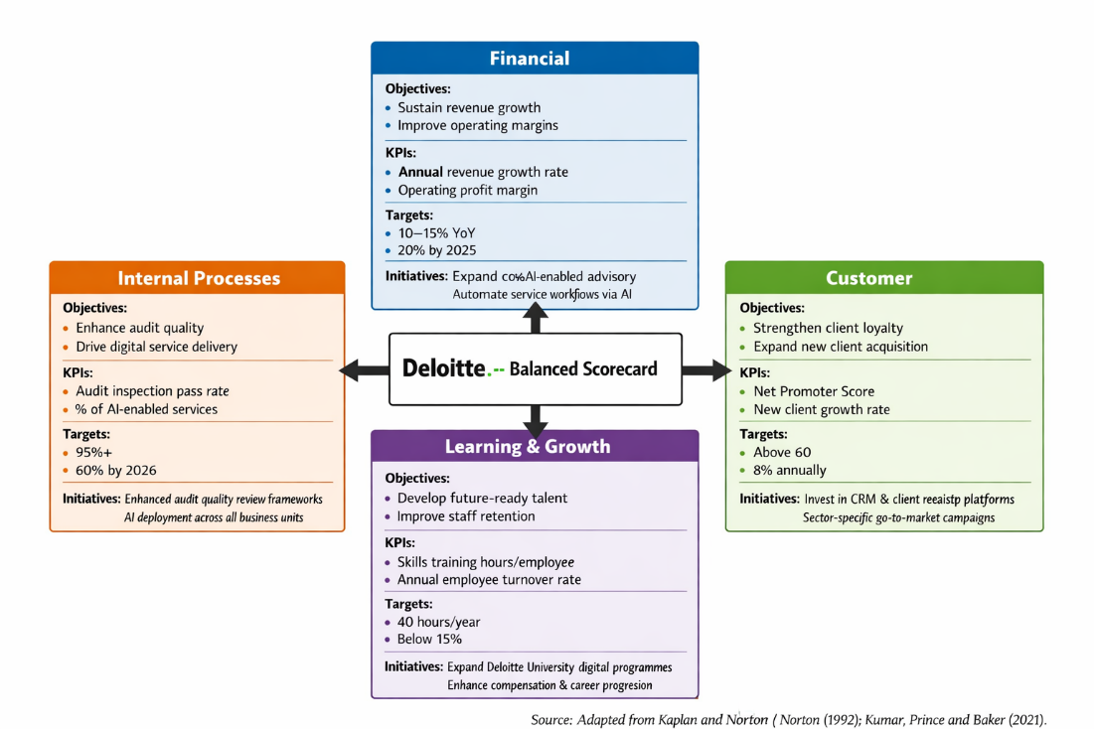
Figure: Balanced Scorecard Framework for Deloitte
The learning and expansion point of view is to ensure that considering the capabilities to handle the dynamic client demands and changing technology environment, the workforce capabilities have met the needs of the variable demand at a fast rate by mandating the workforce with 40-structured professional development hours annually. Reduction to less than 15 percent employee turnover would save the company a ton of money in direct hiring and orientation and indirect costs in restoring productivity of vacated position, and it has been estimated that will cost between 50 and 200 percent of annual salary to recruit a departing professional (Yawson and Paros, 2023).

5. Strategic Choices and Implementation

5.1 Business-Level Strategic Options
There are three major strategic options of the business level, which are cost leadership, differentiation, and focused differentiation of Deloitte. Competition would exist as a result of cost leadership founded on price and uniform delivery of services, which is fundamentally inconsistent with the currently used positioning and high-zone customer under Deloitte, and is not something that should be pursued as it would erode 180 years of premium brand equity (Ali and Anwar, 2021).
The third and the best one that is under going currently being pursued by Deloitte is differentiation; it is creating more value by building stronger sector capabilities, by building multidisciplinary advisory and using better technology in service delivery. Directly relating to the high end as far as the premium market positioning that the differentiation supports is the fact that in the United Kingdom, an average consultant at Deloitte will be charging between 1500 and 5000 dollars per day of its consulting business in 2023. It is a core strategy focused on differentiation, which targets specialty high-value segments of the market like government, healthcare, and financial services that contain specialty industry practice groups, and in doing so it builds development of domain competitive advantage, which competitors facing general purpose can hardly match (Ali and Anwar, 2021).
Recommendation: At the corporate level, Deloitte must work to become more differentiated, which will be the performance of its service provision with the application of artificial intelligence, the additional industry expertise, and its investment in its own analytics systems, which cannot be structurally duplicated by competitors.

5.2 Corporate-Level Strategic Options
At the corporate level, strategic choices that constitute the viable options of Deloitte deal with diversification, geographic internationalization, and strategic acquisition. Contemplated lateral diversification via shifting to nearby high growth potentiality area, e.g. cybersecurity advisory, AI ethics be consulting, and climate risk management, extends existing client relationships and brand loyalty and does not imply developing new market presence (Puyt, Antoniou and Caputo, 2024). The south east Asia, Africa and Latin America expansion represents a rather curious strategic move within the corporate business arena because the demand within the region becomes quicker in terms of governance, regulatory compliance and infrastructure consultancy as the economies become formalised and are turning into more complex regulatory environments. What is referred to as organic growth of capability is facilitated with externally sourced skills and competencies through strategic acquisition of boutique specialist firms in distress through AI, data analytics, and sustainability advisory (Puyt, Antoniou and Caputo, 2024).
Recommendation: The following closely connected area of diversification at Deloitte is connected with guided acquisition and selection wedge on emerging market expansion, concentrating on the market with positive trends in regulatory development and emerging enterprise segmentations.

5.3 Change Management Assessment
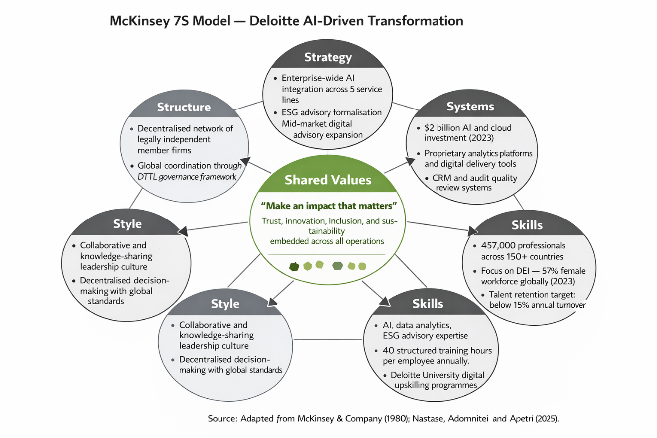
Figure: McKinsey 7S Model — Deloitte's AI-Driven Transformation
Source: (Durth, 2023)
The Deloitte has widely succeeded in its change management as revealed through its Deloitte University platform, a global cultural-building, leadership-building and alignment centre through its network of member firms (decentralised). However, as the rate of organisational change increases because of AI, internal forces are associated with the role redefinition, workforce reorganisation, and culture adjustment (Nastase, Adomnitei and Apetri, 2025). Historically analysis and documentation intense staff feel a significant degree of discomfort when it comes to dynamic value proposal of the professionals. Without effective communication, systematic reskilling investment and adequate career pathway planning, Deloitte can find itself easily having a major employee disengagement at the crucial stages of implementation when organisational alignment cannot be done more than in the course of the implementation (Nastase, Adomnitei and Apetri, 2025).

6. Strategic Evaluation and Recommendations

6.1 SWOT Analysis
Table 4: SWOT Analysis of Deloitte
Source: (marketing91, 2025)
Strengths | Weaknesses
Market-leading revenues of $64.9 billion in FY2023 | Audit reputational exposure from regulatory scrutiny
180-year global brand heritage and recognition | Decentralised governance creates service quality inconsistency
Five integrated service lines with cross-sell capability | Premium pricing limits SME and mid-market accessibility
$2 billion AI and technology investment in 2023 | High talent attrition in competitive professional labour markets
Opportunities | Threats
ESG advisory market projected at $16 billion by 2028 | Accenture ($64.1bn revenues) escalating as direct consulting rival
Emerging market professional services demand | Tightening audit regulation across UK, US, and European Union
EU CSRD creating urgent ESG disclosure advisory demand | Economic slowdown compressing client discretionary advisory budgets
AI-driven scalable and margin-accretive service delivery | Technology-native firms disrupting traditional professional advisory
The SWOT analysis of the prevailing strategic position of Deloitte has been given in Table 4. The strengths are far-rooted and supportive in structure. It is only possible owing to market-leading revenues to sustain the process of development on the levels that could only be afforded by mid-tier competitors to invest in developing technologies and talent and expanding Chicago market segments (Amer, 2026). The governance is decentralised to the member firms that in spite of giving the firms a chance to be highly responsive at local level to the market, raises apparent differences in service provision and the client experience across geographies that may jeopardise the promise of premium brand in specific market. The differentiated positioning that Deloitte has applied to the premium pricing formula limits its total market that can be addressed since a section of the small and medium enterprise customers would be priced out of the market (Amer, 2026).

6.2 Ansoff's Matrix
Table 5: Ansoff's Matrix for Deloitte
 | Existing Services | New Services
Existing Markets | Market Penetration: Deepen AI consulting within existing Fortune 500 client base | Product Development: Launch formalised ESG advisory as a dedicated global service line
New Markets | Market Development: Expand into Southeast Asian and African professional services markets | Diversification: Enter healthcare technology advisory as a standalone practice offering
Table 5 allocates the strategy of Deloitte growth options to the Matrix developed by Ansoff. The least risky, least risky growth path would be to build AI advice on the already existing Fortune 500 client base, riding on already-built network connections and trusts within the institution (Ferreira and Marques, 2024). Such formalization of special ESG advisorial service line would present a strong leverage on the marketing development prospect of an engine of market growth a project defined by EU regulatory demand of CSRD regulations adopted in 2024. Southeast Asian and African market expansion are directed at building up the markets with large growth opportunities within the context of the region in which the market early mover position will provide sustainable competitive advantages before the emergence of the large competitors, who might prove the strong presence in the local markets (Ferreira and Marques, 2024).

6.3 Strategic Recommendations
They provide three recommendations on a strategic basis. First of all, Deloitte must jump-start the enterprise-wide applicability of integrated AI on the basis of all five service lines, abandoning the selective pilot programme to the systematic one. The AI-powered service delivery constructs data of proprietary advantage, improved margins, and customer dependence - capability that fulfills the need of VRIO in terms of creating a competitive advantage founded on enduring effectiveness and strengthen market leadership on a structural degree. Second, simultaneously it is a commercial necessity to institutionalize ESG advisory into a distinct global service line that has its own leadership and bifurcated investment and formulated go-to-market strategy (Farida and Setiawan, 2022). The combination of the two forces of EU CSRD regulatory requirements and the current expansion of ESG markets at 24% per year is an opportunity in time to grab the opportunity before the rivals acquire dominant statuses. Third, a mid-market digitally-based then scaled advisory proposal would substantially expand the general range of clients that can be served by Deloitte, compared to the large-enterprise oriented client focus of its traditional approach and would result in revenue diversification and removal of risky client concentration (Farida and Setiawan, 2022).

Conclusion
The strategic management practices of Deloitte have been examined critically in this report using the six dimensions of analysis and it can be observed that the competitive advantages that have helped it to become the largest provider of professional services in the world originates at a mutually reinforcing cluster of competitive advantages in the form of brand heritage, investment in technology within the company, relationship with clients and multidisciplinary service competence. Based on the PESTEL analysis, regulatory pressure and disruptive competition are some of the primary threats that the macro-environmental forces are potentially having and the opportunities are enormous based on ESG advisory and AI driven service innovation. VRIO and SWOT analyses confirmed the level and sustainability of the strategic resources in Deloitte, the Balanced Scorecard, and the Matrix of Ansoff assessed the current priorities of the area of performance and development opportunities. Recommendations to optimize AI application, formalise ESG advice, and develop mid-market propositions provide Deloitte with a reasonable, theory-driven roadmap of further taking over the competitive arena in the ever-growing and competitive professional service landscape across the globe.

Section 2: Reflective Account Using Gibbs' Reflective Cycle (1988)
Stage 1: Description — What Happened?
I selected the Deloitte organisation as my organisation of choice in the context of the current strategic management report assignment because of its scale, global existence, and the availability of many publicly available facts about it. The 64.9 billion in revenues and the operations of Deloitte in 150 countries provided me with adequate evidence that I could work on each of the six sections in the FY2023 (Deloitte, 2024a). I have begun my research work with reference to the annual reports, disclosed revenue and global impact documents of Deloitte. I have then plied strategic frameworks of PESTEL, VRIO, the Balanced Scorecard, collectively, SWOT and the Matrix of Ansoff of organizing my assessment. During this process, I had to arrange a certain number of words in each of the sections in six interrelated components simultaneously to ensure that the tables had relevant analytical paragraphs that would render meaning to the framework (Buyec, 2026).
Stage 2: Feelings — What Was I Thinking and Feeling?
First, I felt confident and had some degree of real anxiety. I was already quite familiar with such frames as PESTEL and SWOT due to the completion of the modules, which gave some basic assurance. Still, I was also in high anxiety of coming up to analysis that would be theoretically acceptable, numerically substantiated, and constrained in terms of word limit. My decision of Deloitte was initially a strong decision and as I began to research I understood that it is not the issue of getting the information as there is plenty of information that can be determined just online but rather of sifting through the most strategically effective portion of it in a large pool of data (Bükecs, 2026). It baffled me a great deal explaining the capabilities as the source of temporary and sustainable competitive advantage when specifying to the onset of applying the VRIO framework, and my theoretical literature had to grind me down, before I could make sound judgments. The report was constructed logically across its sections and my confidence began growing progressively, and I began experiencing a sense of intellectual masculinity and no longer had feeling oriented to get work done (Deloitte, 2024a).
Stage 3: Evaluation — What Was Good and Bad?
Experience had an equality of successes. The choice to use Deloitte proved to be a good strategic choice based on some numerical figures, including the 2 billion commitment to AI, 14.9 percentage growth in revenues, and a decrease in carbon emissions by 29 percent, that allowed me to develop arguments based on credible numerical data at all times. The way I have organized and detailed each table was also competent because I ensured that structures were not individual images but analytical mechanisms. However, it was rather hard and definitely more rigorous to contain the word-counts when one was to deal with six sections simultaneously than one would have guessed. The PESTEL and VRIO analyses continued to grow beyond the allocated space and I had to struggle a lot in reducing some sections. In comparison, especially with the more framework-based sections of the analysis, I also experienced more issues in the overall evaluative critical tone that was necessary to maintain during both the CSR and change management sections, in its turn, theoretical scaffolding was able to assist me in orienting my thoughts and arguments (Deloitte, 2024a).
Stage 4: Analysis — Why Did Things Happen This Way?
When asked the reasons why these challenges have occurred, one may choose to answer them critically, which makes available to us all the useful information regarding my existing strengths in my academic practice, on the one hand, and regarding my areas of development, on the other one. These problems with the word count are justified by the fact that I was not being selective but comprehensive, which is a characteristic trait of a poor ability to concentrate on the most strategically significant facts of analysis but not on the intriguing bypass observations (DuCoin and Kuo, 2023). This relative weakness of adhering to critical language of evaluation in the descriptive sections of the paper implies that I feel more comfortable when I claim to invoke some form of framework rather than simply develop the evaluative judgements without theoretical underpinnings on which to base the analytical process. These sections of my report were more powerful and aligned directly with frameworks with which I was interacting the most during my module, thus successfully showing that theoretical fluency is converted to more confident and quality academic analysis (Buekecs, 2026).
Stage 5: Conclusion — What Else Could I Have Done?
This would have improved the manipulating of words to be used on different parts better before getting to write and I would have come up with a word outline that would expound the number of words that would be used in each part of analysis instead of having to do it afterwards. I might have also been more judgmental on the sections about CSR and change management at the very beginning and the evaluative questions should be answered in the sections before I completed them, which would have given me an analytical voice throughout the process (DuCoin and Kuo, 2023).
Stage 6: Action Plan — What Will I Do Differently?
The second time will be to make a rich structure plan whereby, each argument will have varying budgets of words, to be used before writing. Nurturing of an independent analysis independent of applying frameworks is also going to be part of nurturing my critical evaluative voice. Critical analysis of the scholarly specimens of the strategic management reports will aid me in internalising the patterns of high-order writing of an analytical writing. Such self-conscious improvements will go a long way in improving the quality of my future academic work and its precision (DuCoin and Kuo, 2023).

References
Ali, B. and Anwar, K. (2021). Porter’s Generic Competitive Strategies and its influence on the Competitive Advantage. [online] ResearchGate. doi: https://www.researchgate.net/publication/352181915_Porter.
Amaya, N., Bernal-Torres, C.A., Nicolás-Rojas, Y.W. and Pando-Ezcurra, T.T. (2022). Role of internal resources on the competitive advantage building in a knowledge-intensive organisation in an emerging market. VINE Journal of Information and Knowledge Management Systems, [online] 54(5), pp.1–17. doi: https://www.emerald.com/insight/content/doi/10.1108/VJIKMS-01-2022-0029/full/html.
Amer (2026). Deloitte SWOT Analysis. [online] Scribd. doi: https://www.scribd.com/document/618551952/Deloitte-SWOT-Analysis.
Bükeç, C.M. (2026). Competitive Advantage Through Strategic Market Analysis. Bridging Traditional Theory and Emerging Corporate Strategies, [online] pp.111–160. doi: https://doi.org/10.4018/979-8-3373-6466-7.ch004.
De Sousa, G.C. and Castañeda-Ayarza, J.A. (2022). PESTEL Analysis and the macro-environmental Factors That Influence the Development of the Electric and Hybrid Vehicles Industry in Brazil. Case Studies on Transport Policy, [online] 10(1), pp.686–699. doi: https://doi.org/10.1016/j.cstp.2022.01.030.
Deloitte (2024a). Annual Reports | Deloitte UK. [online] www.deloitte.com. doi: https://www.deloitte.com/uk/en/about/governance/annual-reports.html.
Deloitte (2024b). Focusing on the foundation: How digital transformation investments have changed in 2024. [online] Deloitte Insights. doi: https://www.deloitte.com/us/en/insights/topics/digital-transformation/where-are-organizations-getting-the-most-roi-from-tech-investments.html.
DuCoin, C. and Kuo, P.C. (2023). Creating an Integrated Strategic Plan. Surgery, [online] 175(4). doi: https://doi.org/10.1016/j.surg.2023.11.006.
Dutt, D., Beena Ammanath, Costi Perricos and Sniderman, B. (2024). State of Generative AI in the Enterprise 2024 | Deloitte Global. [online] Deloitte United Kingdom. doi: https://www.deloitte.com/ce/en/services/consulting/research/state-of-generative-ai-in-enterprise.html.
Farida, I. and Setiawan, D. (2022). Business Strategies and Competitive advantage: the Role of Performance and Innovation. Journal of Open Innovation: Technology, Market, and Complexity, 8(3), p.163. doi: https://doi.org/10.3390/joitmc8030163.
Ferreira, A. and Marques, M.B. (2024). The Importance of the Ansoff Matrix for the Study of the Information Services Market. [online] Canadian Journal of Information and Library Science. doi: https://www.researchgate.net/publication/382141729_The_Importance_of_the_Ansoff_Matrix_for_the_Study_of_the_Information_Services_Market.
Islami, X., Mustafa, N. and Latkovikj, M.T. (2020). Linking porter’s generic strategies to firm performance. Future Business Journal, [online] 6(1), pp.1–15. doi: https://doi.org/10.1186/s43093-020-0009-1.
Kansongue, N., Njuguna, J. and Vertigans, S. (2023). A PESTEL and SWOT impact analysis on renewable energy development in Togo. Frontiers in Sustainability, [online] 3(1). doi: https://doi.org/10.3389/frsus.2022.990173.
Kumar, J., Prince, N. and Baker, H.K. (2021). Balanced Scorecard: A Systematic Literature Review and Future Research Issues. FIIB Business Review, [online] 11(2), p.231971452110496. doi: https://doi.org/10.1177/23197145211049625.
Mailani, D., Hulu, M.Z.T., Simamora, M.R. and Kesuma, S.A. (2024). Resource-Based View Theory to Achieve a Sustainable Competitive Advantage of the Firm: Systematic Literature Review. International Journal of Entrepreneurship and Sustainability Studies, [online] 4(1), pp.1–15. doi: https://doi.org/10.31098/ijeass.v4i1.2002.
marketing91 (2025). SWOT Analysis of Deloitte | Marketing91. [online] Marketing91. doi: https://www.marketing91.com/swot-analysis-of-deloitte/.
Mohamed, R. and Basar, P. (2023). Impact of Strategic Management on Competitive Advantage. Trends in Business and Economics, [online] 37(1), pp.46–56. doi: https://doi.org/10.5152/tbe.2023.1000204.
Nastase, C., Adomnitei, A. and Apetri, A. (2025). Strategic Human Resource Management in the Digital Era: Technology, Transformation, and Sustainable Advantage. Merits, [online] 5(4), pp.23–23. doi: https://doi.org/10.3390/merits5040023.
Park, J.G., Park, K., Noh, H. and Kim, Y.G. (2023). Characterization of CSR, ESG, and Corporate Citizenship through a Text Mining-Based Review of Literature. Sustainability, [online] 15(5), p.3892. doi: https://doi.org/10.3390/su15053892.
Phiri, M., Nyatsambo, M. and Bomani, M. (2024). Porter’s Strategies and Firm Competitiveness: The Mediating Role of Market and Technological Innovation. African Journal of Hospitality, Tourism and Leisure, [online] 13(2), pp.401–409. doi: https://doi.org/10.46222/ajhtl.19770720.522.
Puyt, R.W., Antoniou, P.H. and Caputo, A. (2024). The Ansoff archive: Revisiting Ansoff’s legacy and the holistic approach to strategic management. Strategic Change, [online] 33(6), pp.513–518. doi: https://doi.org/10.1002/jsc.2600.
Yawson, R.M. and Paros, A. (2023). Systems Perspective of the Use of the Balanced Scorecard for Organization Development and Change. SAGE Open, 13(4), pp.1–15. doi: https://doi.org/10.1177/21582440231218064.
Zhu, J.J., Liu, Z., Shen, X., Shan, L. and Zhang, X. (2023). Corporate social responsibility (CSR) in the service industry: a systematic review. 11. doi: https://doi.org/10.3389/fenvs.2023.1150681.
Consultancy.eu (2023). Deloitte doubles global revenues to $65 billion in space of a decade. [online] www.consultancy.eu. Available at: https://www.consultancy.eu/news/9310/deloitte-doubles-global-revenues-to-65-billion-in-space-of-a-decade.
Durth, S. (2023). The organization of the future: Enabled by gen AI, driven by people | McKinsey. [online] www.mckinsey.com. Available at: https://www.mckinsey.com/capabilities/people-and-organizational-performance/our-insights/the-organization-of-the-future-enabled-by-gen-ai-driven-by-people.

Appendix

