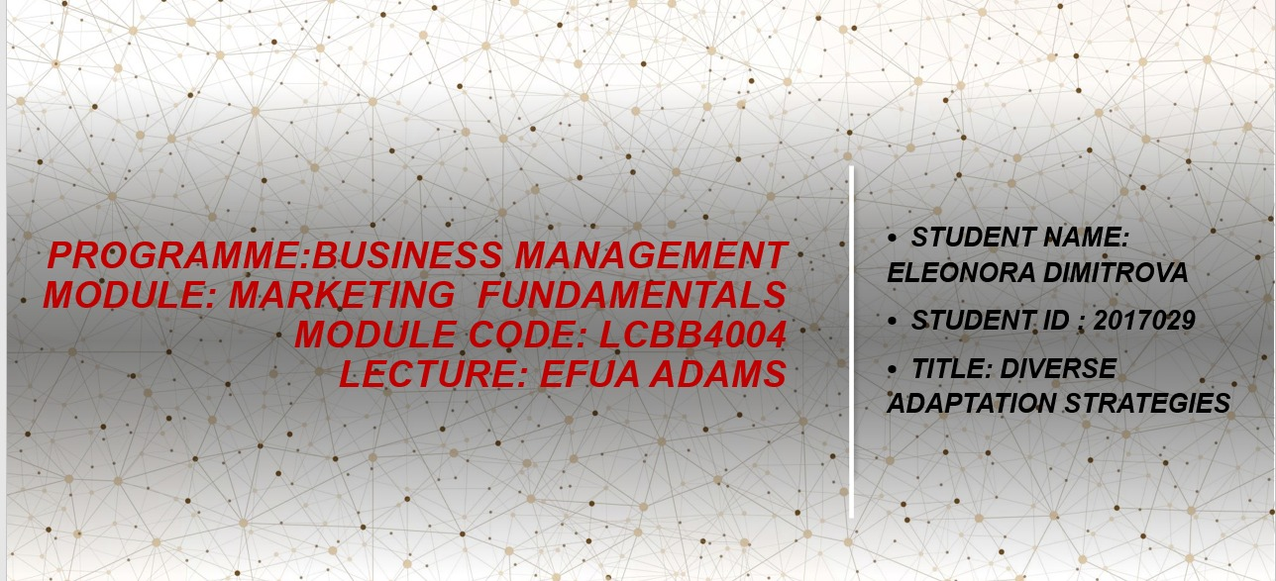

Diverse Adaptation Strategies
Contents
Introduction 3
1. Mission and Corporate Objective 4
2. Analysis of the Situation 4
2.1 Identifying opportunities 4
2.2 SWOT Analysis 4
Strengths 4
Weaknesses 4
Opportunities 5
Threats 5
PESTLE Analysis 5
Political 5
Economic 5
Social 5
Technological 5
Legal 5
Environmental 5
3. Development of a Marketing Strategy 6
3.1 Define the target audience 6
3.2 Measurable goals 6
Increase direct sales to local consumers 6
Expand customer base 6
Strengthen customer loyalty and retention 6
Increase online presence and sales 6
Diversify products 6
Implement effective communication strategies 6
4. Marketing Mix 7
5. Implementation and Control 7
Implementation 7
Control and Adjustement 7
References 8

Introduction

This report will present the marketing process that farmers in Quebec followed to market their products and deal with the issues brought by the covid pandemic.
‘Marketing refers to what an organization must do to create and exchange value with customers’ as said by Silk (2006). It is a set of steps that introduce a product to a community through planning of what are necessary goods or services, who wants to purchase them, and how to get it to them.
The marketing process’ objective is to help analyse the business environment, help comprehend it and help carry out strategies and ensure that they are being successful and monitored. The report will apply relevant marketing frameworks such as SWOT analysis and PESTLE analysis to help showcase the situation of the farmers in Quebec.

1. Mission and Corporate Objective

The first step should be to clearly understand the objectives of the business, ‘a mission statement should explain why your organization exists’ says O’Neill (2023), it is necessary to know what the business is and why it exists to form a marketing process, because it helps put in perspective the end goals of the business so they can be planned around.
The companies in the case study are food production businesses, their primary purpose is to produce food and sell it to local food vendors or consumers.
This case study seeks to gain insight into the challenges facing farmers in the local food supply chain in Quebec, Canada, especially in the wake of Covid-19. The goal of the case study is to gain a better understanding of how the pandemic has affected food production and marketing in the province, as well as the adaptation strategies that farmers are using.

2. Analysis of the Situation

The second step of the marketing process involves conducting an analysis of the situation, it is the part of the process where strengths and opportunities are investigated, to get a view of how the business is standing in the current environment, what problems it faces and what can be changed.

2.1 Identifying opportunities.
Looking at the data from the case study, it can be seen that farmers have the potential to benefit from many strategies, such as online markets and direct sales which have been the most beneficial tools to sustain local food sales, despite the supply chain issues brought by the pandemic. This gave farmers the opportunity to grow e-commerce platforms and reach consumers directly through CSA (Community Supported Agriculture), building direct connections with consumers which ensures a steady and reliable customer base and mitigates the impact of the pandemic. Another opportunity is to collaborate with local businesses and communities to find new distribution channels, or to donate food which can strengthen their public image.

2.2 SWOT Analysis
The marketing process requires a SWOT analysis to assess the strengths, weaknesses, opportunities, and threats faced by the food producers. They need to analyse their internal capabilities, as well as external factors like market trends, customer preferences, and the competitive environment.
SWOT is highly effective because according to Sarsby (2016) it is ‘easy to understand, applicable to many levels of an organisation, applied at different depths, and highly visual so it’s easy to communicate to stakeholders.

Strengths
Combining an online questionnaire with follow-up interviews gives an in-depth understanding of the challenges faced by local farmers and their adaptation strategies in this case study. A large sample size: 1,046 farmers were surveyed, and 133 complete questionnaire submissions were received.
Collaborating with key producer organizations to reach out to farmers and collect data for this study. A detailed questionnaire: The questionnaire was designed with a variety of questions, such as short open-ended ones, multiple choice ones, and likert-style ones.

Weaknesses
The low response rate of 12% may limit the ability to generalize the findings and introduce a potential bias in the responses. The questionnaire was only sent to French and English users, which may have restricted the participation of those who are more comfortable speaking other languages.

Opportunities
Community supported agriculture, direct interactions with customers, producing different types of food, marketing on other provinces, e-commerce, higher prices.
This study opens the door for more research into how local food systems can handle crises, like looking at the long-term effects and strategies for adapting after the pandemic. Plus, it can be compared to other studies in different regions or countries, so we can get a better idea of what's going on.

Threats
On the other hand, the pandemic was still going strong, so there was a lot of changes that could’ve come from government policies putting the sector at further risk. Market trends and consumer behaviour was also subject to change in the face of the pandemic, meaning new challenges could arise at any moment and farmers would have to be fast at adapting.

PESTLE Analysis
A PESTLE analysis looks at the political, economic, sociocultural, technological, legal and environmental factors surrounding the business. Understanding these external forces can help farmers anticipate market changes to adapt accordingly, as the model ‘appraises each of the key factors which are affecting the business performance so strategies can be developed’ as said by Perera (2017).

Political
Farmers should look at lockdowns and other government policy that interrupts the supply chain.

Economic
Inflation and lack of purchase power by the customers due to not being able to work is something to consider when pricing the product. Import and export restrictions.

Social
Social distancing and people’s fear of being infected should be taken into account, by providing delivery services and minimising face-to-face contact for example.

Technological
Using the internet to set an e-shop to reach a broader audience now that the normal customer base has been affected by other factors.

Legal
Making sure to comply with regulations when employing people to keep everyone safe and under government guidance.

Environmental
The weather, pollution, pests, labour shortages.

3. Development of a Marketing Strategy

Using the information from the previous steps, the farmers should proceed to decide what their target market is. The purpose of this stage is to specify the target customers and how to best gain their attention, this is done by looking at various criteria such as behavioural patterns or demographics. Each possible target customer is evaluated and the most convenient is chosen, allowing to keep fitting the marketing strategy to this type of customer to keep meeting their needs.
This step also includes expected results.

3.1 Define the target audience.
Looking at the case study most farmers only sold produce locally, to grocery stores, restaurants, public markets, and farm stores. This would still be the intended target audience, but the distribution method should change to comply with regulations.

3.2 Measurable goals
Measurable goals should be SMART, this is because ‘applying these criteria is a highly effective way of ensuring that the goals are good and likely to deliver results’ as said by Prather (2005), this means they should be specific, measurable, attainable, relevant, and time bound. Progress must be monitored regularly to adjust where necessary.
Increasing the percentage of sales made directly to local consumers. This can be measured by tracking the proportion of sales made through farmers' markets, restaurants, etc, compared to direct sales to customers.
The case study outlines a number of strategies that local farmers in Quebec and beyond can use to succeed in the current climate. These strategies include expanding their distribution channels and reaching out to a wider range of customers through online markets, direct sales, and CSA. Additionally, by diversifying their operations, engaging with local businesses, and donating surplus food, farmers can foster goodwill and strengthen their community engagement. Furthermore, by promoting the concept of "eating local", farmers can create a stronger connection with consumers and stabilise the food system in times of crisis. It is essential for policy makers to recognize the unique challenges local farmers face and to create tailored support programs to help them become more resilient and resilient.

Expand customer base.
Aiming to expand the customer base by reaching out to new local consumers who may have changed their purchasing habits during the pandemic.

Strengthen customer loyalty and retention.
Focus on building strong relationships with existing customers to enhance their loyalty and encourage repeat purchases. This can be measured by tracking customer retention rates or implementing a customer loyalty program and tracking how effective it is.

Increase online presence and sales.
As online shopping and e-commerce surged during the pandemic, having a strong online presence becomes essential. This can be measured by tracking website traffic or monitoring online sales volume.

Diversify products.
Introducing new products. This can be measured by tracking sales of new products, or the percentage of revenue generated from different items.

Implement effective communication strategies.
Clear and consistent communication is vital in the face of the pandemic, giving customers regular updates, sharing information online and engaging with consumers about any problems or requests they may have. This can be measured by tracking social media followers or tracking customer engagement on online platforms.

4. Marketing Mix

The marketing mix is also known as the 4 Ps of marketing, it’s used to develop a marketing strategy focused on 4 elements, product, price, place and promotion. ‘The main reasons the marketing mix is a powerful concept are it makes marketing seem easy to handle’ says Goi (2009).
Product determines the products that the business can offer to customers, the goal is to design a product that meets customer needs and is more desirable than the competitions.
Price is the price given to the product considering every cost to the business, while still being affordable for consumers and making a decent profit.
Promotion is the marketing used to communicate with possible consumers and show them what the business has to offer, it’s advertising to generate interest for the product.
Place is the ways and places where the product is being distributed to the consumers, it has to do with distribution channels, storage, and transport.

Based on the information provided, it seems that the Quebec farmers utilized a Dual distribution system to address the uncertainty surrounding the longevity of high demand for local food. This system involved a combination of conventional sales outlets, such as farmers' markets, and the introduction of alternative distribution channels, such as Community Supported Agriculture (CSA) and online stores.
Farmers had to adapt their distribution strategies to meet the changing demand. Some increased their production capacity to cater to high demands, while others changed their distribution and marketing channels. They redistributed food from closed outlets to remaining ones, streamlined operations by focusing on a single outlet, replaced closed outlets with new ones, collaborated with other producers, adjusted their food production, or adjusted sales procedures or outlet locations. Some farmers turned to online sales and delivery services, while others focused on existing customers. However, for farmers producing specialty products, moving sales online was often not a suitable alternative, as their products required in-person marketing and explanation.

5. Implementation and Control

Implementation
This is putting the plan into action, executing the planned steps such as advertising or building stronger bonds with customers. Resources have to be allocated properly in this step to make sure everything executes as intended.

Control and Adjustment
This is the process of assessing performance by comparing the initial goals to the actual results, helping identify which goals are being met and which areas need more action or a change in plans. Looking at things like revenue or customer engagement are good indicators.
The outcomes of the investigation reveal that the ability to be flexible and have backup options among local farmers in Quebec played a vital role in maintaining stability within the local food system during the initial phase of the global pandemic. The investigation utilized a mixed-method approach to examine how local farmers in Quebec handled the difficulties presented by safety protocols, travel restrictions, and other public health measures from March 2020 to March 2021. Although some farmers encountered obstacles due to the pandemic, it had a positive overall effect on sales and operations for others. Farmers implemented various adjustment mechanisms, like establishing online stores and setting up infrastructure to ensure safe working and sales environments for all stakeholders. The investigation illustrates that local farmers in Quebec were resilient and could endure most disruptions caused by the global pandemic by implementing adaptive strategies. In general, the observation results emphasize the significance of flexibility, backup options, and adaptability in navigating the challenges faced by local farmers during times of crisis.

References

Goi, C. L. (2009). A review of marketing mix: 4Ps or more. International journal of marketing studies, 1(1), 2-15. Available at: https://pdfs.semanticscholar.org/006a/f4780f1cff9f7075ab5b7073f4cebb32c3d5.pdf (Accessed: 20 June 2023).
O’Neill, M. (2023). How to create a Strategic Marketing Process, 23 May [blog]. Available at: https://www.brafton.com/blog/strategy/how-to-create-a-strategic-marketing-process-5-steps-for-success/ (Accessed: 20 June 2023).
Perera, R. (2017). The PESTLE analysis. Available at: https://books.google.co.uk/books?hl=en&lr=&id=ZWpLDwAAQBAJ&oi=fnd&pg=PA2&dq=pestle+analysis&ots=Duf3uO1BLE&sig=rvHVwV0XP2lF48Kl8mhRwMF6ZWw#v=onepage&q=pestle%20analysis&f=false (Accessed: 20 June 2023).
Prather, C. W. (2005). The dumb thing about SMART goals for innovation. Research Technology Management, 48(5), 14. Available at: https://www.proquest.com/openview/066bfc391063c0fb25d2ec04cdfaffc9/1?pq-origsite=gscholar&cbl=37905 (Accessed: 20 June 2023).
Sarsby, A. (2016). SWOT analysis. Available at: https://books.google.co.uk/books?hl=en&lr=&id=Yrp3DQAAQBAJ&oi=fnd&pg=PA1&dq=SWOT+analysis&ots=ODrh3xu10y&sig=2B2yuIfRam8CVNNKblpnqI1o3_g#v=onepage&q=SWOT%20analysis&f=false (Accessed: 20 June 2023).
Silk, A. J. (2006). What is marketing?. Harvard Business Press. Available at: https://books.google.co.uk/books?hl=en&lr=&id=Dj4aBQAAQBAJ&oi=fnd&pg=PR5&dq=what+is+marketing&ots=M4TCzd--MF&sig=sXy7VKcI63ZWIY8EU92eGvoyuEQ#v=onepage&q=what%20is%20marketing&f=false (Accessed: 20 June 2023).

