

Mental health crisis: are the police the correct service?

Name: Sadie France
Student ID: 1805131
School: UWTSD Swansea
Degree: Policing and Criminology
Due Date: 7th May 2021
Wordcount: 8961
Acknowledgements
I would like to thank my supervisor, Bronwen Williams for her continued support and guidance throughout the dissertation process.
I would also like to thank my husband for his ongoing support over the last three years of the degree. The support from both my husband and family has enabled me to focus on my degree and give it my best. I will forever be grateful to them.

Coronavirus (Covid-19)
In light of the continuing impact of the global pandemic, it is important to include a statement at the start of my dissertation which outlines the effects that COVID-19 has had on the research that I have undertaken towards your undergraduate degree.
The University of Wales Trinity Saint David recognises that the COVID-19 pandemic, and consequent closures of our campus (18th March 2020) and national and international lockdowns, has directly or indirectly impacted the work of many of our undergraduate researchers. Although the campus had periods of re-opening in 2020 and 2021, some research will have been disrupted and some personal circumstances difficult to manage. Teaching was arranged via suitable meeting software and documents shared electronically. All research data collection was designed to utilise digital data collection.
The inclusion of this statement is to facilitate the reader’s awareness, both now and in the future, that the pandemic may have had an effect on the scope, direction and presentation of the research.
The academic standards and quality threshold for the award remains unchanged. I wish to reassure readers that this statement is not evidencing a lack of original research or quality.

Declaration
This work has not previously been accepted in substance for any degree and is not being concurrently submitted in candidature for any degree.
Signed:  Date: 07/05/2021
STATEMENT 1
This dissertation is being submitted in partial fulfilment of the requirements for the degree of BA.
Signed: Date: 07/05/2021
STATEMENT 2
This dissertation is the result of my own independent work/investigation, except where otherwise stated.
Other sources are acknowledged in the Reference Section.
Signed: Date: 07/05/2021
STATEMENT 3
I hereby give consent for my dissertation, if accepted, to be available for photocopying and for interlibrary loan, and for the title and summary to be made available to outside organisations.
Signed: Date: 07/05/2021
STATEMENT 4
I hereby give consent for my dissertation, if accepted, to be available on the university’s IT system to those who have consent to use the system.
Signed: Date: 07/05/202
Contents
1- Chapter 1-Introduction 5
1.1 Introduction 5
1.2 Background and rationale 5
1.3 Objectives 6
1.4 Conclusion 7
2. Chapter 2- Literature Review 8
2.1 Introduction 8
2.2 Mental health 8
2.3 Perceptions of mental health 10
2.4 Police approach and procedures for dealing with a person in crisis 12
2.5 Place of safety 14
2.6 Police training to manage a person in crisis 16
2.7 Conclusion 16
3. Chapter 3- Research Method 18
3.1 Introduction 18
3.2 Research Onion 18
3.2.1 Philosophy 20
3.2.2 Approach 21
3.2.3 Strategy 22
3.2.4 Choice 22
3.2.5 Time horizon 23
3.2.6 Techniques for data collection, process and analysis 23
3.2.6.1 Data collection 23
3.2.6.2 Interview design including Literature review matrix 24
3.2.6.3 Pilot study 33
3.2.6.4 Analysis 34
3.3 Sample 34
3.4 Reliability and Validity 35
3.5 Limitations 35
3.6 Ethical considerations 35
3.7 Conclusion 36
4.Chapter 4- Findings 37
4.1 Introduction 37
4.2 Data analysis 38
4.3 Methods 38
4.4 Descriptive statistics 39
4.5 Analysis 40
4.6 Length of service in relation to training 40
4.7 Police perspective of what constitutes a mental health crisis. 40
4.8 Knowledge of mental health prior to joining the police. 41
4.9 Police involvement 42
4.10 Delivery of mental health training 43
4.11 Training to manage mental health crisis situations 44
4.12 Partnerships between the police and mental health services 46
4.13 Support for the police to deal with mental health crisis 47
4.14 Experience of police intervention during a mental health crisis 47
4.15 Conclusion 53
5. Chapter 5- Conclusion and recommendations 54
5.1 Introduction 54
5.2 Main findings 54
5.3 Implications 55
5.4 Recommendations 56
5.5 Limitations 56
5.6 Future research 57
5.7 Self reflection 58
5.8 conclusion 58
Bibliography 60
Appendices 73

1- Chapter 1- Introduction

1.1 Introduction
This chapter will explain the structure to this research project, clearly outlining the aims and objectives, alongside a background and rationale to the study.
Mental health within the UK is on the increase with one in eight people aged under 19 in England having a mental disorder (Siddique, 2018). According to Mental Health First Aider England (MHFAE, 2020), over one third of the public think they have a mental health disorder with one in four experiencing mental health issues each year was it has become the second biggest burden to the NHS. NHS (2019) reported an estimate of a 2% increase in detentions under the Mental Health act, also known as “Sectioning”. In the UK, a police officer is called to respond to a mental health matter every 12 minutes with the police receiving calls relating to mental health once every 4 minutes (HMICFRS, 2018).

1.2 Background and rationale
Research evidences that police custody could have been avoided for a number of vulnerable adults had other services been available. Vulnerable people have been in custody purely to stop them harming themselves or others, not because they have committed a crime (HMIC,2015). According to Leese and Russel (2020), despite there being procedures in place to support vulnerable people whilst in custody, it is still evident that problems exist surrounding safeguarding, correct training of police staff and the uses of an appropriate adult.

Due to a lack of academia surrounding police training, this research aims to analyse if the current training in place is adequate and effective in providing police officers with the correct knowledge and tools to manage a situation where a person is in mental health crisis. The study will also explore perceptions of people who have received police intervention during a mental health crisis in order to compare findings from both perspectives thus to provide a robust conclusion to the study. It is with positive regard that this research contributes to a better understanding of the correct training needed to better aid a person during a mental health crisis.

1.3 Objectives
- To critically analyse police procedures of mental health persons
- To critically evaluate what constitutes a “safe place”.
- To critically analyse current academic literature in relation to procedures in place by the police to respond to a person during a mental health crisis.
- To employ an appropriate primary research approach to explore points of view from police officers regarding training in relation to mental health.
- To employ an appropriate primary research approach to explore points of view from people who have received police intervention during a mental health crisis.
- To critically analyse the data collected from the primary research to gain a greater understanding of the police knowledge surrounding mental health and if the police receive the correct level of training to manage a mental health crisis.
- To acknowledge the findings from the study, including practical implications to the research.
- To offer recommendations on current practice with a view to provide future avenues of investigation into the topic taking into account limitations.
It is with regard that this research study will bring value to the current training in place, putting recommendations forward and will provide a foundation for future research within the topic area.

1.4 Conclusion
This chapter has explained the aim of the study, including the reasoning and background of the topic. It has also clearly identified aims of objectives that will be achieved. The next chapter will provide a literature review to add more substance to which the study will be based on.

2. Chapter 2- Literature Review

2.1 Introduction
The purpose of this chapter is to review academic literature regarding the processes involved with helping a person in mental health crisis, paying particular attention to the current procedures in place. This part of the dissertation will answer objectives 1- 3 of this study:
1. To critically analyse police procedures of mental health persons.
2. To critically evaluate what constitutes a “safe place”.
3. To critically analyse current academic literature in relation to procedures in place by the police to respond to a person during a mental health crisis.

The literature review includes academic journals, publications and primary research available surrounding the topic which have been accessed via Google scholar and University of Wales Trinity St David’s (UWTSD) online library. Search terms include: - Mental health, police, services, mental health act, health.

2.2 Mental health
It is important to distinguish the difference between “mental health” and “mental wellbeing” as they are often misunderstood and confused with one another. Mental wellbeing refers to the desire to want to live our lives as close as to what we want, with an awareness of “self”. Mental health in contrast, is the signs of persistent symptoms that contribute towards emotional distress which festers into a mental illness (Mind, 2020). According to the World Health Organisation (WHO, 2018), mental health is an essential component of our health and is more than the absence of disability or mental disorders. Wellbeing is a state of mental health that allows us to function, be aware of our own abilities and contribute towards society.
The number of people who will be affected by mental health during their lifetime is one in 4 with mental health being the second largest burden on public services in the UK. Excluding Dementia, 75% of mental health illnesses start before a person reaches the age of 18, costing the country around £99 billion each year (MHFA, 2020).
In order to appreciate poor mental health, it is necessary to acknowledge what attributes are conducive to good mental health. Core elements that define good mental health include self-perception and values, mental health literacy, cognitive skills, academic and occupational achievements, emotions, behaviours and good relations with family and others (Fusar- Poli et al. 2020).
People with mental health illness are more likely to be victims than perpetrators (MHFAE, 2020). According to Mind (2013), mental health charity, people with severe mental health problems are three times more likely to be victims of crime, five times more likely to be victims of assault with women who suffer with a severe mental health problem being ten times more likely to be victims of assault. According to Dyfed Powys Police (2019), mental health calls have increased by 30-40% in the UK over the last three to four years. Although officers are trained to deal with a crisis it is felt that at present, they are leading the response. Chief constable, Mark Collins of Dyfed Powys Police has called on the government for more funding to tackle the issue as he feels that valuable police time and resources are taken up by transporting people with mental health to “places of safety”. He also stresses that the police service is not always the correct approach to dealing with someone in a crisis.
According to HMICFRS, 2018, it is felt that the lack of early intervention for people who suffer with mental health problems has led to the increased demand on the police service with growing concern that the needs are beyond that of a police officer. In recognition of the need to provide greater partnerships to build robust access to services for mental health, the Crisis Care Concordat was established in 2014. This is a national agreement amongst 27 services to provide support to a person in crisis. The aim of the partnership is to give people in crisis 24 hours support should they need it, to ensure emergency care is delivered with the same importance as what a physical emergency would be, ensuring people are treated with the correct level of respect and dignity and to put steps in place to prevent a future crisis occurring (Crisis Care Concordant, 2014).

2.3 Perceptions of mental health
According to the charity, Time to change (2017), The national attitudes towards mental health survey, published in 2017 highlighted an 11% increase (since 2009) in a positive attitude towards mental health. The survey also indicated that more people know someone who suffers with mental health and this insight has played a vital role in a societal change.
An example of this can be seen in the change of legislation relating to stress in the workplace that now forms part of the Health and Safety Executives (HSE) Management Standards for employers in the UK to ensure they are protecting their workers welfare (HSE, 2020). In 1991, the HSE undertook a research study to analyse the impact work related stress had on employees. The study showed that stress at work is linked to a change in behaviour and mood and psychological function which proved damaging to the employee’s health. From this study the Management of Standards was initiated to ensure employers use risk assessment tools to identify the hazards posed by work related stress on the employee’s health and to employ reasonable measures to reduce negative effects on the employee’s health. Stress is now to be measured like any other hazard in the workplace (Cousins et al. 2004).
Although attitudes in society have experienced a positive shift, there still lies a stigma and discrimination. According to Mental Health First Aider (2020), one third of the public believe that a person with mental health issues is more likely to become violent. Globally over 70% of people who suffer with mental health receive no treatment from mental health services. Henderson et al. (2013) highlights the presence of stigma being a major contributor towards people being denied help.
It has been established that stereotypical views of mental health can lead to discrimination. The police serve as the intermediary to the criminal justice system and mental health services making their discretionary decisions key to a person accessing the correct services. Research suggests that police officers perceive a person with mental illness in a stigmatised and discriminatory light which could negatively impact on the way in which they are treated (Watson et al. 2004).

Mental health accounts for 10%-15% of all emergency department admissions. Of these admissions people will either be admitted on a voluntary basis, experiencing a crisis or psychotic episode, be in police custody or be involuntary detained through a court order. It has been identified that mental health assessments are a long and slow process and although emergency department staff are trained in this field it is often viewed as a challenging process as they are used to working in a fast-paced environment. It is also acknowledged that staff within the emergency department worry about the unusual behaviours exerted by mental health patience which has created a stigma (Clarke et al. 2007).

Maxwell et al. (2015) argues that health services are hindered due to a lack of an agreed clear definition of what is mental health. There are several definitions amongst the health services which causes vast confusion and conflict in which service is responsible to provide care to a person who is suffering from poor mental health.

2.4 Police approach and procedures for dealing with a person in crisis.
Under the Mental Health Act 1983, a person who is deemed a danger to themselves or others can be detained otherwise known as sectioned, against their will (MHA,1983). In an emergency the police have the powers to evoke a Section 135 warrant to enter a property to detain a person who is at danger of causing harm to themselves or others. The police also have the powers to enforce a Section 136 which is the detention of a person who is in a public place. This person will then be transported to a “place of safety” which could either be a hospital or a police station (NHS, 2019).
According to College of Policing (2016), the police have a duty to act in the least restrictive manner when assisting a person who has mental illness. They are expected to listen to the person and use any information available to best assist, refraining from using force unless absolutely necessary. Where police officers provide an initial response to a mental health crisis incident, they should seek to act in the least restrictive way and take advantage as far as they can, of any information which may be available from healthcare sources to improve the nature and quality of their response. They should listen to the person and act in accordance with what they say will help, as far as they can do so, consistent with advice from mental health professionals, context and safety.
The police service has also put in good practice measures such as ensuring response vehicles attend without flashing lights and a siren, officers limit the use of radios and ensure they communicate clearly ensuring they refrain from any whispering (Bryant and Bryant, 2018).
In recent years we have seen the introduction of various partnership initiatives under the banner of ‘street triage’ and whilst operating models and hours vary, they are consistently flagged as providing fast access to background information that may not be available via police information systems, allowing improved and collaborative decision-making (Horspool et al. 2016).
Each force area takes a different approach to the street triage service. Some involve an on the scene mental health expert to assist the police during a crisis in order to reduce the chances of the person being detained in police custody. Other force areas approach is the intervention of a mental health expert from the control room who assist an incident via radio and others include telephone triage (Horspool et al. 2016).
Alongside the street triage, there are specially mental health trained police officers, often referred to as Crisis Intervention Teams (CIT’s) who will assist a person in crisis. Although both street triage and CIT’s have proved popular, it has been acknowledged that the schemes have been set up based on limited investigation but instead on experimental studies. According to Lindon and Roe (2017), a review of the CTI’s found no overall effect on arrests of mental ill persons. Unfortunately, there is still little evidence to evaluate the effectiveness of these schemes (Puntis et al. 2018).
A comparison can be seen within the London Ambulance Service (LAS). Due to the lack of out-of-hour service by the Crisis Team, the London Ambulance Service experienced high volumes of ambulances being dispatched to mental health related calls. In 2015 the NHS piloted a solution by incorporating mental health staff into the control room to assist call handlers before the ambulance was dispatched. Through the “hear and treat” intervention and other solutions such as screening mental health calls using a risk assessment tool, they were able to reduce ambulance dispatches by 15.9% within a 12-month period. Staff feedback was also captured with 80.87% of control room staff expressing they found having a mental health nurse at hand to help, beneficial (NHS, 2016).

2.5 Place of safety
Under the Mental Health act 1983 a place of safety includes the following: -
- residential accommodation provided by a local social services authority under Part I of the Care Act 2014 or Part IV of the Social Services and Well-being (Wales) Act 2014
- a hospital (as defined by this act)
- a police station
- an independent hospital or care home for people who are mentally disordered
- any other suitable place (College of policing, 2020).
Although police cells have been recognised as not being an appropriate environment for a person who suffers mental health, there are some exceptions which will allow police officers to detain a person in a cell. An example of this is if the person displays behaviours that pose imminent risk of serious injury or death to another person or themselves (College of policing, 2020).
The Police and Criminal Evidence act 1984 (PACE) Code C, states that anyone who is detained under the Mental Health act, must be assessed by a medical practitioner as soon as possible once brought back to the police station. The code also stipulates that such persons should be checked “at least every hour” if detained in a cell (Home Office p.36, 2018). Alongside these measures, the custody officer should ensure that a health practitioner is available during the entire time the person is detained, and the medical practitioner should also check on the detainee but at intervals of every half an hour (Home Office, 2018).
Such measures set out in PACE Code C, have been initiated to protect vulnerable people, in particularly to avoid suicide in police custody. During 2019/20 there were 18 deaths in or following police custody in England and Wales. 11 out of the 18 people who died were identified as having mental health concerns with two of them being detained under the Mental Health act (IOPC, 2020).

2.6 Police training to manage a person in crisis.
According to the College of Policing (2018), Authorised Professional Practice (APP) is the official source of professional practice on policing which has been scrutinised by the colleges legal services unit to ensure it is legally accurate and complies with good diversity practice. Within this source of training sits mental health training which was updated and released to officers in 2020. The new training replaces existing training in situ and is tasked at providing officers with the correct tools to ensure people with mental health are not criminalised but instead give them access to the crisis care they need (College of policing, 2020). Although this training is in place, it remains vague as to its implementation amongst officers, alongside its effectiveness.
The leading mental health charity, Mind (2013), interviewed participants who have serious mental health illness to gain greater knowledge into their experience with the police. Participants described their experience as both positive and negative. The negative experience was said to cause more distress and may have hindered them in getting the help they needed.

2.7 Conclusion
The literature review has answered the following objectives: -
1. To critically analyse police procedures of mental health persons
2. To critically evaluate what constitutes a “safe place”.
3. To critically analyse current academic literature in relation to procedures in place by the police to respond to a person during a mental health crisis.

The literature review has exposed that although the police have taken extra measures to provide police officers with training to deal with a mental health crisis, it still remains unclear due to lack of academia as to the validity of the training in place and its effectiveness. It is also clear that there is very little research into the perceptions of the police from the perspective of people who have mental health and experienced police intervention during a crisis. This study therefore aims to explore the opinions of police officers in relation to training. In comparison, the ambulance service has produced a more robust research model into exploring new avenues to best support a person during mental health crisis as well as providing more efficiency for the service.
The next chapter will identify the correct research approach and methodology to satisfy a legitimate insight into the title of this study. The research undertaken aims to provide greater knowledge of the relationship between people who suffer a mental health crisis and the police service.

3. Chapter 3- Research Method

3.1 Introduction
Chapter 2 achieved to provide the existing academia surrounding the topic, providing an understanding of mental health and procedures taken by the police service to assist someone in mental health crisis. Although some information is available surrounding police training to deal with mental health, it still remains vague as to the exact training employed, the extent to which officers are subjected to training, its frequency and more importantly its effectiveness when managing a mental health crisis.
This chapter aims to complete the following objectives as set out in chapter 1: -
- To employ an appropriate primary research approach to explore points of view from police officers regarding training in relation to mental health.
- To employ an appropriate primary research approach to explore points of view from people who have received police intervention during a mental health crisis.

Research methodology is the procedure in which data will be captured. Saunders et al (2012) describe research as a process by which researchers attempt to learn new things in a systematic way to increase their knowledge (Bakhit Al Zefeiti & Mohammad, 2015).
When undertaking the research, the onion model initiated by Saunders et al. (2016) will be entrusted within the study to provide validity, limitations, reliability and transparency.

3.2 Research Onion
Research is the systematic process of inquiry that evaluates the collection of data in order to provide a substantial body of knowledge on a topic in order to share them and generate questions surrounding the topic (Saunders et al, 2007). The research onion provides a clear discipline to which research should be carried out and for that reason, it will be used throughout the study.
Figure 3.1, Saunders et al. 2016, Research Onion
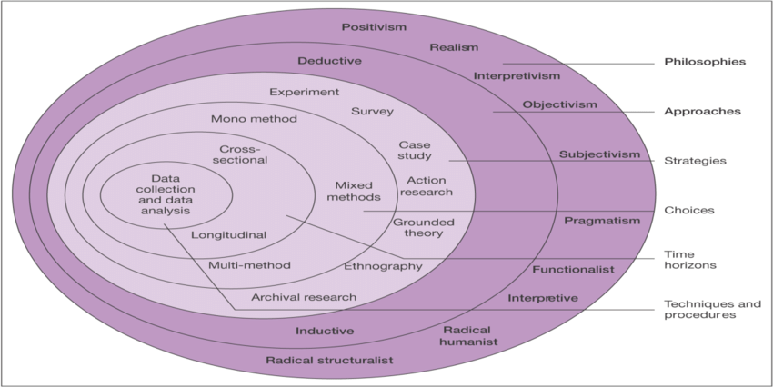
An exploratory approach will aid the study as it merely explores the question in order to gather more insight and information as a pose to finding answers to the problem. This approach will provide the initial research which can form the basis of more conclusive research should that be desired for future purpose (Saunders et al. 2012).

3.2.1 Philosophy
Figure 3.2 Bristow and Saunders 2018
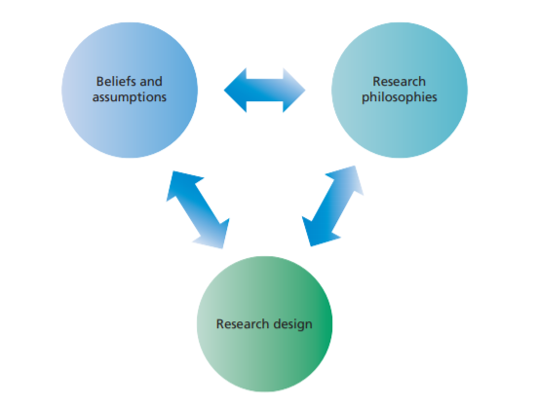
Research philosophy refers to assumptions and beliefs regarding the knowledge that is gained for the study. Subconsciously and consciously the researcher will make a number of assumptions along the journey of the study. A structured set of assumptions will help to underpin and form a coherent research project (Saunders et al. 2019).
A research philosophy is the first and most important layer of the research onion. The philosophy of ontology refers to assumptions, is a belief about the collection, analysis and interpretation of the data collected for the study. This layer will be used throughout the study to interpret the information captured from the research carried out to provide an opinion surrounding the topic (Bakhit Al Zefeiti & Mohammad, 2015).
Epistemology is the study of knowledge and encompasses aspects of validity, reality, facts and methods of capturing knowledge (Mood and Blackman, 2017). Both philosophies of ontology and epistemology will be used throughout the study.
This study uses interpretivism as the participants points of views will be considered to form part of the research. The study also takes a positivism approach which allows quantifiable data and observations performed by the researcher to provide statistical data (Saunders et al. 2012).

3.2.2 Approach
In order to observe the data and understand the patterns that arise, an inductive (empirical) approach will be used. The inductive approach can be described as a systematic procedure to analyse qualitative data which is set by specific objectives. As the opinion of police officers regarding training for dealing with mental health crisis is unknown, an inductive approach will be beneficial as it allows the study to capture more data. The use of interviews allows the participant to freely talk about experiences without restraints imposed by structured methodologies (Thomas, 2003).
It is important to acknowledge that human expressions and intentions are deeply personal to each individual and are not always immediately obvious which can pose a risk with using an interpretive approach to collecting data (Chia, 2002).

3.2.3 Strategy
The method of collecting the data will be in the format of an interview. This qualitative method directs the participant to answer questions in a free manner which will encourage the participant to contribute accordingly. There are three types of interview styles, structured, semi structured and narrative. For the purpose of this study, a semi structure interview will be employed as it serves to guide the participant to answer the desired questions but also allows the participant to add additional data which may be of importance to the study. A narrative structure would also serve as a good method to gather in depth experiences from police officers as it allows participants to tell their story, but this would be more beneficial when little academic background to the topic is available. As stated in chapter 2, this study has adequate academic background which enforces the decision to use a semi structured style (Stuckey, 2018).
Invitations were sent via email and social media to a group of police officers who were known to the researcher. Within the invitation were clear key points explaining the rationale behind the questions and the purpose of the study. Participant’s information such as name, were to remain anonymous and confidential. The researchers contact details were given at the end of the interview should the participant want any further information regarding the study.
Invitations were also made via social media platforms to recruit participants who have suffered with a mental health crisis and required police intervention during this time. The evolution of virtual communities makes online surveys an advantageous way of collecting data as it is fast and easy to do (Wright, 2017).

3.2.4 Choice
While some study’s use a multiple and mixed strategy approach it was acknowledged that a mono-method in the form of qualitative data would be most beneficial to the nature of this study (Vizcarguenaga-Aguirre and López-Robles, 2020). As face-to-face interviews were not an option in light of Covid-19, initially either telephone or virtual teams were used to conduct the interviews. The advantage to virtual interviews included the ability to read facial expressions, body language and social cues. The disadvantage to this form of collecting data include the participant taking the topic off course which can be time consuming. In light of the pandemic, virtual interviews became increasingly challenging, and so a blended method of both qualitative (interviews) and quantitative (questionnaires) were used to continue the study.
Telephone interviews were advantageous as it allowed more access to participants, but one challenge encountered was the restriction in social cues and accessing body language (Opdenakker, 2006).

3.2.5 Time horizon
Cross sectional research takes place over a relatively short time frame and collected from an individual at one point. It is also a less expensive method of research compared to a longitude method (Lavrakas, 2008).

3.2.6 Techniques for data collection, process and analysis

3.2.6.1 Data collection
Primary research is a scientific approach to research based on investigating the world and observing phenomena. The data is collected around the questions put forward at the beginning of the study (Driscoll, 2011). This primary research will be divided into two elements, “research A” which will target police officers and “research B” which will target people who have experienced police intervention to collect perceptions of police treatment during a mental health crisis. Employing a multiple perspective approach will provide an in-depth understanding (Vogl et al, 2018).

3.2.6.2 Interview design including Literature review matrix.
The quality of the data collected highly depends on the design of the interview and questionnaire. It is important that the interviewer does not consciously or unconsciously influence the participants answer and that questions are not misleading, and the participant can clearly understand the question (Fox, 2009).
This interview and questionnaire for research A, has 21 questions, 17 closed and 5 open questions to encourage the feed of data. The Likert scale is one of the most popular scales used in survey design as it allows the data to be analysed and coded accurately and so has been used for the study (Chyung et al. 2017).

Table 1.1 Research A

Questions | References pertaining from questions drawn from previous chapters
Q1. The information collected from this interview will remain confidential and used for the sole purpose of a research dissertation. Do you consent to use this data for this sole purpose?  Q2. What do you identify as?  Q3. How old are you?  Q4. How long have you worked in the police service?  Q5. What is your current role/ latest role?  Q6. Any other roles within the police? | These are demographic questions to obtain some background on the participant.
Q7- Roughly what percentage of call outs are related to mental health?  0-10%  11-20%  21-30%  31-40%  41-50%  51-60%  61-70%  71-80%  81-90%  91-100% | Previous research: - e.g., HMICFRS, 2018, Dyfed Powys Police, 2018.
Q8. Describe what you feel is a mental health crisis situation. | This question was included to gather a perspective on an individual basis.  Previous research: - e.g., Mind,2020, WHO, 2018
Q9. What training have you had during your role within the police to deal with mental health crisis?  Q10.What format of training is used regarding mental health training?  Workbooks  Classroom based.  E- learning  Scenario based role play.  On the job  Q11.Was mental health training delivered as part of your induction training?  Yes  No  Maybe  Q12.How often is training undertaken surrounding mental health?  Once a month  Once a quarter  Once every 6 months  Once a year  Unsure  Q13. Do you know if this is a core element of training?  Yes  No  Unsure  Q14. Prior to joining the police, what was your knowledge of mental health?  Very little  Some  Vast  Q15.Do you feel the training in mental health has been a benefit to your role?  Yes  No  Maybe  Haven’t had training  Q16.Do you feel that the training you’ve received regarding mental health is adequate?  Yes  No  Unsure  Haven’t had training  Q17.Are there any other elements of training that you feel would benefit your role regarding mental health?  Q18. In your opinion, which service do you think should be responsible for attending mental health crisis situations?  Police  Mental health services  Both  Other  Q19. Does your force have any partnerships with mental health services to aid response officers?  Yes  No  Maybe  Q20. How would you rate the training you’ve received surrounding mental health?  Likert scale (1-10)  Q21. Do you feel that response officers have the correct level of support to manage a mental health crisis?  Yes  No  Maybe | These questions were to gather insight regarding the nature of call outs and training that’s in place.  These questions are to gather insight into the training programs in place and to analyse its effectiveness.  Previous research e.g., Bryant and Bryant, 2018, Horspool et al. 2016, Lindon and Roe, 2017.

This interview for research B has 21 questions, 17 closed and 5 open questions to collect perceptions of police approach during a mental health crisis.

Table 1.2 Research B
Questions | References pertaining from questions drawn from previous chapters
Q1- The information collected from this questionnaire will remain confidential and used for the sole purpose of a research dissertation. Do you consent to use this data for this sole purpose?  Q2- What do you identify as?  Q3- How old are you?  Q4- What was your current situation when you received police involvement?  Q5- How long ago was your experience with police intervention?  Less than one year ago  Less than two years ago  Less than 5 years ago  Less than 7 years ago  Less than 10 years ago  More than 10 years ago  More than 20 years go  Q6- Did the police officers involved help you?  Yes  No  Maybe  Q7- Did the police officers involved communicate effectively with you?  Yes  No  Maybe  Q8- Did the police officers act in a positive manner?  Yes  No  Maybe  Q9- Did you experience any discrimination from the police officers?  Yes  No  Maybe  Q10- Did you feel confident in the police officers?  Yes  No  Maybe  Q11- What approach would best describe the officers when they first attended to you?  Friendly  Engaging  Empathetic  Warm  Calm  Abrupt  Cold  Aggressive  Argumentative  Non engaging  Q12- How many police officers attended to you?  Q13- Were you arrested?  Yes  No  Q14- Were you removed from your premises?  Yes  No  Q15- Were you taken to a "place of safety"?  Yes  No  Q16- Were you taken to any of the following?  Hospital  A&E  Psychiatric Ward  Police cell  A friend or families’ home  Other (please describe)  Q17- If taken to a "place of safety", did you feel safe here?  Yes  No  Maybe  Q18- Have you had more than one experience with police intervention during a crisis?  Q19- On a scale of 1-10, how would you rate your experience of the police during this situation?  Likert scale (1-10)  Q20- Would you call the police if you needed help in the future?  Yes  No  Maybe  Q21- Do you feel that mental health services are accessible if needed in an emergency?  Yes  No  Maybe  Q22- What did the police do particularly well during this experience?  Q23- What could the police do better next time? | This question was asked in order to capture a timescale which can reflect data captured in research A.  Previous research e.g., Watson et al, 2004.  Previous research eg- HMIC, 2015, Leese and Russel, 2020.

3.2.6.3 Pilot study
In order to test the feasibility of the interview questions and structure, a pilot study took place using a small audience. A pilot study can help to identify any weaknesses in the study so they can be addressed prior to the research taking place. This “dummy” run also gives the researcher more confidence with their tools (Malmqvist, 2019). The pilot study highlighted a few changes to include the sequence of questions which provided a more streamline interview.

3.2.6.4 Analysis
When using interviews as a technique to collect data it is often easy to use assumptions from the researcher that carries out the interviews. It is crucial that preconceived assumptions are avoided, and an adequate thematic analysis is used to review the data. The thematic analysis includes the use of codes and themes (Mortensen, 2020).

3.3 Sample
It is important to select an audience which represent the wider popularity of police officers to encourage validity and reliability (Hales, 2019). Due to the study’s parameters of audience, a small number of police officers/ staff took place, as with participants for research B.

3.4 Reliability and Validity
Both reliability and validity are important to any research study. Reliability is the extent to which data is consistent and accurate and validity is the measure of how truthful the results are (Golafshani, 2003).
The use of interviews and questionnaires have proven both a reliable and valid source of capturing data. Semi- structured interviews are particularly beneficial to collecting attitudinal data which has proven valuable to the study (Fox, 2009).

3.5 Limitations
Limitations included participants being weary of organisational confidentiality, irrelevant of the participant remaining anonymous. This doubt could influence the honesty in the answers given.
Participant bias was also acknowledged as a limitation due to the nature of the study. Participants took part in the knowledge that the study is to assist an undergraduate student, and this may have played a part in the answers given, to provide more data to the researcher rather than to answer the question in its full integrity (McCambridge, 2014).

3.6 Ethical considerations
The consideration of ethics in a research project is important as it ensures participants are not brought to any harm be it psychological, financial or social (Resnik, 2020). During this study participants remained anonymous, and all information collected, remained strictly confidential.
The research carried out for this study has been done in line with UWTSD guidelines as set out in the completed ethics approval from (please see appendix). Authorisation from the research supervisor has also been obtained.

3.7 Conclusion
This chapter has successfully met the following objective: -
- To employ an appropriate primary research approach to explore points of view from police officers regarding training in relation to mental health.

It is evident from this chapter that the researcher’s choice of a mixed method of both qualitative and quantitative, interpretivist approach was the correct method in which to gather the relevant data.
The following chapter will look into the data collected, to analyse and scrutinise the information in order to form a discussion surrounding the topic.

4.Chapter 4- Findings

4.1 Introduction
The previous chapter identified the method of research employed to gather the information needed for the study. This chapter aims to achieve the following objective: -
To critically analyse the data collected from the primary research to gain a greater understanding of the police knowledge surrounding mental health and if the police receive the correct level of training to manage a mental health crisis.

This chapter will present the data and analyse the findings. The study recruited 26 police staff which investigated the training provided to officers to respond to a mental health crisis as well as gaining greater insight into the police officers knowledge of mental health illness. For the purpose of this study this research is referred to as “research A”.
To form a fair analysis, it was crucial to gain knowledge from people who have experienced police intervention during a mental health crisis. Due to the sensitivity of the topic, more closed questions were asked to focus mainly on the professionalism and behaviours of the police during the situation, as a pose to the emotional experience felt by the participant. 9 participants took part in a questionnaire, to share their experience. For the purpose of this study this research is referred to as “research B”.

4.2 Data analysis
The aim of data analysis is to understand the underlying trends, patterns and relationship of the study’s contextual situation. It is important to remember that when analysing data, the use of valid tools is paramount to provide a valid conclusion (Albers, 2017). For the purpose of analysing the data, Microsoft Excel was used as a tool to deliver the findings in a graph format. A Chi square test was also used to strengthen the evidence. It was important to ensure the data was cleansed prior to analysis to ensure it was accurate and valid to be included within the study. Incorrect or missing data can prove extremely harmful to the validity and reliability of the study (Salkind, 2010).

4.3 Methods
The initial approach was interviews via Microsoft Teams but due to the challenging environment of the pandemic, this proved increasingly hard and so it was decided to change the interview questions into a questionnaire format which proved more successful. The use of Google docs was very productive and user friendly for the participants and it was easily shared via a link in a social media message or email. As a mixed method approach was used, it was ensured that when analysing the data, it was tightly aligned to provide concise results (Brown, 2010).
Participants of research A were categorised by length of service and rating of training received to investigate any specific difference in participants views in relation to training regarding mental health. The range was vast so in order to provide a simplistic analysis the length of service was categorised to under 1-11 years, 11-20 years and more than 21 years (>21). Categorising data in this way is fundamental to qualitative data analysis in order to provide an investigative platform (Give, 2008).
Participants who took part in the research B were categorised by the chronological date of the event. This was used as a tool to investigate if the quality of experience is improving in correlation with the training given to police officers to meet the demand of mental health emergencies.

4.4 Descriptive statistics
Research A
The study recruited 26 participants, all being over the age of 18 years old. 60.9% were female and 39.1% were male. There were no respondents who chose “other” to describe their sex, making this simpler to interpret. Participants responded on a voluntary basis and it was made clear that they can withdraw from the study at any time. Recruitment of participants was through the use of email and social media platforms. Three of the 26 participants took part in an interview format.
Research B
The study recruited 9 participants, all being over the age of 18 years old. 50% were female, 41.7% were male and 8.3% preferred not to say. Participants responded on a voluntary basis and it was made clear that they can withdraw from the study at any time. Recruitment of participants was through the use of email and social media platforms. All participants took part via the questionnaire format.

4.5 Analysis
Research A

4.6 Length of service in relation to training
Of the 26 participants, it was important to analyse the length of service in relation to the level of training delivered. This evidenced a dramatic uplift trend in training that’s delivered today compared to the training that was delivered to officers who has been in the force more than 21 years ago. The research showed a strong relationship in officers who have joined the force within the last 10 years and an increase in training relating to dealing with mental health, with 64.7% expressing they have received mental health training as part of their induction, compared to 10% of officers who joined more than 20 years ago. This shows a positive move towards giving police officers the correct tools to manage such situations alongside acknowledging the demand on the service. As mentioned by College of Policing (2018), new training regarding mental health was due for release in 2020.

4.7 Police perspective of what constitutes a mental health crisis.
A common theme is evident from police officer’s perspective of what constitutes a mental health crisis. Figure 1.0 below illustrates the frequent words used to describe such a situation. To summarise, police officers have described a crisis situation as a person who is threatening to commit suicide of self-harm. A person who is in pain, turmoil, suffers from depression and needs immediate help. A person who is struggling with life.

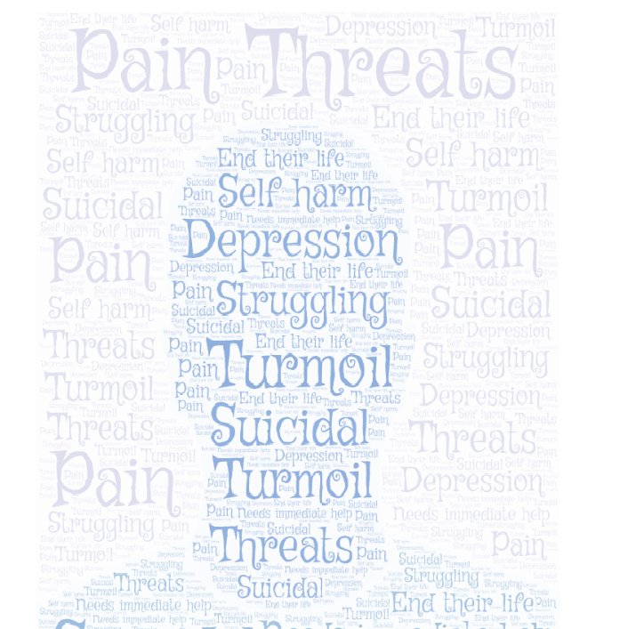

Figure 1.0- Words used to describe a mental health crisis situation.

4.8 Knowledge of mental health prior to joining the police.
The study highlighted that 66.7% of participants had very little knowledge of mental health prior to joining the police service as a police officer. As stated by Watson et al (2012), research suggests that the police still perceive mental illness with stigma which can lead to discrimination. As seen in figure 1.1, there is a dramatic difference in the lack of knowledge officers have prior to joining the police: -

Figure 1.1- Knowledge of mental health prior to joining the police.

4.9 Police involvement
As mentioned by Dyfed Powys Police (2019), it is evident that the percentage of police call outs that are mental health related has increased with some forces expressing that the police service is the leading response to such crisis. This study supports these claims as the data produced evidence of an increase in the percentage of call outs. This was examined by comparing officers who have joined the force more than 11 years ago to officers who have joined less than 10 years ago. By analysing the difference in percentages of call outs, it was evident that call outs to a person in crisis has risen by 34 percent within the last 11 years, as demonstrated in figure 1.2.

Figure 1.2- Percentage of call outs to mental health crisis situations

4.10 Delivery of mental health training
The research evidenced a variety of platforms used to deliver mental health training with E learning being the most commonly used. There is a correlation between the methods of training and the officers who have the opinion of the training not being of benefit to the role. 77% of the officers who accessed their mental health training via E learning expressed that it did not benefit their role, 23% said “maybe” it benefited their role. No participant answered “yes” to it benefitting their role.
It was observed that of the 12% that received “on the job training” as the method of training received, 100% expressed that the training was a positive benefit to the role. A Chi square test was performed to demonstrate the statistical difference as shown in figure 1.3: -

Figure 1.3- Method of training that benefits the role (p< 0.05)

4.11 Training to manage mental health crisis situations.
Participants were asked to express if they felt the training, they had received was adequate for the role. The majority (52.2%) answered “yes”, 17.4% answered “no”, 21.7% answered “maybe” and 8.7% expressed that they “hadn’t received any training” as shown in figure 1.4.

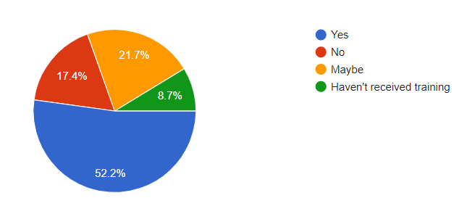
Figure 1.4- Percentage of officers who felt the training received was adequate.

Of the 52.2% that answered yes, it was identified that scenario-based training was the most effective method of training, with 100% of participants that received this method of training answering “yes” to it being adequate. The data captured from both questions researching into the training being of benefit to the role and if the training was considered to be adequate for the role, suggests that a more practical approach (on the job and scenario based) to mental health training is more effective.
It is clear as seen in figure 1.5, that E learning was the most common method of training but 55% of participants who used this method answered “no” to it being of a adequate for the role.

Figure 1.5- Identifying if the training was adequate for the role.
When asked how often mental health training was delivered, 47.8% answered “unsure”, 30.4% answered “once a year”, 4.3% answered “once a quarter” and 17.4% answered “never”. These statistics suggest that as an organisation, a robust infiltration of mental health training appears to be absent.
It was also important to acknowledge that of the participants who expressed the training received was adequate for their role, 29.8% had joined the force less than 10 years ago and 71.2% had joined less than 5 years ago which suggests training programmes are improving.

4.12 Partnerships between the police and mental health services
It was positive to evidence that 65.2 % of participants had knowledge of a partnership within their force between the police and mental health services. As mentioned by Horspool et al (2016), these partnerships have become a more apparent method of supporting officers when attending a mental health crisis and/or to alleviate the police to enable them to pursue serious crime.
When asked who should be responsible for attending mental health crisis situations, 47.8% answered “mental health services”, 39.1% answered “both police and mental health services”,4.3% answered “police service” and 4.3% expressed “mental health is a medical emergency as such those that are in that field should be taking the lead with merely assistance from the police”.
This data suggests that although many forces are participating in partnerships with mental health services, the majority of officers feel that such services need to be more responsible to responding to a person during mental health crisis as a pose to the police service.

4.13 Support for the police to deal with mental health crisis.
78.3% of officers that took part in the study expressed that they did not have the adequate support to deal with a mental health crisis. When interviewed, officer A expressed how little support was available and described the start of his career as “being chucked in the deep end”. Officer A also commented on how other officers felt the same and he questioned if this had impacted on the mental wellbeing of one of his fellow colleagues as these situations were often “traumatic and extremely stressful”.

Research B

4.14 Experience of police intervention during a mental health crisis
When researching into the experience of police intervention during a mental health crisis, a series of questions were answered to gather data to provide insight. The following topics were investigated: -
Circumstances
Participants were asked to describe the circumstances to which the police attended. A common theme was suffering a breakdown, self-harm, suicide threats, intoxication, sufferer of mental health, as seen in figure 1.6. This theme correlates to the theme observed amongst the data collected in research A, what the police perceive to be a mental health crisis.
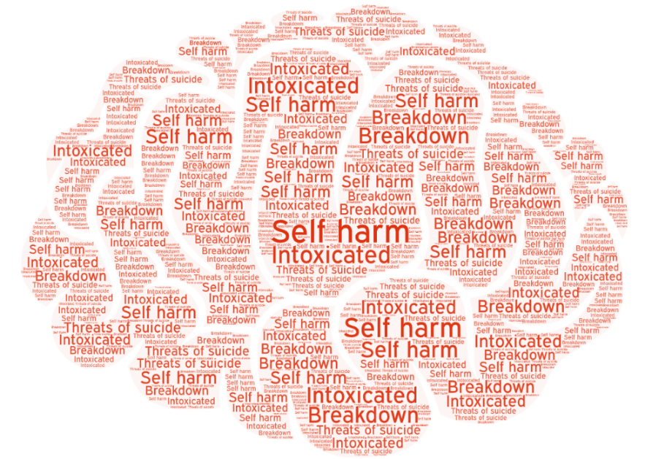
Figure 1.6- Circumstances of mental health crisis
When asked how long ago the event took place, 99% selected within the last 10 years, with 1% selecting “20 years ago”. These statistics support the data produced that evidences an increase in call outs as seen in figure 1.2.
While observing when the event took place, it was evident that participants who have received police intervention less than two years ago have expressed a positive experience compared to those who have experienced police intervention more than 5 years ago with 90% expressing a negative experience. These findings support the data found in research A, as it produced indicative findings of a positive uplift in training delivered within the last 5 years.
Police approach
When asked what type of approach the police took to the situation, 66.7% described the officers of being “abrupt” coupled with 66.7% expressing they did not feel confident in the police officers. 20.1% expressed the officers were “calm” and “friendly” and 10.2% expressed they had received a mixture of treatments.
When asked if the police officers acted in a positive manner 55.6% of participants answered “no”, 22.2% answered “yes” and 22.2% answered “maybe”.
Participants were also asked if they had experienced discrimination during the event, 55.6% answered “no”, 44.4% answered “yes”, none answered “maybe”.
Figure 1.7 demonstrates the police approach as perceived by people during a mental health crisis.

Figure 1.7- Police approach to a person in crisis
Participants were asked “What did the police did well during the event?”. It is important to note that this was the only question in the study that did not have 100% participant engagement with only 45% of the participants commenting. The comments included the following: -

What did the police do well during the event?
“They removed me from the situation”.

“They were calm and friendly”.
“They took me away from the situation”.
“They turned up; they should be ashamed of the poor service provided”.

Participants were asked “What could the police do better next time?” This question received 100% participant engagement, which included: -

What could the police do better next time?
“Be non-bias, be open minded, use what they are trained to do and actually investigate. Dyfed Powys are a shamble compared to South Wales police. The lack of interest in investigations i.e., domestic disputes seem like an effort for them. I’d rather call my family than the police”.

“I believe all officers should be retrained in their approach to people with mental health. The experience I received could have had a huge disastrous effect on me and it had a hugely negative impact on my mental Health state. I was made to feel like I was a drain on resources. I think that specially trained officers should be available to be deployed to mental health cases ensuring the safety and not escalation of people’s issues.”

“More understanding of mental health”

“Not put the blue lights on the car as all my neighbours saw”.

“Be more empathetic- felt like I was wasting their time”.

“Be more professional”.

“They could be more understanding and patient”.

“Not be so rude and aggressive. They made me more fired up by swearing at me and chucking me in the back of the van.”

“Not make me feel like I was wasting their time”.

It is evident that the number of participants that wanted to answer the question “What did the police do particularly well?” compared to the “What could the police do better next time?” was dramatically less suggesting the police provided a negative experience to the majority of participants that took part in the study. It is also observed that the information provided to the latter question is significantly more, suggesting participants felt more passionate about providing information to support their negative experience. According to Vaish (2008), when describing a negative experience, it is common to use more words and stronger language to describe the impact as a pose to a positive experience.

Place of safety
Participants were asked if they were taken to a place of safety. 54% answered “yes” and 46% answered “no”. Of the 54% that were taken to a place of safety, 50% were taken to A&E, 30% were taken to friend or family’s home and 20% were put in a police cell. Of the 50% taken to A&E, when asked if they felt safe here, 80% answered “no” and 20% answered “maybe”.
Of the 30% that were taken to a friend of family’s home, 100% answered “yes” when asked if they felt safe. For those who were put in a police cell, 100% of them answered “no” when asked if they felt safe within the “place of safety”. As mentioned by College of policing (2020), although police cells have been identified as an inappropriate space for people during a mental health crisis, they are imposed if a person is showing significant signs of harm to themselves or the public.

Mental health services
Participants were asked if they felt that mental health services were available in the case of an emergency. 77.8% answered “no” and 22.2% answered “yes”. These statistics support the data captured in research A, where it was suggested by police officers that mental health services need to be more responsible for attending such emergencies.

4.15 Conclusion
This chapter achieved the following objective: -
To critically analyse the data collected from the primary research to gain a greater understanding of the police knowledge surrounding mental health and if the police receive the correct level of training to manage a mental health crisis.
In conclusion it is evident from both areas of research that police officers need a more robust training programme in place to ensure they have the confidence and tools to aid a person during a mental health crisis. It has been suggested that mental health services are failing to provide support to people who suffer with mental health illness and it is felt that this is their responsibility as well as the police service (Dyfed Powys Police, 2019).
This chapter has explored the points of view from both police officers and people who have received police intervention during a mental health crisis. The final chapter will conclude the findings and discuss limitations to the study. It will also provide recommendations and avenues for future research.

5. Chapter 5- Conclusion and recommendations

5.1 Introduction
The previous chapter analysed the data, provided the findings and achieved the final two objectives as set out in chapter one. This chapter will achieve the following: -
To acknowledge the findings from the study, including practical implications to the research
And
To offer recommendations on current practice with a view to provide future avenues of investigation into the topic taking into account limitations

5.2 Main findings
Main findings found that the majority of police officers view the training they receive in relation to mental health training inadequate for their role to accommodate the rise in call outs that are mental health related. These findings are also supported in the data collected from people who have received police intervention during a mental health crisis, as findings suggest that the majority of participants felt the police approach was negative. The data, does however, highlight that within the last 5 years training has improved but there is still room for improvement.
Moreover, the study found that police officers have very little knowledge of mental health prior to joining the service. This data coupled with the police officers view of training in relation to mental health being classed as inadequate, strongly suggests that improvement of training should be treated as a priority in order to avoid the threat of discrimination and stereotyping occurring.

5.3 Implications
The study has highlighted that mental health illness is increasing and so is the demand on the police service. Further to the issue is the lack of knowledge new police recruits have of mental health which leads to an increased likelihood of stereotyping and discrimination which has been evidenced within the study.
The correlation of police viewing training as inadequate and the negative theme derived from the research into experience of police intervention, provides a strong argument that the current training needs to urgently be reviewed and improved.
The study has also evidenced that although police intervention has been vastly negative, recent experience has been viewed more positively which suggests that training is starting to improve. However, the majority of police officers still feel that the training received has little benefit to their role.
The study also highlighted that E learning and classroom-based training has proved an inadequate method of delivering mental health training, instead a more practical approach such as on the job training has so far been received more successfully.

5.4 Recommendations
Following the present study, a number of recommendations can be made but overall priority should be taken in view of scrutinising current training in place for police officers in relation to mental health.
The study has identified that a practical approach to mental health training is effective. Taking this into consideration, a strong recommendation would be made in relation to the method of delivery. It is recommended that the police work collaboratively with mental health services to provide a work placement for newly recruited officers to form part of their induction programme. The intention would be for officers to “shadow” mental health professionals which would enable officers to gain greater knowledge, learn techniques to manage someone in crisis, reduce stigma, stereotyping and provide them with confidence. Shadowing is an effective way of learning through observation (Kitsis, 2011). If the demand on time would make this option a challenge, an alternative would be to establish a new requirement set out within the probation period that would require new recruits to have successfully completed a number of hours within a placement. These hours would be completed on a voluntary basis and would be a compulsory requirement needed to successfully pass probation.

5.5 Limitations
According to Hodkinson and Hodkinson (2001), one major limitation to a research study is the collection of too much data for a small sale investigation. Taking this into consideration, the number of participants remained low to enable a thorough analysis to accommodate this low scale research project.
Due to the pandemic, the majority of data was collected via the internet which presents a series of limitations. According to Lefever et al (2007), technical issues as well as user engagement are some barriers to collecting data in this method. It is also acknowledged that online surveys can increase the likelihood of disingenuous participants which therefore queries the truthfulness in the answers provided. One way in which to reduce this is to ask for identification of the participant but for the purpose of this study, participants remained anonymous.
The impact of the pandemic changed the method in which data was collected. The use of interviews was the preferred and chosen method at the beginning of the study, but this had to be changed to online questionnaires. This could have led to a lack of data being captured as the human, face to face element was not able to be used to extract the data.
As this study has captured opinions and points of view, it is important to recognise negative bias and how it may have impacted on the study. Across a number of tasks and physiological situations, adults display, learn from, and use more negative bias than positive (Vaish et al, 2008).

5.6 Future research
This study has drawn conclusion on current practice but not fully investigated what options could be available to improve training for officers. It would be fruitful to research into how mental health services deliver their training to staff and analyse their findings to compare and contrast. From this research, the police service can use this input to better design a more robust programme of training, to include the recommendation as set out within this chapter.

5.7 Self reflection
The researcher has a keen interest in the growing demand that mental health illness has on the police service and so aimed to provide a greater insight into how police officers felt about the training they received in relation to mental health, and if current training in place was adequate. Due to the lack of research in this area, the researcher was interested in shining light on the topic to learn more and analyse areas for improvement.
Through this study, the researcher has learnt a host of new skills including the use of Chi Square analysis which has added value to the study and will be used in future research projects.

5.8 conclusion
This chapter has achieved its final objectives:
To acknowledge the findings from the study, including practical implications to the research
And
To offer recommendations on current practice with a view of providing future avenues of investigation into the topic taking into account limitations
This study aimed to explore the current mental health training in place for police officers with a particular focus on experiences of police intervention during a mental health crisis. It has achieved a greater insight and provided a basis for future research with a view to produce a more robust training programme for officers that recognises the demand that mental health crisis has on the police service in today’s society. The researcher feels positive that this study will provide a foundation for future research and recommendations.

Bibliography

Albers M (2017) Quantitative data analysis- in the gradual curriculum. Available at: https://journals.sagepub.com/doi/abs/10.1177/0047281617692067 Accessed on: 18 March 2021
Brown G (2010) Practical assessment, research and evaluation. Available at: https://scholarworks.umass.edu/cgi/viewcontent.cgi?article=1227&context=pare Accessed on: 30 March 2021

Bryant R, Bryant S (2019) Blackstone’s handbook for policing students. Oxford. Oxford university press
Bakhit Al Zefeiti S M, Mohamad N A (2015) Management Methodological Considerations in Studying Transformational Leadership and its Outcomes. Available at: https://journals.sagepub.com/doi/pdf/10.5772/60429 Accessed on: 19 February 2021
Chyung S, Roberts K, Swanson I, Hankinson A (2017) Evidence-Based Survey Design: The Use of a Midpoint on the Likert Scale. Available at: https://scholarworks.boisestate.edu/cgi/viewcontent.cgi?article=1086&context=ipt_facpubs Accessed on: 23 February 2021
Chia R (2002) Philosophy and research. Available at: https://pdfs.semanticscholar.org/7e84/cfba25845587ea2b51cb3e1e749923ef872f.pdf Accessed on: 21 February 2021

College of policing (2018) About us. Available at: https://www.app.college.police.uk/about-app/ Accessed on: 18 January 2021
College of policing (2020) Mental health. Mental health detention. Available at: https://www.app.college.police.uk/app-content/mental-health/mental-health-detention/#mental-health-act-1983-hospital-admission-provisions Accessed on: 18 January 2021
College of policing (2020) Mental health training for officers is published. Available at: https://www.college.police.uk/News/archive/October_2016/Pages/Mental_health_training.aspx Accessed on: 18 January 2021
Cousins R, Mackay C J, Clarke S D, Kelly C, Kelly P J, McGraig R H (2004) ‘Management Standards’ and work- related stress in the UK: Practical development. Available at: https://www.researchgate.net/publication/228975882_'Management_Standards'_and_work-related_stress_in_the_UK_Practical_development Accessed on: 3 February 2021
Clarke D, Dusome D, Hughes L (2007) Emergency department from the mental health perspective. Available at: https://onlinelibrary.wiley.com/doi/abs/10.1111/j.1447-0349.2007.00455.x Accessed on: 18 January 2021
Crisis Care Concordat (2014) About crisis care concordat. Available at: https://www.crisiscareconcordat.org.uk/about/ Accessed on: 15 November 2020
Driscoll D L (2011) Introduction to primary research: observations, surveys and interviews. Available at: https://wac.colostate.edu/books/writingspaces2/driscoll--introduction-to-primary-research.pdf Accessed on: 23 February 2021

Dyfed Powys Police (2019) Police boss calls for fair welsh mental health funding. Available at: https://www.dyfed-powys.police.uk/en/newsroom/press-releases/police-boss-calls-for-fair-welsh-mental-health-funding/ Accessed on: 2 November 2020

Fusar- Poli P, Salazar de Pablo G, De Micheli A, Neiman D, Correll C, Kessing L, Pfenning A, Bechdolf A, Borgwadt s, Arango C, Amelsvoort T (2020) What is good mental health? A scoping review. Available at: https://www.sciencedirect.com/science/article/pii/S0924977X19318693 Accessed on: 18 January 2021
Fox N (2009) Using interviews in a research project. Available at: https://www.rds-yh.nihr.ac.uk/wp-content/uploads/2013/05/15_Using-Interviews-2009.pdf Accessed on: 23 February 2021
Golafshani N (2003) Understanding reliability and validity in qualitative research. Available at: file:///C:/Users/Student/Downloads/golafshani.pdf . Accessed on: 25 February 2021
Given L (2008) Categorisation. Available at: https://methods.sagepub.com/reference/sage-encyc-qualitative-research-methods/n41.xml#:~:text=The%20categorization%20process%20encourages%20researchers,the%20observed%20phenomena%20into%20units. Accessed on: 30 March 2021
Hales J (2019) What is audience understanding research? Available at: https://sapioresearch.com/tutorials/audience-understanding-research#:~:text=Decision%20making%20%2D%20Audience%20research%20can,have%20no%20evidence%20to%20support. Accessed on: 25 February 2021
Horspool K, Drabble S, O’Cathain A (2016) Implementing street triage: a qualitative study of collaboration between police and mental health services. Available at: https://bmcpsychiatry.biomedcentral.com/articles/10.1186/s12888-016-1026-z#:~:text=Street%20Triage%20is%20a%20collaborative,of%20these%20services%20is%20limited. Accessed on: 5 April
HMIC (2015) The welfare of vulnerable people in police custody. Available at: https://www.justiceinspectorates.gov.uk/hmicfrs/wp-content/uploads/the-welfare-of-vulnerable-people-in-police-custody.pdf Accessed on: 10 November 2020
Her majesty’s Inspectorate of Constabulary and Fire & Rescue Services (HMICFRS) (2018) Policing and Mental health. Picking up the pieces. Available at: https://www.justiceinspectorates.gov.uk/hmicfrs/wp-content/uploads/policing-and-mental-health-picking-up-the-pieces.pdf Accessed on: 15 November 2020

Hodgkinson P, Hodgkinson H (2001) The strengths and limitations with case study research. Available at: http://scholar.google.co.uk/scholar_url?url=http://education.exeter.ac.uk/tlc/docs/publications/LE_PH_PUB_05.12.01.rtf&hl=en&sa=X&ei=AMeDYOa_FJGPmwG_yLigDA&scisig=AAGBfm0DDIHjuUEG8dIb9BtEsWBSjYRhxA&nossl=1&oi=scholarr Accessed on: 24 April 2021
Health and Safety Executive (2020) Before you start the Management Standard approach. Available at: https://www.hse.gov.uk/stress/standards/before.htm Accessed on: 3 February 2021
Henderson C, Evans- Lacko S, Thornicroft G (2013) Mental illness stigma, help seeking and public health programmes. Available at: https://www.ncbi.nlm.nih.gov/pmc/articles/PMC3698814/ Accessed on: 18 January 2021
Her majesty’s Inspectorate of Constabulary and Fire & Rescue Services (HMICFRS) (2018) Policing and Mental health. Picking up the pieces. Available at: https://www.justiceinspectorates.gov.uk/hmicfrs/wp-content/uploads/policing-and-mental-health-picking-up-the-pieces.pdf Accessed on: 15 November 2020
Home Office (2018) Code C. Revised code of practice for detention, treatment and questioning by Police Officers. Available at: https://assets.publishing.service.gov.uk/government/uploads/system/uploads/attachment_data/file/729842/pace-code-c-2018.pdf Accessed on: 3 February 2021
Horspool K, Drabble S, O’Cathain A (2016) Implementing street triage: a qualitative study of collaboration between police and mental health services. Available at: https://bmcpsychiatry.biomedcentral.com/articles/10.1186/s12888-016-1026-z#:~:text=Street%20Triage%20is%20a%20collaborative,of%20these%20services%20is%20limited. Accessed on: 25 January 2021
Independent Office for Police Conduct (2020) Deaths during or following police contact. Statistics for England and Wales 2019/20. Available at: https://www.policeconduct.gov.uk/sites/default/files/Documents/statistics/deaths_during_following_police_contact_201920.pdf Accessed on: 3 February 2021
Kitsis E (2011) Shining a light on shadowing. Available at: https://jamanetwork.com/journals/jama/article-abstract/645991 Accessed on: 24 April 2021
Lefever S, Dal M, Matthiasdottir A (2007) Online data collection in academic research: advantages and limitations. Available at: https://d1wqtxts1xzle7.cloudfront.net/46417092/j.1467-8535.2006.00638.x20160612-22482-3m9znc.pdf?1465740809=&response-content-disposition=inline%3B+filename%3DOnline_data_collection_in_academic_resea.pdf&Expires=1619007427&Signature=hEDzGz~BY4uO4f1emT3PzrXX5dj3wc-rXplaSohnZLo0FNQHcjt5nquvvmELTjU7S~dsjVbXB7x-LgqTluA8zeVfwbwUZ-dgzK1sORbCNDAdv3M5VDZv6xG8bMr1cdFZCeS0fXK--3WTPdhMzNKHBxnxqUcXXKBRHui4Imls83eaOl5ZJ-hE1nCpBfWTpcjo-kzYYWWOExRXXk6qFjYgnX93NK7Psc9mmX6S8odD26tLjrBDXq7McqoBOBUS1HlI1r5WyatsUUkZVFj8Xyaetbh~L~H~DA3uD-i8anz1UekL5CCo~ldHjT35-cTPt8FTSmC89ILOpfhokMZz820MfQ__&Key-Pair-Id=APKAJLOHF5GGSLRBV4ZA Accessed on: 21 April 2021
Lavrakas P (2008) Cross sectional data. Available at: https://methods.sagepub.com/reference/encyclopedia-of-survey-research-methods/n119.xml Accessed on: 22 February 2021

Leese M, Russell S (2020) Mental health, vulnerability and risk in police custody. Available at: https://core.ac.uk/download/pdf/322321763.pdf Accessed on: 28 January 2021
Lindon G, Roe S (2017) Home office. Deaths in police custody: a review of the international evidence. Available at: https://assets.publishing.service.gov.uk/government/uploads/system/uploads/attachment_data/file/655710/Deaths_in_police_custody_A_review_of_the_international_evidence.pdf Accessed on: 25 January 2021
Mind (2013) Police and mental health. How to get it right locally. Available at: https://www.mind.org.uk/media-a/4356/2013-12-03-mind_police_final_web.pdf Accessed on: 25 January 2021
Maxwell L, Barbic S, Roberts K, Durisco Z, Lee C, Ware E, McKenzie K (2015) What is mental health? Evidence towards a new definition from a mixed methods multidisciplinary international survey. Available at: https://bmjopen.bmj.com/content/5/6/e007079 Accessed on: 18 January 2021
Mental Health First Aider (2020) Mental health statistics. Available at: https://mhfaengland.org/mhfa-centre/research-and-evaluation/mental-health-statistics/ Accessed on: 2 February 2021
Mind (2020) How to improve your mental wellbeing. Available at: https://www.mind.org.uk/information-support/tips-for-everyday-living/wellbeing/wellbeing/?o=10135 Accessed on: 2 February 2021
Malmqvist J, Hellberg K, Mollas G, Rose R, Shevlin M (2019) Conducting the pilot study: a neglected part of the research process? Methodological findings supporting the importance of piloting in qualitative research studies. Available at: https://journals.sagepub.com/doi/full/10.1177/1609406919878341 Accessed on: 25 February 2021
McCambridge J, Kypri K, Elbourne D (2014) Research participation effects: a skeleton in the methodological cupboard. Available at: https://www.ncbi.nlm.nih.gov/pmc/articles/PMC4236591/ Accessed on: 25 February 2021
Mortensen D (2020) How do to a thematical analysis of user interviews. Available at: https://www.interaction-design.org/literature/article/how-to-do-a-thematic-analysis-of-user-interviews Accessed on: 25 February 2021
Moon K, Blackman D (2017) A guide to ontology, epistemology, and philosophical perspectives for interdisciplinary researchers. Available at: https://i2insights.org/2017/05/02/philosophy-for-interdisciplinarity/ Accessed on: 21 February 2021
Mental Health First Aider England (2020) Mental health statistics. Available at: https://mhfaengland.org/mhfa-centre/research-and-evaluation/mental-health-statistics/ Accessed on: 2 November 2020
Mind (2013) Police and mental health: how to get it right locally. Available at: https://www.mind.org.uk/media-a/4356/2013-12-03-mind_police_final_web.pdf Accessed on: 2 November 2020
Muylaert C, Sarubbi V, Gallo P, Neto M, Reis A (2014) Narrative interviews: an important resource in qualitative research. Available at: https://www.scielo.br/scielo.php?pid=S0080-62342014000800184&script=sci_arttext Accessed on: 16 November 2020
NHS (2019) Mental health act. Available at: https://www.nhs.uk/using-the-nhs/nhs-services/mental-health-services/mental-health-act/ Accessed on: 10 November 2020
NHS (2020) Mental health act statistics, annual figures 2018-19. Available at: https://digital.nhs.uk/data-and-information/publications/statistical/mental-health-act-statistics-annual-figures/2018-19-annual-figures Accessed on: 2 November 2020
NHS (2019) Mental health act. Available at: https://www.nhs.uk/using-the-nhs/nhs-services/mental-health-services/mental-health-act/ Accessed on: 10 January 2021
NHS (2016) Introducing mental health nurses to the emergency operations centre at London Ambulance Service. Available at: https://improvement.nhs.uk/documents/330/Case_study_-_LAS_mental_health.pdf Accessed on: 27 January 2021
Opdenakker R (2006) Advantages and Disadvantages of Four Interview Techniques in Qualitative Research. Available at: file:///C:/Users/Student/Downloads/175-Article%20Text-489-2-10-20140203.pdf Accessed on: 22 February 2021
Puntis S, Perfect D, Kirubarajan A, Bolton S, Davies F, Hayes A, Harriss E, Molodynski A (2018) A systematic review of co-responder models of police mental health ‘street’ triage. Available at: https://bmcpsychiatry.biomedcentral.com/articles/10.1186/s12888-018-1836-2 Accessed on: 25 January 2021
Pathak V, B Jena, Kalra S (2011) Qualitative research. Available at: https://www.ncbi.nlm.nih.gov/pmc/articles/PMC3757586/ Accessed on: 23 February 2021
Rensnik D (2020) What is ethics in research and why is it important? Available at: https://www.niehs.nih.gov/research/resources/bioethics/whatis/index.cfm Accessed on: 27 February 2020
Saunders M, Lewis P, Adrian T (2019) Research methods for business students. 8th Ed. Available at: https://www.researchgate.net/profile/Mark-Saunders-10/publication/330760964_Research_Methods_for_Business_Students_Chapter_4_Understanding_research_philosophy_and_approaches_to_theory_development/links/5c53056f299bf12be3f0e2cf/Research-Methods-for-Business-Students-Chapter-4-Understanding-research-philosophy-and-approaches-to-theory-development.pdf Accessed on: 2 March 2021
Saunders M, Lewis P, Thornhill M (2012) Research methods for business students. 6th Ed. Essex. Pearson education limited.
Salkind (2010) Data cleaning. Available at: https://methods.sagepub.com/reference/encyc-of-research-design/n100.xml#:~:text=Data%20cleaning%2C%20or%20data%20cleansing,in%20preparing%20data%20for%20analysis.&text=Missing%20and%20erroneous%20data%20can,careful%20survey%20and%20study%20design. Accessed on: 1 April 2021
Saunders M, Lewis P, Thornhill A (2007) Research methods for business students. Essex. Pearson Education limited
Siddique H (2018) Mental health disorders on rise amongst children. Available at: https://www.theguardian.com/society/2018/nov/22/mental-health-disorders-on-rise-among-children-nhs-figures Accessed on: 2 November 2020
Simundic A (2013) Bias in research. Available at: https://www.ncbi.nlm.nih.gov/pmc/articles/PMC3900086/#:~:text=Any%20such%20trend%20or%20deviation,and%20publication%20is%20called%20bias.&text=Bias%20causes%20false%20conclusions%20and,unethical%20to%20conduct%20biased%20research Accessed on: 18 November 2020
Stuckey L (2018) Three types of interviews: Qualitative research methods in social health. Available at: https://www.thieme-connect.com/products/ejournals/pdf/10.4103/2321-0656.115294.pdf Accessed on: 21 February 2021
Thomas R (2003) A general inductive approach for qualitative data analysis. Available at: https://citeseerx.ist.psu.edu/viewdoc/download?doi=10.1.1.462.5445&rep=rep1&type=pdf Accessed on: 19 February 2021
Time to change (2017) Significant improvement in public attitudes and behaviours – latest research shows. Available at: https://www.time-to-change.org.uk/news/significant-improvement-public-attitudes-and-behaviours-%E2%80%93-latest-research-shows Accessed on: 18 January 2021
Vizcarguenaga-Aguirre I, Ricardo López-Robles J (2020) Mono, mixed or multiple strategy approach: a descriptive study of the latest published articles in the International Journal of Project Management. Available at: http://eprints.rclis.org/40506/1/2020_Vizcarguenaga-Aguirre_et_al_Researches_REPM2020.pdf Accessed on: 22 February 2021
2021
Vaish A, Grossman T, Woodward A (2008) Not all emotions are created equal: The negativity bias in social- emotional development. Available at: https://www.ncbi.nlm.nih.gov/pmc/articles/PMC3652533/ Accessed on: 7 April 2021
Vogl S, Zartler U, Schmidt E M, Rieder I (2018) Developing an analytical framework for multiple perspective, qualitative longitudinal interviews (MPQLI) Available at: https://www.tandfonline.com/doi/pdf/10.1080/13645579.2017.1345149 Accessed on: 2 May 2021
Watson A, Corrigan P, Ottati V (2004) Police offciers’ attitudes towards and decisions about a person with mental illness. Available at; https://ps.psychiatryonline.org/doi/full/10.1176/appi.ps.55.1.49 Accessed on: 15 November 2020
Walsham G (2004) Doing interpretive research. Available at: https://www.tandfonline.com/doi/abs/10.1057/PALGRAVE.EJIS.3000589 Accessed on: 15 November 2020
Watson A, Corrigan P, Ottati V (2004) Police officers’ attitudes towards and decisions about a person with mental illness. Available at; https://ps.psychiatryonline.org/doi/full/10.1176/appi.ps.55.1.49 Accessed on: 15 January 2021
World Health Organisation (2018) Mental health: strengthening our response. Available at: https://www.who.int/news-room/fact-sheets/detail/mental-health-strengthening-our-response Accessed on: 18 January 2021

Wright K (2017) Researching Internet-Based Populations: Advantages and Disadvantages of Online Survey Research, Online Questionnaire Authoring Software Packages, and Web Survey Services. Available at: https://academic.oup.com/jcmc/article/10/3/JCMC1034/4614509 Accessed on: 1 May 2021

Acts
Mental Health act 1983
Police and Criminal Evidence act 1984

Appendices

Ethics form
APPLICATION FOR ETHICAL APPROVAL

SECTION A: About You (Principal Researcher)
Full Name: |  | SADIE FRANCE
Tick all boxes which apply: |  | Member of staff: | ☐ | Honorary research fellow: | ☐
Undergraduate Student | ☒ | Taught Postgraduate Student | ☐ | Postgraduate Research Student | ☐

Institute/Academic Discipline/Centre: | Business School
Campus: | Swansea
E-mail address: | 1805131@student.uwtsd.ac.uk
Contact Telephone Number: | 07539879798
For students:
Student Number: | 1805131
Programme of Study: | BSc Policing and Criminology
Director of Studies/Supervisor: | Bronwen Williams
SECTION B: Approval for Research Activity
Has the research activity received approval in principle?  (please check the Guidance Notes as to the appropriate approval process for different levels of research by different categories of individual) |  | YES | ☒ | NO | ☐
 |  |  |  | Date
If Yes, please indicate source of approval (and date where known): Approval in principle must be obtained from the relevant source prior to seeking ethical approval | Research Degrees Committee |  | ☒
 | Institute Research Committee |  | ☐
 | Other (write in) |  | ☐

SECTION C: Internal and External Ethical Guidance Materials
Please list the core ethical guidance documents that have been referred to during the completion of this form (including any discipline-specific codes of research ethics, and also any specific ethical guidance relating to the proposed methodology). Please tick to confirm that your research proposal adheres to these codes and guidelines.
UWTSD Research Ethics & Integrity Code of Practice | ☒
UWTSD Research Data Management Policy | ☒
 | ☐

SECTION D: External Collaborative Research Activity
Does the research activity involve collaborators outside of the University? |  | YES | ☐ | NO | ☒
If Yes, please provide the name of the external organisation and name and contact details for the main contact person and confirmation this person has consented to their personal data being shared.as part of this collaboration.
Institution
Contact person name
Contact person e-mail address

Has this individual consented to sharing their details on this form? |  | YES | ☐ | NO |  |  | ☒
Are you in receipt of a KESS scholarship? |  | YES | ☐ | NO |  |  | ☒
Is your research externally funded |  | YES | ☐ | NO |  |  | ☒
Are you specifically employed to undertake this research in either a paid or voluntary capacity? | Voluntary | YES | ☐ | NO |  | ☒
 | Employed | YES | ☐ | NO |  | ☒
Is the research being undertaken within an existing UWTSD Athrofa Professional Learning Partnership (APLP) | If YES then the permission question below does not need to be answered. | YES | ☐ | NO |  |  | ☒
Permission to undertake the research has been provided by the partner organisation | (If YES attach copy)  If NO the application cannot continue | YES | ☐ | NO |  |  | ☒

Where research activity is carried out in collaboration with an external organisation
Does this organisation have its own ethics approval system? | YES | ☐ | NO | ☒
If Yes, please attach a copy of any final approval (or interim approval) from the organisation

SECTION E: Details of Research Activity
Indicative title: | Mental health crisis: are the police the correct service?
Proposed start date: | 23/11/2020 | Proposed end date: | MAY 2021
Introduction to the Research (maximum 300 words)
Ensure that you write for a Non-Specialist Audience when outlining your response to the three points below:
The purpose of this research is to analyse if the police are the correct service to respond to a person in mental health crisis. When carrying out the research certain areas will be explored such as investigating if the police have the correct attitude and training to help a person in crisis. Through interviews and questionnaires I hope to gain a greater understanding of the current procedures that are in place to recognise if they are conducive or maybe need improving and put forward any recommendations which may arrive from the research carried out. The aim of using interviews and questionnaires is to gain greater knowledge from the police service and people with mental health issues who have had dealing with the police during a crisis. It is with positive regard that the data collected will help to build a bigger picture from a dual aspect in order to evaluate if the current procedures in place are correct and if anything can be done differently.
Current research states that mental health is on the increase in the UK, the police service are dealing with mental health emergency calls every 12 minutes. It is therefore important to analyse if the police have been given the correct knowledge and training in order to successfully manage and aid a person in crisis. As the demand for policing in this area is increasing, the need to evaluate the current procedures in place is also necessary to evaluate if they are correct to meet the needs of todays policing and look at other ways and/or partnerships that can provide a better service to a person during a crisis.

Purpose of Research Activity

This research addresses the current procedures in place to aid someone during mental health crisis, analysing if it is correct.

Research Questions

Q1: What is the police attitude towards mental health?
Q2: What training is in place for police officers to deal with a mental health crisis?
Q3: What constitutes a safe place? And is it appropriate?

Aims of Research Activity

The research aims to give more in-depth knowledge of the current procedures in place and evaluate there effectiveness.

Objectives of Research Activity

1. To conduct an extant literature review of the current procedures in place to aid someone who is enduring a mental health crisis
2. To carry out interviews and/or questionnaires to collect data from the police
3. To carry out interviewed and/or questionnaires to collect data from a person who has suffered a mental health crisis with police intervention
4. Make recommendations for the police service

Proposed methods (maximum 600 words)
Provide a brief summary of all the methods that may be used in the research activity, making it clear what specific techniques may be used. If methods other than those listed in this section are deemed appropriate later, additional ethical approval for those methods will be needed.
Due to the nature of the dissertation it is vital to gather data from both parties, the police and a person who has experienced police intervention during a mental health crisis. An interview and/or questionnaire will be used to collect data. These methods will be conducted online, in light of the global pandemic. Microsoft Teams will be used for the interviews and I will contact mental health focus groups via email to send them the questionnaires.

Location of research activity
Identify all locations where research activity will take place.
 | Online
Research activity outside of the UK
If research activity will take place overseas, you are responsible for ensuring that local ethical considerations are complied with and that the relevant permissions are sought. Specify any local guidelines (e.g. from local professional associations/learned societies/universities) that exist and whether these involve any ethical stipulations beyond those usual in the UK (provide details of any licenses or permissions required). Also specify whether there are any specific ethical issues raised by the local context in which the research activity is taking place, for example, particular cultural and/or legal sensitivities or vulnerabilities of participants.
Use of documentation not in the public domain: Are any documents NOT publicly available? |  | NO | ☒
 |  | YES | ☐

SECTION F: Scope of Research Activity
Will the research activity include: | YES | NO
Use of a questionnaire or similar research instrument? | ☒ | ☐
Use of interviews? | ☒ | ☐
Use of diaries? | ☐ | ☒
Participant observation with their knowledge? | ☐ | ☒
Participant observation without their knowledge? | ☐ | ☒
Use of video or audio recording? | ☒ | ☐
Access to personal or confidential information without the participants’ specific consent? | ☐ | ☒
Administration of any questions, test stimuli, presentation that may be experienced as physically, mentally or emotionally harmful / offensive? | ☐ | ☒
Performance of any acts which may cause embarrassment or affect self-esteem? | ☐ | ☒
Investigation of participants involved in illegal activities? | ☐ | ☒
Use of procedures that involve deception? | ☐ | ☒
Administration of any substance, agent or placebo? | ☐ | ☒
Working with live vertebrate animals? | ☐ | ☒
Other primary data collection methods, please explain in this box  For example, ‘focus groups’. Please indicate the type of data collection method(s) in this box and tick the accompany box. | ☒ | ☐
Details of any other primary data collection method:  I will use mental health focus groups to conduct interviews and/or questionnaires  (this box should expand as you type) | ☒ | ☐
If NO to every question, then the research activity is (ethically) low risk and may be exempt from some of the following sections (please refer to Guidance Notes).

If YES to any question, then no research activity should be undertaken until full ethical approval has been obtained.

SECTION G: Intended Participants
Who are the intended participants: | YES | NO
Students or staff at the University? | ☐ | ☒
Adults (over the age of 18 and competent to give consent)? | ☒ | ☐
Vulnerable adults? | ☒ | ☐
Children and Young People under the age of 18? (Consent from Parent, Carer or Guardian will be required) | ☐ | ☒
Prisoners? | ☐ | ☒
Young offenders? | ☐ | ☒
Those who could be considered to have a particularly dependent relationship with the investigator or a gatekeeper? | ☐ | ☒
People engaged in illegal activities? | ☐ | ☒
Others (please identify specifically any group who may be unable to give consent) please indicate here and tick the appropriate box. | ☐ | ☒
Other – please indicate here:  (this box should expand as you type) | ☐ | ☒

Participant numbers and source
Provide an estimate of the expected number of participants. How will you identify participants and how will they be recruited?
How many participants are expected? | 10-20
Who will the participants be? | Qualitative interviews will be performed with police officers and a person who has suffered a mental health crisis with police intervention as this is the population seen to be the most knowledgeable.
How will you identify the participants? | The interviewees will be selected with purposive sampling techniques.

Information for participants: | YES | NO | N/A
Will you describe the main research procedures to participants in advance, so that they are informed about what to expect? | ☒ | ☐ | ☐
Will you tell participants that their participation is voluntary? | ☒ | ☐ | ☐
Will you obtain written consent for participation? | ☒ | ☐ | ☐
Will you explain to participants that refusal to participate in the research will not affect their treatment or education (if relevant)? | ☒ | ☐ | ☐
If the research is observational, will you ask participants for their consent to being observed? | ☐ | ☐ | ☒
Will you tell participants that they may withdraw from the research at any time and for any reason? | ☒ | ☐ | ☐
With questionnaires, will you give participants the option of omitting questions they do not want to answer? | ☒ | ☐ | ☐
Will you tell participants that their data will be treated with full confidentiality and that, if published, it will not be identifiable as theirs? | ☒ | ☐ | ☐
Will you debrief participants at the end of their participation, in a way appropriate to the type of research undertaken? | ☒ | ☐ | ☐
If NO to any of above questions, please give an explanation
(this box should expand as you type)

Information for participants: | YES | NO | N/A
Will participants be paid? | ☐ | ☒ | ☐
Is specialist electrical or other equipment to be used with participants? | ☐ | ☒ | ☐
Are there any financial or other interests to the investigator or University arising from this study? | ☐ | ☒ | ☐
Will the research activity involve deliberately misleading participants in any way, or the partial or full concealment of the specific study aims? | ☐ | ☒ | ☐
If YES to any question, please provide full details
(this box should expand as you type)

SECTION H: Anticipated Risks

Outline any anticipated risks that may adversely affect any of the participants, the researchers and/or the University, and the steps that will be taken to address them.

If you have completed a full risk assessment (for example as required by a laboratory, or external research collaborator) you may append that to this form.
Full risk assessment completed and appended? |  | Yes | ☐
 |  | No | ☒
Risks to participants
For example: emotional distress, financial disclosure, physical harm, transfer of personal data, sensitive organisational information
Risk to Participant:  Refer to Flinders’ Ethical framework (1992) to discuss the risks to participants from the three main stages of the study.  Stage 1: the recruitment. The participants could be emotional distressed when they recall the harsh times they have experienced.  Stage 2: the fieldwork. The participants could concern about the questions related to sensitive organisational information.  Stage 3: Reporting. The participants could concern about confidentiality and anonymity of personal data. | How will you mitigate the Risk to Participant  1.If the participant has potential emotional challenges, the emotional distance strategy needs to be considered. For instance, remind participants of their right to withdraw from research or limit their participation. if they become uncomfortable, provide counselling or psychological support for those who experience distress, and thoroughly debrief with participants after research sessions are completed.  2. Protect confidential data collected as well as the fact that the subject is participating in the research project itself.  3. Protect confidentiality of research data and ensure all relevant local laws. The development of science and technology also puts forward higher requirements for data storage.
If research activity may include sensitive, embarrassing or upsetting topics (e.g. sexual activity, drug use) or issues likely to disclose information requiring further action (e.g. criminal activity), give details of the procedures to deal with these issues, including any support/advice (e.g. helpline numbers) to be offered to participants. Note that where applicable, consent procedures should make it clear that if something potentially or actually illegal is discovered in the course of a project, it may need to be disclosed to the proper authorities
(this box should expand as you type)
Risks to investigator
For example: personal safety, physical harm, emotional distress, risk of accusation of harm/impropriety, conflict of interest
Risk to Investigator:  2. Self-disclosure and objective displays of emotion during the interviews.  3. Occurrence of contingencies not related to the investigator himself. For instance, participants quit midway or unable to find enough participants within the limited time. | How will you mitigate the Risk to Investigator:  2. The emotional distance strategy needs to be considered.  3. Be fully prepared to deal with any potential difficulties.
University/institutional risks
For example: adverse publicity, financial loss, data protection
Risk to University:  A negative impact on the university.  (this box should expand as you type) | How will you mitigate the Risk to University:  The goodstanding and reputation of the university will be borne in mind at all times.  (this box should expand as you type)

Disclosure and Barring Service
If the research activity involves children or vulnerable adults, a Disclosure and Barring Service (DBS) certificate must be obtained before any contact with such participants. | YES | NO | N/A
Does your research require you to hold a current DBS Certificate? | ☐ | ☒ | ☐

SECTION I: Feedback, Consent and Confidentiality
Feedback
What de-briefing and feedback will be provided to participants, how will this be done and when?
The feedback will take place on a shared free wordpress.com site after completion of the research activity.

Informed consent
Describe the arrangements to inform potential participants, before providing consent, of what is involved in participating. Describe the arrangements for participants to provide full consent before data collection begins. If gaining consent in this way is inappropriate, explain how consent will be obtained and recorded in accordance with prevailing data protection legislation.
I will ensure that both the consent process and the consent form must be approved by the Ethic committee. The potential participants who are capable of volunteering to participate in a research study must be given sufficient information to allow them to make an informed decision about participation. I will make sure that the participant understands all the important elements of the consent form at the time the consent form is written signed, and, all during the research study. For those online questionnaires, before the questions start, potential participants will be presented (either verbally or in writing) with the same information required in a written consent document.

Confidentiality / Anonymity
Set out how anonymity of participants and confidentiality will be ensured in any outputs. If anonymity is not being offered, explain why this is the case.
Confidentiality and anonymity will be guaranteed by the researcher.
I will employ a number of methods to keep my subjects' identity confidential and anonymous. Foremost, keep their records secure through the use of password protected files, encryption when sending information over the internet. Do not record information in a way that links subject responses with identifying information (usually by use of a code known only to them). And ensure removing the contributor's name as the basic step to protect a participant's identity. Besides, avoiding more pieces of information that are presented together, for example: job title, age, gender, length of service, membership of clubs, and strongly expressed opinions. I will often only report aggregate findings, not individual-level data, to the public.

SECTION J: Data Protection and Storage
In completing this section refer to the University’s Research Data Management Policy and the extensive resources on the University’s Research Data Management web pages (http://uwtsd.ac.uk/library/research-data-management/).
Does the research activity involve personal data (as defined by the General Data Protection Regulation 2016 “GDPR” and the Data Protection Act 2018 “DPA”)? | YES | NO
“Personal data” means any information relating to an identified or identifiable natural person (‘data subject’). An identifiable natural person is one who can be identified, directly or indirectly, in particular by reference to an identifier such as a name, an identification number, location data, an online identifier or to one or more factors specific to the physical, physiological, genetic, mental, economic, cultural or social identity of that natural person. | ☒ | ☐
If YES, provide a description of the data and explain why this data needs to be collected:
To provide an evaluation of how appropriate these determinants are perceived by a defined sample of tourists to the area, age, gender, position, location data, experience will be part of the research.

Does it involve special category data (as defined by the GDPR)? | YES | NO
“Special category data” means sensitive personal data consisting of information as to the data subjects’ –  (a) racial or ethnic origin,  (b) political opinions,  (c ) religious beliefs or other beliefs of a similar nature,  (d) membership of a trade union (within the meaning of the Trade Union and Labour Relations (Consolidation) Act 1992),  (e) physical or mental health or condition,  (f) sexual life,  (g) genetics,  (h) biometric data (as used for ID purposes), | ☐ | ☒
If YES, provide a description of the special category data and explain why this data needs to be collected:
The topic is regarding mental health and experiences with the police which needs to be collected to form a fair evaluation of the procedures currently in place.

(this box should expand as you type)
Will the research activity involve storing personal data and/or special category data on one of the following: | YES | NO
Manual files (i.e. in paper form)? | ☐ | ☒
University computers? | ☐ | ☒
Private company computers? | ☐ | ☒
Home or other personal computers? | ☒ | ☐
Laptop computers/ CDs/ Portable disk-drives/ memory sticks? | ☒ | ☐
“Cloud” storage or websites? | ☐ | ☒
Other – specify: | ☐ | ☒
For all stored data, explain the measures in place to ensure the security of the data collected, data confidentiality, including details of password protection, encryption, anonymisation and pseudonymisation:
1.Take technical and organisational measures to prevent any unauthorised access. The way to verify the identity of a user is a strong password. Key aspects of a strong password: length (the longer the better), a mix of letters (upper and lower cases), numbers and symbols with no ties to your personal information, and no dictionary words.
2. Establish clear access rules. Make the mechanism to allow or deny access to certain data: based on predefined user lists and access rights, e.g. only myself and my supervisor can access data, based on the functions of each user within the project.
3. Organise the processing in a way that gives you the best possible control, for
example by allowing for tracking of access (logbook)
4. All the participants information will not be recorded in a way that links subject responses with identifying information (usually by use of a code known only to them).

All Data Storage
Will the research activity involve any of the following activities: | YES | NO
Electronic transfer of data in any form? | ☒ | ☐
Sharing of data with others at the University? | ☐ | ☒
Sharing of data with other organisations? | ☐ | ☒
Export of data outside the European Union or importing of data from outside the UK? | ☒ | ☐
Use of personal addresses, postcodes, faxes, emails or telephone numbers? | ☐ | ☒
Publication of data that might allow identification of individuals? | ☐ | ☒
Use of data management system? | ☒ | ☐
Data archiving? | ☒ | ☐
If YES to any question, please provide full details, explaining how this will be conducted in accordance with the GDPR and DPA (and/or any international equivalent):
1. Ensure the storage security. Storage concerns are equally important even when my data are on my local PC, portable storage device or in the cloud storage. For instance, operating system controls (authentication & access control), use of passwords to access electronic files (e.g. use the text editor function to save a document password-protected), local encrypted storage (enable the full disk encryption, enable the file system, enable the text editor encryption), database encryption: turning data into a form that makes them unintelligible (for anyone not having access to the key)
2. Endure safe electronic communication for transferring the data. For instance, encrypted communication (SSL/TLS); (e.g. use web services whose URL starts with ‘https://’ and not only http://), firewall systems and access control lists (e.g. make sure the firewall service is enabled
on my PC), anti-virus & anti-malware systems protect data and data carriers when they are physically transferred (paper notes, laptop etc.).
3. Ensure other IT technical controls. PC configuration: security-aware settings at user level (e.g. installing security updates, anti-virus protection, local back-ups, blocking of certain software installation, etc.).

List all who will have access to the data generated by the research activity:
Myself.

List who will have control of, and act as custodian(s) for, data generated by the research activity:
Only myself

Give details of data storage arrangements, including security measures in place to protect the data, where data will be stored, how long for, and in what form. Will data be archived – if so how and if not why not.
Research data must be stored in a managed environment that protects against data loss and corruption, unauthorised access and modification, and complies with relevant legal, regulatory, contractual, and other obligations for the period that it needs to be kept. In my circumstance where institutional storage is not available, I should take steps to maintain the integrity of the data, and ensure that appropriate security measures are in place to prevent unauthorised access. The research data must be transferred into a managed storage environment at the earliest opportunity. Data will be stored on my local PC, portable storage device and in the cloud storage on the University Office 365 system with a strong password to verify the user authentication. Unauthorised access will be prevented through operating system controls, full local data and database encryption, turning data into a form that makes them unintelligible. The data will be stored until the completion of the project and then deleted.

Please indicate if your data will be stored in the UWTSD Research Data Repository (see https://researchdata.uwtsd.ac.uk/ ). If so please explain. (Most relevant to academic staff)
(this box should expand as you type)
Confirm that you have read the UWTSD guidance on data management (see https://www.uwtsd.ac.uk/library/research-data-management/) | YES | ☒
 | NO | ☐
Confirm that you are aware that you need to keep all data until after your research has completed or the end of your funding | YES | ☒
 | NO | ☐

SECTION K: Declaration
The information which I have provided is correct and complete to the best of my knowledge. I have attempted to identify any risks and issues related to the research activity and acknowledge my obligations and the rights of the participants.

In submitting this application I hereby confirm that I undertake to ensure that the above named research activity will meet the University’s Research Ethics and Integrity Code of Practice which is published on the website: https://www.uwtsd.ac.uk/research/research-ethics/
Signature of applicant: | S FRANCE | Date:20/11/20

For STUDENT Submissions:
Director of Studies/Supervisor: | BRONWEN WILLLIAMS | Date:
Signature: |  | Date:

For STAFF Submissions:
Academic Director/ Assistant Dean: |  | Date:
Signature: |  | Date:

Checklist: Please complete the checklist below to ensure that you have completed the form according to the guidelines and attached any required documentation:
☒ | I have read the guidance notes supplied before completing the form.
☒ | I have completed ALL RELEVANT sections of the form in full.
☒ | I confirm that the research activity has received approval in principle
☒ | I have attached a copy of final/interim approval from external organisation (where appropriate)
☒ | I have attached a full risk assessment (and have NOT completed Section H of this form) (where appropriate) ONLY TICK IF YOU HAVE ATTACHED A FULL RISK ASSESSMENT
☒ | I understand that it is my responsibility to ensure that the above named research activity will meet the University’s Research Ethics and Integrity Code of Practice.
☒ | I understand that before commencing data collection all documents aimed at respondents (including information sheets, consent forms, questionnaires, interview schedules etc.) must be confirmed by the DoS/Supervisor, module tutor or Academic Director.
☒ | I have deleted the guidance notes before submitting the PG2 for consideration

RESEARCH STUDENTS AND STAFF ONLY
All communications relating to this application during its processing must be in writing and emailed to pgresearch@uwtsd.ac.uk , with the title ‘Ethical Approval’ followed by your name.
You will be informed of the outcome of your claim by email; therefore it is important that you check your University and personal email accounts regularly.

STUDENTS ON UNDERGRADUATE OR TAUGHT MASTERS PROGRAMMES should submit this form (and receive the outcome) via systems explained to you by the supervisor/module leader.

Questionnaires

Research A
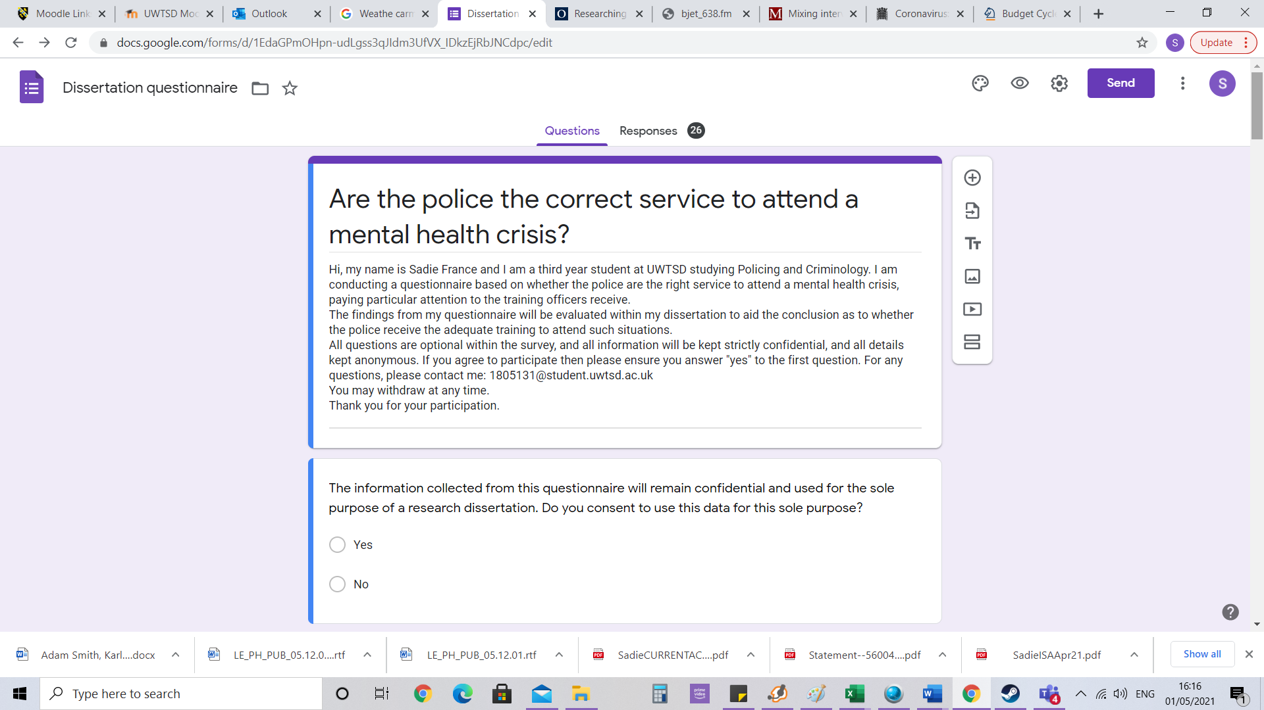

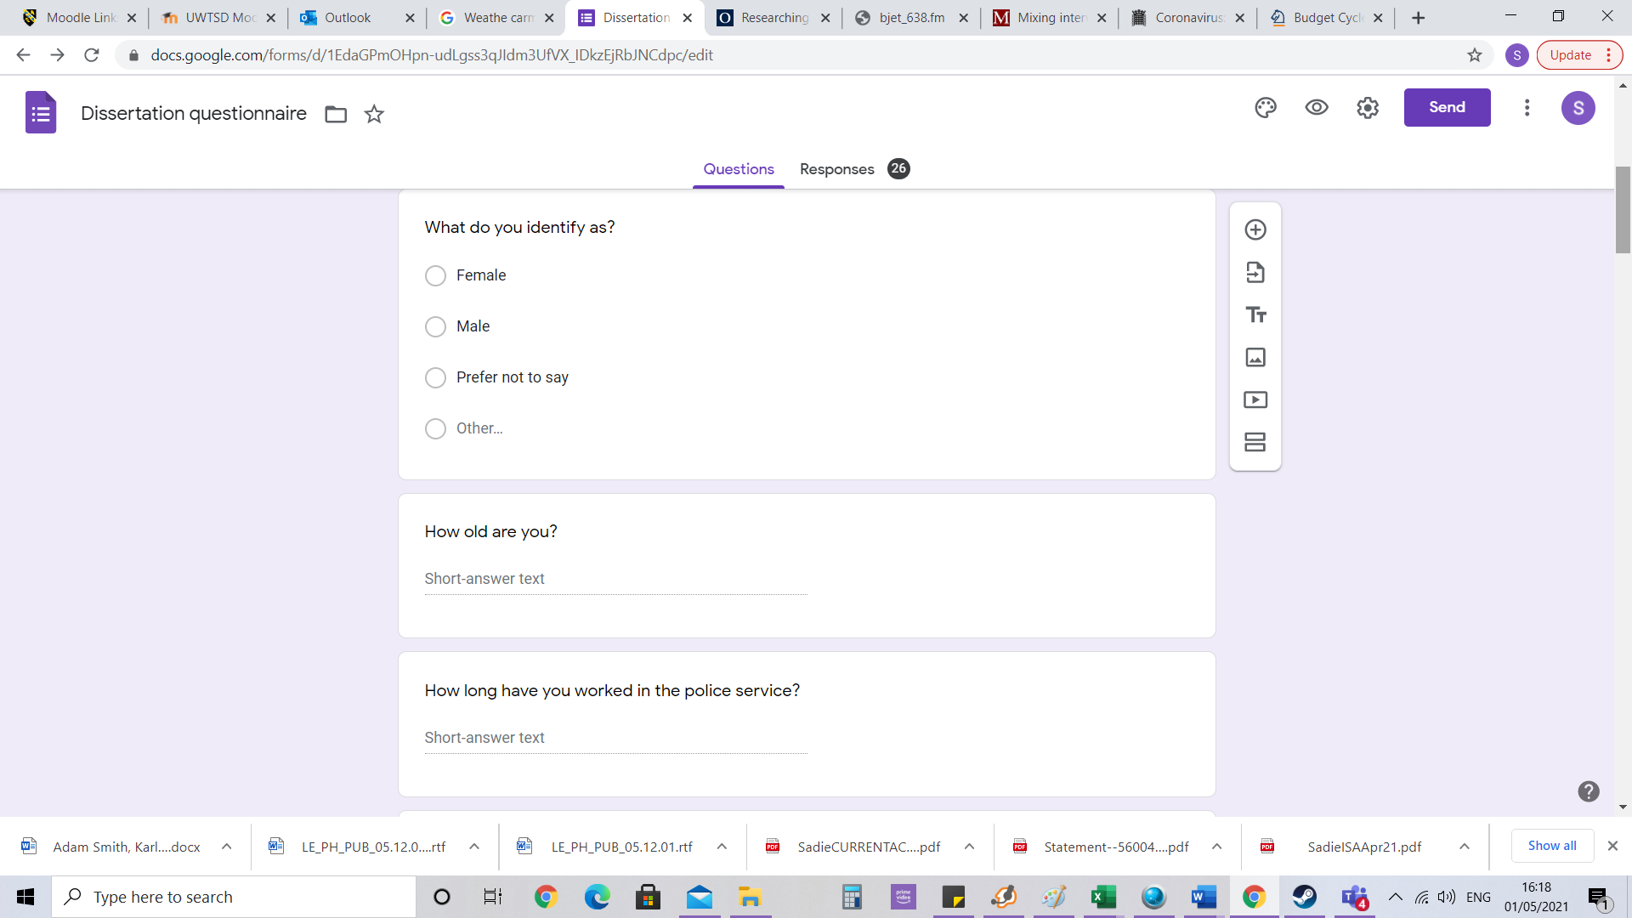
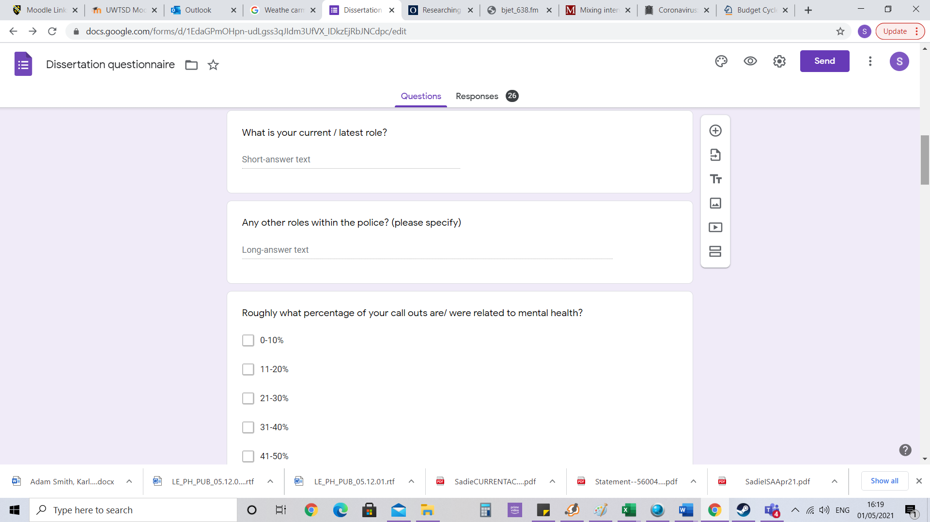

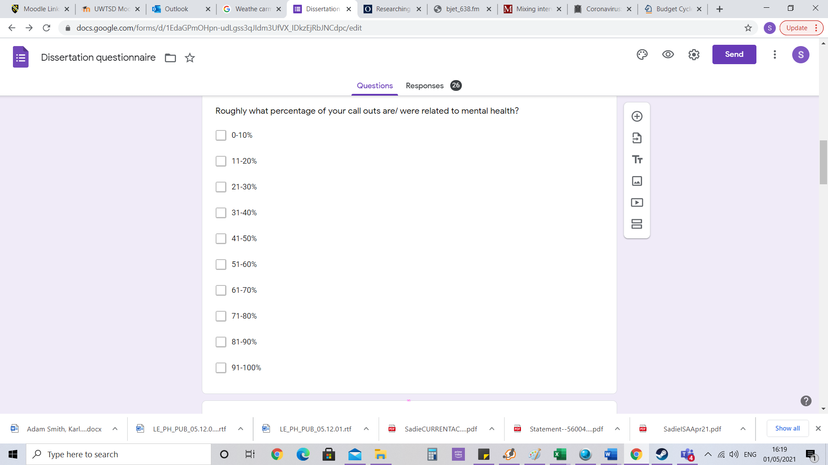
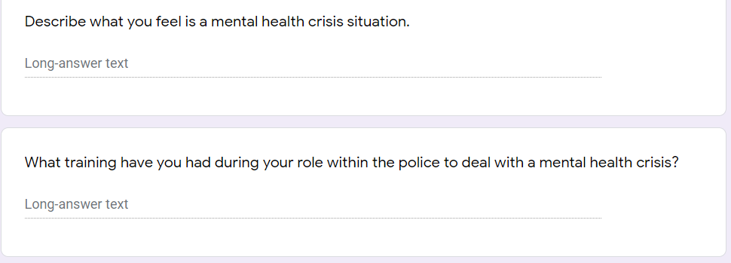
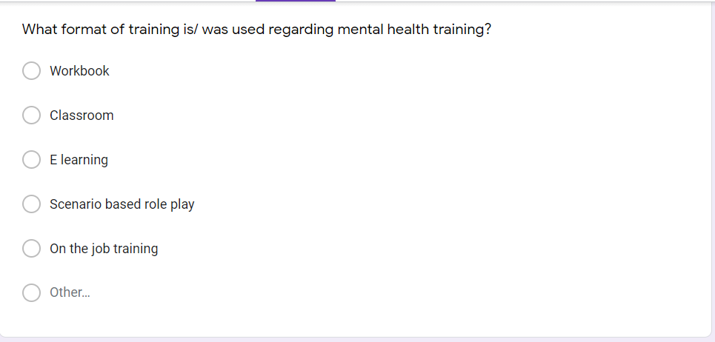

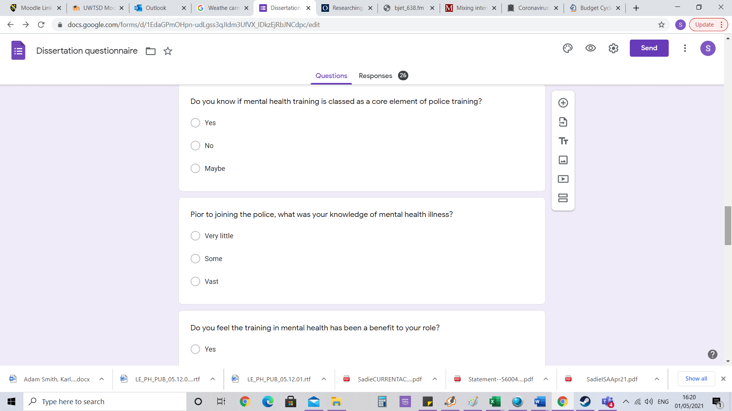
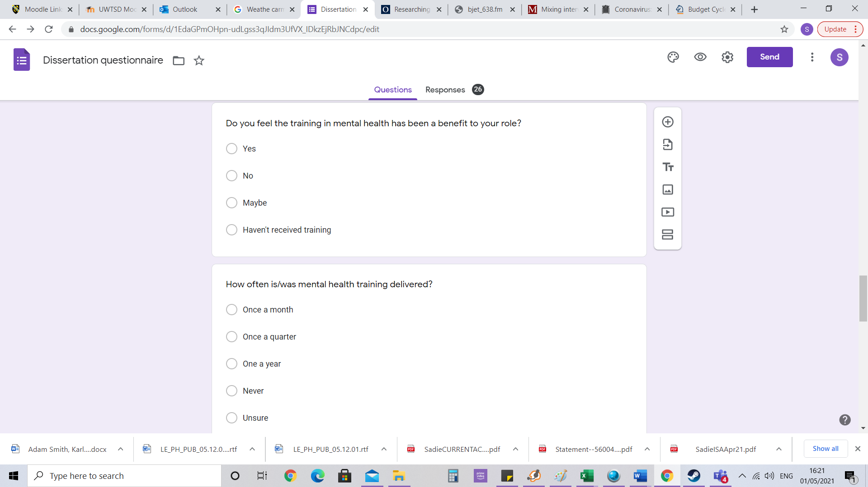

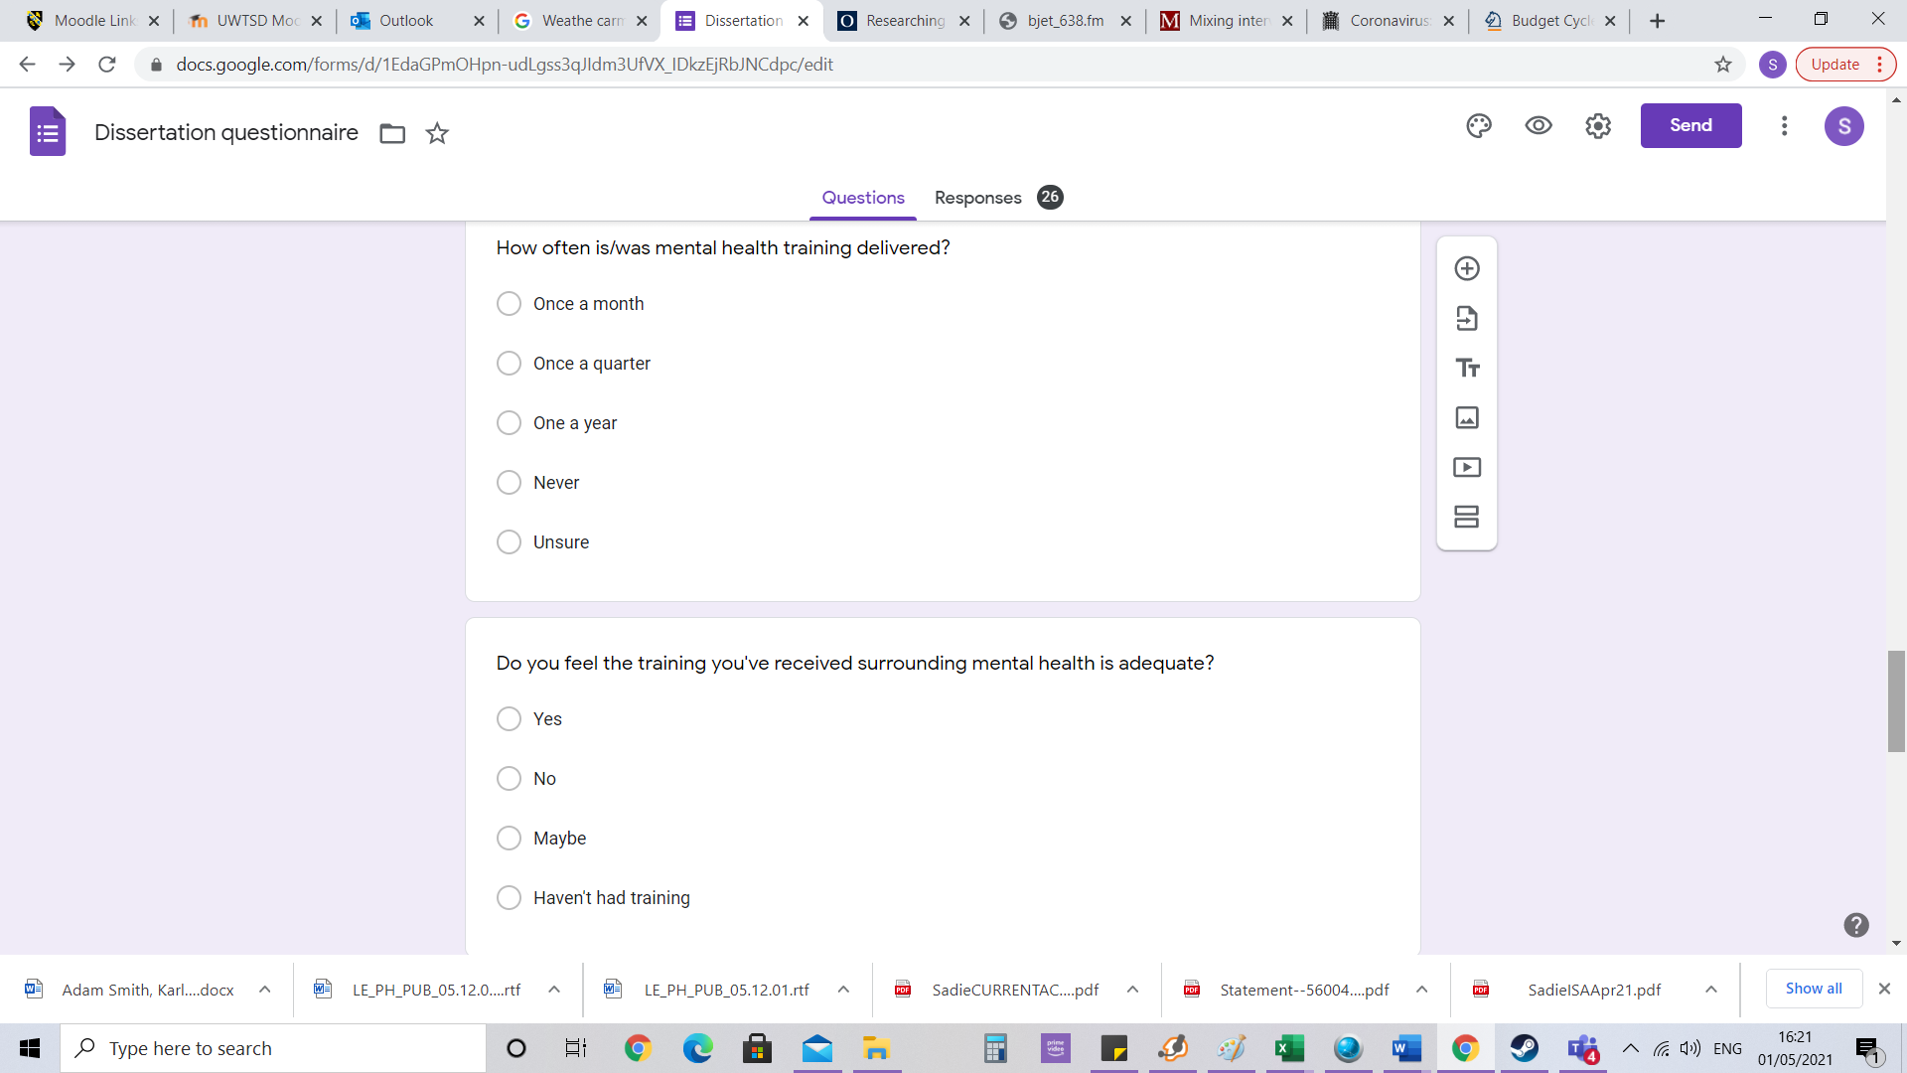

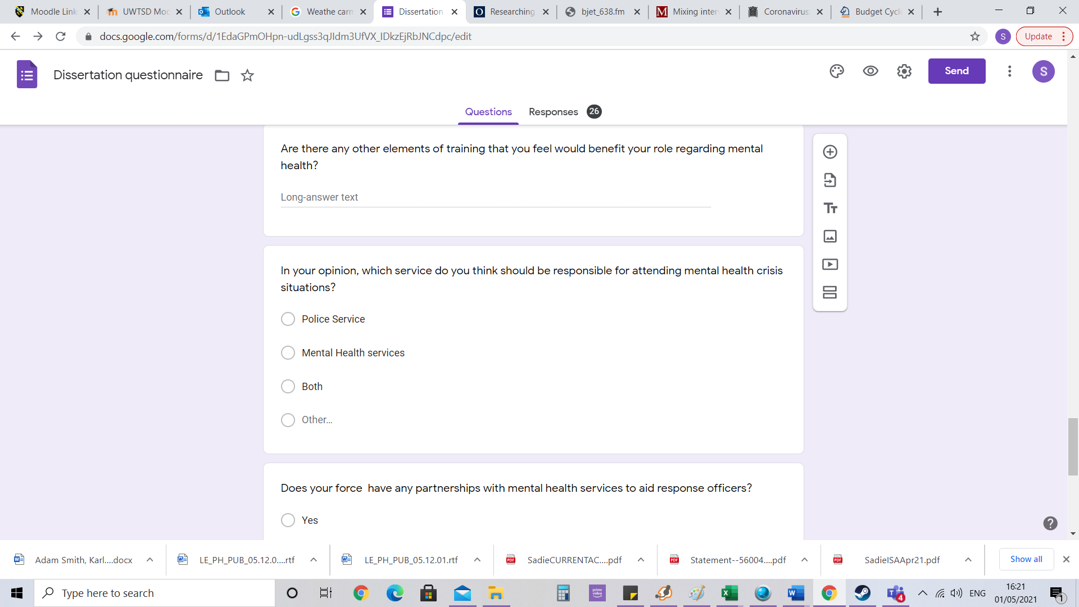

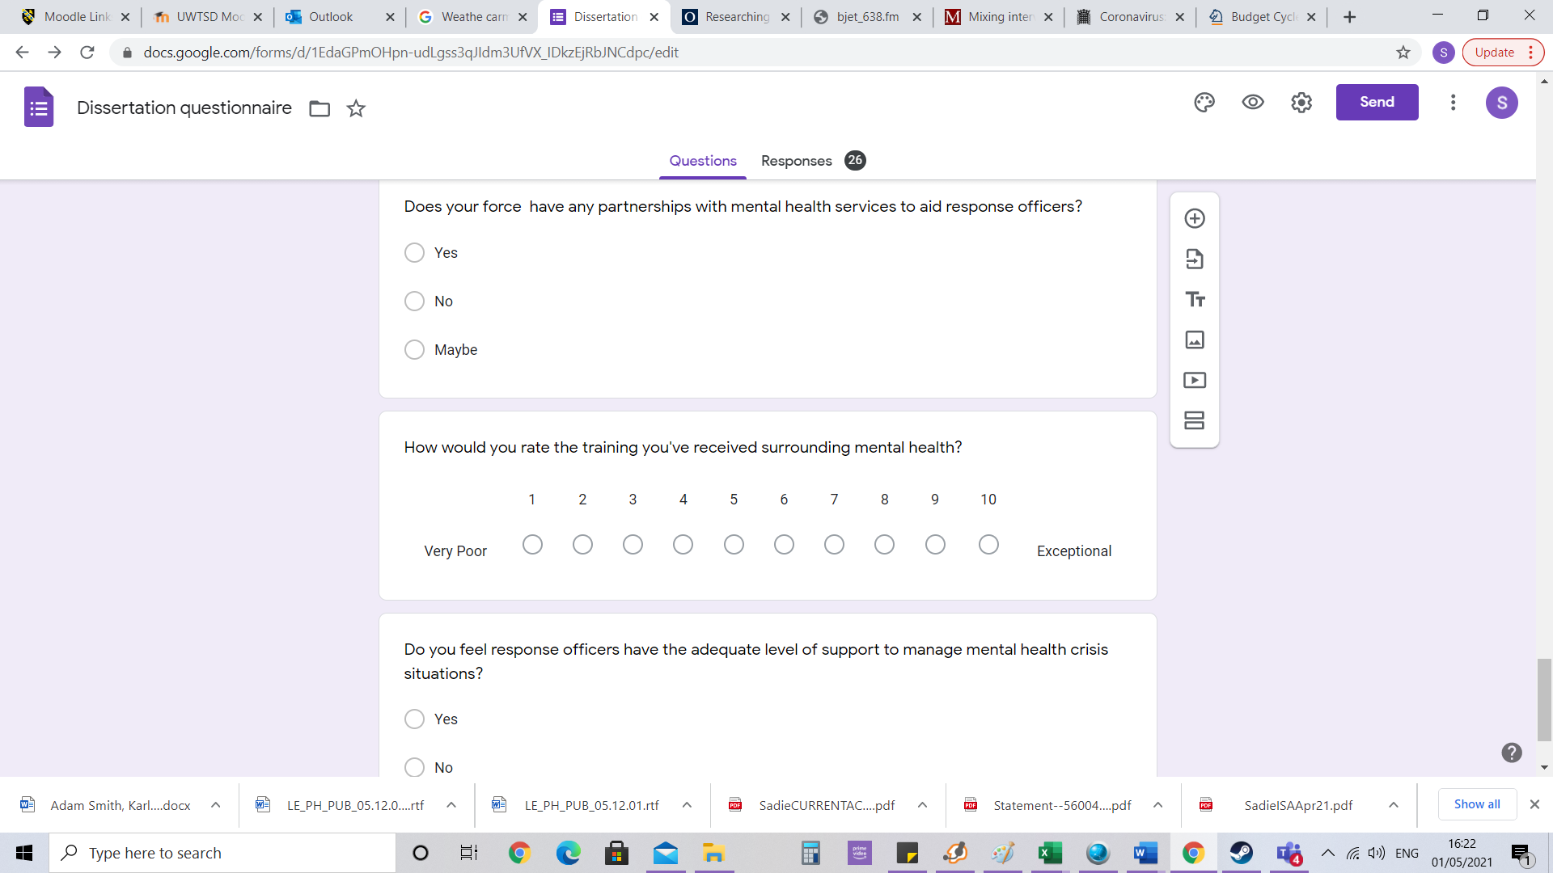
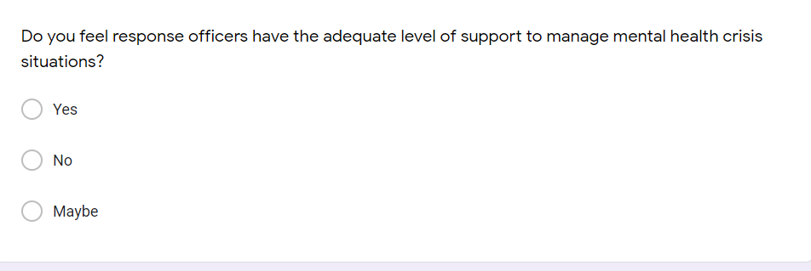

Research B
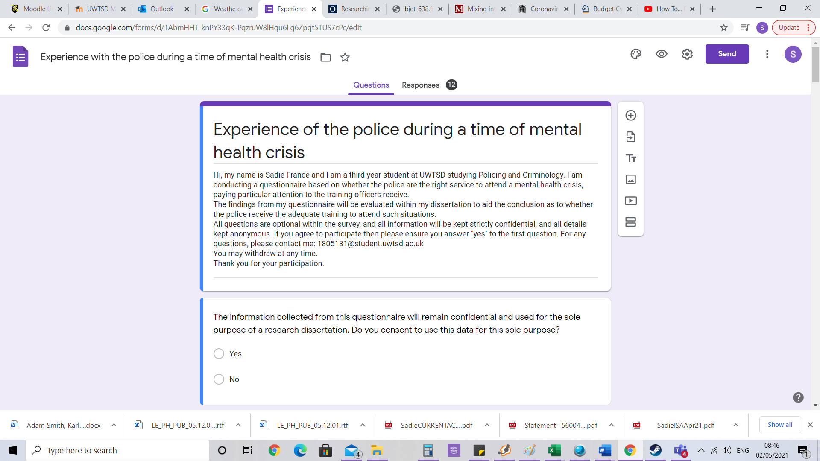

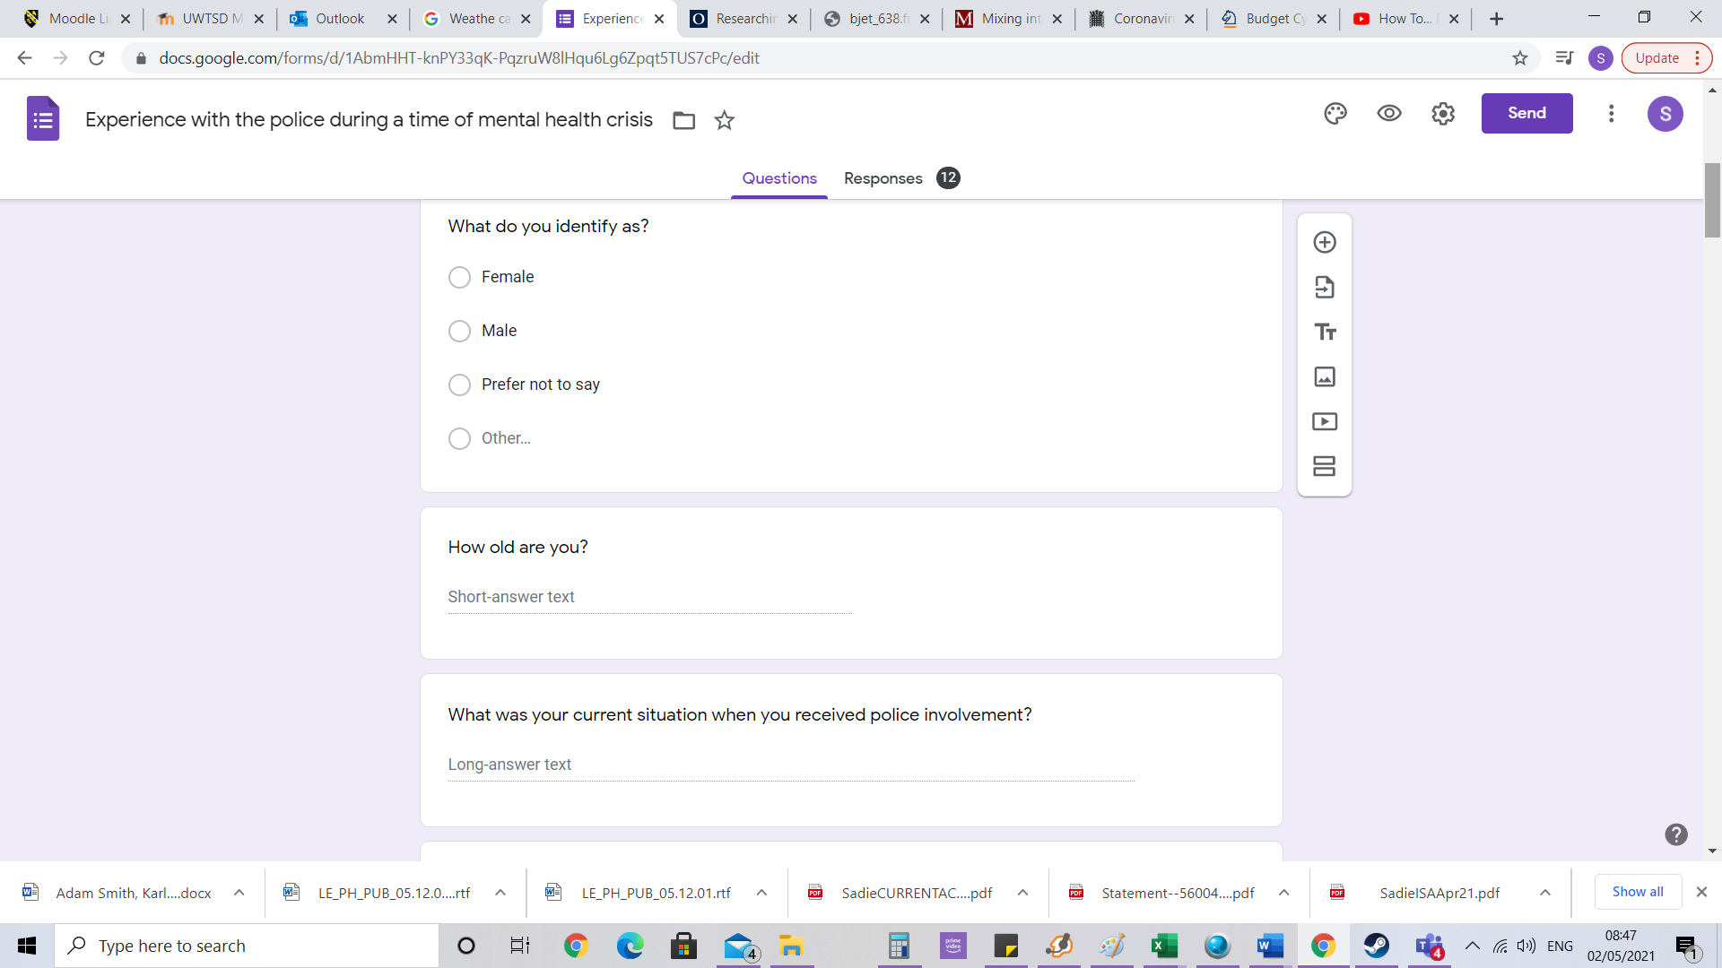

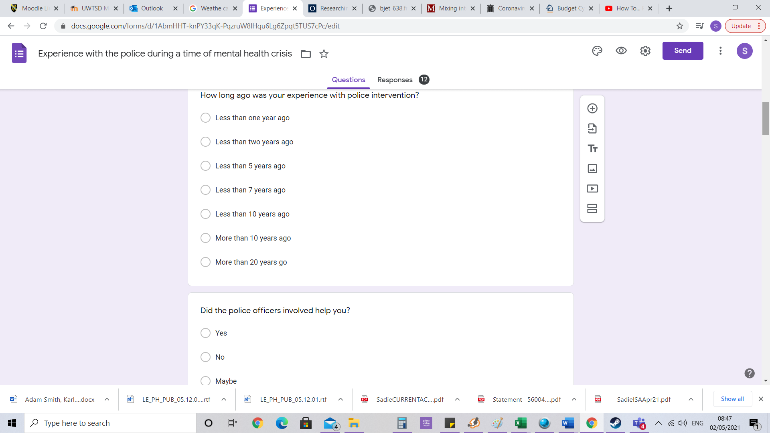
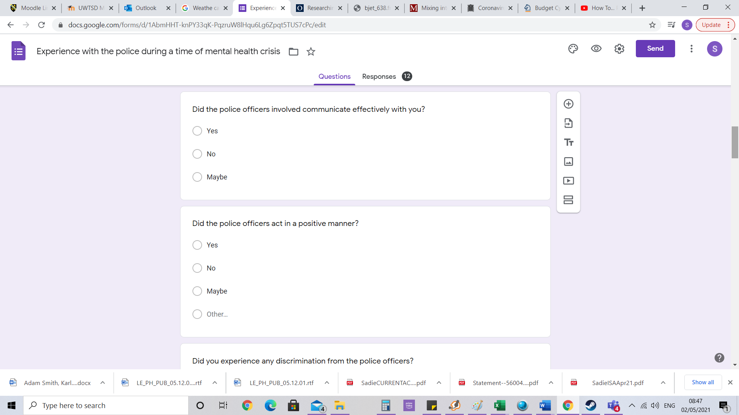
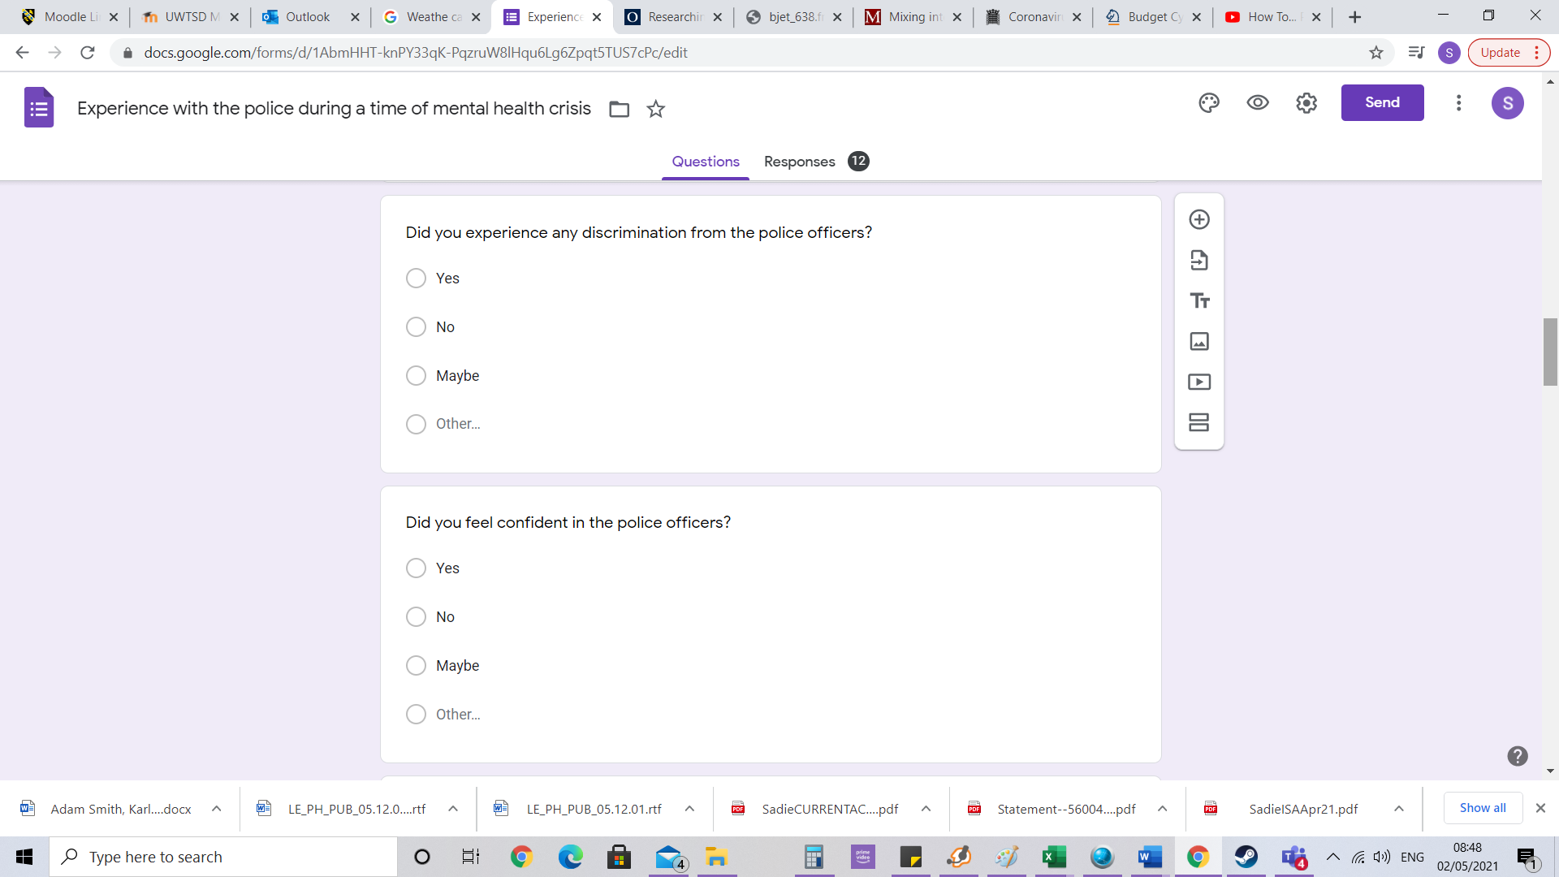
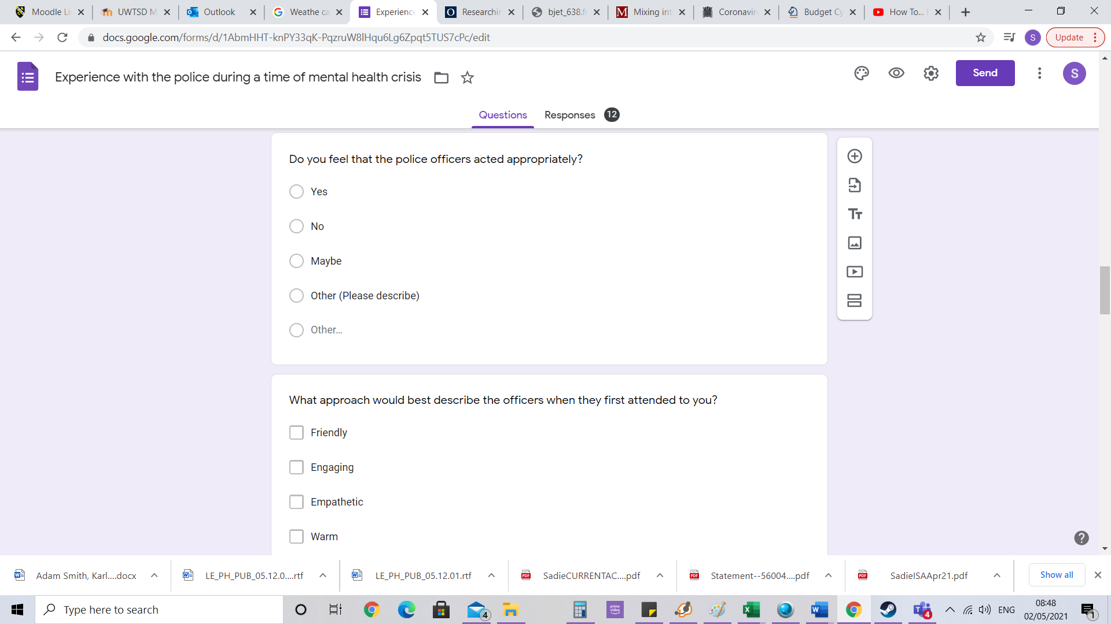

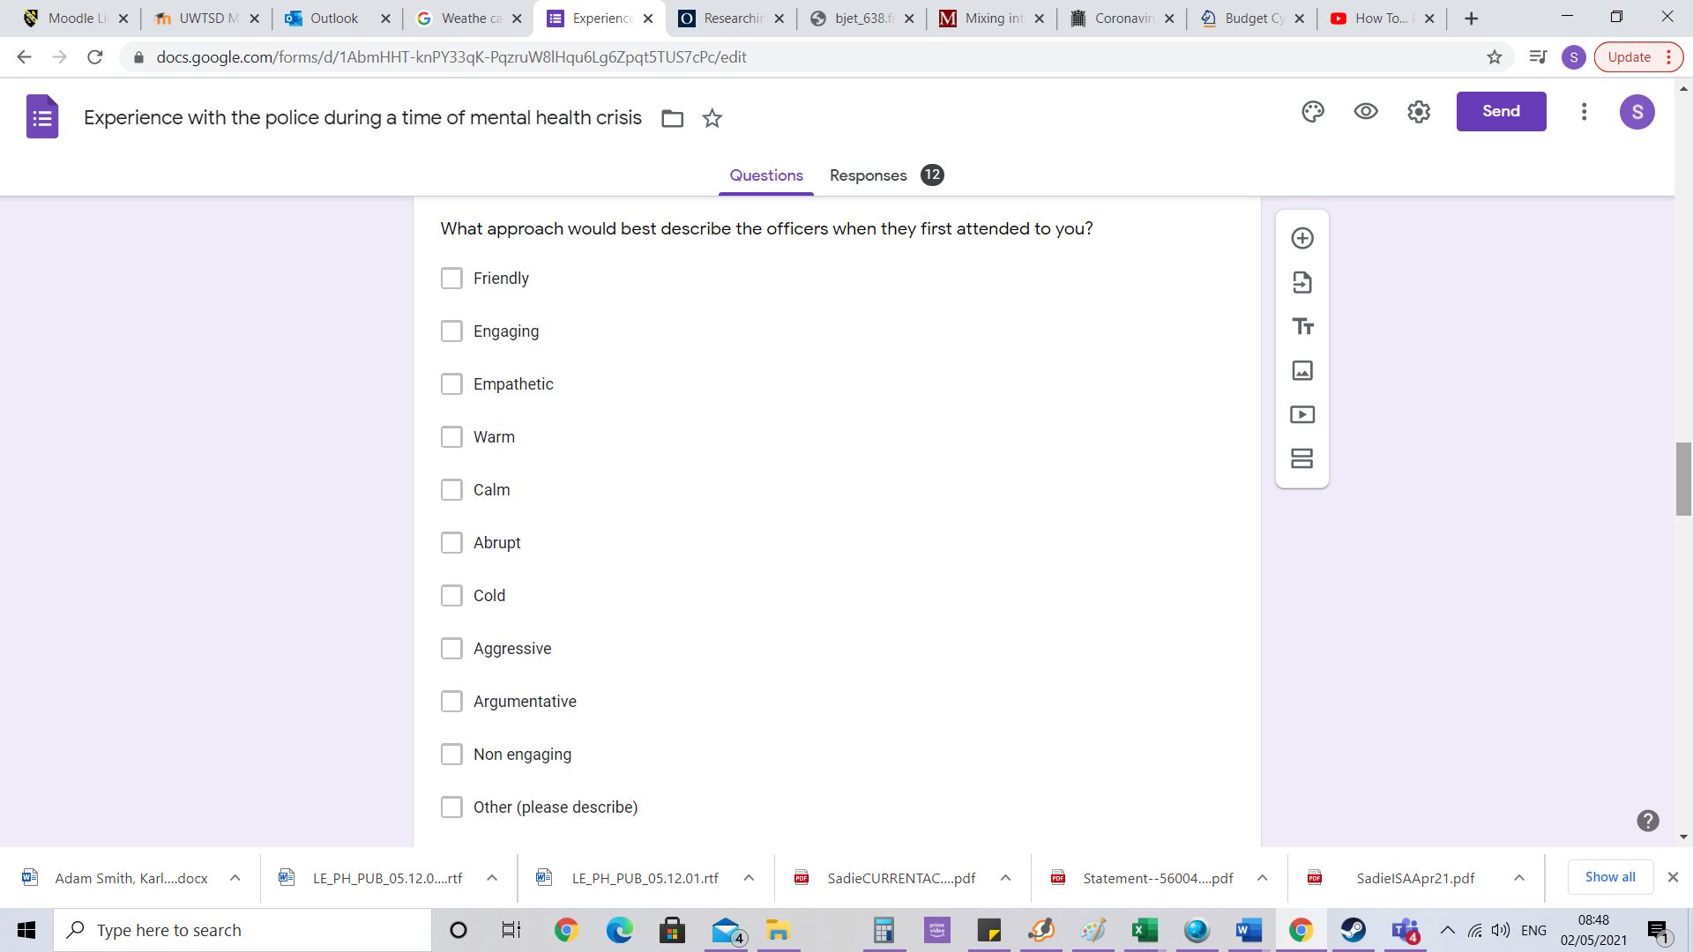
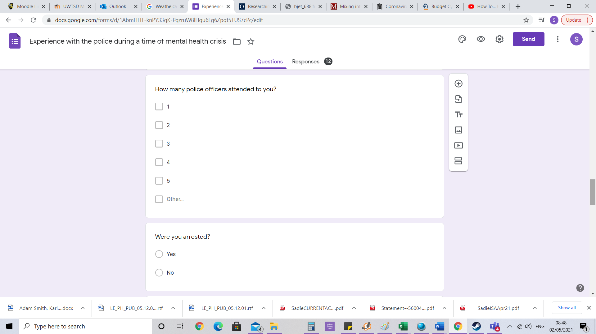

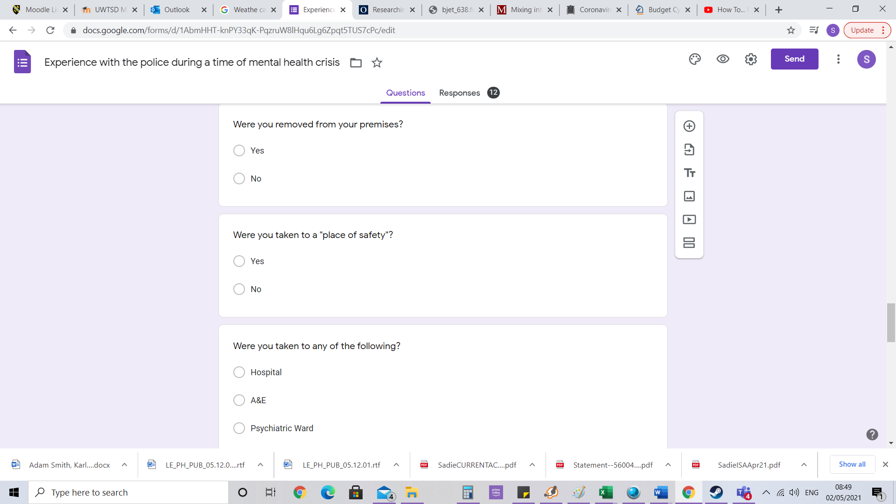

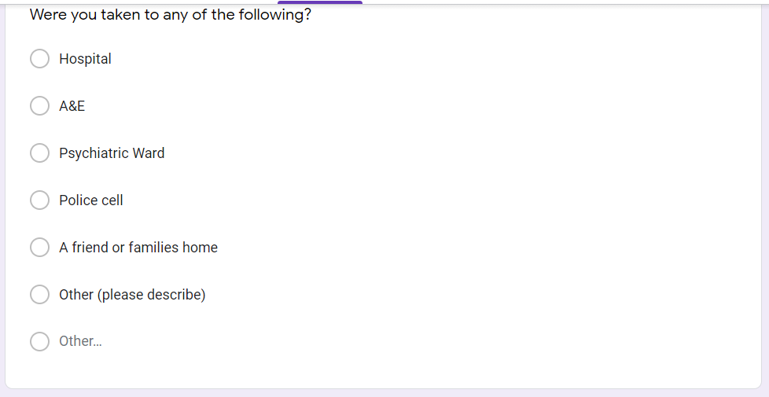
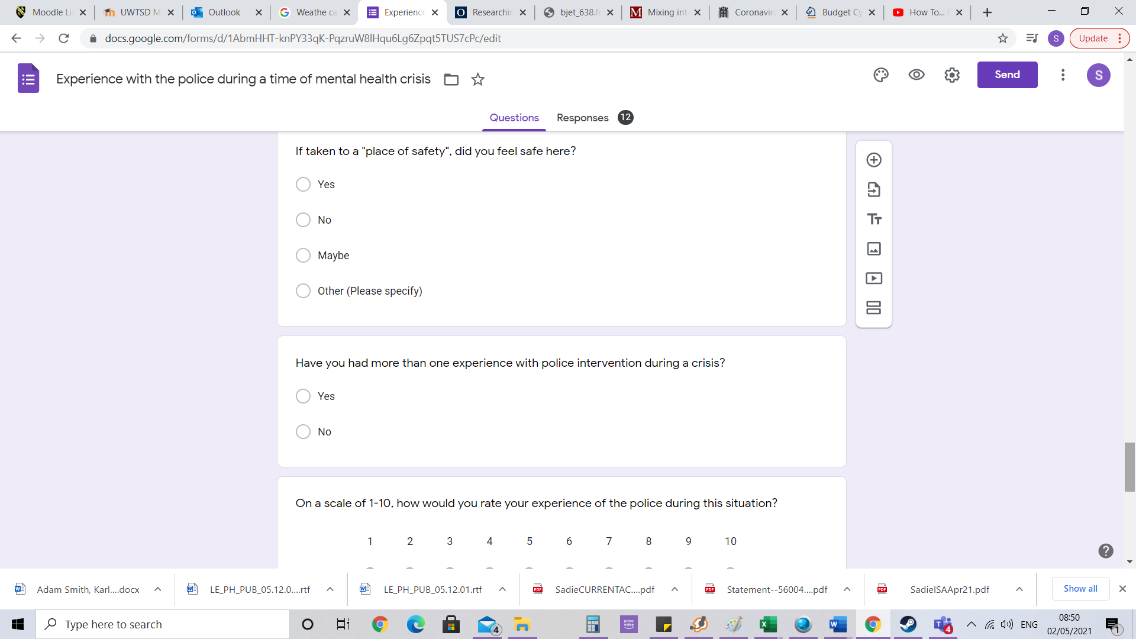

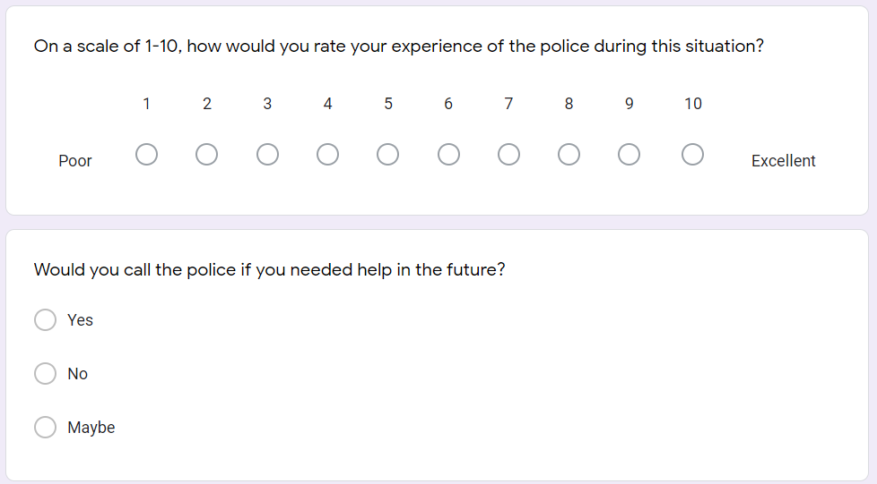

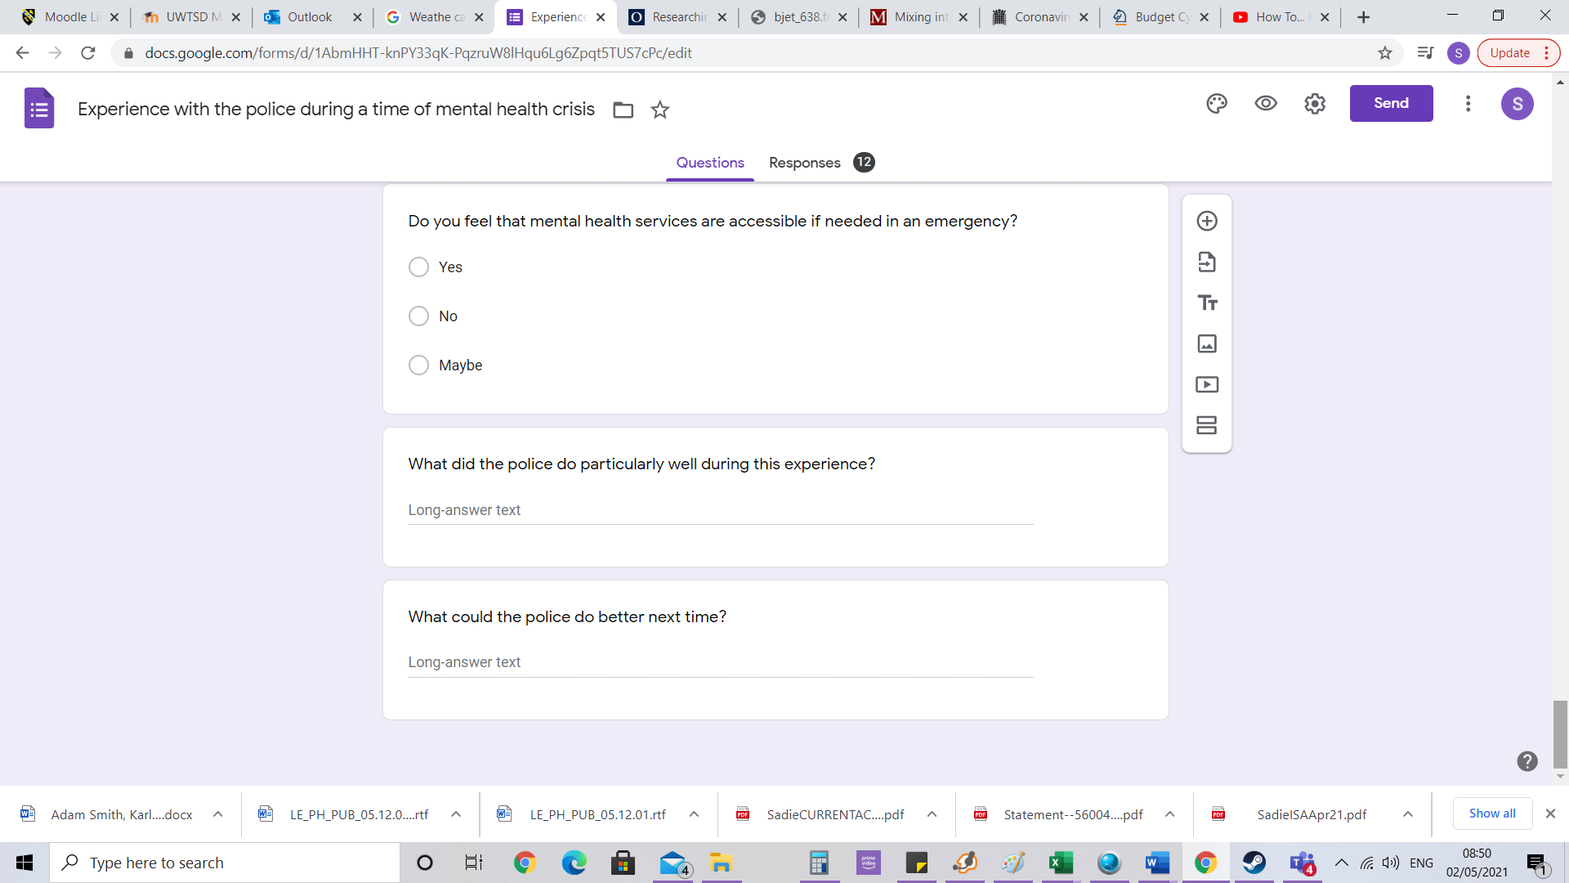

Interview

Q1. The information collected from this interview will remain confidential and used for the sole purpose of a research dissertation. Do you consent to use this data for this sole purpose?

Q2. What do you identify as?

Q3. How old are you?

Q4. How long have you worked in the police service?

Q5. What is your current role/ latest role?

Q6. Any other roles within the police?

Q7. What is your understanding of mental health?

Q8. Describe a scene where a person is in mental health crisis? What would you expect to see?

Q9. Roughly what percentage of your call outs are related to mental health?
10-20%

21-30%

31-40%

41-50%

51-60%

61-70%

71-80%

81-90%

91-100%

Q10.What training have you had during your role within the police to deal with mental health crisis?

Q11.What format of training is used regarding mental health training?

Workbooks

Classroom based

E- learning

Scenario based role play

On the job

Other (please specify)

Q12.Was mental health training delivered as part of your induction training?
Yes

No

Q13.How often is training undertaken surrounding mental health?

Once a month

Once a quarter

Once every 6 months

Once a year

Unsure

Q14. Do you know if this is a core element of training?

Yes

No

Unsure

Q15. Do you feel confident with the level of training given surrounding mental health?

Yes

No

Unsure

Q16. Would you like to see more training surrounding mental health?
Yes

No

Unsure

Q17. In terms of knowledge surrounding mental health, how would you describe the training?

Given you very little knowledge into mental health.

Given you some knowledge into mental health.

Given you an in-depth understanding of mental health.

Q18. Are there any other elements of training that you think would bring value to your role surrounding mental health?

Q19. In your opinion, which service do you think should be responsible for attending mental health crisis situations?

Police

Mental health services

Both

Q20. Does your force have any partnerships with mental health services to aid response officers?
Yes

No

Unsure

Q21. What was your knowledge of mental health before the training?
Scale 1-10 (1 Being very little knowledge , 10 being a vast amount of knowledge)

