AA

Application development
BSc/HND Computing

Jason Edwards (1910399)
1910399@student.uwtsd.ac.uk

Contents
1 Introduction 2
2 Application Development Concepts 2
2.1 Web Development Trend 2
3 Requirements 4
3.1 Introduction 4
3.2 Functionality 4
4 Design 5
4.1 Page 1 (Index Page) 5
4.2 Page 2 (About Page) 5
4.3. Page 3 (England Page) 5
4.4. Page 4 (France Page) 6
4.5 Page 5 (Ireland Page) 6
4.6 Page 6 (Italy Page) 6
4.7 Page 7 (Scotland Page) 6
4.8 Page 8 (Wales Page) 6
5 Implementation 6
5.1 Interactive Functionality 6
5.2 Screen shots 7
6 Evaluation 11
6.1 Browser Testing 11
6.2 Test case testing 12
6.3 Reflection 12
7 References 13
7.1 Image references 14

1 Introduction
This report outlines the research activities of application development. The report will contain a detailed review of current (within the last 12 months) application development trend and also the requirements, design and implementation and evaluation of the 6 Nations 2020 website that has been created by the author, Jason Edwards.

2 Application Development Concepts

2.1 Web Development Trend
Using Google, the author searched for “Web development trends”, selected tools and then Past Year as the time range and used the 1st page of results to collate a list of current development trends as stipulated in the assignment description the author
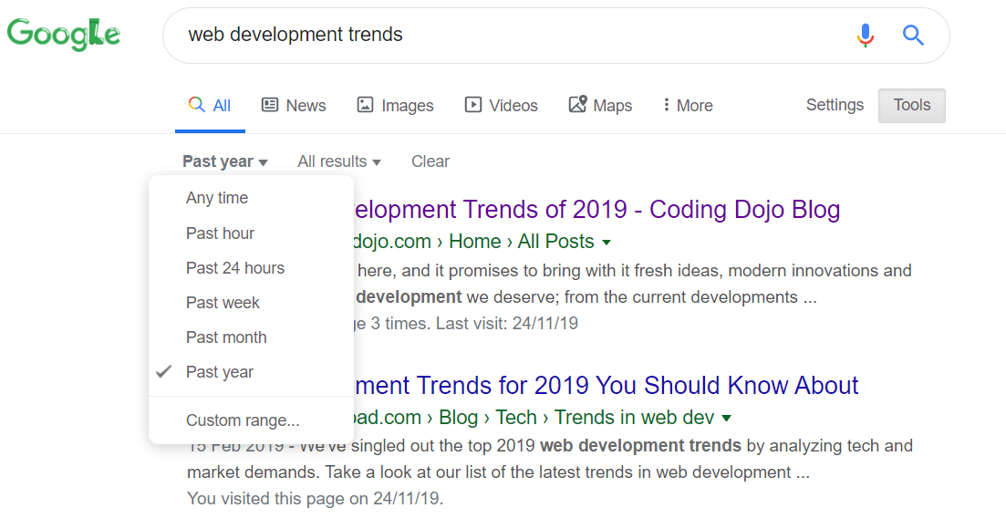
The research highlighted the top three trends as detailed in seven websites visited are:-
- Progressive Web Applications (PWAs)
- AI and Bots
- Motion UI and Voice Search optimisation
Research has identified that mobile users spend 87 percent of their time in apps, versus just 13 percent on the web [1] and in 2018, consumers downloaded 194 billion mobile apps to their connected devices, up from 143.7 billion app downloads in 2016 [2].
This all points to the mobile device being the preferred option for users to utilise applications but the vast majority are being downloaded.
The author will reference a report by Yberg [3] and his observations on PWAs.
A native app is an app for a certain mobile device. They’re installed directly onto the device and are typically downloaded from The App Store or Google Play [4].
Yberg states that “Native applications are hard and expensive to develop” [3]. This is because they require Software Development kits and need to be built for multiple platforms such as Android and iOS. There are further development needs if the app needs to work on a desktop. This requires the use of different languages, expertise and development environments.
Web technologies can be used to build applications for both mobile and desktop devices sharing more of the codebase so this can significantly reduce the resource required and a single application can be built which can be utilised across multiple platforms. This is beneficial for delivering the application quicker into the market-place and also widening the audience base to get a greater return on investment.
According to Google, which coined the term “Progressive Web App”, PWAs need to be reliable, fast and engaging[3], [5].
Reliable – fast loading and be able to work offline. Native apps will load fast and therefore PWAs need to perform to the same level or the user will have a bad experience and not use again. When launched from the user’s home screen, service workers (written in JavaScript) enable a PWA to load instantly, regardless of the network state, ensuring an instant and reliable experience for your users.
Fast – both at time of load-up and also when running to remove any buffering or even crashing. Analysis conducted shows that 53% of users will abandon a site if it takes longer than 3 seconds to load [6]. It should also react to user input and perform well with animation as like a native application.
Engaging – engage the user so that they come back to the app and utilise push notifications. PWAs are installable and live on the user's home screen, without the need for an app store. They offer an immersive full screen experience. A web app manifest file [a simple JSON file that tells the browser about the web application and how it should behave when 'installed' on the user's mobile device or desktop.) Having a manifest is required by Chrome to show the Add to Home Screen prompt [7].
Push notifications enable the app to extend beyond the browser and engage with the user. They can do simple things, such as alert the user to an important event, display an icon and a small piece of text that the user can then click to open up your site [8].
How do PWA work?
Yberg [3] comments that a PWA is an app that uses modern Web capabilities to offer users a very similar (if not better) experience to a native app. PWAs are a hybrid between regular web pages and mobile applications. The term “progressive” refers to the fact that they introduce new features and, from the user experience’s point of view, they are initially perceived as normal websites but progressively behave more like mobile apps [9].
Benefits of PWAs
PWAs have several advantages over traditional native mobile applications in that they are easier and cheaper to develop and distribute, and easier for users to access since they run inside a regular web browser. The purpose of PWAs is to provide users with well-performing applications packed with features previously only seen in native applications[9].
Who is using
Strongly promoted by Google and has been adopted by Twitter, Uber, Instagram [10] and the Washington Post as shown in the image below [11].
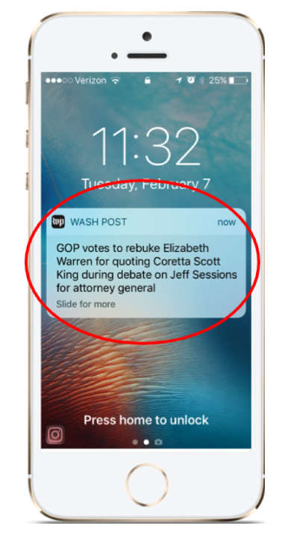

3 Requirements

3.1 Introduction
The 6 Nations 2020 website is targeted at users who are interested in rugby and specifically the 6 Nations tournament which is held annually (usually between February and March) and includes international rugby teams from England, France, Ireland, Italy, Scotland and Wales.
The Rugby World Cup was held in Japan between October and November 2019 and reports detail that over 12m UK viewers watched the Final held between South Africa and England [12].
This shows there is considerable interest in the rugby union and therefore is a relevant subject for the author. The author is also a former player of rugby union and attended multiple 6 Nations matches so can provided a personal perspective of what would be required from this type of website. The website will provide the user with details of the tournament and then specific details about each nation involved in the different competitions (men, women, Under 20s).

3.2 Functionality
Create a website with a minimum of 6 pages.
The website must be professional, responsive and interactive.
- The author will create the website using Microsoft Visual Studio, using both HTML for the webpage creation and CSS for styling.
- The author will utilise the Bootstrap 4 framework as this will allow for the webpages to be responsive and change display based on the device from which it is being used. A ‘mobile-first’ strategy so the webpages will be developed for small devices first and then ensuring they still work e.g. viewable on larger devices.
- The author will use JavaScript and in-built HTML capabilities to deliver user interaction so there is more to do than the normal scrolling.
The website needs to be browser-independent.
All images are free to use and are not restricted by copyright.
The website must consume a JavaScript web API. The author has researched and utilised the Google Maps API and this will enable a map image to be delivered onto the webpage page with a personalised icon to show the location of each of the 6 home stadiums being used by England, France, Ireland, Italy, Scotland and Wales.
The author has also adopted a countdown solution to show how long until the 2020 6 Nations tournament starts and also used this idea on the 6 team web pages to show the specific start time for each country.

4 Design

4.1 Page 1 (Index Page)
Background is white
Font used: Hind Vadoora
Navigation bar with black background and white text. Only a single option to progress to About Page
Rugby ball logo in the left-hand side of navigation bar
Image of rugby field filling complete screen
A countdown timer is displayed using JavaScript
Button to progress to About Page

4.2 Page 2 (About Page)
Background is white
Font used: Hind Vadoora
Navigation bar with black background. The font colour of each of the countries in the navigation bar reflect the colour they play in when paying at home e.g. England is white, Wales is Red.
Rugby ball logo in the left-hand side of navigation bar
Jumbotron with rugby ground scene
Responsive design utilising bootstrap – sections will display as 2 columns with each section being 6 columns wide.
Image of 6 Nations countries. When this image is clicked it will provide additional background on the tournament via JavaScript.
Image of 6 Nations trophy. When this image is clicked it will provide information.
Hover over “wooden spoon” to display image of a wooden spoon.
Form to join mailing list. Front end input only with basic validation for email.
Footer with sitemap for additional navigation options

4.3. Page 3 (England Page)
Background is white
Font used: Hind Vadoora
Navigation bar with black background. The font colour of each of the countries in the navigation bar reflect the colour they play in when paying at home e.g. England is white, Wales is Red. Except the country that is being viewed is in grey and underlined to show that page is active.
Rugby ball logo in the left-hand side of navigation bar
Jumbotron with image of Twickenham stadium. Within Jumbotron is countdown timer to first match of match.
Google map via API showing home ground location. Image of stadium used instead of marker/flag.
Responsive design utilising Bootstrap 4 framework
Onmouseover functionality to display home colour shirt and England flag
The five fixtures for the country are shown
Footer with sitemap for additional navigation options

4.4. Page 4 (France Page)
Same design as England but details, images and fixtures specific to France

4.5 Page 5 (Ireland Page)
Same design as England but details, images and fixtures specific to Ireland

4.6 Page 6 (Italy Page)
Same design as England but details, images and fixtures specific to Italy

4.7 Page 7 (Scotland Page)
Same design as England but details, images and fixtures specific to Scotland

4.8 Page 8 (Wales Page)
Same design as England but details, images and fixtures specific to Wales

5 Implementation

5.1 Interactive Functionality
The author has implemented interactive functionality via JavaScript.
The JavaScript used by the author is active within the About.html page. When a user clicks on either of the images on this page (user is prompted to do so) then information about the image is displayed in a pop-up box. The user can then close the popup and continue browsing.
The author has also utilised hover to display a wooden spoon when the user moves the mouse pointer over the text “wooden spoon” on the About.html page.
HTML
<p>Will Italy avoid the <span><u>"wooden spoon"</u></span> and not finish bottom of the table as they did last year?
<img id="spoon" src="assets/images/wooden spoon.jpg" width="60" height="60" />

CSS
img#spoon {
display: none
}
span:hover + img#spoon {
display: block;
}
JavaScript API
The author has used the Google Maps API to embed a Google Map image in each of the country webpages.
The author has coded map so that:
- The stadium location is centred and cannot be changed
- It cannot be zoomed in/out or moved, street view and full screen zoom disabled
- The co-ordinates for the home stadium for the nation have been input
- A stadium icon which replaces the standard Google marker.
- When the mouse hovers over the stadium, ‘Home of x Rugby’ will display

5.2 Screen shots
Index.html Page
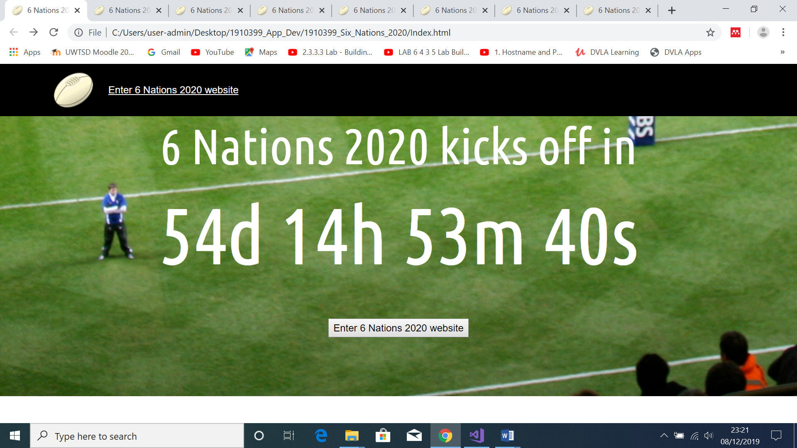
About.html Page
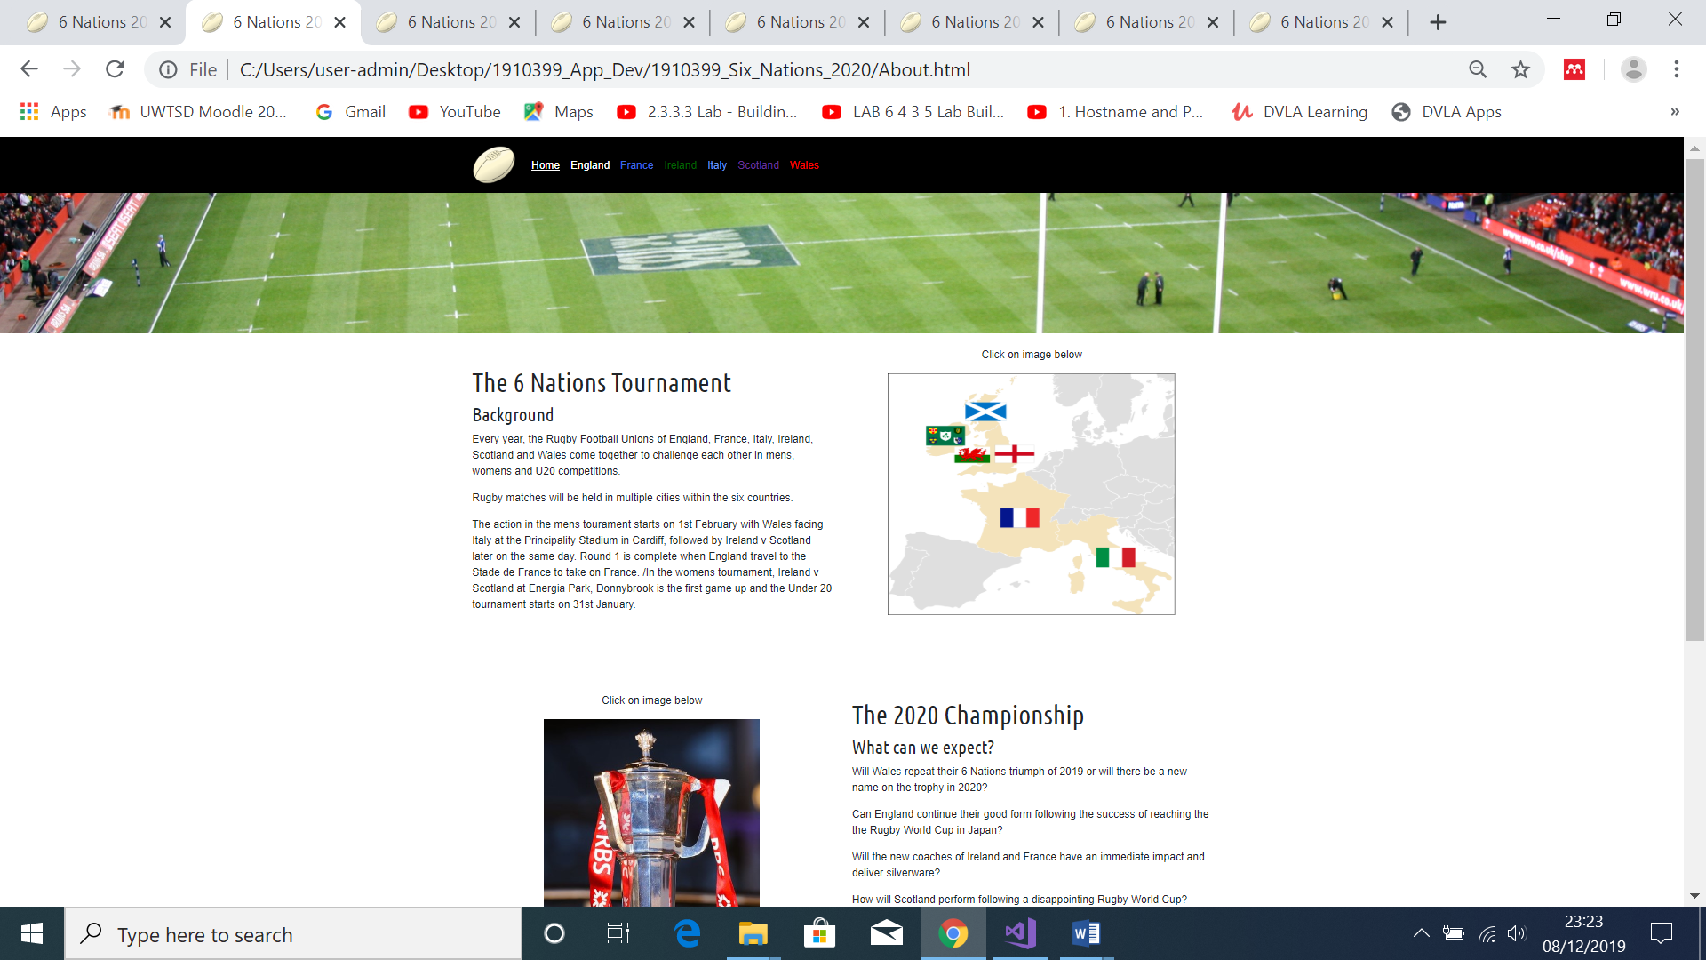
England.html Page
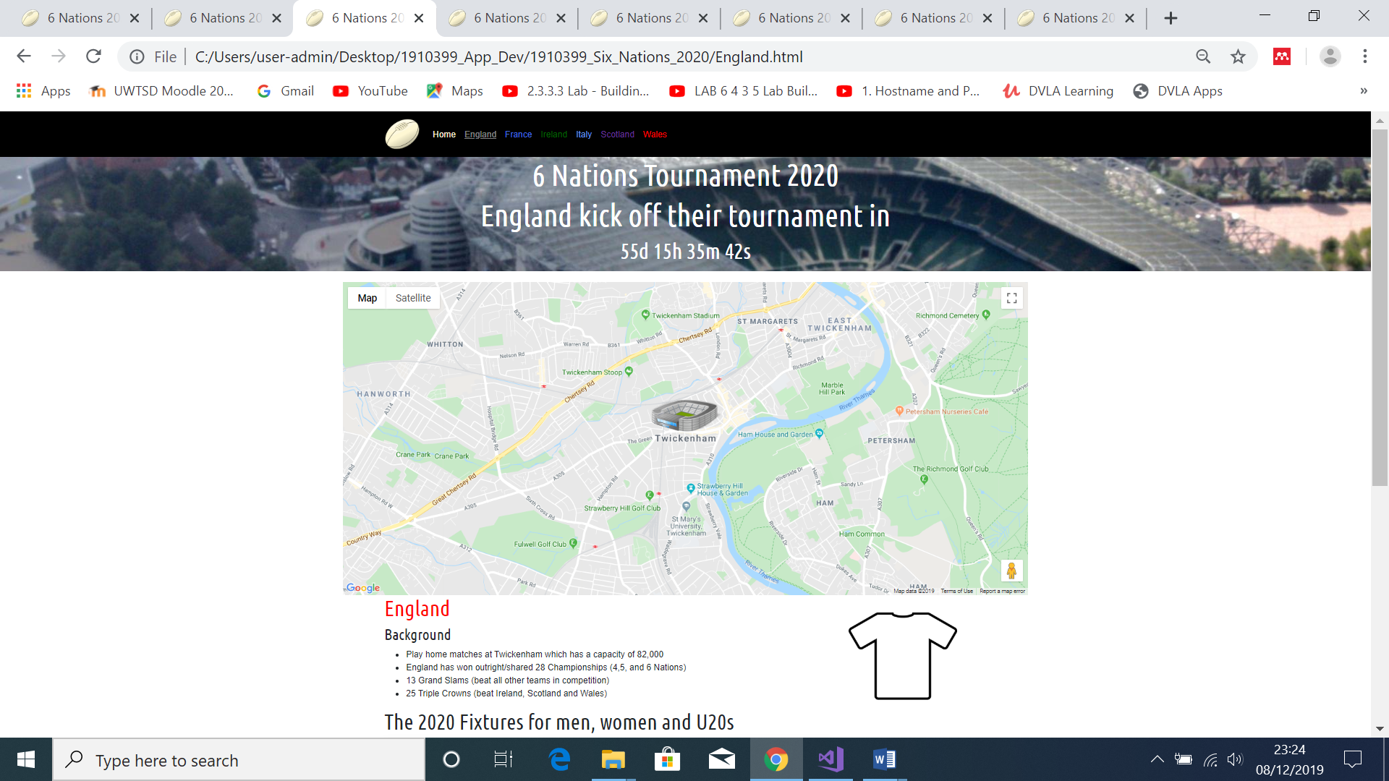
France.html Page
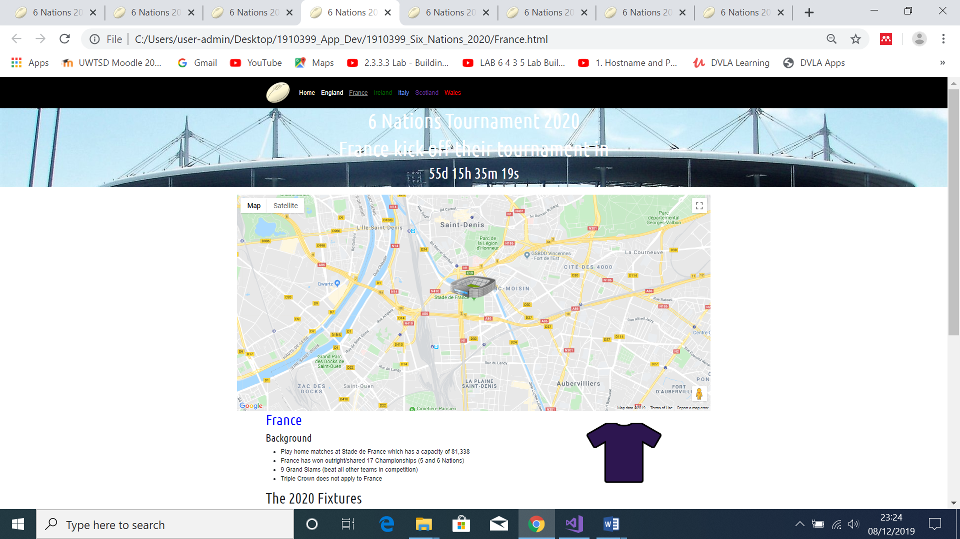
Ireland.html Page
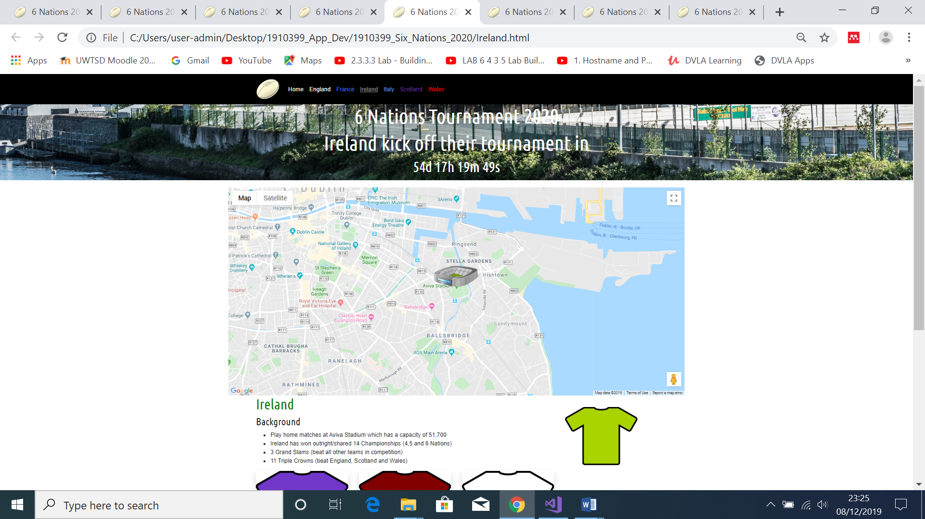
Italy.html Page
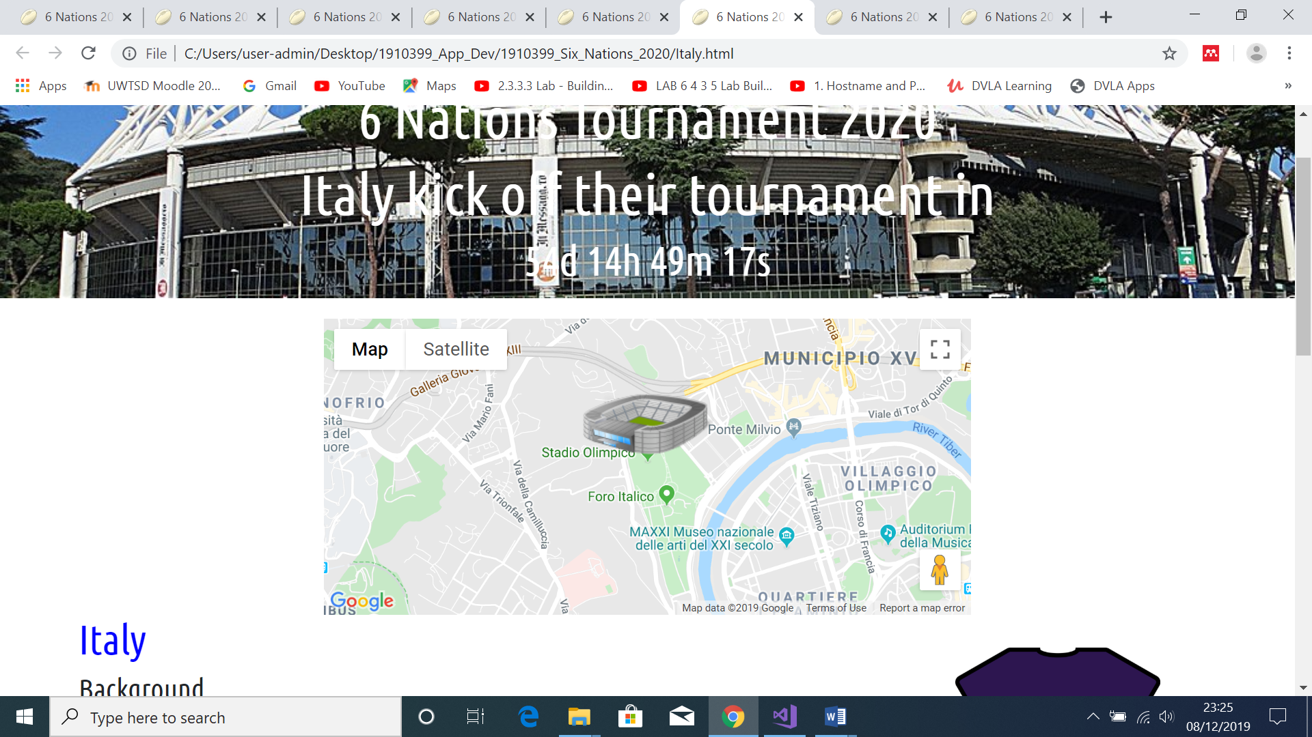
Scotland.html Page
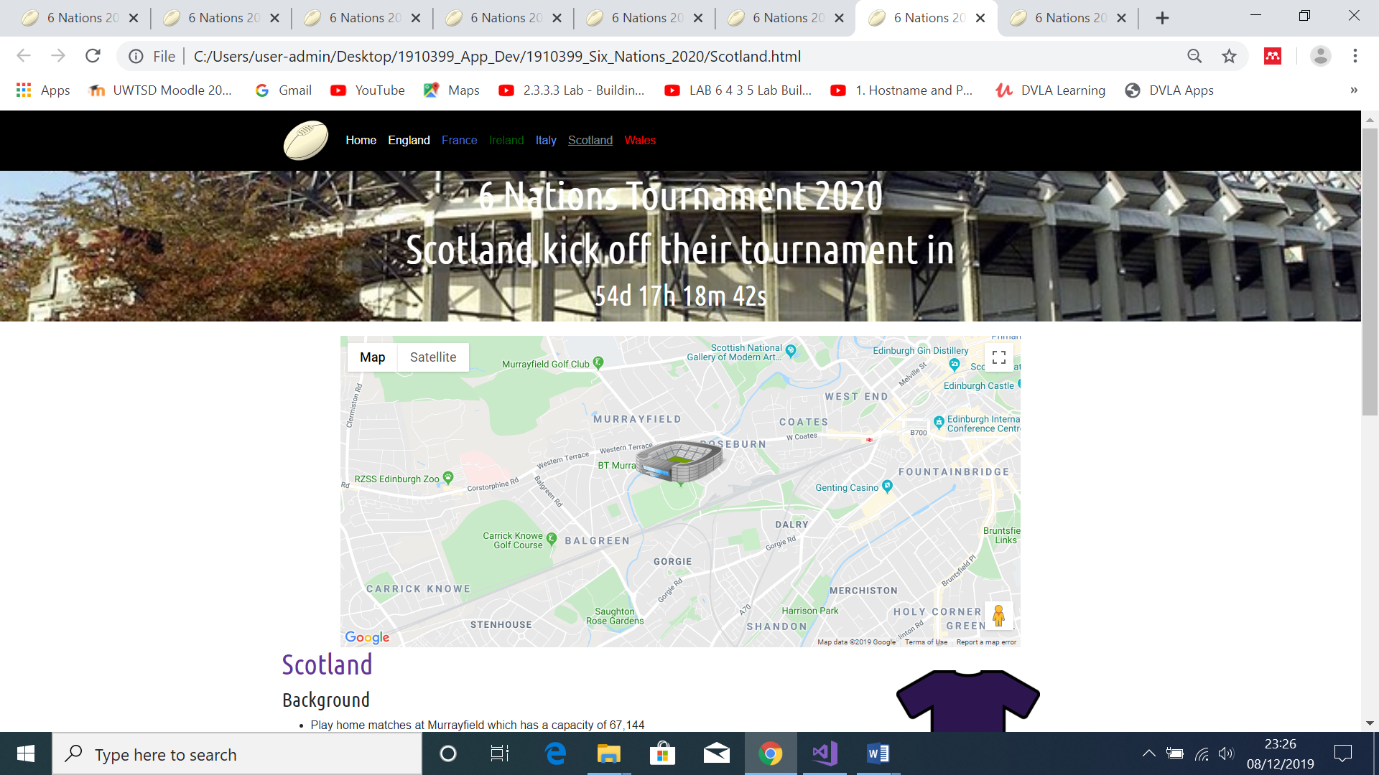
Wales.html Page
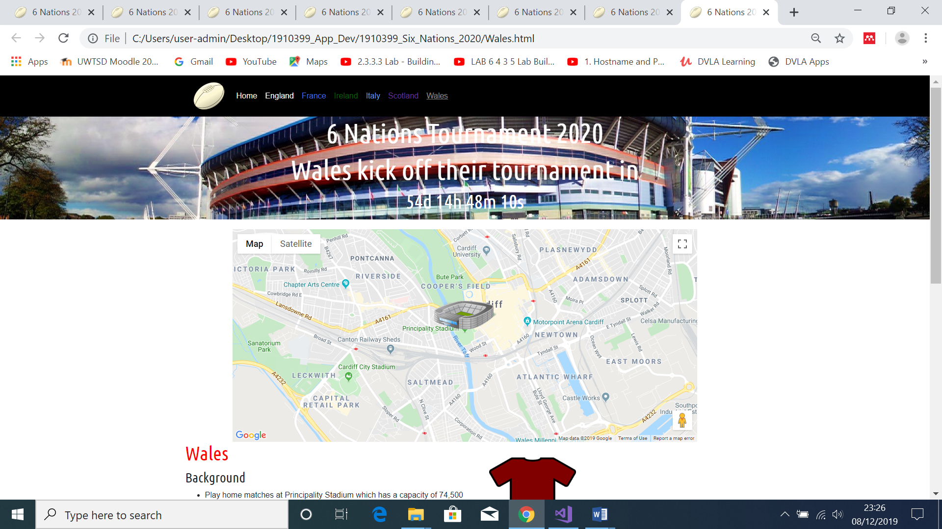

6 Evaluation

6.1 Browser Testing
Image below of England.html displayed in Google Chrome
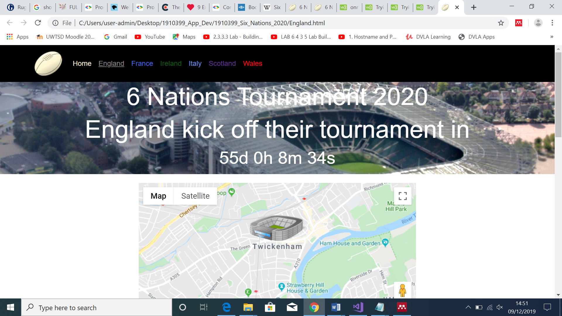

Image below of England.html displayed in Microsoft Edge
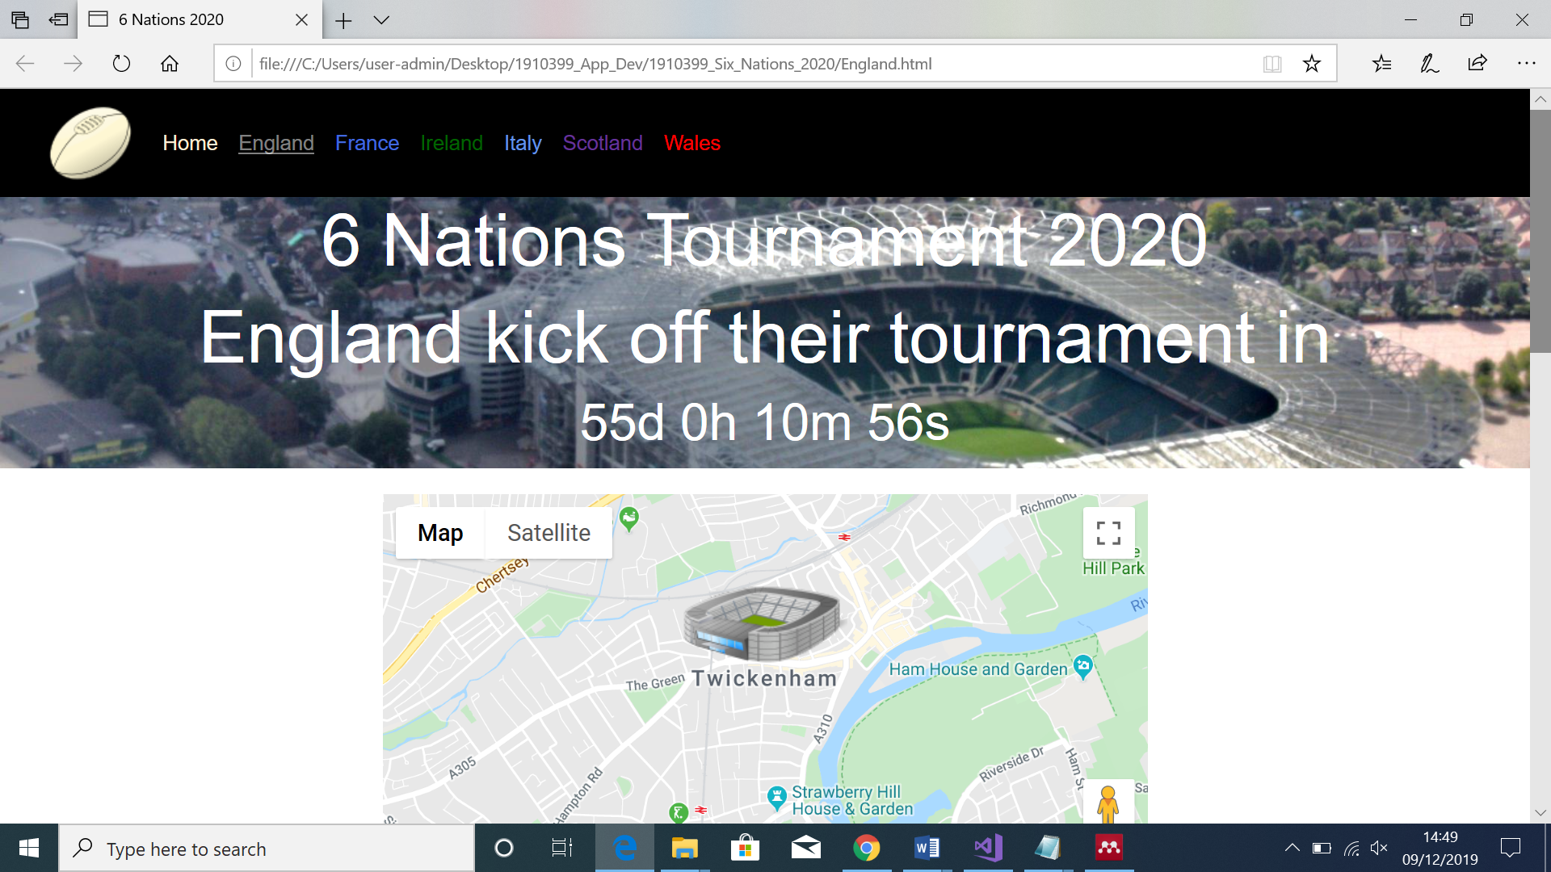

6.2 Test case testing
The author has conducted testing of the functionality of the website as stipulated in the assignment brief. Below are the results.

6.3 Reflection
The author is confident that the website he has designed meets the assignment requirements. The website is professional in appearance and has all the functionality of a modern website. Bootstrap framework has been utilised so that it is responsive and can be viewed on multiple devices and viewpoints. The website includes JavaScript to deliver interactivity and also a JavaScript API as stipulated in the assignment brief.
This has been a steep learning curve for the author who has very little experience of web-design. The author acknowledged a lack of knowledge and therefore undertook some self-learning to increase capability to deliver a product that meets the assignment criteria. A better understanding of the HTML and CSS basics would have saved significant effort in the design phase. The author would implemented a carousel on the country pages rather than a Jumbotron and this would have increased the interactivity and made the website even more professional.

7 References
[1] “2017 U.S. Mobile App Report.” [Online]. Available: https://www.slideshare.net/comScoremarcom/2017-us-mobile-app-report. [Accessed: 09-Dec-2019].
[2] “• Annual number of mobile app downloads worldwide 2018 | Statista.” [Online]. Available: https://www.statista.com/statistics/271644/worldwide-free-and-paid-mobile-app-store-downloads/. [Accessed: 09-Dec-2019].
[3] V. Yberg, “Native-like Performance and User Experience with Progressive Web Apps,” 2018.
[4] “Native App vs. Mobile Web App: A Quick Comparison.” [Online]. Available: https://www.webfx.com/blog/web-design/native-app-vs-mobile-web-app-comparison/. [Accessed: 09-Dec-2019].
[5] “Progressive Web Apps | Google Developers.” [Online]. Available: https://developers.google.com/web/progressive-web-apps/. [Accessed: 09-Dec-2019].
[6] “Mobile site load time statistics - Think with Google.” [Online]. Available: https://www.thinkwithgoogle.com/data/mobile-site-load-time-statistics/. [Accessed: 09-Dec-2019].
[7] “The Web App Manifest | Web Fundamentals | Google Developers.” [Online]. Available: https://developers.google.com/web/fundamentals/web-app-manifest. [Accessed: 09-Dec-2019].
[8] “Introduction to Push Notifications | Web | Google Developers.” [Online]. Available: https://developers.google.com/web/ilt/pwa/introduction-to-push-notifications. [Accessed: 09-Dec-2019].
[9] “Progressive Web App (PWA): what they are, pros and cons and the main examples on the market.” [Online]. Available: https://medium.com/iquii/progressive-web-app-pwa-what-they-are-pros-and-cons-and-the-main-examples-on-the-market-318f4538c670. [Accessed: 09-Dec-2019].
[10] “9 Examples of Brilliant Progressive Web Apps (PWAs).” [Online]. Available: https://www.biggerpicture.agency/insights/9-examples-of-brilliant-progressive-web-apps-pwas. [Accessed: 09-Dec-2019].
[11] “The Pros and Cons of Progressive Web Apps | Clutch.co.” [Online]. Available: https://clutch.co/app-developers/resources/pros-cons-progressive-web-apps. [Accessed: 09-Dec-2019].
[12] “Rugby World Cup final’s TV viewing figures hit 12.8m peak – the best of 2019 | Sport | The Guardian.” [Online]. Available: https://www.theguardian.com/sport/2019/nov/03/rugby-world-cup-final-tv-figures-yearly-best-12m-peak-2019. [Accessed: 09-Dec-2019].
Further reading
[13] “Learn Bootstrap 4 by Example.” [Online]. Available: https://dvla.udemy.com/course/learn-bootstrap-4-by-example/learn/lecture/7260800?start=570#overview. [Accessed: 09-Dec-2019].
[14] “Build Responsive Real World Websites with HTML5 and CSS3.” [Online]. Available: https://dvla.udemy.com/course/design-and-develop-a-killer-website-with-html5-and-css3/learn/lecture/2620088?start=0#bookmarks. [Accessed: 09-Dec-2019].
[15] “Bootstrap 4 Beginners: Code a Responsive Landing Page.” [Online]. Available: https://dvla.udemy.com/course/bootstrap-4-beginners-code-a-responsive-landing-page/learn/lecture/4329846#overview. [Accessed: 09-Dec-2019].
[16] “Six Nations Championship” [Online]. Available: https:// en.wikipedia.org/wiki/Six_Nations_Championship

7.1 Image references

Rugby Ball Logo image
https://commons.wikimedia.org/wiki/File:Ru_ball.svg

Jumbotron Image (Index.html and About.html)
https://commons.wikimedia.org/wiki/File:Millennium_Stadium_6_Nations.jpg

6 Nations Map
https://commons.wikimedia.org/wiki/File:Tournoi_6_Nations.svg

6 Nations Trophy
https://www.flickr.com/photos/nationalassemblyforwales/6862385236

Wooden Spoon
https://pixabay.com/photos/spoon-carved-spoon-wooden-spoon-1990179/

England Jumbotron
https://www.flickr.com/photos/33459161@N06/4080061234

France Jumbotron
https://en.wikipedia.org/wiki/File:Stade_de_France_-_panoramio_(2).jpg#/media/File:Stade_de_France_-_panoramio_(2).jpg

Ireland Jumbotron
https://www.flickr.com/photos/infomatique/26762822150

Italy Jumbotron
https://commons.wikimedia.org/wiki/File:Stadio_Olimpico_-_Fontana_del_Globo_-_panoramio.jpg

Scotland Jumbotron
https://www.flickr.com/photos/126452848@N08/15104500892

Wales Jumbotron
https://www.flickr.com/photos/joncandy/6260837586/sizes/k/

England Flag
https://commons.wikimedia.org/wiki/File:England_flag.png

France Flag
https://en.wikipedia.org/wiki/File:Flag_of_France.png

Ireland Flag
https://commons.wikimedia.org/wiki/File:Flag_of_Ireland_(3-2).svg

Italy Flag
https://commons.wikimedia.org/wiki/File:Flag_of_Italy_(1946%E2%80%932003).png

Scotland Flag
https://en.wikipedia.org/wiki/Flag_of_Scotland

Wales Flag
https://en.wikipedia.org/wiki/File:Flag_of_Wales_(1959%E2%80%93present).svg

White shirt
http://www.freestockphotos.biz/stockphoto/15229

Blue Shirt
http://www.freestockphotos.biz/stockphoto/15225

Purple Shirt
http://www.freestockphotos.biz/stockphoto/15227

Green Shirt
http://www.freestockphotos.biz/stockphoto/15231

Red Shirt
http://www.freestockphotos.biz/stockphoto/15228

