

Student Name: Eden Grace Sissons
Student ID: 2329831
Programme: BSc Applied Computing
Module code: ACCA5019
Module: Business and Web Management
Lecturer: Dr Mobolanle Bello

Contents
1.0 Introduction 2
2.0 Healthy Harvest Website Redesign 2
2.1 Unclear Navigation 2
2.2 Poor Mobile Responsiveness 3
2.3 Minimal Product Information 3
2.4 Outdated Visual Design 4
2.5 Inefficient Checkout Process 4
2.6 Accessibility Issues 5
2.7 Slow Website Performance 5
3.0 Responsive Design Implementation 5
3.1 Implications of Responsive Design for Improving User Experience 6
3.2 Implications of Responsive Design for Improving Mobile Sales 6
4.0 IMPLEMENTATION SECTION 7
Moodboard Screenshot 7
Wireframe Screenshots 8
Web Design Screenshots 10
4.1 MOODBOARD & WIREFRAME 13
Moodboard 13
Wireframe 13
5.0 CONCLUSION 14
References 15

1.0 Introduction
HealthyHarvest is an online organic grocery store that offers fresh produce, pantry essentials, cooked meals, carefully selected shopping boxes, and subscription-based services. Despite having a devoted customer base, the company's existing website has several problems, such as unclear navigation, outdated visual design, poor mobile responsiveness, ineffective checkout procedures, and restricted product transparency. Customer satisfaction, conversion rates, and subscriber retention are all adversely affected by these problems.
This report presents the proposed redesign of the HealthyHarvest e-commerce website to improve usability, accessibility, responsiveness, and the overall customer experience. It describes the UI/UX design approach that was utilised to redesign the HealthyHarvest website through the production of wireframes, mood boards, and interactive Inkscape prototypes. In user interface design, wireframes are frequently used to assist usability in the early phases of development, enhance navigation, and arrange the structure of websites [1]. In e-commerce platforms, visual coherence and branding components are crucial for developing captivating digital experiences and fortifying company identity [2].
The significance of responsive web design in enhancing usability across various devices is also examined in this report. By enabling websites to dynamically adjust to various screen sizes, responsive design enhances mobile shopping experiences, consumer engagement, and accessibility [3]. The overall goal of the redesign is to support HealthyHarvest's sustainable brand values and long-term commercial success while bringing the website into compliance with contemporary e-commerce standards.

2.0 Healthy Harvest Website Redesign

2.1 Unclear Navigation
The current HealthyHarvest website has an unclear navigation structure, making it difficult for users to locate products, subscription plans, and important company information efficiently. Categories and menus are not organised logically, which can create confusion when customers attempt to browse products or access key website content.
Poor navigation can reduce usability and customer satisfaction because users may struggle to find relevant information quickly. Research indicates that effective navigation structures are essential for positive customer experiences and successful e-commerce platforms [4]. When customers cannot easily find products, they are more likely to leave the website without completing a purchase, increasing bounce rates and reducing sales opportunities.
To address this issue, the redesigned website will include clearly labelled categories such as Products, Services, About Us, and Contact Us. Improved menu structures, breadcrumb navigation, filtering tools, and a search function will help users locate information quickly. These changes will improve usability and support a smoother shopping experience.

2.2 Poor Mobile Responsiveness
The current website does not provide optimal experience across different screen sizes and devices. Many customers access online stores through smartphones and tablets, yet some website elements may not display correctly on smaller screens.
Responsive websites are essential because they ensure content and functionality remain accessible across desktops, tablets, and smartphones [5]. A poor mobile experience can lead to frustration, reduced engagement, and abandoned purchases. Customers expect websites to function consistently regardless of the device they use.
The redesigned website will implement responsive layouts, scalable images, flexible grids, and touch-friendly controls. These improvements will ensure consistent user experience across devices and improve accessibility for mobile users.

2.3 Minimal Product Information
The website currently provides limited product information. Customers purchasing organic food products often require detailed information regarding ingredients, nutritional values, sourcing methods, allergens, and sustainability practices.
Transparency plays a significant role in consumer trust and purchasing decisions [6]. When product information is incomplete, customers may hesitate to purchase because they cannot fully evaluate the quality or suitability of products. This issue is particularly important in the organic food sector where customers expect transparency.
The redesigned website will provide comprehensive product descriptions, sustainability certifications, sourcing details, nutritional information, and customer reviews. These features will help customers make informed decisions and increase confidence in the HealthyHarvest brand.

2.4 Outdated Visual Design
The website’s visual design is outdated and does not effectively represent HealthyHarvest’s organic and sustainable brand identity. Visual presentation plays a significant role in how customers perceive a business.
Visual design significantly influences user engagement, trust, and purchasing behaviors [7]. An outdated appearance may reduce credibility and make the website appear less professional than competing online retailers. Customers are more likely to trust websites that have a clean, modern, and attractive appearance.
The redesigned website will incorporate modern layouts, high-quality images, consistent typography, and an earthy colour palette. These design improvements will create a professional appearance and strengthen HealthyHarvest’s brand image.

2.5 Inefficient Checkout Process
The checkout process contains multiple unnecessary steps that may discourage customers from completing purchases. Lengthy forms and complicated processes often increase customer frustration.
Research suggests that website quality and customer satisfaction are linked to efficient purchasing processes [8]. A complicated checkout process can increase cart abandonment rates and reduce conversion rates. Customers generally prefer a fast and simple checkout experience.
The redesigned website will simplify checkout through guest checkout options, progress indicators, auto-fill functionality, and secure payment methods. These improvements will streamline transactions and encourage customers to complete purchases.

2.6 Accessibility Issues
The website currently lacks sufficient accessibility features to support users with disabilities. Accessibility is an important requirement because websites should be usable by all individuals regardless of their physical or cognitive abilities.
Responsive and user-centred website design contributes to greater inclusivity and usability [5], [8]. Poor accessibility may prevent some users from interacting effectively with website content and services.
The redesigned website will include keyboard navigation, alternative text for images, adjustable text sizes, improved colour contrast, and accessible page structures. These features will improve inclusivity and help ensure compliance with accessibility best practices.

2.7 Slow Website Performance
Website loading speed has a significant impact on user experience and customer satisfaction. Slow-loading pages can frustrate users and reduce engagement.
Slow-loading websites can negatively affect engagement, search rankings, and conversions [9]. Customers expect websites to load quickly, and delays often result in users leaving the website before interacting with content.
To improve performance, image optimisation, caching, code optimisation, and efficient resource management techniques will be implemented. Faster loading speeds will improve usability, customer satisfaction, and overall website effectiveness.

3.0 Responsive Design Implementation
Responsive web design is a development approach that enables websites to automatically adapt their layout, content, and functionality to different screen sizes and devices while maintaining usability and consistency [10]. It ensures that users receive an optimal viewing experience whether they access a website using a desktop computer, tablet, or smartphone.
Responsive design is particularly important for e-commerce websites because customers use a variety of devices to browse products and complete purchases. A responsive website provides a consistent user experience across all platforms and improves accessibility, usability, and overall website performance.

3.1 Implications of Responsive Design for Improving User Experience
Responsive design improves user experience by providing flexible layouts, readable content, and intuitive navigation across different devices. Research indicates that responsive design improves usability and user interaction [10], [12].
Responsive design enhances customer satisfaction because website content automatically adapts to different screen sizes. Users are able to browse products, access information, and complete transactions more easily. Responsive design also supports accessibility by ensuring that content remains clear, readable, and functional across a range of devices.
These improvements contribute to greater user engagement, reduced frustration, and a more positive user experience.

3.2 Implications of Responsive Design for Improving Mobile Sales
Mobile commerce continues to grow as more consumers use smartphones to shop online. Responsive design supports mobile sales by improving usability and reducing barriers to completing purchases [11].
Mobile-friendly websites make it easier for customers to browse products, compare options, and complete purchases. Improved usability can reduce shopping cart abandonment rates and increase customer confidence during the purchasing process. Mobile-friendly websites can also improve search engine visibility and increase customer engagement [13].
Responsive design supports business growth by increasing mobile conversions, improving customer retention, and enhancing the overall online shopping experience. As a result, responsive design contributes to higher sales performance and greater customer satisfaction.

4.0 IMPLEMENTATION SECTION

Moodboard Screenshot

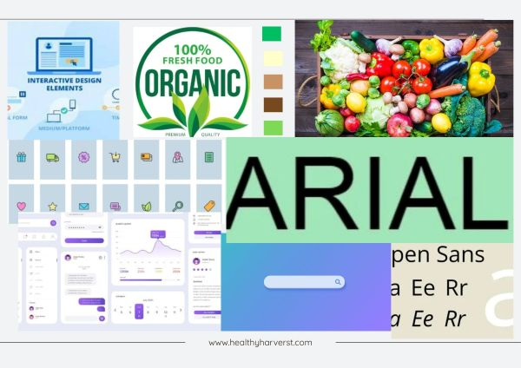
Figure 1 Mooboard

Wireframe Screenshots

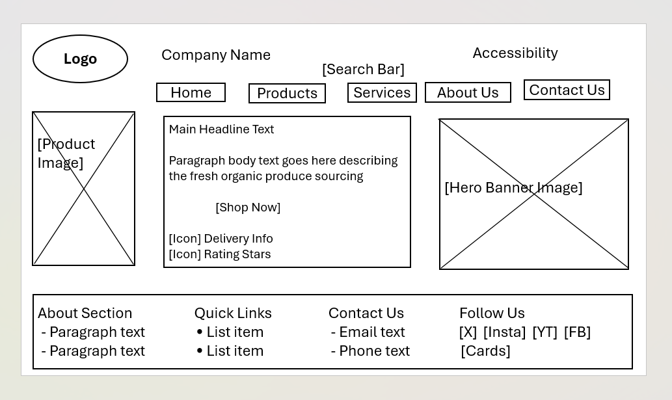
Figure 1 Homepage Wireframe

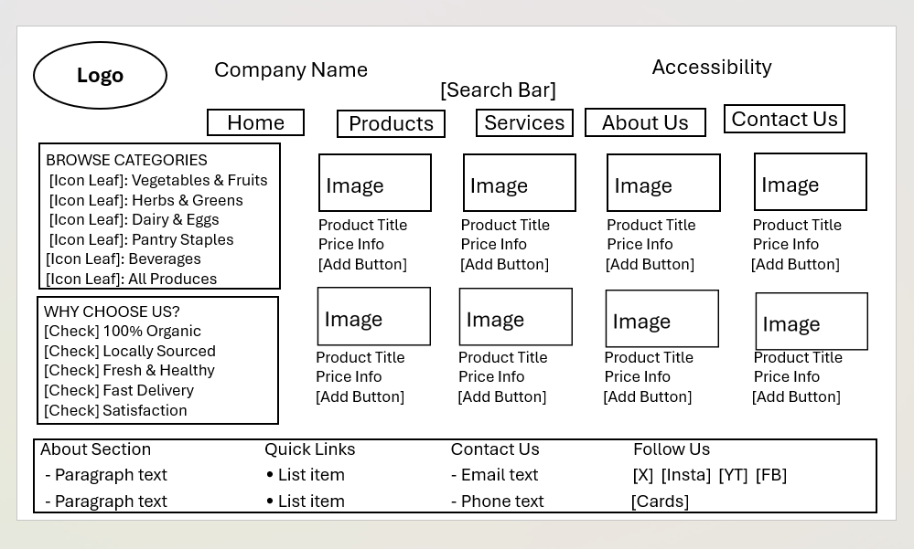
Figure 2 Page-2 Wireframe

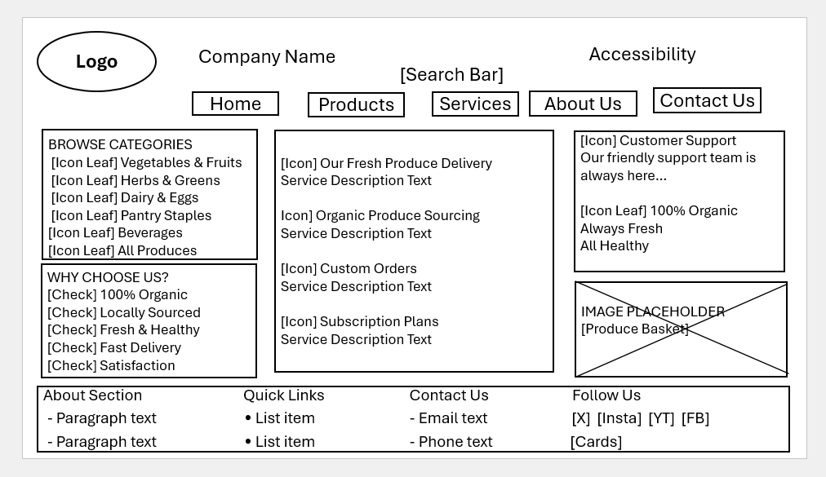
Figure 3 Page-3 Wireframe

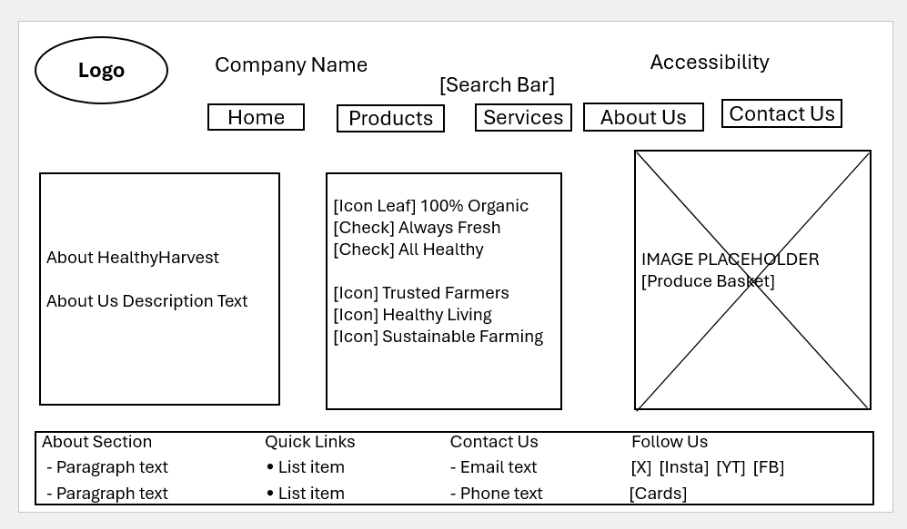
Figure 4 Page-4 Wireframe

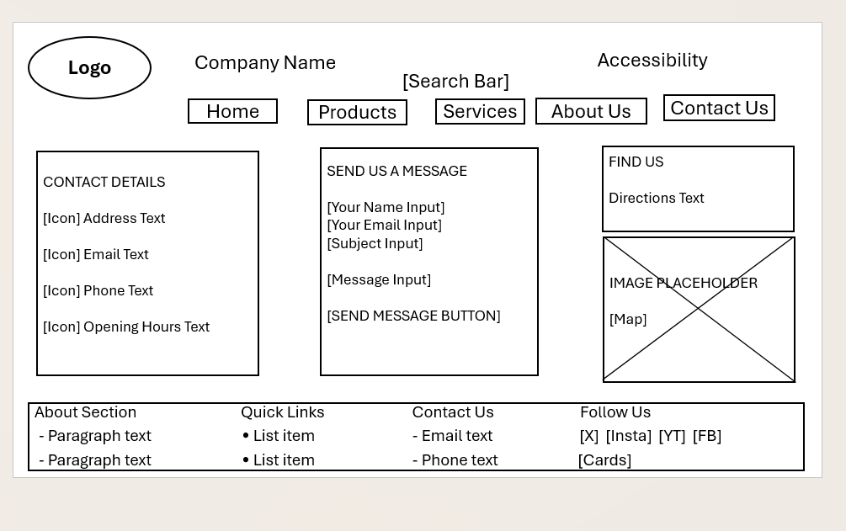
Figure 5 Page-5 Wireframe

Web Design Screenshots
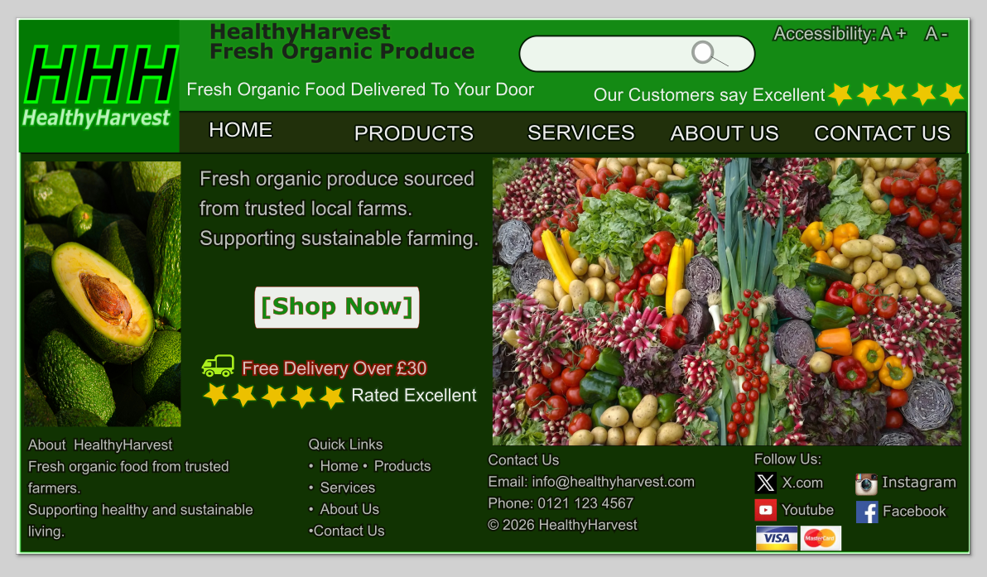
Figure 1 Web Design Home Page

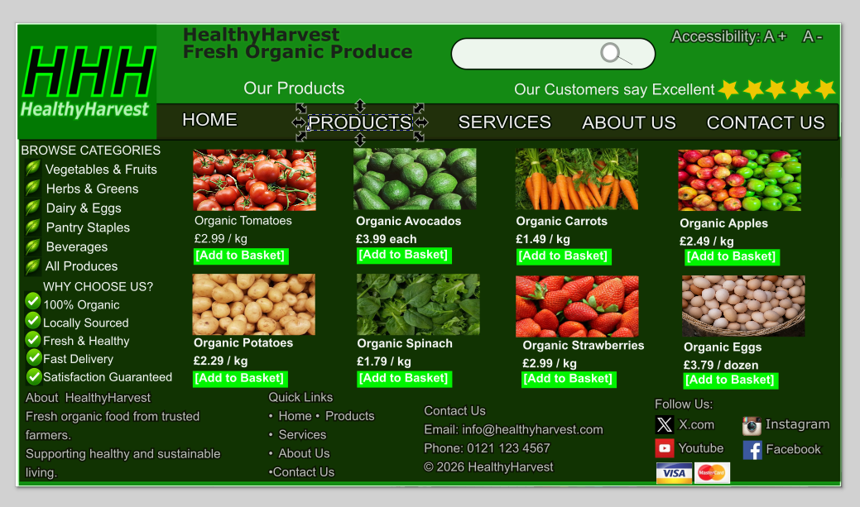
Figure 2 Web Design Product Page

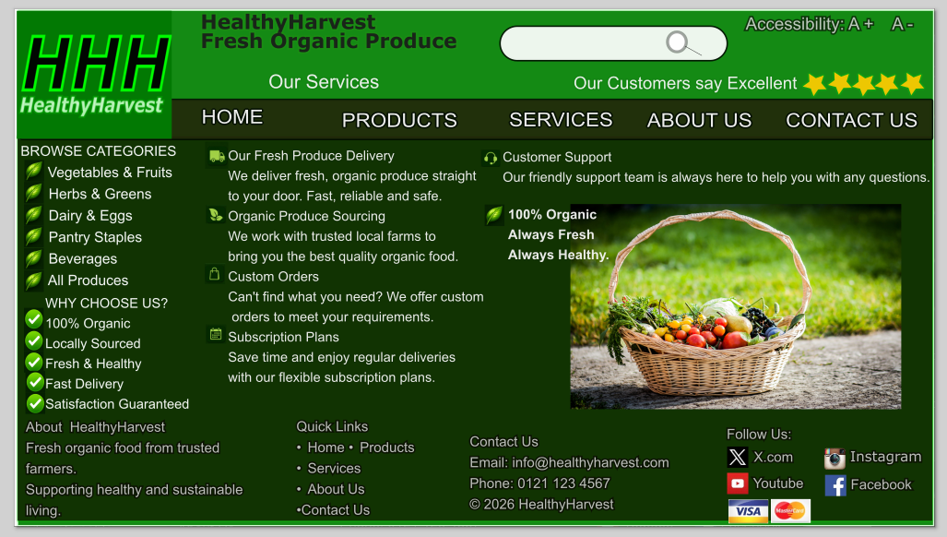
Figure 3 Web Design Services Page

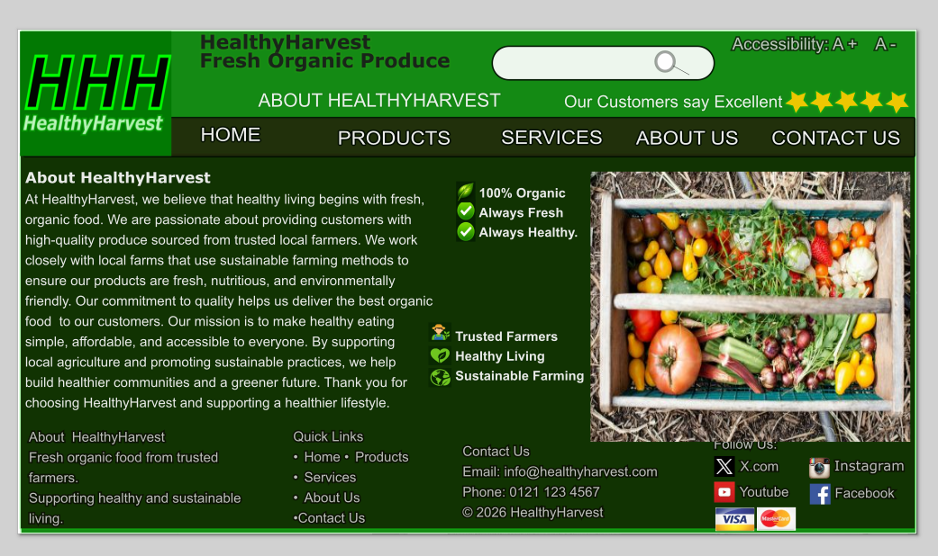
Figure 4 Web Design About Us Page

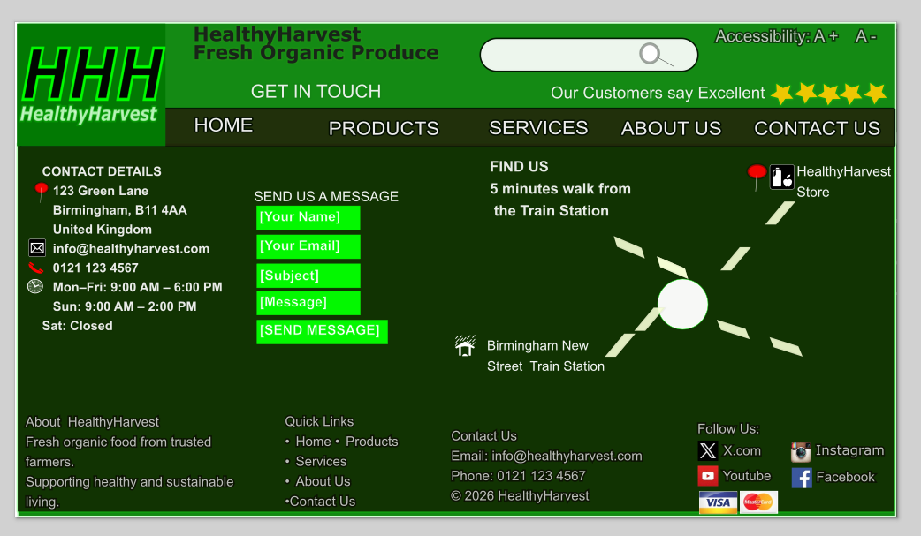
Figure 5 Web Design Contact Us Page

4.1 MOODBOARD & WIREFRAME

Moodboard
A moodboard is a visual representation of a project's overall style and appearance that combines images, colours, typography, graphics, and design inspiration to communicate a design concept and establish a clear visual direction for the design process [19]. It helps designers organise their ideas and develop a consistent design approach before creating detailed designs and prototypes.
The HealthyHarvest moodboard incorporates images of organic farms, fresh fruits and vegetables, delivery services, user interface icons, Google search inspiration, Helvetica typography, and examples of existing organic food websites. Green was selected as the primary colour because it represents nature, freshness, health, and sustainability, which are the core values of the HealthyHarvest brand. Supporting colours such as cream, brown, and light green were included to reinforce the natural, organic, and environmentally friendly identity of the business. The selected imagery highlights locally sourced organic produce, responsible farming practices, healthy lifestyles, and convenient online shopping.
The moodboard played an important role in influencing the website design by guiding the selection of colours, typography, imagery, icons, and the overall visual style. It ensured consistency across all website pages, including the Homepage, Products, Services, About Us, and Contact Us pages. The moodboard helped maintain alignment between design decisions and HealthyHarvest's business objectives by creating a professional, user-friendly, and visually appealing online presence. The selection of colours, imagery, and page layouts was guided by user-centred design principles to improve usability and customer engagement [20]. As a result, the final website effectively communicates the company's commitment to providing fresh organic products while promoting healthy and sustainable lifestyles.

Wireframe
A wireframe is a simple visual representation of a website layout that shows the placement of content, navigation menus, images, buttons, search bars, and other interface elements before the final design is created [21]. It focuses on structure, functionality, and content organisation rather than colours, graphics, and visual styling.
For the HealthyHarvest website, five wireframes were created for the Homepage, Products, Services, About Us, and Contact Us pages. The wireframes were used to plan the placement of the logo, search bar, navigation menu, page content, images, buttons, product information, service details, contact forms, map section, and footer. This process helped organise the website content effectively and ensured that users could easily navigate between pages, supporting recognised usability principles for website design [22].
The wireframes also influenced the design by providing a clear structure before the development of the final website. They allowed potential layout and usability issues to be identified and resolved at an early stage, reducing the likelihood of design errors during implementation. In addition, the wireframes helped maintain consistency across all pages by ensuring that navigation elements, page layouts, and footer sections followed a similar structure.
The final website provides a clear layout, improved usability, and a more user-friendly experience. Wireframing ensured that the completed website met both user requirements and HealthyHarvest's business objectives while supporting effective content organisation and navigation. The wireframes also considered accessibility requirements by including an accessibility section, clear navigation structures, organised content areas, and consistent page layouts to support a wide range of users [23].

5.0 CONCLUSION
For HealthyHarvest, an organic food company that supports sustainable agricultural methods and healthy eating, this project effectively demonstrates the entire design process required in creating a website prototype. The project started with the development of a moodboard, which assisted in defining the visual identity of the website by choosing suitable colours, images, and design elements that represented the company's goals and values. The moodboard guaranteed uniformity across all pages and gave a clear direction for the website's overall look.
Before the final design stage, wireframes were created to arrange the layout, navigation structure, and content placement. By developing a logical and approachable website structure, this procedure made it simpler to find usability problems and enhance the user experience. The construction of the Homepage, Products, Services, About Us, and Contact Us pages was made possible by the wireframes.
By offering easy navigation, eye-catching visual material, and pertinent details about the company's goods and services, the finished website design effectively satisfies HealthyHarvest's commercial needs. The website's appearance and functionality were both enhanced by the application of a disciplined design method. This project improved my knowledge of user interface development, website design concepts, and the significance of planning tools like wireframes and moodboards in producing high-calibre digital solutions.

References
[1] R. Pereira, A. M. Baranauskas, and S. R. P. da Silva, “User-centred design methods for interactive systems development,” International Journal of Human–Computer Interaction, vol. 38, no. 4, pp. 311–325, 2022.
[2] A. T. Stephen and O. Toubia, “Designing effective digital customer experiences in e-commerce,” Journal of Retailing and Consumer Services, vol. 64, Art. no. 102800, 2021.
[3] E. Marcotte, Responsive Web Design, 2nd ed. New York, NY, USA: A Book Apart, 2021.
[4] D. Chaffey and F. Ellis-Chadwick, Digital Marketing: Strategy, Implementation and Practice, 8th ed. Harlow, U.K.: Pearson Education, 2022.
[5] T. Tullis and B. Albert, Measuring the User Experience: Collecting, Analyzing, and Presenting UX Metrics, 3rd ed. Cambridge, MA, USA: Morgan Kaufmann, 2021.
[6] J. Schmutz, A. Sonderegger, and J. Sauer, “Implementing responsive web design for enhanced user experience in e-commerce,” International Journal of Human–Computer Studies, vol. 162, Art. no. 102790, 2022.
[7] S. Kim and H. Lee, “Mobile commerce usability and consumer purchase intention in e-commerce platforms,” Journal of Retailing and Consumer Services, vol. 67, Art. no. 103019, 2022.
[8] R. Pereira and S. Silva, “Responsive design strategies for modern web applications,” IEEE Access, vol. 10, pp. 88452–88467, 2022.
[9] P. C. Verhoef, K. N. Lemon, A. Parasuraman, A. Roggeveen, M. Tsiros, and L. A. Schlesinger, “Customer experience creation: Determinants, dynamics and management strategies,” Journal of Retailing, vol. 97, no. 1, pp. 31–41, 2021.
[10] B. Johnson and M. Carter, “Mobile-friendly design and search engine optimisation in e-commerce websites,” Electronic Commerce Research, vol. 23, no. 4, pp. 855–872, 2023.
[11] H. Nguyen and T. T. Nguyen, “Consumer trust and transparency in online organic food purchasing,” Journal of Retailing and Consumer Services, vol. 68, Art. no. 103070, 2022.
[12] R. Kumar and P. Singh, “Impact of visual design on consumer behaviour in e-commerce platforms,” International Journal of Human–Computer Interaction, vol. 39, no. 5, pp. 522–536, 2023.
[13] N. J. King, “Website performance optimisation and user experience in online retail,” Electronic Commerce Research and Applications, vol. 56, Art. no. 101054, 2023.
[14] M. Alshibly, “E-commerce website quality factors and customer satisfaction,” International Journal of Electronic Marketing and Retailing, vol. 13, no. 2, pp. 145–160, 2022.
[15] G. Adomavicius and A. Tuzhilin, “Personalization technologies in e-commerce: Current trends and future directions,” IEEE Transactions on Knowledge and Data Engineering, vol. 34, no. 7, pp. 3124–3138, 2022.
[16] P. R. Nunes and J. Cespedes, “The customer has escaped,” Harvard Business Review, vol. 99, no. 6, pp. 96–105, 2021.
[17] V. Aienobe and M. Z. Iqbal, “Responsive web design for enhanced user experience (UX) and user interface (UI),” International Journal of Computer Applications, vol. 187, no. 34, pp. 72–93, 2025.
[18] R. Suadamara, “Opportunity and challenges in UX design for e-commerce website,” Engineering, Mathematics and Computer Science Journal, vol. 6, no. 2, pp. 157–162, 2024
[19] L. Timms, The Mood Board Book: Creating Inspirational Boards for Creative Projects. London, U.K.: Thames & Hudson, 2023.
[20] D. Travis and P. Hodgson, Think Like a UX Researcher: How to Observe Users, Influence Design, and Shape Business Strategy. Boca Raton, FL, USA: CRC Press, 2022.
[21] C. Stephanidis and G. Salvendy, Human-Computer Interaction in Intelligent Environments. Boca Raton, FL, USA: CRC Press, 2024.
[22] S. Krug, Don't Make Me Think, Revisited: A Common Sense Approach to Web Usability, 4th ed. Indianapolis, IN, USA: New Riders, 2024.
[23] S. Harper and Y. Yesilada, Web Accessibility: A Foundation for Research. London, U.K.: Springer, 2022.

