Rethinking Business Conference
BMSO4004
Generating Business Data
Business Managment
Eleri Mair Jones
Dr Roisin Mullins
Assignment 1
17/01/2018

Table of Contents
Part 1

Introduction 3
Rationale 3
The Future Well Being of Generations Wales Act 2015 4
Purpose of a database 6
Role of a Business Analyst 7
Tools used to store the information captured 7
Part 2
How data is captured? 8
Current trends 10
Conclusion 10
Appendix 10
References 14

Part 1

Introduction
Members of the Carmarthen Business School have decided to run a yearly conference known as ‘rethinking business conference’. They have decided to create a new business conference venture from scratch. From year to year these conferences will be held along the Wales Costal Path. A business analyst role is to create a database, which includes many different venues all across Wales Costal Path. It is also a business analysis role to decide on an appropriate venue to hold their conference depending on the information that is gathered. As it is the first business conference venture it has been decided that the first conference would be held at Swansea University Bay campus at the Great Hall. The conference will be held on Saturday 18th of August 2018 at 9am until 5pm ("Host a meeting, a conference or an event", 2018).

Rationale
The Great Hall is located in The Bay Campus that is situated in an outstanding location on the eastern approach into Swansea, on a 65-acre site adjacent to a beautiful Site of Special Scientific Interest. The Campus has direct access onto the beach and its own seafront promenade. The architecture has been designed to ensure a friendly and collegiate feel, creating a strong sense of community. The creation of the Bay Campus is one of the largest Knowledge Economy projects in Europe and will propel the growth of high-tech clusters, especially in advanced engineering, and will create over £3 billion in economic impact. The Great Hall is designed to hold conferences, convention, exhibitions, host a dinner or a small meeting reception all year round, it is ideal for both day and residential conferences. There is a choice of meeting rooms available throughout the day and evening and each has its unique style and ambience which are all located within a short walk of Swansea’s sea front ("Host a meeting, a conference or an event", 2018)
Their affordable delegate packages offer excellent event catering and event support services from a team of experienced event professionals. They provide delegates with a range of on-site amenities including cafés, supermarkets and bars. Their first-class team of chefs will provide lunch and refreshment breaks packed with irresistible delicacies. The venue caters for vegetarian and vegan diets and they will always be prepared to provide service of any other special diets as long as they have been told in advance via the conference or event organiser (“The Great Hall | Swansea University Events Hospitality”, 2018).
The Great Hall has a capacity of 700 delegates with wheelchair access that is ideal for conferences at a cost of £550.00 per day. They offer office services of photocopying, faxing and more. The conference rooms include a full range of audio-visual and technical facilities such as a power point projector, large TV Screen and DVD player, Laptop and a PA system including microphone for a cost of £70.00. Free parking is available on campus for the delegates for those that are attending evening and weekend events (The GreaT hall aT The bay campus, 2017).

The Future Well Being of Generations Wales Act 2015
Swansea University is one of the most sustainable universities in the UK, they are currently ranked 8th out of 150 institutions in the ‘University Green League’. Sustainability is at the heart of everything they do. Swansea is the first University in Wales to achieve the EcoCampus Platinum award. The System helps the University with its legal compliance, Green League score, Sustainability Strategy, and represents the first international standard that the University has achieved across all Colleges and administrative functions. Through EMS, the University manage its environmental impacts in areas like resource consumption, waste production, control on emissions, biodiversity, travel, construction & refurbishment and sustainable procurement (“The Great Hall | Swansea University Events Hospitality”, 2018).
The Swansea University’s Sustainability Strategy developed the Carbon Management Plan 2026. They are committed to developing a prosperous Wales in the Future Wales Well Being of Generations Wales Act 2015. To create a prosperous Wales, we need to create a productive and low carbon society which recognises the limits of the global environment and therefore uses resources efficiently and proportionately and which develops a skilled and well- educated population in an economy which generates wealth and provides employment opportunities, allowing people to take advantage of the wealth generated through securing decent work (Well-being of Future Generations (Wales) Act 2015, 2015).
Swansea University does this by implementing a five-core carbon management plan reduction themes are a plan that’s set out for their students and staff. They recognise that if they are going to achieve their goal of lowering carbon emissions by 35% by 2026 they need to engage with the whole university. In 2016 they developed a project called ‘The student Energy Project’ (TSEP) in their singleton halls, that takes data for meter readings in every building, and their energy savings are calculated based on last year’s readings. These saving equal points that students can exchange for vouchers on the TSEP website. In the first year of its operation it recorded a lowering of 4% of their electrical energy consumption, which is a saving of 60,000 kWh. The University also conducts a blackout campaign every year to remind staff and students to switch off appliances, to save energy and lower their carbon emissions. During last year blackouts, 4% of energy was saved compared to an average weekend. This tells us that Swansea University does their best to comply with the Future Wales Well Being of Generations Wales Act (CARBONMANAGMENT PLAN 2016-2026, 2018).
In our conferences we are going to implement some of their strategies to achieve the goal of becoming a prosperous Wales under The Future Well Being of Generations Wales Act 2015. This will be achieved in the ‘rethinking business conference’ through encouraging our delegates to travel through the usage of public transport or car share. This will be done through offering them different ways of transporting such as the bus. Bus travel is one of the most sustainable, most cost efficient and often one of the quickest ways of getting around Swansea. By doing this it will make the delegates think more about what they could do to have a more sustainable life style (CARBONMANAGMENT PLAN 2016-2026, 2018).
In the conference all documents will be distributed electronically rather than printing them out. Through doing this we will be considering our ‘global responsibility’ under The Future Well Being of Generations Wales Act 2015, through realising the impact of printing out obsessive amount of paper has on the planet. Therefore, our conferences will be paperless. Although it may be a challenge to do achieve paperless meeting, we will do our best to achieve this by sending out electronic copies of the handouts. We will encourage the delegates to bring their own electronic devices if they wish to have a look at the handouts while they are in the conferences. They will also have access to look at these handouts after the conference if they wish too (CARBONMANAGMENT PLAN 2016-2026, 2018).

Purpose of a database
A database is a collection of information that is organized so that it can be easily accessed, managed and updated. The Purpose of a database is to transfer data into information. Data is organized into rows, columns and tables, that enables us to store data and related data entry forms, report definition etc. This then is indexed to make it easier to find relevant information. Data gets updated, expanded and deleted as new information is added which allows us to transform the data and present it in different ways through the usage of forms. We can then query the data they contain and running applications against it. When creating a database, it needs to be designed properly, a badly designed database can generate errors that will lead to bad decisions. The Purpose of the ‘rethinking business conference’ database it to collect data and information on different venues across wales. The database identifies many counties across Wales, and in those counties, there are many towns and within those towns there are many venues. Through using the database, we will be able to assess the information gathered and decide on an appropriate venue to hold the conference (Roman, 2002).

Role of a Business Analyst
A Business Analysts (BAs) are engaged at an early point. Their role is to investigate ideas and problems and formulate options for a way forward. The role of a BAs is just as important as a project manager they work at a senior level in an organisation therefore it is vital that they know about the strategy of their organisation so that they can conduct their work with a view to supporting the implementation of the strategy and the achievement of the business objectives. The value of having knowledge about the strategy of the organisation will enable them to identify the tactical options that will address a situation and will support the delivery of the business strategy. Through doing this they will be able to produce a business cases, that sets out their conclusions and recommendations. The value of having a conclusion and recommendations will enable them to advise the organisations on effective courses of action and ensure continuing alignment with business objectives. The role of the BAs analyst in the ‘rethinking business conference’ database is to collect relevant information about conference venues across the Wales Costal Path. They will then present this information in a structured database that allows them to make conclusions and recommendations on which venue would be suitable to use to hold the conference venue, ensuring that the venue caters for the delegates needs (Cadle, Turner & Paul, 2010).

Tools used to store the information captured
The data will be captured in a database using Microsoft Access 2016. The database tools allow us to track and record data on a regular basis, frequently perform action, display, export, or print subsets of that data. By using database tools, we can produce reports in a structured format. The value of this is that it makes it easier to store information that views can read easily to make a rational decision using the factual information stored in the database e.g. what venue to use. The type of data entered into the database can be controlled easily and specifies how data in one table is related to data in other tables through the usage of relationships. The value of this is that we can safely handle updates to your data such as adding more tables. Database also allows us to run complex queries. Through the usage of queries, we can bring information from different tables together, this enables us to look at the information in different ways and analyse it. Access summarises the data collected in a printed or electronic form. This makes it easier to understand the data collected (Coronel, 2018).
The data will then be reported using Microsoft Word. Microsoft Word is a useful tool to write lengthy documents such as reports. The value of Microsoft Word’s is that it is a powerful feature that can help you organize a document even before you start filling it with research. Therefore, the data collected can be analysed thoroughly and others can understand the information collected not only by the database but also by reading the report. The information used to collect the information such as books and website can also be referenced at the end of the word document. The value of this is that people can look at the references and possibly get more information about the venues if they wish too (Coronel, 2018).
Part 2

How data is captured?
The tools used to capture data and information where the internet. The internet provides a wide range of information about venues all across the world. Websites such as ‘Meeting and Conference Venues Wales’ gives information about what the venues offer and how they meet delegates needs (“Meeting and Conference Venues Wales”, 2018).
Information on different kinds of venues across wales needed to be collected to be able to report a viable business and determine a suitable location/venue. When starting a database, a table including different entities needs to be created. As shown in Appendix 1 the rethinking business conference database includes three tables called, County, Towns and Venues. As shown in appendix 2 entities are then inserted into the top Coolum of each table. Entities in the County table include county code, county name English and county name Welsh. As shown in Appendix 1 Entities in the town table include, town code, town name and County code. Entities in the Venue table include venue code, town code, venue location, venue type, venue name, car park, number of car spaces, conference venue, conference rooms, number of conference rooms, number of people attend, canteen, cost per room, cost per delegate and cost for facilities. The information that was collected was then put into the database called records, this then created fields that included 8 counties, 16 towns and 48 venues. In order for Access to search quickly and bring together related information, each table in your database should have a field or fields that uniquely identifies each record. The field or fields which uniquely identify each record are called Primary Keys. The Primary Key quickly allows association between tables and enhances speed (Codd, 1979).
After this a form was created for each field as seen in appendix 3. Forms are used to enter, change, view, and print data. A form is a display that enables the user to enter data into tables easily and in the order required. A form can make viewing or printing easier. A form is usually of more significance on a table with a larger number of fields. As shown in appendix 4 a query is then created to show, locations of venues, cost of venues, car spaces at venues and catering at venues. A database query extracts data from a database and formats it in a readable form. To finish a report was created as show in appendix 5. Reports offer a way to extract and present a specific subset of the information from a large database. After this the database is complete. The database can now be used to extract information and a business analyst can decide on a rational venue to hold the ‘rethinking business conference’ (Codd, 1979).

Current trends
Current trends such as the use of cloud services allows us to store documents such as Word and Access in OneDrive by having access to an Office 365 account. Microsoft’s OneDrive is one of the leading cloud storage service platforms on the market and an obvious choice for both businesses and users who employ Microsoft Office packages such as Word and Access on a regular basis. The benefit of Microsoft’s OneDrive is that you can you can store any kind of file on OneDrive like photos, video, and documents, and then access them from any of your Windows PCs or mobile devices. Files are organised by type, so it’s easy to find what you need (“Free Microsoft Office Online, Word, Excel, Powerpoint”, 2018).

Conclusion
The data repented in the database makes decision making easier. By looking at the information gathered a business analyst can make a decision upon which venue to hold the ‘rethinking business conference’. The Swansea University it the most suitable place to hold the conference as the university is also rethinking a new way of generating business as they adopt into a sustainable business venture themselves. They are currently taking great measures to reduce their carbon admissions and hopping to lower their carbon emissions by 35% by 2026. Through holding the conferences at this venue, we can take advice from them and encourage others to adopt their way of rethinking business as the delegates get to see first-hand evidence of how an organisation is adopting a sustainable business adventure (Great Britain: National Assembly For Wales., 2015).

Appendix

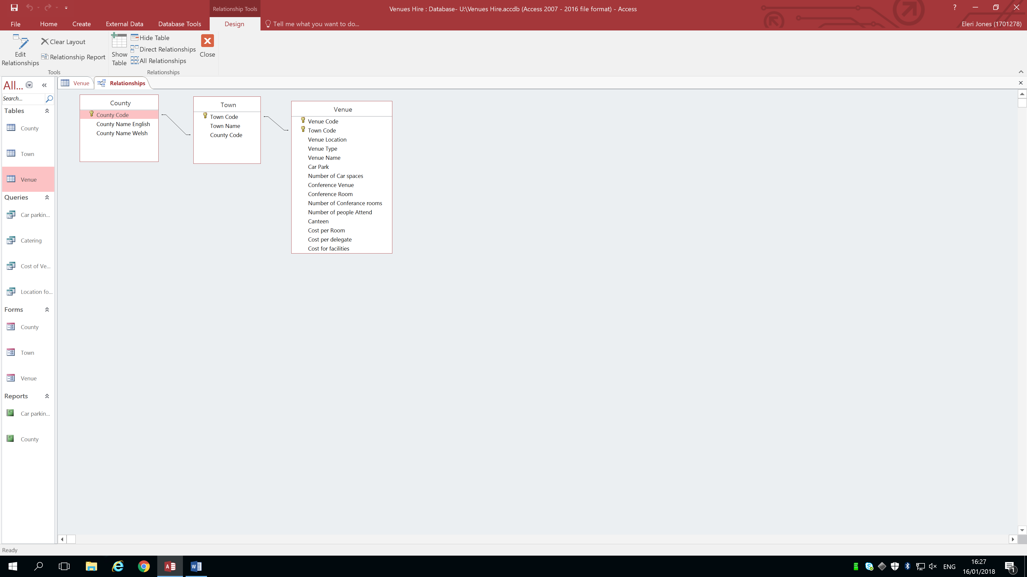
(Appendix 1)

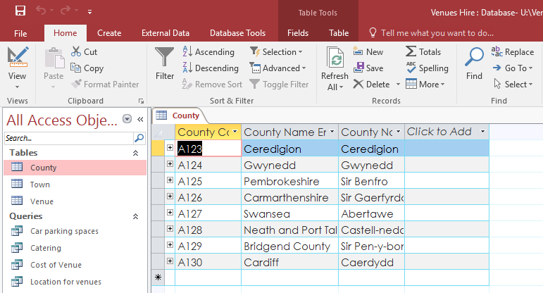
(Appendix 2)

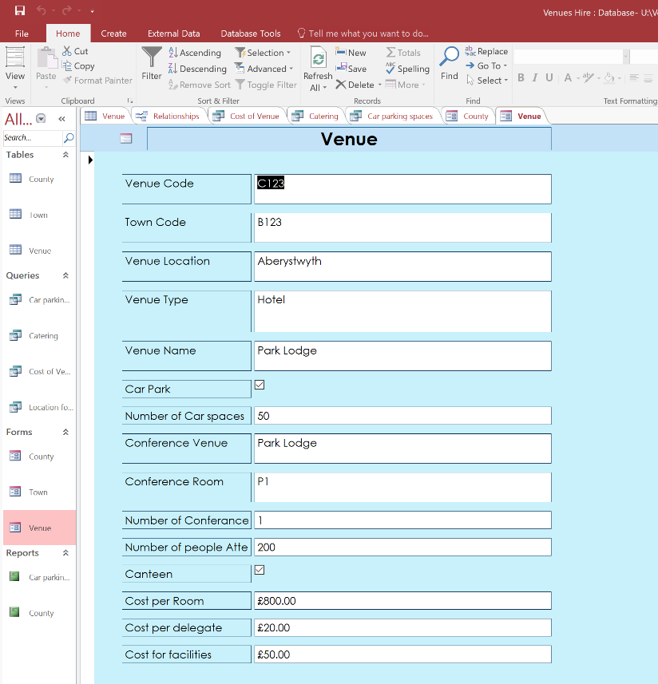
(Appendix 3)

(Appendix 4)
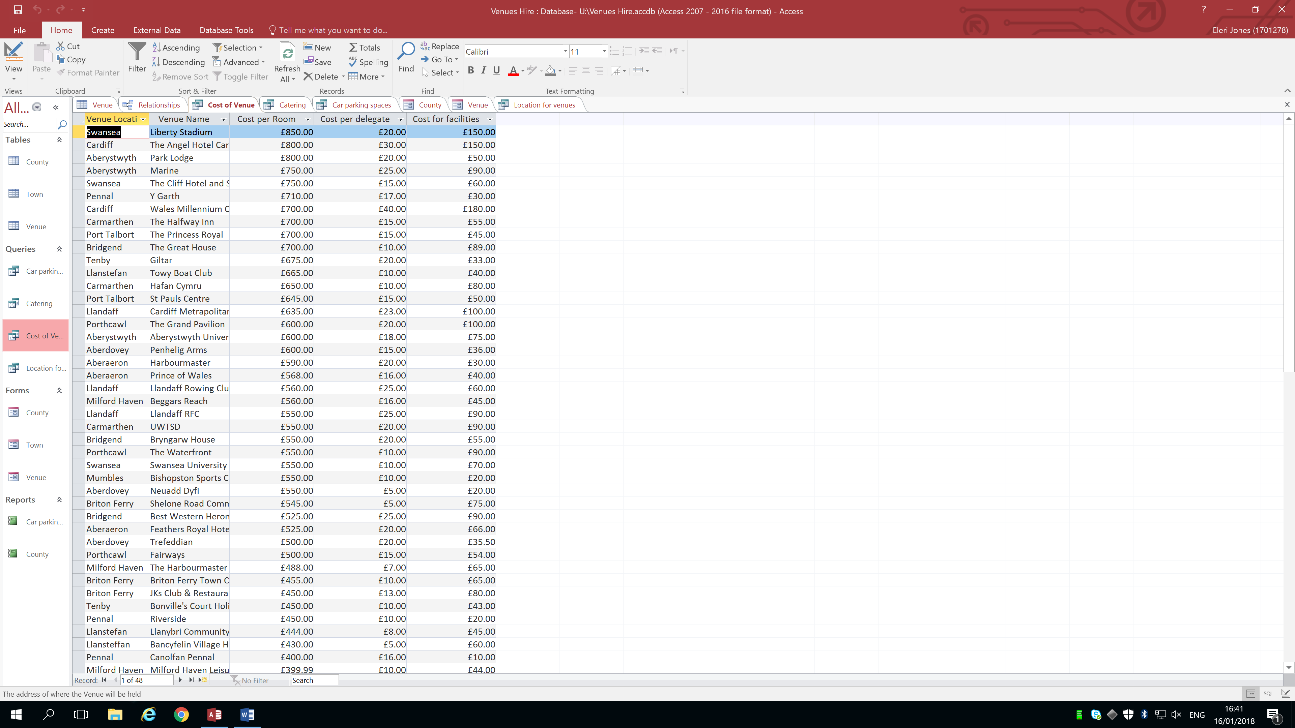
(Appendix 5)
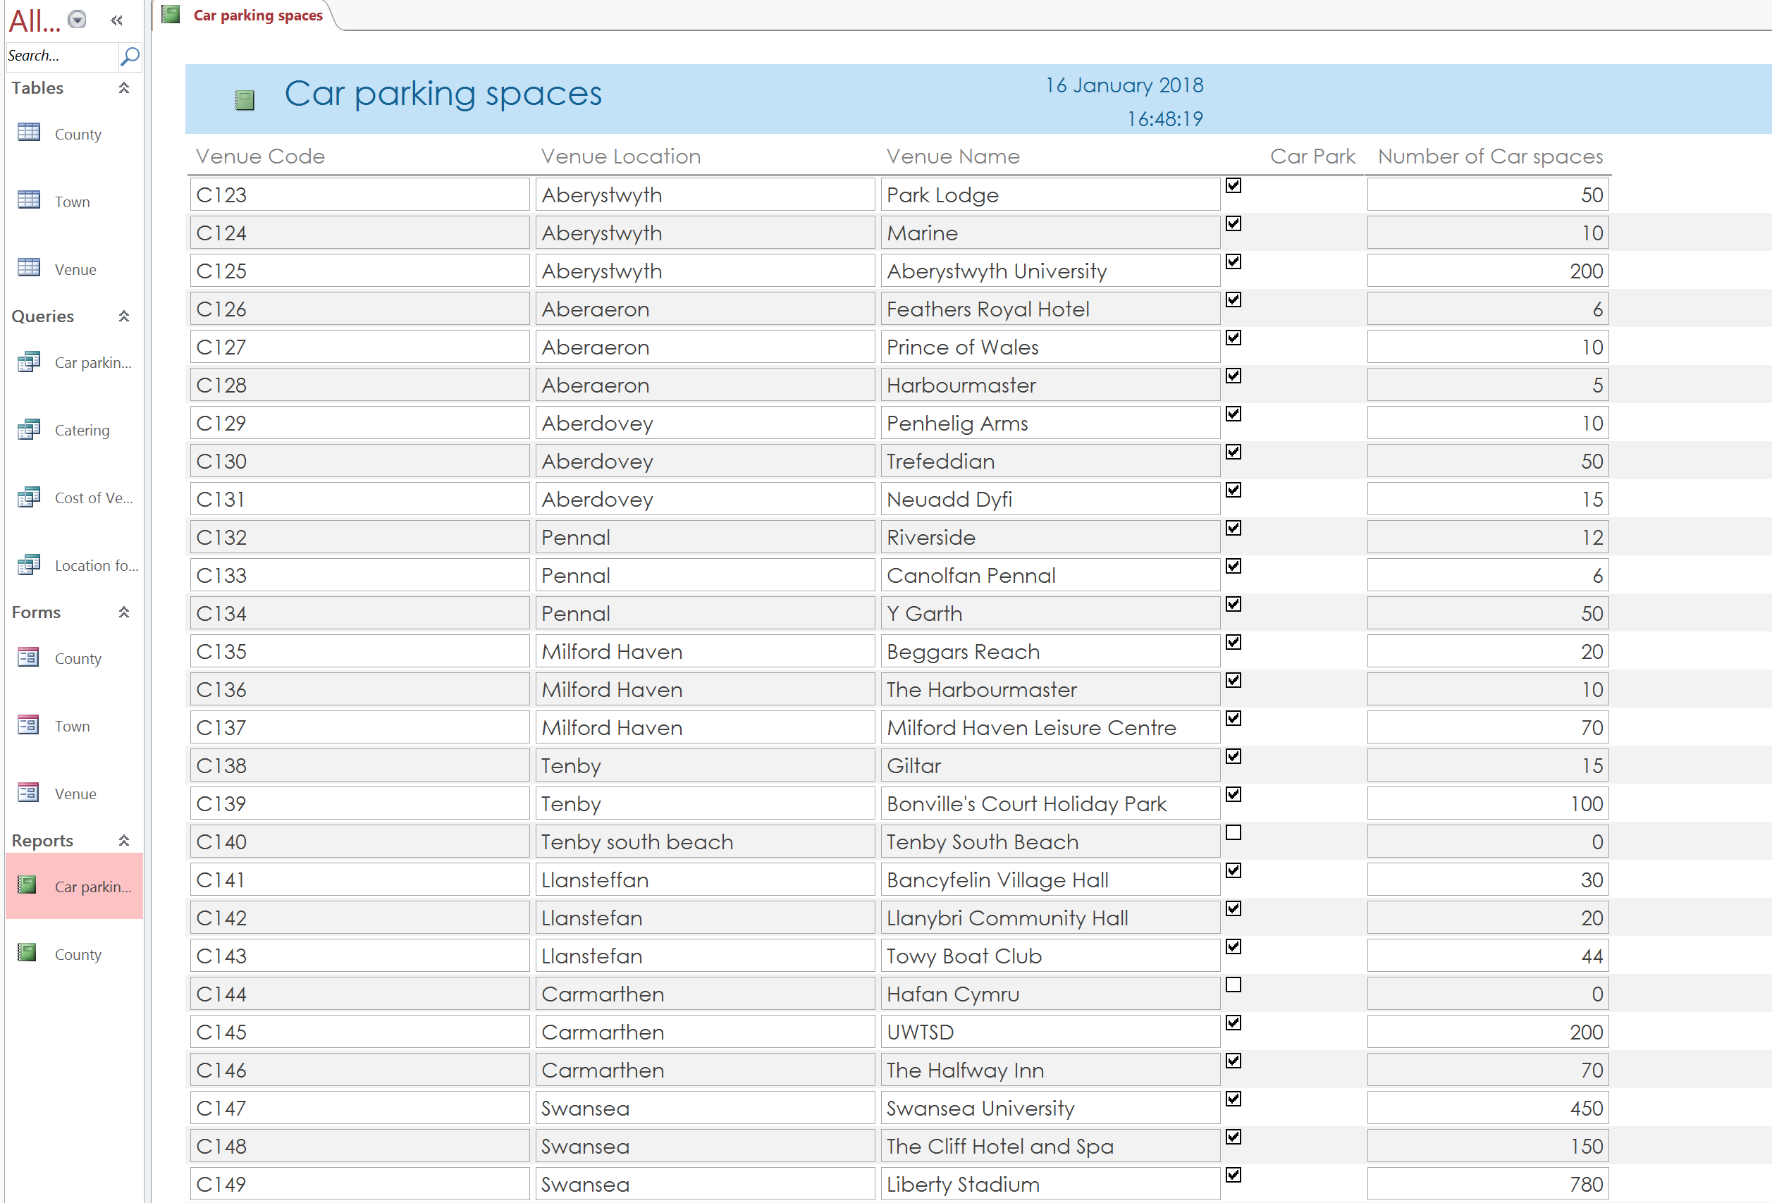

References
adle, J., Turner, P., & Paul, D. (2010). Business analysis techniques. London [England]: British Computer Society.
CARBONMANAGEMENT PLAN 2016 –2026. (2018) (1st ed., p. 29). Retrieved from http://www.swansea.ac.uk/sustainability/
Codd, E. (1979). Extending the database relational model to capture more meaning. ACM Transactions On Database Systems, 4(4), 397-434. http://dx.doi.org/10.1145/320107.320109
CORONEL, C. (2018). DATABASE SYSTEMS (12th ed.). [S.l.]: CENGAGE LEARNING.
Free Microsoft Office Online, Word, Excel, Powerpoint. (2018). Products.office.com. Retrieved 10 January 2018, from https://products.office.com/en-us/office-online/documents-spreadsheets-presentations-office-online
Great Britain: National Assembly For Wales. (2015). Well-being of future generations (wales) act 2015. [Place of publication not identified]: Tso.
Host a meeting, a conference or an event. (2018). Swansea.ac.uk. Retrieved 10 January 2018, from http://www.swansea.ac.uk/business-and-industry/facilitieshire/events&hospitality/
Meeting and Conference Venues Wales. (2018). Conferences-uk.org.uk. Retrieved 10 January 2018, from http://www.conferences-uk.org.uk/wales-conference-venues
Roman, S. (2002). Access database design and programming (3rd ed.). Sebastopol [CA]: O'Reilly.
The Great Hall | Swansea University Events and Hospitality. (2018). Swansea University Events and Hospitality. Retrieved 16 January 2018, from http://venueswales.com/conference-venues-swansea/bay-campus-2/the-great-hall/
The GreaT hall aT The bay campus. (2017) (1st ed., p. 18). Swansea. Retrieved from https://www.swansea.ac.uk
Well-being of Future Generations (Wales) Act 2015. (2015) (1st ed., p. 6). Retrieved from http://www.gov.wales

Rob & Coronel (200

