Confidentiality in Healthcare
Confidentiality is a fundamental of care and a professional responsibility for healthcare providers. Health care providers are required to be accountable in gaining knowledge about the importance of confidentiality. Confidentiality is not only a requirement of professional standard but is also legal obligations. All healthcare providers are expected to gain knowledge regarding confidentiality and how to approach strategies of safeguarding patient information (Warren,2023). Confidentiality is a fundamental principle that requires healthcare providers to keep patients medical and personal information private and secure. Healthcare professionals are required not to disclose any medical or private information about a patient to anyone without the patients consent, unless required by law or for the patient’s safety. Maintaining confidentiality in our roles is crucial for building trust between health care providers, it ensures that patients feel comfortable in sharing information about their health. The Nursing and Midwifery Council states that nurses, midwives, and nursing associates must “respect a person right to privacy in all aspects of their care” (2023). The poster includes information that should be highlighted to healthcare professionals to educate individuals that may not understand the importance of protecting patient’s privacy.
Respecting a patients’ rights to privacy: Confidentiality is extremely important in healthcare as it builds a trust between the patient and the healthcare provider. When people feel that their privacy will be compromised it creates a wedge between the patient, and the care they are receiving will not be regarded as being professional. Reassuring patients from the outset that any information or personal details that is disclosed to a professional will be kept confidential provides an overall better experience for the patient (Moss, 2020). There are ways to protect patient confidentiality and educating healthcare professionals on how to protect patient confidentiality is something that will benefit any organisation. Firstly, as the poster explains, protecting patient confidentiality is respecting their rights to privacy and providing a secure environment for the individual. It is important to understand the boundaries of confidentiality and uphold the trust placed in health care providers by individuals sharing their information. By setting professional standards There are ways of maintaining confidentiality in “modern day nursing” (Moss, 2020).
Healthcare providers are expected to:
Obtain consent: Always seek permission from the individual before sharing their medical or personal information with others.
Limit access to information: Only disclose information to those who have a legitimate need to know, such as health care providers directly involved in the individual’s care.
Secure communication: Use secure channels for transmitting confidential information.
Be mindful: Avoid discussing sensitive information in public or in front of people who do not have the need to know.
Follow legal and ethical guidelines: Familiarising yourself with the laws and regulations governing confidentiality and adhere to professional codes of ethics.
Although confidentiality is a duty of care, some information that is shared can be breached if there is a legal or ethical obligation to disclose information and “confidentiality must be compromised” (Moss, 2020). Examples of when patient confidentiality can be breached are when there is a risk of harm to the patient or others. If a healthcare provider believes that a patient poses serious harm to themselves or others, they may be required to disclose confidential information to prevent harm. In some cases, health care providers may be legally obligated to disclose confidential information. If there is a public health concern, health care providers may be obligated to disclose confidential information to public health authorities to prevent the spread of communicable diseases. Sometimes, healthcare providers will have a duty to report confidential information if there is suspected cases of child abuse or neglect to local authorities (Blightman, 2013). It is important that health care providers consider certain circumstances carefully and discuss information with a line manager.
Securing documents and patient related information:
When maintaining confidentiality, it is essential to secure storage of medical records or any patient related information as well as limiting access to information. Private information on patients should only be accessed by the healthcare providers who are providing the care to the patient. Montgomery explains that new data is being used within the National Health Service and is creating an anxiety around private information not being handled appropriately. With a continuous development in technology data, data is now being used by staff that are not part of the healthcare system for appointments and letters to be sent out more efficiently, which could lead to confidentiality breeches. The shift in technology allows several different healthcare providers to access information on a patient and this is now the way that records are kept (2017). Knight agrees that having patient details stored in many different systems could prove difficult for other organisations to access information about a patient due to Data Protection Regulations (2018). Data Protection Regulations is a law that “governs the collection, processing, storage, and transfer of personal data”. The law came into effect in 2018 allowing all health and care data online to be protected and secured in line with the regulations (National health service England, 2022). Data confidentiality offers significant benefits in terms of security and trust. There are pros and cons to data confidentiality such as:
Pros:
- Protection of sensitive information: Data confidentiality helps protect sensitive information from unauthorised access.
- Trust and credibility: Helps build trust with patients.
- Compliance with regulations (Data Protection Regulations 2018)

Cons:
- Limitations on data sharing between organisations.
- Increased complexity and cost- technology and training.
- Risk of data breaches- despite efforts to maintain confidentiality there is always the risk of data breaches.
Training staff on confidentiality:
Providing training for healthcare staff on confidentiality is crucial to ensure the protection of patients’ sensitive information and keeping in line with privacy regulations. It is important to familiarize staff with legal requirements and regulations governing patient confidentiality. Educating staff on the importance of maintaining patient privacy and the consequences of breaching confidentiality. Keeping knowledge and skills up to date for professional development to improve and develop competencies (Nursing and Midwifery Council, 2018)
Develop comprehensive training materials:
It is important to cover the principles of confidentiality and the types of information that must be kept confidential.
Interactive Training Sessions:
Providing interactive training sessions so staff can engage through discussions, role playing exercises, and quizzes. Staff members should be encouraged to ask questions and seek clarification on any aspects of confidentiality that may be unclear.
Emphasize the importance of data security:
Data security is extremely important as it holds majority of patients personal information. Educating staff on data security by emphasizing the importance of password protection, encryption, and using secure channels.
Regular review and updates of training:
Healthcare regulations and best practices for confidentiality may evolve over time there for ensuring staff are up to date with the latest guidelines and regulations is essential. Monitoring compliance encourages a culture of accountability when it comes to protecting patient information.
Patients will give consent for confidentiality to ensure that their information remains private and secure. By providing consent, patients have control over who can access their sensitive health information and trust that their privacy will be respected by healthcare providers. This helps build a strong patient-provider relationship that is based on trust and respect. According to Murray Patients that have high trust in their care providers have improved outcomes and are satisfied with their care (2015). Roache also describes informed consent as being “valuable” because it “promotes trust” between healthcare providers and the patient. Trusting healthcare providers suggests that there is a better compliance with treatment and participation in research trials (2014). Giving consent for confidentiality allows patients to feel more comfortable sharing personal details about their health, which can lead to better communication and more effective healthcare outcomes. Howick describes good communication between a patient and healthcare provider as being “the heart of healthcare” (2018).
By implementing knowledge on the importance of confidentiality in health care it ensures a patient centred approach. Placing patients at the centre of care ensures their individual needs, preferences and values are prioritised. Confidentiality improves communication and trust. When patients feel heard, respected, and valued, it strengthens the patient- provider relationship. Effective communication and trust are essential for building a collaborative partnership between healthcare providers and patients leading to better health outcomes (Moss, 2020). By placing patients at the centre of care it leads to more accurate diagnosis, appropriate treatment plans, and improved adherence to medical recommendations.
To conclude, confidentiality is paramount in health care for several crucial reasons. Firstly, maintaining patient confidentiality is essential for building trust and fostering a strong patient-provider relationship. Secondly, confidentiality is vital for protecting the privacy and dignity of patients. Medical information is highly sensitive and can have significant implications to an individuals personal and professional life. Respecting and safeguarding this information are essential for upholding ethical principles. Furthermore, confidentiality is a legal requirement in healthcare. Violating patient confidentiality can result in legal consequences, damage professional reputations, and can lead to a breakdown of trust between health care providers and their patients. In conclusion, confidentiality is crucial in healthcare to uphold ethical standards, protect patient privacy, maintain trust, and comply with legal requirements. Health care providers must prioritize patient confidentiality and be accountable in all aspects of their practice to ensure the well being, rights, and privacy of their patients (NMC, 2023).

Poster on Professional Issues in Healthcare

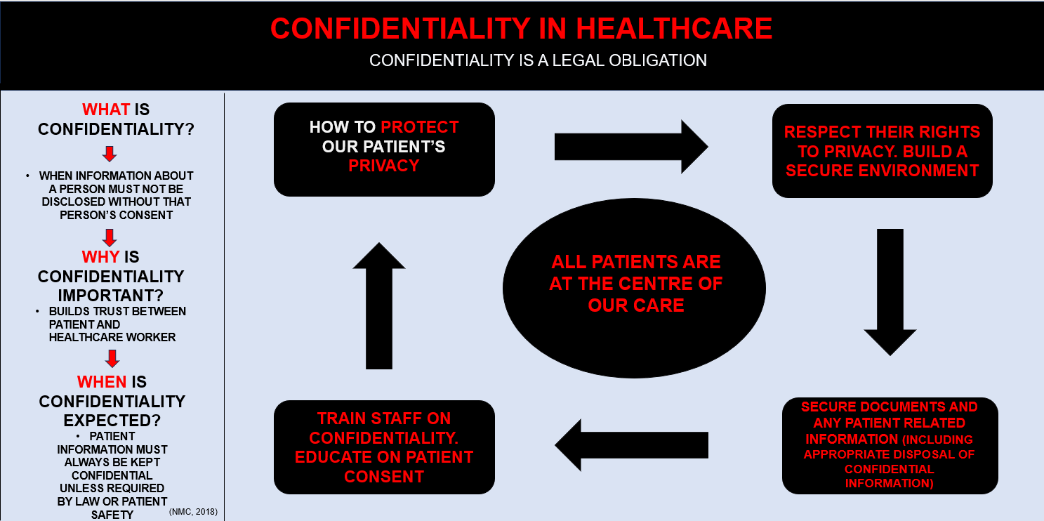

Reference List:
A, Warren., A, Enabnit., and K, Tangella, (2023), Protecting patient confidentiality: Protecting privacy in healthcare’ , Available at: Patient Confidentiality: Protecting Privacy in Healthcare - DoveMed
(1)B, Moss, (2020), Communication Skills in Nursing , Health & Social Care, Edition (5th), London, SAGE
(2)B, Moss, (2020), Communication Skills in Nursing , Health & Social Care, Edition (5th), London, SAGE,
(3) B, Moss, (2020), Communication Skills in Nursing , Health & Social Care, Edition (5th), London, SAGE
Howick, J., Moscrop A, Mebius A, et al. (2018), Effects of empathic and positive communication in healthcare consultations: a systematic review and meta-analysis. Journal of the Royal Society of Medicine, Available at: Effects of empathic and positive communication in healthcare consultations: a systematic review and meta-analysis - Jeremy Howick, Andrew Moscrop, Alexander Mebius, Thomas R Fanshawe, George Lewith, Felicity L Bishop, Patriek Mistiaen, Nia W Roberts, Eglė Dieninytė, Xiao-Yang Hu, Paul Aveyard, Igho J Onakpoya, 2018 (sagepub.com)
J Montgomery, (2017), Balancing confidentiality guidance for you and your patients, Available at: Balancing confidentiality guidance for you and your patients – Improving medical education and practice across the UK (wordpress.com) , (Accessed: 29/2/2024).
K, Blightman., S, E, Griffiths., and C Danbury., (2013) , ‘’Patient confidentiality: When can a breach be justified?’, BJA Education, Volume 14, (2), pp 52-56, Available at: Patient confidentiality: when can a breach be justified? | BJA Education | Oxford Academic (oup.com)
Murray, B., McCrone, S., (2015) ‘An integrative review of promoting trust in the patient-primary care provider relationship’, National Library of Medicine, Available at: An integrative review of promoting trust in the patient-primary care provider relationship - PubMed (nih.gov)
NHS England, (2022), General Data Protection Regulation (GDPR) information, Available at: General Data Protection Regulation (GDPR) - information - NHS Digital , (Accessed:2/3/2024)
(1)NMC, (2023), The Code- Professional standards of practice and behaviour for nurses, midwives and nursing associates, Available at: The Code for nurses and midwives (nmc.org.uk), (Accessed 28/2/2024).
(2)NMC, (2023), The Code- Professional standards of practice and behaviour for nurses, midwives and nursing associates, Available at: The Code for nurses and midwives (nmc.org.uk), (Accessed 28/2/2024).
R, Roache., (2014), ‘Why is informed consent important?’, Journal of Medical Ethics, pp 435-436, Available at: Why is informed consent important? | Journal of Medical Ethics (bmj.com)
S, Knight, and A, Papanikitas, (2018), ‘Confidentiality’, ‘InnovAiT’, Volume 11, (11), pp 598-e122, Available at: Confidentiality (uwtsd.ac.uk)

