LAV6 Contemporary Themes
– Conference Learning Log

Student Name: | Jaliya de Silva ( 1803778)

Week 1 | Monday April 27th, 2020
Planning:

All team members have chosen and decided their own theme for the conference so far, all members divided into 3 group such as (Management, Marketing and Technology) in order to execute the task accordingly. All the deadline being pronounced, now we are working on assigned tasks, group meeting been held during the weekdays and weekend in order to trace the progress and to discuss the matters pertaining to the conference. I have chosen my topic (Sex tourism) and already informed the three groups, so I am closely communicating with the marketing group in order to meet the given tasks and requirements as required, Guest speaker already being decided by Sam (not sure) all minutes been taken by the management team
Organising:

Every individual been allocated a task by dividing all into 3 groups which is Management, Marketing, and Technical

Molly, Renard, Lawrence – Management
Robbie, Jaliya, Pavel, Abdul, Katie – Marketing
Dan, Mo- Technical

Managing:

Minutes been taken the management team; Lawrence makes an extra effort to bring this conference to a successful one, by calling individuals to know their plans and current progress of the project. Technical group has created few ideas of the logos, website designs etc; and posted on team for voting sessions.

Marketing:

My self and the rest of the team work closely to execute the given task for the conference, as per my knowledge Katie has taken up the responsibility to do the marketing mix, since some of them haven’t voted yet we are yet to decide on the logo and the website and so on, we will be discussing with group about the target audience, brand image, and to utilize marketing tools to make it success.

Technical:

Problems/Resolution Action Plan:

Some of the team members have failed to attend the group meetings at all, therefore we are trying to let them update our taken decisions and future plans for the conference and so on. There is some issue with other members in terms of agreeing some matters (not with me) and some collaboration issues, I presume everything will work accordingly with a great outcome.
Focus for the Week:

Working on the assigned task with the marketing team and liaise with Katie and Paval regarding any missed information

Student Signature:

Jaliya De Silva
__________________________________

Date:
4/5/20
_________________________________

Week 2 | Monday May 4th, 2020
Planning:

We’ll be discussing about the slogan for the conference with the team and also the trialled ways to record the presentation. Management team needs the presentation done by 25th of May if not it needs by 1st of June,
Group meeting will be held next week in regard to the website design and for the content.
My self and Pavel have already submitted the mailing list for the conference, I presume Abdul will forward his part by today.
Management team instructs Mo to create a promotional content using Canva Pro.
Guest speaker already been chosen and has been forwarded a video to play for the conference.
I am closely delegate with the Management, Technical, and Marketing teams in order to get best outcome of the project.
Logo for the conference has been finalised by the team members.

Organising

- Management team is closely working with other teams to check with their performance in regard to the deadlines and so on,
- Mo and Dan will be working closely on the website
- Need a whole group discussion pertaining to the website design

Managing:

- Management team has given deadlines for the upcoming projects
- Minutes have been taken by the management team, Laurence, Molly or Renard
- Gantt chart will be updated weekly on performance basis and everybody needs to execute their assigned task duly before the deadline meets
- Renard will be sending final round of emails to acquire another guest speaker if not they are planning to make a small promotional/charity video instead.

Marketing:
Initial steps have been taken by the marketing team for the upcoming project
Mailing lists have been forwarded on team which are Universities, Hospitality industries, leisure parks in Wales, predominately in south Wales region.
Katie will be working on flyers, invitation letter for which sends via email.
Robbie closely delegates with the Technical group
Price and donations have been discussed among groups, waiting for the final decisions
I have already sent “biography and photo” to Robbie, for the website

Technical:

Technical group will be working on with the ways of recording clips for the conference, and the website design

Marketing group closely liaison with the technical group as they require information for the conference such as marketing plan, marketing mix, venue, etc.

Problems/Resolution Action Plan:

Yet experiencing some group members not participating for meetings. Therefore, I believe participation and involvement is highly crucial in order execute the project flawlessly. failure to participate meeting may arise communication errors and may lead to an uncertainly with the assigned work, also, may lead towards chaos.

Focus for the Week:

Due to so many ideas flown from the team members,
There will be a chance of having a voting session for the slogan, will be discussing they ways of uploading videos and the blurbs.

All team members respect and

Student Signature :

Jaliya de Silva
_________________________________

Date :
12/05/2020
_________________________________

Week 3 | Monday May 11th, 2020
Planning:

Every team member work towards the set goals each week. Teams had been analysing the problem which occurred last week in order to choose an action plan as all steps need to be completed within the given timeframe.

We have been discussing the colour code for the website as the logo is not really visible on the website. Management, marketing and technical teams have agreed to permit access to the website, therefor everybody can view the updates on the website. All teams planning a set up a meeting for a brief overview of the conference. Marketing team needs to do up the leaflets with the immediate effect.
effectiveness and individual involvement highly vital as it need to put together individual experiences and commitments in order to produce effective quality of work.

Organising:

Teams are establishing the necessary activities to complete the project at the level of details already agreed.

All teams will be recapping the deadline of each project. Will be discussing about the intro video for the conference. Robbie Molly and Mo setting up a meeting soon to discuss about the website issues. Therefore, teams are mainly focus on the given goals, teams will be discovering new techniques and implementations pertaining to the conference, and all team suggestions will be taking into consideration.

Managing:

Management team motivates every member of the team to engage with the given tasks in order to meet the deadlines and harness the best results, which gives the sort of encouragement, passion and goal-oriented behaviour.

I presume Management going to set up another voting session for the slogan, if it’s been selected, I’m fine with it.
Molly and Laurence will be taking minutes and contributing extra effort and support for the execution of this project with better results.

Marketing:

As we already analyse the target market for the conference, marketing team needs to do a marketing research on groups according to their preference, requirements and characteristics. Therefore, marketing team needs to promote the conference as a theme which creates a different advantage to the society.

Katie will be working on with the promotional side of the conference. And the distribution channels. It will be presented to the management soon before the deadline.

Technical:

Mo is working on Website Layout and had a discussion with the Dan about the execution of the project. Will projecting on Videos uploaded to YouTube and Pictures, Biographies and Direction on the website will be done by Mo and Dan.

= We need to know exactly the way record the presentation; this needs to be discussed next time with the tech team.

Problems/Resolution Action Plan:

I presume issues had been solved pertaining to the new logo and slogan and so on. Some of the team members have shown bit hesitant to upload their face on to the website (I’m completely fine with uploading myself to it) therefore needs to discuss in that regards.

Focus for the Week:

Making intro video, and work on with the presentation and the website

Student Signature:

Jaliya de Silva
__________________________________

Date:
19/5
_________________________________

Week 4 | Monday May 18th, 2020
Planning:

As the management set tasks each week, team is highly engaging with the set goal and objectives, therefore, therefore, team demonstrates the desire to acquire knowledge and skills pertaining to the best results of the project. As the objective is short term and with measurable results.

Marketing team – Katie will be working on Ne letters and Flyers, will be done by this week, will be discussing later this week about the blurb but not yet being confirmed. Later next week we well be having a recap.

As discussed, we will be having the video recording on Monday and then will be uploading it to the website.

Organising:

Team members need to be committed to goal in order to achieve the best results. Therefore each member needs to fulfil its given tasks in timely manner. Therefore management team needs to foloow up other teams to convince that the goal is important.

- Technical team will be focusing on making another tab for the assignment uploads for further reading of the chosen topic.
- There will be more discussions will be held pertaining to the website sections

Managing:

Management team strives to put everyone’s effort and contribution together to accomplish the victual conference successful. Goal and objectives are very precise and time- based therefore, everyone’s contribution is highly solicited.

Lawrence and the management team delegate really well with all three groups, I presume Abdul kind of okay to upload his video online,

Attendees –

Management – Lawrence, Molly
Marketing – Jaliya
Technical – Dan, Mo

Marketing:

Flyer and the newsletters will be up-loaded later this week, Katie has informed management team that she has already made them and it just a matter of uploading to the teams,

- We couldn’t get hold of Pavel for any of the group meeting nor hasn’t been communicated with him in regard to the conference. We will try to liaise with him

Problems/Resolution Action Plan:

I presume Abdul kind of okay to upload his video online, conformation may require if necessary!

Focus for the Week:

Next week we will be focusing on the video uploads and the research paper.

Student Signature:

Jaliya de Silva
__________________________________

Date:

_________26/05________________________

Week 5 | Monday May 25th, 2020
Planning:

Our team worked with the scope of SMART objective (specific, measurable, achievable, realistic, and time specific manner, this method showed us from the begging of the project which proved us the Highlighted progress and reflected the outcome of the virtual conference.

All videos been forwarded to Dan; therefore, he will be working on it, “uploading “it’s to be completed I will be forwarding my sex trafficking research paper upon completion of that,

Organising:

Management closely work with the deadlines a few of them couldn’t do the presentation due to technical failures but management team already given time until today 5pm.

Dan will be meeting up with John and Sam to show how to navigate the website. And no further guest speakers needed

Managing:

Management will be double checking on the spelling and grammar errors before the actual conference day.

Marketing:

Marketing team’ Flyers hasn’t been done yet, tried to contact Katie in regard to the flyers but couldn’t get hold of Katie, send massages but hasn’t replied to it too. Presume can find an alternation for the flyers before the 8th

Technical:

Change date of the conference has been dan by the technical team

Problems/Resolution Action Plan:

I presume Mo will be doing the flyers with no “content” it has discussed but no sure until he does.

Focus for the Week:

Will be focusing on actual conference go live

Student Signature:

Jaliya de Silva
__________________________________

Date:

________2/06/2020_________________________

Week 6 – Final Week | Monday June 1st, 2020
Planning:

Our main strategy was to accomplish the virtual conference with a positive feedback and make it as example for future cohorts. Therefore, from the beginning we have been set goals and objectives as an essential part of planning.

Organising:

With great effort and coordination our teams managed to succeed the project which was assigned by the university “virtual conference” Organisation is the framework for accomplishment of the conference. as duties and responsibilities allocated to each individual member. Every team member appreciates everyone’s suggestions, abilities, values, attitudes and emotion in order to make this project successful.

Managing:

Management greatly made an effort to make the conference go live on the assigned date as of 8th
of June. Therefore, proper coordination, communication, leadership was highly involved in order to make it succeed. Especially Lawrence managed to make everyone enthusiastic to achieve better results.

Marketing:

Marketing team was highly committed to accomplish the project, and closely liaison with other teams. Each member made a great effort on research on marketing mix, marketing segmentation and so on. Marketing team focused on diverse marketing segmentations as to divided them into a small sub segment such as behavioural segments and benefit sought.

Technical:

Problems/Resolution Action Plan:

During the process of the project, our teams had enormous problems such as communicational, time management, teamwork and IT etc;
But our teams managed to identify each problems and explore strategies in order to act on best solutions,

Focus for the Week:

N/A

Student Signature:

Jaliya de Silva
__________________________________

Date:

09/06/2020
_________________________________

Conference Review | Planning; Organisation; Management; Marketing of the Event and Conference Delivery

Please refer the final week !

APPENDIX

 The agreed logo for the conference after the successful vote

Presentation for the conference

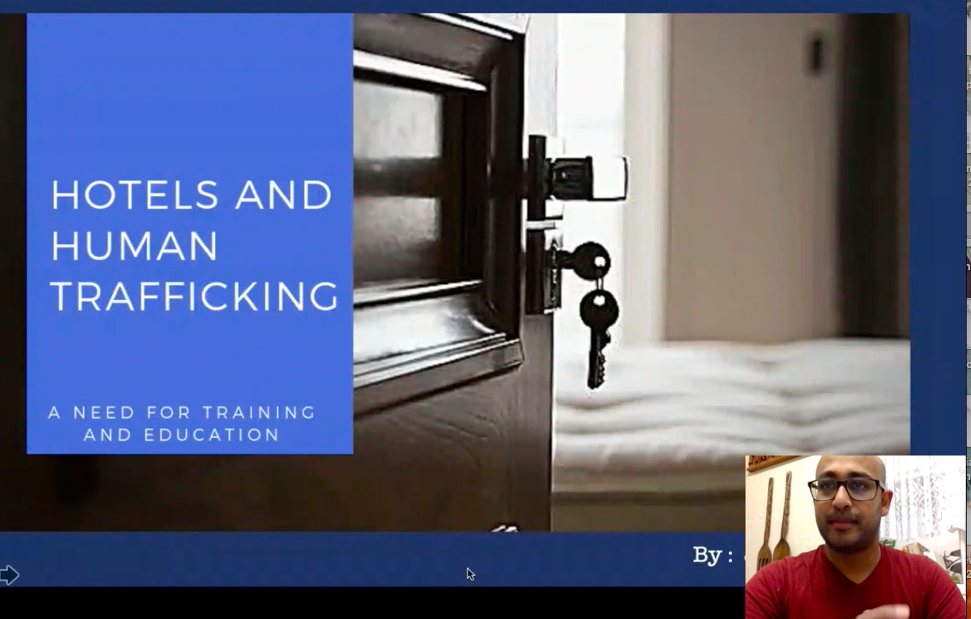

Website profile



