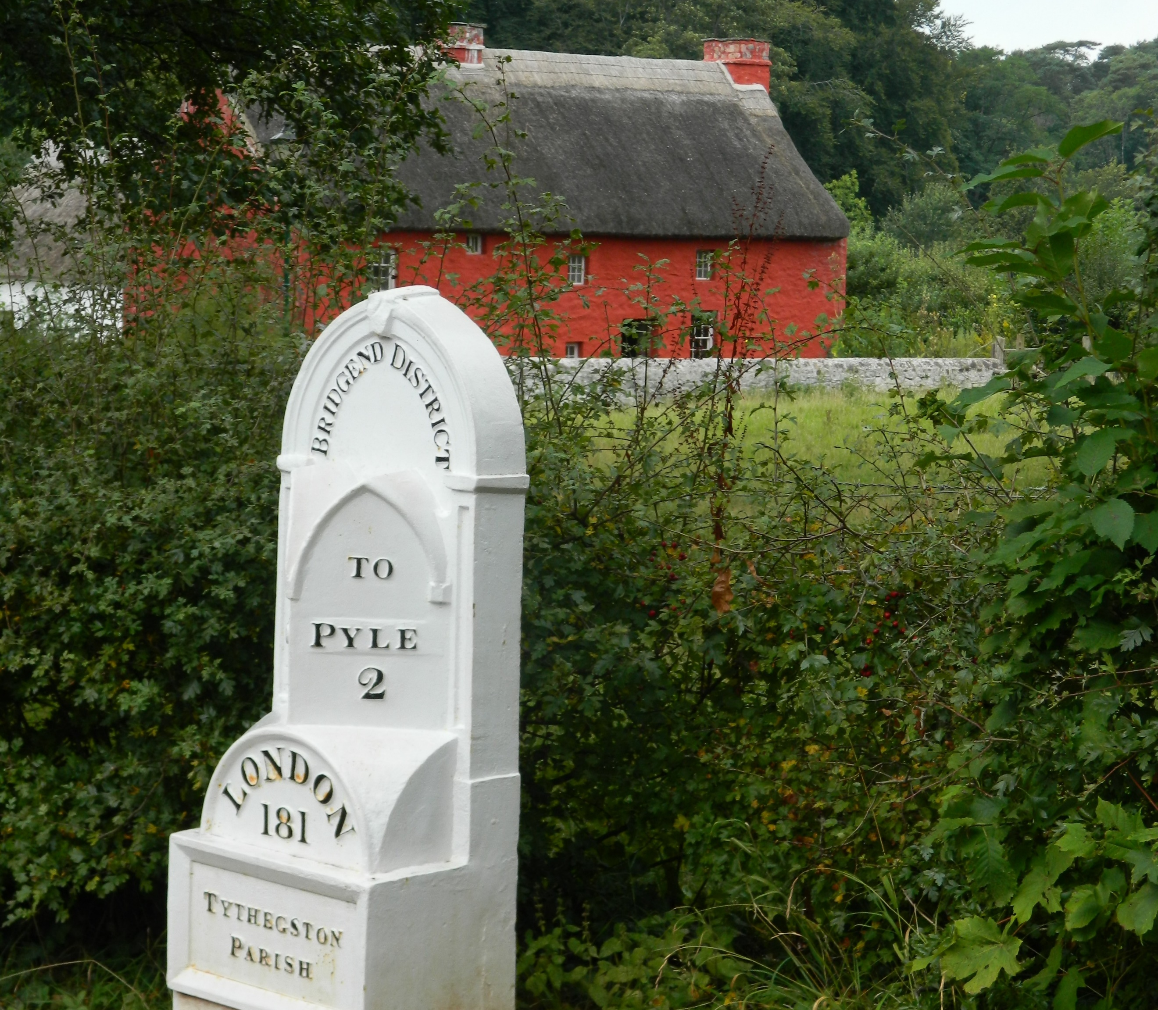
Delivering ‘Welshness’

How easy is it to gain a sense of what constitutes Welsh culture at St Fagans National Museum of History?
Lisa Holland 2014459 | 3 October 2021 | HPHE5008

SYNOPSIS
This is a report on three field trips to St Fagans National Museum of History, Cardiff, which took place in September 2021. The purpose of these visits was to investigate how easy it is to form an impression of Welsh culture based on what is on display there.

Each visit focused on a different aspect of the museum. The first was intended to gain an overview of the entire site; the second involved engaging with guides in some depth at particular buildings; the third looked at the indoor galleries and Gweithdy (workshop).

Covid restrictions meant that some buildings and all activities were unavailable.

The collection of artefacts on display were geographically and chronologically disparate, and were, on the whole, grouped thematically. The collections ranged from the prehistoric to the contemporary, and while accompanying information was minimal, displays were (Covid restrictions aside) easy to engage with.

The historic buildings mostly related to a rural past, in keeping with the museum’s founding principles, although more contemporary structures are now in place. The indoor displays in particular invited the visitor to think about Welsh identity, community, and nationhood.

The breadth of the displays made it easy to form a sense of how traditional Welsh communities might have kept themselves occupied, but initially I did not come away with any particular impression of ‘Welshness’ based on what I saw. Rather than simply looking at the material objects of the people who lived on this land, I would have liked more context to help me understand how and why this corner of Britain came to think of itself as it does. However, after reflection I did come to appreciate how St Fagans describes a nation coming into its own, with a vision of its future and pride in its past.

I am grateful to all the staff I spoke to for giving up their time and knowledge so enthusiastically, to Thomas, an English visitor who was happy to discuss his impressions of Saint Fagans, and to Dafydd Wiliam, Principal Curator: Historic Buildings at St Fagans, who answered my follow-up questions by email.

TABLE OF CONTENTS
Introduction …………………………………………………………………………………………………………. p.3
Definitions:
What is culture? …………………..………………………………………………………… p.3
What is Wales? ……………….……………………………………………………………… p.3
What is St Fagans? .………………………………………………………………………… p.3

Discussion .…………………………………………………………………………………………………………... p.4
Disclosure ………………………………………………………………………………………………….. p.4

The Visits:
Visit One ………………………………………………………………………………………. p.4
Visit Two ………………………………………………………………………………………. p.5
Visit Three ……………………………………………………………………………………. p.6

Analysis ……………………………………………………………………………………………………. p.8

Conclusion ………………………………………………………………………………………………………..... p.9
References ………………………………………………………………………………………………………….. p.10

INTRODUCTION
Definitions
What is culture?
To answer the question ‘How easy is it to gain a sense of what constitutes Welsh culture?’ it is useful to define what is meant by culture.
Culture is a term that describes collective understandings and beliefs held by a group of people, and the way they express those ideas. This expression can be tangible, in things like food habits, social customs, the arts, technology and dress, or intangible – the unconscious beliefs underwriting humour, ethics, or value judgements, for example. It is what makes one group of people distinct from another.
What is Wales?
In When Was Wales?, Gwyn Williams tells the story of Cymru from prehistoric times to the twentieth century. The topography, he believes, has made genuine community in impossible (1985: 3). He describes a country divided politically, economically and culturally throughout history.
Its wealth of natural resources led to Wales becoming one of the world’s first industrialised nations (Dicks 2020: 70); the impact of post-industrial decline has been profound (Dicks 2000). Industrialisation led to the nation’s wealth accumulating around Cardiff and Swansea, exacerbating the sense of dislocation within Wales. The first referendum on devolution, in 1979, came in heavily against. The next, in 1997, only just scraped through at 50.3 to 49.7; if a 40% voting threshold had been implemented, the vote would not have passed (Dewdney 1997). Wales was not a united nation. Since the formation of the Welsh Assembly in 1999, it has been seeking to change that.
What is St Fagans?
St Fagans was originally an open-air museum devoted to preserving aspects of rural Welsh life destroyed by industrialisation. Its founder, Iorwerth Peate, was inspired by the success of Scandinavian outdoor museums in promoting national pride and identity (Owen 2009). His vision was to ‘link the past to the present’ to create a ‘fountainhead of new cultural energy’ (Thomas and Williams 2015). St Fagans opened its doors in 1948.
Its Welsh name at inception was Amgueddfa Werin Cymru (literally, Museum of the Gwerin of Wales – gwerin meaning folk in the sense of ‘the people’ – see Dicks 2020: 73). Over the years, while the Welsh name has stayed the same, the English translation has altered:
1948 - Welsh Folk Museum
1995 – Museum of Welsh Life
2005 – St Fagans National History Museum
2017 – St Fagans National Museum of History

Critics accused the museum of presenting a skewed and sanitised picture of Wales – there was no mention, for example, of mining (Williams-Davies and Thomas n.d.). The name changes reflect the change of focus as this was addressed. Today, St Fagans aims to be representative of all aspects of Welsh life – a ‘cultural democracy’ (Thomas and Williams 2015). In 2018, it was the fourth most popular free visitor attraction in Wales (McAllister 2020).

DISCUSSION
Disclosure
Despite living in Cardiff since 2011, I had never visited St Fagans before. This was a conscious choice: nothing about the idea of ‘a Welsh folk museum’ appealed. I am not Welsh and have no particular interest in historic buildings. Cardiff also felt so much like any other city in the UK that I had not gained any specific sense of Welsh culture while living here, other than noting that Welsh people are fiercely proud of their Welshness.

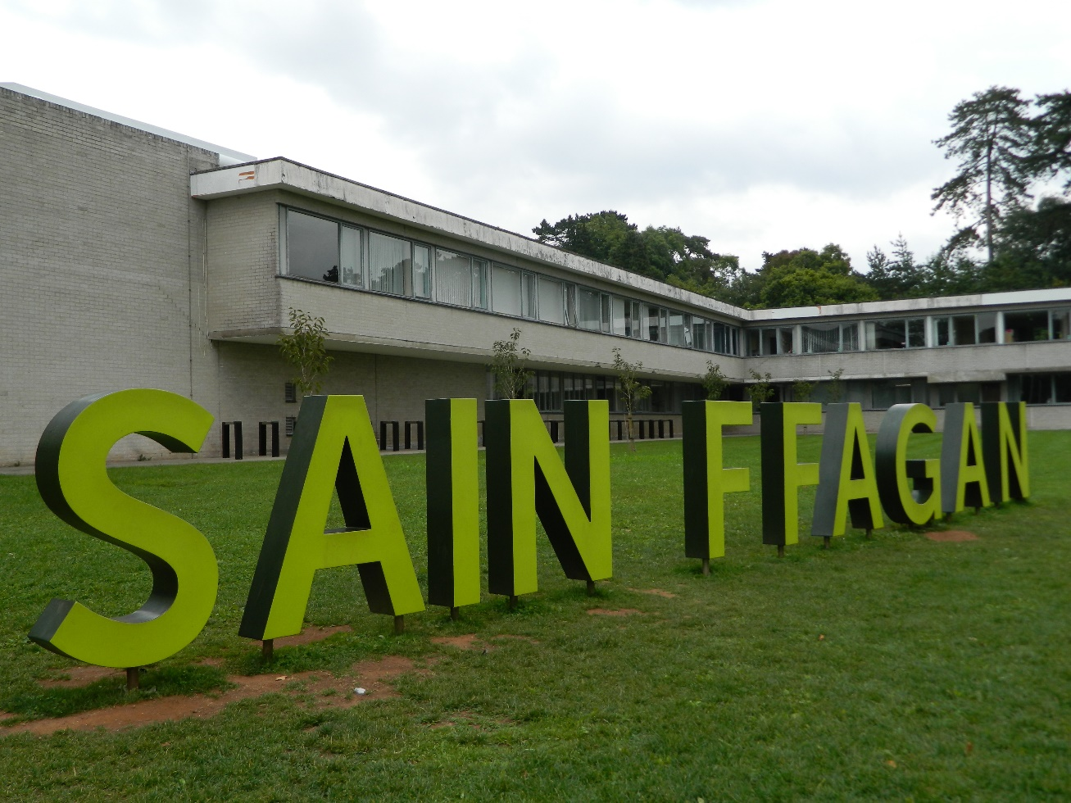
(Say my name… first impressions of St Fagans. Photo: author)

The Visits

Visit One: First Impressions
Purpose: to gain an overview of the entire site
Date: Monday 13 September 2021

Observations:
- The modernist building rising from the green space surrounding it was imposing. Huge letters on the lawn to the right of the entrance spelled out the building’s name in Welsh – the first photo opportunity offered before the visitor had even stepped inside. The large atrium also radiated poise and confidence. It was airy, modern, sleek. This was a self-assured place.

- Site maps were available in Cymru and English, as one would expect, but also in European and Asian languages, indicating a site of international importance.

- Many buildings were closed due to Covid restrictions, and both staff and visitors were thin on the ground. There were no activities or workshops running, and the site felt deserted, almost eerie, as I explored it.

- Rural and more ancient structures were spaced far apart, perhaps to emphasise the isolation of their original locations, whereas the town and village buildings were clustered together, creating an impression of focus and activity despite the closed doors.

- The information boards outside each structure provide only basic details – its original location, a photo or two, a potted history, the date of relocation, a point to ponder.

- The guides I encountered were uncommunicative, so I was left to my own devices. Consequently, I drifted rather aimlessly from place to place, not really understanding how what I was seeing represented ‘Welsh culture’. It felt more like a random collection of sad, silent buildings from a dead and distant past.

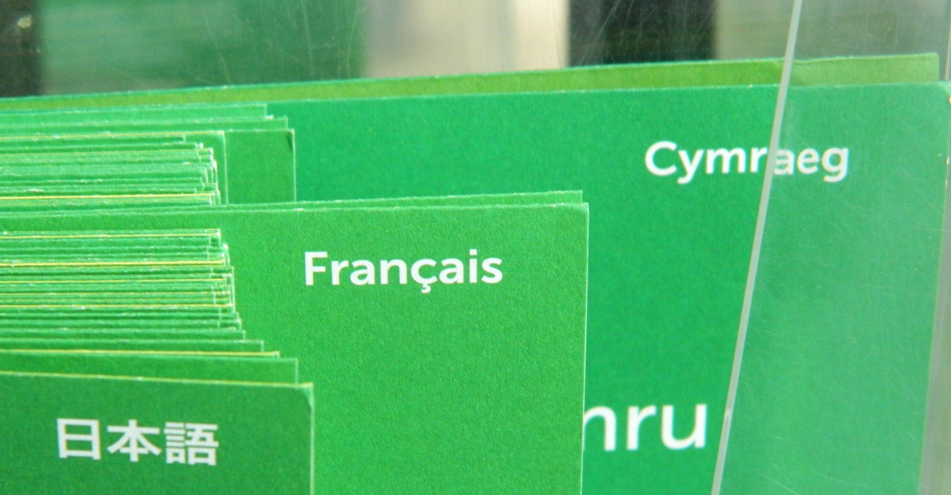
Site maps were available in Welsh, English, Spanish, French, German, Italian,
Dutch and Chinese.
(Photo: author)

Visit Two: Focused Engagement
Purpose: to engage with building guides, ask questions, dig deeper
Date: Thursday 23 September 2021

Observations:
- On this visit I talked to four building guides and one visitor. The guides were stationed at Kennixton farmhouse, the Iron Age roundhouse, the Corn Mill, and the Ironworkers’ Cottages. Speaking to the guides was the missing ingredient from the previous visit. The buildings – and thus the lives of their occupants – came alive as they filled in the blanks with stories, explanations, meanings, context. I started to understand the raison d’être of the museum.

- The visitor was a young English man in Wales that day on business, who had decided to visit on the spur of the moment after seeing the sign on the M4. With scant knowledge of Wales, Thomas had no expectations about what he might find. This provided an interesting counterpoint to the expertise of the museum staff.

- A comment Thomas made summed up my feelings so far on the representation of Welsh culture at St Fagans: “I haven’t seen anything here that strikes me as being quintessentially Welsh.”

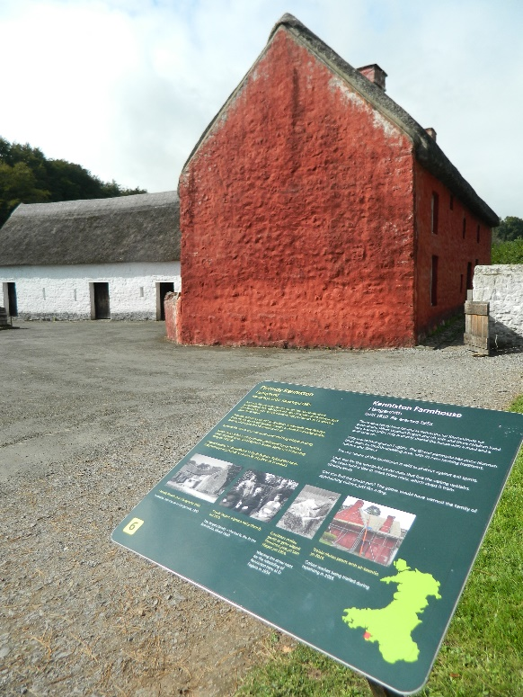

The information board at
Kennixton farmhouse.
(Photo: author)

Visit Three: The Galleries
Purpose: to investigate the displays in the indoor spaces
Date: Friday 24 September 2021

Observations:
- This visit took in the indoor exhibitions: Wales Is…, The Future Has A Past, Life Is…, Gweithdy (workshop).

- The permanent galleries displayed some iconic tokens of ‘Welsh culture’ such as harps, ‘Welsh Lady’ costumes, standing stones, miners’ stories, and rugby paraphernalia. However, the exhibits ranged far beyond these stereotypes and were designed to be thought-provoking.

- Participation was encouraged via questions visitors were encouraged to answer by filling out post-it notes etc. While earlier answers were on display, this activity was not available at the time of the visit due to Covid restrictions.

- Permanent displays were grouped thematically and did not go into much depth – little supporting information was provided. I struggled to gain a sense of the chronology involved.

- The temporary gallery was devoted to an exploration of possible futures for Wales by young artists, in line with the museum’s commitment to community inclusion.

- I noticed some curious omissions in the Wales Is… exhibition: the Welsh diaspora; the traditional importance of religion; the economic, political and cultural divisions inside Wales; post-industrial decline; the complexity of the relationship with England. If those topics were addressed at all, the information was cursory and left open for debate.

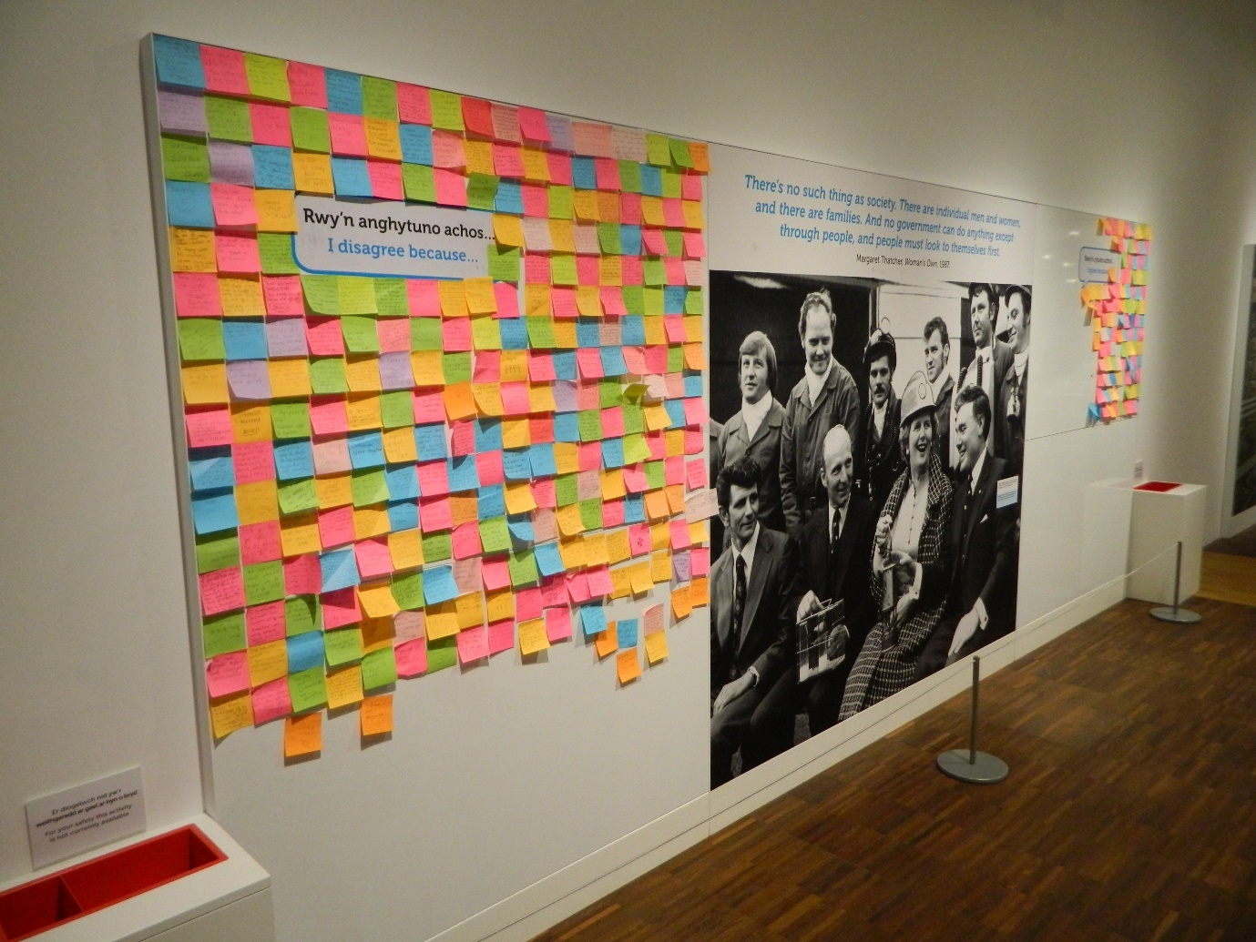(No such thing as society? A discussion board. Photo: author)

Analysis
Initially I failed to understand how St Fagans presented Welsh culture. But Thomas’s comment on the lack of anything ‘quintessentially Welsh’ was a catalyst to examine my expectations about what I thought I might find there. I have lived in New Zealand, where the expression of culture is focused on fetishization of the natural environment and a stylised ‘Māori-ness’, and had just returned from a holiday in Scotland, where the ‘Scottishness’ is unmistakeable wherever you go.
Wales shares with both countries a rural past, beautiful scenery and a battle against English dominance, so I was expecting to see distinct expressions of place and identity similar to the ones found there. Instead, I found understatement – displays that seemed mainly to describe a generic past that could have been found anywhere in Britain: rural communities, medieval life, the Romans, Neanderthals. I failed to spot even a Welsh flag on the premises. It was as if the museum’s founding principle of not indulging ‘localist passions’ (Dicks 2020: 77) had been taken to extremes.

What is ‘Welsh culture’? To an outsider, it is rugby, music, poetry, daffodils, castles, a famous patron saint. Everyone could name a Welsh musician or an actor or two, and most are aware there is a defiant pride in the survival of the language with a political undercurrent. These aspects of culture are given space but melt into a much wider picture at St Fagans. Looking deeper, at the meanings behind what was on display rather than at the objects themselves, I saw the quiet assurance of a nation describing who it was and how it got here.
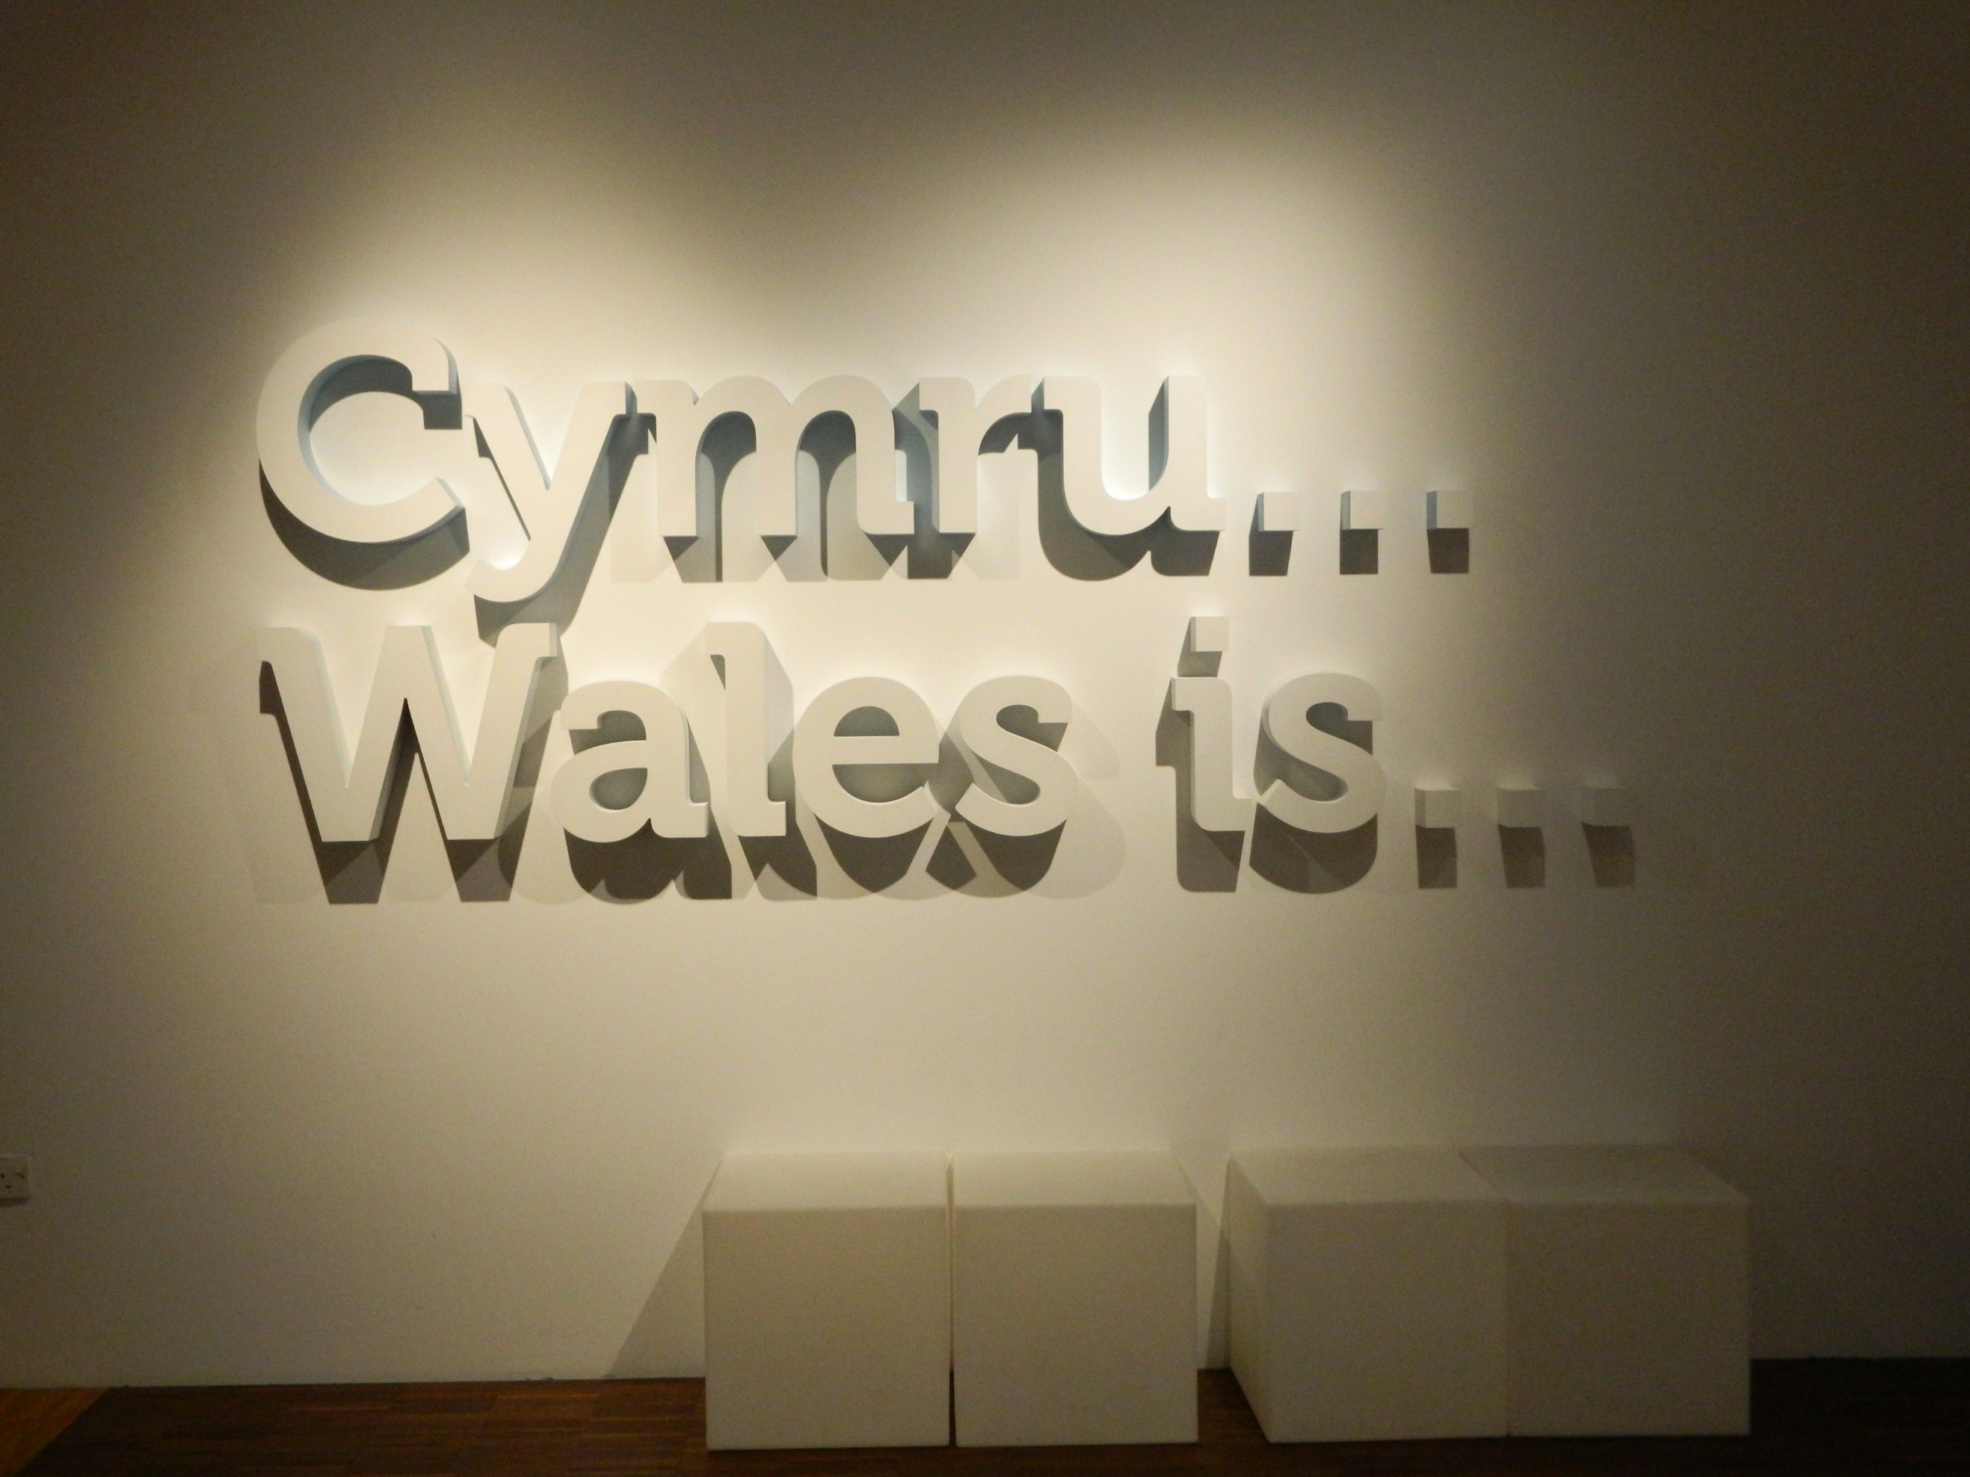
Wales is… thought-provoking.
(Photo: author)
The scope and range of the exhibits described a place with a rich heritage which still matters. The museum’s present form demonstrates a confident expression of agency and self-worth. The unspoken narrative was that the Welsh take themselves seriously, are a creative and practical people who have ridden out a difficult history. This was a powerful message. Once I had understood this, it was easy to appreciate the relevance of the displays.
Representations of the past have always been used to assert Welsh identity (Johnes 2015). St Fagans continues this tradition. By presenting a collective Welsh national memory and inviting debate about Wales’s future, it generates not just a sense of shared identity but a feeling of gathering independent strength, akin to Scotland’s. No wonder the Welsh love it. I am pleased to report that now I love it too.

CONCLUSION
It was not easy at first to gain a sense of Welsh culture at St Fagans. I blame my ignorance and preconceptions for that, although the size of the museum, the Covid restrictions and the sheer quantity and variety of artefacts on display did contribute to this. It was impossible to gain much more than a fleeting impression in the time available.
After consideration and further research, however, I gained a more informed picture of Wales and Welshness. From this grew a better understanding of how the items on display demonstrated Welsh culture. The museum aims to be ‘a world-class museum of learning’ (Williams-Davies and Thomas n.d.). This previously uninformed English visitor certainly came away with her respect for Welsh culture deepened and her curiosity aroused.

REFERENCES

Dewdney, R. (1997) Results of Devolution Referendums (1979 & 1997). London: Social & General Statistics Section, House of Commons Library. Available at
https://researchbriefings.files.parliament.uk/documents/RP97-113/RP97-113.pdf [accessed 3 October 2021]

Dicks, B. (2000) Heritage Place and Community. Cardiff: University of Wales Press.

Dicks, B. (2020) ‘Industrial Heritage as Place-Making: The Case of Wales’, in Berger, S. (ed.) Constructing Industrial Pasts: Heritage, Historical Culture and Identity in Regions Undergoing Structural Economic Transformation (1st ed. Vol. 38). Berghahn Books. Available at https://doi.org/10.2307/j.ctv1850gh6 [accessed 3 October 2021]

Johnes, M. (2015) ‘History and the Making and Remaking of Wales’, in History Vol. 100 (5) pp.667-684. Available at DOI: 10.1111/1468-229X.12141 [accessed 3 October 2021]

McAllister, F. (2020) Visits to Tourist Attractions in Wales – 2018. Treforest: Beaufort Research Ltd. Available at https://gov.wales/sites/default/files/statistics-and-research/2020-01/visits-to-tourist-attractions-in-wales-2018.pdf [accessed 3 October 2021]

Owen, T. M. (2009) Peate, Iorwerth Cyfeiliog (1901-1982). Available at https://biography.wales/article/s6-PEAT-CYF-1901#?c=0&m=0&s=0&cv=11&manifest=https%3A%2F%2Fdamsssl.llgc.org.uk%2Fiiif%2F2.0%2F1465872%2Fmanifest.json&xywh=1199%2C1900%2C1415%2C1224 [accessed 3 October 2021]
Thomas, B. and Williams, N. (2015) ‘Moving Towards Cultural Democracy: Redeveloping St Fagans’. Transactions of the Honourable Society of Cymmrodorion Vol. 21. Available at https://www.cymmrodorion.org/the-transactions/moving-towards-cultural-democracy-redeveloping-st-fagans/ [accessed 3 October 2021]

Williams, G. A. (1985) When Was Wales? Reprint, London: Penguin, 1991.
Williams-Davies, J. and Thomas, B. (n.d.) Social Change: Museums Reflecting Changing Identities. Available at
https://museum-id.com/museums-reflecting-changing-identities-john-williams-davies-beth-thomas/#:~:text=Significantly%20the%20Welsh%20name%20for%20St%20Fagans%2C%20Amgueddfa,in%20order%20to%20distance%20the%20museum%20from%20%E2%80%98folksiness%E2%80%99 [accessed 3 October 2021]

