Programme: MSc Cybersecurity and Digital Forensics
Module Code: ACCA7031

Digital Forensics Analysis: Current State, Challenges, and Future Directions

Student Name: | [Ramanjaneyulu Dandu]
Student ID: | [2430963]

Contents
Task 1 5
Introduction 5
Current State of the Digital Forensics Field 5
Professional Standards and Governance 5
Technical Tools and Methodologies 5
Tool Features and Capabilities Analysis 5
Intersection of Digital Forensics and Cybersecurity 6
Integrated Lifecycle Approach 6
Organisational Implementation 7
Emerging Trends in Digital Forensics 8
Cloud Forensics Evolution 8
Artificial Intelligence Integration 8
Expanding Forensic Domains 8
Key Challenges in Digital Forensics 8
Technical and Data Management Challenges 8
Scientific Validation Requirements 8
Human and Organisational Considerations 9
National and International Digital Forensics Job Market 9
UK Employment Opportunities and Roles 9
UK Compensation and Market Dynamics 9
International Job Market Analysis 9
Conclusion 10
Task 2 11
Introduction 11
Methodology 11
Evidence Acquisition and Ingestion 11
Device Attribution 12
Communication Analysis 12
File System and Keyword Search 13
Metadata and Timeline Reconstruction 14
Analysis Limitations 14
Findings 15
Device Ownership and Attribution 15
Communication Evidence 19
Interpretation of Communication Evidence 22
Additional Artefacts 23
EXIF Metadata and Geolocation 23
Contact Linkage 23
Analysis and Discussion 24
Motive 24
Means 24
Opportunity and Behavioural Indicators 25
Conspiracy and Limitations 26
Conclusion 26
Recommendations 27
References 28
Appendix: Forensic Analysis Screenshots 30

Task 1

Introduction
Digital forensics has become a discipline forensics field that makes use of methodologies to discover, preserve, examine, and document digitised evidence to be used in a court of law. In this report, I will explore the current landscape of digital forensics, its connection with cybersecurity, future trends, the most significant challenges, and the job market in the UK. The analysis is based on the international standards, academic studies, and government regulations.

Current State of the Digital Forensics Field

Professional Standards and Governance
The digital forensics in the UK operates within the code of practice of the Forensic Science Regulator. This requires method validation, quality management and staff competence [1]. This is consistent with the international initiatives through UNODC and the ISO guidelines that ensure consistency in forensic practice globally. The police forensic teams of the UK and the ENFSI laboratories assist in the work of law enforcement, taking into account the newest technologies.

Technical Tools and Methodologies
Digital forensics encompasses computer forensics, mobile device analysis, network forensics, analysis of memory, cloud computing, internet of things, and vehicle forensics [2]. There are systematic working procedures where evidence is collected, a chain of custody, methods of analysis and standards of reporting, to ensure the integrity and admissibility of evidence that gets to the courtroom.

Tool Features and Capabilities Analysis
They have platforms like EnCase, FTK, NUIX, Autopsy, and Cellebrite used in the industry. EnCase offers disk imaging support, hardware write-blocking support and multi-file system analysis [3]. FTK is good at distributed processing and password recovery. Cellebrite are able to perform physical extraction on 20,000+ device profiles, and Autopsy can offer a cost-effective solution; however, it might not support an enterprise [4].
There are still gaps in the validation of tools. According to Horsman and Dodd (2024), not all methodologies are thoroughly validated, and this aspect should be a concern when it comes to errors [5]. The inconsistent tool findings are a drawback of digital evidence, as it lacks a scientific basis. This is taken care of through NIST testing, although there is an inconsistent adoption of standardised protocols.
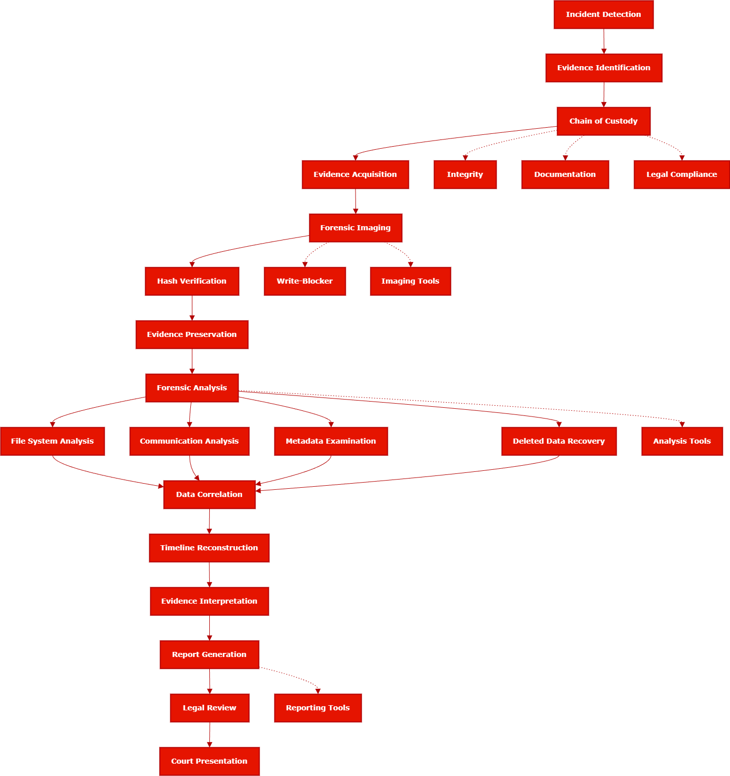
Figure 1: Digital Forensics Process Flowchart

Intersection of Digital Forensics and Cybersecurity

Integrated Lifecycle Approach
Cybersecurity and digital forensics exist in a paradoxical relationship: pre-breach protection and attack response to recovery after an attack. Integration is problematic; the partially integrated (35 per cent) DFIR functions are struggling to coordinate separate teams.
The DFIR team deals with events captured by the logs up to malware assessment as well as threat attribution [6].

Organisational Implementation
Forensic methodologies can be used to collect evidence at the endpoint, servers, cloud workloads and networks without tampering with artefacts. In the case of regulated UK organisations, compliance, post-incident reporting, and investigations are supported by digital forensics.
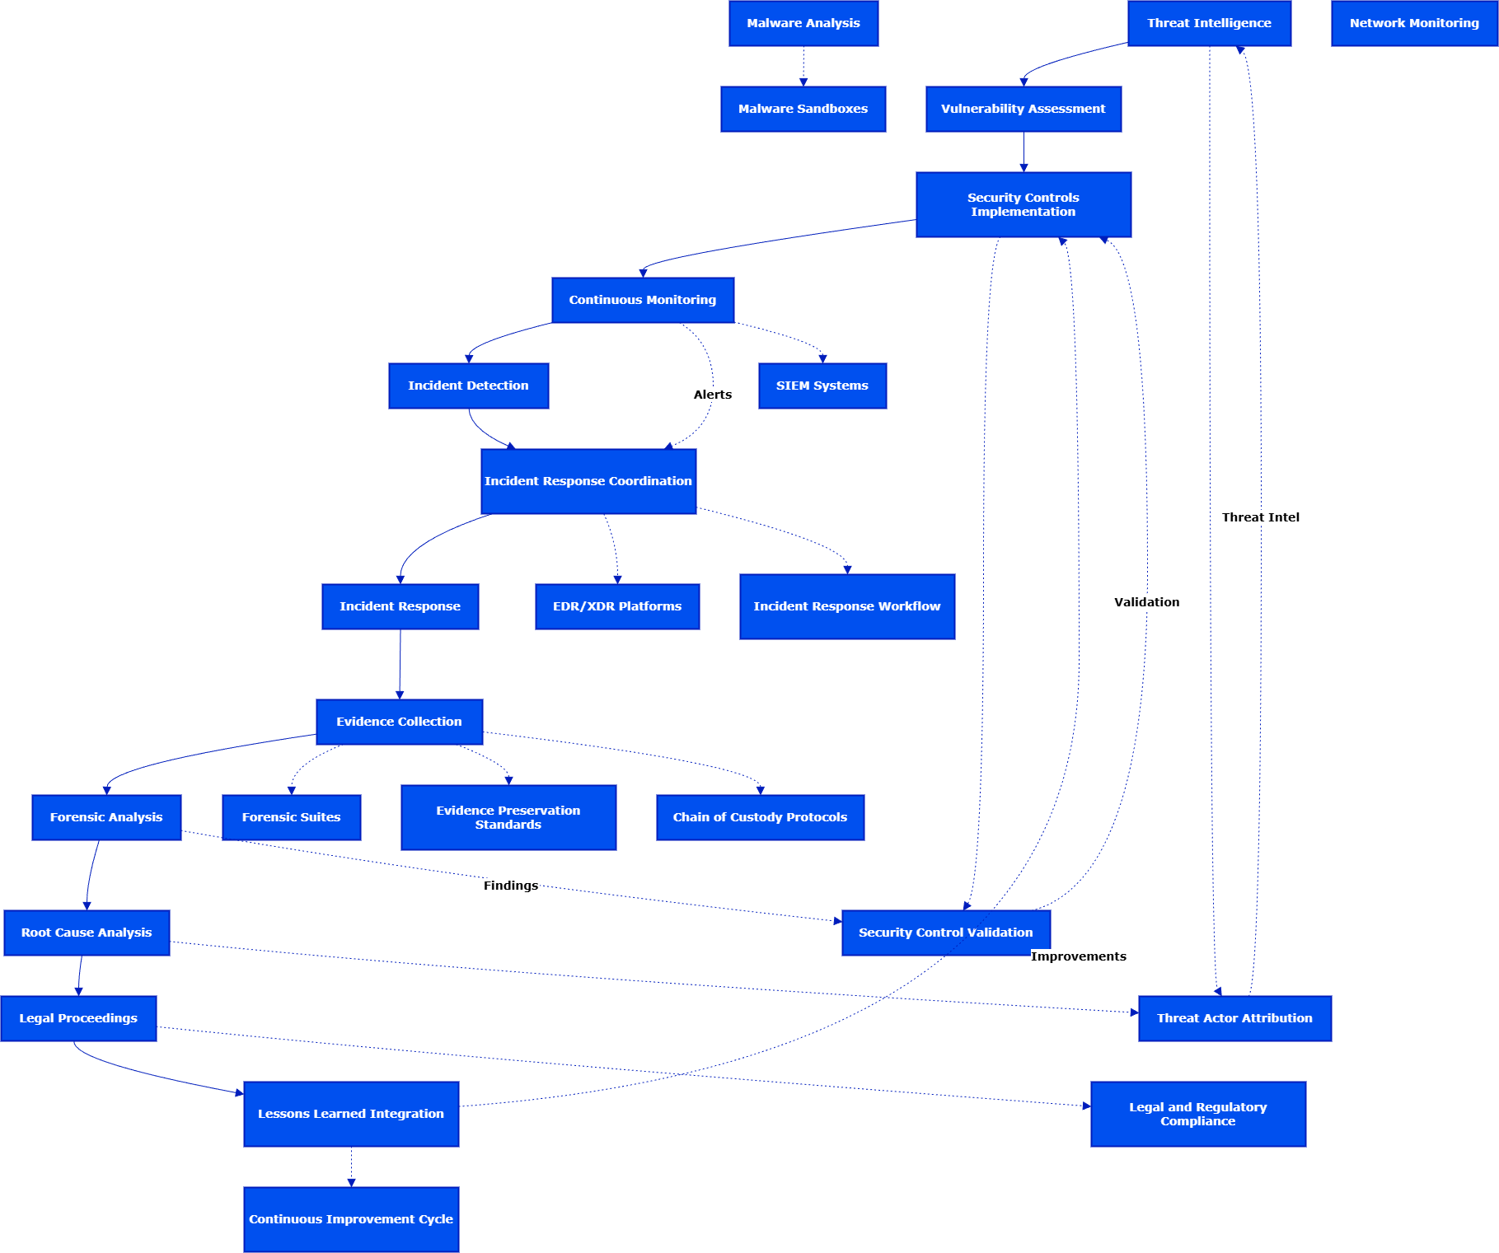
Figure 2: Intersection Diagram Cybersecurity-Digital Forensics
Intersection Diagram indicating the connection between defensive and proactive cybersecurity and the reactive process of digital forensics, the integration points, and the tools they share. Source: Self-representation of the author on the basis of combined DFIR models.

Emerging Trends in Digital Forensics

Cloud Forensics Evolution
Cloud forensics needs the collection of evidence in the virtual machines, containerised applications and saas logs as well as cloud provider infrastructure. The concept of API-based acquisition is progressing, although Caraballo (2024) reports a lack of legal admissibility verification and data preservation differences among vendors [7]. Migration requires the development of methodology, dealing with issues of data jurisdiction, provider cooperation, and distributed evidence.

Artificial Intelligence Integration
One of the main applications of AI in forensic work is the area of triage, pattern recognition, and the automation of the analytical process. There is a problem of validation in implementation. The proponents of European strategy suggest the use of AI-based tools, yet the practices of black box-based decision-making offer challenges. The use of AI is responding to the increasing amounts of data, yet 22% of forensic laboratories use AI outside pilot stages [8].

Expanding Forensic Domains
The areas of development are IoT forensics, vehicle system investigation, and drone investigation, which need specialised tools to investigate proprietary interfaces. Analysis of cryptocurrency transactions grows along with financial crimes that are facilitated through cyberspace.

Key Challenges in Digital Forensics

Technical and Data Management Challenges
The burden of volume and heterogeneity of the evidence, that is, devices, communication records, and long logs, makes analysis a challenge in time. Powerful encryption and privacy solutions limit the availability of content, forcing the use of metadata and endpoint artefacts [9]. The increase in data and the spread of connected devices generate resource requirements that led to the need to focus on prioritisation systems to store backlogs and guarantee case resolution.

Scientific Validation Requirements
The digital forensic methods are not thoroughly vetted, as they increase the error margin and exacerbate the reproducibility issue. The Code prescribes the UK Forensic Science Regulator with quality management, validation of methods and competence testing [10].

Human and Organisational Considerations
There are problems with human resources: lack of skills, uneven training, pressure on human resources in the laboratory and constant development requirements. It is still difficult to balance operational urgency versus documentation, chain-of-custody and ethical treatment [11].

National and International Digital Forensics Job Market

UK Employment Opportunities and Roles
UK practitioners in the discipline of digital forensics are employed in police departments, government programs, consulting companies, incident response teams, and businesses. There are positions of digital forensic analyst, mobile expert, DFIR consultant, cybercrime investigator, and coordinator.

UK Compensation and Market Dynamics
The median salary in one of the UK digital forensics roles is around mid-PS50,000, and the salaries of the experienced specialists can be even higher. Low-PS50,000 are generally advertised in public sector positions. The job vacancies on job portals are uniform across the regions.

International Job Market Analysis
The regional compensation variation is present in the global demand. The median price of US jobs is $85,000 to $120,000 annual incomes among the professionals working in the middle and senior levels, and the federal government and consulting companies propose competitive package offers. In Singapore and India, it is registering fast growth in Asia-Pacific with compensation of 30-40% US.

Conclusion
Digital forensics is fast changing, presenting not only significant possibilities but also significant challenges. Although the inclusion of the cyber-security theory has the potential to resolve defence mechanisms, the practical application of DFIR models is not uniform. The investigations are being transformed by cloud computing and AI, as they are getting bigger in terms of scale, but require strict validation and a new way of operation. Complexity is increased by technical barriers, including large categories of data, encryption, lack of skills, and tough verification requirements. However, the need to increase professional standards and education spots in the workforce continues to increase.

Task 2

Introduction
This document is a case report on a case of digital forensic investigation into the suspected theft of intellectual property that is classified as belonging to ABC Technologies. The reason why the allegation was brought forward concerns the unauthorised access, as well as an attempt to sell sensitive information related to the AI-based Neuro project of the organisation, internally known as QT-AI-2025. Emma is an internal employee who has been suspected of accessing and conveying this proprietary data to third parties via intermediaries. Four mobile phones were purchased to be investigated: a Huawei POT-LX1 that was revealed as the main phone of Emma, a Ulefone Note 14, which was owned by a contractor, Joe Marsh, a Samsung A13 of a potential external owner, Norman, and a Nokia C2 2 nd Edition of unknown belongingness. The investigation was intended to determine and analyse digital artefacts that may be of interest to the investigation into the suspected exfiltration, recover and analyse communications between involved parties, prove ownership of devices and validate connections between causes and effects, build a timeline of events based on messaging information, metadata, communication logs, and EXIF information, as well as determine whether the available evidence suggests or opposes the idea that Emma unlawfully accessed confidential information. The report records the steps followed in the forensic procedures, the evidence collected, and the conclusions made as a result of the analysis of the mobile data sources.

Methodology
The research adhered to formal forensic research methodology in line with industry and other research best practices. The method includes device attribution, analysis of communication, examination of the file system, metadata connection, search by keyword, behavioural analysis, and reconstruction of the timeline.

Evidence Acquisition and Ingestion
The four mobile data sets were all in the Cellebrite UFED extraction files in logical format (.ufdx). These have been ingested into Autopsy 4.22.1 with the help of the Logical File Set ingestion module. Recent Activity, File type identification, Email Parser, Android Analyser, Keyword Search, Metadata Extractor modules and EXIF Metadata modules were turned on [12]. The PhotoRec Carver module was purposely turned off, as it could not be compatible with logical extraction filters.

Device Attribution
In this study, device attribution was performed by systematic analysis of various types of digital artefacts in order to reliably seasonize each mobile device with its respective suspected owner [13]. Contact lists and stored identities were used to give preliminary signs of user affiliation such that cross-verification of names, numbers and saved identifiers could be carried out. These correlations were reinforced by WhatsApp JIDs identities that are associated with familiar phone numbers to resolve identities of communication across different devices. Installed apps were also scanned through; the usage of apps, the artefacts of login, and configuration settings are usually good at letting us know the behavioural features of the specific user. Landmark-specific imagery, e.g. photos of recognisable landmarks or individual spaces, served as one more confirming factor of habitual device use. Another dimension of personal attribution was the introduction of the financial artefacts as photographs of credit cards, which linked financial identities to the device owners. Patterns that determine ownership also adopted communication patterns like frequent contact between familiar associates, repeated messaging behaviour and frequency, among other factors. Together, these artefact sets offered a solid evidentiary foundation on which there was confidence in placing each device into the correct hands, and, therefore, these artefacts allowed one to reliably undertake a contextual and precise forensic evaluation at each stage of the investigation.

Communication Analysis
The communication analysis was a systematic review of messages, artefacts of WhatsApp, and communication logs with the aim of finding meaningful communication between the people participating in the processes. The analysis focused on the content of the messages, which allowed the investigators to spot direct mentions of the stolen intellectual property, negotiation efforts, and conversations which revealed that the parties were aware of the stolen property [14]. Direction of messages between incoming and outgoing messages- needed to be acknowledged to establish the flow of conversation, intention and initiations of various suspects. WhatsApp JIDs were resolved to verified phone numbers to verify the identity of participants and link the communication thread, and identify participants correctly. Timestamps were key to rebuilding the chronological order of the interactions and identifying the points of communication and whether these patterns coincided with the period when the data theft was supposed to have happened. Also, cross-tool connection between suspects was determined by detecting shared contacts, shared communication and coordinated inter-platform activities. The availability or unavailability of communication history gave a clue to the possible efforts to conceal illicit behaviour, including the deletion of messages or the selective application of encrypted applications. The specific focus was given to the messages in WhatsApp as the most significant debates that were focused on the alleged intellectual property theft were found there. All in all, the communication analysis presented a comprehensive account of the collaboration, negotiation, and organised criminal conduct among the suspects.

File System and Keyword Search
The investigation file system and keyword search element entailed an extensive scan of directory structures, file artefacts, and searchable content through all four devices. A list of keywords was created with specific keywords to help find terms that were related to the suspected intellectual property theft, such as, but not limited to, QT, AI, 2025, Patent, Confidential, ABC, Neuro, Prototype, CAD, and PDF. These words were probably file names, project names, or descriptions associated with QT-AI-2025 material. The logical extraction was limited, with searches being done through user-readable files, application caches, and temporary directories and deleted artefacts within the bounds of logical extraction. Though there was no full copy of the QT-AI-2025 patent file found during the search, there were a number of indirect indicators. These consisted of mentions in communication records, behavioural patterns that indicated file manipulation activity, as well as leftover traces that were indicative of an attempt to share or describe sensitive material [15]. The fact that the file was stolen in the first place could probably be explained by the fact that the external storage is used, especially the USB drive, which is missing and the considered to contain the important data. In spite of such limitations, the keyword search ensured the users took the terminology that was directly related to the confidential project of ABC technologies, which served as a valuable corroborative measure of the communication evidence. The scope of digital activity that was applicable to the investigation was also affirmed through the process.

Metadata and Timeline Reconstruction
Metadata and time reconstruction were an important way of contextualising the behaviour of the users, activity of devices and important events around the alleged theft of intellectual property. The EXIF metadata was copied out of images and offered the date and time, geo-location, and specifics of the camera used by a particular device. Such information allowed following the data of actions of the user in different geographic areas, which had the right to verify the movement in the country and determine possible meeting points used in the bargaining process [16]. The timestamps on messaging also helped in establishing the order of the communication and purported times when there were increased communication activities, which correlate to negotiation phases that were observed within the WhatsApp chats. The communication logs were cross-linked to system artefacts, application access times, wifi connection logs, and device configuration logs, and a logical temporal history was created. The comparison of those pieces of data enabled locating periods during which the use of the gadget was coincidental with the planning, organisation, and attempted sale of confidential data. Collectively, metadata sources depicted a steady stream of action in favour of the allegation, such as preparatory contacts, negotiation messages, and follow-up messages. This temporal mapping, relying on a rich body of evidence, helped to build the association of continuity of behavioural evidence and contributed to the overall findings of the investigation.

Analysis Limitations
One of these limitations is the lack of the USB flash drive belonging to Emma, which is believed to be carrying or formerly carrying the stolen files of QT-AI-2025. Absence of such a storage facility limits the possibility of being able to verify that the files were either physically moved or copied. However, the evidence that is present allows for reconstructing intent, communication, and a coordinated effort to sell confidential information to third parties.

Findings

Device Ownership and Attribution
Analysis of the four devices yielded the following ownership conclusions:
Huawei POT-LX1 – Assigned to Emma
Attribution is based on:
- WhatsApp messages involving Emma
- Contacts stored under identifiable names
- EXIF metadata from images taken in Ettumanoor, Kerala
- System configuration and language settings
- Absence of multiple user profiles

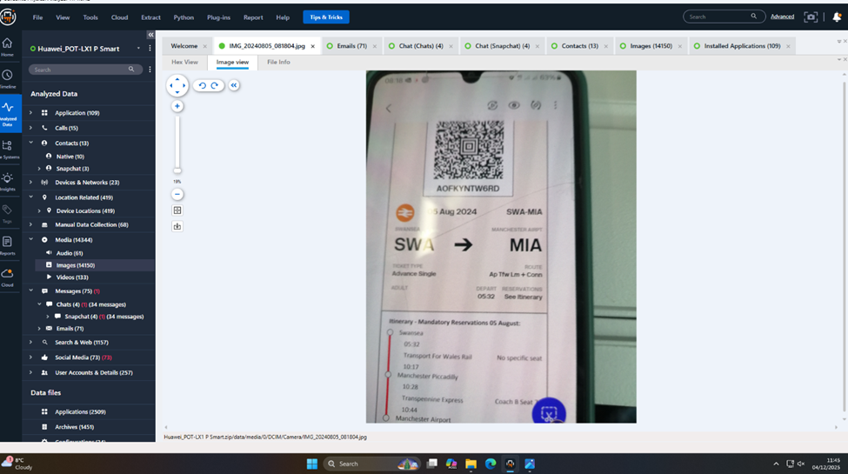 Figure 1 SWA to MIA

Ulefone Note 14 – Assigned to Joe Marsh
Indicators include:
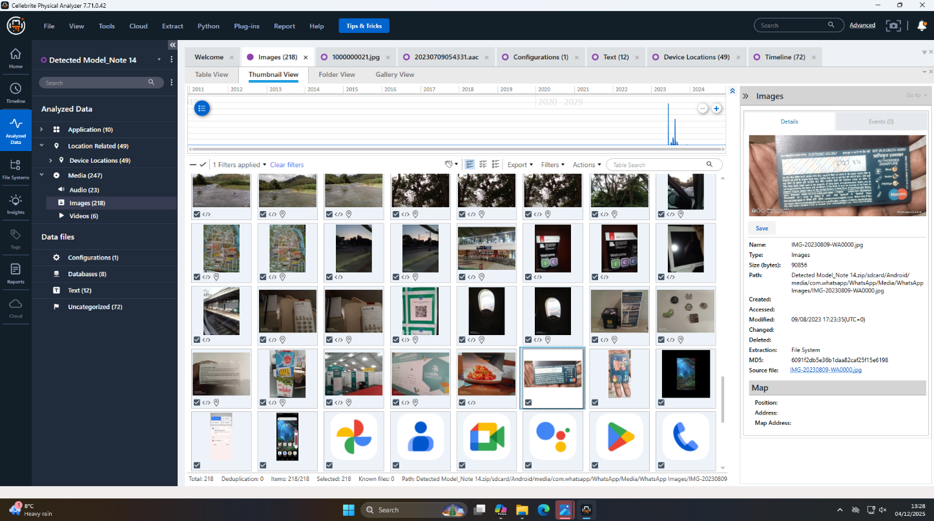 Figure 2 SBI Credit card

- WhatsApp JID matching the number stored as Joe Marsh in Emma’s phone
- A photograph of a State Bank of India credit card tied to Joe
- Personal multimedia content consistent with long-term ownership
- Photographs from the EuroSkills event in Gdansk, Poland
- 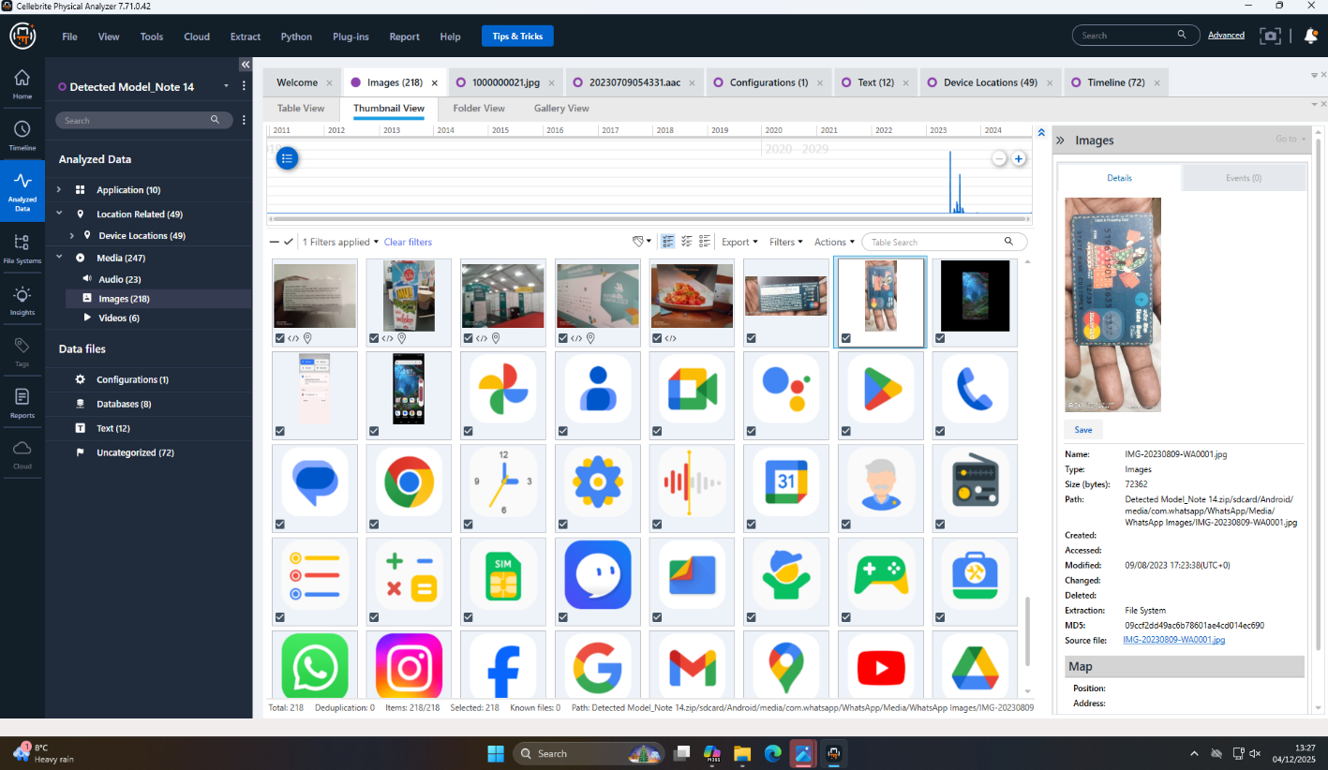

Figure 3 SBI credit card A/C information

Samsung A13 – Assigned to Norman
Evidence supporting
attribution:
- Images from London Bridge and surrounding areas
- Browser history suggesting UK-based activity
- Installed applications associated with personal use
Norman is identified as one of the potential buyers or negotiators involved.
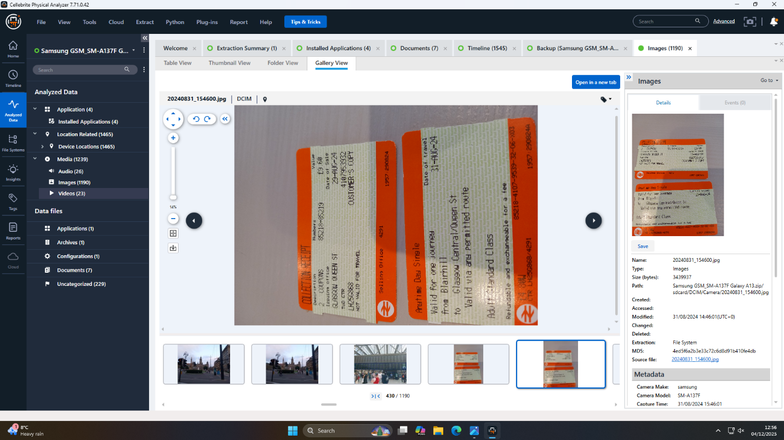

Figure 4 London train ticket
Nokia C2 – Ownership Unconfirmed
With regards to the single photo that was recovered, did displayed the text Shop 19, Nzano Centre, Francistown. There were no individual patient communication tools and identity indicators identified. The gadget is also provided as a supplement to help one learn more about the main investigation, but it does not directly affect it 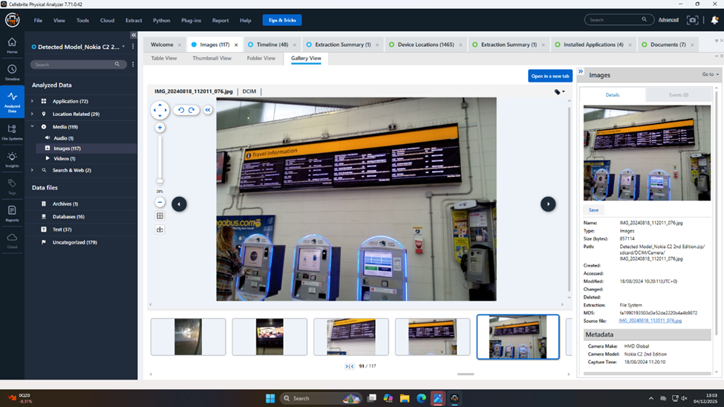 Figure 5 Traveling information
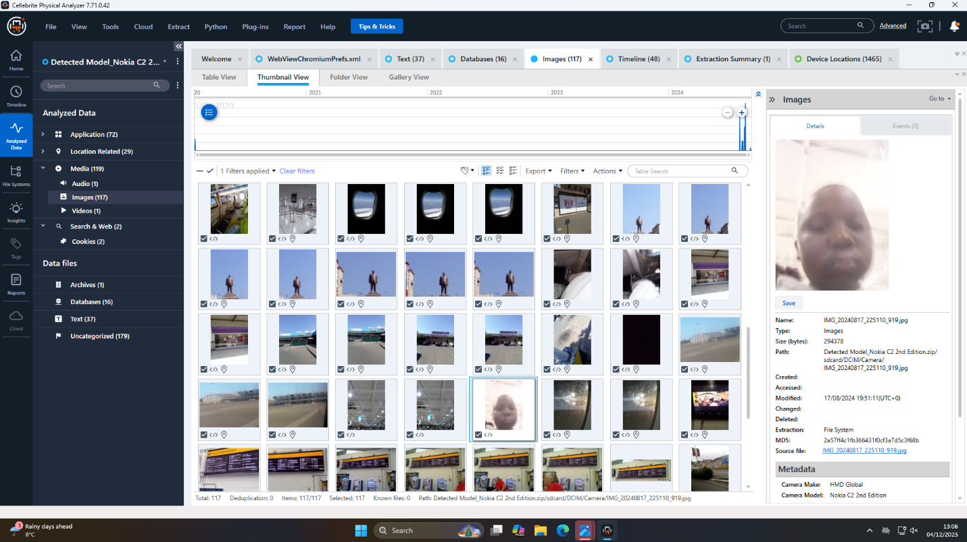 figure 6
Communication Evidence
Initial Discovery of WhatsApp Messages
The preliminary examination of the Huawei phone of Emma seemingly showed that there were no human-to-human SMS/ RCS messages. Nevertheless, a more in-depth examination of WhatsApp exportations showed that there was a detailed communication history between Emma and Joe, where explicit statements about stolen intellectual property can be observed.
This discovery serves as the central forensic evidence of the case.
WhatsApp Conversation Timeline: Direct Evidence of Conspiracy
The following messages were recovered between Emma and Joe (timestamps in local device time):
Phase 1: Initiation of Contact – 21 August 2024
Emma contacts Joe with:
"Hey Joe, I need your help with something sensitive. Do you have time to talk?"
Joe responds:
"Yes, I am available. What’s going on?"
Emma reveals possession of classified materials:
"I have access to some highly valuable information from ABC Technologies. It’s related to our new AI-based Neuro product. I’m thinking about selling it to someone interested."
Joe acknowledges the seriousness:
"That’s serious stuff, Emma. Do you know who might be interested?"
Emma expresses trust in Joe to find a buyer:
"Not exactly, Joe, but I trust you can find the right buyer. The competition must be eager to get their hands on this tech."
Joe responds:
"I will see what I can do. I am meeting a few clients in a hotel meeting room today. Will discuss your offer."
Emma urges secrecy:
"Perfect. Let’s keep this under wraps. This could be huge for both of us."
Joe confirms understanding:
"I will update you once I have got some responses. Stay safe."
This dialogue constitutes clear proof of Emma’s intent to sell stolen data.
Continued Negotiations – 20 November 2024
Emma expresses frustration over delays:
"Hi Joe, any update on the offers? It is disappointing that there has been no response from u. I have managed to find someone with whom I am meeting over the next weeks."
Joe replies:
"Apologies, Emma. I am in final talks about it. Meeting the client this week in Manchester. Will update."
Emma increases pressure:
"I may go with someone if you're not interested."
These exchanges show continued intent and negotiation.
Final Negotiation Phase – 31 January 2025
Emma demands updates:
"Any updates? Need to move fast."
Joe replies:
Met the guy again. He’s still playing slow, wants better numbers."
Emma questions whether to approach others:
"Waste of time? Should I reach others?"
Joe assures progress:
"No, he’s serious. Wants a demo sample. Can we do that?"
Emma refuses but offers partial details:
"Impossible. But a detailed breakdown? Yes. How’s the offshore arrangement?"
Joe confirms success:
"He’s good with it. 5M secured. Waiting for confirmation. The rest?"
Emma confirms that local parts remain planned and expresses dissatisfaction with delays.
Joe advises patience:
"It’s all about patience. We can push harder."
Emma concludes:
"Ok. Keep me posted. I have others waiting."

Interpretation of Communication Evidence
The retrieved WhatsApp record between Emma and Joe will be of great and direct use as it is evidence of a culminated attempt to commit intellectual property theft. It is evident in the messages that Emma was aware of confidential and proprietary information of ABC Technologies, in particular, the AI-based Neuro project. The fact that she openly admits to having possessed highly valuable information, as well as the fact that she had agreed to sell this information, creates motive and deliberate intent. Joe also reacts in a way that serves as a support to the conspiratorial aspect of such an exchange, considering that he is directly involved in them by naming potential buyers, arranging meetings and haggling. In the discussions, both sides use words that suggest secrecy and other undercover plans, such as keeping this between ourselves, an offshore deal, and getting five million as a huge sum. The evolution of the messages: the preliminary contact, the delay in the negotiation process, and the final part of the financial confirmation demonstrates the prolonged cooperation during a period of several months, which was a premeditated move to commercialise the stolen intellectual property. The continuity of the communication, Emma putting pressure on Joe to speed up the process, and the two of them being certain of getting buyers all indicate a very obvious conspiracy. Together, these communications are good pieces of an evidential corpus to prove that Emma and Joe were consciously conspiring in an illegal scheme to share proprietary corporate information.

Additional Artefacts

EXIF Metadata and Geolocation
Images recovered from devices reveal:
- Emma: Photos taken in Ettumanoor, Kerala
- Joe: Images from Gdansk, Poland
- Norman: Images from London, England
- Nokia User: Image referencing Francistown, Botswana
- 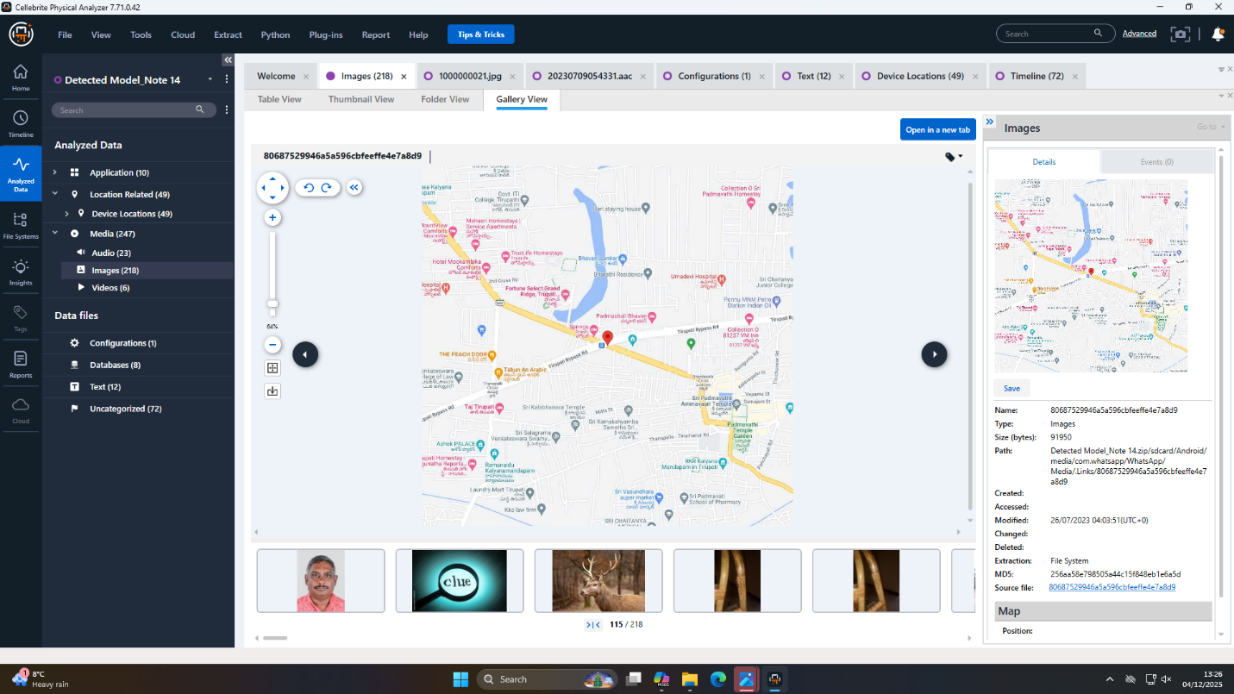 figure 7 Geographical location

Contact Linkage
Emma’s saved contact list includes Joe Marsh.
Joe’s WhatsApp JID matches the contact found on Emma’s device.
This confirms the association.
File Searches
There were no direct copies of QT-AI-2025 files. The absent USB disk is a significant hole, but the conversations within WhatsApp are enough to prove the intent and admission and negotiate stolen materials.

Analysis and Discussion
The evidence shows a very clear trend of intellectual property theft, and all the aspects of corporate espionage are in place: the motive, the means, the opportunity and the conspiracy.

Motive
Motive in this case can be well given out using the explicit intention of Emma to gain a lot of money through the sale of confidential intellectual property of ABC Technologies. The WhatsApp messages show several mentions of payment negotiations, giving an indication of a five-million payout being offered, as well as the acknowledgement of a suggested five-million payout, meaning that a financial reward was the main factor in her actions. The frustration about the delays expressed by Emma, as well as her readiness to go to other buyers, is further testament to her strong desire to make money out of the stolen material. The remarks she made when saying that she is not pleased with the deliberate pace of negotiations imply that she was not making any rash decisions but rather was determined to make a profitable deal [17]. Also, the fact that Emma was a senior engineer gave her direct exposure to the proprietary QT-AI-2025 project, thus accessing the commercial value of the material, as well as understanding its competitive importance. . On balance, Emma has a powerful financial motivator, and she is cognizant of the material value of the intellectual property, as well as her inconsistent act of aiming to negotiate a deal proves a strong and convincing motivation towards stealing intellectual property.

Means
Emma had the technical capability to obtain the theft of the QT-AI-2025 intellectual property because of her position, experience, and authorised access in ABC Technologies. Being a senior engineer who dealt in the work with the AI-based Neuro project directly, she was perfectly aware of the project architecture, developmental elements, and file repositories. This was sufficient access in that she gained access to sensitive content without immediate suspicion. Her WhatsApp communication proves that she had already received highly valuable information, which evidences the ability to extract the data and the opportunity to do so. Furthermore, Emma was dealing with project files on a regular basis, and her technical ability enabled her to transfer or copy proprietary documents to external storage media with ease, like the missing USB drive. The fact that she used encrypted communication platforms, especially WhatsApp, reveals that she was familiar with techniques that make the process of an illegal transaction less noticeable. She also demonstrated her knowledge of how to explain or summarise confidential information to buyers without necessarily creating any hard copy digital evidence, which was seen when she did not give a demo sample but instead provided a breakdown in detail. These actions emphasise a conscious and systematic way of maintaining operational security. Taken together, the position of Emma, her level of skills and familiarity with technology gave her everything required to do the intellectual property theft.

Opportunity and Behavioural Indicators
As the chronology shows, Emma had a long time to steal and share the information about the QT-AI-2025 during a lengthy time frame, which is between August 2024 and January 2025. The position held in the organisation enabled her to have unlimited access to confidential materials, whereby she was able to retrieve and prepare them without direct supervision. As revealed in the communications, she was the one who contacted Joe when she clearly had free access to the project files. Month after month, Emma was free enough in the workplace to hide her actions, especially in light of the fact that there was no additional supervision or restrictive measures over access in the ABC Technologies. The international nature of the conspiracy enhanced her chances even further; Joe could deal with buyers in places such as Manchester, and the geographical dispersion of the suspects developed several avenues in terms of which negotiations could be done most confidentially. WhatsApp usage frequency, coupled with Timing: Emma sent messages at the most favourable times, which would have made it difficult to determine that she was doing it during or outside of her usual work hours. The lost USB also shows that she probably carried with her data physically and did it at a time when she felt like it, and without the digital supervision system noticing it. All these points towards Emma possessing the necessary temporal flexibility as well as the environmental conditions that she needed to accomplish the theft of the intellectual property.

Conspiracy and Limitations
It is proven that there is a good industrial conspiracy between Emma as the origin of the stolen intellectual property, Joe as the middleman, and outside buyers like Norman or Vanessa as the target of the conspiracy. Through the WhatsApp messages, we find out that Emma is also planning to sell the QT-AI-2025 data, but Joe is also actively engaged in dealing, setting up meetings, and negotiating the financial requirements. The systematic quality of the interactions, including several months, repetition of updates and mention of particular milestones of negotiations, proves that it was a coordinated action plan, and not a naked violation. Their talk of secrets, offshoring deals and multimillion-dollar payments depicts a methodical way of evading detection and how to maximise profits. The fact that international contacts are involved in this case is further complicated by data on the geolocation of images found, and confirms the multinational character of the conspiracy. AEvery participant fulfilled his or her role: Emma provided the data, Joe was a negotiator and broker, and the buyers analysed and tried to obtain the stolen information. Their combination of efforts meets the requirements of a criminal conspiracy to steal intellectual property.

Conclusion
The forensic examination of the four mobile devices clearly illustrates that Emma participated in the unauthorised extraction of the confidential AI-based Neuro project information of ABC Technologies, and tried to sell it beyond a reasonable doubt. Explicit WhatsApp messages provide the strongest evidence since she admits that she has very valuable proprietary information and that she intends to sell it to third parties. There is a visible bargaining process including talks of the potential buyer, financial anticipations and approvals of a five-million payment, which are presented in these communications. The intermediate position, which Joe Marsh fulfils, is confirmed numerous times by his attempts to find interested clients, organise meetings, and mediate further dialogues that will correspond to the goal of Emma. Other messages also depict conspicuous intention, silence and urgency, which show that the two parties were fully conscious that their actions were not legal. Attributing devices gets Emma squarely attached to the Huawei device in which these incriminating messages were recovered, and geolocation metadata supports the international travel patterns related to their negotiations. The lack of a USB device that belonged to Emma does not allow verifying stolen files directly; however, the nature and extent of the evidence of the communication does not create any uncertainty with the intention and actions of Emma. Based on this, the investigation can take a conclusion that Emma, in collusion with Joe Marsh, in a bid to sell the QT-AI-2025 intellectual property, had a strong case to prove that the allegation of corporate espionage had a solid basis.

Recommendations
Several important recommendations are offered in order to enhance the investigation and avoid future cases. First, it is important to recover and analyse the lost USB drive of Emma because it might contain data about QT-AI-2025 files or transference of the latter, which would allow conclusively proving the exfiltration of the data. Furthermore, the cloud storage license, as well as email history and other digital platforms of Joe and Norman, should be forensically examined to determine the presence of additional artefacts of communication, exchange of files, or evidence of other negotiations not on WhatsApp. A financial investigation should also be conducted to confirm the assertions of the proposed five-million payment, including bank transfers, cryptocurrency purchases or offshore financial action, which can be used to confirm the commercial motive of the proposed sale. Preventatively, ABC Technologies ought to reinforce internal data access controls through a tacit permission-based access, automatic monitoring of sensitive file interactions, and better logging processes so as to identify abnormal activities. The introduction of strong employee monitoring and auditing procedures for staff working on high-threat or confidential projects would also curb the risks of insider threats. The presence of regular security training, more definitive policies on dealing with intellectual properties, and more robust response actions to an incident would also help make the organisational environment safer. Taken all together, these actions facilitate subsequent investigative activities as well as enhance a better future security posture.

References
[1] R. Adams, A. Owen, and J. Doe, “Comparative study of digital forensics tools and their effectiveness in enterprises,” 2021. https://www.researchgate.net/profile/Antony-Owen/publication/389817515_Comparative_Study_of_Digital_Forensics_Tools_and_Their_Effectiveness_in_Enterprises/links/67d3175f478c5a3feda09ea2/Comparative-Study-of-Digital-Forensics-Tools-and-Their-Effectiveness-in-Enterprises.pdf
[2] C. D. S. Caraballo, W. Candrick, and W. Voster, “Market guide for digital forensics and incident response retainer services,” Gartner, 2024. [Online]. Available: https://www.gartner.com/en/documents/5518995
[3] B. Fakiha, “Unlocking digital evidence: Recent challenges and strategies in mobile device forensic analysis,” Journal of Internet Services and Information Security, vol. 14, no. 2, pp. 68–84, 2024. https://jisis.org/wp-content/uploads/2024/05/2024.I2.005.pdf
[4] G. Horsman and A. Dodd, “Competence in digital forensics,” Forensic Science International: Digital Investigation, vol. 51, p. 301840, 2024. https://doi.org/10.1016/j.fsidi.2024.301840
[5] W. Neuteboom et al., “Quality management in forensic science: A closer inspection,” Forensic Science International, vol. 358, p. 111779, 2024. https://doi.org/10.1016/j.forsciint.2023.111779
[6] A. I. Piraianu et al., “Enhancing the evidence with algorithms: How artificial intelligence is transforming forensic medicine,” Diagnostics, vol. 13, no. 18, p. 2992, 2023. https://doi.org/10.3390/diagnostics13182992
[7] D. N. Premanand Narasimhan, “Ensuring the integrity of digital evidence: The role of the chain of custody in digital forensics,” 2024. doi:10.32628/CSEIT2410612443. https://doi.org/10.32628/CSEIT2410612443
[8] E. Salfati, E. Salfati, and M. Pease, “Digital forensics and incident response (DFIR) framework for operational technology (OT),” NIST, 2022. https://csrc.nist.rip/external/nvlpubs.nist.gov/nistpubs/ir/2022/NIST.IR.8428.pdf
[9] T. Sutikno and I. Busthomi, “Capabilities of Cellebrite universal forensics extraction device in mobile device forensics,” Computer Science and Information Technologies, vol. 5, no. 3, pp. 254–264, 2024. https://doi.org/10.11591/csit.v5i3.p254-264
[10] G. Tully et al., “Quality standards for digital forensics: Learning from experience in England & Wales,” Forensic Science International: Digital Investigation, vol. 32, p. 200905, 2020. https://doi.org/10.1016/j.fsidi.2020.200905
[11] J. B. Vala, V. M. Vekariya, and V. M. Vekariya, “The role and importance of digital forensics and digital evidence in cyber crime detection,” International Journal of Life Science Biotechnology and Pharma Research, vol. 13, no. 6, pp. 413–420, 2024. https://ijlbpr.com/uploadfiles/80vol13issue6pp413-420.20240701042250.pdf
[12] H. Adamu, A. A. Ahmad, A. Hassan, and S. B. Gambasha, “Web browser forensic tools: Autopsy BHE and net analysis,” Int. J. Res. Innov. Appl. Sci., vol. 6, no. 5, pp. 103–107, 2021. https://doi.org/10.51584/IJRIAS.2021.6506
[14] S. Pirzada, N. H. Ab Rahman, N. D. W. Cahyani, and M. F. Othman, “A Framework of Forensic Analysis and Visualisation: Using WhatsApp Chat Data as a Case Study,” JOIV: International Journal on Informatics Visualisation, vol. 8, no. 3–2, pp. 1834–1848, 2024. https://iris.unil.ch/handle/iris/93599
[15] J. Oh, S. Lee, and H. Hwang, “Forensic recovery of file system metadata for digital forensic investigation,” IEEE Access, vol. 10, pp. 111591–111606, 2022. https://doi.org/10.1109/ACCESS.2022.3213030
[16] F. Breitinger, H. Studiawan, and C. Hargreaves, “SoK: Timeline-based event reconstruction for digital forensics: Terminology, methodology, and current challenges,” arXiv preprint arXiv:2504.18131, 2025. https://doi.org/10.48550/arXiv.2504.18131
[17] Y. C. Tok and S. Chattopadhyay, “Identifying threats, cybercrime and digital forensic opportunities in Smart City Infrastructure via threat modelling,” Forensic Science International: Digital Investigation, vol. 45, p. 301540, 2023. https://doi.org/10.1016/j.fsidi.2023.301540

Appendix: Forensic Analysis Screenshots
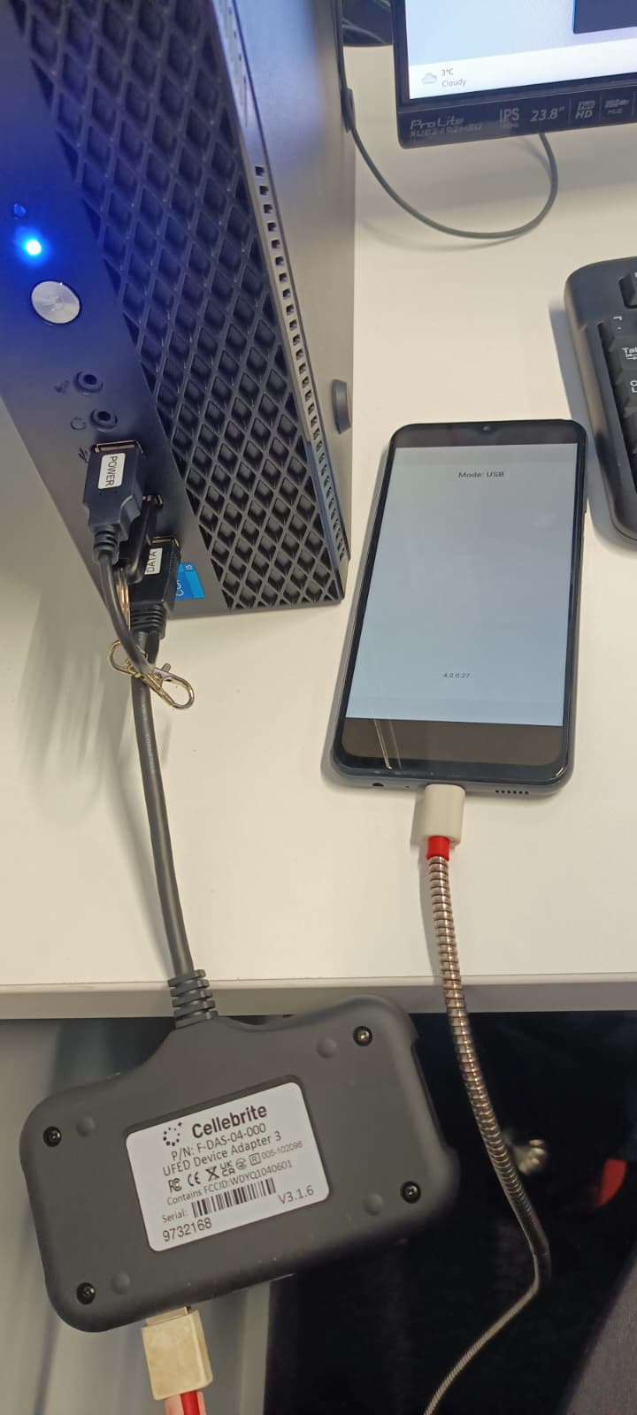
figure 8 UFED Cellebrite connecting with original cable
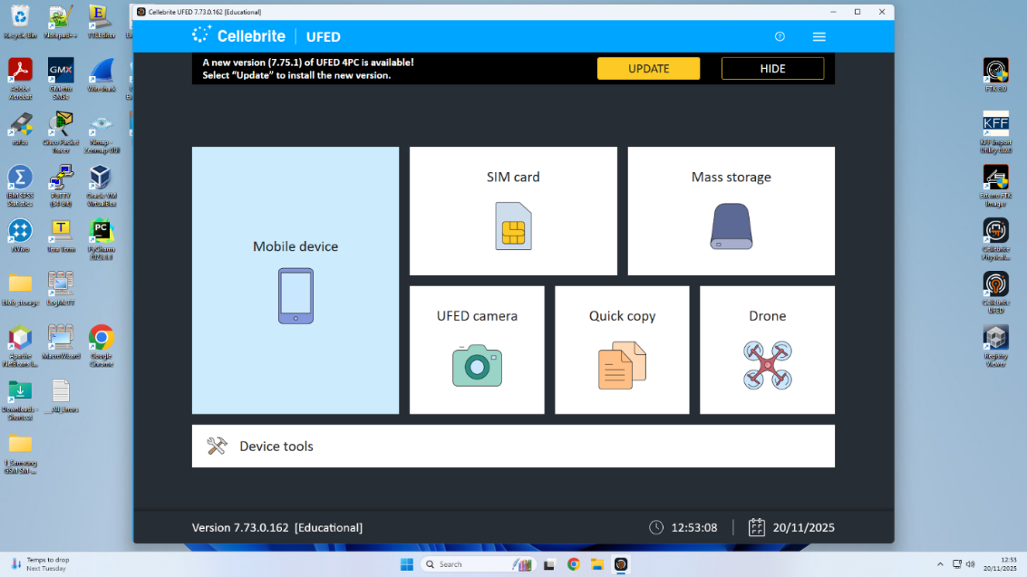
figure 9 electronic options available
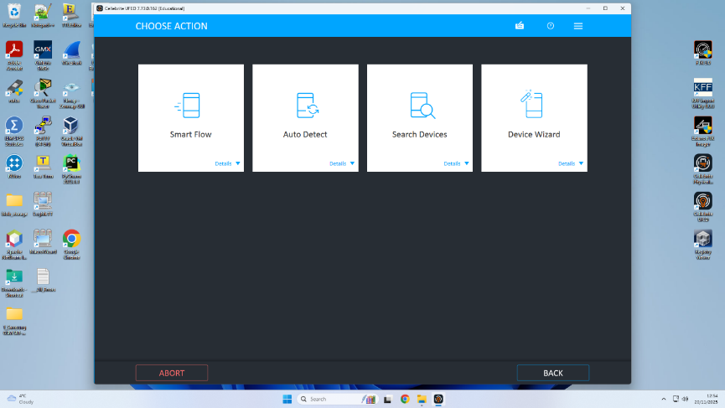
figure 10 select autodetect
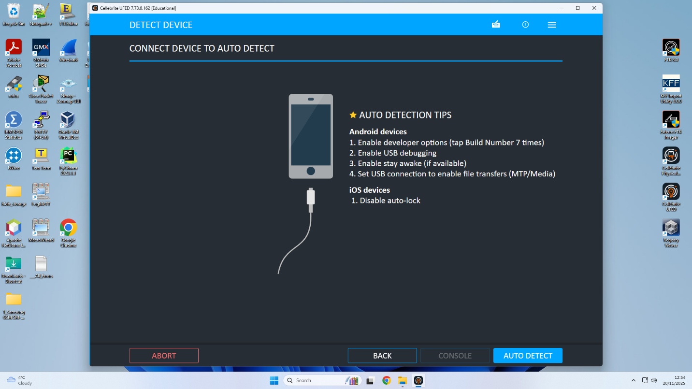 figure 11 connect device to auto detect
 figure 12 connect device to auto detect Samsung
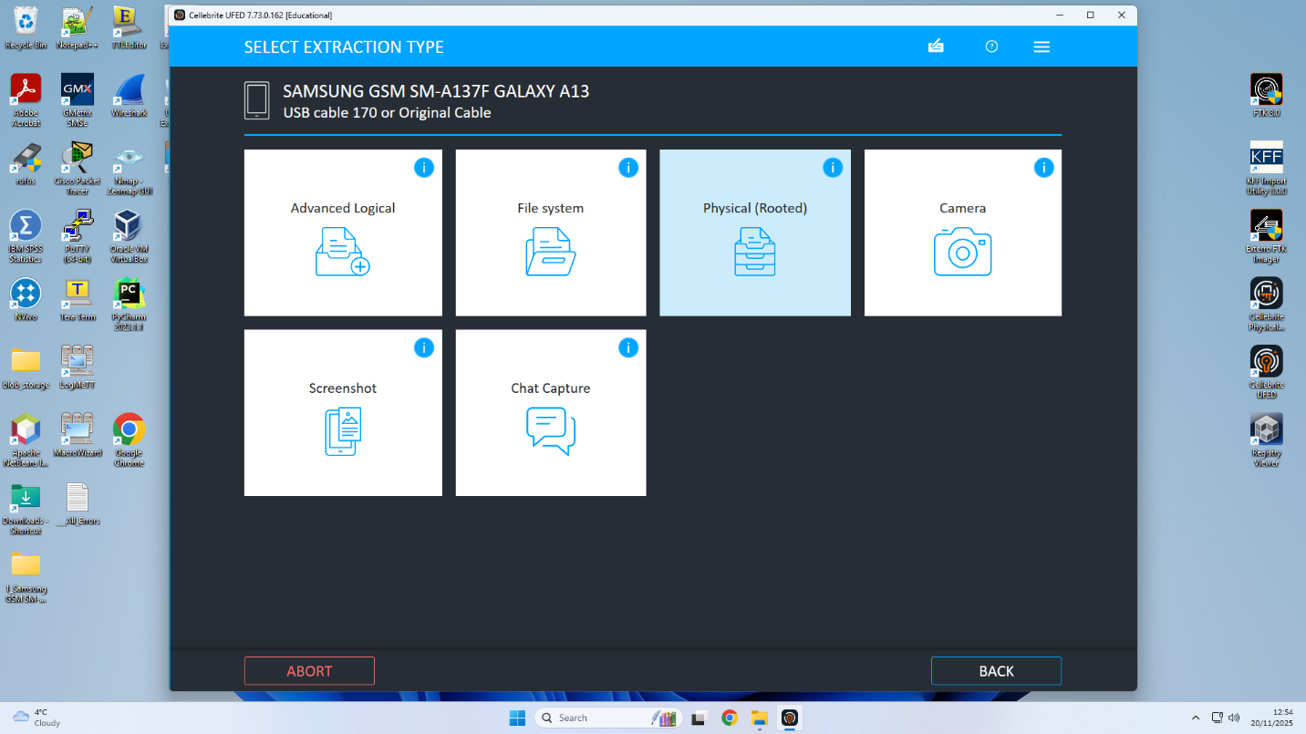figure 13 select the all options 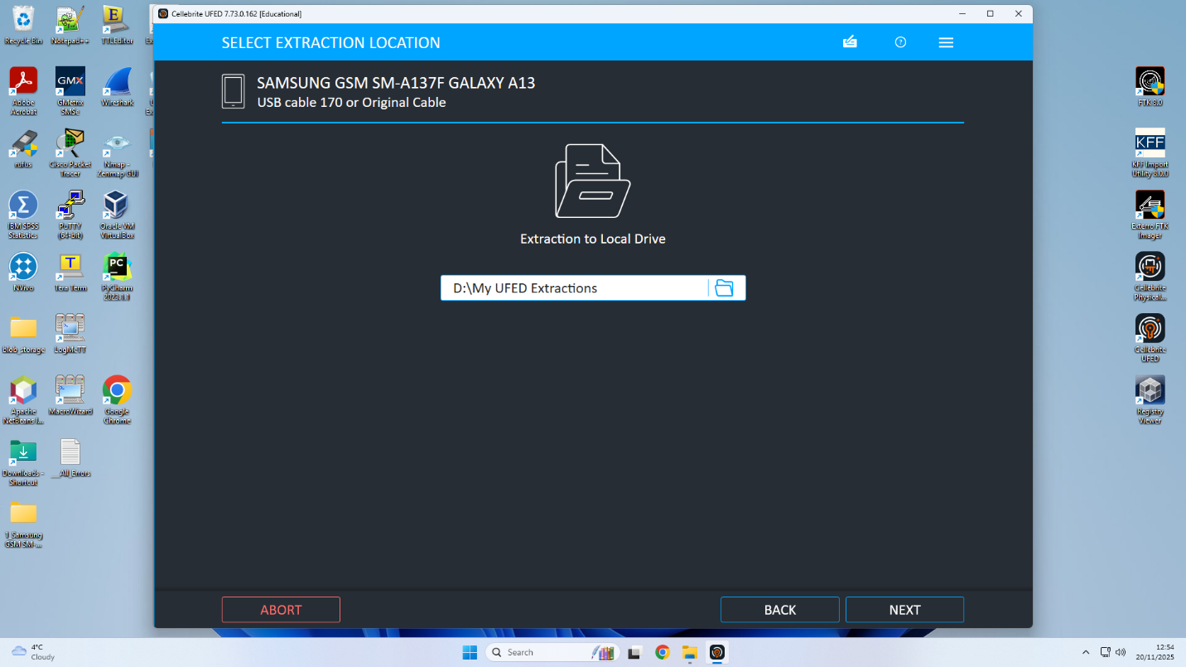 figure14 my UFED extractions 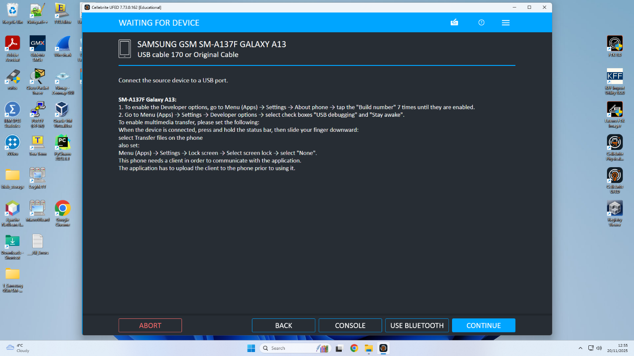 figure 15 Connect secure device to USB port 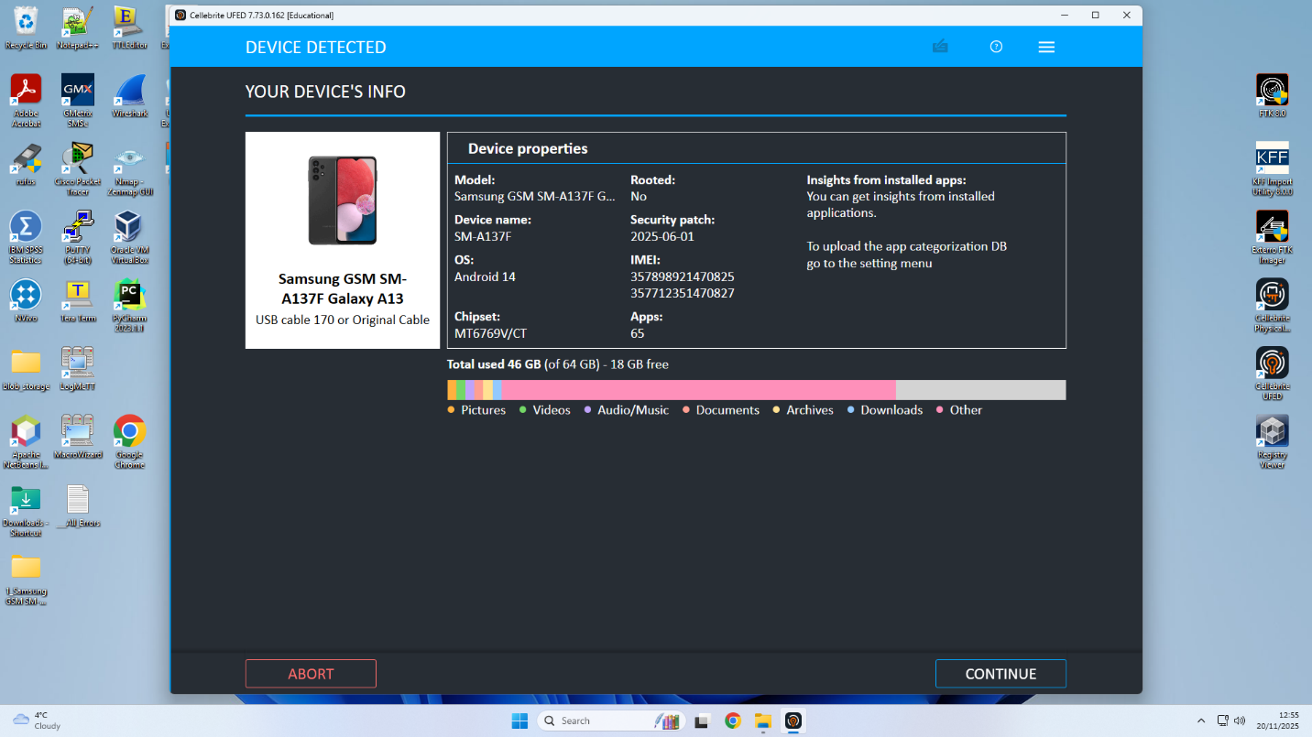 figure 16 Samsung info 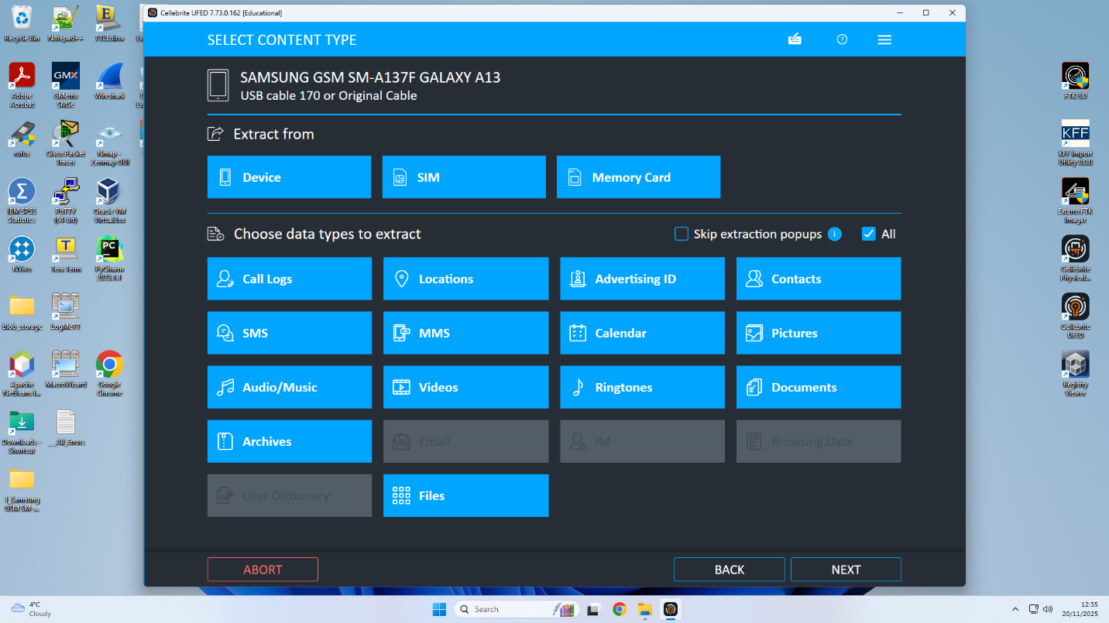 figure 15 processing files indicts blue colour 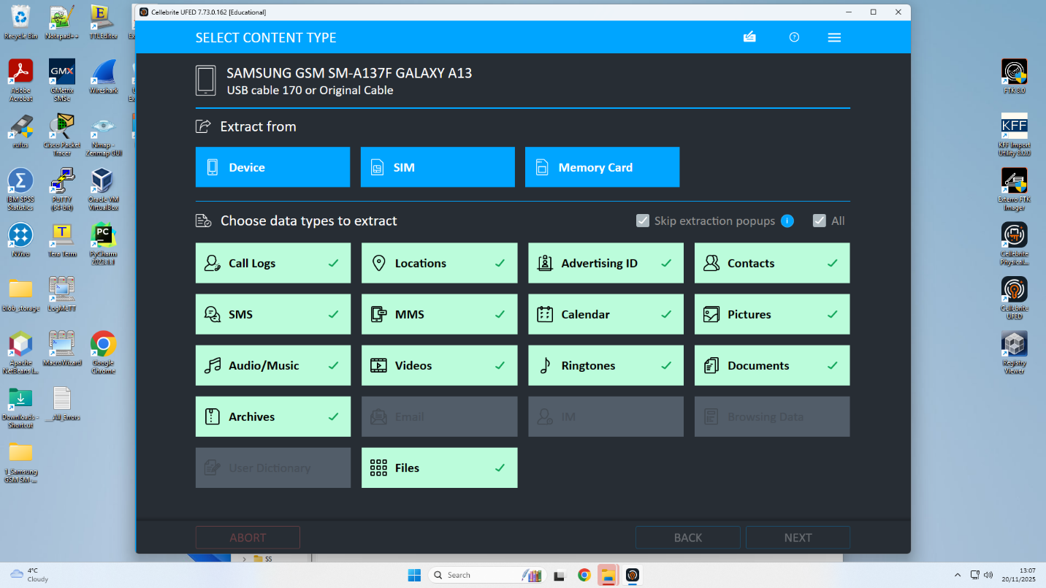 figure 16 processing complete indicts green colour 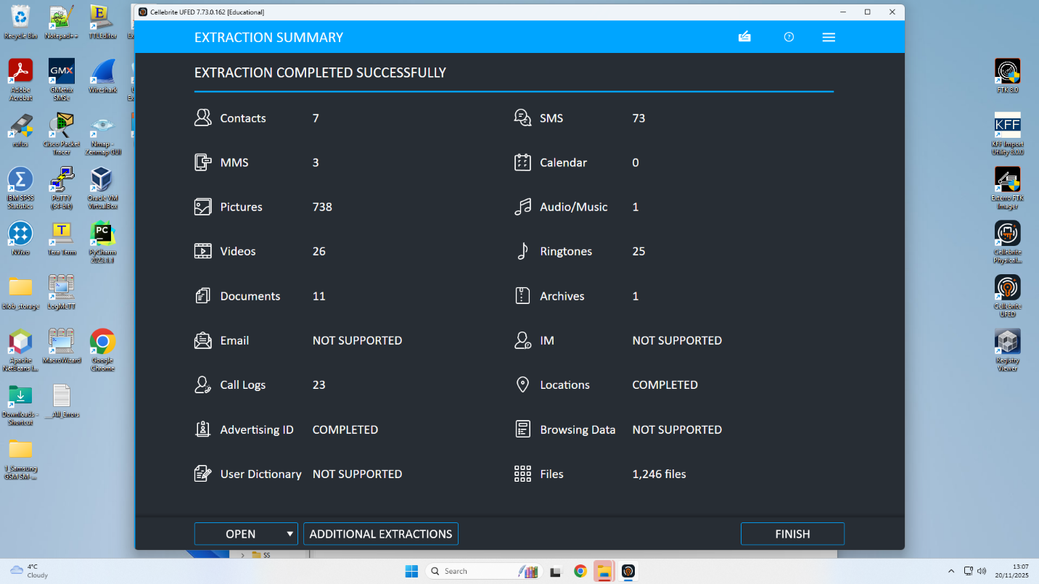 figure 17 extrctions completed successfully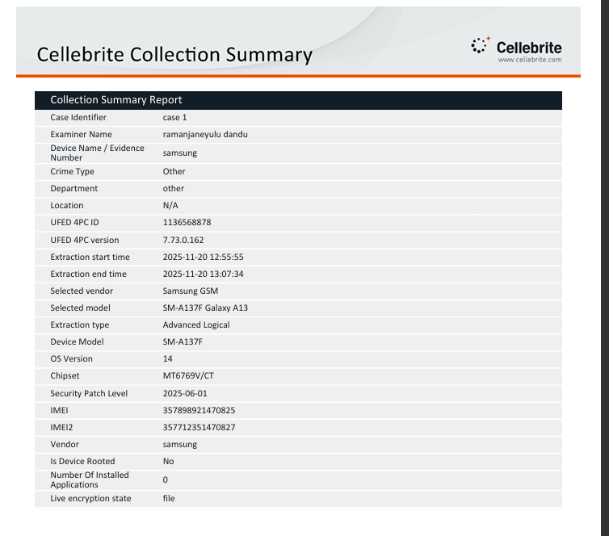 figure 18 summary report

Mobile Evidence Collection configuration Details
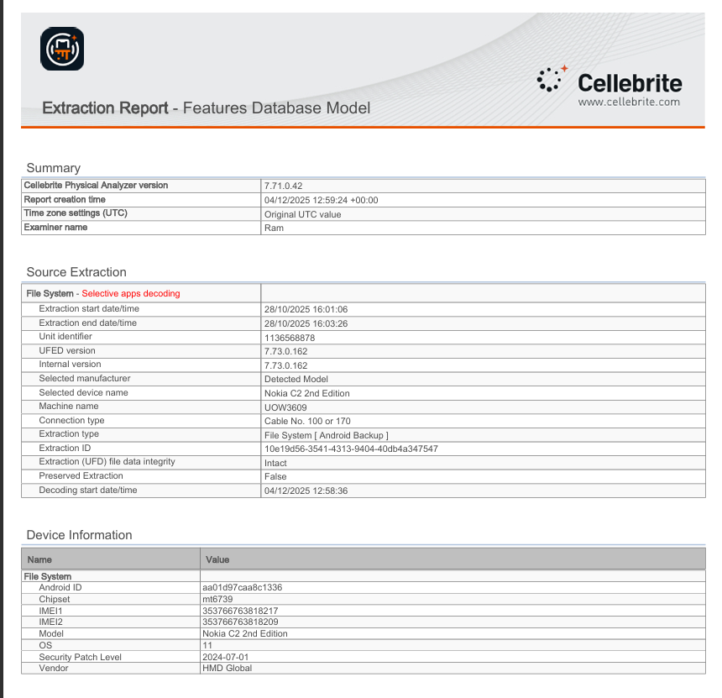figure19 NOKIA C2 Extraction report 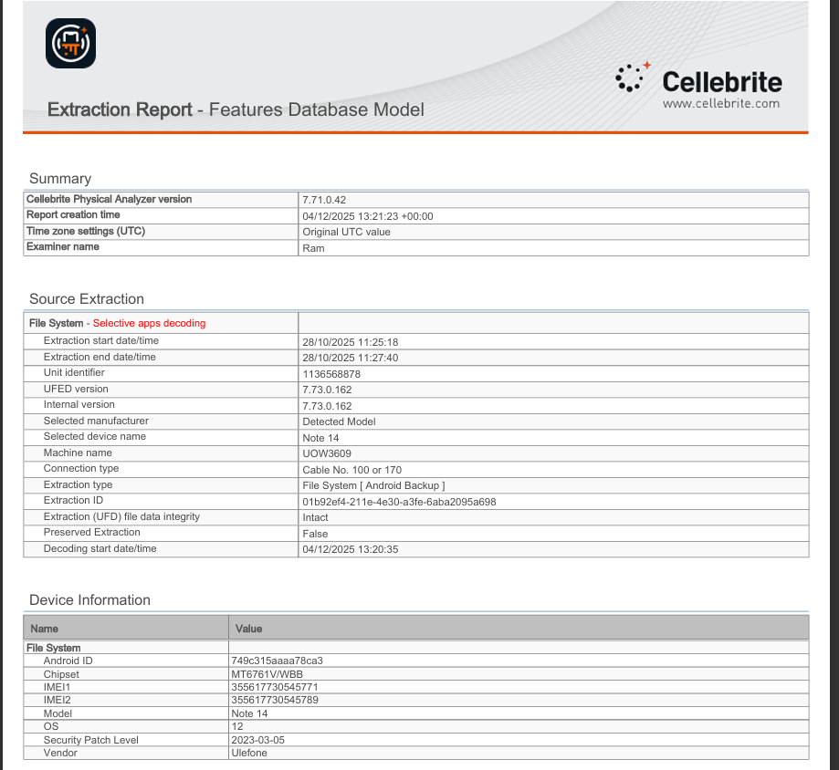 figure 20 NOTE 14 Extraction report 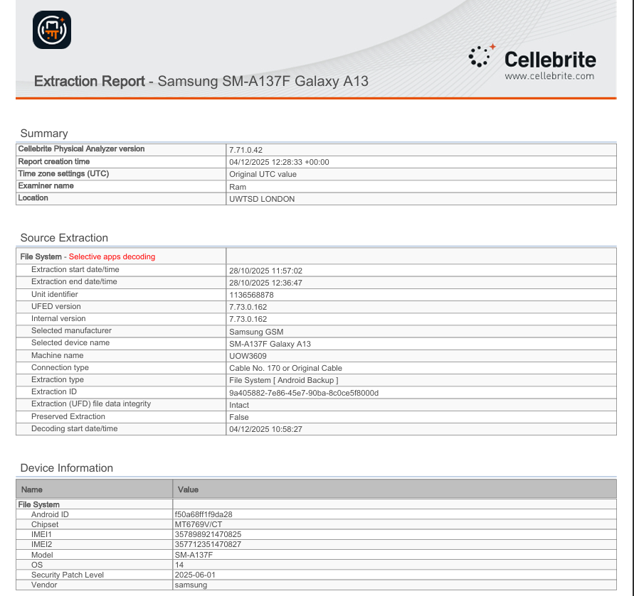 Figure 21 SUMSUNG Extraction report 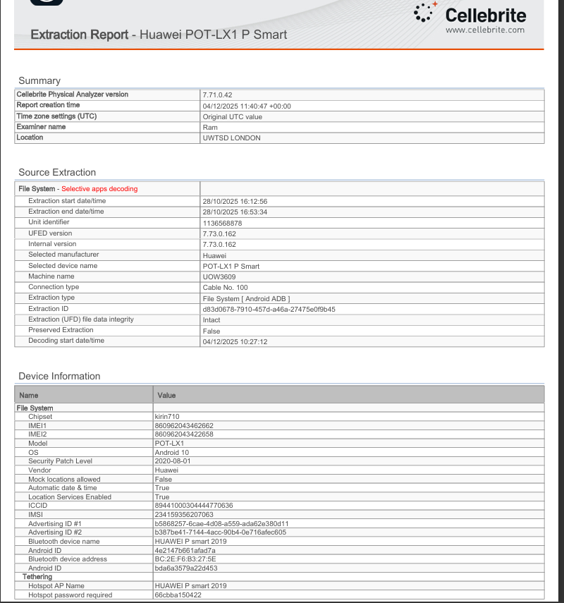 figure 21 HUAWEI Extraction report

‌

