Distinctiveness and Regeneration

BMSP4005

Assignment 2

Hannah Kilburn

1805552

Tutor – Jessica Shore

Introduction
For this assignment the main area to look at is Llanelli town centre and how the area could possibly be regenerated to become a more popular town that appeals to all different ages from the surrounding areas and beyond. Llanelli is seen to be a very historic town with plenty of history that appeals to all sorts of people and has made it the town it is today. Llanelli has many historical factors such as the coal industry that was the very beginning to how the town has been built up and how the surrounding areas have created large businesses to keep Llanelli growing and expanding. The main focus of this assignment is Llanelli town centre as the surrounding area of Llanelli such as Trostre is a much better place to visit and has much better facilities that the main town has. The main aim to is to create new business ideas that will help to bring more people into the town centre and to regenerate the area to give the town a better outlook for future generations. Looking towards the future and to create a sustainable business is what Llanelli needs to make sure that they gain a more positive outlook and bring in more money to the local area. Improving the whole town to make sure it looks at its best and has modern technology to grow with what’s to come in the future is a main priority.

What is regeneration?
The Google dictionary states that regeneration is “the action or process of regenerating or being regenerated.” (GoogleDictionary, 2019) This is mostly linked to places and areas that need to be updated to fit in with the ever-changing world of technology and business ideas. The reason that places may need to be regenerated links to the idea that a place may be run down and not meeting the targets that a town should. There are many areas that have been regenerated and the area has been a great success.
Trostre park was regenerated which is very close to the main town of Llanelli. The development of Trostre began in 1988 and has been continuing to grow and it is becoming more and more popular which is great for the out of town shopping experience, but this has led to the town centre suffering. There is a lack of shops and close parking facilities which does put local people from shopping and visiting there. There are more local shops in the town centre which isn’t what people are always looking for, the large chain stores are more popular and are slightly cheaper than buying from small local shops. (Bannon, 2019)
Regeneration is the idea to make run down neighbourhoods, towns and cities to become a better place to live and visit. Governments are now focussing on looking at new plans that help our community and the housing community has become a very popular area to regenerate as housing is the main priority to get right for many towns and cities so that people have somewhere to live and then have to use the towns close to them. Making a town change the way it looks and making it a better place can take years and it also costs a lot of money depending on the size of the area that needs to change, it can be a very complicated challenge to make ideas work for everyone and make sure it is a sustainable for the future. (Forrest, 2017)
The history of Llanelli town
Llanelli is a large town that is close the sea and has ports which are very useful for businesses that need to ship in and out different products, this was also the main reason why Llanelli was so successful in the coal industry many years ago. Employment was the main reason why people came to the area and how it became a more industrial town as it provided good and steady jobs for many people. Industrial revolution is what helped the town grow into what it is today and give the town a boost and create the large businesses that were created at the time. Llanelli began to change in the early 1700s and large developments appeared to make the town a very business orientated area. Llanelli had the benefit of the sea ports being so close which made trading and sending products far easier and there was a railroad which linked to other close by towns and cities. (Hannam, 2019)
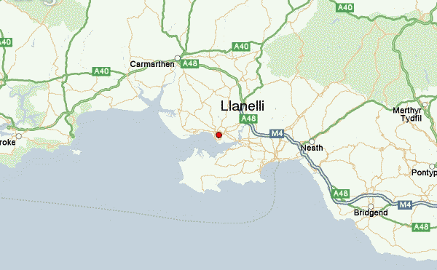

Llanelli is well known for its tinplate, steel and coal mining industry and has been quite successful in these areas since the industrial revolution began. The town is famous for have the Scarlets stadium which makes the area very well known when it comes to rugby and sporting events. (LlanelliCouncil, Llanelli Town Council, 2016)

What has Llanelli got?
Llanelli has many different attractions that have made Llanelli as popular that it is today. The town centre is the one place that suffers and the one area that needs to be reviewed and looked at to make that area somewhere people want to visit. People know Llanelli has being an area to hold rugby matches at the Scarlets Rugby ground which is a very popular area to visit. The area also has a football ground for Llanelli A.F.C which is another well known area. The millennium coastal path is a very popular location to visit for people to go to for walks and to enjoy the seaside as it runs all along the coast, the path is 22km long and has a unique feel with all sorts of wildlife and also a variety of leisure facilities. Llanelli has a council run leisure centre which is great for the fitness world and it includes a swimming pool and gym which anyone can attend whatever their age. The Llanelli Wetland centre is another area just outside of Llanelli which is great for educational purposes and great for all ages to attend. There is a variety of birds which are located from all over the world which can be seen from this centre. It aims to be sustainable and provide for all different kinds of wildlife over the many miles of land across the water, it allows visitors to certain areas of the park and leaves certain areas to be kept free from people to let the wildlife be free. There is a large shopping centre and market in the main town which provides different stores and shops with a variety of products. There is a large supermarket in the town centre but there is also a large supermarket outside of the town in and near the Trostre shopping centre which is just out of town. (LlanelliTownCouncil, 2019)
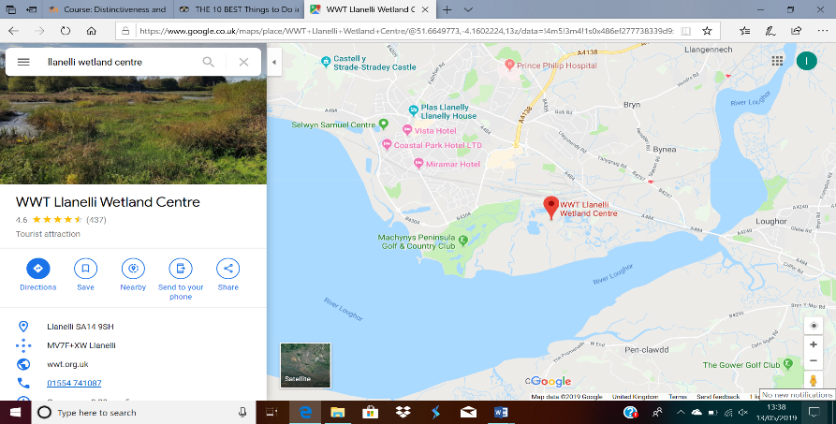
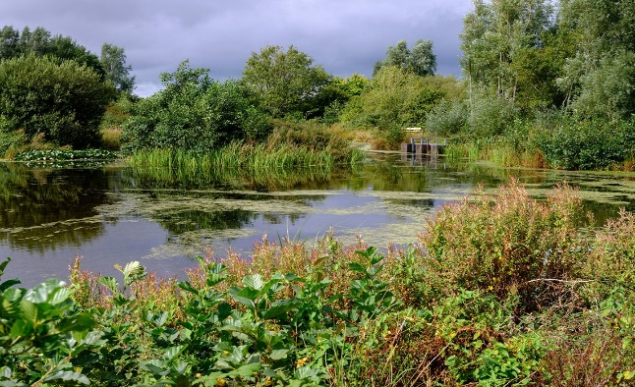
According to Trip advisor the top location in Llanelli to do is Llanelli Wetlands Centre which has many great reviews from people that have visited the area. The area has 450km of land that it has to look after and keep clean and updated for customers to enjoy and learn about different species that they have in the area. (TripAdvisor, 2018)
The town of Llanelli is the main area to look at for this assignment. I must also look at what the town has as much as what the surrounding area of Llanelli has already in place. In the town there is a large shopping centre called St Elli shopping centre which provides for many of Llanelli’s residents and also people visiting the area. In the centre there are places to shop but also places to eat too. The stores that are already there include shops such as Asda, Argos, Burger king, Greggs, Poundland, Wilko and sports direct. These stores are all well-known and are all popular with the public. (LlanelliCouncil, 2018)
Other shops that are based in Llanelli town centre include different banks such as Halifax, NatWest and Lloyds there is also a variety of places to eat such as Burger King, Nando’s and AItalia. All the shops in Llanelli are close together and do provide a range of shops for a variety of ages and different people. Although I still feel as though Llanelli needs to provide more chain stores and big branded shops for everyone to enjoy. There is a Travelodge close by where guests can stay in the centre which is also in close proximity to the Odeon cinema and a Snap fitness gym. There are lounges that may appeal to the younger generation including the Vista Lounge and The Metropolitan Nightspot which will encourage younger people to the area, but this could also lead to people getting drunk on the streets of Llanelli. This town is also an area that has had many issues with drugs so increasing any more nightlife to the area could make the drug and alcohol problems much worse. (GoogleMaps, 2019)
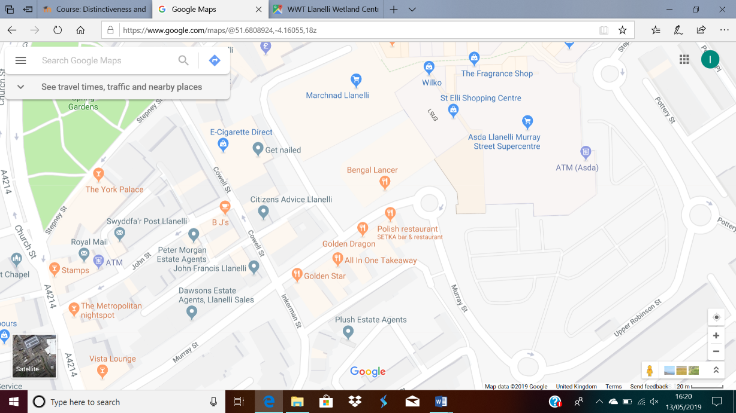
Development strategies already in place to regenerate Llanelli
There are plans in place that are in development to help the area of Llanelli become regenerated and a better place for the locals and visitors to the area to enjoy. The Carmarthenshire County Council is the main branch to reach out to about regenerating an area as they are the people in charge of Llanelli town and want to make sure that any ideas or developments that are in place, work well for the whole area. They believe that the area would definitely improve if a large-scale business plan was in place that related to culture, leisure and commercial ideas. There is a plan in place to spend £60 million on a new investment that will address better housing near to the town centre to encourage people to use the town rather than cars or public transport to reach the out of town shopping centres. It is in place that the train station will be improved as part of this development and so will the public and private housing situation that will improve energy efficiency. There is an Opportunity street which is acquiring different empty properties to create them into an area that will boost jobs and the understanding of growth and earning new skills. There will be 1 and 2 bedroom properties available that are affordable for people who complete a survey to see if they are able to apply. This street is great for start up business as they will receive the help, they need to make sure they are successful and gaining a profit. A plan like this that is already being spoken about should be a great success, but it takes time to follow through with these ideas and get the correct funding for the area. (CarmarthenshireCountyCouncil, 2016)
There is a plan in place to build new modern housing and a better entertainment area on Llanelli waterfront which is proposed to bring in new people to the area and bring in new a population to the town centre which is what is needed. The area is also meant to help improve surrounding locations in Burry Port, North Dock and the Delta lakes. (LlanelliTownCouncil, 2019)
Businesses ideas for Llanelli town centre
We visited Llanelli town centre on the 26th of March 2019 to look around and experience the town as it is now. I had to look at what the town already had and also what the town seemed to be lacking. The area as a whole was reasonably busy for a weekday although lots of people would be at work or school so there was a limited age range that could be seen in the area. The town seemed to be kept clean on the streets and in the main St Elli shopping centre which is one of the main attractions to the area. There were many stores that were empty from shops that had previously closed down many years ago, which suggests that it is hard to pay the charges that may be in place to let a store on this street. That is one possible change that could help new businesses as the rent charges should decrease to give the shop owners a better chance of becoming a successfully run company. From visiting the area there are a few business ideas that could work well to bring in people to the area rather than using Parc Trostre as a main shopping area. The two ideas that I believe will work in this area include a food store where local produce is sold. This store would encourage people to bring their own food containers and take exactly what they need rather than waste what they don’t want. This would also make awareness for using less plastic packaging and encouraging renewable containers to help the plant and be sustainable for the future generations. Another idea that could work is a sports centre for all ages with a range of sporting activities in the town centre. This could distract young teens or young adults from vandalising the area or misusing drugs or alcohol as they would have a great social environment that would create jobs and help the local community to stay fit for a low and affordable cost.
Local food produce idea:
From visiting the area, there are not many local produce food stores which are very popular with the public as everyone likes to know where their food comes from and also get it for a reasonable price. Encouraging people to bring their own containers and take what they want rather than being given a certain weight of food will mean less food waste and also less plastic waste which is polluting our oceans and harming wildlife. This could also be extended into items such as shampoo, conditioner and body washes where the packaging is usually made from plastic, this business plan could really help reduce any form of food waste and packaging waste that is causing an issue in our surrounding environment. This idea could be easily developed and created to make more stores rather than just in Llanelli. Llanelli would definitely benefit from something that the public are interested in and willing to pay for well sourced products and only purchasing what they need rather than standard packaging sizes where people may waste food.

In town sports centre idea:
As a way to keep fit and healthy a sports centre would be great for all ages and easy to access as it will be in the town centre which is easy to travel to via public transport, car, cycling or by walking. Making a centre available for all ages at a cheap price will encourage young people to get active and distract people from being bored and going into vandalism and taking drugs which is a huge problem in the town of Llanelli and there has been a rise in recent years. On a recent BBC news report, it is shown that people are even scared to leave their homes due to the issue of drugs in the area. Although the police are said to be working hard on dealing with the issue, it is hard to control as it is such a massive problem which is hard to contain in a short space of time. (BBCnews, 2019)
Making an area which is safe and contains plenty of space for activities would be great near the town centre as there are so many vacant stores, these shops need to be taken over by something that the public want and what the people of Llanelli are looking for.

Conclusion
To finalise this assignment, I have concluded that Llanelli town centre does need to be regenerated and does need a boost to the area to make it a more popular and better location for the local people and for visitors to the area. There have been plans in place to improve the area, but they will take many years to complete. Lots of money needs to be put into these plans and it can be hard to know if they will be successful and benefit the area and also be sustainable. Bringing in new small stores and making small improvements to the area first is a great step into helping the area. There have been serious issues with drugs and addiction in Llanelli and this has had a huge negative effect on the town, so bringing in new things for young people to do will possibly help the area to make sure that drugs are reduced. Llanelli has plenty of history that has made it the town it is today, and it made use of the ports that it has to make trading with other over seas businesses much easier. After visiting the area, the town seems to be quite clean but there are many run down areas and vacant shops which brings down the appearance of the area. Overall, I think small steps need to be taken to make the area better and work up to bigger plans to make sure they are successful for the area.

References
Bannon, C. (2019, February ). Retrieved from Wales Online: https://www.walesonline.co.uk/news/wales-news/demise-llanelli-how-out-town-15747401
BBCnews. (2019, April ). Retrieved from https://www.bbc.co.uk/news/uk-wales-47792931
CarmarthenshireCountyCouncil. (2016). Retrieved from https://www.carmarthenshire.gov.wales/media/1212060/strategic-regeneration-plan-for-carmarthenshire-2015-2030-pdf.pdf
Forrest, A. (2017, April). Retrieved from The Guardian : https://www.theguardian.com/sustainable-business/2017/apr/10/urban-regeneration-affordability-communities-neighbourhoods
GoogleDictionary. (2019, May). Retrieved from Google: https://www.google.co.uk/search?safe=active&ei=-37VXJC9HKXrxgPojrzQAw&q=regeneration+definition&oq=regeneration+definitio&gs_l=psy-ab.1.1.35i39l2j0j0i67j0l6.5738.6488..8597...0.0..1.318.1346.8j0j2j1......0....1..gws-wiz.......0i71j0i22i30.bvKp6Fg-ubc&safe
GoogleMaps. (2019). Retrieved from https://www.google.com/maps/@51.6808924,-4.16055,18z
Hannam, J. (2019, January ).
LlanelliCouncil. (2016). Retrieved from Llanelli Town Council: http://www.llanellitowncouncil.gov.uk/about-llanelli/
LlanelliCouncil. (2018). Retrieved from https://www.stelli.co.uk/shopping/eating/
LlanelliTownCouncil. (2019). Retrieved from http://www.llanellitowncouncil.gov.uk/things-to-do-and-see-in-llanelli.html
LlanelliTownCouncil. (2019). Retrieved from https://www.llanelli-waterside.wales/development-opportunities/
TripAdvisor. (2018). Retrieved from Tripadvisor.co.uk: https://www.tripadvisor.co.uk/Attraction_Review-g776264-d219276-Reviews-WWT_Llanelli-Llanelli_Carmarthenshire_Wales.html

