  Swansea Sharks swimming club  A Critical Evaluation of the current approaches used by Swansea Sharks Swimming Club and how these can be improved to grow their business | Line Elvira Rosenskiold (P151225)  Marketing Information Systems

Contents
1.0 Topic 2
2.0 Title 2
3.0 Aims and Objectives 2
4.0 Introduction 2
4.1 Swansea Sharks Swimming Club 2
4.2 The Importance of Marketing and Market Research 3
5.0 METHODOLOGY 4
5.1 Research methods 4
5.2 Sampling Framework 5
5.3 Data Collection 5
6.0 Research Design 6
7.0 Resource planning and time management 7
8.0 Appendix 7
Appendix 8.1 Gantt Chart 7
Appendix 8.2 Costing 8
Appendix 8.3 Questionnaire 9
Appendix 8.4 CV 12
9.0 Bibliography 13

Topic
The topic of the report is how The Swansea Sharks Swimming Club can improve and grow the business further in the most efficient way possible, and how they can achieve their main goal of growing.

Title
The title of the final report will be “A Critical Evaluation of the current approaches used by The Swansea Sharks Swimming Club and how these can be improved to grow their business”

Aims and Objectives
This aims of the report is to critically evaluate the current approaches Swansea Sharks Swimming Club are using to continue growing in business. The objectives are as follows;
- Examine the effects of current approaches used by Swansea Sharks Swimming Club
- Critically evaluate whether the approaches they are using is beneficial
- Analyse how Swansea Sharks Swimming Club can improve and grow their business by reviewing their old approach

Introduction
This report will contain a marketing research proposal for the Swansea Sharks Swimming Club. The proposal will include a proposition of what is seen to be the most efficient way to grow their business further. The researcher will consider what approaches the club is already using and focus on how the club can achieve their main goal of growing their business. To do so, the researcher will produce a proposal for the organisation containing a problem definition, as well as what research methods to use to achieve such success. In addition to this, the proposal will also contain a Gantt chart to illustrate the time management up until the final report.

Swansea Sharks Swimming Club
The Swansea Sharks Swimming Club is a well-established swimming club, and is currently seen as the most successful swimming club within Wales. (Swansea Sharks, 2018)
The club aims to help children in becoming the greatest swimmers, whether that is on a competitive level or for any other purpose. With numerous coaches that is STA and ASA qualified, the club has the ability to offer a wide range of different lessons to suit any participant of the club, and they have a strong reputation of producing exceptional swimmers. According to the club themselves, their main focus is to encourage their members to develop skills in their own pace (Swansea Sharks, 2018). In addition to offer a variety of lessons, the club also work closely with the TriSharks, preparing for triathlons. For any interested customer, the club can assist with swimming lessons tailored for triathlons. Lastly, the club have their own shop, offering swimming equipment for their members. Despite having multiple options available for any customer, the swimming club is still seen to be struggling to expand and grow their business and wishes to understand what options they have in order to achieve such success.

The Importance of Marketing and Market Research
It can be argued that market and marketing research is of great importance when creating a marketing strategy in order to accomplish the organisations aims and objectives. The term marketing research can often be confused with market research, however, both research approaches have different qualities. Marketing research is defined as a research method used to minimise risk when making marketing decisions within an organisation. By using both primary and secondary data, it will be a helpful tool in formulating the most effective marketing strategy. (Proctor, T 2003)
AMA (American Marketing Association, 2013) defines marketing research as “The function that links the consumer, customer and public to the marketer through information”. It is further argued that the information collected through marketing research can be used to identify and define marketing opportunities or any potential threats. (Proctor, 2003)
Market research often involves looking at marketing trends and customer needs and wants within a specific market. It refers to researching the potential market and is often seen as a wider look at the different markets and organisations available. (My Market Research Methods, 2018)
ESOMAR (European Society for Opinion and Market Research, 2018) defines market research as “The systematic gathering and interpretation of information about individuals or organisations using the statistical and analytical methods and techniques of the applied social sciences to gain insight or support decision making”
It can be argued that information is critical for any organisation who wish to connect with the public and potential customers, and by collecting useful information it can support the organisation to identify marketing opportunities as well as any potential issues or threats within the market. The research approach can be seen as a systematic way of gathering both quantitative and qualitative data with the purpose of identifying customer behaviour. (My Market Research Methods, 2018)
Some may debate that both marketing and market research may overlap in some ways, and the main reason for this is, for example, that pricing within the market can be associated with overall marketing and to the general market. (My Market Research Methods, 2018)

METHODOLOGY
It can be argued that collecting large amounts of data by studying a bigger audience will help the researcher gaining more reliable results. The researcher can use computerised systems to analyse the collected data in a more efficient way.
Johnson et al (2007) said that mix methods are “the type of research in which a researcher or team of researchers combines elements of quantitative and qualitative research approaches”. The researcher of this proposal will use both quantitative research and qualitative research methods in form of surveys, desk research interviews and focus groups.

Research methods
Wilson (2006) stated that exploratory research is widely used to evaluate customer behaviour and is often collected using internal data or any information that is accessible on the internet, whilst on the other hand Shuttleworth (2018) described descriptive research as “a research methods that is used to observe and describe the behaviour of a subject without influencing it in any way”. The information that will be collected throughout the research for the final report will be defined as both qualitative and quantitative research. Research methods such as interviews, focus groups and surveys are often seen as qualitative research which can be argued is of great importance in order to determine the reason why the swimming club is finding it difficult to grow their business (Housden, 2007).Whilst qualitative research is seen as new data collected for the specific purpose of the current project, quantitative research contains previously used data such as peer-reviewed articles, books and journals, as well as previously published graphs, figures and statistics. (Housden, 2007)
As previously mentioned, Johnson et al (2007) described mixed methods as a combination of both qualitative and quantitative research approaches. The methods used throughout this research will mainly consist of using mixed methods as this can provide pragmatic advantages when exploring research questions.

Sampling Framework
Sampling framework is defined as a selected population of interest where the researcher selects individuals to complete the research. Using sampling framework is an effective to gather valuable information, rather than doing research on individuals that might not be of any help (Wilson, 2006). However, before selecting a chosen sample frame, the researcher must evaluate what method to use for the research. Sampling methods are often grouped in to two sections:
Probability sampling methods – This method is seen to be a conclusive research method where the researcher selects a random group of individuals All individuals has the same opportunity to be selected as the sample presented.
Non-probability sampling methods – Non-probability sampling is where it is unknown which individual is chosen as a sample and is considered to be an exploratory research method (Surbhi, 2016)
As previously mentioned, the researcher will mainly focus on collecting useful information using surveys, interviews and focus groups and it can therefore be argued that random sampling, using the probability sampling method is more suitable.

Data Collection
The researcher of this report will mainly focus on using primary and secondary data, whereas primary data is described by Veal (2011) as “new data specifically collected in the current research project, where the researcher is the primary user of such data”. The researcher will focus on surveys and questionnaires that will be distributed to colleges and universities in areas surrounding Swansea, such as; Neath and Port Talbot, Merthyr Tydfil, Llanelli and Gower. Hox and Boeije (2005) said that if using a survey, there is a larger representative sample of a defined target population that is being interviewed. Robson & McCartan (2016) said that the advantages of using said surveys are; 1) they can be adapted to collect generalizable information from almost any human population, 2) it is a high amount of data standardization, 3) they can be efficient at providing large amounts of data at a relatively low cost in a short period of time if they are conducted correctly and 4) they allow anonymity which can encourage frankness if there are sensitive topics involved. However, these surveys also have a disadvantage, which can include; 1) low response rate, 2) the respondents may not treat the survey seriously, and 3) misunderstandings of survey questions may not be noticed.
As mentioned, the researcher will also use a wide range of secondary data to underpin discussion and analysis. Veal (2011) defined secondary data as “data that already exists and were collected for some other (primary) purpose but can be used a second time in the current project – the researcher is the secondary user”. Secondary data that will be used consists of peer reviewed journal articles, previous research papers on the same subject area and books to discuss how Swansea Sharks Swimming Club can improve and grow their business. A collection of books that will be used includes; Proctor (2000), Housden (2007) and Wilson (2006).

Research Design
To deal with the problems Swansea Sharks Swimming club is experiencing, the researcher, as mentioned, will collect both quantitative and qualitative data and it is recommended to do both exploratory and conclusive research to do so.
Research Methodology (2018) defined exploratory research as “a research method that intends merely to explore the research questions and does not intend to offer final and conclusive solutions to existing problems”. Further it is argued that the data collected from exploratory research is to determine the reason of the problem.
Once exploratory research is done, the marketer can progress on to conclusive research. Conclusive research is used to define a marketing problem. This is done by showing evidence of the hypotheses produced during the exploratory research, however, conclusive research is divided in to two separate categories: descriptive and causal research.
In the case of the problems The Swansea Sharks Swimming Club is facing, the best research method can be argued to be descriptive research. Using that approach, the researcher can find answers to what the problems are and why. (Wilson, 2006)

Resource planning and time management
It is fundamental for any researcher to have a timeframe to execute the above tasks. In response of the difficulties the swimming club is experiencing, the researcher has created a Gantt Chart with an estimated timing plan. Time is argued to be a significant factor for any industry, but as the market continues to change, it is particularly important to have a timing plan set whilst carrying out the research. (MBAskool, 2012). Please see to appendix 8.1 and 8.2 for further timing plan, as well as estimated costs for the market research project.

Appendix

Appendix 8.1 Gantt Chart
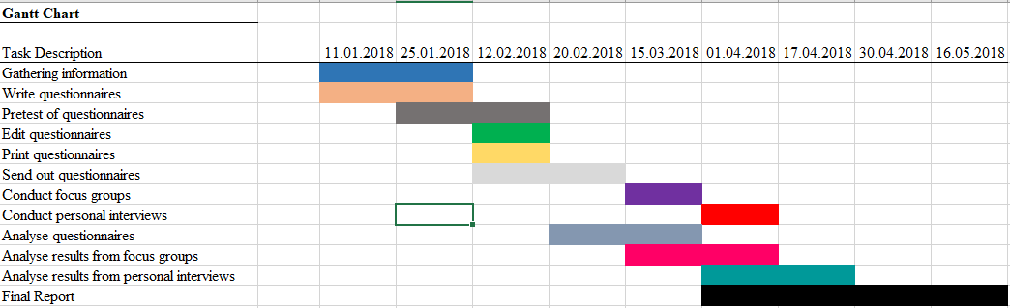

Appendix 8.2 Costing
Market Research Cost Analysis
Mail Surveys | Cost
Printing Questionnaires | £33
Envelopes | £10
Postage for mailing questionnaires | £5
Return postage for questionnaires | £5
Incentives for questionnaire response | £100
Staff costs for analysis and presentation of results | £1,000
Independent researcher cost | £500
Other costs | £60
TOTAL MAIL SURVEY COSTS | £1,713
Phone Surveys | Cost
Preparation of the questionnaire | £15
Interviewer's fee | £50
Phone Chargers | £20
Staff costs for analysing and presenting results | £1,000
Independent researcher cost | £500
Other costs | £0
TOTAL PHONE SURVEY COSTS | £1,585
Personal Interviews | Cost
Printing questionnaires and prompt cards | £60
Interviewer's fees and expenses | £450
Incentives for questionnaire response | £670
Staff costs for analysis and presenting results | £1,000
Independent research costs | £90
Other costs | £0
TOTAL PERSONAL INTERVIEW COSTS | £2,270
Group Discussion | Cost
Interviewer's fees and expenses in assembling groups | £500
Renting conference rooms | £350
Renting audio equipment | £100
Incentives for group participation | £500
Staff costs for analysis and presentation of results | £1,000
Independent researcher cost | £90
TOTAL GROUP DISCUSSION COSTS | £2,540
Total Market Research costs | £8,108

Appendix 8.3 Questionnaire
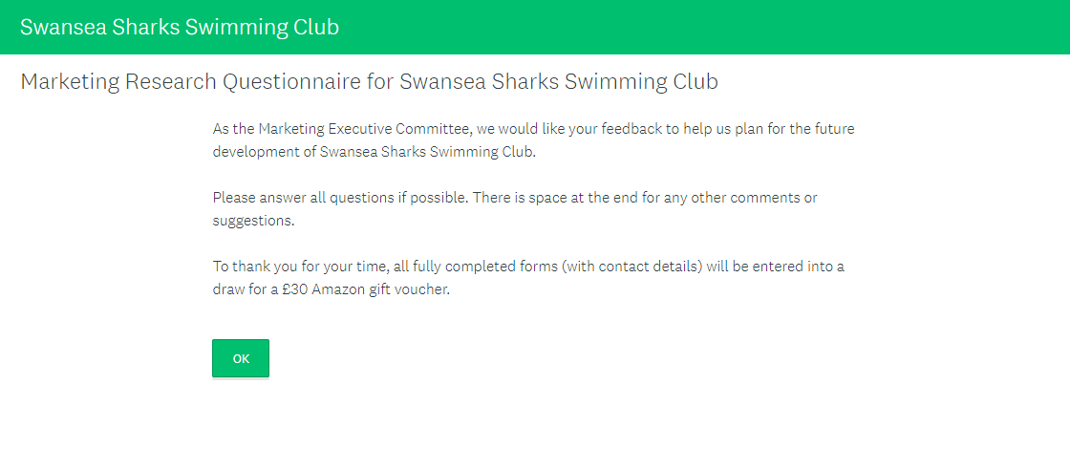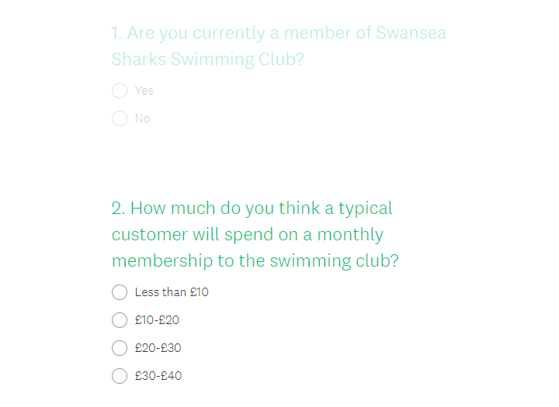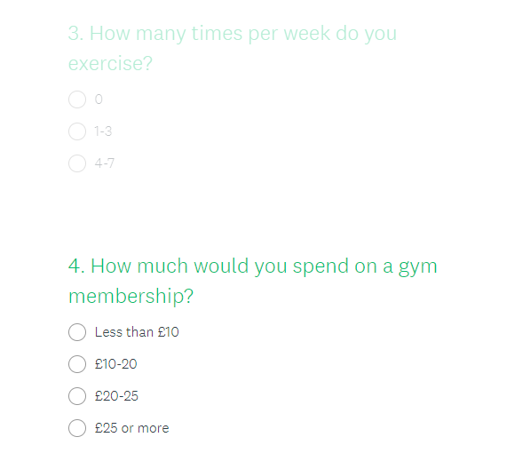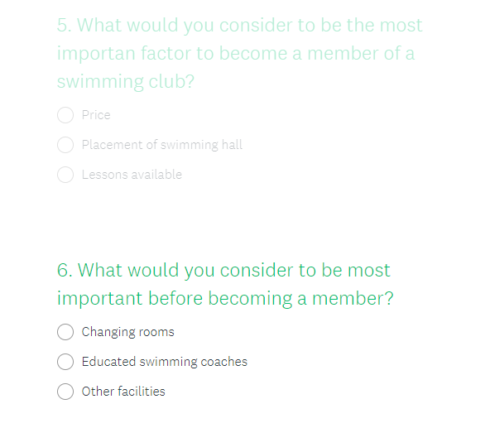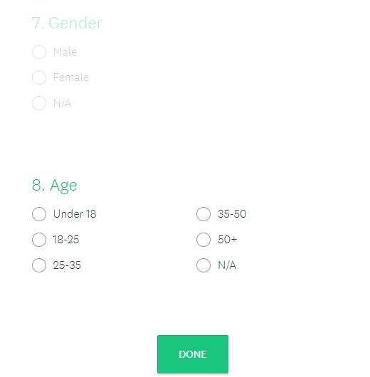

Appendix 8.4 CV
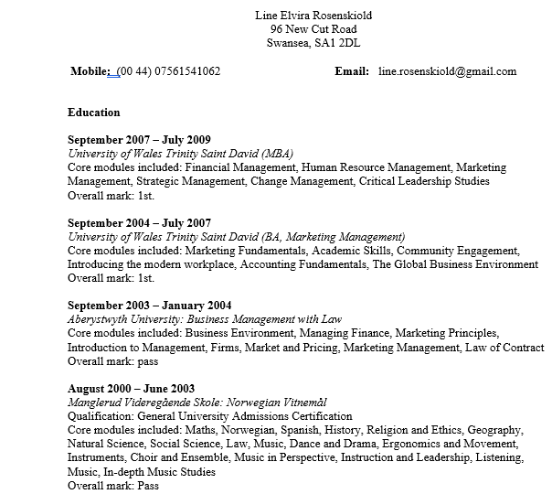
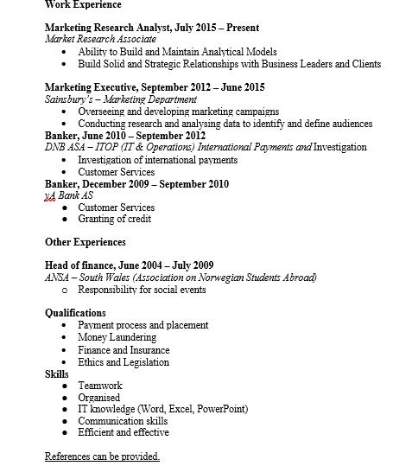

Bibliography
AMA. (2018). About AMA. Available: https://www.ama.org/AboutAMA/Pages/Definition-of-Marketing.aspx. Last accessed 11th Jan 2018.

ESOMAR. (2018). Market Research Explained. Available: https://www.esomar.org/market-research-explained. Last accessed 11th Jan 2018.

Explorable. (2009). Quantitative and Qualitative Research. Available: https://explorable.com/quantitative-and-qualitative-research. Last accessed 11th Jan 2018.

Fluid Surveys Team. (2014). 3 Types of Survey Research, When to Use Them, and How they Can Benefit Your Organization!. Available: http://fluidsurveys.com/university/3-types-survey-research-use-can-benefit-organization/. Last accessed 11th Jan 2018.

Housden, M (2007). Marketing Research and Information. Oxford: Elsevier Ltd.. p70-77.

Hox, J., & Boeije, H. (2007). Data Collection, primary vs secondary. Encyclopedia of Social Management, 1, 593-599.
Johnson, R., Onwuegbuzie, A., & Turner, L. (2007). Toward a definition of mixed methods research. Journal of Mixed Methods Research, 1(2), 112-133.
MBA Skool. (2012). Importance Of Time Management In Marketing.Available: https://www.mbaskool.com/business-articles/marketing/4168-importance-of-time-management-in-marketing.html. Last accessed 11th Jan 2018.

My Market Research Methods. (2018). MARKET RESEARCH VS MARKETING RESEARCH: WHAT’S THE DIFFERENCE?. Available: http://www.mymarketresearchmethods.com/market-research-marketing-research-difference/. Last accessed 11th Jan 2018.

Proctor, T (2000). Essentials Of Marketing Research. 2nd ed. Essex: Pearson Education Limited. p12-16.

Proctor, T (2003). Essentials Of Marketing Research. 3rd ed. Essex: Pearson Education Limited. p99-112.

Qualtrics. (2010). Market Research vs. Marketing Research — What’s the Difference?. Available: https://www.qualtrics.com/blog/market-research-v-marketing-research/. Last accessed 11th Jan 2018.

Robson, C., & McCartan, K. (2016). Real World Research. Sussex: John Wiley & Sons.
Shuttleworh, M. (2018). Descriptive Research Design. Available: https://explorable.com/descriptive-research-design. Last accessed 11th Jan 2018.
Study.com. (2018). Overview of Exploratory, Descriptive & Causal Research in Marketing. Available: https://study.com/academy/lesson/overview-of-exploratory-descriptive-causal-research-in-marketing.html. Last accessed 11th Jan 2018.

Study.com. (2018). Sampling Frame: Definition & Examples. Available: https://study.com/academy/lesson/sampling-frame-definition-examples.html. Last accessed 11th Jan 2018.

Surbhi, S. (2015). Difference Between Market Research and Marketing Research. Available: https://keydifferences.com/difference-between-market-research-and-marketing-research.html. Last accessed 11th Jan 2018.

Surbhi, S. (2016). Difference Between Probability and Non-Probability Sampling. Available: https://keydifferences.com/difference-between-probability-and-non-probability-sampling.html. Last accessed 11th Jan 2018.
Swansea Sharks. (2018). About Us. Available: http://www.sharksswimschool.com/about-us. Last accessed 11th Jan 2018.
Tri Sharks. (2018). Traithlon club. Available: http://www.trisharks.co.uk/. Last accessed 11th Jan 2018.

University of Wales Trinity Saint David. (2018). Master of Business Administration (MBA). Available: http://www.uwtsd.ac.uk/mba/. Last accessed 11th Jan 2018.

Veal, A.J (2011). Research Methods for Leisure and Tourism. Harlow: Financial Times Prentice Hall.
Wilson, A (2006). Marketing Research. 2nd ed. Essex: Pearson Education Limited. p105,106, 196-200.

