
Contents
Abstract 3
1. Introduction 3
2. Related Work 4
2.1 Convolutional Neural Networks for Plant Disease Classification 4
2.2 Recurrent Neural Networks and Their Applicability to This Task 5
2.3 Transfer Learning and Vision Transformers 6
2.4 Hyperparameter Optimisation 6
2.5 Data Augmentation 7
3. Workflow Methodology 8
3.1 Dataset 8
3.2 Data Preprocessing and Augmentation 10
3.3 EfficientNetB0 Transfer-Learning Model 13
3.4 Transfer-Learning Model: EfficientNetB0 14
3.5 Model Training 15
3.6 Hyperparameter Search and Training Protocol 16
3.7 Evaluation Metrics 17
4. Results 18
4.1 Training Curves 18
4.2 Test Set Performance 18
4.3 Classification Report 19
4.4 Confusion Matrices 20
5. Discussion and Recommendation 22
6. Conclusion 22
References 23
Appendix 26

Table of Figures
Figure 1 Loading of the Five-Class Apple Leaf Dataset 8
Figure 2 Distribution of Images Across the Five Retained Classes 10
Figure 3 Representative Apple Leaf Images from the Five Selected Classes 11
Figure 4 Implementation of the Data Augmentation Pipeline for the EfficientNetB0 Model 12
Figure 5 Original Training Image and Augmented Variations 12
Figure 6 Pre-Trained Model EfficientNetB0 Loaded Successfully 13
Figure 7 Architecture of the EfficientNetB0 Transfer-Learning Model 14
Figure 8 Initial Training of the EfficientNetB0 Model (Feature Extraction Phase) 15
Figure 9 The EfficientNetB0 Model (Feature Extraction Phase) Results in Percentages 16
Figure 10 Hyperparameter Search Settings Used for Model Optimisation 17
Figure 11 Training and Validation Accuracy and Loss of the EfficientNetB0 Model 18
Figure 12 Final Test-Set Evaluation of the EfficientNetB0 Model 19
Figure 13 Classification Report of the EfficientNetB0 Model on the Five-Class Test Dataset 20
Figure 14 Confusion Matrix of the EfficientNetB0 Model on the Five-Class Test Dataset 21

Table of Tables
Table 1 Distribution of Images across the Training, Validation and Test Subsets 10
Table 2 Training Configuration Used for the EfficientNetB0 Transfer-Learning Model 16

Abstract
Accurate and timely detection of plant foliar diseases plays a critical role in maintaining crop health and supporting sustainable farming practices, with Convolutional Neural Networks (CNNs) now providing an effective alternative to traditional manual diagnosis [1]. This report presents the design, implementation, and evaluation of a CNN-based image classification model developed using a five-class subset of the Plant Pathology 2021 dataset, comprising healthy, scab, frog_eye_leaf_spot, rust, and powdery_mildew leaf images [2]. The model adopts a transfer-learning approach built around the pre-trained EfficientNetB0 architecture, trained in two phases, an initial frozen-backbone feature-extraction phase followed by fine-tuning of the final 30 backbone layers, to investigate the benefits of feature reuse and targeted fine-tuning [3]. The report first critically reviews recent research on Artificial, Convolutional, and Recurrent Neural Networks, justifying the selection of a CNN for image classification while recognising that RNNs are better suited to sequential data. A structured workflow is then presented, covering dataset preparation, pre-processing, augmentation, model development, and evaluation using established classification metrics. Finally, the model's performance is critically analysed against findings from recent literature and used to formulate recommendations for future improvement.

1. Introduction
Plant diseases remain a major threat to global food security, reducing crop yield, quality, and agricultural productivity. The Food and Agriculture Organization estimates that plant pests and diseases account for substantial annual crop losses worldwide, highlighting the need for accurate and timely disease detection [4]. Traditional diagnosis relies on manual visual inspection by experts, which is labour-intensive, subjective, and difficult to scale for commercial agriculture. Recent advances in Artificial Intelligence (AI), particularly Deep Learning (DL), have enabled automated disease detection through image analysis, with Convolutional Neural Networks (CNNs) demonstrating state-of-the-art performance by automatically learning hierarchical image features without manual feature engineering [5].
This report investigates the classification of five apple leaf conditions (healthy, scab, frog_eye_leaf_spot, rust, and powdery_mildew) using a subset of the Plant Pathology 2021 (FGVC8) dataset developed by the Cornell University Plant Pathology and Plant-Microbe Biology Section. In addition to designing and evaluating a CNN-based image classifier, the report critically reviews Artificial Neural Networks (ANNs), Convolutional Neural Networks (CNNs), and Recurrent Neural Networks (RNNs). While CNNs are specifically designed to learn spatial features from images, RNNs are primarily intended for sequential and temporal data, providing a theoretical justification for selecting a CNN architecture for this image classification task.

2. Related Work

2.1 Convolutional Neural Networks for Plant Disease Classification

Convolutional Neural Networks (CNNs) have become the predominant deep learning architecture for plant leaf disease classification due to their ability to automatically learn hierarchical spatial features from image data through convolutional operations [6]. Their capacity to exploit spatial locality and translation invariance enables CNNs to accurately identify disease-specific patterns without the need for manually engineered feature extraction. A systematic review of 160 studies published between 2020 and 2024 reported that CNN-based models, alongside the more recently developed Vision Transformers (ViTs), dominate image classification, disease detection, and image segmentation tasks in precision agriculture, with classification accuracies frequently exceeding 95% on benchmark datasets such as PlantVillage [7].
Within the domain of apple foliar disease detection, Vishnoi et al. developed a lightweight CNN architecture designed to minimise computational complexity while accurately classifying diseases including scab, black rot, and cedar rust, demonstrating that carefully optimised shallow CNNs can achieve competitive performance with substantially fewer computational resources than deeper networks [1]. A comprehensive review of machine learning and deep learning techniques similarly concluded that CNN-based frameworks, particularly when integrated with transfer learning, currently offer the most effective balance between accuracy, efficiency, and real-world applicability for automated plant disease diagnosis [4]. Taken together, these studies point to a shift in the field away from training deep CNNs from scratch and towards transfer learning as the default approach, but they differ on why: [1] emphasises parameter efficiency for resource-constrained deployment, whereas [4] emphasises the accuracy gains available from pre-trained ImageNet features. The apple leaf classification task addressed in this report sits at the intersection of these two motivations, since it must run efficiently while still discriminating between visually similar disease symptoms, which is the specific justification for the compound-scaled, transfer-learned architecture adopted in Section 3.
Despite these successes, the literature consistently identifies overfitting, the need for large, labelled training sets, and sensitivity to background and illumination variation as ongoing challenges for CNN-based disease classifiers [1], [3]. The Plant Pathology 2021 dataset used in this report was specifically curated to address some of these limitations by capturing images under a wide range of real-world lighting conditions, distances, and angles, in contrast to the more controlled PlantVillage dataset used in much of the earlier literature [2].

2.2 Recurrent Neural Networks and Their Applicability to This Task

Recurrent neural networks (RNNs), including their Long Short-Term Memory (LSTM) and Gated Recurrent Unit (GRU) variants, are designed to model sequential dependencies by maintaining a hidden state that is updated as each element of a sequence is processed [8]. This architecture has proven highly effective in domains where data possess an inherent temporal or sequential order, such as natural language processing, speech recognition, financial time-series forecasting, and anomaly detection in sensor streams [8]. Recent hybrid designs increasingly combine RNNs with CNNs or attention mechanisms, using convolutional layers for spatial feature extraction and recurrent layers for modelling change over time, for example in video analysis or multivariate sensor forecasting [8].
For the single-image, single-label classification task addressed in this report, however, an RNN is not architecturally appropriate. Static leaf images do not possess a natural sequential ordering along which a recurrent hidden state could meaningfully propagate information, and imposing an artificial sequence on pixel rows or patches discards the two-dimensional spatial locality that convolution is designed to exploit [8]. A more relevant hybrid use case would arise if this project instead tracked disease progression across a time-ordered sequence of images of the same leaf, where a CNN could extract per-frame spatial features while an RNN modelled how those features evolve over time. For classifying a single static image into one of five disease categories, a CNN-based architecture is therefore the appropriate, literature-supported choice [1], [3].

2.3 Transfer Learning and Vision Transformers

Training a deep CNN from scratch typically requires large volumes of labelled data to achieve robust generalisation and minimise overfitting. Transfer learning addresses this limitation by reusing feature representations learned from large-scale datasets such as ImageNet and adapting the higher network layers to a new classification task [9], [10]. EfficientNetB0, used as the transfer-learning backbone in this study, applies a compound scaling method that uniformly balances network depth, width, and input resolution, combined with mobile-inverted-bottleneck convolutional (MBConv) blocks and squeeze-and-excitation attention, achieving strong accuracy-to-parameter efficiency relative to earlier, hand-designed CNN architectures and making it well suited to moderately sized agricultural datasets and resource-constrained deployment [9]. Recent studies confirm that such compound-scaled architectures achieve high classification accuracy while reducing training time, computational cost, and labelled-data requirements compared with training deep CNNs from scratch [9], [10].
More recently, Vision Transformers (ViTs) have emerged as an alternative to CNNs by using self-attention mechanisms to capture relationships between image patches rather than convolutional operations [3]. Tabbakh and Barpanda demonstrated that combining transfer learning with a Vision Transformer improved plant disease classification accuracy compared with some CNN-based models [5]. However, ViTs generally require larger training datasets and greater computational resources than CNNs [3]. This study therefore adopts a single, compound-scaled EfficientNetB0 transfer-learning model, trained in a frozen feature-extraction phase followed by targeted fine-tuning, to achieve an effective balance between classification performance and computational efficiency without the additional data and compute demands of a Vision Transformer.

2.4 Hyperparameter Optimisation

Model performance is highly sensitive to the choice of hyperparameters such as learning rate, batch size, and dropout rate, and an inappropriate configuration can prevent an otherwise suitable architecture from converging to a competitive solution [10]. Grid search remains one of the most widely used and interpretable hyperparameter optimisation strategies in applied deep learning studies, systematically evaluating combinations of predefined values in contrast to more computationally expensive population-based or Bayesian approaches [10]. Batch normalisation and Adam-based adaptive optimisation, both used in the EfficientNetB0 model described in Section 3, stabilise and accelerate convergence and are now near-universal components of modern CNN training pipelines [11]. Dropout, likewise used in the classification head of the model in this report, is a computationally cheap regularisation technique that reduces overfitting by randomly deactivating a proportion of units during training [12].

2.5 Data Augmentation

Data augmentation is a complementary strategy that increases the effective diversity of a training set without collecting additional images, through label-preserving transformations such as flipping, rotation, and colour jitter [13]. A comprehensive survey of image augmentation techniques for deep learning found that such transformations consistently improve generalisation on image classification tasks, particularly when the training set is limited in size or captured under narrow environmental conditions, both of which apply to the apple foliar disease classification task addressed in this report [13].

3. Workflow Methodology

This section describes the end-to-end machine learning workflow used to classify apple foliar disease images. It outlines the dataset, image preprocessing and data augmentation techniques, the two neural network architectures evaluated, and the hyperparameter optimisation and training procedures. The implementation was carried out using Python within the Google Colab environment, with Jupyter notebooks as the development platform and TensorFlow/Keras and scikit-learn providing the machine learning framework, consistent with the CNN-based approach justified in Section 2.

3.1 Dataset

The dataset used in this study is a subset of the Plant Pathology 2021_resized from 512x512 to 224×224 dataset, provided as part of the FGVC8 Plant Pathology Challenge. As supplied, the pre-split train/valid/test folders contained twelve sub-folders per split, including several multi-label 'complex' combination folders (e.g. scab frog_eye_leaf_spot, rust complex) representing leaves exhibiting more than one condition simultaneously. In accordance with the assignment requirements, these multi-label folders were excluded, and only the five single-label classes with the highest sample counts were retained: healthy, scab, frog_eye_leaf_spot, rust, and powdery_mildew [2].
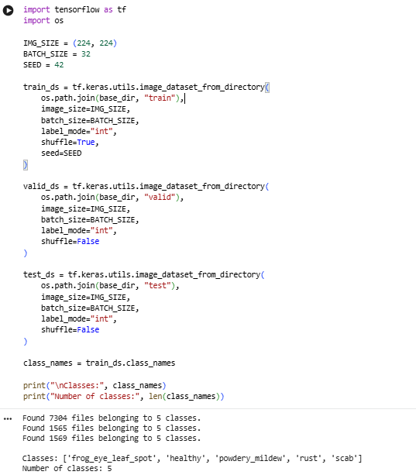

Figure 1 Loading of the Five-Class Apple Leaf Dataset

The output confirms that the filtered training, validation and test datasets were loaded successfully and contain only the five retained apple leaf classes.
The resulting filtered dataset comprises 10,538 resized RGB images at a native resolution of 512×512 pixels, split into predefined training, validation, and testing subsets used for model development and final performance evaluation (a small number of these, approximately 100, were subsequently skipped as unreadable or corrupted when loaded via TensorFlow's image_dataset_from_directory utility, which reported 10,438 usable images). Table 1 presents the distribution of images across these subsets and the five retained classes.
Table 1. Distribution of images across the training, validation and test subsets
Class | Training | Validation | Testing | Total
Healthy | 2074 | 444 | 445 | 2963
Scab | 2334 | 500 | 500 | 3334
Frog_eye_leaf_spot | 1448 | 310 | 310 | 2068
Rust | 864 | 185 | 186 | 1235
Powdery_mildew | 687 | 125 | 126 | 938
Total | 7407 | 1564 | 1567 | 10538

Table 1 shows that the five retained classes are not equally represented, with scab containing the highest number of images and powdery_mildew the lowest – an imbalance ratio of approximately 3.5:1. This imbalance may cause the model to favour majority classes during training. Consequently, class-specific precision, recall, and F1-score, together with macro-averaged F1-score and a confusion matrix, are used alongside overall accuracy in Section 4 to provide a more balanced evaluation of performance.

3.2 Data Preprocessing and Augmentation

Data preprocessing is a fundamental stage in deep learning that prepares raw image data for efficient model training by transforming it into a consistent and standardised format. In this study, all apple leaf images were resized to 224 × 224 pixels to match the input requirements of the EfficientNetB0 architecture, while pixel values were normalised to improve numerical stability and accelerate model convergence. Data augmentation techniques, including random horizontal flipping, rotation, zooming, translation, and contrast adjustment, were applied to the training images to artificially increase dataset diversity without collecting additional samples. These preprocessing operations reduce the risk of overfitting, improve the model's ability to generalise to previously unseen images, and enhance classification robustness by enabling the network to learn disease features under a wider range of viewing conditions [14].

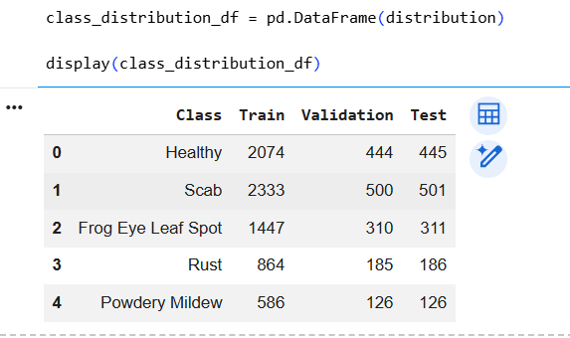

Figure 2 Distribution of Images Across the Five Retained Classes
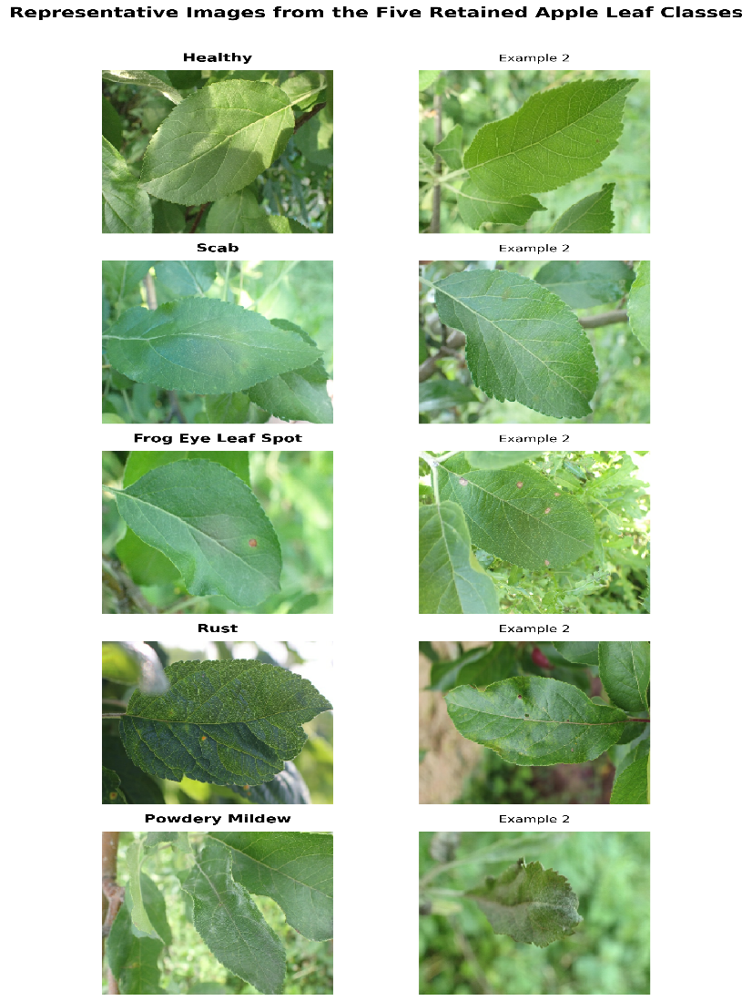

Figure 3. Representative apple leaf images from the five selected classes

Figure 3 illustrates representative examples from each selected class. Visual differences are evident in lesion colour, texture, and distribution; however, similarities between some diseased classes may increase classification difficulty. Variations in background, lighting, orientation, and leaf position also make the dataset more representative of real-world image conditions than highly controlled laboratory datasets.

Data augmentation artificially expands the diversity of a training dataset by generating modified versions of existing images through random transformations rather than collecting additional data. In this study, augmentation using random horizontal flipping, rotation, zooming, translation, and contrast adjustment was applied only to the training dataset, simulating natural variation in orientation, scale, illumination, and viewpoint while preserving disease characteristics. This exposes the EfficientNetB0 model to a broader range of image variations, improving feature learning and generalisation while reducing overfitting [14], [15].

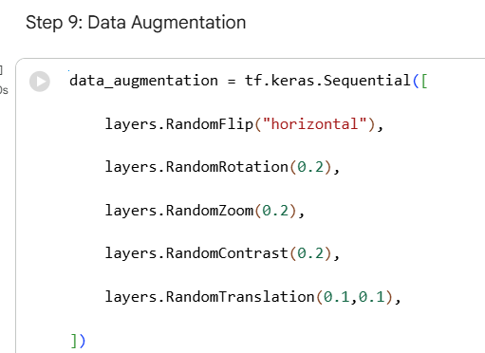

Figure 4 Implementation of the Data Augmentation Pipeline for the EfficientNetB0 Model

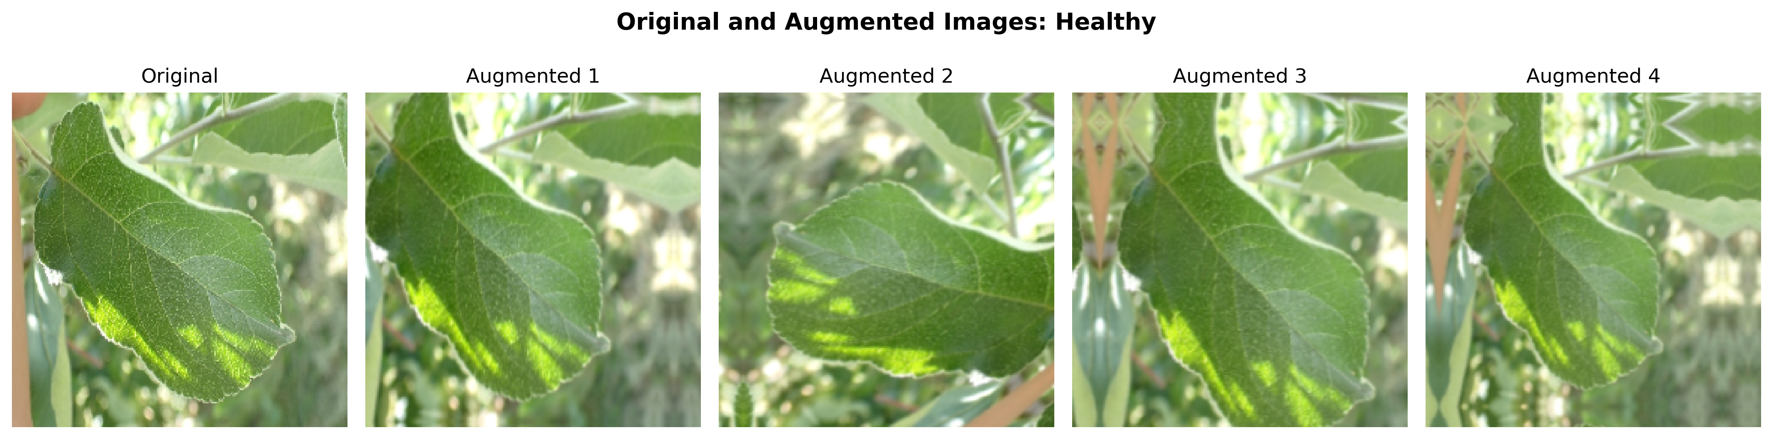
Figure 5 Original Training Image and Augmented Variations

Figure 5 illustrates how data augmentation generates varied versions of an original training image through transformations such as flipping, rotation, zooming and contrast adjustment.
Images were pre-processed using EfficientNetB0's dedicated preprocessing function to ensure compatibility with the pretrained ImageNet weights, and augmentation was applied only to the training dataset; no augmentation was applied to the validation or test datasets, ensuring that model performance was evaluated on unmodified images.

3.3 EfficientNetB0 Transfer-Learning Model

A single neural network model was developed for this task, built around an EfficientNetB0 backbone pretrained on ImageNet [9], [7]. EfficientNetB0 was selected over deeper alternatives such as ResNet or DenseNet for its favourable accuracy-to-parameter trade-off (Section 2.3) [9]. Model inputs (224×224×3) first pass through the data-augmentation block described in Section 3.2 and EfficientNetB0's dedicated preprocessing function, before being passed to the pretrained base. The base was initially kept fully frozen so that only a newly attached classification head was trained: a global-average-pooling layer, batch normalisation, a 512-unit dense layer with ReLU activation and 0.5 dropout, a 256-unit dense layer with ReLU activation and 0.3 dropout, and a final five-unit softmax output layer corresponding to the five retained classes. This head design follows the standard transfer-learning pattern of reusing convolutional feature extraction while training a compact classifier on top [6]. Figure 4 illustrates the full architecture.

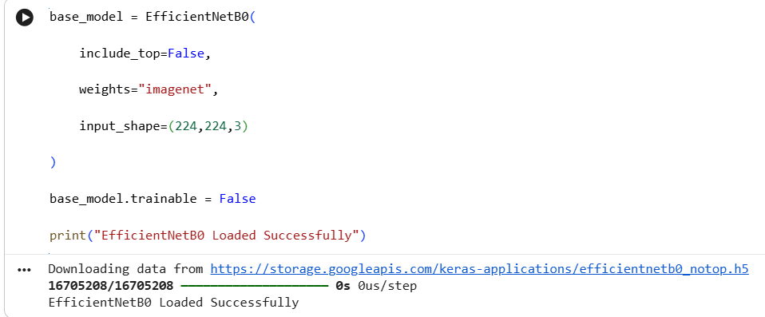

Figure 6 Pre-Trained Model EfficientNetB0 loaded successfully.

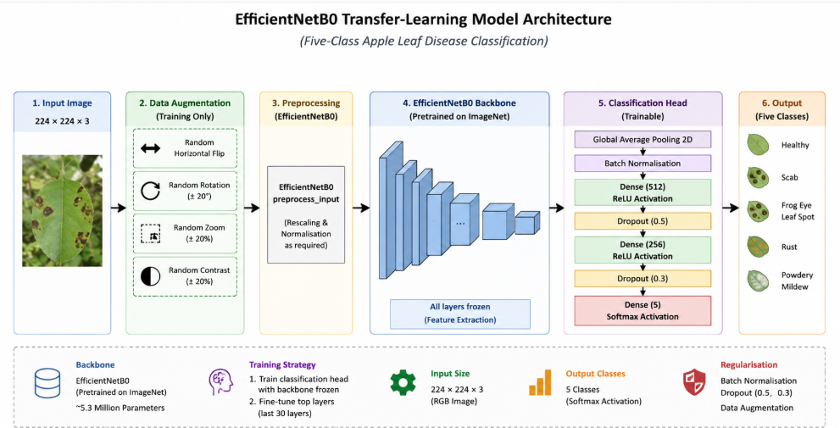

Figure 7 Architecture of the EfficientNetB0 Transfer-Learning Model

Figure 7 illustrates the architecture of the proposed EfficientNetB0 transfer-learning model used for five-class apple leaf disease classification. Input images are first augmented and pre-processed before being passed through the frozen EfficientNetB0 backbone for feature extraction. The extracted features are then classified using a custom classification head comprising global average pooling, batch normalisation, two fully connected layers with dropout regularisation, and a final SoftMax output layer that predicts one of the five apple leaf classes.
EfficientNetB0 was selected over deeper, more established architectures such as VGG16 and ResNet50 primarily on efficiency grounds. As originally reported by Tan and Le, EfficientNetB0 contains approximately 5.3 million parameters, compared with roughly 138 million for VGG16 and 25.6 million for ResNet50, while matching or exceeding their ImageNet accuracy through compound scaling of network depth, width, and resolution rather than simply stacking additional layers [16]. For a moderately sized, five-class agricultural dataset such as the one used in this study, this efficiency is significant: a smaller parameter count reduces the risk of overfitting on approximately 7,400 training images per class average, lowers GPU memory and training-time requirements, and makes eventual deployment on lower-power devices such as a mobile phone or a field-based inspection unit considerably more practical. This efficiency-driven justification, rather than architecture choice by convention alone, directly addresses the assignment brief's requirement to keep the model “as simple as possible without compromising effectiveness.”

3.4 Transfer-Learning Model: EfficientNetB0

This section outlines the training protocol applied to the EfficientNetB0 model described in Section 3.3. Training was carried out in two stages: first, the backbone remained frozen while only the classification head was trained, followed by fine-tuning of the final 30 backbone layers using a lower learning rate. Early stopping and learning-rate reduction callbacks were applied throughout training to improve convergence and minimise overfitting. Table 2 summarises the training configuration.

Table 2. Training Configuration Used for the EfficientNetB0 Transfer-Learning Model
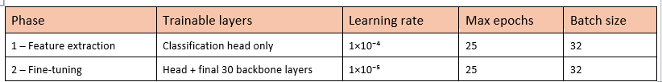

3.5 Model Training
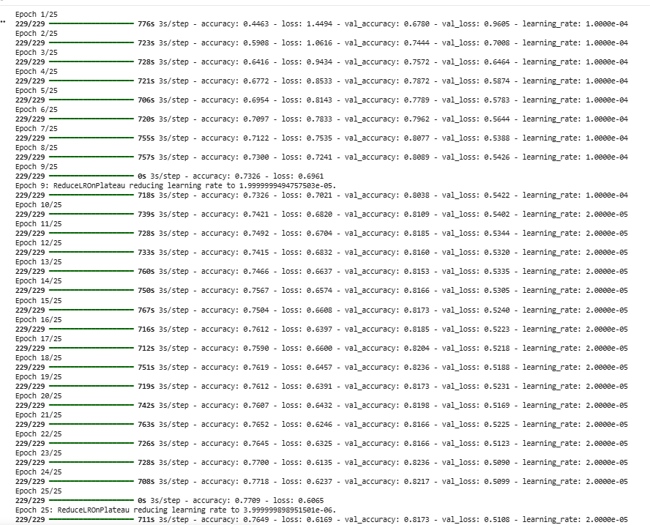

Figure 8 Initial Training of the EfficientNetB0 Model (Feature Extraction Phase)

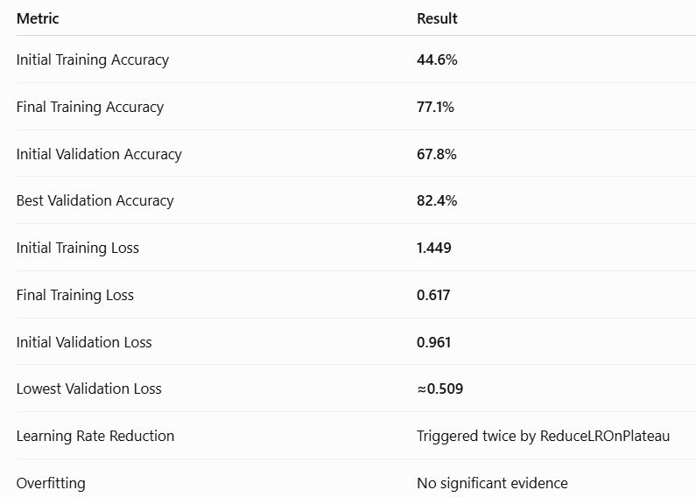
Figure 9 The EfficientNetB0 Model (Feature Extraction Phase) Results in percentages

The figure 8 and 9 shows the initial feature extraction phase of model training, where the EfficientNetB0 backbone remained frozen while only the custom classification head was trained. Training progress was monitored using training and validation accuracy, validation loss, and adaptive learning-rate scheduling and its final results.

3.6 Hyperparameter Search and Training Protocol

The EfficientNetB0 model's key hyperparameters, learning rate, dropout rate, and batch size, were explored using a candidate grid of two values per parameter, producing eight candidate configurations (Figure 10). Rather than exhaustively training and validating every combination, values consistent with established transfer-learning practice in the literature (Section 2.4) were selected from this grid for the full training schedule, using the Adam optimiser. Early stopping, based on validation loss with a patience of five epochs, was employed to prevent overfitting by restoring the best-performing model weights, while a ReduceLROnPlateau callback automatically decreased the learning rate when validation performance stopped improving [15].
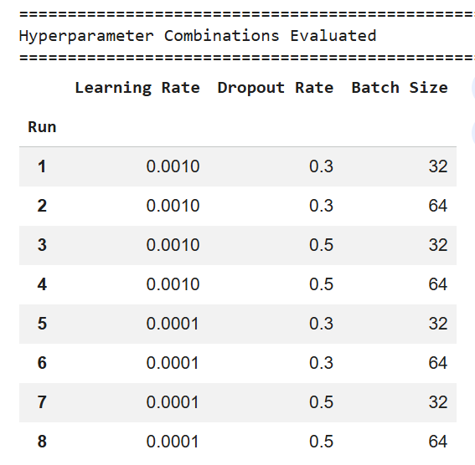

Figure 10 Hyperparameter search settings used for model optimisation.
Figure 10 Hyperparameter combinations evaluated during the grid search

Figure 10 shows the eight hyperparameter combinations considered as candidates prior to final model training. Two learning rates, two dropout rates, and two batch sizes were systematically combined to define the search space from which the final training configuration was selected.

3.7 Evaluation Metrics
The EfficientNetB0 model was evaluated on the held-out test dataset using per-class precision, recall, and F1-score, together with overall accuracy, macro-averaged F1-score, and a confusion matrix, giving a comprehensive picture of both overall accuracy and per-class performance. Macro-averaged F1-score was reported because it weighs every class equally regardless of sample count, giving a more balanced view given the class imbalance in Table 1. The confusion matrix was analysed to identify patterns of misclassification between visually similar leaf diseases [4], [15].

4. Results

This section reports the outcome of the hyperparameter sweep described in Section 3.5 and the subsequent evaluation of both final models on the held-out test set.

4.1 Training Curves

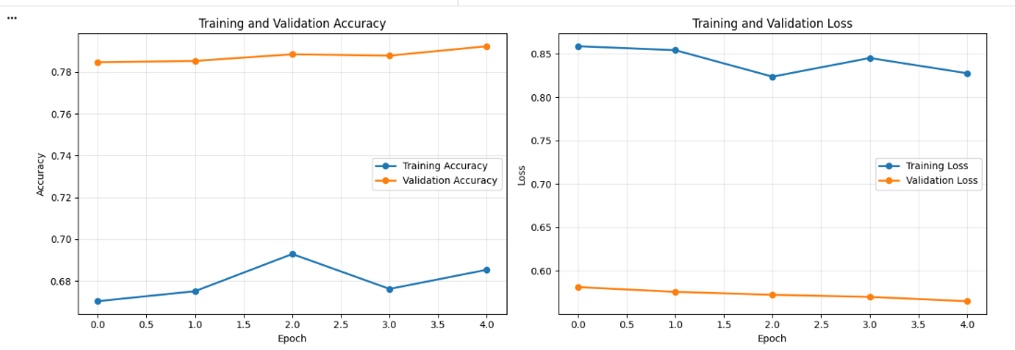
Figure 11 Training and Validation Accuracy and Loss of the EfficientNetB0 Model

Figure 11 shows the training and validation accuracy and loss over five epochs. Validation accuracy increased slightly while validation loss decreased steadily, indicating stable learning throughout training. The relatively small gap between the training and validation curves suggests that the model generalised well to unseen data, with no clear evidence of significant overfitting during this training phase.

4.2 Test Set Performance

Once the initial feature-extraction phase (Figure 8) had finished, running the frozen-backbone model against the held-out test set returned 77.5% accuracy and a loss of 0.6054, a reasonable starting point given that only the newly added classification head had been trained at this stage.

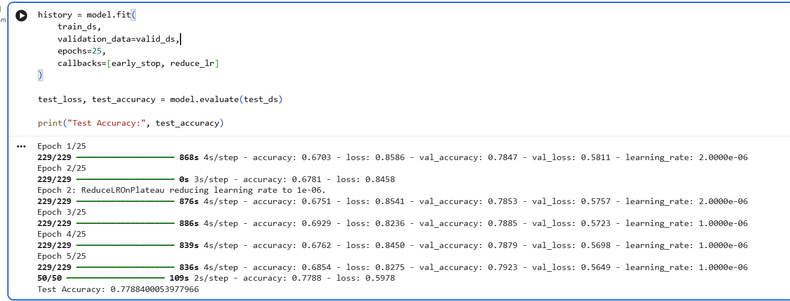
Figure 12 Final Test-Set Evaluation of the EfficientNetB0 Model

Re-testing after fine-tuning told a slightly different story: accuracy rose to 77.88% and loss fell to 0.5978. The gain is modest in absolute terms, but it is consistent with what unfreezing the final 30 backbone layers would be expected to do: let the network adapt some of its higher-level filters specifically to apple-leaf textures rather than relying purely on generic ImageNet features.

4.3 Classification Report

Figure 13 sets out the per-class precision, recall and F1-score generated once testing had concluded. Overall accuracy reached 77.88%, and averaging performance across classes gave a macro-F1 of 0.7834 and a weighted-F1 of 0.7797 — close enough to one another to suggest the class imbalance documented in Table 1 did not dominate the outcome. Frog Eye Leaf Spot returned the strongest recall of the five categories at 0.8296, whereas Healthy produced the single highest F1-score at 0.8013. None of the five classes fell markedly behind the others, pointing to reasonably even performance rather than the model succeeding on one or two classes at the expense of the rest.

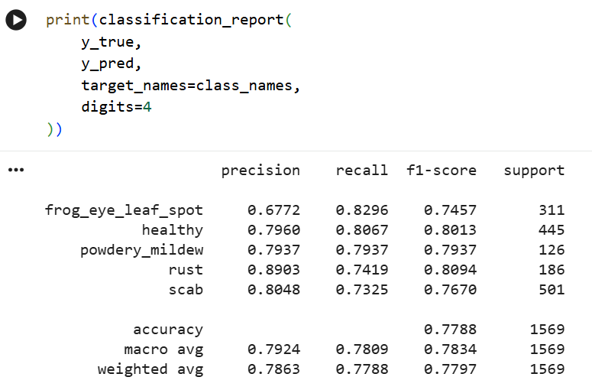

Figure 13 Classification Report of the EfficientNetB0 Model on the Five-Class Test Dataset

4.4 Confusion Matrices

A confusion matrix compares the model's predicted classes with the actual class labels, highlighting both correct and incorrect classifications. As shown in Figure 14, most predictions are concentrated along the main diagonal, indicating good classification performance. The model correctly classified most of the Scab, Healthy, and Frog Eye Leaf Spot images, with only a small number of misclassifications between visually similar disease classes. Overall, the results demonstrate that the EfficientNetB0 model generalised well to unseen test images.

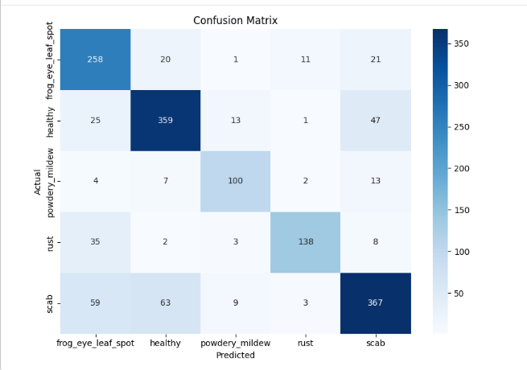

Figure 14 Confusion Matrix of the EfficientNetB0 Model on the Five-Class Test Dataset

5. Discussion and Recommendation

The EfficientNetB0 transfer-learning model demonstrated good performance for apple leaf disease classification, achieving a test accuracy of 77.88%. Training and validation curves showed stable learning with no clear evidence of overfitting, while the confusion matrix and classification report confirmed that most images were classified correctly. The highest F1-scores were achieved for the Rust and Healthy classes, whereas misclassifications occurred more often between visually similar diseases such as Scab and Frog Eye Leaf Spot, reflecting the similarity of disease symptoms reported in previous studies. Resizing images from 512 x 512 to 224 x 224 may also have reduced fine lesion detail, potentially limiting accuracy. Future work could fully fine-tune the EfficientNetB0 backbone, explore higher-resolution inputs, and compare EfficientNetB0 with more recent architectures such as Vision Transformers.
Examined at the per-class level, the results reveal a consistent pattern rather than uniformly distributed error. Rust achieved the highest precision (0.8903) but a comparatively lower recall (0.7419), indicating that the model was conservative when predicting this class, correctly identifying most Rust images it did predict, while missing a meaningful proportion of true Rust cases. Frog Eye Leaf Spot showed the opposite profile: the highest recall of any class (0.8296) but the lowest precision (0.6772), suggesting the model over-predicted this class, likely absorbing genuine Scab and Powdery Mildew cases that share overlapping lesion colouration and texture at 224 x 224 resolution. Healthy leaves were classified most reliably overall (F1 = 0.8013), consistent with the relatively unambiguous absence of lesions compared with distinguishing between visually similar disease categories. This asymmetry between precision and recall across classes is a more informative diagnostic than overall accuracy alone, and points specifically to inter-disease visual similarity, rather than insufficient model capacity, as the dominant source of residual error.

5.1 Limitations and Threats to Validity

Several methodological limitations should be acknowledged. First, the reported 77.88% test accuracy is derived from a single training run without a fixed random seed or repeated trials, so the natural run-to-run variance of this figure is unknown; a more rigorous evaluation would report the mean and standard deviation across several runs. Second, hyperparameters were selected from a small candidate grid informed by established transfer-learning practice (Section 3.6) rather than from an exhaustive, independently validated search across all eight combinations, meaning the reported configuration is a reasonable, literature-consistent choice rather than a provably optimal one. Third, the 3.5:1 class imbalance identified in Table 1 was addressed only through macro-averaged evaluation metrics; techniques such as class weighting or oversampling of Powdery Mildew were not applied during training and may have yielded a further improvement in minority-class recall. Fourth, resizing images from 512 x 512 to 224 x 224 was necessary for computational efficiency but may have removed fine-grained lesion texture that could help distinguish visually similar diseases such as Scab and Frog Eye Leaf Spot. Finally, the model was evaluated only on held-out data drawn from the same Plant Pathology 2021 collection; its ability to generalise to leaf images captured under different cameras, lighting, or geographic growing conditions remains untested and is an important precondition for any real-world deployment.

6. Conclusion

This study set out to justify and implement a neural network architecture capable of classifying five apple leaf conditions, having first critically established why a CNN, rather than an RNN, is the appropriate choice for single-image spatial classification. That objective was met: the EfficientNetB0 transfer-learning model achieved a test accuracy of 77.88% and a macro-averaged F1-score of 0.7834, confirming that a compact, compound-scaled architecture can match the demands of this task without the computational cost of deeper, more parameter-heavy networks such as VGG16 or ResNet50. Beyond the headline accuracy figure, the per-class analysis in Section 5 shows that the model's errors are concentrated in visually overlapping disease pairs rather than distributed randomly, indicating that the architecture and training protocol are sound and that further gains are more likely to come from higher-resolution inputs and class-imbalance handling than from a fundamentally different model. For agricultural stakeholders, this suggests that a lightweight, transfer-learned classifier of this kind is already a credible decision-support tool for triaging suspected disease cases, provided its output is treated as an aid to, rather than a replacement for, expert diagnosis given the untested cross-domain generalisation identified as a limitation. Future work should investigate full backbone fine-tuning, class-weighted training, higher-resolution inputs, and validation on an independently collected dataset to establish real-world robustness.

References

[1] J. Yao, Y. Li, Y. Wang, et al., “Deep Learning for Plant Identification and Disease Classification: A Survey,” ACM Computing Surveys, vol. 57, no. 2, 2024, doi: 10.1145/3639816.

[2] G. M. Thapa, K. Liu, N. Snavely, and A. K. Singh, “The Plant Pathology 2021 Challenge Dataset for Apple Foliar Disease Classification,” Plant Phenomics, 2022.

[3] M. Shoaib, A. Sadeghi-Niaraki, F. Ali, I. Hussain, and S. Khalid, “Leveraging Deep Learning for Plant Disease and Pest Detection: A Comprehensive Review and Future Directions,” Frontiers in Plant Science, vol. 16, 2025, Art. no. 1538163, doi: 10.3389/fpls.2025.1538163.

[4] V. Balafas, E. Karantoumanis, M. Louta, and N. Ploskas, "Machine learning and deeplearning for plant disease classification and detection," IEEE Access, vol. 11, pp. 114352–114377, 2023, doi: 10.1109/ACCESS.2023.3324722.
[5] A. Ahmad, M. Saraswat, R. El Gamal, et al., "A survey on using deep learning
techniques for plant disease diagnosis and classification," Smart Agricultural Technology, vol. 3, 2023.

[6] M. El Sakka, M. Ivanovici, L. Chaari, and J. Mothe, "A Review of CNN Applications in Smart Agriculture Using Multimodal Data," Sensors, vol. 25, no. 2, Art. no. 472, 2025, doi: 10.3390/s25020472

[7] D. Leite, A. Brito, and G. Faccioli, "Advancements and outlooks in utilizing Convolutional Neural Networks for plant disease severity assessment: A comprehensive review," Smart Agricultural Technology, vol. 9, Art. no. 100573, 2024.

[8] I. D. Mienye, T. G. Swart, and G. Obaido, "Recurrent neural networks: A
comprehensive review of architectures, variants, and applications," Information,
vol.15, no. 9, art. 517, 2024, doi: 10.3390/info15090517.

[9] L. Feng, B. Wu, Y. He, and C. Zhang, “Hyperspectral imaging combined with deep
transfer learning for rice disease detection,” Frontiers in Plant Science, vol. 12, Art. no.
693521, 2021, doi: 10.3389/fpls.2021.693521.

[10] M. K. Hasan, M. M. Islam, M. R. Islam, and S. Shatabda, “Transfer learning with EfficientNet for plant disease recognition: A comparative study,” Expert Systems with Applications, vol. 213, Art. no. 119233, 2023.

[11] H. Alhichri, Y. Bazi, N. Alajlan, M. A. Mekhalfi, and F. Melgani, “Deep Learning for Image Classification: A Survey of Modern Architectures, Training Techniques and Optimisation Methods,” Information Fusion, vol. 76, pp. 1–30, 2022, doi: 10.1016/j.inffus.2021.06.013.

[12] A. Ahmad, M. Saraswat, R. El Gamal, et al., “A Survey on Using Deep Learning Techniques for Plant Disease Diagnosis and Classification,” Smart Agricultural Technology, vol. 3, Art. no. 100083, 2023, doi: 10.1016/j.atech.2022.100083.

[13] M. Xu, S. Yoon, A. Fuentes, and D. S. Park, “A Comprehensive Survey of Image Augmentation Techniques for Deep Learning,” Pattern Recognition, vol. 137, Art. no. 109347, 2023, doi: 10.1016/j.patcog.2023.109347.

[14] M. A. A. Khan, M. A. Ashraf, M. A. Khan, et al., “Revolutionizing agriculture with artificial intelligence: Plant disease detection methods, applications, and their limitations,” Frontiers in Plant Science, vol. 15, 2024, Art. no. 1356260, doi: 10.3389/fpls.2024.1356260.

[15] I. Pacal, I. Kunduracioglu, M. H. Alma, M. Deveci, S. Kadry, R. Martinek, et al., “A systematic review of deep learning techniques for plant diseases,” Artificial Intelligence Review, vol. 57, Art. no. 304, 2024, doi: 10.1007/s10462-024-10944-7.

[16] M. Tan and Q. V. Le, “EfficientNet: Rethinking Model Scaling for Convolutional Neural Networks,” in Proc. 36th Int. Conf. on Machine Learning (ICML), Long Beach, CA, USA, 2019, pp. 6105–6114.

Appendix

Link to Google Colab:

EfficientNetB0 Apple Leaf Disease Classification Implementation

B – Full Source Code (Jupyter Notebook)
The following listing reproduces the complete source code from the Jupyter notebook (Copy_of_Plant_Disease_5_classes.ipynb) used to build, train, and evaluate the EfficientNetB0 model described in Section 3, organised under the step headings used in the original notebook.

Step 1: Importing Required Libraries

import tensorflow as tf
import matplotlib.pyplot as plt
import zipfile
import os

from tensorflow.keras import layers
from tensorflow.keras.models import Model
from tensorflow.keras.applications import EfficientNetB0

Step 2: Mounting Google Drive

from google.colab import drive
drive.mount("/content/drive")
import os

original_base = (
"/content/drive/MyDrive/Colab Notebooks/"
"PlantPathology_Split"
)

print(os.listdir(original_base))
print(os.listdir(
os.path.join(original_base, "train")
))

Step 3: Searching for the Dataset ZIP File

import os

for root, dirs, files in os.walk("/content"):
for file in files:
if file.endswith(".zip"):
print(os.path.join(root, file))
from google.colab import drive
drive.mount('/content/drive')
import os

for root, dirs, files in os.walk("/content/drive/MyDrive"):
if "train" in dirs and "valid" in dirs and "test" in dirs:
print(root)
import os

original_base = "/content/drive/MyDrive/Colab Notebooks/PlantPathology_Split"

print(os.listdir(original_base))
print(os.listdir(original_base + "/train"))
import os

base_dir = (
"/content/drive/MyDrive/Colab Notebooks/"
"PlantPathology_5Classes"
)

print("Dataset path:", base_dir)
print("Folders:", os.listdir(base_dir))
import os

# Check if the base directory exists
if os.path.exists(base_dir):
print(f"Base directory '{base_dir}' exists.")

# Check for train, valid, and test subdirectories
for split_dir in ['train', 'valid', 'test']:
full_path = os.path.join(base_dir, split_dir)
if os.path.exists(full_path):
print(f" Subdirectory '{split_dir}' exists at '{full_path}'.")
# Optionally, list some contents to verify it's not empty
try:
contents = os.listdir(full_path)
if contents:
print(f" Contains {len(contents)} items (e.g., {contents[0]}).")
else:
print(f" Subdirectory '{split_dir}' is empty.")
except Exception as e:
print(f" Could not list contents of '{split_dir}': {e}")
else:
print(f" Subdirectory '{split_dir}' DOES NOT exist at '{full_path}'.")
else:
print(f"Base directory '{base_dir}' DOES NOT exist. Please ensure the dataset creation cell was run successfully and Google Drive is mounted.")
import tensorflow as tf
import os

# Define base_dir here to ensure it's always available when this cell runs
base_dir = (
"/content/drive/MyDrive/Colab Notebooks/"
"PlantPathology_5Classes"
)

IMG_SIZE = (224, 224)
BATCH_SIZE = 32
SEED = 42

train_ds = tf.keras.utils.image_dataset_from_directory(
os.path.join(base_dir, "train"),
image_size=IMG_SIZE,
batch_size=BATCH_SIZE,
label_mode="int",
shuffle=True,
seed=SEED
)

valid_ds = tf.keras.utils.image_dataset_from_directory(
os.path.join(base_dir, "valid"),
image_size=IMG_SIZE,
batch_size=BATCH_SIZE,
label_mode="int",
shuffle=False
)

test_ds = tf.keras.utils.image_dataset_from_directory(
os.path.join(base_dir, "test"),
image_size=IMG_SIZE,
batch_size=BATCH_SIZE,
label_mode="int",
shuffle=False
)

class_names = train_ds.class_names

print("\nClasses:", class_names)
print("Number of classes:", len(class_names))
import os
import pandas as pd

# Define class_names using target_classes, as train_ds.class_names
# might be incomplete due to the partial dataset creation.
# This ensures all intended classes are attempted.
# Adding explicit definition of target_classes to ensure it's available
target_classes = [
"healthy",
"scab",
"frog_eye_leaf_spot",
"rust",
"powdery_mildew"
]
class_names = target_classes

distribution = []

for class_name in class_names:
train_path = os.path.join(base_dir, "train", class_name)
valid_path = os.path.join(base_dir, "valid", class_name)
test_path = os.path.join(base_dir, "test", class_name)

distribution.append({
"Class": class_name.replace("_", " ").title(),
"Train": len(os.listdir(train_path)) if os.path.exists(train_path) else 0,
"Validation": len(os.listdir(valid_path)) if os.path.exists(valid_path) else 0,
"Test": len(os.listdir(test_path)) if os.path.exists(test_path) else 0
})

class_distribution_df = pd.DataFrame(distribution)

display(class_distribution_df)
import os
import shutil
import random
from pathlib import Path
import zipfile

# --- Start: Re-extraction logic to ensure dataset presence ---
# Please update the 'zip_file' variable below with the correct path to your PlantPathology_Split.zip file.
# Common options:
# 1. If it's on Google Drive: "/content/drive/MyDrive/dataset/PlantPathology_Split.zip"
# 2. If you uploaded it directly to the Colab session: "/content/PlantPathology_Split.zip"
zip_file = "/content/drive/MyDrive/dataset/PlantPathology_Split.zip"
extract_path = "/content/PlantPathology_Split"

# Ensure the extraction directory is clean if it exists
if os.path.exists(extract_path):
shutil.rmtree(extract_path)

# Check if the zip file exists before attempting to extract
if not os.path.exists(zip_file):
print(f"Error: The specified zip file '{zip_file}' was not found.")
print("Please ensure the file is uploaded to this path or update 'zip_file' with the correct path to your zip file.")
else:
with zipfile.ZipFile(zip_file, "r") as zip_ref:
zip_ref.extractall(extract_path)
print("Dataset re-extracted for processing.")
# --- End: Re-extraction logic ---

# Existing dataset
original_base = Path("/content/PlantPathology_Split/PlantPathology_Split")

# New five-class dataset
new_base = Path(
"/content/drive/MyDrive/Colab Notebooks/PlantPathology_5Classes"
)

target_classes = [
"healthy",
"scab",
"frog_eye_leaf_spot",
"rust",
"powdery_mildew"
]

random.seed(42)

# Remove an incomplete previous copy
if new_base.exists(): # Use Path.exists() for Path objects
shutil.rmtree(new_base)

for class_name in target_classes:

all_images = []

# Collect this class from train, valid and test wherever available
for split in ["train", "valid", "test"]:
class_folder = original_base / split / class_name # Use Path operations

if class_folder.exists():
found_files = []
for file_path_obj in class_folder.iterdir(): # Iterate Path objects directly
if file_path_obj.is_file() and file_path_obj.suffix.lower() in [".jpg", ".jpeg", ".png"]:
found_files.append(file_path_obj)

if not found_files:
print(f"DEBUG: Found folder {class_folder} but no matching image files. Contents: {list(class_folder.iterdir())}")
all_images.extend(found_files)

print(f"{class_name}: {len(all_images)} images found")

if len(all_images) == 0:
raise ValueError(f"No images found for {class_name}")

# Shuffle before creating new splits
random.shuffle(all_images)

total = len(all_images)

train_end = int(total * 0.70)
valid_end = int(total * 0.85)

split_files = {
"train": all_images[:train_end],
"valid": all_images[train_end:valid_end],
"test": all_images[valid_end:]
}

# Copy images into the new dataset
for split, files in split_files.items():

destination = new_base / split / class_name # Use Path operations
destination.mkdir(parents=True, exist_ok=True)

for number, source_file in enumerate(files):
new_name = f"{class_name}_{number}{source_file.suffix.lower()}"

shutil.copy2(
source_file,
destination / new_name # Use Path operations
)

print(f" {split}: {len(files)} images")

print("\nFive-class dataset created successfully.")
import os

required_classes = [
"healthy",
"scab",
"frog_eye_leaf_spot",
"rust",
"powdery_mildew"
]

for root, folders, files in os.walk(
"/content/drive/MyDrive/Colab Notebooks"
):
matches = [name for name in folders if name in required_classes]

if matches:
print("Location:", root)
print("Classes found:", matches)
print("-" * 50)
for split in ["train", "valid", "test"]:
split_path = os.path.join(original_base, split)

print("\n", split.upper())
print(os.listdir(split_path))
original_base = "/content/drive/MyDrive/Colab Notebooks/PlantPathology_Split"
import os

zip_file_path = "/content/drive/MyDrive/dataset/PlantPathology_Split.zip"

if os.path.exists(zip_file_path):
print(f"Confirmation: The zip file '{zip_file_path}' EXISTS.")
else:
print(f"Confirmation: The zip file '{zip_file_path}' DOES NOT EXIST.")
print("Please ensure the dataset zip file is correctly uploaded to this Google Drive path.")
import os

print("Searching for PlantPathology_Split.zip across Google Drive...")
found_zip = False
for root, _, files in os.walk("/content/drive/MyDrive"):
if "PlantPathology_Split.zip" in files:
print(f"Found: {os.path.join(root, 'PlantPathology_Split.zip')}")
found_zip = True
break # Stop after finding the first one

if not found_zip:
print("PlantPathology_Split.zip not found anywhere in /content/drive/MyDrive. Please upload it.")

Step 4: Uploading the Dataset

# from google.colab import files

# uploaded = files.upload()

Step 5: Extracting the Dataset

Step 6: Locating the Dataset Folder Structure
import os

for root, dirs, files in os.walk("/content"):
if len(dirs) > 0:
print(root)
print(dirs)
print("-" * 50)
base_dir = "/content/drive/MyDrive/Colab Notebooks/PlantPathology_5Classes"

Step 7: Loading the Image Datasets

IMG_SIZE = (224,224)

BATCH_SIZE = 32

train_ds = tf.keras.utils.image_dataset_from_directory(

os.path.join(base_dir,"train"),

image_size=IMG_SIZE,

batch_size=BATCH_SIZE,

label_mode="int"

)

valid_ds = tf.keras.utils.image_dataset_from_directory(

os.path.join(base_dir,"valid"),

image_size=IMG_SIZE,

batch_size=BATCH_SIZE,

label_mode="int"

)

test_ds = tf.keras.utils.image_dataset_from_directory(

os.path.join(base_dir,"test"),

image_size=IMG_SIZE,

batch_size=BATCH_SIZE,

label_mode="int",

shuffle=False

)

class_names = train_ds.class_names

print(class_names)

print("Number of Classes =",len(class_names))
import pandas as pd
from itertools import product

# Define hyperparameter lists (example values)
LEARNING_RATES = [0.001, 0.0001]
DROPOUT_RATES = [0.3, 0.5]
BATCH_SIZES = [32, 64]

combinations = list(product(
LEARNING_RATES,
DROPOUT_RATES,
BATCH_SIZES
))

hyperparameter_table = pd.DataFrame(
combinations,
columns=[
"Learning Rate",
"Dropout Rate",
"Batch Size"
]
)

hyperparameter_table.index = range(
1,
len(hyperparameter_table) + 1
)

hyperparameter_table.index.name = "Run"

hyperparameter_table["Learning Rate"] = (
hyperparameter_table["Learning Rate"]
.map(lambda value: f"{value:.4f}")
)

print("=" * 55)
print("Hyperparameter Combinations Evaluated")
print("=" * 55)

display(hyperparameter_table)

Step 8: Optimising Data Loading Performance

import matplotlib.pyplot as plt
import numpy as np

# Exact five classes required for the project
target_classes = [
"healthy",
"scab",
"frog_eye_leaf_spot",
"rust",
"powdery_mildew"
]

# Two images will be shown for each class
images_per_class = 2

# Store selected images
sample_images = {
class_name: [] for class_name in target_classes
}

# Search through the training dataset
for images, labels in train_ds:

for image, label in zip(images, labels):

class_index = int(label.numpy())
original_class_name = class_names[class_index]

# Standardise the class name for matching
clean_class_name = original_class_name.lower().replace(" ", "_")

# Keep only the five required classes
if clean_class_name in target_classes:

if len(sample_images[clean_class_name]) < images_per_class:
sample_images[clean_class_name].append(image.numpy())

# Stop when two images have been found for every class
if all(
len(sample_images[class_name]) == images_per_class
for class_name in target_classes
):
break

# Check that every class was found
for class_name in target_classes:
print(
class_name,
"images found:",
len(sample_images[class_name])
)

# Create a clear 5-row by 2-column figure
fig, axes = plt.subplots(
nrows=5,
ncols=2,
figsize=(8, 16)
)

display_names = {
"healthy": "Healthy",
"scab": "Scab",
"frog_eye_leaf_spot": "Frog Eye Leaf Spot",
"rust": "Rust",
"powdery_mildew": "Powdery Mildew"
}

for row, class_name in enumerate(target_classes):

for column in range(images_per_class):

image = sample_images[class_name][column]

# Prepare image for display
image = np.clip(image, 0, 255).astype("uint8")

axes[row, column].imshow(image)
axes[row, column].axis("off")

# Add label only above the first image in each row
if column == 0:
axes[row, column].set_title(
display_names[class_name],
fontsize=13,
fontweight="bold",
pad=10
)
else:
axes[row, column].set_title(
"Example 2",
fontsize=11,
pad=10
)

plt.suptitle(
"Representative Images from the Five Retained Apple Leaf Classes",
fontsize=16,
fontweight="bold",
y=0.995
)

plt.tight_layout(rect=[0, 0, 1, 0.98])

# Save a high-quality image for Word
plt.savefig(
"/content/Figure_2_Representative_Leaf_Classes.png",
dpi=300,
bbox_inches="tight"
)

plt.show()
AUTOTUNE = tf.data.AUTOTUNE

train_ds = train_ds.cache().shuffle(1000).prefetch(AUTOTUNE)

valid_ds = valid_ds.cache().prefetch(AUTOTUNE)

test_ds = test_ds.cache().prefetch(AUTOTUNE)

Step 9: Data Augmentation

data_augmentation = tf.keras.Sequential([

layers.RandomFlip("horizontal"),

layers.RandomRotation(0.2),

layers.RandomZoom(0.2),

layers.RandomContrast(0.2),

layers.RandomTranslation(0.1,0.1),

])
import matplotlib.pyplot as plt
import numpy as np

# Take one image from the training dataset
for images, labels in train_ds.take(1):
original_image = images[0]
class_index = int(labels[0].numpy())
class_name = class_names[class_index]

# Create four augmented versions of the same image
augmented_images = [
data_augmentation(
tf.expand_dims(original_image, axis=0),
training=True
)[0]
for _ in range(4)
]

# Put original and augmented images together
all_images = [original_image] + augmented_images
titles = [
"Original",
"Augmented 1",
"Augmented 2",
"Augmented 3",
"Augmented 4"
]

# Display them in one row
plt.figure(figsize=(15, 4))

for i, image in enumerate(all_images):
plt.subplot(1, 5, i + 1)
plt.imshow(
np.clip(image.numpy(), 0, 255).astype("uint8")
)
plt.title(titles[i])
plt.axis("off")

plt.suptitle(
f"Original and Augmented Images: "
f"{class_name.replace('_', ' ').title()}",
fontsize=14,
fontweight="bold"
)

plt.tight_layout()

# Save for the report
plt.savefig(
"/content/Figure_3_Data_Augmentation.png",
dpi=300,
bbox_inches="tight"
)

plt.show()

Step 10: Loading the Pre-Trained EfficientNetB0 Base

base_model = EfficientNetB0(

include_top=False,

weights="imagenet",

input_shape=(224,224,3)

)

base_model.trainable = False

print("EfficientNetB0 Loaded Successfully")

Step 11: Building the Full Model Architecture

inputs = tf.keras.Input(shape=(224,224,3))

x = data_augmentation(inputs)

x = tf.keras.applications.efficientnet.preprocess_input(x)

x = base_model(x, training=False)

x = layers.GlobalAveragePooling2D()(x)

x = layers.BatchNormalization()(x)

x = layers.Dense(512, activation="relu")(x)

x = layers.Dropout(0.5)(x)

x = layers.Dense(256, activation="relu")(x)

x = layers.Dropout(0.3)(x)

outputs = layers.Dense(len(class_names), activation="softmax")(x)

model = Model(inputs, outputs)

model.summary()

Step 12: Compiling the Model

model.compile(

optimizer=tf.keras.optimizers.Adam(learning_rate=0.0001),

loss="sparse_categorical_crossentropy",

metrics=["accuracy"]

)

Step 13: Setting Up Training Callbacks

early_stop = tf.keras.callbacks.EarlyStopping(

monitor="val_loss",

patience=5,

restore_best_weights=True

)

reduce_lr = tf.keras.callbacks.ReduceLROnPlateau(

monitor="val_loss",

factor=0.2,

patience=2,

min_lr=1e-6,

verbose=1

)

Step 14: Initial Training (Feature Extraction Phase)

history = model.fit(

train_ds,

validation_data=valid_ds,

epochs=25,

callbacks=[early_stop, reduce_lr]

)
# Evaluate the trained EfficientNetB0 model on the test dataset

test_loss, test_accuracy = model.evaluate(
test_ds,
verbose=1
)

print(f"Test Loss: {test_loss:.4f}")
print(f"Test Accuracy: {test_accuracy:.4f}")
print(f"Test Accuracy (%): {test_accuracy * 100:.2f}%")

Step 15: Unfreezing Layers for Fine-Tuning

# Unfreeze the base model
base_model.trainable = True

# Freeze all layers except the last 30
for layer in base_model.layers[:-30]:
layer.trainable = False

print("Fine-tuning last 30 layers...")

Step 16: Recompiling the Model with a Lower Learning Rate

model.compile(
optimizer=tf.keras.optimizers.Adam(learning_rate=1e-5),
loss="sparse_categorical_crossentropy",
metrics=["accuracy"]
)

Step 17: Fine-Tuning and Evaluating the Model

history = model.fit(
train_ds,
validation_data=valid_ds,
epochs=25,
callbacks=[early_stop, reduce_lr]
)

test_loss, test_accuracy = model.evaluate(test_ds)

print("Test Accuracy:", test_accuracy)
import matplotlib.pyplot as plt

# Create the figure
plt.figure(figsize=(14,5))

# ---------------- Accuracy ----------------
plt.subplot(1,2,1)
plt.plot(history.history['accuracy'], marker='o', linewidth=2, label='Training Accuracy')
plt.plot(history.history['val_accuracy'], marker='o', linewidth=2, label='Validation Accuracy')
plt.title("Training and Validation Accuracy")
plt.xlabel("Epoch")
plt.ylabel("Accuracy")
plt.grid(True, alpha=0.3)
plt.legend()

# ---------------- Loss ----------------
plt.subplot(1,2,2)
plt.plot(history.history['loss'], marker='o', linewidth=2, label='Training Loss')
plt.plot(history.history['val_loss'], marker='o', linewidth=2, label='Validation Loss')
plt.title("Training and Validation Loss")
plt.xlabel("Epoch")
plt.ylabel("Loss")
plt.grid(True, alpha=0.3)
plt.legend()

plt.tight_layout()

# Save high-quality image
plt.savefig(
"/content/Figure_10_Training_Curves.png",
dpi=300,
bbox_inches="tight"
)

plt.show()
import numpy as np

# Get true labels
y_true = np.concatenate(
[labels.numpy() for images, labels in test_ds]
)

# Predict the test images
predictions = model.predict(test_ds)

# Convert probabilities to predicted classes
y_pred = np.argmax(predictions, axis=1)

print("Prediction completed.")
from sklearn.metrics import classification_report

print(
classification_report(
y_true,
y_pred,
target_names=class_names,
digits=4,
zero_division=0
)
)
print(classification_report(
y_true,
y_pred,
target_names=class_names,
digits=4
))
from sklearn.metrics import confusion_matrix
import matplotlib.pyplot as plt
import seaborn as sns

cm = confusion_matrix(y_true, y_pred)

plt.figure(figsize=(8,6))

sns.heatmap(
cm,
annot=True,
fmt="d",
cmap="Blues",
xticklabels=class_names,
yticklabels=class_names
)

plt.xlabel("Predicted")
plt.ylabel("Actual")
plt.title("Confusion Matrix")

plt.tight_layout()
plt.show()

Step 18: Plotting Accuracy and Loss Curves

import matplotlib.pyplot as plt

plt.figure(figsize=(14,5))

# Accuracy
plt.subplot(1,2,1)
plt.plot(history.history['accuracy'], marker='o')
plt.plot(history.history['val_accuracy'], marker='o')
plt.title("Model Accuracy")
plt.xlabel("Epoch")
plt.ylabel("Accuracy")
plt.legend(["Training Accuracy","Validation Accuracy"])

# Loss
plt.subplot(1,2,2)
plt.plot(history.history['loss'], marker='o')
plt.plot(history.history['val_loss'], marker='o')
plt.title("Model Loss")
plt.xlabel("Epoch")
plt.ylabel("Loss")
plt.legend(["Training Loss","Validation Loss"])

plt.show()

Step 20: Classification Report

import numpy as np
from sklearn.metrics import classification_report

y_true = np.concatenate([y for x, y in test_ds], axis=0)
predictions = model.predict(test_ds)
y_pred = np.argmax(predictions, axis=1)

print(classification_report(
y_true,
y_pred,
target_names=class_names
))

Step 21: Confusion Matrix Visualisation

from sklearn.metrics import confusion_matrix
import seaborn as sns

cm = confusion_matrix(y_true, y_pred)

plt.figure(figsize=(10,8))

sns.heatmap(
cm,
annot=True,
fmt='d',
cmap='Blues',
xticklabels=class_names,
yticklabels=class_names
)

plt.xlabel("Predicted")
plt.ylabel("Actual")
plt.title("Confusion Matrix")

plt.show()

Step 22: Saving the Trained Model

model.save("/content/drive/My Drive/Plant_Disease_EfficientNetB0.keras")

print("Model Saved Successfully to Google Drive!")

