Learning in a Digital Era, unit 1, Owain Kell, 2004993, Games Design

Content:
Unit 1
Unit 2
Unit 3
unit 4
E-Portfolio :
https://2004993.wixsite.com/learning

Unit 1
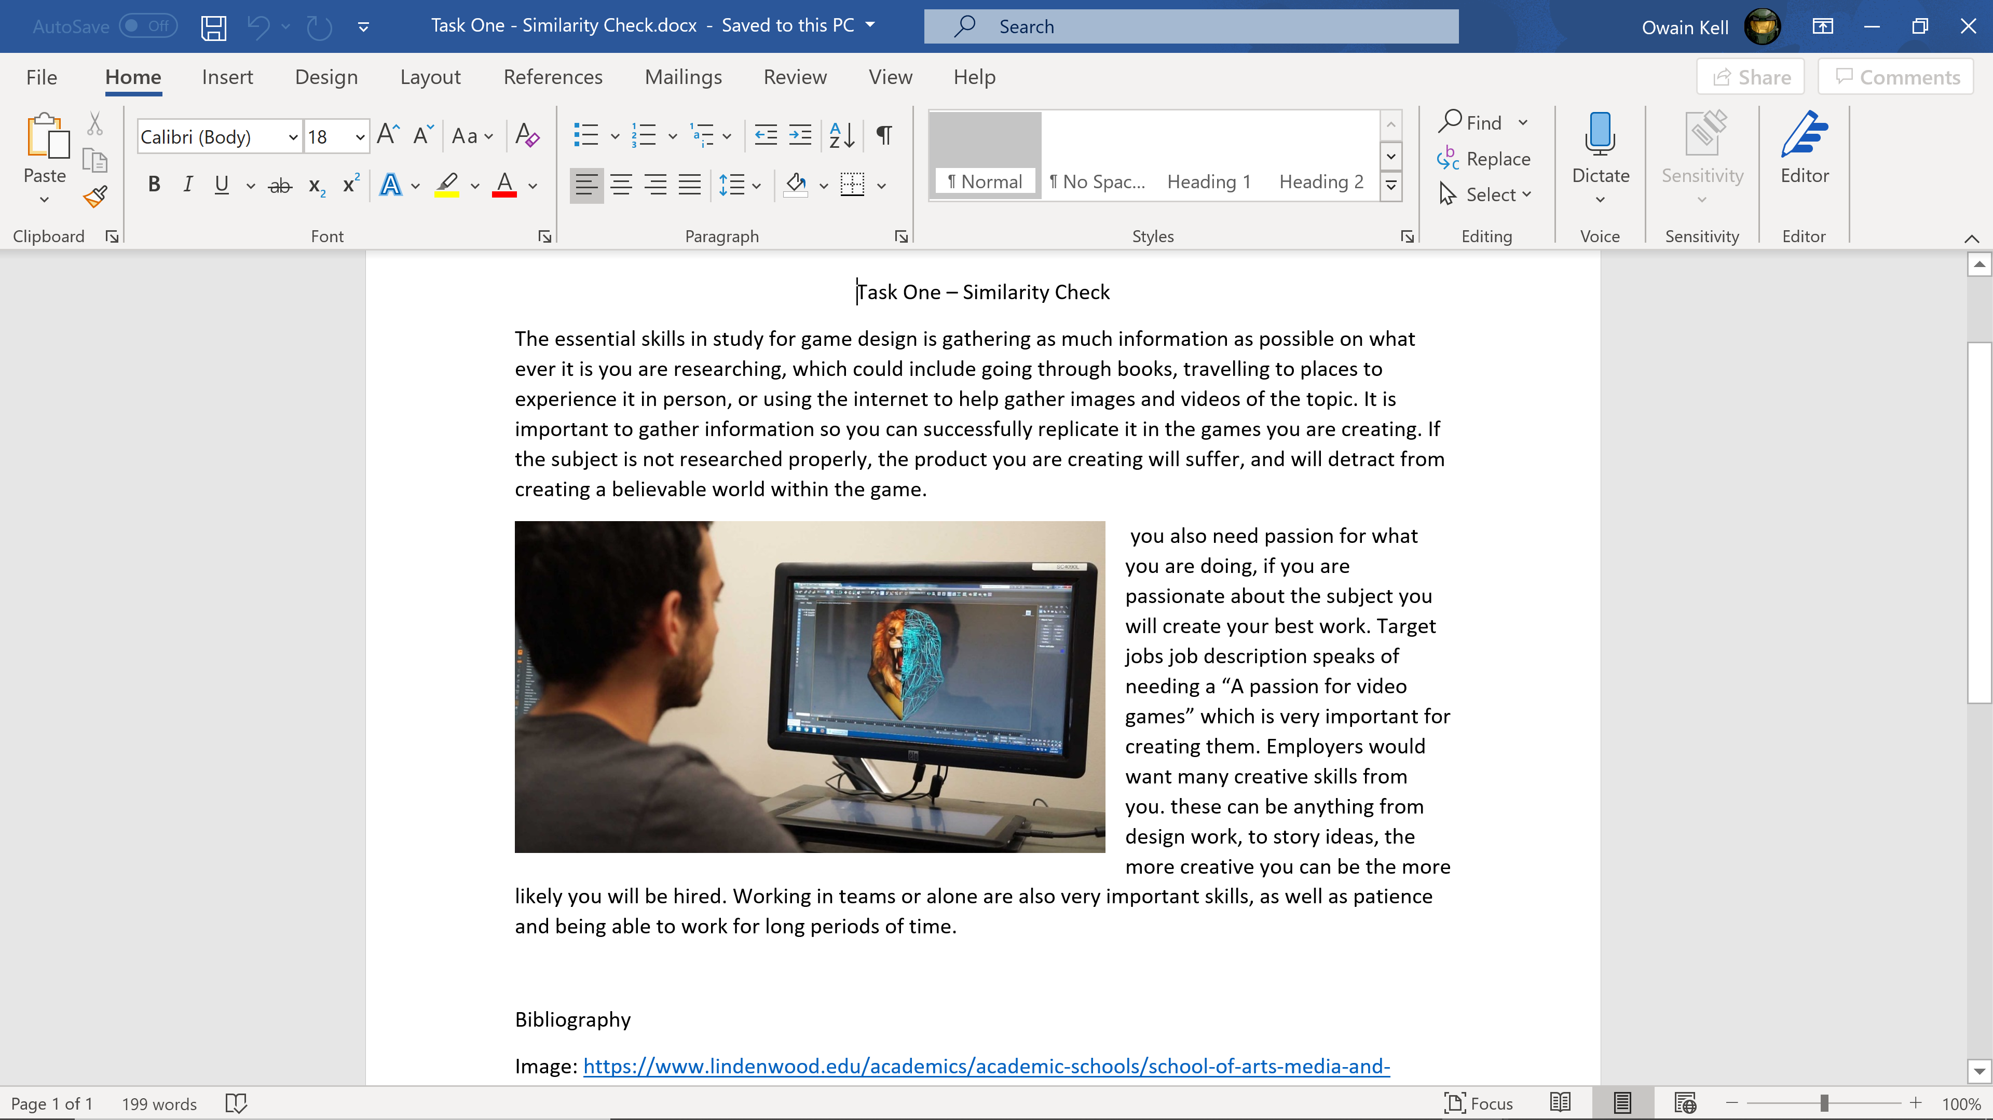
https://2004993.wixsite.com/learning

Unit 2
Link: https://mm.tt/1715011105?t=XLj9hLkui4
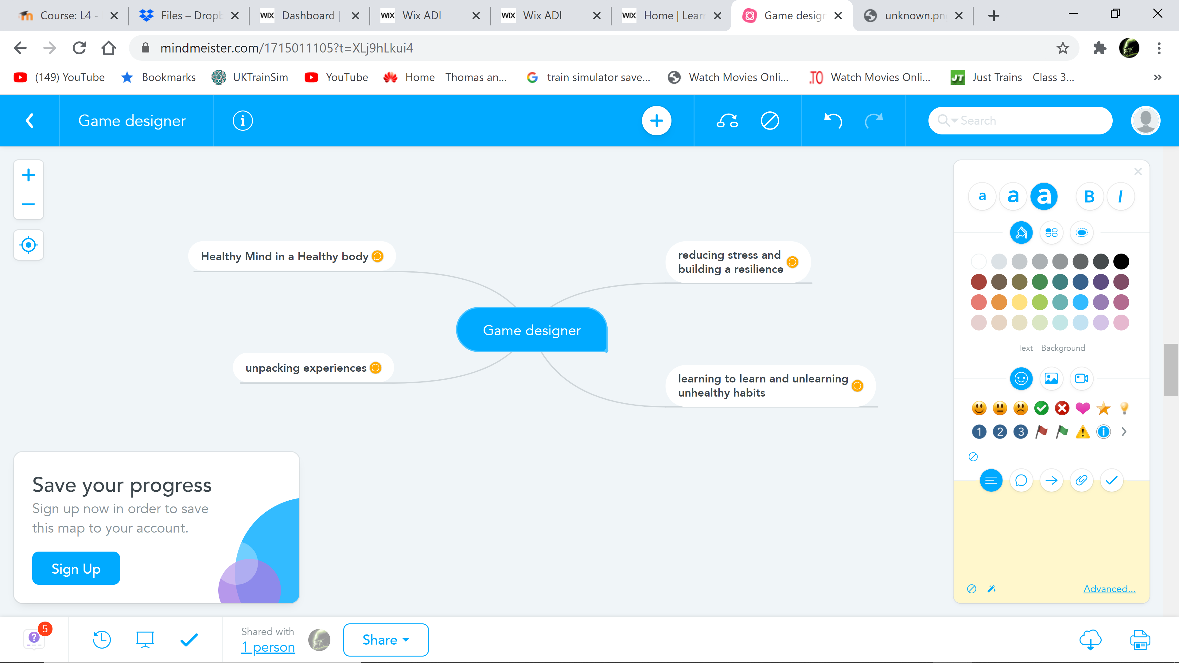
https://2004993.wixsite.com/learning

Unit 3
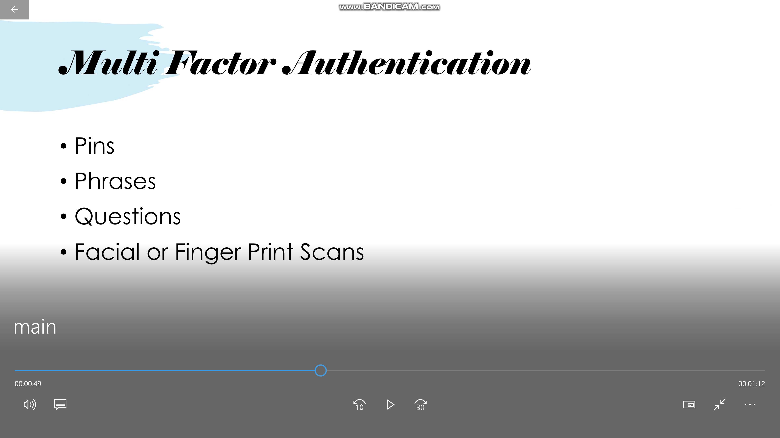
https://2004993.wixsite.com/learning

Unit 4
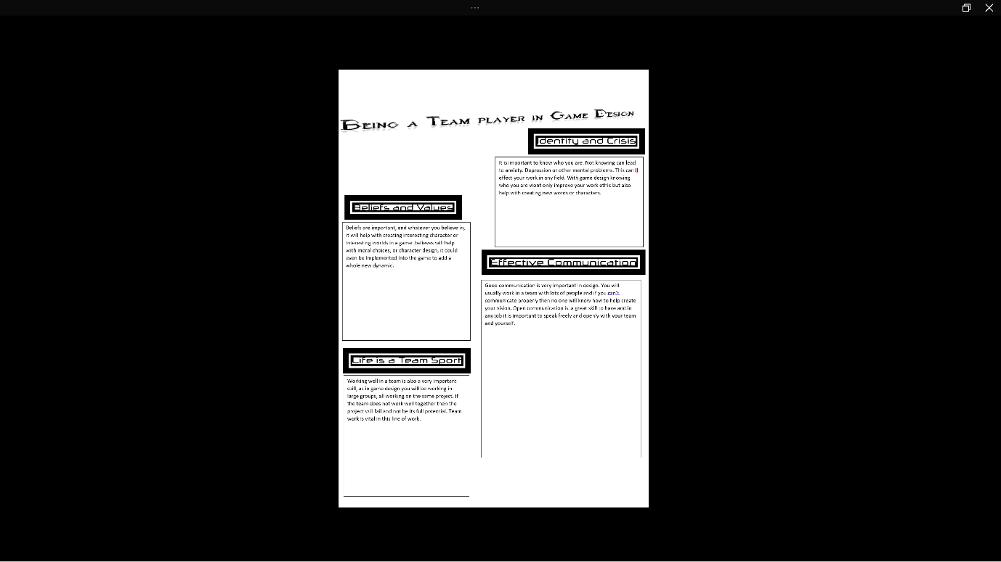
https://2004993.wixsite.com/learning

