
MASTER OF BUSINESS ADMINISTRATION
MODULE: LCMB7035 DISSERTATION

THE IMPACT OF FINANCIAL LITERACY ON INVESTMENT DECISIONS: EVIDENCE FROM BROKERAGE FIRMS IN DHAKA, BANGLADESH

SUBMITTED BY
ABDUL FOYSAL EMRAN
STUDENT ID- 2426916

SUBMITTED TO
Isaiah Oino

Word count: 15587 Words

SUBMISSION DATE: 03/02/2026

DECLARATION
I declare that this dissertation, titled “The Impact of Financial Literacy on Investment Decisions: Evidence from Brokerage Firms in Dhaka, Bangladesh,” is my own original work and has been completed in accordance with the requirements of the Master of Business Administration (MBA) programme and the LCMB7035 Dissertation module. It has not been submitted, in whole or in part, for any other degree or qualification at this or any other institution.
All sources of information and ideas used in this dissertation have been properly acknowledged through appropriate referencing. Any material that is not my own work has been clearly identified and cited.

Emran
Student Name: Abdul Foysal Emran
Student ID: 2426916

ACKNOWLEDGEMENTS
I would like to express my sincere gratitude to my dissertation supervisor for their guidance, feedback, and support throughout the research process. I also thank the participants from the brokerage firms in Dhaka and Savar who generously shared their time and provided the information required for this study.
Finally, I am grateful to my family and friends for their encouragement and support during the completion of this dissertation.

ABSTRACT
This study examines the impact of financial literacy (FL) on the quality of investment decisions among investors of Bangladesh, a country renowned for its unstable capital market. Using brokerage firms in Dhaka and Savar, Bangladesh, and whether this effect operates through investors’ day-to-day practices. Data was collected based on a quantitative, cross-sectional design from 195 active brokerage clients. The study measured FL, investment strategy (INS), risk management (RM), and investment decision quality (IDQ) using multi-item scales, and analysed the data through descriptive statistics, reliability testing, correlation and multiple regression (SPSS), followed by a parallel mediation test using PROCESS Model 4 with 5,000 bootstrap samples. Results show that FL is positively associated with IDQ and remains a statistically significant predictor even after accounting for behavioural practices. INS and risk management both have significant positive effects on decision quality, with risk management emerging as the strongest predictor. Mediation findings indicate that FL improves IDQ partly through stronger INS and, more strongly, through improved risk management practices, while a smaller but significant direct effect remains. Overall, the findings suggest that improving investor outcomes in Dhaka requires more than knowledge alone, it also requires converting knowledge into consistent behavioural routines, especially risk control and diversification. The study recommends that brokerage firms and regulators strengthen practical investor education focused on risk–return understanding, diversification, position sizing, and simple loss-control rules, supported by decision aids and structured planning tools to reduce rumour-driven and impulse-based trading.
Keywords: Financial literacy; Investment decision quality; Investment strategy; Risk management; Brokerage clients.

TABLE OF CONTENTS
DECLARATION i
ACKNOWLEDGEMENTS ii
ABSTRACT iii
TABLE OF CONTENTS iv
LIST OF TABLES vii
LIST OF FIGURES viii
LIST OF ABBREVIATIONS ix
CHAPTER 1: INTRODUCTION 1
1.0 CHAPTER OVERVIEW 1
1.1 BACKGROUND OF THE STUDY 1
1.2 PROBLEM STATEMENT 3
1.3 AIM OF THE STUDY 4
1.4 RESEARCH OBJECTIVES 4
1.6 RESEARCH GAP AND RATIONALE OF THE STUDY 5
1.7 SCOPE AND DELIMITATIONS OF THE STUDY 6
1.8 STRUCTURE OF THE DISSERTATION 6
1.9 CHAPTER SUMMARY 7
CHAPTER 2: LITERATURE REVIEW 8
2.0 CHAPTER OVERVIEW 8
2.1 CONCEPT OF FINANCIAL LITERACY 8
2.2 INVESTMENT DECISION QUALITY 9
2.3 INVESTMENT STRATEGY 10
2.4 RISK MANAGEMENT IN RETAIL INVESTING 10
2.5 FINANCIAL LITERACY AND INVESTMENT DECISION QUALITY 11
2.6 MEDIATING ROLES OF INVESTMENT STRATEGY AND RISK MANAGEMENT 12
2.6.1 INVESTMENT STRATEGY AS MEDIATOR 12
2.6.2 RISK MANAGEMENT AS MEDIATOR 13
2.7 BEHAVIOURAL FINANCE AND UNDERLYING MECHANISMS 14
2.8 EVIDENCE FROM EMERGING MARKETS AND BANGLADESH 14
2.9 THEORETICAL AND CONCEPTUAL FRAMEWORK 15
2.9.1 THEORETICAL FOUNDATIONS 15
2.9.2 CONCEPTUAL FRAMEWORK AND HYPOTHESES 16
2.10 CHAPTER SUMMARY 17
CHAPTER 3: RESEARCH METHODOLOGY 19
3.0 CHAPTER OVERVIEW 19
3.1 RESEARCH PHILOSOPHY 19
3.2 RESEARCH APPROACH 20
3.3 RESEARCH DESIGN 20
3.4 POPULATION, SAMPLING AND SAMPLE SIZE 21
3.5 INSTRUMENT DEVELOPMENT AND MEASURES 22
3.6 DATA COLLECTION PROCEDURES 23
3.7 DATA PREPARATION, SCREENING AND ANALYSIS 23
3.8 ETHICAL CONSIDERATIONS 24
3.9 METHODOLOGICAL LIMITATIONS 24
CHAPTER 4: DATA ANALYSIS AND FINDINGS 26
4.1 CHAPTER OVERVIEW 26
4.2 DEMOGRAPHIC ANALYSIS 26
4.3 DESCRIPTIVE ANALYSIS 29
4.3.1 DESCRIPTIVE STATISTICS OF KEY STUDY CONSTRUCTS 29
4.3.2 FINANCIAL LITERACY DIMENSION PROFILE 30
4.4 RELIABILITY ANALYSIS 30
4.5 CORRELATION ANALYSIS 31
4.6 REGRESSION ANALYSIS 31
4.7 MEDIATION ANALYSIS (PROCESS MODEL 4) 32
4.8 CHAPTER SUMMARY 34
CHAPTER 5: DISCUSSION 35
5.1 CHAPTER OVERVIEW 35
5.2 DISCUSSION ON KEY FINDINGS 35
5.2.1 FINANCIAL LITERACY AND INVESTMENT DECISION QUALITY 35
5.2.1 INVESTMENT STRATEGY AND INVESTMENT DECISION QUALITY 36
5.2.3 RISK MANAGEMENT AND INVESTMENT DECISION QUALITY 37
5.2.4 MEDIATING ROLES OF INVESTMENT STRATEGY AND RISK MANAGEMENT 37
5.3 IMPLICATIONS OF THE STUDY 38
5.4 CHAPTER SUMMARY 39
CHAPTER 6: CONCLUSIONS & RECOMMENDATIONS 40
6.1 CHAPTER OVERVIEW 40
6.2 CONCLUSIONS 40
6.2.1 CONCLUSIONS BY OBJECTIVE 40
6.2.1 CONCLUSIONS BY RESEARCH QUESTIONS 42
6.3 RECOMMENDATIONS 42
6.4 LIMITATIONS OF THE STUDY 43
6.5 SUGGESTIONS FOR FUTURE RESEARCH 43
REFERENCES 45
APPENDIX A: SURVEY QUESTIONNAIRE 49
APPENDIX B: SPSS DATA FILE 57
APPENDIX C: SPSS DATA FILE 58

LIST OF TABLES
TABLE 4.1: DEMOGRAPHIC PROFILE OF RESPONDENTS | 26
TABLE 4.2: DESCRIPTIVE STATISTICS FOR MAIN STUDY VARIABLES | 29
TABLE 4.3: DESCRIPTIVE STATISTICS FOR FINANCIAL LITERACY DIMENSIONS | 30
TABLE 4.4: RELIABILITY STATISTICS FOR STUDY CONSTRUCTS | 30
TABLE 4.5: CORRELATION MATRIX | 31
TABLE 4.6: MODEL SUMMARY | 31
TABLE 4.7: ANOVA | 32
TABLE 4.8: REGRESSION COEFFICIENTS | 32
TABLE 5.1: HYPOTHESES TESTING | 38

LIST OF FIGURES
FIGURE 1.1: ANNUAL DSEX INDEX MOVEMENT (2012–2024) | 02
FIGURE 1.2: MONTHLY DSEX INDEX VOLATILITY (MARCH 2024–FEBRUARY 2025) | 02
FIGURE 2.1: CONCEPTUAL FRAMEWORK OF THE STUDY | 17
FIGURE 4.1: AGE GROUP | 27
FIGURE 4.2: GENDER DISTRIBUTION | 27
FIGURE 4.3: EDUCATION QUALIFICATION | 28
FIGURE 4.5: MONTHLY INCOME | 28
FIGURE 4.6: INVESTMENT EXPERIENCE | 28
FIGURE 4.7: TRADING FREQUENCY | 29
FIGURE 4.8: MEDIATION ANALYSIS | 33

LIST OF ABBREVIATIONS
Abbreviation | Full form / Meaning
Avg_BC | Average score for Basic Concepts (financial literacy dimension)
Avg_COMP | Average score for Product Comparison ability (financial literacy dimension)
Avg_DIV | Average score for Diversification Knowledge (financial literacy dimension)
Avg_FL | Average Financial Literacy score (composite)
Avg_IDQ | Average Investment Decision Quality score (composite)
Avg_INFO | Average score for Financial Information Understanding (financial literacy dimension)
Avg_IS | Average Investment Strategy score (composite)
Avg_RM | Average Risk Management score (composite)
Avg_RR | Average score for Risk–Return Understanding (financial literacy dimension)
Avg_TVM | Average score for Time Value of Money understanding (financial literacy dimension)
BDT | Bangladeshi Taka
DSE | Dhaka Stock Exchange
DSEX | Dhaka Stock Exchange Broad Index
FL | Financial Literacy
IBM | International Business Machines (software provider name in “IBM SPSS”)
IDQ | Investment Decision Quality
INS | Investment Strategy
OECD | Organisation for Economic Co-operation and Development
PROCESS (Model 4) | Hayes’ PROCESS macro, Model 4 (mediation analysis model)
RM | Risk Management
SPSS | Statistical Package for the Social Sciences

CHAPTER 1: INTRODUCTION

CHAPTER OVERVIEW
This chapter presents the study on impact of financial literacy (FL) on investment decision quality (IDQ) in association with brokerage clients in Dhaka Bangladesh. It explains why FL does matter to the individual investor, particularly in a highly uncertain and information-poor capital market like Bangladesh. This introductory chapter begins with background of the study, with an overview of the Bangladesh stock market. Next, it presents the problem statement, aim and objectives of research as well as the research questions. The chapter also highlights key research gaps and the reasons behind concentrating on brokerage clients in Dhaka besides Savar. The chapter further provide the scope and limitations of the study and overall structure of the dissertation. Overall this chapter form the basis and focus of the foundation of this thesis.

1.1 BACKGROUND OF THE STUDY
FL is typically defined as the capacity to comprehend and apply basic knowledge of financial concepts such as saving, budgeting, interest rates, inflation rates, investing and borrowing in one's life. It assists people in reading financial information, comparing the alternatives and making decisions which would satisfy their financial objectives (Sabri & Afiqah, 2016; Raut, 2020). This skill, in today’s financial systems has become life and death for us all as we are bombarded by a variety of complex financial products and risky investment opportunities. When FL is inadequate, people may misjudge risk, select inappropriate products or engage in unsustainable borrowing and speculative investment.
Investment decisions include where people put their monies in different assets including stocks, bonds, mutual funds or real estate to earn returns on money (Hassan et al., 2009; Abdeldayem, 2016). Investing well is not merely about choosing one asset over another. They would include an appreciation of the market’s behaviour, the push and pull between risk and return, why diversity is beneficial and how money goals jibe with life goals. Bad decisions on ill-thought-out, incomplete or emotions-based premises can precipitate large financial losses and personal stress and insecurity in the longer term (Nguyen et al., 2019).
The case of Bangladesh’s capital market provides stark evidence on why FL is important for investors. The benchmark index, DSEX, has seen a series of spikes followed by swift crashes in the past decade. Figure 1.1 The annual performance of the DSEX index, 2012-2024 Data source: Bloomberg LP. The trend shows several booms, separated by significant slumps, signifying overall instability in the market (Dhaka Stock Exchange, 2024). This instability is problematic for retail traders because they lack the expertise, or methods to navigate these fluctuations.
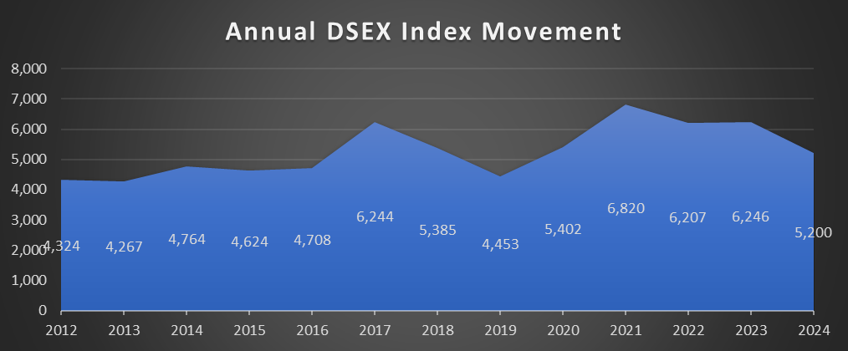
FIGURE 1.1: ANNUAL DSEX INDEX MOVEMENT (2012–2024)
Short-term data paint much the same picture. Table 1.2: Monthly values of DSEX index from March 2024 to February 2025. The figure also indicates large month-to-month fluctuations, along with current price declines and volatility (Dhaka Stock Exchange, 2025). This near-term uncertainty makes it challenging for investors to know when to buy, or hold, or sell — particularly when they lack a plan and have no idea what risk means.
FIGURE 1.2: MONTHLY DSEX INDEX VOLATILITY (MARCH 2024–FEBRUARY 2025)
In this climate, a large number of small investors in Dhaka buy and sell through brokerage houses, and depend heavily on word-of-mouth sources of information. Rather than engaging in formal analysis, or read company reports, they rely upon hearsay and the counsel of friends on threw street or from social media posts often made by unqualified contacts (Raut, 2020; Khalid et al., 2018). This behaviour is associated with over-trading, under-diversification, speculative bets and panic selling when prices fall. Damage to these patterns may erode household wealth and undermine trust in the formal financial sector (Rahman, et al., 2021; Adil et al., 2022).
FL can help investors navigate such conditions more disciplined. Research find that the more educated investor can have a higher opportunity to understand the risk–return trade-offs, create transparent investment strategies, diversify among assets and form use of unadorned value-at-risk measures such as position limits or stop-loss orders (Hasanuh & Putra, 2020; Waheed et al., 2020; Senda et al., 2020). Moreover, they are probably not so responsive to crowd or emotional trading by investors and instead, concentrate on long-run (Khalid et al., 2018; Hadi, 2017). As a significant portion of retail trading in Bangladesh is carried out via brokerage in Dhaka and Savar, this category of firms represent an interesting environment to examine the impact of FL on IDQ.

1.2 PROBLEM STATEMENT
Many individual investors in Dhaka are relatively naive and uninformed when they step into the stock market. They frequently rely on the hearsay from friends, online chat groups or market rumours instead of employing formal analysis, reading the firms reports and conclusions (Raut, 2020; Khalid et al., 2018). That makes them more likely to pursue climbing stocks, trade too much, maintain undiversified portfolios and sell when prices drop in a panic. These behaviours can lead to unstable returns, significant losses and a loss of confidence in the capital market (Rahman et al., 2021; Adil et al., 2022).
International research shows that FL is generally linked to better financial outcomes. More literate investors are more likely to compare products, understand risk, set realistic goals and act in a rational and disciplined way (Abdeldayem, 2016; Janor et al., 2016; Raut, 2020). Yet the exact way in which FL turns into better investment decisions is still not fully clear. It is possible that FL improves decision quality partly by helping investors design better investment strategies and apply stronger RM (RM), but the evidence for this pathway is still limited (Senda et al., 2020; Waheed et al., 2020).
In Bangladesh, there are only a few empirical studies on FL and investment behaviour, and most of them focus on general financial behaviour, retirement planning or direct links between literacy and decisions (Nguyen et al., 2019; Hadi, 2017). Very few studies concentrate on brokerage clients in Dhaka or test whether INS and RM act as mediating variables between FL and IDQ. Because of this, regulators, brokerage firms and training providers have limited local evidence to design effective investor education programmes. This study addresses this problem by examining how FL affects the quality of investment decisions among brokerage clients in Dhaka and by testing whether INS and RM mediate this relationship.

1.3 AIM OF THE STUDY
The aim of this study is to examine the impact of FL on the quality of investment decisions among brokerage clients in Dhaka, Bangladesh, and to test whether INS and RM mediate this relationship.

1.4 RESEARCH OBJECTIVES
To achieve this aim, the study has the following objectives:
- To assess the level of financial literacy among active brokerage clients in Dhaka.
- To examine the direct effect of financial literacy on investment decision quality.
- To analyse whether investment strategy mediates the relationship between financial literacy and investment decision quality.
- To examine whether RM practices mediate the relationship between financial literacy and investment decision quality.
- To provide practical recommendations for investor training and financial education in Bangladesh based on the study findings.
1.5 RESEARCH QUESTIONS
The research is guided by the following questions:
- How does financial literacy influence the quality of investment decisions among brokerage clients in Dhaka?
- To what extent does financial literacy affect investors’ investment strategy and RM practices?
- Do investment strategy and RM mediate the relationship between financial literacy and investment decision quality?

1.6 RESEARCH GAP AND RATIONALE OF THE STUDY
An emerging international literature has provided some evidence of a positive relationship between FL and financial outcomes such as saving, investing and retirement planning (Abdeldayem, 2016; Janor et al., 2016; Raut, 2020). Risk perception, diversification and behavioural bias have also been found to influence the investor’s behaviour and performance (Khalid et al., 2018; Baihaqqy et al., 2020; Suresh, 2024). Investors who are well informed and sophisticated behave more orderly and logically in the financial markets.
Despite this progress, several important gaps remain. First, many studies examine the direct relationship between FL and investment decisions or performance but do not fully explore the mechanisms through which literacy improves decision quality. Only a limited number of studies investigate how FL operates through specific behavioural channels such as INS and RM (Senda et al., 2020; Waheed et al., 2020). Without understanding these pathways, it is difficult to design training programmes that target the most important behaviours.
Second, much of the evidence comes from developed markets, where investors may have higher baseline literacy, stronger regulation and easier access to reliable information (Nguyen et al., 2019; Sabri & Afiqah, 2016). Emerging markets such as Bangladesh differ in terms of market volatility, information quality and investor protection. It is therefore not clear whether findings from developed economies can be directly applied to brokerage clients in Dhaka.
Third, empirical work that focuses on retail investors in Bangladesh is still limited. Existing studies often consider general financial behaviour or retirement planning, rather than detailed stock market behaviour (Hadi, 2017; Nguyen et al., 2019). Studies that look at capital market investors document speculative behaviour, reliance on rumours and vulnerability to market swings, but they do not always measure FL in a structured way or test the roles of INS and RM (Rahman et al., 2021; Adil et al., 2022).
This study responds to these gaps by focusing on brokerage clients in Dhaka and Savar and by examining both the direct and indirect (mediated) effects of FL on IDQ. It aims to contribute to the academic literature on FL and behavioural finance and to offer practical guidance for policymakers, regulators and brokerage firms seeking to improve investor outcomes in Bangladesh.

1.7 SCOPE AND DELIMITATIONS OF THE STUDY
This study focuses on individual investors who place trades through licensed brokerage firms in Dhaka and Savar. It includes active retail clients who invest in the capital market during the data collection period. Institutional investors such as banks, insurance companies and mutual funds are outside the scope of the research. The study also excludes individuals who trade only through informal channels or invest solely in non-market assets such as land or gold.
The research uses a quantitative, cross-sectional design. Data are collected at a single point in time using a structured questionnaire. This design allows the study to identify relationships between FL, INS, RM and IDQ, but it cannot fully establish causal links over time. The constructs are measured using self-reported Likert-scale items, which may be influenced by perception and recall, although this is common in behavioural finance research.
The empirical model focuses on four main constructs: FL, INS, RM and IDQ. Other factors such as detailed behavioural biases, emotional intelligence and long-term retirement outcomes are recognised in the literature but are not measured as separate variables here. The focus on investors in Dhaka and Savar also means that the results may not fully represent all investors in Bangladesh, especially those in rural areas or those who invest outside formal brokerage channels.

1.8 STRUCTURE OF THE DISSERTATION
The dissertation is organised into six chapters.
- Chapter One introduces the research topic, explains the background and problem, sets out the aim, objectives and research questions, presents the research gap and rationale and defines the scope of the study.
- Chapter Two reviews the existing literature on FL, IDQ, INS, RM and behavioural influences. It also develops the conceptual framework and research hypotheses.
- Chapter Three describes the research methodology, including the research philosophy and approach, research design, population and sampling, instrument development, data collection procedures, ethical considerations and the data analysis techniques used in the study.
- Chapter Four presents the results of the empirical analysis, including descriptive statistics, reliability tests, correlation analysis and regression and mediation models.
- Chapter Five discusses the findings in relation to the research questions and the existing literature, and draws out their theoretical and practical implications.
- Chapter Six concludes the study by summarising the main findings, highlighting the contributions and limitations and offering recommendations for practice and future research.

1.9 CHAPTER SUMMARY
This chapter has introduced the study on the impact of FL on IDQ among brokerage clients in Dhaka, Bangladesh. It has explained the key concepts of FL and investment decisions and described the volatility of the Bangladeshi capital market and the risks faced by retail investors. The problem statement, research purpose, research objectives and research questions have been introduced in this chapter. It has also structured the main research gaps through literature review, rationalized why focus is on brokerage clients in Dhaka and Savar, delimited the scope of their study to justify their boundary and explained where each chapter fits into this thesis. The next chapter will include an in-depth review of the relevant literature on FL, Investment Decision Making, INS, RM and behavioural determinants and will formulate the detailed conceptual framework of the study with hypotheses.

CHAPTER 2: LITERATURE REVIEW

2.0 CHAPTER OVERVIEW
This chapter reviews the main literature on financial literacy (FL) and investment decision quality (IDQ), with a focus on how investment strategy (INS) and risk management (RM) may link the two. It first defines FL and explains its key dimensions. It then clarifies what is meant by IDQ in this study. After that, it discusses two central behavioural constructs: INS and RM. The chapter then examines empirical evidence on the relationship between FL and IDQ, and explores why INS and RM may act as mediating variables. Insights from behavioural finance are used to explain the psychological mechanisms behind investor behaviour. The chapter also reviews evidence from emerging markets, including Bangladesh, to connect the study to its context. Finally, it presents the conceptual framework and the hypotheses that will be tested in the empirical chapters.

2.1 CONCEPT OF FINANCIAL LITERACY
FL is well understood to be a key life skill in today’s economies. According to the OECD, it is comprised of awareness, knowledge, skills dispositions, and behaviours that are necessary for people to make informed financial decisions and achieve overall well-being (OECD, 2018). It is perceived as the capability to grasp elementary financial concepts and utilize them for saving, borrowing, investing decisions (Lusardi & Mitchell 2014). Sabri and Afiqah (2016) stress the practical side of this topic, regarding FL as the ability to understand financial documents, compare different choices and choose appropriate products.
It is well-documented in the literature that FL is multi-faceted. One important area is in grasping elementary ideas on saving, interest, inflation and credit (Lusardi & Mitchell 2014; Sabri & Afiqah 2016). Other key dimensions include the knowledge about how risk–return trade-off mechanism operates, the ability to determine the advantages of portfolio diversification and to read and interpret financial statements, account summaries and market news (see Abdeldayem, 2016; Raut, 2020; Baihaqqy et al., 2020). FL also involves the ability to compare different investment products—such as stocks, mutual funds and bonds—in terms of risk, cost and potential return, and to judge whether they are appropriate for one’s own situation (Janor et al., 2016; Ahmed et al., 2021). Clearly, time value of money and compounding is another fundamental component as it allows individuals to think about how their investments can increase with time and prepare for future goals (Lusardi and Mitchell, 2014; Nguyen et al., 2019).

2.2 INVESTMENT DECISION QUALITY
Traditional finance often judges investment decisions mainly by their returns. Recent work argues that this is too narrow because it may label thoughtful but unlucky decisions as “bad” and lucky but poorly reasoned decisions as “good” (Abdeldayem, 2016; Nguyen et al., 2019). IDQ is now understood more broadly as relating to the process and consistency of decisions, not just their short-term outcomes.
In this thesis, IDQ is defined as the extent to which decisions are based on relevant information, consistent with long-term financial goals, not driven by rumours or impulses and compatible with the investor’s risk tolerance. This is measured through five items: information search before investing, alignment with long-term goals, avoidance of decisions based only on rumours or social media, making well-thought-out rather than impulsive choices and satisfaction that the portfolio suits one’s risk tolerance (IDQ1–IDQ5).
Expected utility theory and mean–variance portfolio theory provide the foundation for this concept. In expected utility models, rational investors choose among risky options to maximise expected utility given their preferences and information (von Neumann and Morgenstern, 1947). In Markowitz’s (1952) mean–variance framework, a good decision is one that selects a portfolio with an attractive risk–return trade-off for a given level of risk aversion. In both views, quality is tied to coherence with preferences and information, not only to realised returns.
Researchers often distinguish between process quality and outcome quality. Process quality covers actions taken before deciding, such as collecting information, comparing options and checking consistency with goals and risk tolerance (Hassan et al., 2009; Abdeldayem, 2016). Outcome quality covers results such as risk-adjusted returns, portfolio stability and satisfaction over time (Nguyen et al., 2019). A decision can have high process quality but poor short-term results because of randomness, though better processes are expected to produce better average outcomes over time.
Behavioural finance shows that many investors do not follow rational rules. Overconfidence, herd behaviour and loss aversion can lead to over-trading, chasing rising stocks and panic selling during downturns, all of which reduce decision quality (Khalid et al., 2018; Hadi, 2017; Oteng, 2019). In volatile markets such as Bangladesh, where rumours and short-term price moves are common, IDQ depends strongly on the ability to resist these pressures and maintain a structured, information-based approach (Rahman et al., 2021; Adil et al., 2022).

2.3 INVESTMENT STRATEGY
INS refers to the structured plan or approach that guides an investor’s decisions over time. It usually includes setting financial goals, defining an investment horizon, choosing a mix of assets and deciding when and how to review or adjust the portfolio (Amisi, 2012; Senda et al., 2020). A good strategy serves as a guide to individual actions and helps traders move from one-off trading to more co-ordinated, purposeful behaviour.
The literature suggests that well-defined strategies are closely linked to FL. Investors who understand basic financial concepts are more likely to set clear goals, link those goals to time horizons and choose instruments that fit their objectives and risk tolerance (Nguyen et al., 2019; Kumari, 2020). They are also more likely to distinguish between short-term speculation and long-term investment and to value regular saving, periodic rebalancing and performance review (Sharma, 2020; Parsai and Chandok, 2025).
Empirical studies show that literate investors are more inclined to have structured plans and follow them over time (Janor et al., 2016; Shaheen et al., 2022). Of course, less sophisticated investors trade in more reactive manner; they tend to be more influenced by market noise or other trades. Suresh (2024) identifies that higher FL is related to consistent and disciplined trends while low literacy, high sentiment influence and frequent change.
In this study, INS is measured by items capturing key elements highlighted in the literature: considering time horizon, having a clear plan, reviewing investments regularly, adjusting decisions when gaining new knowledge and using financial knowledge to distinguish speculation from genuine long-term opportunities. These behaviours are expected to improve process quality by reducing reliance on rumours and aligning decisions with long-term goals. INS is therefore treated as a behavioural channel through which FL may affect IDQ.

2.4 RISK MANAGEMENT IN RETAIL INVESTING
RM in retail investing is the set of practices used by individuals to identify, assess and control the risks in their portfolios. It covers risk awareness and perception, diversification, downside protection and the use of simple rules such as position limits or maximum losses (Raut, 2020; Waheed et al., 2020). Effective RM helps investors limit potential losses while still working towards their financial objectives.
FL influences how investors perceive and handle risk. Literate investors are more likely to understand the risk–return trade-off, recognise that higher expected returns come with higher risk and check whether a given risk level suits their financial situation (Sabri and Afiqah, 2016; Nguyen et al., 2019). They are better able to think about worst-case scenarios and ask whether they can absorb potential losses, which guides their choices about which assets to hold, how much to invest and what to avoid (Khan, 2016; Hasanuh and Putra, 2020).
The literature identifies several core RM practices that match this study’s items. Careful investors assess potential losses before investing and may avoid investments they consider too risky (Khan, 2016; Suresh, 2024). They diversify by spreading investments across assets and sectors to reduce exposure to any single risk (Sabri & Afiqah, 2016; Baihaqqy et al., 2020). They use their financial knowledge to manage portfolios during volatility, for example by rebalancing rather than reacting emotionally (Waheed et al., 2020). Finally, they apply simple risk-control rules such as maximum loss limits or caps on position size (Raut, 2020).
Empirically, there is evidence that a higher FL is related with more RM practices: less concentrated portfolios, higher risk averseness and less frequency of radical losses (Hasanuh and Putra, 2020; Waheed et al., 2020; Baihaqqy et al., 2020). Low-literate investors concentrate in stocks, chase tips and take inordinate amounts of risk they don’t fully understand: recipe for susceptibility to booms and busts. In this thesis, RM is viewed as a central element of IDQ: The decision that exposes an investor to intolerable loss cannot be regarded as sensible or high-quality even though it might sometimes work.

2.5 FINANCIAL LITERACY AND INVESTMENT DECISION QUALITY
Many studies link FL with better investment behaviour and higher-quality decisions. People with high literacy are more likely to gather and evaluate information before making any investments, compare alternatives and evaluate whether a decision is suitable for their goals and risk preferences (Abdeldayem, 2016; Sabri &Afiqah, 2016: Raut, 2020). They are likely more long-term-oriented, and they are less likely to use investment as a short cut plan than those who rely on within day trading (Janor et al., 2016; Nguyen et al., 2019).
Evidence from various contexts indicates that FL is a significant predictor of the right portfolio, in terms of appropriate asset allocation, diversification and alignment of risk levels with personal situations (Baihaqqy et al., 2020; Ahmed et al., 2021; Maheshwari et al., 2025). Literate investors also report greater satisfaction with their portfolios and fewer regrets, suggesting that they perceive their decisions to be more consistent and justifiable (Abdeldayem, 2016; Raut, 2020). FL can enhance decision quality in a variety of ways. Financially literate investors are individuals that can comprehend the terms in financial statement, sense what is happening in marketplace news and understand about product features such as costs, risks and returns (Huston, 2010; Sabri and Afiqah, 2016). They can better discern between risks and safer investments, refrain from improper products and detect early signals of fraudulent or highly speculative plans (Nguyen et al., 2019; Khalid et al., 2018; Niazi & Malik, 2019).
FL can improve decision quality through numerous mechanisms. Literate investors can read financial statements, interpret market news and understand product features such as costs, risks and expected returns (Huston, 2010; Sabri and Afiqah, 2016). They are better able to evaluate trade-offs between risky and safer assets, avoid unsuitable products and recognise warning signs of fraud or extremely speculative schemes (Nguyen et al., 2019; Khalid et al., 2018; Niazi and Malik, 2019).
At the same time, some studies find that knowledge does not always translate directly into behaviour. Social and environmental factors such as peer pressure, informal advice, media and intermediaries can still drive decisions, even among those with reasonable literacy (Huston, 2010; Khalid et al., 2018; Oteng, 2019). This suggests that FL often operates through specific behaviours and habits rather than in isolation.
In volatile, rumour-driven markets such as Dhaka, it is reasonable to expect that FL will have a direct positive effect on IDQ because literate investors are better able to filter noise and judge risk (Rahman et al., 2021; Adil et al., 2022). However, existing work also shows that having a clear strategy and practising sound RM are key in turning knowledge into action (Waheed et al., 2020; Baihaqqy et al., 2020). This supports the expectation that FL will influence decision quality both directly and indirectly through these behavioural channels.

2.6 MEDIATING ROLES OF INVESTMENT STRATEGY AND RISK MANAGEMENT
The literature suggests that FL shapes investor behaviour partly through specific behavioural mechanisms, especially INS and RM (Senda et al., 2020; Waheed et al., 2020; Baihaqqy et al., 2020). In this study, these two constructs are therefore modelled as mediating variables that may explain how FL translates into IDQ.

2.6.1 INVESTMENT STRATEGY AS MEDIATOR
FL provides investors with tools to set realistic goals, understand asset classes and design strategies that fit their time horizon and risk appetite. Literate investors are more likely to separate short-term speculation from long-term investment and to value regular saving and disciplined portfolio management (Amisi, 2012; Nguyen et al., 2019; Kumari, 2020).
Empirical studies show that investors with higher literacy are more likely to have clear plans, define their investment horizon, review performance and adjust portfolios when they gain new knowledge or when circumstances change (Janor et al., 2016; Sharma, 2020; Parsai and Chandok, 2025; Shaheen et al., 2022). These behaviours match the INS items used in this thesis (IS1–IS5).
A well-defined strategy can improve process quality by reducing dependence on rumours and tips, strengthening the link between individual transactions and long-term goals and providing a reference point in volatile markets (Khalid et al., 2018; Sharma, 2020). In this sense, FL provides the knowledge base, while strategy converts that knowledge into a coherent pattern of decisions. IDQ then reflects the quality of this pattern. This logic supports treating INS as a mediator between FL and IDQ.

2.6.2 RISK MANAGEMENT AS MEDIATOR
RM is a second pathway through which FL may influence decision quality. Literate investors are more accurate in their understanding of risk and the risk–return trade-off and can better judge whether an investment suits their financial situation (Sabri and Afiqah, 2016; Nguyen et al., 2019). They are more likely to consider potential losses before investing and to think about how these losses would affect their overall finances.
Research shows that financially literate individuals are more likely to hold diversified portfolios, avoid extremely risky instruments and use risk-control rules such as loss limits or position size caps (Raut, 2020; Waheed et al., 2020; Hasanuh and Putra, 2020; Baihaqqy et al., 2020). These match the RM items in this study (RM1–RM5).
Effective RM can prevent severe losses, keep risk in line with tolerance and support more stable decisions during market stress (Baihaqqy et al., 2020; Suresh, 2024). Investors who manage risk well are less likely to panic, sell at the worst time or take desperate risks to recover losses. Their decisions are more consistent and sustainable and thus of higher quality.
Overall, the literature suggests that RM is a central channel through which FL affects outcomes. FL improves risk awareness and understanding, which encourages diversification, careful position sizing and the use of protective rules. These practices, in turn, support higher-quality decision-making. It is therefore reasonable to treat RM as a mediating variable alongside INS.

2.7 BEHAVIOURAL FINANCE AND UNDERLYING MECHANISMS
Traditional finance supposes that investors are rational and optimize expected utility. Behavioural finance disputes this by demonstrating the impact of psychological biases and emotions. Four biases that are particularly relevant for ordinary investors include overconfidence, herd behaviour, loss aversion and short-termism (Khalid et al., 2018; Hadi, 2017; Niazi and Malik, 2019).
Overconfidence induces investors to overestimate their knowledge and forecasts, which in turn reinforces excessive trading and a disregard for risk. Herd behaviour occurs when investors follow the actions of others instead to what their analysis suggests, which pushes them to run after winning stocks (Khalid et al., 2018). Loss aversion, the psychological bias in which losing hurts more than winning feels good, can cause investors to hang onto their losers too long or sell in a panic in bear markets (Hadi, 2017). Short-termism causes investors to concentrate on recent price changes while ignoring long-term fundamentals (Oteng, 2019).
These biases can help explain why a lot of investors trade on rumours, pursue short-term gain and ignore risk capacity, factors which lower IDQ. Behavioural finance therefore reinforces the significance of sharp strategy, robust RM and disciplined decision processes (especially when information is noisy and social influence particularly pronounced).
FL is not able to eliminate such biases entirely, but may help mitigating them. The more literate investors are better to suspect rumours, and realize a short-term volatility is typical situation, observe the advantages of diversification, appreciate how valuable it is to stick plans and risk rules (Raut 2020; Suresh 2024). In this way, FL supports stronger strategies and better RM and thus contributes indirectly to improved decision quality.

2.8 EVIDENCE FROM EMERGING MARKETS AND BANGLADESH
Studies from emerging markets show that FL is important for saving and investment behaviour. In Malaysia, Sabri and Afiqah (2016) find that higher literacy is linked with better saving habits and greater use of formal investment products. Research from India and Pakistan reports that literate investors are more likely to diversify, choose appropriate products and avoid very risky schemes, while those with low literacy rely more on informal advice and speculation (Baihaqqy et al., 2020; Waheed et al., 2020). Evidence from African markets suggests that FL helps both professional and retail investors make more consistent portfolio choices in volatile settings (Amisi, 2012).
In Bangladesh, studies note widespread use of rumours, tips and short-term price movements by retail investors, contributing to speculative trading and vulnerability during downturns (Rahman et al., 2021; Adil et al., 2022). Other work links FL to better general financial behaviours such as budgeting, saving and retirement planning but often does not examine detailed stock market behaviour (Hadi, 2017; Nguyen et al., 2019). Overall, Bangladesh appears to face issues of limited FL, high volatility and speculative trading in the capital market.
Important gaps remain. Few studies focus specifically on brokerage clients in Dhaka or Savar, even though most formal equity investing by individuals occurs through brokerage houses. There is also little empirical work on how FL influences outcomes through INS and RM. Most existing research tests only direct links between literacy and behaviour or performance. These gaps justify this study’s focus on brokerage clients in Dhaka and Savar and on examining both direct and mediated relationships between FL and IDQ.

2.9 THEORETICAL AND CONCEPTUAL FRAMEWORK

2.9.1 THEORETICAL FOUNDATIONS
This study draws mainly on human capital theory and behavioural finance. Human capital theory argues that education and skills increase an individual’s productivity and ability to make better economic decisions, which leads to improved outcomes over time. In the financial context, knowledge of concepts such as interest, risk, diversification and compounding can be seen as a form of human capital that helps people to plan, evaluate alternatives and choose suitable products (Lusardi and Mitchell, 2014; Abdeldayem, 2016). Empirical work shows that financially literate individuals are more likely to participate in formal financial markets, select appropriate instruments and achieve better long-term performance (Janor et al., 2016; Nguyen et al., 2019; Maheshwari et al., 2025). In this study, FL is therefore treated as a stock of human capital that enables brokerage clients to understand information, process risk and make higher-quality investment decisions.
Behavioural finance provides a second key lens. It show that rationality is not always the order of the day for investors. Rather, they are shaped by psychological heuristics including overconfidence, herd mentality and loss aversion mentality as well as emotions (fear and greed) 2.5(Oteng, 2019; Khalid et al., 2018; Hadi, 2017). Some of those biases drive over trading, chasing winning stocks, holding losers and panic selling in downturns, which are all moves that diminish IDQ. Studies in behavioural finance also propose that certain structured habits – like having a defined INS, adhering to rules for diversification and setting loss thresholds – can aid investors in overcoming these biases.
FL and behavioural finance are therefore linked. Human capital theory explains why FL is important: it provides you with “know how” and skills. Behavioural finance explains how this knowledge is translated into behaviour: literate investors are better able to design disciplined strategies, manage risk and resist biases. In this study, INS and RM are considered two main behavioural mechanisms by which FL influences decision quality.

2.9.2 CONCEPTUAL FRAMEWORK AND HYPOTHESES
By referring to the human capital and behavioural finance lenses, the conceptual model illuminates how FL affects IDQ through direct and behaviour mechanisms. FL is considered as a type of human capital that enhances investors’ skill to make sense out of information, appraise options, and decide whether an investment will meet their objectives and risk preference (Lusardi & Mitchell, 2014; Abdeldayem, 2016). At the same time, behavioural finance suggests that retail investors are often exposed to biases such as herding, overconfidence and loss aversion, which can lower decision quality in volatile, rumour-driven markets (Khalid et al., 2018; Hadi, 2017). In this context, FL is expected to reduce vulnerability to market noise by strengthening disciplined investing behaviours.
Accordingly, the framework positions FL as the independent variable and IDQ as the dependent variable, defined as information-based, goal-consistent and risk-aligned decision-making (Nguyen et al., 2019). Two behavioural constructs, INS and RM, are modelled as mediators because prior studies show that knowledge is most effective when it becomes consistent habits, such as planning, periodic review, diversification and loss-control rules (Senda et al., 2020; Waheed et al., 2020; Baihaqqy et al., 2020). The framework is therefore extended by adding two direct effects, recognising that strategy and RM may also independently improve decision quality beyond their mediating roles.
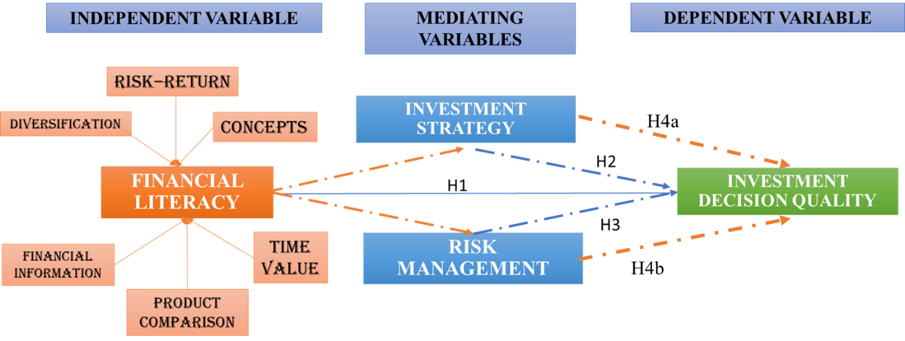
FIGURE 2.1: CONCEPTUAL FRAMEWORK OF THE STUDY
Figure 2.1 presents the conceptual framework. From this framework, the following hypotheses are derived:
- H1: Financial literacy has a positive and significant effect on investment decision quality among brokerage clients in Dhaka.
- H2: Investment strategy has a positive and significant effect on investment decision quality among brokerage clients in Dhaka.
- H3: Risk management has a positive and significant effect on investment decision quality among brokerage clients in Dhaka.
- H4a: Investment strategy mediates the relationship between financial literacy and investment decision quality.
- H4b: Risk management mediates the relationship between financial literacy and investment decision quality.
These hypotheses will be tested using survey data from brokerage clients in Dhaka and Savar through SPSS-based correlation, regression and mediation analysis in the subsequent chapters.

2.10 CHAPTER SUMMARY
This chapter has reviewed the main theories and empirical studies related to FL, INS, RM and IDQ. It defined each construct, drew on human capital theory and behavioural finance to explain why they matter, and highlighted how psychological biases can shape investor behaviour. Evidence from emerging markets, including Bangladesh, showed that FL is generally linked to better information use, more structured strategies, stronger RM and, overall, higher-quality investment decisions, although these effects often work through specific behaviours rather than knowledge alone. Using these insights, the chapter developed the theoretical and conceptual framework for the study and set out the key hypotheses, focusing on the direct and mediated effects of FL on IDQ among brokerage clients in Dhaka and Savar. Research methodology, including research design, sampling, measurement of variables data collection and method of data analysis to test these hypotheses will be described in the next chapter.

CHAPTER 3: RESEARCH METHODOLOGY

3.0 CHAPTER OVERVIEW
This chapter explains how the study on the impact of financial literacy (FL) on investment decision quality (IDQ) among brokerage clients in Dhaka and Savar is designed and implemented. It describes the research philosophy and approach, research design, target population and sample size as well as questionnaire development. The informational setting, data collection and ethical considerations are then described, followed by an explanation of how the data was formatted and inspected, and a concise account of the statistical methods performed in SPSS: correlation analysis as well as regression analysis including mediation. The chapter concludes with the major methodological constraints and a short summing up.

3.1 RESEARCH PHILOSOPHY
Research philosophy is the belief about the ways in which data about a phenomenon should be collected, analysed and used (Saunders et al., 2019). In business and management research, four positions are often highlighted: positivism, interpretivism, critical realism and pragmatism (Sanchez et al., 2023). Positivism assumes that there is an objective reality that can be observed, measured and explained through regularities expressed as cause–effect relationships. Interpretivism emphasises subjective meanings and seeks to understand social phenomena from the perspective of participants, usually with qualitative methods. Critical realism acknowledges an external reality and suggests what we are able to perceive is determined by structures and mechanisms. Pragmatism is interested in “what works” for a particular question and it is willing to merge different philosophical assumptions (Creswell & Creswell, 2018; Saunders et al., 2019).
This study adopts a positivist philosophy. The core constructs—FL, INS, RM and IDQ—are treated as variables that exist independently of the researcher and can be measured with structured scales. The aim is to test hypotheses about the strength and direction of relationships between these variables across a sample of brokerage clients. Such a focus on explanation, prediction and generalisation is consistent with a positivist stance, which typically relies on standardised instruments and statistical analysis (Saunders et al., 2019).
Positivism is appropriate here for three main reasons. First, the study is theory-driven: it derives hypotheses from human capital theory and behavioural finance rather than building concepts inductively from narratives. Second, regulators and brokerage firms are interested in patterns that hold across many investors—for example, whether higher FL is associated with better decision quality—so generalisable, numerical evidence is useful. Third, the constructs are operationalised using Likert-scale items, which are well suited to quantitative analysis in a positivist framework (Creswell and Creswell, 2018).

3.2 RESEARCH APPROACH
Research approach describes how theory and data are linked. Three broad approaches are commonly discussed: deductive, inductive and abductive. Deductive research starts from existing theory, formulates hypotheses and then tests these using empirical data. Inductive research moves in the opposite direction, building concepts and theory from observations, often using qualitative methods. Abductive research alternates between theory and data, using surprising findings to refine explanations (Saunders et al., 2019).
This study follows a deductive approach. Chapter 2 reviewed the literature on FL, INS, RM and IDQ and, based on human capital theory and behavioural finance, proposed a conceptual framework. From this framework, three hypotheses were derived: a direct effect of FL on IDQ and two mediating effects through INS and RM. The questionnaire, data collection and statistical analysis are then designed specifically to test these hypotheses.
A deductive approach is justified because the main constructs are already well-established in the literature and the purpose is to examine how these relationships operate in the context of brokerage clients in Dhaka rather than to develop entirely new theory. Deduction is also consistent with the use of structured questionnaires, large samples and inferential statistics, where concepts are translated into measurable indicators and tested for statistical significance (Creswell and Creswell, 2018). If the data do not support the hypothesised relationships, the findings provide evidence to refine or question the theoretical assumptions, which aligns with the logic of deductive reasoning.

3.3 RESEARCH DESIGN
Research design is the overall plan that links the research questions to data collection and analysis (Creswell and Creswell, 2018). Designs can be broadly quantitative, qualitative or mixed methods. Within quantitative research, common designs include surveys, experiments and quasi-experiments. Designs can also be cross-sectional, where data are collected at one point in time, or longitudinal, where the same units are observed repeatedly.
This study uses a quantitative, cross-sectional survey design. It is quantitative because it collects numerical data through a standardised questionnaire and applies statistical techniques to examine relationships between variables. It is cross-sectional because all data are collected during a defined period rather than tracking investors over time. The survey strategy is appropriate when the aim is to describe characteristics of a large population and to test hypotheses about associations between variables in a cost-effective way (Saunders et al., 2019).
A quantitative cross-sectional survey is particularly suitable here because the objectives are to assess the levels of FL and related behaviours among brokerage clients and to test whether these variables are significantly related. Experimental or longitudinal designs could provide stronger causal evidence but are not feasible within the time and access constraints and the practical realities of working with brokerage houses. The chosen design therefore balances methodological rigour with practicality.

3.4 POPULATION, SAMPLING AND SAMPLE SIZE
The population of interest consists of individual retail investors who place trades through licensed brokerage firms in Dhaka and Savar. These investors operate directly in the formal capital market and are exposed to the volatility and information challenges described in Chapter 1. Institutional investors are excluded because their decisions are usually taken by professional teams with different resources and constraints.
Ideally, probability sampling would be used so that every investor has a known chance of selection, but a complete sampling frame of brokerage clients is not available and brokerage houses are understandably reluctant to share client lists. In these circumstances, non-probability convenience sampling is used, supplemented by snowball referrals where existing participants share the online link. Convenience sampling involves selecting respondents who are easily accessible, for example clients present in trading floors or reachable via investor networks. Although this limits statistical generalisability, it is widely used in behavioural finance and FL research where access is constrained and the primary aim is theory testing rather than precise population estimation (Sekaran and Bougie, 2019; Saunders et al., 2019).
The sample size is guided by recommendations for multiple regression and mediation analysis. Tabachnick and Fidell (2007) suggest that a minimum of 50 plus 8 times the number of predictors is acceptable for regression models. Given that the main models include FL, two mediators and at least one control variable, a target of around 150 valid responses provides a reasonable balance between statistical power and feasibility. Field (2018) similarly notes that samples of 100–150 are often adequate in social science regression studies. Achieving this size allows the study to detect at least medium-sized effects and to estimate the mediation models with acceptable stability.

3.5 INSTRUMENT DEVELOPMENT AND MEASURES
Data are collected using a structured self-administered questionnaire. Questionnaires enable standardised data collection from relatively large samples and are commonly used in FL and investor behaviour research (Sekaran and Bougie, 2019). The instrument is designed to operationalise the key constructs identified in the literature review.
The questionnaire has five sections (Appendix A) . Section 1 gathers demographic information: age, gender, education, income and capital market experience. Age is later used as a control variable in regression models, while the other items provide descriptive context. Sections 2–5 measure the main constructs using five-point Likert scales (1 = strongly disagree to 5 = strongly agree). Likert scales are suitable for capturing attitudes and self-reported behaviours and can be treated as approximately interval-level in large samples, which supports the use of parametric statistics (Creswell and Creswell, 2018).
- Financial literacy (FL) is measured by six items covering understanding of basic financial concepts, awareness of risk–return trade-offs, knowledge of diversification, ability to read financial information, skill in comparing products and understanding of compounding (FL1–FL6). These reflect dimensions emphasised by Lusardi and Mitchell (2014), Sabri and Afiqah (2016) and Raut (2020).
- Investment decision quality (IDQ) is measured by five items on information search, goal alignment, avoidance of rumours, deliberation versus impulsiveness and satisfaction with portfolio risk appropriateness (IDQ1–IDQ5).
- Investment strategy (IS) is measured by five items on considering time horizon, having a clear plan, regular review, adjustment when gaining new knowledge and using knowledge to distinguish speculation from long-term opportunities (IS1–IS5).
- Risk management (RM) is measured by five items on assessing potential losses, avoiding unsuitable risks, diversifying, protecting investments during volatility and using simple rules to limit losses (RM1–RM5).
All items are adapted from constructs used in prior studies on FL, strategy and RM and modified for clarity and local relevance (for example, Amisi, 2012; Baihaqqy et al., 2020; Waheed et al., 2020; Senda et al., 2020). Content validity is enhanced by ensuring that each item maps clearly onto the conceptual definitions in Chapter 2. A small pilot test is conducted with a few brokerage clients and academic peers to check wording, order and completion time. Feedback from the pilot informs minor revisions to improve clarity and flow.

3.6 DATA COLLECTION PROCEDURES
Data for this study will be collected using an online self-administered questionnaire created in Google Forms. An online survey is appropriate because it allows efficient access to a dispersed group of brokerage clients and reduces printing and data entry costs, while preserving the standardisation required for quantitative analysis (Saunders et al., 2019; Creswell and Creswell, 2018).
The survey link will be circulated through multiple channels connected to licensed brokerage firms in Dhaka and Savar. With informal cooperation from brokerage personnel, the link will be shared via the social media pages or groups used by brokerage houses to communicate with clients (for example, Facebook or WhatsApp groups), and the researcher’s own investor networks and personal contacts who trade through these firms.
Recipients will be encouraged to complete the questionnaire if they are active retail investors and, where appropriate, to forward the link to other eligible investors in their networks. This approach combines convenience and snowball elements, which is common in investor-based survey research where full client lists are not publicly available (Sekaran and Bougie, 2019).

3.7 DATA PREPARATION, SCREENING AND ANALYSIS
After data collection, responses from Google Forms will be exported into IBM SPSS Statistics. Initial screening will check for duplicate entries, coding errors and impossible values by inspecting frequencies and basic descriptive statistics. Missing data will then be examined at both case and item level. Cases with a high degree of missingness will be deleted, and few low-level item-missing values will be handled through replacement by sample average or listwise deletion depending on the pattern of missing values and particular analysis (Field, 2018). Boxplots and standardised scores will be employed to inspect outliers; true outliers will not be excluded but rather observed in the context of regression diagnostics.
Prior to calculating composite scores, a reliability analysis will be conducted for each multi-item construct. Reliability Cronbach’s alpha coefficients of .70 or higher will be considered as evidence of acceptable internal consistency (Sekaran and Bougie, 2019). If an item strongly discriminates against alpha and is conceptually weak, it serves to be removed justified in theoretical basis. If needed, exploratory factor analysis will ensure that items loading predominantly on its intended constructs. Assumptions for parametric analysis—linearity, homoscedasticity and approximate normality of residuals—will be examined using scatterplots and residual plots, and variance inflation factors will be inspected to detect multicollinearity (Field, 2018).
The analysis will then proceed in several stages. Descriptive statistics (means, standard deviations, frequencies and percentages) will summarise demographic characteristics and the distributions of the FL, IS, RM and IDQ scales. Pearson correlation coefficients will be calculated to explore bivariate relationships among the main variables and to provide an initial check on the expected directions of association. Multiple regression will be used to test the direct effect of FL on investment decision quality, controlling for age and other relevant demographics. Finally, mediation analysis will be conducted using the PROCESS macro for SPSS (model 4), with FL as the independent variable, INS and RM as mediators and investment decision quality as the dependent variable.

3.8 ETHICAL CONSIDERATIONS
The study is conducted in line with standard ethical principles of respect for autonomy, beneficence and confidentiality in social science research and align with good practice guidelines for online survey studies (Creswell and Creswell, 2018; Saunders et al., 2019). Ethical safeguards are built directly into the Google Forms survey. The first section of the form presents a Participant Information Sheet (Appendix B) followed by a Participant Consent Form (Appendix C). The information sheet explains the purpose of the study, the voluntary nature of participation, the approximate time required, and how the data will be used and stored. No names, account numbers or other directly identifying information are collected. Responses are anonymous and will be reported only in aggregate form. Participants are informed that they may exit the survey at any time before submitting their answers, and that any partial responses will not be used without their consent. Data downloaded from Google Forms will be stored on password-protected devices accessible only to the researcher and will be used solely for academic purposes.

3.9 METHODOLOGICAL LIMITATIONS
Several limitations arise from these methodological choices. The use of convenience sampling means that the sample may not fully represent all brokerage clients in Dhaka and Savar, let alone all investors in Bangladesh. Those who attend brokerage offices more frequently or are more engaged in online investor networks may be over-represented. The cross-sectional design measures all variables at one point in time, so while associations can be identified, strong causal claims cannot be made. It is possible, for example, that investors with higher-quality decisions seek out more financial knowledge, as well as FL influencing decisions.
The reliance on self-reported Likert-scale data introduces the risk of social desirability bias and inaccuracies in recall. Some respondents may overstate their knowledge or discipline. Objective tests of literacy and actual transaction records would provide stronger evidence but are difficult to obtain within the scope of this project. The focus on brokerage clients in Dhaka and Savar also means that the findings may not generalise to investors in other regions or those who invest solely through informal channels.
Finally, although the models include some demographic controls, other unobserved factors—such as personality traits, household financial pressures or exposure to financial advice—may also influence IDQ. These limitations do not invalidate the study but should be borne in mind when interpreting the results and considering their applicability.
3.10 CHAPTER SUMMARY
The chapter has described the methodological base of this study. It has justified the use of a positivist philosophy and a deductive approach, and it has explained the choice of a quantitative, cross-sectional survey of brokerage clients in Dhaka and Savar. The target population, non-probability sampling strategy and intended sample size have been defined. Description of the structured questionnaire, FL, INS, RM and IDQ measurements as well as data collection strategy and ethical considerations have been presented. It has also explained the data session, screening and analysis in SPSS that will be conducted bringing into association descriptive statistics, reliability test, correlations, multiple regressions and mediation analysis (using PROCESS). Lastly, it has recognized the primary methodological constraints. The empirical findings of these analyses will be reported in the next chapter.

CHAPTER 4: DATA ANALYSIS AND FINDINGS

4.1 CHAPTER OVERVIEW
This chapter discusses the empirical findings of research on financial literacy (FL) influences investment decision quality (IDQ), among brokerage clients in Dhaka and Savar. Guided by the conceptual framework, the chapter begins with a demographic profile of respondents to support subsequent interpretations of the findings. It subsequently presents descriptive statistics for the principal constructs in the study, that is, FL, INS, RM and IDQ as well as a dimension-level profile of FL. Then internal consistency reliability (Cronbach’s alpha) is measured to establish that all scales are acceptable for inferential analysis. Finally, Pearson’s correlations test is applied to investigate the direction and strength of bivariate relations between the variables. Finally, multiple linear regression and PROCESS-based parallel mediation analysis are employed to verify the hypotheses (i.e., whether INS and RM carry the influence of FL on IDQ).

4.2 DEMOGRAPHIC ANALYSIS
This section highlights the demographics of the respondents (N = 195) and is important for interpreting descriptive findings that follow. A demographic profile of respondents is shown in Table 4.1.

TABLE 4.1: DEMOGRAPHIC PROFILE OF RESPONDENTS
 | Category | Frequency (n) | Percentage (%)
Age | 18–25 years | 62 | 31.8
 | 26–30 years | 39 | 20.0
 | 31–40 years | 57 | 29.2
 | 41–50 years | 21 | 10.8
 | 51 years and above | 16 | 8.2
Gender | Male | 122 | 62.6
 | Female | 71 | 36.4
 | Prefer not to say | 2 | 1.0
Education level | Higher Secondary | 51 | 26.2
 | Undergraduate | 88 | 45.1
 | Postgraduate | 50 | 25.6
 | MPhil/PhD and above | 6 | 3.1
Monthly income (BDT) | Below 30,000 | 41 | 21.0
 | 30,001–50,000 | 67 | 34.4
 | 50,001–70,000 | 66 | 33.8
 | Above 70,000 | 14 | 7.2
 | Prefer not to say | 7 | 3.6
Investing experience | Less than 12 months | 17 | 8.7
 | 1–3 years | 95 | 48.7
 | 3–7 years | 58 | 29.7
 | 7–10 years | 16 | 8.2
 | 10+ years | 8 | 4.1
 | Other (data entry anomaly) | 1 | 0.5
Trading frequency | Daily | 44 | 22.6
 | Weekly | 79 | 40.5
 | Monthly | 61 | 31.3
 | Less often | 11 | 5.6
In age, the greatest proportion were 18-25 years old (31.8%) followed by 31-40 (29.2%) and 26-30 years (20%), respectively (Figure 4.1). Respondents ages 41–50 and 51+ accounted for smaller portions at 10.8% and 8.2%. That suggests a younger or mid-career investor focus.
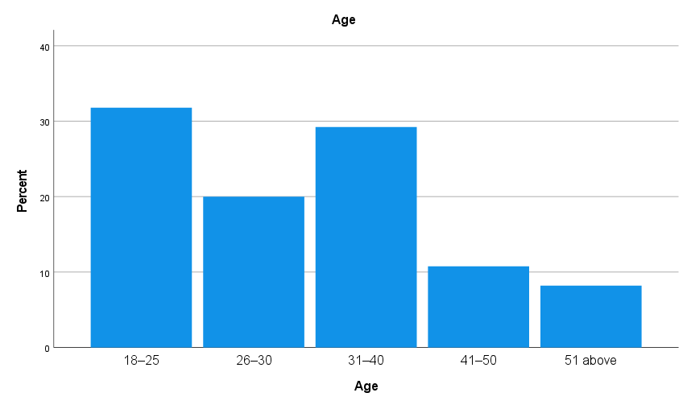
FIGURE 4.1: AGE GROUP
Regarding gender, 62.6% were men and 36.4% women (with1 % preferring not to disclose; Figure 4.2). This is indicative of the gender skew often found in investments in emerging markets.
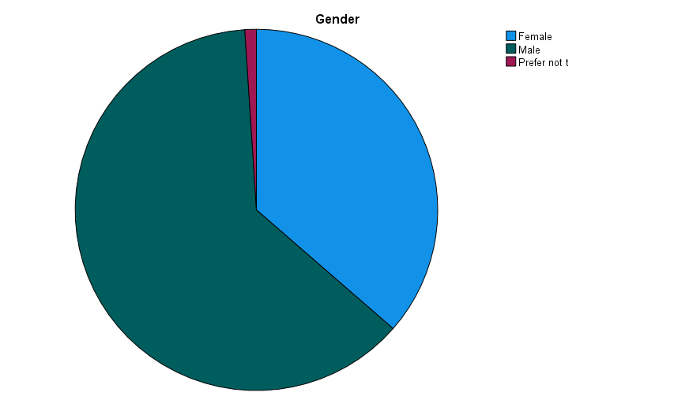
FIGURE 4.2: GENDER DISTRIBUTION
The majority of the sample was highly educated and it was a significant representation (45.1%) of those who had graduated at university level, followed by HS level (26.2%) and post graduate level (25.6%) respectively (Figure 4.3). Only 3.1% had MPhil/PhD qualifications.
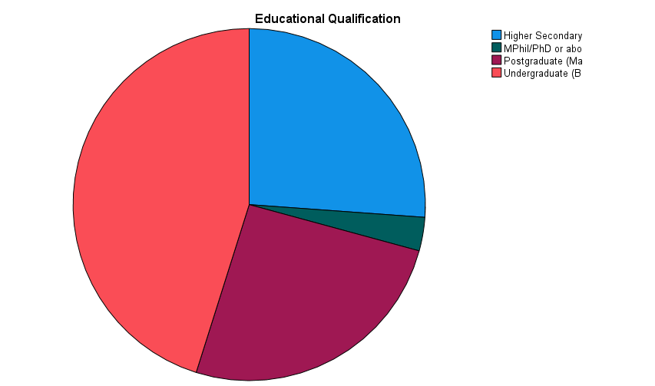
FIGURE 4.3: EDUCATION QUALIFICATION
Income in the range of BDT 30,001-50,000 (34.4%) and BDT 50,001-70,000 (33.8%) were the two largest monthly-income brackets (Figure 4.4). Lesser proportion had a monthly income of less than BDT 30,000 (21%) and above BDT 70,000 (7.2%).

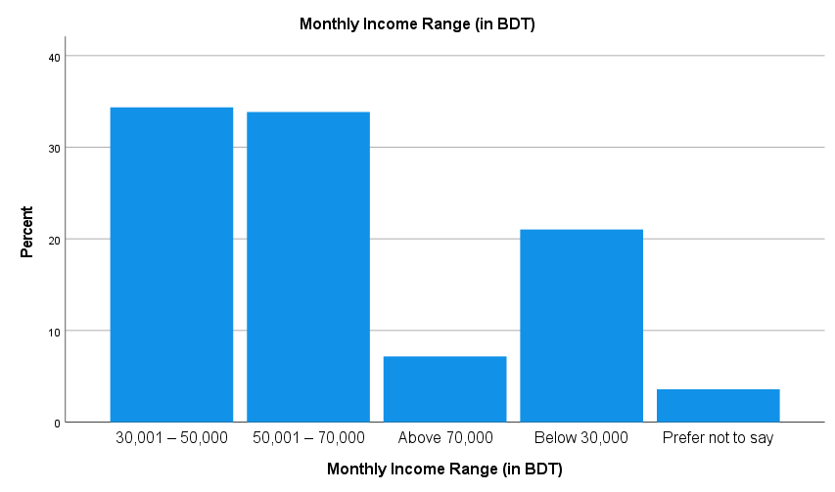

FIGURE 4.4: MONTHLY INCOME
In terms of investment experience, almost a half (48.7%) had 1–3 years, followed by 3–7 years (29.7%) "(Figure 4.5). The less than one year, 7–10 years, and over 10 years had smaller proportions (8.7%, 8.2%, and 4.1%).
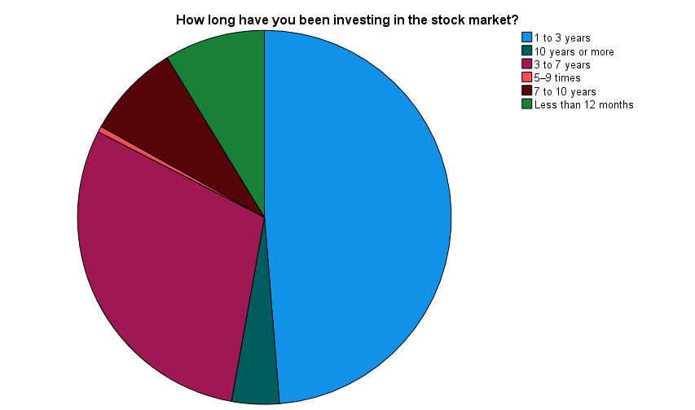

FIGURE 4.5: INVESTMENT EXPERIENCE
Finally, 40.5% of the respondents traded weekly, 31.3% monthly and 22.6% daily (Figure 4.6), whereas only 5.6% did it less frequently than daily trading. This indicates a great deal of involvement, validating the focus on active investors in the study.
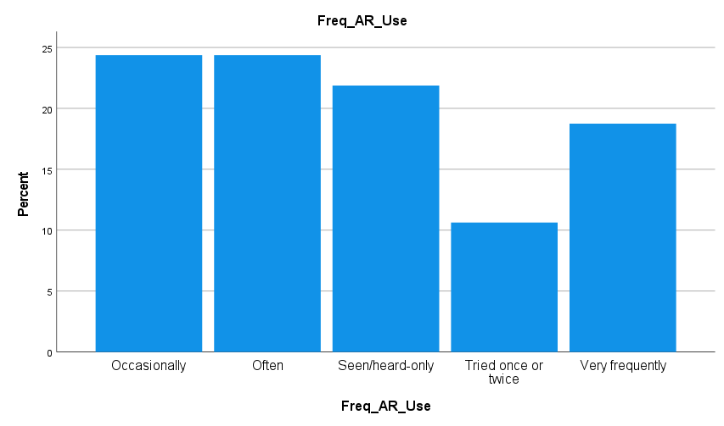
FIGURE 4.6: TRADING FREQUENCY

4.3 DESCRIPTIVE ANALYSIS
This section reports the descriptive statistics for the study variables to provide an overall picture of respondents’ FL, INS, RM practices, and IDQ.

4.3.1 DESCRIPTIVE STATISTICS OF KEY STUDY CONSTRUCTS
Referring to Table 4.2, for all measures the reported data show that the mean scores were above moderate level of modesty in FL, INS, RM and IDQ (scores >3). The average FL score was 3.8043 (SD = 0.5962) with a range from 2.08 to 4.75, indicating on the whole general financial literacy competence but a subpopulation that was less competent.

TABLE 4.2: DESCRIPTIVE STATISTICS FOR MAIN STUDY VARIABLES
 | N | Minimum | Maximum | Mean | Std. Deviation
Avg_FL | 195 | 2.08 | 4.75 | 3.8043 | .59615
Avg_IS | 195 | 1.60 | 5.00 | 3.7990 | .65974
Avg_RM | 195 | 2.60 | 5.00 | 3.9118 | .56897
Avg_IDQ | 195 | 2.20 | 5.00 | 3.9149 | .56817
Valid N (listwise) | 195
INS scores ranged from 1.60 to 5.00, with a mean score of 3.7990 (SD = 0.6597), showing that there was some difference in the degree of structure with which investors planned. RM and IDQ had the highest mean scores, 3.9118 (SD = 0.5690) and 3.9149 (SD = 0.5682), respectively, indicating that respondents perceived themselves as having self-discipline in handling investment risk and would make sound decisions. This emphasises the importance in quality of decision making not only of knowledge but also behavioural processes.

4.3.2 FINANCIAL LITERACY DIMENSION PROFILE
Table 4.3 presents the six components of FL. The highest mean score was for knowledge of diversification (3.8846, SD = 0.6930), followed by IOIs ability to compare products (3.8615, SD =0.8115). The lowest mean was in risk-return capability (3.7051, SD = 0.8787), respondents were less confident about their ability to identify the correlation between risk and expected returns! This pattern facilitates the interpretation of general financial literacy and indicates potential for improvement, particularly with respect to risk perception.

TABLE 4.3: DESCRIPTIVE STATISTICS FOR FINANCIAL LITERACY DIMENSIONS
 | N | Minimum | Maximum | Mean | Std. Deviation
Avg_BC | 195 | 1.50 | 5.00 | 3.7744 | .94725
Avg_RR | 195 | 1.50 | 5.00 | 3.7051 | .87871
Avg_DIV | 195 | 1.50 | 5.00 | 3.8846 | .69295
Avg_INFO | 195 | 1.00 | 5.00 | 3.8000 | .90160
Avg_COMP | 195 | 1.50 | 5.00 | 3.8615 | .81152
Avg_TVM | 195 | 1.00 | 5.00 | 3.8000 | .90160
Valid N (listwise) | 195

4.4 RELIABILITY ANALYSIS
Table 4.4 shows the Cronbach’s alpha of each study construct to measure internal consistency. 5.3.Financial Literacy Checklist reliability The FL internal consistency Cronbach’s alpha was 0.834 showing good reliability (Nunnally & Bernstein, 1994). This high estimate means that the 12 FL items measure a homogeneous construct. The RM subscale (α = 0.804) also demonstrated good reliability, which indicates that its five items are representing one same concept (Sekaran & Bougie, 2019).

TABLE 4.4: RELIABILITY STATISTICS FOR STUDY CONSTRUCTS
Construct | Number of Items | Cronbach’s Alpha (α) | Interpretation
Financial Literacy (FL) | 12 | 0.834 | Good reliability
Investment Strategy (IS) | 5 | 0.687 | Acceptable (short scale)
Risk Management (RM) | 5 | 0.804 | Good reliability
Investment Decision Quality (IDQ) | 5 | 0.687 | Acceptable (short scale)

Regarding IS and IDQ, Cronbach’s alpha was 0.687, slightly below compared to the commonly used benchmark of 0.70 (Tavakol & Dennick, 2011; Hair et al., 2019), although still acceptable for short scales with low numbers of items. These reliability figures point to acceptable levels of internal consistency and support the inclusion of constructs in subsequent analyses.

4.5 CORRELATION ANALYSIS
This section presents Pearson’s correlations to check the direction and strength of the bivariate relationships among the variables under study before testing hypotheses.

TABLE 4.5: CORRELATION MATRIX
 |  | Avg_FL | Avg_IS | Avg_RM | Avg_IDQ
Avg_FL | Pearson Correlation | 1 | .205** | .565** | .526**
Avg_FL | Sig. (2-tailed) |  | .004 | .000 | .000
Avg_FL | N | 195 | 195 | 195 | 195
Avg_IS | Pearson Correlation | .205** | 1 | .543** | .699**
Avg_IS | Sig. (2-tailed) | .004 |  | .000 | .000
Avg_IS | N | 195 | 195 | 195 | 195
Avg_RM | Pearson Correlation | .565** | .543** | 1 | .886**
Avg_RM | Sig. (2-tailed) | .000 | .000 |  | .000
Avg_RM | N | 195 | 195 | 195 | 195
Avg_IDQ | Pearson Correlation | .526** | .699** | .886** | 1
Avg_IDQ | Sig. (2-tailed) | .000 | .000 | .000
Avg_IDQ | N | 195 | 195 | 195 | 195
**. Correlation is significant at the 0.01 level (2-tailed).
The correlation results provide preliminary support for the conceptual framework. FL is positively and significantly correlated with IDQ (r = 0.526, p <. 001), indicating that higher FL respondents would report better quality of investment decision making including more extensive information use (H2-a), stronger goal congruence, and greater decision style conformity to risk tolerance. FL is also significantly associated with INS (r = 0.205, p =. 004) and RM (r = 0.565, p <. 001). This pattern suggests that the richer literacy is associated with more organized planning behaviors and higher RM among brokerage clients.
Moreover, both mediating variables are positively associated with IDQ. Positive correlation of INS with IDQ (r = 0.699, p <. 001), suggesting that greater clarity, more frequent review and discipline in strategy by investors leads to higher-quality decision making. RM is positively correlated with IDQ (r = 0.886, p <. 001), which suggests that the more person who possesses a higher ability with respect to risk evaluation, diversification and controlling losses tends to greater report decision quality.

4.6 REGRESSION ANALYSIS
This section presents the multiple regression results examining how FL, IS, and RM predict IDQ. The regression model (Table 4.6) shows a very strong overall fit (R = 0.926).

TABLE 4.6: MODEL SUMMARY
Model | R | R Square | Adjusted R Square | Std. Error of the Estimate
1 | .926ª | .857 | .855 | .21657
a. Predictors: (Constant), Avg_RM, Avg_IS, Avg_FL
b. Dependent Variable: Avg_IDQ
ANOVA results confirm that the overall regression model is statistically significant, F(3, 191) = 381.419, p < .001 (Table 4.7).

TABLE 4.7: ANOVA
Model |  | Sum of Squares | df | Mean Square | F | Sig.
1 | Regression | 53.668 | 3 | 17.889 | 381.419 | .000^{b}
1 | Residual | 8.958 | 191 | .047
1 | Total | 62.627 | 194
a. Dependent Variable: Avg_IDQ
b. Predictors: (Constant), Avg_RM, Avg_IS, Avg_FL
All three predictors show positive and statistically significant effects on IDQ (Table 4.8). FL remains significant (B = 0.083, p = .010), indicating that higher literacy contributes to better decision quality even when behavioural factors are included. INS has a stronger positive effect (B = 0.278, p < .001), suggesting that structured planning and review behaviours enhance decision quality. RM shows the largest effect (B = 0.660, p < .001), indicating that stronger risk control practices are most strongly associated with higher-quality investment decisions in this sample.

TABLE 4.8: REGRESSION COEFFICIENTS
Model |  | Unstandardized Coefficients |  | Standardized Coefficients | t | Sig.
 |  | B | Std. Error | Beta | t | Sig.
1 | (Constant) | -.039 | .126 |  | -.307 | .759
1 | Avg_FL | .083 | .032 | .087 | 2.592 | .010
1 | Avg_IS | .278 | .028 | .323 | 9.790 | .000
1 | Avg_RM | .660 | .039 | .661 | 16.927 | .000
a. Dependent Variable: Avg_IDQ

4.7 MEDIATION ANALYSIS (PROCESS MODEL 4)
This section reports the parallel mediation analysis examining whether INS and RM mediate the relationship between FL and IDQ (Figure 4.8). The analysis was conducted using PROCESS Model 4 with 5,000 bootstrap samples and 95% confidence intervals (Hayes, 2022).
FL significantly predicted both mediators. For INS, the model was significant (R² = 0.0419, F(1,193) = 8.4506, p = .0041), and Avg_FL had a positive effect on Avg_IS (B = 0.2267, p = .0041). For RM, the model showed stronger explanatory power (R² = 0.3187, F(1,193) = 90.2967, p < .001), with Avg_FL positively predicting Avg_RM (B = 0.5388, p < .001).
When Avg_FL, Avg_IS, and Avg_RM were entered together to predict Avg_IDQ, the overall model was significant (R² = 0.8570, F(3,191) = 381.4189, p < .001). All predictors were significant: Avg_FL (B = 0.0828, p = .0103), Avg_IS (B = 0.2778, p < .001), and Avg_RM (B = 0.6604, p < .001). The total indirect effect was significant (0.4188, BootCI [0.2985, 0.5424]), with separate significant indirect effects via Avg_IS (0.0630, BootCI [0.0135, 0.1205]) and Avg_RM (0.3559, BootCI [0.2687, 0.4449]). These results support mediation, indicating that FL improves decision quality partly through stronger strategy and RM practices.

FIGURE 4.8: MEDIATION ANALYSIS

4.8 CHAPTER SUMMARY
This chapter analysed survey data from 195 brokerage clients to test the proposed relationships between FL, INS, RM, and IDQ. Descriptive results indicated that respondents reported above-midpoint levels across all core constructs, suggesting moderate to relatively high self-assessed literacy and behavioural discipline. Reliability analysis confirmed acceptable to good internal consistency for all scales, supporting the use of composite measures. Correlation results showed significant positive associations between FL and IDQ, and between FL and both mediators. Regression findings demonstrated that FL, INS, and RM each contributed positively to IDQ, with RM showing the strongest effect. Mediation analysis using further indicated that FL improves IDQ partly through stronger INS and, more strongly, through RM practices. Overall, the findings provide empirical support for the study framework and set the foundation for the discussion in Chapter Five.

CHAPTER 5: DISCUSSION

5.1 CHAPTER OVERVIEW
Chapter five discusses and interprets the empirical findings reported in this study, as well as its relationship to the research aim and hypotheses. The core objective of the study is to investigate the impact of FL on IDQ considering brokerage clients in Dhaka and Savar, and to check whether INS and RM mediate this path. The chapter presents and discusses the main findings using correlation, regression and mediation results to state if each hypothesis is supported or not. It begins by elucidating the direct effect of FL on IDQ, before examining the separate consequences of INS and RM for decision quality. Then, it explains the mediational positions of INS and RM through PROCESS outcomes. Finally, the chapter discusses practical and theoretical implications of the findings for brokerage services and investor protection in Bangladesh.

5.2 DISCUSSION ON KEY FINDINGS
Empirical findings are interpreted here in light of the hypotheses and conceptual framework postulated in this study. This section also checks the conclusion with previous works to see if its conclusion is in an agreement with previous literature or not.

5.2.1 FINANCIAL LITERACY AND INVESTMENT DECISION QUALITY
The results demonstrate that FL is associated with IDQ in a positive manner. The correlation analysis indicated that there was a significant moderate positive relationship between FL and IDQ (r = 0.526, p <. 001). This implies that those with greater literacy indicated higher quality of decision-making in overall information use, congruence with goals, lack of decisions based on rumours and level of risk tolerance. This sequence is consistent with the process-based notion of decision quality taken in this paper where sound processes rather than resulting short-term returns are emphasized (Abdeldayem, 2016; Nguyen et al., 2019).
Indeed, FL continued to be statistically significant beyond both INS and RM in the regression analyses (B = 0.083; p =. 010). Although the strength of the coefficient diminished with encouragement of behavioural factors, this direct effect is significant suggesting that literacy affects decision quality independent of patterns in behaviour. From a theory of human capital viewpoint, FL may be regarded as a capacity to elevate an investor’s propensity to process financial information, assess alternatives and reach sounder judgments under uncertainty better over time (Lusardi and Mitchell, 2014; OECD, 2018). This is consistent with the view that knowledge does not simply inform, but rather works productively by enhancing the investor’s ability to evaluate trade-offs and make decisions in line with goals.
Under the Dhaka brokerage setting, these results are consistent with the behavioural finance predictions as well. Investors are subject to noise trading pressure, social influence and psychologically biased reactions under volatile market conditions. FL may help mitigate exposure to these behavioural biases by enhancing investors’ capacity to question hearsay and instead concentrate on evidence-based information and risk judgements (Khalid et al., 2018; Rahman et al., 2021). Thus, the findings validate acceptance of H1 and add further support for FL acting as a cornerstone competence which enhances IDQ by facilitating improved information processing and judgment (Huston, 2010; Nguyen et al., 2019).

5.2.1 INVESTMENT STRATEGY AND INVESTMENT DECISION QUALITY
Results indicate that the INS is positively associated with the IDQ. As can be observed in the correlation results, there is a significant and high positive relationship between INS and decision quality (r =.699, p <.001). In regression analyses, INS continued to predict IDQ significantly (B = 0.278, p <.001), even after adjustment for FL and RM. This suggests that structured planning, regular review, and the ability to separate speculation from long-term investing enhance the quality of decisions independently.
This finding can also be rationalised in terms of behavioural finance. In unstable markets, investors are susceptible to short-termism and herding as decisions become influenced by recent price action and peer group behaviour rather than long-term fundamentals. A well-defined INS acts like a discipline device by inducing a set of rules and reference points that limit short-term trading and render the decisions more aligned with goals and risk tolerance (Khalid et al., 2018; Oteng, 2019). Moreover, from the perspective of human capital, financial literacy is found to increase in its value when it is transformed to habits or decision rules. Strategy embodies this translation as it converts common sense into a structured system (planning, analysis, adaptation) that enhances decision processes and enables better decisions over time.
This is consistent with the research that was covered in Chapter 2, when INS was identified as a structured method to enhance coherence, diminish ad hoc trading and enhance goal consistency (Amisi, 2012; Senda et al., 2020). Therefore, H2 is supported and the research provides evidence from Bangladesh in supporting INS as an important behavioural determinant of IDQ.

5.2.3 RISK MANAGEMENT AND INVESTMENT DECISION QUALITY
The results indicate that RM is significantly and positively associated with IDQ. The relationship between RM and decision quality was extremely strong (r = 0.886, p <.001), and in regression analysis, it had a significant independent predictor effect (B = 0.660, p <.001). This suggests that behaviours that RM scale has captured (risk assessment, not exposing oneself to excessive risk, diversification, managing volatility and application of loss limits) are particularly associated with better quality investment decisions for the brokerage participants.
This is in line with the traditional finance theory and behavioural finance. In expected utility theory, a good decision is one that corresponds to the investor’s preferences and risk aversion in the presence of uncertainty (von Neumann and Morgenstern, 1947). Just like Markowitz’s portfolio theory teaches us that good decisions mean picking portfolios with an adequate risk–return trade-off and diversification, not high concentrations or hunches (Markowitz, 1952). In practice, the RM items of the study closely approximate these principles, particularly diversification and minimizing downside exposure.
Behavioural finance further explains why RM is so strongly linked with decision quality in volatile markets. Loss aversion and fear can trigger panic selling, while overconfidence can drive excessive risk-taking and poor diversification, reducing decision quality (Hadi, 2017; Khalid et al., 2018). RM rules, such as position limits and loss controls, reduce the space for emotionally driven decisions and help investors remain consistent during market swings. Therefore, H3 is accepted, and the evidence suggests that in the Dhaka context, strengthening RM behaviours is likely to be one of the most direct ways to improve IDQ.

5.2.4 MEDIATING ROLES OF INVESTMENT STRATEGY AND RISK MANAGEMENT
The mediation analysis confirms that INS and RM partially transmit the effect of FL to IDQ. PROCESS results showed that FL significantly predicted INS (B = 0.2267, p = .0041) and RM (B = 0.5388, p < .001). When FL and both mediators were entered jointly, all predictors remained significant, and the model explained a substantial proportion of variance in decision quality (R² = 0.857). The bootstrapped total indirect effect was significant (0.4188, 95% BootCI [0.2985, 0.5424]), indicating mediation. Importantly, the direct effect remained significant (B = 0.0828, p = .0103), confirming partial mediation rather than full mediation (Hayes, 2022).
These results fit the human capital theory argument that FL is a capability that improves decision-making performance. However, the findings also show that capability matters most when it becomes observable behaviour. Behavioural finance supports this mechanism because investors face psychological biases and emotional pressures, especially in volatile and socially influenced markets. FL seems to alleviate these weaknesses partially by reinforcing structured INS and RM routines that shield investors from rumour-based and emotion- based decisions (Khalid et al., 2018; Hadi, 2017).
The relative mediation effects make the picture even clearer. The indirect path via INS was significant, but weaker and the one via RM was much stronger. This unique pattern indicates that the potential benefit for FL to enhance decision quality is mainly from practical risk-control actions, such as diversified choices and limiting downside exposure. In sum, H4a and H4b are supported and the study has made a contribution by revealing that not only does FL matter but this construct’s most robust behavioural path to DQ is RM.

TABLE 5.1: HYPOTHESES TESTING
Hypothesis | Accepted or Not
H1: FL has a positive and significant effect on investment decision quality. | Accepted
H2: Investment strategy has a positive and significant effect on investment decision quality. | Accepted
H3: Risk management has a positive and significant effect on investment decision quality. | Accepted
H4a: Investment strategy mediates the relationship between financial literacy and investment decision quality. | Accepted
H4b: Risk management mediates the relationship between financial literacy and investment decision quality. | Accepted

5.3 IMPLICATIONS OF THE STUDY
This study has practical and theoretical implications. Practically, the results indicate that increasing IDQ in Dhaka needs both greater FL and enhanced everyday investing behaviors particularly RM. During account opening, brokerage firms can implement a straightforward literacy screen to identify clients who could require additional assistance. In this connection, short and practical training modules could be provided at the brokerage houses or through online classes. These modules should concentrate in basic risk–return comprehension, diversification, position sizing and simple loss-control rules as RM presented the highest correlation with decision quality. Brokers also may offer standard investment planning templates that can guide clients through establishing new goals, deciding on time horizons and revisiting their portfolios regularly. As decisions based on rumour are widespread in emerging markets, investor education should involve “rumour-check”, for example how to cross verify news with official disclosures, regulator announcements and credible financial media. Regulators can play a role by mandating some level of basic investor education for new retail investors and pressuring brokerage firms to better incorporate clear risk warnings on their trading platforms. Easy app-based nudges, such as reminders about diversification and risk tolerance, can lessen impulsive trading in times of market volatility.
From a theoretical perspective, the results support human capital theory as they indicate that FL is a valuable competence that enhances the quality of investment decisions. Meanwhile, the findings of partial mediation provide evidence for behavioural finance which suggests that knowledge impacts outcomes by way of behaviour particularly risk-control processes that reduce actions driven by bias during volatility. A powerful role for RM is also consistent with the logic of portfolio theory in which rational investment decision-making is centred on diversification and downside mitigation (Markowitz 1952). These theoretical connections collectively enhance the explanatory power of the study and justify why decision quality is contingent on knowledge and disciplined behavioural routines.

5.4 CHAPTER SUMMARY
This This chapter presented the findings of the study with respect to the conceptual framework and previous literature. Such findings provide strong evidence in support of all three hypotheses, indicating that FL is positively associated with IDQ and retained significance despite the inclusion of behavioural factors. INS and RM demonstrated a large positive effect on decision quality, with RM being the strongest predictor. Mediation analysis suggested partial mediation, that is, FL has a direct and indirect effect (i.e. via behaviour) on DQ. The indirect effect through RM was much stronger than that for INS, which indicates risk-control strategies are the dominant behavioural mechanisms by which literacy leads to improved quality of decisions in this context.

CHAPTER 6: CONCLUSIONS & RECOMMENDATIONS

6.1 CHAPTER OVERVIEW
This chapter concludes the study on the impact of financial literacy (FL) on investment decision quality (IDQ) among brokerage clients in Dhaka and Savar, Bangladesh. It summarises the study purpose, explains how far the research achieved its aim and objectives, and answers the research questions based on the results. It then provides practical recommendations supported by the findings, outlines key limitations, and suggests directions for future research.

6.2 CONCLUSIONS
This study examined whether FL improves IDQ and whether INS and RM explain part of this relationship. Using survey data from 195 brokerage clients, the findings show that FL is positively associated with decision quality. However, the results also show that the strongest links to decision quality come from behavioural practices, especially RM.
Overall, the results confirm the central argument of the dissertation: FL matters, but it produces better IDQ mainly when it becomes disciplined behaviour. In the Dhaka brokerage context, characterized by volatile market conditions and informal advice agents, this study seems to suggest that investors are better off when they adopt practical risk management measures and patterned decision structures.
The findings also support the theoretical orientation of the study. Human capital perspective on FL can be seen as a skill that enhances investors’ ability to comprehend information and assess their decisions. From a behavioural finance perspective, information operates at least in part through behaviour, reinforcing planning discipline and risk control that prevents investors from making impetuous or rumour-driven decisions. Importantly, the mediation results indicate that this behaviour pathway is not trivial. It is a critical component of how literacy becomes decision quality.

6.2.1 CONCLUSIONS BY OBJECTIVE
Objective 1: To assess the level of financial literacy among active brokerage clients in Dhaka.
The descriptive results indicate that respondents reported a moderate to high level of FL overall (Mean = 3.80 on a scale from 1 – 5). The dimension profile points out that the knowledge of diversification, and comparison of products scored relatively higher, whereas the understanding risk–return was the lowest in average Mean = 3.71). This implies that many investors do understand sound investing concepts, albeit they might find it difficult to judge risk-return trade-off accurately as is important in what is an essentially rocky market. Thus, Aim 1 was addressed by offering a general literacy level and a practical breakdown by major dimensions of literacy.
Objective 2: To examine the direct effect of financial literacy on investment decision quality.
The positive association between FL and IDQ was evident in the analysis. Correlation analysis revealed statistically significant correlation (0.526; p <. 001). Furthermore, results of the regression analysis indicated that FL still was a significant associated factor included with INS and RM (B = 0.083, p =. 010). This implies that literacy adds to the decision-making quality over and above strategy and risk routines. As a result, we achieved Objective 2, and the research concludes that increasing literary competence is likely to increase how investors who search for information about investments invest according to goals avoid rumour-based decisions remain consistent in risk tolerance.
Objective 3: To analyse whether investment strategy mediates the relationship between financial literacy and investment decision quality.
The mediation analysis indicates that INS mediates the effect of FL on decision quality. Strategy was strongly predicted by FL (B = 0.2267, p =. 0041) and the indirect effect through strategy was significant (indirect effect =0.0630, bootstrapped CI did not include zero). This shows that better planning and review behaviour, which in turn leads to higher decision quality, is fostered by increasing literacy. However, the mediation effect of strategy is weaker than that of RM. Overall, Objective 3 was achieved, and the study concludes that strategy is a meaningful but secondary pathway in this context.
Objective 4: To examine whether risk management practices mediate the relationship between financial literacy and investment decision quality.
RM emerged as the most powerful pathway in the model. FL strongly predicted RM (B = 0.5388, p < .001), and RM showed the strongest association with decision quality (r = 0.886, p < .001) and the largest regression effect (B = 0.660, p < .001). The indirect effect through RM was large and significant (indirect effect = 0.3559, bootstrapped CI did not include zero). This confirms that literacy improves decision quality partly by improving investors’ ability to assess losses, diversify, manage volatility, and apply basic loss-control rules. Objective 4 was achieved, and the study concludes that RM is the dominant behavioural mechanism linking literacy to decision quality among brokerage clients in Dhaka and Savar.
Objective 5: To provide practical recommendations for investor training and financial education in Bangladesh based on the study findings.
The findings offer a clear direction for practice. Because RM and INS are strongly related to decision quality, training and education should not focus only on concepts. It should focus on applied behaviours and simple decision routines that investors can follow consistently. The next section provides practical recommendations based directly on the empirical results, thereby achieving Objective 5.

6.2.1 CONCLUSIONS BY RESEARCH QUESTIONS
In addition to fulfilling the research objectives, the study answers the research questions as well. First, FL influences IDQ positively, both directly and indirectly. Second, FL affects INS and RM, with a stronger effect on RM. Third, both INS and RM mediate the literacy–decision quality relationship, but RM is the stronger mediator. Overall, the study concludes that improving decision quality in this setting depends heavily on turning financial knowledge into practical risk control and disciplined investing routines.

6.3 RECOMMENDATIONS
Based on the findings from the empirical evidences the study provides following recommendations:
- Training Should Prioritise: Because RM had the largest effect on decision quality (highest correlation and strongest regression coefficient), training should prioritise applied risk tools rather than theory alone. This should include basic risk–return judgement, diversification rules, position sizing, and simple loss limits. These sessions can be delivered as short weekly classes at brokerage houses and as online modules for clients.
- Use a simple “new investor checklist” at account opening: Brokerage firms can use a short screening checklist based on the lowest literacy area found in this study (risk–return understanding). Clients who score low can be encouraged to complete a brief learning module before trading actively. This improves investor protection without restricting participation.
- Provide strategy templates and portfolio review routines: Since INS significantly predicted decision quality, brokers should provide clients with a simple one-page strategy template: investment goal, time horizon, preferred risk level, diversification plan, and review schedule. Regular review prompts can reduce impulsive trading and support goal-based decisions.
- Incorporate “decision nudges” within trading platforms and groups of investors: Given that such rumour-driven investing is a common feature of the markets, brokers should be able to provide verified sources of information and remind clients to develop a routine for checking official disclosures and confirming fundamentals, rather than trading simply on social media tips. Going viral with a small set of standard messages, used obsessively until they become habitual, can serve to reinforce disciplined behaviour.
Overall, the key recommendation is to pivot investor education from “knowing” to “doing.” The most compelling empirical challenge in this study is the behavioural, especially RM, particularly for interventions in practical habits

6.4 LIMITATIONS OF THE STUDY
This study has several limitations. First, it used non-probability (convenience and network-based) approach was which limits the generalisability of the findings. The sample may over-represent active or engaged investors who are more willing to respond to surveys. Second, the cross-sectional design captures relationships at one point in time, so the results cannot confirm causality. It is possible that investors with better decision quality also choose to learn more over time. Third, the data are self-reported using Likert-scale items, which may introduce social desirability bias. Some respondents may overestimate their literacy or discipline. Finally, the strong relationship between RM and decision quality may partly reflect conceptual closeness between these behaviours in practice, even though they were modelled as separate constructs in this study.

6.5 SUGGESTIONS FOR FUTURE RESEARCH
Future research can strengthen and extend these findings in several ways. First, studies should use longitudinal designs to examine causality, for example whether improvements in FL lead to better RM and decision quality over time. Second, future work can use objective measures of FL (quiz-style questions) and, where possible, real trading records to reduce self-report bias. Third, researchers can test additional behavioural variables such as overconfidence, herd behaviour, and loss aversion to explain decision quality more fully in the Bangladesh stock market context. Finally, future studies can expand coverage beyond Dhaka and Savar to compare patterns across regions and investor types, including investors who trade digitally or through informal channels.

REFERENCES
Abdeldayem, M.M. (2016) ‘Is there a relationship between financial literacy and investment decisions in the Kingdom of Bahrain’, Journal of Management and Accounting Studies, 4(2), pp. 68–78.
Adil, M., Singh, Y. and Ansari, M.S. (2022) ‘How financial literacy moderate the association between behaviour biases and investment decision?’, Asian Journal of Accounting Research, 7(1), pp. 17–30.
Ahmed, Z., Noreen, U., Ramakrishnan, S.A. and Abdullah, D.F.B. (2021) ‘What explains the investment decision-making behaviour? The role of financial literacy and financial risk tolerance’, Afro-Asian Journal of Finance and Accounting, 11(1), pp. 1–19.
Amisi, S.A.R.A.H. (2012) The effect of financial literacy on investment decision making by pension fund managers in Kenya (Doctoral dissertation).
Andarsari, P.R. and Ningtyas, M.N. (2019) ‘The role of financial literacy on financial behaviour’, Journal of Accounting and Business Education, 4(1), pp. 24–33.
Baihaqqy, M.R.I., Disman, N., Sari, M. and Ikhsan, S. (2020) ‘The effect of financial literacy on the investment decision’, Budapest International Research and Critics Institute (BIRCI) Journal, 3(4), pp. 3073–3083.
Creswell, J.W. and Creswell, J.D. (2018) Research design: Qualitative, quantitative, and mixed methods approaches. Los Angeles: SAGE.
Dhaka Stock Exchange (2025) DSE data archive. Available at: https://www.dsebd.org/data_archive.php (Accessed: [insert date]).
Field, A.P. (2018) Discovering statistics using IBM SPSS statistics. 5th edn. London: SAGE.
Hadi, F. (2017) ‘Effect of emotional intelligence on investment decision making with a moderating role of financial literacy’, China-USA Business Review, 16(2), pp. 53–62.
Hair Jr., J.F., Hult, G.T.M., Ringle, C.M., Sarstedt, M., Danks, N.P., Ray, S. et al. (2021) ‘Evaluation of reflective measurement models’, in Partial Least Squares Structural Equation Modeling (PLS-SEM) Using R. Classroom Companion: Business, pp. 75–90. Springer. https://doi.org/10.1007/978-3-030-80519-7_4
Hasanuh, N. and Putra, R.A.K. (2020) ‘Influence of financial literacy and financial attitude on individual investment decisions’, in Advances in Business, Management and Entrepreneurship, pp. 424–428. CRC Press.
Hassan Al-Tamimi, H.A. and Bin Kalli, A.A. (2009) ‘Financial literacy and investment decisions of UAE investors’, The Journal of Risk Finance, 10(5), pp. 500–516.
Hayes, A.F. (2018) Introduction to mediation, moderation, and conditional process analysis: A regression-based approach. 2nd edn. New York, NY: Guilford Press.
Huston, S.J. (2010) ‘Measuring financial literacy’, Journal of Consumer Affairs, 44(2), pp. 296–316.
Janor, H., Yakob, R., Hashim, N.A., Zanariah, Z. and Wel, C.A.C. (2016) ‘Financial literacy and investment decisions in Malaysia and United Kingdom: A comparative analysis’, Geografia – Malaysian Journal of Society and Space, 12(2), pp. 1–15.
Khalid, R., Javed, M.U. and Shahzad, K. (2018) ‘Impact of behavioral biases on investment decision making with moderating role of financial literacy’, Jinnah Business Review, 6(2), pp. 34–41.
Khan, S. (2016) ‘Impact of financial literacy, financial knowledge, moderating role of risk perception on investment decision’, Financial Knowledge, Moderating Role of Risk Perception on Investment Decision (February 4, 2016).
Kumari, D.A.T. (2020) ‘The impact of financial literacy on investment decisions: With special reference to undergraduates in Western Province, Sri Lanka’, Asian Journal of Contemporary Education, 4(2), pp. 110–126.
Lusardi, A. and Mitchell, O.S. (2014) ‘The economic importance of financial literacy: Theory and evidence’, Journal of Economic Literature, 52(1), pp. 5–44.
Maheshwari, H., Samantaray, A.K., Panigrahi, R.R. and Jena, L.K. (2025) ‘Financial literacy in predicting investment decisions: Do attitude and overconfidence influence?’, International Journal of Social Economics, 52(2), pp. 220–235.
Markowitz, H. (1952) ‘Modern portfolio theory’, Journal of Finance, 7(11), pp. 77–91.
Nguyen, T.A.N., Polách, J. and Vozňáková, I. (2019) ‘The role of financial literacy in retirement investment choice’, Equilibrium. Quarterly Journal of Economics and Economic Policy, 14(4), pp. 569–589.
Niazi, M.K.S. and Malik, Q.A. (2019) ‘Financial attitude and investment decision making – moderating role of financial literacy’, NUML International Journal of Business & Management, 14(1), pp. 102–115.
OECD (2023) OECD/INFE 2023 international survey of adult financial literacy. Available at: https://www.oecd.org/content/dam/oecd/en/publications/reports/2023/12/oecd-infe-2023-international-survey-of-adult-financial-literacy_8ce94e2c/56003a32-en.pdf (Accessed: [insert date]).
Oteng, E. (2019) ‘Financial literacy and investment decisions among traders in the Techiman Municipality’, Research Journal of Finance and Accounting, 10(6), pp. 50–60.
Parsai, P. and Chandok, A.K. (2025) ‘The role of financial literacy in investment decision-making: A review’, International Journal of Innovations in Science, Engineering and Management, 2(1), pp. 296–301.
Rahman, M. H., Naser, M. S., Islam, M. E., & Hossain, M. S. (2021) ‘Is the capital market of Bangladesh efficient?’, The Journal of Developing Areas, 55(4), 173-186.
Raut, R.K. (2020) ‘Past behaviour, financial literacy and investment decision-making process of individual investors’, International Journal of Emerging Markets, 15(6), pp. 1243–1263.
Sabri, N.A.A. and Afiqah, N. (2016) ‘The relationship between the level of financial literacy and investment decision-making millennials in Malaysia’, Taylor’s Business Review, 6(1), pp. 39–47.
Sanchez, J.I., Bonache, J., Paz-Aparicio, C. and Oberty, C.Z. (2023) ‘Combining interpretivism and positivism in international business research: The example of the expatriate role’, Journal of World Business, 58(2), article 101419.
Saunders, M.N.K., Lewis, P. and Thornhill, A. (2019) Research methods for business students. 8th edn. Harlow: Pearson.
Sekaran, U. and Bougie, R. (2019) Research Methods for Business: A Skill Building Approach. John Wiley & Sons.
Senda, D.A., Rahayu, C.W.E. and Rahmawati, C.H.T. (2020) ‘The effect of financial literacy level and demographic factors on investment decision’, Media Ekonomi dan Manajemen, 35(1), pp. 100–111.
Shaheen, F., Tariq, M.A., Zahoor, Q. and Mehmood, A. (2022) ‘Role of financial literacy in investment decisions: Exploring the individual investors’ perspective through a qualitative approach’, Journal of Business and Social Review in Emerging Economies, 8(4), pp. 719–726.
Sharma, R. (2020) ‘Impact of financial literacy and risk tolerance on investment decision’, International Journal of Management and Humanities, 4(11), pp. 53–56.
Suresh, G. (2024) ‘Impact of financial literacy and behavioural biases on investment decision-making’, FIIB Business Review, 13(1), pp. 72–86.
Tabachnick, B.G., Fidell, L.S. and Ullman, J.B. (2007) Using multivariate statistics. 5th edn. Boston, MA: Pearson.
Waheed, H., Ahmed, Z., Saleem, Q., Din, S.M.U. and Ahmed, B. (2020) ‘The mediating role of risk perception in the relationship between financial literacy and investment decision’, International Journal of Innovation, Creativity and Change, 14(4), pp. 112–131.

APPENDIX A: SURVEY QUESTIONNAIRE
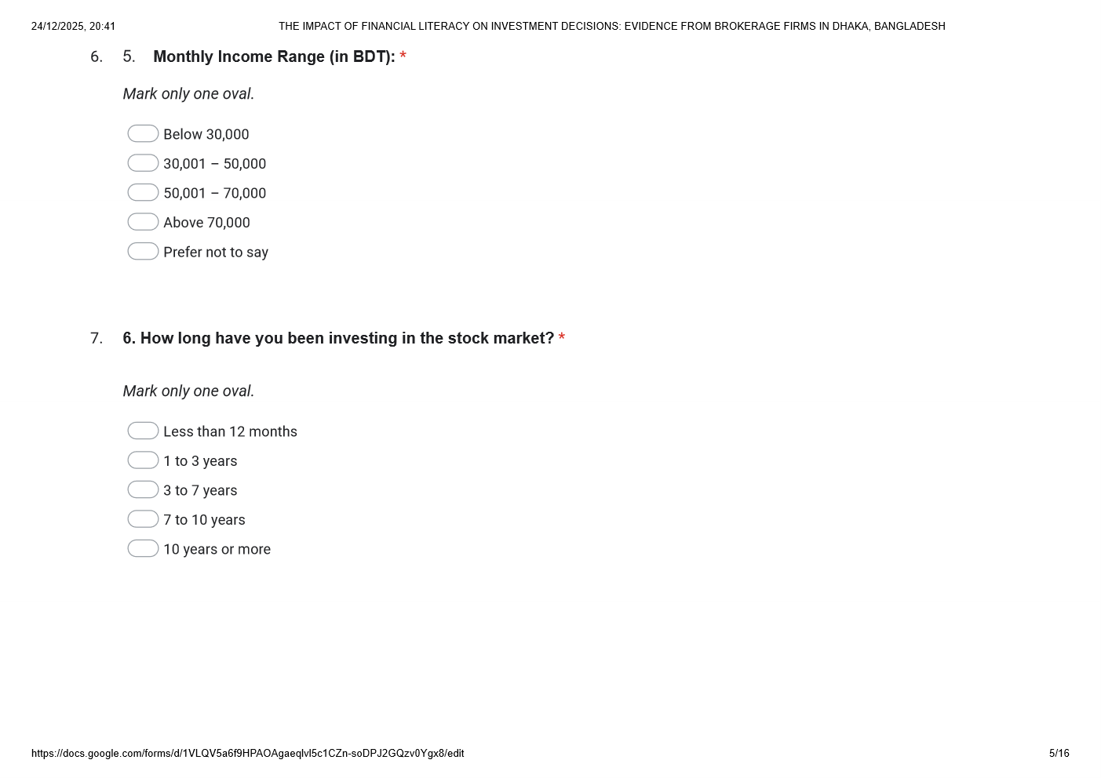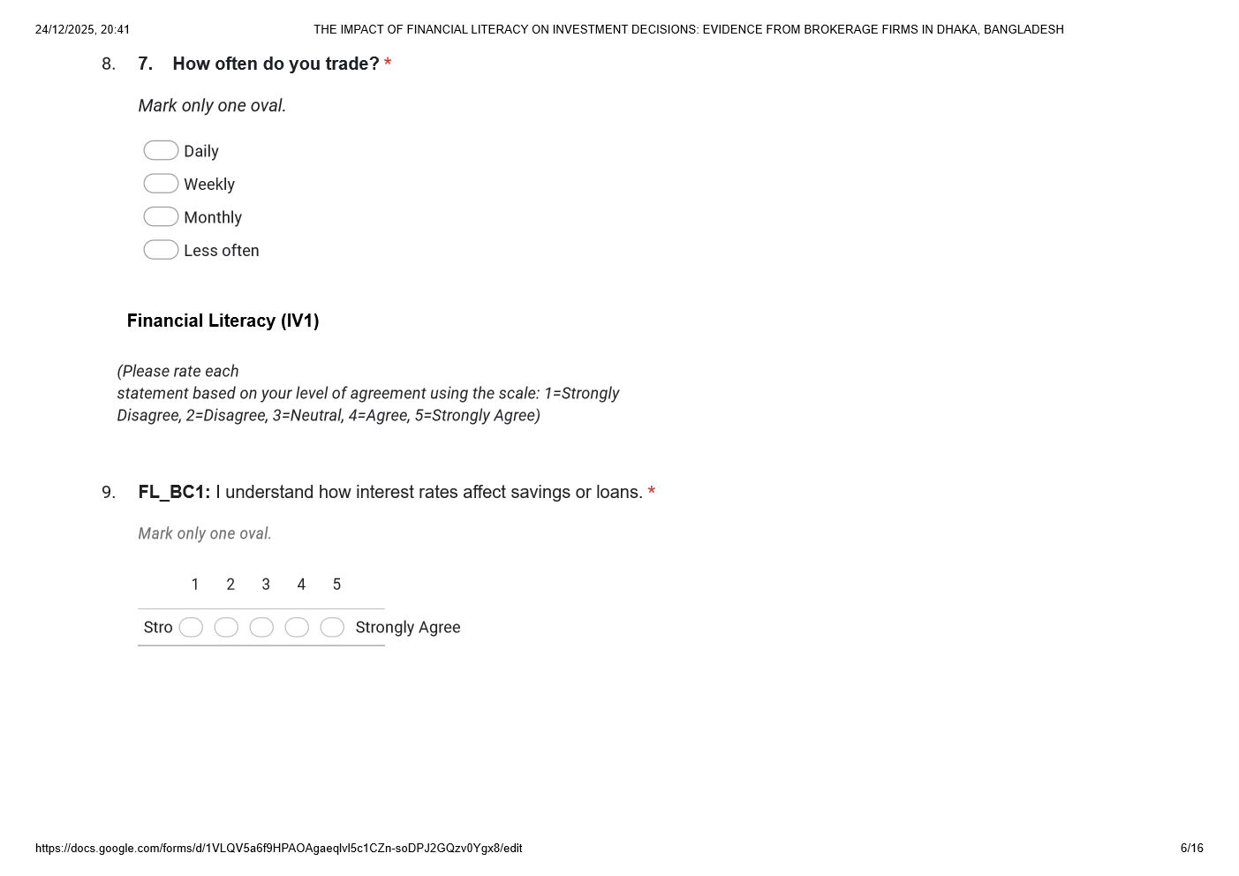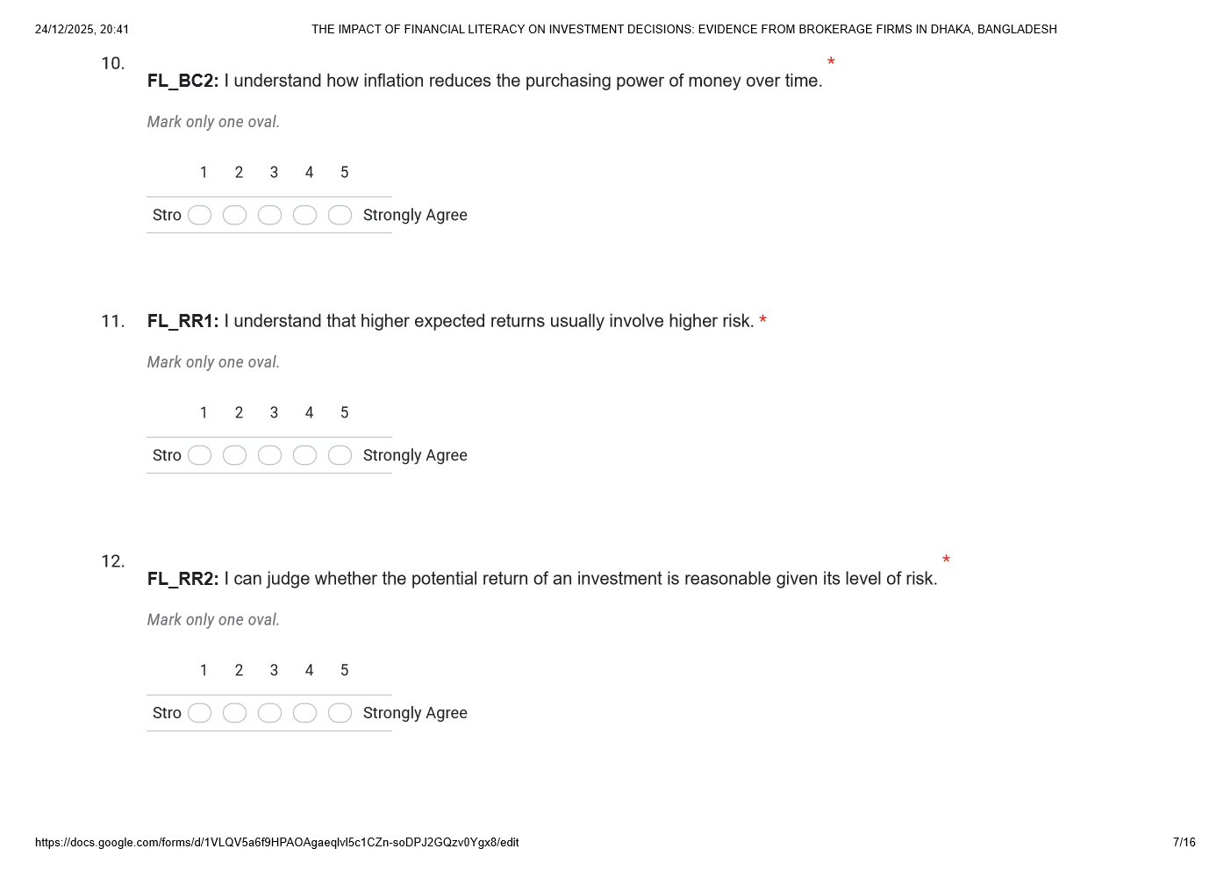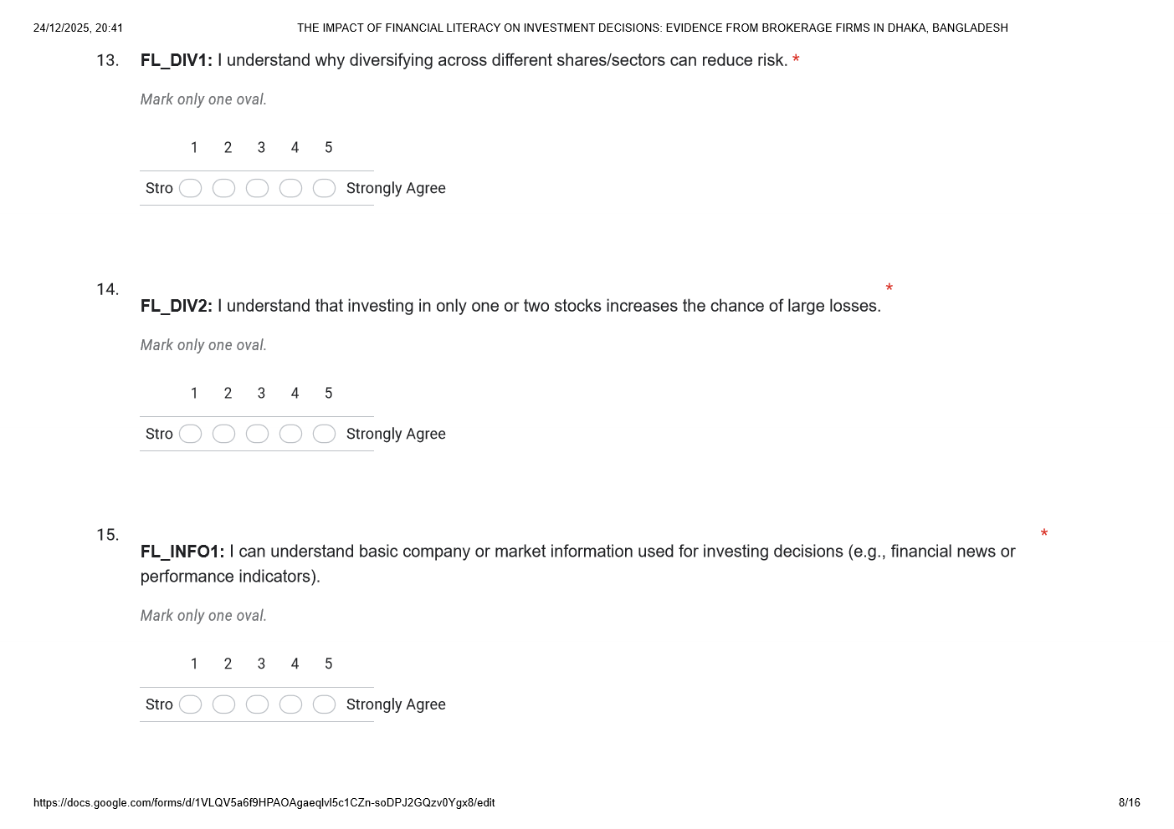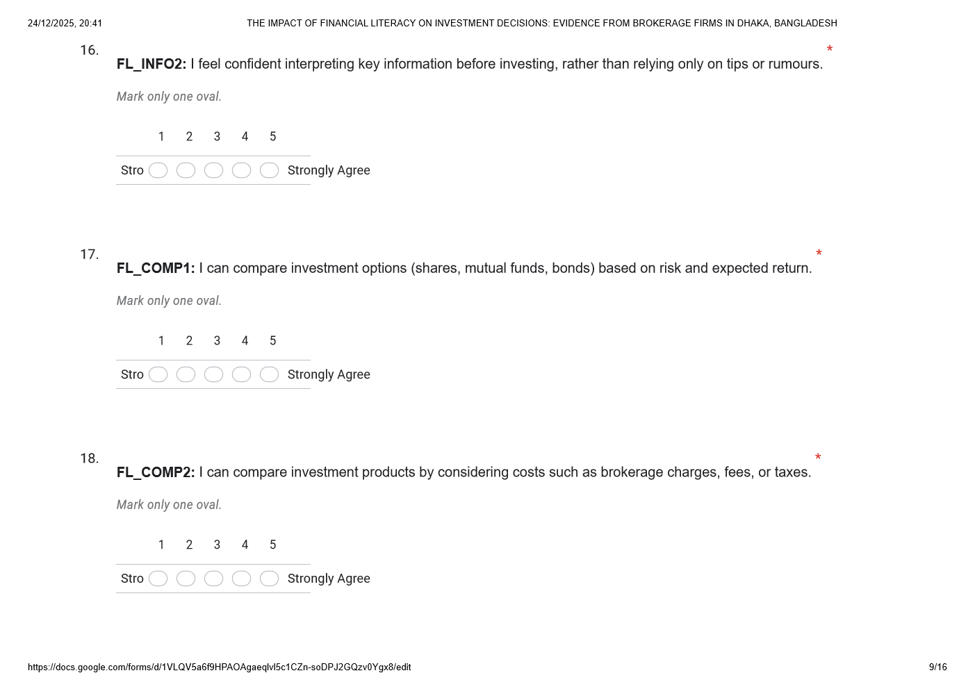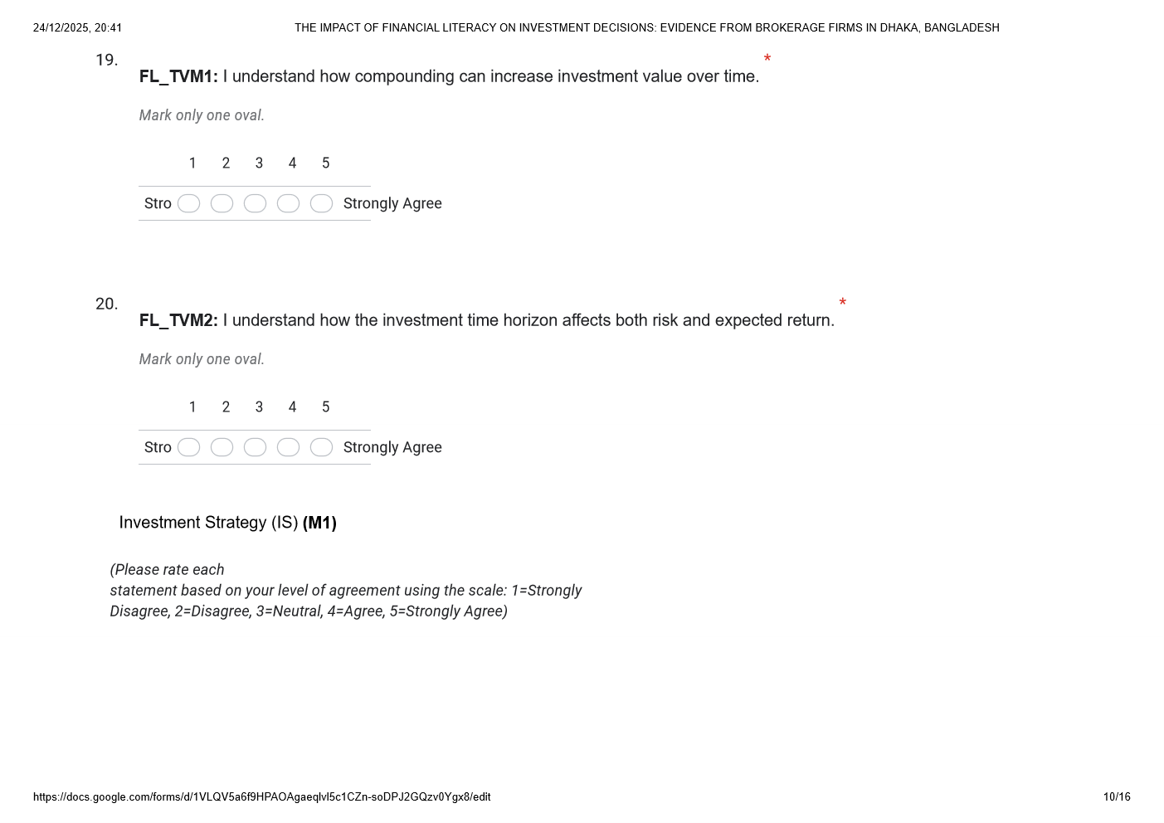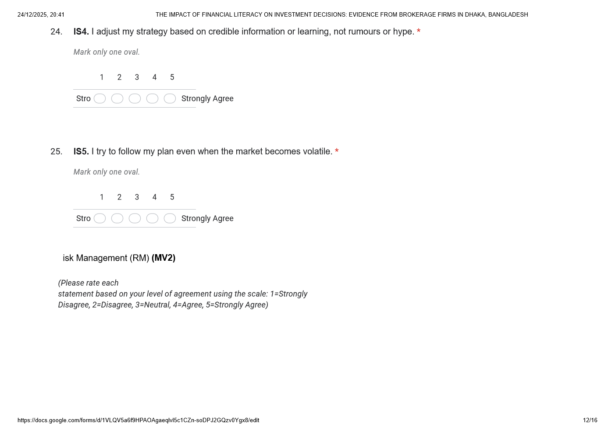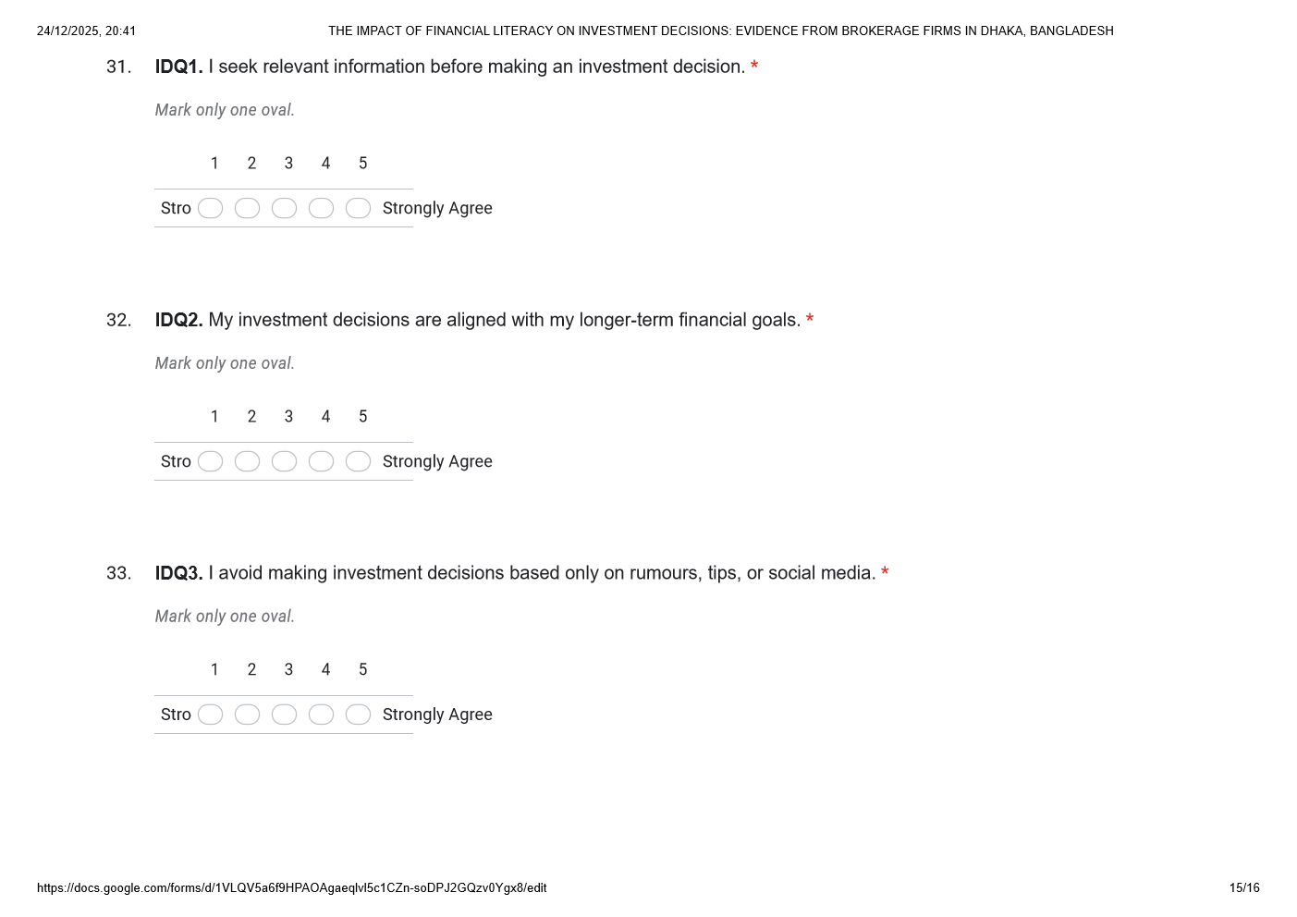


APPENDIX B: SPSS DATA FILE
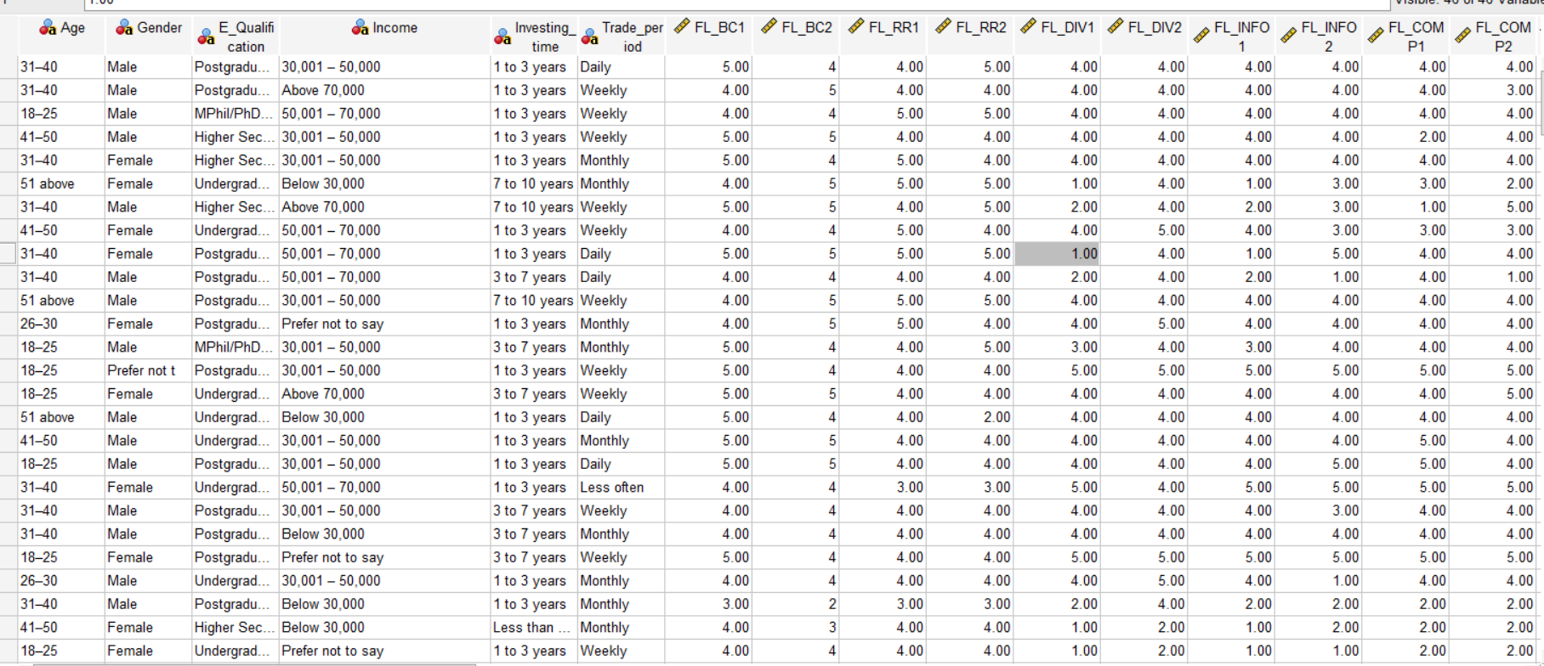

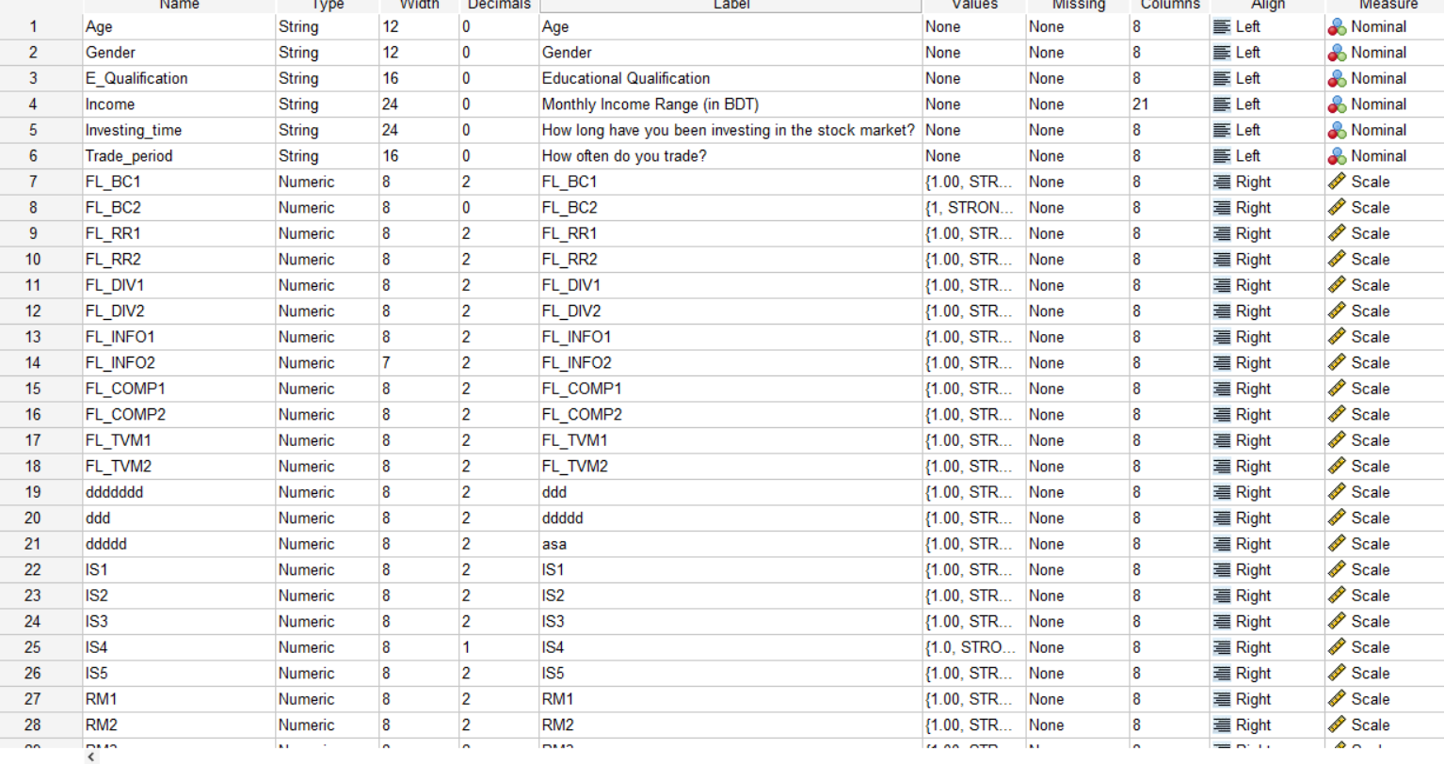

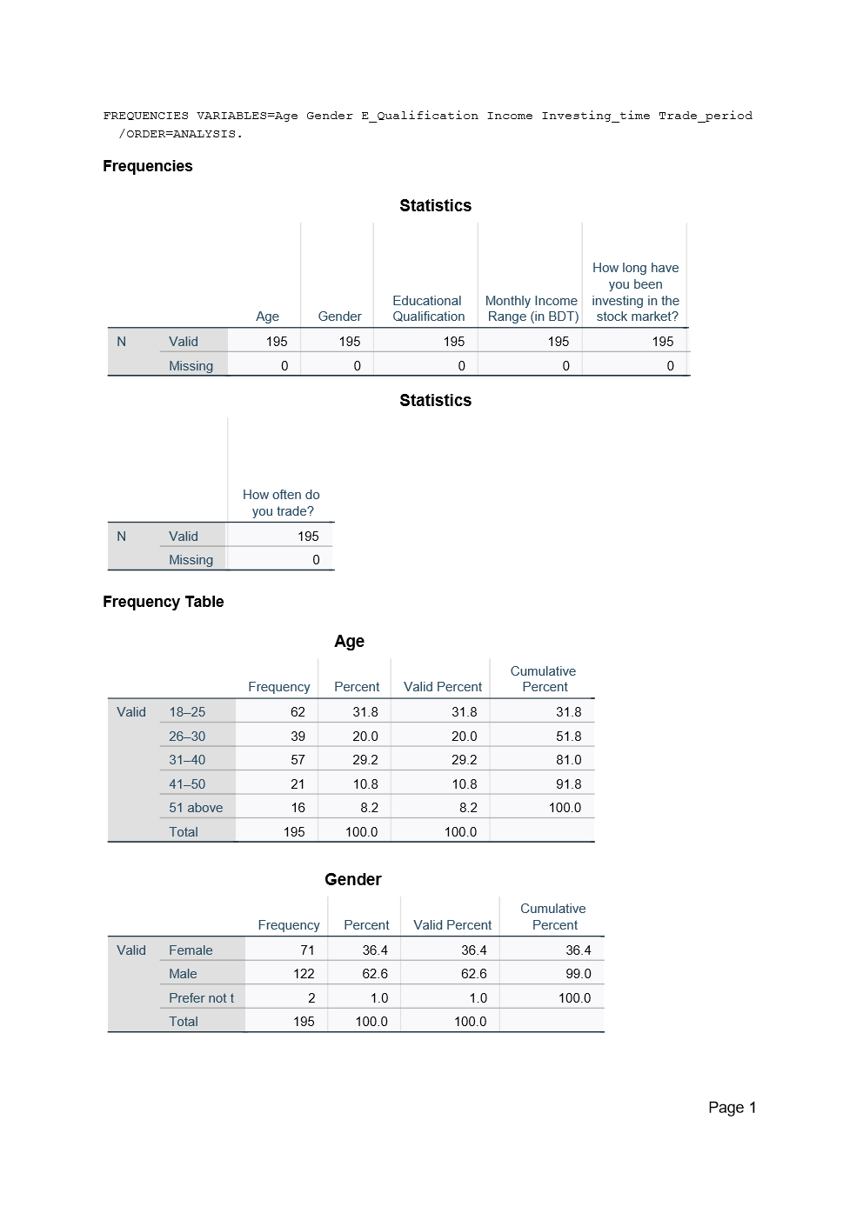
APPENDIX C: SPSS DATA FILE



