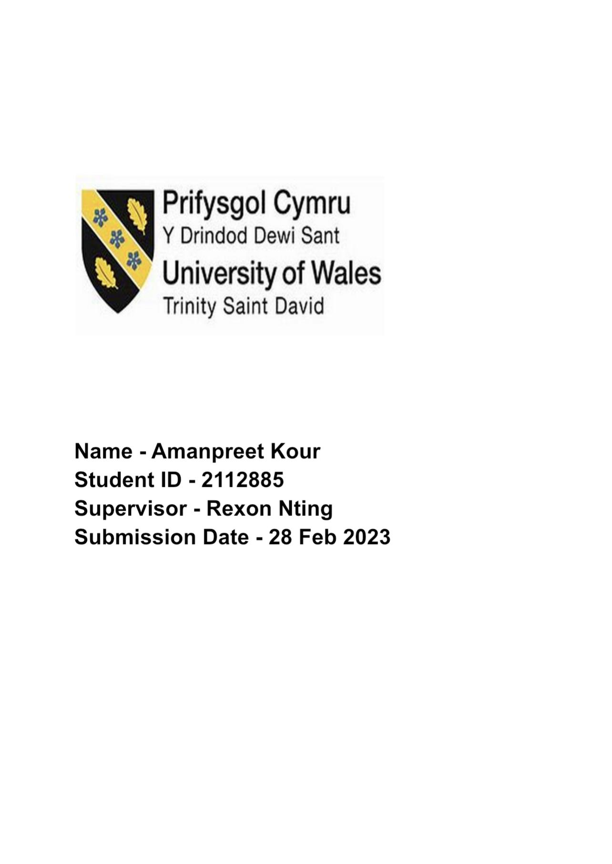

ENTREPRENEURSHIP OF WOMEN IN THE FINANCE INITIATIVE
By Amanpreet Kour

Acknowledgement
I would like to express my sincere gratitude to all those who have supported and contributed to the completion of this research study on “entrepreneurship of women in the finance initiative".
Special thanks to our research advisor, for providing invaluable guidance, insights, and expertise throughout the entire research process.
I would also like to extend my appreciation to the institution, for providing us with the resources and facilities necessary to conduct this research.
Finally, I would like to acknowledge the time and effort put in by the participants, who made this research possible through their willingness to share their thoughts and opinions.
Thank you all for your support and contribution.

Declaration
I, hereby declare that the research titled “entrepreneurship of women in the finance initiative” is an original work completed by me under the guidance of the advisor. The data and findings presented in this research are based on thorough research and analysis conducted by me, and any sources used have been appropriately cited and referenced.

Abstract
This study is aimed to analyze the concept of female entrepreneurship in the finance initiative in the United Kingdom. The introductory chapter includes a background study of the research topic and points out the current scenario of women’s entrepreneurship. The chapter includes a rationale for the research and a problem statement. In addition, this chapter includes the research aim, objectives as well as research questions.
The literature review section has focused on the existing information on women's entrepreneurship and finance initiatives. The significance of reducing the gender gap to encourage women entrepreneurs and their current contribution to the UK economy has been assessed in this part. Challenges faced by female entrepreneurs have been discussed here along with available facilities and access offered by the UK government. Furthermore, the theoretical concept has been evaluated besides the existing literature gaps.
The third chapter has elaborated about all the methodologies, techniques, tools and strategies that has aimed to retain the appropriate answers against of the asked questions has been outlined in the research paper. It has also explored the research philosophy, research approach and research design. Along with this, it has also demonstrated the data collection tools, data analysis method and ethical considerations.
This chapter has discussed the overall findings of the research based on the primary as well as secondary data analysis method. For the primary method survey has been conducted and the secondary method thematic analysis has been discussed in this chapter. In this chapter the discussion part is discussed based on the data analysis part.
This chapter is the final chapter of this dissertation and this chapter has concluded the entire discussion. In this chapter a recommendation has been provided for improving the future dissertation of the researcher.
Keywords: Entrepreneurship, finance initiative, gender gap.

Table of Contents
CHAPTER 1: INTRODUCTION 8
1.1. Introduction 8
1.2. Background of the study 8
1.3. Rationale of study 10
1.4. Problem statement 11
1.5. Research aim and objectives 12
1.6. Research questions 12
1.7. Significance of the study 12
1.8. Research outline 13
CHAPTER 2: LITERATURE REVIEW 15
2.1. Introduction 15
2.2. The way in which the concept of female entrepreneurship changed over the years 15
2.3. Significance of women's intervention in entrepreneurship initiatives 17
2.4. The importance of women entrepreneurs to improve the financial standards 18
2.5. Analysis of the challenging factors faced by women entrepreneurs to improve the financial structure 20
2.6. The scenario of strategic planning to mitigate the complications associated with financial growth done by women entrepreneurs 21
2.7.Enabling access to finance for women entrepreneurs 22
2.8. Theoretical framework 23
2.9. Dependent and independent variables (DV and IV) 25
2.10. Conceptual framework 26
2.11. Literature gap 26
2.12. Chapter Summary 27
CHAPTER 3: RESEARCH METHODOLOGY 28
3.1 Introduction 28
3.2 Research Onion 28
3.3 Research Philosophy 29
3.4 Research Design 30
3.5 Research Approach 31
3.6 Research Strategy 32
3.7 Data Collection Tools 33
3.8 Data Analysis Method 33
3.9 Sampling Method 34
3.10 Ethical Considerations 35
3.11 Chapter Summary 36
Chapter 4: Findings & Discussion 37
4.1 Introduction 37
4.2 Primary Data Analysis 37
4.2 Secondary Data Analysis :Thematic Analysis 44
4.2.1 Theme 1: Entrepreneurship initiatives of women in Finance Industry in UK 44
4.2.2 Theme 2: Scope and success scale of women entrepreneurs in finance industry 44
Theme 3: Challenges faced by women entrepreneurs in financial initiatives 46
Theme 4: Mitigation strategies for resolving women's entrepreneurs in financial initiatives challenges 46
4.3 Discussion of findings 47
4.4. Chapter summary 51
Chapter 5: Conclusion and recommendations 52
5.1. Conclusion 52
5.2. Linking with Objectives 53
5.3. Recommendations 55
5.4. Research GAP 56
5.5. Future Scope 56
Reference list 57
Appendices 66
Appendix 1: Survey questionnaires 66

CHAPTER 1: INTRODUCTION

1.1. Introduction
In the contemporary era, entrepreneurs are among the most profound and radical members of society who support economic expansion and promote greater living standards. Entrepreneurs, by achieving their goals and expanding their businesses, foster community support and benefit societies. Despite being one of the most developed nations in the world, female entrepreneurship has often been trivialized in the UK. However, over the years, the emergence of women entrepreneurs has become increasingly prominent and women are now positioned in a central position for economic recovery. Ever since the Great Recession of 2008, the need for female empowerment and entrepreneurship has come into a greater focus as the government started acknowledging the role of women in accelerating economic recovery. In the present scenario, more women are launching new business ventures, leading to economic improvement on local as well as national scales through woman entrepreneurship. In this regard, the current study seeks to explore the role of female entrepreneurship in enabling growth in the UK’s financial sector.
This study analyses the overall condition of the microfinance initiatives of women in economic growth. The introductory chapter is designed to provide a background of the study and discusses the rationale that has guided the research. The aim and objectives that the research seeks to address will be established in this chapter along with the research questions. Further, this chapter highlights the significance of the topic in contemporary research and justifies the reason behind choosing this topic. Finally, this chapter will provide an overall outline to the study, highlighting the different areas that will be covered in each chapter.

1.2. Background of the study
The economic empowerment of women is critical to reaching the inclusive economic development essential to end extreme deprivation that is the reason it has been such a longstanding preference for the entire world. A woman or group of women who launch, organize, and manage a business are referred to as entrepreneurs. Consequently, a woman business owner is a powerful, creative, and inventive woman. It has been identified that in developing countries around the world, women have successfully participated in business however, the percentage rate of small and medium enterprises that are run and owned by women is around 30% (World Bank, 2022). Additionally, 70% of the women in developing countries who owned or run SMEs are either not capable of getting the required capital or are shut out of the financial organizations (World Bank, 2022).
The UK government has identified the need for women's employment and entrepreneurship to sustain long-term economic productivity. With new business ideas emerging every day, the number of female entrepreneurs is increasing exponentially as women are known to identify gaps and tap into the market by addressing unmet needs in their communities and specifically addressing those deficits through innovative solutions (Ahl and Marlow, 2021). The majority of female-owned enterprises belong to the healthcare sector, social assistance, and technical or professional services. This can be attributed to the nation that the inclination to launch a new business idea is more common in women as they can acknowledge the needs of a market. In this regard, Roos (2019) points out that social structure and embeddedness play a crucial role in facilitating female entrepreneurship. The concept of female entrepreneurship has improved significantly in the UK through a general role revolution where throughout the last several decades female engagement in the labour force has increased to 72% (Roos, 2019). With this increase in the labour market, policymakers in the UK are taking different measures to minimise conflicts and challenges of females in maintaining work-life balance notably by providing daycare, improving the environment for part-time employment and providing adequate maternity leaves.
Despite the growth of female self-employment, the number of women scaling businesses and establishing enterprises is still relatively low than the male population in comparable economics, notwithstanding a strong rise in female self-employment after the 2008 financial crisis. According to recent reports, nearly one-third of UK business owners are females which represent a missing market of 1.1 million companies (GOV, 2019). The number is lower in the UK where 5.6% of women had ownership of companies in 2017 compared to over 9% in Australia over 8% in the Netherlands over 11% in the US and 15% in Canada (GOV, 2019). Regardless a new entrepreneur movement has already been observed in the UK responding to the persistent issue of the high cost of living and the movement includes more women than before. According to Government data, 14% of women in the UK claim to think about establishing a business and really 48% of the females are motivated to start self-employment ventures out of the desire for more money and the opportunity to be their own boss (World Economic Forum, 2023). Recent statistics show that females are exponentially launching new businesses all across the globe. In the United Kingdom 145,200 incorporations were recorded in 2021 which were led by women and the number has increased from 56,200 in 2018 (Diversity UK, 2022). These statistics show a 37% annual growth rate on average where the incorporations increased to 20% in 2021 up from 16% in 2018. According to studies there were 148,800 female directors in 2021 in the UK (Diversity UK, 2022).

1.3. Rationale of study
It has been identified that the annual credit deficit resulted in around 300 billion US dollars for women-owned organisations in developing countries (World Bank, 2022). Additionally, it has been identified by Martínez-Rodríguez et al. (2022), that entrepreneurship women have encountered several issues and challenges with sufficient access to capital. Additionally, it has been also recognized that the lack of efficient knowledge, network as well as appropriate links with the large value markets are creating limitations for the female entrepreneur in several countries. However, it has been identified that the entrepreneurship of women performs a significant role in developing the GDP of the countries along with influencing growth and creating job opportunities, which is particularly contributed by the 40% of the population (World Bank, 2022). As a result, it creates poor professional connections, and a lack of mentor opportunities and role models enhances complications for women's entrepreneurship in financial initiatives. Hence, this study is going to the entrepreneurship of women in finance initiatives.
Despite the numerous approaches to facilitate women's empowerment, female entrepreneurs often encounter societal and structural issues in all parts of the world. Some of the most common social barriers faced by women include dealing with institutionalised oppression, lack of confidence, the dominant patriarchal views, lack of support from society and families as well as the responsibility to take care of children and households. As per the notions of Cullen (2020), the most fundamental issue of female entrepreneurship in the contemporary world remains to be a lack of information and adequate education in the fields of basic business skill development and women's rights. Women all across the world still lack economic and political authority and are often subject to legal distribution (Ahl and Marlow, 2021). As a result, every time women try to start a new business, they have to deal with a wide range of obstacles in terms of accessing adequate funding, earning respect from stakeholders and trust from customers. Other than these factors women open shy away from contributing to financial initiatives due to a lack of respect from the community and the dominant hegemony.

1.4. Problem statement
The main problem that has been identified regarding women's entrepreneurship is that lack of access to adequate finance for business Ventures still remains a crucial challenge for female entrepreneurs. The Global recession brought in by the coronavirus pandemic in recent years has significantly affected female employment, and it has become even more challenging to acquire the finances required to move forward in a self-employed venture. The following are the key problems that contemporary entrepreneurs have to face in the finance initiative:
- Even though government authorities are encouraging female entrepreneurship for rapid economic recovery, a lack of access to funds remains to be a major issue for women in a male-dominated society (Solesvik, Iakovleva and Trifilova, 2019).
- Women are often found to be rather conservative in stating their business projections which affect their access to funds as investors look for businesses that show valuable projections.
- Cullen (2020) points out that most female entrepreneurs and CEOs fail to be taken seriously to acknowledge leadership roles due to male stereotypes. This is causing the majority of female entrepreneurship ventures to fail as the owners are not able to convince stakeholders about their business's potential.
- It becomes challenging for women entrepreneurs to take on finance initiatives due to a lack of access to connections, role models and business networks.
It has been observed that female entrepreneurs in the United Kingdom are mostly engaged in the technology sector and highly educated. Female entrepreneurs in the UK can access a wide range of training programs and readily available support across the nation. Regardless the population faces a major social obstacle due to the anxiety of failure and insufficient confidence. The main issues that female entrepreneurs in the UK face, according to Cullen (2020), include a lack of proper funding options the social pressure to behave according to the dominant patriarchal norms, failure to be taken seriously and difficulty juggling family obligations with work. Additionally, a major hindrance to female entrepreneurship in the UK is the challenge to form strong professional networks due to a persistent fear of failure.

1.5. Research aim and objectives
Aim: This study aims to analyse the role of entrepreneurship of women in the microfinance initiative and economic growth in the UK.
Objectives:
The research objectives based on the given topic are discussed below:
● To identify the entrepreneurship initiatives of women in the finance initiative
● Toanalyse the scope and success of women entrepreneurs in the finance initiative
● To evaluate the challenges faced by women entrepreneurs in the finance initiative
● To develop critical strategies for the mitigation of the issues faced by women entrepreneurs.

1.6. Research questions
The research questions based on the given topic are explored in the below section:
RQ1: What are the entrepreneurship initiatives of women in the finance initiative in the UK?
RQ2: What are the scope and success of women entrepreneurs in the finance initiative?
RQ3: What are the challenges faced by women entrepreneurs in terms of microfinance initiatives?
RQ4: What are the potential strategies for the mitigation of the issues faced by women entrepreneurs in the finance initiative?

1.7. Significance of the study
The research tries to build a dynamic research objective following a strategic concept about women's entrepreneurship and its importance to improve the financial density of a country. Apart from that, the research objective based on the analysis also helps to generate a compact idea about the research subject and implement a dynamic concept that signifies the future potentiality of the research accordingly. The research is also important to develop a compact idea that is significant concerning past research based on subjective areas.

1.8. Research outline
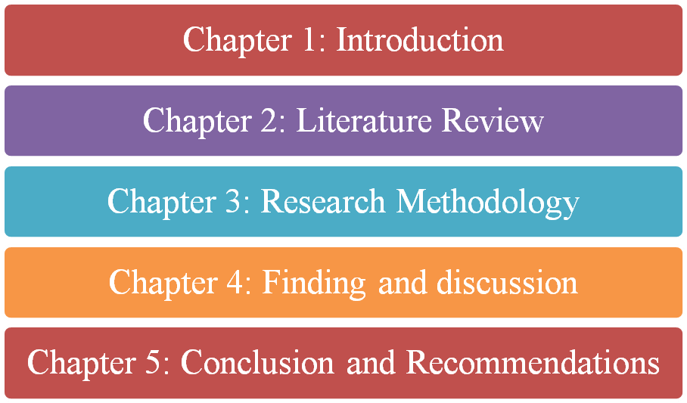

Figure 1.8.1: Research outline
(Source: Author)
This study has been divided into five chapters to specifically discuss each relevant aspect of the research. The first chapter has created a ground for the research by establishing the objective in and questions and providing a background to the study. The next chapter literature review will examine the research topic through multiple sources of literature available on the internet to develop a construct on the concept of women entrepreneurship in the UK. This chapter will also provide a theoretical framework and conceptual framework while also highlighting the dependent and independent variables and analysing the literature gap. In the following chapter the methodology guiding this research will be discussed in detail individually focusing on the philosophy research design approach and strategy. In addition the methodology chapter will specify the approaches taken by the research to collect and analyse data as well as identify the most suitable sample for the analysis. In the findings and discussion chapter the overall data and information gathered from primary and secondary sources will be analysed to explore the research topic through evidence. Finally the fifth chapter will summarise the overall findings of the study, link the research findings with objectives and create a set of recommendations while also reflecting on the research gap and future scope.

CHAPTER 2: LITERATURE REVIEW

2.1. Introduction
Women's empowerment and promoting gender equality on the global stage make access to education, jobs and business opportunities easier for women. As a result, the proportion of female candidates in higher business managerial posts has enhanced all over the globe significantly. Women have adequate potential to make effective decisions in business and thus many MNCs priorities on gender equality to promote female employees to higher designation so that they can contribute the maximum towards organisational goals. Accordingly, the proportion of women entrepreneurs has drastically increased especially in the twenty-first century due to having open access to business resources, funds, debt, capital ventures, networks and mentorship. This section is going to focus on the changed scenario of women's entrepreneurship over years. The significance of women's entrepreneurship and their contribution to boosting the financial growth of the overall industry will be assessed here. Accordingly, common challenges faced by women entrepreneurs in starting up new business ideas will be illustrated along with available access for them to become successful inb business and take financial initiatives. Furthermore, the theoretical aspects related to the research topic are going to be discussed in this chapter besides specific literature gaps.

2.2. The way in which the concept of female entrepreneurship changed over the years
The concept of woman entrepreneurship has been brought to a new light since the Great Recession of 2007/2008 which disrupted the global economy till 2009. As per the observations of Nadin, Smith and Jones (2020), images of women participating in activities are often tagged as “feminine” and are produced and reproduced by the media in a stereotypical construct to match the dominant hegemony. During the Great Recession, women in the UK employed in various sectors dominated by them lost jobs more rapidly than males. The austerity measures that followed resulted in significant budget reductions, widespread layoffs in the public sector and the eradication of job-related benefits such as childcare subsidies and tax credits (Fegitz, 2022). However, in addition to budget cuts from the public sector, the government of the UK implemented numerous programs of labour market activity to bring in new facets of labouring subjectivity for women.
During the recession of 2008, the UK government started focusing majorly on “enterprise culture” where policymakers and authorities viewed small business startups and self-employment as crucial elements of economic recovery (Nadin, Smith and Jones, 2020, p. 558). During this period, an essential focus was placed on female empowerment and women were encouraged to start entrepreneurial ventures and launch their own businesses. As a result, female self-employment and entrepreneurship were brought into a new light following the Recession, and the scenario continues to improve in the contemporary era. According to recent reports by the UK Parliament, 19% of small and medium-sized businesses (SMEs) in the UK were led by women in 2021, whereas 24% of SMEs had “equally-led” employers (Hutton, 2022). Currently, 9% of “SME employers” in the construction industry are women, whereas the percentage is 44% in the education sector, 29% in the “food service” sector, 31% in “arts and entertainment”, 37% in “health and social care” and 30% in other segments (Hutton, 2022).
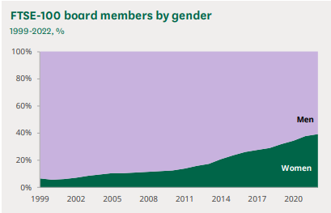

Figure 2.2.1: Men-women proportion in the FTSE 100 directorships (1999-2022)
(Source: Hutton, 2022)
The above statistics show that 39.1% of companies currently identified under the “Financial Times Stock Exchange 100 Index” (FTSE 100) were occupied by females in February 2022 (Hutton, 2022). The 2021/22 monitoring report conducted by the “Global Entrepreneurship Monitor” shows that the “total entrepreneurial activity” (TEA) rate among UK females has increased to 9.7% in 2021, which shows a significant increase in the female entrepreneurship ratio (Hutton, 2022). With a greater focus on woman empowerment and maximising female potential, a significant portion of the UK female population is resorting to self-employed ventures. According to a review study released by the government in March 2019, the UK economy is projected to gain up to 250 billion GBP in value, given that women start launching and selling new firms at a similar rate as males (GOV, 2019). As a result, the governmental authorities have declared an intention to double the female entrepreneurship number by 2030, roughly estimating “600,000 additional female entrepreneurs” (Hutton, 2022).

2.3. Significance of women's intervention in entrepreneurship initiatives
According to the reports, the degree to which lenders and investors in the United Kingdom have supported female business owners, and the Investing in Women Code, a world-leading vow to boost the availability of finance for enterprises controlled by women. Investing in Women Code was developed in response to recommendations by the government-commissioned Rose Review, which was led by NatWest CEO Alison Rose. The goals of the code include expanding access to mentorship and financing opportunities for female company owners in the UK. Women entrepreneurs are playing a significant role to improve the financial standing of a country. Such initiatives help to improve the GDP rate of a country. Apart from that, it is also significant to underline that women's empowerment in the business process helps to build sustainable knowledge which is important in the era of globalisation. According to the findings of Ngoasong and Kimbu (2019), it can be delivered that increasing the rate of women entrepreneurs helps to improve the social structure. Some of the research also highlights those women entrepreneurs are also motivators for a country that stands in a financially backward position.
Additionally, it has been identified by the International financial corporation, (2022), that the contribution of women's entrepreneurship is around 75 million US dollars in the year 2021 with co-investment from the IFC. Thus it is significant to deliver that women entrepreneurs play a pivotal role in increasing the rate of women's employment which helps to improve the economic density according to the high earnings of a company as well as improve productivity in reference to a productive and developed country. It has been observed that the proportion of women entrepreneurs is significantly high in developed countries such as the United Kingdom and the United States. It clearly reflects women can make significant changes in the organisational output with individual and collaborative efforts if they have available access to all resources. As per the studies of Brixiová, Kangoye, and Said (2020), women can be sometimes physically weak with respect to men but they are similar potential in terms of emotional intelligence, innovation and management aspects. Thus, women can contribute along with men to optimise the gross industrial performance in the UK. it has been recognised that the “Women’s Business council” has been established in the UK in 2012 as an autonomous working group with the aim of advising women on how they can contribute to the business sector to optimise the economic growth of the country (Delloite, 2023).
The prioritisation of gender equality in all the business sectors in the UK has helped in empowering women so that they can achieve their deserving designation based on their potential and performance and regardless of their gender identity. Corporate jobs at managerial posts assist female employees to gather practical experience to start up their own businesses based on innovative business ideas and exceptional execution plans. The UK government has backed female-led business initiatives to maximise the financial growth of the nation and encourage more women to follow their passion and invest in new businesses. As a result, around 150,000 enterprises have been developed by female entrepreneurs in 2022 which is near about two times of 2018 (Pioneer post, 2023). Most interestingly, many of these new businesses have been created by young women who are 16 to 25 years old. Organisations led by female entrepreneurs represent around 20% of the overall business in the UK in 2022 which was approximately 16% in the fiscal year 2018 (Pioneer post, 2023). It clearly reflects the significant contribution of women entrepreneurs in the UK in terms of financial initiatives and the capability of female candidates in operating businesses successfully.

2.4. The importance of women entrepreneurs to improve the financial standards
The research based on women entrepreneurs highlights that Alison Rose, CEO of Natwest is one of the most famous and reputed names of women entrepreneurship in the UK. A report based on NatWest group highlights that the organization has earned around $16.844B in the year 2020. Therefore it is important to deliver that Alison Rose plays a significant role in improving the company’s business and carrying it forward. Apart from that, Sharon White is another important name in the UK business industry and she is in the chair of John Lewis. A report based on John Lewis shows that the company has around £7.785 billion in assets according to the FY2022. It is also seen that the company has around 80,800 Partners or employees according to 2020. According to the idea of Smith et al. (2020), it can say that the employment rate of a company plays a significant role to improve the financial standing of a country.
The latest census reveals that over 70% of the overall social enterprises in Scotland are led by women entrepreneurs (Pioneer post, 2023). Therefore, it is clear that the contribution of women entrepreneurs plays a significant role in boosting the national economy of the UK. Women empowerment in professional fields on the global stage encourages women all over the world to start up new businesses. It has been estimated that around 163 million women run their own businesses in 74 countries all over the world in 2016 (Prowess, 2022). Most importantly, among all of these businesses, 111 million business enterprises were already established sustainable positions in their concerning markets. The scenario of women entrepreneurship has been drastically enhanced in the US in the last decade. It has been observed that near about 30% of all businesses in the US are led by female owners (Prowess, 2022). Accordingly, women-led business in the US is growing at twice the rate of overall new businesses. It has helped in enhancing the economic clout of the US by depending on the capability of women entrepreneurs and offering them all plausible resources and access to operating businesses successfully.
It is important to empower women in business and professional fields to utilise their capabilities and potential to optimiseorganisational performance and meet business goals. According to the statistics, 1 out of every 3 entrepreneurs in thre UK is female which reveals the uplifting scenario of women's entrepreneurship in the UK (Prowess, 2022). It has been recognised that 5.6% of women in the UK were associated with their own business in 2017, while the proportion in the US, Canada and Australia were 11%, 15%, and 9% respectively (Prowess, 2022). It clearly portrays that the gender gap in entrepreneurship in all developed countries around the globe has been decreasing remarkably and the contribution of women in finance initiatives has grown drastically. On the contrary, businesses led by female entrepreneurs in the UK have a comparatively greater churn rate. In this context, most women entrepreneurs denied to accept the business closure due to business failure rather they cited it as personal reasons at the peak age of 25-34 years. It impacts the success and sustainability rate of women-led businesses in the UK. However, the contribution of women entrepreneurs in finance initiatives has been growing day by day. It has been expected that the participation of female candidates in the UK SME sector is going to enhance by 10%, and the contribution of theses of overall women-led SMEs will cross the benchmark of 180 billion British Pounds by the financial year 2025 (Deloitte, 2023). Moreover, women entrepreneurs in the UK can give a boost of 100 billion GBP in the next 10 years with the facility of government backup and assistance.

2.5. Analysis of the challenging factors faced by women entrepreneurs to improve the financial structure
Maintaining the aspect of entrepreneurship is challenging for women according to the business policies of a country. Therefore, it is seen that gender biases are one of the biggest factors that affect the business density of start-up companies. Moreover, past studies based on the research objectives also highlight that Unequal Payment is another complication that most women entrepreneurs is facing to enhance their business process.
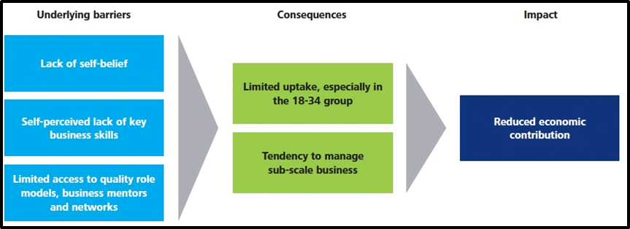

Figure 2.5.1: Challenges in Women's entrepreneurship in financial initiatives
(Source: Adapted from UK Consultancy, 2022)
According to the above-mentioned figure, it is significant to underline that lack of self-belief, proper business development skills, and limited access to business potentiality are some of the common barriers for women to maintain entrepreneurial activities in the competitive business world (The World Bank, 2022). As a result of the complications, it is also seen that economic contributions are significantly reduced to maintain a continuous business process. There are several challenges faced by women entrepreneurs in order to start up their own businesses. The first issue related to personal empowerment; it has been noticed that female candidates generally face challenges regarding self-confidence and self-belief while working on new business ideas. The main challenge a women entrepreneur faces regarding start-up is arranging funds or venture capital for the new business. Generally, private investors do not want to invest easily in a female entrepreneur due to a lack of experience in business management and self-belief (UK Consultancy, 2022). Thus, arranging funds for the business becomes very challenging for all women entrepreneurs. In most cases, women entrepreneur start their own businesses by gathering funds from personal savings or family members. Along with this, insufficient self-perceived business skills cause difficulties in operation management, especially finance and marketing management. Accordingly, the major proportion of women-led businesses in the UK lies in the employee range of 2-10 as they mainly prioritise sub-scale businesses.
In addition, most women entrepreneurs in the UK do not have enough experience working in large scaled organisations or MNCs. As a result, they do not have in-depth ideas on how to manage different business operations and build strong networks to make the business operation smooth and comfortable. Thus, the limited role models and mentorship related to entrepreneurship make the job more difficult for women entrepreneurs. Besides this, poor business networks create hindrances in business expansion and thus the uptake of business becomes very limited (UK Consultancy, 2022). A lack of initiative in women entrepreneurs in investing in large-scale ventures or technology start-ups has been identified due to having limited resources, financial backup, knowledge and experience. As per the studies of Cohen et al. (2019), it is crucial to give full-time concentration and effort to start-up businesses to uphold their economic sustainability. However, women in the age group of 25-34 years have failed to maintain the success of their own businesses due to personal reasons including spending time with families and motherhood. It impacts the contribution of female entrepreneurs to the national economy as well.

2.6. The scenario of strategic planning to mitigate the complications associated with financial growth done by women entrepreneurs
It is important to ensure a sustainable process for improving the complex attribute associated with the participation rate of women in entrepreneurial activities. As stated in the following figure in the year 2014 women-led GVA was £85 billion in the sectors of SMEs following such a rate of contribution it is significant to ensure that such a rate of Gross Value (UK Consultancy, 2022). The addition helps to improve the complications among women entrepreneurs as well as helps to build a sustainable business strategy that is important and relevant to build a policy focusing on the financial year of 2025.
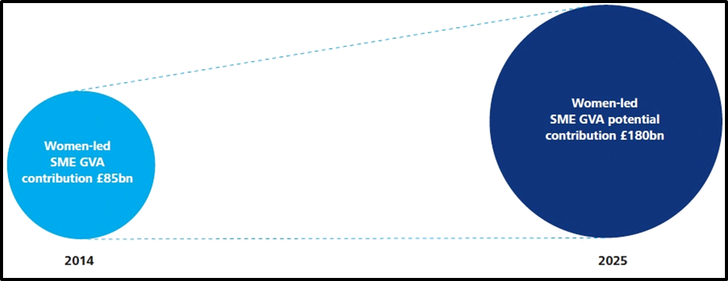

Figure 2.6.1: Effective contribution of Women led entrepreneurial business in the economy of the world.
(Source: Adapted from UK Consultancy, 2022)
According to the business idea of Prowess (2022), it is also underlined that the GVA rate will be increased to around £180 billion within the year 2025 in the sector of SMEs, Thus it is significant to deliver that such a study helps to maintain a potential outcome based on the analysis. Moreover, this segment is also important to underline a compact knowledge to develop a dynamic strategy that is relevant to the objective of women's potential as entrepreneurs in the UK financial development and growth.

2.7.Enabling access to finance for women entrepreneurs
The UK government has taken multiple initiatives to enhance the number of women entrepreneurs by half by the financial year of 2030 (GOV, 2022). The minister of “women and equalities”, Liza Trusas has launched a task force to empower women and provide required facilities to them to encourage entrepreneurship by recruiting Anne Boden (CEO of Starling bank) as the chairperson. The government is trying to mitigate the gender gap in entrepreneurship as it can boost the economy of the country by generating around 250 billion GBP (CNBC, 2019). Thus, the government offers easy access to funding for women entrepreneurs to support and encourage them. In this context, the government found allows a female entrepreneur to grant easy loans between 1,000-500,000 GBP on an unsecured basis where no collateral is required (SME Loans, 2022). The loan is provided with a very low-interest rate and fixed monthly installments to repay the debt with a timeline of 1-3 years. Besides this, the government has taken initiative to provide free mentorship to female entrepreneurs and assistance in making strong business networks to minimise the gender gap in this context.

2.8. Theoretical framework
Feminist theory
Following the objective of feminist theory and its dimensions, this content will follow the objective of liberal feminism. Through analyzing the information of Akteret al. (2019) that Liberal feminism even screamed as mainstream feminism, according to the objective of the central concept of feminism characterised by its direction on reaching gender parity via political and permitted reform within the concept of liberal democracy. Apart from that, the main objective of liberal feminism tries to focus on gender parity in the general globe, such as similar education, equivalent pay for comparable outcomes, concluding gender biases at employment, and more reasonable working circumstances. From this standpoint, modifications in the law will construct these goals achievable.
Three-dimensional model of women empowerment
The three-dimensional model is based on three fundamental pillars which should be followed by women to chase their dream. As per the studies of Dewi (2021), It is high time to empower women by giving them all access to use their potential in maximising financial initiatives across the globe. The complete empowerment of women depends on these three factors:
- Personal empowerment: It is all about controlling life and making effective decisions according to self-goals and expectations. Women have to prioritise self-esteem, self-discipline and self-confidence to empower themselves personally. Besides this, actual employment refers to the ability to convert the international into action with proper execution strategies.
- Relational empowerment: Entrepreneurs have to acquire knowledge regarding team management and how to interact with diverse people. As per the views of Dewi (2021), relational empowerment can be achieved by focusing on interpersonal skills to make strong relations with people.
- Societal empowerment: It includes the ability to make the effective decision to enact required changes. Thus, women need to focus on building confidence, power, and autonomy to empower individual performance and make exceptional changes in society.
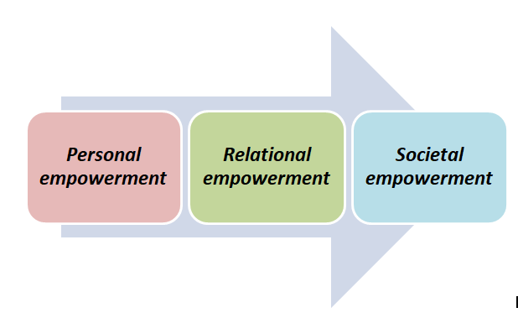

Figure 2.8.1: “Three-dimensional model”
(Source: Self-developed)
Cochran’s theory of entrepreneurship
It is a sociological theory related to entrepreneurship and it is completely separate from other theoretical aspects as it assesses the entrepreneurship programs with respect to social aspects and associated processes. Entrepreneurship can introduce a robust change in technologies, social institutions, and organisational outcomes through exceptional innovation and it can produce new business ideas (Cochran, 2019). Various scholars have analysed the different aspects of entrepreneurship including economic, psychological, cultural and sociological aspects. Here, Cochran’s theory is going to be illustrated to analyse the sociological context regarding entrepreneurship.
“Cochran's theory of entrepreneurship” is developed by Thomas Cochran in the year 1965. This particular theory evaluates the approaches of an individual to be an entrepreneur by considering the expectations from his/her profession and the occupational hazards he/she might have to face. It depicts that entrepreneurship majorly depends on specific variables such as social sanctions, cultural values and role expectations (Cochran, 2019). Cochran's theory proposes that entrepreneurs can not be super-normal individuals; rather they have to comprise modal personalities. According to Winkler et al. (2022), modal personality refers to the behavioral trait that some individuals can develop to respond to cultural, psychological and neurological factors. Thus, entrepreneurs need to be very innovative and visionary to make huge differences with exceptional ideas and have the power to shake the social conventional norms. The theory conveys that an entrepreneur is shaped by the following factors:
- The attitude of individuals towards their passion, and profession
- Operational requirements related to the profession
- The expectations related to the societal role
- The capacity of dealing with social acceptance and economic hazards.
Thus, according to this theory entrepreneurs regardless of their gender identity have to face occupational and societal challenges. In this context, modal personality, innovativeness, and strategic determination can bring the expected success in entrepreneurship.

2.9. Dependent and independent variables (DV and IV)
As opined by Bulturbayevich and Abdulkholik (2022), it is crucial to identify the important variables for research work to accomplish the formulated objectives by determining the relationship between these variables. These variables can be categorised as dependent variables (DV) and independent variables (IV). The relationship between DVs and IVs evaluates the conceptual framework of particular research. Based on the discussion, the DV and IV of this study are as follows:
Dependent Variables: DV refers to the variables that depend on other variables. Here, the DV are women's entrepreneurship, and financial initiatives are taken by women.
Independent Variables: IVs are those variables that do but depend on others. In this study, gender equality, feminism, women empowerment, and available open access to entrepreneurship have been considered IVs.

2.10. Conceptual framework
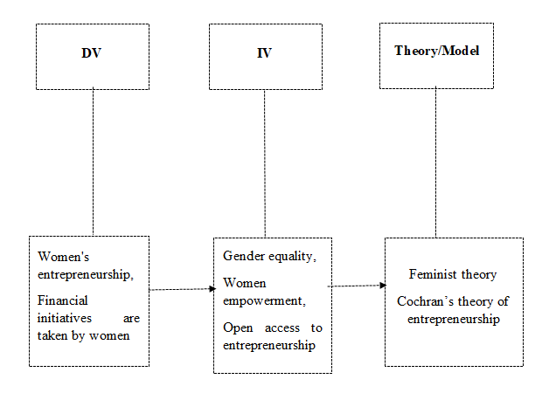

Figure 2.10.1: Conceptual framework
(Source: Self-created)

2.11. Literature gap
The research faces some major complications to accumulate accurate data based on the objectives. As per the studies of Wallis and Wright (2020), it is important to determine literature gaps specifically to conduct data collection on the uncovered areas to explore relevant information that can enrich the quality of the current research. While conducting this particular study, certain information was missing in the previous studies. There are no such particular materials in the secondary sources that illustrated the change in the scenario of women's entrepreneurship over the last two decades. Repetition of the same data on the secondary sources makes the literature review very limited in terms of covering a wide range of aspects related to the research topic.
In addition, differences in the same information in different existing studies arouse questions regarding the authenticity of data. For instance, challenges faced by women entrepreneurs in terms of microfinance initiatives have fewer details to include in this study. Also, potential strategies for the mitigation of the issues developed by women entrepreneurs with regard to financial initiatives have fewer details in past studies. This study will focus on addressing these gaps with appropriate information. Moreover, there are several stories of successful women entrepreneurs; however how they get success or from where they get access to resources, funding and business networks have not been assessed anywhere in detail. It makes the literature findings and reviews limited up to a certain limit.

2.12. Chapter Summary
The Literature review chapter has discussed the overall scenario of women's entrepreneurship over years and how it rapidly changed in the last two decades. The essence of women's intervention in the global business sector and financial initiatives has been assessed here. It has been observed that female entrepreneurs contributed remarkably to accelerating economic growth. Women entrepreneurs came up with exceptional business ideas and made effective decisions to assure lucrative outcomes. However, they have faced several challenges in setting up and continuing business sustainably which are discussed in this section. On the contrary, available opportunities and access to female entrepreneurs have been evaluated here along with theoretical aspects. Moreover, the conceptual framework of the study and existing literature gaps have been illustrated which would be adhered to in the next sections of this study.

CHAPTER 3: RESEARCH METHODOLOGY

3.1 Introduction
This particular chapter has aimed to elaborate all the methodologies, tools and techniques adopted for the current study area. In order to follow a systematic method, a research onion has been developed before selecting the suitable yet most effective research methods and strategy to outline the major findings and interpret the data then thoroughly analyze it. All the methods, tools and techniques have been selected accordingly to distinguish the actual factors and facts related to the role of women entrepreneurship in the UK’s financial industry. Following the research onion framework, this chapter has shed light on research philosophy, research design, research approach and research strategy. It has phenomenally discussed the data collection tools and data analysis method including sampling method for this research area. A good discussion has also been done on the ethical considerations that have been taken for this current topic of interest.

3.2 Research Onion
A framework of research onion has been followed throughout the methodological section of this particular research. According to the statement of Al-Ababneh (2020), a research onion is a systematic framework that helps to design or create a robust research methodology. Here, the development of the research onion framework has helped to make a series of decisions in a systematic manner. Based on those decisions, research philosophy, design, approach and strategy has been constituted. There are six basic layers included in the framework of research onion such as research philosophy, research design, research approach, research strategy, research choices, time horizons and techniques & procedures. Here, for this particular research the process of data collection, data analysis, sampling process and ethical consideration has been exhaustively discussed. Additionally, the research onion has also said to highlight the rationale behind every selected tools, techniques and methodologies which has aimed to lead the overall research or study to retain proper conclusion at the end of analysis.
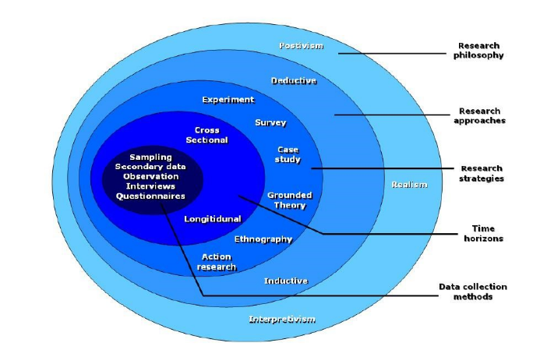
Figure 3.2: Research Onion
(Source: Al-Ababneh, 2020)

3.3 Research Philosophy
In general, a research philosophy refers to a belief regarding data gathering process, analysis and needs to be used based on a particular phenomenon. Researchers and scholars mainly utilize four different types of research philosophy that includes pragmatism, positivism, realism and interpretivism. In this particular case, positivism research philosophy has been selected. Pragmatism research philosophy refers to a type of research philosophy that highly incorporates operational decisions that crucially looks for the most appropriate answers against of asked questions Casulaet al. (2021). On the other hand, realism research philosophy tends to explain the actual cause or mechanism that is used to generate an observed phenomenon. Meanwhile, interpretivism research philosophy strictly relies on the assumptions that state reality is subjective, multiple and socially constructed. Therefore, based on the different meanings of each research philosophy, it is observed that the positivist research philosophy is suitable for this specific research area or study. The positivism research philosophy has been selected here to create belief in the data collection procedures. As per the report of Al Harahsheh and Pius (2022), among various other research philosophies, positivism philosophy provides in-depth knowledge about the research topic to measure the outcome of the research. Henceforth, the positivist research philosophy has been assumed to be the most suitable for this particular research area.
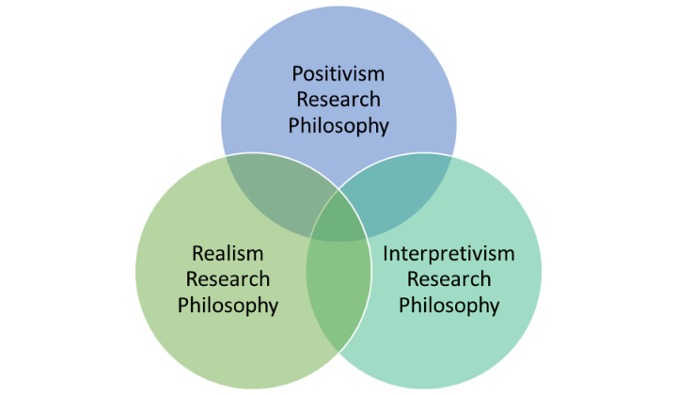
Figure 3.3: Research Philosophy
(Source: Casulaet al. 2021)

3.4 Research Design
Research Design is the second most important layer within the research onion framework. Research design is commonly defined as the blueprint of any scientific study. According to Asmussen and Møller (2019), research design can be vast and various , although it mainly identifies and addresses the major issue that may occur during the process of research and design. There are four types of common research design used in a study that includes descriptive research design, correlational research design, experimental research design and diagnostic research design. Among all types of research designs, descriptive research design is the only research design that prefers to systematically obtain all the valid and valued information to define a particular situation, population or phenomenon. Based on completing this research study the descriptive research design has been selected. On the other hand, correlational research design is different from any other types of research designs, as it investigates relationships between two or more variables without manipulating or highly controlling any of them. Apart from this, it has been explained that experimental research design aims to build the effect as a factor or independent variable impacting over a dependent variable. While, diagnostic research design specifically puts its concentration on evaluating the major reason of a specific phenomenon or issue. As per the information of Maben et al. (2018), descriptive research design permits the flexibility of the researchers to proceed with multiple methods of data collection. Hence, descriptive research design aids the study to arrive at an effective outcome based on both primary and secondary research data and information.
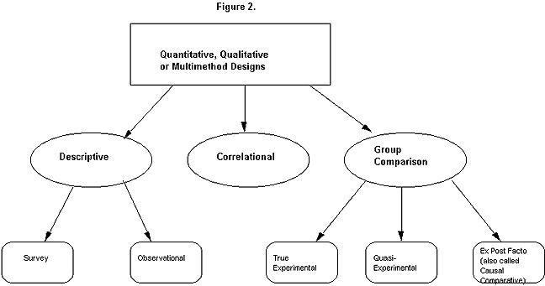
Figure 3.4: Research Design
(Source: Asmussen and Møller, 2019)

3.5 Research Approach
It has been stated that in research methodology, research approaches are the plans or procedures or conducting a particular research. In the views of Patel and Patel (2019), research approaches are also defined as the span of several stages starting from the broad assumptions to the detailed methods of data collection, data analysis and interpretation. There are two types of research approaches mostly used by researchers and scholars around that world and that includes deductive research approach, inductive research approach and deductive research approach. A deductive research approach under research methodology, critically concerned with development of hypotheses relative with any existing theory. Meanwhile, the inductive research approach is different from the deductive research approach. Inductive research approaches act along with moving specific observations to broad generalizations. Here, this particular research has chosen an abductive research approach to collect data, analyze the gathered data and interpret based on the entrepreneurship of women in finance initiatives. Along with that, as stated by Mitchell and Education (2018), the abductive research approach permits the researcher for intuition and creativity to broadcast theoretical elaboration and to comprehend the generalizable along with the specifics of the experimental phenomena. Therefore, the Abductive research approach has been effective for this research study. Furthermore, one of the major reasons that compared to other two research approaches such as deductive and inductive research approach, abductive research approach has been selected, as this particular research approach allows for intuition and creativity that further informs theoretical evolution.
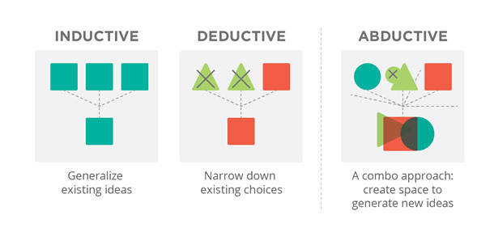
Figure 3.5: Research Approach
(Source: Patel and Patel , 2019)

3.6 Research Strategy
Research strategy in under research methodology refers to an overall plan that is essentially required to conduct a study. As per the view of Rashid et al. (2019), it has been stated that the development of a good research strategy allows a researcher to effectively plan, execute and monitor the study. In addition to this, it has been further highlighted that there are three common research strategies that exist which include quantitative research method, qualitative research method and mixed research method. It has been stated that quantitative research method refers to a type of research method that mainly collects and analyzes numerical data. In contrast to this, qualitative research method is different from quantitative research methods as it involves collecting or gathering non-numerical data (Sharma et al. 2023). Qualitative research method highly focuses on understanding the important concepts, opinions or experiences including grounded theories, descriptive account of practices and uses various methods such as participants observations. The mixed method has been selected here to conduct the entire research methodology. Based on the opinion of Crespo et al. (2021), the mixed method strategy such as qualitative and quantitative helps the researcher in gaining in-depth knowledge about the provided topic and meet the research questions effectively. Therefore, based on meeting the research question, the Mixed method has been assumed to be suitable. Apart from this, one of the major reasons this particular research has been selected is the mix-research method rather than the quantitative or qualitative research method, as it compromises both numeric and non-numeric information in a study. It aims to strengthen overall study through establishing both statistical and observational viewpoints.
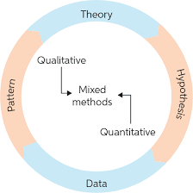
Figure 3.6: Mixed Research Method
(Source: Sharma et al. 2023)

3.7 Data Collection Tools
It has been already reviewed that this particular research paper has been selected to use a mixed method that includes both “primary quantitative research” and “secondary qualitative research”. Here, the primary quantitative research has been done through conducting a survey using google forms of 51 people who are related with the finance industry in the UK. On the other hand, for secondary qualitative research, multiple research on secondary resources has been done that has investigated vast and various journals, articles, news , websites and others (Beck, 2019). This research is going to adopt mixed methods for critical analysis. It has to adopt pets “primary quantitative and secondary qualitative” for detailed observation of this research. Based on gathering the primary quantitative data, 10 survey questionnaires that have been for the selected 51 participants from different backgrounds, which are provided in appendix 1. Additionally, based on gathering 51 responses, the primary data and information has been collected. Along with that for collecting secondary data and information journals, articles, websites and news reports have been gathered. Additionally, all the data has been gathered from authentic websites and databases such as Google scholar, PubMed, and ProQuest. Apart from this, it has been further acknowledged for statistical interpretation of the data, it has used MS-Excel as a software for statistical analysis to solve the numerical answers in easier and simpler ways.

3.8 Data Analysis Method
The Data Analysis Method has been done through using both “statistical analysis” and “thematic analysis”. As per the report of Mikalefet al. (2020), statistical analysis in a research field refers to the science of “collecting”, “exploring” and “presenting” large amounts of data that helps to discover various underlying trends and patterns. Hereby, in this case for statistical analysis, an online survey has been conducted using google forms for 51 participants who are associated with the finance industry in the UK. a pre-questionnaire has been prepared to set both demographic and non-demographic questions that have been asked from each individual participant. Furthermore, for analysis of statistical data or collected information MS-Excel as a software programing has been used which has formed the collected numeric information or data in the form of descriptive statistics, regression, correlation, histogram and others. Meanwhile, here the thematic analysis has been done based on research questions that have been outlined during the previous section or chapter of the research. Related to those questions four different themes have been created and the information and relative yet relevant data has been explored from various articles, journals, news, pdf documents and many others. Additionally, two types of data analysis procedures have been selected here for interpreting the data and information of this given study. Analyzing the primary data and information has been done in this study with the help of creating pie charts and statistical graphics has been used as well for interpreting the secondary data.

3.9 Sampling Method
In general, sampling methods in a research method refers to the process of selecting a group which has been used for data collecting in a research. As per the statement of Gabriel et al. (2019), it has been stated that sampling or sampling method allows a researcher to test hypotheses based on the different characteristics of a population. Researchers use different types of sampling method that includes “simple random sampling method”, “systematic sampling method”, “stratified sampling method”, “cluster sampling method”, “convenience sampling method” and others. It has been stated that systematic sampling method is a type of method that allows researchers to select members of the population based on regular intervals (Bhardwaj, 2019). In addition to this, sampling method refers to a process that is used for statistical analysis and it undertakes a predetermined number of observations within a large population. It has been seen that this particular research has chosen a random sampling method. The 51 random participants were selected for the primary survey because it has given an overall idea of the overall situation and authentic journals, websites and new articles have been used for the secondary qualitative data. It has ensured that all the journal articles and news websites that have not been more than five years old which helps in collecting up-to-date information about the research question. In addition to this, the random sampling method refers to a type of sampling technique that states each sample has equal probability of being chosen.
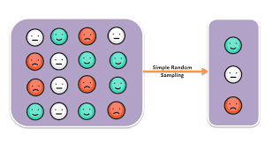
Figure 3.9: Simple Random Sampling Method
(Source: Bhardwaj, 2019)

3.10 Ethical Considerations
Ethical consideration in a research or study demonstrates a set of principles or guidelines for a research design and practices. As per the statement of Brittainet al. (2020), ethical considerations allow a researcher to critically follow the ethical guidelines that is essential required for a particular research paper to gather information, analyze and interpret it, effectively. Similar to every common ethical consideration principle maintained in a research paper it includes “voluntary participation”, “informed consent”, “anonymity”, “confidentiality”, “potential for harm” and results of communications. All the ethical considerations have been maintained while conducting this entire research based on the entrepreneurship of Women in the financial initiative in the UK. The gathered data and information has been protected by the “Data Protection Act of 2018” (The UK Government, 2022). Additionally, the trustworthiness has been maintained by providing credit to the authors of the collected journal articles. Along with this, full consent research has been obtained from the participants regarding prior to this study. Furthermore, the protection of privacy or security of every individual participant has been also ensured throughout the research and survey. Apart from this, it has been also reviewed that each of the participants were aware of the survey and the research before their participation and they have participated in the research with full and clear concerns.

3.11 Chapter Summary
In conclusion to this particular research chapter, it can be stated that each of the methods, tools, techniques and strategies that has been chosen for this particular topic of interest has been suitable and yet effective to disclose all the valid and valuable information and data. It has been foreseen that this study has chosen a mixed research method which means both qualitative and quantitative data has been gathered. In specific to this, primary quantitative research method and secondary qualitative research method has been adopted. Under the primary quantitative research method, a survey of participants has been done through google form. Meanwhile, under a secondary qualitative method, thematic analysis has been done which has primarily created different themes aligned with research questions. In addition to this, it is also observed that research onion framework has been used to acknowledge research philosophy, research design, research approach and strategy has been selected. For example, positivism research philosophy, descriptive research design, abductive research approach and mix research strategy has been chosen. On the other hand, a simple random sampling method has been chosen and the research paper has also concerned about the ethical principles in order to make the research free from any error.

Chapter 4: Findings & Discussion

4.1 Introduction
In this particular section, the major findings and a detailed discussion has been outlined based on the current research topic. It has been observed that to find out the major factors, causes or any phenomenon, it has used both primary quantitative method and secondary qualitative method. The primary quantitative method has been aimed to provide a statistical analysis of the research. While the secondary qualitative method has been used to provide a thematic analysis over the information and data has been scattered related to the current topic of interest.

4.2 Primary Data Analysis
The survey which was created regarding the role of women entrepreneurs in the finance industry within the sector of the UK has generated positive responses. The investigator has also used a random sampling method in choosing 51 responses from the total survey.
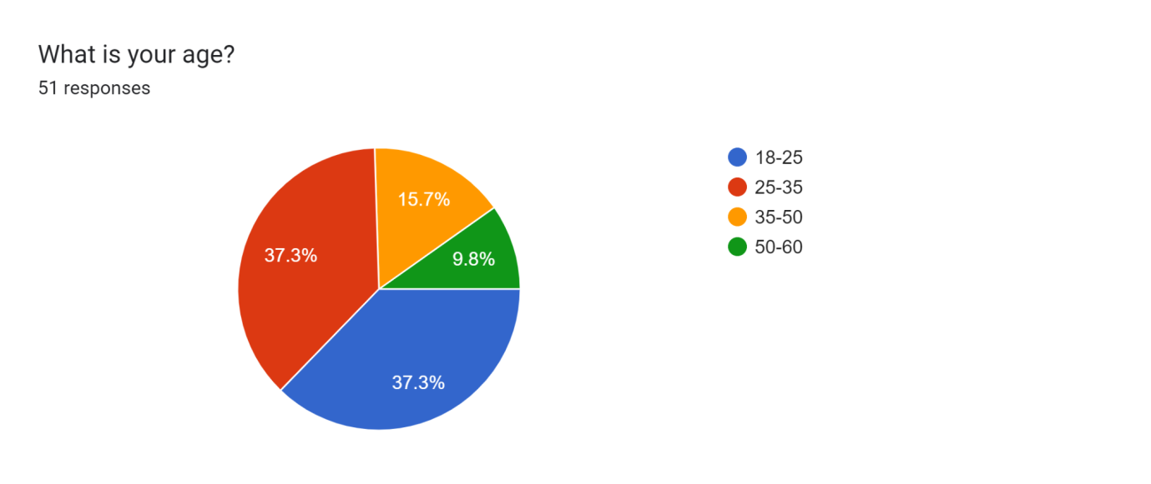
In this it can be seen that most of the respondents are between the ages of 18 to 25. This has helped in generating positive response throughout the survey as the younger people having the positive mindset of women entrepreneurs in the finance industry is helpful in supporting and encouraging the same cause.

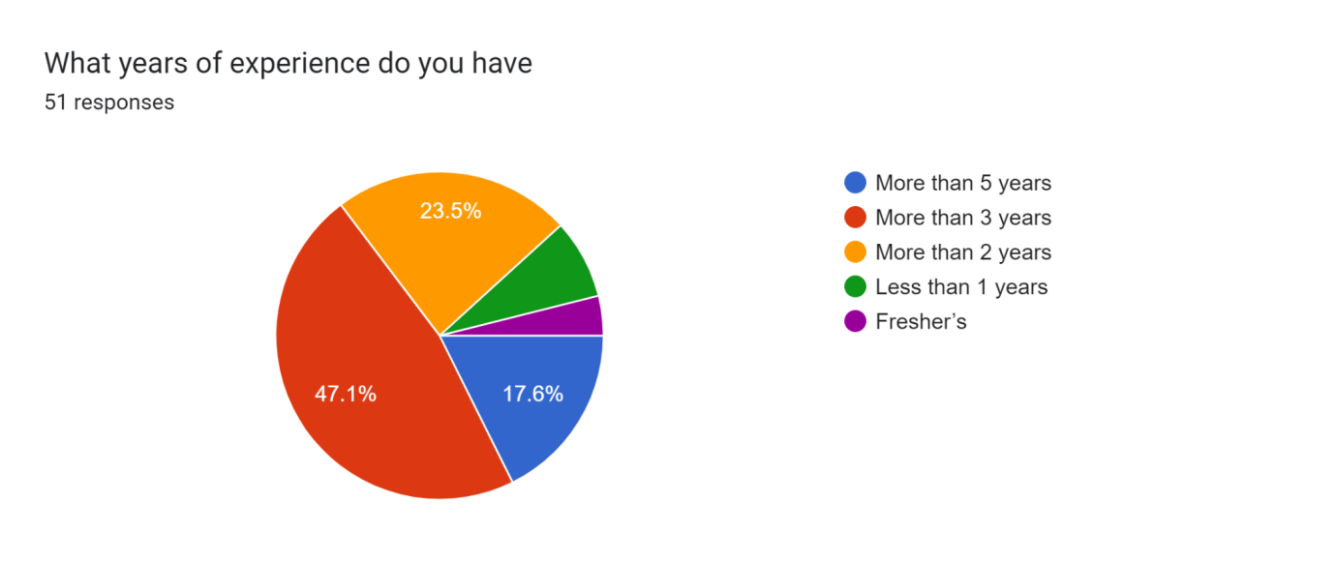
In this result it can be observed that most of the participants in the survey have a work experience of more than 3 years. This clearly States that the participants have a knowledge regarding the finance industry in the market segment of the UK and the stature held by women entrepreneurs in the same. In addition to it the participants who responded in the survey also have acquired the work experience of more than 10 years and more than 5 years prior to it.
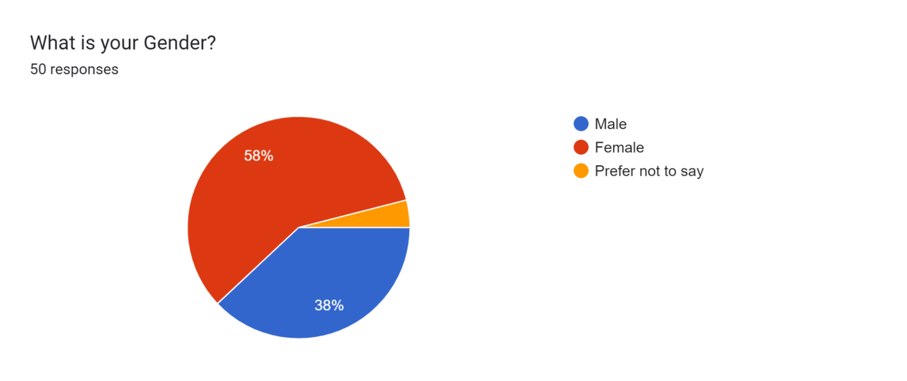
In this it can be noticed that most of the participants in the survey are female therefore they closely understand the problems which are faced by women entrepreneurs in the UK segment. Approximately 38% of the participants are male in the survey and 58% are from the female category. A small group of participants also prefer not to divulge their gender but have generated active responsiveness in the survey.
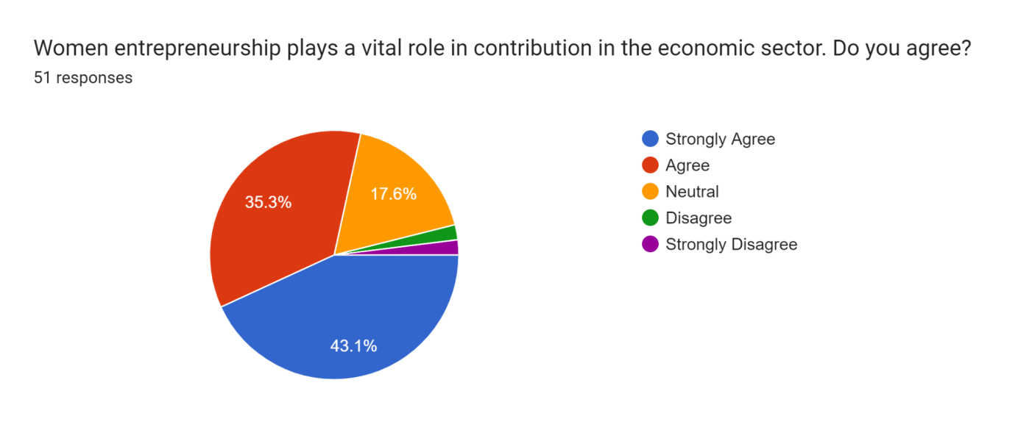
In this result it can be noticed that 43.1% of the participants strongly agree with the fact that women leaders play a vital role in contribution to the economic sector. This also reflects the fact that women have been playing pivotal roles in the management and other streets that are directly influencing the GDP contribution and creation of economic opportunity for other individuals (Aruna and Sunil, 2020). Approximately 35.3% participants also agree with the fact of women playing an important role in uplifting the economic sector and contributing to the opportunities made for other individuals and companies. 17.6% of individuals are also neutral to the fact that they neither support nor deny the claim. Small group of participants are also disagreeing with the fact stated above.
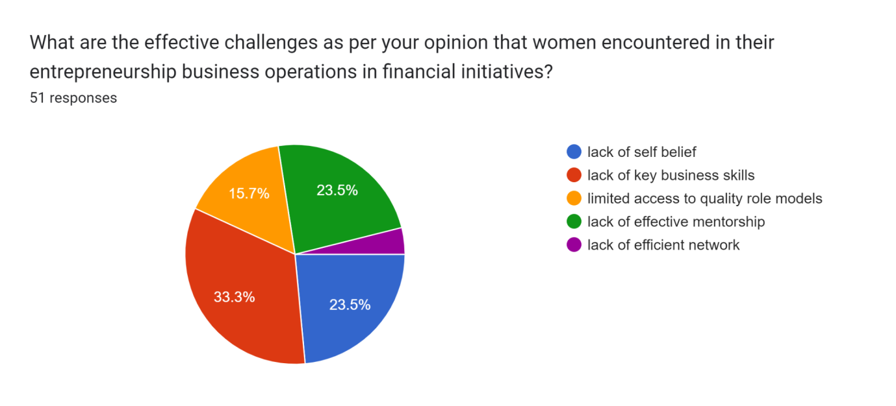
In this survey it can be noticed that 33.3% of individuals agree that lack of business skills are the effective challenges that are encountered by women entrepreneurs in business operations and financial initiatives. There are many other challenges that are faced in commencing business operations that are to be tackled down using efficient resources and expertise upon the market segment for creating better opportunities for the company as well as the individual(Onoshakporet al. 2020). 23.5% of individuals are also accepting that lack of self belief and lack of effective mental shape are also the vital challenges that have to be overtaken using profitable planning. 15.7% of the individuals believe limited access to quality role models are the main challenges that are faced by women entrepreneurs in business operations and financial initiatives.
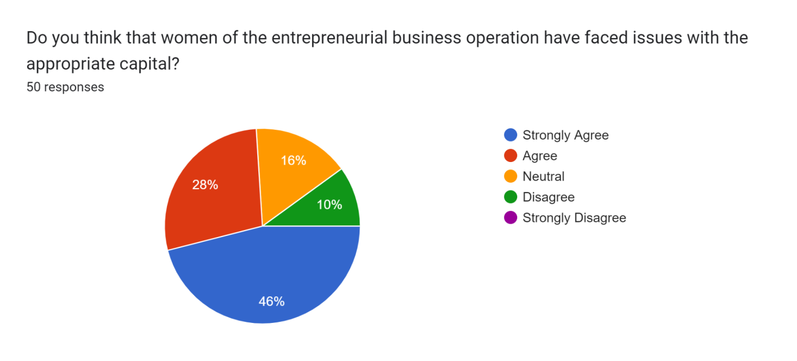
In this result 46% of individuals strongly accept the fact that women in entrepreneur business operations are facing issues concerning appropriate capital. This is mainly due to the fact that the entrepreneurs are facing challenges in defying the social expectations and have to actively participate in enlarging their business network. In addition to this they would also have to generate greater accessibility regarding investors for fundraising (Avnimelech and Rechter, 2023). Women entrepreneurs also need to undertake proper accomplishment using vital role models and supporting networks that would help them in balancing business as well as family life. Coping with the fear of failure is also the vital variable that encourages women in struggling and acts as a milestone. In addition to it 28% of the participants from the survey are also agreeing to the fact in issues being faced in appropriate capital. It has also been noticed that 10% of the individuals are disagreeing with the fact however it is evident that the issues are being faced by women entrepreneurs in business operation regarding appropriate capital.

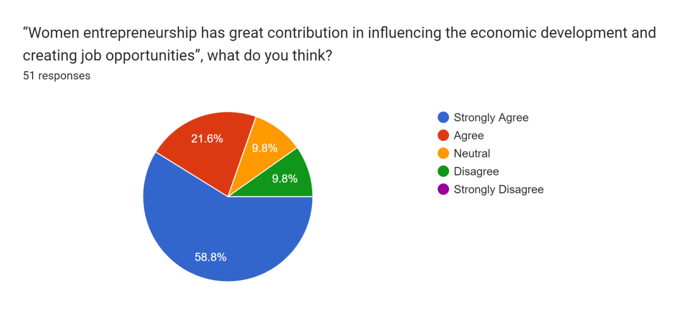
In this result it has been noticed that 58.8% of the individuals are strongly agreeing to the fact that women entrepreneurs have a great contribution in influencing the economic development as well as job creation opportunities. Rise of female business owners in the current global scenario is highly noticeable and has been pulled within business ownerships with the active involvement in choosing self employment (Alva et al. 2021). In addition to this the woman also dominates many of the micro enterprise sector within rural as well as urban areas. Micro enterprises are one of the main strongholds in influencing economic development and are largely participating in the taking care of the residents by increased job opportunities. These enterprises are also a result of innovation and contribute for improvement within living standards of the localized individuals. In this result 9.8% of the participants are neutral to the fact. On the other hand, 9.8% participants are also disagreeing with the fact that women entrepreneurs contribute to economic development as well as job opportunities.
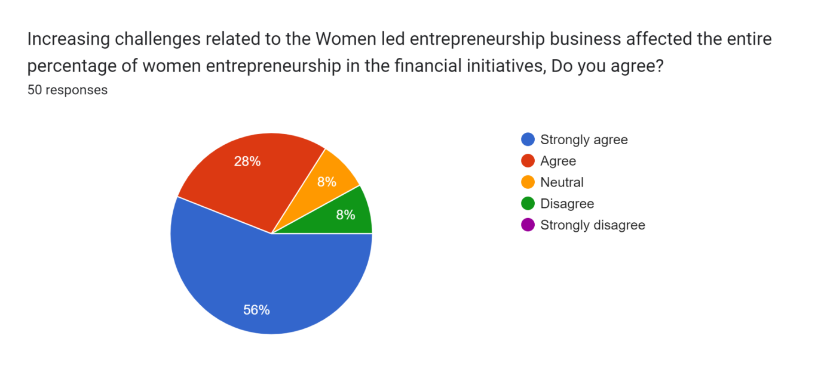
In this result 56% of the participants strongly agreed to the fact that there are increased challenges related to women led entrepreneurships businesses which affect the entire percentage concerning women entrepreneurship in financial initiatives. The main challenges which are faced by women and business entrepreneurship are the fewer sectors being women friendly and actually promoting gender equality within their business hierarchy. In addition to this they also have to counter lack of social as well as institutional support that is required in kick starting their careers (Street et al. 2022). Women business owners are also prey to poor funding prospects that are massively gender biassed. The owners also face the lack of access in professional markets and the insufficient survey results are not able to generate greater opportunities for their business. Limited mobility as well as lack of business expertise is also one of the major drawbacks that are being faced by female business owners that is evidently hampering the playing field. In addition to this the results also show 8% of the individuals disagreeing to the fact of the increasing challenges that are faced by women entrepreneurs in financial initiatives.
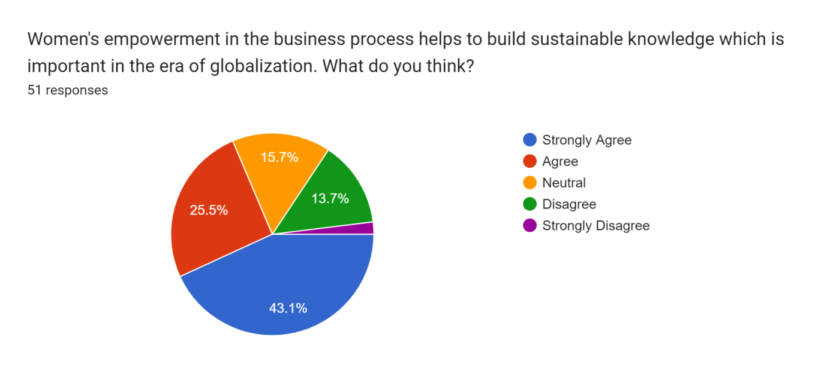
In this 43.1% of the participants are strongly agreeing to the fact that women empowerment within the business process helps in building sustainable knowledge that is important in globalization. It is evident that the equal accesses within education as well as employment opportunities create the profitable conditions within the market segment and lowers the inequalities while removing the key hindrances in advancement. Women empowerment is also helpful in initiating the major shift with the mindset that would lead to the positive attitude towards development of individuals and society as a whole. Additionally active participation of women is also helpful in the critical decision-making process and possesses the positive impact upon social protection as well as health of the society. Women entrepreneurship is also helpful in obtaining power as well as wealth with the support of a positive attitude and the necessary self confidence that is required for profitable business. In this result 15.7% of participants have also stated their neutral point of view in the fact that women empowerment in the business process helps in building up sustainable knowledge that is important in globalization.
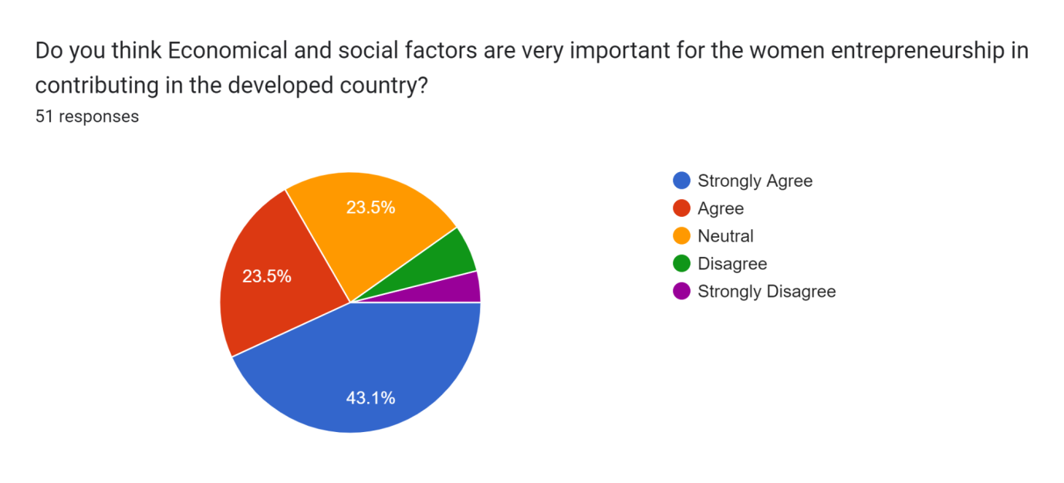
In this result it has been noticed that 43.1% of individuals are strongly agreeing to the fact that economic as well as social factors are important for women entrepreneurship to contribute to the development of a country. There are different economic factors in entrepreneurship success of women that refers to the arrangement of entrepreneur ventures within the UK. The contributions generated from women led businesses are invisible and need to be investigated properly which can be measured by the economic development in global and domestic markets. There is also a significant impact of entrepreneurship within the economies and active participation of women in businesses supports family income addressing the different social issues (Kamberidou, 2020). It also helps in uplifting the living standards of society with the significant role in the job creation opportunity addressing the economic development. Women entrepreneurs also need to be made aware about the different benefits within the globalization factor and the importance of different measurement metrics. It can also be said that women are also important for the sustainable development of a country as they are likely to share the gains generated from health education as well as other resources with the society and their family members. In addition to this it has also been noticed that 23.5% of the individuals are neutral to the fact stated above and a small group of participants are also disagreeing with the same.

4.2 Secondary Data Analysis :Thematic Analysis

4.2.1 Theme 1: Entrepreneurship initiatives of women in Finance Industry in UK
There are very big names of women entrepreneur have been appeared in finance industry within UK such as Alison Rose, CEO Natwest; Sharon White, chair of John Lewis; Milena Mondini de Focatiis, CEO Admiral; NishaKatona, founder Mowgli Street Food restaurants; Denise Coates, founder Bet365. The British Government has taken several initiatives to promote women entrepreneurship in the finance industry in the country. According to the report of Geet al.(2022), it has been reviewed that women entrepreneur have undertaken various approaches such as innovation, initiation, engagement and ability to run the business as it contributes for domestic development of a business as well as of a nation. It has been found that the government in the United Kingdom has launched a special code called “Investing in Women Code”. This special code has been launched in order to support the industry and government as it aids to provide understanding of the major barriers of women’s entrepreneurship in a better and easier way. Along with this, it has been reviewed that this code has been established with the purpose of motivating businesses, banks and other financial sectors to signatories with the code as it helps to address the inequalities.
Furthermore, it has been reviewed that under entrepreneurship initiatives, the government of the UK also offers various financial supports to these women entrepreneurs to successfully build and lead a business under the financial industry in the UK. As per the statement of Darwishet al. (2020), it has been stated that the financial industry compared to retail or manufacturing and technological sectors are more profitable. Thereby, holding a strong position in the financial industry will increase the economic growth and financial opportunities by women in more terms. In such instances, the government of the UK has also issued loan facilities including a fixed interest for these women to have a minimum ability to increase financial capacity of running or expanding the business.

4.2.2 Theme 2: Scope and success scale of women entrepreneurs in finance industry
In recent years, women entrepreneurs are getting more recognition and importance compared to the past years in every industry including finance. It has been stated that women entrepreneurs are currently addressed as the untapped source of economic growth for a country during recent years. According to the report of Fazalbhoy and Naik (2019), it has been reviewed that currently business entities owned by women represent around 30% of formal and registered businesses throughout the world. Meanwhile, it has been further seen that 70% of formal women owned small and medium sized enterprises or businesses. However, it has been reviewed that 70% of small and medium sized enterprises or SMEs are either shut down by financial institutions or failed to receive financial services within developing countries. This factor has caused nearly a $ 300 billion annual credit deficit for the women entrepreneurs holding SMEs under the finance industry. Researchers and scholars have demonstrated that lack of networks, knowledge and links to high value markets has led to constraint in women entrepreneurship in the finance industry in the United Kingdom. It has been reviewed those women entrepreneurs in the finance industry in the UK are surviving in many ways such in terms of owning, financing and growing in a business. Along with this, it is further foreseen that limited access to capital and technologies is one of the major barriers or constraints that hold back the success of women entrepreneurs in the finance industry in the United Kingdom. Along with this, other major types of issues such as lack of networks, lack of knowledge, poor capacity of resources and legal or political obstacles for business development and ownership.
Nowadays, it has been known that women entrepreneurs play an important role that provides extreme support for economic development that increases economic and financial growth and creates job opportunities. As per the statement of Blogs.worldbank.org (2020), it has been stated that women-led enterprises have aimed to concentrate on those sectors where the profit opportunities or growth margin is lower. Additionally, most of the women entrepreneurs are found providing funds in such industries that are rarely profitable. Apart from this, it has been reviewed that compared to women entrepreneurs, men entrepreneurs have more strong social connections and networks which leads them to have more business opportunities and industrial growth. These strong social connections or bonds have allowed men entrepreneurs to build strong business ethics, brand values, business opportunities, spread of valuable information and contacts compared to women. It has been reviewed that based on these factors , women entrepreneurs have been staying behind more than men entrepreneurs as they have very few professional connections (AbrarulHaq et al. 2021). Along with this, it has been further seen that in terms of role models, mentorship opportunities as it adversely affects the businesses for a long run. On the other hand, it has been reviewed those enterprises owned by women in the finance industry of the UK are assumed to have fast-growing economies. Furthermore, it has been reviewed that the latent entrepreneurial potential of women has changed compared to previous decades. Growing skills, knowledge and adaptability of the company are also found as one of the key reasons that women entrepreneurs have high potentiality of gaining profits in the future within the finance industry in the UK.

4.2.3. Theme 3: Challenges faced by women entrepreneurs in financial initiatives
In the present day, the women’s are facing a lot of issues in the different industries in the UK. These challenges impact the financial contribution of women in the national GDP of a country (Arnold and Gammage, 2019). The women’s are faces different kinds of issues such as gender discrimination, lower benefits and these are impacted the work performance of women’s in different organizations. Gender discrimination is a common problem at the present time in most of the organizations. Report shows that, more than 60 percent of organizations women’s are facing this gender discrimination issue for a long time. And this is the reason that the women’s are left out of this job and it negatively impacts the national GDP of countries all over the world. In most of the organizations women’s employees are getting low benefits as compared to the male employees and this is the issue that the women's faces. Along with that, another issue is low benefits, which means women’s are getting low benefits and they do not get required help from the management and this is also a major issue that women’s are facing in different organization in the UK. These impacts the financial performance of the organization and the country as a good amount of contribution comes from the women's income (Baharudin et al. 2021). These are the challenges that the women’s are facing in different industries in the UK and it impacts the overall financial performance of the country.

4.2.4. Theme 4: Mitigation strategies for resolving women's entrepreneurs in financial initiatives challenges
The previous thematic discussion shows the challenges that women face at the present time in the different industries in the UK. However, it is important in the context of resolving the challenges that the women’s are faced as the women’s have a huge contribution in the national GDP of the countries in the UK (Okello et al. 2020). There are some particular strategies necessary to mitigate these issues; the first strategy is to resolve gender discrimination. This strategy will help the women’s in order to increase their interest in working and it will be important for enhancing the financial stability of the countries in an effective manner. The organizations should provide equal benefits to the male as well as female employees and this can resolve job left out issues among the women. Another strategy is to provide equal benefits to all the employees. The organizations should provide the same benefits to the male and female employees in order to gain the women's interest in working (Nguyen et al. 2020). These strategies are important to mitigate the women's challenges at the present time in different industries and it will help to increase the national GDP of the countries.

4.3 Discussion of findings
The last decades have been witnessing the unprecedented changes as women entering higher education as well as big employment within growing numbers. Overall rise within the female economic activities during the particular time is also reflected in the number of women entrepreneurs setting up examples by establishing their own businesses. It has also been noticed in the UK segment of the female owned ventures with companies featured within the news stories despite the ongoing economic problems that are faced by many high technology companies (Liu et al. 2019). The legislative authorities have also been evidently saying that everyone is expected within the clinical changes that are helpful in uplifting the economy of the segment and establishing themselves as an entrepreneur. Many companies within the UK segment have been seeing the inclination with the decline in the major manufacturing sectors of the industrialized segments in the UK region. This is also reflected in the rise of the personal services sector and the industries that are varied within features and have the possibility which offers the technology and the male dominated service sector where there are negligible opportunities generated for women led businesses (Solesviket al. 2019). In addition to this the Internet, which can also be a technological advancement, has attracted women entrepreneurship has the evident role in technological changes have increased the incidents regarding self employment. Small businesses concerning important innovators in the service sector have also led to new reforms in the work that is involved in the subcontracting and remote working features. Women within the entrepreneurship era in the finance led businesses have adopted the changes in technology which influences the profound impact and the influence created on critical business scenarios.
It has also been argued that the main reason for women going into the sector of self employment is to escape the negative position within the financial market that has been portrayed with occupational segregation as well as labor market segmentation (Moreno-Gavaraet al. 2019). This is also subdivided within the different forms of segregation namely horizontal vertical and firm. The increased chances of public administration within education and health accounted for one third of women jobs in the different categories and the past years have recorded growth within female employment that has been majorly concerned feed upon managerial and professional sectors. Women also need to focus mainly upon the financial sector in the UK segment where the same has remained a minority already for a long time.
Entrepreneurship can also be considered as the fundamentally important sector within modern economic as well as social life that is defined as the vital process in using private initiative for transforming a business concept into new ventures and diversifying the same (Yildiz, 2021). Women led businesses have greater chances in the creation of business opportunities and is an important asset for seeking new ventures and taking the risk beyond security while having the necessary tenacity for pushing ideas through the reality combined with special perspective. These businesses also stress upon the entrepreneurship results that is the outcome of innovative creation and enhance realisation of value for the owners as well as stakeholders. Women in the financial sector are more capable in taking various and critical business decisions in order to achieve greater profitability and sustainability. In addition to this it has also been noted that creativity as well as innovation in the woman entertainers have the possibility of creating something new by subtracting the orthodox ways in perceiving reality. These women also have the drive as well as determination in not being easily discouraged and have the self starter capability for encouraging themselves and their employees (Vukmirović, 2019). Women business owners are also highly energetic with having the necessary emotional as well as mental capability for encouraging the company in greater job creation and the organizational cooperation for economic development that is necessary in adapting greater profitability. There are also valuable examples of women led enterprises within the global market that are based upon the informal sector of the economy in urban as well as rural areas (Geet al. 2022). However women in the UK segment concerning the financial sector have faced certain challenges with the poor access to information and technology for managing business operations.
Women entrepreneurs within the finance industry are the main reason for radical as well as profound outcomes contributing to the increasing standards of living for individuals and also ensure the stable growth in the economy. These entrepreneurs also help in meeting the goals of individuals have been proven in being successful proprietors with many opportunities generated in the forefront of entrepreneurship and innovation (Andriamahery and Qamruzzaman, 2022). Productivity search and expansion of creativity are the ultimate outcomes of female entrepreneurships in the financial sector. There has also been noticeable rates in economic growth as compared to previous times with improvement on smaller as well as large scales. It has been noted that businesses which are owned by women have experienced a growth of approximately 21% in 2019 and it has continued in advancing despite the obstacles faced. The platform leading this conversation regarding woman entrepreneurship is also contributing with the active growth in women ventures funds.
The women entrepreneurs are also often underfunded and have to struggle as compared to other owners in receiving the proper resources as well as capital data necessary for sustainability of the organization. In the modern times they are also provided with loans and programs with other services that help them in reaching the entrepreneurial goals with achievement of success and the benefit of self and the employees as a whole. As a result of this job creation results have also upsurged with the economy being stipulated through the increased revenue and reinvesting dollars (Somers et al. 2021). In the finance industry women are also more likely to reinvest the money being earned that helps the local economy in blooming. Innovations as well as creativity with enhanced productivity are also possible with women entrepreneurs in recognizing the gaps and the unmet needs within communities for creating effective products as well as services.
The industry's falling within the financial sector of the UK segment have also generated greater revenue with women entrepreneurs and are likely contributing to small scale businesses for increasing their profit earning capacity over time. Problem solving ability is also linked to creativity and women in the entrepreneurs sector have also reflected creative solutions with innovative tactics that are unparalleled in every industry (Grandyet al. 2020). Societies are also benefited from the productivity of women entrepreneurs that are introduced and the strategic plans implemented by them. It can also be said that the success stories of women entrepreneurs help serve as a vital role model to the younger generation in finding themselves unable to generate encouragement (Abbasianchavari and Moritz, 2021). Venture funds created by government authorities for women entrepreneurs also allow them in sharing the entrepreneurial experiences with under individuals looking to start their own business. This serves as a vital milestone for the individuals in accusing themselves for going after their goals and pursuing the entrepreneur dream.
The UK government has also launched the investing within women's code that is committed by the signatories for playing a vital part in supporting as well as encouraging female entrepreneurs. The government authorities are also actively participating in the event that supports vital recommendations that is tasked with the critical identification of unfair obstacles being faced by female entrepreneurs and the vital amendments that could be done to it (Afshanet al. 2021). The government review has also revealed that at different stages within the business journey UK women are less likely to pursue entrepreneurism as compared to men. This is mainly because of the fact that male entrepreneurs are more likely in growing the business to approximately one million pound turnover or more because of the social and economic challenges being faced by women at every stage in the commencement process. The main reason for women owned enterprises in bringing the need for diversity within the business world is translated within UK economic growth as well as creation and the necessary maintenance of jobs. This is also helpful in supporting the individual, families, communities and the domestic segment.
It can be concluded that women have the necessary potential as well as determination in setting up and upholding the supervision of their enterprises in a profound systematic manner. The main benefits of women entrepreneurship in the finance sector is the application of individuals and the society as a whole with necessary business capabilities in taking critical decisions. Female led businesses can also be considered as the instrumental part with an economy that are continuing in leading the change through the genuine brought with economic growth creativity innovation and the productivity. These businesses also play the vital role in inspiring other women as well as individuals for setting up the businesses supporting the economy and helping in creation of job opportunities. Women entrepreneurship also encourages the new ideas that are dropped in the manufacturing of products and creation of services while contributing to the social challenges reducing the dependence of people upon outdated technology (linkedIn.com, 2023.). In addition to this it also addresses the different social as well as economic problems with the creation of effective solutions meeting the society needs and enabling competition that is helpful in improving business efficiency as well as lowering price for the consumers. Thus the bottom line can be said that female entrepreneurship in the finance sector is helpful as a vital strategy in economic independence for the society and the nation with the encouragement of capital formation and elimination of different social problems.

4.4. Chapter summary
This chapter has mainly discussed the findings as well as discussion of this dissertation. This chapter has analyzed the data through the secondary as well as the primary research method. For the primary method survey has been conducted and the secondary method thematic analysis has been discussed in this chapter.

Chapter 5: Conclusion and recommendations

5.1. Conclusion
This dissertation has been concluded with the entire discussion of the Entrepreneurship of women in the finance initiative. The entire dissertation has provided all the information regarding this topic and this is a quite important topic to summarize the financial initiative of women in Entrepreneurship. The empowerment of all women has significantly helped in order to improve the economic development of a country and it is also important to reach inclusive economic development. The womens are trying too hard to contribute in the financial development as well as enhancement of a country and it is important for all the country to get help from the womens. Consequently, a woman business owner is a powerful, creative, and inventive woman. Individual employment and financial independence are also a major factor that the women should get from the country's government.
It has been identified that the contribution of women is quite high in developing countries around the world and it is also a major reason for enhancing their present economy in a significant manner. A group of women are responsible for handling all the work such as launching, organizing as well as managing any kind of business organization in an effective manner. As per the latest report it shows that in developed countries, more than 30 percent employees are women. Along with that, the income statements show that all the womens are contributing equally to the economy of the country. Moreover, more than 70% of the women in developing countries who own or run SMEs are either not capable of getting the required capital or are shut out of the financial organizations. Hence, this study analyses the overall condition of the microfinance initiatives of women in the finance industry. However, it is clearly visible that the entrepreneurship women have encountered several issues and challenges with sufficient access to capital.
Along with that, it has been also identified that the lack of efficient knowledge, network as well as appropriate links with the large value markets are creating limitations for the female entrepreneur in several countries. Thus, women entrepreneurship is mostly visible in the developed countries as compared to the underdeveloped or undeveloped countries in the UK. Thus, the entire dissertation shows the impact of the female employees in order to gain the overall GDP of a country at the present times in the UK. The first chapter of this dissertation is Introduction, this chapter is mainly the main chapter of this dissertation. This chapter has provided a short explanation regarding the role of the women in the context of developing financial stability of a country. However, this chapter also provides the objectives as well as questions for this particular research. And the entire discussion is based on these research questions and objectives.
This chapter also discusses the rationale for choosing this particular topic to develop this dissertation. And the significance of the study is also discussed in this part which is also important for this dissertation. The next chapter is Literature Review, this part is also important for this dissertation as it provides all the information regarding the research topic based on the research objectives as well as questions. Along with that, the researcher has also provided important information based on the various literatures. This chapter is important to increase knowledge as well as experience regarding the topic of the research. The next chapter of this dissertation is methodology, this chapter is important as it discusses the methods the researcher uses to collect data. Here, both the primary as well as the secondary method has been used to collect data and information. However, this chapter has provided all the ways that the researcher has collected data, in this dissertation a survey has been performed for collecting data and it is a part of primary research.
On the other hand, thematic analysis is also provided in this task which is a part of the secondary method. The next chapter of this dissertation is Data analysis and discussion and this is also an important part as the researcher analyses the collected data from 51 responses. Along with that, thematic analysis also performed in this part based on the various journals, reports and articles. The last chapter of this dissertation is conclusion and recommendation and this is the final chapter where the researcher concludes the overall discussion. Along with that, the researcher has also provided recommendations for improving the future dissertation more effectively. However, the entire discussion has mainly focused on the Entrepreneurship of women in the finance initiative. And the researcher has provided a lot of information regarding this topic and the researcher effectively completed the entire dissertation based on the research topic. This dissertation is important for the readers to know about the entrepreneurship of women in the finance initiative.

5.2. Linking with Objectives
Objective 1: To identify the entrepreneurship initiatives of women in the finance initiative.
The objective 1 is mainly to find out the entrepreneurship initiatives of women in the finance industry. This objective is important for this research as linking with the topic of the research. The researcher has provided a lot of information regarding the entrepreneurship initiatives of women in the finance industry (Anser et al. 2020). Along with that, the researcher also develops sub points based on this objective. However, from the overall discussion it is clear that the womens are plays a major role in the national GDP of the country. Along with that, the womens are doing the same kinds of work in different industries as well as in different organizations. And the womens income also helps to gain the National GDP and in industries more than 30 percent of womens are working in different professions (Balasubramanian et al. 2019). Thus, the researcher has provided a lot of information in this dissertation based on this objective.
Objective 2: To analyze the scope and success of women entrepreneurs in the finance initiative.
The second objective is mainly to find as well as analyse the scope as well as success of women entrepreneurs in the finance industry. This objective is also important for this research and the researcher has provided all important information based on this objective. Along with that, this objective is also based on the topic of the research. From the discussion it is clear that, the womens are getting huge success in different industries around the world. The womens also have a huge contribution in the economy of the different countries and the economy of the countries also gaining from the contribution of the womens (Fouejieu et al. 2020). However, it also has a scope as the trend of women working is significantly increasing all around the world and this is important for increasing the success of the country's financial position.
Objective 3: To evaluate the challenges faced by women entrepreneurs in the finance initiative.
This objective has mainly identified all the challenges that are faced by women entrepreneurs in the finance industry (Ali et al. 2022). The researcher also provided lots of information regarding this objective and this objective also based on the research topic. However, from the discussion it reflects that, the womens are facing a lot of challenges in different industries in the UK. And this impacts the financial stability of the different countries as the womens have a good contribution in the economy of the countries in the UK. However this objective is quite important to know in terms of developing this dissertation.
Objective 4: To develop critical strategies for the mitigation of the issues faced by women entrepreneurs
This objective has mainly developed some effective strategies in order to mitigate all the issues that are faced by the womens in different industries in the UK (Le and Nguyen, 2021). The researcher also provided the strategies in the above part and the researcher also developed this objective based on the research topic. However, the discussion shows that it is important to mitigate all the issues of the women and it will help to increase the women's spirit and it is necessary to increase women income in the near future. And it will help to increase the contribution of women's income in the national GDP.

5.3. Recommendations
The entire discussion is related to the Entrepreneurship of women in the finance initiative. The entire dissertation has provided all the information regarding the entrepreneurship of women in the finance initiative (Hendriks, 2019). Here, the dissertation shows that women face different kinds of issues in different industries in the UK. However it is most important to mitigate all the issues that the women face at the present time. The researcher has also provided all the information regarding the role of the women in finance initiatives and the researcher will have to provide more information in the future to develop the future dissertation more effectively. The researcher's efforts to provide all the necessary information throughout the research and it will also be important to develop the research for the future dissertation.
The researcher has developed the knowledge as well as experience by developing this study and this also helps the researcher in order to develop the future dissertation more effectively. However, the researcher will try to implement more effective approaches in the context of developing the future dissertation in an effective way. However, the researcher needs to improve the future dissertation and the researcher needs to increase research ability. That means the researcher should enhance the ability of the research that will help the researcher in the context of developing more effective dissertations in the future (Dorfleitner and Nguyen, 2022). The researcher should increase information standard in the future dissertation and they can take some new as well as effective approaches that will help the researcher to develop the researcher more attractive and informative. These are the recommendations that the researcher should follow to develop the future dissertation in an effective manner.

5.4. Research GAP
This particular research has some gaps that the researcher should consider and these gaps identification is important to develop the future research more effectively. In this research the main gap is information gap, that means the researcher has lacked to provide reliable as well as relatable information that should be important in this research. Along with that, information standard is somehow missing in this research that is also a gap in this particular research. Along with that some minor gaps such as knowledge, understanding gaps of the researcher are also present in this research.

5.5. Future Scope
This research will have a wide range of scopes that will be important to know for the future. This research has mainly discussed the entrepreneurship of women in the finance initiative and this is an important discussion at the present time. Along with that, this will also be important research in the future as the trend of entrepreneurship of women in the finance initiative is increasing dramatically in the UK. This research will have good future opportunities and the researcher has tried to provide the essential information which helps the readers to know about the woman's role in increasing the financial stability of any country in the UK. This research will be important as it contains some raw data and all the data as well as information is quite effective to develop the knowledge and understanding of the learners. However, it can be said that this particular research has a wide scope in the future as it contains effective and efficient information regarding the entrepreneurship of women in the finance initiative.

Reference list
, P., Krogstie, J., Pappas, I.O. and Pavlou, P., 2020. Exploring the relationship between big data analytics capability and competitive performance: The mediating roles of dynamic and operational capabilities.Information & Management, 57(2), p.103169.
Abbasianchavari, A. and Moritz, A., 2021. The impact of role models on entrepreneurial intentions and behavior: a review of the literature. Management Review Quarterly, 71, pp.1-40.
AbrarulHaq, M., Victor, S. and Akram, F., 2021.Exploring the motives and success factors behind female entrepreneurs in India.Quality & Quantity, 55, pp.1105-1132.
Afshan, G., Shahid, S. and Tunio, M.N., 2021. Learning experiences of women entrepreneurs amidst COVID-19. International Journal of Gender and Entrepreneurship, 13(2), pp.162-186.
Ahl, H. and Marlow, S., 2021. Exploring the false promise of entrepreneurship through a postfeminist critique of the enterprise policy discourse in Sweden and the UK.Human Relations, 74(1), pp.41-68.
Akter, M., Rahman, M. and Radicic, D., 2019. Women entrepreneurship in international trade: Bridging the gap by bringing feminist theories into entrepreneurship and internationalization theories. Sustainability, 11(22), p.6230.
Al-Ababneh, M.M., 2020.Linking ontology, epistemology and research methodology.Science & Philosophy, 8(1), pp.75-91.
Alharahsheh, H.H. and Pius, A., 2020. A review of key paradigms: Positivism VS interpretivism. Global Academic Journal of Humanities and Social Sciences, 2(3), pp.39-43.
Ali, M., Nazir, M.I., Hashmi, S.H. and Ullah, W., 2022. Financial inclusion, institutional quality and financial development: Empirical evidence from OIC countries. The Singapore Economic Review, 67(01), pp.161-188.
Alva, E., Vivas, V. and Urcia, M., 2021. Entrepreneurial bricolage: crowdfunding for female entrepreneurs during COVID-19 pandemic. Journal of Entrepreneurship in Emerging Economies, (ahead-of-print).
Andriamahery, A. and Qamruzzaman, M., 2022. Do access to finance, technical know-how, and financial literacy offer women empowerment through women’s entrepreneurial development?. Frontiers in Psychology, 12, p.776844.
Anser, M.K., Yousaf, Z., Zaman, K., Nassani, A.A., Alotaibi, S.M., Jambari, H., Khan, A. and Kabbani, A., 2020. Determination of resource curse hypothesis in mediation of financial development and clean energy sources: Go-for-green resource policies. Resources Policy, 66, p.101640.
Arnold, J. and Gammage, S., 2019. Gender and financial inclusion: the critical role for holistic programming. Development in Practice, 29(8), pp.965-973.
Aruna, P. and Sunil, D.B., 2020. Factors affecting the competitive capability of small and medium women entrepreneurs. International Journal of Advanced Science and Technology, 29(5), pp.574-584.
Asmussen, C.B. and Møller, C., 2019. Smart literature review: a practical topic modeling approach to exploratory literature review. Journal of Big Data, 6(1), pp.1-18.
Avnimelech, G. and Rechter, E., 2023. How and why accelerators enhance female entrepreneurship. Research Policy, 52(2), p.104669.
Baharudin, D.M., Marimuthu, M. and Shahimi, S., 2021. The Integrated Business Model's Contributory Role Towards Financial Performance: Women Directorsâ€™ One Third Presence. Business Management and Strategy, 12(2), pp.1-18.
Balasubramanian, S.A., Kuppusamy, T. and Natarajan, T., 2019. Financial inclusion and land ownership status of women. International Journal of Development Issues, 18(1), pp.51-69.
Beck, C.T., 2019.Secondary qualitative data analysis in the health and social sciences.Routledge.
Bhardwaj, P., 2019. Types of sampling in research.Journal of the Practice of Cardiovascular Sciences, 5(3), p.157.
Blogs.worldbank.org, 2020. Women entrepreneurs needed—stat! [Online] Available at https://blogs.worldbank.org/opendata/women-entrepreneurs-needed-stat [Acessed on 10th February, 2023]
Brittain, S., Ibbett, H., de Lange, E., Dorward, L., Hoyte, S., Marino, A., Milner‐Gulland, E.J., Newth, J., Rakotonarivo, S., Veríssimo, D. and Lewis, J., 2020. Ethical considerations when conservation research involves people. Conservation Biology, 34(4), pp.925-933.
Brixiová, Z., Kangoye, T. and Said, M., 2020.Training, human capital, and gender gaps in entrepreneurial performance.Economic modelling, 85, pp.367-380.
Bulturbayevich, M.B. and Abdulkholik, I., 2022, June.SELECTION OF DEPENDENT AND UNRELATED VARIABLES.In Conference Zone (pp. 38-41).
Casula, M., Rangarajan, N. and Shields, P., 2021.The potential of working hypotheses for deductive exploratory research.Quality & Quantity, 55(5), pp.1703-1725.
CNBC, 2019.Supporting female entrepreneurs could add $326 billion to the UK economy, review finds. Available at: https://www.cnbc.com/2019/03/08/rose-review-on-female-entrepreneurs-and-benefits-for-uk-economy.html [Accessed February 22, 2023].
Cochran, S.L., 2019. What's gender got to do with it? The experiences of US women entrepreneurship students.Journal of Small Business Management, 57, pp.111-129.
Cohen, S., Fehder, D.C., Hochberg, Y.V. and Murray, F., 2019.The design of startup accelerators.Research Policy, 48(7), pp.1781-1797.
Crespo, N.F., Curado, C., Oliveira, M. and Muñoz-Pascual, L., 2021. Entrepreneurial capital leveraging innovation in micro firms: A mixed-methods perspective. Journal of Business Research, 123, pp.333-342.
Cullen, U., 2020. Sociocultural factors as determinants of female entrepreneurs’ business strategies. Journal of Entrepreneurship in Emerging Economies, 12(1), pp.144-167.
Darwish, S., Alzayed, S. and Ahmed, U., 2020. How women in science can boost women’s entrepreneurship: Review and highlights. International Journal of Innovation Creativity and Change, 14(1), pp.453-470.
Delloite, 2023.Women entrepreneurs. Available at: https://www2.deloitte.com/uk/en/pages/growth/articles/women-entrepreneurs.html [Accessed February 22, 2023].
Dewi, G.D.P., 2021, April. Women’s empowerment for socioeconomic sustainable development in Singapore.In IOP Conference Series: Earth and Environmental Science Vol. 729(1), pp. 012098.
Dorfleitner, G. and Nguyen, Q.A., 2022. Mobile money for women’s economic empowerment: the mediating role of financial management practices. Review of Managerial Science, pp.1-30.
Fazalbhoy, S. and Naik, A., 2019. Development and Internationalization of Women’s Enterprises: Benchmarking Indian Policies with OECD Policies. Transnational Entrepreneurship: Issues of SME Internationalization in the Indian Context, pp.305-321.
Fegitz, E., 2022. Neoliberal feminism in old age: Femininity, work, and retirement in the aftermath of the Great Recession. Gender, Work & Organization, 29(6), pp.1815-1830.
Fouejieu, A., Sahay, R., Cihak, M. and Chen, S., 2020. Financial inclusion and inequality: A cross-country analysis. The Journal of International Trade & Economic Development, 29(8), pp.1018-1048.
Gabriel, A.S., Podsakoff, N.P., Beal, D.J., Scott, B.A., Sonnentag, S., Trougakos, J.P. and Butts, M.M., 2019. Experience sampling methods: A discussion of critical trends and considerations for scholarly advancement. Organizational Research Methods, 22(4), pp.969-1006.
Ge, T., Abbas, J., Ullah, R., Abbas, A., Sadiq, I. and Zhang, R., 2022. Women’s entrepreneurial contribution to family income: innovative technologies promote females’ entrepreneurship amid COVID-19 crisis. Frontiers in Psychology, 13, p.828040.
Ge, T., Abbas, J., Ullah, R., Abbas, A., Sadiq, I. and Zhang, R., 2022. Women’s entrepreneurial contribution to family income: innovative technologies promote females’ entrepreneurship amid COVID-19 crisis. Frontiers in Psychology, 13, p.828040.
GOV, 2019.The Alison Rose Review of Female Entrepreneurship. Available at: https://assets.publishing.service.gov.uk/government/uploads/system/uploads/attachment_data/file/784324/RoseReview_Digital_FINAL.PDF [Accessed: February 25, 2023].
GOV, 2022.Government launches taskforce to boost women starting fast-growing companies. Available at: https://www.gov.uk/government/news/government-launches-taskforce-to-boost-women-starting-fast-growing-companies [Accessed February 22, 2023].
Grandy, G., Cukier, W. and Gagnon, S., 2020. (In) visibility in the margins: COVID-19, women entrepreneurs and the need for inclusive recovery. Gender in Management: An International Journal, 35(7/8), pp.667-675.
Hendriks, S., 2019. The role of financial inclusion in driving women’s economic empowerment. Development in Practice, 29(8), pp.1029-1038.
Hutton, G., 2022. Business Statistics. Available at: https://researchbriefings.files.parliament.uk/documents/SN06152/SN06152.pdf [Accessed: February 25, 2023].
International financial corporation, 2022.Women Entrepreneurs Finance Initiative (We-Fi), available at: https://www.ifc.org/wps/wcm/connect/topics_ext_content/ifc_external_corporate_site/bf/focus-areas/bf-sme/bf-we-fi[Accessed December 1, 2022]
Kamberidou, I., 2020. “Distinguished” women entrepreneurs in the digital economy and the multitasking whirlpool. Journal of Innovation and Entrepreneurship, 9(1), p.3.
Le, K. and Nguyen, M., 2021. How education empowers women in developing countries. The BE Journal of Economic Analysis & Policy, 21(2), pp.511-536.
linkedIn.com, 2023.The Importance of Women Entrepreneurs (2023). [online] Available at: https://www.linkedin.com/pulse/importance-women-entrepreneurs-jeffery-aguiar-mba/ (Accessed: 25 February 2023).
Liu, J., Zhu, Y., Serapio, M.G. and Cavusgil, S.T., 2019. The new generation of millennial entrepreneurs: A review and call for research. International Business Review, 28(5), p.101581.
Maben, J., Taylor, C., Dawson, J., Leamy, M.C., McCarthy, I., Reynolds, E.F., Ross, S., Shuldham, C., Bennett, L. and Foot, C., 2018.A realist-informed mixed-methods evaluation of Schwartz Center Rounds® in England.
Martínez-Rodríguez, I., Quintana-Rojo, C., Gento, P. and Callejas-Albinana, F.E., 2022.Public policy recommendations for promoting female entrepreneurship in Europe.International Entrepreneurship and Management Journal, 18(3), pp.1235-1262.
Mitchell, A. and Education, A.E., 2018, July.A review of mixed methods, pragmatism and abduction techniques.In Proceedings of the European Conference on Research Methods for Business & Management Studies (pp. 269-277).
Moreno-Gavara, C., Jiménez-Zarco, A.I. and Alabi, S.A., 2019.Challenges and opportunities for women entrepreneurs. Sustainable fashion: Empowering African women entrepreneurs in the fashion industry, pp.115-145.
Nadin, S., Smith, R. and Jones, S., 2020. Heroines of enterprise: Post-recession media representations of women and entrepreneurship in a UK newspaper 2008–2016. International Small Business Journal, 38(6), pp.557-577.
Ngoasong, M.Z. and Kimbu, A.N., 2019. Why hurry? The slow process of high growth in women‐owned businesses in a resource‐scarce context.Journal of Small Business Management, 57(1), pp.40-58.
Nguyen, T.H.H., Ntim, C.G. and Malagila, J.K., 2020. Women on corporate boards and corporate financial and non-financial performance: A systematic literature review and future research agenda. International Review of Financial Analysis, 71, p.101554.
Okello Candiya Bongomin, G., Munene, J.C. and Yourougou, P., 2020. Examining the role of financial intermediaries in promoting financial literacy and financial inclusion among the poor in developing countries: Lessons from rural Uganda. Cogent Economics & Finance, 8(1), p.1761274.
Onoshakpor, C., Etuknwa, A. and Karamalla-Gaiballa, N., 2020.STRATEGIC FLEXIBILITY AND ORGANIZATIONAL RESILIENCE OF WOMEN ENTREPRENEURS’IN AFRICA DURING THE COVID-19 PANDEMIC. Research journal of business and management, 7(4), pp.277-287.
Patel, M. and Patel, N., 2019.Exploring Research Methodology.International Journal of Research and Review, 6(3), pp.48-55.
Pioneer post, 2023.Women entrepreneurs create record number of new UK companies in 2022, finds Rose Review. Available at: https://www.pioneerspost.com/news-views/20230223/women-entrepreneurs-create-record-number-of-new-uk-companies-2022-finds-rose#:~:text=Women%20founded%20a%20record%20number,twice%20the%20number%20of%202018. [Accessed February 22, 2023].
Prowess, 2022.FACTS ABOUT WOMEN IN BUSINESS.Available at: https://www.prowess.org.uk/facts/[Accessed December 1, 2022]
Rashid, Y., Rashid, A., Warraich, M.A., Sabir, S.S. and Waseem, A., 2019. Case study method: A step-by-step guide for business researchers. International journal of qualitative methods, 18, p.1609406919862424.
Roos, A., 2019. Embeddedness in context: understanding gender in a female entrepreneurship network. Entrepreneurship & Regional Development, 31(3-4), pp.279-292.
Sharma, L.R., Jha, S., Koirala, R., Aryal, U. and Bhattarai, T., 2023. Navigating the Research Landscape: A Guide to the Selection of the Right Research Design.International Research Journal of MMC (IRJMMC), 4(1), pp.64-78.
SME Loans, 2022.Business Loans for Women – Funding up to £500k. Available at: https://www.smeloans.co.uk/products/business-loans-for-women/ [Accessed February 22, 2023].
Smith, S., Hamilton, M. and Fabian, K., 2020. Entrepreneurial drivers, barriers and enablers of computing students: gendered perspectives from an Australian and UK university. Studies in Higher Education, 45(9), pp.1892-1905.
Solesvik, M., Iakovleva, T. and Trifilova, A., 2019. Motivation of female entrepreneurs: a cross-national study. Journal of Small Business and Enterprise Development, 26(5), pp.684-705.
Solesvik, M., Iakovleva, T. and Trifilova, A., 2019. Motivation of female entrepreneurs: a cross-national study. Journal of Small Business and Enterprise Development, 26(5), pp.684-705.
Somers, M.A., Muffels, R.J. and Künn-Nelen, A., 2021. Micro-and macro-economic effects of Unconditional Basic Income and Participation Income: a systematic review. Maastricht University, School of Business and Economics, ROA.
Street, C.P., Ng, P.Y. and Al-Dajani, H., 2022. Refugee women business mentors: New evidence for women’s empowerment. Sustainability, 14(15), p.9154.
UK Consultancy, 2022.Female entrepreneurs can add 95 billion in GVA to UK economy. Available at: https://www.consultancy.uk/news/11925/female-entrepreneurs-can-add-95-billion-in-gva-to-uk-economy [Accessed December 1, 2022]
UK Government, 2022.Data Protection Act 2018, available at: https://www.legislation.gov.uk/ukpga/2018/12/contents/enacted[Accessed December 1, 2022]
Vukmirović, V., 2019.Entrepreneurship education among university students as a predictor of female entrepreneurial undertakings. Journal of women's entrepreneurship and education, (3-4), pp.86-102.
Wallis, S. and Wright, B, 2020.Gap analysis for literature reviews and advancing useful knowledge. Available at: https://www.researchtoaction.org/2020/06/gap-analysis-for-literature-reviews-and-advancing-useful-knowledge/ [Accessed February 25, 2023].
Winkler, C., Liguori, E., Van Gelderen, M., Noyes, E., Pittz, T., Liñán, F., Hytti, U., Walmsley, A., Cochran, S.L., Hudson, M. and McGuire, S.J., 2022.Publishing in entrepreneurship education and pedagogy.Entrepreneurship Education and Pedagogy, 5(4), pp.511-522.
World Bank, 2022.Women Entrepreneurs Finance Initiative (We-Fi), Taking Women-Owned Business to the Next Leve. Available at: https://thedocs.worldbank.org/en/doc/818721508187147267-0090022018/original/WeFiBrochureSinglePages.pdf[Accessed December 1, 2022]
World Bank, 2022.Women Entrepreneurs Finance Initiative Invests In Over 15,000 Women-Led Businesses Amidst COVID-19 Crisis, available at: https://www.worldbank.org/en/news/press-release/2020/08/20/women-entrepreneurs-finance-initiative-invests-in-over-15000-women-led-businesses-amidst-covid-19-crisis[Accessed December 1, 2022].
World Economic Forum, 2023. This is how entrepreneurship will change in 2023. Available at: https://www.weforum.org/agenda/2023/01/davos23-entrepreneurship-change-this-year/ [Accessed: February 25, 2023].
Yildiz, O., 2021. Changing paradigms in the digital age and entrepreneurial universities. University-Industry Collaboration Strategies in the Digital Era, pp.1-21.

Appendices

Appendix 1: Survey questionnaires
S No. | Question
1. | What is your age?  A. 18-25  B. 25-35  C. 35-50  D. 50-60
2. | What are your Years of experience?  A. More than 5 years  B. More than 3 years  C. More than 2 years  D. Less than 1 years  E. Fresher’s
3. | What is your Gender?  A. Male  B. Female  C. Prefer not to say
4. | Women entrepreneurship plays a vital role in contribution in the economic sector. Do you agree?  A. strongly agree  B. Agree  C. Neutral  D. Disagree  E. Strongly Disagree
5. | What are the effective challenges as per your opinion that women encountered in their entrepreneurship business operations in financial initiatives?  A. lack of self belief  B. lack of key business skills  C. limited access to quality role models  D. lack of effective mentorship  E. lack of efficient network
6. | Do you think that women of the entreprenurial business operation have faced issues with the appropist capital?  A. Strongly agree  B. Agree  C. Neutral  D. Disagree  E. Strongly Disagree
7. | “Women entrepreneurdhip has great contribution in influencing the economic development and creating job opportunities”, what do you think?  A. strongly agree  B. Agree  C. Neutral  D. Disagree  E. Strongly Disagree
8. | Increasing cahllenegs related to the Women led entrepreneurship business affected the entire percetage of womwn entrepreneurship in the financial initiatives, Do you agree?  A. strongly agree  B. Agree  C. Neutral  D. Disagree  E. Strongly Disagree
9. | Women's empowerment in the business process helps to build sustainable knowledge which is important in the era of globalization. What do you think?  A. Strongly agree  B. Agree  C. Neutral  D. Disagree  E. Strongly Disagree
10. | Do you think Economical and social factors are very important for the eomenintrepreneurship in contributing in the developed country?  A. Strongly agree  B. Agree  C. Neutral  D. Disagree  E. Strongly Disagree

