Marketing management
Zara

Student Name: Bhartee Bussoopun
Student ID: 2030068

Contents
Introduction: 2
Main body: 3
Describing the existing methods of promotion used by Zara: 6
Discussion on the new and suitable promotional strategies for Zara for increasing customer awareness regarding the brand: 7
Assessing branding equity of Zara for maximizing customer satisfaction and loyalty 8
Analyzing customer journey for Zara through assessment of customer touch points 11
Conclusion: 14
Reference: 14

Introduction:
The concept of marketing management can be explained as the discipline or system of an organization which focuses on the practical application of marketing orientation, methods and technique inside within the organization and on the marketing activities. Through the help of this paper, the concept of marketing management and how this is operated within an organization has been represented. In order to have an effective marketing management, having efficient communication and customer engagement is the key to success for every business. The paper has also represented the different models of communication for representing the understanding about the communication executed by the brand for keeping their customers engaged within the organizational operations. Also, different touch points of the customers and their importance for improving customer engagement has been analysed and evaluated. In this report, the organization of Zara has been selected which is a fashion retail company of Spain and currently operating worldwide. The organization specializes in fast fashion and provides products like apparels, shoes, accessories, beauty products, and perfumes. Currently the organization is operating in 2270 stores. The organization has been seen to increase the market share and brand awareness by conducting right use of communication channels. This report has carefully analysed the marketing strategies of the organization by using suitable communication channels for meeting the customer expectations in the long term aspect.

Main body:
Communication within any brand is an important aspect for conducting internal and external operations successfully. Business communication is a process of sharing information between people outside of the company. In other words, it can be stated that effective business communication is how employees and the management of the organization interact for achieving the organizational goals. In case of Zara, the communication is an important tool for the organization to stay connected with their customers and to satisfy their customers by understanding their expectations through proper interactions. Generating effective message and communication is very essential for the brand to ensure uninterrupted and clear messaging with their consumers (Ali,2021).
Shannon and Weaver’s Communication Model
This model of communication can be explained as a mathematical theory of communication which states that human communication method can be divided into six key concepts which involves- sender, encoder, channel, noise decoder and lastly receiver. Through this model of communication, it is represented that how messages are lost and distorted during the process of communication. In other words, this is a liner model of communication which provides a framework for analysing how messages are received and sent (Kuznar, 2020).
Sender (source of information): Sender is the person who starts the communication or the source of information. The process starts with selecting the message to be send, some to send the message and the channel through which the message to be sent.
Encoder (Transmitter): The next step in the communication is encoder which is the machine that converts the idea into signals which can be sent from the sender towards the receiver. In some cases, encoder can also be a poison who turns idea into spoken or written words and sometimes sign language to communicate an idea to someone.
Channel: The channel of communication indicates the infrastructure which obtains information from the sender and transmitter through to decoder and lastly receiver.
Noise: This is the interruption in the communication which is occurred when the message in on the way from the sender to the receiver (Kastberg,2022).

Decoder: Decoding is the opposite of encoding; in this stage the message is decoded from binary digits or waves back into a format which can be understood by the receiver.
Receiver (destination): The last stage is the receiver which is the end point f the communication process. In this stage the person obtains the message finally.
In case of Zara, the organization needs to select the suitable channel in order to conduct the communication process within the business. in this communication process the sender of message is the brand while the receiver are the customers of the organization. The organization needs to focus on eliminating noise throughout the communication by selecting the suitable methods of communication within the organization. also, feedback can be sent in case of ineffective communication based on which immediate action needs to be taken by the organization for ensuring an uninterrupted and clear communication process with the customers or the receivers of the messages.
IMC or integrated marketing communication:
The concept of integrated marketing communication in the contemporary time is an important aspect which can be represented as the process which is used for unifying marketing communication elements like- social media, public relations, business development principles, audience analytics, advertising within a brand identity which remains consistent across different media channels. Adapting IMC within the business of Zara is a very important step as it will allow the organization in delivering an engaging and seamless consumer experience. In addition, it is also beneficial for the brand to optimize the brand image of the organization and also to improve the relationship of the brand with their stakeholders (Duralia, 20018). The use of such communication method within the chosen brand can create, execute and track multi-channel advertising and communication message which target and influence specific audiences of the organization. Zara needs to select the suitable channels for promoting their brand which can help them to reach towards wider number of target audiences all over the globe. Zara is a fast fashion brand and for them using the right approach integrated marketing communication by selecting the suitable approaches are extremely important. In this regard, selecting the approaches of advertising, sales promotion, and public relation are extremely essential channels along with adapting social media advertising for the brand. These channels can lead to very positive results for the brand by connecting with the target customers and improving customer relationship which can be reflected through long term business and profitability within the organization (Juska,2021)
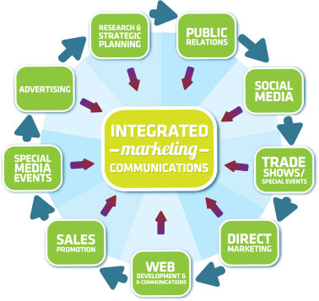.

Describing the existing methods of promotion used by Zara:
Zara is a well known fashion brand which specializes in women fashion including clothing, shoes, accessories, perfumes. In 2019, the brand was ranked 29th on the global brand consultancy Interbrand’s list of best global brands. However, analysing the promotional and marketing strategy of the company, it can be seen that the organization does not believe in huge advertising. Instead of advertising their brand, the organization uses heir store location and store displays as their main elements of marketing strategy. The promotional strategies of the organization are quite different from other fashion brand which makes it unique and stand out in the competition.
Advertising:
Zara tends to execute traditional marketing and advertising from their stores itself. The brand is seen to display their new clothing ranges and attractive elements within their stores. The organization is seen to select their stores within the prime locations with higher traffic opportunities. This is one of the key methods of promoting their products in the market (Aldovino, 2022). The discounts and different offers given by the organization are displayed within the stores itself. Even though this is a very traditional method of marketing, but it works for the organization in increasing customer awareness. The organization does not use print media or television advertisement for reaching to their tar=get customers.
Website promotion:
The organization provides their entire brand related information and new launch information with their website. This is another channel which is being used by the organization for reaching towards their target audiences successfully. In addition, the brand has their own online application through which they provides information and different offers for keeping their customers engaged and reaching wider audience through online platforms (Veverka, 2021).
Personal selling:
Personal selling is the highly practiced method of selling and promoting the brand which is conducted within the franchises and the stores of the organization. The brand focuses on smart selling through assisting the customers in the stores by describing the quality and the designs of the clothing, accessories offered by the brand (Paesbrugghe, 2018). The assistance within the stores helps in creating emotional connects with the customers and improves the overall shopping experience of the customers successfully.

Discussion on the new and suitable promotional strategies for Zara for increasing customer awareness regarding the brand:
In order to survive in the volatile and highly saturated market with similar brands having unique identity and effective marketing strategies is extremely essential for sustainability for Zara. Even though Zara is one of the renowned brands for high end fast fashion, but there are many competitors which can affect the market share of the brand. In the contemporary time promotion plays a huge role for any brand to succeed in the market by increasing market share, sales, and customer loyalty. A better customer engagement and customer loyalty is always equal to organizational success, and for achieving that having an effective promotional strategy within the business is extremely important. In this regard, the suitable methods of promotional strategy for Zara to promote their brand and reach out to a wider audience and improve brand awareness has been discussed accordingly-
Social media campaigns:
In order to increase the brand awareness within the operating markets of Zara, the organization can conduct effective social media marketing campaigns by selecting suitable hashtag for trending in the social media feeds. In this regard, selecting suitable platforms of social media such as Facebook, Instagram could be extremely useful ad relevant for gaining attention of millions of people easily and in a cost effective manner (Seyyedamiri, 2019). These types of campaigns are very useful for improving brand visibility and improve the customer purchase intention. Other than that, focusing on the right use of social media content and posting attractive pictures and contents can bring lots of traffic in the campaign which can help the brand in achieving the goal of a successful promotional event within the business.
Celebrity endorsement:
Zara can select suitable celebrity for promoting their products which is a great way of attracting customers. In addition, this is a great way of differentiating the brand from the competitors and it can also improve and recall making the consumers remember the advertisement. This method also makes customers realize that their favourite celebrity is connected with the brand which automatically improves the sales and the brand recognition within the market. Displaying the pictures of the celebrity wearing the dressed and accessories of Zara through the offline as well as online platforms can create a huge buzz which can enhance the visibility and the emotional connect with the target audiences of the brand (Yang, 2018).
Running social media contest:
Social media contests are a great way of increasing brand awareness and promoting a brand. In this regard, Zara can execute social media contest where they can advertise their products as the prize for the winner. In order to conduct such contest, the brand can use social media platforms such as Twitter, Facebook, Instagram etc. These types of promotional events are very suitable in this contemporary time for attracting the young generation successfully and improving brand awareness (Arrigo, 2018).
These promotional strategies could be extremely helpful for the organization in order to existing brand awareness and customer engagement.

Assessing branding equity of Zara for maximizing customer satisfaction and loyalty
The dimension of brand equity is associated with enhancing the customer awareness, associations and loyalty towards brand so that they can entrench upon their perceived quality. From the view point of Seliani, and Pratomo, (2019), it can be seen that for renowned brand, the roadmap to customer satisfaction and loyalty is to engage customers with potential value of the products and services they entrench. With the process of branding, it can be seen that Zara as a exquisite fashion retail brand can pounce upon attracting new customers with rapid shift in consumer behaviour and build upon a sustainable advantage. In this respect, the notion of brand equity is apprehending to the generic correspondence of the brand’s products, premium value in an industrial market that can comes for vicinity of the customers to entail their product as valuable.
Aaker’s Brand Equity Model
Aaker’s Brand Equity Model has been seen to be viewing brand equity as an amalgamation of brand awareness, associations and loyalty that finally procure to a value providing a product or service by a brand. The model denotes for building up brand management by initiating arrangement of different brand affiliations that offers consumers a lucrative brand picture. The model deciphers for four assets like brand loyalty, awareness, perceived quality, associations and other proprietary assets. With these four assets, the model is seen to be focussing on recognition identity of a brand as it entails for how a brand is known to the customers in a different way (Jiang, 2022). In this respect, Zara as a fashion retail brand is seen to be resonating their brand recognition process with the customers by adhering to different brand tactics idealizing their unique fashion boutique recognition in front of customers. Through Aaker’s Brand Equity Model assets, the customer satisfaction and maximizing their loyalty for Zara can be judged.
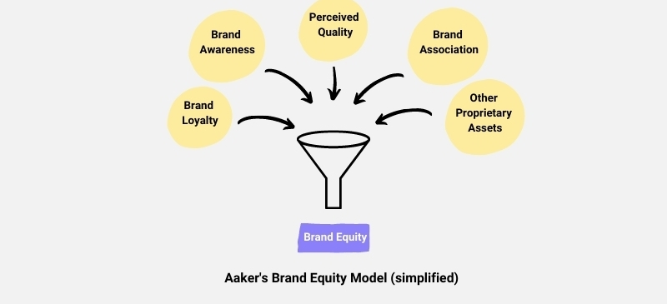
Fig: Aaker’s Brand Equity model
Brand loyalty – The brand loyalty determines for the extent to which customers show their loyalty to the brand in terms of their reduced marketing costs, trading leverages and attracting new customers. Zara as a recognized fashion retailer is seen to be using upon “pull marketing” tactics that cultivates as a brand that influence customers to shop. It can be seen that shopper’s fluency for Zara is 2-3 times higher than traditional fashion clothing retailer (Sharma, 2020). With use of AR in in-store experience, Zara helps in retaining old customers in enhancing customer curiosity to innovate new type of services that bring ease to their shopping.
Brand awareness – This step suggests for the extent to which a brand is known to their customers as it depends to a lot of factors like brand familiarity, commitment level by brand and purchasing process (Sari et al., 2022). Zara in terms of brand awareness has achieved quite significance in adding personal appearance as well as serving new styles to clothing apparels that denies a new category of brand awareness among consumers.
Perceived quality – The perceived quality determines for a brand providing good quality of products and services measured on the basis of quality, levels of differentiation, pricing and availability to the end customers. Zara is perceived by its customers in terms of affordable and premium range of clothing apparels (Amarkhil, 2018). In terms of branding, Zara aims to perceive their customers with best quality spun and threads that can be alluring to the end customers. Moreover, it can be seen that Zara’s customers perceive their brand identity by attaining a differentiated products with attribute to new designs along with availability at well-decorated stores and online channels.
Brand Associations – The brand associations underpins for retrieving the associations of customer’s brain adhering to advertising and extent to which those promotions and advertising related to the consumer’s benefits of buying the product. It can be seen that Zara accomplishes for extending their associations to promote new summer or winter clothing through premiere channels as it creates opportunity to engage new customers (Blomberg, and Furman, 2021). Moreover, their associations with positive attitude by customers about showing commitment to buy their premium range clothes helps in extending their brand equity.
Other proprietary assets – This asset identifies for various patents and intellectual property rights in relation to the trading slots of a brand that can earn them competitive advantage. It has been found that Zara invests heavily over proprietary assets amounting to € 25 billion in 2019 as it ensures for them appropriate tradeoffs in their exporting and licensing activities in different franchise based stores at different parts of the world (Wirjohadikusumo, and Santoso, 2021). In fact, it can be seen that their RIFD assets through proprietary software in centralized warehouse systems at EU helps in attaining their brand competitiveness.

Analysing customer journey for Zara through assessment of customer touch points
It has been found that the way a customer perceives a brand is seen in the process of customer journey while purchasing a product. Popović-Šević et al., (2021), has stated that a customer journey comprises of different stages as the customers passes through different stages of buying a product or service. In terms of customer journey, an individual passes through stages of awareness, investigation about products, buying through recognizing thoughts and finally act as influencers to enact others to buy from those brands. In fact, while passing through different stages of buying, enactment of customer touch points endures for making their journey smoother in gaining brand loyalty and remaining satisfied with their products.
Customer Journey mapping of Zara
In terms of customer journey for Zara, it can be found that there are five stages – awareness, considerations, decision, retention and advocacy for brand. Under these five stages, the customer journey for Zara can be mapped.
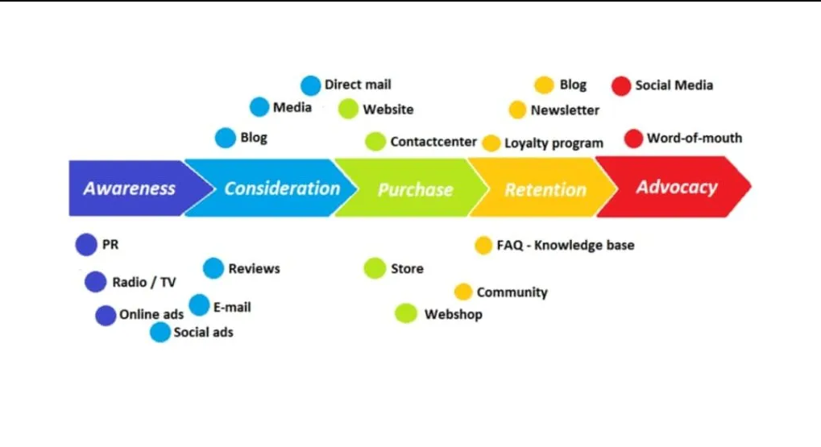
Fig: Customer Journey Mapping
Awareness – This determines for making the customers aware about the brand’s consistency in producing effectual products and services according to the demands. It can be seen that Zara though not so much induced to personal advertising is now days engaged in enacting customer touch points through creating different communication channels by brand campaigning,, endorsements so that they can make a focused message or content based scenario of recognizing their brand. In fact, the distinctiveness of their designs, well-decorated stores, use of AI in stores for virtual display of personalized clothing make the customers aware of their premium brand recognition (Guimarães, 2020).
Considerations – The following stage identifies for initiation of search content where customers can narrow down their buying provisions through gathering on different information. Zara as a brand persuades upon digitalized and automated in-store experience that makes the searching content for the customers easier and thereby acting as a major aspect to purchasing decision (Palazón et al., 2022). It has been found that Zara is able to create different customer touch points like AI enabled display, VR in their stores to make customer’s considerations more profound.
Decision-making – In terms of decision making, it can be seen that this stage acts as relating brand’s conceptualization of products related to buyer’s personas as they are able to influence the target market and their choices. Zara has been able to customize different channels of communications both online and offline with accessibility of service to entrench customer’s buying decision making process to buy. Their social media use by Zara where they count for 35.5 million customers as followers enact their ability to influence customers through digital content for buying decision making.
Retention – In terms of retention process, it can be seen that customers already a sustainable end users of a brand is hold by a brand through extending their various channels to align to changing needs of the customers and post purchase service (Mosquera et al., 2019). Zara as a premium fashion band has been able to retain customers by alluring to different loyalty programs where customers get discounts and offers against their purchase, and this helps them to retain for prolonged period within the firm.
Advocacy – The advocacy of brand is aligned to the new customer attraction process where customization of product with effective illustration of brand identity is placed in front of customers. Zara accompanies to different social blogging and earns upon credibility about their brand by accompanying to their premium range clothing products that are shared through feedbacks and opinions through different social blogs to attract new customers.
Customer engagement through touch points
It can be seen that customer engagement is a process, where the customer’s various touch points are fulfilled by the brands to entrench upon value proposition of their brand. It can be seen that the Total Engagement Model of consumer engagement is perfect to assess how Zara attributes to different engaging techniques by adhering to customer touch points. The model proposes for four distinctive elements – value proposition, branding, internal culture and experience of customers (Kuusisto, and Lagergren, 2021). One of the main ideology of the model is that it entrusts for clarifying the communication being perceived by consumers of a brand so that it can yield upon effective customer engagement strategy.
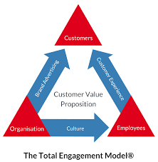
Fig: Total Engagement Model for customer value creation
Zara as a premium-clothing brand has been ideally creating a way to provide value to its customers where they fascinates for brand recognition by accessibility and in-store automation of process (Guimarães, 2020). Their core principles of fetching customer’s communication are entitled to promotion of their clothing apparels though unique designs and in-store features that can create upon customer resilience imbibed within their integral culture of fashion.

Conclusion:
Through the help of the following report, it is clear that marketing management is an important aspect and it has a huge role in organization success. The paper has carefully represented the communication followed by the organization with their consumers for providing all the essential information and keeping customers engaged within the business. In addition, the existing promotional strategies of the business has also analysed through which it has been understood that the organization needs to redesign the promotional strategies for increasing brand awareness and suitable promotional strategies for the organization has also been mentioned and discussed through the paper. Other than that, the concept of branding and brand equity for Zara has been discussed by using the Keller’s brand equity model and lastly, the customer’s journey and customer touch points for Zara has been analysed. The overall report has been very valuable for understanding that Zara needs to improve their marketing and branding through digitalization for improving customer engagement in the business.

Reference:
Aldovino, I.L.G., Cruz, N.P., Luzaran, T.C.B. and Etrata Jr, A.E., 2022. Gen Z and TV: An Analysis of Traditional Advertising Medium and Perception. Journal: Millennium Journal of Humanities and Social Sciences, pp.50-67.
Ali, B.J., Anwar, G., Gardi, B., Jabbar Othman, B., Mahmood Aziz, H., Ali Ahmed, S., Abdalla Hamza, P., Burhan Ismael, N., Sorguli, S. and Sabir, B.Y., 2021. Business communication strategies: analysis of internal communication processes. Ali, BJ, Anwar, G., Gardi, B., Othman, BJ, Aziz, HM, Ahmed, SA, Hamza, PA, Ismael, NB, Sorguli, S., Sabir, BY (2021). Business Communication Strategies: Analysis of Internal Communication Processes. Journal of Humanities and Education Development, 3(3), pp.16-38.
Amarkhil, H., 2018. Brand management that creates value to customer: the case of Zara brand (Master's thesis).
Arrigo, E., 2018. Social media marketing in luxury brands: A systematic literature review and implications for management research. Management Research Review.
Blomberg, L. and Furman, J., 2021. Enhancing Fast Fashion Brands Through Environmentally Sustainable Efforts: An explorative study on Generation Z’s perceptions towards circular economy initiatives and its impact on Customer-Based Brand Equity.
Duralia, O., 2018. Integrated Marketing Communication and Its Impact on Consumer Behavior. Studies in Business & Economics, 13(2).
Guimarães, A.M.D.S.R., 2020. Customer journey analysis-building a customer journey map based on consumer behaviour.
Jiang, B., 2022. How Consumers’ Response on CSR Affects Brand Competitiveness in the Fast Fashion Industry——Case Study of Zara (Inditex) and H&M. Academic Journal of Business & Management, 4(1).
Juska, J.M., 2021. Integrated marketing communication: advertising and promotion in a digital world. Routledge.
Kastberg, P., 2022. Modelling Knowledge Communication as Co-Actional Communication. In Perspectives on Knowledge Communication: Concepts and Settings. Routledge.
Kuusisto, F. and Lagergren, O., 2021. MAKING SENSE OF THE CUSTOMER JOURNEY: THE MOBILE DEVICES ROLE IN CONSUMERS’SHOPPING EXPERIENCES.
Kuznar, L.A. and Yager, M., 2020. The Development of Communication Models, Quick Look. Joint Staff J39, Strategic Multi-layer Assessment Washington, DC United States.
Mosquera, A., Juaneda Ayensa, E., Pascual, C.O. and Murillo, Y.S., 2019. Omnichannel shopper segmentation in the fashion industry. Journal of Promotion Management, 25(5), pp.681-699.
Paesbrugghe, B., Sharma, A., Rangarajan, D. and Syam, N., 2018. Personal selling and the purchasing function: where do we go from here?. Journal of Personal Selling & Sales Management, 38(1), pp.123-143.
Palazón, M., López, M., Sicilia, M. and López, I., 2022. The customer journey: a proposal of indicators to evaluate integration and customer orientation. Journal of Marketing Communications, pp.1-32.
Popović-Šević, N., Jeremić, A., Slijepčević, M. and Ilić, M., 2021. Marketing focused on the online brand community: The example of Zara. Marketing, 52(1), pp.32-42.
Sari, N.N., Chan, T.J. and Abd-Ghani, N.H., 2022. The Influence of Brand Equity and Price Consciousness on Consumers’ Brand Purchase Intention of Fashion Retail Apparel.
Seliani, A. and Pratomo, L.A., 2019. Antecedents of Brand Equity. Manajemen Bisnis, 9(2), pp.144-157.
Seyyedamiri, N. and Tajrobehkar, L., 2019. Social content marketing, social media and product development process effectiveness in high-tech companies. International Journal of Emerging Markets.
Sharma, R., 2020. Building Consumer-based Brand Equity for Fast Fashion Apparel Brands in the Indian Consumer Market. Management and Labour Studies, 45(3), pp.337-365.
Veverka, L. and Holý, V., 2021. The Impact of TV Advertising on Website Traffic. arXiv preprint arXiv:2112.08530.
Wirjohadikusumo, J. and Santoso, S.M., 2021. The Influence of Consumer-Based Brand Equity on Consumer Purchase Intention Mediated by Brand Loyalty towards Fast Fashion Industry in Indonesia: A Case Of UNIQLO. iBuss Management, 9(2).
Yang, W., 2018. Star power: the evolution of celebrity endorsement research. International Journal of Contemporary Hospitality Management.

