2x2 mixed anova
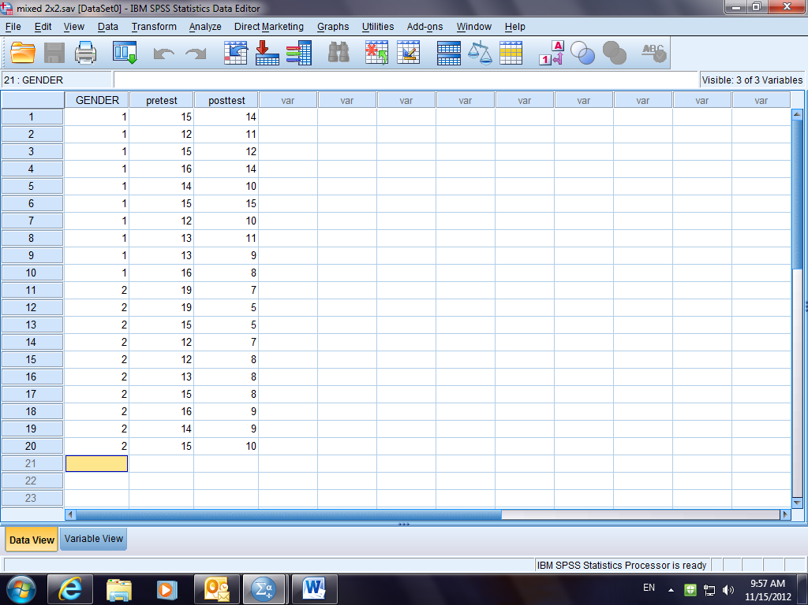
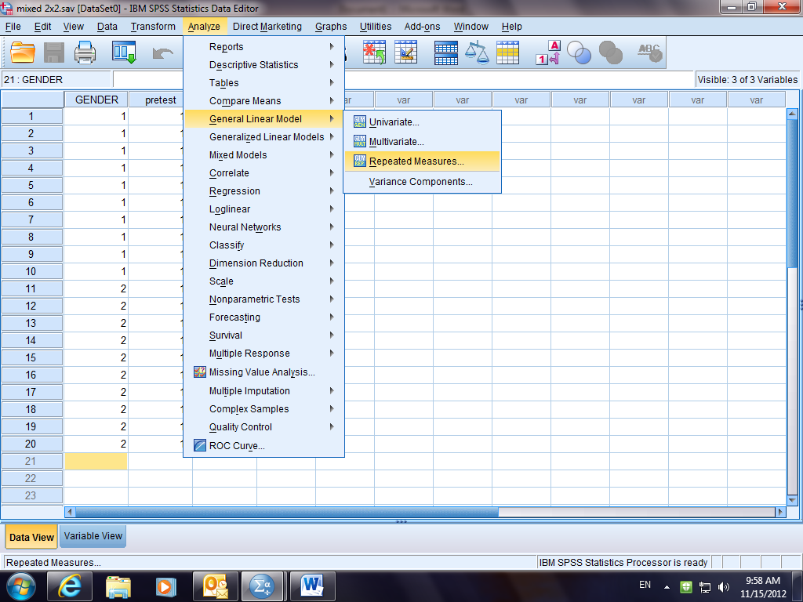

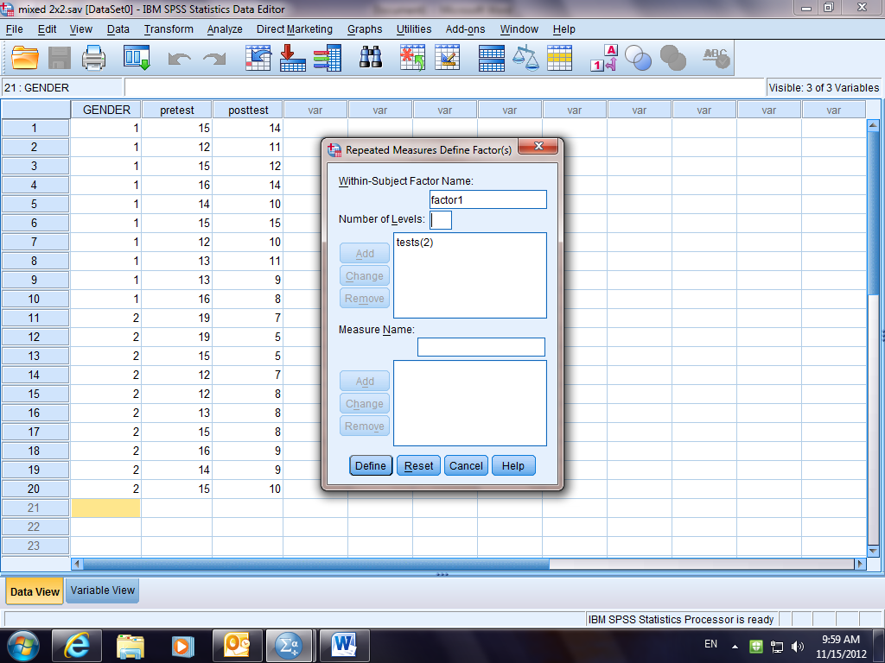
Factor name - word tests – you have 2 conditions/levels. Then press define
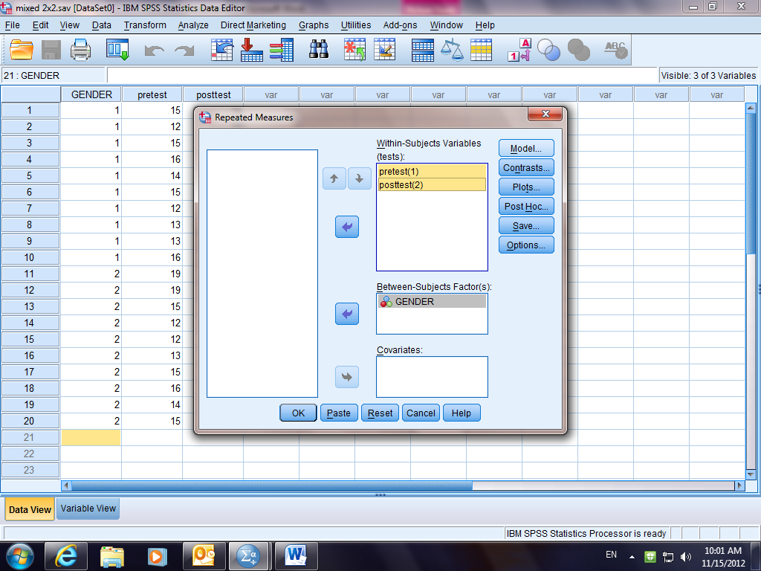
Move the tests from the left-hand box to the right-hand box. Place gender in the between-subjects box
Select plots
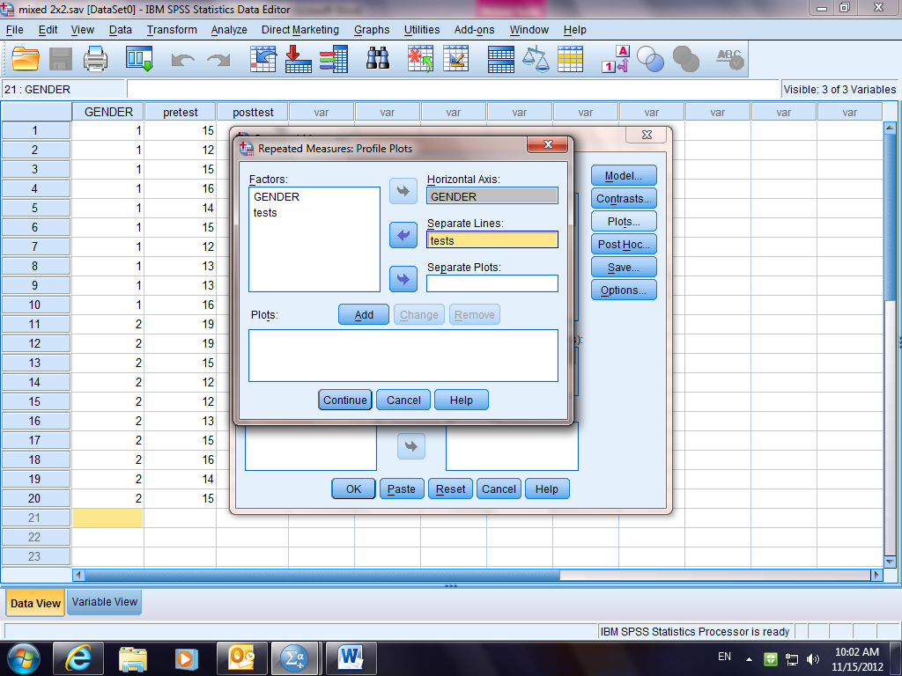
Move gender and tests into the axis and line boxes, click the add button. Continue. Options
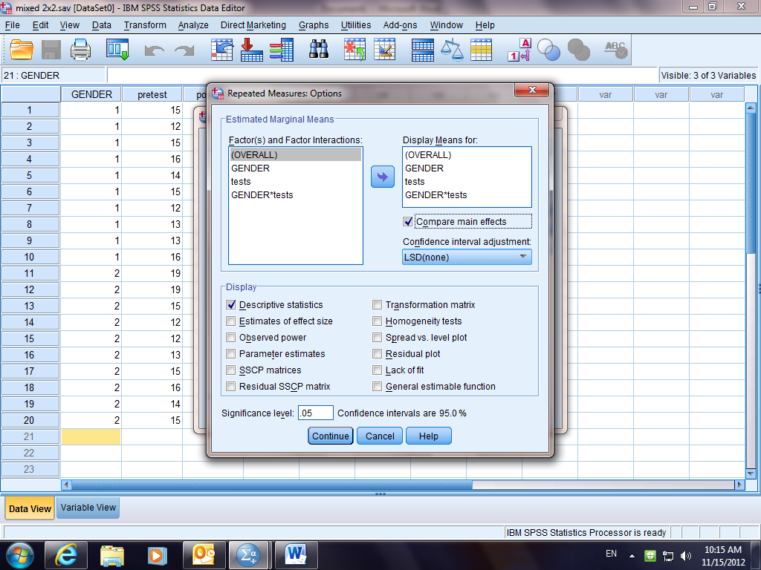
Move all factors into the right-hand box. Check the descriptive box and compare main effects. Continue. OK
Descriptive Statistics
 | GENDER | Mean | Std. Deviation | N
pretest | male | 14.10 | 1.524 | 10
pretest | female | 15.00 | 2.494 | 10
pretest | Total | 14.55 | 2.064 | 20
posttest | male | 11.40 | 2.319 | 10
posttest | female | 7.60 | 1.647 | 10
posttest | Total | 9.50 | 2.763 | 20

Tests of Within-Subjects Effects
Measure:MEASURE_1
Source |  |  |  |  |  |  |  |  |  | Type III Sum of Squares |  |  |  | df |  | Mean Square |  |  |  | F | Sig.
tests |  |  | Sphericity Assumed |  |  |  |  |  |  | 255.025 |  |  |  | 1 |  | 255.025 |  |  |  | 60.203 | .000
 |  |  | Greenhouse-Geisser |  |  |  |  |  |  | 255.025 |  |  |  | 1.000 |  | 255.025 |  |  |  | 60.203 | .000
 |  |  | Huynh-Feldt |  |  |  |  |  |  | 255.025 |  |  |  | 1.000 |  | 255.025 |  |  |  | 60.203 | .000
 |  |  | Lower-bound |  |  |  |  |  |  | 255.025 |  |  |  | 1.000 |  | 255.025 |  |  |  | 60.203 | .000
tests * GENDER |  |  | Sphericity Assumed |  |  |  |  |  |  | 55.225 |  |  |  | 1 |  | 55.225 |  |  |  | 13.037 | .002
 |  |  | Greenhouse-Geisser |  |  |  |  |  |  | 55.225 |  |  |  | 1.000 |  | 55.225 |  |  |  | 13.037 | .002
 |  |  | Huynh-Feldt |  |  |  |  |  |  | 55.225 |  |  |  | 1.000 |  | 55.225 |  |  |  | 13.037 | .002
 |  |  | Lower-bound |  |  |  |  |  |  | 55.225 |  |  |  | 1.000 |  | 55.225 |  |  |  | 13.037 | .002
Error(tests) |  |  | Sphericity Assumed |  |  |  |  |  |  | 76.250 |  |  |  | 18 |  | 4.236
 |  |  | Greenhouse-Geisser |  |  |  |  |  |  | 76.250 |  |  |  | 18.000 |  | 4.236
 |  |  | Huynh-Feldt |  |  |  |  |  |  | 76.250 |  |  |  | 18.000 |  | 4.236
 |  |  | Lower-bound |  |  |  |  |  |  | 76.250 |  |  |  | 18.000 |  | 4.236
2. GENDER
Measure:MEASURE_1
GENDER |  | Mean |  |  |  | Std. Error |  |  | 95% Confidence Interval
 |  |  |  |  |  |  |  |  | Lower Bound |  |  |  | Upper Bound
male |  | 12.750 |  |  |  | .452 |  |  | 11.801 |  |  |  | 13.699
female |  | 11.300 |  |  |  | .452 |  |  | 10.351 |  |  |  | 12.249
3. tests
Measure:MEASURE_1
tests | Mean |  |  | Std. Error |  |  | 95% Confidence Interval
tests |  |  |  |  |  |  | Lower Bound |  |  |  |  | Upper Bound
1 | 14.550 |  |  | .462 |  |  | 13.579 |  |  |  |  | 15.521
2 | 9.500 |  |  | .450 |  |  | 8.555 |  |  |  |  | 10.445
4. GENDER * tests
Measure:MEASURE_1
GENDER |  | tests |  |  | Mean |  |  | Std. Error |  |  | 95% Confidence Interval
 |  |  |  |  |  |  |  |  |  |  | Lower Bound |  |  |  | Upper Bound
male |  | 1 |  |  | 14.100 |  |  | .654 |  |  | 12.727 |  |  |  | 15.473
 |  | 2 |  |  | 11.400 |  |  | .636 |  |  | 10.064 |  |  |  | 12.736
female |  | 1 |  |  | 15.000 |  |  | .654 |  |  | 13.627 |  |  |  | 16.373
 |  | 2 |  |  | 7.600 |  |  | .636 |  |  | 6.264 |  |  |  | 8.936

