

University of Wales Trinity Saint David

Module code: ACCA7015

Module: L7 - Data Mining & Visualisation

Assignment: Exploratory Data Analysis – Report and Demonstration

Submission date: 2 pm, Tuesday, 31/03/2026
Lecturer: Dr Nouh Elmitwally

Student Name: Majib Miah
ID: 2234516

Contents
Abstract 1
1. Introduction 1
2. Aim and Objectives 1
3. Literature Review 1
3.1 Predictive analytics in crime and public safety 1
3.2 Classification for binary outcomes 1
3.3 Logistic Regression (strengths and limits) 1
3.4 Tree-based models and Random Forest 1
3.5 Handling class imbalance and model validity 1
3.6 Association rule mining and interpretability 1
4. Dataset Description 1
5. Methodology (Model Building) 1
6. Implementation 1
7. Results Model Evaluation and Comparison 1
Figures (Model Evaluation Evidence) 1
8. Association Rule Mining on the Positive Class 1
8.1 Why association rules 1
8.2 Method 1
8.3 Results (Top rules from Arrest=True subset) 1
8.4 Interpretation 1
9. Discussion of Findings 1
9.1 What influenced arrest likelihood 1
9.2 Practical meaning of model errors 1
10. Critical Evaluation (Validity and Suitability) 1
11. Recommendations (Actionable) 1
12. Conclusion 1
Reference 1

Exploratory Data Analysis – Report and Demonstration

Abstract
This report applies classification techniques to predict whether an arrest occurs (Arrest: True/False) using the cleaned Chicago crime dataset for 2022. Two models were trained and compared: Logistic Regression (baseline) and Random Forest (ensemble). Data preparation used a scikit-learn pipeline with one-hot encoding for categorical variables, scaling for numeric attributes, and a stratified 80/20 split to preserve class balance. Performance was evaluated using confusion matrices, precision, recall, F1-score[1], and ROC-AUC due to class imbalance. To complement classification with interpretable pattern discovery, Apriori association rule mining was applied to the positive class (Arrest=True) using support, confidence, and lift. Results show a clear precision–recall trade-off between the two classifiers and highlight frequent arrest contexts involving domestic battery and time-of-day patterns. The report concludes with recommendations for decision support and notes limitations around missing operational policing variables.

1. Introduction
Police and public safety teams make decisions about resourcing, scheduling, and targeted interventions. Predictive analytics can support these decisions by finding patterns in recorded crime data. This report uses Chicago crime records from 2022 and focuses on predicting Arrest (True/False) as the classification target.
Arrest prediction is challenging because arrests are less frequent than non-arrests (class imbalance) and because the dataset lacks important operational factors such as response time, on-scene evidence, or whether an offender was identified. For that reason, the aim is decision support rather than treating model outputs as certainty. Alongside classification, the report applies association rule mining on the Arrest=True subset to uncover interpretable patterns (support/confidence/lift) that help explain common arrest contexts.
The report covers a brief literature review, dataset description, modelling methodology, model evaluation, association rules, discussion, and recommendations.

2. Aim and Objectives
Aim
To apply classification techniques to predict whether an arrest occurs based on selected features in the Chicago 2022 crime dataset, and to complement this analysis with association rule mining applied to Arrest=True cases in order to uncover additional patterns and support decision-making.
Objectives
- Implement and evaluate at least two classification models for Arrest prediction using relevant attributes from the dataset.
- Apply association rule mining to the Arrest=True subset to identify frequent patterns and relationships.
- Critically assess model suitability considering the dataset characteristics, class imbalance, and intended use.
- Interpret results in context and communicate insights and recommendations clearly for a decision maker.
.

3. Literature Review

3.1 Predictive analytics in crime and public safety
Predictive analytics can support decisions such as resourcing and prevention by identifying patterns in recorded crime data. However, outcomes like arrests can reflect reporting and policing strategy, not only offender behaviour. For this reason, models should be treated as decision support and interpreted cautiously to avoid overstating causality or reinforcing bias[2].

3.2 Classification for binary outcomes
Binary classification predicts two outcomes, here Arrest=True or Arrest=False. With class imbalance, accuracy can be misleading, so evaluation should focus on precision, recall, F1-score, and ROC-AUC. Which metric matters most depends on operational goals and the relative cost of false positives vs false negatives[3].

3.3 Logistic Regression (strengths and limits)
Logistic Regression is a strong baseline because it is fast and relatively interpretable[4]. It can underfit if important relationships are non-linear or depend on feature interactions. With class weighting, it may increase minority-class recall but often reduces precision.

3.4 Tree-based models and Random Forest
Random Forest captures non-linear patterns and interactions and often performs well on mixed tabular data[5]. The trade-off is reduced interpretability compared with linear models. In policing datasets, area-based signals may also reflect enforcement intensity, so outputs must be interpreted carefully.

3.5 Handling class imbalance and model validity
Imbalance affects training and evaluation. Techniques include class weighting, resampling, and threshold tuning. Validity depends on intended use: recall matters when missing positives is costly, while precision matters when false alarms are costly. ROC-AUC helps compare discrimination across thresholds.

3.6 Association rule mining and interpretability
Association rules identify frequent co-occurring conditions using support, confidence, and lift[6]. They do not prove causation but provide interpretable patterns that can support operational understanding. Filtering by minimum support and lift helps avoid trivial rules.
In summary, Logistic Regression is more interpretable, Random Forest is often stronger for non-linear patterns, and both require careful evaluation under class imbalance; association rules add interpretability for the positive class.

4. Dataset Description
The dataset contains approximately 234,891 crime incident records for Chicago in 2022. It includes both categorical and numeric features. Key fields relevant to this assignment include:
- Primary Type: broad crime category
- Arrest: outcome label (True/False) — used as the target variable
- Domestic: whether domestic-related (True/False)
- District, Ward, Community Area: area-based categories
- Latitude, Longitude: coordinates for geographic context
- Month, Day_of_Week, Time_Period, Hour: temporal context
Target definition
Class balance (Arrest):
The target variable is imbalanced. In the cleaned dataset, Arrest=False = 207,650 and Arrest=True = 27,241, meaning the positive class represents approximately 11.6% of records.
The target for classification is Arrest (True/False). In modelling, Arrest is converted to binary format (True=1, False=0). The dataset is likely imbalanced, with Arrest=True appearing less frequently.
Feature selection rationale
Features were selected to represent:
- Offence context (Primary Type, Domestic)
- Time context (Month, Day_of_Week, Time_Period, Hour)
- Location context (District, Ward, Community Area, Latitude, Longitude)
The features were chosen because they are available at record time and can plausibly influence arrest likelihood in recorded data, while avoiding target leakage.

5. Methodology (Model Building)
Step 1: Environment setup
Python was used in PyCharm with Pandas for data handling, scikit-learn for modelling, Matplotlib/Seaborn for evaluation plots, and mlxtend for Apriori association rules. Using Python supports reproducibility: the same pipeline can be rerun if the dataset changes.
Step 2: Data loading and initial checks
The cleaned CSV was loaded and inspected for:
- shape and columns
- target distribution (Arrest value counts)
- remaining missing values
This stage prevents simple errors such as incorrect column names and confirms whether the target is imbalanced.
Step 3: Preprocessing pipeline
The dataset contains multiple categorical fields. These were converted into machine-readable inputs using one-hot encoding. Numerical features (Hour, Latitude, Longitude) were scaled for Logistic Regression to ensure stable optimisation. A scikit-learn pipeline was used so that preprocessing is applied consistently across training and testing[7].
A stratified train/test split was used to preserve the Arrest distribution in both splits. This is important in imbalanced datasets because random splitting can produce a test set that does not reflect the overall class balance[8].
Step 4: Addressing class imbalance
Because Arrest=True is expected to be the minority class, the modelling approach incorporated class weighting. Logistic Regression used class_weight=balanced, and Random Forest used balanced_subsample[9]. Class weighting increases the penalty for misclassifying the minority class, encouraging the model to pay attention to Arrest=True cases.
Alternative approaches (not necessarily implemented) include oversampling the minority class (e.g., SMOTE) or adjusting the decision threshold away from 0.5. These were considered in the critical evaluation because they can improve recall at the cost of more false positives[10].
Step 5: Model selection
Two models were selected for evaluation:
- Logistic Regression: baseline model, interpretable, useful for explaining relationships in a decision-maker context.
- Random Forest: non-linear ensemble model, expected to capture interactions and improve predictive power.
This selection allows comparison between an interpretable baseline and a stronger model, supporting critical evaluation.
Step 6: Evaluation strategy
Multiple metrics were used:
- Confusion matrix: to quantify false positives and false negatives[11].
- Precision, recall, F1-score: focusing particularly on Arrest=True.
- ROC-AUC: to evaluate discrimination across thresholds.
Accuracy was included but not relied upon due to imbalance. The evaluation emphasised the minority class metrics because the assignment requires meaningful predictive intelligence, not a superficial accuracy score.
Step 7: Association rule mining on Arrest=True
To complement classification, the dataset was filtered to the positive class (Arrest=True). Association rules were generated from a manageable set of categorical features. One-hot encoding transformed each category into an “item” (e.g., District=8, Month=November). Apriori produced frequent itemsets, and association_rules generated rules evaluated by support, confidence, and lift.
This step helps interpret the positive class by identifying frequent combinations that commonly appear in arrest cases[12].

6. Implementation
The implementation was completed in Python using PyCharm. The cleaned dataset (cleaned_crime.csv) was loaded using Pandas and the target variable Arrest was converted into binary format (True=1, False=0). A preprocessing pipeline was built using scikit-learn’s ColumnTransformer, applying one-hot encoding to categorical features (Primary Type, Domestic, District, Ward, Community Area, Month, Day_of_Week, Time_Period) and standard scaling to numeric features (Hour, Latitude, Longitude). The dataset was split into training and testing subsets using a stratified 80/20 split to preserve the arrest class distribution (≈11.6% positive class). Logistic Regression and Random Forest models were trained using the same preprocessing pipeline to allow a fair comparison. Outputs were generated using confusion matrices, classification reports, ROC-AUC, and ROC curves saved as image files. Association rule mining was implemented using Apriori on the Arrest=True subset with min_support=0.02 and rule filtering using lift ≥ 1.2.

7. Results Model Evaluation and Comparison
Logistic Regression (baseline)
The Logistic Regression model produced an accuracy of 0.7648 and ROC-AUC of 0.8181. The confusion matrix was [[32180, 9351], [1699, 3749]], showing a relatively high number of false positives (9351). For the positive class (Arrest=True), precision was 0.2862, recall was 0.6881, and F1-score was 0.4042. This indicates the model is tuned to capture arrests (high recall) but at the cost of many false alarms, which lowers precision. This behaviour is consistent with class imbalance handling (class_weight=balanced), which encourages the model to identify minority-class cases.
Random Forest
The Random Forest model achieved higher accuracy (0.9148) and a slightly higher ROC-AUC (0.8275) than Logistic Regression. The confusion matrix was [[40990, 541], [3463, 1985]], showing far fewer false positives (541) but more false negatives (3463). For Arrest=True, precision was 0.7858, recall was 0.3644, and F1-score was 0.4979. This means Random Forest makes fewer incorrect “arrest” predictions (high precision) but misses a larger portion of true arrest cases (lower recall). Overall, the Random Forest provides stronger overall performance and better reliability when predicting an arrest[13], but its lower recall suggests it may under-identify arrest cases unless the decision threshold is adjusted.
Model comparison and selection
Comparing both models, Random Forest performed better on overall discrimination (ROC-AUC 0.8275 vs 0.8181) and substantially better on accuracy (0.9148 vs 0.7648) and precision for Arrest=True (0.7858 vs 0.2862). Logistic Regression performed better on recall for Arrest=True (0.6881 vs 0.3644). Therefore, the “best” model depends on the intended use. If the goal is to produce fewer false alarms and provide a more reliable prediction of arrests, Random Forest is preferable. If the goal is to capture as many arrest cases as possible (minimising missed arrests), Logistic Regression is preferable. In this report, Random Forest is treated as the stronger model overall due to higher accuracy, higher ROC-AUC, and much higher precision, while Logistic Regression is used as a baseline and as an example of a recall-focused model.
The ROC curves for both models are shown in Figure 1 and Figure 2, supporting the ROC-AUC comparison.
The confusion matrices and classification report excerpts in Figure 3 and Figure 4 highlight the different error patterns between the models.

Figures (Model Evaluation Evidence)
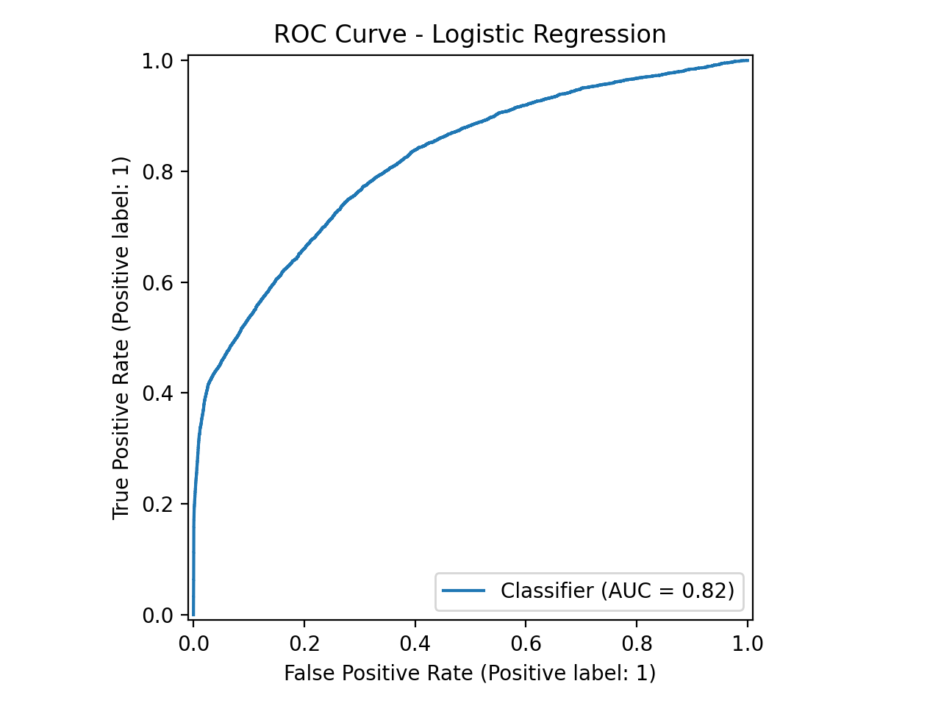
Figure 1 Logistic Regression ROC curve (ROC-AUC = 0.8181)
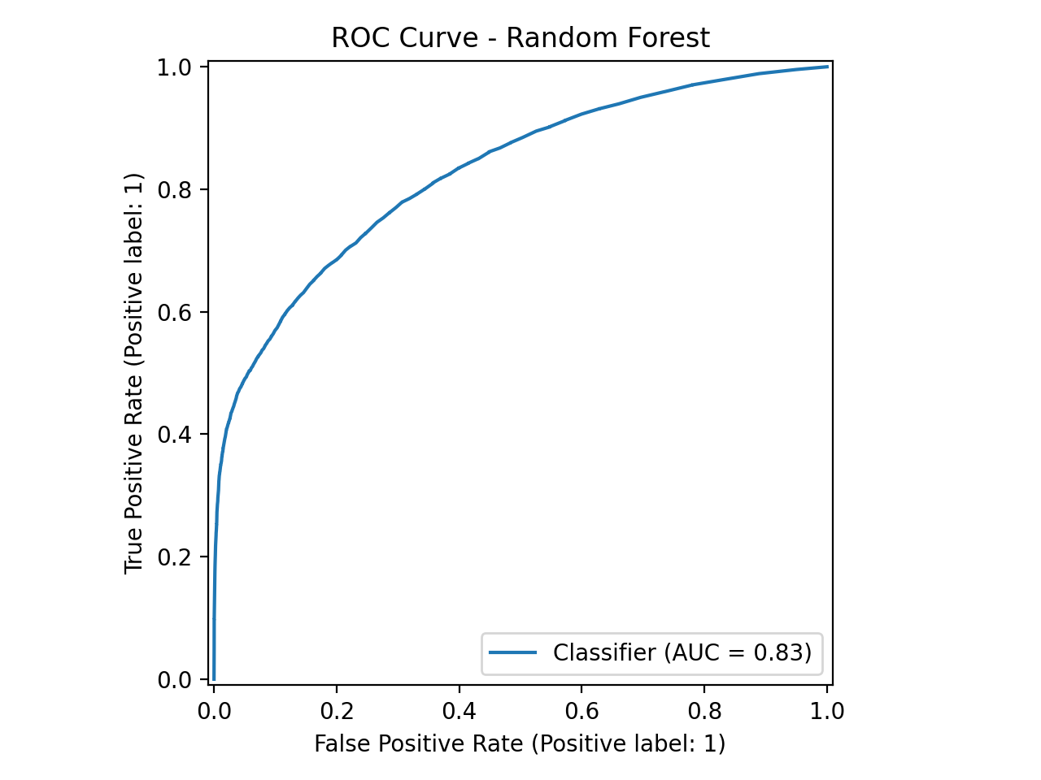
Figure 2 Random Forest ROC curve (ROC-AUC = 0.8275)
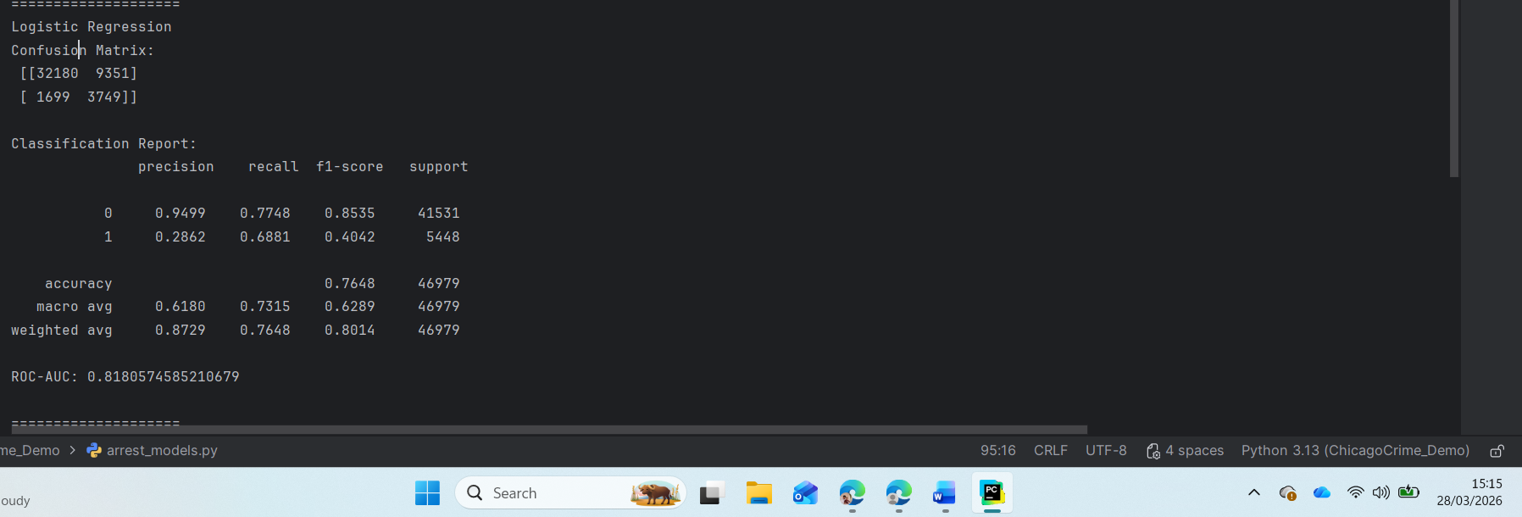
Figure 3 Logistic Regression confusion matrix and classification report (evidence of high false positives)
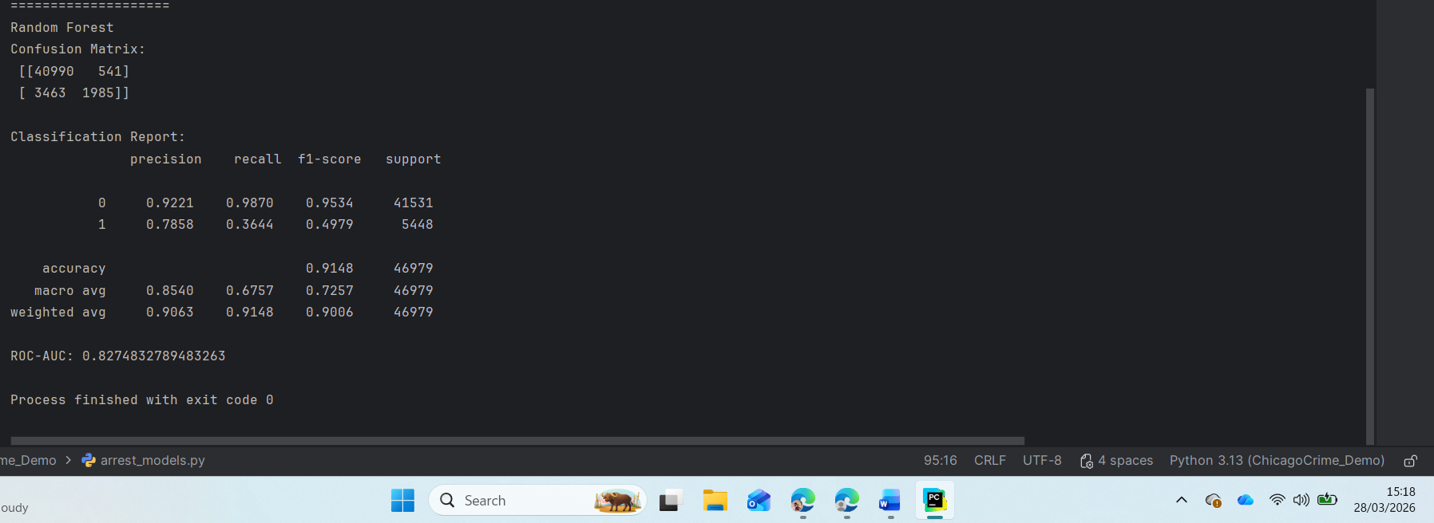
Figure 4 Random Forest confusion matrix and classification report (evidence of higher precision but lower recall for Arrest=True).

8. Association Rule Mining on the Positive Class

8.1 Why association rules
Classification gives predictions, but it can be difficult to interpret what combinations of conditions commonly appear within Arrest=True cases. Association rules provide interpretable patterns using support/confidence/lift.

8.2 Method
- Filtered dataset to only Arrest=True
- Selected categorical fields: Primary Type, District, Month, Day_of_Week, Time_Period, Domestic
- Applied one-hot encoding with get_dummies
- Ran Apriori to find frequent itemsets
- Generated rules using a minimum lift threshold to avoid weak relationships
- Apriori settings: min_support = 0.02, rules filtered with lift ≥ 1.2

8.3 Results (Top rules from Arrest=True subset)
Rule 1: (Primary Type=BATTERY AND Time_Period=Night) → Domestic=True
Support = 0.0619, Confidence = 0.6793, Lift = 3.2862
Rule 2: (Domestic=True AND Day_of_Week=Sunday) → Primary Type=BATTERY
Support = 0.0263, Confidence = 0.7036, Lift = 3.2307
Rule 3: (Primary Type=BATTERY AND Day_of_Week=Saturday) → Domestic=True
Support = 0.0238, Confidence = 0.6523, Lift = 3.1554
Rule 4: (Domestic=False AND District=11) → Primary Type=NARCOTICS
Support = 0.0394, Confidence = 0.4439, Lift = 3.1157
Rule 5: (Primary Type=BATTERY) → (Domestic=True AND Day_of_Week=Sunday)
Support = 0.0263, Confidence = 0.1208, Lift = 3.2307
Rule 6: (Time_Period=Night AND Domestic=True) → Primary Type=BATTERY
Support = 0.0619, Confidence = 0.6793, Lift = 3.1189
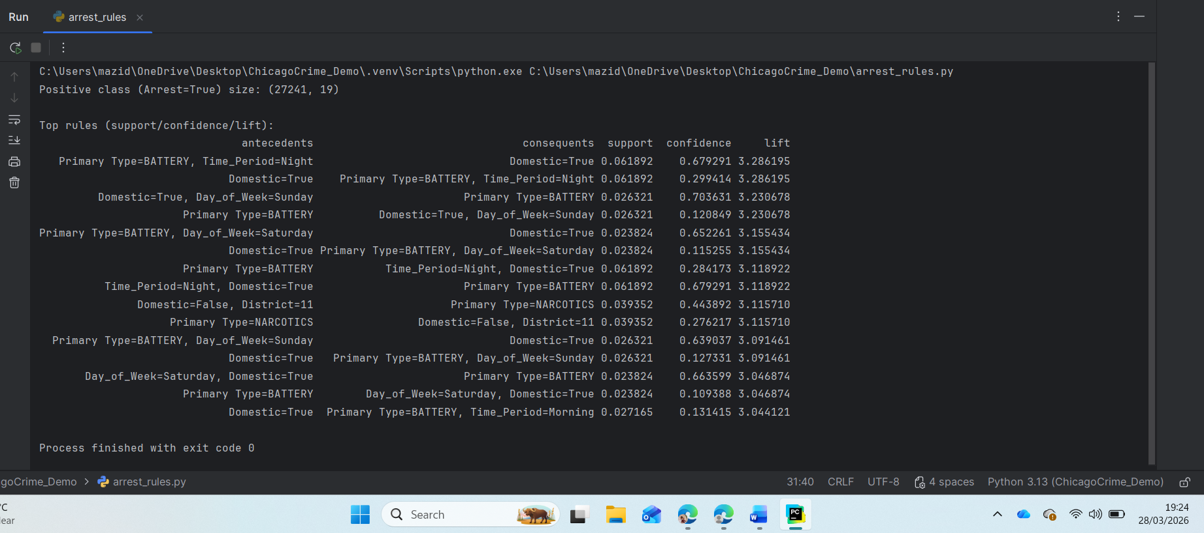
Figure 5 Apriori association rules output for the Arrest=True subset (support, confidence, lift)

8.4 Interpretation
- The rules highlight frequent co-occurring conditions within Arrest=True cases, not cause-and-effect.
- High lift values (around 3) suggest these combinations occur much more often than chance within arrest cases.
- Several top rules involve BATTERY + Domestic=True, especially during Night and on weekends, indicating arrests are commonly recorded in domestic battery contexts.
- A separate pattern appears linking NARCOTICS with District 11 under Domestic=False, suggesting a recurring arrest context for narcotics in that district.
- These patterns can support decision-making by identifying common arrest scenarios, but they should be interpreted carefully because arrest outcomes can also reflect policing practices and resource deployment.

9. Discussion of Findings

9.1 What influenced arrest likelihood
The results suggest that arrest likelihood is linked to a combination of offence type, time context, and location context. Crime category (Primary Type) is likely a major driver because different offences have different levels of “arrestability” in recorded data. For example, crimes involving direct confrontation or situations where offenders are identified quickly may lead to higher arrest rates than offences where the offender is unknown. Time variables (Hour and Time_Period) can influence arrests because patrol coverage, reporting behaviour, and incident conditions vary across the day. Location variables (District, Ward, Community Area) reflect differences in policing presence and area characteristics, so arrest likelihood may vary geographically even for the same offence type.
The association rule mining reinforces this interpretation by identifying recurring patterns inside Arrest=True records. Several high-lift rules focus on BATTERY combined with Domestic=True, particularly at Night and on weekends. For example, the rule (Primary Type=BATTERY AND Time_Period=Night) → Domestic=True has confidence 0.6793 and lift 3.2862, indicating this pattern appears substantially more often than chance within arrest cases. A second pattern links narcotics-related arrests to a particular district context: (Domestic=False AND District=11) → Primary Type=NARCOTICS with confidence 0.4439 and lift 3.1157. These findings do not prove causation, but they provide interpretable contexts that occur frequently in arrest outcomes.

9.2 Practical meaning of model errors
The confusion matrices show that the two models behave differently. Logistic Regression achieved higher recall for Arrest=True (0.6881) but low precision (0.2862), meaning it flags many arrest cases but also produces many false positives (9351). In practice, this model is useful if the priority is to avoid missing arrest cases, but it may waste resources by over-predicting arrests. Random Forest achieved much higher precision for Arrest=True (0.7858) and higher overall accuracy (0.9148), but recall was lower (0.3644), meaning it missed a larger number of true arrest cases (3463 false negatives). This model is more conservative: when it predicts an arrest it is usually correct, but it does not detect many arrests. Therefore, which model is “better” depends on operational goals. A realistic improvement step would be threshold tuning, where the probability cut-off is adjusted depending on whether the decision-maker prioritises catching more arrests (higher recall) or reducing false alarms (higher precision).

10. Critical Evaluation (Validity and Suitability)
A key challenge in this task is class imbalance. Arrest=True represents 27,241 of 234,891 records (≈11.6%), so accuracy alone can be misleading. This is demonstrated by the Random Forest model: despite high accuracy (0.9148), it still missed many arrest cases (recall 0.3644). Therefore, it is essential to evaluate minority-class metrics and ROC-AUC rather than relying on accuracy.
Feature limitations also affect validity. The dataset does not include several operational factors that strongly influence whether an arrest occurs, such as response time, presence of witnesses, investigation resources, officer availability, or whether the offender is known. As a result, the models learn patterns from proxy variables (crime type, time, and location) rather than direct causal drivers of arrests. This limits how confidently the model can be used for real-world decisions.
Bias and fairness concerns must be acknowledged. Arrest outcomes reflect policing strategy and deployment, not only crime behaviour. This means the model may learn signals related to enforcement intensity in certain districts rather than underlying criminal activity. For decision support, the model should be interpreted as describing patterns in recorded data, and it should not be used to justify automated enforcement decisions without additional governance and monitoring.
Finally, there is a trade-off between interpretability and performance[14]. Logistic Regression is easier to explain and offers transparency, but it may underfit complex relationships. Random Forest achieved stronger overall performance (higher accuracy and ROC-AUC, and much higher precision for Arrest=True), but is less interpretable. A practical approach in real settings is to use the stronger model for prediction while providing decision-makers with interpretable evidence (such as association rules) and monitoring performance drift over time.

11. Recommendations (Actionable)
- Choose the model based on operational priority.
If decision-makers want fewer false alarms and more reliable “arrest likely” predictions, Random Forest is preferable due to much higher precision for Arrest=True (0.7858). If the priority is to catch as many arrest cases as possible (higher sensitivity), Logistic Regression may be preferred due to higher recall (0.6881). In practice, probability threshold tuning should be used to balance precision and recall depending on the use-case.
- Use association-rule patterns to guide targeted planning (not causation).
The strongest rules show that Arrest=True cases frequently involve BATTERY + Domestic=True, especially at Night and on weekends. This supports targeted operational planning and safeguarding-focused response strategies during those time windows. These patterns should be treated as associations within recorded arrest cases, not causal explanations.
- District-informed strategies for specific offence contexts.
The association rule linking District=11 and NARCOTICS in Arrest=True records suggests recurring arrest contexts for narcotics in that area. Decision-makers can use this intelligence for district-specific planning (e.g., focused operations or prevention measures), while ensuring fairness and oversight.
- Improve data capture for stronger future modelling.
Add richer contextual features (response time, incident severity indicators, offender known/unknown, repeat call locations) to improve predictive validity and reduce reliance on geographic proxies that may reflect enforcement intensity.
- Responsible use and review.
The model should be used as decision support, not as an automated decision-maker. Performance should be re-checked on future time periods to detect drift and potential bias.

12. Conclusion
This report applied two classification models to predict Arrest outcomes in the Chicago 2022 crime dataset and evaluated them using metrics suitable for class imbalance. Logistic Regression achieved higher recall for Arrest=True but produced many false positives, while Random Forest achieved higher accuracy and much higher precision for Arrest=True but missed more arrest cases. This shows the importance of selecting a model based on operational goals rather than relying on a single metric.
Association rule mining applied to Arrest=True cases complemented classification by providing interpretable patterns, particularly linking domestic battery contexts with night/weekend time periods and identifying a narcotics-related pattern in District 11. Overall, the analysis provides useful intelligence for decision-makers, but performance and validity are constrained by imbalance, limited operational features, and the possibility of bias in arrest outcomes. Future work should focus on threshold tuning, richer contextual data, and responsible deployment frameworks.

Reference
[1] E. S. Wahyuni et al., “Wound Depth Measurement System in Forensic Cases using Image Processing and Machine Learning,” Jurnal ELTIKOM : Jurnal Teknik Elektro, Teknologi Informasi dan Komputer, vol. 9, no. 2, pp. 184–195, Dec. 2025, doi: 10.31961/eltikom.v9i2.1636.
[2] M. Z. Hossan and T. Sultana, “Causal Inference in Business Decision-Making: Integrating Machine Learning with Econometric Models for Accurate Business Forecasts,” International Journal of Technology, Management and Humanities, vol. 9, no. 01, pp. 11–24, Mar. 2023, doi: 10.21590/2885fr16.
[3] Radek. Silhavy and Petr. Silhavy, Artificial intelligence application in networks and systems : proceedings of 12th Computer Science On-line Conference 2023. Volume 3. Springer, 2023.
[4] S. Kost, O. Rheinbach, and H. Schaeben, “Using logistic regression model selection towards interpretable machine learning in mineral prospectivity modeling,” Geochemistry, vol. 81, no. 4, p. 125826, Nov. 2021, doi: 10.1016/j.chemer.2021.125826.
[5] A. Orlenko and J. H. Moore, “A comparison of methods for interpreting random forest models of genetic association in the presence of non-additive interactions,” BioData Min., vol. 14, no. 1, p. 9, Dec. 2021, doi: 10.1186/s13040-021-00243-0.
[6] A. Vincent-Paulraj, G. Burnside, F. Coenen, M. Pirmohamed, and L. Walker, “Sequential Association Rule Mining Revisited: A Study Directed at Relational Pattern Mining for Multi-morbidity,” 2021, pp. 241–253. doi: 10.1007/978-3-030-91100-3_20.
[7] M. Salama, “Optimization of Regression Models Using Machine Learning: A Comprehensive Study with Scikit-learn,” International Uni-Scientific Research Journal, vol. 5, pp. 119–129, 2024, doi: 10.59271/s45500.024.0624.16.
[8] Q. H. Doan, S.-H. Mai, Q. T. Do, and D.-K. Thai, “A cluster-based data splitting method for small sample and class imbalance problems in impact damage classification,” Appl. Soft Comput., vol. 120, p. 108628, May 2022, doi: 10.1016/j.asoc.2022.108628.
[9] Y. Aydoğan, O. Duygun, and İ. Cantürk, “Predicting smoking status from short voice recordings under small-sample constraints: A calibrated leave-one-speaker-out study,” Biomed. Signal Process. Control, vol. 119, p. 109915, Jun. 2026, doi: 10.1016/j.bspc.2026.109915.
[10] D. Doumanas, A. Soularidis, D. Spiliotopoulos, C. Vassilakis, and K. Kotis, “Fine-Tuning Large Language Models for Ontology Engineering: A Comparative Analysis of GPT-4 and Mistral,” Applied Sciences, vol. 15, no. 4, p. 2146, Feb. 2025, doi: 10.3390/app15042146.
[11] S. Zeeshan, T. Aized, and F. Riaz, “The Design and Evaluation of an Orange-Fruit Detection Model in a Dynamic Environment Using a Convolutional Neural Network,” Sustainability, vol. 15, no. 5, p. 4329, Feb. 2023, doi: 10.3390/su15054329.
[12] T. Wang, C. Rudin, D. Wagner, and R. Sevieri, “Learning to Detect Patterns of Crime,” 2013, pp. 515–530. doi: 10.1007/978-3-642-40994-3_33.
[13] O. P. Adebayo, A. Ibrahim, and K. T. Oyeleke, “Predicting Arrest Release Outcomes: A Comparative Analysis of Machine Learning Models,” Journal of Education and Science, vol. 34, no. 4, pp. 62–73, Oct. 2025, doi: 10.33899/jes.v34i4.49670.
[14] B. S. Virdee, T. Ali, J. Anguera, and S. L. Tripathy, Connecting Intelligence. Boca Raton: CRC Press, 2026. doi: 10.1201/9781003773504.

