Business Issues and the Contexts of Human resources

Louise Mordue
January 11th 2018

Contents
Introduction 2
Shaping the HR agenda 2
Compare different tools for analysing business environment 5
Factors Impacting HR and the organisation 8
Key Stages of Strategy and the role of HR 9
How can the business performance be evaluated? 11
Assessing and integrating data 14
References 17

Introduction
‘The Evolving role of HR in the contemporary business world’ is the discussion. How does the role of HR professionals support their organizations to succeed in short and long term goals? How has this been done in the past? And how will it be done in the future? By understanding the HR function and strategies within the profession, this will support the fundamental success of your organisation by future proofing and shaping company objectives.
“If what we do on the inside does not create value on the outside, in the ability of the company to attract, serve, and retain customers and investors, its value is zero.” (Ulrich, 2009)
As part of this delegate pack we will look at various strategies, models, tools and factors that can and will shape the HR for the future and how and why these practise will add value to your organisation.

Shaping the HR agenda
The role of HR has dramatically changed and evolved since its first existence in 1901 where the main function was to administrate the welfare and wages of the workers, as part of the Personnel Department or Personnel Management (PM). At the end of the 20th century the value of people as a resource became more significant and the development of Human Resource Management (HRM) was established to focus on developing, training and retention of people. As per CIPD Strategic Human Resource Management Factsheet, by the end the early 1990’s the Strategic Human Resource Management (SHRM) concept of Human Capital - existing workforce is an asset rather than an expense was established - and needed to be built into business planning and strategy, requiring the HR role to align itself with organisation objectives that may include:
- Linking HR practices to organisational strategy
- Fostering a healthy psychological contract of the short term employment rather than job security
- The linking of compensation to contribution
- Training and development linked to encouraging innovation
- Knowledge management and talent development planning
- Employee participation
- Motivation through enriching the work experience
- Performance and talent management as opposed to appraisals
- Cross cultural issues
- Measuring the value added by HR activities (Taylor, 2016)
As per Taylor, 2016 the workforce had evolved from ‘cogs’ to ‘resources’ and then became ‘assets’. The HR functure has evolved to ensure development within the business market but the core concept has always revolved around recruitment, competency, performance and engagement. This development is mirrored in David Ulrich, 2012 and the Waves of HR Evolution (Fig:1) this looks at the strategic development of the HR function to be more effective and consider who and how organisation strategy will be achieved.

Fig: 1 Evolution of HR work in waves
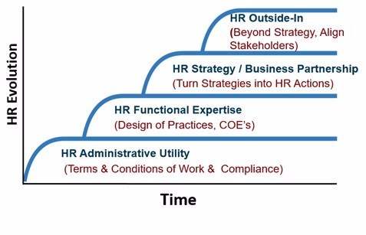
There are various models to the HR function which can be used to shape organization’s HR proposal and these will vary on the type of sector, organizational size and company objectives. A model that can be referred to is the ‘Ulrich model’ or ‘three legged Stool’ which focused on three different types of HR professionals that work in distinctive ways.
In Taylor, 2016 they summuriase the professions as-
- HR Business Partner: Senior Hr professionals who work closely with business leaders, who influence and steer strategy and implementation.
- HR Centres of Excellence: Small teams of HR specialists that focus on evolving and providing innovation in specific areas, generally focusing on learning development and employee engagement.
- HR Shared services: Large teams that deal with the day to day situations on an administrational lever, including payroll, absence management and recruitment.
Within most organisations there is a cross over between professions and this is unavoidable due to the constraints of company structures and the model should be used as a guideline to be adapted.
“A generation of HR professionals used the ‘Ulrich model’ as the basis for transforming their HR functions, based on the idea of separating the HR policy making, administration and business roles” (Foster, 2015)
In a report by Georgi Gyton, 2017 Ulrich himself states that the model was relevant at the time but should now be the foundation for the future development. “HR is not about HR …. It begins and ends with business” The HR role was historically to ensure workforce was competent, with a positive experience and had wellbeing. Current thinking has changed to encompass the HR role to consider all elements of the organisation including internal and external stakeholders. Outlined in Ulrich, 2009 comon pitfalls are that the HR transformation is not embeded within the business demands. If the HR Strategy is constructed in isolation from the business strategy this will result in one or both not succeeding Both need to work in alignment with each other and have integrated principles to add value to the organisation and optimize the HR function for longevity. This theory is supported by Farnham, 2015 who discuses the notion of Business and HR inputs to achieve positive organisation outputs, using the concept of David Guest framework model (Fig:2).

Fig:2 Model of the link between HRM and Performance
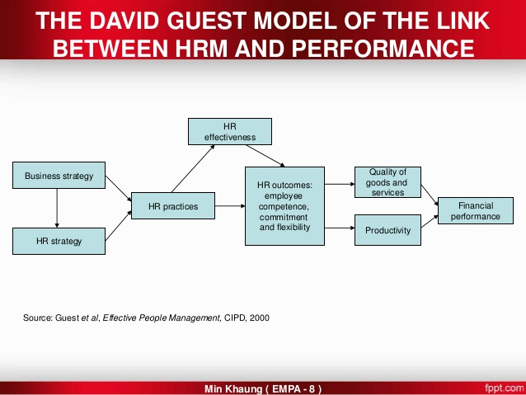 (Khaung, 2003)

Other models that can be considered to shape the HR agenda are Best Practice, Best fit, contingency theory and resource based view. The Best Practice approach is based on high commitment, high performance or high involvement. This follows the same theories as Pfeffer, 1998 by considering employment security, selective hiring, extensive training and wage pay reflective to company performance. Pfeffer states implementing high performance work teams and giving employees an input will raise performance in turn resulting in higher productivity, production and enhanced service levels due to-
- Improved employee attitude/ behaviour
- Improved Morale
- Higher skill levels
- Lower absenteeism and turnover
By ensuring that the employee is given the best opportunities and development structure this should be beneficial for the business in the long term. Unfortunately in the short term this can be financially draining and not have the organisation’s foresight.

Compare different tools for analysing business environment
To grow as an organisation, you first need to analyse the business environment, including external and internal factors that will formulate your business strategy to become innovative to assess the effectiveness of change. Tools in the area can assess the potential positives and negatives of future changes that may affect the organisation on various levels, and highlight areas for development or resistance.
In this section we will look at three frameworks that can be used as part of developing a business strategy. PESTLE that evaluates external factors, SWOT that looks at internal factors and PORTER’s FIVE FORCES combines both internal and external factors.
“PESTLE analysis is in effect an audit of an organisation’s environmental influences with the purpose of using this information to guide strategic decision-making.” (CIPD, 2015) A PESTLE analysis reflects on external factors that will impact on an organisation, by considering 6 elements, (Fig:3) understanding of these will highlight opportunities and reduce threats to an organisation on a broad and long term trend.
Fig:3 PESTLE Analysis
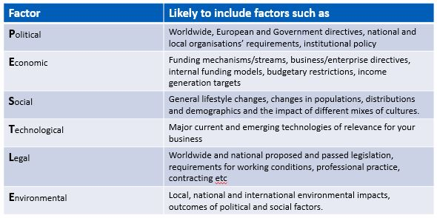
To do a PESTLE analysis as per CIPD, 2015 the following elements need to be considered:
- Identify the area of the research
- Decide how the information is gathered and by whom
- Select approriate sources for information
- Record information gathered
- Analyse the resources
- Identify the importance of factors
- Identify the business specfic options to address issues
- Produce a discussion document for stakeholders
- Discusses finding with descion makers
- Set actions and monitor trends
Advantage | Disadvantage
Simple format | Can be over simplified and not use enough data
Understanding of wider business environment | To much data will not formulate a change
Development of strategic and external thinking | Needs to be regular monitored to be effective
Predict future threats and establish actions to reduce impact | Pace of change may not be reflective development for the future
Promote business opportunities | Information maybe assumption based

A SWOT analysis reflects on internal factors that will impact on an organisation by considering 4 elements, “understanding the Strengths, Weakness, Opportunities and Threats involved in a project or in business. It involves stating the objectives of the business or project and identifying the internal and external factors that are either supportive or unfavourable by achieving objectives” (CIPD, 2015a). A structured approach to analysis the organisation can give insight to future objections and opportunities within a problem solving format (Fig:4).
Fig:4 SWOT Analysis template
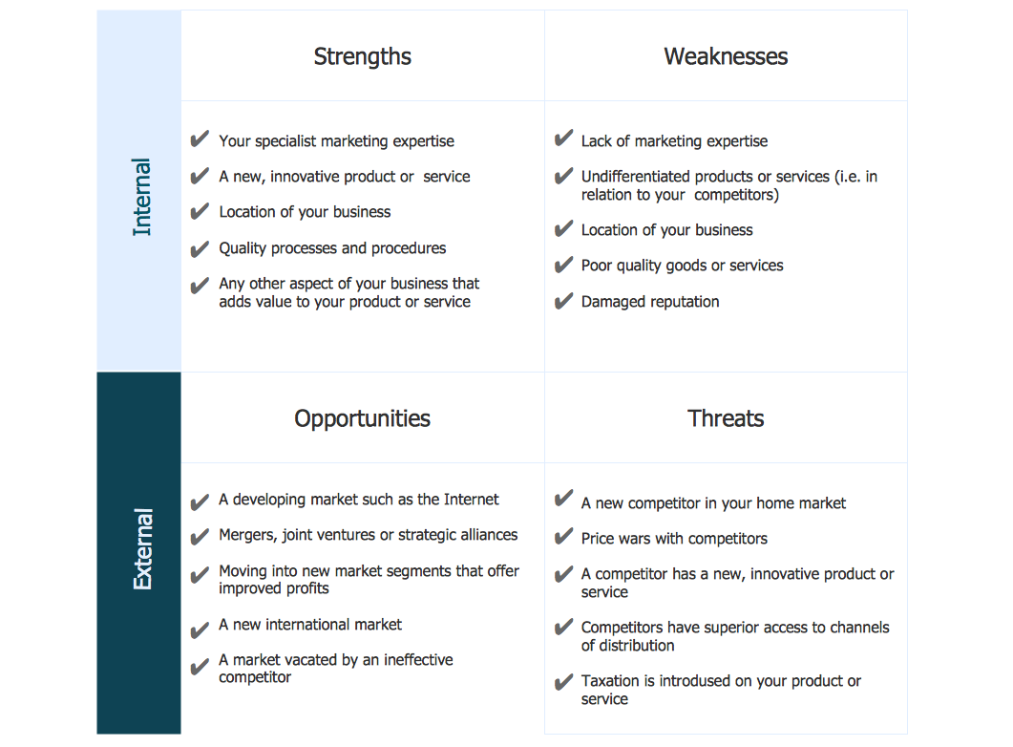
To do a SWOT as per CIPD, 2015a it is a simple process. Ideally the analysis will be done in addition to other techniques using collective views for multi perspectives and flexibility for change. The following steps will need to be addressed and have similar structure to PESTLE process:
- Decide how the information is gathered and by whom
- Select approriate sources for information
- Gather information
- Record findings
- Identify the most important factors
- Identify the strategic options to address issues
- Produce a discussion document
- Discusses finding with descion makers
- Set actions and monitor trends
Advantage | Disadvantage
Simple 4 box format | Can be over simplified and not use enough data or too much data
Understanding of organisation strengths and weakness (Internal) | Needs to be regular monitored to be effective
Development of strategic thinking | Collective perspective is required to be effective
Focuses on Strengths and development of opportunities | Access to Internal data can be lacking or time consuming
Highlights areas of future threats to minimalize the effect | Data used may be assumption based rather than factual and will produce unfound objections
Flexible | Lacks detailed structure and elements can be over looked

Porter’s Five Forces as per WIKIPEDIA, 2017 and Mindtools, 2018a is an analysis framework to asses the attractivness (Fig:5). This was developed in 1979 to replace SWOT, as Micheal E. Porter demend it to be lacking in precision and wanted to focus on profitability - “three forces from’horizontal’ competition - threat of substitute products or services, the threat of established rivals, and the threat of new entrants – and two others from’vertical’ competition – the bargainig power of suppliers and bargaining power of customers.” (WIKIPEDIA, 2017)
Fig:5 Porter’s Five Forces
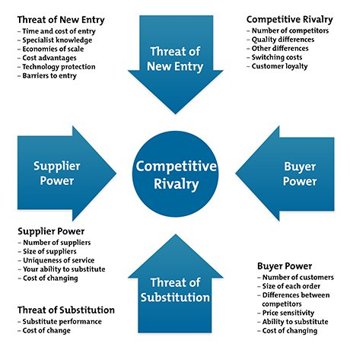
Porter’s Five Forces is designed to understand the impact of competition within an industry by assesing the power of profits, whether that is from the consumer, supplier or direct market. The following forces are to be addressed:
- Supplier Power
- Buyer Power
- Competitive Rivalry
- Threat of substitution
- Threat of new entry
Advantage | Disadvantage
Create customer loyalty and improve retention | Can be expensive to action changes
Improve market placement | Customers’ needs become integral to the success rather than business needs
Clear guide to customers’ needs and Trend patterns | Lends itself to being reactive and not proactive
Predict failure rates | Outcomes can be easily duplicated by competitors
Awareness of customer relation and communication | Requires skills and experience to analysis retrospective changes

Not specfic to any set analysising tool, the Organisations and coresponding HR professionals should make commitment to guaranteeing a positive work place enviroment that promotes a happy work life balance with accesibile legal policies and procedures in place. This ensures the future success of the business by protecting the organisation and employees by having sound strategies in place that consider the enviorment in which they are part of.

Factors Impacting HR and the organisation
Organisations and HR departments can have influences from internal and external factors which need to be analysed to build a systematized and positive business brand (Fig:6). Micro factors are affected by the internal business and Macro factors are modified by the external environment. Micro factors take into consideration the company structure, Business sector (Public, Private or Voluntary) and business size (Small, Small and Medium enterprise /SME or Large Corporation). Macro factors are not controllable by the set organisation as they encompass the outside world as in a PESTLE analysis, relating to environment, political change, technological and competition development.
Fig:6 Micro/ Macro Environment factors
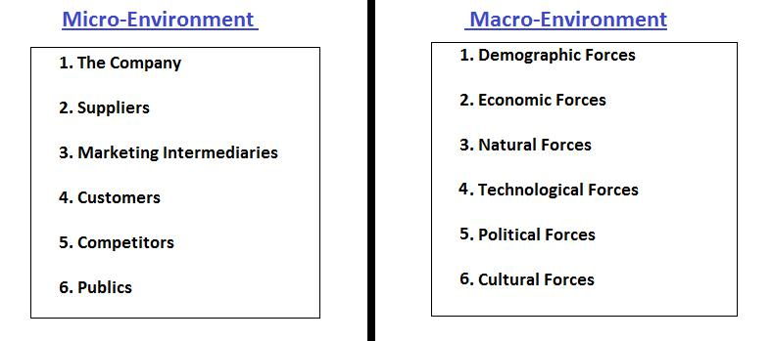
The Micro factors of HR (Fig:7) will be the same throughout the different categories but will not necessary have the same significance, for example business sectors have different agendas but they all aim to provide a service and have some form of stakeholders. “It is obvious that, public firms and private firms have mainly different purposes. Accordingly, in general, the priority of public organizations is to create social benefit, while private firms focusing on profitability and growth. On the other hand, both types of organizations should be competitive to survive in today’s complicated business environment” (Genc, 2014)

Fig:7 Internal HR Micro factors

- Employees- Recruiting with relevant skills and experience, whilst managing the age working population, cultural changes and diversity.
- Competitors- Awareness of existing competition and drive greater position within the market place. This will retain and source the right talent for the organisation.
- Media- Continues Positive media coverage can raise an organisations profit and company profile. Poor media reviews can potentially destroy a business by losing productivity and profit. Employees aspire to work for reputable and recognised companies.
- Shareholders- Company growth is reliant on investment. The need for ongoing profit development may play a deciding factor in strategy planning.
- Suppliers- Good working relations with supply chain, ensure valued products at competitive prices. Confidence in a product/ service develop ethical and good work practice.
- Customers- Provide the service to exceed expectations to retain and build loyalty.

Key Stages of Strategy and the role of HR

‘How do business strategies get formed? And what kinds of alternatives are available when shaping HR strategies to support them?’ (Taylor, 2016)
For a business to grow and be successful it needs to have ambition and direction, which can only be achieved by implementing future plans for change as part of a strategy. How the strategy is formulated and the reasons behind it can take various visages. Taylor, 2016 discuses three various approaches:
- Rational/ Classical- means identifying actions to achieve a goal in the future as part of a long term plan. Information-gathering is front-loaded and based on evidence from internal and external research and economical awareness. The plan is fixed and implemented without deviation. Useful in large hierarchy companies, those comprising of multiple joint small businesses, or ones that struggle with responsive change.
- Emergent / logical Incrementalism- is a plan of accomplishment concerning a goal that happens in the moment, changing and shaping dependent on factors without a fixed future plan. The general outcome is set but the individual steps combine a logical and consistent plan that evolves through development. Brown, 2017 discribes this as per a flock of geese in flight; aware of the common goal and able to adapt to moment-to-moment manoeuvring adjustments, in order to collectively achieve. Information is collected on an ad hoc basis as required using trial and error. This approach is generally used in small organizations that have flat or minimal hierarchy.
- Symbolic/ radical- is opposed to the other approaches by reliant on trial and error. Actions that move closer to end result are retained and others are adapted or discarded. This is experiment based strategy that retrospectively records the plan to give organisations significance and integrity. This approach is for small organisations that are willing and able and to respond to change quickly with little resistance.

Henry Mintzberg is considered to be highly influential in the design and implementation on strategies as per Taylor, 2016 and Stredwick, 2016 and formulated the 5P’S in 1987 as different approaches to strategy planning. Taken from Stredwick, 2016 and Mindtools, 2017 these are the Mintzberg’S 5 P’s of Stratergy-
Plan- What action plan is required? To forecast for the future. The use of external analysis like PESTLE or internal analysis like SWOT can be used to outline the plan, but it needs to be taken further than that stage to have effect .From a HR point the observation and influence of surrounding environment could be a key part.
Ploy- Who is doing what and when? To outsmart the competitors. Awareness of competitors as potential threats and by intentionally planning to disrupt or influence them can be linked into the plan, by understanding how a response may unfold. HR can use this information to actively give a company a competitive edge by pursuing a positive work culture.
Pattern- What works and why does it work? Take a historical review on success. Positive behaviour or ethics can develop into a strategy by being consistent and successful by their own intentional rather than a deliberate plan for change. Hr strategy might use the patterns of behaviours, attendance and trends to underline development.
Position- How do you fit in and where? The balance between competitors and organisation success can be a deciding factor as the market environment will have a direct correlation to the business strategy and can be analysed using SWOT and Porters Five Forces. Examining the external environment from a HR spectrum could be used to change the culture of the organisation to promote resilience and advantage.
Perspective-Why do we think that? The view of the organisations will have a direct reflection on its culture and perception, by encouraging innovation will evolve a diverse ethos, where as a structured regime will produce restricted but concise outcomes. The HR strategy can mirror the organisation vision to promote a collective company positive attitude.

Implementing a strategy is idealistic as this is estimation of future business needs reflecting current information and perceptions available. Generally a long term strategic plan will not be completed without modifications throughout to its completion due to environmental or organisational change. The intended strategy may need to be adapted to another model to become successful and relevant over time. HR Roles can use strategy to estimate future business needs that could consider recruitment and training as per business costs, whether that be to reduce or increase cost to ensure productivity and skillset is in line with business forecasts.

The key area in any form of strategy planning is communication as all parties will need to be aware of changes effecting themselves. There are four (Fig:8) possible types of strategy communication - ‘top down’, ‘bottom up’, ‘interactive approach’ and ‘semi-autonomous’ depending on the organisation culture and structure.

Fig:8 Communication Strategy

The Hr department not only has the responsibility of ensuring ethical decisions are made and promote a role model figure, they are also responsible for promoting ethical behaviour for all. By ensuring that all employees are aware and follow the code of conduct, these are moral standards which shape an organisation and employees behaviour. Each company will have their own version of ethical code dependent on the organisation but all should outline the expected behaviour of employees on a variety of topics and be compliant with employment legislations. They may consider the following-
- Equality of opportunity- fairness to all with no discrimination
- Diversity- promote the interests of variety and inclusiveness
- Dignity at work- zero tolerance to bullying and harassment
- Work-life balance- seek opportunities and provisions for a happy balance, which complies with working directives
- Health and well-being- seek opportunities and provisions for a healthy employees both mentally and physically
As per Wikinson and Taylor, (2016) there are three different types of codes. Educational: to increase moral awareness and behaviour, Regulatory: detailed rules on behaviour to resolve morale conflicts, and Aspirational: general layout of values and communications for individuals.

How can the business performance be evaluated?
Evaluation and assessing the business performance by the HR department is needed to predict the future company requirements in response to the workforce planning model set out by company managers. The workforce planning can consider recruitment and retention, when and how many new recruits the business will need? Is a recruitment freeze required? What is the budget for possible pay increases to retain or attract new employees? As per the CIPD, 2016 Fact sheet states workforce planning is to match the business short and long term objectives by the ensuring the right people with the right skills are employed at the right time. It also outliners other potential objectives:
- Flexible working
- Risk management
- Talent management
- Multi Skilling/ cross training
- Outsourcing
There are both traditional and modern performance indicators businesses can use to evaluate themselves. Traditional indicators would comprise of internal statistical data including –Bench marking, Absence rates, employee average cost, training cost etc. The HR department can assist by recording and providing this data for senior management and stakeholders. Modern indicators would be opinion based data, including -employee engagement, staff surveys, training surveys, the HR department can record the noted responses and present finding to the senior management and stakeholders.
Tools can be used by the HR department to analyse and evaluate the business performance. They can consist of Statistics (quantitative and qualitative data), KPI’S (Key Performance Indicators for each employee to develop), Talent management (CIPD, 2017) (the attraction and retention of individuals that add value to an organisation) and Balanced scorecard (specific performance measures and how they relate to the business).
In Foot & Hook (Hook, 2011) and Wilkinson & Taylor (Taylor, 2016) describe the Balance Scorecard as a four way approach to the business (Fig:9) which must be measured. Understanding the factors (what contributes to outcome and in what way) will help validate actions, identify and evaluate sucesses for the future. The balance score card comprises of 4 areas Finance, Internal business process, learning and growth and Customer.
Fig:9 Balanced Scorecard
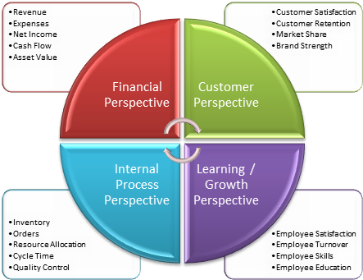
Implementation of a balanced score card should result in-
- Improved Processes
- Motivated/ trained employees
- Enhanced Information Systems
- Monitored Progress
- Improved Customer satisfaction
- Increased Financial usage
There are numerus ways of evaluating business performance and the process required is dependent on the organisation’s objections and what the intended strategy is set to achieve. Organisations may select to use Talent management to focus on skills within in a company compared to the desired skills required to move forward. They may select to invest in learning and development, to promote within or specifically recruit a set skill set; the downside being that this has a financial strain on an organisation that can outweigh the value. Talent requirement can change frequently as environmental changes happen with regards to Political, Social and Technological advancement. Companies can focus too heavily on individuals rather than collective talent, as per Ulrich “HR could be making the mistake of focusing on the talent of the individuals in organisations instead of looking at the talent of the organisations as a whole. And HR departments often see employees as the customer rather than actual customers of the business” David Ulrich (Wood, 2009)
Change is inevitable. For change to be a positive successful process in an organisation the key is communication and justification for the change. Change is often seen as a negative and some may resist or actively stop this. Understanding an individual’s change process is addressed in The process of Transition (Chapman, 2000) (Fig:10) and Wlikinson & Taylor, 2016 the HR role during change is to support, communicate and implement actions.
Fig:10 The process of Transition
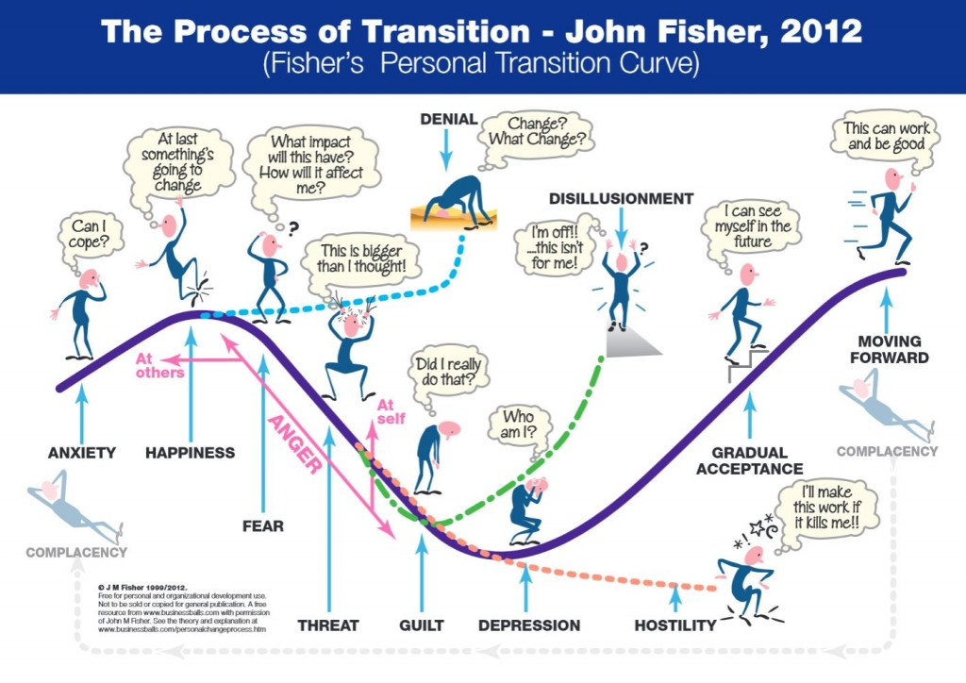
Many change models are adapted from Kurt Lewins’s 3 step model of change (Miner, 2007) devised in 1947 (Fig:11) the model asses that change needs to be completed in stages to be successful and adaptable by reviewing process before moving to next stage.

:11 Kurt Lewins’s 3 step model of change
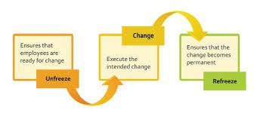

Assessing and integrating data
Data is crucial for organisations to develop, grow and prosper. Without robust data, the validation and quality is not supported making strategic plans and future objectives unrealistic. Statistical data provided by the HR department enables stakeholders to make informed decisions for organisation expansion and development.
HR data that may be required or have gravitas is-
- Absence and disciplinary statistics
- Employee retention/ recruitment / length of service
- Employee pay and benefits ( wages, benefits and reward packages)
- Breakdown of employees per department and organisation
- Employee hourly contact split (full/ part/zero)
- Holiday planning
- Learning and development skills (training course, cost and time)
- Workforce demographics (age, gender and ethics)
- Performance management, including productivity and profitability against targets that are outlined with in KPI’S
- Employee relations and satisfaction survey results
This data can be used by the stakeholders to forecast budgets and profit shares taking into consideration recruitment, learning and development and future expansion. The data could play a vital part within a business strategy to change the structure or working contact of its employees in order to meet the business strategy for success and future proofing. This type of information would normally be produced on regular intervals and not for an annual review.
The HR department can use this data to asses and monitor trends for establishing the business needs. “What are the important Trends for each of these realities? What are the key data points that illustrate these trends? What do I need to know about these trends in order to contribute to management team discussions? Where can I find this information?” (Ulrich, 2005)
Awareness of trends within Absence rates could raise senior management to develop a business strategy to look at employee wellbeing or address absence policies to reduce the cost to the business. Other areas that the HR data could provide is poor staff retention within a specific department/ role- could indicate poor group dynamic or recruitment, changes to holiday patterns- could indicate a change in home life balance (no longer requiring school holidays off) or change in organisations religions culture. In the CIPD Best to Good practice Research report, (Louisa Baczor, 2015) (Fig:12) they address eight drivers (Utilisation of technology, Workfore diversity, Globalisation, Industrial change, Individalism, Social responsibility, Quality of education and Diversity of employment relationahips) to change and considered the impact of the trend upon the organization as a whole.
Fig:12 Trends Impacting the world of work and implications for the profession
Trends | Predictions for the trend becoming more prominent | Risks | Implications for people management and development
Diversity of employment relationships | Diversity of working patterns, as well as the types of employment contracts, driven by the changing needs of organisations in when and how they want to provide services, as well as by the evolving expectations of individuals about the ways of working. | Controls imposed by governments concerned with the security of some of the non-standard arrangements | Planning the alignment of workforce availability with the customer demand for services.
 | Two-tiered workforce, with the traditional core comprising permanent staff, complemented by a large group of contractors and freelancers | Long-term service may become more desirable once again, challenging organisations to focus their value proposition on appropriate rewards and career pathways | Transforming organisational culture to embed flexible performance management processes.
 | Fragmentation of organisations into smaller ‘businesses’, representing collaborative networks of contingent workers. | Hierarchical and control-driven organisational structures and management approaches are slow to adapt to employee expectations. | Managing inequality of terms and conditions between different categories of workers.
 |  |  | Giving a voice to contingent workforce in when and how they work.

The HR statistic data can be used as a competitive measure in line with the business strategy of competition by having clear understanding of staff retention. Having information on what employees might be won or lost by a direct competitor and proactively enabling measures to promote the business. HR can also use the data for future Talent management by instilling early Learning development plans to skill up current workforce to minimise skill gap.
Conclusion
From a HR perspective it is essential to understand the historical and future organisations strategies to enable a cohesive rationale between the business and ethical fulfilment. “in the current climate, HR is faced with a series of paradoxes and may, as a result , become confused as to whether to do everything; or to take a short-term view or a long –term view.” David Ulrich (Wood, 2009)
Organisations need to analyse and asses all concepts of internal and external environment to fully understand the influences on Technological, Political and Globalization that will affect the business and individuals. Change and development is inevitable and needs to be encompassed within the daily workforce structure; by combining and analysing data to plan for the future this will enable organisations to be resilient and effective. The HR position throughout is to ensure that the workforce has the structure, skills and principles to ensure profitable success of the business. The type of strategies and methods used are inconsequential but need to be executed in a proactive and ethical way that supports the organisations and it’s flexibility. This concept is supported in the reports by Louisa Baczor, 2015 and Miller, 2014 who looked at HR within business and the changing dynamics of current times.
“in creating sustainable value through people management and development processes, they will have to embrace the different stakeholders …… understand the type of value that they expect to gain from the relationship” (Louisa Baczor, 2015)
The HR role can no longer mearly exist within an organisation but has to add value. This will support business strategies and promote workforce agendas. HR professionals need to adapt by being innovative and proactive within the changing enviroment to ensure company future proofing.

References
Brown, A. M., 2017. Emergent Strategy: Shaping Change, Changing Worlds. California: AK Press.
Chapman, A., 2000. Personal Change Stages - John Fisher. [Online]
Available at: https://www.businessballs.com/change-management/personal-change-stages-john-fisher-162/
[Accessed 10 2017].
CIPD, 2015a. SWOT Analysid Factsheet. [Online]
Available at: https://www.cipd.co.uk/knowledge/strategy/organisational-development/swot-analysis-factsheet
[Accessed 27 12 2017].
CIPD, 2015. PESTLE Analysis Factsheet CIPD. [Online]
Available at: www.cipd.co.uk/knowledge/strategy/organisational-development/pestle-analysis-factsheet
[Accessed 22 December 2017].
CIPD, 2016. Workforce planning. [Online]
Available at: https://www.cipd.co.uk/knowledge/strategy/organisational-development/workforce-planning-factsheet
[Accessed 02 01 2018].
CIPD, 2017. Talent Management. [Online]
Available at: https://www.cipd.co.uk/knowledge/strategy/resourcing/talent-factsheet
[Accessed 27 12 2017].
David Ulrich, W. B. J. Y. M. U., 2012. HR from the Outside In: Six Competencies for the Future of Human Resources. s.l.:McGraw Hill Professional.
Farnham, D., 2015. Human Resource Management in Context: Insights, Strategy and Solutions. London: Kogan Page Publishers.
Foster, S., 2015. The Ulrich Model: 18 years old, but is it working?. [Online]
Available at: https://www.ngahr.com/de/blog/ulrich-model-18-years-old-it-working
[Accessed 24 December 2017].
Genc, K. Y., 2014. Environmental Factors Affecting Human Resources Management. International Journal of Business and Management, 9(11), pp. 102-122.
Gyton, G., 2017. Q&a: Dave Ulrich - People Management Magazine Online. [Online]
Available at: http://www2.cipd.co.uk/pm/peoplemanagement/b/weblog/archive/2017/03/28/q-amp-a-dave-ulrich.aspx
[Accessed 27 December 2017].
Hook, M. F. &. C., 2011. Introducing Human Resource Management. 6th ed. Harlow: Pearson Education Limited.
Khaung, M., 2003. Introduction to Human Resource Management. [Online]
Available at: https://www.slideshare.net/minkhaung77/introduction-to-hrm-28738798
[Accessed 24 12 2017].
Louisa Baczor, K. Z. &. R. Y., 2015. From best to good practise HR: Developing principles for the profession, London: CIPD.
Miller, J., 2014. Keeping culture, purpose and values at the heart of your SME, London: CIPD.
Mindtools, 2017. Mintzberg's 5 Ps of Strategy, London: Mindtools.
Mindtools, 2018a. Porter's Five Forces, Understanding Competitive Forces to Maximize Profitability, London: Mindtools.
Mindtools, 2018. Out lined in Ulrich, 2009 comon pitfalls are that the HR transformation is not embeded within the business demands, If the Hr Strategy is constructed in isolation from the business strategy this will result in one or both not succeeding, both need to work, London: Mindtools.
Miner, J. B., 2007. Organizational Behavior 4: From Theory to Practice. 1st ed. Oxford: Routledge.
Pfeffer, J., 1998. The Human Equation: Building Profits by Putting People First. Boston: Harvard Business School Press.
Stredwick, J. K. &. J., 2016. Human Resource Management in a Business Context. 1st ed. London: CIPD.
Taylor, K. a. W. S., 2016. Managing and Co-ordinating the HR Function. In: 2nd, ed. Studing Human Resource Management. London: Chartered Institute of Personnel and Development, pp. 21-41.
Ulrich, D., 2005. The HR Value Proposition. s.l.:Harvard Business Press.
Ulrich, D., 2009. Transformation Building Human Resources from the Outside In. New York: McGraw Hill.
WIKIPEDIA, 2017. Porter's five forces analysis. [Online]
Available at: https://en.wikipedia.org/wiki/Porter%27s_five_forces_analysis
[Accessed 15 12 2017].
Wilkinson, S. T. &. K., 2016. Business Issues and the Context of Human Resources. In: 2nd, ed. Studying Human Resource Management. London: Chartered Institute of Personnel and Developmemt, pp. 43-66.
Wood, D., 2009. HR challenged by paradoxes, Dave Ulrich tells HR Leaders Club. [Online]
Available at: http://www.hrmagazine.co.uk/article-details/exclusive-hr-challenged-by-paradoxes-dave-ulrich-tells-hr-leaders-club
[Accessed 28 12 2017].

