Essentials of People Practice – Task 5
Learning and Development – Fact Sheet
L&D also provides employees with better futures; both personal and professional. Constant L&D for the employee enhances their skills and knowledge in the workplace but will benefit them in the real world as well. Overtime, L&D enhances employee performance as they develop into better employees. For the organisation, having a workforce that is learning and developing will create a strong, dedicated workforce who are strong performers and will make it easier for organisations to reach targets.

A.C 6.1 contd.
L&D activities in the workplace provides huge benefits to both the employee and the employer. Growth Engineering (2022) list several benefits these have. One benefit is that it encourages employees to learn more. They say that learning is continuous development. Having a system in place that provides and tracks learning gives the employees a platform that allows them to learn and develop different aspects of their job role. For the organisation, this will ensure its employees are constantly being reminded of workplace regulations and how to perform job duties, having it fresh in their mind increasing performance.
Another benefit they list is that it reinforces organisational culture. This means that L&D promotes o positive workplace culture as its one that encourages personal growth. This benefits the employee because they will have increased job satisfaction when feeling happy in their workplace and it benefits the organisation as it gives them a great company image.

Benefits of L&D – A.C 6.1



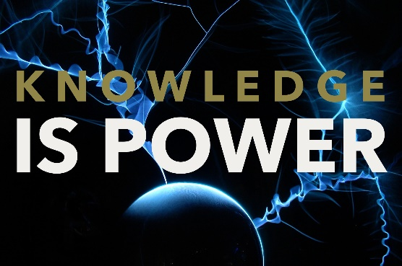
Various Learning Needs – A.C 6.2

Every employee has different learning needs. A learning need can be defined as the qualities that employees need in order to learn and grow in a particular area, as defined by Malec (2022). A learning need is normally knowledge, skill or attitude and/or behavioural related according to Waite et al. (2021)

An example of a knowledge-based need would be an employee in a mobile phone call centre not knowing the different packages available to the customer. This would require knowledge-based training to get the employee equipped with the sufficient knowledge. This may arise because the organisation hasn’t provided the correct training, or the employee hasn’t listened properly during training.

A skills-based need would be an employee who works with computers and struggles with different software such as Excel or payroll systems. This need would call for training on these systems, so the employee knows how to use them properly. The employee may be of an older age so they may not be comfortable on computers; that’s why this problem may arise for them. For the organisation, however, this problem may arise because they didn’t think to offer any computer training and assumed that each employee would have the same skill level.





A.C 6.2 contd.

A behavioural need may be a restaurant waiter using slang when talking to customers or standing with their arms crossed. This sort of behaviour isn’t tolerated in big restaurants so they would need to be told how not to speak and act in the workplace. This may arise as the employee may be used to this sort of behaviour in an old workplace that was seen as acceptable, or the organisation hasn’t made it clear enough on how they should act in the workplace.

Mentoring is slightly different as this is where the employee shadows an older/more experienced colleague, where the mentor can directly supervise and give them advice on the job. The mentor shares personal experience and knowledge and tips that helped them when they were first starting out in that role.
A.C 6.3 contd.
Facilitation
This is where a group of learners of led by an instructor/teacher, and they guide the learners to a learning outcome by getting them to work together in an easy environment (Luenendonk, 2019). This engages the group as everyone gets involved and shares ideas, so everyone is learning from each other together.
Training
There are many types of training, as explained by Avelino (2022). One type she describes is orientation training. This is the training everyone receives when they first join the company to tell them about the organisation, workplace regulations and the resources available to them. There is also classroom training and online training that can be held in the workplace or externally. This can be general training such as fire-safety or specific job-related training.
Coaching and Mentoring
Sword (2021) provides definitions of coaching and mentoring. With coaching, she says that the employee is provided with guidance on their goals and objectives to help them develop in their personal and professional career. This allows the employee to come to their own conclusions of their development.

L&D Approaches – A.C 6.3





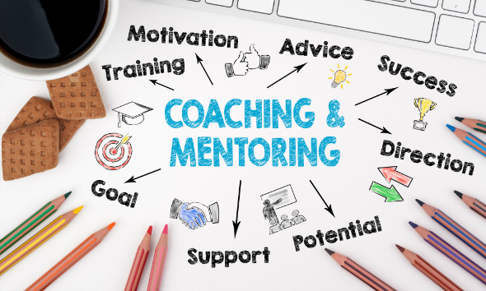


Every learner has a different style of learning and different requirements. The University of Massachusetts Dartmouth (2021) wrote an article about how to accommodate the three different learning styles: visual, audio and tactile.
Visual learners learn better when they can see things such as diagrams, tables and physical handouts. To accommodate these, leaders can provide these handouts and highlight the key data, show them images to explain points and get the learners to create flash cards.
Audio learners prefer being told audibly the information – this can simply be from the instructor giving them a lecture and the learner writing down notes as they get told the information. They prefer to discuss things through dialogue. These can be accommodated by simply giving a lecture and getting them to make notes and have slides of information in the background as a backup. The instructor could also get them to listen to podcasts or audiobooks relevant to the subject matter.

How Learner Preferences are Accommodated – A.C 6.4





Lastly, there are tactile learners. This type of learner prefers physical learning – touching, feeling, doing and practical learning. It’s a very hands-on approach to learning as they like to give things a go themselves as they feel they will learn quicker while doing the actual activity. This style can be accommodated by getting the learners to perform certain tasks and activities while supervising them and giving them pointers and advice to guide them to completion.

A.C 6.4 contd.

Evaluating L&D – A.C 6.5
With L&D, it needs to be evaluated to ensure it is effective and benefiting the employees. Hayden (2022) discusses some of these methods on a CIPD factsheet. One way that L&D can be evaluated is by the Brinkerhoff success case method (SCM) which is a system that finds individuals or groups that have had a positive learning experience, ‘success cases’, through training reports, surveys etc. With this data, they interview these individuals/groups to see if they actually benefited from the learning and explore the positives from that training. The SCM also analyses non-success cases too so they can see why some individuals/groups didn’t have the same success as the success cases. With this data, they can look on how to improve in the future and if certain training may not be right for some people.
Another method of evaluating L&D is the Kirkpatrick model. This outlines four levels of evaluating L&D: reactions, learning, behaviour and results. This model looks into the reactions employees have with different training courses, what they actually learn from it, how it affects their behaviour after and the results it gives such as increased performance, a decrease in costs etc. When this was launched in the 1950’s, it was deemed very helpful, however, later on in the 1980’s, other theorists felt that it was lacking due to each of the four levels didn’t link perfectly to the next.

Wordcount
(Not including titles, reference list or this box)

1,272

Reference List
Avelino, J. (2022) 10 Types of Training. Available at: 10 Types of Training | EdApp Microlearning (Accessed 18th December 2022).
Growth Insider (2022) 12 REASONS WHY LEARNING AND DEVELOPMENT (L&D) IS SO IMPORTANT RIGHT NOW. Available at: 12 Reasons Why Learning and Development (L&D) is So Important (growthengineering.co.uk) (Accessed 18th December 2022).
Hayden, D. (2022) Evaluating learning and development. Available at: Evaluating Learning & Development | Factsheets | CIPD (Accessed 19th December 2022).
Luenendonk, M. (2019) What “Facilitation” Really Means and Why It’s Key to the Future of Work. Available at: What “Facilitation” Really Means and Why It’s Key to the Future of Work | Cleverism (Accessed 18th December 2022).
Malec, M. (2022) How to Identify Learning Needs in Your People. Available at: How to Identify Learning Needs in Your People (learnerbly.com) (Accessed 18th December 2022).
Sword, R. (2021) Coaching vs. Mentoring: What’s the Difference? Available at: What is Coaching and Mentoring? | Differences, Principles & Benefits (highspeedtraining.co.uk) (Accessed 18th December 2022).
University of Massachusetts Dartmouth (2021) How to Accommodate Different Learning Styles. Available at: How to Accommodate Different Learning Styles | Center for Access and Success | Student Affairs | UMass Dartmouth (Accessed 19th December 2022).
Waite, K. et. Al. (2021) People Practice: A Complete Guide. London: Kogan Page Limited, pp. 208-210.

