APPLE INC
ASSIGMENT 1

Programme: BA Business Management
Module: Management Economics
Module code: LCBB5008
Lecturer(s): Taye Osadiya, Riaz Bhatti

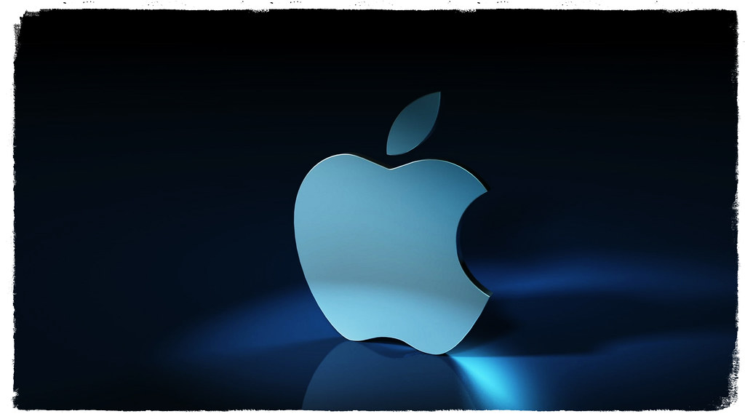
This Photo by Unknown Author is licensed under CC BY-NC-ND

Student Name: Valeria Peeva
Student Number: 2029005

Table of Contents
INTRODUCTION 3
BUSINESS PICTURE 3
DEMAND and market equilibrium 4
Indicate the demand if it is more elastic or more inelastic 7
CONCLUSION 9
REFERENCES 11

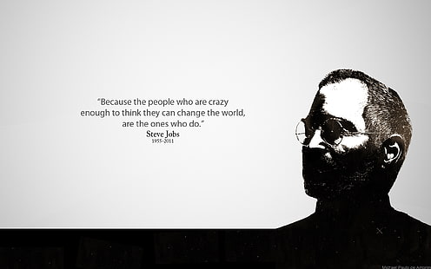

INTRODUCTION
Business management is the practice of planning, organising, directing, and controlling a company's or organization's activities to achieve its goals and objectives. It entails overseeing all parts of a company, from finance and operations to marketing and human resources. Business managers must be skilled in leadership, communication, and problem-solving, as well as make strategic decisions that drive the organization's success. Management economics is important to every business organisation since it helps to analyse the behaviour and markets of the business organisation and effectively make informed decisions on how organisations can effectively improve their performance and achieve their objectives.
This study will examine the company's history, operations, industry, types of services and goods produced, business environment, primary sells, and additional traits of the business's corporate summary. It will show the most famous product of Apple Inc and it will determine market equilibrium and demand. Indication of demand if it is more elastic or more inelastic will be discussed too.
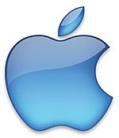
This Photo by Unknown Author is licensed under CC BY-SA

BUSINESS PICTURE
Apple Inc., originally Apple Computer, Inc., is a global establishment that produces private PCs, processer peripherals, and laptop package in the US. It occurred the initial productive personal PC firm and the graphic client edges universalize. The corporate office is in Cupertino, California. Jobs and Wozniak named their companies. Additionally, the company also sells its products through retailers and distributors across the global. Furthermore, the company has a range of services that help customers with installation, maintenance, and support of its products. The company also offers services like cloud computing, data analytics and cybersecurity solutions.
One of the most well-known and significant brands in the world is Apple, and the iPhone participated an important responsibility in the development of the smartphone. So, iPhone sales have stopped, Apple has investigated new ways to generate income from the device. In 2015, Apple Watch was unveiled as an iPhone attachment that monitors a variety of fitness and health metrics. Then came Air Pods, opening the way for wireless headphones to become widely used. I have chosen to concentrate on this report with the product iPhone because I this is the most famous product and the first thing when you think of the company Apple.

DEMAND and market equilibrium
The equilibrium price in a market with competition is established by the supply and demand for a good or service. Corresponding to Chatterjee, a healthy mix of higher-end gadgets, as well as supply and demand approaching equilibrium, bodes well for the December quarter. He also stated that Apple will most certainly achieve optimal inventory levels, which could result in advantages in the March 2022 quarter. As such both the economic concept is important in determining the product demand of an organisation and role of market equilibrium in determining the cost of the produce.
Price of substitute
Value of substitute refers to a price of product or service that can be used as a replacement for the original product and ensures that it satisfies the same customer needs and preferences. The price of substitutes is one of the factor that really affects the demand of a product. Because a fall in price causes a decrease in demand for hamburger and an increase in price can raise demand for a substitute product. Although not every non-iPhone on the market is identical to Apple's current line-up of smartphones, there are plenty that are similar enough in terms of capabilities and performance to be regarded as "true" alternatives. The solutions you'll find in the next section are mostly standard, but a few go even further and explore the potential of mobile devices as we currently know them in the future.
The most recently unveiled next-generation smartphone on our list is also the cheapest "true" iPhone alternative (assuming you have a good trade-in). Samsung also boasts 5G network connectivity, which means it has blazing-fast data transmission speeds, and a quad rear camera array with ultra-wide telephoto lenses, which is somewhat expected. As if that weren't enough, it also features a massive 512GB hard drive, 12GB of RAM, and the ability to film in 4k/60fps. For a product that costs roughly half as much as the costliest iPhone, that is astounding.
Price of complements
The Rapid Air Vent Mount Wireless Charger makes charging your iPhone 11 while driving much easier. Accessories such as cases, chargers, and headphones that are compatible with Apple Inc's smartphones, tablets, and laptops are examples of complements that are frequently used alongside its goods. Apps built specifically for their operating systems, such as the App Store for iOS and the Mac App Store for macOS. Apple Music, iCloud, and Apple TV+ are services designed to be utilised with Apple products. If the prices of these supplements rise, it could lead to a decline in demand for Apple's products. It is crucial to note, however, that Apple's brand loyalty and reputation for quality can affect buyer behaviour and reduce the impact of changes in accessory costs.
Consumer Income
It is again one of the factor that determines the demand of the product and a rise in the consumer income promotes the customer to buy more amount of product as its disposable income increases and in the case of decrease in the total disposable income, the demand is affected negatively. Demand for Apple's products may rise as consumer income rises and they have more discretionary income to spend on luxury goods. When consumer income falls, demand for Apple's products may fall as people prioritise spending on needs over luxury items.

Consumer tastes and preferences
It is a common fact that whatever trend is prevailing in the country, the demand for that product will flourish and vice versa. Apple has a strong brand identity, and many customers have formed a sense of allegiance to the company. Apple products are noted for their intuitive user interfaces, ease of use, and seamless connectivity with other Apple devices and services. Apple is well-known for its sleek and modern looks, which can be an important aspect in enticing customers. Features: Apple regularly releases new features and enhancements to its products, which might pique buyers' attention.
Owning an iPhone is sometimes linked with a certain level of social status and distinction, which can be a driving factor for some customers. Consumer preferences and interests can have a big impact on the demand for Apple's iPhone products. For instance, if consumers learn to demand larger screen sizes or more advanced camera functions, Apple may need to change its product offers to accommodate these desires while remaining competitive in the market.
Consumer expectations of price
The expectations regarding the price of the product also impact the increase and decrease in the existing demand of the product. Consumer price expectations can also have a substantial impact on demand for Apple's iPhone products. The iPhone, as a luxury device, is generally more expensive than many other cell phones on the market. As a result, buyers have high expectations for the iPhone's price and what they consider to be a fair value for the device. If buyers believe the iPhone's price is too high, they may choose for a different smartphone or postpone their purchase until the price drops. Consumers, on the other hand, may be more likely to acquire the iPhone if they judge the pricing to be acceptable and a good value for the capabilities and services it offers.
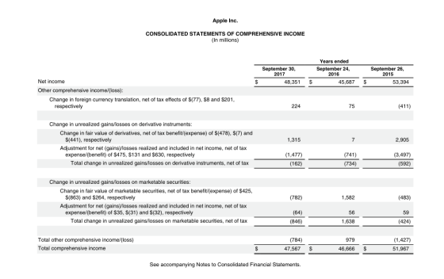
This Photo by Unknown Author is licensed under CC BY-SA-NC

Demographics
This includes decease, increase in the number of a customer in the market which affect the consumption of a particular product as high number of people in market will mean the chances of high number of sales and low number of people in an economy will represents, low consumption of the product. iPhone users are better educated than the overall population, with a higher percentage of users having attended college or graduate school. iPhone usage is more widespread in cities than in rural areas. It is crucial to note that these demographic features are broad trends that may change based on the market or location under consideration. Apple has a big and diversified client base, and the company's products and marketing techniques are continually evolving to appeal to a wide range of people.
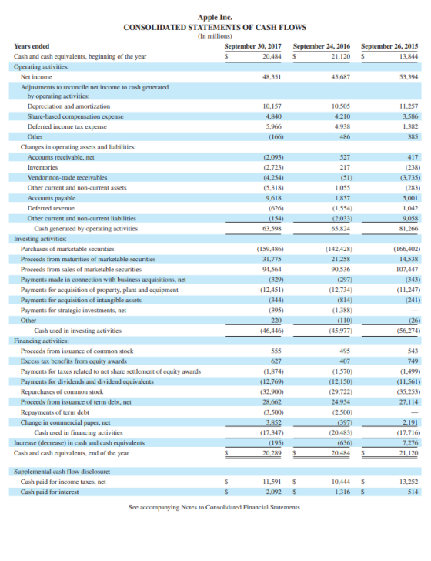
This Photo by Unknown Author is licensed under CC BY-SA-NC

Indicate the demand if it is more elastic or more inelastic
Substitute Availability: The availability of substitutes influences the price elasticity of demand for the iPhone. If there are many replacements for the iPhone, demand for the iPhone will be more elastic since buyers would have more options. Conversely, if there are few competitors for the iPhone, demand for the iPhone would be more inelastic, as buyers will have fewer options.
Time: The price elasticity of demand for the iPhone is also affected by time. Consumers will be more elastic if they have more time to evaluate alternatives or wait for a price fall if they have more time to adjust to a price shift. However, if buyers require an iPhone immediately, demand would be more inelastic, as consumers will be less sensitive to price changes.
Brand Loyalty: The price elasticity of demand for the iPhone is affected by brand loyalty. If customers are extremely devoted to the iPhone brand, demand for the iPhone will be more inelastic, as customers would be less inclined to move to other brands even if costs rise. If consumers are less committed to the iPhone brand, demand for the iPhone will be more elastic, as consumers are more inclined to move to other brands if costs rise.
Necessity: The iPhone's necessity influences the price elasticity of demand. If the iPhone is regarded as a necessity, demand for the device will be more inelastic since users would be less likely to lower their demand for the device even if costs rise. If the iPhone is regarded a luxury item, however, demand for the iPhone will be more elastic, as buyers are more inclined to cut their demand for the iPhone if costs rise.
The dimension of revenue applied on the iPhone influences the estimate movement of query for the iPhone. If the iPhone represents a small portion of consumers' budgets, demand for the iPhone will be more inelastic, as buyers would be less sensitive to price changes. However, if the iPhone accounts for a considerable number of consumers' budgets, demand for the iPhone would be more elastic, as consumers will be more sensitive to price changes. Overall, the Price Elasticity of Demand for iPhone can be modified by a range of factors, and the extent to which these factors make demand more elastic or inelastic depends on the market and customer situations.
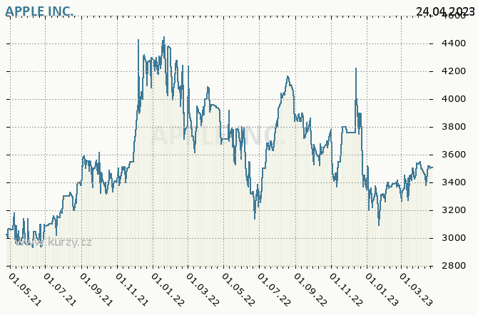
This Photo by Unknown Author is licensed under CC BY-SA
From consumer's perspective, whether an iPhone is a luxury, or a necessity depends on their specific circumstances and tastes. For some users, having an iPhone is a requirement because it is a necessary tool for communication, employment, or personal productivity. Others may regard the iPhone as a luxury device, as there are more economical solutions for communication and productivity. In general, if the iPhone is regarded as a luxury item, demand for the iPhone will be more elastic, as buyers will be more sensitive to price changes and are more likely to cut their demand if prices rise. If, on the other hand, the iPhone is regarded as a need, demand for the device will be more inelastic since users will be less inclined to lower their demand for the device even if costs rise.
The amount to which the purchase of an iPhone represents a substantial or insignificant measure of the purchaser's wages can influence iPhone Price Elasticity. If purchasing an iPhone accounts for a significant amount of a consumer's income, then demand for iPhone will be more elastic, implying that consumers will be more sensitive to changes in iPhone pricing. If, on the other hand, purchasing an iPhone represents a small amount of the consumer's income, then demand for iPhone will be more inelastic, which means that consumers will be less sensitive to changes in iPhone pricing.
For example, if someone earns minimum wage and purchases the latest iPhone, the cost of the phone will be a major amount of their income; if the price of the iPhone rises, they may be more likely to choose a lower-priced alternative or wait until the price falls. If someone earns a six-figure salary and purchases the latest iPhone, the cost of the phone will be a relatively tiny fraction of their income, and they may be less likely to be discouraged by price hikes and choose for a more expensive model instead.
As a result, the proportion of money spent on an iPhone can suggest whether demand for the product will be elastic or inelastic. Demand is more elastic when the cost of purchasing an iPhone is a substantial percentage of a shopper's revenue, but query is extra inelastic when the cost of purchasing an iPhone is a small portion of a consumer's income. A rigorous review of various elements, including production costs, competition, consumer demand, and overall corporate objectives, is required to determine the optimal price policy for the iPhone. However, iPhone should use a price model that maximises revenue while taking market conditions and consumer demand into account.
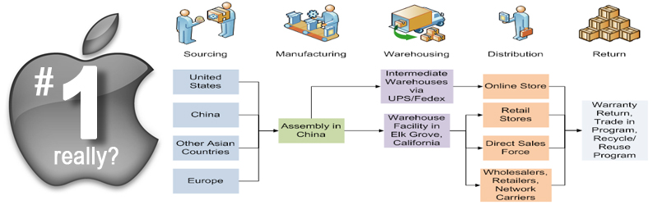
This Photo by Unknown Author is licensed under CC BY
iPhone might use variety of price techniques, including skimming pricing, penetration pricing, and premium pricing. Skimming pricing entails charging a high starting price for a new product, usually aimed at early adopters, and progressively dropping the price over time. In contrast, penetration pricing is setting a low starting price to recruit a wide client base, with the objective of raising prices once the product has established a presence in the market. Setting a high price for a product to position it as a high-quality or luxury item is what premium pricing entails.

CONCLUSION
The different factors like the price of substitutes and compliments, consumer income and many more has been assessed and the impact they have on the demand is being identified. Finally, best price policy for iPhone is determined by the specific product, target market, and business objectives. However, considering the huge demand for iPhones and its reputation as a high-quality, technologically advanced product, a premium pricing plan may be an appropriate solution. While producing significant money, premium pricing can help sustain the iPhone's reputation for excellence and exclusivity. However, it is vital to highlight that when deciding its price policy, Apple should also consider the potential elasticity of demand. If demand for the iPhone is highly elastic, which means that users are extremely sensitive to price changes, a premium pricing strategy may not be as effective. In this instance, iPhone may need to employ a new pricing model, such as skimming or penetration pricing.

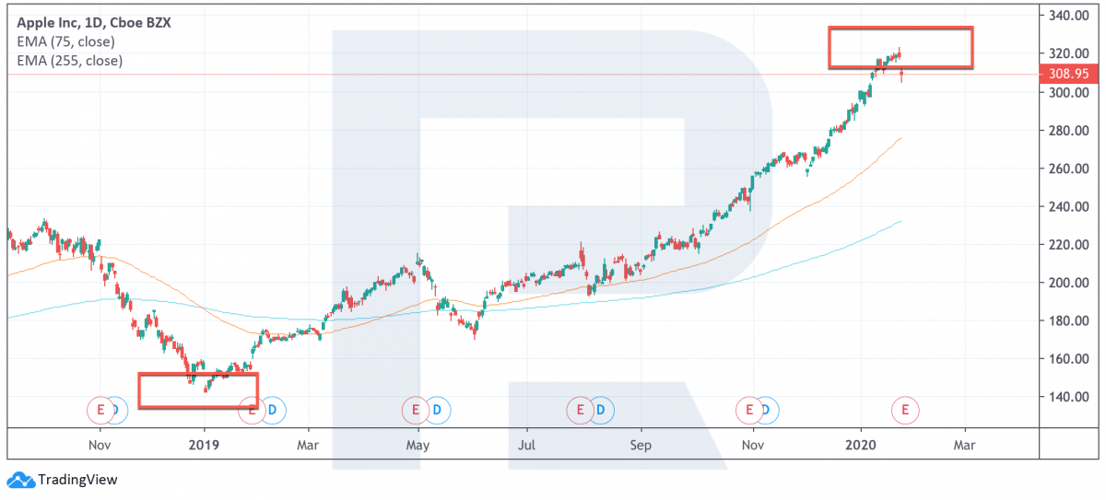
This Photo by Unknown Author is licensed under CC BY-NC

REFERENCES
Apple, Available at: https://www.techtarget.com/whatis/definition/Apple, (Accessed on 26/04/23)
Apple - statistics & facts, Available at: https://www.statista.com/topics/847/apple/#topicOverview, (Accessed on 01/05/23)
Apple Statistics (2023), Available at: https://www.businessofapps.com/data/apple-statistics/, (Accessed on 28/04/23)
Apple's top 10 products, Available at: https://www.theguardian.com/technology/2011/oct/06/apple-top-10-products, (Accessed on 27/04/23)
Has Apple Finally Matched Supply and Demand, Available at: https://www.fool.com/investing/2022/07/21/has-apple-finally-matched-supply-and-demand/, (Accessed on 02/05/23)
Latest News, Available at: https://www.apple.com/uk/newsroom/, (Accessed on 25/04/23)
Levitt, Steven D., (2006). Freakonomics: a rogue economist explores the hidden side of everything, Penguin.
Samuelson, William F., (2015). Managerial economics, Wiley
Six accessories that will compliment your new iPhone 11 & iPhone 11 Pro, Available at: https://alogic.co/blog/post/six-accessories-that-will-compliment-your-new-iphone-11-iphone-11-pro, (Accessed on 03/05/23)
Sloman, John., (2019). Economics for business, Pearson
Sloman, John., (2020). Essential economics for business, Pearson
The 10 Best iPhone Alternatives You Can Buy Right Now, Available at: https://hiconsumption.com/best-iphone-alternatives/, (Accessed on 29/04/23)
The new iPhones overcharge UK consumers more than any previous model, Available at: https://www.finder.com/uk/high-iphone-prices-have-cost-the-uk-over-a-billion-pounds, (Accessed on 30/04/23)

