Sport Physical Activity and Society

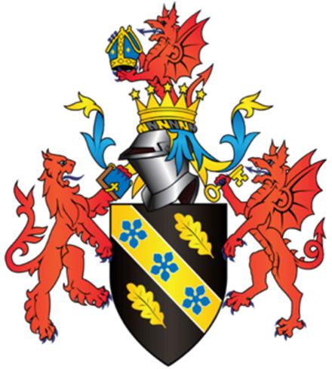

Student Name: Najmeldin Babikr
Student Number: 2110673

Introduction
Physical activity is very important in our daily life. However, over 40 years ago, proof of physical activity, stop heart disease prevention (CHD). The finding are consistent and show that sedentary people have about twice the risk of developing or dying from CHD, physical inactivity as one of the major modifiable risk factors for CHD. A recent analysis suggests that 37% of deaths from CHD are attributable to physical inactivity; this is second only to raised blood cholesterol according to (Oxford Acadmic, 2021).



An expression of physical sports. However , in the general is one of the most important activities that every person must practice constantly, and sports are divided into two types: mental sports related to exercises of the mind, and physical sports related to the movements and physical sports exercises that a person practices by walking, running, lifting weights and other physical movements, and sports Physical activity is very useful for the body, as it protects against many chronic diseases such as: high blood pressure, cardiovascular diseases, diabetes, maintains the health of bones and joints, increases the softness of the body, helps burn fat accumulated in the body, and many more benefits health that is reflected in every organ of the human body.

Benefits of Physical Activity

One of the advantages of physical sports and Activity is that a person can practice it at any time, and it is diverse and far from boredom, as anyone who wants to exercise physical sports can do it in the way they like by choosing the type of sport that he wants to practice, such as: walking, swimming, horse riding, running and lifting Weights, boxing, and many other types of it, and they are generally inexpensive, and anyone can do physical sports movements without even having to leave his home, and at the present time professional sports clubs have spread, which help people to professionalize physical sports, and physical sports have become Thanks to this, a sport that is not only fun, but has become a sport that brings income and players practice it for fame and money.

Several systematic reviews have clearly shown the importance of engaging in regular exercise to attenuate or reverse the disease process in patients with car- blood vessels disease. Physical activity has skills and personal enjoyment and other rewards, example improve balance, reflex and coordination, keeping in good physical body shape and health weight and promote health physical development (Warburton, 2006). Physical activity can help you to lose fat and lose Wight hence increasing energy level, physical activity they can help you reduce your risk for other health problem high blood pressure and diabetes.

Risk of physical activity

Reduces the risk of hypertension, coronary heart disease, stroke, diabetes, various types of cancer (including breast and colon cancer), and depression, It reduces the risk of falls and fractures of the hip and vertebrae, It is necessary for energy balance and weight control. (World Health Organisation, 2021). Insufficient physical activity is one of the major risk factors for mortality worldwide and is increasing in many countries, adding to the burden of no communicable diseases and affecting public health around the world. The risk of death increases among people who suffer from a lack of physical activity by between 20% and 30% compared to people who engage in sufficient physical activity.

Sport
It is a normal physical effort or skill practiced according to agreed rules for the purpose of entertainment, competition, pleasure, distinction, skill development, or strengthening self-confidence or body. Different goals in terms of their combination or singularity characterize sports, as well as the impact that players or teams add to their sports.

Sports is one of the most important human activities.

Hardly any human society is devoid of form of sport; Regardless of the degree
Progress or backwardness of this society; and man has known her through its various eras and civilizations; If you miss the orientations of each civilization regarding it; some civilizations
I was interested in sports for military considerations, whether it was defensive or expansive; some other ^ exercise for leisure; as a form of recreation. While sport was employed in other civilizations as a method educational; where did the 3 ancient educators come to terms with it?
Framework of values ​​in sport; and its great ability on upbringing, normalization and building a social personality A3 is balanced; not to mention the associated health effects
Since ancient times, we have practiced sports and physical exercises; it is a 3 concept that was confirmed by the results of scientific research about the functional and health effects at the biological level 3 for human being.

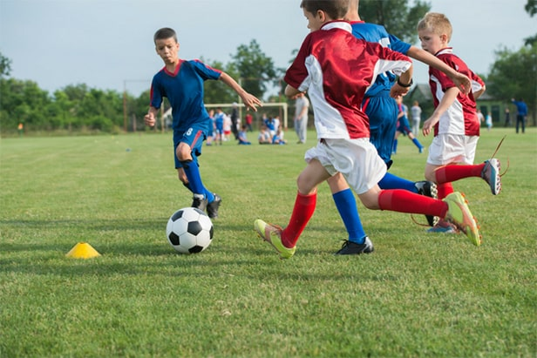

In the modern era; As a result of 3 continuous efforts for physical education and sports scientists and researchers in their quest to confirm the informational construction of their academic system; possible for the first time looking at sports an inclusive view. It was difficult to deal with this human activity A3 is growing after the social and cultural dimensions began for sports.

Risk of Sport

The first stage of risk assessment is identification of the risk factors associated with the sport and determination of how these may impinge on stakeholders. Participants normally represent the major stakeholder in most sports but other stakeholders include, for example, officials, spectators, the media and the public. The present discussion is focused on the risks to participants. Risk factors can arise from the facilities required to play the sport, such as stadiums, public roads and waterways; the equipment, such as goal posts, hockey sticks and hurdles; and the physical activity itself, such as running, cycling and swimming. These risks can be categorised as situational or event-based risks. Situational risks exist permanently within the sport’s environment and arise from issues such as the facilities and equipment. Event-based risks exist only at specific points in time and occur because of a particular set of circumstances, such as the way in which one player tackles another player. The next stage is to consider how each of the identified risk factors might affect.
The Importance of Sport, Exercise, and Physical Activity since Lockdown.

Exercise- is good for everyone who practice during the lockdown, but as you know how In order to boost your mood and improve your sexual abilities, know how exercise can improve the life. It's hard to ignore the health benefits of regular exercise and physical activity. Everyone benefits from it, regardless of age, gender or physical ability. For examples

By Exercise can controls weight during the lockdown, however can help prevent excessive weight gain or help maintain weight loss. When you engage in physical activity, your body burns calories. The more intense the activity (World Health Organisation, 2021).

Exercise controls weight
Exercise can help prevent excessive weight gain or help maintain weight loss. When you engage in physical activity, your body burns calories. The more intense the activity, the more calories you burn.

Going to the gym on a regular basis is a great idea, but don't if you don't find enough time to exercise every day. Any amount of activity is better than no activity at all.

Exercise activity

There are many different types of exercises and sport in the world, and new ones are constantly being created, including: Bodybuilding, Weight lifting, Basketball, Football, Rugby, Golf, Yoga, long jump, High jump, Obstacle race and finally swimming.
Performance of exercises

In order to avoid these symptoms, you must do a warm-up before starting sports. You should do some very simple exercises, such as jogging, arm movement with the foot, pelvic and ankle exercises, abdominal exercises, leg raises, knees and many more to make the body prepare to do sports that may not be accustomed to the stress resulting from it. Which leads to the emergence of these bruises and cramps.

Conclusions

To conclude that the sport is very important part of the life from what has been presented that the practice of physical and motor activities such as running, table tennis, volleyball and other aerobic activities leads to improving cognitive functions such as increasing the ability to comprehend, analyse, memorize, remember, mental focus, planning and decision-making, as well as improve short-term memory and creative thinking, as a result of increased levels of gray matter in The brain is responsible for maintaining the health of nerve cells.

References

Better Health, 2020. Sport, physical activity and our health. [Online]
Available at: https://www.betterhealth.vic.gov.au/health/healthyliving/sports-and-physical-activity
[Accessed 3 November 2021].

Dominic Malcolm editor; Barrie Houlihan, 2016. Sport and society : a student introduction. 3rd ed. London: SAGE Publications Ltd.

Miles, L., 2007. Physical activity and health.. Nutrition bulltin,32(4),, pp. pp.314-363..
Oxford Acadmic, 2021. Physical activity: the evidence of benefit in the prevention of coronary heart disease. [Online]
Available at: https://academic.oup.com/qjmed/article/96/4/245/1528536
[Accessed 11 November 2021].

Warburt, D. N. B., 2006. Health benefits of physical activity:the evidence.Cmaj,174(6),. pp. pp.801-809.
Warburton, D. N. B., 2006. benefit of physical activity. pp. pp.801-809..
World Health Organisation, 2021. [Online]
Available at: https://www.who.int/ar/news-room/q-a-detail/be-active-during-covid-19
[Accessed 11 November 2021].

Better Health, 2020. Sport, physical activity and our health. [Online]
Available at: https://www.betterhealth.vic.gov.au/health/healthyliving/sports-and-physical-activity
[Accessed 3 November 2021].

Dominic Malcolm editor; Barrie Houlihan, 2016. Sport and society : a student introduction. 3rd ed. London: SAGE Publications Ltd.

Miles, L., 2007. Physical activity and health.. Nutrition bulltin,32(4),, pp. pp.314-363..
Oxford Acadmic, 2021. Physical activity: the evidence of benefit in the prevention of coronary heart disease. [Online]
Available at: https://academic.oup.com/qjmed/article/96/4/245/1528536
[Accessed 11 November 2021].
Warburt, D. N. B., 2006. Health benefits of physical activity:the evidence.Cmaj,174(6),. pp. pp.801-809.
Warburton, D. N. B., 2006. benefit of physical activity. pp. pp.801-809..

Warburton, D.E., Nicol, C.W. and Bredin, S.S., 2006. Health benefits of physical activity: the evidence. Cmaj, 174(6), pp.801-809.
Miles, L., 2007. Physical activity and health. Nutrition bulletin, 32(4), pp.314-363.

Fuller, C. and Drawer, S., 2004. The application of risk management in sport. Sports medicine, 34(6), pp.349-356.

Washington, R.E. and Karen, D., 2001. Sport and society. Annual review of sociology, 27(1), pp.187-212.

Fitzgerald, H., Stride, A. and Drury, S., 2020. COVID-19, lockdown and (disability) sport. Managing Sport and Leisure, pp.1-8.

