

Assessment 1 – Reading Task Template
PART 1: Upload your photo of your A3 in-class notes here:
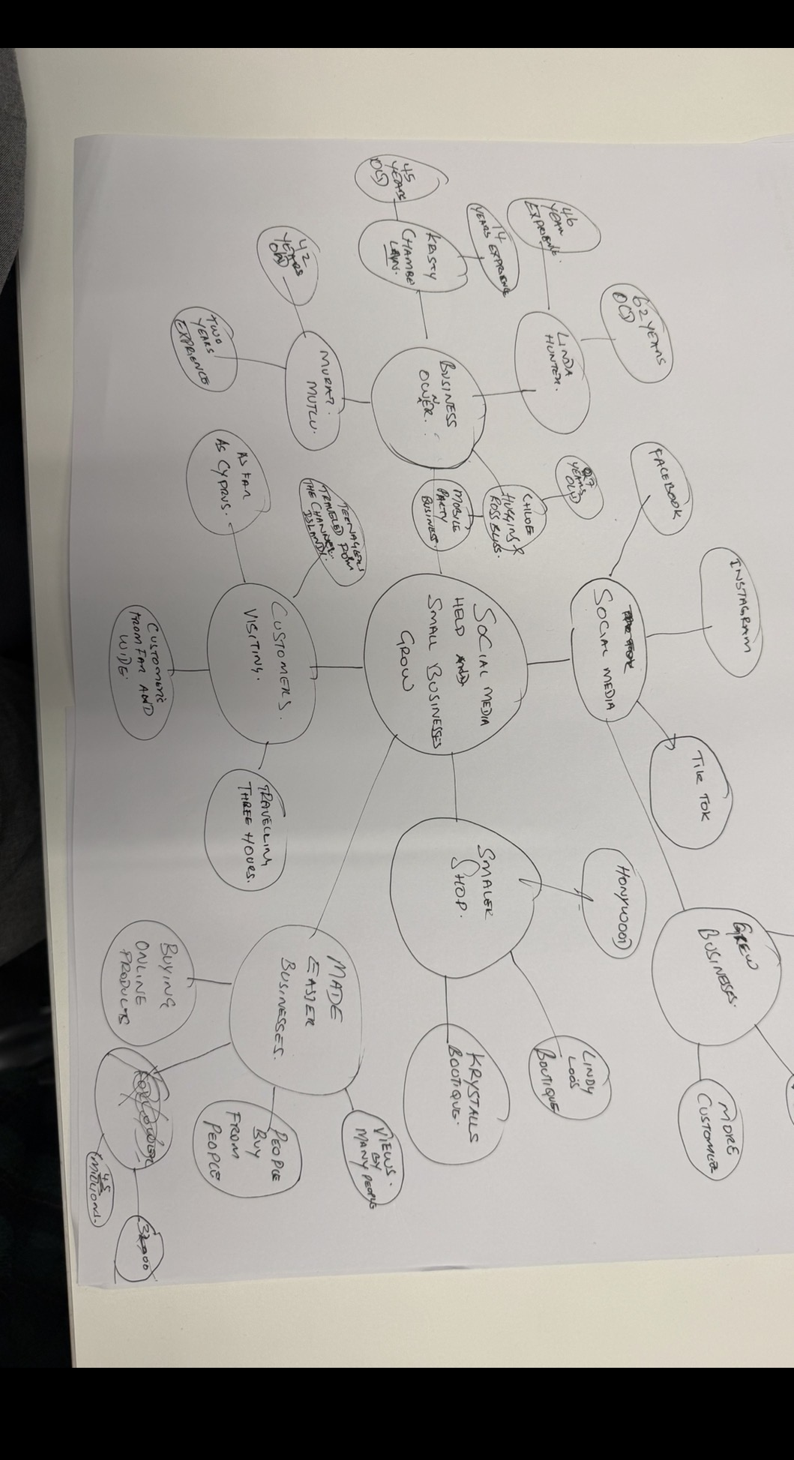

PART 2:
- Answer every question below in 1-3 full sentences.
- Use your own words. Do not use generative AI to answer these questions.
- Include a specific detail from the text when asked.
REMINDER
- The main idea is the overall message of the whole text.
- A key point helps to explain the main idea.
- A specific detail or example from the text shows that the key point is true.

- What is the main idea of the whole text?

The central point of the text is that Digital platforms like TikTok and Instagram are playing an increasingly important role in business growth by boosting brand awareness, drawing in new customers, and generating higher revenue through viral content.

- What is one key point that supports the main idea, and which specific example from the text shows this?

The key takeaway in support of the main argument is that viral Digital media content can greatly boost a business's visibility and raise its revenue. This is shown by the case of Binley Mega Chippy, which experienced a tenfold increase in trade following the widespread dissemination of viral video content across social media platforms. This example shows how strongly viral content can influence consumer behaviour and how social media can help businesses expand.

- What is a different key point that supports the main idea, and which specific example from the text shows this?

Another important point is that content created by users on social media can greatly boost a business's visibility and bring in new customers. Honywood Sandwich Shop in Basildon demonstrates this, as it saw more business thanks to videos its customers posted on social media. This shows how customer-generated content can build brand awareness and have a positive effect on consumer behaviour.

- Which part of the text do you think is most important, and why?

Main key point of the text is the claim that social media has fundamentally transformed the business of Little Love’s Pamper Bus. This is particularly important because it shows the substantial impact that viral content can have on business growth. Reaching roughly 45 million views in less than a year highlights how social media can boost brand awareness, widen market reach, and open up new business opportunities. As a result, this example strengthens the main argument that social media platforms are essential to promoting business growth and commercial success.

Reflection:
- What did you find difficult in this task (including in-class components), and why was it difficult?

What I found challenging, particularly in this group task is managing the differing perspectives, coordinating individual’s contributions, and to distribute an equal distribution of responsibilities. Furthermore, effective communication and time management could have prevented difficulties while working collaboratively.

- What helped you with this difficulty, and how did it help you?

However, establishing clear expectations, maintaining open communication, and allocating tasks appropriately this all helped me minimise these challenges which facilitated a successful teamwork.

