PROJECT MANAGEMENT

STUDENT NAME MARIA CORINA BUJOR
STUDENT NUMBER 1602991
MODULE NAME PROJECT MANAGEMENT
LECTURER NAME MOLLY JACK

Table of Contents

PROJECT NAME 3
INTRODUCTION 3
PROJECT SCOPE 3
PROJECT GOALS 3
PROJECT OBJECTIVES 4
PROJECT REQUIREMENTS 4
PROJECT DELIVERABLES 5
SCHEDULE OF THE PROJECT 5
HUMAN RESOURCE MANAGEMENT IN PROJECT 6
ORGANIZATIONAL STRUCTURE OF THE PROJECT 6
WORK BREAKDOWN STRUCTURE OF THE PROJECT 6
STAKEHOLDERS OF THE PROJECT 7
COMMUNICATION WITH STAKEHOLDERS 8
RISK MANAGEMENT IN THE PROJECT 8
COST OF THE PROJECT 9
CRITICAL PATH OF THE PROJECT 10
REFERENCES 11

PROJECT NAME

A mobile application for communication purposes called “Talk.co”.

INTRODUCTION

This report is basically a project initiation document (PID) that refers to the project plan of the application development for communication. In this document, all the aspects that are required to be covered in a project would be thoroughly explained including the project scope which comprises of the goals, objectives and requirements of the project. Moreover, the project deliverables would be discussed to show the best possible product achievement from the project. This document also aims to outline the measurement and management of the roles and responsibilities in the project and how the human resources would be managed in the project for effective results. Also, this document would attempt to provide a clear perspective of the project for the stakeholders to attain understanding about the processes in the project respectively.
The name of the application is “Talk.co” and is centered to provide communication purposes to people online. This application would be an android based application and the best possible features would be designed to produce such product which attain satisfaction of the stakeholders of the project. The assumed schedule of the project is about 2-3 months which includes its development, testing, promotion and selling. The schedule of this project as well as the work flow of the operations is also thoroughly highlighted in this document. Finally, the cost assumptions are made to have an idea of the amount that would be used in the operations of the project. If the project plan is followed accordingly and the challenges encountered during the project are measured in an orderly manner then the success of the project is guaranteed.

PROJECT SCOPE

Project scope is recognized as a fundamental part of the project planning which allows the project manager or organizer of the project to evaluate and document the goals that are to be achieved in the project and desired by the project manager, the deliverables of the project, deadlines, necessities and assumed cost of the project (Khan, 2006 ). By the help of identified project scope, the roles and responsibilities can be determined that are most essential and required to be assigned to those team members who are capable of carrying it out. Project scope can also include the aspects of project such as milestones that are to be achieved, duration required for all the activities and limitations of the project. The several aspects of the project scope are discussed below including the objectives, goals, schedule and deliverables.

PROJECT GOALS

Project goals are those desires of the project developers that are to be recognized and accomplished in the project (Atkinson et al., 2006). The most essential goal of this project is the development and featuring of such an app with most updated features and functions for the communication purposes and spreading it in the marketplace so that people can be benefited from such an easy-to-use mobile application.

PROJECT OBJECTIVES

The project objectives helps in identification of those activities and operations that are essential to be performed and makes the team members of the project more objective-oriented and driven to achieve those goals. For the fulfillment of the desired goal of the project, the project manager is required to deal its project team that a way by which they can carry out all the desired objective in a required manner. For making the objectives of the project possible to achieve, the objectives are designed that a way which are Specific, Measurable, Agreeable, Real and Time assured i.e. the SMART technique. This technique is used widely by project managers to make their goals and objectives possible to achieve (Hartman and Ashrafi, 2004). Following are the objectives of the project that are necessary to be achieved.
- The foremost step and initial objective is to plan the project plan document in such a way which shows that it is both beneficial and achievable.
- Second objective of the project is to get approval of the project idea from the corporate of the university as the project cannot start without the permission.
- When the permission is attained, the third objective is the planning of unique features and functions for the application which can make it both unique and presentable among the other common communication apps.
- Fourth objective is to initiate the development of application by the help of web developers and programmers and spread the awareness regarding the benefits of the app.
- Fifth objective of the project is to finalize and test the application by various means.
- Sixth objective is regarding the finalizing and modifications of the application and promote it in the market.
- Last objective is to decide the price of the application to sell in the market.

PROJECT REQUIREMENTS

To specifically measure that all the tasks are done in a smooth and orderly fashion then it is essential for the project manager to know the requirements of the project (Dalcher, 2014). The requirements of this project are described as follows:
- Approval for the project idea.
- Programmers and web developers
- Technical equipment for application development
- Investors
- Individuals for testing of application
- Finance manager
- Marketing operative

PROJECT DELIVERABLES

The deliverables of the project are said to be the achievable product that is delivered by the project (Chow, 2014). As the nature of the project is based on development of a mobile phone application then the deliverables of the project can be the best possible and recent features in the application that people desire. The application would have negligible amount of errors and would include features better than the common and most used mobile communication apps such as Skype, WhatsApp and Line.

SCHEDULE OF THE PROJECT

The schedule of the project enables the manager to draw limits of time duration for the activities that are required to be done. The initiation dates and deadlines are provided by the manager to all the team members so that the tasks can be acquired on the specified time. By the preparation and assumptions that are made by the schedule, a lot of help is provided in managing people and their responsibilities by the manager. Also, the schedule of the project aims to deliver the assumed duration to the stakeholders so that they can also measure the success of the project by the time that is being consumed. Furthermore, the Gantt chart has been used in this project to represent the initiating dates and deadlines of all the project operations. It also shows the flow of the work and provides guidance that which task is to be done after the completion of one task (Snyder, 2014).
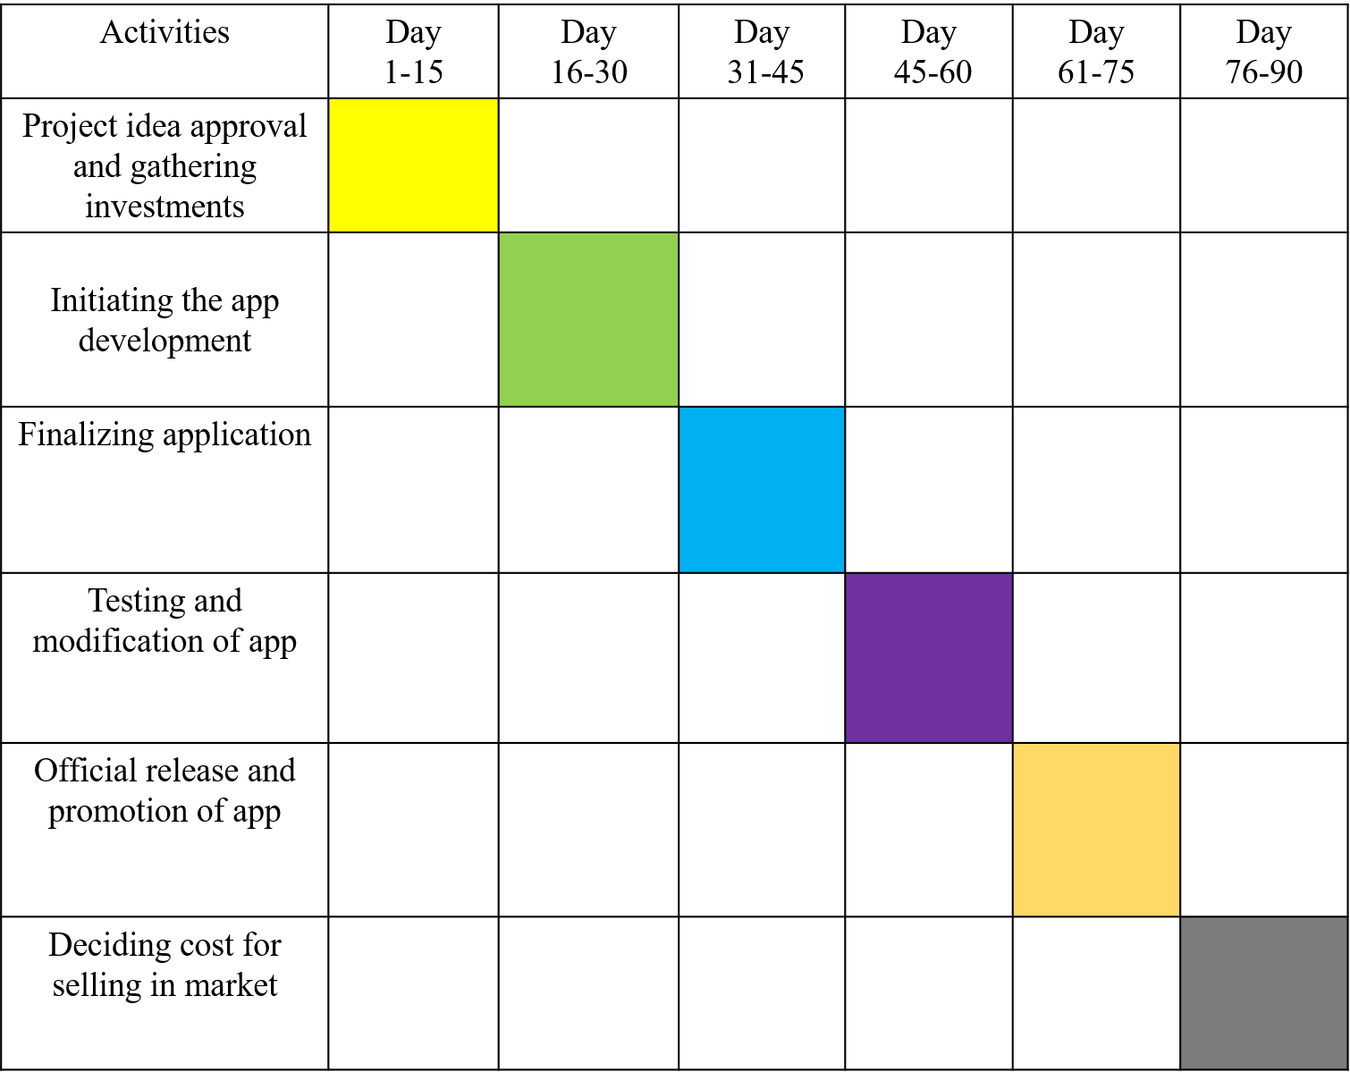

HUMAN RESOURCE MANAGEMENT IN PROJECT

Human resource management can be facilitated by the project manager in a project by utilizing such strategies that can enhance motivation among the employees and make them driven towards the goals and manage their tasks that a way which aids in delivering the deliverables of the project in an effective manner. Human resources can also be managed by increasing team work within the project and clarify the position of each group member so that they perform their duties in an orderly fashion. The HRM in a project can also aid in achieving the desired objectives of the project on the specified timing (Fan et al., 2017).

ORGANIZATIONAL STRUCTURE OF THE PROJECT

Organizational structure delivers such sequence and flow of authority within the project which makes it extremely beneficial and easy for the project manager to acknowledge and guide the project members about their position in the project and shows them who has the most responsibilities and whose commands they are required to follow. Following is the organizational structure for this project provided showing the line of clarified authority distributed in a project.
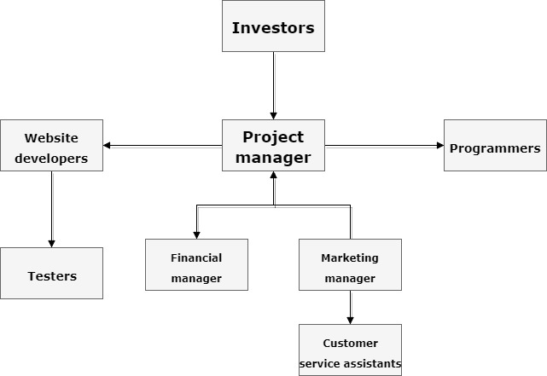

WORK BREAKDOWN STRUCTURE OF THE PROJECT

The work breakdown structure also known as WBS of the project is an effective tool for distributing tasks, prioritizing tasks and showing task dependency on each other effectively. In project management, work breakdown structure provides guidelines to manage the project in an orderly manner and perform all the activities in a flow and in a well-organized way. Work breakdown structure aims to provide direction to the project. When the tasks are divided among the team members, it aims in the reduction of conflicts and reduces the burden and workload on the individuals in a team. This helps in acquiring best possible performance with maximum effort delivery by the team members. Work breakdown is also effective in providing sustainability to the project as the tasks that are followed in a proper flow tend to help in organizing and managing the project operations effectually. WBS also shows importance towards the project manager and by using it as a tactical tool, human resources in the project can be managed accordingly. Furthermore, the objectives and tasks are clarified thoroughly as well as the responsibilities of each individual. The WBS for this project is described as follows:
- Getting the project idea approved (2 days)
- Gathering investments for the project (5 days)
- Gathering required technical equipment (5 days)
- Initiating application development by the help of Web developers and programmers (10 days)
- Adding latest and unique features in the application and finalizing it (10 days)
- Asking different individuals to test the application and give feedback about the features (2 days)
- Modification of features according to the feedback (3 days)
- Official release of the application (4 days)
- Promotion of application in the market by marketing manager (5 days)

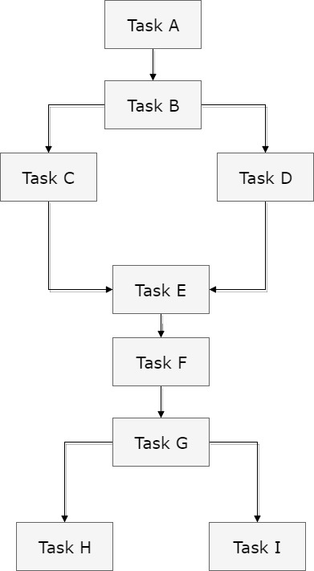

STAKEHOLDERS OF THE PROJECT

Stakeholders are influential bodies of the project who have their own standardized stake which either effects the project progress negatively or positively. In project management, stakeholders are recognized as those people or group of people who show their potential interest and involvement in the performance of a project as well as its success rates (Eskerod and Huemann, 2016). These stakeholders can either be directly or indirectly involved in the project and may include the customers, audience, and managers of the project, employees, investors, suppliers and others according to the nature of the project. If this project is taken into consideration, then it is important for highly important for the project manager to analyze the degree and intensity of the interest and involvement of the stakeholders in the project. Further provided is the list of those stakeholders which might have possible impact, power or interest in the project’s performance. By the help of creating power and interest graph, the level of each stakeholder would be extracted which would provide guidance to the project members to evaluate different strategies to deal according to the level of their significance to the project.
 | STAKEHOLDERS | POWER | INTEREST
1 | Investors | High | High
2 | Programmers and website developers | Low | High
3 | Finance manager | Low | Low
4 | Marketing manager | Low | Low
5 | Users | Low | High
6 | Team members | High | Low

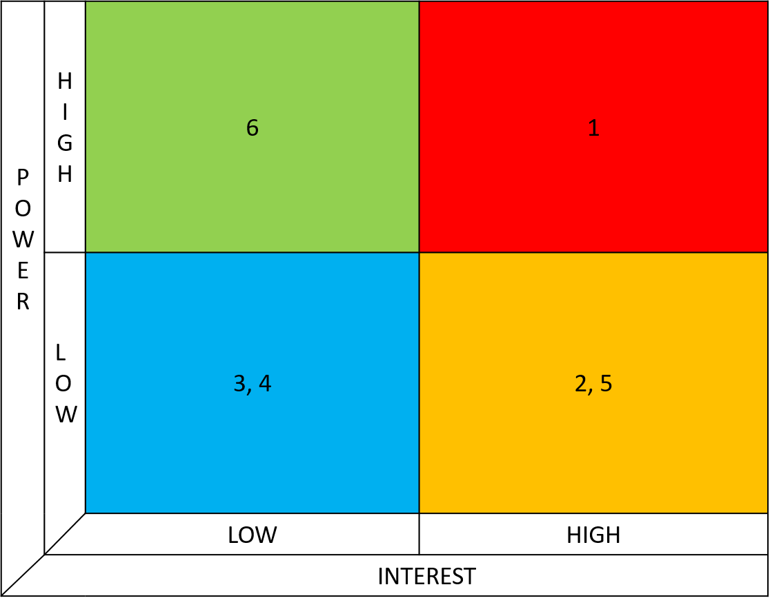

COMMUNICATION WITH STAKEHOLDERS

Communication with the stakeholders holds crucial importance towards the management of the project. It is challenging and complex to deal with the stakeholders but after it is analyzed which stakeholders are important for the project it becomes easier to deal and handle communication with them accordingly.

Stakeholders | When | How | What | How often
Investors | After completing project plan | By meeting the investors | Regarding the project idea | One time in whole project
Programmers and website developers | After completing project plan and deciding features and functions required | By arranging meetings and sending emails frequently | Regarding the features and functions of application | Each week
Users | After completion of whole project | Making calls and sending emails | Regarding the testing and feedback | One time in whole project
Team members | Before starting the project | By team meetings and emails | Updates on tasks and responsibilities regarding the project | Every day during the project
Marketing manager | After official release of application | By making calls and arranging meetings | About the marketing of the application | One time in whole project
Finance manager | After official release of application | By making calls and arranging meetings | About the selling of the application in the market | One time in whole project

RISK MANAGEMENT IN THE PROJECT
Risk management is facilitated by the project manager in order to recognize and identify the risks that might be faced as a challenge and tend to effect the progress and productivity of the project causing several issues including delay in the project and failure in attaining the project objectives as well as being unable to produce the deliverables up to the required level. When the risks are assessed, plans and strategies are created by the project manager to manage those risks and identify the risks with high effect rate and negative and positive impact over the performance of the project. Risk factors can be measured by the help of analyzing the probability of the risk occurring and its degree of impact by which the affect upon the project can be easily assumed. For avoiding excessive uncertainties, risk assessment is vital or else the project might lead towards failure. If the risks are managed properly, then there would be no issue in the management of cost and delivery of the desired objectives.
Following table shows the risks and its probability and impact on the application development project.

 | Risk factors of the project | Probability | impact
1 | Lack in investments | Low | High
2 | Dominancy of other communication applications | High | High
3 | Not a good price for the application | Low | High
4 | Web developers and programmers fail to deliver the required features | Low | High
5 | No interest of the users | Low | high

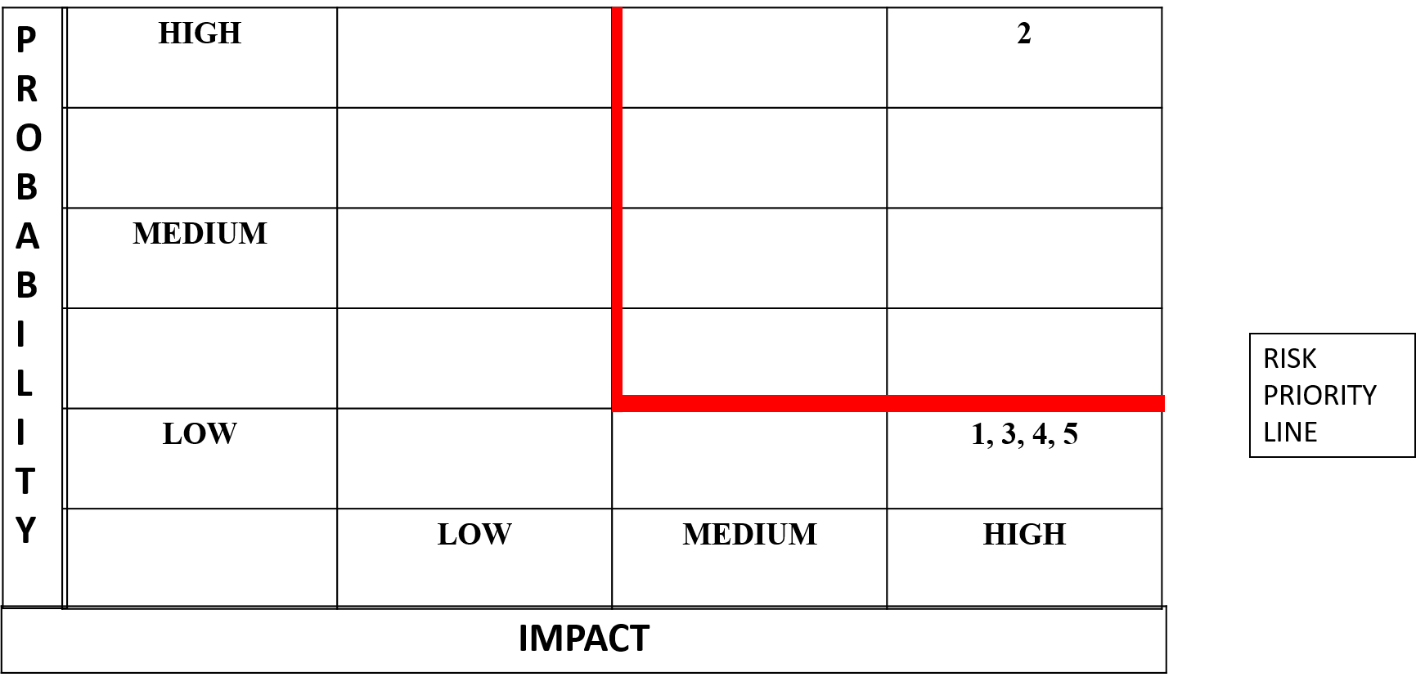

COST OF THE PROJECT

In order to successfully achieve the project objectives and produce deliverables in a required manner and level of satisfaction it is important to set up a cost assumption which can provide direction and guide to the project manager and team members regarding the availability of the money and where to utilize it. Following are the cost assumptions that are made considering the nature of the project.

 | EXPENSES | AMOUNT
1 | Web developers | £200
2 | Programmers | £200
3 | Financial manager | £200
4 | Marketing manager | £200
5 | Technical supplies | £300
 | TOTAL | £1100

CRITICAL PATH OF THE PROJECT

Critical path aids in providing such timeline for the project that is the shortest one and the longest one by which it can be seen which one must be used in the project. Furthermore, the critical path helps in understanding how the project tasks depends upon each other and what influence can they generate over the project performance.
The below diagram shows the forward pass and the backward pass of this project. The red area indicates the critical path of the project.

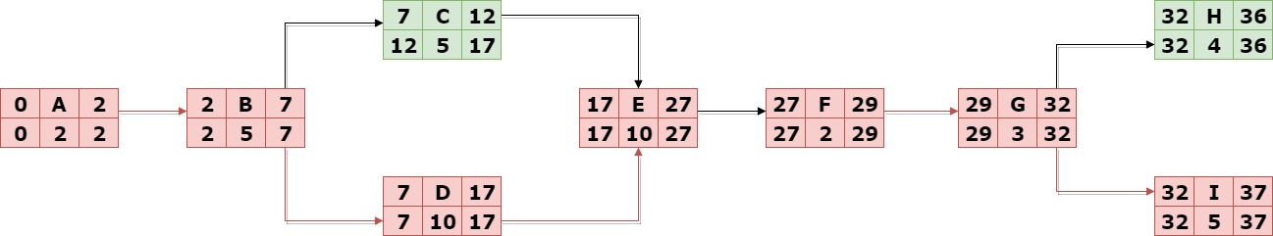

REFERENCES

- Atkinson, R., Crawford, L. and Ward, S., 2006. Fundamental uncertainties in projects and the scope of project management. International journal of project management, 24(8), pp.687-698.
- Chow, A.F., Woodford, K.C. and Lambe, N., 2014. Using project deliverables and project management for timely completion of student projects. Journal of Emerging Trends in Economics and Management Sciences, 5(3), p.323.
- Dalcher, D., 2014. Who Needs Project Requirements? PM World Journal, 3.
- Eskerod, P. and Huemann, M., 2016, February. Rethink! Project Stakeholder Management. Project Management Institute.
- Fan, C., Song, Y. and Pei, Q., 2017. Project schedule with alternative activities and relationships. Journal of Engineering Research, 5(3).
- Hartman, F. and Ashrafi, R., 2004. Development of the SMART TM project planning framework. International Journal of Project Management, 22(6), pp.499-510.
- Khan, A., 2006. Project scope management. Cost engineering, 48(6), pp.12-16.
- Snyder, C.S., 2014. A Guide to the Project Management Body of Knowledge: PMBOK (®) Guide. Project Management Institute.

