Mahmud Akbar
SN - 1711691
Programme: BA (Hons) Leadership and Management - Skills for the Workplace
Module: Project Planning and Management in the Workplace
BMSK5004
Lecturer: Paul Ranson
A formal report about project management for the course lecturer’s eyes only

Executive Summary
This report presents the critical analysis about project management. The purpose is to apply the various methods and ideas into achieving a successful project delivery. It will discuss about the various stages of a project. The report will evaluate some of the tools and techniques used in project management. It will review some of the exercises practiced in the class. It will also focus on the case study of the Vintner’s Antiques company. The reporter will endeavour to explain how integrating cost, time, team performance, efficient management and collaboration with the project commissioners are vital to attaining a good standard of project deliverance.
Table of Contents
Executive Summary 2
Introduction 5
The Project Charter 6
The Vintner’s Antiques 7
The Five Stages of Project Management 8
The Initiation Stage 8
User Stories 9
Brown Paper Planning 9
Stakeholders 10
The Project Manager 10
Steering Group 10
The Sponsor 11
The Commercial Manager 11
The Specialist 11
The User 11
Phase Two 13
The Iron Triangle 14
Phase Three 15
Phase Four 16
Estimate Using Project Techniques 16
The Delphi Technique 16
The Wisdom of The Crowd 16
Phase Five - Project control 17
Gantt Chart 18
Conclusion 19
Appendix 20
References 26
Table of Figures
Figure 1: Project Management Table (Slack et al. 2013). 8
Figure 2: Project Manager (Ray 2018). 8
Figure 3: Brown Paper Planning (Leading Learner 2014). 9
Figure 4: Iron Triangle (Leong et al. 2014). 14
Figure 5: Stages in the Planning Process (Slack et al. 2013) 14
Figure 6: Gantt chart 20

Introduction
Whether arranging a birthday party, a wedding party, an important event or managing a project on a professional level, it is a big ask and requires a lot of team effort, resources and meticulous planning (Roberts 2011). Embarking on a new project can bring a lot of anxieties to newcomers, and even cause stress for most seasoned practitioners (Cobb 2011). As our focus is on managing projects on a large-scale operation, it is best to be acquainted with the demands of what a project entail.

The Project Charter
A project is a series of activities that need to be accomplished to attain a defined outcome. The project charter highlights the roles and responsibilities of the project team. All projects commence with a mission statement, which defines the objectives, direction and goals. It is a brief written affirmation clarifying the project, the sponsor’s demands and instructions on what they want to achieve. All consist of a particular purpose, specified end result and determine the set of resources to be applied (Slack et al. 2013). After the upheaval of the initial phase, now the project is formalised and structured.

The Vintner’s Antiques
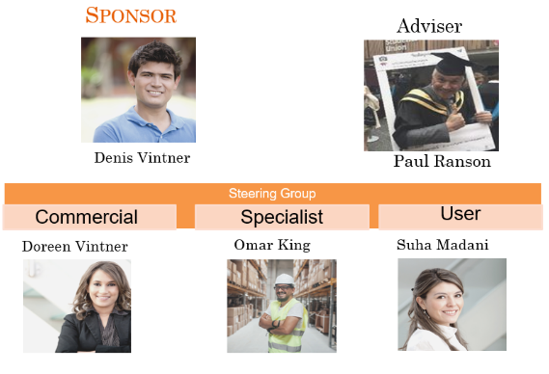

The organization assigning the project is the Vintner’s Antiques. It is a company currently based in Shirley, specialising in the sale of antiques and artefacts. The business is owned by a brother and sister duo of Doreen and Denis Vintner. This is a family-led business, which is in its third generation. For the business to flourish, they have forsaken sibling rivalry and accepted their roles.
They have been inspired by Salvage Hunters programme and have decided to enhance their outlook and take their business to the top level. In order to achieve their goals, they want to relocate to their other premises in Spark-hill. This a more central location, bigger place and provides more scope to realise their goals. They have allocated this project to the Avengers Project Management Group.

The five stages of project management
In project management, there are five phases that need to be properly applied to accomplish the tasks (Weiss and Wysocki 1992). The chart below illustrates the five stages.
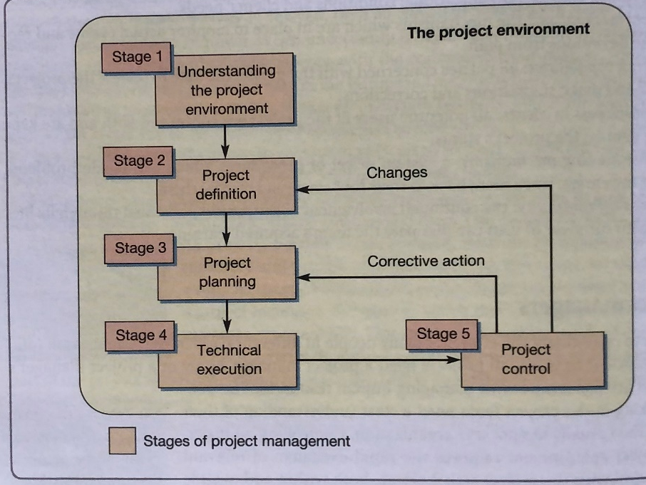

Figure 1: Project Management Table (Slack et al. 2013).

The Initiation Stage
The project initiation is taking the first steps to commence the project life cycle (Ray 2018). It is here, where the reason for the project is identified, discussed and developed to take the venture forward. This documents the basis for the project. The chart below describes the first phase into creating a project file.
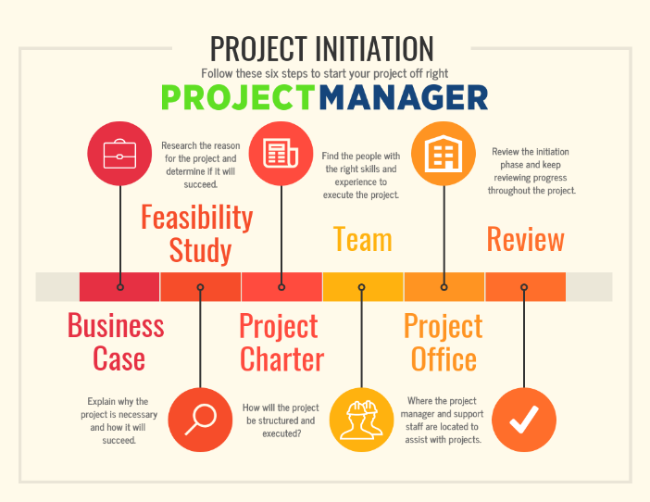
Figure 2: Project Manager (Ray 2018).

User Stories
This process is the user stories that have been compiled at the initiation stage of the project, which is like a brain storming session. User stories are conversations or narratives from a user’s perspective, talking about their expectations about the outcome of the assignment. They restate about the project, describe the problems or inadequacies to be resolved by the product or system that is being built or going to be utilised.
In the Vintner’s case we discussed about the relocation, making the new warehouse fit for purpose, prioritising the needs and the best ways to transfer the stock in possession.
Brown Paper Planning
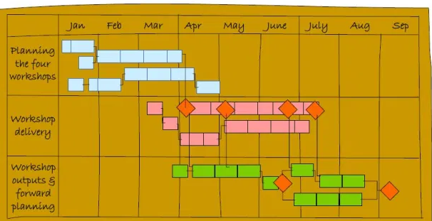
Figure 3: Brown Paper Planning (Leading Learner 2014).
User stories can be applied in the form of brown paper, sticky notes, briefly informing or telling people what is happening or trending within the place or organisation.
The user stories are written in few sentences and in plain and easy to understand language. As the name suggests all the notes are applied on a large brown and stuck on a wall for all team members to read and analyse their contributions. They are usually written using the subsequent template:
As a < user type >, I want < feature/function > so that <benefit> (medium.com).

Stakeholders
All projects consist of many stakeholders, who have a vested interest in the venture, its progression and they are able to influence it to a certain extent. They have different needs, opinions and priorities. It is best for the management team to listen to them at the initial stage and make it clear they will communicate with them at various phases and intervals to seek their views and support. This will allow smooth functioning and also make the stakeholders aware they are important. This will prevent objections and may help to gain more support.
The Project Manager
Various tasks need to be carried out to conclude the challenges and fulfil the project’s aims. The activities require to be co-ordinated effectively, to enable this a competent project manager is a must. To be a successful project manager, you need to be able to balance deadlines, a budget, the quality of work and communicate effectively with the interested people. It is essential for a manager to possess good interpersonal and technical skills to successfully oversee the outcome of the project.
Proficient team members with the requisite skills need to be selected to and work in unison to complete the venture. By recognizing the team's talents, the leader can assign the tasks to the best or most qualified person (Belbin 2012). Every individual has something unique to offer, which can enhance the project. By understanding each other's strengths, weaknesses, and interests, helps to promote harmony and create a positive work culture.
Steering Group
The steering group is formed by members in an organisation, who are experts in their fields (Roberts 2011). They are the most senior and influential group within the realm of the project and are accountable for its success. They will approve the project plans and ensure that protocol is followed for the positive outcome of the assignment.
They usually represent the clients’ organisation and monitor the project, by holding meetings at key phases of the project. They help to solve if any difficult problems arise and recommend if any changes need to be made.

The Sponsor
The most important client is the sponsor, the most influential person in the entire project management process. As the leader of the host organization, who has the power to authorise the project, direct the specifications, approve the resources and most importantly provide the funding (Cobb 2011).
A sponsor needs to be knowledgeable, reliable, possess excellent communication skills, be assertive and ensure the project is completed successfully.
Some of Denis’s main responsibilities would be as subsequent:
Arrange funding for the project and engage with the senior management. He would be involved in the initial project planning, developing the project charts and explaining about the project scope.
According to the Prince2 Programme (2019), the sponsors' who support the project sincerely and provide regular feedback, help to create a better working environment and achieve success on time, within budget and to the client’s or organisation’s satisfaction.
The Commercial Manager
The commercial project manager defines the goals of the assignment. They work in collaboration with the finance and marketing team. Their main responsibilities are to manage the budget, get the tasks done effectively using the resources available and deal with the marketing side of the business.
The Specialist
The specialist is a person who is the pundit in their field, possessing great knowledge and a distinctive skill. They are involved in the design, development and technical aspects of a project.
The User
The user can be the client or the people who will eventually benefit from a project. Like the proof of the pudding is in the eating, the success of the project is determined by the user’s satisfaction and feedback. The power-interest grid below helps to distinguish between the stakeholders’ influence and the level of involvement.

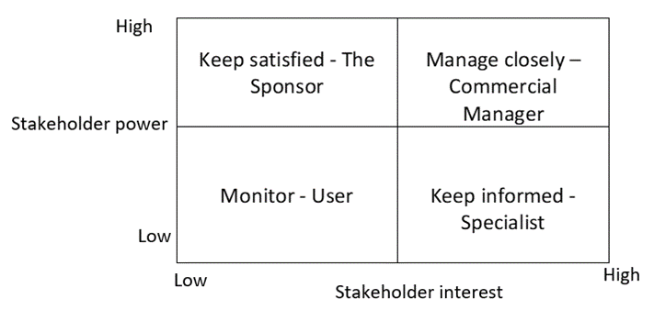

Phase two
This focuses on defining the project, its objectives, scope and strategies to accomplishing it.
- Objectives – what the project is endeavouring to attain, through its aims and efforts.
- Scope – all the relevant tasks required to fulfil the end product. The scope defines all the resources, such as human, financial, equipment and amenities required for the project.
- Strategy – the plan designed to specify how the objectives will be reached.
- The best way to analyse the outcome is to apply the SMART method (Doran, 1981). This describes that to attain the best results, it should be Specific, Measurable, Actionable, Realistic and Time-related.

The Iron Triangle
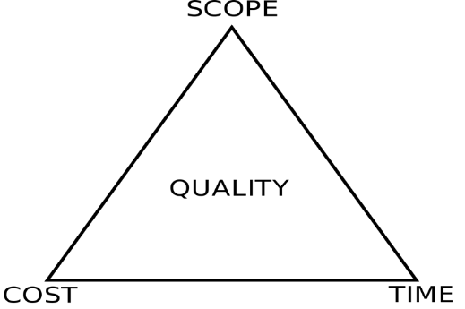

Figure 4: Iron Triangle (Leong et al. 2014).
The Iron Triangle defines the triple constrains of time, cost and quality that must be overseen in the project delivery. The triangle illustrates that the three essential factors of time, scope and cost are interrelated, and each point’s functioning or changes impacts the other two factors (Pollack et al. 2018). For example, the cost focuses on the financial restrains, which is the project budget. The funding determines the hallmarks of the success that can be attained with financial resources. Insufficient funding will be a huge drawback, meaning not all the objectives will be achieved and compromises need to be made.

Phase Three
This involves the planning of the project. Many resources are required, but three vital factors that have a huge influence on the outcome, are human prowess, information and authority. By assigning the resources effectively, ensuring the project is delivered on time and on budget. According to Eisenhower, the plans are nothing, planning is everything (Phillips 1957).
Project scheduling is fundamental into delivering it on the completion date. Project teams are always under pressure to perform within the time set for completion.
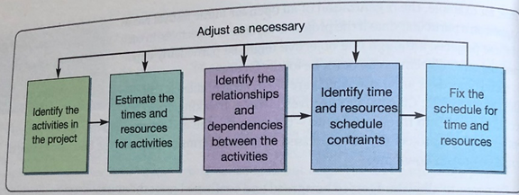
Figure 5: Stages in the Planning Process (Slack et al. 2013)

This stage fulfils four purposes:
1. Dictates the cost and duration of the project.
2. The amount of resources required.
3. The allocation of responsibilities and the focus on monitoring the progress.
4. It enables to evaluate the impact of any amendments to the project.

Phase Four
This focuses on the estimated time and resources required for the project to be put in motion. It Is not possible to state how project will plan out, so the estimates are just educated guesses.
All the activities that are required for a project, will have some relationship with one another, which is known as dependencies. Some activity will need to be executed in a particular order, for example in the Vintner’s case the roof needs to be sorted out before any other work can be done in the warehouse.
Estimate using project techniques
For any business cost and time are very significant factors that can impact the performance of the business as well as its revenue or profit. In the long run the shifting from store to warehouse will be a very cost- effective decision for the Vintner’s family.
The Delphi Technique
The Delphi Technique – was devised by Olaf Helmer and Norman Dalkey in the 1950’s (Hsu and Sandford 2007). It is a framework to estimate the possibility and outcome of future events. A group of experts participate in questionnaires, their independent answers and views provide estimates and assumptions. It is analysed by the facilitator, who acts as the head of proceedings. The final result determines the consensus of the group and as this is the most popular choice, this is applied for the predictions.
The wisdom of the crowd
This method originates from Aristotle’s theory of collective judgement. This method implies that the ideas of many people are collectively better than individual pundits. It is a collection of diverse and independent opinions. The information is analysed, the method of mean averages is implemented and eureka, this provides the estimates for our use (Surowiecki 2004).

Phase Five - Project control
One way of monitoring a project is having stand-up meetings. These are regular short meetings between team members to discuss the daily events. These meetings must take place in the designated area and at the stated time and should not last more than fifteen minutes. Each member stands up and takes turns to talk about important tasks that have been finished, are in progress or about to be started. They talk about any problems that have been encountered. This allows team members help each other and solve issues before they hinder progress.
These meetings improve collaboration, understanding of the goals and teamwork. A great example of this is the daily updates and advice provided by our Prime Minister Boris Johnson and his team during this Coronavirus pandemic.
Gantt Chart
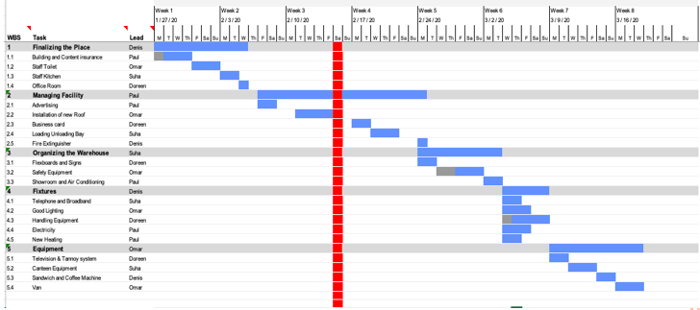

Figure 6: Gantt chart
The Gantt chart is a scheduling method that illustrates the timeline at the top and represents all the project activities on the left side of the chart.
In the Vintner’s case, the total project is expected to be completed in within 30 days. The Gantt Chart has been prepared for 27 days, and the three extra days provides a bit of leeway.

Conclusion






High fives amongst all the team members, mission accomplished. This was a gratifying experience and learning curve for us all. The secret to our success was, great team collaboration, reviewing progress regularly, using updates and feedback from our team and the project steering group. This was an effective approach to address issues as they arose and allowed us make amendments where it was required.
As this was a small project, we all feel confident we can now manage bigger ventures. As this takes a great deal of proficiency to perform well, we must now invest some money and time, to acquire excellent project management skills.
As we needed to cover lot of aspects in this report, if we use the iron triangle to analyse it, I reckon like a lack of funding, the constraints of the words limit has impacted the quality of the report. The appendix provides further information.
As the project manager, our endeavour to delivering an organization's objectives by completing the project on time, on budget and to their satisfaction is a joyous accomplishment for all my team members. This will be profitable for the business and enhance our reputation. Projects may-be temporary, but the experience and the quality of the end results leave an everlasting impression.

Appendix
Chevron Technique
Furthermore, the project needs to be broken down into sub-tasks at this stage. This Is known as the work breakdown structure (WBS), which allows the project operators to work more effectively and efficiently (Johnston, 2013).
When an assignment has many tasks to resolve, time management and prioritising is essential. According to the Agile techniques, it is best to make a ranked list of priorities. Although it is very difficult to decide the importance, prioritising is a must and has to be done to advance to the next level.
There are three levels of prioritisation that need to be referred to when deciding the ranking of the tasks. This focuses on Musts, Wants and Nice. At the Vintners Antiques store, there are many decisions that need to be made, to enable us to make them efficiently and effectively, we shall use the Chevron techniques.
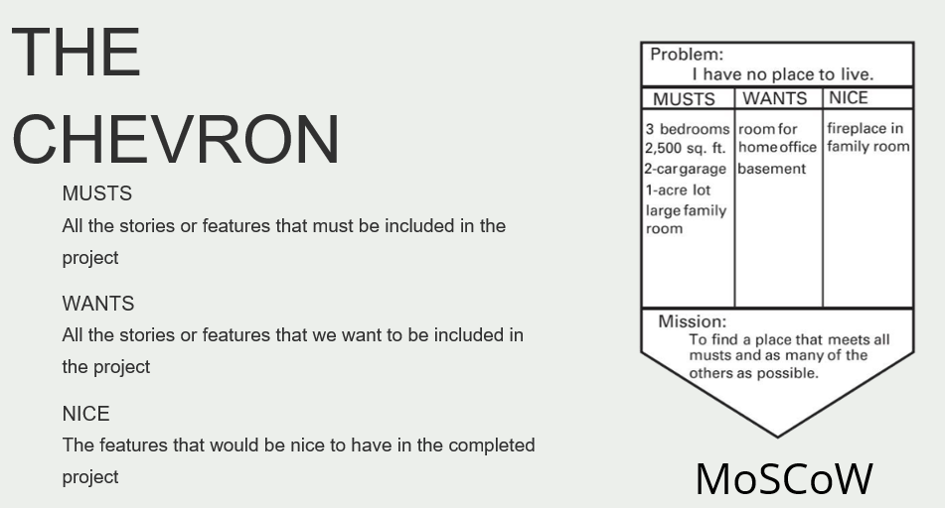

Vintner’s Antiques
Problem:
MUSTS | WANTS | NICE
- New roof  - Maintaining fire safety procedures  - Installing a good lighting system | - New van  - HD camera  - New signage | - New coffee machine  - Leather office chair
Mission: To provide customers with the merchandise as advertised, give exceptional service whilst making a profit

Risk Assessment
It is essential to have a risk management plan. This verifies the procedures for managing risks throughout the project. Without knowing how the plans will be executed or what obstacles may be encountered. Risk management is about things going wrong and what the project operators can do to prevent this (Regester and Larkin 2008).
Risks, Assumptions, Issues and Dependencies (RAID) is a term used in risk management to analyse the hazards associated with project implementation or other ventures.
In the event of things going wrong it is best to have a contingency plan. This is like plan B, a backup strategy, which will be activated if an oncoming risk is assessed. (Wrike 2020). This process essentially aids organizations apprehend, evaluate and act on all the risk elements. This operation will allow the organizations to increase the possibility of their success and lessen the threats of failure.

Management by exception
Subordinates or project team members all independently strive to perform to their best, but sometimes things do not go according to expectations, this is when the managers come in. As the name implies, this is the exception when the management action is required to steady the situation.
The managers analyse where the performances are lacking, where it is side-tracked and retrieving the exceptions to the norm. By resolving the problem rapidly, will prevent any compounded effects.

Failures as a learning point
In week one of our initial seminar, we had to build a LEGO village. This was our lecturer's way of introducing himself and setting the tone for an enjoyable journey into effective project management. The instructions to build the houses with the LEGO pieces were somewhat confusing, which contributed to our failure. I felt the exercise did not run smoothly due to a lack of information, direction and motivation.
In hindsight, our performances can be easily enhanced, and the project can be successfully delivered. The first stage of accomplishing a venture, is defining the project and ensuring everyone has understood it properly, we failed to do this.
Our lecturer told us about some of his of failures in his businesses. Although it is a costly experience, one should avoid the negative effects of failure, stay positive and carry on. One lesson to learn from failures is, successfully recovering from it, can produce more benefits than if the failure had not happened.

Future Improvement Tools
Our team is very eager to learn and improve their skills. We have decided to enrol on a project enhancement course.
The PRINCE2®course, which stands for Projects IN Controlled Environments. Originally it was called PRINCE, since then it has been updated and improved, hence the name PRINCE2. By studying this accredited approach, it provides a platform to clarify people's roles, improves communication, finance, managing project risk skills and other project related subjects.
References
Belbin, R.M. (2012). Team roles at work. Routledge.
Cobb, A. (2011) Leading Project Teams: The Basics of Project Management and Team Leadership. 2nd edition. SAGE Publications, Inc
Hsu, C.C. and Sandford, B.A., 2007. The Delphi technique: making sense of consensus. Practical Assessment, Research, and Evaluation, 12(1), p.10.
Leading Learner (2014) Leading in Challenging Times [online] available from <https://leadinglearner.me/2014/03/18/leading-in-challenging-times/> [29 March 2020]
Leong, T.K., Zakuan, N., Mat Saman, M.Z., Ariff, M., Md, S. and Tan, C.S. (2014). Using project performance to measure effectiveness of quality management system maintenance and practices in construction industry.
Phillips, C. (1957) The Eisenhower 'Inner Circle'; No President Before Has Created Such an Elaborate Apparatus of Aides and Advisers. Here Are the Men Around Eisenhower And the Roles They Play. [online] available from <https://www.nytimes.com/1957/02/03/archives/the-eisenhower-inner-circle-no-president-before-has-created-such-an.html> [29 March 2020]
Pollack, J., Helm, J. and Adler, D. (2018). What is the Iron Triangle, and how has it changed? International Journal of Managing Projects in Business.
Prince2 Programme (2019) Difference Between A Project and A Programme | UK [online] available from <https://www.prince2.com/uk/blog/project-vs-programme> [29 March 2020]
Ray, S. (2018) Project Initiation: How to Start Off A Project Right [online] available from <https://www.projectmanager.com/blog/project-initiation> [29 March 2020]
Regester, M. and Larkin, J. (2008) Risk Issues and Crisis Management in Public Relations: A Casebook of Best Practice. 4th edition. London: Kogan Page
Roberts, P. (2011) Effective Project Management: How to Plan, Manage Risks and Deliver (Business Success). London, UK: Kogan Page
Slack, N., Brandon-Jones, A. and Johnston, R. (2013) Operations Management.
Surowiecki, J. (2004) The Wisdom of Crowds: Why The Many Are Smarter Than The Few And How Collective Wisdom Shapes Business, Economies, Societies, And Nations. Concordville, Pa: Soundview Executive Book Summaries
Weiss, J. and Wysocki, R. (1992) Five-Phase Project Management: A Practical Planning and Implementation Guide. Reading, Ma: Addison-Wesley
Wrike (2020) What Is Contingency Plan in Project Management? [online] available from <https://www.wrike.com/project-management-guide/faq/what-is-contingency-plan-in-project-management/> [29 March 2020]

