AC1.1

“Structure is how the individuals working within an organisation (either as employers or suppliers of a service) are formally organised into groups and structured into hierarchies (or not).” (Taylor and Woodhams, 2016)

Both non-hierarchical management structure and hierarchical bureaucratic structure benefits for the workplace. According to workleap.com, a flat non-hierarchical structure is most commonly implemented within small businesses (which is at the beginning of this particular case study), whereas a bureaucratic hierarchical structure is most common in larger organisations (which is after the sale of the care home in this particular case study).

Non-hierarchical Structure
“A flatter organisational structure is about empowering teams with fewer management layers.” (Baigley,2025)

Under non-hierarchical management, the extent to how this could be appropriate is that it can create a more personal approach, which is how Kirsten managed the care home. With all staff reporting directly to one manager, it can mean open communication without the fear of going above someone. By eliminating a chain of command and communicating regularly, staff can feel listened to and involved in decision making. By taking this approach, Kirsten’s employees felt a sense of commitment, not only to the manager, but to the business and the goals it wants to achieve.
The benefit of this form of structure can also equate to very little staff turnover, which in turn would lead to better relationships with residents, which then means retaining client satisfaction.
Another reason that this approach would be appropriate is that instructions and change can be implemented more directly and quicker, leading to no confusion of directions coming down a chain of command. Plus, any issues that arise can then be discussed openly and potentially suggest alternative ideas to improve process and feel that their suggestion is listened to and empower further creativity to other tasks, which is demonstrated in the case study with the meetings that Kirsten had with her staff.

Hierarchical Bureaucratic Structure

“Weber argues that a bureaucratic organization is one in which tasks are divided into small, manageable units, and each unit is overseen by a specialist who has the necessary skills and knowledge to carry out the task.” (Nickerson,2024)

A hierarchical organisational structure is one that resembles a pyramid, for example, a single person at the top then down to different levels of management/employees. This is the approach that Chaffinch used. It could be appropriate as it ensures that decision making is clear and that there is a chain of command for employees to communicate issues and also higher management to inform changes to the business. Another benefit to this structure is that there is a possibility of progression within an organisation for employees who feel stagnant in their roles. This can mean more involvement with management decisions, potentially communicating possible ideas/grievances between lower employees and higher management. This type of structure certainly works to manage larger numbers of employees, however, this may be a future approach for Chaffinch to adopt once the takeover has been integrated and staff are settled.

AC1.2
The rational approach that the Chaffinch Group could use would potentially be to create a plan using factual data. Once the data is gathered from different sources, they could then look to objectively analyse that information to create a plan that aligns with the goals that they want to achieve, potentially creating plans that they could ‘trial and error’ to see which works more effectively for the care home as a business, the staff and the residents.

A method they could incorporate could be SWOT analysis. “SWOT is often used as part of a strategic or planning process, but can be applied to help understand an organisation or a situation, and also for decision-making for many different scenarios.” (CIPD,2025)
This analysis can help gather data on the company’s Strengths, Weakness, Opportunities and Threats. By looking at the strengths, it can identify what the company does well in terms of meeting customer needs and retaining staff, and plan future goals to still be able to continue with these effectively. In this particular case, Chaffinch has the funding available to invest in the maintenance of the care home, such as refurbishment of the residents’ rooms and the facilities of the care home. This is one element that Kirsten could not provide due to lack of funds.
Analysing weaknesses can highlight gaps for improvements, for example, up-skilling internal staff so they can provide better service to customers, and by reviewing the data gathered, can make rational and objective changes to implement into a company’s long term goal to meet customer needs. An example of a potential weakness would be that due to Kirsten taking a more informal management approach, implementing policies, procedures and training to staff could be a struggle seeing that the staff have been working with no clear chain of command and structure in place.
When a company looks at opportunities and how to meet customer needs, these could be external factors, such as competitors, gaps in the market and technology advancement. By gathering data on these factors, the company could then ensure they incorporate potential opportunities into their plan to meet customer needs.
When looking at threats, this may refer to what could/is negatively impacting the company. By understanding threats, the company can formulate a strategy to support its long term plans to meet customer needs and be prepared for any unexpected shocks, whether internal or external. A potential negative impact to Chaffinch is their lack of communication with the staff. By not involving or notifying them of any changes, this has led to employees leaving or sickness absence and then being replaced with external agency workers who may not fit the ethics of the company.

By analysing these factors, Chaffinch will have a rational balanced view on the company’s current position and can then make informed objectives for their plan to meet the needs of its customers, taking into consideration a broader picture of cost, efficiency and the time is would take to achieve their goal.

AC 1.3

To analyse positive and negative effects on a company or industry, they can adopt the PESTLE analysis method.

“A PESTLE analysis is a management framework and diagnostic tool. The outcome of the analysis will help you to understand factors external to your organisation which can impact upon strategy and influence business decisions.” (CIPD, 2025)

P = Political
E = Economic
S = Social
T = Technology
L = Legal
E = Environmental

The economy is a factor that is currently having a negative impact on the care industry. An example would be to the salaries in care roles. According to Simon van Os at Quality Care Group, “Care workers in the UK earn some of the lowest wages among developed nations.” The consequences of this can lead to high staff turnover as people cannot afford basic necessities such as food and energy. Also, with wages being so low, staff can feel disgruntled if they feel under appreciated in their work for such little pay, and that existing staff are working longer hours to cover the gaps in employment. The case study shows this after Chaffinch has taken over the care home, and staff have left due to the negative impact the company and management has had on the care home.
An example of an external positive impact to the care sector the environment and what sources we have today. Clean running water enables care homes to be able to sterilise, clean and wash the facilities, in turn, reducing the risk of infection to vulnerable residents and staff. Care homes would also have to factor in being efficient if it is to maintain the safety of staff and residents. WCS Group stated that research conducted by Future Care Capital advises that “there are 15,661 care homes in the UK with a total of 465,545 beds. With the average person using 140 litres of water a day”. So, maintaining its facilities and putting plans in place, such as installing fixtures to promote water conservation, the care sector can have a positive impact on the environment whilst the environment has a positive impact on the care sector.

AC1.4

“The adult social care sector is beginning to embrace the use of technology and learning how different types of technology can improve the ways care and support is provided.” (Skills for Care, 2025)

Chaffinch Group can implement technology into the care home to benefit not only the residents, but also the staff.
For the residents, there are items that they can wear to assist with their health care as well as their safety. Personal alarms can notify staff when a resident is in need of urgent assistance. There are numerous companies that have invested in providing wearable items like personal alarms to care homes, something of which Chaffinch could use with their residents.
Another way Chaffinch can implement technology would be to deliver additional staff training, online training and mandatory updates to keep on top of policy. The impact this could have at the care home would be that, by staff receiving further training, they can provide better care to residents. Also, this would keep staff up to date with any legal requirements that Chaffinch have to adhere to run their care homes.

AC2.1

Problems that have arisen since the takeover by Chaffinch is that the residents are becoming disgruntled due to the lack of individuality in their care and surroundings. Another problem is that the existing staff no longer feel listened to and that their views and opinions are no longer asked or valued. This has then led to a high turnover of staff and absence, and in turn, the gaps are then being filled by agency workers. Also, since the take over, the long term residents have moved to alternative care homes which has led to difficulty attracting new residents.
Looking at Edgar Schein’s theory, he breaks down organisational culture into 3 levels –

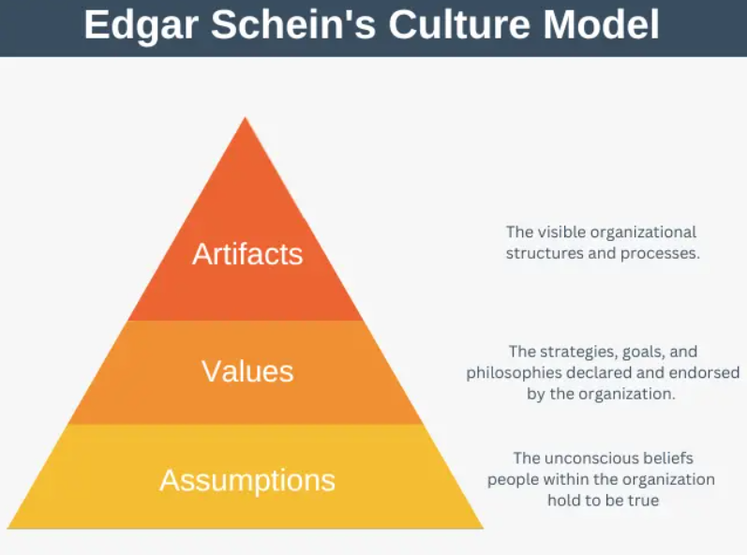

Artifacts represent the visible structures, for example, the physical look or layout of the building, dress code, procedures in place and communication/behaviours that can be seen. With the case study, the problems that have arisen since Chaffinch has taken over that link to this theory is that the residents, although appreciate the refurbishment, are now feeling that there is no individuality to their rooms and personal space.
Another link to this theory is that they are putting procedures in place for staff to adhere by, and informing them via email, which is completely the opposite to how Kirsten managed the care home.
According to Schein’s theory, values are goals and priorities that are expected by the company and/or management. Reviewing the case study, the problems that have arisen since Chaffinch took over is that they are promoting policy and procedures in to the care home that are the same for all their care homes under their umbrella. These may be what the company is expected to provide, but not necessarily what actually happens.
Looking at Schein’s Assumptions, these are the beliefs and behaviors that are true within the organisation. An example of this would be the new manager, Kath’s approach to management. Kath does not give an opportunity for employees to raise their concerns, and when they do, she “knows what Chaffinch wants, and they need to see a return on their investment.” This is an example of what the manager wants and believes, not what is outwardly portrayed by the company. Another problem is that due to staff leaving, Chaffinch are then sourcing agency staff, only looking at qualifications and experience of people, rather than looking at the values of the company. This could potentially show a lack of understanding and caring to the staff and residents, and only being driven to fill the gaps and get a financial return rather than promote the policies and goals of Chaffinch that are portrayed outwardly.
To overcome these problems, Chaffinch could approach them using Dr David Rock’s SCARF model

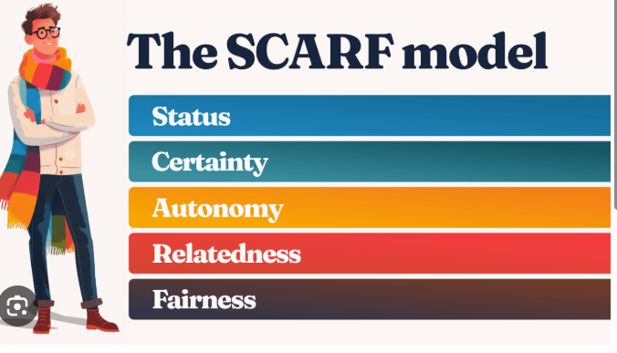
‘Status’ is how a person is recognised. In the case study, staff do not feel listened to or valued, however, if they were, they would feel more involved and valued which could lead to staff retention rates being better.
‘Certainty’ is centered around staff being involved in future planning. Chaffinch do not take this element into consideration, however, if they did, staff and residents would feel more secure in their future at the care home, and again, retain staff and residents.
‘Autonomy’, in this instance, is how the staff are managed, with Kath’s approach being unquestionable. If she was to listen to the staff and residents, they would feel more involved in the decision making which would make changes become more acceptable. This also links to the ‘Relatedness’ in Rock’s model. If management communicated with staff, then they would have more understanding as to why the changes are being implemented.
‘Fairness’ relates to an emotional response when decisions or processes are being implemented, and if people feel that they are being treated fairly. Reviewing Chaffinch’s problems relating to this part of Rock’s model, listening to their staff about how they feel, and taking this into consideration rather than dismissing them, would lead to job satisfaction and the feeling of being supported after the takeover.

Overall, reviewing these two models and implementing them to find potential solutions to the problems, Chaffinch can improve motivation and communication to their staff.

AC2.2

Rachel Sharp from HR Magazine Matthew Taylor, chief executive of the Royal Society for the encouragement of Arts, Manufactures and Commerce (RSA) who concluded that employees’ voices being listened to creates happier workers, ‘a more collegiate environment between managers and staff’, and boosts productivity.(Taylor,R. 2018)

Reviewing the case study, the approach to selection and employee voice was that Kirsten valued her employees’ input, holding regular face-to-face meetings to discuss the care home’s goals and how best to achieve this. With the selection process, Kirsten also involved staff to ensure that the new recruits had the same beliefs and behaviours as well as the qualifications and experience.
Now that Chaffinch has taken over, employees feel that they do not have a voice or opinion that is listened to or valued, and that they no longer have input into the new staff joining the care home due to being replaced by agency staff. Unfortunately, by taking this approach, it has had a negative impact on the organisational culture and the behaviours of staff. By suppressing the voice and opinions of its current staff, this has led to a lack of motivation for the staff to stay, meaning high turnover and the outsourcing to agency. With agency only looking at qualifications and experience, this doesn’t necessarily mean that their beliefs align with the organisations goals and core values. This in turn could lead to an affect on the quality of care given to the residents if they do not share the same attitude to care as the other members of staff, or Chaffinch.
Another negative impact by not listening to their employees voice is that higher management will not have a true understanding of the workings of the care home and the concerns the staff and residents have, resulting to the confusion as to why it is not as successful as it was before the takeover.
In summary, suppressing employee voice and outsourcing the selection process for new members of staff has led to Chaffinch now having an unstable workforce and losing money and residents.
AC2.3

To make the transition from Kirsten’s management of the care home to it now being part of the larger organisation of Chaffinch, there are significant elements that Chaffinch could have managed better to ensure a smoother transition.
One model to look at would be Lewin’s Three Stage model. “This provides a structured way to understand how organizations transition from a current state to a desired future state.” (Prosci. 2025)
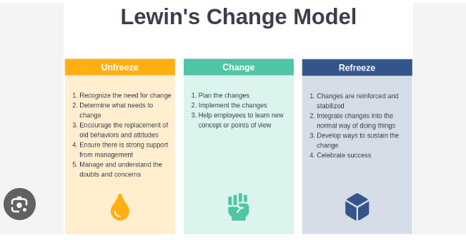
To ‘Unfreeze’ the care home, Chaffinch could have communicated to the staff in a face to face method, to listen to any views that the staff had and understand and manage any doubts and concerns raised. It could have also been communicated about how Chaffinch work as a company and that changes would be made under this new management and the reasons why. To ‘Action’ the change, the plans that Chaffinch decided on could have been implemented in a more communicative way but offering support, guidance, and allowing staff time to adjust to the change of management.
After Chaffinch communicated the changes they wanted to make and implemented them, the ‘Freezing’ is to reinforce the new changes and policies into place. A way in which Chaffinch could have implemented this better than they did would have been to speak with the employees and the residents to understand their issues.
As already discussed previously, the importance of employee voice is crucial to retaining staff and giving them a sense of value and say in the way the care home is run on a hands-on basis, rather than from a senior management point of view.
Overall, this model would have been an effective tool to transition from Kirsten’s management to the takeover by Chaffinch as it would have focused on the staff and residents and ensured that the continuation of care and stability was met in an open and communicative way.

AC2.4

The experience of change for employees when they were advised that they were going to be taken over can be shown through the Kubler-Ross Change Curve.
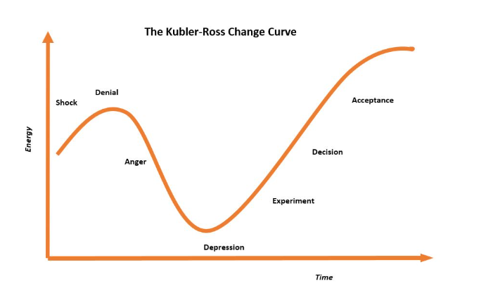
This curve shows the varying emotional stages an employee would have felt and the outcome if they felt it was not dealt with appropriately by Chaffinch.
Reviewing the case study, employees were shocked that the sale was going ahead, especially knowing the personal connection Kirsten had to the care home.
The next stage of Kubler Ross Change curve is frustration and denial. Once Chaffinch appoint the new manager that the workforce reports to, they try to voice their opinions and concerns, but are only met with a barrier and an expectation that they are to do as they are asked, which would have created much frustration in comparison to Kirsten’s management.
With this in effect, the next stage of the curve is depression and low morale. The employees felt undervalued and unheard, leaving them demotivated to commit to the care home and its new management.
The curve then leads to experimenting and testing the management’s new ways of working. By doing this, the staff still struggle to feel positive about the take over, causing sickness absence and turn over to increase. This is now the point in which the employees decide whether to seek alternative employment or adopt Chaffinch’s changes.
Looking at this model and the case study, it reflects the emotional change of the employees at the care home and could highlight the potential reasons for employees leaving.

AC2.5

“Smart employers know that organisations perform better when staff are healthy, motivated and focused.” (Mind,

Wellbeing in the workplace is such an important factor as it can effect other people, the customers and the overall business.
A key factor that has an impact on employee wellbeing is management. The case study shows that Kirsten’s approach to her staff at the care home makes her staff feel valued, appreciated, involved in decisions and committed to Calmere House and its goals. Her approach of communicating in an open way and engaging in their views and opinions led to retaining staff. This is in contrast to the way Chaffinch manages the staff after the takeover, with employees feeling the exact opposite to before.
Another key factor that has an effect on wellbeing that has a link to management is workload. In respect of the case study, due to the staff leaving because of management, the workload has increased for the remaining staff, working longer hours and missing the support of their co-workers. With a heavy workload, this can lead to stress, demotivation, no job satisfaction, physical and emotional problems.

With these two factors being in place for the employees at Calmere House after the takeover, they can have a serious impact to wellbeing in the workplace.

AC3.1

In the case study, Chaffinch Group have three key members of staff that can contribute to retaining staff.
One of the factors in the employee lifecycle is Recruitment and Selection, so the Recruitment Advisor that Chaffinch has would support the candidates applying to work at the care home. It would be their role to look at applicants that would fit into the company’s values and goals, what experience and qualities they could bring to the role. By matching the right candidate to the right role, this could reduce staff turnover and retain staff. Recruitment would also put in place the onboarding induction for any new starter, as per the employee life cycle. By incorporating a structured onboarding process, this can “make all the difference when a new starter is feeling awkward and uncertain about whether they made the right decision to join the organisation”. (CIPD. 2022)
A People Manager would contribute to the life cycle by being involved in the staff’s day to day work environment, in particular, development. Not only would they be involved with their development for training and progression, but also as someone who employees can feel supported by, listened to and manage the workloads of staff. If an employee has this support from a People Manager, this will contribute to the creation of a work environment that staff will want to stay.
With the Employment Relations Advisor, they are in a position to resolve any workplace grievances and difficult situations in a fair manner to prevent it escalating further and stop staff leaving. They also play a key role in the retention of staff by assisting with these issues not just for the employees, but for the the managers also, improving communication and development.

Overall, having these three roles within a company such as Chaffinch Group, they should be able to recruit the right people for the jobs, develop and support their progression in the company, and maintain an open fair communication with all parties when concerns arise.

AC3.2

People practices could help Chaffinch achieve their goal by using both vertical and horizontal integration.
Vertical integration means that HR or people practices align to meet the overall goal of the company.
In the case study, Chaffinch already have a Recruitment Advisor, an Employee Relations Advisor and a People Manager.
Using vertical integration, an example would be the Recruitment Advisor would look at the staffing needed to fill the gaps so that they recruit in-house rather than using agency. This would give them more control over the type of staff that would be joining the company. The more aligned that the new staff are to the company’s core values, the better care that staff can give to the residents, therefore meaning that less residents leave.
Horizontal integration would be that all three are working together to support each other.
In the case study, an example of this to achieve the goal would be that Recruitment would employ quality members of staff that align with the Chaffinch’s goals and values. Once onboarding is completed, the People Manager would then be there for their day to day working, encouraging development and rewarding performance, and the Employee Relations would then ensure that the member of staff is being treated fairly and that wellbeing is high. If all align to retain staff, this then creates a better work environment, which then creates a better quality of care for the residents, therefore retaining the customers, and possibly attracting new residents.

3.3
There are a variety of constructive methods that a manager could use to engage with staff to discuss employee turnover to give them an insight to how staff feel about the workplace.
Reviewing the case study, Kirsten’s approach to open communication would be a good example that Kath could use to understand why staff are leaving. Incorporating face to face meetings or one-to-one meetings on a regular basis would give staff the opportunity to voice their concerns. However, Kath’s approach would need to be an ‘open’ discussion, rather that closing down the members of staff is they challenge anything. This would make Kath more approachable as a manager.
Another place to start is possibly doing a regular anonymous staff survey, asking open questions to gather more information on how the staff are feeling. Being anonymous, staff can potentially be more honest in their answers if they do not feel confident enough to air their thoughts openly. The answers can then be passed through the chain of command to the higher management so that they can see how the staff on ‘the ground’ are feeling.
Another approach would be to look at staff and the potential they show in their role, rewarding hard working staff with development opportunities or even more responsibility in their job. This could then create a feeling of worth to the staff, knowing that the company is investing in them by developing their skills and trusting them with the extra responsibility. This can then lead to retention of staff as there is then a clear progression for people who want to progress, rather than stagnation.
If Kath incorporated the above, there would certainly be positives to the working morale of the staff, however, she would also need to be clear that, although wanting to keep staff and create a better working environment, she is a manager and that Chaffinch and Calmere is a business, so cannot agree to everything that staff want if it is not in the best interest to the business and the residents.
Overall, if management listened to the staff and took on board what concerns were, this would create a work environment where employees feel listened to and their opinions valued, leading to staff retention rather than loss.

Reference | AC
Baigey, E. and Hall, I. (2025) Flatter organisational structure: Definition and how to implement, Factorial. Available at: http://www.factorialhr.co.uk/blog/flatter-organisational-structure/ (Accessed: 19 November 2025). | 1.1
Workleap (2025) Hierarchical vs flat organizational structure: Benefits of each, Workleap. Available at: https://workleap.com/blog/hierarchical-vs-flat-organizational-structure-and-benefits-of-each (Accessed: 19 November 2025). | 1.1
Taylor, S. and Woodhams, C. (2016) Studying Human Resource Management. Chartered Institute of Personal Development | 1.1
By et al. (2024) Bureaucratic Management Theory of Max Weber, Simply Psychology. Available at: https://www.simplypsychology.org/bureaucratic-theory-weber.html (Accessed: 19 November 2025). | 1.1
CIPD (2022) SWOT analysis: Factsheets, CIPD. Available at: https://www.cipd.org/uk/knowledge/factsheets/swot-analysis-factsheet/ (Accessed: 19 November 2025). | 1.2
Pestle analysis (2025) CIPD. Available at: https://www.cipd.org/uk/knowledge/factsheets/pestle-analysis-factsheet/ (Accessed: 19 November 2025). | 1.3
The UK private care industry pay crisis: Enough is enough (no date) Quality Care Group News. Available at: https://www.qcaregroup.co.uk/latest-news/the-uk-private-care-industry-pay-crisis-enough-is-enough#:~:text=Care%20workers%20in%20the%20UK,is%20%C2%A39.50%E2%80%93%C2%A310.50. (Accessed: 29 November 2025). | 1.3
Web@Digitalnrg.co.uk (2025) Water efficiency - 3 top tips for care home operators, WCS Environmental. Available at: https://www.wcs-group.co.uk/news/water-efficiency-3-top-tips-for-care-home-operators/ (Accessed: 29 November 2025). | 1.3
Using Technology in Social Care (no date) Skills for Care-Using technology in Social Care. Available at: https://www.skillsforcare.org.uk/Support-for-leaders-and-managers/Managing-a-service/Digital-technology-and-social-care/Using-technology-in-social-care/Using-technology-in-social-care.aspx (Accessed: 29 November 2025). | 1.4
Sharp, R. (2024) Breaking the silence: Employee voice, HR Magazine. Available at: https://www.hrmagazine.co.uk/content/features/breaking-the-silence-employee-voice (Accessed: 30 November 2025). | 2.2
Prosci (2025) What is Lewin’s change theory? explanation, pros and cons, Prosci. Available at: https://www.prosci.com/blog/lewins-change-theory#:~:text=Lewin%27s%20Change%20Theory%2C%20developed%20by,to%20a%20desired%20future%20state. (Accessed: 30 November 2025). | 2.3
(No date) Resource 3 how to promote wellbeing and tackle the causes of work-related. Available at: https://www.mind.org.uk/media-a/4662/resource3_howtopromotewellbeingfinal.pdf (Accessed: 30 November 2025). | 2.5

