
hotel hilton holdings
Financial Analysis

June 1, 2022
University of Wales Trinity Saint David

By Sandra Poupino
2018518

Executive Summary

The purpose of this report is to analyse the financial information and analysis for Hilton Hotel Holdings, for 2019 and 2020, looking in this previous information, we can see what Hilton did well and what at failed. Using a combination of trend and ratios analysis helps understand this report and will gather financial reviews and probability analyses. Having a strong balance sheet, and quick decisive actions, Hilton like all Hospitality business had to face unprecedented external factors, the pandemic covid-19, had a huge impact on organisations, and bringing loads of limitations. After a bad year in 2019, Hilton started 2020, with 96% of his hotels open, and 14% of global RevPAR, +6,6% of net Unit growth. Looking into the financial information itself, can be interesting and quite scary, with sales falling -55%, profit before income tax having -174%, also the interest expenses having an increase of 4%,and gross profit reduced by -76%, 2020 was a miss , but showing good indicators of recovery and speedy trend of growth.2020 Year end , with 2.194 of index for sales , -1.232 for net income , which was not a surprise , 0.892 for total assets overall , due to the circumstances and how covid-19 affected the hospitality industry , Hilton supervised , and with good indicators of growth , and good decision making .

Table of Contents

Executive Summary 1
Introduction 3
Financial Analysis 4
Financial Analysis Trends 13
Conclusion (average of 10% of word count) 17
Bibliography 17

Introduction

The environment in which hospitality organisations operate are competitive and hostile, in order to successfully operate, they are required to have many resources. Most companies measure their success in many ways, including the ability to have profit, capture market share, generate cash and provide services, more effectively than competitors. Looking at financial information available, helps into decision making, control and planning. The environment is so complex, that would be impossible to survive, without this valuable information. To achieve objectives and goals companies must analyse and interpreting trends, and ratios can be a quick and effective way of doing it. Financial ratio analysis is normally utilized to obtain knowledge where their organizations are healthy and their potential in the future, also analysis the current performance against competitors, or other organisations of the same sector, ration only show trends, and help with decision making. Hilton Worldwide Holdings Inc. is one of the world’s fastest and largest growing hospitality company. With 18 different brands, operating in 122 countries, with more than 6800 properties in the globe. Hilton was founded in 1919, reaching 100 years of experiences, in 1946 Hilton Hotels Corporation was listed on the New York stock Exchange. Hilton had welcomed more than 3 billion guests in their 100 years of history, introducing many innovations in the industry, such as key cards, etc. Hilton in 2019 and 2020 faced very difficult times, with the impact of covid -19. As a resilient business model, and a strong balance sheet, and quick decisive actions, we ensure our ability to navigate all the challenges presented, Hilton started 2020 with 96% of its hotels open, with 14% of global RevPAR premium, +6.6% net unit growth, and a share price: NYSE HLT: $136.59 (growing 3 to 4%). We are passionate about delivering exceptional guest experiences, we do the right thing, all the time, have won a few awards around the world in 2020, for best place to work. This report will help to read and understand the analysis of Ratios for 2019/2020, and what conclusions we can get for future decisions. (Hilton, 2022)

Financial Analysis

Income Statement | Hilton Worldwide Holdings Inc. (HLT)
 | 2020 | 2019 | Change | % Change
Fiscal Year Ends | 31/12/2021 | 31/12/2020
Sales | 4,307,000 | 9,452,000 | -5,145,000 | -54.43292 | -55%
Cost of goods sold | 3,724,000 | 7,017,000 | -3,293,000 | -46.92889 | -47%
Gross profit | 583,000 | 2,435,000 | -1,852,000 | -76.05749 | -76%
Operating Expenses | 702,000 | 859,000 | -157,000 | -18.27707 | -18%
Operating income | -119,000 | 1,576,000 | -1,695,000 | -107.5508 | -108%
Interest Expense | 429,000 | 414,000 | 15,000 | 3.6231884 | 4%
Total Other income/ expenses net | -376,000 | 82,000 | -458,000 | -558.5366 | -559%
Income before taxes | -924,000 | 1,244,000 | -2,168,000 | -174.2765 | -174%
Net income | -715,000 | 881,000 | -1,596,000 | -181.1578 | -181%

 | 2020 | 2019 | Change | % Change
Current Asset | 4,202,000 | 2,093,000 | 2,109,000 | 100.76445 | 101%
Non-Current Asset | 15,810,000 | 12,558,000 | 3,252,000 | 25.895843 | 26%
Total Asset | 16,755,000 | 14,957,000 | 1,798,000 | 12.021127 | 12%
Current Liabilities | 2,431,000 | 2,871,000 | -440,000 | -15.32567 | -15%
Non-current Liabilities | 15,810,000 | 12,558,000 | 3,252,000 | 25.895843 | 26%
Total Liabilities | 18,241,000 | 15,429,000 | 2,812,000 | 18.22542 | 18%
Common Stock | 3,000 | 3,000 | 0 | 0 | 0%
Retained Earnings | -6,732,000 | -5,965,000 | -767,000 | 12.85834 | 13%
Total Stockholders' Equity | -1,490,000 | -482,000 | -1,008,000 | 209.12863 | 209%
Total Liabilities and Stockholder | 16,755,000 | 14,957,000 | 1,798,000 | 12.021127 | 12%

- Calculate Horizontal ratios for 2019 and 2020 to aid the analysis of the financial information included within the attached financial statements. You should discuss the trends seen in these ratios in detail and draw appropriate conclusions.

The Horizontal ratios were calculated for 2019 and 2020, horizontal analyses are composted with two aspects, comparative analyses (compare the organisation results from one year to the other), and trend Analyses (compare results for multiple rears against the year to investigate, within the organisation), this is done by comparing the results of 2020 to 2019, to realize how sales are to profit, etc. First thing to analyse is what the organisation trades, we do this by looking at the financial statement and look for gross profit, and cost of goods sold because is only available for organisations that trade goods. To analyse this numbers is necessary a formula, currently known as NO (new year-old year), to calculate de percentage we use NOO (new year-old year, /old year) (2020-2019/2019 x 100 = %), below is a representative of analyse of the outcome.

Hilton Holding had a representative decline between 2019 to 2020, sales are represented by $9,452,000 in 2019 to $4,307,000in 2020, making a loss of -5,145,000, by around -55%, which is not surprising having in consideration the current environment in which this occur, 2019 brought Covid -19 and all the restriction imposed by the governments around the world, with most of the hotels, closed to any practise of business, therefore this numbers are very representative of that. Evidence Suggest that in the face of uncertainty and liquidity constraints, current income may still be a key factor influencing consumption (Griffiths, Wall, 2007)

1- Graphic representative of sales

The cost of goods sold was $7,017,000 in 2019, and $3,724,000, making a loss of - $3,293,000, by -47%, although this is a bad result, it is good and surprising, we want revenue to increase and the cost to decrease, each occur by 8%, this means higher profitably, and higher retain earnings, higher equity and that is positive, the company own more to the owners now.

2- Graphic of cost of goods sold

The we analyse the Gross profit, this is an important indicator for organisations, is the amount available to cover expenses, operating expenses, interest and income tax, also is the amount that allow us to generate profit for the owners. Not surprising that 2019 $2,435,000 to $583,000 in 2020, is a loss of -$1,852,000, representing -76%. This is bad, having less gross profit then expected to cover our expenses, because of sales being down by -55%. If is too low to cover the expenses, then the profit is going to go down, this may mean the organisation is not profitable, again because of the external factor of the environment, this number were not a surprise.

3- Graphic of Gross Profit

In operating expenses is not surprising to see a decrease, due to decrease in sales as well, normally we would expect our operating expenses to increase, however the percentage show as more, only decrease by -18%, this is Good because the decrease is less than in sales, this show that Hilton reduce the cost by 37% operating the business, however reducing the costs to operate our organisation will leave more profit for other expenses and profit. A further analyse show that operating expenses have consume more than the gross profit, means Hilton is good at managing the cost they still spend more in operating expenses, means less profit for 2020, and have a negative impact in profit. Although Hilton should celebrate the lower operating expenses, regards to sales, the people in charge of this department should be reward for reducing costs. However, is not a great result we know that the savings was not enough to compensate, for the lower gross profit, and why the gross profit is lower because of less sales -55%, and this will have a negative impact in the Hilton.

4- Graphic of operating Expenses

Analysing the interest expenses, we see that increase by $15,000, or 4%, which is bad, this means either Hilton had to borrow more money from creditors (bank), or their interest rate went up. This is bad, reduce profit available for growth and expansions, and less money to pay to the owners (dividends).

5- Graphic for interest expenses

Profit before income tax decreased by -$2,168,000 or -174%, this is not surprising, although sales only fall by -55%, and Hilton had less decrease in operating expenses of -18%, and the interest expenses raised by 4%, the cost of goods sold had a decrease of -47%, the result of fall by -174% is 100% due to all departments being decreasing, and this negatively affected the profit before income tax.

6 – Profit before income taxes

Other income/expenses had an incredible decrease of -$458,000 at -559%, when calculate the income tax rate we see that Hilton had a 15% tax rate for 2019 (1,244,000/82,000), in the other hand in 2020 only 2,4% of tax rate in 2020(-924,000/-376,000),the data from the source suggest that this is excellent as Hilton is paying lower taxes to the government and this will improve profitability.

7- Graphic of other income/expenses

Financial Analysis Trends

Financial Trend analysis provides dynamic picture of Hilton by showing is financial direction over a period. Index numbers are used in trend analysis to show percentage change in various financial statement items. We need to have at least 2 years for horizontal analyse, in this report we have 2019 and 2020. Using 2019 as an index number (rate) = year amount (portion)/year base amount (base). Even with 2019 and 2020, there were very bad years for the business, Hilton still maintains a good position, a relatively good number. In 2019 had 2.194 or 219,4% in net sales, net income had -1.232 or -123,2%, which is not surprising, and Total assets had a slight increase of 0,892 or 0,89%, which is very good, under the circumstances Hilton faced by governments around the world. The findings suggest that, Hilton still was able to maintain a good reputation in the market and showing good signals of recovery.

8-Graphic of trend analysis

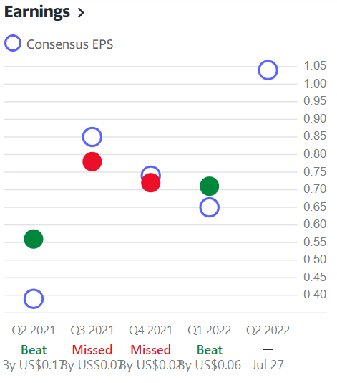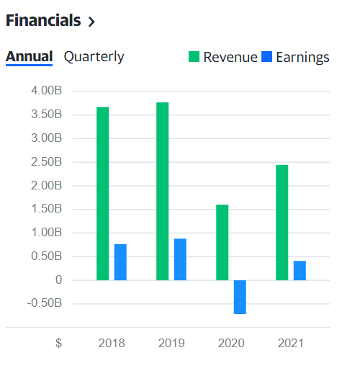
9- Graphics representative from Yahoo (2022), for Hilton Hotels.

- Outline the importance of using ratio analysis for decision making.

Assessing corporate performance, is important, this knowledge will help management to determine new strategies, or to change or amend existing strategies taking in account the changing circumstances. When analysing ratios management is looking for how risky the business is, how to compare to current markets, is it earning enough to cover costs, and how well competitors are. Different persons in the business seek for different information in the ratio analysis (Ratio Analysis, 2022) Managers are more interested in indicator ratios, of how well the business running, and how well is performing in relation to the competitors in the same sector. When organisations must make decisions, numerous factors will be analysed, compared and considered, managers will look and analyse competitors, markets and all economic environments. However crucial to any decision is the health of the business itself, the manager will need to analyse all company numbers before taking any action, and there are some ratios that will give the business key information. (Solman, Jones, 2017), Management and organisations should consider all the ratios available to make sure that is making the proper use of the current assets and that it has enough reserves to carry out any change, plans, targets, etc.

- You are to investigate the limitation of ratio analysis, including why an understanding of ratios and their fluctuations is essential for hotel management in analysing the information seen in their financial statements.

Although Ratio analysis can be very useful technique, is important to realise is limitations. The Statements are historical information and backwards- looking. Inflation can and will influence in the evaluation demonstrated in financial statements, specifically where assets are detained at historical cost in the balance sheet (statement of financial position), also the balance sheet is an illustration of liabilities and assets, on the last day of each year (Collier, 2015). Therefor the use of out-of-date information for comparison may be of limited use if the organisation made substantial changes. There is a need for rather careful interpretation, when comparing two or more organisations liquidity ratios, if one company have higher numbers this may look good, further investigation may reveal that higher ratios are outcome of higher inventory, and receivable levels, which indicated a weak working capital management by the organisation with higher ratios (ACCA, 2018). These judgments are to influence this financial numbers which are the basis of ratio analysis. Ratios are not definitive , unless estimated and calculated over a considerable amount of years, to be able to identify a trend , or in comparison with identical industry for benchmarking (measure of your company success against competitors, to improve performance).For this reason ratios interpretation should have in consideration the context of economic industry, competitive factors , as well as company unique strategy , ratio analysis is not sufficient on its own , they are only calculated once a year with published publish financial statements , being susceptible of manipulation, accounts may choose to distorted the profit (small companies may distorted working capital ratios depending on customer pays , and how suppliers are paid before or after the year-end). Accounts in the companies have access to more information, and organisation will look at a monthly ratio basis, internally this will be more reliable in terms of trends and opportunities for improvement. when making ratio analysis, two considerations must be made, first is there are many different definitions of ratios, and the availability of comparable information, so care is needed when interpreting and calculating ratios. To gather more information, it is of good use to read annual reports, financial and trade press, internet reports, consultant and analyst reports, market research, providing information about economic change, the industry, competitors, suppliers issues, condition, etc (collier, 2015, ACCA, 2018). Understanding of ratios and their fluctuations is essential for hotel management, Malk and Schmidgall (1993) made an investigation about room departments and conclude that ratios are developed for the environment of hotel operations, and recommend their use for decision makers, in the sector. So many academics and Professionals had investigated and discussed so much about the subject, therefore is not surprising that now a days general managers consider activity and operating ratios as the most preferable and useful tool to help them in decision making. Interpreting the financial statements and ratios helps to improve performance, based on business context and competitiveness, giving the information necessary for judgement and ideas about trends, patterns, financial health and futures investments. When analysing ratios over two years, it is important to understand the causes, influencing the change. Since most organisation have accounted this ratio numbers can be analysed monthly, therefore going an advantage to the manager to correct the targets and goals of the organisation quite quickly and maximise the performance.

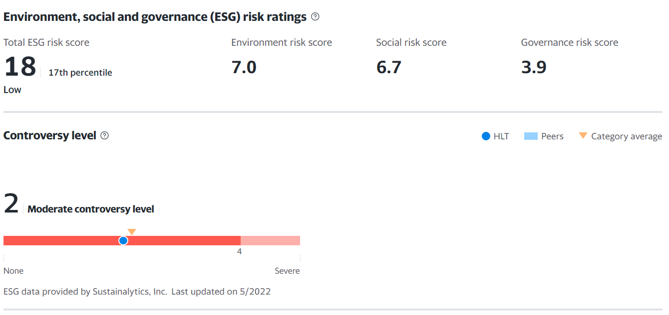
10 – Representation of risk rating of Hilton

Conclusion (average of 10% of word count)

These reports analyse Hilton worldwide Holdings for the year 2019 and 2020, for horizontal analysis, ratios and financial analysis with trends. 2019 and 2020 were not very good years, seeing a decrease falling -55% of sales, we need to remember and have in consideration that 2019 has the beginning of the pandemic covid-19, and that Hilton had many external factors helping this decrease, because most of Hilton hotels were infect close. Ratios are only representative number that alone do not say much, in 2020 Hilton had very bad results, with revenue still very good, but the earnings decreasing very sharply, it is not surprising under the external factor affecting Hospitality industry. Ratios analysis are great indicators and tools to use for decision making, discovered that different people read and are interested in different ratios, when analysing Hilton has found that the help of all ratios can give a completely different picture of the company. And Hilton position, although had a miss in 2019 and 2020, was not so bad. Looking to the ratios and their fluctuations is essential for hotel management, to outline plans, solutions, to understand how the company is performing, and implement the changes necessaries to rich the targets and goals of the organisations.

Bibliography

ACCA Approved Study Text, 2018,” Advanced Financial Management (AFM)”, London, 3PP Learning Media Ltd
Corporate Finance Institute. 2022. Ratio Analysis Available at https://corporatefinanceinstitute.com/resources/knowledge/finance/ratio-analysis/ Accessed 20/ 05/ 22
Davies. D, 2015, Managing Financial Information, 2nd Edition, Wiltshire, CIPD
Finance.yahoo.com. 2022. Yahoo is part of the Yahoo family of brands Available at https://finance.yahoo.com/quote/HLT/balance-sheet/ Accessed 18/05/2022
Hilton annual report 2022, Izoterma.in.ua. 2022. Hilton annual report 2022 Available at https://izoterma.in.ua/clc/hilton-annual-report-2022 Accessed 22 /05/2022
Griffiths. A Wall. S, 2011, “Economics for business and management “, 3rd edition, Harlow, Pearson
Griffiths. A Wall. S, 2007, “Applied Economics”, 11th Edition, Harlow, Pearson
Marr.B, 2012,” Key Performance Indicators: 75 Measures every Manager needs to know, UK, Pearson
Malk, M. & Schmidgall, R. (1993).” Financial analysis of the rooms department”. The Bottom Line, 8
Paulo M Collier, 2015,” Accounting for managers, interpreting accounting information for decision making”, 5th Edition, West Sussex, John Wiley &Son Ltd
Solman. J, Jones. E, 2017, “Essential Economics for business”, 5th Edition, Harlow, Pearson
Smart Capital Mind. 2022. What Is the Connection between Trend and Ratio Analysis? Available at: https://www.smartcapitalmind.com/what-is-the-connection-between-trend-and-ratio-analysis.htlm accessed 19/05/2022
Walsh.C,2010, “Key Management Ratios- The 100+Ratios every Manager needs to Know, 4th Edition, UK, Prentice Hall

