Ordinance, Munitions & Explosives (Degree Apprenticeship)
An investigation into a cost effective alternative to copper as the material of choice for Cylinder Expansion experiments.
ACDA6017,Progect Proposal
Lawrence Groom

Contents
Introduction 2
Aims & Objectives. 2
Aims 2
Objectives 2
Expected Outcomes. 2
Background Research 2
Experimental Design 3
4.1 Outline of Experimental Procedure – 3
4.2 Data Collection 3
4.3 Data Evaluation 4
4.4 Risks & Limitations 4
Resources and planning 5
6.1 Resources Required. 5
6.1.1 Physical Resources 5
6.1.2 Human Resources 5
6.1.3 Ethical Issues 6
Appendix 0
References 10

Table 1 Data Collection 3
Table 2 Data, Method and Outputs 4
Table 3 Risk, Impact and Mitigations 4

Figure 1 Gantt Chart 0
Figure 2 Cost Quotation 0

Introduction
To analyse the performance of different explosive materials and to collect the data required to model explosive materials in numerical models, cylinder expansion (CYLEX) tests are conducted. Annealed copper 101 has historically been used in CYLEX experiments due to its ductile properties which allow for a large volumetric expansion before rupture. This produces a long wall expansion measurement which is an important component for feeding into numerical models of the explosive material under test.
However, when conducting large scale tests or for building large data-sets the cost of manufacture and raw materials for the tubes becomes prohibitive.
An investigation is to be done into alternative materials; initially identifying potentially suitable materials and examining relevant variable such as material properties and manufacturing techniques. Tests will be carried out using FMEA modelling of the cylinder expansion experiment and using experimental data to compare chosen materials to copper C101.

Aims & Objectives.

Aims
The aim of this investigation is to produce a report that assess and highlights the potential use of several materials as a replacement copper C101

Objectives
- To critically analyse potential materials against copper, specifically with regards to ductility, cost and its performance when used under expansion tests conditions
- Evaluate alternative manufacturing methods, such as annealing, to improve the performance of materials when compared to copper
- To establish a list of potential materials suitable for further study and experimentation against copper, outside of the scope of this investigation
- To carry out suitable modelling or experimentation to test materials.

Expected Outcomes.
It is expected that through completion of this investigation, alternative materials will have been identified as potential replacements of copper C101 for use in CYLEX experiments.

Background Research
The cost of a single Copper C101 tube of 300mm with internal diameter of 25mm and wall thickness of 5mm is approximately £400. This is the standard dimension required by a CYLEX experiments. See Appendix for further evidence. Any alternative proposed material should show a significant reduction, greater than ten percent, in cost for manufacture without compromising the reliability and accuracy of the experiment.

In order to evaluate alternative materials’ performance to C101 copper it must first be understood why this material is used, and its performance parameters under test defined. As described in [1], C101 copper has a high ductility and impact strength. Jackson further supports this by stating C101 copper, annealed, is the standard material for Cylinder test practices as it does not rupture prematurely [2]. Lindsy states that velocity of wall expansion at volume expansion 2 and 7 are most useful. Therefore any material selected to compare with copper C101 must not rupture before 7 volume expansion has been achieved [3].
Copper, being naturally resistant to corrosion and inert, also results in good compatibility testing with various explosive materials.

Others have attempted to combine multiple test such as CYLEX and DAX (Disc Acceleration test) to avoid the high costs of CLYEX tubes [4]. This may provide insight as to why Copper C101 has not been assessed for replacement in any great depth as others has looked to mitigate the CYLEX tests short comings by splicing the experimental design with other characterisation tests. From research, one paper has been found which looks to assess steel as an alternative to copper, Svingala et al substitute a c101 copper for steel due to the explosive having a large critical diameter, thus increasing the size of tube require and resulting in C101 copper being financially unsupportable as a tube material [5]. The conclusion of [5] does state their testing had agreement with previous CYLEX tests and that this experimental method appears to be viable.

R. Castedo states that Lagrangian style models appear to be the best for replicating the cylinder wall expansion [6]. This will be explored further in for application in investigation modelling.

Experimental Design

4.1 Outline of Experimental Procedure

Catanach et al outline the specification for a Cylinder test [7]. This information in combination with experiment designs from [8] and [9] will be used to derive a test arena and inform data capture requirements. Test design from [4] will also be assessed for contribution to experimental design.
A generic test design of the tube under test being placed in a charge holder which allows the placement of Time of Arrival Devices and precise, measurable positions from the tube walls. This holder will also accommodate Heterodyne Velocimetry (HET-V) collimators, again, as precise and measurable distances. The holder will be designed such that optical measurements from standoff imaging devices will have an unobstructed field of view of the tube as well as suitable surrounding area to capture wall expansion.

4.2 Data Collection
Data will be collected from FMEA modelling of the CYLEX experiment and from experimental firings. Data collection from both methods will be undertaken by suitably trained personnel.
Table 1 Data Collection
Data type (variable) | Method/spec | output
Case rupture | Optical | Calibrated High speed footage of event
Wall velocity | Het-V heterodyne velocimetry | Velocity time trace
VOD | Time Of Arrival Device’s time of arrival device | Voltage time data points
Detonation pressure | Time Of Arrival Device’s time of arrival device | Voltage time data points

4.3 Data Evaluation
Data will be evaluated against wall expansion, expansion volumes and time of tube rupture in order to compare different materials and there properties to that of copper C101.
Table 2 Data, Method and Outputs
Type of data | Analysis Method | Output
Wall velocity | Bespoke MatLab code | Velocity time graph
Time of case rupture | Visual inspection of footage | Table of time and volume
Time Of Arrival Device’s output voltage time reading | FAMOS | Graphical displacement time and table of figures.

4.4 Risks & Limitations
Table 3 Risk, Impact and Mitigations
Risk | Impact | Mitigation
Effects of COVID 19 pandemic, restriction to staffing/site access. Site closure | Failure to deliver output to timescale | Regular LFT testing for all individuals taking part in the investigation. Regular sanitisation of work stations and hand washing. Masks to be worn when within two meters of other staff.
Infrastructure booking failure | Milestones missed, increase financial cost, loss of experimental data/inability to collect experimental data | Regular minuted meetings with resourcing managers of the booked facilities to ensure any problems are resolved in a timely manner.
Commercial failure to deliver equipment | Financial cost increase | Request regular updates on commercial status
Staff injury / incapacitation | HSE investigation, cessation of work. | In-depth trials plan and Risk Assessment assessed by company Health and Safety team. No work to be carried out before sign off of documentation is completed. All staff working on investigation will be suitably qualified and competent with evidence and senior management authorisation
Instrumentation failure | No data collection from experiment | Instrumentation will be set-up and tested in a “dummy” arena in the lab before being deployed to the experiment site. All cabling, cameras and electronic equipment will be tested before deployment and testing pre and post firing will be carried out.
Man power booking/deployment failure | No staff available, failure to deliver to timescale | Regular meeting with staff resourcing mangers will be carried out. Staff redundancy will be in place such as back-up TCO’s and Trials managers
Damage to infrastructure | Great financial increase, failure to collect data, cessation of experiment | Instrumentation equipment will be protected using steel cable covers and sand-bags. Cameras will be positioned outside of the test chamber, at 90 degrees to the event and within hardened cover (splinter-proofs) they will view the test via mirrors

Resources and planning

6.1 Resources Required.

6.1.1 Physical Resources
- FMEA modelling package, most likely ABAQUS.
- Suitable high-speed imagers
- Time of Arrival Devices
- HET-V.
- Data acquisition system.
- Detonators
- PE8 plastic explosive.
- Suitable trials area.

6.1.2 Human Resources
- Trials manager.
- Deputy Trials manager.
- TCO, Trials Conducting Officer.
- Instrumentation technician.
- Range group team member to act as safety link for TCO.
- Health and safety representative
- Project manager

6.1.3 Ethical Issues
This proposal does not require the use of participants in any capacity, nor does it contain any element of animal or human testing. See Appendix for further information.

Planning
A Gantt chart has been produce, see Table 4 Gantt chart to assist with the planning of the project.

Figure 1 Gantt Chart

Appendix

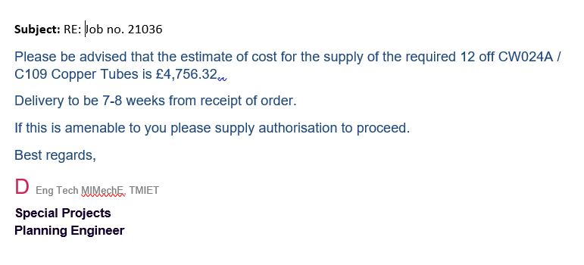
Figure 2 Cost Quotation

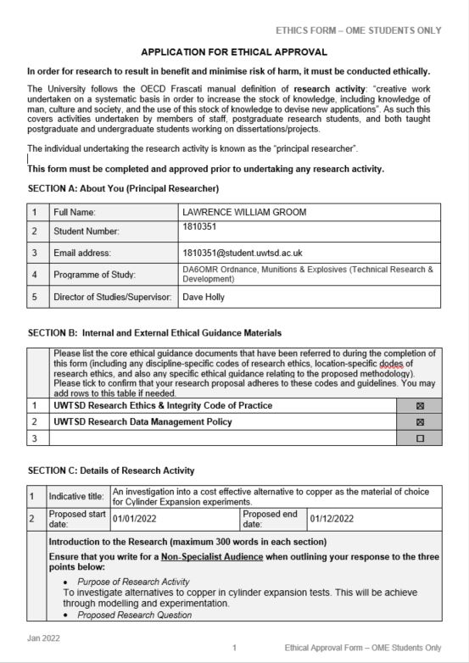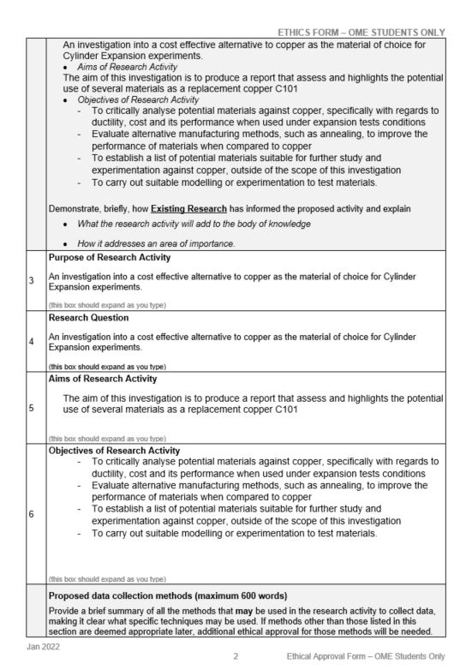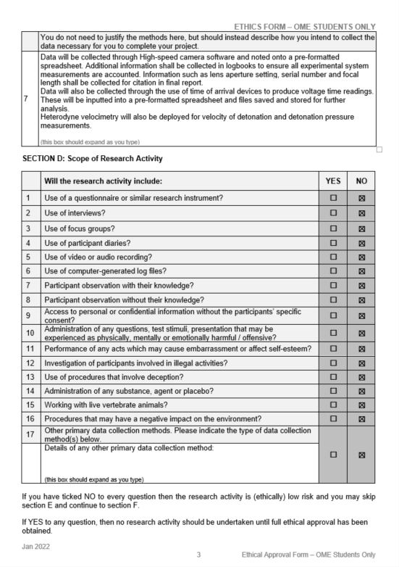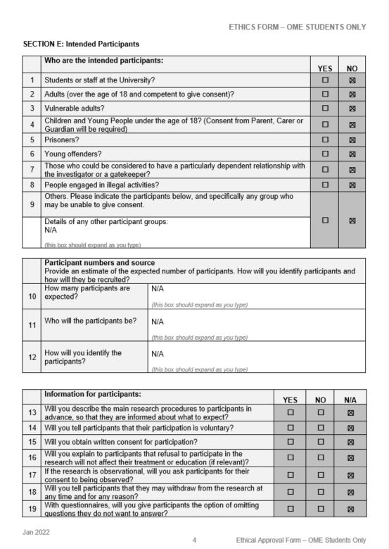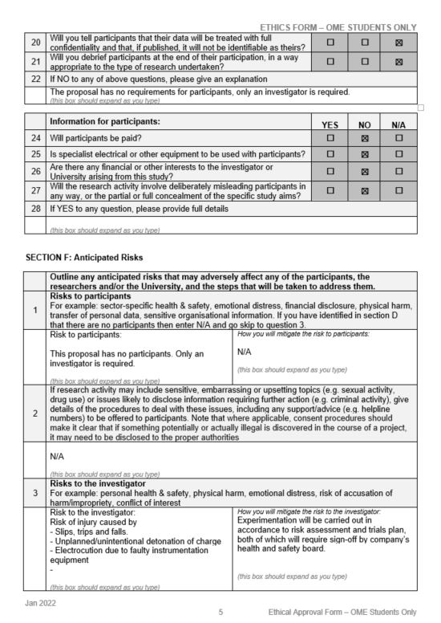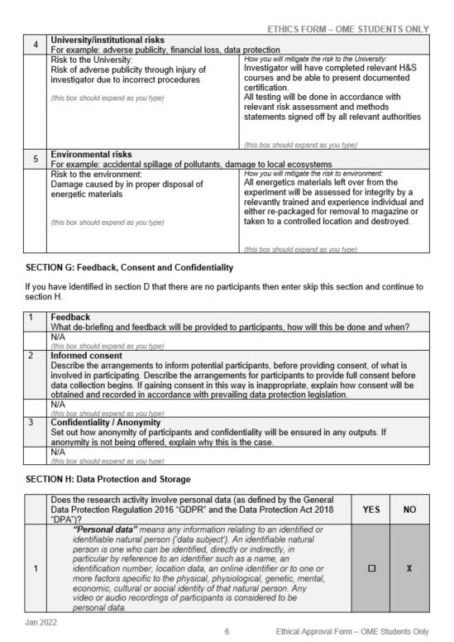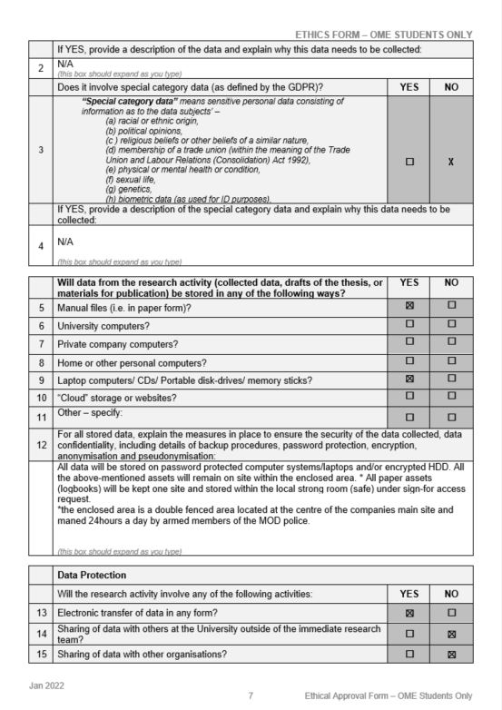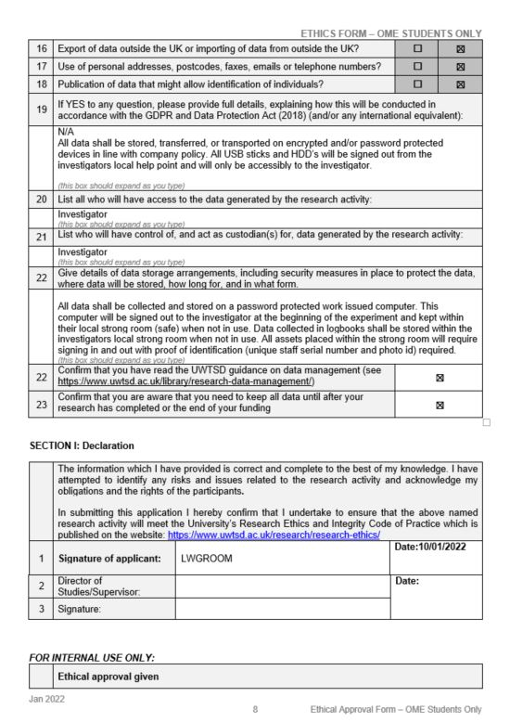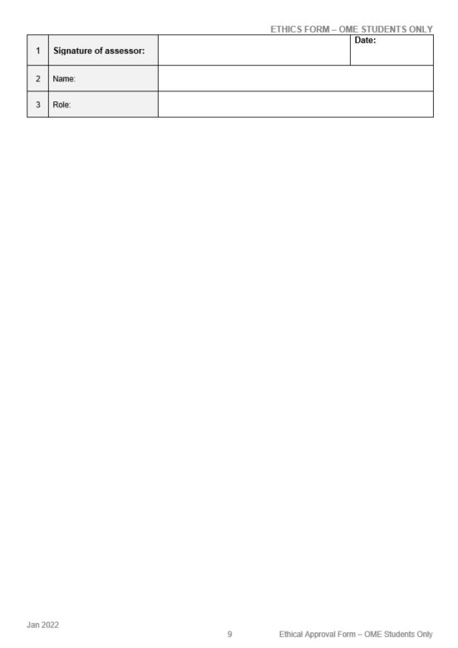

References

[1] | A. Materials, “Copper Alloys - Copper C101 Properties, Fabrication and Applications,” AZO Mterial , 11 May 2005. [Online]. Available: https://www.azom.com/article.aspx?ArticleID=2850. [Accessed 10 Jan 2022].
[2] | S. I. Jackson, “Scaled Cylinder Test Experiments with Insensetive PBX 9502 Explosive,” International Symposium of Detonation , Los Alamos, New Mexico, USA , 2014.
[3] | C. M. L. E. al, “Increasing the Utility of the Copper,” AIR FORCE RESEARCH LABORATORY, MUNITIONS DIRECTORATE, Eglin Air Force Base, 2012.
[4] | D. E. K. a. M. L. H. Warren R. Maines, “Combined Mini-Cylex & Disk Acceleration Tests in Type K,” Propellants Explos. Pyrotech., vol. 43, pp. 1-7, 2018.
[5] | F. R. Svingala, “steel as a Copper Alternative in Large Scale Cylinder Expansion Tests,” International Detonation Symposium, Cambridge, Maryland,, 2018.
[6] | R. E. al, “Estimation of Jones-Wilkins-Lee parameters of emulsion explosives using cylinder tests and their numerical validation,” International Journal of Rock Mechanics and Mining Sciences, vol. 112, pp. 290-301, 2018.
[7] | L. H. H. H. E. A. a. D. M. Richard Catanach, “Cylinder Test Specflcation,” Los Alamos National Laboratory , Los Alamos, 1999.
[8] | E. TOPKARAOĞLU, “DESIGN AND DEVELOPMENT OF A CYLINDER EXPANSION TEST SETUP,” THE GRADUATE SCHOOL OF NATURAL AND APPLIED SCIENCES, 2014.
[9] | B. E. Fuchs, “Picatinny Arsenal Cylinder Expansion Test and a Mathmatical Examination of the Expanding Cylinder,” US Army Reasearch, Development and Engineering Centre, New Jersey , 1995.

