Indie Game Development
  - Lecture 3a Lab Tutorial Exercise

Dynamically Generating a Scene Layout: Part 1

Objectives
This exercise is split into two parts and is used to show you how to dynamically generate a 3D scene from a layout defined in XML.
In this first part, you will set up all the framework elements and classes needed.

Exercise 1: Creating the Tile Prefab
- Open up your Unity project from the last lab exercise.
- Add a new Cube game object and rename it to Tile.
- Reset the cube’s Transform properties to the defaults – Position (0, 0, 0), Rotation (0, 0, 0) and Scale (1, 1, 1)
- Create a new Material using the BrownTile texture.
- Now apply the material to the Tile game object.
- Make the Tile game object a prefab and delete it from the scene.

Exercise 2: Adding the XML Resource
- Create a new folder in the Project Assets window called Resources.
- Go to Moodle and download the Rooms.xml file and add it to this folder.

Exercise 3: Creating the XML Classes
The XML is going to be deserialised into C# objects at runtime. Two classes are required Room and Rooms.

Room Class
- Create a new script called Room.
- Open it in your Editor and delete the default Start() and Update() methods. This class does also not need any Unity Behaviour, so it does not need to inherit from MonoBehaviour or use the UnityEngine. Delete the highlighted items shown.
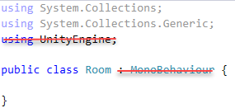
- Import the following libraries into the class so you can deserialise the XML into an object of this type. These libraries allow you to specify the mappings between the XML and the class and its properties.
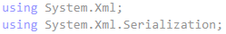
- Mark the class as corresponding to a <room>…</room> element in the XML.
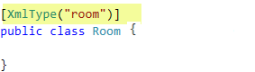
- This class requires the following properties:
Type | Name | Auto-Implemented Property | XML Mapping
string | FloorMaterial | Y | Attribute floor
string | WallMaterial | Y | Attribute wall
int | Number | Y | ??
string | Layout | N | Xml Text for the room element
int | Length | Y | ??
int | Width | Y | ??

- In C#, auto-implemented properties help you to quickly implement properties – all you need to do is specify the property name and get; and set;. Below is an example of the auto-implemented property definition for FloorMaterial and its corresponding mapping to the XML attribute.
- Now add auto-implemented properties for all the other properties except the Layout.
  - Note: I have deliberately left out the XML Mappings for some of the properties. You will need to figure these out.
- For the Layout property, you need a full property definition.
  - This requires defining a private field first (known as a backing field) e.g. _Layout.
  - Updating this private field in the set accessor method.
  - Returning this private field in the get accessor method.
  - You use a full property definition, when you want to do something else when the property is set e.g.
    - Set an additional field
    - Make some changes to the property value before setting it.
- Add the following backing field for the Layout property.
- Now add the following full property definition for the Layout property, adding its mapping to the corresponding XML too.
  - Notice that we trim the value before setting it.
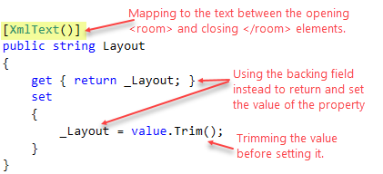

Rooms Class
- Create a new script called Rooms and Open it in your Editor.
- As before:
  - Delete the default Start() and Update() methods
  - The class does not need to inherit from MonoBehaviour or use the UnityEngine library. Delete these.
- Import the XML libraries that allow you to specify the mappings between the XML and the class and its properties.
- This class will be used to store a List of Room objects and map.
  - The rooms come from the list of different <room>…</room> elements in the XML.
  - The root <rooms>…</rooms> element is the parent (container) of the individual rooms, so this class maps to the root element. Mark the class as corresponding to the root <rooms>…</rooms> element in the XML.
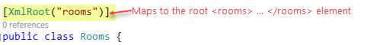
- This class has only one property, Collection. It will contain a list of rooms constructed from each of the <room>…</room> elements.
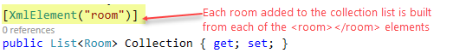
- Save your changes.

Exercise 4: Defining the Room Layout Map Codes
- In the ASCII art, different characters are used to represent different things in the layout. For example:
  - Space: simply a space (used for non-rectangular rooms)
  - 0 – 9: numbers and capital letters A to E are used to represent doors
  - | vertical bar/pipe character represents a wall
  - . a dot (.) represents a floor tile
  - e a small e represents an enemy.
  - X capital X represents the player character’s starting position in the first room
You can add loads more. It’s your layout
- You will create an enum (we did this in the last exercise) to define each of these codes.
- Create a new script file called LayoutMapCodes in your scripts folder.
  - Delete all the default code.
  - Replace it with the code to create an enum called LayoutMapCodes with the following items:
    - Space
    - Door
    - Wall
    - Floor
    - Enemy
    - Player
    - Anything else you wish to add.

Exercise 5: Creating an Enum to Define Tile Types
- In the same way, create another script file called TileTypes.
- Replace the code with an enum definition called TileTypes containing two items:
  - floor
  - wall

Exercise 6: Create a Tile Texture Material Class
You can have different tile textures e.g. one for the wall and another for the floor. You may even decide to use different textures for different rooms.
In this exercise you will define a class with properties to define a tile texture material type.
- Create a new C# script called TileTextureMaterial.
- Open it in the editor.
  - Delete the default Start and Update method.
  - It does not need to inherit from MonoBehaviour – delete this too
  - Delete the default imported libraries except the library for UnityEngine.
- Mark the class as being serializable so that it appears in the Inspector window when we use it to create an array object.
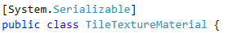
- Add the following three public fields to the class.
  - I have included an example of the first one.
  - Note that I am not using property definitions. This is because I want to be able to configure these properties from the Unity Inspector window.
Type | Name
string | Name
Texture2D | Texture
TileTypes | TileType

- Save your changes.

Exercise 7: Create a Tile Class
- Create another C# script called Tile.
- Attach this script to the Tile prefab you created earlier. Look in the Project Assets Prefab folder (there is no need to add it to the scene).
- Open it in the editor.
  - Delete the default Start and Update method.
  - It needs to inherit from MonoBehaviour – do not delete this
  - Delete the default imported libraries except the library for UnityEngine.
- Add a new public, auto-implemented property of type float called Height.
- The other property needs to be a fully implemented property. Add a backing field called _TextureMaterial of type TileTextureMaterial (the class you created earlier).
- Now, add the full property implementation as follows:
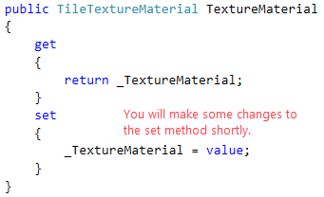
- Now, when you set the Texture Material, you will use this material information to:
  - Update the game object name
  - Update the material attached to the game object’s renderer component.
- Now create a new private method in the class called SetGameObjectName. The method’s return type is void as it does not return anything.
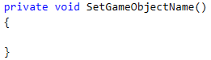
- Now add the following code to this method.
// Check if the Texture Material has a name
// If yes, set the game object created from this prefab
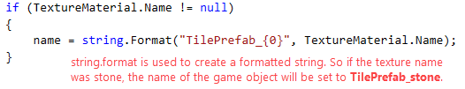
- Now, create another private method in the class called SetMaterial and set the return type to void.
- Add a statement to set the renderer’s main texture. Look at Lecture 3, Slide 13.
- Finally, go back to the set accessor method for the TextureMaterial property definition and make the changes highlighted below to call these two methods so they can update the relevant properties when the texture material is set.
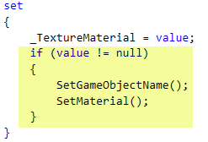
- Save your changes.

Exercise 8: Create a Portal Class
This script is for the doors (portal to next room) in the layout
- Create another C# script called Portal.
- Open it in the editor.
  - Delete the default Start and Update method.
  - It needs to inherit from MonoBehaviour – do not delete this
  - Delete the default imported libraries except the library for UnityEngine.
- Add the following two auto-implemented properties to it.
  - An integer property called ToRoom. // indicates the room the door portal leads to
  - A Boolean property called JustArrived. // indicates if the player character has just entered the portal door
- You will add more to this class later.
- That’s all for this part of the exercise.

