Human Resource Management
(LCMB7000_BIRM)

Student Name – Mustafizur Rahman
Student ID – 1711957
Lecturer Name – Uju Ugochukwu
Assignment Title – Component 1 Indivdual Report

Contents
Introduction 3
Literature review 3
Challenges in Human Resources 4
Competitive Challenges 4
Emerging Challenges 5
Recent Challenges 6
Future Challenges 9
The key theories and models of HRM that helps to face these challenges 10
Conclusion 13
Recommendations 13
Reference 14

Table of Figure
Figure 1: Sales growth from the year 2012-2021 due to the issue of work culture 7
Figure 2: Fashion retail fell in Marks and Spencer due to gender issue 8
Figure 3: The Harvard Model of HRM. 10
Figure 4: Maslow’s hierarchy of needs. 11
Figure 5: Herzberg Two factors theory 12

Introduction
HRM (Human Resource Management) is a critical function in managing the human capital through managing the potential individual. The primary purpose of HRM is to ensure the organisational objectives by the thorough practices of its framework. For this reason, the senior manager of the company needs to get the leadership qualities to ensure the proper management from employees to other resources. Therefore, for this report, the chosen organisation is Marks and Spencer from the e-commerce sector, facing severe challenges from 2010 to 2021. This report aims to explore HRM, various approaches related to management and human resources, and the primary functions of HRM. Moreover, this report will significantly analyse the HRM models to understand the challenges facing the chosen company.

Literature review
According to Darwish, (2013, p. 8). human resource management is a strategic approach that deals with hiring, deploying, training, and motivating employees to ensure sustainable development and to gain a competitive advantage. Pilbeam, and Corbridge, (2010, p. 17) stated that human resources are the main driving force for any medium and large business organisation to sustain in the competitive market and to gain sustainable development.
According to Collings, Wood, and Szamosi, (2018, p. 15) strategic HRM approach is effective to get long-term business solutions as it focuses on employee management developing the specific program. According to Mariappanadar, (2019, p.48) a business organisation has to identify the future challenges and it should develop effective strategy and policy to face the future challenges. The proactive approach is the best way to HR management in this case.
According to Podgorodnichenko, Edgar, and McAndrew, (2020, pp. 54-58). The key contemporary challenges in the HRM world are change management, managing diversity in the workplace, salaries, benefits costs, job satisfaction, retention, training, and development. De Vos, and Van der Heijden, (2017) stated that talent management is another significant challenge in the business world. The rapid growth of multinational organisation increases the competition in the labour market. Increased competition enhances the bargaining power of employees and they get the opportunity to switch jobs. According to Thite, Wilkinson, and Shah, (2012) every business organisation regardless of local, national, and multinational are faces challenges in managing ethics at the workplace. It increases the operational cost of the business.
According to Fugate, (2012) leadership development is one of the significant challenges of an organisation especially for giant business firms. An effective leadership and management system can increase the performance of a business. Armstrong, (2012) suggested that a business organisation should select a specific leadership style for a specific functional department based on its needs.
According to Ghazzawi, Al-Khoury, and Saman, (2014) HR managers should develop effective strategies and policies analysing the current condition of the firm and future needs. The challenges can be faced using some models of HRM. Total Quality Management (TQM) and Six Sigma of HRM are effective techniques to manage the HR activities of a business organisation. Lester, (2013) stated that it is very much important to understand the needs of the employees to motivate them. Maslow’s hierarchy, ERG model, and Herzberg two factors theory are effective to identify the needs of the employee properly and to motivate them fulfilling their needs.

Challenges in Human Resources
Marks and Spencer are facing severe challenges in Human Resources that are hindering its effective performance. With various forces, based on the business environment and foreign marketplace, Human Resources are facing difficulties due to the change in the business environment and to ensure sustainable development (Bastas, and Altinay, 2019). The key challenges of Mark and Spencer are briefly discussed below:

Competitive Challenges
Due to the change in the business environment and due to increasing the activities of national and multinational organisation competition is increased. Here are some challenges that are facing Marks and Spencer given below:
Globalization: It increases the mobility of people over the world and reduces the communication gap. Employees are searching for opportunities over the world and shift where they get the best opportunity. So, Marks and Spencer also need to recruit employees from the local and global areas. It creates several types of challenges to search and recruit employees.
Change Management: The business environment is changing according to the change of internal and external environments. An organisation has to cope with the changes; manage the changes; need to utilise the opportunities created by the change (Lendzion, 2015). For example, the technological change increases the efficiency of the business. So, Marks and Spencer has to modify the operating system by implementing new technology.

Emerging Challenges
Managing Talent or Human Capital: Talent management refers to managing talented employees who are innovative and have a good quality to lead the business. An organisation has to give them the opportunity to develop careers; has to motivate them to increase efficiency; has to retain them for the long term (Stone and Deadrick, 2015). It is not easy in this modern world as competitors also search those kinds of employees. Marks and Spencer also face talent management challenges. The operational cost of the business increases due to ensure effective talent management. However, it increases the sustainability of the business.
Ethics at the Workplace: This is another significant challenge for a business organisation. It mainly deals with the moral issues towards the employees (Terziev, Kuzdova, and Georgiev, 2017). An organisation has to ensure equality and justice to the employees. It needs to ensure basic human rights and other ethical issues. Employee rights need to be ensured after the selection period. The Equality Act 2010, National Minimum Wage, Working Time Regulations, Employment Rights Act 1996, and other contractual rights need to be formulated. Marks and Spencer has to ensure safety security and employees' health security. It is challenging as it increases the cost of business and it needs to do price competition to retain and increase the customer.
Demographic and Employee Concerns: In any organisation, employees are diversified in terms of age, gender, colour, religion, and culture (Vardarlıer, 2016). The behaviour and mentality of the employees are different. In this case, Marks and Spencer has to manage issues to ensure harmony and good interpersonal relationship among the employees. For example, the mentality of senior and junior is not the same to understand the teamwork capability. Sometimes, the junior staff fails to engage with any activity, and they suffer from expressing their innovative thoughts for fear of the senior manager. So, Marks and Spencer has to manage these issues properly by developing an effective HR strategy.
Managing Workforce Diversity: It creates some problems such as communication, culture, and behavioural issues. It also creates conflicts among the employees due to several issues (Armstrong, 2012). Marks and Spencer needs to manage workforce diversity perfectly in the workplace. The company operates in more than 29 international locations. But cultural diversity becomes a possible issue that creates various traumas for the line manager. Due to the appointing the local employees, individuals from the UK may find it unsuitable for adjusting. As a result, it creates hatred and lacks teamwork. But in the horizontal integration of the bundle of Best Practices ensures proactive cultural values to every employee. That means the HRM is unable to establish a fruitful connection among these staff. Thus, cultural diversity is increasing and making the HRM framework more complex.
Interpersonal Relations and harmony among the employees: The organisational culture is the only approach that provides value to the staff. Otherwise, the team may not produce efficient work culture. Moreover, deprived of the leadership style in the horizontal integration in the Best Practice of HRM, the management would fail to create a suitable bond (Langford, 2014). This may hinder the performance in managing raw materials with the suppliers also. Therefore, the overall HRM framework may collapse in closing the business of Marks and Spencer in the future. In addition, the investment by the shareholders might not gain the profit margin for this irrespective situation in the HRM.

Recent Challenges
Leadership: A business organisation has to develop an effective leadership system that the operation and managerial activities of a business can be managed perfectly. Macro and microenvironmental change influence the business to modify the leadership and management (Bastas, and Altinay, 2019). A single leadership style cannot be effective for all functional activities. So, marks and spencer has to select and develop an effective leadership system to lead the business currently and in the future.
Issues in Work Cultures: The work cultures issue arrives with the unsuitable case of cross-cultural activities through the expatriate selection. Moreover, individuals from different county and different languages may create problems with the UK individual.
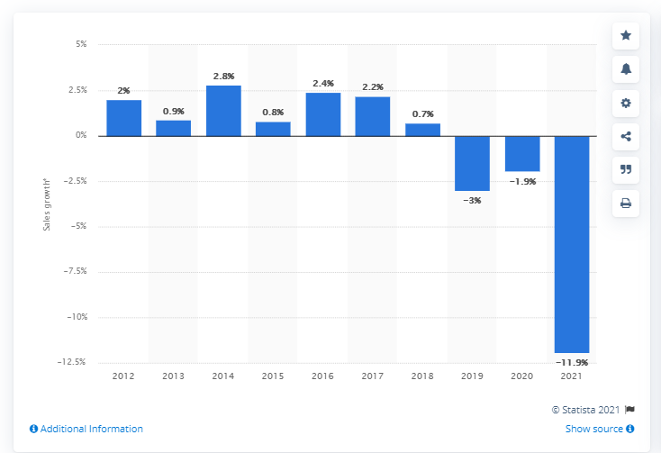
Figure 1: Sales growth from the year 2012-2021 due to the issue of work culture(Statista, 2021)
From figure-1, it indicates the value of cross-cultural management under the HRM through the bundle integration of the Best Practice does not get an appropriate response for the weak leadership style in the senior manager. Moreover, Marks and Spencer do not appoint a local consultant to understand the market condition in the operating places. Thus, this issue has tended to bring more loss in the last ten years.
Gender Issues in the Management: From figure-2, the gender issue is another form of challenge in the employee concern of Marks and Spencer. The performance in fashion branding in this e-commerce platform was such a disgrace for collecting funds in the market.
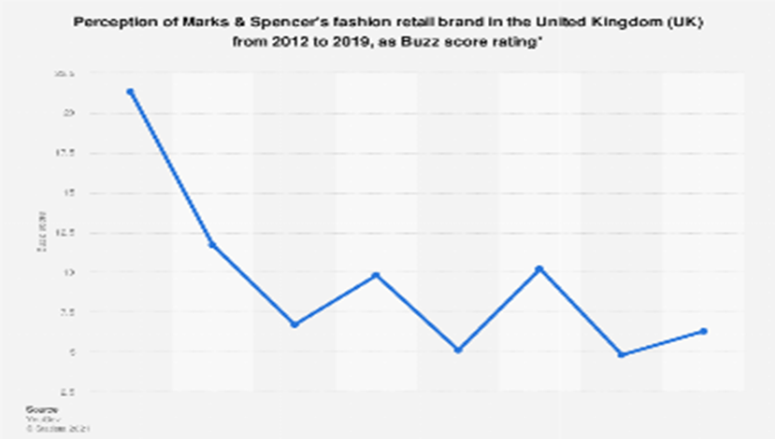
Figure 2: Fashion retail fell in Marks and Spencer due to gender issue (Statista, 2021).
The main reason stands for not having a proper leadership style that may allow each male and female to follow the equality. Thus, the work culture becomes more toxic, and single working hinders the business strategy of Marks and Spencer. Moreover, the product development idea goes in vain for not establishing equality by the line manager of the company's HRM.
HR Effectiveness Measurement: The appraisal is the evaluation of the employees that reflect in the overall performance of Marks and Spencer (Lendzion, 2015). For this reflection, a balanced scorecard is produced to understand the compelling business strategy of Marks and Spencer.
Particulars | Objectives | Goals | Indicators | Initiatives
Financial | Increase in sales unit and reduce in expenses | 25% increase in sales and 15% decrease in operating expense | Average Financial Positions | Poor negotiation with the suppliers
Customer Relations | Consist various products | Satisfy by launching new products in quarter | No new product launched recently | Unavailable to create a improved committee
Internal Processes | Consistency for developing products | Product development activities | Poor project innovation reports in ecommerce | Zero process for acquiring product development software
Learning Growth | Knowledgeable employee in product improvement | Higher professional of two master degrees | Zero output from the product development | No process of training and hiring potential candidates
Table 1: Balanced Scorecard of Marks and Spencer

Future Challenges
The Role of HRM Manager: A skilled and efficient HR manager can dig the opportunity and can able to forecast future change. Due to Covid-19 pandemic, the business world understands the needs of work from home and outsourcing. So, it is very important to be ready for any kind of future change. Only skilled and efficient HR managers can make an effective policy and strategy to cope with the change easily. It is very important to make flexible leadership and management system as it can easily modify based on the needs of change.
Workplace management: At the time of the Covid-19 pandemic every business organisation has to go online office system. The distribution system also needs to change to run the business activities properly. Manufacturing operations also need to be had to run to fulfill the demand of the customer. In this case, the HR manager of Marks and Spencer has to face the change properly. Marks and Spencer needs to develop an effective system of operation where the employees can do operational activities staying in the office and home accurately.

The key theories and models of HRM that helps to face these challenges
The Harvard Model of HRM
The Harvard model is consisting of six components of HRM. It suggests analysing the stakeholder interest and situational factors. Based on the analysis of these factors HR manager has to develop an HR policy. After that, the HR manager needs to assess the outcomes of the policy and activities and convert them into long-term benefits.
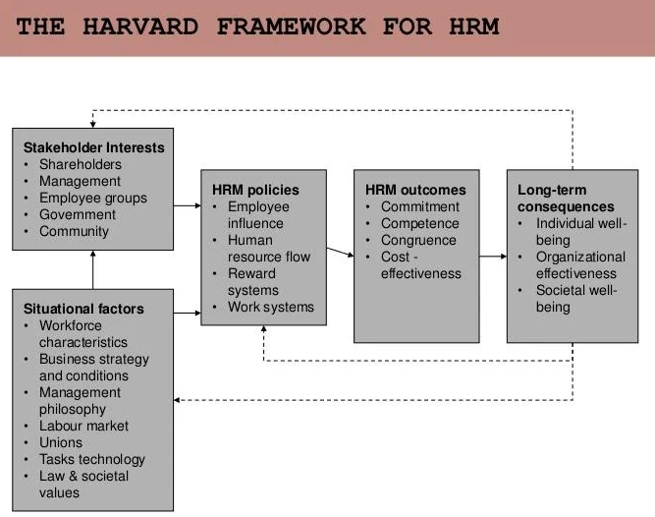
Figure 3: The Harvard Model of HRM (Vardarlıer, 2016).
Maslow’s hierarchy
This model is effective to identify the needs of the employee of an organisation. Maslow categorises the need of human beings into five segments. The model says that the needs of the upper segment cannot rise before fulfilling the lower segment needs. So, the HR manager has to identify the needs of employees and he should offer opportunities and compensation based on the needs of the employees.
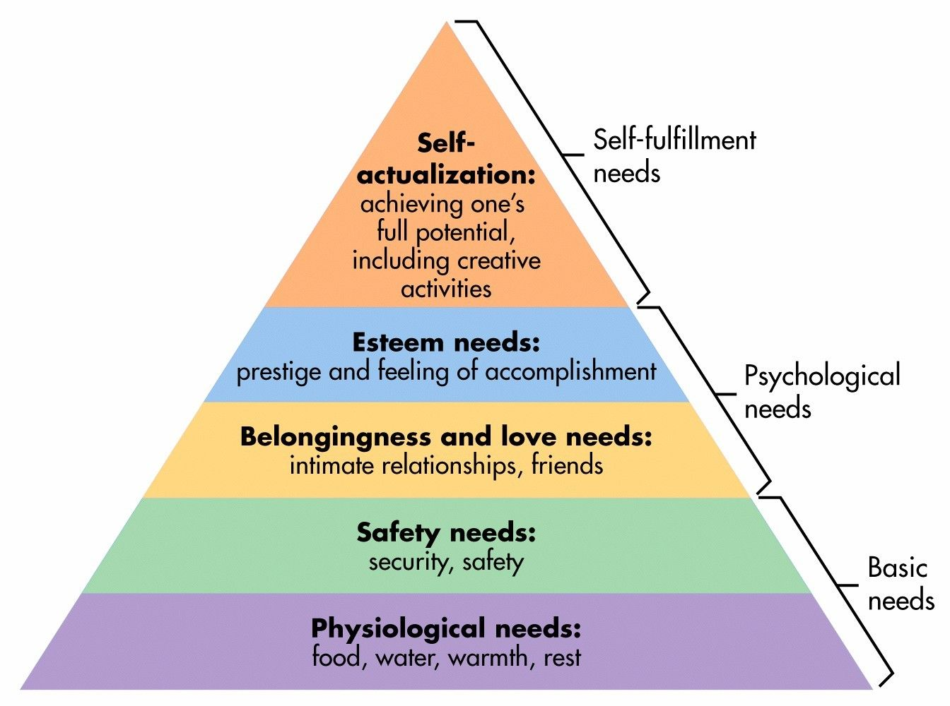
Figure 4: Maslow’s hierarchy of needs (Langford, 2014).
The HR manager of the Marks and Spencer should follow Maslow’s hierarchy of needs model to overcome the challenges of motivation and employee satisfaction. The manager should offer relevant facilities to the employees based on their needs.
Herzberg Two factors theory
This is another HR theory that discus job satisfaction and dissatisfaction of the employees. Herzberg classified the influencing factors into two such as motivator factors and hygiene factors.
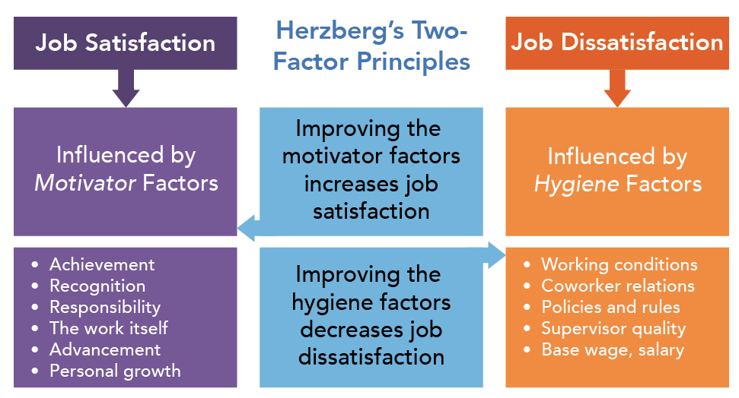
Figure 5: Herzberg Two factors theory (Armstrong, 2012)
The improvement of motivator factors increases the level of job satisfaction of the employees. On the other hand, the improvement of hygiene factors decreases the level of job dissatisfaction of the employees. The HR manager of Mark and Spencer can follow the model to face the challenges of the workplace environment, cultural issues, motivation, and employees retention.

Conclusion
The HRM framework is not stable in one of the top ten e-commerce of the UK, Marks, and Spencer. It is essential to support the employees in perspective of salary, bonus, increment, family concern, equality, etc. But the absence of the crucial factors made the sales growth very poor in the last ten years. Moreover, the shareholders need to appoint a senior manager possessing the leadership style. Otherwise, this HRM framework's sustainability may lead to severe damage or the closing of the business in different operational places. Therefore, the thorough insights may help to recognise the challenges and issues that the internal business of Marks and Spencer is facing and needs to sort for its longevity.

Recommendations
- Marks and Spencer should focus on sustainable development by developing an effective HR strategy considering the current challenges and future probable changes. It should develop an effective performance appraisal system to evaluate the performance of the employees.
- It should follow the Total Quality Management (TQM) and Six Sigma approach to improve the performance of the employees. TQM is a practice that helps to understand the customer needs and focus on continuous improvement. Six Sigma is a statistical method that is effective to understand the customer needs and setting the optimal task that compares the performance of one and another.
- It should develop an effective motivational policy that encourages the employees to increase their effort and level of skills in work. It should focus not only on the output of the employee but also should identify the cause of the good or bad performance and output.
- It should give enough training facilities to the employees to overcome their weaknesses. Learning by doing and coaching leadership is the suitable system in this case. The communication system and leadership should modify based on the current needs of the business.

Reference
Armstrong, M., (2012). Armstrong's handbook of management and leadership: developing effective people skills for better leadership and management. Kogan Page Publishers.
Bastas, M. and Altinay, Z., (2019). Employment for Disability: Human Resources Management in Higher Education for Quality. International Journal of Disability, Development and Education, 66(6), pp.610-615.
Collings, D.G., Wood, G.T. and Szamosi, L.T., (2018). Human resource management: A critical approach (pp. 1-23). Routledge.
Darwish, T.K., (2013). Strategic HRM and performance: Theory and practice. Cambridge Scholars Publishing.
De Vos, A. and Van der Heijden, B.I., (2017). Current thinking on contemporary careers: the key roles of sustainable HRM and sustainability of careers. Current opinion in environmental sustainability, 28, pp.41-50.
Fugate, M., (2012). The impact of leadership, management, and HRM on employee reactions to organizational change. In Research in personnel and human resources management. Emerald Group Publishing Limited.
Ghazzawi, K., Al-Khoury, P. and Saman, J., (2014). The effect of implementing technology in HRM on the level of employee motivation.
Lendzion, J.P., (2015). Human resources management in the system of organizational knowledge management. Procedia Manufacturing, 3, pp.674-680.
Lester, D., (2013). Measuring Maslow's hierarchy of needs. Psychological reports, 113(1), pp.15-17.
Mariappanadar, S., (2019). Sustainable human resource management: Strategies, practices and challenges. Macmillan International Higher Education.
Pilbeam, S. and Corbridge, M., (2010). People resourcing and talent planning: HRM in practice. Prentice Hall.
Podgorodnichenko, N., Edgar, F. and McAndrew, I., (2020). The role of HRM in developing sustainable organizations: Contemporary challenges and contradictions. Human Resource Management Review, 30(3), p.100685.
Statista., (2021). Brand perception M&S fashion 2019 | Statista. [online] Available at: <https://www.statista.com/statistics/415295/marks-and-spencer-mands-buzz-score-united-kingdom-uk-fashion-brand/> [Accessed 16 October 2021].
Statista., (2021). Marks & Spencer: sales growth 2021 | Statista. [online] Available at: <https://www.statista.com/statistics/872848/marks-and-spencer-sales-growth-worldwide-uk/> [Accessed 16 October 2021].
Stone, D.L. and Deadrick, D.L., (2015). Challenges and opportunities affecting the future of human resource management. Human Resource Management Review, 25(2), pp.139-145.
Terziev, V., Kuzdova, B.V. and Georgiev, M., (2017). Opportunities of application of the balanced scorecard in management and control. IJASOS-International E-journal of Advances in Social Sciences, 3(9).
Thite, M., Wilkinson, A. and Shah, D., (2012). Internationalization and HRM strategies across subsidiaries in multinational corporations from emerging economies—A conceptual framework. Journal of World Business, 47(2), pp.251-258.
Vardarlıer, P., (2016). Strategic approach to human resources management during crisis. Procedia-Social and Behavioral Sciences, 235, pp.463-472.

