Introduction
This poster aims to provide a clear understanding of the terms- health, well-being and lifestyle and why they are vital in the early years- by exploring their definitions and relationships. It highlights the importance of adopting a holistic approach to personal health and the role of lifestyle choices in enhancing both physical and mental well-being. Through a deeper understanding of these concepts, we will be able to better support individuals and communities in achieving balanced and fulfilling lives. The poster will look into and examine how these three ideas are related to one another, with supportive relationships serving as its main topic.

Health, Well-being and Lifestyle

Health-
Health is beyond just the absence of illness or disability. The definition of health is complex and includes social, mental and physical well-being. An individual surrounding, lifestyle choices, genetics, and access to healthcare can impact someone’s health. However, theoretical perspectives suggest that individuals may conceptualize good health and well-being in diverse ways, shaped by their unique life experiences and personal contexts, as Underdown (2007) asserts. In agreement with this, Lovell and Bibby (2018) argue that an individual’s perception of health is influences by a range of factors, including social, cultural, and environmental contexts. This suggests that the definition of good health is not universal, but rather can vary significantly depending on an individual’s unique experiences and circumstances.

It is a dynamic and changing state that is influences by social circumstances, individual behaviors, and larger society institutions. In order to attain and maintain long-term well-being, it is crucial to preserve balance in all areas, as this holistic viewpoint emphasizes.

Having positive interactions with others is important for children’s health, according to the Welsh Government (2020). Since these relationships serve as a basis for feeling safe and secure, children flourish when they have healthy relationships and develop close attachments with their parents and carers. Emotional stability, normal development and general well-being all depend on early childhood secure bonds. Children are more likely to grow up with resilience, confidence, and improved mental health when they experience love, support, and understanding. Their current and future health are significantly impacted by these early experiences of connection. John Bowly’s attachment theory highlights the importance of secure attachments between children and their caregivers. These early relationships shape not only the child’s development but also long-term mental and physical health. Healthy emotional connections in early childhood promote positive relationships and emotional well-being, reducing the risk of mental health issues later in life. Also, secure attachment supports a balanced lifestyle, as individuals with secure emotional bonds are more likely to develop healthy coping strategies and self-esteem. NSPCC Learning (2021) recognize the vital significance of fostering and supporting children’s health and well-being in relation to children and young people. Early experiences have a lasting effect on a child’s physical, emotional, and mental health throughout their life, according to research. Positive early experiences, like as safe attachments, excellent nutrition, and emotional support, are critical for developing a firm foundation for lasting health and well-being, whereas unfavorable experiences can contribute to health and development difficulties later in life.

Lifestyle-
A child’s health and well-being can be significantly affected by their lifestyle. Wales Center for Public Policy (2022) believe the term lifestyle describes the routines, habits, and behaviors that affect a child’s general growth and well-being. It includes social contacts, mental health, sleep patterns, physical activity and diet. The quality of a child’s connections with carers, their exposure to a secure and nurturing environment, and their availability of learning opportunities all have an impact on their lifestyle.
Together these factors shape children’s development, health and well-being, laying the groundwork for habits and overall wellbeing that lasts a lifetime.
The concept of lifestyle in the early years is closely linked to Bronfenbrenner’s Ecological Systems Theory, which highlights how various aspects of a child’s surroundings influences their development. A child’s daily routine are directly influences by their immediate environment which is also known as their microsystem. (Bronfenbrenner, 1979)

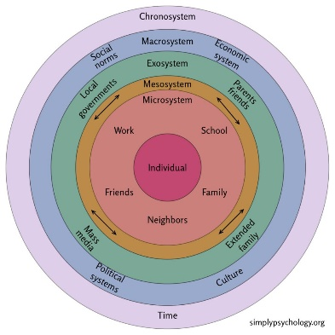
Bronfenbrenner’s Ecological Systems Theory highlights how a child’s environment influenced their development, making it especially relevant when thinking about their lifestyle. Children don’t frow up in isolation, they are shaped by the interactions between various environments. A child’s family, for example, offers direct assistance at home, while peers and teachers at school provide other experiences that also influence how the child learns and behaves. Beyond these direct impacts, their worldview and prospects are shaped by more significant elements such as media, economic circumstances, and social standards. The way these settings interact affects a child’s emotional and cognitive development in addition to how they conduct in various contexts. In practical terms, this means that the aggregate impact of these several levels of influence shapes a child’s lifestyle. (Guy-Evans, 2024).
Simply Psychology (2024)
Well-being-
Although Roberts (2010) concluded that well-being is commonly referred to as feeling ok, or doing well, she acknowledges that the phrase is wide and, like health, which may be challenging to define. She suggests that it is linked to happiness and enjoyment, thereby, the state of mind and contentment of a child is referred to as their well-being. It is imperative that professionals strive to enhance the health and well-being of the children and adolescents under their supervision. Following on, Berlinski and Schadv (2015) state that well-being goes beyond simply the absence of illness or distress. It involves physical, emotional, social and cognitive aspects of a child’s development and is strongly influences by the environment in which the child grows up. Bradshaw (2016) agrees with this and believes it is a multidimensional concept that encompasses both subjective and objective aspects of a child’s life. He states it involves physical, emotional, social and material aspects of a child’s life, all of which are influences by the quality of the environment in which they are surrounded by. In order to be considered well, it is extremely important none of these areas get neglected. Musgrave (2017) emphasizes the significance of making sure children’s health and wellbeing are at the forefront of each practitioners’ ideas and objectives, acknowledging that every professional practitioner has a responsibility to ensure the health and well-being of the child. Welsh Government (2010), accept this as they state that practitioners should be able to support individual needs and should also be able to identify the children and young people who would benefit from support and guidance. Roberts (2010) recognize that various factors influence the concept of child well-being, with one of the most crucial concepts being children’s rights, as outlined by UNICEF (2019). These rights are integral to a child’s well-being, as they promote safety and the ability for children to express themselves. In today’s world, a child’s well-being is essential, as research indicates that early childhood experiences play a significant role in shaping a child’s future.
Eudaimonic and hedonic wellbeing represent two distinct dimensions of wellbeing, as identified by research. The hedonic approach, as articulated by Fabio and Palazzeschi (2015), emphasizes the pursuit of happiness, which is achieved through pleasurable and enjoyable experiences. In contrast, eudaimonic well-being is concerned with life experiences that provide meaning, purpose, and foster self-acceptance. Additionally, McLeod (2020) highlights that Maslow’s hierarchy of needs offers a valuable framework for understanding well-being as well as health, particularly in the context of early childhood. Maslow Hierarchy of Needs is a framework for comprehending the idea of well-being since it ranks human needs for more fundamental physiological requirements to more complex psychological and self-fulfilling demands. Before advancing to higher levels people must satisfy lower level needs, which eventually affects their general well-being. (Maslow, 1943). The model highlights the importance of providing children with each need to allow them to achieve good health and well-being. As studies by Hoffman and Boatwright (2012) a baby’s wants must be satisfied in order for them to develop into a healthy, content individual who feels cared for and have a high sense of self-worth. Dahlgren and Whitehead’s (1989) model of health determinants provide further support for this framework, with Public Health England (2017) integrating this model in their discussion of its various components. When comparing the two models, it becomes clear that they share similarities, particularly in their emphasis on living and working conditions. In this context, the working conditions would primarily refer to the employment situation of a child’s parents. They both underscore the importance of addressing children’s basic needs, social environments and lifestyle choices to support the overall development. GOV.UK (2017).

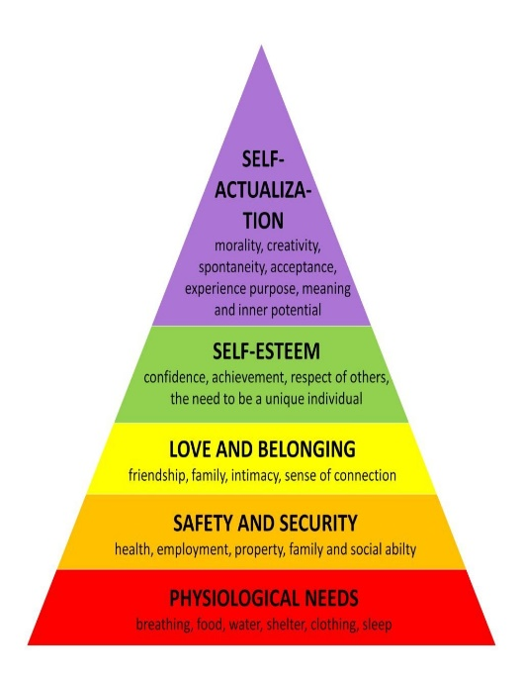

Simply Psychology (2024)

Conclusion
In conclusion, well-being, care and healthy living are essential components of early years practice that significantly impact children’s development. by promoting healthy habits, emotional support, and physical care, early educators lay the groundwork for lifelong well-being. A holistic approach, considering both physical and emotional health, helps children develop positive behaviors and resilience. Ensuring inclusive and supportive environment allows children to thrive, setting them up for a healthy, successful future. We can see how crucial it is to have a comprehensive approach to children’s development in order to provide them with the finest assistance and guarantee their good well-being by employing the models and theories throughout.

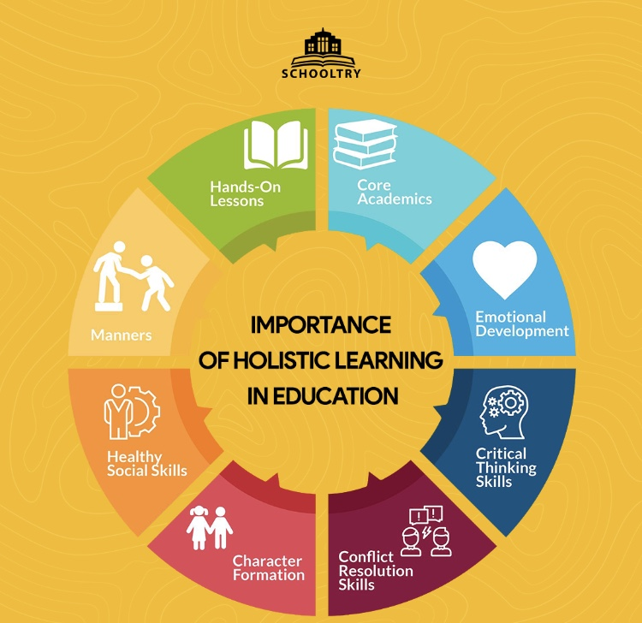

Application to Early Years Practice
Promoting well-being, care and healthy living is crucial for the physical, emotional, and cognitive development of young children. Howard (2020) believes by providing a loving environment that encourages healthy habits and positive lifestyle choices, early childhood educators play a crucial role in promoting these elements. Establishing daily routines that incorporate regular cleanliness, nutritious foods, and physical activity is one of the most basis strategies to support well-being. Practitioners may promote physical fitness in a fun and interesting way by combining structured exercise activities, outside play, and opportunity for children to learn about healthy habits. For example, during practice, letting children help with the growing and harvesting of fruits and vegetables or making easy, nutritious snacks help them learn about nutrition while also fostering social interaction and fine motor skills.
A child’s total health depends on critically on their mental and physical well-being. Early childhood educators foster emotional health by establishing a secure, welcoming atmosphere where they are able to feel appreciated and encouraged. Fostering self-expression, facilitating positive peer interactions, and giving children the chance to practice emotional regulation are all essential components of mental health promotion. (Barnardo’s, 2022).
In practice, Welsh Government (2010) state that meeting children’s needs holistically is another aspect of encouraging health and well-being. Recognizing the various cultural influences and backgrounds that children bring to the classroom is apart of this. By being aware of these variations, practitioners can modify their methods to be more inclusive and culturally appropriate. By incorporating care, well-being and healthy living, early childhood educators can create the groundwork for children to grow up healthy and happy.
Overall, early childhood educators not only support children’s immediate physical and emotional health but also provide the foundation for their future development into happy, healthy and well-rounded adults by integrating care, well-being and healthy living into everyday life. early childhood educators have a crucial role in influencing the destiny of the next generation since these early experiences lay the groundwork for long term health and well-being

SchoolTry (2023)

